Transforming capital: slavery, family, commerce and the making of the Hibbert family.

Introduction:

This chapter presents a case study that demonstrates the potential for the deployment of both our empirical data and integrative conceptual frameworks to explore the original accumulation and subsequent continuity of wealth and status from slavery. Using the research strands which have underpinned the overall project this chapter examines the political, social, cultural, financial, imperial and physical legacies established by the Hibbert family following their involvement with the slavery business. The Hibbert family story charts the trans-generational transformation of capital from property in commodities, to property in people, and finally investment in land, political position and cultural capital. From mercantile beginnings through to colonial plantation and finally metropolitan land and country house ownership, the narrative charts the movement of capital from the instability of merchant venture into investment in traditional forms of metropolitan property thus securing for the Hibberts a lasting position within Britain’s aristocratic elite through marriage into the Holland family, a position which is still maintained today.

The history of the Hibbert family during the period is one in which the entanglement of metropole with colony is a central theme. Not only were the family involved in the movement of goods and people across the globe, but more intimately they themselves were part of a continuous ocean borne traffic as various members supplied the personnel required for a successful colonial enterprise. The wealth generated through participation in the slavery system enabled the Hibberts to return to the imperial centre, positioning themselves within the social, political and cultural sphere of the landed classes. The sites in which they were located connect the various industries involved in making slavery work. The geographic reach of the Hibbert business network - from Manchester and Liverpool to Kingston and finally London - paralleled developments within the structure of the wider slave economy. As they reaped the rewards of their colonial ventures and returned to England, they spread away from the metropolitan commercial centres associated with transatlantic trade, into the genteel surroundings of the countryside of Cheshire, Buckinghamshire and Hertfordshire.

Using the profits accrued from the very highest levels of mercantile trading both in and with the West Indies they began to exert their influence on their surroundings. They invested in property in both England and Jamaica and set about improving, expanding and remodelling it. They filled their houses with art, books and furniture which conformed to the dictates of fashionable taste, allowing them to participate in the culture of conspicuous consumption. As a dissenting family they were debarred from formal political power, although one of their number - George (1757-1837) - publicly adhered to the Anglican faith enabling him to enter Parliament. As an alternative to formal political power they adopted positions of civic power, becoming church trustees, school governors, serving on the judiciary and as High Sheriffs. They used their wealth to support charities and invested in philanthropic institutions, helping to create legacies which befitted their reputation and status. The children of this generation of Hibberts would be schooled in the best institutions in England. Their marriages would seal the family transformation from mercantile to gentry and even aristocracy, although for the younger Hibbert sons the commercial world continued to provide a living.

When the campaign to abolish the slave trade and later slavery mobilised they were at the forefront of its defence. Three generations of members of the Hibbert firm were involved with the Society of West India Planters and Merchants. They gave evidence before the Select Committee in 1790, presented petitions, published pamphlets, wrote to newspapers and gave speeches to Parliament. In this way they helped to constitute and disseminate anti-abolition discourse. From 1790 onwards, George (1757-1837), as the most politically powerful of the group, was an advocate of compensation. This public rhetoric belied a private acknowledgement by the 1820s that slavery would inevitably come to an end. This realisation engendered a growing interest in expanding the family’s portfolio. The Hibberts championed several early railway schemes, although not all of them came to fruition. They also became involved with burgeoning areas of finance capitalism and investment in both maritime and life insurance companies. At the ending of slavery in the Caribbean Nicholas Draper has estimated that the family were awarded £103,000 in compensation claimed either as outright owners of enslaved people, or as creditors.

The Hibbert family experience is not necessarily representative of all those who claimed ownership in people. As the database demonstrates, ownership could take different forms, was of varying intensity and infiltrated a wide cross section of metropolitan society. Instead they are an example of the merchant-planter elite; a family who were able to exploit and profit from every stage of the processes necessary for the slave economy to work. They were able to convert their identification as both merchants and colonial rentiers into positions of power within the metropole. This transformation was never complete; as with the younger sons of many of the landed gentry who did not receive the inheritance of country houses or large sums of capital, some members continued to work for their livings. They did this through the commercial continuity offered by involvement in the family merchant house as well as expanding that interest to take advantage of new investment opportunities.

This chapter will begin by outlining the foundation of the Hibberts’ commercial interests. It will break down the establishment of their colonial business empire geographically starting in Manchester, then moving to Jamaica and finally London. It will consider the role of family, marriage and religion in the constitution of commercial networks, giving an impression of the various interconnections which allowed the Hibberts to flourish. It will give details of the Hibberts’ involvement in the campaign to secure compensation and which of them received it. It will then consider their influence on the metropole by outlining some of their activities within a series of distinct spheres; town and country house ownership, cultural consumption, philanthropy and charity, political and civic power, as well as commercial investment. It will examine the next generation of Hibberts, the marriages they made and their subsequent positions in society. The chapter will conclude with some thoughts on what kinds of legacies the Hibbert family left behind and the work that has been done to tie these legacies to the history of slave-ownership. In assembling a survey of data related to the Hibbert family this chapter is designed to demonstrate some of the ways in which the profits and power accrued from slave-based wealth infiltrated British society in complex and varied forms, touching not only the lives of those who benefitted directly from slave-ownership but also affecting those for whom slavery appeared a distant and disconnected phenomena.

The Hibbert family in Manchester:

The Hibbert family formed part of a network of wealthy dissenting merchants which spread across Manchester, Liverpool, Leeds and their rural environs. Dissenting merchant communities were close-knit; marriage, religion and trade were intimately entwined. Up until the repeal of the Test Acts in 1828 dissenters suffered under discriminatory legislation. Barred from political and educational institutions which might have fostered ambitions towards power, individuals from the dissenting community found different ways of securing status. Commerce represented an alternative path to wealth and influence; utilising dissenting networks meant that wealth circulated within the community. Dissenters fostered these links using the twin virtues of respectability and trust to ensure the integrity of their social and economic relationships. The Memorials of a Dissenting Chapel tells the history of the Cross Street Chapel in Manchester. Its ‘founders and worthies’ were dominated by men involved in commerce and manufacturing. Many of the names to whom the author attributed ‘the rise of Non-Conformity in Manchester’ - the Hibberts, Touchets, Diggles, Bayleys, Philips and Robinsons - were related to one another through the interlocking ties of kinship and commerce. In his discussion of Manchester’s role in the slave economy, Eric Williams named some of the individuals above, although he did not outline a specific network. Marriage played a central role in forming these relations, with women acting as the conduits for commerce, bringing with them important connections. This was certainly the case for the Hibberts. For example Sarah Hibbert married Thomas Diggles of Booth Hall in 1763. The Diggles, like the Hibberts were involved in both the African and West Indian trades; as Eric Williams has stated ‘Robert Diggles, African slave trader of Liverpool, was the son of a Manchester linen draper and the brother of another.’ Robert was the uncle of Thomas, and was documented as a partner in an Africa ship which delivered cotton to Liverpool in 1716. He was also a trustee of the Cross Street Chapel as were three generations of the Hibbert men.

Manchester had a key role to play in the maintenance of the slave economy. Finished cotton pieces were particularly in demand in the Guinea trade, as it was known. It was one of a number of desirable commodities used in the slave trade on the coast of West Africa. Raw cotton produced by enslaved workers in both America and, more substantially, the Caribbean was then shipped back to the port at Liverpool for processing in Lancashire. Manchester’s proximity to Liverpool and its port made the area into one of slavery’s hinterlands. The Hibberts ‘at one time supplied check and imitations of Indian goods to the African Company for the slave trade.’ As cotton manufacturers during the period of the traditional cottage industry of the north, the Hibberts’ role involved ‘organising and financing the separate stages, procuring the raw wool, linen or cotton, then delivering it to the cottagers’ and finally collecting and warehousing the finished article ready for delivery to Liverpool and finally shipment to Africa. The trade required a good knowledge of African tastes; specific colours and patterns were requested by ship’s captains who knew the market through their experiences of trading in Africa, with bright colours and checks particularly in demand. In a letter of 1765 to the Messrs. Hibbert of Manchester, the African Company asked that green and yellows be avoided when producing cloth for the Africa trade.

The Hibberts in Jamaica:

In the Memorials of a Dissenting Chapel the first Robert Hibbert (1684-1762) was listed as a ‘linen draper’. The description of his sons - Robert (1717-1784) and Thomas (1710-1780) - indicated a geographic expansion of their commercial interests; ‘Robert... was a West Indian merchant, and his elder brother, Thomas, resided the greater part of his life in Jamaica, superintending estates which the family had acquired.’ In 1734 Thomas arrived in Jamaica and like many before him he settled in Kingston. During the eighteenth century Kingston was ‘the leading metropolis of the British West Indies’ and ‘was inferior in population only to Havana in the Spanish Caribbean and to Philadelphia and New York in British North America.’ Dominated by its vast natural harbour Kingston was by far the most important port on the island; Burnard and Morgan have estimated that of the Guinea ships ‘whose disembarkation point is known, eighty seven percent landed at Kingston.’ Slave factors purchased the enslaved from the ships themselves; if they were large-scale merchants they would buy in large lots, as the ‘economies of scale ensured that much of the slave trade was concentrated in relatively few hands.’ The investors would give instruction to their ship’s captains who then agreed a bonding contract for the local factor to sell the slaves for no less than a premium price agreed beforehand. As Richard Pares has explained; ‘In these cases the factor insensibly became the real purchaser of the slaves: he paid the limit demanded by the owners, resold the slaves to the planters for payment in six, nine or twelve months, and compensated himself – indeed, made his fortune – out of the difference between the cash price and the credit price.’

Thomas had several commercial partners over the years. As an indication of the scale at which Thomas was trading, in partnership with Samuel Jackson, he acted as a factor for sixty-one ships over a ten year period between 1764 and 1774, selling 16,254 enslaved people. The partnership was successful enough for the firm to open ‘a branch house (Barnard & Montague) at Montego Bay.’ Trevor Burnard has argued that the lending of money by Kingston merchants is an undervalued part of the plantation economy. He has suggested that a better understanding of the internal credit system in the West Indies would add a further dimension to the discussion about the relationship between merchants and planters which both Richard Pares, and more recently Simon D. Smith have explored. Basing his estimate on the estate inventories left by mercantile men of a similar standing in Kingston, he has stated that debts owed to Thomas could well have reached up to £250,000. In evidence given by Hercules Ross to the parliamentary select committee in 1791, Ross spoke of ‘the late Mr. Thomas Hibbert, who had for forty or fifty years before been the most eminent Guinea factor in Kingston, and a most respectable character.’
Thomas compounded his economic influence with the acquisition of political and civic power acting as an assistant judge of the Grand Court and a Justice of the Peace by 1751. He represented both St. George’s and Portland before becoming Speaker of the House of Assembly in 1756. Thomas’ magnificent town house, built in 1755 and situated on Duke Street, was the seat of the Jamaica Assembly following the temporary move of the capital of Jamaica from Spanish Town to Kingston. Not content with success as a merchant in the early 1760s Thomas invested in a large tract of land in the parish of what is now St. Mary’s for the purposes of developing his own sugar plantation - Agualta Vale. In later years his nephew Robert (1750-1835) invested £14,501 on the dilapidated property adjacent to Aqualta Vale - the estate formerly owned by William Beckford Ellis Esq. The Hibberts transformed the usage of the estate, replacing the coffee with a large cattle breeding pen. The scale of the plantation is indicated by the size of the workforce which by 1825 had reached eight hundred and ninety-six enslaved people. This accumulation of economic, political and social power as well as an investment in land-ownership would be repeated by the Hibberts both at home and in the colony.

With Thomas’ success began a period in which the Hibberts, alongside their various partners, were a major force in Kingston’s mercantile trade. His brother John (1732-1769) was sent to join him in 1754, with the three eldest sons of their brother Robert (1717-1784) - Thomas (1744-1819), John (1748-1770) and Robert (1750-1835) - following in 1766, 1769 and 1772. Thomas (1710-1780) himself never had any legitimate heirs, although he fathered three daughters with a free woman of colour, Charity Harry, whom he described euphemistically as his ‘housekeeper’ in his will. Thomas was not alone in this practice - a number of the Hibbert men had ‘outside’ families. Thomas’ daughter Jane Harry is the best documented of these offspring, others are mentioned in wills and in the diaries kept by Thomas’ nephew Robert (1750-1835). John (1732-1769) married Janet Gordon in 1760, she was part of a Scottish family who had become prominent within the legal profession in Jamaica with several members acting as Attorney General and taking seats in the Jamaica House of Assembly. Their son Thomas (1761-1807), alongside his cousins from England would go on to inherit their uncle Thomas’ vast wealth, his estate and his slave factorage business. Thomas’s nephews - Thomas (1744-1819) and Robert (1750-1835) - worked within the family counting house and married into the Boldero London banking and Nembhard Jamaica planter families respectively. This consolidated their ties within both the capital’s mercantile sphere and the colony’s landed classes. The next generation of Hibbert men followed the pattern set by their uncle becoming judges, members of the Chamber of Commerce and of the House of Assembly. Involvement in the Assembly gave the Hibberts a voice within planter-dominated island politics enabling them to represent both their own and the wider mercantile interest. It afforded them access to vital information regarding trade, defence, the convoy system and the mail packets, all of which were important in giving them the edge over their less well connected competitors. With success came expansion; having secured the Hibberts’ commercial houses in Jamaica the family looked to move into the lucrative sugar trade.

The Hibberts in London:

London had always been important to the colonial slave-economy and by the third quarter of the eighteenth century it had become the centre of both finance and distribution for the sugar industry. As Richard Sheridan noted ‘Here was a large and growing market for sugar; an important source of plantation supplies; a financial, exchange and shipping centre; and the seat of imperial government.’ With planters consigning their sugar to the London merchant houses, the Hibberts saw an opportunity to share in the profits that were flowing into the City of London from the colonies. In 1770 Thomas (1710-1780) wrote to his Jamaica correspondent Nathaniel Phillips informing him of a new co-partnership between his nephew Thomas (1744-1819), and the London merchants John Purrier and Thomas Horton. With Thomas (1744-1819) and his brother Robert (1750-1835) already established in Jamaica the partnership utilised the relationships garnered through their uncle’s commercial houses to move into plantation supply, sugar commission and finance credit. Over the years the Hibberts partnerships went through various reconfigurations including; Hibbert, Purrier & Horton (1772-81), Hibbert, Fuhr & Hibbert (1791-99), Hibbert, Fuhr & Co.(1800-2), Hibbert, Fuhr & Purrier (1802-18), Geo. Rob. Wm Hibbert (1804-1805), Geo. Rob. Wm & Sam. Hibbert (1811-1818), G. W. S. Hibbert & Co. (1820-1838), Hibbert & Co.(1839-1863). The personnel was made up of trusted business associates including John Purrier, his son John Vincent Purrier, Thomas Horton, and Edward Fuhr. As with the firm in Jamaica close family members were the cornerstone of the merchant house; brothers Thomas (1744-1835), Samuel (1752-1786), George (1757-1837), and William (1759-1844), Samuel’s son Samuel Junior (1783-1867), George’s son George Junior (1796-1882) and William’s son William Junior (1792-1881) all operated at different times within the various co-partnerships.

The London firm connected the Hibberts’ interests in Manchester and Kingston allowing bills from Jamaica to be drawn on the London house. In 1802 this connection seems to have dissipated somewhat with George (1757-1837) complaining that ‘the Manchester business by their abruptly becoming merchant importers of their own account is greatly changed from what it was in my Father’s day and cannot be followed up without great energies.’ Family also played a key role outside of the co-partnership with the Hibberts working closely with their brother-in-law Thomas Greg (1752-1832), a member of Lloyd’s, to provide insurance for their correspondents. Thomas’ nephew Robert Greg wrote of his uncle that;

by sundry letters he appears to have started on his own account as Insurance Broker, & Underwriter in 1772. He commenced with many good connections, his Father’s House of Thos & John Greg of Belfast, Robt & Nath’l Hyde of Manchester, & Philips, Hibberts & others... The Business was first carried out in Lloyds Coffee House, then Old Bethlehem Broad St, & finally Warnford Court, Threadneedle Street’.
The Philips were connected to the Hibberts through marriage, the bonds of matrimony and kin providing a steady commerce between the families. The stability of the firm was one of its main strengths and undoubtedly influenced the calibre of its correspondents who were drawn from the elite of Jamaica’s plantocracy and included both Simon Taylor and John Tharp. By 1823 the scale of the Hibberts’ sugar trading was vast; George (1757-1837) claimed that the family had concerns in sixteen hundred hogshead brought into the Port of London that year.

Merchant houses involved in transatlantic trade had to be prepared to fulfil a number of functions for their clients. They arranged for the shipping, insurance, warehousing, porterage, lighter wharfage and distribution of their goods - all of which they took a healthy commission from. Their expert knowledge of the London sugar markets was deployed to get the best value for their customers which sometimes meant holding onto the sugar until it could achieve a better price. They acted as financiers offering their correspondents credit, paying their debts and dispensing allowances to their family members on their accounts. They sourced plantation supplies from ‘Negro clothes’ to soap, candles, and cooking utensils. They provided journals, ledgers and paper for bookkeeping on the estates. They sourced pepper, cinnamon, mustard and cloves to flavour their correspondents’ food, and wine, madeira, port and brandy to wash it down with. If their correspondents sent their children back to Britain they sometimes acted as guardians and were involved in arranging their schooling. They were a source of information for their clients on a variety of topics from trade and politics, to intimate family matters. The Hibbert counting house undertook all these activities and more.

As well as the partnership in the counting house, the Hibberts eventually came to own their own ships and private quays. As well as acting as a convenient transatlantic transport for the Hibberts and their friends, this provided both themselves and their clients with a greater degree of control over the movement of produce and afforded a greater protection against theft when the vessels arrived into the Port of London. In evidence given to a Select Committee in 1823 George (1757-1837) stated that he had personally owned or held a part share in eight ships in the West India trade. The Hibberts’ ships were famed for the quality of their captains, a number of whom were Brethren of Trinity House. The speed of their ships was also noted - the vessel Hibberts broke a record in 1785 by sailing from the Downs to Port Royal in 35-38 days. In 1793 George became involved in the plan to build closed docks for the West India trade. The West India Docks were constructed on the Isle of Dogs and opened for business in 1802. George stated that he had invested £2,000 and acted as Chairman of the West India Dock Company eight times between 1799-1815. Two more Hibberts - Thomas and Robert - were also listed as investors. The West India Dock Act of 1799 made it compulsory for ships in the West India trade to use the new facilities. The government awarded compensation to those affected by the Act, including the Hibberts who owned Wiggan’s Quay. The Hibberts received £33,408 in compensation. On top of this lump sum of capital, as both an investor and Director of the Company, George was paid dividends and could exert a degree of control over the practical running of the docks, for example he and the Court of Directors were able to set the rates for using the dock facilities.

Like the Hibberts in Jamaica this new generation of London-based Hibberts sought to build on their economic position with political and civic representation. George (1757-1837) was the most powerful of the Hibberts in the metropole. He was the younger brother of the three Manchester Hibberts who had been sent to work for their uncle Thomas (1710-1780) in Jamaica. He arrived in London in 1781 and took his place as a junior member of the firm Hibbert, Purrier and Horton. By 1782 his name had begun to appear in the minute book of the SWIPM. This organisation was the centre of the West India interest in London and was attended by the elite of planter and merchant circles. The SWIPM was effectively a lobby group; it formulated the interests’ position on matters affecting trade such as freight rates, duties, the organisation of convoys, the timing of the mail packets and later in defence of the slave trade and slavery. George was a regular attendee as were his brothers Thomas (1744-1819), Robert (1750-1835) and William (1760-1844), and later his nephews Samuel Junior (1783-1867) and William Junior (1792-1881), and his sons Nathaniel (1794-1865) and George Junior (1796-1882).

The SWIPM was dominated by planters and merchants connected to Jamaica, and given the Hibberts’ predominance there George rapidly became a useful and active member of the group. By 1798 George began to Chair the SWIPM’s meetings, acting in place of the permanent chair as a trusted stand in. George’s importance to the SWIPM can be seen in his election to various committees, particularly the slave trade sub-committee of which he became a member in 1792. The SWIPM regularly sent deputations to the government to lobby on the issues affecting the West India trade. George was routinely selected to make a representation, so much so that it was said that ‘Mr Pitt was accustomed to say, that “he never got so clear a view of the objects of a Deputation, as when he saw Mr. George Hibbert at the head of it”.’. This gave him access to privileged information and allowed him to have an influence over important practicalities of trade such as when a convoy might leave during times of war, or the delay of the mail packet. These were not decisions he alone made but together with the elite members of the SWIPM they could ensure that their interests, and those of their correspondents were best served. In 1806 he became M.P. for Seaford. From this national platform he made three speeches in defence of the slave trade which were later published by the SWIPM, outlining the West India position and making public calls for compensation for those planters and merchants who would be affected by the loss of their source of labour. Hibbert’s success was crowned in 1812 when he was elected Agent for Jamaica, a position he maintained until 1830 when ill health and old age finally necessitated his retirement from public life.

The Hibberts and compensation:

George (1757-1837) first made a public argument for compensation in 1790, when alongside his brother Robert (1750-1835), he was called to give evidence to the Select Committee looking into the slave trade. He suggested that the £70,000,000 invested by merchant and planters in the plantation economy would be irredeemably lost were the source of labour and therefore cultivation to be brought to halt. In a speech to Parliament in 1807 he made the case for the payment of compensation using the example of the West India Dock Act, from which he himself had benefitted. He argued that ‘if the spirit of reform be consistent’ then those whose property would be interfered with through the abolition of the slave trade, should likewise be compensated. Following the abolition of the slave trade in 1807 and the amelioration campaign, it became clear that the institution of slavery would be the abolitionists’ next target. George consistently argued that both the slave trade and slave-ownership had been sanctioned and legislated for by the British Parliament leading to heavy investment in the plantation complex by both metropolitan merchants and colonial planters. He demanded a fair and equitable settlement to end the practice of property in people. In 1818 he wrote to Earl Bathurst, the Secretary of State for War and the Colonies stating ‘By [British] Law Slaves are considered as Property, they are not distinguished from ordinary articles of Merchandize’. He argued that people of respectable position were maintained by the system of slavery, they therefore deserved compensation for the dismantling of their economic stability. In 1827 Robert Wilmot Horton, the Colonial Secretary, wrote to George about the practicality of slave compensation to which he replied ‘An Appraiser may measure a Man & ascertain his strength – but it is impossible that he could adequately estimate the importance of the Man in every relation to the Plantation’. In other words it was the incalculable value of the system of slavery and not the actual individual slave which should be taken into consideration when calculating compensation.

Given the level of involvement the Hibberts had with the West India trade it is unsurprising they lobbied so hard for the payment of compensation. The database shows that eleven Hibberts were awarded compensation totalling £103,000. These included Robert (1750-1835), George (1757-1837), William (1759-1844), Robert Junior (1769-1849), Samuel Junior (1783-1867), Thomas (1788-1879), Thomas Junior (1795-1845), William Junior (1792-1881), George Junior (1796-1882), John Nembhard (1796-1886), and John Washington (1804-1875). Robert Junior, William, his son William Junior, George, his son George Junior and George’s son-in-law Samuel Junior were all based in London and were involved with the merchant house. Thomas and John Nembhard were the sons of Robert Hibbert (1750-1835) and Jamaica-born Letitia Nembhard. Thomas Junior and John Washington were the sons of Jamaica born Thomas (1761-1807) and Dorothy Mansfield. The Hibberts made claims as trustees, owners-in-fee, mortgagees, judgement creditors, devisees in trust and executors. Their ownership of slaves was based both on plantation ownership as well as the complex system of credit relationships which characterised the West India trade. George died in 1837, before the compensation process could be completed. He did however recognise that he would be a significant recipient (he received £63,000) and therefore made provisions in his will; ‘My estates in Jamaica, compensation monies, stock, leaseholds, dock, canal and other shares, and all residue of personal est. to my Ex’ors on trust to sell.’ By the time compensation was awarded the Hibberts had already secured a place for themselves in British society. The compensation money was no doubt of practical use to the Hibberts but more than that it confirmed them in their claims to respectability. It was an admission by the government that George’s arguments around the legitimacy of property in people were held to be true. This allowed those who had been involved with slavery to rebuild their tarnished reputation and reinvent themselves ready for the dawning of a new age of Victorian imperial Britain.

The Hibbert family legacies:

Over the course of three generations the Hibberts had transformed themselves from their Manchester cotton origins through their involvement with colonial slavery. Their success can be traced in the types of marital alliances they formed. The first generation married into the dissenting mercantile families of the north, the second made matches within the commercial and banking families of London and the plantocracy in Jamaica, and by the third generation the Hibbert children were marrying into the English aristocracy and gentry. David Hancock’s detailed study of merchant men closely matches the Hibbert family’s trajectory: the amassing of a commercial fortune and its subsequent deployment to secure social status. Hancock identified key activities which were seen as vital in the process of becoming what he termed as a gentleman improver. Among those were the acquisition of land and an attendant interest in its improvement and cultivation, public service through political engagement, active philanthropy, the building and renovation of country houses and gardens, and participation in the culture of conspicuous consumption. The Hibberts enthusiastically adopted these practices moulding themselves in the image of the respectable metropolitan gentleman.

At home with the Hibberts: land, property and cultural capital

London:

The Hibberts’ rise can be charted through their appearance in the various London directories. Up until the 1790s they were only listed in the commercial handbooks, but by 1796 Thomas’ (1744-1819) address at 38 Weymouth Street could be found in Boyle’s Court Guide: The Fashionable Court Guide or Town Visiting Directory. Over the course of the next thirty years an increasing number of Hibberts were included in this type of publication so that by 1830 The Royal Blue Book. Fashionable Directory for 1830; containing the Town and Country Residences of the Nobility and the Gentry listed seven Hibberts within its pages; George Hibbert Esq. FRS. FSA. FLS. 38 Portland Place, George Hibbert Esq. Junior, 4L Albany, John Hibbert Esq., 47 Great Ormond Street, Nathaniel Hibbert Esq., 10 King’s Bench Walk, Temple, Samuel Hibbert Esq., 78 Harley Street, Thomas Hibbert Esq., 16 Berkeley Street, Portman Square, and William T. Hibbert, 36 Upper Harley Street. Clustered around central London these residences allowed the Hibberts access to the social, political, cultural and economic heart of the imperial centre. The possession or rent of a fashionable London property was essential for a family like the Hibberts. Close to the City of London, Parliament and the social entertainments of the season, their residences in the capital were an important marker of status. The newly developed Marylebone area, including the Portland Estate, was popular with absentee West Indian proprietors giving the Hibberts an instant network for social and business calling.

Interestingly between 1796 and 1820 George Hibbert’s main London residence was on Clapham Common Northside. Inhabited by the mercantile and banking classes, Clapham was also the home of the Evangelical anti-slavery sect, known afterwards as the Saints. Its residents included William Wilberforce, Zachary Macaulay, the Thorntons and James Stephens. Both the Hibberts and the Saints worshipped at Holy Trinity Church, with George paying for eleven seats for the family and their servants. He was included in a list of trustees and was involved in the establishment of a Chapel of Rest located at St. Paul’s Clapham, where his two year old son George was interred after his death in 1795.

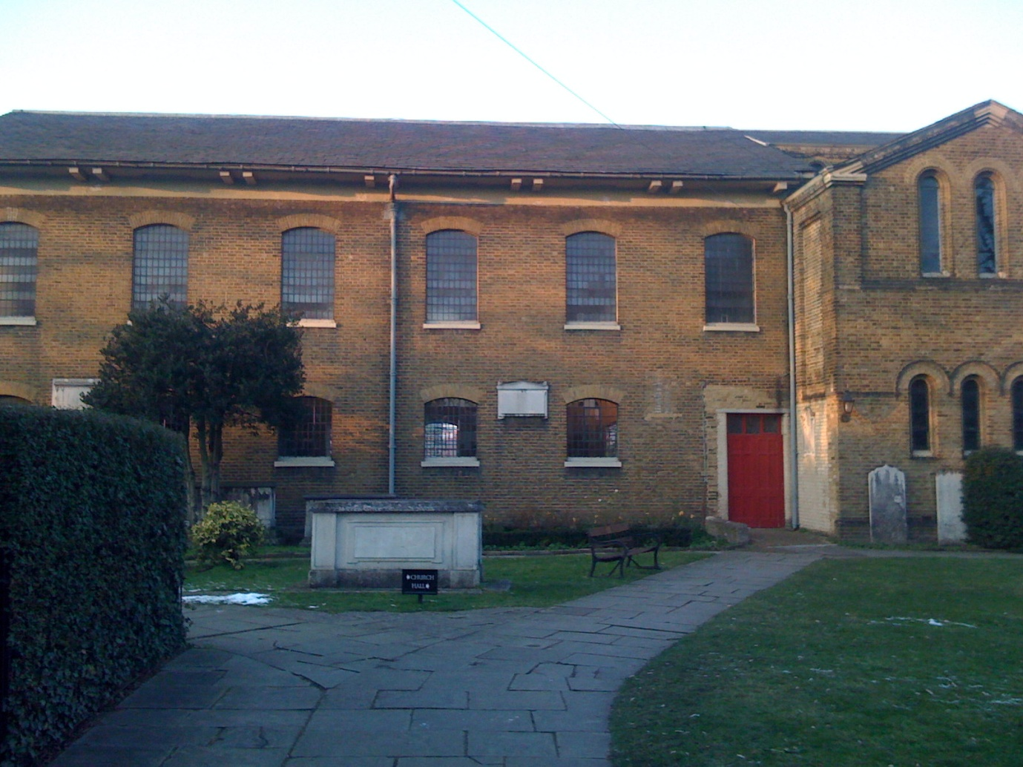

St. Paul’s Church, Clapham. The chest tomb in the foreground contains the remains of George’s son and his brother William (1759-1844). Boys from Sierra Leone who had travelled to Zachary Macaulay’s African Institution were also buried in this cemetery, although the sites of their graves is now unknown.

The house itself was described in detail in a sales advert of 1820. The description captures vividly the lifestyle which the Hibberts had grown accustomed to. The residence is described as a ‘Capacious Family House, Pleasure-Grounds, extensive Hot-Houses, PADDOCK, and LAND.’ The land consisted of eleven acres and stretched back towards the Wandsworth Road. In 1795 it was recorded that ‘Mr. Hibbert is allowed to fence in a piece of ground from the Common, opposite his house, and to plant trees for the ornament of the Common.’ The acquisition of such prime land so close to Holy Trinity Church, the worship place of the Evangelical anti-slavery Clapham sect, certainly must have caused George to make an impression on his neighbours. The interior of the house was conjured up in lavish terms by the Reverend Thomas Dibdin, who was a friend and a fellow Roxburghe Club member. In his Bibliographical Decameron he wrote about Hibbert using the name Honorio and stated that;

the mansion of Honorio is both capacious and richly furnished. And his Albanos, his Annibal Caraccis, Murillos, Berghems, Bassans, and Cuyps! All these - in a Palladio-proportioned room, some twenty- five feet in height - are the rich accompaniment of his stained glass book-vistos, and scattered and classically-embellished libraries.

The house was laden with cultural treasures including George’s famed library, his print and art collection and a specially painted frieze which had been executed by Henry Howard R.A.. George’s garden at Clapham was considered to rival Kew in the variety of specimens which could be found growing there. George was not the only Hibbert to settle in Clapham; his brother William (1759-1844) and his brother Samuel’s widow Mary and their families also lived in the area. Thus it is possible to see the ways in which slave-based wealth impacted even upon the heartland of the abolitionist movement - Clapham Common.

‘The Cit’s Country Box’: the Hibberts and country house ownership:

Away from the bustle of London and Manchester the Hibberts had purchased and inherited land and estates in the surrounding countryside allowing them to adopt a lifestyle of country gentility. The estates which were associated with the family over the course of the three generations discussed are as follows; Stockfield House, Birtles Hall and Hare Hills in Cheshire, Chalfont House in Buckinghamshire, Munden House in Hertfordshire, Bilton Grange in Warwickshire, Pains Hill in Surrey, East Hyde in Bedfordshire and Braywick Lodge in Berkshire. Stockfield House was the original family home of the Hibberts described by John Seed as one of several ‘fine houses and small estates within the orbit of Manchester.’ Pains Hill, a 230 acre estate, was purchased by Robert (1750-1835) however it only stayed in the family between 1798 and 1802. Robert sold it on to William Moffat M.P. a London banker and East India Company stockholder. Robert had previously offered the estate to his Jamaica born cousin Robert (1769-1849) for the sum of £27,000, giving a rough estimate of what Moffat would have been likely to have paid. Likewise East Hyde in Bedfordshire did not remain in the family very long. Purchased in 1806 by Robert Junior (1769-1849), the cousin to whom the offer of Pains Hill was made, it was sold in 1833 to Levi Ames, who had at one time been an Alderman of Bristol. Birtles, Chalfont, East Hyde and Hare Hills were all purchased by the Hibberts during the period of slavery. Bilton Grange and Braywick Lodge were acquired shortly after the ending of slavery. Munden was inherited by George (1757-1837) through his wife Elizabeth Fonnereau whose uncle Rogers Parker had bequeathed it to her on his death in 1829. The next section will examine three of the Hibberts’ principle properties; Chalfont, Munden and Bilton Grange.

Chalfont, Buckinghamshire:

Thomas (1744-1819) acquired the estate of Chalfont in 1794. He had made a fortune through his involvement firstly with his uncle’s slave factorage business and secondly on his own account by setting up the co-partnership Hibbert, Purrier and Horton. Thomas had been in Jamaica between 1766 and 1780 and from an extract in his brother Robert’s (1750-1835) diary it seems that he did not enjoy life in the colonies; ‘Take a walk in the evening with my Bro. In the back garden when he explains to me how little his present way of life agrees with his feelings and wishes.’ In 1780 the two brothers and their cousin Thomas (1761-1807) each inherited from their uncle Thomas a third part of his vast estate. Thomas (1744-1819) returned to England the same year and set about enjoying life as an absentee. Following his marriage to Sophia Boldero in 1784, he and his new wife lived at Upper Grosvenor Street. After purchasing Chalfont, Thomas hired John Nash to transform the house between 1799 and 1800. Chalfont was painted by Thomas Girtin and J. W. M. Turner - the Turner painting was only recently rediscovered in 2003 following a project by curators at the Tate to catalogue Turner’s works. Chalfont’s owners Thomas and Sophia were captured on canvas, this time by Thomas Gainsborough. Whilst Thomas’ portrait is now in a private collection his wife’s was sold to Baron Alphonse de Rothschild of Paris for 10,000 guineas in 1885. It now hangs in the Neue Pinakothek in Munich.

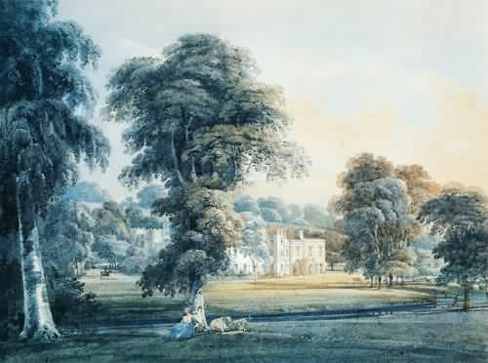

Chalfont House painted by Thomas Girtin c.1800

Between 1800 and 1803 the Hibberts’ counting house suffered financial instability. Thomas’ brother George wrote to Simon Taylor in 1803 explaining that a ‘totally misguided attack has been made upon the Credit of our House originating as I think in the failure of our next door neighbour in Mincing Lane, thank God we stand though sorely pelted’. Interestingly in the same letter he offered Chalfont as security on a loan which the Hibberts had taken out with Taylor. Chalfont then was both an ornamental status symbol and a practical capital investment which could be lent upon to support the Hibberts when necessary.

Thomas and his wife Sophia separated in 1796 and did not have any children. On Thomas’s death in 1819 he left Chalfont to his brother Robert (1750-1835). Robert in turn bequeathed it to his son younger John Nembhard (1796-1886), his eldest son Thomas (1788-1879) having inherited Birtles Hall in Cheshire. Robert left the staggering sum of £250,000 in personalty as well as his ‘Jamaica estates with slaves, stocks etc.’ Both John Nembhard and his elder brother Thomas are listed in the slave compensation registers. John Nembhard lived at Chalfont with his wife Jane, the daughter of Sir Robert Alexander a banker with parliamentary connections who acted as Governor of the Bank of Ireland. He served in the King’s Dragoon Guards as a Cornet at Waterloo before retiring at the rank of Major in 1848. His diary of his experiences during the Napoleonic Wars is kept in the collection of the First Queen’s Dragoon Guards. After John Nembhard’s death in 1886 Chalfont was sold by his executors to Captain Berton, and by him in 1899 to Mr. John Bathurst Akroyd, and was purchased from the latter by Mr. Edward Mackay Edgar.

Munden, Hertfordshire:

Unlike the previous property Munden was inherited by George (1757-1837) through his wife Elizabeth Fonnereau’s uncle Rogers Parker. George, like his brothers Thomas (1744-1819) and Robert (1750-1835), was involved in the family merchant house; unlike them he never visited Jamaica. His business and political interests kept him attached to London and therefore he was content to wait for his wife to inherit the property rather than buying an estate in the mode of his brothers. The house was neither fashionable nor elegant: ‘at the time of the death of Rogers Parker in 1828 Munden was merely an old fashioned farm-house’. However, it held the potential, given the right balance of capital investment and taste, to become a respectable family seat. It was located at a distance from London but was not so far as to make access to the capital difficult. Relatives by marriage of the Hibberts - the Gregs and the Thellusons - already owned land in the area, allowing George to consolidate the family’s presence. In 1829 Hibbert relinquished his property at Portland Place, ‘retired from London, and applied himself to the improving and ornamenting his newly inherited property’.

The need for extensive renovation work to be carried out on Munden necessitated George selling part of his famous and much prized book and print collection. George was a renowned collector; his brother Robert wrote in 1801 of a ‘Story of George having given £5,000 for Woodhouse’s Pictures.’ Hibbert had several major book and print sales in 1802, 1809, 1829 and 1833. Important sales of George’s collection also took place after his death in 1860, 1868 and 1902. The sale in 1829 was noteworthy in that it ‘occupied altogether forty-two days... There were eight thousand seven hundred and ninety-four lots, representing about twenty thousand volumes; and the total amount realised was twenty-one thousand seven hundred and fifty-three pounds, nine shillings.’ The money enabled George to transform Munden from its former state into a resplendent Tudor Gothic mansion. The estate at Munden was passed down to George’s eldest son Nathaniel allowing him to claim the status of country gentleman.

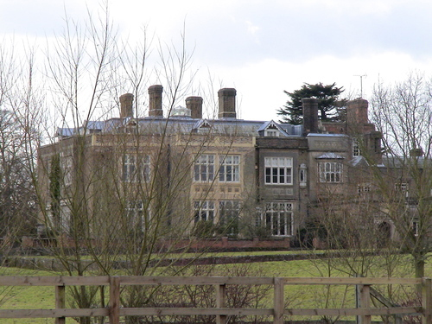

Munden House, Hertfordshire © Copyright Brian Smith

Following an education at Winchester, Nathaniel had been prepared for a life of genteel sociability. Unlike his father, Nathaniel went into the legal profession, although he occasionally attended the meetings of the SWIPM. In 1828 Nathaniel married Emily Smith, the daughter of the renowned wit and later Canon of St. Paul’s, the Reverend Sydney Smith. A letter from the Reverend to Lady Gray in 1827, telling her of the engagement, betrayed a degree of reticence regarding Nathaniel’s association with the West Indies. As Nicholas Draper has pointed out the letter ‘characterised George Hibbert as ‘the Indian’ rather than West Indian, merchant: Nathaniel he described as ‘Mr Hibbert of the North Circuit... a sensible high-minded young man who will eventually be well off.’’ Inheriting Munden would distance Nathaniel from his father’s roots in the increasingly unacceptable world of slave-based commerce. Nathaniel was remembered by Barbarina, the wife of Admiral Sir Francis Grey, who wrote ‘Mr. Hibbert was, I think, the most agreeable man I ever met, full of cleverness and knowledge, very original in his views, and with that rare gift of making those he talked to feel clever too.’ On his death Nathaniel left £9,000 in personalty. However with Munden secured as the family seat, alongside his well connected marriage, his daughter was well placed to make an excellent match.

The marriage to Emily brought with it an important social network; Emily’s elder sister Saba was the second wife of Sir Henry Holland. Holland had two sons by his first wife, the eldest of whom was Henry Thurston Holland. In 1852 Nathaniel and Emily’s daughter Elizabeth married Sir Henry’s eldest son. Henry Thurston Holland had an illustrious political career and was eventually made Viscount Knutsford in 1895. Henry and Elizabeth had twin sons Arthur and Sydney Holland in 1855. Elizabeth died shortly after and Henry married again, this time to Margaret Trevelyan, the daughter of Charles Trevelyan and Hannah More Macaulay. The granddaughters of proslavery George Hibbert and abolitionist Zachary Macaulay were thus linked by marriage and it was Margaret who would help to raise George’s great-grandchildren. Arthur entered into the Royal Navy as an Acting Lieutenant but retired upon inheriting Munden. There was a stipulation in his mother’s will which required him to take the additional surname of Hibbert, which he assumed by Royal License in 1876. His twin brother Sydney inherited the title Viscount Knutsford from their father. Sydney pursued a successful legal career. He was also Director of the English and Scottish Australian Bank, the Electric Underground Railway Company and of the London and Lancashire life Insurance Company. His philanthropic work earned him the title ‘The Prince of Beggars’ after he wrote thousands of letters to raise money for the London Hospital. Munden remains within the Hibbert-Holland family today.

Bilton Grange, Warwickshire:

John Washington (1804-1875) rented the property in 1839 and purchased it in the early 1840s. His father Thomas (1761-1807) had purchased the two third interest held by his cousins Thomas (1744-1819) and Robert (1750-1835) in their uncle Thomas’ (1710-1780) plantation Aqualta Vale. His father died in 1807 just three years after John Washington was born. In his will he left each of his children £10,000 and a further £10,000 for each son who lived to the age of twenty-five. In 1839, aged thirty-five, John Washington married Julia Talbot née Tichborne, the third daughter of Sir Henry Joseph Tichborne. He completely remodelled the house employing Augustus Pugin to design both the exteriors and interiors. The work was on a grand scale: starting in 1841 it took ten years to complete and has been described as ‘one of the other great domestic schemes of Pugin’s mature years’. Relations between the two men were strained with ‘frequent disputes’ breaking out between the architect and his client. Pugin’s work is described in detail below;

Pugin greatly expanded a small eighteenth-century house, adding a new wing that completely dominated the existing structure, and creating a sequence of new rooms which included a galleried Great Hall with stained glass windows. There was a dramatic staircase with carved newel posts in the form of heraldic beasts and birds, some fine carved stone fireplaces with heraldic andirons or firedogs, a rich array of carved and painted panelling, elaborate chandeliers and decorative metalwork including some finely wrought keys, a Pugin speciality. A range of specially designed tiles and wallpapers featured the Hibbert initials and coat of arms. In its diversity, Bilton Grange represented a typically extravagant and completely coordinated Pugin interior, in his modern medieval style.

Employing the Gothic architect Pugin may have been a result of Julia’s connection to the Talbot family, who themselves were significant recipients of slave compensation money. Julia had previously been married to Lieutenant-Colonel Charles Talbot and their son Bertram went on to become the seventeenth Earl of Shrewsbury. John Talbot, the sixteenth Earl of Shrewsbury, had hired Pugin to remodel part of his country house, which then became known as Alton Towers. Like Talbot and Pugin, Julia was a Catholic which may have influenced her husband’s choice. The Gothic form and its later revival were strongly associated with English liberties. John Washington’s choice of an architectural style which was closely associated with forms of English freedom is an interesting one. Perhaps like his namesake George Washington - the slave-owning champion of American independence - he was able to reconcile slave-ownership and claims to a particular - racially bounded - notion of freedom. Or perhaps, like his namesake, he found that in relinquishing his claims to ownership he could clothe himself in the mantle of the emancipator.

In 1866 the Hibberts sold Bilton Grange and moved to London. They had transformed the house, which remains an English Heritage grade II listed building. Shortly after the Hibberts’ departure the house became a school with pupils entering under the Reverend Walter Earle in 1887. The school - Bilton Grange - still exists as an independent preparatory school.

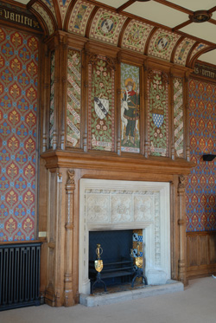

An example of a Pugin fireplace at Bilton Grange.

Acquiring property and land was part of the mechanism for transforming a mercantile fortune into a more stable and respectable form of wealth. Works of improvement were part of the lexicon of gentlemanly culture; a man might talk with landed neighbours or within his club about new innovations upon his English estate, in ways that he could no longer do so with regards to his Caribbean holdings. Land and houses offered a sense of permanency which mercantile capital could not guarantee, although of course there was always the possibility that these acquisitions might be lost. If kept and managed well, land and property could be passed along the generations creating a legacy of respectability and power. The Hibberts had risen from their involvement in the slavery business but they were shrewd enough to recognise that investment in land ownership in England would secure for them and their successors the position they craved within metropolitan society.

The benevolent slave-owners? Philanthropy, charity and moral capital:

These estates brought with them social, political, civic and cultural power. They enabled the Hibberts to cultivate an identity in the traditional mode of paternalistic land-ownership. Not only did the family exert their influence on the physicality of the estates they lived on by building, remodelling and landscaping, they also became involved in the social, moral and spiritual fabric of the area. This manifested itself through a keen concern in the local churches, hospitals and schools as well as support for the poor in the community through contributions to relief funds and the establishment of almshouses. The Hibberts were philanthropists at both a local and a national level. Whilst some of their activities were intimately tied to their estate ownership, other projects they were involved with were designed to be of benefit to the nation. The Hibberts saw no incompatibility between their actions as philanthropists and their activities as slave-owners. A particular form of philanthropy was articulated by George (1757-1837) during the slave trade debates of 1807. He stated that ‘the rational principle of self-love... puts first the centre in motion, and then extends itself in progressive circles of beneficence to the extremities’. George believed that charity could and should be extended, but only to proper objects - the deserving of the metropole. In later years George increasingly utilised the discourse of benevolence to publically defend slave-ownership as can be seen from his position in 1823 as a Governor of the Society for the Conversion and Religious Instruction and Education of the Negro Slaves in the British West India Islands.

The Hibberts’ philanthropic activities were in part about legacy building - for example John (1811-1888) of Braywick Lodge was described in a 2007 government brochure as ‘a local philanthropist’. The memory of the family is closely bound up with public reputation which they established as benevolent improvers. Charitable acts confirmed the social order of things and endowed the Hibberts with a moral authority which justified their position within society. It also provided an alternative narrative to their increasingly controversial identification with slave-ownership. Their donations were often accompanied by memorial plaques; others resulted in streets or buildings adopting the Hibbert name. These physical remnants of the Hibberts’ presence remain dislocated from the history of the family’s involvement in slavery, thus allowing a pamphlet to be printed in 2007 - the bicentenary of the abolition of the slave trade - which uncritically celebrated John of Braywick as a philanthropist without gesturing to the origin of his wealth.

Religion, almshouses and education:

Religiosity was an important part of demonstrating one’s respectability. The provision of religious instruction, places of worship and supporting the dissemination of the Christian faith was both an expression of one’s personal devotion as well as a marker of social position. As wealthy land-owners the Hibberts felt it their duty to ensure that adequate spiritual sustenance was available to both themselves and those who lived on or close to their properties. This was a lesson which had been learnt through the generations with successive Hibbert men acting as trustees for the Cross Street Chapel in Manchester. In 1840 Thomas (1788-1879) of Birtles Hall built the private chapel of St. Catherine’s Church in Over Alderley, Cheshire. The church is designated as a grade II listed building by English Heritage. As patron Thomas’ name was worked into the design; on the four centred arched door case ‘T.H.’ was inscribed in Lombardic script in the spandrels. It became the parish church of Birtles and Over Alderley in 1890.

Saint Marie’s Catholic Church in Rugby owes its existence to John Washington of Bilton Grange. John’s wife Julia was a Catholic and later in life he himself converted. John Washington purchased land on Dunchurch Road and commissioned Augustus Pugin to design a church. When the congregation required an extension of the church building he and others put together the funds for Pugin’s son Edward Welby Pugin to undertake the necessary work. In recognition of the part the Hibberts had played in the founding of the church the old chancel became known as Hibbert Chapel. John Washington paid for a 200 foot tower and spire designed in the Gothic style by Bernard Wheelan which was completed in 1872. The Hibbert coat of arms can be seen entwined with that of his wife in tiling in the church. The couple were interred in the family vault beneath the Hibbert Chapel.

At Bray, John (1811-1888) was responsible for the construction of St. Mark’s Hospital Church. Opened in 1873, the church served the Cookham Workhouse inmates and the poor of Maidenhead. John was a Chairman of the Board of Guardians and contributed the entire £2000 cost of erecting the church, purchasing an organ and all the necessary furnishings. In memory of his father, John paid for the chancel window, underneath which was a plaque inscribed with his father’s name and the date of his death. Memorial inscriptions and family vaults can be found at Aldenham churchyard in Hertfordshire, St. Anne’s in Manchester, Exeter Cathedral in Devon, St. Peter’s Chalfont in Buckinghamshire and Kingston Cathedral in Jamaica.

The Hibberts not only built churches and chapels as expressions of their religiosity, Robert Junior (1769-1849) - a Unitarian - also founded the Hibbert Trust. Robert Junior was born in Jamaica, the son of John (1732-1769) and Janet Gordon. Despite his dissenting faith he was a pragmatist and must have signed the Thirty Nine Articles in order to receive his BA from Cambridge. In 1791 he returned to Kingston to take his place in the family business. He was a plantation owner with one of his estates - Georgia - becoming embroiled in a newspaper controversy involving a Unitarian missionary called Reverend Thomas Cooper. Cooper had been sent to Jamaica in 1817 to assist in the process of Christianising the population but had abandoned the attempt when it became apparent he would not be allowed to educate the enslaved. Cooper published an account of his experiences in Zachary Macaulay’s Negro slavery in 1823. Following this George (1757-1837), Robert Junior’s cousin, wrote into both John Bull and the Morning Chronicle to defend his relative. Robert Junior then waded in with his own tract entitled Facts verified on Oath, after which Cooper and his wife published a rebuff which included scandalous details about the sexual conduct of George and Robert Junior’s nephew George Hibbert Oates (1791-1837). The correspondence between Cooper and George was published by the former in 1824 just as the debates around amelioration were set to reignite.
In 1847 Robert Junior executed a deed conveying to trustees $50,000 in 6% Ohio stock, and £8,000 in railway shares. The trustees appointed alongside Robert were Mark Philips M.P. for Manchester and his brother Robert, both of whom were Robert Junior’s cousins. He stipulated that the income should be spent ‘in such manner as they in their uncontrolled discretion shall from time to time deem most conducive to the spread of Christianity in its most intelligible form, and to the unfettered exercise of the right of private judgement in matters of religion.’ The Hibbert Trust, as it then became known, offered divinity scholarships. Candidates would only be considered if their degree came from an institution such as the London University ‘where degrees were granted without subscription to the articles of religion.’ The trust instituted an annual Hibbert Lecture, the first being delivered by Professor Max Muller in 1878 and it also published The Hibbert Journal between 1902 and 1968. The Hibbert Trust is still in existence today and awards grants in line with Robert Junior’s wishes. The Trust’s website carries no biographical detail of Robert Junior other than the date of his will and his status as a Unitarian. His association with slavery is dealt with - albeit sympathetically - in Jerom Murch’s Memoir of Robert Hibbert, Founder of the Hibbert Trust.
Alongside the spiritual needs of the local residents the Hibberts made provision for their lodgings, physical health and education. In the mode of paternalistic philanthropy the Hibberts supported the dependents of the parish through the establishment of a number almshouses. It was not just the Hibbert men who undertook this form of action; philanthropy provided an acceptable way for women to enter the public sphere as the care of the destitute was an acknowledged part of the remit of wealthy women. John Nembhard’s wife Jane bequeathed £300 for the benefit of two Chalfont almshouses (which have since been demolished) through a legacy which was invested in the North British Railway Company. Robert of the Hibbert Trust, purchased an estate at East Hyde in Bedfordshire in 1806. In 1819 he funded twelve Cottages on Castle Street in Luton for twenty-four poor widows as well as funds for their maintenance. These cottages were later demolished but only on the condition that new almshouses would replace them and that the street they were to be built on would be named Hibbert Street. Hibbert Street still exists today as does the Robert Hibbert Almshouse Charity which offers housing for ‘elderly persons with preference being given to those living in the ancient borough of Luton’.
Robert Junior’s cousin William (1759-1844) lived at Crescent Grove just off the Southside, Clapham Common from 1810 until his death. William had been out to Jamaica in the early 1780s and as his brother George (1757-1837) explained ‘was intended for a Planter, but a prize in the lottery brought him home.’ He was a partner in the firm Geo, Rob. & Wm. Hibbert which first appeared in Kent’s Directory in 1804. Despite investing in Hare Hills - a country residence in Cheshire - William died and was buried in Clapham, an indication of his attachment to the area. William died a very wealthy man, leaving upwards of £100,000 in personalty. In his will of 1844 he stipulated that his two youngest daughters Sarah and Mary Anne were granted use of the house. In memory of their father the sisters erected an almshouse on Wandsworth Road.

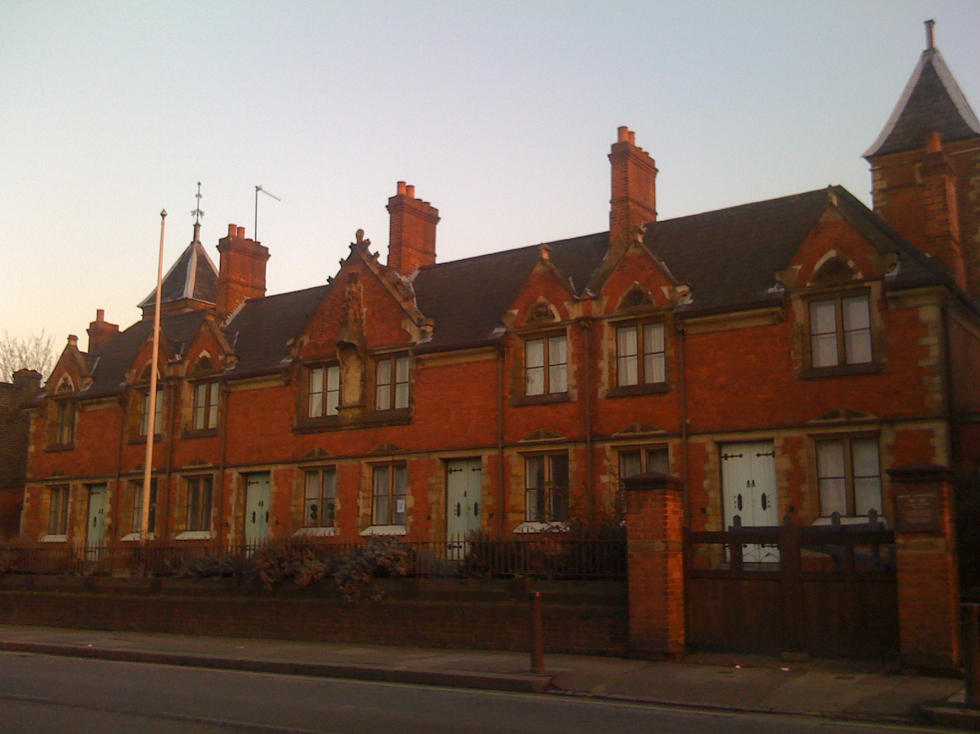

Hibbert Almshouse, Wandsworth Road

The house remains today, and visible on the building is an inscription which reads; ‘These houses for eight aged women were erected by Sarah Hibbert and Mary Ann Hibbert in grateful remembrance of their father William Hibbert Esq. long an inhabitant of Clapham anno domini 1859.’ The building and the plaque have ensured that William’s memory has been enshrined in the local area although it is unlikely that many people are now aware of his involvement with slavery. During 2007 historian Steve Martin conducted guided tours of Clapham which highlighted the forgotten presence of slave-owners, revealing a history which has been largely obscured by the abolitionist presence. The almshouse continues to be administered by the Hibbert Almshouse Charity.
As well as the founding and support of almshouses the Hibberts were also involved with improving both the educational and healthcare facilities in the vicinity of their estates. John of Braywick Lodge made a significant contribution to Bray School in Maidenhead allowing the schoolroom to be enlarged, and a preparatory school to be added to the original building. He was also on the Committee of Management for Bray School. He made contributions towards the establishment of three hospitals; Maidenhead Cottage Hospital, Windsor Hospital and Jesus Hospital. A £2000 donation for Jesus Hospital became known as Hibbert’s Gift. John Washington invested in educational facilities for the local Catholic community close to Bilton Grange. He founded a boys school, a girls school and a convent with four Sisters of Providence to teach the female students. John Nembhard’s wife Jane made contributions to a school in Chalfont and for the establishment of the Cottage Hospital through a legacy in her will.
For the benefit of a nation:

Whilst some of the Hibberts chose to concentrate their charitable efforts on improving the populace in their immediate neighbourhoods, others committed to philanthropy on a national scale. George (1757-1837) was involved in two major projects - the London Institution and the National Institution for the Preservation of Life from Shipwreck, which later became the Royal National Lifeboat Institution. Investing in this kind of large scale public work earned George a reputation for philanthropy which has been perpetuated over the course of centuries. The RNLI’s Wikipedia entry describes George as one of the ‘philanthropic members of London society’ without giving any indication of the specifics of his interest in maritime ventures - his role in the shipping of slave-produced goods. George had also carefully cultivated an identity as a cultural connoisseur and collector. He was involved with a variety of learned societies and kept an extensive library and print collection. The London Institution helped to fix his position among London’s cultural elite, creating a legacy which was separate and distinct to that of his involvement with slave-based commerce.

The London Institution:

The London Institution was founded in 1805 and paid for by subscription by members of the City’s mercantile and banking elite. The enterprise involved George and his friends Sir Francis Baring and John Julius Angerstein, as well as the abolitionists Henry and John Thornton, and Zachary Macaulay, who acted a managers. An address on the founding of the London Institution decreed that;

the metropolis of the British Empire is still destitute of a public library, upon any scale at all commensurate to the want of its inhabitants, or to the dignity of its situation as the first city in the world, the seat of the arts, of learning, and of opulence.

The Institution was intended for the diffusion of useful knowledge in the arts and sciences with an eye to increasing the productivity and efficiency of commerce and industry both at home and out in the empire. Janet Cutler has suggested that the London Institution was conceived of by its commercial founders as an alternative to the more aristocratic Royal Institution. George took a leading role in its establishment and acted as both President and Vice-President between 1805-30. The magnificent building at Finsbury Circus was designed by William Brooks and constructed by Thomas Cubitt. Lectures took place on the subjects of chemistry, mineralogy, natural philosophy and botany. The Institution also enjoyed a well-stocked library and reading rooms. The Institution closed its doors in 1912 whereupon the library was broken up with parts of the collection going to the British Museum (later the British Library), the Guildhall Library and the University of London. The building itself was immediately afterwards occupied by the School of Oriental Studies before being demolished in 1936.

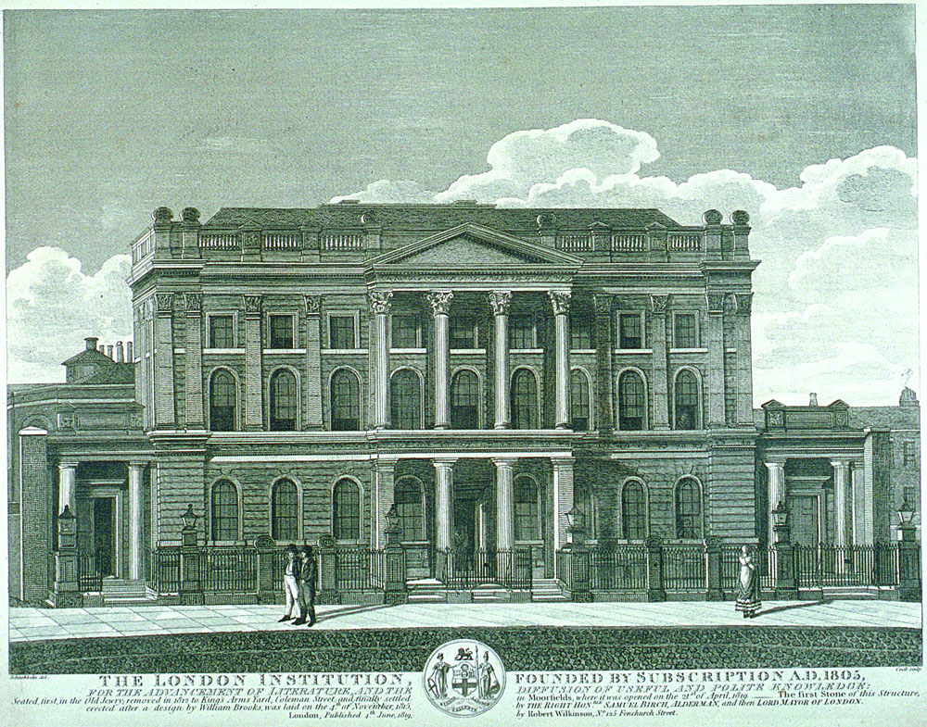

The London Institution, 1819. Image © City of London, London Metropolitan Archives.

The Royal National Lifeboat Institute

Sir William Hillary was the driving force behind the establishment of the National Institution for the Preservation of Life from Shipwreck in 1824. Hillary recruited George (1757-1837) to help generate funds from his mercantile connections in the City. Hillary and George had had an uneasy relationship in the past. Hillary and his brother had an interest in the Adelphi plantation in Jamaica and had borrowed £19,607.15.8 from the Hibberts. As George explained to his commercial correspondent Simon Taylor in 1808 ‘Sir William Hillary is gone to pieces and has absconded... Hillary has scandalously treated and deceived us’. Over the ensuing years the two men clearly resolved their differences, although as the slave compensation register reflects two claims awarded for 154 and 79 enslaved persons respectively on the Adelphi estate were still being disputed by Hillary, the Hibberts, their partner John Vincent Purrier, and Isaac Lascelles Winn up until the early 1840s. It is clear that both George and Hillary had a vested interest in the preservation of ships, their crew and their cargo, they also doubtless had many friends among the seafaring community. The RNLI provided rescue lifeboats to retrieve the crew of foundering ships, many of whom, despite their maritime occupation could not swim. The RNLI has continued its work up until the present day and indeed makes mention of Hibbert on their website, although he is referred to as ‘Chairman of the West Indies Merchants Company’ in a somewhat opaque reference to his participation in the slave economy.

Philanthropic activity secured the family’s reputation in both life and death. The Hibbert name lives on through various legacies which they endowed, in street names and carved into the very fabric of the buildings they erected. With the passing of time the family’s association with the West Indies and slavery has gradually faded so that the name has become disconnected from the origins of the wealth which enabled their charitable activities. In demonstrating some of the ways in which the Hibberts invested their money in improving works it is possible to trace the ways in which slavery money infiltrated different geographic locations, impacting on people and places for whom slave-ownership remained at a distance.

Political and civic power

The Hibberts’ ownership of rural estates led them to seek the civic power which could be attained through the adoption of positions such as that of High Sheriff. The post was unpaid and largely ceremonial; the holder was the sovereign’s representative in the counties, serving a one year term. Drawn from the elite of countryside landowners the title conveyed a sense of status and social acceptance. The High Sheriff represented the moral, social and legal order and as such was considered a highly respectable position. The post required deep pockets owing to the expenses the High Sheriff was expected to defray. This led to a Committee of the House of Commons in 1830, on the expenses which fell on the High Sheriff. During a debate of the House of Lords in 1839 Lord Colborne spoke on the subject. His speech gives an indication of the type of person who might be expected to take on the role;

that the office of high sheriff was one of great importance; and yet this office of high ambition, instead of being regarded as an honour, was looked on as a burden, and every person tried to shuffle it off his shoulders... He only knew two objections that had been started against this measure; one was, that the effect of it would be to lower the character and station of the high sheriff... That was an objection far more specious than true.... The office of high sheriff was a very arduous task imposed on a very useful class of society— namely, the country gentlemen.

The Hibberts, keen to secure their credentials as country gentlemen, felt no such fear of the office and a great number of them served as High Sheriff during the period 1796-1890. For Buckinghamshire both Thomas (1744-1819) and his nephew John Nembhard of Chalfont served in 1796 and 1837 respectively. For Cheshire Robert (1750-1835), his son Thomas (1788-1879) and Thomas’ son Colonel Hugh Robert Hibbert, all of Birtles, served in 1798, 1839 and 1885. For Bedfordshire Robert Junior (1769-1849) of East Hyde served in 1815. John Washington’s son Paul Edgar Tichbourne Hibbert of Ashby St. Ledgers, was High Sheriff of Northamptonshire in 1889. Finally for Hertfordshire George’s son Nathaniel and his grandson Arthur Henry Holland Hibbert of Munden took the post in 1855 and 1890. That members of the family were elected across the span of nearly one hundred years is indicative of the stability and continuity in social position that involvement in the slavery business offered elite participants.

For those Hibberts who chose to remain in London other forms of power were adopted. Both George and his son George Junior became involved in the politics of the City. George entered the Clothworkers’ Company by redemption in 1796. His admission to the Company had been recommended by order of the Lord Mayor and Court of Alderman. Archivist Jessica Collins has explained that;

The few that came in by redemption were usually either wealthy and/or had ambitions for civic office. Up until the nineteenth century when reforms were made, one had to be a Freeman of the City of London to live and operate a business or shop in the City and the only means of gaining the City Freedom was to become Free of a Livery Company. One had also to be a Freeman before one could become an Alderman or Lord Mayor of the City.

George went on to become Alderman for the City of London Bridge Within between 1798-1802. As with the office of High Sheriff, ‘only the richest citizens could aspire to aldermanic rank.’ The formidable rounds of social functions associated with participation in the City oligarchy required substantial wealth but bestowed on the holder status within the business community as well as access to, and influence within the most powerful circles of the City. George also acted as Commissioner of the Lieutenancy of London in 1825, a post that his son George Junior also held in 1835. During a period in which fear of invasion and of the mob pervaded, the Lieutenancy of London was designed to maintain law and order in the City. Position within the institution allowed the post-holders to present themselves as the defenders of property - respectable citizens of the metropolis.

The Hibberts also held formal political power through both the House of Commons and the House of Lords. George (1757-1837) served as an M.P. for the rotten borough of Seaford between 1806-1812, displacing fellow West Indian Charles Ellis. In a letter to their sister Mrs. Mary William Oates, George’s brother Robert (1750-1835) commented on the family’s political ambitions writing that ‘George is at Seaford electioneering. His elder Brothers are waiting for a Call to the upper House.’ They waited in vain, George however secured his parliamentary seat as the ‘paying guest of John Leach’. His position enabled him to lobby on issues affecting the West India trade, he made three speeches in defence of the slave trade in 1807, later (once the trade had been banned) he supported Brougham’s motion calling for measures to put an effective end to the slave trade claiming he had always thought it to be against the dictates of humanitarianism. As a leading member of the SWIPM he attempted to influence trade policies in Parliament; he supported the ban on grain distillation, and sought an extension to Ireland. He also supported Foster Barham’s proposal to use free labour from the East Indies in the Caribbean colonies in 1811.

His biographer J. H. Markland described George’s political character, stating that ‘Though numbered among the Whigs in the days of Windham and Posonby, Mr. Hibbert was a temperate Reformer, and after the passing of the Reform Bill, gave his support to the Conservatives.’ On key reform issues George voted in favour of the release of John Gale Jones, for parliamentary reform, and divided on the pro-Catholic side. He also supported the Middlesex petition for the release of Francis Burdett. George left Parliament to become Agent for Jamaica in 1812, a position which increased his influence on the issues which mattered most to the family - West India trade, the maintenance of slavery and the campaign for compensation. The family gained representation in the House of Lords in 1978, when Julian Holland Hibbert entered the upper house. He served again in 1983. Next to follow Julian into the Lords was Michael Holland Hibbert who was a member in 1988, 1989 and finally in1999.

Whilst George was considered a temperate reformer his cousin Thomas’ (1761-1807) son Julian (1800-1834) was described as ‘wealthy supporter of radical causes such as free thought.’ Julian’s father Thomas had been a partner in his uncle Thomas’ (1710-1780) slave trading firm in Kingston. He had sold his share of the business and purchased the interests of his English cousins Thomas and Robert in the family plantation Agualta Vale. Like his younger brother John Washington, Julian had also received £20,000 in his father’s will. Julian was educated at Eton and later at Trinity College, Cambridge. Julian wrote and published a number of atheist leaning works including Plutarchus, and Theophrastus, on superstition; with various appendices, and the Life of Plutarchus, which was printed using his personal printing press which was kept at his home at No.1 Fitzroy Place, Kentish Town in 1828.

Julian’s circle included the radical activist and Chartist James Watson. When Watson was struck by illness, Julian took him into his house and cared for him. In Watson’s own words:

I was attacked by cholera, which terminated in typhus and brain fever. I owe my life to the late Julian Hibbert. He took me from my lodgings to his own house at Kentish Town, nursed me, and doctored me for eight weeks, and made a man of me again.

In 1831 Julian gave his printing press to James Watson. As George William Erskine Russell noted ‘With the help of Hibbert's legacy, Watson commenced business as a printer and publisher on his own account, and for something like a quarter of a century sent forth a flood of the most advanced literature of the day.’ During the early 1830s many radicals were imprisoned for publishing material deemed illegal by the government, Julian used his money to support these radicals and their families during the period of their detainment. He was the chairman and treasurer of the Victim Fund, when The Poor Man’s Guardian, of which he was an editor, came under attack.

Julian shared a close relationship with Richard Carlile, helping him financially when he was imprisoned between 1831 and 1834. Hibbert’s own work was first published in Carlile’s Republican. Carlile and Hibbert were both involved in the establishment of the National Union of the Working Classes and the transformation of the Blackfriars Rotunda into a meeting place for London’s radicals. Christina Parolin has stated that the formation of the National Union of the Working Classes in 1831 ‘combined the talents of radical artisans William Lovett, Henry Hetherington, James Watson, John Cleave, William Carpenter, John Gast and the veteran ultra William Benbow, with Rotunda financier and radical strategist Julian Hibbert.’ In 1830, when Carlile took over the Blackfriars Rotunda, the building had been left in a neglected state and was in severe need of renovation. As Parolin has documented; ‘With the assistance of wealthy freethinking allies, William Devonshire Small and Julian Hibbert, as well as anonymous donations to the cause of ‘rational debate’, Carlile undertook refurbishments to make the building fit for public use at the considerable sum of £1300.’ By 1833 Carlile had formed a relationship with Eliza Sharples and on leaving prison she became his common law wife. Such was the nature of the relationship between Hibbert, Carlile and Sharples that the couple named their son, born in 1835, Julian Hibbert Carlile.

Carlile’s daughter Theophila Carlile Campbell wrote a history of the struggle for press freedoms in which she dedicated several very flattering passages to Julian’s role. Her text is revealing of the tensions between Julian’s radicalism and his family’s role in the slavery business. She wrote that his ‘ample fortune’ had ‘enabled him to live in a way that sheltered him from the storms as well as the battles of life’, providing the means for him ‘to devote his life to study, to writing, and to acts of benevolence.’ Yet Julian had ‘separated himself from his family at an early age, and never spoke of them or of his birth to anyone as far as known. His family affairs were a secret to his most intimate friends.’ Theophila recorded that ‘There was no doubt that he came of some fine family’ however she added ‘of that or of any other part of his past, or youth, he never spoke.’ Julian was so concerned to erase his past that ‘At his death he laid the embargo of silence on all his friends as to himself, and begged them as they loved him to burn all his letters and to cease to speak of him.’ Radicalism’s relationship to antislavery was a complicated one; as Michael J. Turner has highlighted ‘radicals frequently disagreed with each other on the West Indies.’ Certainly men like Julian’s cousin George (1757-1837) had appropriated the radical discourse of ‘white slavery’ during the parliamentary debates over the abolition of the slave trade. He argued that the abolitionists were concerned with the plight of the enslaved African at the cost of improving the condition of the ‘ruddy-cheeked boy’ and ‘blooming girl’ who were immured in ‘putrid haunts of vice and disease.’ Julian, it seems, was uncomfortable enough about his past to attempt to obscure his origins from his radical friends.

Evidence of the Hibberts’ diverse political affiliations provides an interesting counterpoint to Nicholas Draper’s statement that ‘Slave-owning in Britain was predominantly an Anglican, Tory phenomenon.’ However, alongside Julian’s radicalism and George’s moderate Whig reformist tendencies (with the obvious exception of the issue of slavery), some of the Hibberts were more conservative in their political beliefs particularly over issues affecting Jamaica. As Draper has emphasised, the Governor Eyre controversy during the mid-1860s polarised opinion in Britain. Many former slave-owning families supported Eyre, using the rebellion as a means of vindicating their support for slavery. Julian’s brother John Washington was given a prominent position on the list of individuals who had contributed to the Eyre Defence and Aid Fund and was listed as a Committee member. Whatever the nature of their opinions (and despite Julian’s distancing of himself from it) the Hibberts were given their entrée into the political sphere through their participation in the slavery business. It was the wealth and influence accrued from trade which allowed them to take part in political culture both inside and outside of Parliament.

Commercial investment

Whilst the Hibberts undoubtedly sought to establish themselves in ‘circumstances independent of the hazards and anxieties of commerce’ it was not possible for every member of what was an extensive family to do so. This was particularly true of the younger sons. The family merchant house provided a means of supporting sons, nephews and broader kin. This was part of an inheritance which allowed elite mercantile families to maintain their wealth and position. Three of the the younger Hibberts joined the merchant house under various partnerships; Samuel Junior (1783-1867), George Junior (1796-1882) and William Junior (1792-1881). Samuel was the son of Samuel (1752-1786) and Mary Greenhalgh. His father had died when he was three and the family counting house provided the living he would need to make his way in life. George Junior (1796-1882) was the third son of George (1757-1837) and Elizabeth Fonnereau. He was educated at Eton and entered Trinity College, Cambridge where he received a Bachelor’s degree in 1818 followed by a Master’s in 1823. His elder brother Nathaniel had inherited the family seat at Munden and with another brother in the navy George Junior joined his father in the counting house. William Junior was the eldest son of William (1759-1844) and Elizabeth Greenhalgh. Like their fathers before them they all led successful commercial careers.

The younger generation were attendees of the SWIPM and by 1835 George Junior had become the Treasurer. George and Samuel Junior were involved with the West India Dock Company and acted as both the Chairman and as Directors. In 1838 the East and West India Dock Companies merged to form The East and West India Dock Company. The Company had thirty two directors, of whom twenty were West India Dock company affiliated, including George Junior who remained on the Board until 1877. A magnificent painting of George Senior, executed by society artist Sir Thomas Lawrence in 1811 and paid for by the West India Dock Company, hung on the wall of the East and West India Dock Company boardroom. One of the major undertakings of improvement to the docks was the London and Blackwall Railway. The plans were underway by 1836 with George Junior as the Deputy Chairman. In a meeting of the East and West India Dock Company to discuss the railway the Chairman, George Junior stated the benefits of the proposed plan, arguing that; ‘the nearer the Docks were brought to the commercial centre of the City... the greater attractions would the Docks present for steamers, and the greater facilities to the public for availing themselves for their use.’ The plan was a success and the London and Blackwall Railway opened in 1840 although in the end the railway failed to provide direct links to the docks which only came in 1851, when the East and West India Docks and Birmingham Junction Railway Company's Railway Dock was opened at Poplar. In total the Hibberts contributed £26,000 in the form of various railway subscriptions, with £18,500 coming solely from John Nembhard.

Whilst the counting house remained committed to the West Indies, the men also diversified their interests becoming involved in finance, banking, insurance, as well as different imperial ventures. Samuel, George and William Junior all moved in the direction of the lucrative insurance industry. Following the Marine Insurance Bill of 1824 the monopoly held by Lloyd’s and the London Royal Exchange was finally broken and the market opened up to newcomers. George Junior became a Director of the Indemnity Marine Insurance Company, taking out its first ever policy on 4th August 1824. This company would go to become the insurance providers Aviva, a now familiar household name. Aviva’s online heritage section mentions George Junior by name, however his association with the slave economy is not recorded. Both Samuel and George Junior became Directors of the Imperial Life Insurance Company and the Imperial Fire Assurance Company serving at different times between 1831 and 1858. Between 1851 and 1867 William Junior was a Director of the Royal Exchange Assurance Corporation. He was a Director of the Canada Company between 1826-30. This was a private chartered land development company which was set up to facilitate the colonisation of Upper Canada. The Canada Company assisted emigrants by providing low cost transport in ships, farming equipment, and cheap land. Hibbert Township in Ontario, Canada was opened in 1830 and named after the family. William Junior was also involved in the establishment of the Colonial Bank of the West Indies. Closer to home, Samuel Junior was appointed as a Director of the Bank of England five times between 1820 and 1833. George Junior’s personal estate was valued at £70,000 in 1877, the majority of which he left to his brother Nathaniel’s grandson Sydney George Holland. Samuel Junior prospered to an even greater degree leaving £90,000 in personalty in his will of 1867. It was William Junior who accrued the greatest wealth leaving a personal estate of £165,288 1s 11d.

Conclusion:

The Hibberts’ story is one of continuous acquisition. Spanning both metropole and colony, they accrued power in all its forms - economic, political, social and cultural - as well as expropriating the labour power of the enslaved. Their story is remarkable in the fact that they survived in the uncertain world of global commerce during a period in which bankruptcy and financial crisis was a common feature of life. It also shares a commonality with many other successful colonial families in that it epitomises the centrality of networks of association. Beginning in the close-knit world of the dissenting north, the Hibberts utilised their connections to Liverpool and Jamaica, before expanding into London. Once they had secured the means to, they then expanded outwards into the countryside, which (owing to the connection between land-ownership and power) continued to hold status. Along the way marriage played an important part in consolidating their social position, bringing with it the solid relationships required in a system which was still deeply reliant on trust and personal reputation. Marriage also provided the means of achieving social mobility: the unions made by the third generation of Hibberts were marked by their movement into the sphere of the gentry and aristocracy. The Hibberts’ narrative mirrors, in part, a traditional interpretation of the trajectory of commercial men; that ‘the summit of their ambitions was to enter landed society.’ Certainly they set about acquiring land, building country houses and partaking in paternalistic acts of philanthropy. However they also retained their ties to commerce; George’s memorial inscription proudly proclaimed him as ‘of Munden in this county, and of the City of London, Merchant’. It is interesting to note that by the time of his death in 1837 the usual prefix of ‘West India’ had been dropped from the mercantile title. Neither his son George Junior nor son-in-law Samuel Junior purchased country houses despite having wealth enough to do so. A number of the Hibberts went on to become decorated members of the British Army and Navy serving across Europe and the empire. The family’s desire for, and attainment of power was a quest which spanned the generations. Over the course of that period they transformed themselves from prosperous merchants operating on the periphery of power in the north of England, to a landed family with considerable economic, political and cultural influence both in the capital as well as the surrounding environs of their newly acquired country seats.

The historical memory of the Hibberts is both diverse and problematic. Their involvement with philanthropy secured a lasting reputation for the family as generous benefactors. This image has been perpetuated by the ongoing work of the charities and churches that benefitted from their wealth. Their name is commemorated by streets named for them in Luton, Maidenhead, Battersea, Manchester and Marple. The relationship between their activities as patrons of the arts, country house owners, even as the devout disseminators of religion in the case of the Hibbert Trust, remains dislocated from the origins of the wealth which supported them. The Hibberts were a respectable family. Their connection to slavery in no way debarred them from participation within the elite, indeed it paved the way for their transformation from merchants to gentlefolk. However as the abolition of slavery approached their connection to it became increasingly controversial. Not only did the Reverend Sydney Smith attempt to elide the association of his in-laws to the slavery business but even George’s biographer J. H. Markland - himself a relation of the Hibberts and a member of the West India interest - avoided all mention of the morally loaded term slave-owner when he wrote his eulogising Sketch of the Life and Character of George Hibbert in 1837.

In 2007 Britain marked the bicentenary of the abolition of the slave trade. In the same year an exhibition opened at the Museum of London in Docklands entitled London, Sugar, Slavery. Situated in the old sugar warehouses of the dock complex championed by George and expanded by his son George Junior and son-in-law Samuel Junior, the exhibition highlights the relationship between the metropolis and the slavery business. Hanging at the centre of the exhibition is George’s portrait by Sir Thomas Lawrence, the same painting which once hung in the boardroom of the East and West India Dock Company.

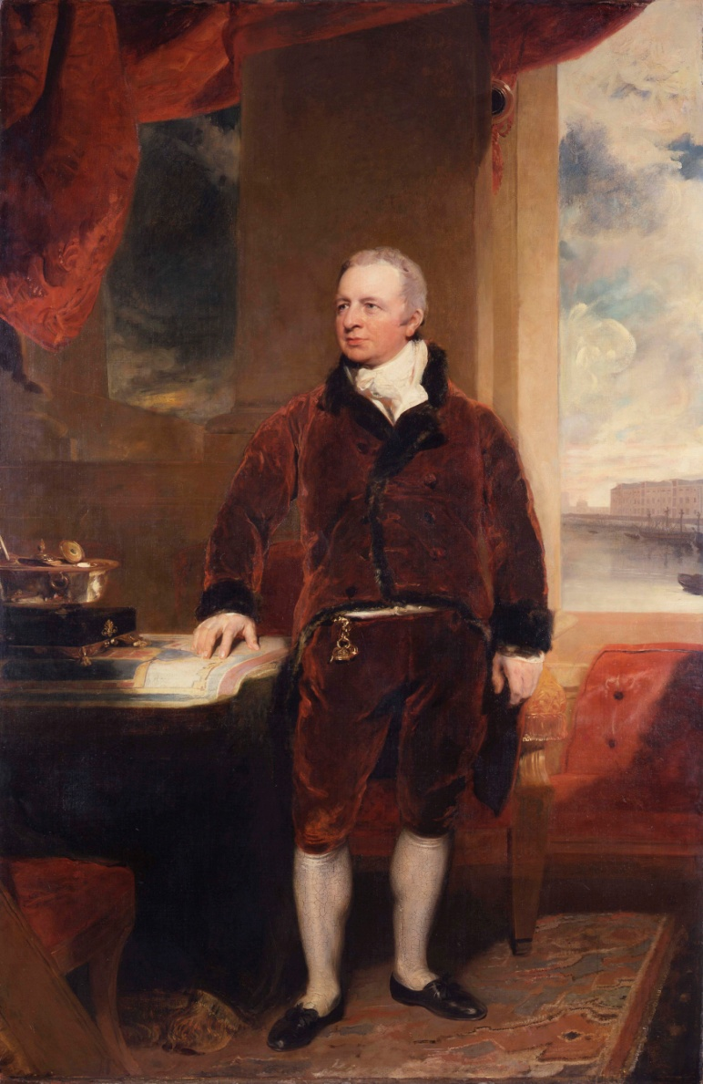

George Hibbert by Sir Thomas Lawrence, oil on canvas, 1811 © Museum of London

Removed from the context of that powerhouse of colonial commerce and repositioned in a display which explores the violent denigration of humanity in the pursuit of profit, the exhibition unflinchingly restores the connections between metropolitan enrichment and colonial exploitation. Distanced from the brutality of the plantations, the maps, the docks and sumptuously clad figure of George Hibbert were intended to be a celebration of the achievements of commerce and empire. By placing the portrait in a narrative which begins with huge panels listing the number of enslaved people carried across the Atlantic the exhibition asks important questions about the ways in which we think about Britain’s imperial past. Michael Gove, Secretary of State for Education, has recently emphasised the need to understand ‘our island story’. The story of the Hibbert family, indeed the story of many of the individuals and families whose names can be found within the Slave Compensation Registers, is this island’s story of the interconnection between metropole and colony. Britain’s story is not bounded by its geographical borders, instead it has had a global reach. People and places far beyond its formal territories, as we now understand them, have been affected in the course of British history and those same peoples and places have had a profound influence on Britain. The imprint left by the Hibberts is also the tangible legacy of those enslaved people who generated the wealth which paid for it. It is only by acknowledging and exploring these interconnections that we can begin to understand and appreciate the global roots and routes that have paved the way to a modern British society.

From this point on SWIPM.
Nicholas Draper, The Price of Emancipation: Slave-Ownership, Compensation and British Society at the End of Slavery (Cambridge University Press, 2010), p.346.
Sir Thomas Baker, Memorials of a Dissenting Chapel, its foundation and worthies; being a sketch of the rise of Non-Conformity in Manchester and the erection of the Chapel in Cross Street, with notices of its Ministers and Trustees (Manchester: Johnson and Rawson, 1884).
Eric Williams, Capitalism and Slavery (London: Andre Deutsch, 1964), p.71.
Williams, Capitalism and Slavery, p.71.
Alfred P. Wadsworth and Julia De Lacy Mann, The cotton trade and industrial Lancashire, 1600-1780 (Manchester University Press, 1965), p.229.
Williams, Capitalism and Slavery, p.71
Michael James, From Smuggling to Cotton Kings: the Greg Story (Gloucestershire: Memoirs, 2010), p.15.
T/ 70/ 69 Letter to the Messrs. Hibbert of Manchester ,15 Aug 1765. Quoted in Wadsworth and De Lacy Mann, The cotton trade and industrial Lancashire, 1600, p.231.
Baker, Memorials of a Dissenting Chapel, p. 85, 89.
Trevor Burnard, ‘‘The Grand Mart of the Island’: The Economic Function of Kingston, Jamaica, in the Mid-Eighteenth Century’, in, Jamaica in Slavery and Freedom: History, Heritage and Culture, eds. Kathleen E. A. Monteith and Glen Richards (University of the West Indies Press, 2001), pp.225-241.
Trevor Burnard and Kenneth Morgan, ‘The dynamics of the slave market and slave purchasing patterns in Jamaica’, William and Mary Quarterly, Third Series, Vol.58, No.1, New Perspectives on the Transatlantic Slave Trade (Jan., 2001), p.209.
Burnard and Morgan, ‘The dynamics of the slave market’, p.212.
Richard Pares, ‘A London West-India Merchant House, 1740 – 1769, in Essays Presented to Sir Lewis Namier (London: Macmillan, 1956), p. 103.
Burnard and Morgan, ‘The dynamics of the slave market’, p.213.
Richard Sheridan, ‘The Commercial and Financial Organisation of the British Slave Trade, 1750-1807’, in Economic History Review, New Series, Vol.11, No.2 (1958), p.255.
Trevor Burnard, ‘Credit, Kingston Merchants and the Atlantic Slave Trade in the Eighteenth Century’, unpublished paper for BGEAH, Stirling, 3 September 2009.
Richard Pares, ‘Merchants and Planters’, Economic History Review Supplement, No.4 (Cambridge, 1960). Simon D. Smith, ‘Merchants and Planters Revisited’, Economic History Review, Vol.55, No.3 (August, 2002), pp.434-465.
Evidence given by Hercules Ross, 1790-91, quoted in Richard Sheridan, ‘The Commercial and Financial Organisation of the British Slave Trade, 1750-1807’, Economic History Review, New Series, Vol.11, No.2 (1958), p.255.
Frank Cundall, Historic Jamaica (London: Ballatine, Hanson & Co., 1915), p.179.
Diary of Robert Hibbert, 6 May 1777. Transcripts of these diaries have been generously supplied by Nick Hibbert Steele, Hibbert Archive and Collection, Melbourne, Australia.
James Hakewill, A picturesque tour of the island of Jamaica from drawings made in the years 1820 and 1821, (London: Hurst and Robinson, 1825).
Oliver Vere Langford, Caribbeana being miscellaneous papers relating to the history, genealogy, topography, and antiquities of the British West Indies, Vol.4 (London, 1919), p.193.
Judith Jennings, ‘A Trio of Talented Women: Abolition, Gender, and Political Participation’, Slavery and Abolition, 26, 1 (April 2005), pp. 55-70. Jennings, Gender, Religion, and Radicalism in the Long Eighteenth-Century: An ‘Ingenious Quaker’ and Her Connections (Aldershot: Ashgate, 2006). Jennings, ‘‘By No Means in a Liberal Style:’ Mary Morris Knowles versus James Boswell,’ in Women Editing / Editing Women: Early Modern Women Writers and the New Textualism, eds. Ann Hollinshead Hurley and Chanita Goodblatt (Newcastle: Cambridge Scholars Publishing, 2009), pp. 227-247. See also Daniel Livesay, ‘Children of uncertain fortune: mixed race migration from the West Indies to Britain, 1750-1820’, unpublished PhD thesis, University of Michigan, 2010.
Diary of Robert Hibbert.
Richard Sheridan, ‘The Commercial and Financial Organisation of the British Slave Trade, 1750-1807’, in Economic History Review, New Series, Vol.11, No.2 (1958), p.252. See also S. G. Checkland, ‘Finance for the West Indies, 1780-1815’, The Economic History Review, New Series, Vol. 10, No. 3 (1958), pp. 461-469.
Thomas Hibbert to Nathaniel Phillips, London, 20 August 1770, NLA8897, Slebech Archive, National Library of Wales.
These dates are a rough guide to the dates of the partnerships which may well have predated and continued beyond the dates given. The dates are taken from listings in the London Trade Directories including; New Complete Guide to London, Kent’s Directory, London Directory, The Universal British Directory of Trade, Commerce and Manufacture, Post Office Annual Directory, Boyle’s City & Commercial Companion to the Court Guide and Holden’s Triennial Directory. Institute of Historical Research, Senate House Library.
George Hibbert to Simon Taylor, 3 March 1802, M965 Reel 17/30, Simon Taylor Papers, Institute of Commonwealth Studies, Senate House Library.
Robert Greg, quoted in James, From Smuggling to Cotton Kings, p.33.
Report from the Select Committee into the means of improving and maintaining the foreign trade of the Country (London, 1823), p.142.
Report from the Select Committee into the means of improving and maintaining the foreign trade of the Country (London, 1823), p.145.
Anthony Partington, ‘A memorial to Hibberts’, Mariner’s Mirror, Vol.95, No.4 (November 2009), p.452.
Evidence given by George Hibbert, Report from the Select Committee into the means of improving and maintaining the foreign trade of the Country (London, 1823), p.142.
George Hibbert to Simon Taylor, 3 May 1804, M65 Reel 17/52, Simon Taylor Papers, Institute of Commonwealth Studies, Senate House Library.
David Beck Ryden, West Indian slavery and British abolition, 1783 – 1807 (Cambridge University Press, 2009), pp.40-82.
Markland, Sketch, p. 5.
George Hibbert, Substance of three speeches in Parliament on the bill for the abolition of the slave trade and the petition respecting the state of the West India trade in February and March 1807 (London: Lane, Darling & Co., 1807).
George Hibbert, Abridgment of the minutes of the evidence, taken before a committee of the whole House, to whom it was referred to consider of the slave trade, 1789[-91]. [n.p.], [1792?], p.146. The Making Of The Modern World. Web. 1 Mar. 2013.
HC debate, 23 February 1807, Vol.8, cc.945-95.
George Hibbert to Earl Bathurst, April 1818, CO 137/146, National Archives, Kew.
George Hibbert to Robert Wilmot Horton, 2 April 1827, CO 137/166, National Archives, Kew..
Will of George Hibbert dated 29 February 1836, Langford, Caribbeana, p.199.
David Hancock, Citizens of the World: London Merchants and the Integration of the British Atlantic Community, 1735-1785 (Cambridge University Press, 1995).
Trustee Minute Book of Holy Trinity Church, Clapham Common, P95 TR11-1 / X077/084, London Metropolitan Archive.
G85/2/1/1/134 20F4, Surrey History Centre.
http://www.outlines.org.uk/claphamsociety/Articles/article6.html#xiv, Kenneth Cozens, ‘George Hibbert of Clapham – Eighteenth Century Merchant and ‘Amateur Horticulturalist’’. Available at http://www.merchantnetworks.com.au/periods/1775after/hibbertgeorge.htm
Thomas Frognall Dibdin, Bibliographical Decameron or Ten Days Pleasant Discourse Upon Illuminated Manuscripts, and Subjects Connected with Early Engravings, Typography, and Bibliography, Vol.III (London: W. Bulmer &Co., 1817), pp.35-6.
Cozens, ‘George Hibbert of Clapham’.
John Seed, ‘Gentlemen Dissenters: the Social and Political Meanings of Rational Dissent in the 1770s and 1780s’, The Historical Journal, Vol.28, No.2 (Jun., 1985), p.303.
http://www.historyofparliamentonline.org/volume/1790-1820/member/moffat-william-1737-1822
Diary of Robert Hibbert, 18 January 1802.
Diary of Robert Hibbert, 2 June 1772.
http://www.georgehibbert.com/
‘Annals of T. H.’ note added by Mabel Nembhard , http://jamaicanfamilysearch.com/
http://www.pinakothek.de/thomas-gainsborough/mrs-thomas-hibbert
Letter from George Hibbert to Simon Taylor, 5 September 1803, M965 Reel 17/47, Simon Taylor Papers, Institute of Commonwealth Studies, Senate House Library.
William Rubinstein, Who were the rich, Vol. I (2009), 1835/14.
Langford, Caribbeana, p.199.
CARDG:1988.1764, extracts are available online at http://www.qdg.org.uk/diaries.php?dy=29.
'Parishes: Chalfont St. Peter', A History of the County of Buckingham: Volume 3 (1925), pp. 193-198. URL: http://www.british-history.ac.uk/report.aspx?compid=42545 Date accessed: 01 October 2012.
‘Watford: Manors', A History of the County of Hertford: volume 2 (1908), pp. 451-464. URL: http://www.british-history.ac.uk/report.aspx?compid=43308 Date accessed: 16 January 2012.
J. H. Markland, A Sketch of the Life and Character of George Hibbert Esq., F. R. S., S. A., and L. S (London: 1837), p.18.
Diary of Robert Hibbert, 22 February 1801.
Pieces from George Hibbert’s collection featured in the ‘Prized Possessions’ exhibition at the Fitzwilliam Museum in Cambridge which ran from 25 May 2010 to 26 September 2010.
William Younger Fletcher, English Book Collectors (London: Kegan Paul, Trench, Trübner and Co., 1902), p.302.
Sydney Smith, Selected Letters of Sydney Smith, 2nd Edition, ed. N. C. Smith (Oxford: Oxford University Press, 1986), p.119, quoted in Draper, The Price of Emancipation, p.19.
Ed. Nowell C. Smith, Selected Letters of Sydney Smith (Oxford University Press, 1981), pp.260-261.
http://venn.lib.cam.ac.uk/cgi-bin/search.pl?sur=holland&suro=c&fir=sydney&firo=c&cit=&cito=c&c=all&tex=&sye=&eye=&col=all&maxcount=50
Paul Atterbury, ‘Pugin and Interior Design’, in, A.W.N. Pugin: Master of Gothic Revival, ed. Paul Atterbury (The Bard Centre for Studies in the Decorative Arts, 1996), p.194.
Megan Aldrich, ‘Gothic sensibility: the early years of the Gothic revival’ in A.W.N. Pugin: Master of Gothic Revival, p.15.
HC Deb 23 February 1807, vol.8, cc.945-95.
http://www.rbwm.gov.uk/public/100202_prow-greenway-leaflet_1200kb.pdf
http://www.stmaries.co.uk/history-of-st-maries.html?showall=1&limitstart=
A guide to St. Mark’s Hospital Church. http://www.berksfhs.org.uk/genuki/BRK/Maidenhead/St%20Mark%27s%20Hospital%20Church,%20Maidenhead%20Guide.pdf
Langford, Caribbeana, pp.200-2.
Zachary Macaulay, Negro slavery; or a view of some of the more prominent features of that state of society, as it exists in the United States of America and in the colonies of the West Indies, especially in Jamaica (London: Richard Taylor, 1823).
Robert Hibbert Junior, Facts verified on oath in contradiction of the report of Rev. Thomas Cooper, concerning the general condition of slaves in Jamaica; and more especially relative to the management and treatment of the slave upon Georgia estate, in the parish of Hanover, in that island (London: John Murray, 1824).
Thomas Cooper, A letter to Robert Hibbert Jun. Esq., in reply to his pamphlet, entitled, ‘Facts verified upon oath, in contradiction of the report of the Reverend Thomas Cooper, concerning the general condition of the slave in Jamaica (London: J. Hatchard & Son, 1824).
Thomas Cooper, Correspondence between George Hibbert, Esq., and the Rev. T. Cooper, relative to the condition of The Negro Slaves in Jamaica, extracted from the Morning Chronicle: also A Libel on the character of Mr. and Mrs. Cooper, published in 1823, in several Jamaica Journals; with notes and remarks by Thomas Cooper (London: J. Hatchard, 1824).
Jerom Murch, Memoir of Robert Hibbert, Founder of the Hibbert Trust: With a Sketch of its History (Bath: William Lewis, 1874), pp.32-33.
Murch, Memoir, p.34.
http://www.seekinghyde.org.uk/13474.html
http://www.charitycommission.gov.uk/Showcharity/RegisterOfCharities/CharityWithoutPartB.aspx?RegisteredCharityNumber=227358&SubsidiaryNumber=0
George Hibbert to Simon Taylor, 3 March 1802, M965 Reel 17/.30, Simon Taylor Papers, Institute of Commonwealth Studies, Senate House Library.
Rubinstein, Who were the rich, MS 1844/10.
Charles Kerry, The history and antiquities of the hundred of Bray in the county of Berks (London: Savill and Edwards, 1861), p.65, 67.
Kerry, The history and antiquities of the hundred of Bray, p.77.
http://en.wikipedia.org/wiki/Royal_National_Lifeboat_Institution
Letters, printed notices and papers relating to the founding of the London Institution 1805-1817. CLC/009MS03080, London Metropolitan Archives.
Janet C. Cutler, ‘The London Institution, 1805-1933’, PhD Thesis, University of Leicester (1976), p.7.
George Hibbert to Simon Taylor, 7 July 1808, M965 Reel 17/81, Simon Taylor Papers, Institute of Commonwealth Studies, Senate House Library.
Nick Draper by private communication, 3 February 2012.
http://rnli.org/safetyandeducation/teachersandyouthleaders/teachingpacks/Pages/Save-lives-at-sea/Tab2/How-did-they-plan-for-success.aspx
HL Deb 27 June 1839 vol 48 cc921-3.
Jessica Collins Archivist for the Clothworkers’ Company by private communication 24 August 2011.
Nicholas Rogers, ‘Money, Land and Lineage: The Big Bourgeoisie of Hanoverian London’, Social History , Vol. 4, No. 3 (Oct., 1979), p. 439.
Robert Hibbert to Mrs. William Oates, Devonshire Place, 5 May 1807, D1799/C153, Blathwayth Family Collection, Gloucestershire Archive.
R. G. Thorne, The Commons, Vol. IV, Members G-P (London: Secker and Warburg, 1986), pp.193-194.
http://www.historyofparliamentonline.org/volume/1790-1820/member/hibbert-george-1757-1837
http://www.historyofparliamentonline.org/volume/1790-1820/member/hibbert-george-1757-1837
Markland, Sketch, p.7.
Joel H. Wiener, Biographical Dictionary of Modern British Radicals (1979), p. 221.
Roderick Cave, The Private Press (New York: R.R. Bowker Co., 1983).
George William Erskine Russell, Dr. Pusey (London: A. R. Mowbray & Co., 1907), p.16.
Ed. Laurel Brake and Marysa Demoor, Dictionary of Nineteenth-Century Journalism in Great Britain and Ireland (Gent: Academia Press, 2009), p.501.
Christina Parolin, Radical spaces: venues of popular politics in London, 1790-1845 (Canberra: Australian National University Press, 2010), p.231
Parolin, Radical spaces, p.200.
Theophila Carlile Campbell, The Battle of the Press As Told in the Story of the Life of Richard Carlile By His Daughter, Theophila Carlile Campbell (London: A. & H. B. Bonner, 1899). http://www.gutenberg.org/files/38370/38370-h/38370-h.htm
Michael J. Turner, ‘‘Setting the captive free’: Thomas Perronet Thompson, British Radicalism and the West Indies, 1820s-1860s’, Slavery and Abolition, Vol.26, No.1 (April, 2005), p.115.
HC Deb 23 February 1807 vol.8, cc.945-95.
Draper, The Price of Emancipation, p.165.
Draper, The Price of Emancipation, p.71.
The Times, 1 January 1867.
Markland, Sketch, p.18.
Ancestry.com. Cambridge University Alumni, 1261-1900 [database on-line]. Provo, UT, USA: Ancestry.com Operations Inc, 1999. Original data: Venn, J. A., comp.. Alumni Cantabrigienses (London: Cambridge University Press, 1922-1954).
The Royal Kalendar and the Court and City Register for England and Scotland.
'The West India Docks: Historical Development', Survey of London: volumes 43 and 44: Poplar, Blackwall and Isle of Dogs (1994), pp. 248-268. URL: http://www.british- history.ac.uk/report.aspx?compid=46494&strquery=Hibbert Date accessed: 05 October 2012.
Margaret Baker, Discovering London statues and monuments (Buckinghamshire: Shire Publications, 2002), p.172.
The Railway Times, Volume II, (London: J. T. Norris, 1839), p.367.
http://www.aviva.com/about-us/heritage/companies/indemnity-marine-assurance-company/
Robert C. Lee, The Canada Company and the Huron Tract, 1826-1853; Personalities, Profits and Politics (Ontario: Natural Heritage, 2004). Appendix C Huron Tract Township Names and Their Origins.
The Illustrated London News, No.2254—Vol. LXXXI, Saturday, July 15, 1882, p.74
England & Wales, National Probate Calendar (Index of Wills and Administrations), 1858-1966.
England & Wales, National Probate Calendar (Index of Wills and Administrations), 1858-1966.
Rogers, ‘Money, Land and Lineage’, p.437.
Markland, Sketch, p.21.
http://www.conservatives.com/News/Speeches/2010/10/Michael_Gove_All_pupils_will_learn_our_island_story.aspx

