Title: Acute spontaneous intracerebral haemorrhage: current treatment and management

Abstract
Acute spontaneous intracerebral haemorrhage (ICH) is a devastating form of stroke with high rates of mortality and disability in survivors. Despite the burden of ICH, there remain few effective treatments to definitively improve outcome when compared to ischaemic stroke. Nonetheless, patients benefit from specialist stroke unit care including early interventions to prevent complications. Therapeutic nihilism should be avoided during the acute phase and early care limitations avoided. A proactive multi-targeted approach based on therapeutic strategies against early haematoma expansion and attenuation of secondary brain injury are likely to be important in improving outcome. This clinical review aims to outline the key principles of acute care management.

Introduction
Globally, stroke remains the second leading cause of death and the third leading cause of death and disability (Global Burden of Diseases (GBD) (2021). Since the global population is aging and older age contributes greatly to the burden of stroke (Radholm, et al. 2015; Alonso, et al. 2015) the challenge of stroke will increase in future years.
Spontaneous ICH is the most devastating sub-type of stroke and has the worst outcomes with a case fatality at 1 month of 30-40% and only 20% of survivors regaining independence (Krishnamurthi, et al. 2020). Severe disability frequently significantly influences the patient’s physical, social and psychological functioning with a concomitant impact on health-related quality of life (HRQoL) (Sallinen, et al. 2019). ICH is therefore a major healthcare challenge (Parry-Jones, et al. 2016) for which there are limited definitive treatment options when compared to the success in improving outcomes after ischemic stroke.
Intracranial haemorrhage refers to any form of bleeding within the skull vault (figure 1). In this article we will concentrate on the management of spontaneous ICH (figure 1. A) and not other intracranial haemorrhages. Spontaneous (i.e., non-traumatic) intracerebral haemorrhage (ICH) refers to non-traumatic bleeding in the brain substance (parenchyma) which can extend into the ventricles and constitutes 27.9% of all incident strokes globally (GBD, 2021).

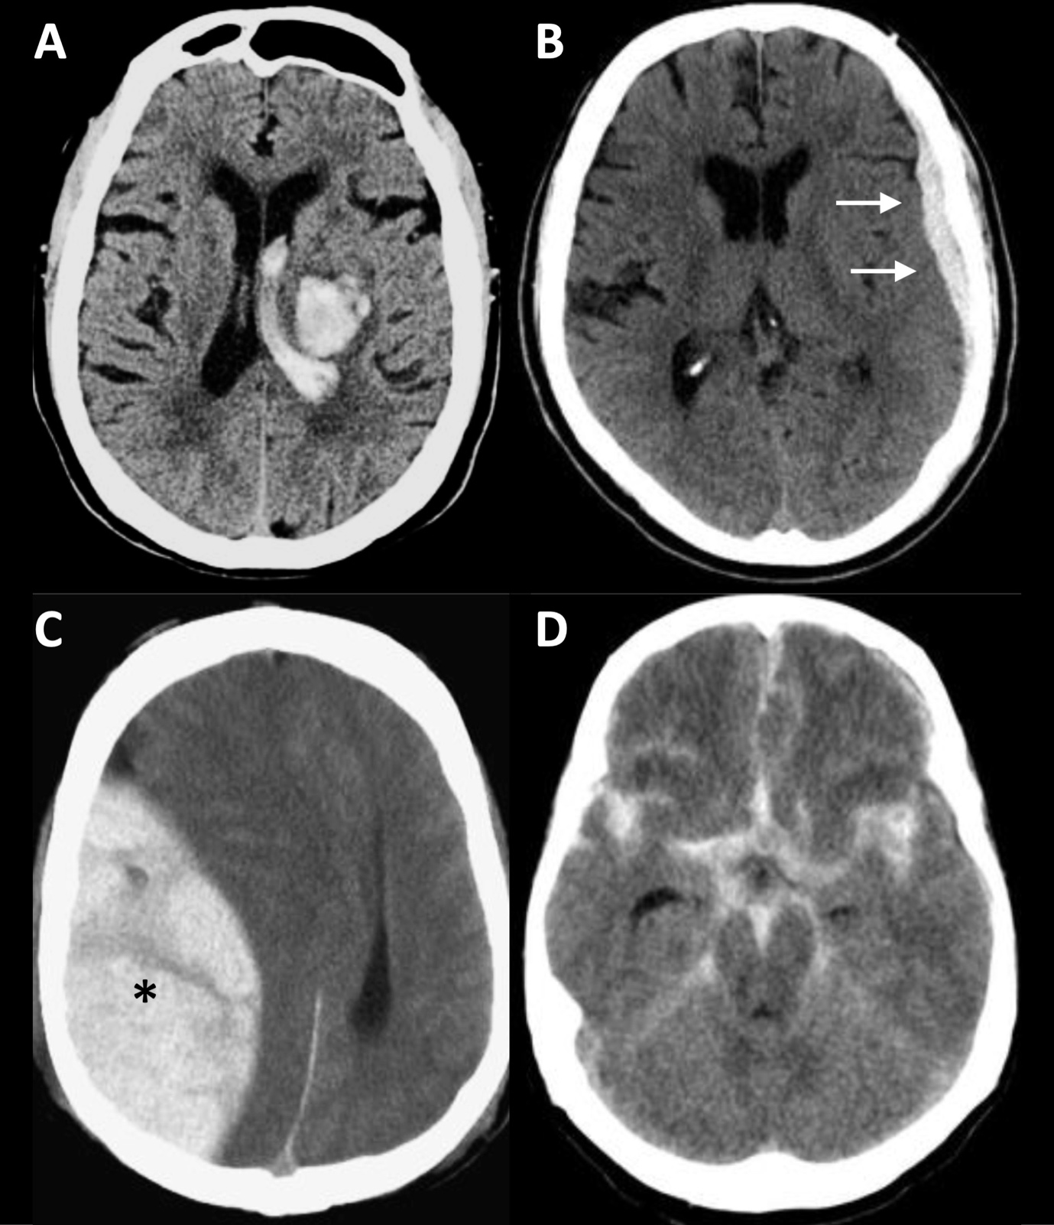
Figure 1: types of intracranial haemorrhage. (A) deep ICH within brain parenchyma, extending into ventricles; (B) subdural haemorrhage (white arrows); (C) extradural haemorrhage (black asterisk); (D) subarachnoid haemorrhage.

Spontaneous ICH is a heterogeneous pathology, but the vast majority (85%) are due to cerebral small vessel diseases (SVD); the commonest SVD processes related to ICH are arteriolosclerosis (also termed hypertensive arteriopathy or deep perforator arteriopathy) and sporadic cerebral amyloid angiopathy (CAA) (Banerjee, et al. 2017). The remainder mostly result from a macrovascular cause (common macrovascular lesions include cavernomas, arterio-venous malformations, cerebral venous sinus thrombosis, and aneurysm). Other rarer causes of ICH include: bleeding disorders, tumours, venous thrombosis, endocarditis. Vascular malformations are one of most common causes of ICH in younger adults (McGurgan, et al. 2021).
ICH are often classified according to their location in the brain as “deep” (figure 2) or “lobar” (figure 3) haemorrhage. Deep haemorrhages occur in the internal capsule, basal ganglia or brainstem, and more likely result from deep perforator arteriopathy. About 9–10% of ICH occurs in the posterior fossa or cerebellum (Datar and Rabinstein, 2014). The remainder is spontaneous lobar haemorrhage located in cortico-subcortical areas, often near or reaching the cerebral convexities, which are commonly associated with arteriolosclerosis and cerebral amyloid angiopathy (CAA) (McGurgan, et al. 2021). CAA typically occurs in elderly patients, often presenting with ICH or with cognitive decline and is characterised neuropathologically by the deposition of the amyloid beta (Aβ) protein and degenerative changes in capillaries, arterioles, small and large arteries (Banerjee, et al. 2017). In practice CAA can be diagnosed with good accuracy in vivo using the Boston criteria, based on the presence of biomarkers of previous bleeding near the brain surface (i.e., strictly lobar intracerebral bleeding or cortical superficial siderosis) (Figure 4). Note that the unhelpful term “primary” ICH (previously used to describe ICH not related to an underlying macrovascular or structural cause) is not well-defined, discourages adequate investigation or classification, and should not be used.

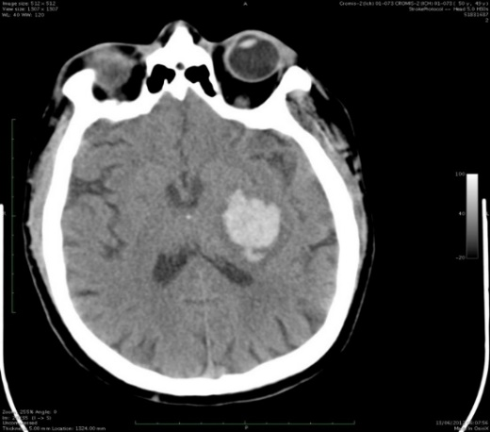
Figure 2: Deep (basal ganglia) ICH – most often this is due to arteriolosclerosis, a form of cerebral small vessel disease often (but not always) associated with hypertension
Figure 3: Lobar ICH – most often caused by cerebral small vessel diseases (arteriolosclerosis or cerebral amyloid angiopathy)

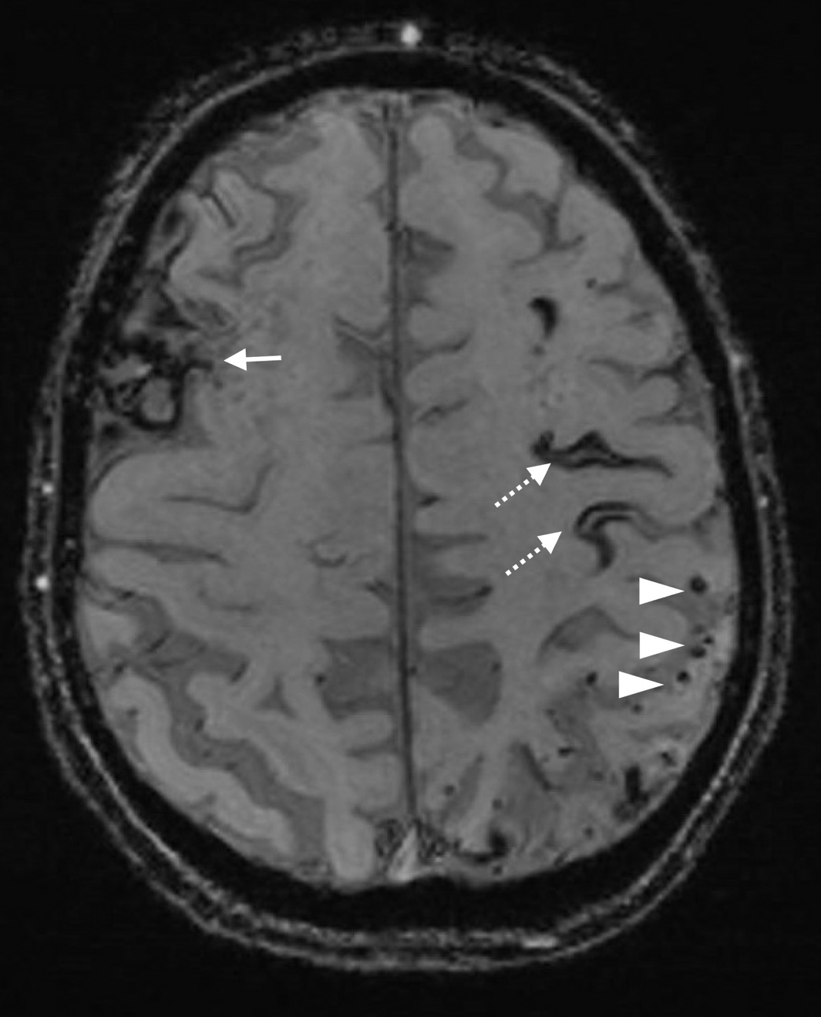
Figure 4: Cerebral amyloid angiopathy (CAA). Axial susceptibility-weighted imaging (SWI) MRI showing right frontal lobar ICH (white arrow), cortical superficial siderosis (black “tram-lines”; dotted white arrows), and lobar cerebral microbleeds (small black rounded lesions; white arrowheads).

The most important modifiable risk factor for ICH is chronic arterial hypertension, accounting for over half of the population attributable risk (Parry-Jones, et al. 2020). Smoking, obesity and heavy alcohol intake are other important modifiable risk factors for ICH (O’Donnell, et al. 2016). Non-modifiable risk factors for ICH include male sex, older age, Asian ethnicity, and chronic kidney disease (An, et al. 2017). The incidence of ICH increases in patients 75 years and older and coincides with the increased use of statin and anticoagulant medications (Lioutas, et al. 2020). Asians are at a higher risk of stroke due to their cardiometabolic profile(Singh, et al. 2017). High-carbohydrate diets with high salt and low fat, economic status, and underlying genetic factors have been shown to be possible determinants for the epidemic of vascular risk factors in Asian countries(Kim, et al. 2016).
The large increase in the global burden of stroke is multifactorial and is due not only to population growth and ageing but also because of the substantial increase in exposure to several important risk factors such as: high BMI, ambient particulate matter pollution, high fasting plasma glucose, high systolic blood pressure, alcohol consumption, low physical activity, kidney dysfunction(GBD,2021). The burden of stroke varies by income group with an intracerebral haemorrhage twice as likely in a low-income to upper-middle-income groups combined than in the high-income group(GBD, 2021).
Due to the different aetiologies associated with ICH, with implications for acute treatment, prognosis and prevention, early diagnosis and direct appropriate management strategies are essential. Early optimal supportive management of patients is a priority as evidence-based treatments which, when combined, are likely to have a considerable impact on outcome (although randomised controlled trial data are lacking). The implementation of a ‘‘ABC’’ care bundle for ICH which incorporated current treatment strategies such as rapid treatment to normalise coagulation, intensive blood pressure (BP) lowering within 6 hours of onset and care pathways that prompt immediate neurosurgical referral, resulted in lower 30 day-case fatality (Parry-Jones, et al. 2019).
The following sections will discuss the current treatment strategies and acute management for patients who have experienced an ICH.
Early diagnosis: time is brain
Spontaneous ICH is a life-threatening neurological emergency that requires prompt diagnosis via brain imaging to distinguish it from ischaemic stroke (Hostettler, et al. 2019). The principle of “time is brain” is as important when managing ICH as it is for ischaemic stroke. Early supportive management in the ‘golden hour’ after ictus provides an opportunity to mediate the effects of secondary brain injury (Cordonnier and Tymianski, 2019). A rapid non-contrast CT scan is highly sensitive and specific and can reliably distinguish acute ischaemic stroke and ICH which Is not possible from bedside assessment (McGurgan, et al. 2021). Every effort should be made to minimise delays to the initial CT brain scan. Most patients with spontaneous ICH will require some form of intracranial vascular imaging (angiography; usually CT angiography (CTA), but MR angiography (MRA) is also useful (Hostettler, et al. 2019) to exclude a macrovascular cause; in a small number of patients with a high suspicion of such a cause, intra-arterial digital subtraction angiography (IADSA) is recommended. The ¹DIAGRAM score is a useful way to practically assess the likelihood of a macrovascular cause in patients with non-traumatic ICH based on age, ICH location, SVD and CTA (Hilkens, et al. 2018).
A focused neurological examination including the Glasgow Coma Score (GCS) and The National Institutes of Health Stroke Scale (NIHSS) and general medical assessments using a structured approach should be performed. Patients with declining GCS and/or equal to or less than 8 should be rapidly assessed for airway support by endotracheal intubation (Shoamanesh, et al. 2021). Time is limited so the approach should be an efficient and focused history and physical examination (McGurgan et al. 2021). The CT scan should be assessed for ICH location, size of the haematoma, brain changes consistent with SVD (atrophy, leukoaraiosis and lacunes), the presence and degree of mass effect or midline shift, hydrocephalus, and intraventricular extension. Neurological complications of ICH include seizures and non-neurological complications include aspiration pneumonia and venous thromboembolism which are associated with poor prognosis (Law, et al. 2017). Blood tests including coagulation studies, glucose, and a toxicology screen should be performed (McGurgan et al. 2021).
In the acute phase, ICH is a dynamically evolving process due to the risk of neurological deterioration and on-going secondary injury (Jauch, et al. 2015; McGurgan, et al. 2021). Haematoma volume is the strongest predictor of morbidity and mortality, therefore early protection against haematoma growth is the mainstay of current treatment (Tanaka and Toyoda, 2021). Early neurological deterioration is associated with a high rate of poor long-term outcome (Al-Shahi Salman, et al. 2018) and is often attributed to factors including: ICH growth in the acute phase (<6hrs), evolving perihematomal tissue injury, hydrocephalus and oedema all of which may lead to a subsequent increase in intracranial pressure and fatal brain herniation syndromes (Sarma, et al. 2019). Perihematomal oedema and disordered cerebral autoregulation may result in delayed ischemia (Sarma, et al. 2019). Current therapeutic management is aimed at limiting haematoma expansion, mass effect (or both) thereby reducing further brain injury, preventing the complications of disability, and promoting recovery (Tanaka and Toyoda, 2021).
Implementation of early supportive care
Following the diagnosis of ICH, patients with ICH should be admitted to an acute stroke unit as soon as possible where they can receive targeted specialist care by the stroke multidisciplinary team(NICE, 2019). Nurses have a pivotal role. Close physiological monitoring and early detection of neurological and physiological deterioration and the maintenance or restoration of homeostasis are crucial in the acute phase. The benefits of stroke unit care are as great for patients with ICH as it is for those with ischaemic stroke (Langhorne, et al. 2013). The ICH score is probably the most broadly known prognostication tool for predicting mortality of ICH patients at different predicted time points (Hemphill, et al. 2001). However, there is little data to quantify the actual use of prediction scores in clinical practice hence it is mainly used for communication purposes and not as a tool to deny treatment.
ICH has been associated with therapeutic nihilism due to the high rates of poor outcomes and a perceived lack of effective treatments (Zahuranec, et al. 2007: Hemphill and White, 2009; Parry-Jones, et al. 2016). However, the “self-fulfilling prophecy” of poor outcome must be challenged: patients with ICH can do better than predicted if provided with early supportive care concordant with evidenced based and guideline-recommended interventions (Hemphill, et al. 2015; NICE, 2019; Parry-Jones, et al. 2019). Early Do Not Attempt Cardiopulmonary Resuscitation (DNACPR) orders (e.g., in the first 24-48 h) should be avoided in the majority of ICH patients as outlined in current guidelines (Hemphill, et al. 2015; NICE, 2019). Early DNACPR can lead to early palliation during the first 72 hours, precludes stroke unit admission and independently increases mortality even after adjusting for clinical stroke severity (Parry-Jones, et al. 2016). Clinicians need to consider all factors, communicate with patients and relatives and provide proactive supportive care early so that outcome can be optimised. Decisions about instituting a ceiling of care should depend on an assessment of prognosis and involve shared decision making amongst members of the direct care team, the patient where possible and carers (Visvanathan, et al. 2017; NICE, 2021). Therefore, the focus for the vast majority of patients with ICH should be on the full provision of high-quality active treatment and supportive care, at least in the first 24–48 hours, to optimise patient outcome. Only those with no prospect of survival (e.g., showing signs of brainstem compression such as fixed dilated pupils or multiple life-limiting co-morbidities) should not be offered early supportive care.
Intracranial pressure (ICP) monitoring is recommended in those with a GCS <9, evidence of herniation or hydrocephalus (McGurgan, et al. 2021). Therefore, for severely affected ICH patients, specialised stroke care in a neurocritical care unit can optimise ICH patient outcome (Damien, et al. 2013). Neurocritical care with specific expertise by the multidisciplinary team aims to provide neuroprotection, avoidance of secondary brain injury, prompt recognition and treatment of systemic complications to provide the best possible recovery (Kramer and Couillard, 2020). Although recent evidence has found that experienced doctors and nurses working in a neurocritical care found caring for patients with ICH challenging and at times caused emotional distress, this was counterbalanced by the need to provide dignified end of life care to those whose lives could not be saved (Mc Lernon, et al. 2020). Meeting the palliative care needs of severely-affected ICH patients and families is an important nursing consideration which can improve the quality of life of stroke patients, their families, and their care providers.

Acute medical management
ICH associated with oral anticoagulants or antiplatelet agents
Coagulopathies i.e., the use of antithrombotic or thrombolytic agents, congenital or acquired clotting deficiencies and systemic diseases are possible contributory factors for ICH. Around a third of patients with ICH are taking oral anticoagulants or antiplatelet drugs at ICH onset which is associated with a high risk of early haematoma expansion (Seiffge, et al. 2019; Parry-Jones, et al. 2020). The concern for haematoma expansion is particularly true for patients with ICH taking vitamin -K antagonists (VKAs) such as the oral anticoagulant warfarin. VKA-ICH patients tend to be older, have a larger haematoma at baseline, a higher risk of haematoma expansion and a higher mortality when compared to those not taking anticoagulants (Seiffge, et al. 2019). This issue has been further complicated by the introduction of direct oral anticoagulants (DOACs). The most commonly used agents in the UK are factor Xa inhibitors. These are a type of anticoagulant that works by selectively and reversibly blocking the activity of clotting factor Xa, preventing clot formation. They are first line treatments for atrial fibrillation and other indications such as venous thromboembolism as they affect both factor Xa within the blood and within a pre-existing clot (Connolly, et al. 2019). DOAC-ICH appears to be associated with lower baseline hematoma volume and less severe stroke syndromes, but not a lower-case fatality, when compared to VKA-ICH (Tsivgoulis, et al. 2018). Andexanet alfa is a modified recombinant inactive form of human factor Xa which has been shown to be effective for reversal of factor Xa inhibitors such as rivaroxaban, apixaban, edoxaban and enoxaparin (Connolly, et al. 2019). Although used in the USA and Europe, its use in the UK is not yet commonplace because of its cost and the lack of trial evidence demonstrating improved outcomes. A multi-centre randomised controlled trial is in progress hoping to demonstrate improved outcomes (ANNEXA-I) (https://clinicaltrials.gov/ct2/show/NCT02329327).
Important information upon arrival is therefore to establish whether the patient is taking anticoagulation and/ or antiplatelet medications. If confirmed the exact medication used should be noted. Restoration of vitamin-K-dependent clotting factors in VKA-ICH and normalization of the International Normalised Ratio (INR) can be achieved rapidly by treatment with four-factor prothrombin complex concentrate (PCC), which has shown to be superior to fresh frozen plasma (Steiner, et al. 2016). Rapidly achieving normalization of the INR appears to be associated with a lower risk of hematoma expansion and is a key priority in the early acute management of ICH (Parry-Jones, et al. 2020). Clinicians should thus work to minimize delays in care processes, and the use of point-of-care INR testing, agreed protocols, and rapid access to PCC has all been shown to help.
Prior antiplatelet use is associated with a larger ICH volume, haematoma expansion, increased mortality. Platelet transfusion has been shown to led to significantly higher death and dependence at 90 days so should thus be avoided for this indication (Baharoglu, et al. 2016). There are currently no treatments of benefit in antiplatelet-associated ICH therefore discontinuation of antiplatelets in the acute phase, is recommended. Patients with ICH in the context of coagulation factor deficiencies or thrombocytopenia should undergo replacement, with advice from a haematologist (Mc Gurgan, et al. 2021). Stopping antithrombotic therapy and reversing anticoagulation (Table 1) immediately after the diagnosis of ICH is, therefore, a key priority.
Table 1 summarises the use of antithrombotic medications.
Anticoagulant | Reversal strategy | Rationale
Dabigatran | 1: Stop dabigatran immediately and check bloods /clotting profiles
 | 2: Idarucizumab 2x2.5 g boluses intravenously as per results from clotting profiles | Humanised monoclonal antibody fragment that leads to a rapid reversal of the anticoagulant effect
 | 3: Consider oral-activated charcoal (50 g) if last intake is <4 hours and safe to administer to patient
Warfarin (VKA’s) | 1: Stop warfarin immediately, check bloods/ clotting profile | Rapidly restores normal coagulation
 | 2: Vitamin K 10 mg intravenous infusion | Vitamin K may help to prevent a later re-increase in INR
 | 3: Four factor prothrombin complex concentrate (PCC) (e.g., octaplex)with INR-based dosing  4: Repeat INR every 3-6 hours | PCC is superior to fresh frozen plasma in normalising the INR
Factor Xa inhibitors (Rivaroxaban, apixaban, edoxaban and betrixaban) (DOACs) | 1: Stop the agent immediately, check bloods/clotting profile  2: Consider oral-activated charcoal (50 g) if last intake is <4 hours and safe to administer to patient  3: Four factor prothrombin complex concentrate (PCC)
 | 4: Andexanet alpha intravenous bolus and infusion- NICE (2020) have not yet recommended its use | Andexanet alpha is a modified recombinant inactive form of human factor Xa
Heparin | 1: Stop heparin infusion/low -molecular weight heparin (LMWH) immediately  2: Check bloods/ clotting profile
 | 3: Protamine sulphate slow intravenous infusion | Protamine sulphate fully reverses the effect of unfractionated heparin but only partly neutralises the effect of LMWH

Table 1. Strategies used for anticoagulation reversal in acute ICH (adapted from Mc Gurgan, et al. 2021)

Haemostatic agents (tranexamic acid and activated factor VIIa)
Early haemostatic therapy has the potential to reduce haematoma growth by facilitating clot stabilisation (Tanaka and Toyoda, 2021). However, the Tranexamic Acid for Hyperacute Primary IntraCerebral Haemorrhage (TICH-2) randomised placebo-controlled trial investigating the effect of tranexamic acid showed modest but significant reductions in early death, hematoma expansion and appeared safe but did not improve functional outcome at 90 days (Sprigg, et al. 2018). As a result, its use is not standard practice.
As the majority of bleeding occurs within the first 2-3 hours after onset, the administration of rFVIIa (recombinant factor VIIa) has the potential to decrease ICH growth (Broderick, et al. 2021). The rFVIIa is a manufactured recombinant protein which interacts with tissue factor at the site vessel injury which leads to thrombin generation. Thrombin converts fibrinogen to fibrin producing a stable clot. However, although trials of rFVIIa have shown a reduction in haematoma expansion, there was a high rate of adverse thromboembolic events which outweighed the benefits (Al-Shahi Salman, et al. 2018). Its use is not recommended pending further trial data.

Acute blood pressure lowering
Elevated blood pressure (BP) is reported in patients with acute ICH and has been found to be associated with increased likelihood of death or dependency in a meta-analysis of observational studies (Tsivigouli, et al. 2014; de Oliveira Maneol, et al. 2016). A high systolic blood pressure (SBP) (particularly initial SBP ≥ 200 mmHg) is associated with haematoma enlargement and increased mortality after ICH (Qureshi, et al. 2007). Due to the association of acutely elevated BP with ICH patient outcome, and the rationale of reducing systolic blood pressure (SBP) to reduce early haematoma expansion, the effect of reducing SBP in the initial hours after the onset of ICH has been tested in Randomised Controlled Trials (RCTs) and was found to be safe but with only modest benefit (Anderson, et al. 2013; Qureshi, et al. 2016). A sub-analysis of the RCT, Antihypertensive Treatment of Acute Cerebral Haemorrhage (ATACH)-2 trial, (Qureshi, et al. 2016) found that by lowering the SBP to 120–130 mmHg the benefits of preventing hematoma expansion were offset by increased cardio-renal adverse events (Toyoda, et al. 2019). A recent systematic review and meta-analysis from The Blood Pressure in Acute Stroke Collaboration (BASC) concluded that a moderate degree of BP lowering does not improve the odds of a functional recovery (Moullaali, et al. 2021).
Currently, the most recent UK national guidelines and European Stroke Organisation(ESO) Guidelines(Sandset, et al. 2021) recommend that all stroke units develop processes to quickly identify patients presenting with ICH within 6 hours of symptom onset with a systolic blood pressure (SBP) between 150mmHg-220mmHg (RCP, 2016; NICE, 2019; ES0, 2021). Evidence has shown that rapid BP lowering is safe, provided the extreme target of <130 systolic is avoided. Patients with extremely high BP >220 systolic were excluded from the trials, so there is no evidence to reduce these patients to the stringent target of <140 systolic and doing so might put patients more at risk of acute kidney injury as found in the subgroup of patients in ATACH-2 where SBP was reduced to <130 systolic. In these circumstances many clinicians choose an intermediate SBP target of 140-160 mmHg.
Patients should be offered rapid BP lowering treatment who do not have any contraindications such as: underlying structural cause , have a GCS score of 6 or below, require neurosurgery to evacuate the haematoma or have a massive haematoma with a poor expected prognosis(NICE, 2019). A locally agreed protocol for intensive blood pressure lowering should be utilised. In most cases, aim to achieve the SBP target of 140mmHg or lower while ensuring that the magnitude drop does not exceed 60mmHg within 1 hour of starting treatment (NICE, 2022). BP fluctuations should be avoided and intravenous agents with short half-life time are recommended (NICE, 2019). Labetalol, hydralazine, glyceryl trinitrate, nicardapine, and/or enalapril (oral or intravenous) may be considered for acute blood pressure reduction. Oral (or nasogastric) treatment should be started as soon as possible for maintenance treatment, and the intravenous therapy weaned and stopped within 2–3 days if possible (NICE, 2019; Mc Gurgan, et al. 2020). Non-pharmacological strategies such as adequate pain relief and reassurance should also be employed to lower BP. In conclusion, setting a target of 140mmHg (not lower than 130mmHg) is recommended. However, a tailored systolic target of 140-160 mmHg may be required in some selected cases. The choice of agent is based on physician preference and local protocols. Importantly, close monitoring for effectiveness and any side effects by specialist nurses working in stroke units is essential.

Surgical management and timing

The rationale for haematoma removal is to reduce direct and secondary brain injury (McGurgan, et al. 2021). However, the optimal timing of neurosurgery for ICH is uncertain and practice is varied (Hostettler, et al. 2019). Evidence supports the role of neurosurgery for infratentorial ICH as evacuation can result in good clinical outcome given the high risk of brainstem compression and herniation syndromes in the confined space of the posterior fossa (Da Pian, et al. 1984; Karollas, et al. 2001; McGurgan, et al. 2021). However, this has not been tested in a randomised control trial (for ethical reasons given the poor untreated outcome and consensus for benefit). Clinical guidelines recommend posterior fossa decompressive evacuation for cerebellar ICH>3 cm in diameter, or for smaller haematomas associated with brainstem compression or hydrocephalus from ventricular obstruction (Hemphill, et al. 2015; Shoamanesh, et al. 2021).
Despite several randomised controlled trials that have investigated surgical evacuation of supratentorial ICH compared to medical management alone in improving patient outcome (Mendelow, et al. 2005; Mendelow, et al. 2013), its use remains unclarified and a matter for debate. The question of who to operate on and when remains uncertain (Mendelow, et al. 2013; Hostettler, et al. 2019). Individual patient data meta-analysis shows that subgroups of patients may benefit (Gregson, et al. 2012; Gregson, et al. 2019). Patients with larger haematomas (20-50ml) and with reduced consciousness but who are not comatose (i.e., Glasgow Coma Scale (GCS) score 10-13) and those with superficial bleeds may experience improved outcomes and are outlined in current recommendations (Hemphill, et al. 2015; NICE, 2019). Results from the ongoing Swiss trial of decompressive craniectomy versus best medical treatment of spontaneous supratentorial haemorrhage (SWITCH) may offer a future treatment option to patients with ICH which can reduce both mortality and disability (www.clinicaltrials.gov, No: NCT02258919).
Results from a recent systematic review and meta-analysis have indicated that minimally invasive surgery for patients with supratentorial ICH have showed some promise in improving outcome (Sondag, et al. 2020). The only large trial of catheter evacuation followed by irrigation with alteplase (MISTIE III) found no clear benefit but noted that the procedure was safe (Hanley, et al. 2019). Overall, the minimally-invasive procedure failed to show superiority to standard medical care. For this reason, the pragmatic use of this technique in the treatment of ICH cannot be recommended (Cordonnier and Tymianski, 2019). However, MISTIE III provided critical information about the feasibility of a minimally invasive surgical approach for ICH. Subsequently the ongoing ENRICH trial is investigating a novel minimally invasive technique involving a small-directed craniotomy and image-guided transsulcal evacuation (Labib, et al. 2017) which will provide more data on the use of minimally invasive procedures.
In summary, the optimal timing and technique of surgical intervention remains controversial due to the risk of re-bleeding. However, reducing haematoma volume early may reduce secondary brain injury and could improve outcome (Sondag, et al. 2020). Minimally invasive techniques with or without clot lysis hold promise for the surgical management of deep bleeds, where access is limited or risky for open surgery. Ongoing and future research hopes to provide further clarification on the use of surgery and its effects on functional outcome after ICH.
Conclusions
It is clear that a multitargeted and multidisciplinary approach is required to improve the future outcome of patients who have experienced ICH. Management should be aimed to protect against early haematoma growth and incorporate a standardised approach with effective delivery of evidence-based guidelines. Further development and implementation of ICH care bundles throughout the UK aim to standardise ICH acute patient management and may help to improve the outcome of patients with ICH.

Table 2: Key priorities for ICH acute management
Key Key points
- Intracerebral haemorrhage is a neurological emergency: “time is brain”
- Full supportive care (avoid DNACPR) for first 24-48 hours in acute stroke unit and/or critical care
- Rapid anticoagulation reversal
- Acute blood pressure lowering
- Neurosurgery if clinically indicated

Table 3: CPD Reflective questions
Reflective Questions
1: Is the patient with ICH at risk of neurological deterioration based on CT findings such as haematoma expansion, IVH extension, hydrocephalus
Is a frequent neurological assessment being conducted to assess for any signs of neurological deterioration?
2: How do I reverse anticoagulant/antiplatelet treatment if required?
3: Do I need to lower the patient’s blood pressure and if so when, by how much and with what agent, dose and route of administration?
4: Does the patient fulfil criteria for emergency neurosurgery?
5: What are the key priorities for the neuroscience nurse in acute ICH management?

References
An S, J Kim TJ, Yoon BW, Epidemiology, Risk Factors, and Clinical Features of Intracerebral Hemorrhage: An Update. Journal of stroke. 2017; 19(1) 3-10
Anderson CS, Heeley E, Huang Y, et al. INTERACT2 Investigators. Rapid blood-pressure lowering in patients with acute intracerebral hemorrhage. New England Journal of Medicine. 2013;368(25):2355-65.

Antoniou SA, van Veenendaal N, Bonjer HJ. Systematic reviews and meta-analyses in minimally invasive surgery. American Journal of Surgery. 2019 ;218(1):232-233.
Al-Shahi Salman R, Frantzias J, Lee RJ, et al. Absolute risk and predictors of the growth of acute spontaneous intracerebral haemorrhage: a systematic review and meta-analysis of individual patient data. Lancet Neurology. 2018; 17:885–94
Al-Shahi Salman R, Law ZK, Bath PM, et al. Haemostatic therapies for acute spontaneous intracerebral haemorrhage. Cochrane Database Systematic Review. 2018;17;4(4):CD005951.
Alonso A, Ebert A.D, Kern R, et al. Outcome Predictors of Acute Stroke Patients in Need of Intensive Care Treatment. Cerebrovascular Disease. 2015; 40, 10-17
Banerjee G, Carare R, Cordonnier C, et al. The increasing impact of cerebral amyloid angiopathy: essential new insights for clinical practice. Journal of Neurology, Neurosurgery, Psychiatry. 2017; 88(11), 982-994
Broderick JP, Grotta JC, Naidech et al. The Story of Intracerebral Hemorrhage: From Recalcitrant to Treatable Disease. Stroke. 2021; 52(5), 1905-1914
Baharoglu MI, Cordonnier C, Al-Shahi Salman R, et al. Platelet transfusion versus standard care after acute stroke due to spontaneous cerebral haemorrhage associated with antiplatelet therapy (PATCH): a randomised, open-label, phase 3 trial. Lancet (London, England) 2016;387:2605–13
Boulouis G, Morotti A, Goldstein JN, et al. Intensive blood pressure lowering in patients with acute intracerebral haemorrhage: clinical outcomes and haemorrhage expansion. Systematic review and meta-analysis of randomised trials. Journal of Neurology, Neurosurgery Psychiatry 2017; 88:339–4
Cordonnier C, and Tymianski M, MISTIE III: What’s Next? Stroke; 2019; 50(6), 1634-1635
Connolly SJ, Crowther M, Eikelboom JW, et al. for the ANNEXA-4 Investigators. Full study report of Andexanet Alfa for bleeding associated with factor Xa Inhibitors. New England Journal of Medicine 380:1326-1335
Da Pian R, Bazzan A, Pasqualin A, Surgical versus medical management of spontaneous posterior fossa haematomas: a cooperative study of 205 cases. Neurology Research. 1984; 6(3), 145-151
Damian MS, Ben–Shlomo Y, Howard R, The effect of secular trends and specialist neurocritical care on mortality for patients with Intracerebral Haemorrhage, Myasthenia Gravis and Guillain-Barre Syndrome admitted to critical care. Intensive Care Medicine. 2013;39, 1405-1412
de Oliveira Manoel AL, Goffi A, et al. The critical care management of spontaneous intracranial hemorrhage: a contemporary review. Critical Care. 2016; 20:272.
Datar S, Rabinstein AA. Cerebellar hemorrhage. Neurologic Clinics. 2014;32(4):993-1007.
Gregson BA, Broderick JP, Auer LM, et al. Individual patient data subgroup meta-analysis of surgery for spontaneous supratentorial intracerebral hemorrhage. Stroke. 2012;43(6):1496-504.

Gregson BA, Mitchell P, Mendelow AD, Surgical Decision Making in Brain Hemorrhage
New Analysis of the STICH, STICH II, and STITCH(Trauma) Randomized Trials. Stroke. 2019;50:5,1108-1115
Global Burden of Diseases 2019 stroke collaborators (GBD) Global, regional, and national burden of stroke and its risk factors,1990-2019: a systematic analysis for the Global Burden of Disease Study 2019. Lancet Neurology. 2021; 20:795-820
Hanley DF, Thompson RE, Rosenblum M, et al. MISTIE III Investigators. Efficacy and safety of minimally invasive surgery with thrombolysis in intracerebral haemorrhage evacuation (MISTIE III): a randomised, controlled, open-label, blinded endpoint phase 3 trial. Lancet. 2019;393 (10175), 1021-1032
Hemphill JC, Bonovich DC, Besmertis L, Manley GT, Johnston SC. The ICH score: a simple, reliable grading scale for intracerebral hemorrhage. Stroke. 2001;32(4):891-897
Hemphill JC, Greenberg SM, Anderson CS, et al. Guidelines for the Management of Spontaneous Intracerebral Hemorrhage. A Guideline for Healthcare Professionals From The American Heart Association/American Stroke Association, Stroke. 2015; 46, 2032-2060
Hemphill JC, and White DB, Clinical Nihilism in Neuroemergencies. Emergency Medicine Clinics of North America. 2009; 27, 27-37
Hostettler IC, Seiffge DJ, Werring D, Intracerebral haemorrhage: an update on diagnosis and treatment. Expert Review of Neurotherapuetics. 2019; 19(7), 679-694
Hilkens NA, van Asch CJJ, Werring DJ, et al. DIAGRAM study group. Predicting the presence of macrovascular causes in non-traumatic intracerebral haemorrhage: the DIAGRAM prediction score. Journal of Neurology and Neurosurgery Psychiatry. 2018; 89(7):674-679.
Jauch EC. Pineda JA, Claude HJ, Emergency neurological life support: intracerebral haemorrhage. Neurocritical Care. 2015; 23. Supplement 283-93
Karollas RW, Tyagi AK, Ross SA Management of spontaneous cerebellar haematomas; a prospective treatment protocol. Neurosurgery.2001; 49(6), 1378-1386
Kramer AH, Couillard P, Neurocritical Care: A Growing International Collaborative. Neurocritical Care. 2020; 32(1):80-83.
Krishnamurthi RV, Ikeda T, Feigin VL, Global, Regional and Country-Specific Burden of Ischaemic Stroke, Intracerebral Haemorrhage and Subarachnoid Haemorrhage: A Systematic Analysis of the Global Burden of Disease Study 2017. Neuroepidemiology. 2020; 54(2), 171-179
Kim YD, Jung YH, Saposnik G. Traditional Risk Factors for Stroke in East Asia. Journal of Stroke. 2016;18(3):273-285.
Langhorne P, Fearon P, Ronning OM, et al. Stroke Unit Care Benefits Patients with Intracerebral Hemorrhage. Systematic Review and Meta–Analysis. Stroke. 2013; 44, 3044-3049
Labib MA, Shah M, Kassam AB, et al. The safety and feasibility of image-guided brainpath-mediated transsulcul hematoma evacuation: a multicenter study. Neurosurgery 2017; 80:515–24
Law ZK, Appleton JP, Bath PM, et al. Management of acute intracerebral haemorrhage-an update. Clinical Medicine Journal. 2017; 17(2), 166-172
Lioutas VA, Beiser AS, Aparicio HJ, Himali JJ, Selim MH, Romero JR, Seshadri S. Assessment of Incidence and Risk Factors of Intracerebral Hemorrhage Among Participants in the Framingham Heart Study Between 1948 and 2016. JAMA Neurology. 2020 1;77(10):1252-1260.
Mendelow AD, Gregson BA, Fernandes HM, et al. Early surgery versus initial conservative treatment in patients with spontaneous supratentorial intracerebral haematomas in the international surgical trial in intracerebral haemorrhage (STICH): a randomised trial. Lancet (London, England) 2005;365:387–97
Mendelow AD, Gregson BA, Rowan EN, et al. Early surgery versus initial conservative treatment in patients with spontaneous supratentorial lobar intracerebral heamatomas (STICH 11): a randomised trial. Lancet. 2013;382, 397-408
McGurgan IJ, Ziai WC, Werring DJ, et al. Acute intracerebral haemorrhage: diagnosis and management. Practical Neurology. 2020; 0, 1-12
Mc Lernon S, Werring D, Terry L, Clinicians’ Perceptions of the Appropriateness of Neurocritical Care for Patients with Spontaneous Intracerebral Haemorrhage (ICH): A Qualitative Study. Neurocritical Care. 2020; 35(1), 162–171
Minhas, J. S. Sammut-Powell, C. Birleson, E. et al. Are do-not-resuscitate orders associated with limitations of care beyond their intended purpose in patients with acute intracerebral haemorrhage? Analysis of the ABC-ICH study. British Medical Journal Open Quality. 2021; 10, e001113
Moullaali TJ, Wang X, Sandset EC, et al. On behalf of the Blood Pressure in Acute Stroke (BASC) Investigators.Early lowering of blood pressure after acute intracerebral haemorrhage: a systematic review and meta-analysis of individual patient Journal of Neurology, Neurosurgery, Psychiatry. 2021;0.1-8
National Institute for Health and Care Excellence (NICE). NICE guideline [NG128] stroke and transient ischaemic attack in over 16s: diagnosis and initial management. 2019.Available https://www.nice.org.uk/guidance/ng128 (accessed March 2022)
National Institute for Health and Care Excellence (NICE) COVID-19 rapid guideline: critical care in adults. NICE guideline. 2020; (NG159)
O'Donnell MJ, Chin SL, Rangarajan S, et al. INTERSTROKE investigators. Global and regional effects of potentially modifiable risk factors associated with acute stroke in 32 countries (INTERSTROKE): a case-control study. Lancet. 2016;388(10046):761-75.
Parry-Jones AR, Paley L, Bray BD, et al. on behalf of the SSNAP Collaborative Group. Care limiting decisions in acute stroke and association with survival: analyses of UK national quality register data. Journal of Stroke. 2016;11(3), 321-331
Parry-Jones AR. Camilla Sammut-Powell C, Paroutoglou K, et al. An Intracerebral Haemorrhage Care Bundle Is Associated with Lower Case Fatality. Annals in Neurology. 2019; 86, 495–503
Parry-Jones AR, Moullaali TJ, Ziai WC, Treatment of intracerebral hemorrhage: From specific interventions to bundles of care. International Journal of Stroke. 2020; 15(9), 945-953
Qureshi AI, Palesch YY, Barsan WG, et al. Intensive Blood–Pressure Lowering in Patients with Acute Cerebral Hemorrhage. The New England Journal of Medicine. 2016; 375, 10331043
Radholm, K. Arima, H. Lindley, R.I, et al. Older age is strong predictor for poor outcome in intracerebral heamorrhage: the INTERACT 2 study. Age and Ageing. 2015;44(3), 422-427
Royal College of Physicians (RCP) Stroke Guidelines 2016 Available at: https://www.rcplondon.ac.uk/guidelines-policy/stroke-guidelines (Accessed March 2022)
Salinas, J, Sprinkhuizen, S.M, Ackerson, T. et al. An International Standard Set of Patient-Cantered Outcome Measures After Stroke. Stroke. 2016; 47, 180-186
Sallinen H, Sairanen T, Strbian D, Quality of life and depression 3 months after intracerebral hemorrhage. Brain and Behaviour. 2019; 9(5), e0127
Sarma AK, Ghoshai S, Craven J. et al. Intracerebral Hemorrhage: A Brief Evidence-Based Review of Common Etiologies, Mechanisms of Secondary Injury, and Medical and Surgical Management. Journal of Neuroanaesthesiology and Critical Care. 2019; 6, 119-130
Sandset EC, Anderson CS, Bath PM, et al. European Stroke Organisation (ESO) guidelines on blood pressure management in acute ischaemic stroke and intracerebral haemorrhage. European Stroke Journal. 2021;6(2):XLVIII-LXXXIX
Seiffge DJ, Werring DJ, Paciaroni M, et al. Timing of anticoagulation after recent ischaemic stroke in patients with atrial fibrillation. Lancet Neurology. 2019; 18:117–126.
Sprigg N, Flaherty, Appleton JP, Al-Shahi Salman R. et al. Tranexamic acid for hyperacute primary IntraCerebralHaemorrhage (TICH-2): an international randomised, placebo-controlled, phase 3 superiority trial. Lancet. 2018; 391, 2107-2115
Steiner T, Poli S, Griebe M, et al. Fresh frozen plasma versus prothrombin complex concentrate in patients with intracranial haemorrhage related to vitamin K antagonists (INCH): a randomised trial. Lancet Neurology 2016; 15:566–73
Sondag L, Schreuder HB, Boogaarts H, et al. on behalf of the Dutch ICH Surgery Trial Study Group, part of the CONTRAST consortium Neurosurgical intervention for Supratentorial Intracerebral Hamorrhage.2020;Annals Neurol. 88:239-250
Shoamanesh A, Lindsay PM, Castellucci LA, et al. on behalf of the Canadian Stroke Best Practices Advisory Committee in collaboration with the Canadian Stroke Consortium and the Canadian Hemorrhagic Stroke Trials Initiative Network (CoHESIVE Canadian stroke best practice recommendations: Management of Spontaneous Intracerebral Hemorrhage, 7th Edition Update International Journal of Stroke. 2021; 0(0)1-21
Tanaka K, Toyoda K, Clinical Strategies Against Early Hematoma Expansion following Intracerebral Hemorrhage. Frontiers in Neuroscience. 2021;15, 677744
Toyoda K, Koga M, Yamamoto H, et al. ATACH-2 Trial Investigators. Clinical Outcomes Depending on Acute Blood Pressure After Cerebral Hemorrhage. Annals of Neurology. 2019; 85(1):105-113.
Tsivgoulis G, Katsanos AH, Butcher KS, et al. Intensive blood pressure reduction in acute intracerebral hemorrhage. A Meta-analysis.Neurology. 2014; 83:1523–1529
Tsivgoulis G, Wilson D, Katsanos AH, et al. Neuroimaging and clinical outcomes of oral anticoagulant-associated intracerebral hemorrhage. Annals of Neurology. 2018 Nov;84(5):694-704.
Visvanathan A, Dennis M, Mead G, et al. Shared decision making after severe stroke-How can we improve patient and family involvement in treatment decisions? International Journal of Stroke. 2017;12(9), 920-922
Zahuranec DB, Brown DL, Lisabeth LD, et al. Early care limitations independently predict mortality after intracerebral haemorrhage. Neurology. 2007;68, 1651-1657

