Manuscript written by Song, Wang, Gillich, Ford & Hewitt

Modelling development and analysis on the Balanced Energy Networks (BEN) in London

William Hasung Song^{a,b,*}, Yang Wang^{a,,*}, Aaron Gillichª, Andy Fordª, Mark Hewitt^{c}

- School of the Built Environment and Architecture, London South Bank University, SE1 0AA, London, UK
- College of Letters and Sciences, University of California, 94720, Berkeley, US
- ICAX Limited, SW15 1BN, London, UK

Abstract
In the UK up to 40% of total final energy use is accounted for by the heating and hot water systems, which makes up 20% of greenhouse gas emissions. One path to low carbon heating is to electrify heat, and then meet the electricity demand via a smarter grid. This article presents a novel approach to electrifying heat based on a balanced energy network (BEN) system located at the London South Bank University (LSBU) campus. The BEN system includes borehole thermal storage, an ambient temperature heat network (heat transmission and distribution), water source heat pumps, smart hot water storage, and demand side response (DSR) service. Its thermal and electrical energy performances were mainly investigated. A novel energy performance index (TSE: total system efficiency) was also proposed and applied in assessing the performances. Several key findings were achieved as follows: 1) The TSE varied from 1.4 to 2.2 in one of the coldest months of the year, indicating a great improvement on energy efficiency. 2) The ICAX high-temperature heat pumps in BEN operate with a higher COP fluctuating between 3.1 and 3.2 with a Carnot efficiency of 0.5. 3) With an acceptable level of thermal comfort, the BEN system can reduce CO₂ emissions up to 3.62 t for two weeks. 4) Corresponding with the initial design setting, 70ºC has been proved as the optimal operating output temperature of heat pump.

Keywords
Balanced Energy Networks; Cold Water Heat Network; Electricity Price; Water Source Heat Pump; Total System Efficiency; Smart Hot Water Tank; Borehole
- Introduction
Climate change and the need to reduce carbon emissions have placed heavy pressure on the building energy reductions, in particular high-energy consumption ageing existing buildings [1-4]. In the UK, the building sector accounts for approximately 40% of national carbon emissions [1, 5]. Meanwhile, the UK faces a considerable challenge in the energy trilemma of creating a low cost, low carbon, and secure energy system. The Committee on Climate Change has stated that the UK’s 2050 carbon targets are unachievable without a near complete decarbonisation of the heating sector [1]. One possible path to low carbon heating is to electrify heat, and then meet the electricity demand via a greener grid. This is facilitated by delivering space and water heating through more efficient heat pumps in heat networks. The UK Department for Business, Energy and Industrial Strategy (BEIS) (formerly DECC) has declared the goal of delivering 15~25% of space and water heating demand via heat networks [6]. However, the current capacity of heat networks is estimated just at around 2% [6].
There has been a significant body of research delivered on heat networks and electrifying heat (see e.g. [7-8], etc.). While the benefits of heat pump driven heat networks have been well studied theoretically, there are few practical examples in the UK. The UK lags behind EU examples such as Denmark and the Netherlands in utilizing other novel approaches including borehole thermal storage, heat pumps and waste heat recovery to boost the performance of heat networks. The technical potential now exists to move beyond even these precedents and incorporate distributed ‘smart thermal storage’ to demand side response services (including dynamic pricing) as an integral part of the control strategy for a whole heat network. The combination of principles such as the electrification of heat, low distribution temperatures, waste heat recovery, borehole and distributed thermal storage, and dynamic pricing is an emerging field of multi-vector energy networks that has the potential to greatly expand the role of heat networks in low carbon infrastructure. The methods used to model this potential are the subject of increasing academic interest. Although the modelling and optimizations of existing energy networks have been broadly investigated, however, there is still a significant lack of knowledge concerning the next-generation energy network feasibility, application and its system modelling development.
Several studies in the past years focused on the energy network and energy system modelling, whereas they were still based on traditional district heating networks. Zheng et al. [7] compared a new physical model named as the function method with the node method for the simulation of dynamic supply temperature of district heating network. The function method was validated at large and quick temperature changes and diverse flows. Based on measurements, it was found that the new model performed better than the node method. Sartor et al. [8] experimentally validated the heat transport modelling in district heating networks and investigated thermal losses and inertia of pipes. The results showed pipe thermal inertia has significant influence on heat transfer, particularly on the outlet pipe temperature response when a morning network boosts. Pan et al. [9] investigated interactions in one district electricity and heating system concerning time-scale characteristics. A quasi-steady multi-energy flow model using Matlab was therefore proposed and studied. The interaction process is separated into four quasi-steady stages, including normal, quasi-steady hydraulic, quasi-steady thermal and quasi-steady building states. Attention should be on the slow thermal process and quick hydraulic process for whole system security and economic operation. Pan et al. [10] also presented a feasible region method for the formulation of new district heating system (DHS) models, which could exploit DHS flexibility including building thermal inertia. The proposed new models are similar to a virtual power plant concept. It could enable integrated heat and electricity dispatch in an electricity control center. It was found that the proposed method is effective in facilitating integrated heat and electricity dispatch and making the dispatch extensible, scalable and acceptable. Grunewald et al. [11] studied up to 176 demand site response (DSR) sites and found that just a small minority engaged in demand turn-down and load shifting, while the major demand response was supplied by stand-by generators. Maclean et al. [12] proposed that there are three key options based on the provision of carbon-free heat: a) electrification: using heat pumps in buildings typically, b) heat networks: district heating with a carbon-free source, and c) repurposed gas grids: employing existing gas infrastructure with biogas or hydrogen. The same conclusions were also drawn in the research by DECC [13]. Liu et al. [14] modelled the electricity, heat and gas as a whole network via integrated analysis. The proposed model can be flexibly fitted to generic network topologies and multi-energy supply technologies.
In addition, there were a number of studies focusing on the energy network and energy system optimization algorithms. Vesterlund et al. [15] optimized the operation of multi-source complex district heating networks taking into account the detailed behavior of pressure and thermal losses along the pipes. A hybrid evolutionary-mixed integer linear programming (MILP) algorithm has been developed and coupled to a district heating network. The results from the Matlab/Simulink modelling using this algorithm showed that the cost of thermal losses is more important than those of the pumping power. Jie et al. [16] developed four strategies for the minimum pumping costs and heat loss costs using the operational optimization model with Matlab. It was found that both the operating strategy and heating parameters could affect the optimal results for the existing district heating system. The pump frequency limit could be a concern if the proposed optimization model was used in engineering practice. Carpaneto et al. [17] proposed a model for the district heating systems with solar heating and thermal storage in Northern Italy. Through the optimization for the overall operational cost function, the minimum cost could be obtained on a weekly schedule with electricity market price. The best proportions of solar and conventional sources and the optimal capacity of storage could be determined after an optimization procedure. Li et al. [18] studied a combined heat and power dispatch (CHPD) model solved by an iterative method concerning temperature dynamics of district heating network. The proposed CHPD approach could improve whole economic efficiency of CHP system, and offer more flexibility for system operation. Falke et al. [19] developed a multi-objective optimized model used in a medium-sized town district, and meanwhile studied the effects of different efficiency measures concerning total costs and CO₂ equivalent emissions. The multi-objective approach included an integrated economic and ecological optimization. Morvaj et al. [20] investigated the optimal design, distributed energy system operation, and optimal heating network layouts. A detailed multi-objective MILP model for urban energy systems has been developed. It has been illustrated the proposed district heating could decrease emissions 23% compared with the standard case for the same costs. In addition, the limits on possible network routs could have significant effects on the optimal design. Morvaj et al. [21] proposed a novel framework consisting of optimal design and distributed energy system operation, which focuses on the calculation of grid constraints and building energy use. Electricity grid constraints have been integrated by the linearizing AC power flow equations. In the operation schedule, 18% carbon emissions have been reduced due to inclusion of grid constraints. Ayele et al. [22] developed an algorithm consisting of a more flexible hydraulic model and a more realistic thermal model, which can simulate diverse network configurations when applicable. The proposed modelling approach is illustrated by a highly coupled heating and electricity network. Jiang et al. [23] presented a comprehensive model using Matlab/Simulink for an integrated energy, including electric water and gas-fired boilers and solar water heater, based on the district hot water heating system. An optimal operating strategy with Matlab code has been developed via the above model. Compared with the natural gas heating system, this system could save 25.22 kgce (Kilogram of Coal Equivalent) and the running costs could be reduced by 17.192 dollars in a typical day. Zheng et al. [24] introduced a model for a large-scale integrated energy system (LSIES) and therefore proposed a multi-objective optimization method (MGSO-ACL: Multi-objective group search optimizer with adaptive covariance and Levy flights). Compared with GSOMP (Group search optimizer with multiple producers), MGSO-ACL is more efficient in searching the better Pareto-optimal solutions taking into consideration convergence and diversity.
From the aforementioned studies, it can be clearly found most of research focused on the traditional energy network, energy system modelling, and their optimization algorithms. However, the modelling of whole energy network received less attention. This article aims to investigate the feasibility of next-generation energy network and the modelling of its integrated energy systems, including renewable energy systems, demand side response in an energy network linking different buildings. On the other hand, this study will assess energy performance of the proposed BEN system according to the real operations. The proposed integrated system model is dynamic, easy to operate and simplified but fully embodying the performance parameters of the BEN demonstration case study.
This paper presents results from a model created in LabVIEW to represent the recently built BEN at London South Bank University. LabVIEW has been adopted as a tool to model and monitor/measure the energy systems in several significant studies [25-28]. Wichert et al. [25] developed a test facility for simulating PV-diesel hybrid energy systems using LabVIEW. Based on a graphical user-interface integrated with the optimal control methods, this tool can effectively manage the PV-diesel hybrid energy systems. The modelled system demonstrated the potential for improving performance using a predictive dispatch strategy. Chouder et al. [26] presented another LabVIEW-based PV energy system that has detailed performance characteristics and can display a dynamic performance. This well developed LabVIEW-based system could compare simulated results with monitored data in real time taking into account solar resource, local weather and system behavior. LabVIEW was also applied in a two-stage optimization study of energy management [27], which focused on the advanced building energy systems with MILP. The proposed system optimized the scheduling of all resources for a given energy system. In a complex energy supply system consisting of grid-connected sub-system, renewable energy and battery energy storages, Arcos-Aviles et al. [28] successfully adopted the LabVIEW to build an energy management system (EMS) based on the low-complexity fuzzy logic control (FLC). Compared with available energy management strategies, this innovative EMS has been proved to be operated with a minimize fluctuations and power peaks.
BEN has been retrofitted to two buildings in central London, including a cold-water heat network, linked to wells in the aquifers [29] and the electrification of heat [30]. A novel energy performance index of total system efficiency (TSE), which includes borehole, ground water heat pump and hot water tank (thermal storage), has been proposed, applied and investigated in this study. The objectives are as follows: 1) to build the robust model of whole BEN system numerically using LabVIEW based on the real-world BEN; 2) to evaluate energy performance of the BEN system; 3) to propose possible optimizing methods for the whole system using the monitored data and TSE.
The structure of this paper is as follows. In the following sections, the BEN project and its dynamic model will be described and analysed. Subsequently, BEN model validations will be carried out against historic data and measurements as well as manufacturer performance data. Following that, thermal and electrical energy performance of the BEN system will be numerically investigated focusing on the effects of borehole and heat pump output temperatures, heat pump COP and TSE. Finally, the Section 7 will draw the conclusions and propose future work.

- Project description
This section describes contributions to evaluating the system performance of the BEN system through a modelling process, undertaken by a team at LSBU. The BEN project is part-funded by Department for Business, Energy and Industrial Strategy through the Innovate UK programme, and has been delivered by a consortium led by ICAX Limited, including LSBU, Origen Power, Cranfield University, Upside Energy, Mixergy Limited and TFGI Limited.
The BEN system is a demonstration project located at LSBU located in central London (Fig. 1(a)). BEN was designed to combine heat networks with smart-grid technology to balance the delivery of heating and electricity generation in a way that minimizes costs and carbon emissions. It builds on the principles of aquifer thermal energy storage popular in the Netherlands to create the first cold water heat networks (CWHN) [29] for use in district heating in the UK.
The basic principle behind BEN is to electrify heat while minimizing the impact to peak grid electrical loads using a novel combination of measures. BEN links the Tower Block and J-Block (see Fig. 1(b) and (c)) to two 110 m boreholes with the rated power 22 kW, which can deliver groundwater from the London aquifer at around 13 – 15 ºC [29-30]. The main parameters for the two blocks include: volume - 27231 m³ (T-Block) and 31830 m³ (J-Block); average U-value of both - 0.3 W/m²K [29-30]. These values will be used for the simulations. Conveyed by the CWHN, this open loop borehole system provides the heat sink source for the heat pumps with the maximal power 95 kW. The temperature in the CWHW can be raised by the heat rejection, which would in turn improve the COP of heat pumps in heating modes. Overall system performance can also be improved by shifting loads to off-peak times through a combination of distributed thermal storage with 10 kL volume and DSR. While these technologies have all been proven individually, BEN is one of the innovative heat network which integrates them all into a balanced system.

(a)

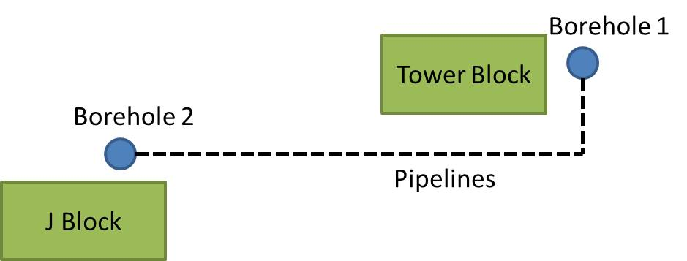
(b)

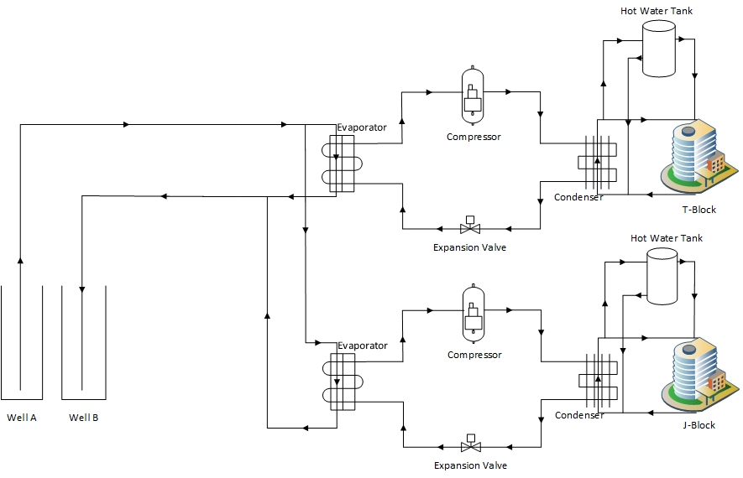

(c)
Fig. 1: Layout for two boreholes and Tower Block & J-Block in LSBU (a) (background from [31]) and schematic diagrams of BEN project (b) and system model components (c)

- Methodology
  - Dynamic Model of BEN
LabVIEW [32] was chosen for use as the simulation environment for a number of reasons. The simplified nature of the simulation and calculations did not require many of the extra features and parameters that are used in other software such as TRNSYS. Building the simulated network’s components from scratch enables the user to have full control of how values are calculated and propagated through the system. Furthermore, the application of VI’s (Virtual Instruments) and SubVI’s in LabVIEW is flexible and modular, which makes it capable of simulating different network configurations. Thus, it is possible to expand the BEN system to include a third or fourth building even the whole campus buildings. Our model framework will be useful in conducting preliminary analysis, evaluating its performance, and extending many other potential BEN configurations (e.g. extending more boreholes, heat pumps and thermal storage tanks etc.). The proposed integrated BEN system model is dynamic, easy to operate and simplified but fully embodying the performance parameters of the BEN demonstration case study.
Computing time was also not a large concern as LabVIEW is an interpreted language lightweight programming environment being primarily built upon C++. This analysis suite for simplified calculation and simulation is not computationally demanding, as the simulation was run in 15-minute time steps [33-34]. Should shorter time steps be used in more rigorous simulations, it may prove necessary to change platforms in the interest of computing time. In this study, the total computation time of the proposed methodology is several minutes for the whole BEN system operation. Finally, this model is only implemented to make preliminary assessments of different BEN designs not create them. Using neural networks and machine learning libraries to design optimal networks would be considerably more CPU intensive and is an area yet to be sufficiently explored.
  - Model assumptions
This simulation is a preliminary analysis of the expected performance of the BEN system at LSBU. With this simplification comes some uncertainties that will be catalogued in this paper. These uncertainties manifest in how many of the performance metrics will be presented as either upper or lower boundaries. The assumptions made are consistent with those used in other physical models of heat networks [7, 35] and HVAC systems [36]:
- The steady-state hydraulic condition is considered.
- Fluids are treated as ideal, unless otherwise stated.
- Hydraulic dispersion, thermal diffusion, and axial heat transmission along water pipes are neglected.
- T-Block and J-Block have uniform temperature and heating.
- The heat storage of pipe insulation and the ground are ignored.
- The effects of humidity on building heat losses are neglected.
Although BEN is designed to fulfill heating and cooling needs, the two buildings, T-Block and J-Block, are overwhelmingly heating dominated.
Each of BEN components is simulated independently in a virtual LabVIEW environment as distinct SubVI’s. Heat pump carnot efficiency ε should be considered in real-world BEN. According to performance data of heat pump from the manufacturer and through calibration, εhas been calculated as 0.5 in this work. Hot water tanks use immersion heaters to additionally heat the water if required. Electricity charges vary throughout the day and night, based on different distribution network operator (DNO), i.e., distribution use of system (DUoS) charges scheme (dynamic pricing) outlined in the London power networks (LPN) schedule of charge [37]. Table 1 shows LPN price schedule for DUoS employed in following simulation section [37].
Table 1: BEN electricity pricing scheme [37]
Band Price (p/kWh) | Time period
Green: 0.005 | 0:00 – 7:00
Yellow: 0.221 | 7:00 – 11:00
Red: 4.367 | 11:00 - 14:00
Yellow: 0.221 | 14:00 – 16:00
Red: 4.367 | 16:00 – 19:00
Yellow: 0.221 | 19:00 - 23:00
Green: 0.005 | 23:00 – 24:00

  - Numerical modelling methodologies for BEN
The first step in the BEN model is to operate the boreholes and pump the cold water that carries and distributes thermal energy throughout the network. They are essentially stable water supply. Heat loss through the borehole’s lining into the ground is simulated and electricity is consumed based on the volume of water pumped. Electricity consumption of the borehole pump is also recorded. Inside temperature of borehole $T_{{bin}_{i+1}}$ in i+1 step is calculated as follows:
$T_{{bin}_{i+1}}=T_{{bin}_{i}}-\frac{A_{bor}VU_{bor}}{V_{T}C_{H20}M}\left(T_{{bin}_{i}}-T_{amb}\right)$ (1)

where $T_{{bin}_{i}}$ is the inside temperature of borehole in i step, A_{bor} is the outside area of borehole, V is the volume of water in step i, U_{bor} is U-value of borehole lining, V_{T} is the flow rate of water in the borehole, C_{H2O} is the specific heat of water, M is the mass of water in the borehole, T_{amb} is the ambient temperature.
The pipework is simulated similarly to the borehole by what is commonly referred to as the “node” method [7]. The pipes are “segmented” into discrete sections then, temperatures and heat losses are calculated for each segment down the pipe. The pipe’s internal inside temperature T_{pini+1} in i+1 step is defined by
$T_{p{in}_{i+1}}=T_{{pin}_{i}}-\frac{A_{pip}VU_{pip}}{V_{T}C_{H20}M}\left(T_{p{in}_{i}}-T_{amb}\right)$(2)

Where T_{pini} is the inside temperature of pipework in i step, A_{pip} is the outside area of pipework, V is the volume of water in step i, U_{pip} is U-value of transport pipe, V_{T} is the flow rate of water in the pipe, C_{H2O} is the specific heat of water, M is the mass of water in the pipe, T_{amb} is the ambient temperature.
As mentioned before, the heat pumps were modeled as standard Carnot heat pumps with a 0.5 scaling factor applied to the COP. Heat Pump COP was determined from the temperature of the condenser/evaporator water loops and is defined by Equ.(3) [38-39]. The flow rate is adjusted to the heat available. The heat available is in turn determined by the temperature of the water from the boreholes. Then heat is pumped from the cool water to the warm water until the warm water temperature reaches 70 ºC.

$COP= \frac{useful energy}{required work}=\frac{T_{wo}+273}{T_{wo}-T_{co}}*ε$ (3)

where T_{wo} is the temperature of heat pump warm water output, T_{co} is the temperature of heat pump cool water output.
The smart hot water tanks were simulated by calculating weighted averages of the water in the tank and the water flowing into it. The 15-minute time steps are then divided in the hot water tank simulations into 1-minute long “sub-time steps” to further improve accuracy. At each time step the water temperature is averaged as water flows in and out. Finally, heat losses are calculated. Immersion heaters supplied by electricity in the hot water tanks maintain the water temperature once the COP of the heat pumps drops below 2. This water is then sent to the buildings at around 70 ºC to supply the heat emitters (primarily conventional radiators).
T-Block and J-Block are simulated as thermal stores. Fabric heat losses Q_{fab} and ventilation heat losses Q_{vent} are calculated at each time step and determined by Equs. (4) and (5), respectively. Q_{heat} is the thermal energy that is needed to heat the building temperature to the desired temperature and calculated by Equ. (6). Q_{tot} is the total thermal energy required to heat the buildings and is defined by Equ. (7). Furthermore, the total required heat T_{tot} to maintain the desired building temperature is extracted from the water pumped through it by Equ. (7), Q_{gain} includes solar gain and internal gain, which are considered as a constant (see Table 2) based on local average solar radiation level [40] and internal gain level of T and J-blocks [29-30]. Actual building temperature in time step i+1 T_{bldgi+1} is determined by Equ.
(8). The flow temperature into buildings T_{bldgin} and out of buildings T_{bldgout} are defined by Equ. (9), respectively. The water then repeats its transfer through the warm cycle once again by flowing to the heat pumps to be reheated.

$Q_{fab}=\frac{A_{bldg}\left(T_{in}-T_{Amb}\right)U_{bldg}t}{3600kJ/{kWh}}$ (4)
$Q_{vent}=\frac{V_{bldg}\left(T_{bldg}-T_{Amb}\right)t*ACH*C_{air}ρ_{air}}{3600{kJ}/{kWh}}$ (5)
$Q_{heat}= M_{ther}(T_{des}-T_{bldg})$ (6)
$Q_{tot}=Q_{fab}+Q_{vent}+Q_{heat}-Q_{gain}$ (7)
$T_{{bldg}_{i+1}}=T_{{bldg}_{i}}-(\frac{Q_{heat}*3600{kJ}/{kWh}}{M_{ther}})$ (8)
$T_{bldgout}=T_{bldgin}-\frac{Q_{tot}}{V_{T}tC_{H20}ρ_{w}}$ (9)

where A_{bldg} is the building surface area, T_{in} is the current inside building temperature, T_{Amb} is the ambient temperature, U_{bldg} is U-value of building, t is the length of time step, V_{bldg} is the volume of building, T_{bldg} is the temperature of the building, ACH is the air exchange rate, C_{air} is the specific heat of air, ρ_{air} is the air density, M_{ther} is the thermal mass, T_{des} is the desired indoor temperature, T_{bldgin} is the water temperature into buildings, T_{bldgout} is the water temperature out of buildings, V_{T} is the flow rate of water in the pipe, C_{H2O} is the specific heat of water, ρ_{w} is the water density.

Table 2: BEN simulation parameters [29-30, 40]
Parameter (unit) | Value
Time step (sec) | 900
T-block surface area (m²) | 20000
T-block volume (m³) | 27231
T-block thermal mass (kJ/K) | 9607096
T-block solar & internal gain per step (kJ) | 9600000
J-block surface area (m²) | 22456
J-block volume (m³) | 31830
J-block thermal mass (kJ/K) | 11229624
J-block solar & internal gain per step (kJ) | 11200000
Mean U-value (W/m²K) | 0.3
Air exchange rate (h⁻¹) | 1
Borehole rated power (kW) | 22
HWT volume (kL) | 10
HWT rated power (kW) | 50
HWT output temperature (ºC) | 70
Heat pump maximal power (kW) | 95
Ground temperature (ºC) | 15
Pipe radius (m) | 0.05
Pipework u-value (W/m²K) | 0.1

The buildings construction materials for T-Block and J-Block is primarily concrete which has a specific heat of 0.84 kJ/(kgK) and density of 2100 kg/$m^{3}$. Building thermal masses were then calculated using the building concrete volume V_{con} and the density of concrete ρ_{con} and specific heat of concrete C_{con}. With these parameters the building thermal masses M_{ther} were calculated by
$M_{ther}=V_{con}ρ_{con}C_{con}$ (10)

Total system efficiency (TSE) for borehole, heat pump and hot water tank was defined and calculated by:

$TSE=\frac{\left(T_{bldgin}-T_{bldgout}\right)tV_{T}ρC_{H20}}{\left({W_{Bor}+W}_{HP}+W_{HWT}\right)*3600{kJ}/{kWh}}$(11)

TSE was calculated at each time step to represent the heat delivered per unit of electrical work. TSE could be used in system performance analyses of heating systems.

- Model validations
It is essential to validate the model using LabVIEW before it has been extensively employed in our study, although the present numerical program has been successfully used in several researches [25-28]. The validations have been done by comparing the simulation results with the historic data and experimental data by the on-site measurements. Parameters that characterize T-Block and J-Block including its surface area, volume, air exchange rate and average u-value [29-30] are listed in Table 2.
Firstly, the LabVIEW simulation model was validated by simulating the past performance of T-Block’s gas boiler-based heating system. A simulation was run using gas boilers as the heating sources to the two buildings, substituting for the BEN system. The outputs of this simulation were compared to site collected data from monitoring. Step-by-step first principles calculation of water and building temperatures were made and compared to historical data over the course of January 3rd, 2017. Gas boiler operation and heat output was derived from historical records of T-Block’s natural gas usage from invoices. The heat is transferred to the water in the boilers and is then passed on to T-Block by pipes and radiators.
There are 10 Tinytag Ultra 2 (TGU-4017) indoor temperature data loggers with an accuracy of +0.4 ºC of the measured values (0 to +40 ºC) and with a reading resolution of 0.01 ºC or better placed in seven reference office rooms of T-Block and J-Block. The data was collected over the course of January 3rd, 2017 at one minute intervals. The outdoor temperature ranged from -1 ºC to 6 ºC (see Fig. 2) and the natural gas usage ranged from 14.7 kWh/min to 84.79 kWh/min based on historical records of T-Block’s natural gas usage from invoices. Comparison of simulated indoor temperature for reference room T601 in T-Block to actual measurement values yields an average error of 1.5%, based on Equ. (12), with a maximum deviation of 0.79 ºC, i.e., the aforementioned results are in good agreement with each other, seen from Fig. 2. This suggests the model is useful and it could guarantee the reliability of the subsequent numerical simulation investigations.

$Error= \frac{|T_{meas}-T_{sim}|}{T_{meas}}$ (12)

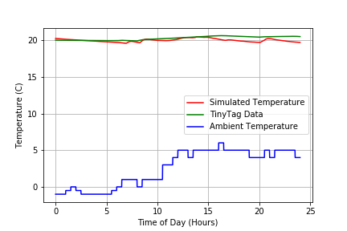

Fig. 2: Indoor temperatures including simulation results (red) and measurement data (green) and ambient outdoor temperature on January 3rd, 2017

The simulation model was also validated by comparing the modelled performance of BEN system heat pump with the manufacturer’s performance data (PD) at 70 ºC (Leaving load temperature: LLT) and 80 ºC (LLT) flow conditions, which are main practical operation heating modes since 2018 commissioning of whole BEN system, with the COP values of 3.15 (Entering source temperature (EST) is 15 ºC), 2.74 (EST is 15 ºC) and 3.03 (EST is 10 ºC), 2.59 (EST is 10 ºC), seen from Table 3, respectively. The model gives results for the mentioned above at COP 3.12 (EST/LLT: 15/70 ºC), 2.717 (15/80 ºC) and 2.86 (10/70 ºC), 2.52 (10/80 ºC), respectively. It is very close to the manufacturer’s rated COP of 3.15 (15/70 ºC), 2.74 (15/80 ºC) and 3.03 (10/70 ºC), 2.59 (10/80 ºC). The maximal discrepancy between simulation value and real COP are 5.61% ((3.03 – 2.86)/3.03). These results are in reasonable agreement.
Table 3: Comparison of COP for model results with PD from heat pump manufacturer

Type | EST (ºC) | ELT (ºC) | LLT (ºC) | COP of PD | COP of model | Discrepancy
1 | 15 | 60 | 70 | 3.15 | 3.12 | 0.95%
2 | 15 | 70 | 80 | 2.74 | 2.717 | 0.84%
3 | 10 | 60 | 70 | 3.03 | 2.86 | 5.61%
4 | 10 | 70 | 80 | 2.59 | 2.52 | 2.61%

In addition, the simulation model of BEN has been validated via the comparison between the modelled flow rates of BEN system borehole submersible water pump under the rated power of 22 kW with field experimental data on 7 November 2017. The tests on site have been carried out 10 times and their experimental results are shown in Table 4. The liquid flow meter applied is Honeywell LLE 205/305 series with an accuracy of ±2% of the measured values. The simulation average result for the flow rate of BEN system borehole submersible water pump under the rated power of 22 kW is 17.2 l/s. The maximal discrepancy between simulation value and measured data are 6.4% ((17.2 – 16.1)/17.2).
Table 4: Experimental results of borehole submersible water pump flow rates on November 7, 2017

Type | Measured flow rate (L/s)
1st | 16.7
2nd | 16.2
3th | 16.7
4th | 16.1
5th | 16.2
6th | 16.7
7th | 16.2
8th | 16.4
9th | 16.3
10th | 16.7

The tests show a proper validation of the simulation model, based on the prediction of building heat losses, heating effectiveness, and energy consumption.

- Results and findings
The BEN system was simulated for two weeks in January 2017 in London. BEN was required to be operated to maintain the indoor temperature of both T and J blocks at 20 ºC (heating set-point). This section first investigated heat losses in T and J blocks at LSBU campus. Second, the comparison of energy performance between the BEN system and an old heating system based on the gas boiler were conducted via the novel index TSE. Following that, effects of heat pump COP, borehole and heat pump output temperatures were studied to evaluate the performance of BEN system.

5.1 Heat losses in two buildings
In the following simulation, the inputs are the natural gas usage of the boilers from historic T-Block invoices, ambient temperature, water input flow rate, and water input temperature. The output variables are the final building temperature, heat losses, cooled water (after heating the building circuit) temperature, and cooled water flow rate. Parameters that characterize T-Block and its thermal loss rates are identical to that of the main simulation and are listed in Table 2. Simulation of the radiator heating system, fabric heat loss, and ventilation heat loss is identical to that of the main BEN simulation.
Extrapolating total heat loss from both fabric and ventilation sources yield similar results to the main analysis. The indoor temperature was kept stable at 20 ºC. Gas boilers heated water in accordance to historic data on T-Block’s natural gas usage.
The profile of building heat losses from both fabric and ventilation heat loss are shown in Fig. 3(a). The ambient London ambient temperature readings for this two-week period used in the simulation are displayed in Fig. 3(b). As shown in Fig. 3(a), all trends of heat losses between J and T blocks within the time of period are similar. Heat losses, including fabric, ventilation and net heat losses for J block are higher, due to the larger building volume.
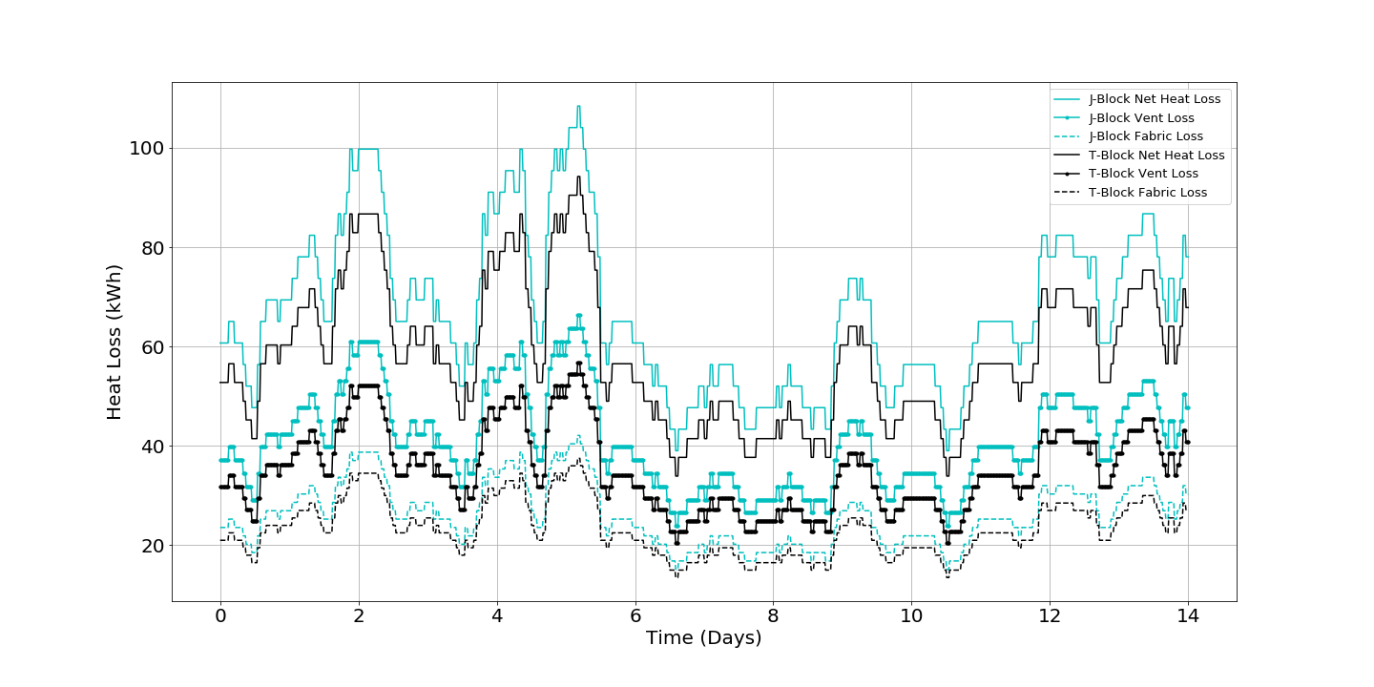

(a)

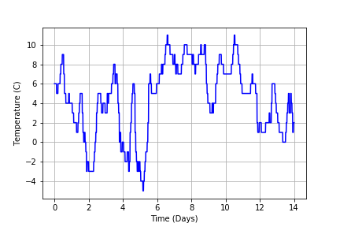

(b)

Fig. 3(a): Building heat losses from individual sources, (b): Ambient London temperature levels from TMY2 [40]

5.2 Total system efficiency

As mentioned earlier, the heat pumps were calibrated and then simulated to operate at 50% of the Carnot efficiency between the operating temperatures. This is to predict the real performance of the heat pumps installed at LSBU which are reported by their manufacture performance data (MPD) to operate at an average COP of 3.2 when operating between a warm reservoir of 60 ºC to be heated to 70 ºC and a cool reservoir of 15 ºC being cooled to 10 ºC. These conditions match normal operating conditions of the BEN system, so the heat pumps operate at half the maximum theoretical efficiency. Modelled efficiency fluctuated between 3.1 and 3.2 in Fig. 4. Furthermore, observing from Fig. 4, the average COP of the simulated heat pumps fluctuating slightly under the recorded operating COP of 3.2 means that the resultant values of electrical usage and operating costs should have a conservative margin. This then informs the expectation that the fully-constructed and operational BEN system may slightly outperform its’ LabVIEW simulation counterpart.
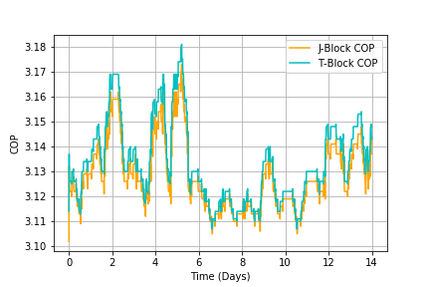

Fig. 4: Heat pump COPs for J-block and T-block

The TSE over the course of the two-week simulation is shown in Fig. 5. The TSE for T-block and J-block varies in two ranges of 1.5 to 2.2, and 1.4 to 2.1. Even taking into account the electricity consumptions of the borehole, heat pump and hot water tank, the BEN system performs well since the total system efficiency is always above 1.0. In addition, compared with previous gas boiler heating system, the BEN system could reduce energy consumption from around 50% to 120% with T-Block and from 40% to 110% with J-Block. Figs. 6 and 7 illustrate the TSE of T-block and J-block when their individual heat pump COPs are fixed at 3 and 3.2, respectively. Closely scrutinizing the TSE of Fig. 6, it changes within the range of 1.4 to 2.1 for T-block and the range of 1.3 and 2.0 for J-block when their COPs of heat pumps are fixed at 3. The TSE difference between them is caused by a fact that the volume and heating loads of J-block are slightly larger than those of T-block. However, as found in Fig. 7, T-block and J-Block have the TSE varying ranges of 1.5 to 2.2 and 1.4 to 2.1, respectively, according to a constant COP of 3.2. Both TSEs are still above 1.0, illustrating that the BEN system could replace the old gas boiler based heating system in terms of its energy efficiency. In addition, there is no direct relationship between COP and TSE e.g. increasing correlation in between. The differences between variable COP (Fig. 5) and fixed COP 3 (Fig. 6), 3.2 (Fig. 7) are the former total system efficiency range lies between the latter two.
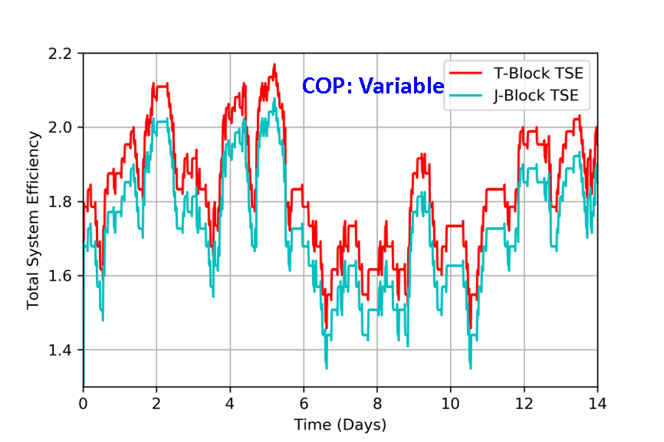
Fig. 5: Total system efficiency for heat pump and hot water tank based on variable heat pump COPs from Figure 4
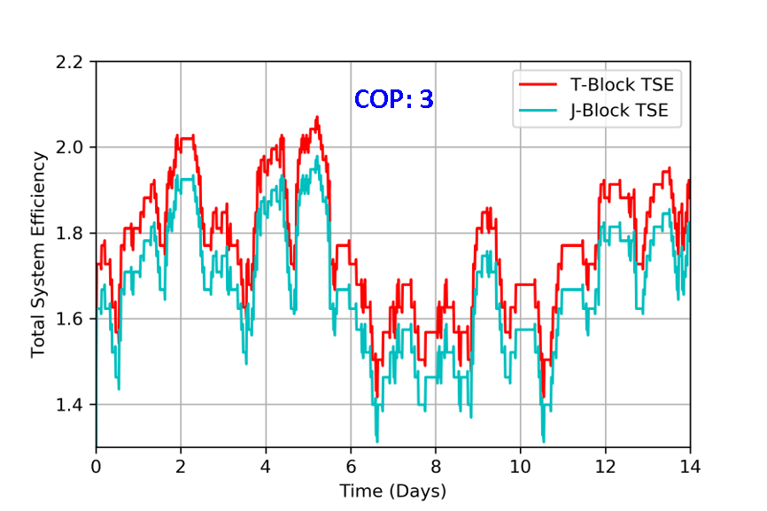
Fig. 6: Total system efficiency with HP COP fixed at 3 for T and J blocks
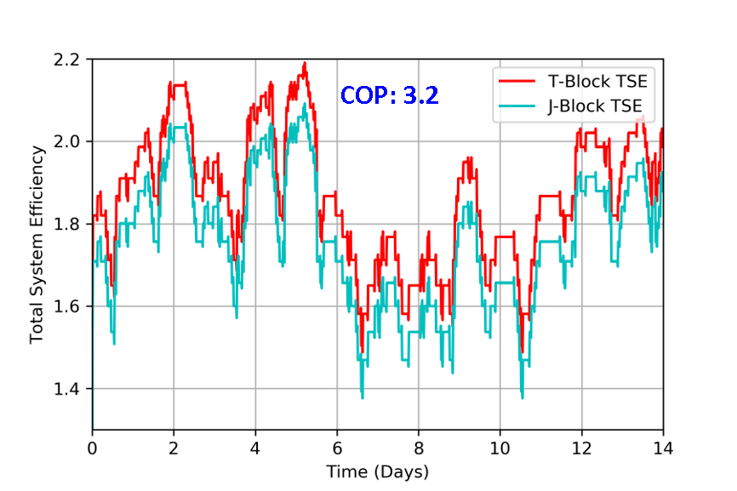
Fig. 7: Total system efficiency with HP fixed at 3.2 for T and J blocks

5.3 Electricity costs
The electrical usage and associated costs are profiled for the heat pump COPs fixed between 3 and 3.2 in Fig. 8 and Fig. 9, respectively. The electricity costs vary throughout the day according to the pricing scheme outlined in Table 1.
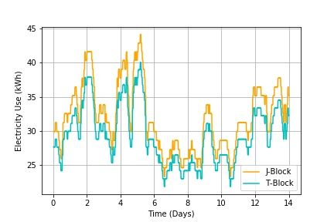
Fig. 8: BEN electricity usage each time step for two weeks with variable heat pump COPs (yellow curve: J-Block, blue curve: T-Block)
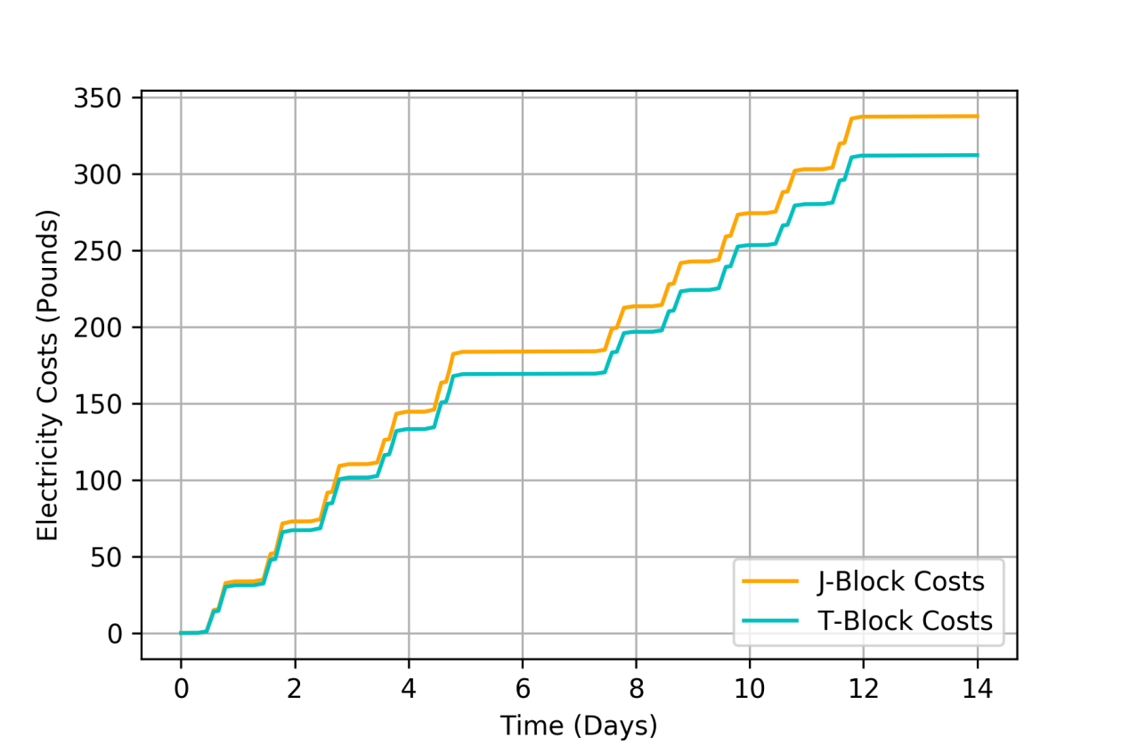
Fig. 9: BEN electricity operation costs each time step for two weeks with variable heat pump COPs

The simulations were run again with the heat pump COPs fixed between 3 and 3.2. The performances of the simulated BEN at these factors correspond to upper and lower bounds on predicted costs and electricity usage. The TSE of these simulations are displayed in Figs. 6 and 7. The resultant BEN system whole electricity consumption and costs for a 2-week mid-winter period are as follows.
Figs. 8 and 9 illustrate the profiles of electrical usage and associated costs, respectively, based on the variable COPs of heat pump corresponding to Fig.4. Observing from Figs. 8 and 9, the electricity usage and associate costs of J-Block are obviously higher than T-Block, which also proves the heating loads of J-Block is larger than T-Block as mentioned earlier. In addition, the electricity usage profile in Fig. 8 is also corresponding to Fig. 3(a) heat losses and (b) outdoor temperature profile. During two weeks, the minimal and maximal electricity use for T-block and J-block are around 22 kWh and 40 kWh (T-block), and 23 kWh and 44 kWh (J-block), respectively. Fig. 9 illustrates BEN electricity costs for two weeks in the coldest month, i.e., January in London, with variable heat pump COPs between 3.0 and 3.2 as shown in Fig. 4. It could indicate the maximum electricity consumed by the BEN system, and how the dynamic pricing scheme works.
After calculation, the total electricity usage and costs for both T and J-blocks will change within the range of 81,102.3 kWh ~ 85,497.1 kWh and £643.11 ~ £686.13 if the heat pump COP fixed at 3.2 to COP fixed at 3.0, respectively. Based on the above electricity usage and costs, it could be decreased by around 5.1% ((85497.1 kWh – 81102.3 kWh)/85497.1 kWh) (i.e., 4394.8 kWh) and 6.3% ((£686.13 – £643.11)/£686.13) (i.e., £43), respectively, compared the heat pump COP fixed at 3.2 to COP fixed at 3.0.
Fig. 10 indicates the two-week gas and electricity usages for T-Block as well as their CO₂ equivalent emissions in January. The natural gas and electricity CO₂ equivalent emission factors are 0.18416 kg/kWh and 0.35156 kg/kWh in the UK [41], respectively. After calculation, the sum of gas and electricity CO₂ equivalent emissions are around 18.26 t and 14.64 t, respectively. Therefore, the BEN project could decrease CO₂ equivalent emissions approximately 3.62 t, i.e., by 19.82 % (((18.26 t – 14.64 t)/18.26 t) = 19.82%) just for two weeks compared to the old heating system in T-Block.
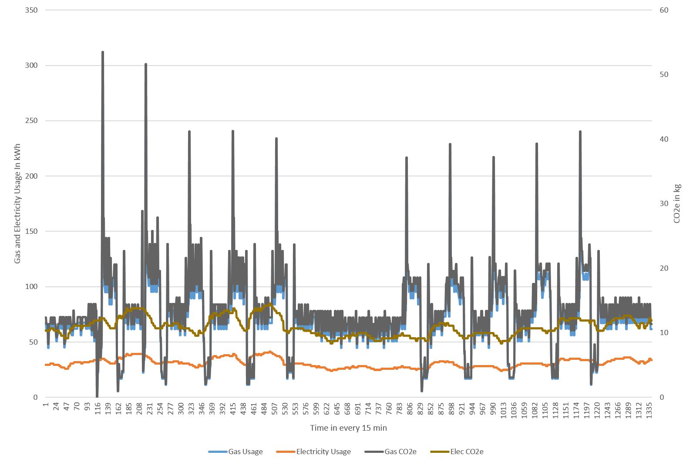
Fig. 10: Comparison of gas (old heating system) and electricity (BEN) usages for T-Block as well as gas and electricity CO₂ equivalent emissions for two weeks in January.

5.4 Effect of borehole output temperatures
Fig. 11 demonstrates electricity usage for ideal COP and COP with Carnot efficiency 0.5 as a function of borehole output temperatures. Observing from Fig. 11, a linearly decreasing function between the borehole output temperature and electricity usage could be established, not only for the ideal COP of heat pump also for COP with Carnot efficiency 0.5. In other words, electricity usage will reduce with the increasing borehole output temperature. However, as mentioned before, in the London area the underground water temperature is constant at around 15 ºC [29-30], it is therefore hard to reduce the electricity usage of the BEN system through enhancing borehole output temperature. It could be also seen from Fig. 11, the electricity usage could be reduced by increasing the Carnot efficiency of heat pump. In the case of borehole output temperature with 15 ºC, the electricity usage could be decreased by 41.5% ((82 MWh – 48 MWh)/82 MWh) compared COP with Carnot efficiency 0.5 to ideal COP. The Carnot efficiency could be improved with the increasing condenser temperature for the heating mode of heat pump; however, its maximal value has the limitation due to heat losses of compression cycle.
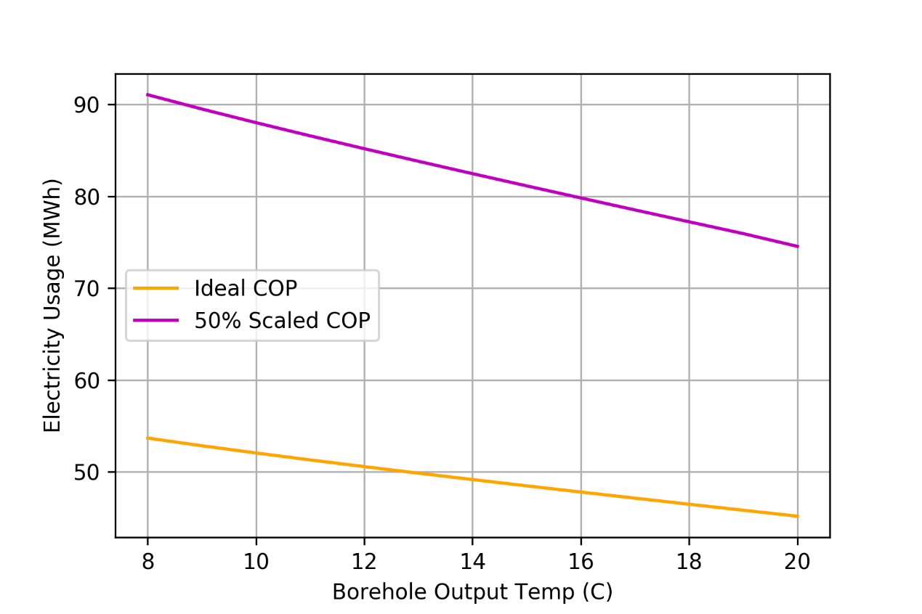
Fig. 11: BEN electricity usage with different borehole output temperatures

5.5 Effect of heat pump COP
Electricity costs can be heavily affected by the heat pump COP. Here, the effect of the heat pump COP on the BEN system electricity costs is investigated, looking at a COP range of 2.5 to 6.0.
Fig. 12 shows the BEN system electricity costs as a function of heat pump COP for two weeks in January. Observing from Fig. 12, the exponentially decaying function between the heat pump COP and electricity costs could be established. With a heat pump COP of 6.0, the electricity costs would be approximately 48.7% ((780 £ - 400 £)/780 £) lower compared to that a COP of 2.5.

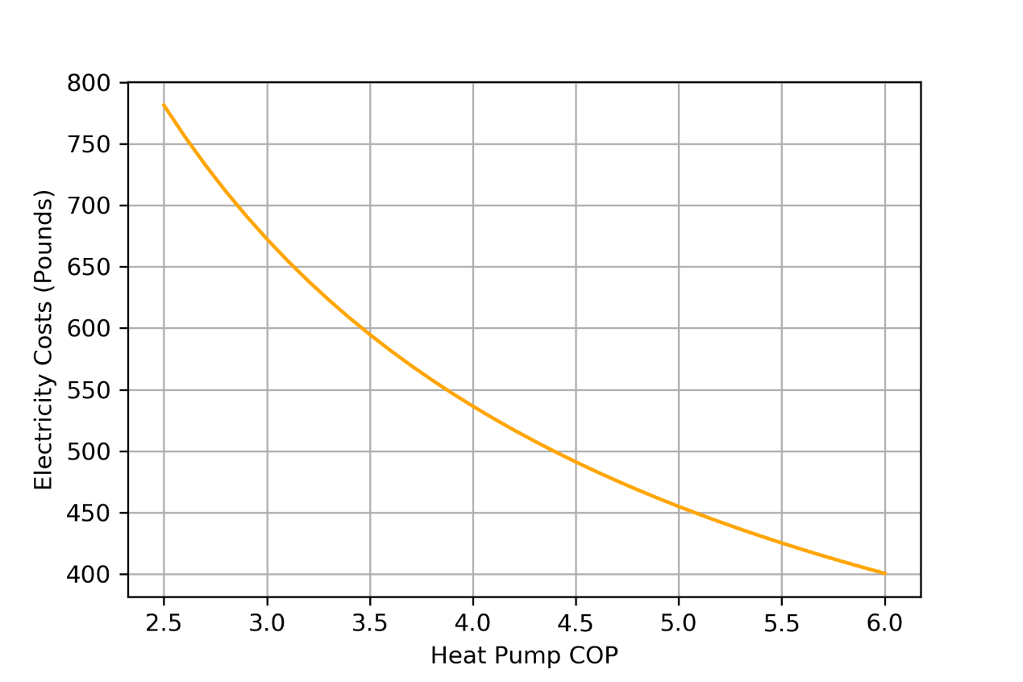
Fig. 12: BEN electricity costs with different heat pump COPs

5.6 Effect of heat pump output temperature
Heat pump output temperature is very significant for delivering the required hot water to the hot water tank for energy storage and to buildings for supplying heating energy. Building energy costs, particularly the electricity costs, will be influenced by the heat pump output temperature, since this is linked to heat pump overall COP. Now, the aforementioned simulation parameters are still adopted excluding the electrical immersion heater of hot water tank is always on, while the borehole pump power is improved and maintained at 52.3 kW and the output temperature of heat pump varies from 30 ºC to 90 ºC.
Fig. 13 illustrates the electricity costs as a function of heat pump output temperature. Seen from Fig. 13, with the increasing heat pump output temperature from 30 ºC to 65 ºC, the electricity costs enhance from approximately £650 to £720, however, the electricity costs suddenly drop to around £600 when temperature is 70 ºC. The main reason is that the temperature of hot water sent to the buildings is around 70 ºC to supply the heat emitters (as mentioned in the Section 3.3). If the output temperature of heat pump was less than 70 ºC, the Mixergy tank would start to heat the water to reach 70 ºC using electrical immersion heater. More importantly, the electricity price is generally higher during the peak period of 4 pm to 7 pm. Thus, in Fig. 13, the electricity costs will apparently increase as a function of the output temperature from 30 ºC to 65 ºC, while there is a significant drop in costs between temperatures 60 ºC to 70 ºC. However, for the requirement of a higher output temperature (> 70 ºC), the heat pump needs more electricity to heat the output water. Then the electricity costs improve again from 70 ºC to 90 ºC. 70 ºC is thus the optimal operating output temperature of heat pump in the BEN system, which just matches initial design for BEN. It is important to note that in many existing buildings, emitters are designed to a 80/70 ºC flow return regime. Even taking into account overdesign margin, this means that, for retrofit situations to existing building stock, higher temperature heat outputs are required. In addition, the heat pump output temperature below 40 ºC will lead to buildings being insufficiently heated and thermal uncomfortable indoor environment according to our simulation results.
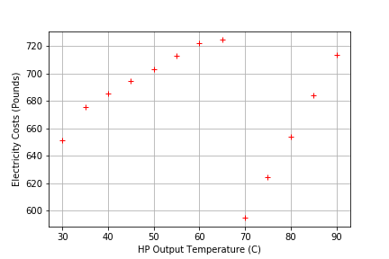
Fig. 13: Electricity costs with varying heat pump output temperature

- Discussion
With respect to the results above, due to a fact that the water temperature e.g. 15 ºC [29-30] is closer to ambient ground and air temperatures, cold water heat networks like the BEN system – next-generation energy networks - significantly reduce thermal losses through pipeline transfer. It will also leverage smart grid technology and system management to minimize wasted energy. The reduction of emissions and cost can be achieved by the optimized management of thermal resources using reversible heat pumps and networks with diversified heating loads.
When considering the energy usage from borehole, heat pump and hot water tank, the TSE of BEN could be up to 1.4 ~ 2.2. However, the heat loss through the envelope of components or pipework during the heat transmission was not included.
Other limits of this study could be found in the hypotheses of steady-state hydraulic condition and theoretically ideal fluids. The studied system did not fully take into account the hydraulic dispersion, thermal diffusion, and axial heat transmission along water pipes, heat storage of pipe insulation and the ground. These aspects would be investigated in the next- stage work.

- Conclusions and future work
This work has theoretically and numerically investigated the thermal and electrical energy performance of the BEN at London South Bank University. BEN consists of borehole thermal storage, cold water heat network, heat pumps, smart hot water storage, demand side response service (dynamic pricing) and two buildings on campus. The main conclusions of this paper are presented as follows:
- The BEN system could decrease CO₂ emissions approximately 3.62 t, i.e., by 19.82% compared to the old natural gas-based heating system in T-Block just for two weeks, while maintaining thermal comfort e.g. indoor temperature maintaining at 20 ºC.
- The heat pumps in the BEN system operate at predicted higher COP, which fluctuated between 3.1 and 3.2 with Carnot efficiency as 0.5. Those COP values just match initial design level for the BEN system installed at LSBU.
- A novel energy performance index, i.e. total system efficiency, considering the borehole, heat pump and hot water tank has been put forward and used in evaluating whole BEN system performance. The TSE varied from 1.4 to 2.2 in one of the coldest months of the year which greatly improves on the energy efficiency.
- Electricity usage and costs are heavily affected by the heat pump COP, TSE, borehole output temperature and heat pump output temperature. 70 ºC is the optimal operating output temperature of heat pump in the BEN system, which just matches initial design for BEN.
In future, this research could benefit for designing the energy networks including heating and electricity, particularly with lower distribution temperature. Further studies, including the optimization of practical BEN system and predictive models, and system operating evaluation, will be carried out as part of the ongoing BEN project. Providing DSR services has potential to further reduce electricity costs and greenhouse gas emissions, and hence modelling these further benefits including DSR strategy is an area for our future work.

Acknowledgements
This research was partially supported by the Innovate UK. This work was made possible by the technical and intellectual contributions of the members of the BEN Consortium including ICAX Limited, London South Bank University, Origin Power, Cranfield University, Upside Energy, Mixergy Limited and TFGI Limited. Underlying research material for this project can be accessed by contacting the corresponding author and the principal investigator of this project Prof. Andy Ford and Dr. Aaron Gillich. We would also like to acknowledge the helpful comments from Dr. Jiangtao Du in the Liverpool John Moores University in UK. The authors are also very grateful to the referees who provide invaluable and constructive comments.

Nomenclature
A_{bldg} Building Surface Area (m²)
A_{bor} Outside Area of Borehole (m²)
ACH Air Exchange Rate (1/h)
A_{pip} Area of Pipe Outer Layer (m²)
C_{air} Specific Heat of Air (kJ/kgK)
C_{con} Specific Heat of Concrete (kJ/kgK)
C_{H2O} Specific Heat of Water (kJ/kgK)
M Mass of Water in the Pipe/Borehole (kg)
M_{ther} Thermal Mass (kJ/K)
Q_{fab} Fabric Heat Loss (kWh or kJ)
Q_{heat} Required Heat for Desired Building Temperature (kWh or kJ)
Q_{gain} solar gain and internal gain in T-Block and J-Block, respectively (kWh/kJ)
Q_{tot} Total Required Heat for Water (kWh or kJ)
Q_{vent} Ventilation Heat Loss (kWh or kJ)
t Length of Time Step (sec)
T_{amb} Ambient Temperature (ºC)
T_{bin} Inside Temperature of Borehole (ºC)
T_{bldgi} Temperature of the Buildings in time step i (ºC)
T_{bldgin} Water Temperature into Buildings (ºC)
T_{bldgout} Water Temperature out of Buildings (ºC)
T_{co} Temperature of Heat Pump Cool Water Output (ºC)
T_{des} Desired Indoor Temperature (ºC)
T_{in} Current Inside Building Temperature (ºC)
T_{meas} Measurement Data for Inside Temperature (ºC)
T_{pin} Inside Temperature of Pipework (ºC)
T_{sim} Simulation Results for Inside Temperature (ºC)
T_{wo} Temperature of Heat Pump Warm Water Output (ºC)
U_{bldg} U-Value of Building (W/m²K)
U_{bor} U-Value of Borehole Lining (W/m²K)
U_{pip} U-Value of Transport Pipe (W/m²K)
V Volume of Water in Step/Segment i (L)
V_{bldg} Volume of Building (m³)
V_{con} Volume of Concrete (m³)
V_{T} Flow Rate of Water in the Pipe or Borehole (L/sec)
W_{Bor} Borehole Power Output (kWh)
W_{HP} Heat Pump Power Output (kWh)
W_{HWT} Hot Water Tank Power Output (kWh)
ρ_{air} Air Density (kg/m³)
ρ_{con} Concrete Density (kg/m³)
ρ_{w} Water Density (kg/L)

Abbreviations
BEIS Department of Business, Energy and Industrial Strategy
BEN Balanced Energy Network
CHPD Combined Heat and Power Dispatch
COP Coefficient of Performance
CWHN Cold Water Heat Networks
DHS District Heating System
DNO Distribution Network Operator
DSR Demand Side Response
DUoS Distribution Use of System
ELT Entering Load Temperature (ºC)
EMS Energy Management System
EST Entering Source Temperature (ºC)
FLC Fuzzy Logic Control
LLT Leaving Load Temperature (ºC)
LPN London Power Networks
LSBU London South Bank University
MILP Mixed Integer Linear Programming
TSE Total System Efficiency
VI Virtual Instruments

Subscripts
i time/length-step

References
[1] CCC, 2016. Next step for UK heat policy, London: Committee on Climate Change.
[2] Y. Wang, J. Kuckelkorn, F. Y. Zhao, H. Spliethoff, W. Lang. A state of art of review on interactions between energy performance and indoor environment quality in Passive House buildings. Renewable and Sustainable Energy Reviews 72 (2017) 1303-1319.
[3] Y. Wang, J. M. Kuckelkorn, F. Y. Zhao, M. L. Mu, D. L. Li. Evaluation on energy performance in a low-energy building using new energy conservation index based on monitoring measurement system with sensor network. Energy and Buildings 123 (2016) 79-91.
[4] E. Beusker, C. Stoy, S. N. Pollalis. Estimation model and benchmarks for heating energy consumption of schools and sport facilities in Germany. Building and Environment 49 (2012) 324-335.
[5] Y. Wang, A. Shukla, S. L. Liu. A state of art review on methodologies for heat transfer and energy flow characteristics of the active building envelopes. Renewable and Sustainable Energy Reviews 78 (2017) 1102-1116.
[6] DECC. The future of heating: Meeting the challenge. London: Department of Energy and Climate Change, 2013.
[7] J. Zheng, Z. Zhou, J. Zhao, J. Wang. Function method for dynamic temperature simulation of district heating network. Applied Thermal Engineering 123 (2017) 682-688.
[8] K. Sartor, P. Dewalef. Experimental validation of heat transport modelling in district heating networks. Energy 137 (2017) 961-968.
[9] Z. Pan, Q. Guo, H. Sun. Interactions of district electricity and heating systems considering time-scale characteristics based on quasi-steady multi-energy flow. Applied Energy 167 (2016) 230-243.
[10] Z. Pan, Q. Guo, H. Sun. Feasible region method based integrated heat and electricity dispatch considering building thermal inertia. Applied Energy 192 (2017) 395-407.
[11] P. Grunewald, J. Torriti. Demand response from the non-domestic sector: Early UK experiences and future opportunities. Energy Policy 61 (2013) 423-429.
[12] K. Maclean, R. Sansom, T. Watson, R. Gross. Managing heat system decarbonisation – Comparing the impacts and costs of transitions in heat infrastructure, London: Imperial College London 2016.
[13] DECC. The future of heating: A strategic framework for low carbon heat in the UK, London: Department of Energy and Climate Change, 2012.
[14] X. Z. Liu, P. Mancarella. Modelling, assessment and Sankey diagrams of integrated electricity-heat-gas networks in multi-vector district energy systems. Applied Energy 167 (2016) 336-352.
[15] M. Vesterlund, A. Toffolo, J. Dahl. Optimization of multi-source complex district heating network, a case study. Energy 126 (2017) 53-63.
[16] P. Jie, N. Zhu, D. Li. Operation optimization of existing district heating systems. Applied Thermal Engineering 78 (2015) 278-288.
[17] E. Carpaneto, P. Lazzeroni, M. Repetto. Optimal integration of solar energy in a district heating network. Renewable Energy 75 (2015) 714-721.
[18] Z. Li, W. Wu, M. Shahidehpour, J. Wang, B. Zhang. Combined heat and power dispatch considering pipeline energy storage of district heating network. IEEE Transactions on Sustainable Energy 7-1 (2016) 12-22.
[19] T. Falke, S. Krengel, A. Meinerzhagen, A. Schnettler. Multi-objective optimization and simulation model for the design of distributed energy systems. Applied Energy 184 (2016) 1508-1516.
[20] B. Morvaj, R. Evins, J. Carmeliet. Optimising urban energy systems: Simultaneous system sizing, operation and district heating network layout. Energy 116 (2016) 619-636 a.
[21] B. Morvaj, R. Evins, J. Carmeliet. Optimization framework for distributed energy systems with integrated electrical grid constraints. Applied Energy 171 (2016) 296-313 b.
[22] G. T. Ayele, P. Haurant, B. Laumert, B. Lacarriere. An extended energy hub approach for load flow analysis of highly coupled district energy networks: Illustration with electricity and heating. Applied Energy 212 (2018) 850-867.
[23] X. S. Jiang, Z. X. Jing, Y. Z. Li, Q. H. Wu, W. H. Tang. Modelling and operation optimization of an integrated energy based direct district water-heating system. Energy 64 (2014) 375-388.
[24] J. H. Zheng, J. J. Chen, Q. H. Wu, Z. X. Jing. Multi-objective optimization and decision making for power dispatch of a large-scale integrated energy system with distributed DHCs embedded. Applied Energy 154 (2015) 369-379.
[25] B. Wichert, M. Dymond, W. Lawrance, T. Friese. Development of a test facility for photovoltaic hybrid energy systems. Renewable Energy 22 (1-3) (2001) 311-319.
[26] A. Chouder, S. Silvestre, B. Taghezouit, E. Karatepe. Monitoring, modelling and simulation of PV systems using LabVIEW. Solar Energy 91 (2013) 337-349.
[27] J. K. Gruber, F. Huerta, P. Matatagui, M. Prodanovic. Advanced building energy management based on a two-stage receding horizon optimization. Applied Energy 160 (2015) 194-205.
[28] D. Arcos-Aviles, J. Pascual, F. Guinjoan, L. Marroyo, P. Sanchis, M. P. Marietta. Low complexity energy management strategy for grid profile smoothing of a residential grid-connected microgrid using generation and demand forecasting. Applied Energy 205 (2017) 69-84.
[29] A.Gillich, A. Ford, M. Hewitt, E. Thompson. Cold water heat networks and the thermal storage revolution. Proceedings of the CLIMA 2016 12th REHVA World Congress. Aalbourg, Denmark.
[30] A.Gillich, A. Ford, M. Hewitt, C. Zagoni, G. Oakes. A smarter way to electrify heat – the balanced energy network approach to demand side response in the UK. Proceedings of ECEEE 2017 Summer Study. Belambra Les Criques, France.
[31] http://richardbowring.co.uk/illustrated-map-southwark-campus-lsbu-surrounding-area/
[32] LabVIEW Manuals. National Instruments, Austin, US, 2017.
[33] T. Beck, H. Kondziella, G. Huard, T. Bruckner. Optimal operation, configuration and sizing of generation and storage technologies for residential heat pump systems in the spotlight of self-consumption of photovoltaic electricity. Applied Energy 188 (2017) 604-619.
[34] J. H. Yoon, R. Baldick, A. Novoselac. Dynamic demand response controller based on real-time retail price for residential buildings. IEEE Transactions on Smart Grid 5-1 (2014) 121-129.
[35] H. Ma, C. Li, W. Lu, Z. Zhang, S. Yu, N. Du. Investigation on a solar-groundwater heat pump unit associated with radiant floor heating. Renewable and Sustainable Energy Reviews 75 (2017) 972-977.
[36] Y. Wang, J. Kuckelkorn, F. Y. Zhao, D. Liu, A. Kirschbaum, J. L. Zhang. Evaluation on classroom thermal comfort and energy performance of passive school building by optimizing HVAC control systems. Building and Environment 89 (2015) 86-106.
[37] www.ukpowernetworks.co.uk/.../LPN-Schedule-of-charges-and-other-tables-2017-V2.0
[38] M. R. Ally, J. D. Munk, Van D. Baxter, A. C. Gehl. Exergy analysis of a two-stage ground source heat pump with a vertical bore for residential space conditioning under simulated occupancy. Applied Energy 155 (2015) 502-514.
[39] M. Saikawa, S. Koyama. Thermodynamic analysis of vapor compression heat pump cycle for tap water heating and development of CO₂ heat pump water heater for residential use. Applied Thermal Engineering 106 (2016) 1236-1243.
[40] TRNSYS: TMY2data, website: http://sel.me.wisc.edu/trnsys/weather/tmy2data.htm[final access:27/03/2018]
[41]Department for Business, Energy & Industrial Strategy: Greenhouse gas reporting: conversion factors 2017, website: https://www.gov.uk/government/publications/greenhouse-gas-reporting-conversion-factors-2017 [final access: 27/03/2018]

* W. H. Song and Y. Wang contributed equally to this work. Author to whom correspondence should be addressed. Address: School of the Built Environment and Architecture, London South Bank University, Borough Road 103, SE1 0AA, London, UK Contact: Tel.: +44 20 7815 7632; wanghongyang1767@gmail.com, wangy47@lsbu.ac.uk (Dr. Yang Wang);
LabVIEW is systems engineering software for applications that require test, measurement, and control with rapid access to hardware and data insights.
Innovate UK Integrated Supply Chains for Energy Systems programme
www.benuk.net

