EBN Opinion: Rethinking Pain Education
Amelia Swift
Alison Twycross, Editor – Evidence Based Nursing, Deputy Dean and Lead Nurse, London South Bank University (@alitwy)
This month’s opinion draws on a Twitter chat we hosted while at the British Pain Society Annual Scientific Meeting in May 2017. It is timely to revisit this chat now because the International Association for the Study of Pain (IASP) have just launched the Global Year for Excellence in Pain Education (see: https://www.iasp-pain.org/GlobalYear?navItemNumber=580). The Blog published ahead of this Twitter chat can be seen at: http://blogs.bmj.com/ebn/2017/04/30/do-we-need-to-rethink-how-we-educate-healthcare-professionals-about-pain-management/. The storify of the chat is available at: https://storify.com/alitwy/do-we-need-to-rethinkhow-we-educate-healthcare-pro#publicize

Background:
Poor pain management has been documented consistently over the years in all types of pain across all settings and is an international problem. Its persistence is due to the complex nature of pain, and the innumerable factors that can hinder effective management. In the relatively straightforward category of postoperative pain management barriers to achieving satisfactory analgesia include patient- and nurse-related issues. Patients can be fearful of addiction, feel that being stoical is desirable, and save their medication for when it is ‘really’ needed(1). Nurses are said to be poor communicators, failing to provide emotional support, making inadequate use of drugs available, failing to assess, being inattentive or failing to notice pain, or having inadequate authority and being over-ruled by medical staff (2). One of the most commonly cited reasons for poor pain management is a lack of knowledge among health care professionals; the most frequently suggested solution is (more) education.
Key messages from the Twitter Chat (#ebnjc)
Three themes emerged from the Twitter chat: the theory-practice gap, teaching strategies, and outcome assessment.
The theory-practice gap
The first theme of the chat was knowledge translation and the ‘theory-practice gap’. Students tell us that what they are taught as best practice in university is not what they see happening in the clinical setting. Knowledge is only useful in so far as it helps the nurse to do the right thing. The failure to translate knowledge to practice has two distinct components – the knowledge cannot be acquired in isolation of the context in which it is to be used. On the one hand teaching in the University setting must be ‘authentic’ – it must marry best evidence with the realities of clinical practice. On the other hand, practice based education must address the knowledge deficit of staff and support the development of strategies to improve practice in the face of known constraints such as high patient acuity and challenging workloads.
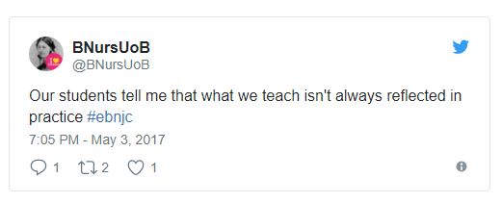

In relation to authenticity, the clinical currency, or credibility of nurse lecturers emerges as a topic for debate from time to time. The requirements of an academic role in a University sometimes make it difficult for the lecturer to practice hands-on nursing care(3) but clinical currency is a crucial component in effective nurse education(4). We would argue that it is reasonably straightforward to keep up to date with current practice, and easier for academics to keep abreast of innovation and research. Indeed our tweeters were not concerned with the quality of teaching content. What is challenging is to be aware of the context of care and to incorporate this into teaching. Several tweeters alluded to there being a barrier to translation of knowledge to practice.
“Getting people to do things differently can be tricky (as in respond to new knowledge)” @drabbiejordan
“my students say that knowing the right thing to do is ineffective, we need to teach strategies to challenge poor practice” @nurseswift
The ‘Knowledge to Action’ process (5) describes a cycle in which knowledge is selected and adapted to take into account the local context, then the barriers to use of that knowledge are assessed before interventions for implementation of knowledge are created or selected. Once the knowledge has been transferred to the clinical situation the next step is to monitor its use and evaluate outcomes before identifying ways in which the use of knowledge can be sustained. This theory is most commonly used for getting research into practice. However, the description of barriers to implementation are like those experienced by students trying to use best practice or apply new knowledge in the clinical area. The first relevant step of this process is ‘local context’. In other words, we must know what happens in practice, and importantly why it happens.
One of the strategies that people have tried to increase the translation of knowledge to practice is reflection. Nurses are keen experiential learners, often preferring to learn from doing. @drabbiejordan captured this with her comment that learning by doing can also mean making mistakes. There is compelling evidence that helping students to explore their mistakes and learn from them is a powerful learning strategy(6) and many use simulation as a means to provide a safe space to do this (7).
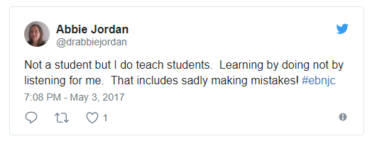
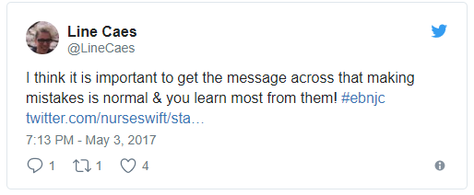
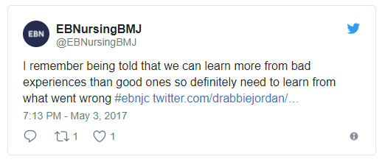
Teaching strategies
The participants in the chat had used or experienced a variety of teaching and learning strategies including didactic lecture, in-class discussion, role play, case studies and simulation. One of the favoured strategies of the participants in our chat was bringing the voice of the patient into the classroom. Having a pain patient working with a group of students was described as a powerful way to help the student appreciate how pain impacts on the individual. Some programmes have sessions led by the patient, while others make use of patient stories as videos or case studies. Case studies are generated by the patient and expert team and presented using a variety of approaches from a simple paper narrative to a more sophisticated online resource (8). Those tweeters with experience of bringing patients into the classroom pointed out how important it is that they are paid, well supported, prepared, and given feedback. These are sentiments echoed in the literature on this topic(9). These approaches increase awareness of the impact of living with pain, the experience of healthcare from their perspective, and can be transformative for the student (10).
Our chat didn’t go so far as to discuss methods used in practice-based learning to improve the knowledge, skills, and behaviour of post-registration nurses. Drake and Williams (11) conducted a systematic review of educational interventions used in acute hospital settings to improve pain management. The studies (n=12) they appraised gave unhelpfully brief descriptions of the educational intervention but these included web-based evidence guidelines, teaching sessions, audit and feedback, a pocket pain assessment guide, and a computer decision-support system
Outcome assessment
Participants explored how we can determine whether an educational evaluation has an impact on patient care. In Drake and Williams’ systematic review (11) the outcome measures included completion of pain assessment documentation, use of a pain assessment tool, mean pain rating of a patient group, and reduction in the percentage of patients reporting moderate to severe pain as well as one study that used pre- and post-knowledge scores. One of the criticisms of evaluation of teaching interventions is an over-reliance on pre- and post-knowledge testing, which doesn’t reflect any changes in practice. In the studies in this systematic review we can see how efforts are being made to explore a change in behaviour of the participants. However, the follow-up periods tend to be short with relatively few studies measuring outcomes for more than three months. Participants in the chat discussed the need to measure more than knowledge when evaluating these interventions because one of the main purposes of pain education is to change behaviour – to improve the ability of the nurse to detect, assess and manage pain and to increase his/her intention to do this.
Conclusion
This was a lively chat in which the passion for pain education was based in a desire to find ways to ensure education benefits patients. The quality of the chat and the willing exchange of ideas demonstrates the value of a community of practice for pain education. Many of the issues raised deserve fuller attention and the analysis of this chat identifies other areas that were only touched on and deserve fuller attention (for example, the notion of role models in practice, pain champions and link nurses was a thread that didn’t get fully established). Keep an eye out for further Twitter chats in this area during 2018.
References
1. Cogan J, Ouimette MF, Vargas-Schaffer G, Yegin Z, Deschamps A, Denault A. Patient attitudes and beliefs regarding pain medication after cardiac surgery: barriers to adequate pain management. Pain Manag Nurs. 2014;15(3):574-9.
2. Manias E, Bucknall T, Botti M. Assessment of patient pain in the postoperative context. Western Journal of Nursing Research. 2004;26(7):751-69.
3. Spitzer A, Perrenoud B. Reforms in nursing education across Western Europe: implementation processes and current status. Journal of Professional Nursing. 2006;22(3):162-71.
4. Leonard L, McCutcheon K, Rogers KM. In touch to teach: Do nurse educators need to maintain or possess recent clinical practice to facilitate student learning? Nurse Education in Practice. 2016;16(1):148-51.
5. Graham ID, Logan J, Harrison MB, Straus SE, Tetroe J, Caswell W, et al. Lost in knowledge translation: time for a map? Journal of Continuing Education in the Health Professions. 2006;26(1):13-24.
6. Abdulghani HM, Al-Drees AA, Khalil MS, Ahmad F, Ponnamperuma GG, Amin Z. What factors determine academic achievement in high achieving undergraduate medical students? A qualitative study. Medical Teacher. 2014;36 Suppl 1:S43-8.
7. Schultz MA, Shinnick MA, Judson LH. Learning from mistakes in a simulated nursing leadership laboratory. CIN: Computers, Informatics, Nursing. 2012;30(9):456-62.
8. Lax L, Watt-Watson J, Lui M, Dubrowski A, McGillion M, Hunter J, et al. Innovation and design of a web-based pain education interprofessional resource. Pain Research & Management. 2011;16(6):427-32.
9. Speed S, Griffiths J, Horne M, Keeley P. Pitfalls, perils and payments: service user, carers and teaching staff perceptions of the barriers to involvement in nursing education. Nurse Education Today. 2012;32(7):829-34.
10. Scammell J, Heaslip V, Crowley E. Service user involvement in preregistration general nurse education: a systematic review. Journal of Clinical Nursing. 2016;25(1-2):53-69.
11. Drake G, de CWAC. Nursing Education Interventions for Managing Acute Pain in Hospital Settings: A Systematic Review of Clinical Outcomes and Teaching Methods. Pain Management Nursing. 2017;18(1):3-15.

