Noise and Vibration from Urban Wind Turbines

Dr Stephen DanceBSc(Hons),Phd, FIOA, MASA, SFHEA, MIABP
School of the Built Environment and Architecture, London South Bank University
dances@lsbu.ac.uk

Dr Ben DymockBSc(Hons), Phd, AMIOA
School of the Built Environment and Architecture, London South Bank University
bendymock@hotmail.com

Introduction
In 2004 the Mayor of London outlined an energy strategy to make London ‘more green’ by achieving a 60% reduction in London’s carbon emissions and becoming a low carbon economy (1). The government’s reduction targets were set towards supplying 10% of UK electricity demand via renewable energy sources with the goal of extending this to 25% by 2025 (2).These goals are to be met utilizing, amongst other renewable energy systems, wind power
In 2007 London saw Brookfield Multiplex begin construction on the world’s first residential skyscraper to include wind turbines in to the fabric of its design. In June 2010 the Strata Tower was complete, a 150m high, 43 storey complex residency to over 1000 people, see Figure 1. Three 5 m blade, 9m diameter, 19kW custom turbines were installed at the very top of the structure with an estimated energy production of 50MWh per year. Concurrently, a Proven 6 kW 3 blade wind turbine was installed on top a newly refurbished 10 storey office block at London South Bank University,see Figure 1. This paper presents the work undertaken to understand the performance (wind, energy, noise and vibration) of the turbine on the campus of London South Bank University.Full information is available in (3).

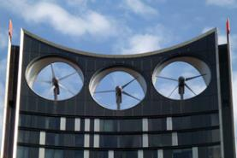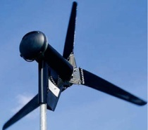

Figure 1: Strata Tower's 3Norwin 18 kW turbines, LSBU’s Proven 6kW turbine

Methodology and Instrumentation
Synchronised measurements of noise, vibration, wind and energy generation were recorded over a period of eighteen months, September 2013- February 2015 on the rooftop and immediately adjacent areas. The collected data was analysed and compared to prediction models to assess the suitability and performance of the wind turbine installation.A full method statement was undertaken for the site to minimise the risk necessary to undertake the research on the rooftop. There were technical difficulties on the Strata Tower site, after which the turbines were switched offand hence this paper focuses on the LSBU site.

Below is the complete list of the monitoring on the LSBU site
- Monitor and logatmospheric data at hub height, 10 m rooftop anemometer
- Monitor and log real-time energy generation.
- Monitor and logbackground and operation turbine noise on the rooftop, in the building and other locations, as appropriate.
- Generate a noise map around LSBU campusfor community noise annoyance.
- Monitor vibration on the rooftop, offices and other locations, as appropriate.
- Appropriate aerodynamic modelling of wind flow to analyse energy performance for validation purposes.
.
Vibration was measured usinga 6 channel Svantek SV106 vibration meter allowing two sets of 1/3rd octave X,Y& Z axis vibration data to be recorded simultaneously, every 5 minutes, on the turbine and in the building in accordance to BS 6472:2008 (4). The two sets of data allowing the efficiency of the vibration isolation to be assessed. ANorsonic Nor140Class 1 sound level meter was used to establish the sound power level produced by the turbine under a range of wind conditions in accordance to ISO 61400-11 (5). In addition Class 1 sound level meters were used to measure at four locations, sensitive receptors, the overall dBA values and 1/3rd octave environmental noise levels. The noise, vibration and wind measurements were synchronised and measured every 5 minutes. This data was used to predict and validate the noise levels produced bythe CADNA-A noise mapping software package (6). These predictions were then used to assess the impact of the turbine on all local residents in accordance to the World Health Organisation (7).

3. Noise Results

The noise monitoring consisted of two parts: firstly on the rooftop to assess the relation between noise and wind both with and without the turbine operating and secondly, to determine the environment noise condition in the area, in particular at the nearest sensitive residences.

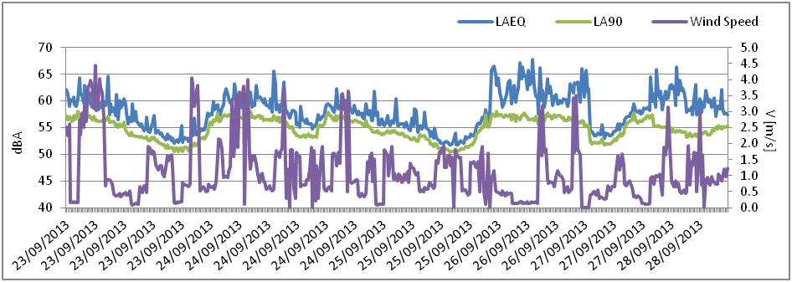
Figure6: Background noise and wind speed levels at the LSBU rooftop (Dec 2013).
Figure6 demonstrates no strong correlation betweenoverall noise level, L_{Aeq,} and wind speed on the rooftop without the turbine. The consistent, repetitive fluctuation of noise levels suggests the background noise within the area was predominantly dictated by other factors such as traffic with a correlation coefficient of -0.13.

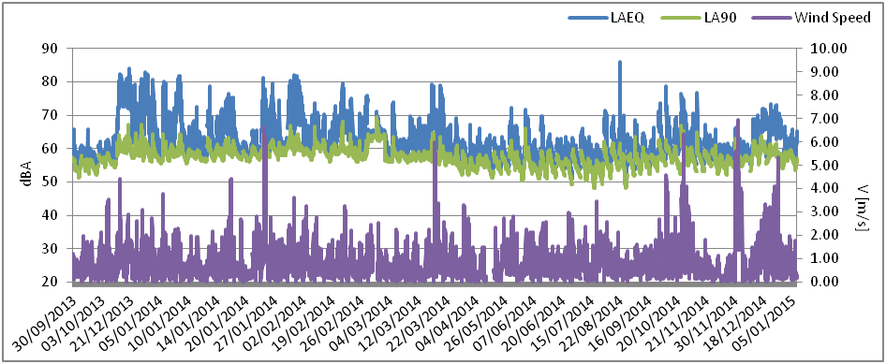

Figure 7: Operational noise levels at the LSBU turbine against wind speed.

Figure 7 shows a relationship between noise levels, L_{Aeq}, and wind speed with a 1 dB increase in noise per wind speed bin above the cut in speed of the turbine, 3 m/s giving a correlation coefficient of 0.25.

An analysis of the noise spectrum was undertaken to determine the frequency content 1//3 octave bands, for below turbine cut in speed, above cut in speed and at high wind speed.

Figure 8 Comparison of operational ¹/₃ octave noise level results at low, average and high wind speeds for the operation turbine on the LSBU rooftop.

As can be seen from Figure 8 low frequency noise from the turbine can typically be attributed to changes in wind speed, above the cut-in speed,caused by the blades due to the mast and wind shear. The spectral content of the sound was dominated by the blade passing frequency, 10 Hz, and the harmonics there of. At higher wind speed the spectrum became broadband with a 10 dB increase in noise level across the frequency range. This information was used to determine the maximum, or worst case, sound power level, produced by the turbine.

Propagation of induced turbine noise into this area was predicted using CADNA-A based on this worst case condition, 74 dBA at 12.5 m.The CADNA-A model assumed a hub height point source radiating hemi-spherically from the rooftop, giving a Sound Power Level of 106.9 dBZ. Figure 9 presents the noise map of the local area predicting overall noise levels, dBA, at the nearest residential properties in the region of 50-59 dBA. This was just above the measured ambient noise levels, L_{Aeq,1 hour}, 50-55 dBA. Hence, it would be just possible to perceive the turbines in the worst case condition for the nearest residents. It should be noted that for the higher range of wind speeds, over 6 m/s, this occurred for only 13% of the time.

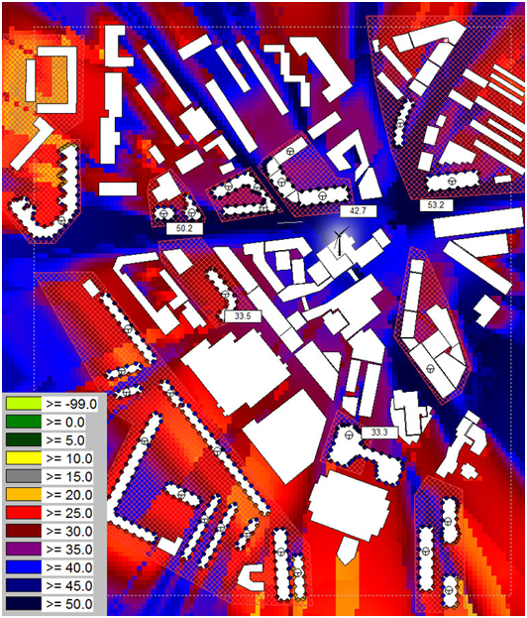

Figure 9: Worst case, operational turbine, scenario L_{Aeq} grid calculations of propagated sound into LSBU residential areas (200m by 300m).

4.0 Vibration Results
Vibration measurements were taken simultaneously on the LSBU turbine mount and the concrete mass beneath the mast. Vibration Dose Values, as well as peak acceleration data was captured and synchronised to the on-site collected atmospheric data, which is shown in Figure 10.X and Y RMS acceleration results have been omitted as no correlation between them and wind speed was observed. However, a correlation of 0.4 was found between wind speed and for the Z axis RMS acceleration.

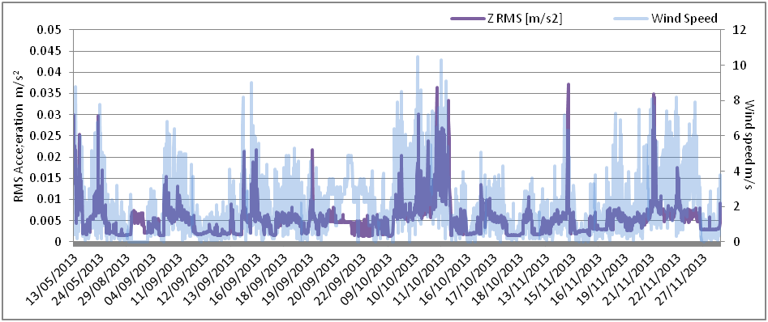

Figure 10: Z-axis RMS acceleration measurements against wind speed on LSBU turbine

The simultaneously measured vibration on the turbine mount and the concrete roof found a general reduction in RMS Z axis acceleration, see Figure 11. However, there was no installed damping or isolation beneath the turbine although requested;therefore, the reduction is most likely due to the mass of the concrete structure the turbine is mounted on. Appropriate isolation design was offered as mitigation(3).

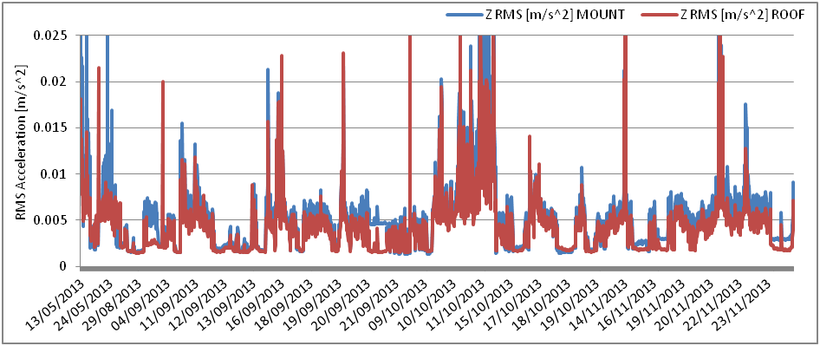

Figure 11: Compares simultaneous Z axis RMS acceleration levels simultaneously measured on the LSBU turbine mount and rooftop

The dynamic wind load on the turbine did cause structural vibration in the mounting system to such as extent that in February 2015, the turbine fell over shearing off its mounting bolts. Unfortunately this irreparably damaged the turbine blades and mounting system andthe turbine had to be removed from the rooftop. There was a mitigating factor; the inverter had been switched off which allowed the turbine to runfree without the electro-mechanical drag caused by generator. Just before the turbine collapsed there were structural vibrations in the building which caused annoyance in staff offices according to measurement taken to BS 6472:2008, see (3).

Conclusions
This study was instigated from London's need to reduce CO₂ emissions via the employment of renewable energy sources. Central London is densely populatedand the topography does not lend itself to traditional turbine placement, hence more bespoke methods are required for successful installation. The wind turbine installed on the newly refurbished building on the LSBU Campus was used as a case study.The purpose of the investigationwas to optimise the design of the installation using a multifaceted approach including:
(i) local noise surveys to inform acceptable turbine operating ranges,
(ii) acoustic modelling of manufacturer provided data and/or acoustic testing of the proposed turbine across all applicable wind speed ranges
(iii) vibration assessment of the turbine system and any lower residential floors
(iv) measurement of site specific wind data to inform architectural design, turbine selection and placement, or
(v) CFD modelling of local topography for insight into the wind resource (3).

Urban wind turbines, if well located, can generate meaningful amounts of electricity. The installation should account for the wind flow, wind direction and any ability of the turbine to turn to make best use of this resource.The study also found that any installation should include vibration isolation to prevent annoyance to the users of the property and to safe guard the whole system. Noise levels produced by the wind turbine were unlikely to have adverse impact on local residents due to high ambient noise conditions in Central London over almost all wind conditions.

Acknowledgements
The research was jointly funded by a London Development Agency supported EPSRC Industry Case Award with Brookfield Multiplex Europe.

References
- Green Light to Clean Power, The Mayor's Energy Strategy [online] PDF, available from: www. Greater London Authority. 2004.
- Climate Change is top priority of London Plan Review [online] Press Release Greater London Authority, 2006.
- Dymock B, Urban wind turbines: A Feasibility Study, London South Bank University, PhD thesis, 2016
- British Standards, BS6472: 2008 - Evaluation to Human Exposure to Vibrations in Buildings, 2008
- British Standards, BS61400-11: 2003 – Wind turbine Generator Systems Acoustic Noise Measurement Techniques, London, BSI, 2003
- Datakustik, http://www.datakustik.com/en/products/cadnaa accessed Nov 2017
- World Health Organization, Guidelines for Community Noise, Geneva, World Health Organization, 1999.

