Experimental Setup to Compare Measurements and Numerical Simulations in Magnetic Resonance Imaging RF Dosimetry
Umberto Zanovello, Michele Borsero, Domenico Giordano, Luca Zilberti, Francesca Maggiorelli, and Gianluigi Tiberi

Abstract— Many of the parameters associated with the mag- netic resonance imaging (MRI) coils are estimated by means of numerical simulations. Taking into account the unavoidable numerical approximations and imperfections of the models, an experimental validation of the theoretical results becomes essential. This paper describes two measuring setups which allow
the tissues per mass unit
SAR 1
,=
M Mass
where

σ(P)E(P)² W
dm

ρ(P) kg

(1)

the comparison between measurements of electromagnetic fields and the same quantities computed numerically. The experimental activity highlighted some critical aspects of the numerical results that could bring to a wrong estimation of the parameters associated with the MRI coils. Results show the importance and feasibility of a dosimetry experimental setup suitable for MRI coils characterization.
Index Terms— Field probes, magnetic resonance imag- ing (MRI), MRI coils, MRI dosimetry uncertainty, near-field measurements, RF electromagnetic measurements.

- INTRODUCTION
M
AGNETIC resonance imaging (MRI) is an imaging technique used primarily in medical settings to produce
high-quality images of inside of the human body. MRI has a wide range of applications in medical diagnostics and over 25 000 scanners are estimated to be in use worldwide. Even though MRI is, in general, a safe technique, the number of accidents causing patient damage has risen [1].
One of the most important and indicative parameters asso- ciated with the safety of a human body subjected to radio frequency (RF) radiation is the “specific absorption rate” (SAR) of energy developed by the electromagnetic field in
Manuscript received July 8, 2016; revised January 19, 2017; accepted
March 10, 2017. Date of publication April 12, 2017; date of current version
May 10, 2017.
U. Zanovello is with the Politecnico di Torino, I-10129 Turin, Italy, and also with the Istituto Nazionale di Ricerca Metrologica, I-10135 Turin, Italy (e-mail: u.zanovello@inrim.it).
M. Borsero, D. Giordano, and L. Zilberti are with the Istituto Nazionale di Ricerca Metrologica, I-10135 Turin, Italy (e-mail: m.borsero@inrim.it; d.giordano@inrim.it; l.zilberti@inrim.it).
F. Maggiorelli is with the Dipartimento di Scienze Fisiche, della Terra e dell’Ambiente, Università di Siena, Siena I-53100, Italy, and also with the Sezione di Pisa, Istituto Nazionale di Fisica Nucleare, Pisa I-56127, Italy (e-mail: maggesca@gmail.com).
G. Tiberi is with the Laboratory of Medical Physics and Biotechnologies for Magnetic Resonance, IRCCS Stella Maris Foundation, Pisa I-56018, Italy, and also with the Imago7 Foundation, Pisa I-56018, Italy (e-mail: g.tiberi@iet.unipi.it).
E(P) electric field intensity in point P of tissue (V/m);
ρ(P) mass density in point P of tissue (kg/m³);
σ (P) electrical conductivity in point P of tissue (S/m);
M averaging mass (kg).

International standards and guidelines [2], [3] distinguish between the local SAR, averaged over the mass of 10 g, and the global SAR averaged over the whole body. Different limits have been established for the two quantities, in function of the exposure time, both for patients and operators.
Whereas the global SAR can be estimated by the active power flowing through the coils of the MRI scanner, the only way to have a satisfactory idea of the local SAR is by means of numerical simulations.
Considering the direct relation of SAR with the electric field [see (1)] generated by the MRI coils inside the tissues, the importance of such field measurements to validate the numerical results becomes evident to avoid possible estimation errors in numerical codes.
On the other hand, there are several parameters describing the coils efficiency based on the magnetic field. For example, the transmit efficiency is defined as the ratio between the clockwise rotating magnetic field and the square root of the active power flowing through the coil. Furthermore, in order to reduce artifacts in the final MRI image, it is essential to ensure a magnetic field inside the region of interest as homogeneous as possible [4]. These considerations explain the need to provide an experimental characterization of the coil also in terms of the generated magnetic field.
Performing such characterization in a clinical MRI scanner is not simple. Indeed, an MRI scanner is not easily available, and however, it would be not so versatile to perform the measurements that we propose in this paper.
For these reasons, a dosimetry setup for RF electromag- netic measurements has been designed and realized at the Istituto Nazionale di Ricerca Metrologica (INRIM), Italy. The experimental setup is composed of a cylindrical polycarbonate phantom filled with a tissue-simulating liquid (TSL), prepared

by ZurichMedTech [5], whose electric properties (i.e., electric permittivity and electrical conductivity) are comparable to those of human tissues with high water content [6]. All the measurements have been acquired along predefined investiga- tion lines inside the phantom thanks to an automatic triaxial positioning system (gantry).
It should be highlighted that the purpose of this paper is not to cause the nuclear magnetic resonance as in a real MRI scanner. The RF electromagnetic fields generated inside the TSL by the MRI coils should be intended only for comparisons with numerical simulations.
This paper is an extension of our work presented for the CPEM 2016 Digest (Proceedings) [7] and proposes the comparison between numerical results and experimental acqui- sitions for two different loop coils.
The “setup” section is divided into three parts. In the first section, measurements have been carried out generating the electromagnetic field with a well-known coil already char- acterized with a previous setup [8], [9]. Although the coil was not designed to work inside a real MRI scanner, it has been tuned to work at 128 MHz that is the frequency used in most clinical, high-resolution MRI scanners. It represents the 1H-Larmor frequency associated with a 3 T static magnetic field.
In the second section, the RF electromagnetic fields have been generated inside the TSL with a real MRI RF coil. The coil was provided by the “Imago 7” Foundation (Pisa, Italy), and all the measurements have been carried out at INRIM. The coil was double tuned at the frequencies of 79 and 298 MHz that correspond to the Larmor frequencies of the 23Na and 1H associated with a 7 T static magnetic field, respectively.
In the third section, a brief description of the design of a volume coil (“Birdcage” coil) is given. The birdcage coil has been recently realized at INRIM, and it will be the object of future work.

- SETUP
- First Experimental Setup
A first experimental setup (Fig. 1) has been used to perform measurements generating the fields by means of a well-known coil designed and realized at INRIM. The coil had already been characterized with a previous experimental setup based on a manual positioning system [8], [9]. The main aim of this acquisition phase was to validate the new setup and to develop an accurate measurement model that takes into account all the possible contributions that concur to the uncertainty associated with the measurand. An accurate description of the measure- ment model and of the uncertainties propagation is provided in the Appendix. The old positioning system has been replaced by a new automatic triaxial robot (“gantry”). A new manage- ment software based on a graphical user interface has been developed through the so-called “python-QT” bindings. The program handles both the acquisition and generation processes and allows to control the gantry movement in different ways. A new TSL liquid [5], in which all the measurements have been performed, has replaced the previous one with slightly different electric proprieties. Finally, a new electric field probe,

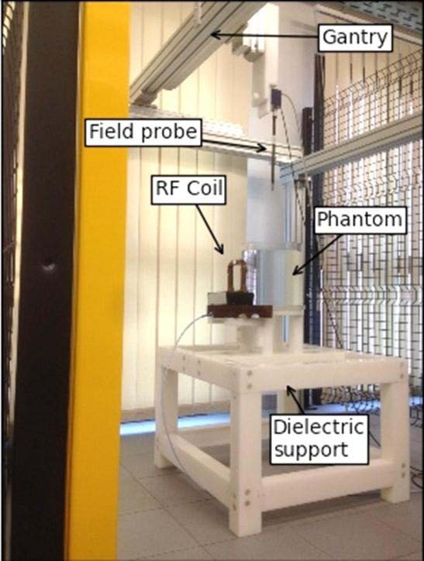
Fig. 1. First experimental setup.

calibrated inside the actual TSL, has been used to perform the electric field measurements.
The considered experimental setup was hence composed of a cylindrical phantom, of radius equal to 125 mm and height equal to 250 mm, filled with the TSL almost up to the edge. The liquid was characterized by a relative permittivity ε_{r} equal to 78 and an electrical conductivity σ equal to 0.47 S/m (all the parameters have been provided with the liquid by ZurichMedTech). The phantom was placed on a dielectric support (height equal to 50 cm) on which also the coil has been positioned. The coil has been supplied by a vector signal generator and an RF amplifier (see Table I). The INRIM coil is made of an active rectangular wire (110 mm 110 mm) surrounded by a metallic shield. The shield presents a gap to avoid blocking the intentional coupling between the source and field to be generated [10]. The coil has been tuned to 128 MHz by means of proper capacitors connected in series
×
to the supply.
Since the electromagnetic field measurement should be per- formed in the near-field region, where the spatial field gradient is relatively large, RMS isotropic field probes with very small dimensions have been chosen [11]. Moreover, owing to their use inside the phantom, resistance to organic solvent must be guaranteed. Both the electric and magnetic field probes have been connected to their remote unit by means of an optic fiber to avoid measurement interferences. The remote unit has been managed by the PC thanks to a LAN cable connection. Both the electric and magnetic field probes can measure the three Cartesian components of the field intensity at the same time. The measurements have been performed along four vertical lines inside the TSL and, for each line of 18 cm length, a set of 37 acquisitions (5 mm spaced) has been carried out. The four lines have been selected to highlight the effects of

TABLE I
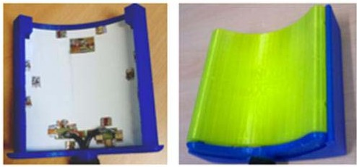
EQUIPMENT USED IN THE EXPERIMENTAL SETUP

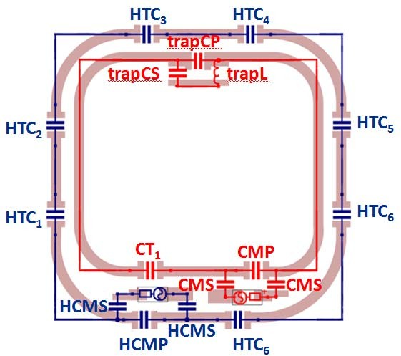
Fig. 2. Double-tuned 1H/23Na planar coil electrical scheme.
the coil asymmetries and anomalies on the electromagnetic fields. Moreover, the lines are close enough to the source to allow measurable field levels. The stepper motor of the gantry has been stopped and turned off at each acquisition to avoid interference to the measured field. Thanks to the gantry and to the software “lines acquisition” function, every set of measurements lasted no more than 5 min. After that, the results have been compared with numerical simulations. In a simulation environment (CST-MWS), the physical setup has been properly modeled and simulated with the frequency- domain solver. The numerical results have been extracted along the same lines on which the measurements have been carried out. For each experimental acquisition, the active power flowing through the coil has been acquired thanks to a reflectometric power measurement method. By means of a bidirectional coupler associated with two power meters (see Table I), it has been possible to evaluate the incident and reflected power to the coil and, hence, the actual power flowing through it. For each line, the measured power has been used as driving term for the corresponding simulation.

- Second Experimental Setup
A second set of measurements has been carried out gener- ating the RF electromagnetic field with a double-tuned planar coil instead of the previous one. The coil was provided by the “Imago 7” Foundation, and it was designed to work in a clinical 7 T MRI scanner. The coil consists of two concentric rectangular loops with independent supply (Fig. 2). For both the loops, the angles are blended with 28-mm curvature radius. The loops are etched on an FR4 printed circuit board with 200 μm thickness and are plunged in a mechanical support made of polylactide (PLA) thermoplastic (Fig. 3).
Fig. 3. Double-tuned 1H/23Na planar coil PLA thermoplastic mechanical support.

The external loop (110 mm 110 mm) is tuned at 298 MHz in order to stimulate the 1H nuclei response under a static magnetic field at 7 T. Considering the short wavelength at this frequency, seven tuning capacitors are distributed along the loop at the same distance from each other.
×
The internal loop (85 mm 95 mm) is tuned at 79 MHz in order to stimulate the 23Na atoms response under a 7 T static magnetic field. In this case, taking into account the smaller dimension and the longer wavelength, only three tuning capacitors are used.
×
At the 23Na frequency of 79 MHz, the 1H loop presents a high impedance, ensuring a good decoupling with the sodium coil. On the contrary, the 23Na loop shows a low impedance at the 1H frequency. To decouple the loop also at 298 MHz, a “trap” circuit is inserted on the sodium coil. The “trap” consists of a 298 MHz LC resonator that opens the circuit of the sodium loop avoiding the coupling at this frequency between the two loops.
Both the coils are matched to 50 ▲ with a capacitive matching network, and the supply symmetry is ensured by the use of “baluns.”
Clinical practice for this double-tuned coil requires that the 1H loop be used only as a “localizer.” When the correct placement is found through the localizer, the 23Na loop is employed in order to obtain the required 23Na image [12].
The coil has been fixed to the phantom thanks to some paper tape being careful to maintain the loop in a vertical position and central to the phantom height.
Also in this case, electric and magnetic field measure- ments have been performed along the same lines defined in Section II-A with 37 acquisitions for each line.
Since the magnetic and electric field probes are not cali- brated at 298 MHz and the TSL is not characterized for this frequency, all the measurements have been carried out for the sodium coil at 79 MHz. Furthermore, it should be underlined

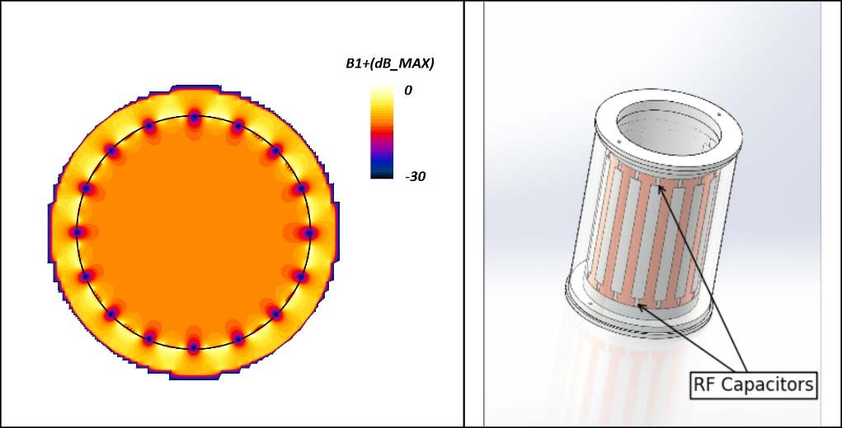

Fig. 4. Left: chromatic map of the B1+ (in air) expressed in decibel referred to the maximum B1+ of the slice. The result has been carried out with a finite-difference time-domain commercial software (Sim4Life) developed by ZurichMedTech. Right: 3-D CAD project of the 16-legs birdcage high-pass coil designed at INRIM.

that considering the minor application of this hydrogen coil used only with a “localizer” function, there is no practical interest to investigate its behavior in detail. Concerning an experimental activity at 298 MHz, electromagnetic field mea- surements will be the subject of a future work where the fields will be generated with a coil specifically designed for an extensive use at this frequency.
The setup has been left unchanged with respect to Section II-A, and the experimental results have been com- pared to numerical results. Also in this case, the simulations have been computed with the frequency-domain solver of CST-MWS, and the numerical results have been extracted along the same investigated lines.

- Volume Coil Design
A volume coil, the “birdcage” coil, has been designed and recently realized to generate the electromagnetic fields inside the cylindrical phantom filled with the TSL. Birdcage resonators are the typical coils involved in the RF electro- magnetic field generation in MRI and are designed to feature a homogenous circularly polarized magnetic field inside their volume [13] (Fig. 4).
In particular, a 460 mm high, with a 320 mm diameter, high- pass 16-legs birdcage resonator has been designed. Thirty-two capacitors, whose capacitance determines the tuning frequency of the coil, link one leg to the next (see Fig. 4). The birdcage is tuned at 128 MHz, which represents the 1H-Larmor frequency associated with 3 T static magnetic field, and can be fed in quadrature operation. Finally, a cylindrical shield made of copper, with a 600 mm height and 350 mm diameter, surrounds the coil.

- RESULTS AND DISCUSSION
In this section, some of the results obtained during the experimental activity are proposed and discussed. As explained

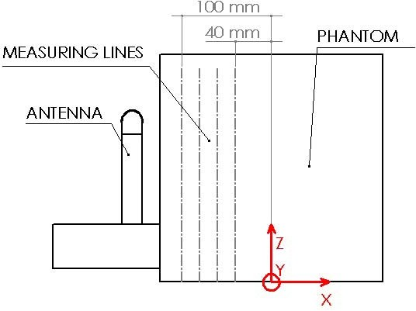

Fig. 5. Reference coordinate system and measuring lines for the experimental setup. In the picture, the coil used for the first experimental setup is shown (side view).

TSL, and for each line, a set of 37 acquisitions (5 mm spaced) has been carried out. The four lines are 100 (“line-100”), 80 (“line-80”), 60 (“line-60”), and 40 mm (“line-40”) distant from the center of the phantom toward the coil, respectively. In Section III-A, the acquisitions carried out with the first experimental setup (refer to the “setup” section) are reported and compared with the corresponding numerical simulation results. In Section III-B, all the proposed comparisons refer to the second experimental setup. The z-coordinate in all the following figures should be intended as growing from the phantom base to the top. The x -axis is parallel to the longitudinal axis of the loop coil, and the y-axis remains parallel to the plane of the coil as shown in Fig. 5.
In this section, only the results of the measurements along the lines evaluated to be more interesting are reported. The uncertainty bars shown in the figures refer to the expanded uncertainty associated with the corresponding acquisition val- ues (see the Appendix).

- First Experimental Setup

in the previous section, electric and magnetic field measure- ments have been performed along four vertical lines inside the
In the first experimental setup, the coil has been sup- plied with a net active power (the power incident to the

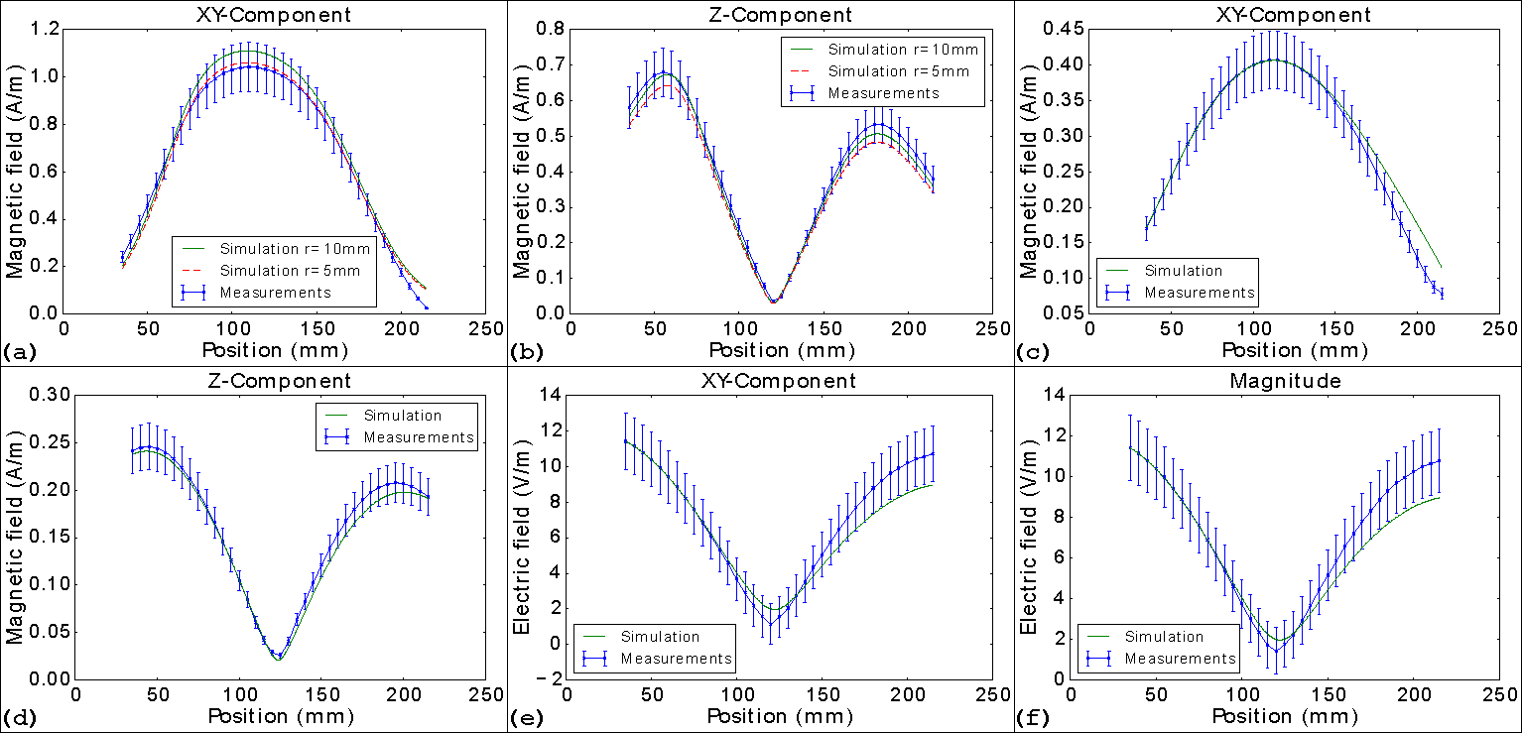

Fig. 6. Comparison between the experimental results obtained with the first experimental setup and the numerical simulations. The comparison is reported for the magnetic field (a) and (b) along the “line-100” and (c) and (d) along the “line-40” both for the z-component and for the xy-component. The comparison for the electric field is reported for (e) and (f) “line-40” both for the xy-component and for the field magnitude.

coil minus the reflected one) equal to 15 W. In this setup, the center of the coil corresponds to a z-coordinate equal to 120 mm.
The comparisons of the xy-component (H_{xy}) and of the z-component (H_{z}) of the magnetic field at 128 MHz between the experimental acquisitions and the numerical results are reported in Fig. 6(a)–(d). In Fig. 6(a) and (b) the acquisi- tions have been carried out along the “line-100,” whereas in Fig. 6(c) and (d) the investigated line is the “line-40.” The results are found to be satisfactory for all the four presented cases. Indeed, for most acquisitions, the numerical results lie within the range of the measurement expanded uncertainty. In Fig. 6(a) and (b), it is highlighted the high sensitivity of the magnetic field, at close distances, to internal conductor shape variations. In the INRIM coil, the internal conductor is hidden by the external shield. It is hence almost impossible to evaluate its actual shape. The green lines represent a simulation where the rectangular shape of the internal wire has the vertices blended with a radius of 10 mm, whereas those dashed (in red) refer to a radius of 5 mm. Differences are found to be appreciable especially on the peaks of the curves. In Fig. 6(a), the 5 mm radius improves the results but has a negative effect on the z-component of the magnetic field [Fig. 6(b)]. The relative differences between the numerical results obtained with the two radii are muffled at greater distances. The simulation lines in all the other proposed results are to be intended with a “blend radius” equal to 10 mm. In Fig. 6(c), the peaks difference notable in Fig. 6(a) becomes negligible. However, some discrepancies between the two curves are found in the upper part of the “line-40.” Aside from the modeling inaccuracies, these are presumably due to
the very small magnetic field amplitudes. These magnetic field magnitudes are comparable with the field noise, and the probe behavior could be unsatisfactory at these low signal levels. The agreement between the z-component of the measured magnetic field and the simulated results, depicted in Fig. 6(b) and (d), is very appreciable and supports the correctness both of the experimental procedure and of the numerical model. The asymmetry of the experimental curves, due to the asymmetry of the coil frame (see figures 1 and 5), is confirmed by the numerical simulations.
The results for the electric field along the “line-40” are depicted in Fig. 6(e) and (f). In Fig. 6(e) the comparison for the xy-component (E_{xy}) and in Fig. 6(f) the comparison for the magnitude of the electric field is shown. The agreement between the numerical and measurements curves is found to be satisfactory in both cases. Again, the numerical results lie within the range of the measurement expanded uncertainty for most values.
Some disagreements between the curves are appreciable in Fig. 6(e) and (f) in the upper part of the “line-40” where the acquired points are nearer the liquid surface. The shield effect of the TSL decreases in these points, and the electric field noise (not predictable from simulations) of the environment could cause some discrepancy between measurements and numerical results. The similarity between the xy-component [Fig. 6(e)] and the magnitude [Fig. 6(f)] of the electric field is not surprising considering the value of the z-component that is negligible as expected by theory.
Finally, considering the points where the measured elec- tric or magnetic field values are different from those simulated, it is noticeable the importance of a proper characterization of

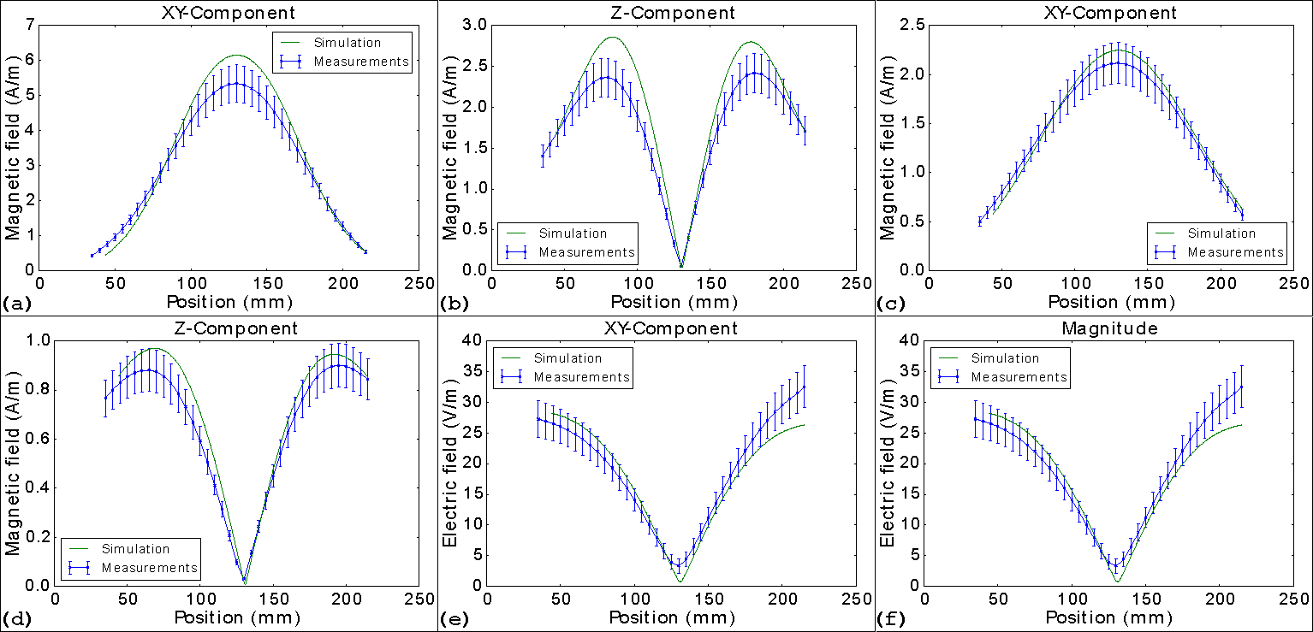

Fig. 7. Comparison between the experimental results obtained with the second experimental setup and the numerical simulations. The comparison is reported for the magnetic field (a) and (b) along the “line-80” and (c) and (d) along the “line-40” both for the z-component and for the xy-component. The comparison for the electric field is reported for (e) and (f) “line-40” both for the xy-component and for the field magnitude.

the MRI coils to avoid, for example, possible underestimations of the SAR values or overestimations of the transmit efficiency.
- Second Experimental Setup
In the second setup, the planar coil used to generate the electromagnetic field, has been supplied with a net power of 9.5 W. The results shown in this section refer to the sodium coil at 79 MHz.
The comparisons of the xy-component (H_{xy}) and of the z-component (H_{z}) of the magnetic field at 79 MHz between the experimental acquisitions and the numerical results are depicted in Fig. 7(a)–(d). Fig. 7(a) and (b) refers to mea- surements along the “line-80” and Fig. 7(c) and (d) refer to those along the “line-40.” Although the trend of the curves for measurements and simulations is similar, in Fig. 7(a) and (b), it is appreciable a difference between the peak values both in the xy-component case and in the z-component one. This inconsistency is partially compensated considering a farther line as in Fig. 7(c) and (d). As pointed out in Section III-A, the electromagnetic field near the coil could be highly influenced by any minimum shape variation of the model. Considering the unavoidable errors committed in the effort of reproducing the real experimental setup in a simulation environment, some reasonable differences between experimental and numerical results should be taken into account.
It should be noted that the magnetic field values obtained in this setup are higher than those obtained with the first experimental setup. In Fig. 7(c), at the upper part of “line-40,” the relative errors between the experimental results and the numerical ones are smaller with respect to the previous setup [see Fig. 6(c)]. This assumption could partially confirm the observation, highlighted in Section III-A, that the probe behav- ior is unsatisfactory at low magnetic field values.
The results for the electric field along the “line-40” are shown in Fig. 7(e) and (f). In Fig. 7(e), the comparison for the xy-component (E_{xy}) and in Fig. 7(f) the comparison for the magnitude of the electric field are depicted. The agreement between the numerical and experimental results is considered satisfactory for both Fig. 7(e) and (f). As for the results obtained with the first experimental setup, also in this case, some disagreements appear in the upper part of the “line-40” probably due to the weaker shield effect of the TSL.
The affinity between the measured values of the xy-component and the magnitude of the electric field is due to a measured z-component that is negligible as expected by theory.
Finally, also in this case, similar considerations concerning possible SAR underestimation or transmit efficiency overesti- mation can be applied for this coil.

- CONCLUSION AND DEVELOPMENTS
Some comparisons between numerical results and experi- mental measurements have been proposed. The experimental acquisitions have been carried out along specific lines in a liquid that simulates the electrical properties of human tissues. Such comparisons have been proposed with two different experimental setups. In the first setup, the electromagnetic fields have been generated with a well-known coil designed and developed at INRIM. In the second setup, the fields have been generated with a coil specifically designed for an MRI application and provided by the “Imago 7” Foundation (Pisa, Italy).
All results have been analyzed in detail, and several critical aspects have been highlighted. The absolute importance of a good experimental characterization that guarantees a correct

estimation of all the parameters related to the electric and magnetic field generated (e.g., SAR and transmit efficiency) has been put in evidence.
Future works will include the extension of the calibration of the field probes and of the TSL electrical properties evaluation up to 300 MHz. After that, it will be possible to perform the characterization of a planar hydrogen MRI coil.
Finally, the birdcage coil will be completed and new electric and magnetic field measurements will be carried out and compared to numerical simulations.

APPENDIX
A. Measurement Model
In the following analysis, all the contributions in the mea- surement model that introduce an uncertainty in the measurand are described in detail. The following considerations deal with the magnetic field but the same description can be applied also to the electric field. The uncertainty estimation and propagation is carried out taking into account the guidelines proposed by the JCGM 100:2008 (GUM) [14].
The measurement model is given by
“T_{inst}” and so does the real power in the coil. It has been evaluated that C_{δpow(∆T}ins) does not contribute to significant errors; hence, the estimated value has been considered 0, i.e.
H˜p,Tliq,P 0.
=
As prescribed by the GUM, at each of the previous contri- butions, it is associated a probability density function based on the available knowledge of the quantity itself. In the following list the procedure is described in detail.
H_{p,T}liq,P is affected by the uncertainty due to the device res- olution. The instrument resolution is 0.001 A/m, and hence a rectangular distribution with limits a H _{p,T}liq,P 0.0005 A/m and b H _{p,T}liq,P 0.0005 A/m has been used to characterize the knowledge of the quantity. The associated uncertainty is u(H _{p,T}liq,P ) b a/(12)^{1/2} 0.0003 A/m. For the electric field probe, the uncertainty associated with this parameter
= +
= −
= − =
has been evaluated to be 1/(3)^{1/2} 0.58V/m. This higher value is due to the high noise level detected during such field measurements
=
C_{cal} is affected by the uncertainty provided in the probe calibration certificate. It is said that the calibration factor influences the read value in a Gaussian way with an expanded uncertainty equal to 10% of the read field value with a 95%

H ˜ = H_{p} _{T}
P + Ccal + C M
confidence interval. The associated uncertainty is u(C_{cal}) =

p0,Tliq0 ,P
, liq, ∆
(0.1/1.96)H_{p,T}liq,P = 0.05H_{p,T}liq,P A/m

+ C∆Tliq + Cδpow(∆Tins) (A.1)
where Hp0,Tliq0 , P˜ represents the best estimate of the magnetic field in the point “ p₀,” at the liquid temperature “T_{liq}0 ” and at the power “ P˜” flowing through the coil, evaluated at the
mean power of all the acquisitions along a specific line
H_{p,T}liq,P represents the observed quantity, read from the instrument display, in the actual point “ p,” at the actual liquid temperature “T_{liq}” and at the actual supply power “ P.” Only
one reading has been done for each point of acquisition,
i.e. H˜p,Tliq,P Hp,Tliq,P .
=
C_{cal} takes into account the effect of the calibration coef- ficient, associated with the specific field probe, on the mea- surand. It has been evaluated that C_{cal} does not contribute to significant errors; hence, the estimated value has been
considered 0, i.e. ˜C_{cal} 0.
=
C_{ΔM} takes into account the positioning error that is the difference from the actual acquisition position “ p” and the desired position “ p₀.” It has been evaluated that C_{∆M} does not contribute to significant errors; hence, the estimated value
has been considered 0, i.e. C˜∆M 0.
=
C_{ΔT}liq takes into account the effect of the temperature oscillation on the electric properties of the liquid that is the difference from the actual liquid temperature “T_{liq}” and the
desired one “T_{liq}0 .” Since we are not able to measure the exact liquid temperature, we cannot take into account any significant effect of C_{∆T}liq on the measurand. Hence, the estimated value
~ =
has been considered 0, i.e. δ_{rep}(∆T_{liq}) 0.
C_{δpow(ΔT}ins) takes into account the difference from the actual power flowing through the coil “ P” and the mean power used in the simulations “P˜.” During the line acquisition
procedure, the supply voltage is set by the generator but the real supply voltage depends on the instrument temperature
C_{ΔM} does not contribute to the measurand uncertainty. This assertion came from a set of 100 acquisitions developed in the following way. A measurement point characterized by a high position gradient field has been individuated in order to maximize the effect of the positioning error on the field reading. Before every acquisition, the gantry has been forced to return in the origin of its axis and the quantity
(H_{p,T}liq,P)/(P)^{1/2} has been computed in order to avoid the effect of C_{∆pow(∆T}ins) on the positioning error. The standard deviation of the distribution results to be negligible compared to all the other uncertainty contributions.
C_{ΔT}liq takes into account the uncertainty associated with the actual liquid temperature T_{liq}. It is known that the lab- oratory temperature is (24 3) °C, and it is foreseeable
±
that also the liquid temperature will change in the same range (21 °C to 27 °C). For a temperature variation within this range, the maximum difference in terms of field ampli- tude has been estimated to be less than 2% of the read field amplitude. Hence, a rectangular distribution with limits
a (1 0.01)H_{p,T}liq,P and b (1 0.01)H_{p,T}liq,P has been used to characterize the knowledge of the quantity. The associated uncertainty is u(C_{∆T}liq ) b a/(12)^{1/2}
= − =
= − = +
0.006H_{p,T}liq,P A/m
C_{δpow(ΔT}ins) takes into account the uncertainty associated with the power flowing through the coil, statistically dif-
ferent from its mean value used to obtain the numerical results. In order to evaluate this effect, 80 consecutive acquisi- tions (corresponding to acquire consecutively two lines) have been carried out without moving the gantry. Considering the temperature variation of the instruments from the first to the last acquisition, the maximum difference in terms of read field amplitude has been estimated to be less than 2% of the read field amplitude. Hence, a rectangular distribution with limits

TABLE II
SUMMARY OF THE CONTRIBUTIONS TO THE MEASURAND STANDARD UNCERTAINTY
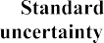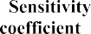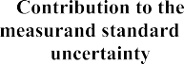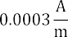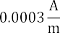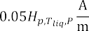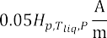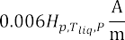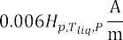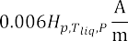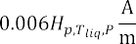

a (1 0.01)H_{p,T}liq,P and b (1 0.01)H_{p,T}liq,P has been used to characterize the knowledge of the quantity. The
= − = +
- O. Bottauscio et al., “Assessment of computational tools for MRI RF dosimetry by comparison with measurements on a laboratory phantom,”

associated uncertainty is u(C
0.006H_{p,T}liq,P A/m.
δpow(∆Tins)
) = b − a/(12)^{1/2} =
Phys. Med. Biol., vol. 60, no. 14, pp. 5655–5680, Jul. 2015.
- C. F. M. Carobbi and L. M. Millanta, “Analysis of the common-mode rejection in the measurement and generation of magnetic fields using

Table II summarizes all previous contributions. For each quantity in (2), the estimate, standard uncertainty, associated probability distribution, and sensitivity coefficient are shown. The model linearization is taken into account to propagate
the uncertainty to the measurand as suggested by the GUM.
loop probes,” IEEE Trans. Instrum. Meas., vol. 53, no. 2, pp. 514–523, Apr. 2004.
- SPEAG. SPEAG/PRODUCTS, accessed on Apr. 3, 2017. [Online]. Avail- able: https://www.speag.com/products/easy4-mri/easy4-systems/easy4- mri-5/
- J. D. Kaggie et al., “7 T sodium/proton knee imaging: First results,” in

Since the variance u²(H

p,Tliq,P
) is much larger than any other
Proc. ISMRM UHF Symp., Heidelberg, Germany, 2016, p. 21.
- N. De Zanche, J. T. Vaughan, and J. R. Griffiths, RF Coils for MRI.

from a non-normally distributed quantity, it is possible to apply the central limit theorem. As a consequence, the expanded uncertainty referred to the measurand H_{p,T}liq,P (for a coverage probability of 95%) is
Hoboken, NJ, USA: Wiley, 2012.
- Evaluation of Measurement Data—Guide to the Expression of Uncer- tainty in Measurement, document JCGM 100:2008, BIPM Joint Committee for Guides in Metrology, Working Group 1, (JCGM/WG 1), BIPM, Paris, France, 2008.

U(H
p0,Tliq0 ,P˜ ) = 1.960 ∗ u(H
REFERENCES
p0,Tliq0 ,P˜ ).
Umberto Zanovello received the bachelor’s degree and the master’s degree in electrical engineer- ing from the Politecnico di Torino, Turin, Italy, in 2011 and 2014, respectively, where he is currently pursuing the Ph.D. degree in electrical, electronics, and communications engineering, with a focus on

- J. G. Delfino and T. O. Woods, “New developments in standards for MRI safety testing of medical devices,” Current Radiol. Rep., vol. 4, pp. 1–9, Jun. 2016.
- Exposure to High Frequency Electromagnetic Fields, Biological Effects and Health Consequences (100 kHz–300 GHz), ICNIRP, Ober- schleißheim, Germany, 2009.
- Medical Electrical Equipment—Part 2–33: Particular Requirements for the Basic Safety and Essential Performance of Magnetic Resonance Equipment for Medical Diagnosis, document IEC 60601-2-33:2010+A1:2013+A2:2015, 2015.
- E. Pusey et al., “Magnetic resonance imaging artifacts: Mechanism and clinical significance,” Radiographics, vol. 6, no. 5, pp. 891–911, Sep. 1986.
- ZurichMedTech. TLe78c0.47@64 (Liquid Simulating Averaged Tis- sue Parameters), accessed on Apr. 3, 2017. [Online]. Available: http://www.zurichmedtech.com/validation-hw/tsm/tle78c0-47-64
- S. Gabriely, R. Lau, and C. Gabriel, “The dielectric properties of biological tissues: II. Measurements in the frequency range 10 Hz to 20 GHz,” Phys. Med. Biol., vol. 41, no. 11, pp. 2251–2269, Nov. 1996.
- U. Zanovello, L. Zilberti, D. Giordano, and M. Borsero, “Experimental set-up to compare measurements and numerical simulations in magnetic resonance imaging RF dosimetry,” in Proc. Conf. Precis. Electromagn. Meas. (CPEM), Jul. 2016, pp. 785–786.
- D. Giordano, L. Zilberti, M. Borsero, R. Forastiere, and W. Wang, “Validation of numerical methods for electromagnetic dosimetry through near-field measurements,” ACTA IMEKO, vol. 4, no. 1, pp. 90–95, 2015.
the study, design, and development of RF coils for magnetic resonance imaging (MRI).
In 2015, he received a research scholarship with a focus on the realization of a laboratory for electro- magnetic dosimetry. He is currently with the Istituto
Nazionale di Ricerca Metrologica, Turin. His current research interests include MRI principles, electromagnetic fields and related measurements.
Michele Borsero was born in Turin, Italy, in 1952. He received the M.S. degree in electronic engineer- ing from the Politecnico di Torino, Turin, in 1977.
Since 1978, he has been a Researcher with the Istituto Nazionale di Ricerca Metrologica, Turin, where he is in charge of the Electromagnetic Com- patibility (EMC) Laboratory. His current research interests EMC, emission and immunity measure- ments, measuring equipment calibration techniques, uncertainty evaluation and the generation of refer- ence electromagnetic fields.
Mr. Borsero coordinates the Italian participation in the international inter- comparisons organized by the Bureau International des Poids et Mesures by the European Association of National Metrology Institutes in the area of electromagnetic field and EMC measurements. Since 1986, he has been contributing to the works of the Comité International Spécial des Perturbations Radioélectriques of the International Electrotechnical Commission as an Italian delegate of Sub-Committee A (Radio-interference measurements and statistical methods).

Domenico Giordano received the Ph.D. degree in electrical engineering from the Politecnico di Torino, Turin, Italy, in 2007.
Since 2010, he has been a Researcher with the Electromagnetic Division, Istituto Nazionale di Ricerca Metrologica, Turin. His current research interests include the development and characteri- zation of systems and voltage/current transducers for calibration and power quality measurements on medium voltage grids, the study of ferroresonance phenomena, and the development of generation and
measurement systems of electromagnetic fields for calibration and dosimetric purposes.
Francesca Maggiorelli received the bachelor’s degree in telecommunication engineering from the University of Siena, Siena, Italy, in 2009, and the master’s degree in biomedical engineering from the University of Pisa, Pisa, Italy, in 2015. She is cur- rently pursuing the Ph.D. degree with the University of Siena, with a focus on the design and development of RF double tuned coils for magnetic resonance imaging at ultra-high field.
She is involved in her project in collaboration with the National Institute of Nuclear Physics Pisa and the
Imago7 Foundation, Pisa.

Luca Zilberti received the B.Sc., M.Sc., and Ph.D. degrees in electrical engineering from the Politec- nico di Torino, Turin, Italy, in 2004, 2006, and 2010, respectively.
Since 2010, he has been a Researcher with the Istituto Nazionale di Ricerca Metrologica, Turin. His current research interests include electromag- netic field theory, electromagnetic dosimetry and the biomedical applications of electromagnetic fields.
Gianluigi Tiberi received the Ph.D. degree University of Pisa, Pisa, Italy, in 2004.
He joined the Microwave and Radiation Laboratory, Department of Information Engineering, University of Pisa, Pisa, Italy. From 2009 to 2010, he was with the Department of Engineering Science, University of Oxford, Oxford, U.K., where he received Marie Curie Intra European Fellowships for Career Development, Seventh Research Framework Programme. He is involved in research with the Imago7 Foundation, University of
Pisa, where he is coordinating the Radio Frequency Laboratory. His current research interests include applied electromagnetics, low-/high-frequency approaches for solving electromagnetics problems, wideband/ultra-wideband antennas, channel modeling, microwave imaging for medical application and magnetic resonance imaging for medical application.

