Visible-light enhanced TiO₂ photocatalysis due to localised surface plasmon effect of supported palladium
Armando M. Lacerda†, Igor Larrosa*,‡, Steve Dunn*,†
†School of Engineering and Materials Science, Queen Mary, University of London, Mile End Road, E14NS,London, UK ‡School of Chemistry, University of Manchester, Oxford Road, M13 9NJ, Manchester, UK

KEYWORDS Photocatalysis, TiO₂, dye degradation, co-catalyst, noble metal, palladium, visible light catalysis, heterogeneous catalysis

ABSTRACT: Pd modified TiO₂ displayed an increased light harvesting potential into the visible region of the solar spectrum by 8% and an enhanced photocatalytic decolorization rate of rhodamine B by a factor of 19 compared to bare TiO₂. A red-shift in the light harvesting ability of the catalyst means that there is photochemical activity present for excitations up to 600 nm. We attribute this enhanced photo-reactivity to a localized plasmon associated with nanostructured Pd that we photochemically deposited onto TiO₂ prior to dye decolorization. This catalyst system has significant potential to treat environmental pollution via solar energy harvesting.

The use of commercial dyes by manufacturing industries such as the textile, pharmaceutical, paint and cosmetic industries regularly results in the release of excess contaminants into the local environment posing a threat to both aquatic and human populations.¹ A promising method for the effective treatment of this industrial effluent is via photocatalysis. Of the photocatalytic materials used in the remediation of environmental pollution, titanium dioxide (TiO₂) has been one of the most studied catalysts^{2–10} ever since Fujishima and Honda reported the photolysis of water by a TiO2 coated electrode under ultraviolet (UV) irradiation.¹¹ Due to its low toxicity, high chemical stability and photosensitivity, TiO₂ is a promising material in a wide range of applications from environmental depollution to the production of solar fuels.^{12–18} However, its energy band gap value of 3.2 eV limits the photo-functionality of TiO₂ to the UV region of the electromagnetic (EM) spectrum. As only around 4 % of solar irradiation incident on the surface of the Earth is in the UV, many efforts have been made to increase the absorption cross-section of TiO₂ photocatalysts into the visible region.^{19–21}
The photo-active properties of TiO₂ arise from the absorption of incident super band gap photons resulting in the generation of excited charge carriers within the material known as electron-hole pairs. The absorption of a photon puts an electron (e⁻) into an excited state where it can make a transition from the valence band of the TiO₂ to the conduction band (CB). This energy band gap transition generates a vacancy in the valence band (VB) known as a positively charged hole (h⁺). This photo-induced charge separation can then propagate in one of two ways: the e⁻ and h⁺ migrate to the surface and react with adsorbed species in reduction/ oxidation (redox) reactions, or recombination occurs and the excess energy is dissipated radiatively or non-radiatively. The effective charge separation and prevention of e⁻ and h⁺ recombination, as well as the increase in the absorption by TiO₂ are crucial to increasing its photocatalytic activity.
Tuning the physical properties of TiO₂ can be achieved via techniques such as doping or surface modification. The efficiency of the modified catalyst can be increased by either: introducing trap sites to prevent the recombination of excited charge carriers responsible for redox reactions with adsorbates on its surface; extending its optical response into the visible spectrum; a combination of both.^{22,23}
Surface modification with some transition metal nanoparticles such as those of Ag and Au are known to exhibit distinct absorption peaks due to the localized surface plasmon resonance (LSPR). This has been reported to increase the absorption cross-section of the catalyst into the visible region and increase its overall activity.^{24–26}
LSPR can be described as the collective excitation of free electrons around a fixed positive ion center resulting in an increased absorption of light at the resonance frequency of the oscillation²⁷ and is reported to be highly dependent on the size, morphology, distribution and the local environment of the NPs.²⁸ In the case of Pd, Leong et al. have shown that there is a shift of the Pd LSPR to the visible for Pd particles that are in the order of 20-30nm, this shift in plasmon position over that of free standing Pd particles is associated with an interaction with the support material.²⁹
To date many TiO₂ based photocatalysts have been developed and tested in dye decolorization experiments.³⁰ One of the most common ways to present the results of dye degradation experiments is via half-life of decolorization (t_{1/2}) or the reaction rate. The lowest t_{1/2} values reported for any TiO₂ based catalyst, to the best of our knowledge are limited to around 7 minutes under solar and visible light irradiation.^{31,32} This work reports the synthesis and characterization of a photocatalyst composed of palladium nanoparticles (NPs) supported on TiO₂ (Pd:TiO₂) and tested in the degradation of rhodamine b dye (RhB) under solar, UV and visible light irradiation. A 19-fold increase in activity compared with untreated TiO2 was observed for the new Pd:TiO₂ photocatalyst under solar light irradiation where a significant increase in activity was observed under visible light irradiation only.
Palladium was chosen as the metal for deposition on TiO₂ as it is one of the most versatile metals at catalyzing chemical reactions³³ and shows excellent catalytic activity compared with Ag and Au.³⁴ Furthermore, the photocatalytic degradation of organic compounds in the presence of supported Pd nanoparticles has not thus far been as well reported compared with supported Au or Ag, hence the motivation to add research to the body of work in this field.
The Pd:TiO₂ catalyst was prepared via the photochemical reduction of Pd metal from a PdCl₂ solution onto commercially available TiO2 (P25) under UV irradiation (see SI for details). The BET (Brunauer-Emmet-Teller) surface area was measured at 52 m²/g and the Pd loading was determined via ICP (inductively coupled plasma) to be 0.5 wt %. The deposited NPs were confirmed to be metallic Pd by XPS and ranging in size from 1.8 nm to 3.0 nm as determined through TEM analysis. The distribution of the Pd NPs and the morphology of the catalyst are shown in figure 1.
Figure 1 TEM micrographs of the Pd:TiO₂ photocatalyst showing Pd NPs as hemispherical artefacts distributed on the TiO₂ support. The Pd is well dispersed in a range of sizes to a maximum of 3 nm
The Pd nanoparticles are well dispersed on the P25 although the distribution appears to be uneven across the surface. Crystallographic data from these samples were unable to shed light regarding the crystal structure of the Pd as the metal loading and supported NP sizes were such that they were not detected via XRD. No changes were observed to the supporting material indicating that the photo-deposition procedure did not interfere with the structure of P25.
Diffuse reflectance (DR) analysis measured a significant increase in light absorption in the visible region for the Pd:TiO2 compared with that of P25 as shown in figure 2. An 8% increase in light harvesting capability of the catalyst was calculated from the normalized spectra, which highlighted the change in the absorption profile of the new catalyst and where no anamorphic effects were observed after normalization.

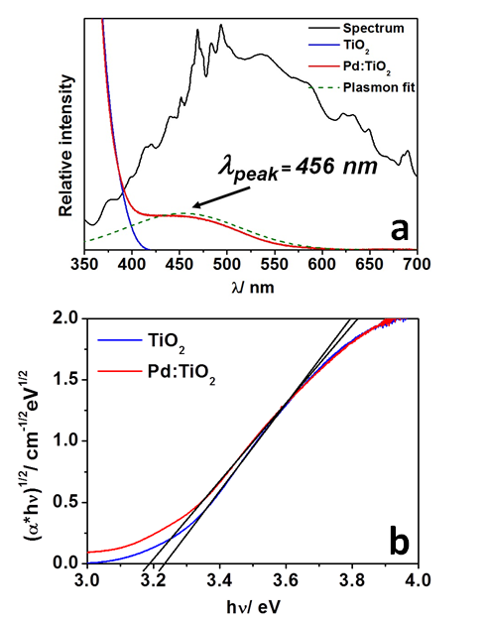
Figure 2 Normalized absorption specrtra of DR measurements of Pd:TiO₂ compared with P25 a) and energy band gap calculation from the Tauc plot b) where the extinction coefficient α is approximately the Kubelka-Munk function and is plotted against the energy of incident photons in eV
The onset of absorption for P25 is in agreement with that of the literature (~ 390 nm) and the band gap was estimated to be 3.23 eV. In contrast to the sharp absorption of P25, the Pd:TiO2 exhibits a broad absorption into the visible region with the peak centered at 456 nm and an estimated energy band gap of 3.19 eV. This lower value of the band gap is significant as it shows that electron excitation within Pd:TiO2 can occur at longer wavelengths compared with P25
In addition, a well-defined absorption peak observed during diffuse reflectance measurements is a characteristic feature of the LSPR of certain metal NPs such as that of Au and Ag plasmons. The LSPR effects of Pd nanoparticles is known, however, these studies have usually been confined to discrete nanoparticles and the LSPR effect of supported Pd is less well documented. The absorption peak measured for the Pd:TiO₂ catalyst is attributed to the LSPR effect of the Pd NPs and thought to be the source of the increase in optical response of the system.
On account of the increased light harvesting potential of Pd:TiO₂ we investigated whether this directly translated to an increase in the photocatalytic efficiency of the system. This was done by testing the efficiency of the catalyst in the photodecolourisation of RhB under simulated sunlight and using optical filters to block regions of the spectrum and determine the activity of the catalyst under these conditions. The irradiance value from the solar simulator was adjusted when using the optical filters to compensate for the reduction in transmittance of photons. For each filter used, the power of the solar simulator was adjusted to match the irradiance value of the region of interest to the same value as when no filter was used. This ensured that there was no loss of irradiation intensity at the incoming regions.
The decolorization of RhB in the presence of Pd:TiO₂ was monitored by measuring the change in the absorbance value of the dye over time at λ_{max} = 554 nm following the Beer-Lambert law. This was repeated over several experiments using optical filters to block irradiation at λ > 400 nm (VIS block) and also at λ < 400 nm (UV block) where P25 was used as a reference. The catalysts and optical filters used, as well as the calculated t_{1/2} and rate of reaction values of RhB are given in table 1.
Table 1 The photocatalytic activity of Pd:TiO₂ compared with P25.
Photocatalyst | Filter used | t_{1/2}/ minutes | k_{app}/  minute⁻¹
TiO₂ | No filter | 9.4 | 0.073
 | VIS block | 19.3 | 0.04
 | UV block | 63.6 | 0.011
Pd-TiO₂ | No filter | 0.5 | 1.410
 | VIS block | 3.1 | 0.226
 | UV block | 8.5 | 0.078

The decolorization pathway and mechanism for the degradation of RhB has been reported elsewhere³⁵⁻³⁷ for TiO₂ based catalysts and it is thought that the degradation of RhB in the presence of the Pd:TiO₂ co-catalyst undergoes a similar pathway.
The lowest t_{1/2} value was measured for the Pd:TiO₂ catalyst under full solar irradiation. This value constitutes a 19 fold increase in activity compared with P25 under the same conditions. For visible irradiation the reaction rate of P25 was significantly reduced and was the lowest value of any catalyst for the conditions tested. The minimal activity observed for P25 under these conditions is attributed to the photo-assisted oxidation (PAO) of the dye. Since RhB absorbs light at 554 nm, this stimulation can lead to the transfer of an excited electron to the conduction band of TiO₂. The electron is then free to react with adsorbed species and the RhB may decompose via this mechanism. This is likely to be occurring in tandem with the photocatalytic oxidation of RhB in the presence of an active catalyst.
Under visible irradiation Pd:TiO₂ gave the highest t_{1/2} value for this new catalyst but showed a marginally higher rate of reaction compared with P25 under full solar illumination. At λ < 400 nm irradiation, the rate of P25 was reduced compared with its activity in solar conditions, while the Pd:TiO₂ catalyst also showed an intermediate value compared to its activity under full spectrum and visible spectrum irradiation. This effect was attributed the cut-off point of the optical filter that blocked some super band gap photons and thus reduced the reaction rate under UV conditions for both P25 and the new catalyst. The decolorization rate profiles for P25 and Pd:TiO₂ in the RhB decolorization experiments are shown in figure 3 (A comparison of the catalytic performance of this catalyst compared with other Pd-TiO₂ systems can be found in the SI).
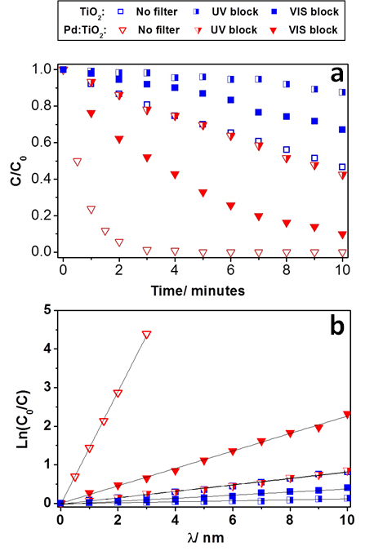
Figure 3 Decolorization profiles of RhB under different regions of the spectrum a) normalized decolorization curves of P25 and Pd:TiO₂, b) logarithmic plots used to calculate the rate constant for the degradation reactions

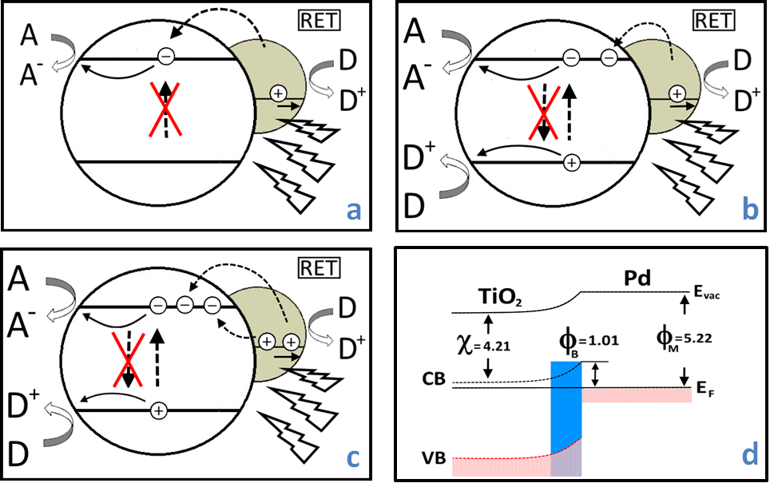
Figure 4 Schematic representation of the reaction mechanisms thought to be occurring on during photocatalyst excitation by different regions of the spectrum where a) shows that excited electrons can overcome the Schottky barrier and transfer to the TiO₂ via resonant energy transfer (RET) from Pd NP promoting oxidation on the Pd under visible light irradiation b) Under UV irradiation, charge carriers are generated within TiO₂. The LSPR effect of the Pd also extends into the UV region where RET can occur leading to charge transfer to TiO₂ and oxidation on Pd c) the combination of these processes results in the enhanced photocatalytic activity of the co-catalyst system d) shows the Schottky barrier formed at the metal/ semiconductor interface and the values of χ, ϕ_{B} and ϕ_{M}, which are the TiO₂ electron affinity, barrier height and the Pd work function, respectively.

The Pd:TiO₂ catalyst was shown to outperform P25 under all the experimental conditions. A significant activity for this catalyst was observed under visible light irradiation showing that the Pd NPs extended the photo-activity of P25 into the visible region. However, it was found that a combination of both UV and visible light irradiation was necessary for the catalyst to reach the highest rate of reaction.
The optical filters were used in this investigation to highlight the activity of the catalyst in the visible region by effectively stopping charge carrier excitation in the TiO₂ support via blocking the transmission of super band gap photons with the UV cut-off filter. As TiO2 does not absorb photons at λ > 390 nm, the photo-excited charge carriers required for redox reactions are not generated. However, the presence of the Pd NPs was found to enhance the optical response of the catalyst up to ~ 600 nm, which constitutes an increase of 8% compared with P25. This altered absorption profile improved the photocatalytic activity of Pd:TiO₂ in the visible region and may be explained in terms of the LSPR effect of the Pd NPs as depicted in figure 4.
It has been reported that self-supported Pd nanocubes of diameters of 10 nm do not exhibit LSPR above at wavelengths 300 nm.³⁸ However, Kelly et al. showed that a strong metal-support interaction for supported Ag nanoparticles exists. This was found to result in a red-shift of the LSPR peak wavelength by up to 100 nm and proportional to the refractive index of the substrate.³⁹ The LSPR for supported Pd on TiO₂ has been reported for nanoparticles ranging from 17 nm to 27 nm to be in the visible region²⁹ and we believe a similar metal-support effect is responsible for the increase in light harvesting potential of our catalyst and the corresponding enhancement in its photocatalytic activity.
Two main processes are thought to be taking place on the catalyst surface. One mechanism is attributed to the LSPR effect where the incident irradiation can excite some of the electrons in the Pd sufficiently to overcome the Schottky barrier at the semiconductor/ metal interface and transfer ‘hot electrons’ to the TiO₂ (figure 4a). This phenomenon has been reported for TiO₂ supported Au nanoparticles⁴⁰ and may explain some of the increase in activity of the Pd:TiO₂ catalyst. Furthermore, the height of the Schottky barrier (ϕ_{B}) formed at the Pd/TiO₂ junction was calculated to be 1.10 eV (figure 4d and details in SI), which makes it theoretically possible for visible irradiation to excite electrons above this value and transfer to the CB of TiO₂. It has also been suggested that the ‘hot holes’ remaining in the metal NP can react with adsorbed species and further increasing the reactivity of the co-catalyst.⁴¹
The other mechanism occurs under UV irradiation where electron excitation within the TiO₂ occurs, generating the charge carriers required for redox on the surface (figure 4b). Hot electrons may also be excited from the Pd NP to the CB of TiO₂ and thus the activity of the catalyst is further increased by the combination of these processes. It is also possible that charge recombination is suppressed, where the Pd NPs on the surface of the TiO₂ can act as electron sinks, thus increasing carrier lifetimes.
Under full solar irradiation both mechanisms are thought to be occurring simultaneously (figure 4c) and this results in the highest rate of reaction. It was also found that that the combination of the two processes had a beneficial synergistic effect on the photocatalytic activity.
In experiments measuring the activity of the catalyst in the decolorization of dye, we showed that the activity of Pd:TiO₂ changed significantly under different irradiation conditions and propose that the changes in the rates of reaction are due to separate mechanisms occurring under stimulation by different regions of the spectrum. The separation and combination of the two mechanisms was shown experimentally via the use of optical band pass filters and calculations of the height of the Schottky barrier from band gap measurements confirmed it was theoretically possible for ‘hot electron’ transfer to the CB of TiO₂ under visible light conditions. At full solar irradiation the photocatalytic activity of Pd:TiO₂ was found to be greater in terms of the reaction rate than the sum of the reaction rates under visible and UV excitation suggesting a beneficial synergistic effect to be taking place. In solar conditions, the activity of the Pd:TiO₂ catalyst showed a 19 fold improvement on the activity of commercially available TiO₂. This work adds further support to the beneficial properties of supported transition metals as co-catalysts in efficient light harvesting systems in the visible region for environmental remediation.
ASSOCIATED CONTENT
Supporting Information Detailed catalyst synthesis and dye degradation procedures with calculation of half-life of degradation and rate constant values; raw XPS, XRD, DR UV-VIS data; absorption increase calculation; figure of optical filter cut-off points; plasmon fit calculation and comparison of catalyst with other Pd-TiO₂ systems in the literature . This material is available free of charge via the Internet at http://pubs.acs.org.
AUTHOR INFORMATION
Corresponding Author
* Email: s.c..dunn@qmul.ac.uk
* Email: igor.larrosa@manchester.ac.uk

Author Contributions
The manuscript was written through contributions of all authors. / All authors have given approval to the final version of the manuscript. / †‡These authors contributed equally.
Notes
The authors declare no competing financial interest.
ACKNOWLEDGMENT
The authors would like to thank the Engineering and Physical Sciences Research Council (EPSRC) for supporting this work.
ABBREVIATIONS
LSPR localized surface plasmon resonance; RET resonant energy transfer.
REFERENCES
(1) Chong, M. N.; Jin, B.; Chow, C. W. K.; Saint, C. Water Res. 2010, 44 (10), 2997–3027.
(2) Prairie, M. R.; Evans, L. R.; Stange, B. M.; Martinez, S. L. Environ. Sci. Technol. 1993, 27 (9), 1776–1782.
(3) He, H.; Liu, C.; Dubois, K. D.; Jin, T.; Louis, M. E.; Li, G. Ind. Eng. Chem. Res. 2012, 51, 11841–11849.
(4) Hoffmann, M. R.; Martin, S. T.; Choi, W.; Bahnemannt, D. W. Chem. Rev. 1995, 95 (1), 69–96.
(5) Wold, A. Chem. Mater. 1992, 5 (3), 280–283.
(6) Hashimoto, K.; Irie, H.; Fujishima, A. Jpn. J. Appl. Phys. 2005, 44 (12), 8269–8285.
(7) Kamat, P. V. J. Phys. Chem. C 2012, 116 (22), 11849–11851.
(8) Chen, X.; Mao, S. S. Chem. Rev. 2007, 107 (7), 2891–2959.
(9) Kumar, S. G.; Devi, L. G. J. Phys. Chem. A 2011, 115 (46), 13211–13241.
(10) Linsebigler, A. L.; Lu, G.; Yates, J. T. Chem. Rev. 1995, 95 (3), 735–758.
(11) Fujishima, A.; Honda, K. Nature 1972, 238, 37–38.
(12) Roy, S.; Varghese, O.; Paulose, M.; Grimes, C. ACS Nano 2010, 4 (3), 1259–1278.
(13) O’Regan, B.; Grätzel, M. Nature 1991, 353 (6346), 737–740.
(14) Wang, C.-M.; Gerischer, H.; Heller, A. J. Am. Chem. Soc. 1992, 114 (17), 5230–5234.
(15) Zhao, J.; Wu, T.; Wu, K.; Oikawa, K. Environ. Sci. Technol. 1998, 32 (16), 2394–2400.
(16) Wu, T.; Liu, G.; Zhao, J.; Serpone, N. J. Phys. Chem. B 1998, 5647 (1), 5845–5851.
(17) Aarthi, T.; Madras, G. Ind. Eng. Chem. Res. 2007, 7–14.
(18) Liu, Z.; Hou, W.; Pavaskar, P.; Aykol, M.; Cronin, S. B. Nano Lett. 2011, 11, 1111–1116.
(19) Kuvarega, A. T.; Krause, R. W. M.; Mamba, B. B. J. Phys. Chem. C 2011, 115, 22110–22120.
(20) Zhang, N.; Liu, S.; Fu, X.; Xu, Y. J. Phys. Chem. C 2011, 2, 9136–9145.
(21) Liu, R.; Wang, P.; Wang, X.; Yu, H.; Yu, J. J. Phys. Chem. C 2012, 116 (33), 17721–17728.
(22) Wang, Q.; Chen, C.; Zhao, D.; Ma, W.; Zhao, J. Langmuir 2008, 24 (14), 7338–7345.
(23) Choi, W.; Termin, A.; Hoffmann, M. R. J. Phys. Chem. 1994, 98 (51), 13669–13679.
(24) Lu, X.; Rycenga, M.; Skrabalak, S. E.; Wiley, B.; Xia, Y. Annu. Rev. Phys. Chem. 2009, 60, 167–192.
(25) Kochuveedu, S.; Kim, D. D. J. Phys. Chem. C 2012, 116 (3), 2500–2506.
(26) Cushing, S. K.; Li, J.; Meng, F.; Senty, T. R.; Suri, S.; Zhi, M.; Li, M.; Bristow, A. D.; Wu, N. J. Am. Chem. Soc. 2012, 134, 15033–15041.
(27) Hutter, E.; Fendler, J. H. Adv. Mater. 2004, 16 (19), 1685–1706.
(28) Noguez, C. J. Phys. Chem. C 2007, 111 (10), 3806–3819.
(29) Leong, K. H.; Chu, H. Y.; Ibrahim, S.; Saravanan, P. Beilstein J. Nanotechnol. 2015, 6, 428–437.
(30) Akpan, U. G.; Hameed, B. H. J. Hazard. Mater. 2009, 170 (2-3), 520–529.
(31) Zhang, Q.; Lima, D. Q.; Lee, I.; Zaera, F.; Chi, M.; Yin, Y. Angew. Chemie - Int. Ed. 2011, 50 (31), 7088–7092.
(32) Yu, K.; Yang, S.; He, H.; Sun, C.; Gu, C.; Ju, Y. J. Phys. Chem. A 2009, 113 (37), 10024–10032.
(33) Campelo, J. M.; Luna, D.; Luque, R.; Marinas, J. M.; Romero, A. a. ChemSusChem 2009, 2 (1), 18–45.
(34) Nørskov, J. K.; Ressmeisl, J.; Logadottir, a.; Lindqvist, L.; Kitchin, J. R.; Bligaard, T.; Jonsson, H. J. Phys. Chem. B 2004, 108, 17886–17892.
(35) Cui, Y.; Goldup, S. M.; Dunn, S. RSC Adv. 2015, 5 (38), 30372–30379.
(36) Li, J.; Ma, W.; Chen, C.; Zhao, J.; Zhu, H.; Gao, X. J. Mol. Catal. A Chem. 2007, 261 (1), 131–138.
(37) Li, J.; Ma, W.-H.; Lei, P.-X.; Zhao, J.-C. J. Environ. Sci. (China) 2007, 19 (7), 892–896.
(38) Xiong, Y.; Chen, J.; Wiley, B.; Xia, Y.; Yin, Y.; Li, Z. Y. Nano Lett. 2005, 5 (7), 1237–1242.
(39) Kelly, K. L.; Coronado, E.; Zhao, L. L.; Schatz, G. C. J. Phys. Chem. B 2003, 107 (3), 668–677.
(40) Sá, J.; Tagliabue, G.; Friedli, P.; Szlachetko, J.; Rittmann-Frank, M. H.; Santomauro, F. G.; Milne, C. J.; Sigg, H. Energy Environ. Sci. 2013, 6 (12), 3584–3588.
(41) Clavero, C. Nat. Photonics 2014, 8 (2), 95–103

Insert Table of Contents artwork here

