Short-term side-effects of brain MR examination at 7 T: a single-centre experience
M. Cosottini • D. Frosini • L. Biagi • I. Pesaresi •
M. Costagli • G. Tiberi • M. Symms • M. Tosetti

Abstract
Objective To study patient tolerability of brain imaging that employs an ultrahigh field (7 T) MR system
Methods We examined 180 subjects that underwent brain MR examination at 7 T. A tolerability test consisting of two parts (during patient table motion and during the examination) was administered to all subjects in order to monitor their discom- fort. The scores range from 0 to 5 for the first part, and from 0 to 10 for the second part, the total score of each subject therefore ranging from 0 (no side effects reported) to 15 (lowest tolerability)
Results A total of 51 % of subjects reported at least one side effect but all were mild in intensity and did not require examination interruption. No serious adverse event was re- ported. The total score (mean ± standard deviation) was 1.1±
1.5 out of 15 (mean score 0.4±0.7 out of 5 during patient table motion and 0.7±1.1 out of 10 during MR).
Patient discomfort was not related to gender or health status, but it was reduced with time after system installation
with increasing operator experience in performing UHF MR examinations.
Conclusions Ultrahigh field MRI is well tolerated without excessive discomfort to subjects.

Key Points
- 7-T MRI is well tolerated with low incidence of side effects
- The subjects’ discomfort during 7-T MRI is reduced as the operators’ experience increases
- 7-T MRI is practicable in healthy subjects and patients with neurodegenerative diseases

Keywords Magnetic resonance imaging . Tolerability . Side effects . 7T . Prospective study

Introduction

The number of ultrahigh field (UHF) MR systems for human

studies installed around the world is currently about 40, the

M. Cosottini (*)
Department of Translational Research and New Technologies in Medicine and Surgery, University of Pisa, Via Paradisa 2, Cisanello, 56124 Pisa, Italy
e-mail: mircocosottini@libero.it

D. Frosini
Unit of Neurology, Santa Chiara Hospital, Pisa, Italy
L. Biagi : M. Tosetti
IRCCS Stella Maris, Pisa, Italy

I. Pesaresi
Unit of Neuroradiology, Santa Chiara Hospital, Pisa, Italy
M. Costagli : G. Tiberi
IMAGO7 Research Foundation, Pisa, Italy

M. Symms
General Electric ASL Scientist (EMEA), Pisa, Italy
majority employing a static field of 7 T.
To date, UHF MR equipment is provided in a research environment as an investigational device rather than as a medical device in a clinical setting. Local health authority guidelines and authorization procedures for using UHF MR systems vary from country to country. Apart from the desired diagnostic gain, the prerequisite for UHF MR acceptance in transferring UHF MRI (>3 T) into clinical diagnostic workup is a low rate of side effects. While UHF MRI is on course to become a clinical reality for specific situations [1], static field safety is not uniformly regulated because, for example, clini- cal systems are considered “without significant risk” up to4T in Europe [2], and up to 8 T in the USA [3].
In contrast to the extensive experience concerning conven- tional magnetic field strength, the objective and subjective side effects at UHF are less well known and the collection of

data during ongoing research is thus essential. For this reason, the International Society for Magnetic Resonance in Medicine (ISMRM) [4] recently constituted a UHF safety list for collecting data regarding safety and side effects among UHF users in order to support the transition of 7-T MRI into the clinical setting.
Short-term effects to UHF exposure are expected to be related to the effects induced by the static magnetic field, while gradient fields should play only a minor role in tolera- bility. An important difference between a 7-T system and lower field systems is the higher levels of electric currents induced through the patient body moving within the static magnetic field [5]. Patients exposed to a conventional static magnetic field have been previously shown to report short- term side effects such as vertigo, nausea and metallic taste [6]. Another aspect that should be taken into account at UHF is the increase of radio-frequency (RF) energy deposition in the form of heat [7, 8]. The specific absorption rate (SAR) pro- vides a measure of the power absorbed in tissue per unit mass and it can cause an increase in body temperature. Temperature measurement data collected at lower fields (0.5–3 T) showeda temperature increase that can reach 0.5 °C [9, 10], while electromagnetic-based simulations performed at 7 T suggest a temperature increase of up to 1 °C [11]. During MR exam- inations, SAR exposure must be monitored to make sure it remains below the regulatory limits imposed by law (IEC EN 60601-2-33), in order to guarantee the thermal safety of the patient [12] by ensuring the maximum temperature in the head is lower than 38 °C.
The tolerability of UHF MR examinations might be influ- enced by variations in design and installation setup of the magnet, as well as by differences among types of gradient and RF coils provided by different manufacturers. Until now, subjective short-term effects of UHF are described in studies that use Siemens [13] or Philips [14] MR equipment; we report the experience of our centre, in which a GE Healthcare MR system is installed. The purpose of this study was to evaluate the subjective tolerability of UHF MRI by analysing in a quantitative and qualitative manner the data obtained from a questionnaire on tolerability/side effects collected during the examinations of a sample of healthy volunteers and patients included in research protocols performed at our centre.

Materials and methods

UHF MR acquisitions were performed at the Imago 7 Foun- dation, Pisa, Italy, using a passively shielded GE MR950 7-T whole body system (GE HealthCare, Milwaukee, WI, USA) equipped with a high-performance gradient system (50 mT/m maximum amplitude and 200 mT/m/ms slew rate) and a dedicated head coil system consisting of a 2-channel transmit coil and a 32-channel receive array coil (Nova Medical). The
dimensions of the system bore are 60 cm diameter and 3.5 m length whilst the head coil is 18.5 cm wide (diameter) and 21 cm long.
All the experiments on human adults performed at the Imago 7 Foundation have adopted a “tolerability protocol”
[15] that monitors objective as well as subjective side effects at 7 T. Specifically, we evaluated the data obtained from a questionnaire on tolerability/side effects collected during the UHF examinations on a sample of healthy volunteers and patients pertaining to two research projects (RF-2009- 1546281: Clinical impact of ultra high-field MRI in neurode- generative diseases diagnosis; IMAGO7-001-2012: Refine- ments of 7 MR techniques for research on humans) that were authorized by the Ministry of Health of Italy and approved by the competent ethical committee.
The team involved in conducting the MR protocol and directly interacting with patients included two neuroradiolo- gists (22 and 9 years of experience with MR on human subjects), two neurologists (experience 6 and 4 years), one physicist (13 years), one engineer (9 years) and one nurse (11 years).
One hundred and eighty three patients were enrolled in the study. Three of them did not start the examination because of claustrophobic reactions.
MR examinations were therefore performed on 180 sub- jects (101 male, 79 female; mean age 43±17 years, range 18– 84) comprising 105 healthy volunteers (62 male, 43 female; mean age 40±14 years, range 18–74) and 75 patients affected by neurodegenerative disorders (extrapyramidal disorders and motor neuron diseases) (39 male, 36 female; mean age 61± 12 years, range 34–84)
All patients received an information brochure regarding the specific study to which they gave their written informed consent. All the subjects were informed by a physician about pos- sible side effects (claustrophobia, dizziness, metallic taste, noise, phosphenes and possible muscle twitching), and, in particular, it was specified that the examination had exclusive- ly a research purpose and authorization, and therefore it would not yield any individual diagnostic information. All the sub- jects that gave their signed informed consent were carefully screened for MR contraindications, such as permanent medi-
cal devices or metal in the body.
All subjects were positioned in the “head-first supine” position for studying the brain. Initially, the patient’s head was located immediately outside the magnet bore, where the static magnetic field is approximately 2 T. The patient was then introduced inside the magnet bore very slowly at a speed limited by the manufacturer (table speed, 2 cm/s; distance between landmark and isocentre, 180 cm; time to reach the magnet isocentre, 1 min 30 s; magnetic field difference from initial position to magnet isocentre, 7 T–2 T=5 T) in order to maximally reduce the magneto-dynamics effects on the laby- rinthine fluids [16] and minimize side effects.

All participants received earplugs (Bilson 303 L with noise reduction 29 dB) to limit the acoustic noise and two pads covering the ears were placed within the RF coil cage. In all cases heartbeat and respiration frequency were monitored with dedicated peripheral and respiratory gating devices supplied by the manufacturer. During MR examination, the subject was able to communicate with the operator at the console by using a two-way speaker system and squeezing a rubber bulb con- nected to an acoustic alarm. Moreover, the subject was super- vised directly by visual observation through an RF-shielded window and indirectly with two video-cameras situated at both ends of the magnet bore.
The total acquisition time was conservatively established to be approximately 1 h (range 55–70 min). The types of se- quences used for each subject are not reported in detail for each subject; however, they included gradient echo (GRE), echo planar (EPI), fast spin echo (FSE), inversion recovery (SE-IR or FSE-IR), spoiled gradient echo (SPGR) and time of flight (TOF) angiography.
Immediately after the examination was completed, subjects were asked to fill in the tolerability/side effects questionnaire. The data collection for statistics was done by assigning a score for each item and generating a final score. The possible side effects were divided into two groups, one related to the moving phase while the bed moved through the magnet, and the other one related to the static phase of the examination period. The score for the two different phases of the experi- ment was assigned as follows: in the moving phase there are five items (vertigo, nausea, metallic taste, phosphenes, electric sensation); we assigned a value of 0 to the answer NO, and 1 to the answer YES. Therefore, for the moving phase, the score ranged between a minimum score of 0, indicating that no side effects occurred, to 5. In the static phase there are 10 items (pain, claustrophobia, palpitation, discomfort, troublesome noise, vertigo, nausea, metallic taste, phosphenes, electric sensation) and similarly to the moving phase we assigned a value of 0 to the answer NO, and 1 to the answer YES. Therefore for the static phase the score ranged between a minimum of 0, indi-
cating no side effects, and 10.
In the last part of the questionnaire, subjects that previously underwent MR examination at conventional field strength had to express a subjective opinion concerning differences in the tolerability of the MR examinations in terms of more or less comfortable.
The significance of differences among side effects in pa- tients and healthy subjects, males and females, was tested with the Mann–Whitney U test. A p value less than 0.05 was considered significant. Data were collected in about
18 months of activity, and retrospectively divided into six time periods of 3 months each. Variation of side effects occurring with time was also analysed for each 3-month period and any difference between each period was assessed with the Student t test.

Results

Among the 180 subjects that were examined, 92 (51 %) reported at least one side effect (mean total score 1.1±1.5), but none of them required examination interruption. No seri- ous adverse event was reported.
Mean side-effect score for MR examination was 0.4±0.7 out of 5 for the moving phase, and 0.7±1.1 out of 10 for the static phase.
The incidence of each adverse effect during the bed motion and during the static phase of acquisition is reported in Figs. 1 and 2, respectively.
During the movement of the bed inside the scanner, the most frequent adverse effects were vertigo (25.6 %) and the sensation of metallic taste (7.2 %).
During the static phase of the MR examination, the per- centage rate of experiencing vertigo and nausea dropped (8.9 % and 2.2 % respectively), while the other side effects increased, but were always less than 10 %. During the imaging period, the most frequent adverse effect was troublesome noise, reported by 13.9 % of subjects.
We report that the incidence of total side effects is not significantly different in healthy subjects with respect to

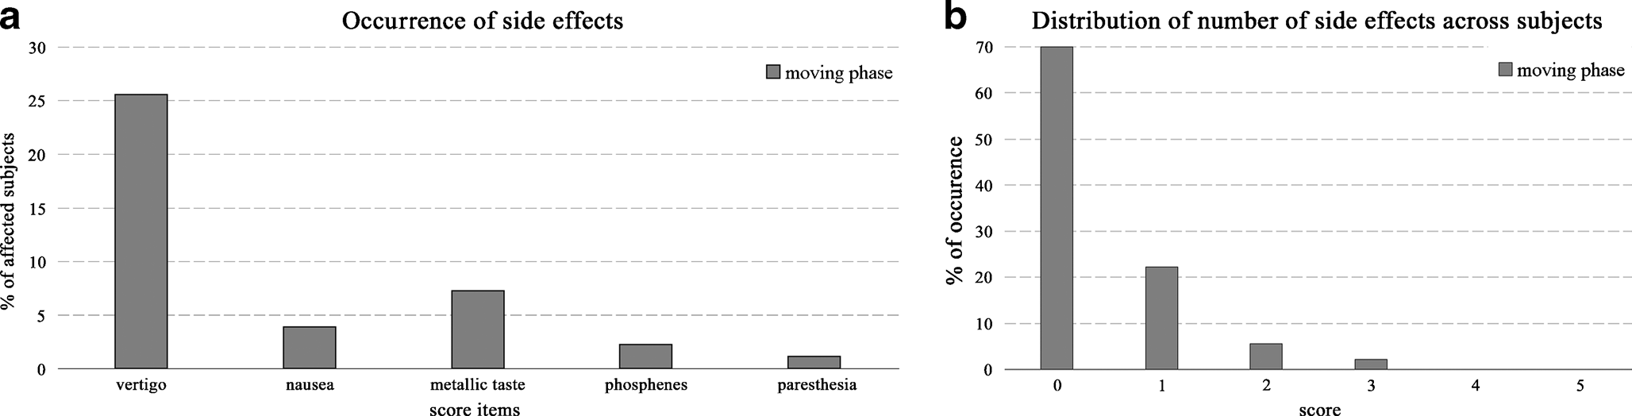
Fig. 1 Percentages of side effects (a) and distribution of number of side effects across subjects (b) perceived while advancing to examination

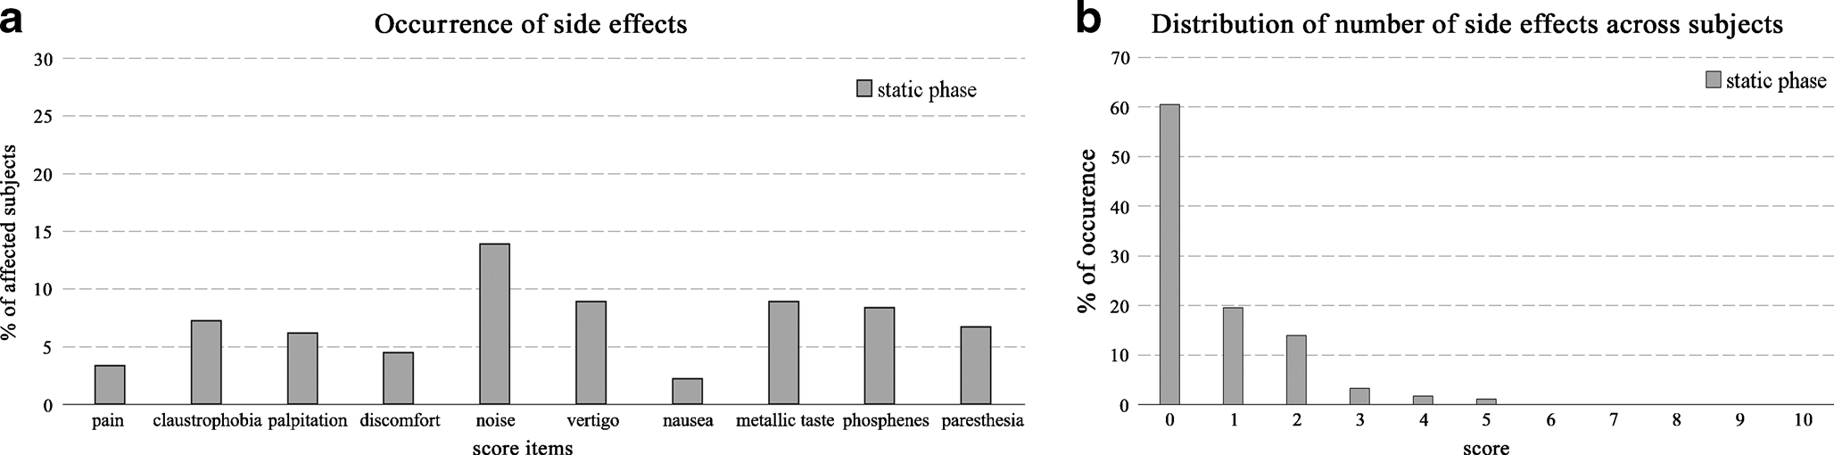
Fig. 2 Percentages of side effects (a) and distribution of number of side effects across subjects (b) perceived during the examination

patients (Z=1.27, p=0.21), nor in men with respect to women (Z=−0.35, p=0.73).
Comparing subjects who reported at least one side effect to those who were unaffected, the former were younger (p<0.001, 37±14 years vs 49±18 years).
In Fig. 3 we report the distribution of the side effects appearance as a function of time since the 7-T facility was operational. The global number of adverse effects appeared to be reduced over time. In particular, after 6 months of MR acquisitions on human subjects, we noticed a significant re- duction of side effects: the first 6-month period significantly differs from the following period (t test p=0.009).
The comparison with MR examinations conducted at me- dium (1.5 T) and high (3 T) field strength was not possible in 52 subjects that had never previously undergone MR investi- gations. In 128 patients, the comparison among magnets with different field intensities was judged identical in 82.8 % (106 subjects), more comfortable in 6.3 % (8 subjects) and less comfortable in only 10.9 % of cases (14 subjects). Out of the subjects that considered the UHF MR examination to be worse than previous MR experiences, seven attributed the cause to the noise, two to vertigo and five to the excessive length of the examination. Only 3.9 % of the total number of subjects (seven subjects: two patients and five healthy volun- teers, three male, four female; mean age 37±13 years, range
21–58 years; mean tolerability score 2.9±2, range 0–7) were not willing to volunteer again for another examination at 7 T since the examination was considered uncomfortable by four of them (2.2 %), while the others would not repeat the exam- ination because of the excessive length of the session.

Discussion

The main result of our single-centre study was the low inci- dence of side effects during UHF MR examinations. None of the subjects terminated the examination prematurely. The three patients that did not begin the examination were affected by claustrophobic reaction and not by UHF-related distur- bances. The 7-T MR examination was judged to be comfort- able overall by 96.7 % of the examined subjects.
Out of seven subjects that would not repeat the UHF MR examination, three subjects would refuse because of the long acquisition time: this is not always considered an important cause of discomfort [14]. This side effect is not inherent to UHF examinations but it depends on the protocol design, and could be reduced in future clinical applications. Two patients would not repeat the examination because of the loud noise during image acquisition. This type of problem could be attenuated by better patient positioning and padding, by the

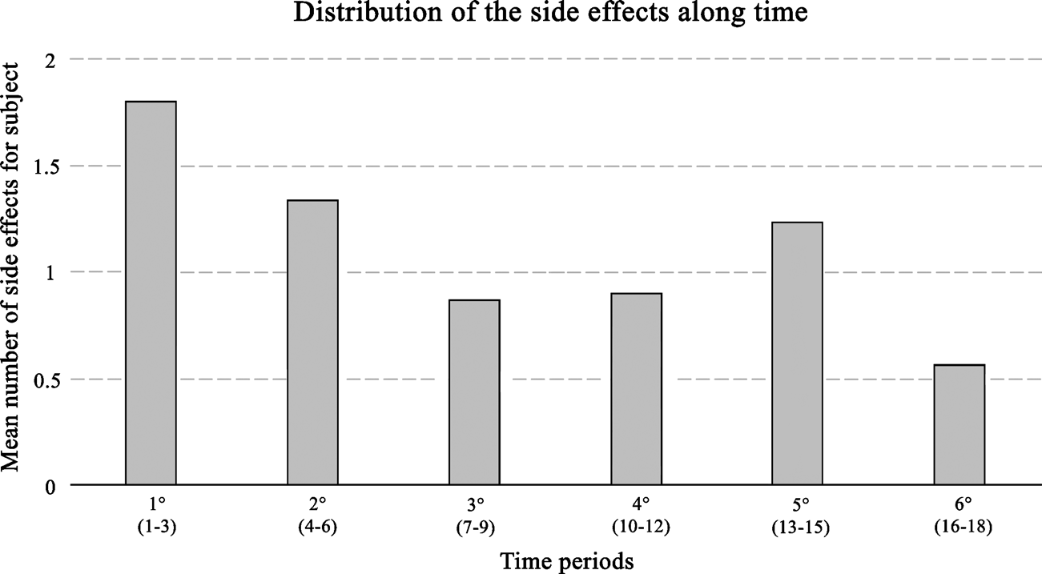
Fig. 3 Mean number of side effects during the first 18 months of acquisition at Imago 7

application of more effective earplug devices, and by design- ing MR sequences that produce less noise. Excluding these five cases of non-toleration left only two patients (1.1 %) that were unwilling to repeat the examination, which is in line with previous experiences [13].
The observed side effect occurrence is low for both moving and rest phases, approaching about 95 % of the maximal rate of tolerability. No major adverse events have been reported to date. The most frequently reported side effect was dizziness while the bed was moving inside the scanner bore. Vertigo was the most frequently mentioned adverse sensation in pre- vious studies at 7 T [14] and was more frequently reported than at 1.5 T [8]. The pathophysiology of the magnetic-field- related vertigo is under evaluation but it could result from both magnetic susceptibility differences between vestibular organs and surrounding fluid, and induced currents acting on the
vestibular hair cells [16].
A reduced postural stability with increased exposure to static and variable magnetic fields in healthy volunteers has been objectively measured in the literature [17].
Since previous observations demonstrated that only mov- ing subjects in a static magnetic field reported vestibular- related symptoms [16] the discomfort could be limited by decreasing the movement within the magnet [18] or, as in our setting, by slowing down the bed speed in the magnet.
A further unpleasant sensation during UHF MR examina- tion is the noise.
While Lorenz, or “motor”, forces are known to increase with magnetic field strength [19], the overall acoustic noise generated by the gradient coils can be reduced by careful design of the associated physical structures. This allowed the manufacturers to keep the acoustic noise within the safety guidelines [20] even for the loudest sequences. However, out of the subjects who considered the UHF MR examination to be less comfortable than those at lower field strength (10.9 % of subjects who underwent lower field scans), 50 % identified acoustic noise as the major cause of discomfort. Although it is difficult to make a direct subjective comparison of noise in examinations acquired at different times, the dis- comfort due to noise has been reported also in previous experiences of direct comparison between 7-T and 1.5-T magnets [13]. Although no patient requested, or considered requesting, the interruption of the UHF examination owing to intolerable noise, an RF coil geometry at 7 T that would allow the introduction of additional protective earphones or pads would be desirable. The introduction of silent sequences could be even more advantageous [21].
The incidence of the sensation of metallic taste differs significantly in the literature ranging from less than
5 % [22] to 11 % [14]. In our study, this unpleasant sensation was reported by 8 % of the subjects and does not significantly differ between the bed moving phase and imaging periods.
In addition to what was reported in previous work, we tested whether subgroups of subjects experienced different incidence of side effects; in particular we compared patients and healthy volunteers and demonstrated a comparable rate of adverse effects during the UHF examination. While in the largest study on tolerability of UHF [8] patients and healthy volunteers were included but not compared, we have shown that the UHF MR tolerability is satisfactory for both healthy subjects and patients with different grades of disability.
Moreover, it is generally accepted that besides the field- dependence of side effects, individual well-being [16] and nocebo effect (as the adverse effect produced by expectations)
- play an important role in the perception of discomfort. The role of the operators favouring acceptance of UHF exam- inations is not fully explored but a nocebo effect could simply be due to the mere communication of potential adverse effects in the informed consent process [24].
In our study we observed that the medical team confidence is a fundamental factor influencing the subjective tolerability of UHF MR examinations. Indeed the progressive reduction of subjective side effect occurrence over time suggests that the improved experience and confidence of the operators in informing the subjects and performing UHF examinations contributed to reduce their expectancy of complications and possibly reducing the nocebo effect and the subjective dis- comfort of patients. Our opinion is supported by the increased incidence of side effects in the fifth trimester of activity corresponding to the start of acquisition of a new group of patients (ALS) that were not previously examined. These severely affected patients probably in- crease our alertness, transiently enhancing the nocebo effect that returns in line with the learning curve in the last period of activity.
The present study includes a large proportion of patients (71 %) who previously underwent a lower field MR exami- nation. This potential bias may underestimate the number of claustrophobic reactions or other side effects when performing UHF MR examinations on the general population. However, considering that at present the UHF MR examination is an investigational procedure, which is normally performed fol- lowing a conventional MR examination, this bias can be considered a negligible effect. In these patients, the compari- son between UHF and lower field examinations may be questionable, because the examinations to be subjectively compared were conducted at different times; for all subjects the UHF MR examination was a very recent experience that occurred a few minutes before filling in the questionnaire, while the lower field examination might have occurred months or even years before. Moreover it cannot be guaran- teed whether, at the time of conventional MR examination, patients were systematically instructed about the MR protocol and potential adverse effects, similarly to how it was done for the UHF examination.

The general patient acceptance of UHF MR examinations in the current study does not differ from that reported when using magnets of other manufacturers with different settings and configurations. This study adds to the literature describing the number of subjects that underwent a 7-T UHF examina- tion with limited side effects, providing further evidence supporting the feasibility of 7-T UHF equipment in a clinical environment.

Conclusion

This single-centre study suggests that UHF MRI is practica- ble. It demonstrates the low incidence of side effects and concludes that UHF examinations are well tolerated without excessive discomfort requiring interruption of the examina- tion. In particular, the discomfort was similar to that experi- enced at lower field strengths.
Subjective tolerability in our population does not differ from that reported in other studies using 7-T MR equipment from different vendors, thereby providing further evidence supporting the acceptance of 7-T UHF MR systems in a clinical research environment.
We report that patient discomfort is not influenced by health status or gender, but is reduced with time from system installation with the increasing experience of operators who perform the UHF MR examinations.

Acknowledgments The scientific guarantor of this publication is Mirco Cosottini. Mark Symms, author of this manuscript, declares relationships with the following companies: General Electric Healthcare Systems. The others authors of this manuscript declare no relationships with any companies whose products or services may be related to the subject matter of the article. This study has received funding by the Italian Ministry of Health (RF-2009-1546281) and co-founded by the Tuscany Region. No complex statistical methods were necessary for this paper. Institutional review board approval was obtained. Written informed con- sent was obtained from all subjects (patients) in this study. Methodology: prospective, performed at one institution.

References

  - Knopp MV (2011) Clinical applications of ultra-high field 7T MR – moving to FDA/EU approval: potential clinical appli- cations for ultra-high field MR. Proc Intl Soc Mag Reson Med 19
  - International Electro Technical Commission (2002) Medical electri- cal equipment—Part 2–33: particular requirements for the safety of magnetic resonance equipment for medical diagnosis. IEC 60601-2-33
  - United States Food and Drug Administration (2003) Guidance for industry and FDA staff: criteria for significant risk investigations of magnetic resonance diagnostic devices. Center for Devices and Radiological Health, Rockville
  - International Society for Magnetic Resonance in Medicine (ISMRM) http://www.ismrm.org.
  - van Nierop LE, Slottje P, Kingma H, Kromhout H (2013) MRI- related static magnetic stray fields and postural body sway: a double-blind randomized crossover study. Magn Reson Med 70: 232–240
  - Schenck JF (2005) Physical interactions of static magnetic fields with living tissues. Prog Biophys Mol Biol 87:185–204
  - Kangarlu A, Robitaille P (2000) Biological effects and health impli- cations in magnetic resonance imaging. Concepts Magn Reson 12: 321–359
  - Collins CM, Li S, Smith MB (1998) SAR and B1 field distributions in a heterogeneous human head model within a birdcage coil. Magn Reson Med 40:847–856
  - Machata AM, Willschke H, Kabon B, Prayer D, Marhofer P (2009) Effect of brain magnetic resonance imaging on body core tempera- ture in sedated infants and children Br J Anaesth 102:385–389
  - Bryan YF, Templeton TW, Nick TG, Szafran M, Tung A (2006) Brain magnetic resonance imaging increases core body temperature in sedated children Anesth Analg 102:1674–1679
  - van Lier ALHMW, Kotte ANTJ, Raaymakers BW, Lagendijk JJW, van den Berg CAT (2012) Radiofrequency heating induced by 7 T head MRI: thermal assessment using discrete vasculature or Pennes’ bioheat equation. J Magn Reson Imaging 35:795–803
  - Collins CM, Liu W, Wang J, Gruetter R, Vaughan JT, Ugurbil K, Smith MB (2004) Temperature and SAR calculations for a human head within volume and surface coils at 64 and 300 MHz. J Magn Reson Imaging 19:650–656
  - Heilmaier C, Theysohn JM, Maderwald S, Kraff O, Ladd ME, Ladd SC (2011) A large-scale study on subjective perception of discomfort during 7 and 1. 5 T MRI examinations. Bioelectromagnetics 32:610–619
  - Versluis MJ, Teeuwisse WM, Kan HE, van Buchem MA, Webb AG, van Osch MJ (2013) Subject tolerance of 7 T MRI examinations. J Magn Reson Imaging 38(3):722–725
  - Frosini D, Pesaresi I, Biagi L, Dolce G, Costagli M, Tiberi G, Stara R, Tosetti M, Cosottini M (2013) Safety protocol for monitoring side-effects at 7 T. In: Proceedings of ISMRM workshop on ultra high field MRI, Noordwijk aan Zee, the Netherlands, 2–5 March 2013
  - Glover PM, Cavin I, Qian W, Bowtell R, Gowland PA (2007) Magnetic-field-induced vertigo: a theoretical and experimental in- vestigation. Bioelectromagnetics 28:349–361
  - van Nierop LE, Slottje P, van Zandvoort MJ, de Vocht F, Kromhout H (2012) Effects of magnetic stray fields from a 7 tesla MRI scanner on neurocognition: a double-blind randomised crossover study. Occup Environ Med 69:759–766
  - de Vocht F, van Drooge H, Engels H, Kromhout H (2006) Exposure, health complaints and cognitive performance among employees of an MRI scanners manufacturing department. J Magn Reson Imaging 23: 197–204
  - More SR, Lim TC, Li M, Holland CK, Boyce SE, Lee JH (2006) Acoustic noise characteristics of a 4 Telsa MRI scanner. J Magn Reson Imaging 23(3):388–397
  - International Electrotechnical Commission (2008) Medical electrical equipment-Part 2-33: particular requirements for the basic safety and essential performance of magnetic resonance equipment for medical diagnosis. IEC 60601-2-33
  - Hennel F, Girard F, Loenneker T (1999) “Silent” MRI with soft gradient pulses. Magn Reson Med 42:6–10
  - Theysohn JM, Maderwald S, Kraff O, Moenninghoff C, Ladd ME, Ladd SC (2008) Subjective acceptance of 7 Tesla MRI for human imaging. Magn Reson Mater Phys 21:63–72
  - Colloca L, Miller FG (2011) The nocebo effect and its relevance for clinical practice. Psychosom Med 73:598–603
  - Barsky AJ, Saintfort R, Rogers MP, Borus JF (2002) Nonspecific medication side effects and the nocebo phenomenon. JAMA 287(5): 622–627

