INFLUENCE OF GEOLOGICAL FORMATIONS ON mammal density and distribution (A CASE STUDY FROM goRNY ALTAI, RUSSIA)
RUNNING TITLE: GEOLOGY AND MAMMAL DISTRIBUTION

Alexander V. Shitov * ¹, A.V. Karanin¹, Rachel A. Grant²
1. Gorno-Altaisk State University, Gorno-Altaisk (Russia)
2. Faculty of Arts, Science and Technology, University of Northampton, UK
*corresponding author email: sav103@yandex.ru

Acknowledgements

Abstract
Aim
There has been little research on how the composition of underlying rock formation affects animal species’ distribution and abundance. The subject is worthy of consideration as it has been shown that ultrabasic and serpentine rocks in particular can give rise to plant biodiversity hotspots with a high level of endemism, and should be prioritized for conservation efforts. Corresponding studies of fauna are lacking. We aim to test the hypothesis that rock type affects mammal abundance and biodiversity.
Here we present a comparative analysis of the abundance of mammals and its relationship with geological composition in the area of Gorny Altai, a mountainous region in Russia.
We used GIS approaches to map the influence of rock types on mammal abundance, while holding other factors such as soil type, relief, etc. constant. The study reveals significant correlations between underlying geology and variation in mammal distribution even when other factors such as soil type, climate and vegetation are held constant.
Intrusive rocks were found to have the greatest impact on variation in mammal distribution whereas sedimentary and metamorphic rocks have almost no effect. A characteristic feature of magmatic formations is their clear geochemical specialization, i.e. certain geochemical anomalies (Fe, Cu, Au, Hg, Ag, etc.) are confined to intrusions. We suggest that geophysical fields (magnetic and electric fields) and geochemical anomalies associated with intrusive rocks may have an impact on the distribution and species composition of mammals, as well as geodynamic processes such as fault activity.

Key words
Animal distributions, Biodiversity, Geology, Geodynamic processes, Intrusive rocks, Mammals,

MAIN TEXT
Introduction

Geoecology, the study of interactions between the geosphere and ecosystems is a field of study which is under-represented in the current literature. Although there have been several studies looking at the effects of the geosphere on plant communities, similar studies on animal distribution are sparse. The ecology of serpentine soils derived from rocks high in ferromagnesian, or mafic minerals [Kruckeberg, 2002] has been relatively well characterized. Serpentine soils often give rise to highly specialized endemic species of vascular plants and very high biodiversity [Stevanović et al., 2003; Brady et al. 2005; Casazza at al, 2005], making them noteworthy for conservation purposes. It has been reported that in the Mediterranean, benthic communities are species-poor where the rocks have a high quartz content and differences in fish assemblages have been found between limestone and granite [Cattaneo‐Vietti et al. 2002) Guidetti & Cattaneo-Vietti 2002; Guidetti et al. 2004].

Geophysical factors which could influence ecosystems include geochemical and geophysical anomalies, inhomogeneity of the Earth’s crust: fault zones, accumulations of metal ores, underground water, changes in the exertion of rock, etc. These anomalies are of interest because in the case of geodynamic processes, such as degassing from faults animals are not necessarily adapted to them because of the rarity of their occurrence [Osipov, 1993; Kosinova et al., 2009; Nikolaev, 2014]. However, in the case of longstanding or more frequent anomalies, animals will have co-evolved with the geological landscape [Kirschvink et al, 1985]. The effects of the geological environment on public health (medical geology) are well documented [Selinus et al., 2005; Finkelman et al., 2007; Shitov, 2010, 2012; Rapant & Cvečkova 2014], so it is logical that animals could be similarly affected by both transitory and longterm geological effects.
In this research we carry out a correlational analysis using mammal abundance data obtained in earlier research and the results of quantitative analysis of the geochemical and geological composition of landscape records in the south-eastern Altai. Long term monitoring of the abundance, species composition and distribution of mammals was carried out as part of a zoological project run by The Institute of Systematics and Ecology of the Altai Republic, which provided the data used in this study.
This former analysis assessed the level of correlation between geological and geochemical landscape variables with quantitative characteristics of animal distribution. Mammal abundance would be expected to vary according to geochemical factors (such as soil types and soil minerals) but the prior analysis showed that correlation coefficients (Kendall’s Tau) between mammal abundance and geological data were double that of the correlation between mammal abundance and geochemical data. Consequently, we concluded that the influence of geological aspects of the landscapes on the distribution of mammals in the south-eastern Altai is higher than the comparable influence of the chemical composition of soils of these landscapes [Karanin & Shitov, 2006]. Based on the results of this smaller study we carried out a similar correlational analysis on a much larger scale, throughout the Altai mountains.
Methodology

The previous analysis

Data on the distribution of mammals in the landscapes of Gorny Altai has been previously collected by the Department of Zoology, Ecology and Genetics of Gorno-Altaisk State University and by Yu. P. Malkov (Table S1) Malkov & Belikov 2005)). The records are the result of extensive monitoring of mammal distribution from numerous sources over many years. Data collection methods are shown in the supplementary material and Table S2, but are outlined briefly here.
Malkov & Belikov [1995] extrapolated collected data to estimate the number and biomass of mammals in each landscape area. In this earlier study, the biomass of each species was calculated as the product of the number of each individual of that species multiplied by the average weight of the animal. Total mammal biomass was calculated by the sum of species’ biomass. Average mammalian masses were calculated from data on the abundance and average masses of each species based on the concept of K - and K-selection [see Begon, Townsend, Harper, 2006]. To calculate biodiversity in the South-Eastern Altai the Simpson biodiversity index was used as the main index, and the Shannon biodiversity index as an auxiliary [Karanin, 2004]. Additional indicators of community uniformity (uniformity of distribution of species) on Simpson and on Shannon (on density and biomass) were used. For the current analysis, extrapolated animal numbers / km² were used.

The study site and its characteristics

Gorny Altai is a region of Russia, located in the south of Western Siberia, bordering China and Kazakhstan (Coordinates: 82-90°E, 49-52.5°N) (Fig. 1). The area is characterized by a complex system of ranges, deep river valleys and wide mountainous troughs. Gorny Altai, which in turn is structurally included in the Western part of the Altai-Sayan folded region, is composed of a mosaic of blocks representing different age geosynclinal-folded systems [Dobretsov et al., 1993; Buslov et al, 1998].
The territory of the Altai Mountains is a complex folded system formed by Precambrian and Paleozoic strata intensively deployed in the Caledonian era of tectogenesis and the Hercynian era of tectogenesis (Fig.2).
In the post-Paleozoic, mountain-folded structures were destroyed and turned into a denudation plain (peneplain). Anticlinoria Gorny Altai (Holynska-Chuyskiy, talitskiy, etc.) is mainly composed of terrigenous flysch series of the upper Cambrian – lower Ordovician overlying Vendian-Cambrian ophiolites, siliceous-shale formation and presumably Precambrian metamorphic rocks, sometimes exposed to the surface (Fig. 2).
Superimposed troughs and grabens (the largest – Korgonsky) is made Moloss middle Ordovician – lower Silurian and early Devonian. The deposits are broken by late Devonian granites. Within the Altai Mountains, which has a Caledonian Foundation, widespread volcanic rocks of the plutonic Association of the middle Devonian-early Carboniferous and late Paleozoic granitoids. In Oligocene-Quaternary time, the territory experienced uplift associated with regional compression of the earth's crust caused by the convergence of its limiting lithospheric microplates (Jungar, Tuvan-Mongolian).
The formation of the mountain structure took place on the type of a large arch, which in the last stages of development was deformed by a system of breaks, resulting in a series of block morphostructures in the form of high ridges and troughs separating them in the Central and southern parts. Instrumental observations record vertical movements of the earth's crust, the speed of which reaches several centimeters per year. Uplifts occur unevenly, accompanied by thrusts, which causes the asymmetry of the ridges.
Landscape structure in the provinces of the Altai Mountains varies, the Atlas of the Altai Krai (1978) [Samoilova, 1973] was used as the cartographic standard. Fig. 1 shows the study area divided into landscape provinces, which was further subdivided into 26 “landscape-complexes” for the purposes of this study. There were five landscape provinces; North, Northwest, Northeast, Central, East and Southeast. A geological map was superimposed on to this map showing various intrusive and non-intrusive formations (Fig 2.)

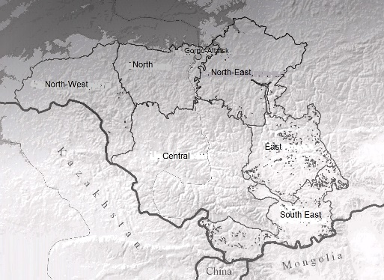
Figure 1.Location of landscape provinces of Gorny Altai
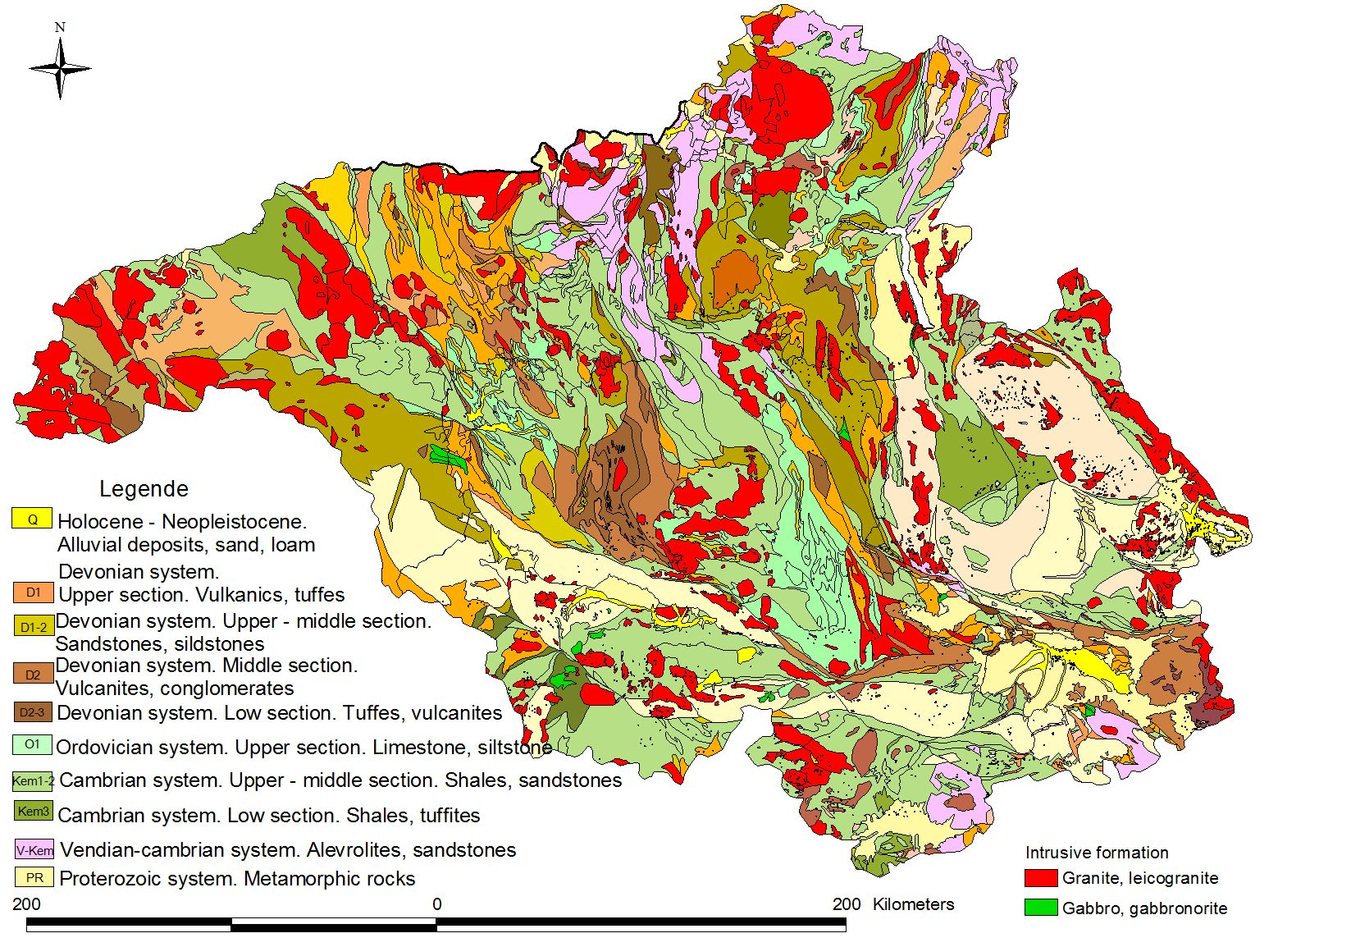
Figure 2. Geological map of the Altai Mountains showing the location of intrusive formations.
Animal abundance (individuals / km²) was calculated for each landscape-complex, making the landscape-complex the unit of measurement. We used GIS to overlay geological and landscape maps. Since the concept of landscape-complex includes a number of factors (such as altitude, vegetation, soil type and climate), the use of landscape-complexes as a basis allowed us to account for their combined influence. Thus, the combination of landscape and geological maps, allowed us to isolate the influence of geological factors from the sum of other factors that are already taken into account in the landscape – complex unit. Any variation in animal distribution could therefore be assumed to result directly from underlying geology as other factors has been held constant.
A digitized landscape map was used to visualize the distribution of species across the territory (Atlas of the Altai Krai, 1976). Data on the distribution of each mammal species was merged with the landscape database. Fig.3 shows an example of the map produced for Canis lupus (wolf).
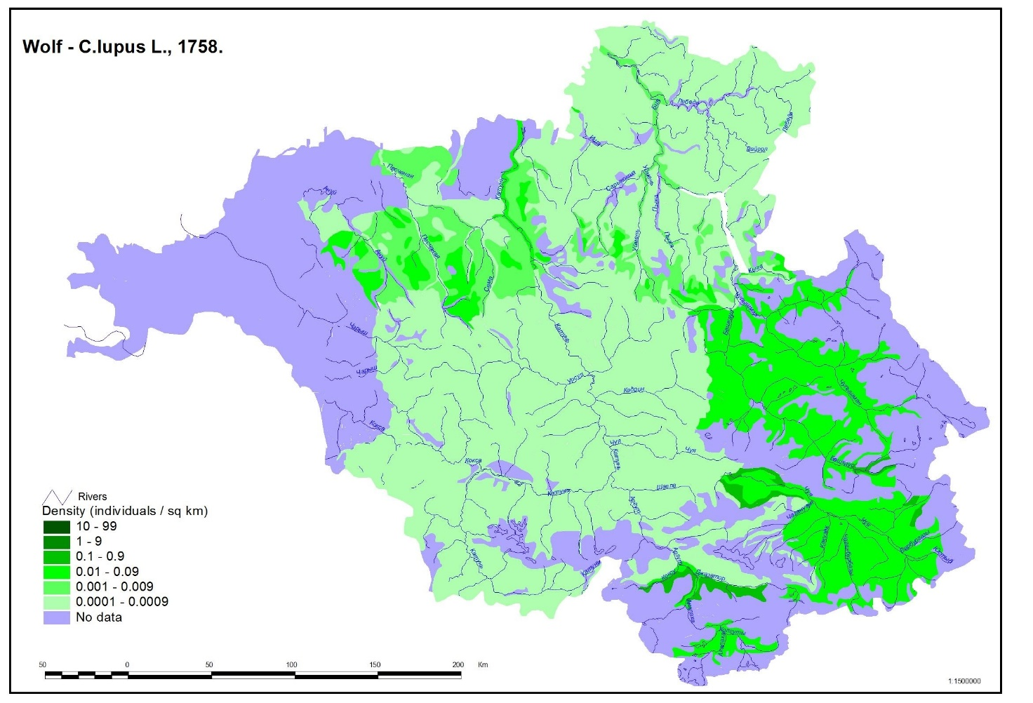
Figure 3. Density of wolf distribution on the territory of the Gorny Altai: individuals / km²
The geological map of the territory was constructed by a team of Gorno-Altaisk researchers during an expedition [Turkin & Fedak, 2008]. In our study, we used data on the distribution of mammalian habitats. At the same time we carried out work on the study of the distribution of habitats of mammals in the Altai Mountains, on the basis of geological formations in this study, the number of mammals, which was obtained from the Malkov survey (Fig.3). Data on the calculation method is given in the Supplementary Material .
Because of the properties of the obtained data (nonlinear, small sample size) nonparametric statistics were used, i.e. Kendall’s Rank Correlation [Kendall, 1970].
The following software were used: ArcView 3.2 Geographic Information System, Statistica 6.0 and OpenOffice Calc.
The work was carried out in the following stages:
1) Data on mammal density were collected
2) The geological and landscape maps of Altai Krai (1978) were digitized with ArcView 3.2.
3) Geological and landscape maps were overlaid to form a single layer in ArcView 3.2.
4) Mila Utilities 2.0 (ArcView 3.2) was used to produce a “landscape complex” for each object on the map which was a composite measure of both landscape and geological features (incl soil type, climate, microhabitat)
6) The percentage of the territory of each landscape complex occupied of the total area occupied by a particular rock type was calculated (Table 1).
7) Geological formations which occupied only a small area in the parental landscape (<10km) were filtered out, resulting in a loss of data of less than 3%
8) The table with the data on the density of mammals in landscape complexes and the table containing the data on composition of the landscapes according to their geological formation periods were combined. Kendall’s correlation coefficient was calculated between the distribution of geological formations across the landscape complexes and the number of mammals in the landscape complexes using Kendall’s correlation.
9) The significance of the correlations was assessed.
10) The resulting data were organised in accordance with their importance, singling out the significant amounts (p<0.05) and grouping them in a form of a table to be further analysed.
Further information on the methods can be found in the Supplementary material and Tables S1, S2, S3 and S4.

Results
Kendall’s correlation coefficient revealed a number of significant negative correlations between geological composition and mammal density. Furthermore, differences in the extent of the correlations were found between magmatic, metamorphic and sedimentary formations. The highest number of significant correlations occur with intrusive rocks. Taking into account that in different landscape provinces there are mountainous rocks of similar types, we grouped the landscape according to type of rock in order to study the distribution of the types of formation that cause the maximum number of correlations with population numbers - the intrusive rocks – granitoids, diorites, gabbro; the metamorphic rocks – slates, gneisses and the sedimentary rocks – limestone, sandstone (Table 2). The study of the mountainous rocks found in different landscape provinces and grouped according to their composition allows us to conclude that there is a possibility for the influence of the formation-related characteristics of the rocks upon mammal distribution
At the same time the correspondence with the area, occupied by these types of formations, shows that they comprise comparatively insignificant percentage of the area of the landscape provinces (Tables 2 and S3).

Table 1. The area of various rock types in the different landscapes provinces (km²)

Provinces | Total area of province, km² | Intrusive rocks |  |  | Igneous-sedimentary rocks, km² | Metamorphic rocks, km² |  |  | Sedimentary rocks, km²
 |  | Granites, km² | Diorites, km² | Gabbro, km² |  |  | A | B | C | D | E
South-Eastern | 14976 | 2770 | 49 | 16 | 2280 |  | 48 | 1684 | 69 | 4189 | 3871
Eastern | 14239 | 2033 | 91 | 15 | 405 |  | 0 | 7171 | 138 | 4305 | 81
Central | 37345 | 3726 | 469 | 305 | 7790 |  | 725 | 5655 | 644 | 17148 | 983
North-Eastern | 18840 | 1874 | 600 | 1107 | 4684 |  | 2772 | 1641 | 452 | 5244 | 466
Northern | 13210 | 1764 | 301 | 47 | 857 |  | 3511 | 51 | 470 | 5543 | 666
North-Western | 16210 | 2702 | 1523 | 53 | 4182 |  | 0 | 1348 | 0 | 6277 | 123
A – slates; B – gneisses; C – limestone; D – sandstones, aleurolits; E – sands, bench gravel.

To reflect the degree of correlation between the area of the geologic formation and the number of mammals we chose a geological formation (granodiorites and biotite melanogenic Kubadrinskyi complex) having the largest spread on the territory of 6 landscape provinces (Table 2). It should be noted that this geological formation has no distribution in the territory of the Northern, North-Western and Central Altai.

Table 2. Example of correlation outcomes Kendel’s Tau (τ) (95% confidence level) between mammal numbers and the area of intrusive geological formations.

 | Geological formation |  | Mammal species | Correlation coefficient
 |  |  |  | East Altai | Northern Altai | Northern - Eastern Altai | North-Western Altai | Central Altai | South East Altai
Granodiorites and biotite melanogranites kubadrinskyi complex  γD₁₋₂kb |  | Alticola macrotis |  | 0.641 |  | 0.623 |  |  | 0.424
 |  | Apodemus agrarius |  |  |  | 0.721
 |  | Canis lupus |  |  |  | 0.435
 |  | Capra sibirica |  | 0.848 |  |  |  |  | 0.477
 |  | Cervus elaphus |  | 0.672 |  |  |  |  | 0.388
 |  | Gulo gulo |  |  |  | 0.725 |  |  | 0.411
 |  | Lynx lynx |  |  |  |  |  |  | 0.367
 |  | Marmota baibacina |  | 0.458
 |  | Martes zibellina
 |  | Microtus agrestis
 |  | Microtus gregalis |  | 0.549 |  |  |  |  | 0.431
 |  | Microtus mongolicus |  |  |  | 0.490
 |  | Microtus oeconomus |  | 0.772 |  |  |  |  | 0.733
 |  | Mustela altaica
 |  | Myodes glareolus |  |  |  |  |  |  | 0.457
 |  | Myotis daubentonii |  | 0.438 |  | 0.481
 |  | Neomys fodiens |  | 0.464
 |  | Ochotona alpina |  | 0.864 |  | 0.534 |  |  | 0.537
 |  | Ovis ammon |  |  |  | 0.515
 |  | Sorex araneus |  | 0.613 |  | 0.45
 |  | Sorex minutissimus |  | 0.805 |  | 0.42
 |  | Sorex roboratus Holister |  |  |  |  |  |  | 0.457
 |  | Sorex tundrensis Merriam |  | 0,733 |  | 0,633
 |  | Talpa altaica |  | 0.464 |  |  |  |  | 0.409
 |  | Uncia uncia |  | 0.742 |  | 0.42
 |  | Ursus arctos
 |  | Vulpes corsac |  |  |  | 0.459 |  |  | 0.744
 |  | Vulpes vulpes |  | 0.458

To show the number of correlations in rocks of different formations, we grouped them by types: Intrusive, effusive, metamorphic, sedimentary rocks. Then the number of significant correlation coefficients for each type of rock was calculated (Fig. 4).
Figure 4. Number of significant correlation coefficients by rock types

As a result of our investigation we composed a map of the degree of the influence of geological formations on mammal density (Fig. 5; Table S4). It is worth noting that the degree of influence is understood as a quantity of significant correlations between the number of population of mammals at different landscapes and the size of the area of every definite formation at the same landscapes. The higher the quantity of the relevant correlations, the higher the influence of the studies formation. Our map reveals the number of coefficients of correlations with regard to every geological formation.
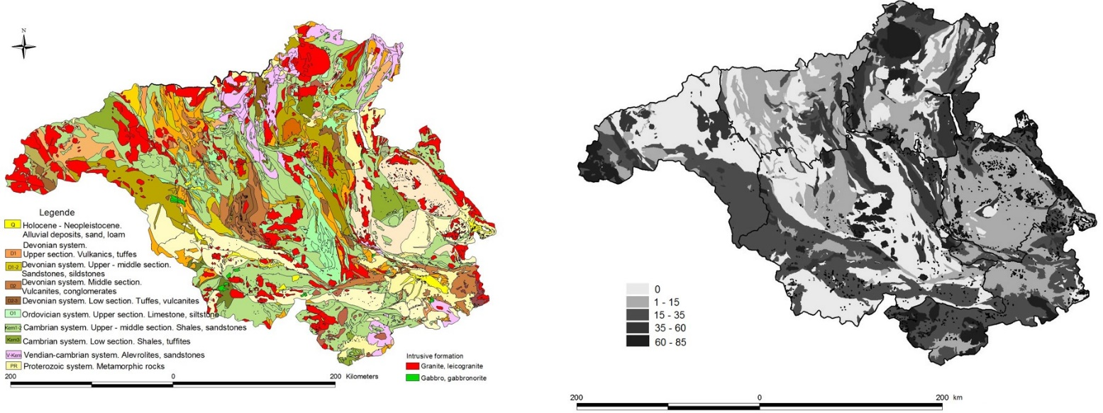
Figure 5. Left: Geological map of the area showing intrusions in red. Right: The degree of influence of geological formations on mammal numbers - number of significant correlations

Discussion
Since metamorphic formations make up the largest percentage of the study area, and intrusive rocks only represent 10-20 percent of the area, we conclude that intrusive rocks and the geochemical and geophysical processes connected with them influence the distribution of mammals; these animals tend to avoid areas with high levels of intrusions. It could be argued that the intrusive rocks create some form of relief which particular species of mammals avoid, but our statistical methods have filtered out this type of interaction by holding constant all factors except purely geological ones (rock type) so we have rejected this explanation. Similarly we have rejected climate, soil and vegetation based explanations for the same reason.
The fact that intrusive rocks have the greatest effect on mammal biodiversity and sedimentary and metamorphic rocks have almost no effect on mammal biodiversity suggests that elements such as Fe, Cu, Hg and other metals, may be having an effect, as these elements are usually connected with intrusive arrays. The high level of correlations between mammal distributions and areas containing intrusions (granites, granodiorites, leucogranites, gabbro) suggests the possibility of geochemical and geophysical anomalies and the possible influence of magnetic and electric fields on mammals. The effects of geomagnetism on the migration, homing and alignment of fauna is well documented [Burda et al., 2009; Belova & Acosta-Avalos, 2015; Tian et al. 2015].
The defining feature of the magmatic formation of different stages is its clear geochemical specialization that defines the profile of the formation. That is why the formation-based approach reflects the connection of particular types of hydrothermalites and ores with particular magmatic formations. It is found that the low-depth conditions necessary for endogenous formations define geoecological characteristics of certain territory, whose properties are the contents of lithologic, structural, geochemical, geophysical, hydrothermally changing rocks with regard to its magmatic specialization, and some other characteristics.
Our research shows that the highest number of relevant correlations is found in the territory of the South-Eastern, Eastern and Central Landscape Provinces, where the maximum geodynamic processes for the region are registered (the sum of Neogene-Quarternary deformations is 1500-3000 m) [Atlas1978], i.e. it is possible that within the territory of these provinces the additional influence on animal density is caused by geodynamic activity of the territory. We note that at the zones with the active geodynamics the most intensive variations of geophysical fields, the maximal amplitudes of modern movements and the gradients of the stress fields are found. Avoidance responses and changes in distribution of various species around active faults and in earthquake preparation zones have been reported [Grant & Halliday 2009; Fidani et al. 2014; Grant et al. 2015].
Similarly, our hypothesis is indirectly supported by the results of studies on the number of population of rodents in epicentral zone of the Chuya earthquake, which took place within our study area (September 27, 2003; 18:33 M= 7.3). The work reveals considerable influence of geodynamic activity on the behavior and distribution of mammals [Dolgovykh, 2004]. Dolgovykh, (2004) reports that:
- The Siberian ibex (Capra sibirica) disappeared from the earthquake area about a month before it took place.
- Fish left the water in the area of the earthquake. The pattern of this migration was different from the usual seasonal migration patterns. It is possible that such changes may be connected with the changes of the chemical composition of water (V.G. Ushakova, Pers comm).
- According to the evidence of residents of Ongudai Village there were cases when people caught a particular species of freshwater cyprinid fish, (Oreoleuciscus potanini, O. humilis,) in an area where it is not usually seen, the mouth of the river Ursul (lat 50,68/ long 86,55 approx). These species usually live at high elevations of the Altai in rivers in the Kosh-Agach and Ulagan Districts. Fishermen reported that they were unable to catch this, usually common, fish between September 26 and October 2. It was also reported that water in the area was discolored with sediment and suspended material.
- The grey (Altai) marmot (Marmota baibacina) that had already entered hibernation at the beginning of the September, woke up in the middle of September, and was noted to be active. After the main shock, it resumed its hibernation.
Conclusion
Here we have shown how the geochemical, geophysical, geodynamic specialization and other geological characteristics of the underlying rock influences mammal density and distribution. In this process the biological systems (flora and fauna) and underlying geological rocks make up a self-sustaining ecogeological system (ecogeosystem) [Trofimov & Ziling, 2002], so the whole ecosystem is likely to be affected by underlying geology. Our in depth investigation of mammals as an integral part of the natural-territorial complexes improves our understanding of the mechanisms of how internal and interenvironmental correlations operate. In our previous work we have already noted that they are responsible for the information availability and the modification of ecosystems [Karanin, 2004; Karanin, Shitov, 2006].

References
Atlas of Altai Krai. Vol. 1. Barnaul – Moscow. 1978. (in Russian)

Begon, M., Townsend, C. R., & Harper, J. L. (2006). Ecology: from individuals to ecosystems (No. Sirsi) i9781405111171).

Belova, N. A., & Acosta-Avalos, D. (2015). The effect of extremely low frequency alternating magnetic field on the behavior of animals in the presence of the geomagnetic field. Journal of biophysics, 2015.

Burda, H., Begall, S., Červený, J., Neef, J., & Němec, P. (2009). Extremely low-frequency electromagnetic fields disrupt magnetic alignment of ruminants. Proceedings of the National Academy of Sciences, 106(14), 5708-5713.

Bibikov D. I. (1963). Methods of counting the number of marmots and experience of its application. Organization and methods of accounting of birds and harmful rodents. M., 1963. pp192-198. (in Russian)

Brady, K. U., Kruckeberg, A. R., & Bradshaw Jr, H. D. (2005). Evolutionary ecology of plant adaptation to serpentine soils. Annu. Rev. Ecol. Evol. Syst., 36, 243-266.

Brief instructions for the winter route accounting of hunting animals. M., 1986. 30 c. (in Russian)

Buslov, M., Delvaux D., Zykin V.S., Novikov V.S. (1998). Altai Alpine structure: tectonics and evolution // Active tectonic continental basins: Interaction between structural and sedimentary processes. Abstracts of the international conference, Gent, Belgium, Apr. 30 – May 2, 1998. − Gent. Belgium: University of Gent, 1998. − P. 61–62.

Casazza, G., Barberis, G., & Minuto, L. (2005). Ecological characteristics and rarity of endemic plants of the Italian Maritime Alps. Biological Conservation, 123(3), 361

Cattaneo‐Vietti, R., Albertelli, G., Bavestrello, G., Bianchi, C. N., Cerrano, C., Chiantore, M., ... & Schiaparelli, S. (2002). Can rock composition affect sublittoral epibenthic communities?. Marine Ecology, 23, 65-77.

Chasovskikh S. N., Chasovskikh V. A. (1999). Account Siberian ibex by direct visual detection. The Fauna of the Altai-Sayan mountain country. Gorno-Altaysk. pp160-163. (in Russian)

Dobretsov N.L., Buslov M.M., Berzin N.A., Simonov V.A. (1993). Geology and tectonics of Gorny Altai. Guide-book for post-symposium excursion: The 4-th International Symposium of IGCP Project 283 "Geodynamic evolution of the Paleoasian Ocean" // Appendix. – Novosibirsk: UIGGM SD RAS Publ., 1993. p122.

Dolgovykh S.V. (2004). Biological aspects, noted in Kosh-Agach region at a territory that suffered the influence of the earthquake // The Altai (Chuya) Earthquake: prognoses, characteristics, consequences. Materials of the scientific and practical conference. Ed. by A.V. Shitov. Gorno-Altaisk: RIO. p148-149. (in Russian)

Fidani, C., Freund, F., & Grant, R. (2014). Cows come down from the mountains before the (Mw= 6.1) earthquake Colfiorito in September 1997; a single case study. Animals, 4(2), 292-312.

Finkelman R.B., Selinus O., Centeno J. (2007). Earth and environmental science-Introduction. Environmental Geochemistry and Health, 29 (2), 81-82.

Grant, R. A., & Halliday, T. (2010). Predicting the unpredictable; evidence of pre-seismic anticipatory behaviour in the common toad. Journal of Zoology, 281(4), 263-271.

Grant, R. A., Raulin, J. P., & Freund, F. T. (2015). Changes in animal activity prior to a major (M= 7) earthquake in the Peruvian Andes. Physics and Chemistry of the Earth, Parts A/B/C, 85, 69-77.

Guidetti, P., & Cattaneo-Vietti, R. (2002). Can mineralogical features influence distribution patterns of fish? A case study in shallow Mediterranean rocky reefs. Journal of the Marine Biological Association of the United Kingdom, 82(6), 1043-1044.

Guidetti, P., Bianchi, C. N., Chiantore, M., Schiaparelli, S., Morri, C., & Cattaneo-Vietti, R. (2004). Living on the rocks: substrate mineralogy and the structure of subtidal rocky substrate communities in the Mediterranean Sea. Marine Ecology Progress Series, 274, 57-68.

Karanin A.V. (2004). Relationship of mammal biodiversity of the South-Eastern Altai province with geoecological characteristics of landscapes. Abstract Diss. ... PhD Gorno-Altaysk, p28. (in Russian)

Karanin A.V., Shitov A.V. (2006). The correlation of geological and geochemical characteristics of landscapes with biodiversity of mammals (with reference to South-Eastern Altai Province) // Newsletter of Tomsk State university. Bulletin of scientific information “Relevant questions of geoecology of the Altai and its neighboring regions”. 2006. No. 72. May. – P. 84-95. (in Russian)

Kirschvink J.L., Jones D.S., MacFadden B.J. Magnetite Вiomineralization and Мagnetoreception in Оrganisms: а new Вiomagnetism. − New York: Plenum Press, 1985. – 682 р.

Kosinova I.I., Baraboshkina T.A., Kosinov A.E. et. al. Ecological geology of Kursk magnetic anomaly (KMA). − Voronezh: print office of Voronezh State University, 2009. − 216 p. (in Russian)

Kruckeberg AR (2002) Geology and plant life: the effects of land forms and rock types on plants. University of Washington Press, Seattle, USA

Kucheruk V. V. New in a technique of the quantitative account of harmful rodents and shrews // the Organization and methods of the account of birds and harmful rodents. M., 1963. P. 159-183. (in Russian)

Kuzyakin, A. P. Landscaped areas of the USSR as a basis for zoogeographical survey // proceedings of the conference on questions of zoogeography of the land. Alma-Ata. 1960. P. 75-76. (in Russian)

Kucheruk V. V., Tupikova N. V., Evseeva V. S. et al Experience a critical analysis of methods for quantifying rodents and insectivores with traps / lines // Organization and methods for accounting of birds and harmful rodents. M., 1963. P. 218-227. (in Russian)

Malkov, Yu. P. (1993). The Bats Of Altai. Gorno-Altaysk, p35 (in Russian)

Malkov Yu.P., Belikov V. I. (1995). Mammals of the Altai Republic and Altai Krai. Gorno-Altaysk, p196 (in Russian)

Malkov, Y. P., Shitov A.V. (2003). Theriological and geographical Atlas of South-Eastern Altai. Gorno-Altaysk: GASU, p30. (in Russian)

Nikolaev A.V. (2014). The study of geophysical processes in the geological sphere at the stage of preparation and development of large-scale seismic catastrophe. Designing of physical bases of methods of man-made influence on local areas in the earth’s crust to partially reduce tectonic pressure and decrease of catastrophic earthquakes // Natural environment of Russia: adaptive processes in conditions of changing climate and development of atomic energy: Scientific results obtained in 2012-2014 when the Program No. 4 of fundamental research of the Panel of Russian Academy of Science / Ed. and comp. by A.L. Sobisevich. – Мoscow: IPHZ RAN, 2014. – P. 284-286. (in Russian)

Kendall, M. G. Rank correlation methods (4th ed). – London: Griffin, 1970. 202 p.

Osipov, V.I. (1993). Geoecology as an interdisciplinary science about ecological problems of geospheres // Geoecology. − 1993. – No. 1. − P. 4−17. (in Russian)

Ravkin, Y. S., Shvetsov, Y. G., Malkov N. P. Malkov, Yu. p. (1997). Density, biomass and diversity of the summer terrestrial vertebrate communities of the Altai // the Model of sustainable socio-economic development of the Altai Republic and the countries of the Altai-Sayan region. Doc. to the Intern.SIMP. Gorno-Altaysk, 1997. P. 20-36. (in Russian)

Turkin Yu.A., Fedak S.I. (2008) Geology and Structure-Substance Complexes of Gorny Altai. − Tomsk: STT, 2008. − 460 p. (in Russian)

Samoilova, G. S. (1973). Types of landscapes of mountains of southern Siberia. − M.: Moscow state University, 1973. - 55 p. (in Russian)

Shitov. A.V. (2010). Health and people living in a seismically active region faults / Man and geosphere. Ed. I.Florinski. – New York: Nova Science Publishers, Inс. 2010. – P. 185-213.

Shitov A. V. (2010). Changes in the Effect of Geological Factors on the Health of the Population during Geodynamical Activation / Izvestiya, Atmospheric and Oceanic Physics, 2012, Vol. 48, No. 8, pp. 859–870.

Sviridov N.S. Vodop'yanov B. G. (1977). Records of fur-bearing animals. Part 2. Irkutsk, 1977. 68 p. (in Russian)

Tian, L. X., Pan, Y. X., Metzner, W., Zhang, J. S., & Zhang, B. F. (2015). Bats respond to very weak magnetic fields. PloS one, 10(4), e0123205.

Trofimov V.T., Ziling D.G. (2002). The Ecological Geology. Moscow: Geoinformarket, 2002. – 465 p. (in Russian)

Rapant S., Cvečkova V. (2014). The potential impact of geological environment on health status of residents of the Slovak Republic Environ. Geochem. Health., 2014. 36:543–561.

Selinus O., Alloway B.J., Centeno J.A., Finkelman R.B. et al. (2005). Essentials of medical geology, impacts of the natural environment on public health. Amsterdam: Elsevier Academic. 2005. – 793 p.

Stevanović, V., Tan, K., & Iatrou, G. (2003). Distribution of the endemic Balkan flora on serpentine I.–obligate serpentine endemics. Plant Systematics and Evolution, 242(1-4), 149-170.

Vorozhtsov G.A. (1990). The error in the calculation of the number of animals in the mountain taiga hunting and fishing farms // Resources of the animal world of Siberia. Sat.nauch.Tr. Novosibirsk: Science, 1990. P. 22-25. (in Russian)

Yudin B. S., Galkina L. I., And Potapkina, A. F. (1979). The Mammals Of The Altai-Sayan Mountain Country. Novosibirsk: Science p293 (in Russian)

Biosketch
Alexander Shitov is a researcher interested in the impact of earthquakes and related abiotic processes on human health and ecosystems

Andrey Karanin is a specialist in the digital mapping of natural characteristics, biodiversity and nature protection.

Rachel Grant is a researcher with an interest in animal behavior, in particular the effects of geophysical factors and geodynamic processes on animal behavior and ecology.

Data Availability Statement
The data that supports the findings of this study are available in the supplementary material of this article, and from the corresponding author on request.

Conflict of interest statement
The authors declare no conflicts of interest

