SUPPLEMENTAL MATERIAL

Figure I- Peer befriender flow diagram detailing recruitment and contribution to the intervention

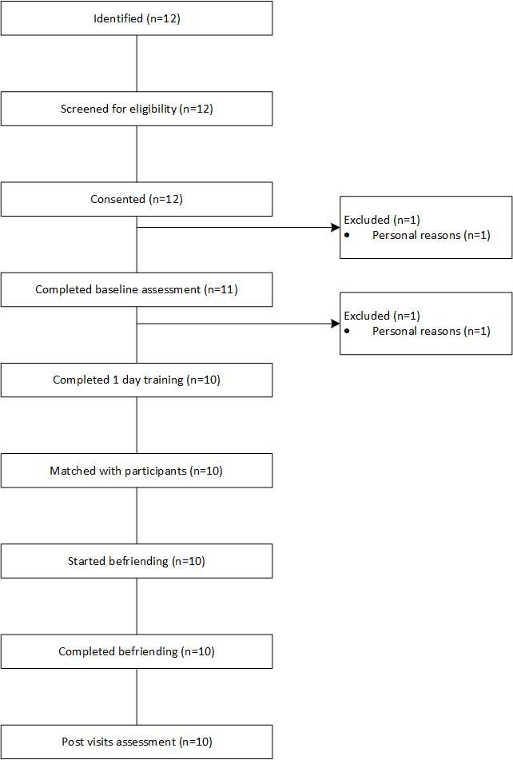

Table I: Personal history characteristics for significant others at baseline, 4- and 10-month follow-up (to determine potential changes during the course of the study)
Personal history variables for significant others |  | Baseline |  |  | 4 months |  |  | 10 months
 |  | Usual  N=24  N (%) | Peer  N=24  N (%) | Overall  N=48  N (%) | Usual  N=23  N (%) | Peer  N=24  N (%) | Overall  N=47  N (%) | Usual  N=22  N (%) | Peer  N=23  N (%) | Overall  N=45  N (%)
Is the significant other the participant’s main carer? | No | 6 (25.0) | 5 (20.8) | 11 (22.9) | 6 (26.1) | 4 (16.7) | 10 (21.3) | 5 (22.7) | 4 (17.4) | 9 (20.0)
 | Yes | 18 (75.0) | 19 (79.2) | 37 (77.1) | 15 (65.2) | 18 (75.0) | 33 (70.2) | 15 (68.2) | 16 (69.6) | 31 (68.9)
 | Missing | 0 (0.0) | 0 (0.0) | 0 (0.0) | 2 (8.7) | 2 (8.3) | 4 (8.5) | 2 (9.1) | 3 (13.0) | 5 (11.1)
Marital status | Single | 8 (33.3) | 9 (37.5) | 17 (35.4) | 6 (26.1) | 8 (33.3) | 14 (29.8) | 6 (27.3) | 8 (34.8) | 14 (31.1)
 | Married | 12 (50.0) | 11 (45.8) | 23 (47.9) | 12 (52.2) | 11 (45.8) | 23 (48.9) | 11 (50.0) | 9 (39.1) | 20 (44.4)
 | Has partner | 1 (4.2) | 3 (12.5) | 4 (8.3) | 1 (4.3) | 2 (8.3) | 3 (6.4) | 1 (4.5) | 2 (8.7) | 3 (6.7)
 | Widowed | 2 (8.3) | 0 (0.0) | 2 (4.2) | 1 (4.3) | 0 (0.0) | 1 (2.1) | 1 (4.5) | 0 (0.0) | 1 (2.2)
 | Divorced | 1 (4.2) | 1 (4.2) | 2 (4.2) | 1 (4.3) | 1 (4.2) | 2 (4.3) | 1 (4.5) | 1 (4.3) | 2 (4.4)
 | Missing | 0 (0.0) | 0 (0.0) | 0 (0.0) | 2 (8.7) | 2 (8.3) | 4 (8.5) | 2 (9.1) | 3 (13.0) | 5 (11.1)
Work situation | Full-time paid work | 8 (33.3) | 9 (37.5) | 17 (35.4) | 4 (17.4) | 7 (29.2) | 11 (23.4) | 3 (13.6) | 6 (26.1) | 9 (20.0)
 | Part-time paid work | 4 (16.7) | 2 (8.3) | 6 (12.5) | 4 (17.4) | 2 (8.3) | 6 (12.8) | 4 (18.2) | 1 (4.3) | 5 (11.1)
 | Volunteer work | 0 (0.0) | 0 (0.0) | 0 (0.0) | 0 (0.0) | 1 (4.2) | 1 (2.1) | 0 (0.0) | 1 (4.3) | 1 (2.2)
 | Retired prior to stroke | 9 (37.5) | 11 (45.8) | 20 (41.7) | 9 (39.1) | 10 (41.7) | 19 (40.4) | 10 (45.5) | 10 (43.5) | 20 (44.4)
 | Looking after home | 2 (8.3) | 2 (8.3) | 4 (8.3) | 4 (17.4) | 2 (8.3) | 6 (12.8) | 3 (13.6) | 2 (8.7) | 5 (11.1)
 | Unemployed | 1 (4.2) | 0 (0.0) | 1 (2.1) | 0 (0.0) | 0 (0.0) | 0 (0.0) | 0 (0.0) | 0 (0.0) | 0 (0.0)
 | Missing | 0 (0.0) | 0 (0.0) | 0 (0.0) | 2 (8.7) | 2 (8.3) | 4 (8.5) | 2 (9.1) | 3 (13.0) | 5 (11.1)
Work pattern changed | No | 16 (66.7) | 18 (75.0) | 34 (70.8) | 17 (73.9) | 16 (66.7) | 33 (70.2) | 16 (72.7) | 18 (78.3) | 34 (75.6)
 | Yes - stopped working | 1 (4.2) | 2 (8.3) | 3 (6.3) | 1 (4.3) | 2 (8.3) | 3 (6.4) | 1 (4.5) | 1 (4.3) | 2 (4.4)
 | Yes - reduced hours of work | 7 (29.2) | 3 (12.5) | 10 (20.8) | 3 (13.0) | 2 (8.3) | 5 (10.6) | 3 (13.6) | 0 (0.0) | 3 (6.7)
 | Yes - increased hours of work | 0 (0.0) | 1 (4.2) | 1 (2.1) | 0 (0.0) | 2 (8.3) | 2 (4.3) | 0 (0.0) | 1 (4.3) | 1 (2.2)
 | Missing | 0 (0.0) | 0 (0.0) | 0 (0.0) | 2 (8.7) | 2 (8.3) | 4 (8.5) | 2 (9.1) | 3 (13.0) | 5 (11.1)

Table II: Personal history characteristics for peer-befrienders, before and after peer-befriending (to determine potential changes during the course of the study)
Personal history characteristics for peer-befrienders |  | Before befriending all N=12 N (%) | Before befriending in study N=10 N (%) | After befriending  N=10 N (%)
Marital status | Single | 3 (25.0) | 3 (30.0) | 5 (50.0)
 | Married | 1 (8.3) | 1 (10.0) | 1 (10.0)
 | Has partner | 7 (58.3) | 5 (50.0) | 3 (30.0)
 | Divorced | 1 (8.3) | 1 (10.0) | 1 (10.0)
Employment | Part-time paid work | 0 (0.0) | 0 (0.0) | 1 (10.0)
 | Volunteer work | 5 (41.7) | 5 (50.0) | 5 (50.0)
 | Retired prior to stroke | 1 (8.3) | 1 (10.0) | 1 (10.0)
 | Retired because of stroke | 1 (8.3) | 1 (10.0) | 1 (10.0)
 | Unemployed | 5 (41.7) | 3 (30.0) | 2 (20.0)
Work prior to stroke* | Full-time paid work | 9 (75.0) | 7 (70.0) | .
 | Part-time paid work | 2 (16.7) | 2 (20.0) | .
 | Retired prior to stroke | 1 (8.3) | 1 (10.0) | .
Socioeconomic class* | Higher managerial, administrative and professional | 3 (25.0) | 3 (30.0) | .
 | Intermediate occupations | 5 (41.7) | 4 (40.0) | .
 | Routine and manual occupations | 4 (33.3) | 3 (30.0) | .
Education* | Did not finish school | 3 (25.0) | 2 (20.0) | .
 | Finished school | 3 (25.0) | 2 (20.0) | .
 | Further education qualification (not university) | 4 (33.3) | 4 (40.0) | .
 | University degree | 2 (16.7) | 2 (20.0) | .
Able to use public transport | Yes | 12 (100.0) | 10 (100.0) | 10 (100.0)
Able to drive | No | 7 (58.3) | 6 (60.0) | 6 (60.0)
 | Yes | 5 (41.7) | 4 (40.0) | 4 (40.0)
Able to keep going for 3-4 hours | No | 1 (8.3) | 0 (0.0) | 0 (0.0)
 | Yes | 11 (91.7) | 10 (100.0) | 10 (100.0)
If no, for how long can you? | 2-3 hours | 1 (100.0) | 0 (.) | 0 (.)
* Data not collected after befriending as variables relate to pre-stroke and cannot change.
Table III: Estimated differences between Peer and Usual arms for the per-protocol population

 | 4 months |  | 10 months
 | Estimate | Confidence Interval | Estimate | Confidence Interval
General Health Questionnaire-12 (GHQ-12) | -0.13 | [-1.65, 1.39] | -1.25 | [-2.74, 0.24]
GHQ-12 categorical (odds ratio) | 0.96 | [0.11, 8.09] | 0.05 | [0.002, 1.02]
Depression Intensity Scale Circles | 0.29 | [-0.34, 0.91] | -0.17 | [-0.79, 0.44]
Friendship scale | 0.51 | [-2.09, 3.11] | 0.05 | [-2.52, 2.62]
Communication Participation Item Bank | 2.77 | [-0.96, 6.49] | 3.33 | [-0.35, 7.00]
Community Integration Questionnaire | -1.80 | [-3.57, -0.04] | -1.86 | [-3.59, -0.13]
Short Warwick Edinburgh Mental Well-Being Scale | -0.03 | [-2.66, 2.60] | 0.23 | [-2.35, 2.82]
Communication Confidence Rating Scale for Aphasia | -0.22 | [-3.17, 2.72] | 0.18 | [-2.73, 3.10]
Estimates represent point differences on the scales between Peer and Usual arms after adjusting for baseline scores. A lower score shows a clinical improvement on the GHQ-12, Depression Intensity Scale Circles and Friendship scale. A higher score shows a clinical improvement on the Short Warwick Edinburgh Mental Well-Being Scale, Communication Participation Item Bank, Community Integration Questionnaire and Communication Confidence Rating Scale for Aphasia.

Table IV: Standardised effect sizes for the intention-to-treat population

 | 4 months |  | 10 months
 | Effect size | Confidence Interval | Effect size | Confidence Interval
General Health Questionnaire-12 (GHQ-12) | -0.19 | [-0.57, 0.20] | -0.34 | [-0.73, 0.05]
Depression Intensity Scale Circles | 0.14 | [-0.30, 0.58] | -0.13 | [-0.57, 0.31]
Friendship scale | -0.21 | [-0.63, 0.21] | -0.11 | [-0.53, 0.31]
Communication Participation Item Bank | 0.19 | [-0.29, 0.66] | 0.30 | [-0.17, 0.78]
Community Integration Questionnaire | -0.30 | [-0.58, -0.03] | -0.27 | [-0.55, 0.01]
Short Warwick Edinburgh Mental Well-Being Scale | 0.18 | [-0.29, 0.64] | -0.12 | [-0.58, 0.35]
Communication Confidence Rating Scale for Aphasia | -0.03 | [-0.42, 0.36] | -0.03 | [-0.42, 0.36]
Legend: All presented effect sizes show arm Peer vs arm Usual. A lower score shows a clinical improvement on the GHQ-12, Depression Intensity Scale Circles and Friendship scale. A higher score shows a clinical improvement on the Short Warwick Edinburgh Mental Well-Being Scale, Communication Participation Item Bank, Community Integration Questionnaire and Communication Confidence Rating Scale for Aphasia.

Table V: Estimated differences between Peer and Usual for significant others.

 | 4 months |  | 10 months
 | Estimate | Confidence Interval | Estimate | Confidence Interval
General Health Questionnaire-28 | -0.04 | [-2.73, 2.66] | 1.31 | [-1.49, 4.12]
Warwick Edinburgh Mental Well-Being Scale | 1.28 | [-1.08, 3.64] | 0.67 | [-1.76, 3.11]
Bakas Caregiving Outcome Scale | -0.97 | [-8.35, 6.41] | -2.53 | [-10.13, 5.06]
Estimates represent point differences on the scales between Peer and Usual arms after adjusting for baseline scores. A lower score for the General Health Questionnaire-28 indicates a clinical improvement whereas a higher score indicates clinical improvement for the Warwick Edinburgh Mental Well-Being Scale and the Bakas Caregiving Outcome Scale.

Table VI: Peer befriender outcomes

 | Mean difference | Confidence interval
Warwick Edinburgh Mental Well-Being Scale | -2.3 | [-6.97, 2.37]
Generalised Self-Efficacy | 0.1 | [-3.59, 3.79]
Community Integration Questionnaire | 0 | [-1.97, 1.97]
Mean differences were calculated by comparing pre and post time (post minus pre) point scores for the peer befrienders whose data was collected before and after completion of peer-befriending.

