Reducing carbon footprint and cooling demand
in arid climates using an integrated hybrid ventilation and photovoltaic approach

Mohamed H. Elnabaw i¹ ² • Esmail Saber ³
'

Abstract
A hybrid ventilation system combining both natural and mechanical ventilation has proven very promising in moderating indoor climate, based on its ability to ensure indoor air qual­ ity with low energy consumption. The system maintains indoor thermal comfort conditions by switching to mechanical mode whenever natural ventilation is not possible. However, the application of such a system in severe arid climates is still very limited and challenging, and almost half the urban peak load for energy demand is used to supply cooling and air­ conditioning in summer. This paper assessed the application of the hybrid ventilation mode for an educational building in a hot, arid climate, with the aim of reducing the buil ding's energy consumption without compromi sing the occupants' thermal comfort. A dynamic simulation was conducted using Integrated Environmental Simulation in a Virtual Environ­ ment building energy software, and the outcomes were validated against actual consump­ tion data over one year. The results were then evaluated for indoor thermal comfort and energy reduction and showed the potential of the hybrid system to provide energy savings of 23% across the year. Better energy performance was achieved during the cooler seasons (33.5 %) compared to hot (17.1%). When photovoltaic systems were incorporated, by exam­ ining different inclination angles and locations for energy savings and carbon emissions (CO ₂) reductions, the outcomes proved that photovoltaic south and a 25° tilt angle recorded the maximum energy and minimum CO₂ emissions annually. This integration of hybrid ventilation and photovoltaics reduced the building's energy consumption from 106.1 MWh to 36.6 MWh, saving almost 85% in total annual energy and cut down the carbon emissions from 55,227 kgCO2 to 6390 kgCO2.
Keywords Hybrid Ventilation· Arid Climate· Thermal Comfort· Photovoltaics · Carbon Emissions

Nomenclature
ASHRAE American Society of Heating, Refrigerating and Air-Conditioning Engineers BSI British Standards Institution
BWh Hot desert climate

M. H. Elnabawi, E. Saber

CIBSI
oc
l
kWh
m2 MWh mis
N
RMSE
W/m²-K
Chartered Institution of Building Services Engineers Celsius/Centigrade
Variable i Kilowatt-hour Meter square Megawatt-hour Metre per second
Number of non-missing data points Root Mean Square Error
Watts per meter square-Kelvin Actual observations time series Estimated time series

Introduction

Globally, buildings account for approximately 40% of total world annual energy consump­ tion due to population increases, housing stock, and better living standards, all of which have led to an expected escalation in energy use. Most of this energy is used to provide comfortable levels of lighting, heating, cooling, and air conditioning (AC). As a result, the global energy demand increased by 2.3% in 2018, and is considered to have had the sharp­ est growth in the last decade, as per a report from the International Energy Agency (IEA, 2019). The elevated quantity of energy used, in addition to its quality, is placing more pres­ sure on the surrounding environment by raising carbon emissions (CO₂) intensities from the building sector, which in turn increases the indoor and outdoor air pollution levels, leading to health risks, energy insecurity, and climate change. The scenario is even worse for countries with arid climates as the consequences include more energy loads for cooling and an elevated occurrence of heat stress and other heat-related diseases due to extremely warm weather (Harlan et al., 2006). For instance, based on 2014 statistics, the Kingdom of Bahrain was found to consume three times more energy per person than the world average; the country consumes 11,500 kWh per capita compared with the global average of 3,030 kWh. Similar to other Gulf Cooperation Council (GCC) countries, this high consumption is due to the very hot climate, which places more load on energy for cooling purposes. This includes AC units, which account for 60-65% of electricity usage in buildings, and will lead to more carbon emissions and other heat-trapping gases being emitted (Mardiana & Riffat, 2015; UN Environment and International Energy Agency, 2017).
Increasing awareness of climate change and energy savings has triggered renewed inter­ est in the integration of environmentally friendly energy sources and efficient cooling and heating techniques. These benefits could be addressed using different systems and com­ ponents, including passive systems such as natural and hybrid mode ventilation instead of conventional AC systems (Pfafferott et al., 2004; Pollock et al., 2009; Bianco et al., 2009; Cardinale et al., 2003). In addition, switching from a conventional energy source to a renewable one, such as a photovoltaics (PV) system, as an additional source (Sudimac et al., 2020) is another way to reduce a building's carbon emissions and save energy. In this context, the paper evaluates the performance of an integrated PV and hybrid ventila­ tion system on energy savings and carbon emissions on a yearly basis, and its potential to provide indoor thermal comfort for occupants. The paper also presents empirical data from in situ field measurements coupled with numerical analysis for an educational building

within an urban area of Bahrain, where a very rare application for a hybrid ventilation model has been examined for such a climate (Ezzeldin & Rees, 2013).

Literature review

Natural ventilation has long been used to moderate indoor climate and ensure indoor air quality at low energy consumption (Pfafferott et al., 2004; Annan et al., 2014). According to Annan et al. (2014 ), based on the current weather profile in the Middle East, natural ventilation can be used for almost 52% of all hours year-round. Furthermore, according to a recent study, the use of natural ventilation in moderate months is responsible for 10-40% of energy savings in the UAE (Taleb, 2015). However, year-round thermal comfort can­ not be maintained by relying on natural ventilation alone (Fiorentini, 2019; Gomis et al., 2021), especially in spaces where the productivity levels are affected by the levels of com­ fort within the space. Moreover, the cooling potential for natural ventilation depends on appropriate local climatic conditions, and is not applicable to all climate zones (Gomis et al., 2020). Therefore, the use of mixed mode or hybrid ventilation systems can maxi­ mize the use of natural ventilation in the moderate seasons, while switching to mechanical ventilation in extreme weather (Ezzeldin & Rees, 2013; Bianco et al., 2009; Griffiths & Eftekhari, 2008); it will thus reduce the mechanical ventilation and cooling energy while maintaining indoor comfort conditions.
In hybrid ventilation, mechanical and natural forces are combined in a two-mode sys­ tem, which controls the windows and HVAC systems to take maximum advantage of ambi­ ent conditions at time, minimize energy use, and provide occupant comfort by control­ ling the operation mode according to the season or within individual days. This hybrid mode will extend the use of natural ventilation at an acceptable level for a longer period (Alves et al., 2015), and including natural ventilation within the system widens the comfort range adaptation and acceptability for the occupants (Alves et al., 2015; Wang & Green­ berg, 2015; Humphreys & Nicol, 1998). Although different studies have proven the reli­ ability of such a system and its potential for saving energy and comfort, most were almost exclusively designed for mid-latitude climates in North America and Europe, and thus have very limited application to the Middle East (Ezzeldin & Rees, 2013; Daaboul et al., 2017; Gomis et al., 2020). According to a recent review, only four studies have been performed during the last ten years for hot, arid climates such as the Middle East (Gomis et al., 2020).
In addition to this lack of research, hybrid mode buildings are more challenging due to the nature of mixed system operation and controls. First, regulating natural ventilation systems is more complex than mechanical ones, as it relies on the outdoor air conditions to be better than the indoor air quality in terms of temperature and humidity; sufficient and appropriate wind speed and direction are also needed to enable effective air flow within the building. A hybrid system also requires effective coordination between mechanical and nat­ ural ventilation modes, to maintain comfort while preventing energy waste from opening the windows at the wrong times or set points. Moreover, the evaluation of the occupants' thermal comfort in hybrid mode buildings remains difficult, as comfort standards face the problem of differentiation between mechanically and naturally ventilated buildings; this adds to the challenge of applying mixed mode or hybrid ventilation systems. According to Brager and de Dear (2000 ), a building's occupants are more likely to tolerate a wider temperature range in a naturally ventilated building, but these changes in thermal comfort temperature are dependent on location (Humphreys et al., 2015). Other studies in different

climatic regions have supported this hypothesis and indicated a wider range of adapta­ tion and tolerance to local conditions (Elnabawi & Hamza, 2019, 2020), questioning the validity of the recommended methods used for international standards. For instance, the American Society of Heating, Refrigerating and Air-Conditioning Engineers (ASHRAE, 2009) states that 55 adaptive can only be used in buildings with no heating or cooling sys­ tem, while the International Standard Organization (ISO) 17,772 and European Standards (EN) 15,251 only apply outside the heating season in buildings with no mechanical cooling (Khovalyg et al., 2020; Gomis et al., 2021). Accordingly, most hybrid mode buildings were found to be managed as if the occupants are in a naturally ventilated building, with addi­ tional mechanical cooling being added if required, rather than as in an ordinary AC build­ ing (Rijal et al., 2007; Gomis et al., 2020).
However, applying just one active or passive design strategy is insufficient to achieve energy reduction target levels, and it is very important to integrate passive approaches with active techniques (Feng et al., 2019). One active technique switches from conventional energy sources to renewable ones, such as photovoltaic (PV) systems, as an additional energy source (Sudimac et al., 2020). PV energy is electrical energy generated by the vis­ ible spectrum of solar radiation (photons). Once the PV is installed, it becomes an integral component of the building, where the panels serve not only for energy generation on site but also as an outer layer of the building structure. In arid climates, it might be used on roofs or walls to avoid undesired thermal transference, but it can also be installed as fac;ade shelves or window awnings to control the amount of daylight and reduce heat gain in inte­ rior spaces. Several scholars have found that the use of building integrated photovoltaic (BIPV) windows is ideal for the achievement of almost 'zero-energy' buildings (Kalogirou, 2013). However, to maximize BIPV efficiency, the direction and angle of inclination still have to be wisely examined , based on the site's local conditions and location latitude.
In accordance with the above, the aim of the paper is twofold. Firstly, there is an exami­ nation of the main gaps identified regarding the application of hybrid ventilation mode in buildings, including: the limited number of studies conducted in arid climates; the com­ plexity of operating a system relying on the outdoor microclimate conditions, and, the design of the windows and AC-controlled scheme, to avoid energy waste without compro­ mising indoor thermal comfort. Secondly, there is an evaluation of the efficiency of inte­ grating the PV solar approach with the hybrid ventilation system. Compliance with the European standard BS EN 15,251 (BSI, 2007), the study aimed to ensure that energy effi­ ciency is, as far as possible, achieved without cost to the comfort, performance or well­ being of the building occupants.

Methodology

The study particularly reflects on the effectiveness of integrating a hybrid ventilation mode application and PV on buildings in an arid climate, to save energy without com­ promising indoor thermal comfort. Accordingly, the proposed framework presented in Fig. 1 is designed based on: (1) the interoperability of different phases of assessment;
(2) the contextualization of the quantitative characteristics of incorporating the hybrid ventilation system and PV within the building design regarding a particular urban cli­ mate, including climate analysis and dynamic energy modelling for base case valida­ tion purposes; (3) a second dynamic simulation following integration of the hybrid ventilation system within the buildings of phase one, and, (4) another set of parametric

Case Study (Building Model)
Case study (Refer to Figure 2)
i
Climate ana lysis
Bas+e case Energy modelling (Refer to Figure 3)
validation | S imulation Results VS actual monthly average  electrici ion

I
windows and HVAC con trolled sche me (Refer to figure 4)

Proposed scenarios

Testing parameters

PV analysis

Location and orientation

Inclination angles
Hybrid venti lation energy modelling

Energy analysis

Indoor thennal comfort

-----

Fig. 1 Th e overall methodological approach

solutions to develop the optimal integration of the PV by assessing the best location and inclination angle for maximum energy output. The objectives of the two phases are as follows:

- Identify the effectiveness of hybrid ventilation system in hot, arid climate;
- Calculate the overheating reduction hour s caused by automatic operation windows;
- Assess the occupants' indoor thermal comfort after applying the hybrid ventilation system
- Identify the best orientation and inclination angle for the PV for maximum energy output;
- Identify the maximum energy savings by integrating the hybrid ventilation mode and the PV within the building.

Case study selection

The reference case study for the research is an educational building on a university campus in a hot arid climate. The reasons for selecting this case study include:

- Data availability for building drawings, materials, properties, operational schedule and energy consumption rate. These supported more realistic results for validation and facilitate further analysis in the future;
- The lack of available studies on educational building types (16 %) compared to commercial (56 %) and residential ones (25 %) (Gomis et al., 2020);
- The complexity of the investigated building, where thermal comfort is required for proper levels of productivity.

Building model and location -the base model

The case study building, known as Building Technology, is part of the Applied Science University, Bahrain. Having extremely hot summers and mild winters, Bahrain is in cli­ mate zone lB according to ASHRAE Standards, and BWh in the Koppen-Geiger climate classification (Peel et al., 2007). As presented in Fig. 2, Building Technology has a total area of 1,488 m² and a mixed typology of offices, classrooms, computer labs and laborato­ ries, distributed over three floors. The basic construction is a reinforced concrete post and beam structure with 0.2 m thick brick infill walls without insulation or an airtight build­ ing envelope. The windows are double glazed with visible light transmittance of 39%. The total amount of glass in the facades is estimated at 50%, and these have no solar protection. Table 1 lists the general description of the sample building and certain properties of the construction materials used. The building has no heating system and AC runs continuously at a setpoint of 21 °C. A lighting density of 10 W/m² and computer load of 7 W/m² are set for the building during operational hours of 08.00-17.00. Occupancy density was assumed as 10 m²/person in offices and 5 m²/person in classrooms. Multi split indoor/outdoor units are installed in this building, which have an energy efficiency ratio (EER) of 5 in the cool­ ing mode.

Modelling setups

    - Software selection

The dynamic simulation tool Environment Solution Virtual Environment (IES-VE) is considered a powerful means of performing complex thermal modelling, including nat­ ural ventilation and mixed ventilation. IES-VE outcomes have been validated and used

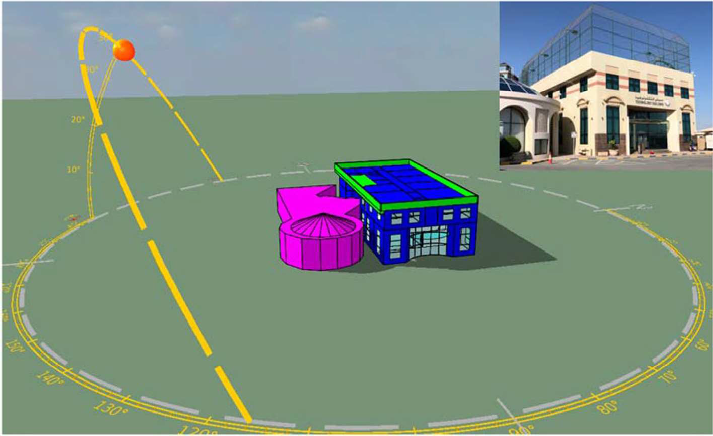

Fig. 2 Building technology case study

building's properties
Table 1 Simulation inputs for Building properties |  | Unit
Total floor area | 1488 | m2
Total vol ume | 5613 | m3
External wall area | 1146 | m2
External opening area | 260 | m2
External wall insulation | U-value: 0.35 | W/m2- K
Roof insulation | U-value: 0.35 | W/m2- K
Glazing | 2 Dbl LoE Spec Se!
 | Clr 6 mm/13 mm
U-value | 1.92 | W/m2- K
Shading Co-efficient | 0.37
Light transmission | 0.42
 | 0.68
Window-to-wall ratio | 50 | %
Shading | Blinds (inside) with
 | high-reflectivity
 | slats
Shading control type | Glare
Maximum allowable glare index | 22

in several studies with similar aims to the current study (Pollock et al., 2009; Annan et al., 2014; Elnabawi, 2020). As per the IES-VE manual, all the required data (Fig. 3) were identified, including the location, weather file, building geometry, construction materials, HVAC system, operational schedule and internal load. These data were used

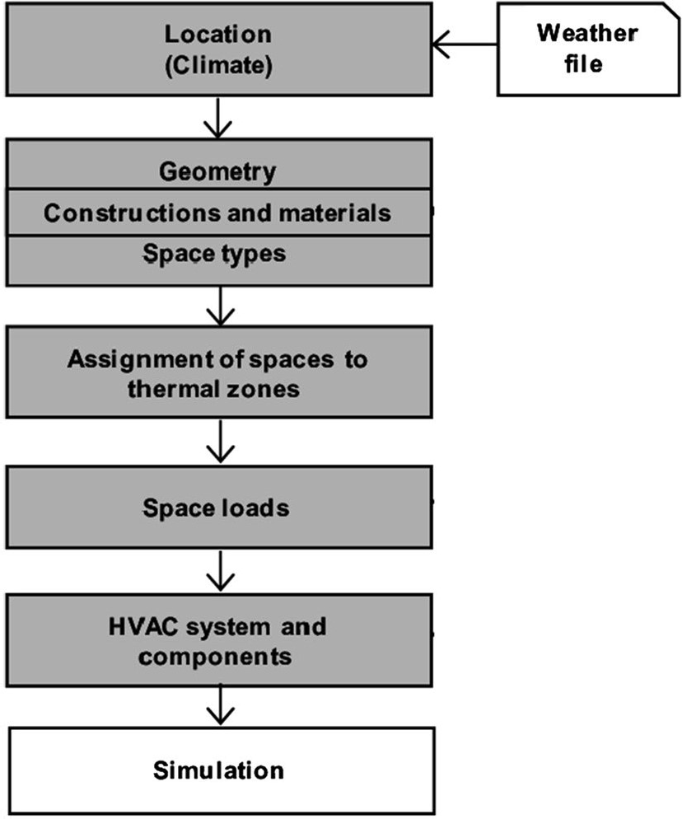
Fig. 3 Ideal workflow for building energy modelling tools (Maile et al., 2007)

to create a dynamic energy simulation model for the base case for validation purposes, before the integration of the hybrid system and active PV techniques.

      - Windows and HVAC-controlled scheme The operation of hybrid mode ventilation has to be designed wisely to prevent excessive energy use for full AC and to avoid any conflict occurring when switching between mechanical and natural ventilation (i.e. using the windows opening control). This is in addition to providing the building users with the proper amount of thermal comfort and fresh air, which are essential for their well-being and productivity. Since comfort standards face the problem of differentiation between mechani­ cally and naturally ventilated buildings, this is a greater challenge when considering mixed mode or hybrid ventilation systems. However, a meta-analysis of more than 700 surveys found that people usually respond similarly to all types, regardless of the ventilation system (Humphreys et al., 2013; CIBSE TM52, 2013). British Standard EN 15,251 (BSI, 2007) suggests a degree-hours measure, whereby the number of hours over the limiting value is weighted, as shown in Table 2. This takes discomfort to be linearly proportional to the difference between the discomfort threshold criteria, taking into account both severity and occurrence. Table 2 also shows that the optimum temperature for indoor thermal condi­ tions lies between 24 and 25 °C. The same temperature of 25 °C is also recommended in CIBSE Guide A (CIBSE, 2006) as the acceptable operative temperature for non-AC office buildings. This explains the conclusion of Gomis et al. (2021) in their review of cooling set point, and indeed 25 °C is proposed in most recent studies on indoor thermal comfort in hybrid ventilation buildings. Therefore, the operation control scheme for the case study building was held for both summer and winter; when the indoor temperature was above 25 °C and higher than the outdoor air temperature, with a proportional band of 1 °C, the AC was switched off and the windows opened, as shown in the window and HVAC control scheme in Fig. 4. In addition to, the opening types including the fixed and movable parts of the external windows were adjusted as shown in Fig. 5.

Table 2 Weighting factors based on temperature difference (or predicted percentage dissatisfied (ppd) for mechanically heated or cooled buildings) , following the assumptions shown above (BSI, 2007)
Description | Temperature  oc | Weighting factors  wf (Temp.) | wf (ppd)
Cool | 20 | 3 | 4.7
 | 21 | 2 | 3.1
 | 22 | 1 | 1.9
Neutral | 23 | 0 | 0
 | 24 | 0 | 0
 | 25 | 0 | 0
 | 26 | 0 | 0
Warm | 27 | 1 | 1.9
 | 28 | 2 | 3.1
 | 29 | 3 | 4.7

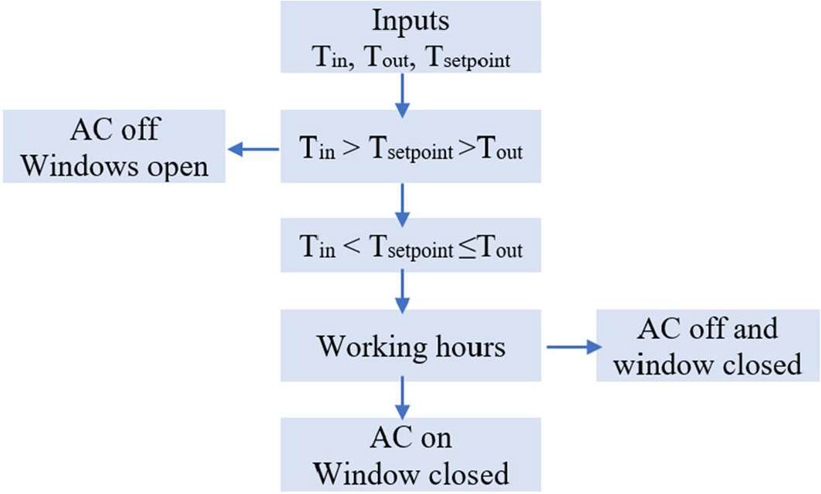

Fig. 4 Windows and HVAC-controlled scheme

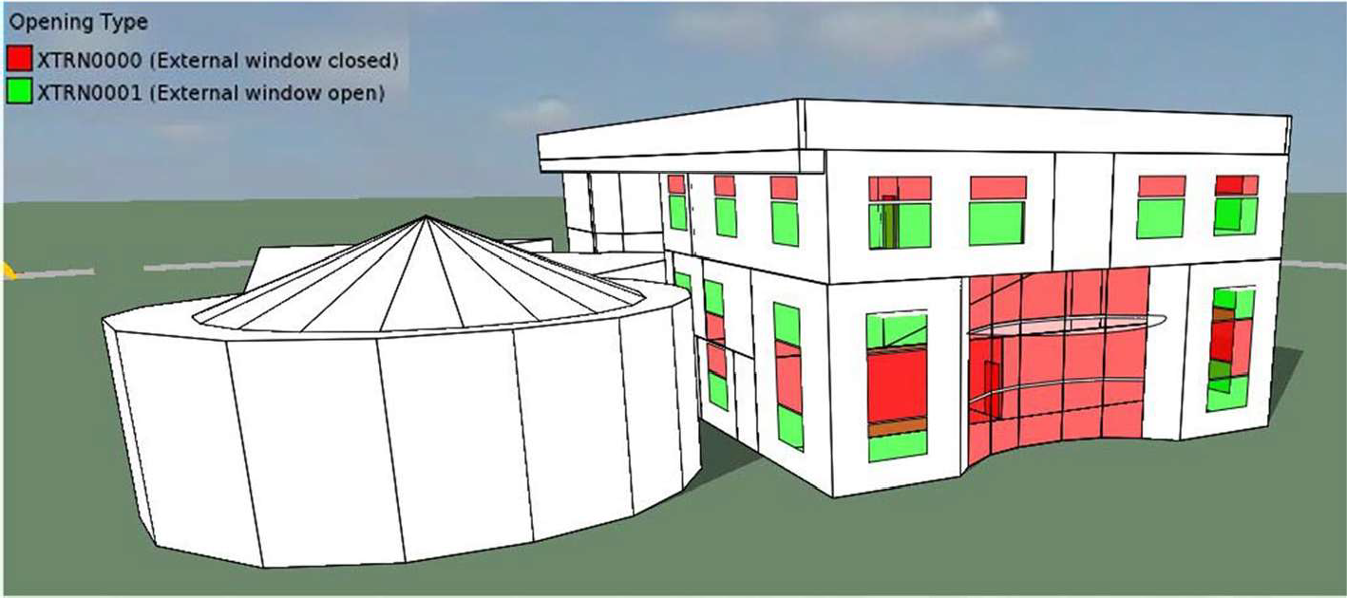

Fig. 5 The opening type including the fixed and movable parts

- Results and discussion

  - Wind analysis

A wind analysis was conducted on the building to identify the possibility of using natu­ ral ventilation for the project (Fig. 6). Prevailing wind direction for this location seems to be from North West with wind speed could reach 12 m/s for limited time during the year. These facts indicate the potential of natural ventilation for this building although necessary consideration should be taken into account regarding sandy weather at certain time of the year.

0- 3 mis
3 - 6 mis
6 - 9 mls
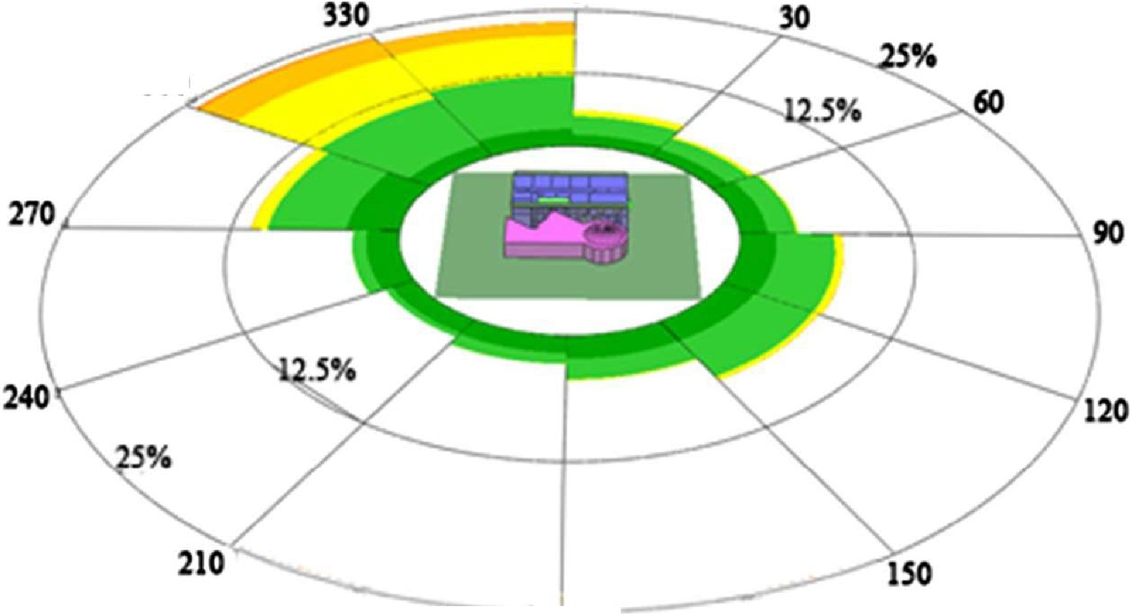
9-12 mis 12 - lS mis
> IS mis 300

0

180
Wmdltos101 Jmto 31 Dec

Fig. 6 The building wind analysis

  - Base model validation by measurement

Since the main aim of the study was to examine the validity of the hybrid ventilation system in the hot, arid conditions of Bahrain, it was crucial to validate the simulation results to add confidence in the outcomes. Therefore, the IES simulation results for the base case and the actual electricity metre data were compared for different months of the year, using dynamic methods of calculating energy balance and modelling of heat trans­ mission through the building envelope. Losses or gains due to ventilation and solar heat gain in each space within the building were calculated as per European Standard EN 15.603 (DS/EN, 2008) validation procedures (std. EN ISO 13,790:2008). The annual electricity consumption of the building was estimated at 106 MWh, which is within 5% of the actual electricity use in this building in 2019 at 109 MWh. In term of Root Mean Square Error (RMSE) (Eq. 1) which is a good measure of how accurately the model predicts the response. The RMSE was 3.03% which fall within ASHRAE 14 tolerance criteria of the RMSE ± 20% (Hong et al., 2017; Cipriano et al., 2015; Kim et al., 2012). This shows that the developed IES model captured the main aspects of the building's physics in the simulation (Fig. 7), although the reported energy use for certain months such as April and May seemed to be significantly higher than the simulation results. This could be explained by the fact that occupancy in this building varies depending on the academic semester and teaching periods of the univer sity.

RMSE= 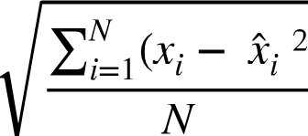
RMSE=Root Mean Square Error, i= Variable i, N= number of non-missing data points. xi= actual observations time series.x t= Estimated time series.

18000

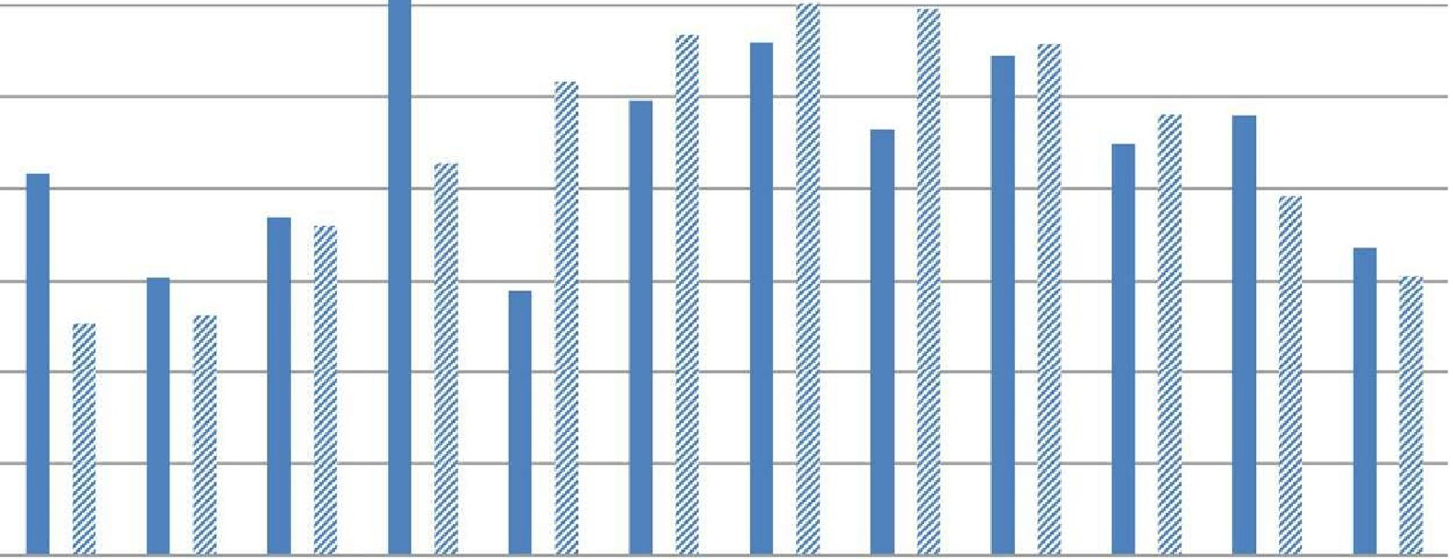16000

14000

'-'

.c....
-
.b
12000

10000

8000

6000

4000

2000

0

Jan Fab March April May June July Aug Sep Oct Nov Dec

- Actual Metered Data (kWh) IES Simulation Results (kWh)

Fig. 7 Simulated and actual electricity consumption

  - Hybrid ventilation energy efficiency

To examine the hybrid mode ventilation system as a potential solution to energy sav­ ing, the base case energy consumption was compared to the mixed mode ventilation case generated by the IES-VE. As shown in Fig. 8, automated window operation could reduce by 23% overheating hours or the number of hours in the year when the cooling system is required (from 447,816 to 352,565 h). The hybrid ventilation system's per­ formance was better during the cooler season between November-April, with almost an energy saving of 33.5%, compared to 17.1% in summer. Ezzeldin and Rees (2013) reported a similar outcome of a 35% energy reduction for a like climate using the hybrid ventilation system, as did Daaboul et al. (2017), who identified a 31% energy saving for an office building in Lebanon using the same ventilation system. These energy savings fit well with the examined climate conditions due to the fact that natu­ ral ventilation was the dominant mode during the moderate months, and this reduced the demand for mechanical ventilation, leading to reduced energy consumption. Simi­ larly, in hot months the savings in energy were lower due to the high outdoor air tem­ perature, which definitely limits the use of natural ventilation (Fig. 9).
Accordingly, Fig. 10 illustrates the air mass flow during a winter typical day of dry bulb outdoor temperature (according to Bahrain's typical meteorological year - TMY), indoor air temperature, and the mass flow in and out from windows. Figure 10 presents the hourly behaviour patterns for the window opening and closing mechanism in these days with maximum energy savings. During a typical day, the outdoor dry bulb temperature varied between 19 and 23 °C, while the indoor air temperature varied between 23 and 25 °C, within the comfort range in Table 2.

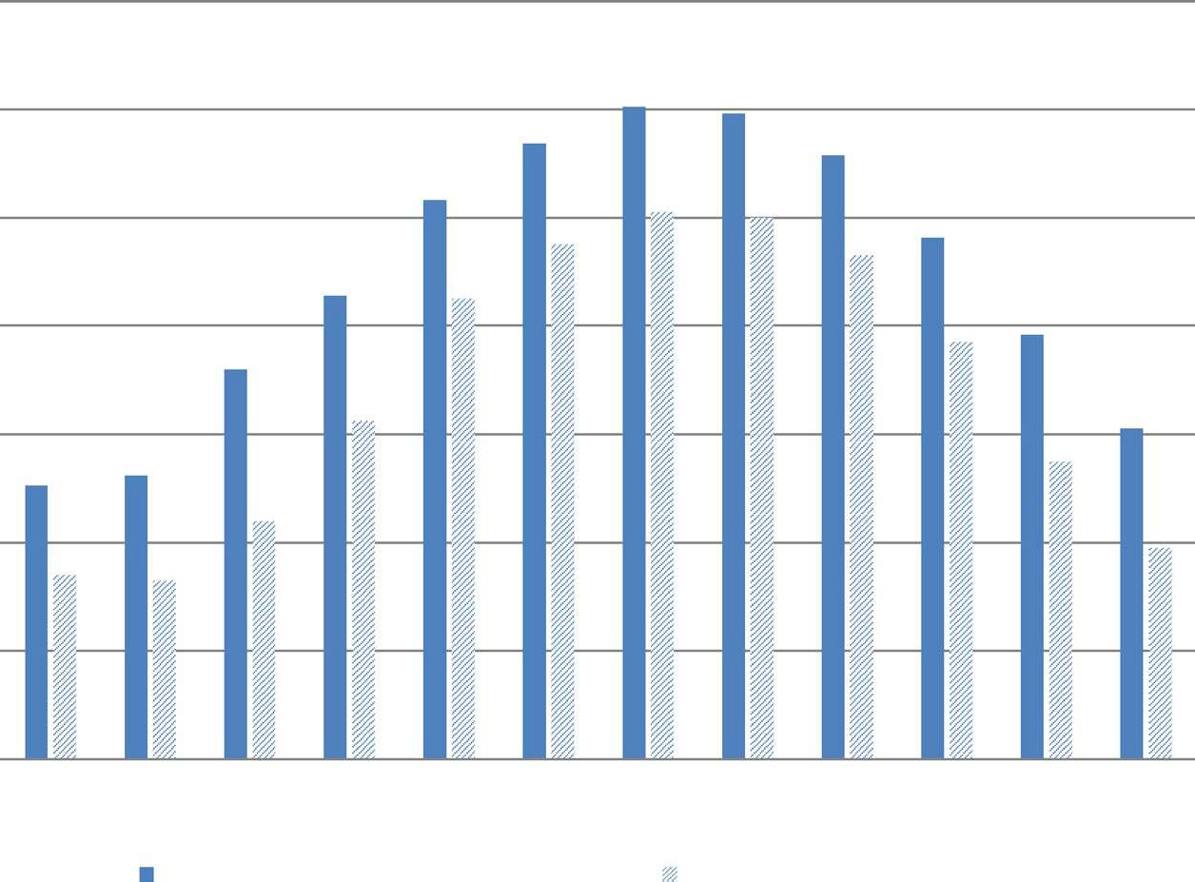14000
Jan Fab March April May June July Aug Sep Oct Nov Dec
IES Simulation Results (kWh)
IES mixed ventilation mode (kWh)

12000

10000

8000

6000

4000

2000

0

Fig. 8 IES-VE Base case and IES-VE hybrid ventilation mode system electricity consumption simulation outputs

45

40

35

:>-. 30
.⁰.¹..⁾.
(!)
25
s:::

01)
s::: 20
-
rfJ
15

10

5

0
Jan Fab March April May June July Aug Sep Oct Nov Dec

Fig. 9 IES-VE hybrid ventilation mode system electricity saving percentage per month

25.0 0.16

24.5

24.0

23.5

,-.., 23.0
u
,0_,
2::! 22.5
e
::,

0. 14

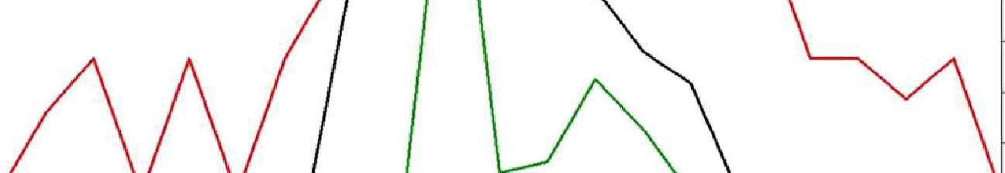0.12

0.10 f
"'
'Tl
0

Ill 22.0
C.
8
0.08

21.5

21.0

20.5
0. 06 '-"' '

0.04

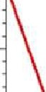
20.0

19.5

0.02

19 .0 -1--- - - - - - - - - - - ...,.......,. - - - --,--,.- ,.. -+o.oo
0 1 2 3 4 5 6 7 8 9 10 11 12 13 14 15 16 17 18 19 20 21 22 23 00
Date: Wed 13/Jan

--- Dry bulb outdoor temperature (°C)
Mass flow-in : external window (ventilative cooling aps)

---
Mass flow-out: external window Air temperature indoors (°C) (venti lative cooling aps)

Fig. 10 The air mass flow during a typical wint er day of dry bulb outdoor temperature (Bahrain's TMY)

  - Time/temperature analysis

As per the energy analysis, natural ventilation will be the dominant mode during the mod­ erate seasons, leading to a significant reduction in cooling energy. Because the hybrid ven­ tilation system changes and automatically adjusts the mode according to the climate con­ ditions, it is essential to evaluate the operational time s for both modes during the leading months for energy savings. As per the operational control scheme, natural ventilation mode will function when the indoor air temperature is higher than the set point air temperature, which is higher than the outdoor air temperate (Tin> 25 °C > Tou t ), as presented in Fig. 4. To calculate the operational time of the hybrid ventilation mode, a time/temperatures graph was generated for the average air temperature of the cooler months, using the long-term analysis of Bahraini weather data (Fig. 11). The set point temperature and occupancy schedule (from 08.00- 18.00) were also added. According to the graph, theoretically speak­ ing, during November, December and January , mechanical ventilation is not required as the outside air temperature does not exceed the set point temperature, but in February mechan­ ical cooling will operate for two hours from 13.00 to 15.00 and for one hour in March. In April, the natural ventilation will function for only two hours from 08.00 to 10.00.
The base case's monthly mechanical cooling energy data were compared with the hypothetica lly calculated operating periods from Fig. 11. A monthly energy profile was generated based on the hours of natural ventilation operation deducted from the mechani­ cal cooling energy, at a set temperature point equal to 25 °C, as presented in Fig. 12 and

M. H. Elnabawi, E. Saber
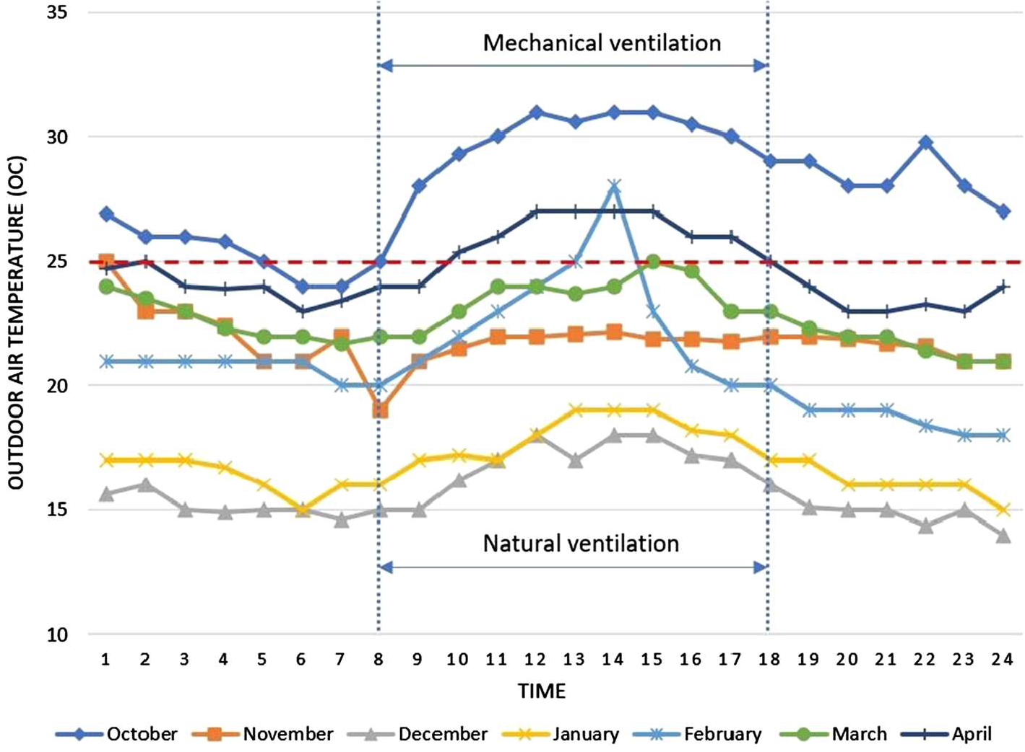

Fig. 11 Average Daily outside air Temperatures> 25 °C During occupancy schedule

9000
•
.,
I'
, --- --- ...,,
I
' '
•
.-
Jan
•
,,,,._
..
I
I
I
\
\
\
\
\
\
•
Fab March April May June July Aug Sept Oct
Nov
•-
\
..
•
Dec

8000

7000

6000

..i:: 5000
;$
4000

3000

2000

1000

0

- base case cooling -e- Hybrid ventilation Tin > 25°C >Tout
Fig. 12 Monthly mechanical cooling energy consumption for the base case, and after applying the hybrid ventilation system

Table 3 The percentage of energy reduction using hybrid ventilation at a set point of 25 °C
Months | Base case cooling (kWh) | Hybrid ventilation Tin > 25 °C> Tout (kWh) | Energy saving %
Nov | 4,200 | 0 | 100
Dec | 2,300 | 0 | 100
Jan | 1,850 | 0 | 100
Fab | 2,000 | 600 | 70
March | 3,700 | 370 | 90
April | 5,000 | 4,000 | 20

Table 3, which shows a cooling energy saving by 22% which is almost the same percentage reported by the IESVE simulation (23%) which add more confident for the simulation out­ comes and the high possibility of applying the hybrid ventilation mode in hot, arid climate. Moreover, there is a high possibility for more energy reduction by applying a higher set point following the numerous studies which stating that people living in hot climates might have higher thermal tolerance and wider range of adaptation to the local climates (Brager & de Dear 2000; Nikolopoulou & Steemers, 2003; Humphreys, et al., 2015; Elnabawi & Hamza, 2019, 2020).

  - Hybrid ventilation and occupant thermal comfort

The importance of occupant comfort in hybrid mode buildings has been the subject of sev­ eral recent studies because of the lack of applicable comfort standards for hybrid ventila­ tion buildings. The two most common approaches are the fixed set point temperature and the adaptive model. Based on the reported findings from several studies (Humphreys et al., 2013; Gomis et al., 2021) and standards such as CIBSE TM52: 2013 and BS EN 15,251 (BSI, 2007), the fixed set point temperature approach was used in this study. However, other studies such as Rupp et al. (2014) have examined the appropriateness of the two most common adaptive methods, including ASHRAE Standard 55 and the Givoni method for hybrid ventilated buildings located in hot and humid summer climates. This study recom­ mends the Givoni method as the most appropriate for assessing occupant comfort in hot summer climates.
The paper correlated the indoor applied fixed set point temperature and Givoni's adap­ tive approach using the Bahraini long-term weather file, including outdoor air tempera­ ture and relative humidity data as presented in the psychrometric chart in Fig. 13. This represents the thermal comfort zone in the psychrometric chart, applying Givoni's method (Givoni, 1992), to account for the acclimatization and comfort expectations of the occu­ pants for buildings utilizing passive cooling in hot climates (Gomis et al., 2021). As shown in the figure, the recommended set point is located in the centre of the comfort zone, giv­ ing a greater tolerance of the indoor environment and thus a wider range of acceptabil­ ity on the part of the occupants. This indicates three significant results as follows. First, there is still room for flexibility in having an upper and lower fixed set point temperature between 22 and 29 °C. This was also reported by Albatayneh et al. (2018), who examined the indoor comfort range in the hot, arid climate of Newcastle, Australia; the study found that the identified range of temperatures matched 90% and 80% acceptability limits, and could reach around 30 °C following the adaptive model. Second, the thermal acceptance

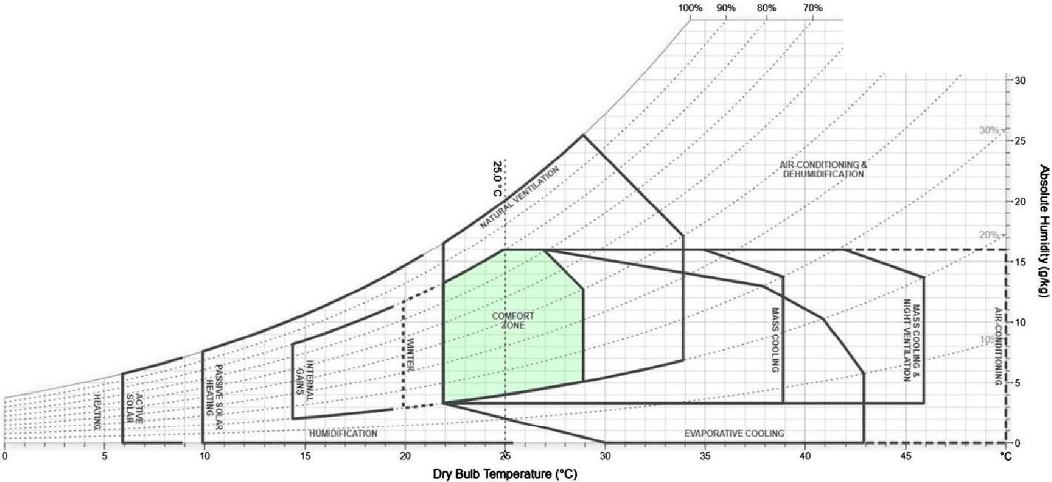Psychromertic Chart Givoni BioclimaticChart
60% ""'
J _.::>- 4 .,- 35
g,tg
.--- -· .··

Fig. 13 Psychrometric chart for the case study, correlated between the indoor applied fixed set point tem­ perature and the Givoni adaptive approach, using the Bahraini long-term weather file, including the outdoor air temperature and relative humidity

range on the psychrometric chart (22-29 °C) is higher than the British Standards Institu­ tion (2007) scale (21-26 °C) shown in Table 2, suggesting that people living in different climates might have different thermal preferences. This confirms the existence of thermal adaptation, which may support the application of hybrid ventilation in a hot, arid climate. Third, applying the thermal comfort range instead of a fixed set point temperature will reduce the space cooling energy consumption in the case study building.

PV and building integration

Due to the nature of the case site location, and according to the World Bank (2020), the global map for solar PV power potential by country, Bahrain has the highest maximum energy output from PV. The country tends to have low seasonality in solar PV output, meaning that the resource is relatively constant between different months of the year. Therefore, it is essential to fully utilize the opportunity for a more energy efficient build­ ing. The fundamental first step before installing any PV is to maximize its energy output by orienting the PV panels and their tilt angle (Kern & Harris, 1975; Bairi, 1990; Bari, 2000; Hailu et al., 2019). Accordingly, and based on the case study form and location analysis, PV panels were installed as follows (Fig. 14):

- 300 m² PV panel on the rooftop
- 22 m² PV panel as PV external shade on east and west windows
- Monocrystalline silicon, 13% efficiency, temperature coefficient for module efficiency (0.004).

As per Table 4, the main orientations of south, east, north and west were examined based on a 30° tilt angle in terms of annual energy yield (MWh) and total building carbon emission (kgCO₂) . The south-oriented PV achieved the maximum energy output with 66.1 (MWh) and a minimum CO₂ emission recording of 20,943 (kgCO ₂) ; this was followed by the west orientation, recording 56 MWh energy output and 26,374 (kgCO ₂) for CO₂

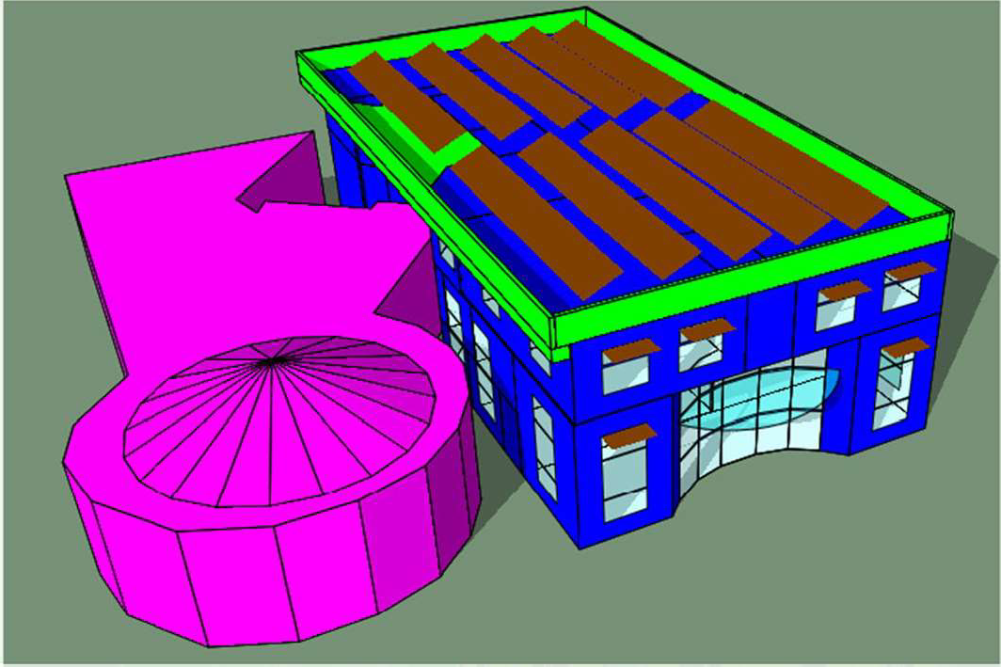

Fig. 14 PV panel on the rooftop and external shade on the east and west windows

Table 4 PV panel tilt angles in relation to annual total energy and carbon emission output

 | Annual energy yield (MWh) | Total building carbon emission (kgC0 ₂)
Without PV System | NA | 55,227
PV south 30 incl | 66.1 | 20,943
PV east 30 incl | 55 | 26,789
PV north 30 incl | 41 | 33,730
PV west 30 incl | 56 | 26,374
PY south 20 incl | 66.1 | 20,912
PV south 40 incl | 64 | 21,874
PV south 50 incl | 61 | 23,690
PY south 10 incl | 64.4 | 21,792
PY south 15 incl | 65.5 | 21,238
PV south 25 incl | 66.3 | 20,814
Rooftop PV plus PV shade on east/west | 69.8 | 18,368
Rooftop PV plus shade PV plus mixed cooling system | 69.8 | 6,390

emission, and then east (55 MWh energy output and CO₂ 26,789 kgCO₂) . The north align­ ment recorded the least amount of energy (41MWh) and highest CO₂ (33,730 kgCO2). Based on these outcomes, the PV south option underwent further analysis for different tilt angles to maximize the energy outcomes and minimize total carbon emission for the build­ ing over the year. The examined tilt angles for PV south were: 10, 15, 20, 25, 30, 40, 50. The best inclination angle was PV south 25°, recording the maximum energy of 66.3 MWh and minimum CO₂ of 20,814 kgCO₂, as per Table 4 and Fig. 15. The energy started to rise with an increase in the inclination angles, starting from 10°, until the curve reached the maximum at 25° before declining as it went further towards higher angles.

67

,-._
66
,..s::::
-- 65
"O 64
Q)
63
>-.
01)
62
1-,
(!.)

q
i:r.1 61
j 60
59
58

10 15 20 25 30 40 50
PV Panel Inclination

Fig. 15 Rooftop PV panel towardsthe di south inclination and annual energy yield (MWh)

The final step in the study was to evaluate the efficiency of integrating the PV solar approach with the hybrid ventilation system in the hot, arid climate. The original building used to consume 106.1 MWh of energy, at a cost of USD 8,193.57, but on applying the hybrid ventilation this cut the energy used for cooling and heating by almost 23%, to reach
81.85 MWh (USD 6,302.45). Adding the energy generated from the PV solar approach based on the best positioning on the roof and the PV shade on the east and west facades, the annual energy yield reached 69.8 MWh; therefore, the building would only require
36.6 MWh, at an annual cost of USD 2,818.97 instead of USD 8,193.57, saving almost 85% in total energy (Table 5). Regarding the building's carbon emissions, these drop from 55,227 kgCO₂ to just 6,390 with the integration of the hybrid ventilation system and PV solar panels, as per Fig. 16.

Conclusion

The application of a hybrid ventilation system in a hot, arid climate is still very limited and challenging, as almost half the urban peak load of energy demand is used to supply cooling and AC in summer. Therefore, the goal of this study was to explore the integration

Table 5 Annual energy consumption and cost for the base and hybrid ventilation cases , and after applying PV

 | Base case | Hybrid ventilation | PV annual energy yield | Build-  ing annual energy/cost
Energy consumption (kWh) | 106,410 | 81,850 | 69,800 | 36,610
Energy cost (USD) | 8,193.57 | 6,302.45 | 5,374.6 | 2,818.97
As per the Bahrain Electricity and Water Authority's (EWA) website, the Electricity Usage Charge (Unit) for commercial building s is USD .077

bl) 60000
t::
:§
·s 50000
co
4-,
0
^{t::} 40000
.S:
r.r,
·s
r.r, N
0
i:.I.l u 30000
t:: bl)
0 '-"
-r€o 20000
-
u
ro
§ 10000
<

0
Without PY System

PV South 30 Incl Rooftop PV plus
PV shade on East/West

Rooftop PV plus shade PV plus mixed cooling system

Fig. 16 Building annual carbon emissions for the four scenarios

of a hybrid ventilation system with PV to save energy without compromising occupant thermal comfort. A dynamic simulation was performed by employing commercial IES-VE energy modelling software in three phases. The first was for validation purposes to com­ pare the base model outcomes with the actual building energy consumption; this gave con­ fidence to the further analysis. The second phase was to perform modelling with the hybrid ventilation system with windows and an HYAC-controlled scheme, as per CIBSE TM52: 2013 indoor thermal comfort. This modelling was used to assess the impact on cooling energy consumption and occupant thermal comfort. In the third phase, PV solar panels were included and examining for the best orientation and tilt angle for maximizing overall energy saving. The key results addressing the study questions can be concluded as follows:

- The automatic operation of windows could reduce overheating hours or the number of hours throughout the year when cooling system is required by 23% (from 447,816 to 352,565 h);
- The performance of the mixed mode ventilation system is better over the cool season between November and April with almost 33.5% energy saving compared to 17.1% in summer;
- Although the hybrid mode saved energy, the performance over winter had almost dou­ ble the energy savings compared to the severe, arid summer climate, whereas the win­ ter is generally mild and temperatures are pleasant;
- In this case, a fixed set point temperature (25 °C) was used based on the BSI (2007) and CIBSE Guide A (2006). By extending the upper and lower comfort limits (22-29 °C) as per Givoni's psychrometric chart (Fig. 11), more flexibility is gained, leading to more energy savmg.
- Energy reduction can be further improved if the set temperature point is correctly cus­ tomized for the local climate condition instead of applying international comfort stand­ ards, such as ASHRAE and ISO, which are based on theoretical analyses of human

heat exchange performed in mid-latitude climatic regions in North America and North Europe;
- The original building used to consume 106.1 MWh of energy, but with the hybrid ventilation this reduced the energy used for cooling and heating by almost 23% (81.85 MWh); adding the energy generated from the PV solar approach, based on the best positioning on the roof and the PV shade on the east and west facades, the annual energy yield can reach 69.8 MWh. The building thus saves almost 85% in total energy. Building carbon emissions dropped from 55,227 kgCO₂ to 6,390 kgCO₂ by integrating the hybrid ventilation system and PV solar panels;
- The hybrid ventilation system is still very limited in application in arid climates; how­ ever, all the results are very promising and should encourage designers and scholars to work more on such an approach for better applications, development and energy sav­ mg;
- The simulated results demonstrated a substantial improvement in energy saving by rely­ ing on PV as a primary source of energy. However, the BIPV electric power systems not only produce electricity, they are also part of the building, as the roof and wall sys­ tems can provide R-value to diminish undesired thermal transfer, and the PV awnings can reduce unwanted glare and heat gain. Therefore, further investigation is required from the design point of view.

Integrating a hybrid ventilation system to save energy with PV solar panels as a pri­ mary source of energy could be a very reliable tool for sustainable and low energy build­ ing design in the near future; having said this, the process is as yet a non-standardized practice which varies from one designer to another and one location to another. Therefore, it is crucial to differentiate the capabilities of these two approaches based on the climate, design requirements, and targeted indoor comfort conditions. In closing, some of the issues investigated in the paper still need to be addressed, as the paper has only investigated one building type and a simple indoor comfort condition approach. All these areas need further investigation and present possibilities for future research.

Declarations

Human and animal rights With reference to the above-mentioned manuscript, the authors whose names are listedimmediately below certify that This study does not contain any studies with humanparticipants or ani­ mals performed by any of the authors

References

Albatayneh , A., Alterman, D., Page, A., & Moghtaderi , B. (2018). The impact of the thermal comfort mod­ els on the prediction of building energy consumption. Sustainability, 10, 3609. https://doi.org/10.3390/ sul0103609
Alves, C. A., Duarte, D. H., & Gorn;alves, F. L. (2015). Residential buildings' thermal performance and comfort for the elderly under climate changes context in the city of Sao Paulo, Brazil. Energy and Buildings, 114, 62-71.
American Society of Heating, & Refrigerating and Air-Conditioning Engineers . (2009). ASHRAE Hand­ book: Fundamentals; American Society of Heating: Atlanta (p. 2009). GA.
Annan, G., Ghaddar, N., & Ghali, K. (2014). Natural ventilation in Beirut residential buildings for extended comfort hours. International Journal of Sustainable Energy, 35(10), 1-18.

Bahrain Electricity and Water Authority (EWA). Retrieved from 26 Mar 2021. https://www.ewa.bh/en/ Customer/BillsTariffs/electricity-water-tariffs
Bairi, A. (1990). Method of quick determination of the angle of slope and the orientation of solar collectors without a sun tracking system. Solar & Wind Technology, 7, 327-330.
Bari, S. (2000). Optimum slope angle and orientation of solar collectors for di_erent periods of possible utilization. Energy Converservation Management , 41, 855-860.
Bianco, V., Manca, 0 ., & Nardini , S. (2009). Electricity consumption forecasting in Italy using linear regression models. Energy, 34(9), 1413-1421.
Brager, G., & de Dear, R. (2000). A Standard for Natural Ventilation. UC Berkeley: Center for the Built Environment. Retrieved from https://escholarship.org/uc/item/3f73w323
BSI, BS EN 15251. (2007). Indoor environmental input parameters for design and assessment of energy performance of buildings addressing indoor air quality, thermal environment, lighting and acoustics, British Standards Institution, London, 2008.
Cardinale, N., Micucci, M., & Ruggiero, F. (2003). Analysis of energy saving using natural ventilation in a traditional Italian building. Energy and Buildings, 35(2), 153-159.
CIBSE (2006). Environmental Design Guide A, CIBSE Publications, London.
CIBSE, CIBSE TM52 (2013). The limits of thermal comfort: Avoiding overheating in European buildings
(p. 2013). The Chartered Institution of Building Services Engineers.
Cipriano, J., Mor, G., Chemisana, D., Perez, D., Gamboa, G., & Cipriano, X. (2015). Evaluation of a multi­ stage guided search approach for the calibration of building energy simulation models. Energy Build­ ings, 87, 370-385.
Clarke, J. A. (2001). Energy simulation in building design. Oxford: Butterworth Heinemann.
Daaboul, J., Ghali, K., & Ghaddar, N. (2017). Mixed-mode ventilation and air conditioning as alternative for energy savings: a case study in Beirut current and future climate. Energy Efficiency, 11, 13-30. https:// doi.org/10.1007/s12053-017-9546-z.
DS/EN. 2008. DS/EN 15603: Energy performance of buildings - Overall energy use and definition of energy ratings. Charlotten lund Denmark.
Elnabawi, M. H., & Hamza, N. (2019). Behavioural perspectives of outdoor thermal comfort in urban areas: Acritical review. Atmosphere, 11, 51.
Elnabawi, Mohamed H., & Hamza, Neveen. (2020). A behavioural analysis of outdoor thermal comfort: A comparative analysis between formal and informal shading practices in urban sites. Sustainability, 12(21), 9032.
Evola, G., Costanzo, V., Infantone, M., & Marletta, L. (2021). Typical-year and multi-year building energy simulation approaches: A critical comparison, Energy, Volume 219, 2021. ISSN , 119591, 0360-5442. https://doi.org/10.1016/j.energy.2020.119591
Ezzeldin, S., & Rees, S. J. (2013). The potential for office building s with mixed-mode ventilation and low energy cooling systems in arid climates. Energy and Buildings , 65, 368-381.
Feng, W., Zhang , Q., Ji, H., Wang, R., Zhou, N., Ye, Q., Hao, B., Li, Y., Luo, D., & Lau, S. S. Y. (2019).
A review of net zero energy buildings in hot and humid climates: Experience learned from 34 case study buildings. Renewable and Sustainable Energy Reviews. https://doi.org/10.1016/j.rser.2019.10930 3109303
Fiorentini, M., Tartarini, F., LedoGomis, L., Daly, D., & Cooper, P. (2019). Development of an enthalpy­ based index to assess climatic potential for ventilative cooling of buildings: An Australian example. Applied Energy. https://doi.org/10.1016/j.apenergy.2019.04.165113169
Givoni, B. (1992). Comfort, climate analysis and building design guidelines. Energy Buildings, 18(1),
11-23. https://doi.org/10.1016/0378-7788(92)90047-
Gomis, L. L., Fiorentini , M., & Daly, D. (2021). Potential and practical management of hybrid ventilation in buildings. Energy and Buildings. https://doi.org/10.1016/j.enbuild.2020.110597
Griffiths , M., & Eftekhari, M. (2008). Control of CO2 in a naturally ventilated classroom. Energy and Build­ ings, 40(4), 556- 560.
Hailu, G., & Fung, A. S. (2019). Optimum tilt angle and orientation of photovoltaic thermal system for application in greater toronto area, Canada. Sustainabili ty, 11, 6443.
Harish, V. S. K. V., & Kumar, Arun. (2016). A review on modeling and simulation of building energy sys­
tems. Renewable and Sustainable Energy Reviews, Elsevier, 56, 1272-1292.
Harlan, S. H., Brazel, A. J., Prashad, L., Stefanov, W. L., & Larsen, L. (2006). Neighborhood microclimates and vulnerability to heat stress. Journal of Social Science & Medicine, 63, 2847-2863.
Hong, T., Kim, J., Jeong, J., Lee, M., & Ji, C. (2017). Automatic calibration model of a building energy simulation using optimization algorithm. Energy Procedia, 105, 3698-3704.
Humphreys, M., Nicol, F., & Roaf, S. (2015). Adaptive thermal comfort: Foundations and analysis. Taylor
& Francis Group.

Humphreys, M. A., & Nicol, J. F. (1998). Understanding the adaptive approach to thermal comfort.
ASHRAE Transactions, 104, 991-998.
Humphreys, M. A., Rijal, H. B., & Nicol, J. F. (2013). Updating the adaptive relation between climate and comfort indoors; new insights and an extended database. Building and Environment, 63(2013), 40-55. https://doi.org/10.1016/j.buildenv.2013.01.024.
IEA. (2019). Global Energy & CO2 Status Report 2019, IEA, Paris. https://www.iea.org/reports/ global-energy-co2-status-report-2019
Kalogirou, S. A. (2013). Building integration of solar renewable energy systems towards zero or nearly zero energy buildings. International Journal of Low-Carbon Technologies, 10, 379-385.
Kern, J., & Harris, I. (1975). On the optimum tilt of a solar collector. Solar Energy, 17, 97-102.
Khovalyg, D., Kazanci, 0. B., Halvorsen, H., Gundlach, I., Bahnflet h, W. P., Toftum, J., & Olesen, B. W. (2020). Critical review of standards for indoor thermal environment and air quality. Energy Buildings, 213, 109819. https://doi.org/10.1016/j.enbuild .2020.109819
Kim, J., Hong, T., & Koo, C. W. (2012). Economic and environmental evaluation model for selecting the optimum design of green roof systems in elementary schools. Environmental Science & Technology, 46(15), 8475-8483.
Maile, T., Fischer, M., & Bazjanac, V. (2007). Building energy performance simulation tools-a life-cycle and interoperable perspective, in CIFE Working Paper 107, 1-49.
Mardiana , A., & Riffat, S. B. (2015). Building energy cons umption and carbon dioxide emissions: Threat to climate change. J Earth Sci Climat. Change, S3(001), 1-3. https://doi.org/10.4172/2157-7617.S3-001 Morsy, A. D., & Al-Bahrana, N. (1995). Energy conservation in buildings in Bahrain. University of
Bahrain.
Nikolopoulou, M., & Steemers, K. (2003). Thermal comfort and psychological adaptation as a guide for designing urban spaces. Journal of Energy and Buildlings, 35, 95-101.
Peel, M. C., Finlayson, B. L., & McMahon, T. A. (2007). Updated world map of the Koppen-Geiger climate classification. Hydrology and Earth System Sciences, 11, 1633-1644.
Pfafferott, J., Herkel, S., & WambsganB, M. (2004). Design, monitoring and evaluation of a low energy office building with passive cooling by night ventilation. Energy and Buildings, 36(5), 455-465.
Pollock, M., Roderick, Y., McEwan, D., & Wheatley, C. (2009). Building simulation as an assisting tool in designing an energy efficient building: a case study. Proceedings of the Eleventh International IBPSA Conference, Glasgow, Scotland, July 27-30, 2009.
Prado, R. T. A., & Ferreira, F. L. (2005). Measurement of albedo and analysis of its influence the surface temperature of building roof materials. Energ y and Buildings, 37, 295-300.
Rijal, H. B., Tuohy, P., Humphreys, M. A., Nicol, J. F., Samuel, A., & Clarke, J. (2007). Using results from field surveys to predict the effect of open windows on thermal comfort and energy use in building s. Energy Buildings, 39(7), 823-836. https://doi.org/10.1016/j.enbuild. 2007.02.003
Rupp, R. F., & Ghisi, E. (2014) . What is the most adequate method to assess thermal comfort in hybrid commercial buildings located in hot-humid summer climate? Renewable and Sustainable Energy Reviews. https://doi.org/10.1016/j.rser.2013.08.102
Sudimac, B., Ugrinovic, A., & Jurcevic, M. (2020). The application of photovoltaic systems in sacred build­ ings for the purpose of electric power production: The case study of the Cathedral of St. Michael the Archangel in Belgrade. Sustaina bility, 12( 4 ), 1-18.
Taleb, H. M. (2015). Natural ventilation as energy efficient solution for achieving low-energy houses in Dub ai. Energy and Buildings, 99, 284-291.
UN Environment and International Energy Agency. (2017). Towards a zero-emission, efficient, and resilient buildings and construction sector. Global Status Report 2017.
Urge-Vorsatz, D., Petrichen ko, K., Staniec, M., & J. (2013). EomEnergy use in buildings in a long-term per­
spective. Curr Opin Environ Sus tain, 5(2), 141-151.
Wang, H., & Chen, Q. (2014). Impact of climate change heating and cooling energy use in buildings in the United States. Energy and Buildings , 82, 428-436.
Wang, L., & Greenberg, S. (2015). Window operation and impacts on building energy consumption. Energy and Buildings, 92, 313-321.

