Bending Performance of Timber Beam Strengthened with Passive Prestressing

**David Yeoh1*, Violet Leng2, Norwati Jamaluddin1, Koh Heng Boon1, Seyed Jamalaldin1, Ali Tighnavard1, Nor Hayati Abd Ghafar1**

**Abstract:** Prestressing technology and its application is common in concrete design and construction particularly in Malaysia and most parts of the world. However, prestress strengthening in timber is rare and not widely applied especially in Malaysia. Application of prestressing in timber has the potential to allow the use of longer span with reduced cross-sectional size and simultaneously exhibiting some level of ductility through the prestressing rod since timber material is susceptible to brittle tensile failure. This paper highlights exploratory research into the extent of bending performance enhancement in Malaysian Kempas species timber beam strengthened by way of passive prestressing. The research was conducted to investigate the change in bending strength and moment capacity of timber beam with passive prestressing rods installed at different lever arm positions, and the enhancement of moment capacity of timber beam with and without passive prestressing. Five Kempas timber specimen configurations with size of 40 mm (*b*) × 90 mm (*d*) × 900 mm (*l*) were prepared for four-point bending tests, and their bending behaviours were evaluated. The timber beam with passive prestressing steel rods applied at tension side bottom fibre of timber beam exhibited the greatest enhancement in bending performance and stiffness. The improvement of bending performance ranges from 1.1 to 1.5 times greater compared to the timber beam without prestressing steel rods. The improvement of stiffness in prestressed timber beam is up to 11% at service limit state and a reduced rate of stiffness degradation is prominent.

**Keywords:** Kempas timber, passive prestressing, bending strength, stiffness, moment capacity

# Introduction

The use of timber in construction in Malaysia is very low statistically in comparison the nation’s rich sawn timber resources (Wong, 2008). Only few structural applications of engineered timber namely glued laminated timber (commonly known as glulam) are found in Malaysia. For example, the curved glulam bridges in Forest Research Institute Malaysia (FRIM) and the Malaysian Timber Industry Board (MTIB) Glulam Gallery building which are government initiated, as shown in Figure 1 and Figure 2, respectively. Only in recent past years, there are privately initiated glulam buildings developed for commercial purpose found in the southern region of Peninsular of Malaysia (Figure 3). Regardless of their presence, by and large, many engineers and architects particularly in Malaysia are not aware of the

419

benefits of timber as construction materials be it from its high strength to weight ratio characteristics nor the material’s environmental and sustainable benefits (Jumaat et. al., 2006). In contrast to countries where timber is commonly used as structural members in buildings, prestressing concept found in concrete technology is now applied into timber with the intention to achieve long span with controlled deflection limits and higher bending moment capacity (McConnell et. al., 2014).



|  |  |
| --- | --- |
| **Fig. 1 - First curved glulam bridge in FRIM** | **Fig. 2 - MTIB glulam gallery building** |

In this research, an exploratory step was taken to study the bending performance of Kempas timber with passive prestressing. Kempas species timber is a medium hardwood with air dry density of 770-1120 kg/m3 grouped under Strength Group SG2 commonly used for structural purposes (Department of Standard Malaysia, 2001). Kempas timber is known for its economic benefits for construction, as it is largely prepared in factory and transported to site for rapid assembly (Ramage, 2008 and Ratnasingam, 2016). However, similar to all other construction materials, timber has its vulnerable behaviour. Timber, under bending beyond its elastic limit will result in a brittle split tensile failure normally at the bottom fibre of the beam (Negrao, 2012). As such, efforts are taken by many researchers and engineers to improve this behaviour by attempting to enhance the ductility of the beam system, for example by way of prestressing and fibre reinforce strengthening. To name a few of these works are Brady & Harte (2008), Negrao (2012), Balserio & Faria (2014), and Halicka & Ślósarz (2021).

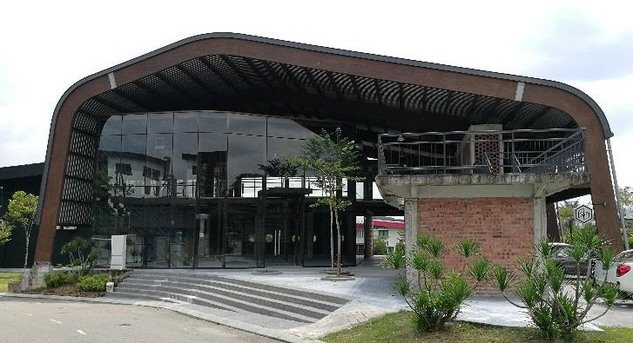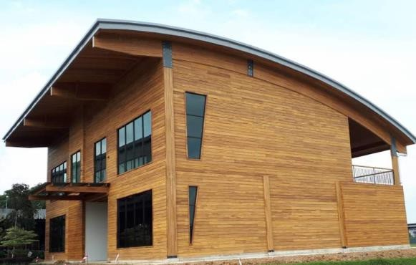

**Fig. 3 - Recent past privately initiated glulam buildings in Peninsular Malaysia**

The experimental investigation was conducted on different configurations of Kempas timber beams with passive prestressing to evaluate the contribution of prestressing to the improvement of timber strength, as well as the changes in the failure behaviour of timber beams. This prestressing method was designed with the intention to improve the serviceability feature of strengthened Kempas beams in contrast with the non-strengthened beams.

The primary purpose of this research is to investigate the improvement in bending performance and reduction in deformation or rate of deformation in the timber beam with and without passive prestressing, and with passive prestressed rods installed at different lever arm position. The findings and lessons from this research contribute significantly to encouraging the application of prestressed timber beam in Malaysia through enhancing the structural performance of timber.

In the research, passive prestressing technique was utilized to strengthen the timber beams. It was applied through external installation of threaded rods and connecting rods to timber beam by using carefully detailed steel bracket elements. These steel elements ensure the anchorage of rods and increase prestressing actions through eccentricity. Examples from De Lima et. al. (2018) was used as a point of reference in this experiment. The anchorages were used to avoid premature debonding mechanisms and to allow for further loading on timber beams. The presence of threaded rods assured a small reserve in load capacity and allowed some additional loading of timber beams.

# Experimental Programme

* 1. **Specimen Types**

Kempas timber beams sized 40 mm (*b*) × 90 mm (*d*) × 900 mm (*l*) were tested under four-point bending with a total of 10 timber beams comprising of 5 specimen types of configurations. The density of the Kempas timber ranges from 756 kg/m3 to 789 kg/m3 with moisture content of 12.7 % to 16.4 % measured using oven dry method. The control specimen is timber beam only (notation assigned as TB) while the other 4 specimen types have passive prestressing steel rods placed at different positions along the vertical depth geometry of the timber cross-section (assigned notations are TBN with steel rods at neutral axis, TBC with steel rods at compression upper fibre, TBT with steel rods at tension lower fibre, and, TBTC with steel rods at both compression upper and tension lower fibre . Table 1 presents the specimen types and their given notations while Figure 4 to Figure 8 show the corresponding four-point bending test setup schematic diagram and cross-section diagram representation of the specimen types. The details of timber specimens are also illustrated.

**Table 1 - Notation of specimen types**

|  |  |
| --- | --- |
| **Specimen Types** | **Notation (Figure)** |
| Timber beam only (Control Beam) | TB (Fig. 4) |
| Timber beam with passive prestressed rods at its neutral axis | TBN (Fig. 5) |
| Timber beam with passive prestressed rods at its compression upper fibre | TBC (Fig. 6) |
| Timber beam with passive prestressed rods at its tension lower fibre | TBT (Fig. 7) |
| Timber beam with passive prestressed rods at both tension and compression fibre | TBTC (Fig. 8) |

The prestressing rod used is 6 mm diameter steel threaded type with tested yield strength ranging between 671 N/mm2 to 683 N/mm2 and maximum ultimate tensile strength recorded at 756 N/mm2. On both ends of the timber beam, 10 mm thick steel plates are used as anchorage brackets where the prestressing rods were fastened on both sides of the timber, securely tightened using long nuts (Figure 9). The rods are only tightened with the nuts and no tensioning force is applied to the rods – this condition is defined as passive prestressing. The clear spacing between the holes on the steel plate is 20 mm and this comply with the minimum clear spacing requirement (for 8 mm diameter of the hole clearance) for externally prestressing tendons in accordance with Eurocode 2 (British Standard Institute, 2004). Figure 10 shows a typical test setup of the four-point bending test.

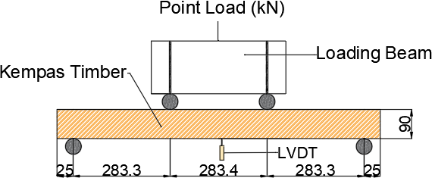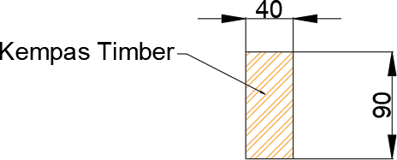

**Fig. 4 - Four-point bending test setup (left) and cross-section (right) for TB specimen type (dimensions in mm)**

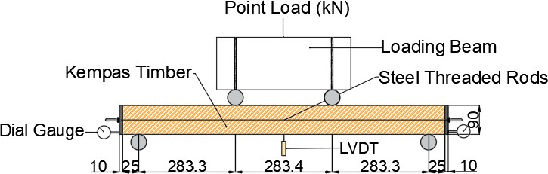 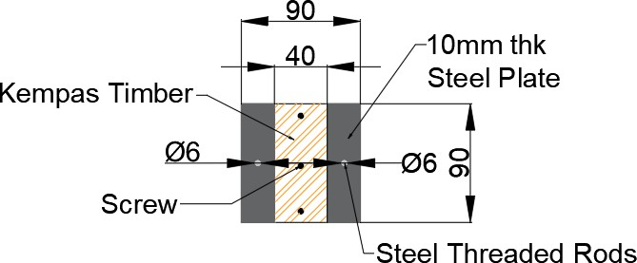

**Fig. 5 - Four-point bending test setup (left) and cross-section (right) for TBN specimen type (dimensions in mm)**

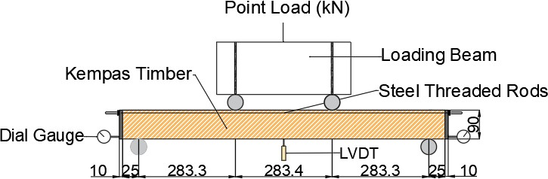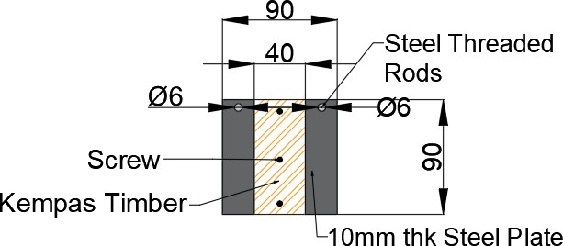

**Fig. 6 - Four-point bending test setup (left) and cross-section (right) for TBC specimen type (dimensions in mm)**

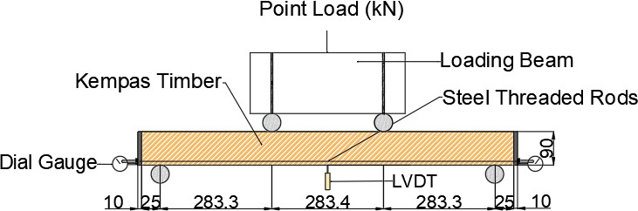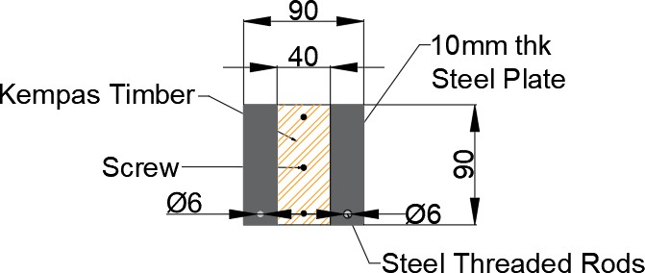

**Fig. 7 - our-point bending test setup (left) and cross-section (right) for TBT specimen type (dimensions in mm)**

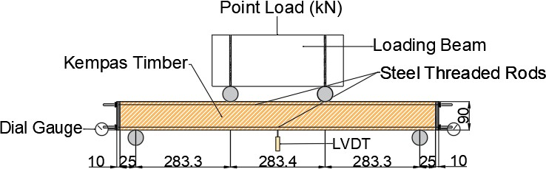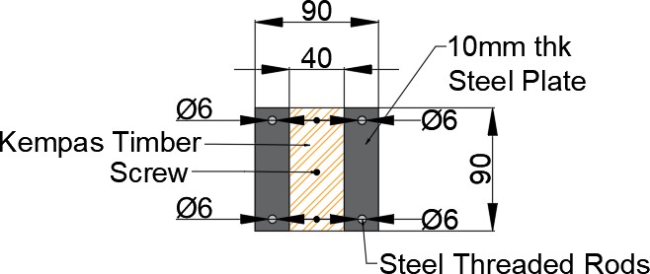

**Fig. 8 - Four-point bending test setup (left) and cross-section (right) for TBTC specimen type (dimensions in mm)**

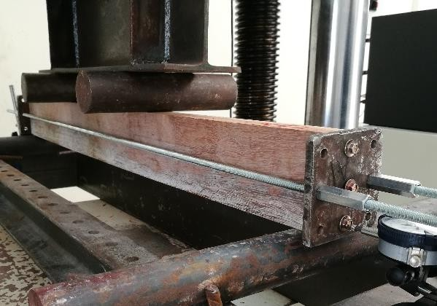

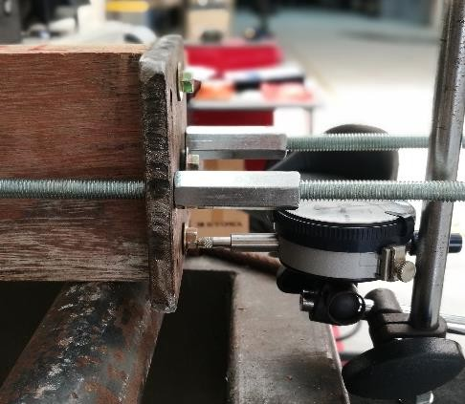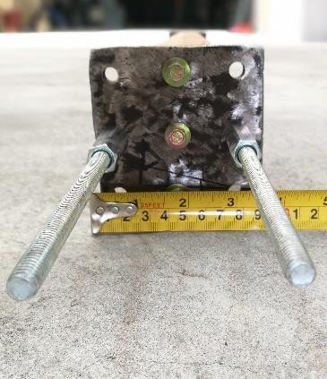

|  |  |
| --- | --- |
| **Fig. 9 - Anchorage 10 mm steel plate and prestress threaded**  **rods fastened with long nuts** | **Fig. 10 - Typical experimental setup of**  **four-point bending test** |

# Specimen Testing

Initial tests on the material were conducted on the timber pieces and the prestressing steel rod. Randomly selected of timber were sawn to be tested for their density and moisture content under oven-dry test and 3 prestressing steel rods tested for their tensile strength under a 100 kN Universal Testing Machine. The main experimental test conducted is the four-point bending test on the timber beams in accordance with BS EN 408 (British Standard Institute, 2010) using the same 100 kN Universal Testing Machine. The set up is schematically presented in Figure 4 to Figure 8 with two loading points spaced at one-third along a nominal span of 900 mm. Figure 10 presents the picture of a typical setup of the prestressed timber beam ready to be loaded to collapse. The load was applied at a constant load-head movement such that the collapse load is attained within 300±120 seconds. The mid-span deflection of the beam was measured at the bottom of timber specimen with LVDT, while the longitudinal slip of beam was measured by the dial gauge mounted at the beam ends. Load-deflection graphs were plotted and the mode of failures corresponding to load increments were recorded.

# Results and Discussions

The mode of failures of the four-point bending tests for all the types of specimens are first presented followed by the load-deflection graphs. The bending performance results of this research are analysed and presented as ultimate load, bending moment, bending strength, and beam stiffness at 0.4Fult referring to Serviceability Limit State (SLS), at 0.6Fult and at 0.8Fult referring to Ultimate Limit State (ULS) which is collapse of structure.

# Observed Failure Modes

The typical failure observed in all the specimens regardless of having passive prestressing or without is simple split tensile at the lower fibre (tension zone) of the timber beam due to bending (see Figure 11). The difference between with prestressing (Figure 12) and without prestressing is not observed in the type of failure modes but is found in the progression rate of failure and the bending performance. These are discussed in the following sub-sections. The tensile cracks due to bending typically first appeared at the bottom of timber beams near the loading point or near to any possible timber defects weak points and subsequently propagated diagonally toward the mid-span and to the top surfaces under increased loads. Under excessive bending load, the prestressing steel rods at the lower fibre tension zone began to respond in compression trying to restrain the timber beam from deflection downward. This phenomenon caused compressive stress parallel to the grain at the end anchorage plates. Such failure is observed and prolonged loading after collapse tend to cause a combined compression parallel to grain and split tensile failure effect resulting in continuous splitting along the timber parallel to the grain (Figure 13). Figure 14 shows the response of prestressing rods in a specimen type with upper and lower steel rods (notation TBTC). Here, the top steel rods appeared to be without much effect while the bottom steel rods functioned as a restraining element against bending failure in the timber beam. This result in further increment of bending load capacity in the timber beam.

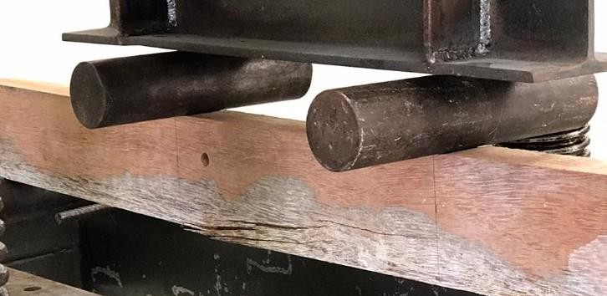 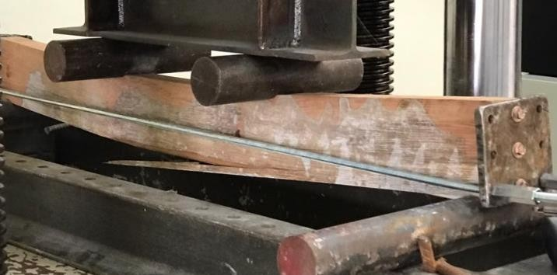

|  |  |
| --- | --- |
| **Fig. 11 - Typical split tension failure at lower fibre tension zone of timber beam without prestressing** | **Fig. 12 - Typical split tension failure at lower fibre tension zone of timber beam with passive**  **prestressing** |

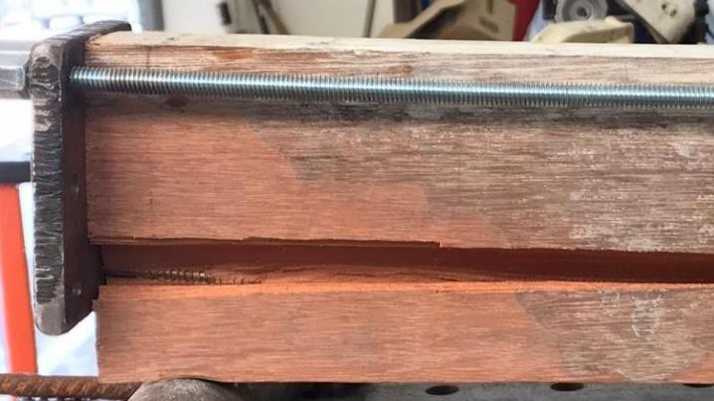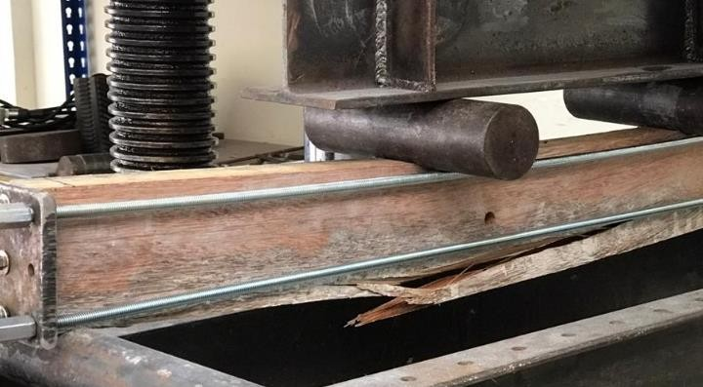

|  |  |
| --- | --- |
| **Fig. 13 - Compression parallel to grain failure of timber at anchorage end plate** | **Fig. 14 - Typical split tension failure at lower fibre**  **tension zone of timber beam with passive prestressing top and bottom timber fibre** |

# Experimental Load-Deflection Graphs

The experimental load-deflection graphs are given in Figure 15 to Figure 19 for types of specimen TB, TBN, TBC, TBT, and TBTC respectively. Important points marked with under case alphabets in the graphs denotes the observations made corresponding to the load increment as the four-point bending test progressed. These observations are indicative of the behaviour of the specimens under bending load and the progression of behaviour are given in Table 2.

**Table 2 - Experimentally observed behaviour of specimens under four-point bending load**

|  |  |
| --- | --- |
| **Point** | **Description of observation** |
| a | Slight hair cracks appeared at bottom of specimens |
| b | Cracks enlarged and propagated to load points |
| c | Longitudinal slip reached 10mm |
| d | Loud 'bang' sound and cracked separation of timber |
| e | Shear longitudinal failure of anchorage and timber ends |
| f | Final failure of timber |
| t | Twisting effect (torsion) existed on timber beam. |

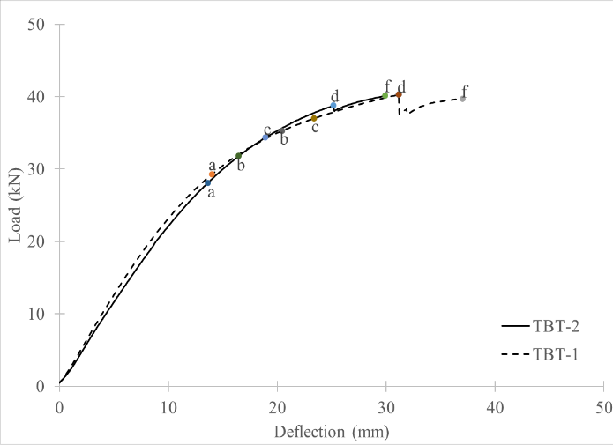

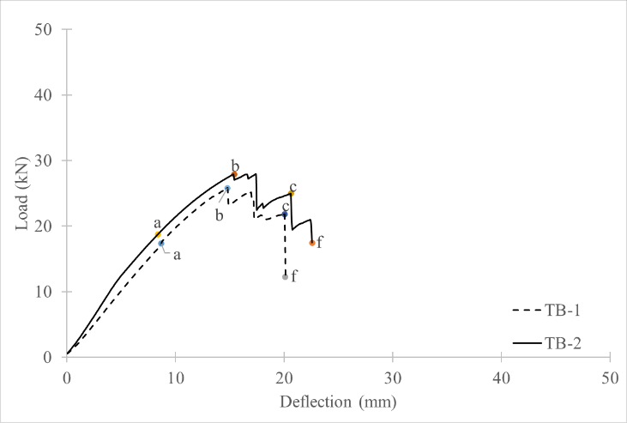 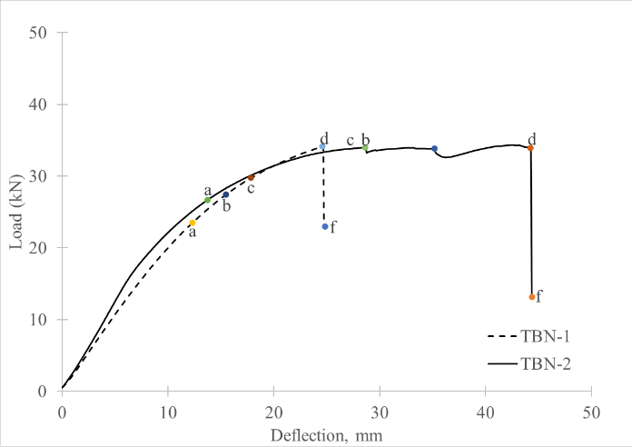

|  |  |
| --- | --- |
| **Fig. 15 - Four-point bending load-deflection graph for TB specimen** | **Fig. 16 - Four-point bending load-deflection graph for TBN specimen** |
| **Fig. 17 - Four-point bending load-deflection graph for TBC specimen** | **Fig. 18 - Four-point bending load-deflection graph for TBT specimen** |
| **Fig. 19 - Four-point bending load-deflection graph for TBTC specimen** | **Fig. 20 - Four-point bending load-deflection graph for TBTC specimen** |

# Bending Strength and Moment Capacity

The recorded ultimate collapse load (Fult) and mid-span deflection (max) are averaged and presented in Table 3. From the experimentally recorded data, the maximum moment capacity for a four-point bending (Mexp) and beam bending strength (m,ult) are analysed. The bending strength (m,ult) is computed as moment capacity divided by the section modulus of the beam. Based on load-deflection graphs for all tests (Figure 15 to Figure 18), it is observed that two beam samples for each type of specimen appeared to be consistent and near except for specimen type TBTC (Figure 19). TBTC- 2 exhibited significantly lower ultimate collapse load in contrast to TBTC-1. During the experimental test of TBTC-2, lateral torsional twisting effects were observed between 15 kN to 20 kN load progress, marked as “t” in Figure 19. This torsional effect (Figure 20) has drastically jeopardised the bending performance of this sample reducing it by more than 30%. As such, the result of TBTC-2 had to be discounted off because it does not reflect the true performance of such type of specimen. TB type specimen is made as the control reference benchmark and the incremental ratio of maximum moment capacity for the other specimen types against the control reference is shown in Table 3. TBT type specimen (timber beam with steel rod at tension zone lower fibre) had the highest incremental ratio of 1.5 and the enhanced effect on the mechanical properties of timber was evidently reflected with bending load redistributed to the steel rod at the tension zone hence effectively strengthening the whole beam system. TBN type specimen had the second highest incremental ratio of 1.3 followed by TBTC type specimen (1.2 ratio) and lastly TBC type specimen (1.1 ratio).

**Table 3 - Average results of four-point bending test**

|  |  |  |  |  |  |
| --- | --- | --- | --- | --- | --- |
| **Timber Specimen** | **Fult (kN)** | **Mexp (kNm)** | 𝜎**m,ult (Mpa)** | **Δmax (mm)** | **Incremental Ratio** |
| TB | 26.9 | 3.8 | 70.4 | 16.0 | 1 |
| TBN | 34.3 | 4.9 | 89.8 | 34.0 | 1.3 |
| TBC | 30.6 | 4.3 | 80.1 | 17.5 | 1.1 |
| TBT | 40.2 | 5.7 | 105.5 | 30.5 | 1.5 |
| TBTC | 31.1 | 4.4 | 81.6 | 17.0 | 1.2 |

**Table 4 - Average beam stiffness**

|  |  |  |  |  |  |  |
| --- | --- | --- | --- | --- | --- | --- |
|  | **Beam Stiffness (kN/mm)** | |  | **Stiffness Reduction (%)** | | |
| **Timber Specimen** | ***K0.4F*** | ***K0.6F*** | ***K0.8F*** | **0.4Fult to 0.6Fult** | **0.6Fult to 0.8Fult** | **Service to Collapse** |
| TB | 2.19 | 1.82 | 1.46 | 16.9 | 19.8 | 33.3 |
| TBN | 2.21 | 1.69 | 1.17 | 23.5 | 30.8 | 47.1 |
| TBC | 2.44 | 2.27 | 1.70 | 6.97 | 25.1 | 30.3 |
| TBT | 2.24 | 1.98 | 1.51 | 11.6 | 23.8 | 32.6 |
| TBTC | 2.43 | 2.06 | 1.63 | 15.2 | 20.9 | 32.9 |

# Beam Stiffness

Beam stiffness values of the tested specimens were computed and reflected in the form of secant slip moduli at three distinct levels throughout the lifespan of the structure corresponding to beginning stage of Serviceability Limit State (SLS), end stage of Ultimate Limit State (ULS) or at collapse, and mid stage which is in between SLS and ULS. At beginning stage, beam stiffness, *K0.4F* was determined at 40% of the observed ultimate load, followed by 60% of the observed ultimate load for mid stage *K0.6F* beam stiffness, and finally end stage, *K0.8F* beam stiffness at 80% of the observed ultimate load.

Table 4 gives the computed beam stiffness for the different type of beam specimens. The values of *K0.4F* was higher than that of *K0.6F*. When reaching the near collapse, *K0.8F* indicated the lowest stiffness value. It can be noted that all specimens indicated a decrease in stiffness before reaching the failure point and the reduction rate appeared incremental in pattern. The trend observed clearly shows that at the beginning stage, all beams have inherent larger beam stiffness and as the four-point bending test progressed, the beam stiffness consistently drop at varying rate depending on the presence of prestressing steel rod and the steel rod’s position about the neutral axis of the beam cross-section. The stiffness reduction from one stage to another is presented in percentage showing that the presence of prestressing steel rod is able to control the stiffness reduction rate significantly especially when the steel rod is positioned at the tension zone bottom fibre of the timber cross-section. It is obvious that timber beam without any steel rod (TB) has the lowest stiffness in comparison to those specimens with steel rods at the beginning stage. The presence of prestressing steel rods enhances the stiffness of beams at all stages in particularly at serviceability limit for TBT by up to 11%. This phenomenon is prominently evident in TBC, TBT and TBTC specimen types. Higher beam stiffness implies that the beam can withstand greater load at lesser deflection or deformation. On the contrary, TBN specimen type presented lower beam stiffness especially at end stage compared to timber beam only, TB type specimen. This is possibly due to the positioning of the steel rod at neutral axis of the cross-section which do not effectively activate the function of the steel rod in increasing the beam stiffness. It can be summarized that the timber stiffness of all prestressed sample configurations had been improved, except for TBN specimen. The increase in bending stiffness promoted the redistribution of the load and subsequently reduced the deflection of timber. Other than stiffness enhancement, prestressing timber beams also improve the plasticity of structure which timber by itself is known for its brittle failure behaviour. However, with prestressing steel rods, the plasticity of the beam is seen to have improved judging from the extended deformation prior to complete collapse indicating the beam system has moved from brittle behaviour to ductile behaviour.

# Discussion

Timber is a natural material of long history known for its structural benefits of high strength to weight ratio. However, it also comes with its disadvantage of high variations in timber properties and behaviour even from the same species or same tree. Therefore, experimental tests involving solid sawn timber is affected by such variations especially tests with small number of specimens The distributional characteristics of bending strength and stiffness can be influenced by the biological composition of timber (Castera and Morlier, 1994). Thelandersson and Honfi (2009) explained that the coefficient of variation for bending strength of timber beam is in the range of 20-40%, depending on the species. Smaller sample sizes tend to have larger variations, reduced accuracy when evaluating parameters and subsequently affect the experimental results. These are the limitations and challenges encountered in this research endeavour, nevertheless, the experimental data and lessons learnt here are important for extending the use of timber beam hybrid with prestressing steel. These important lessons are:

* Strengthening timber beam with passive prestressing steel rods can effectively improve the bending performance (moment capacity and bending strength) by 1.1 to 1.5 times greater depending on the position of the steel rod and the type of steel rod. This is evidential through the findings of this study.
* Applying passive prestressing steel rod at the tension zone bottom fibre of the timber beam cross-section is more effective resulting in bending performance appreciation by 1.5 times.
* Applying passive prestressing steel rods in timber beam enhance the serviceability performance of the beam by increasing the beam stiffness by up to 11% resulting in a reduction of midspan deflection and slowing down the progression of deflection as load increases.
* Applying passive prestressing steel rod at the compression zone top fibre of the timber cross-section do not return with significant benefits to bending performance although it does increase the stiffness of the beam resulting in a more controlled deflection under greater load. Therefore, prestressing steel rod application at this position is not recommended.
* Applying passive prestressing steel rods in timber beam change the failure mode of timber beam from brittle behaviour to ductile behaviour.

# Conclusion

In conclusion, passive prestressing technique improved the overall behavior of timber beams, thereby increasing the bending strength and moment capacity, as well as reducing the deflection of the beam. Nonetheless, the increased number of steel rods at top fibre of the cross-section did not significantly enhance the timber strength possibly due to the neutralization counteraction between top (compression zone) and bottom (tension zone) steel rods. The different positioning of prestressing steel rods is able to control the strength, stiffness and moment capacity of timber specimens. Future research recommended includes using larger diameter steel rods for prestressing, increasing the number of steel rods, using engineered timber for better variation control, dimensionally stable and sustainable material, and, applying active prestressing instead of passive prestressing.

# Acknowledgement

This research was supported by Universiti Tun Hussein Onn Malaysia (UTHM) through **TIER 1 (Vot Q189)**.

# References

Balseiro, A.R. & Faria, J.M. (2008). Use of Active and Passive GFRP Reinforcement for The Strengthening and Rehabilitation of Timber Beams. *Enhancing Bonline Performance - Final Proc Conference on Bonding of Timber.* Hungary. pp. 24-30.

Brady, J. F. & Harte, A. (2008). Prestressed FRP Flexural Strengthening of Softwood Glue - Laminated Timber Beams.

*World Conference of Timber Engineering,* pp. 910-917.

British Standard Institute (2004). *BS EN 1992 Eurocode 2 – Design of concrete structures – Part 1-1: General rules and rules for buildings*. Brussels, Belgium.

British Standard Institute (2010). *BS EN 408 Timber Structures – Structural timber and glued laminated timber – Determination of physical and mechanical properties*. Brussels, Belgium.

Castera, P. & Morlier, P. Variability of the Mechanical Properties of Wood: Randomness and Determinism. *H. Press*, Germany.

De Lima, L.C.C., Costa, A.A. & Rodrigues, C.F. (2018). On the Use of Prestress for Structural Strengthening of Timber Beams: Assessment with Numerical Support and Experimental Validation. *Int. J. Archit. Herit.*, Vol. 2. pp. 1–16. https://doi:10.1080/15583058.2018.1442526

Department of Standards Malaysia (2001). *MS 544: Part 2: 2001, Code of Practice for the Structural Use of Timber: Permissible Stress Design of Solid Timber*. Selangor, Malaysia.

Halicka, A., & Ślósarz, S. (2021). Strengthening of Timber Beams with Pretensioned CFRP strips. *Structure*, 34, 2912– 2921. <https://doi.org/10.1016/j.istruc.2021.09.055>

M. Z. Jumaat, A. H. A. Rahim, J. Othman, and F. M. Razali (2006) Timber Engineering Research and Education in Malaysia. *9th World Conf. Timber Eng. Proceeding, WCTE*. pp. 2494–2497.

McConnell, E., McPolin, D. & Taylor, S. (2014). Post-tensioning Glulam Timber with Steel Tendons. *Construction and Building Materials*. (73) pp. 426-433.

Negrao, J.H. (2012). Prestressing Systems For Timber Beams. *14th World Conf. Timber Eng. Proc.*, Vol. 2, pp. 1–10. Ramage, M.H. (2016). “The Wood from The Trees: The Use of Timber in Construction,” *Journal Renew. Sustain. Energy*

*Rev.*, Vol. 68, pp. 333–359. https://doi:10.1016/j.rser.2016.09.107

Ratnasingam J. (2016). Wood Use in Building Construction: The Malaysian Dimension. *Asian Woodwork.* Vol. 14, No.

3, pp. 18–23.

Thelandersson, S. & Honfi, D. (2009). Behaviour and Modelling of Timber Structures with Reference to Robustness. *J. Work. COST Actions TU0601 E55*. pp. 125–138.

Wong, T.M. (2008). Ensuring Quality Assurance in Timber Applications. *Master Build. J.*, Vol. 1, pp. 84–87.