Electrokinetic biocementation of an organic soil

Research paper submitted to the Special CEST2019 issue
Date written: December 2020
Date revised: February 2021

Author 1
- Dr Safdar UM, BSc, MSc
- Division of Civil and Building Services Engineering, London South Bank University, UK

Author 2
- Prof Mavroulidou M* Dipl-Ing; D.E.A., PhD, MA, BA
- Division of Civil and Building Services Engineering, London South Bank University, UK

Author 3
- Prof Gunn MJ
- Division of Civil and Building Services Engineering, London South Bank University, UK

Author 4
- Prof Purchase D BSc, MSc, PhD, PGCHE
- School of Natural Sciences, Faculty of Science and Technology, Middlesex University, UK

Author 5
- Payne I. MSc
- Geotechnical Asset Management, East Anglia Route, Network Rail, UK

Author 6
- Garelick J MEng
- Design Delivery, Network Rail, UK

*Corresponding author
Prof Maria Mavroulidou (Professor of Geotechnics)
Department of Civil and Building Services Engineering, BEA
London South Bank University
103 Borough Road
London SE1 0AA
Tel (work): 02078157646; (please use preferably email)
Email: mavroum@lsbu.ac.uk

Electrokinetic biocementation of an organic soil

Abstract Organic soils are a continuing challenge to civil engineers, as they are subject to settlements, negatively impacting on civil engineering infrastructure. To improve the in situ properties of these, chemical soil stabilisers (e.g. cement or lime) can be commonly used. Although successful in minimising severe damage, these stabilisers may have environmental side-effects (e.g. cement and lime production is linked to 7%–8% of overall CO₂ emissions). Therefore, the development of innovative, superior, cost-effective and overall more sustainable soil improvement techniques are a field of ongoing research effort. In this context, this paper studies the electrokinetic (EK) biocementation of a problematic soft organic soil of the UK railway network using indigenous ureolytic bacteria. The paper focuses on aspects relevant for the effective implementation of treatments, namely the effect of degree of saturation of the soil and different ways of treatment implementation. The results in terms of unconfined compressive strength and CaCO₃ content, proved the feasibility of EK biocementation using an indigenous microorganism, either premixed with the soil or injected electrokinetically. Higher strength gains were recorded for degrees of saturation in the region of 85%-95%. Strength gains and increased CaCO₃ contents compared to the control samples were also noted when treatment duration was halved to one week although strengths increased further by 13-17% after a two-week treatment. Overall, the study gives promise for the applicability of the EK-biocementation technique under existing infrastructure. Further optimisation of the treatment variables and refinement of the implementation details could enhance the efficiency of the process.
Keywords: Biocemementation; electrokinetics; ground improvement; organic soil

Introduction
Growing urbanisation worldwide leads increasingly to construction on inferior ground in urbanised areas; at the same time the growing population in urban centres will require new infrastructure based on complex engineering with little tolerance for error (e.g. high rise buildings, deep basements in urban areas, high-speed trains). Existing infrastructure facilities will also need to be upgraded to meet future needs and changing environmental loads due to climate change. These include ageing transport earthworks in many European countries (some built as early as in the mid-19th century) which were poorly constructed if viewed by modern engineering standards. They are thus suffering from serviceability problems or failures and need continuing and costly maintenance/remediation works. This is becoming a major constraint for railway owners and operators, especially in view of the increased risk of hazards posed by climate change.

Current government strategies in Europe and worldwide, require infrastructure to be provided in an economical and environmentally responsible manner, reducing material use, embedded carbon and other impacts on the natural environment and ecosystems. In this context improving rather than replacing and landfilling inferior for construction soils is becoming critically important in engineering practice towards low-carbon, sustainable solutions. Still, common ground improvement techniques (e.g. stone columns, vibro-compaction as well as chemical stabilisation with Portland cement or lime) use carbon-heavy approaches to give control over cost, timeline and uncertainty. Thus, although successful in minimising severe damage, they suffer from high costs, disturbance of services, site accessibility issues due to heavy machinery, limited lifetime and environmental side-effects (e.g. cement and lime stabiliser production is linked to 7%–8% of overall CO₂ emissions). In addition, their applicability to existing earthworks and the underlying foundation soils can be limited. Therefore, the development of innovative, superior, cost-effective, and overall more sustainable soil improvement techniques to mitigate natural and man-made hazards while minimising waste and other environmentally impact, is a field of ongoing intensive research effort. Among these techniques, non-pathogenic bacteria can be used to induce precipitation of minerals to bind soil particles together in the form of biologically produced cement (biocement). The technique, called biocementation, has attracted the interest of researchers worldwide, as a potentially more sustainable ground improvement technique, because it is based on a natural process, and the treatments are potentially renewable and more cost-effective if the long-term costs are considered (Venda Oliveira and Rosa, 2020).

While various metabolic routes and/or precipitates are possible (Ivanov and Stabnikov, 2017), the vast majority of works on biocementation has studied calcium carbonate precipitation using urea hydrolysing bacteria. This process is based on a multi-step chemical reaction, which can be described as follows (Krajewska, 2018): first, the initial urea [CO(NH₂)₂] hydrolysis generates ammonia (NH₃) and carbon dioxide (CO₂) (Eq 1).
CO(NH₂)₂ + H₂O 2NH₃ + CO₂ (1)
Urease

The local increase in pH occurs due to the hydroxyl ions (OH⁻) generated by the conversion of ammonia to ammonium, which leads to the breakdown of bicarbonate to carbonate ions (Eq. 2).
2NH₃ + 2H₂O 2NH₄⁺ + 2OH⁻ (2)
The carbon dioxide quickly reacts with the water and produces bicarbonate (HCO₃⁻) (Eq 3), which further reacts with hydroxyl ions (OH⁻) to generate carbonate ions (Eq 4).
CO₂ + H₂O HCO₃⁻ + H⁺ (3)
HCO₃⁻ + H⁺ + 2OH⁻ CO₃²⁻ + 2H₂O (4)
Hence, the precipitation of CaCO₃ occurs in the presence of calcium ions (Ca²⁺).
Ca²⁺ + CO₃²⁻ CaCO₃ (5)
The overall process of urea hydrolysis and CaCO₃ precipitation is thus given as:
CO(NH₂)₂ + 2H₂O + Ca²⁺ 2NH₄⁺ + CaCO₃ (6)

The urea hydrolysis process for the precipitation of the calcium carbonate mediated by ureolytic bacteria and predominantly Sporosarcina pasteurii was used successfully mostly for sands (e.g. Whiffin, 2004 and Whiffin et al, 2007; Al-Thawadi, 2008; Al Qabany et al, 2012; Montoya and De Jong, 2015; Gao et al., 2018; Terzis and Laloui, 2019; Nafisi et al, 2020 amongst many others).

On the other hand, biocementation was not deemed applicable to fine-grained soils, as the size of an individual bacterium is similar to or larger than the largest size of clay particles. Small pore and pore throat size (recommended to be not less than 0.4 μm in Mitchell & Santamarina, 2005) would restrict the transport and growth of bacteria as well as air, water and substrate fluxes, thus influencing microbial activity (Or et al., 2007; Rebata-Landa, 2007; Negassa et al., 2015). However recent works showed that biocementation is feasible for a wider range of soils than previously thought possible e.g. peats (Sato et al, 2016; Safdar et al a-c) and clays (Islam et al, 2020). For fine-grained soils and in particular under existing infrastructure a major challenge is to supply effectively the treatments, while ensuring treatment uniformity. In this respect, electrokinetics (EK) can be a viable solution. In EK an electric current is applied within the porous media to induce specific transport phenomena and accelerate considerably the transport of treatments. Namely, the application of a DC current can induce (a): “electroosmosis” i.e. water migration from the anode to cathode through the soil pores; (b) “electrophoresis” i.e. the migration of charged colloidal particles (e.g., clay mineral particles or bacteria cells) in a soil–water suspension; (c) “electromigration,” i.e. migration of ions (cations and anions) towards the electrodes under the influence of an electric potential gradient. Referring to the CaCO₃ precipitation process with urea hydrolysing bacteria described above (see Eq1-6), the expected mechanisms of soil stabilisation would therefore involve: (a) transport of urea solution (non-ionic) by electro-osmotic flow from the anode to the cathode; (b) transport of calcium ions from the anode to the cathode by electro-osmosis and electromigration; (c) electrophoresis movement of the negatively charged bacteria from the cathode to the anode; then, (d) release of the urease enzyme when the bacteria are exposed to the urea solution, leading to CaCO₃ precipitation in the presence of calcium ions. Keykha et al (2012) noted that the urease enzyme is negatively charged at a pH value over its isoelectric point (pH = 5.5) and due to its electrolytic features, it can be diffused in the soil during the EK process. Moreover, they state that it can be immobilized in the presence of salts (NaCl is mentioned) and thus be more stable than the free urease enzyme, as it is bound to the carrier gel through electrostatic interactions.

From the above considerations, EK shows good potential for delivering chemicals or nutrients to indigenous bacteria in the soil effectively or introducing bacteria into the soil while enhancing the bioavailability of treatments. It can also give a more uniform flow distribution and control over the flow direction, while promoting a much faster transport of treatments in comparison to hydraulic potential flow. Despite these anticipated advantages EK has mainly only been combined with biological treatments as a contaminant remediation technology (e.g. Lageman and Godschalk, 2007; Barba et al, 2019). Conversely using EK to convey treatments for geotechnical biocementation applications is rare (e.g. Keykha et al, 2014 and 2018; Terzis et al, 2020) and only limited to laboratory studies so far. Therefore, further research is required to take the technique to technical readiness level for industry adoption.

Recent work by the Authors (Mavroulidou et al, 2019 and Safdar 2020a-c) has proven the feasibility of biocementing Nordelph Peat soil from a site of the East Anglia railway network route in the UK. Nordelph Peat is a soft, unstable foundation soil of existing embankments, subject to severe settlements, which cause approximately £900,000 delay minute costs per mile for some of the worst sections. Peats and organic soils are suitable candidates for EK treatment, as the diffuse double layer on the humus particles in organic soils induces and enhances EK phenomena. Thus, preliminary EK tests (Safdar et al, 2020a-c) realised for the first time the EK biocementation of this organic soil in the laboratory, using native ureolytic bacteria to precipitate CaCO₃ as the binding agent (biocement). The anticipated advantage of using native bacteria as opposed to strains from commercial banks is that they are adapted to the specific physico-chemical properties of the native site, thus have the prospect to flourish in the site (Marίn et al, 2021; Maity et al, 2019) and can be more cost-effective; in addition to any site adaptability issues, commercially available strains also need to compete with the established native microbiome and have an impact on local ecology (Safdar et al. 2020a). The Authors found that the electrokinetic implementation of the treatments resulted in higher strengths and CaCO₃ contents than pressure injection (using a pressure flow column) (Safdar et al 2020a). For the particular engineering problem in question (railway embankments founded on Nordelph Peat), an additional reason of proposing the use of EK are that it can convey treatments under existing earthworks without pore pressure development in the foundation soil (unlike pressure driven flow) and that it has the potential of not affecting groundwater table levels (which could trigger further peat oxidation and wastage during treatment in case of falling groundwater levels). Finally, for biocementation via the urea hydrolysis route in particular, the use of EK also offers an excellent opportunity for the removal of ammonia by-products.

This paper thus focuses on the further study of the EK process as a promising method of conveying the biocementation treatments under the existing railway embankments to treat the problematic organic soil. The authors aspire to the future upscaling and pilot field application of the EK-biocementation technique. The investigations in this paper focus on the effect of the degree of saturation on the success of the bioelectrokinetic treatment, different ways of EK treatment implementation, and the overall efficiency of the system. The assessment of the biocementation treatments is based on unconfined compressive strength (UCS) testing and CaCO₃ content (measured by acid digestion).

The research is novel in that it attempts the biocementation treatment of a problematic organic soil, whose behaviour is still not familiar and well understood by engineers compared to mineral soils. As mentioned earlier in the background literature review, biocementation of peats and organic soils was rarely proven (even without EK). The success of EK itself is strongly dependent on the characteristics of the porous medium, such as buffering capacity, mineralogy, organic matter content, saturation, salinity, hence its effectiveness for the concerned soil type must be proven. In addition to this, a major complication and unknown (hence an aspect open to research) is the interaction of the EK with the biocementation process (e.g. in terms of effects on the bacteria population or the effect on the CaCO₃ precipitation due to pH changes during the EK process), especially for this problematic soil under different degrees of saturation. This is a most novel aspect of this research (to the Authors’ knowledge, it is the first publication internationally on this topic). In addition, to achieve EK biocementation, use is made of bioaugmentation with indigenous bacteria, adapted to their native environment, whereas the vast majority of research works on biocementation were using exogenous bacteria and mostly Sporosarcina pasteurii.

2. Materials, methods and processes
The characterisation of the soil used in this study (originating from two boreholes at an East Anglian railway site) is described in Safdar et al (2020a). A summary of the properties of the sample retained for testing are shown in Table 1. The soil had a low natural moisture content, which is consistent with a humified /decomposed organic soil. The soil was classified as sandy (sand>50%) amorphous peat (i.e. “of no visible plant structure and mushy consistency”, BS EN ISO 14688-1:2018, BSI, 2018), based on its organic content (>20%). It is equally classified as peat (basic sapric peat) according to ASTM D4427-92 (1997), based on its ash content by dry weight (< 25%).

Table 1. Properties of the organic soil sample
Property | Value | Test/Standard
Liquid limit (% w/w) | 101 | Cone penetrometer; BS 1377 : 1990 (BSI, 1990)
Plastic limit (% w/w ) | 63 | BS 1377 : 1990 (BSI, 1990)
Plasticity index (% w/w) | 38 | BS 1377 : 1990 (BSI, 1990)
Specific gravity, G_{s} | 2.06 | BS EN ISO 11508:2017 (BSI, 2017)
Natural gravimetric moisture content (% w/w) | 55.5 | BS EN ISO 17892 : Part 1 : 2014
pH (of soil suspended in distilled water) | 7.15 | BS ISO 10390:2005 (BSI, 2005)
Ash content (% w/w) | 17.7 | ASTM D2974-14 (ASTM, 2014)
Organic matter content (% w/w) | 50.8 | Loss of ignition; ASTM D2974-14 (ASTM, 2014)
Zeta potential (ζ) (mV) | -38.4 | BS ISO 13099-2:2012
Cation Exchange Capacity (CEC) (meq/100 g soil) | 72 | pH 7 Ammonium Acetate CEC; Chapman (1965)
Colour Description | 10YR 3/2 | Munsell Chart
D60 (mm) | 0.2 | Sieving test followed by hydrometer test ; BS 1377:1990 (BSI, 1990)
D10 (mm) | 0.003 | Sieving test followed by hydrometer test ; BS 1377:1990 (BSI, 1990)

Following a microbiological study described in Safdar et al (2020a and b), which involved the isolation and screening of native ureolytic strains, four candidate strains for biocementation were selected based on their urease activity and ability to grow and survive at low to medium temperatures and pH values of 4.5-10. One of these was selected for further testing in this study, namely, Bacillus licheniformis (Biosafety Level 1, according to the American Type Culture Collection, i.e. not known to consistently cause disease in healthy adults and presenting minimal potential hazard to laboratorians and the environment). In addition to the observed strengths and calcite contents upon biocementation using this monoculture (Mavroulidou et al, 2019 and Safdar et al 2020a), other reasons for this selection were: (a) the abundance of this bacterium in natural soils; (b) its relatively small size (of about 1 μm diameter, against about 2 μm for B. cereus, Bisset and Street, 1973) which facilitates its motility (using its flagellum) through smaller pore throats; (c) its elongated, rod-shaped cell which makes it difficult to flush out during EK injection; (d) its facultative anaerobic nature (Clements et al, 2002) allowing it to survive in environmental conditions of reduced oxygen supply, rendering it potentially suitable for treating foundation soil at depth; (e) its ability to form endospores, which could be exploited for potential self-healing of the treatments, further increasing their sustainability (Botusharova et al, 2020).

The bacteria were cultivated at pH 7 under aerobic batch conditions in a sterile culture medium of Nutrient Broth (Oxoid, UK) consisting of 5-g/L peptone, 5-g/L sodium chloride, 2-g/L yeast extract, and 1-g/L beef extract. Incubation was performed in a shaking incubator at 200 rpm and 37°C. The strains were grown to an early stationary phase i.e., Optical Density (OD): OD600 ranging from 0.5-0.7; they were then harvested by centrifuging at 8000 g for 10 minutes to achieve the final concentration of approximately 1x10⁸ cfu/mL.

A tank of 10 mm-thick nonconductive acrylic PMMA sheet with internal dimensions 210 mm length x 160 mm width x 140 mm depth was used for the EK method. It included a purpose-built sample extractor internal layer of PMMA, used to prevent sample disturbance during extraction at the end of the test. The tank had perforated partition walls between the soil-containing chamber and the electrolyte chambers, whose internal dimensions were 100 mm length x 160 mm width x 140 mm depth (see Fig. 1(a)). The dimensions of the cell allowed the extraction of duplicate UCS specimens (cylinders of 50 mm diameter and 100 mm height) from three different locations in the soil sample (next to the two electrolyte chambers and from the middle of the sample). Filter paper was used on the perforated walls to prevent the movement of soil particles into the electrolyte chambers. Inert graphite sheet electrodes of 99% purity were used to eliminate electrode corrosion that would reduce the effectiveness of the system due to substantial voltage loss at the electrodes. Note that to overcome the effect of generated gases at the electrodes on the degree of saturation and electrical resistance of the soil, hence the effectiveness of the treatment, electrodes were not inserted into the soil but into the electrolyte compartments (see Fig 1(b)). This arrangement allows the generated gases at the electrodes to escape from the system and was recommended and implemented by many researchers (e.g. Tajudin, 2012, Mosavat, 2014, Ahmad, et al., 2011; Ozkan et al., 1999; Alshawabkeh & Sheahan, 2003; Méndez et al., 2012; Xiao et al., 2020 amongst many others).

Using a hydraulic compression frame, the soil sample was compacted in the EK tank in five equal layers to the required dry density of 0.919 g/cm³ (i.e. that of the undisturbed soil). A DC power supply was used (Rapid, HY5003 DC power supply) capable of providing a maximum voltage output of 50V and a maximum current of 3 A. This apparatus is also capable of reversing the voltage/polarity by simply switching the terminals on its panel. A constant voltage gradient of 0.4 V/cm was applied during the tests; the value of the voltage gradient was selected based on the literature in order to prevent potential harm to the bacteria (Mizuno and Hori, 1988; Hassan et al, 2016). Each electrode had opposite polarity, starting with the right electrode as anode. Periodic polarity reversal was then applied by changing the terminals on the DC power supply apparatus every 24 h. This was done to improve the uniformity of the treatment and prevent high pH gradients (due to electrolysis reactions at the electrodes) that could be harmful to the bacteria (Mena et al, 2016).
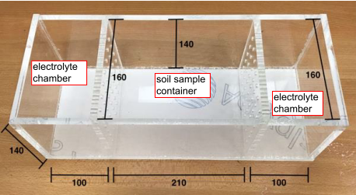
(a)
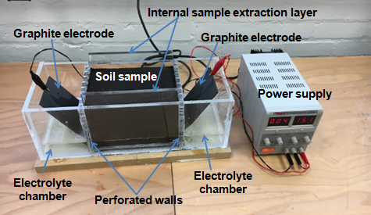
(b)
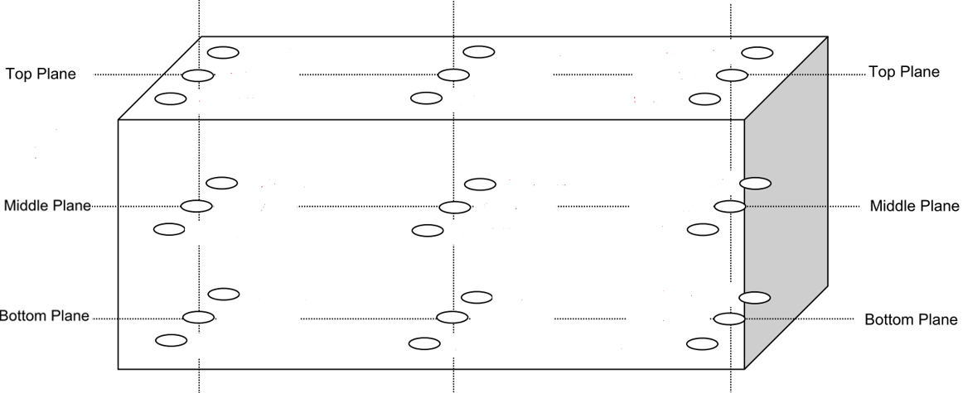
(c)

Figure 1 EK system and sampling locations: (a) Details of EK cell (all dimensions in mm); (b) full system setup; (c) sampling locations

The boxes were covered with cling film to avoid evaporation and prevent cracking. Disposable subdermal hooked needle electrodes were inserted at set distances of 42 mm from the cathode and voltage readings were taken at these points during the experiment using a portable voltmeter. These showed a progressive reduction of the resistance of the soil during the process. As both electrodes were perforated, drainage was allowed at both electrodes. Tests were thus performed under an open-cathode and open-anode condition, maintaining a constant level in the electrolyte compartments and adding a 15% water, so that consolidation due to EK does not occur, as this would be undesirable under existing embankments. Again, in order to control the pH gradient, the nutrient broth solution and the cementing reagents (divided equally in the two electrolyte compartments i.e., 7.5% per dry soil mass per compartment) were added gradually in three equal parts (starting at day 1, then at day 3 and day 7).

The pH of the solutions was monitored inside both electrolyte chambers during the treatment. Indicative results are shown in section 3 (Fig. 3). The pH of the effluents from both electrolyte compartments was determined directly using a portable HI-9831-5 pH/EC/TDS/ºC metre manufactured by Hanna Instruments. At the end of the testing the pH of soil samples was determined according to BS 1377-3:2018 (BSI, 2018) using a soil suspension in water. These pH measurements were performed at 0 mm, 50 mm and 100 mm away from the electrodes at 27 different locations of the soil sample (see Fig. 1(c)) to ensure that the pH did not change considerably due to the EK. End-of testing moisture content, CaCO₃ and ammonia measurements were also performed at the same locations. In addition, temperature was recorded during the testing, as this can affect bacteria growth. Indicative measurements are shown in section 3 (Fig. 4).

Before starting the EK biocementation testing, preliminary investigatory tests were performed to establish the amount of water that needs to be added to maintain a constant soil volume during the EK treatment; this is of practical importance to avoid soil settlement under existing earthworks. The results showed that approximately 15 % water (or aqueous solutions, of about 14.59 % water content considering the molecular weights of the nutrient broth, urea and calcium chloride) was required to maintain a relatively constant sample volume during the EK treatment.

Table 2 shows the list of the tests conducted during this study. These included a number of control samples, namely EK samples with 15% added water only, and also soil samples treated with 15% nutrient broth solution (of a 3 g/L concentration) per dry soil mass. The latter were prepared as a control to exclude any effects on the strength (e.g. due to flocculation/binding of soil particles) because of the salts contained in the nutrient solution. As shown in Table 2, for the majority of the biocementation treatments the nutrient broth solution and the cementing reagents were supplied all in one single solution (divided equally in the two electrolyte compartments i.e. 7.5% per dry soil mass per compartment). In one of the tests however (Bac2b_mix_85 (2 sol)) the bacteria and the nutrient solution were implemented first and the cementation reagent solution was implemented 7 days later. All EK treatments but one (Bac1b_mix_85 (7d)) lasted for two weeks, (i.e. 7 days per electrode polarity), which is a typical field treatment length (see Mena et al, 2016), followed by one additional day of curing. Bac1b_mix_85 (7d) lasted for 7 days without an additional day of curing to assess the effect of treatment length. Note that the first set of biocementation tests (Batch 1, Table 2) used bacteria pre-mixed with the soil before the application of the EK treatment, which was used to supply the nutrients and cementing reagents. This was to assess the feasibility of biocementation at different degrees of saturation considering only the potential effect of the EK on bacteria and hence the biocementation success; also, in order to eliminate any other effects on the success of the treatment linked to the bacteria transport and distribution in the sample. However, in subsequent tests (Batch 2, Table 2) the bacteria were also supplied electrokinetically, consistently with the realistic field implementation of the treatment.

At the end of the tests, specimens for unconfined compressive strength (UCS) were cut from the EK cell samples. The open rectangular surface and dimensions of the cell allowed the extraction of duplicate UCS specimens (50mm diameter and 100 mm height cylinders) from three different locations in the soil sample, namely from the areas next to the two electrolyte chambers (right and left) and from the middle of the sample (i.e. a total of six UCS specimens for each treatment). The CaCO₃ content of the specimens was measured by acid digestion testing using 20 g of oven-dried (at 105°C) soil samples soaked with 2 M hydrochloric acid (HCl) (Ng et al., 2014). The residue was collected on filter paper and oven dried at 105°C and the mass loss was measured to estimate the calcium carbonate content in the soil, expressed as a percentage of the dry sample mass. Note that consistently with the humified state of the soil, there was no change in soil colour during the EK treatment.

Table 2: List of UCS testing specimens used for this study
Test ID | Injected solutions | Degree of saturation (S_{r}) |  | Premixed bacteria | Treatment duration (days) | Curing (days)
Control Samples
C1_Wat_75 | Distilled Water | 75 % |  | N/A | 14 | 1
C1_Wat_85 | Distilled Water | 85 % |  | N/A | 14 | 1
C1_Wat_95 | Distilled Water | 95 % |  | N/A | 14 | 1
C2_ Nutr_75 | 3g/L nutrients | 75 % |  | N/A | 14 | 1
C2_ Nutr_85 | 3g/L nutrients | 85 % |  | N/A | 14 | 1
C2_ Nutr_95 | 3g/L nutrients | 95 % |  | N/A | 14 | 1
Batch 1 (bioaugmentation, with pre-mixed bacteria)
Bac1_mix_75 | 3g/L nutrients + cement. reagent | 75 % |  | Bacillus licheniformis (1x10⁸ cfu/mL) | 14 | 1
Bac1a_mix_85 | 3g/L nutrients + cement. reagent | 85 % |  | Bacillus licheniformis  (1x10⁸ cfu/mL) | 14 | 1
Bac1_mix_95 | 3g/L nutrients + cement. reagent | 95 % |  | Bacillus licheniformis  (1x10⁸ cfu/mL) | 14 | 1
Bac1b_mix_85 (7d) | 3g/L nutrients + cement. reagent | 85 % |  | Bacillus licheniformis  (1x10⁸ cfu/mL) | 7 | 0
Batch 2 (bioaugmentation, with electrokinetically injected bacteria)
Bac2_inj_75 | 3g/L nutrients +Bacillus licheniformis 1x10⁸ cfu/mL + cement. reagent  (all in one solution) |  | 75 % | N/A | 14 | 1
Bac2a_inj_85 | 3g/L nutrients +Bacillus licheniformis 1x10⁸ cfu/mL + cement. reagent  (all in one solution) |  | 85 % | N/A | 14 | 1
Bac2_inj_95 | 3g/L nutrients +Bacillus licheniformis 1x10⁸ cfu/mL + cement. reagent  (all in one solution) |  | 95 % | N/A | 14 | 1
Bac2b_mix_85(2 sol) | Two separate solutions:  Solution 1: 3g/L nutrients +Bacillus licheniformis 1x10⁸ cfu/mL  Solution 2: cement reagent (injected on day 7) |  | 85 % | N/A | 14 | 1

3. Results and Discussion
3.1 UCS testing sample results
Figure 2(a)-(d) shows the UCS testing results of specimens shown in Table 2 and other related measurements i.e. CaCO₃ and ammonia content, moisture content and pH of the specimens at the end of the tests. All strengths (including those of the control samples) were considerably higher than that of the natural soil (174 kPa) at its in situ dry density and water content. The increase in the strength of the pure systems (from 174kPa in the natural soil to a maximum of 374kPa (next to the electrode) for the EK treated pure system) with virtually no increase in precipitated calcite indicates that this was most likely due to electroosmotic effects, leading to changes in the soil structure. The organic matter/humus component of peat has a high net negative charge causing movement of hydrated ions (whose quantity depends on the soil cation exchange capacity (CEC)) from anode to cathode when an electric field is imposed. The high cation exchange capacity (CEC) of peat linked to the presence of organic matter/humus, justifies its good response to EK treatment (Asadi et al, 2011). As the studied soil is of a high degree of humification, it would have accordingly high electro-osmotic conductivity and a high electroosmotic water transport efficiency (Asadi et al, 2011).

The increase in strength between the untreated soil and the pure system (distilled water) treated by EK is however high; therefore, literature was consulted to ascertain the results. For mineral soils, literature reports high increases in strength after EK treatment (without chemical injection). These strength increases were attributed to the effect of electrochemical reactions during the electro-osmotic treatment changing the soil structure in terms of both fabric as well as bonding due to some possible mineral precipitation. For instance, Esrig and Gemeinhardt (1967) reported an increase in undrained shear strength of EK-treated illite clay by more than an order of magnitude over that of the untreated clay at the same water content. Micic et al. (2003) summarised their previous EK results on skirted foundation models embedded in simulated marine sediment and continued their study along these lines. Based on previous findings they reported shear strength increases in the vicinity of the anode up to 185%, attributed partly to electroosmosis; in the vicinity of the cathode the shear strength increased up to 80% despite the negligible decrease in the water content. This was attributed to electro-cementation of soil particles because of the precipitation of amorphous cementing agents such as iron oxides and carbonates generated by EK in the highly saline marine clay. The shear strength further increased with time after the electric field was withdrawn, which was attributed to soil particle cementation because of ionic diffusion following the EK treatment. Treatments with polarity reversal on a natural marine sediment and a river sediment mixed with artificially prepared seawater, resulted in an increase in the undrained shear strength of up to three times that was mostly attributed to electro-cementation of soil particles; the same strength increases were observed in the new series of tests presented in the paper (Micic et al, 2003). For peats Yee (2016) reported shear strength increases of 4.5-27 times the untreated peat strength (i.e. up to a 5706% increase), depending on the voltage gradient applied. For an organic soil the same author recorded eight to twenty-three times higher strengths after EK treatment. Whilst in the case of Yee, the soils had very high initial water contents and therefore the dramatic undrained shear strength increase can be due to the dramatic reduction in moisture content and subsequent consolidation (which was not allowed to happen in the presented study here), the increase can also be partly due to the changes in the soil structure induced by the EK, due to changes in the properties of the diffused double layer enhancing particle bonding. Referring to Asadi et al (2010), Yee explains that the release of H+ and the pH reduction next to the electrodes (when acting as anodes) neutralize the negative charges in zeta potential, leading to a reduction in the thickness of the diffused double layer; this leads to a reduction in repulsive forces between particles, causing a flocculation of the organic particles, thus an increase in undrained shear strength. Ion exchange processes causing reduction of diffuse double layer and enhancing soil particle bonding could thus explain the findings of the presented study, regarding the high increase in strength of the pure system treated by EK. The further improvement in the soil strength of the control samples with nutrients compared to that of the pure system (water) can be attributed to the action of salts, inducing changes in the physicochemical properties and flocculation and binding of the particles due to electromigration of ionic species.

Using the control samples with nutrients to compare the effect of bio-augmentation, it can be seen that all bacteria-treated specimens had higher strengths than the respective nutrient only control specimens; differences were however very small for degrees of saturation of 75% compared to the higher degrees of saturation. The beneficial influence of using higher degrees of saturation (i.e. 85-95%) for the EK treatment can be observed in all the EK treatments (control samples and batches with bacteria). In ﬁne grained and organic soils the water phase surrounds the particles and is continuous at the saturation ratios employed in these experiments (>75%), which is of importance for the success of the EK technique. From the results of the presented experiments, it would appear that there is suﬃcient water and space for the bacteria to circulate, although for some time it was believed that biocementation was not feasible in ﬁne grained soils because of restrictions of pore size. As explained earlier the placement of the electrodes outside the soil (see Fig 1(b)) circumvented the effects of the generated gases at the electrodes on the degree of saturation and hence the effectiveness of the EK treatment.

Comparing specimens with degree of saturation S_{r}= 95% against those with S_{r}=85% it is notable that greater strength gains were recorded next to the electrodes. Strengths in the specimens from the middle of the cells were however lower for the majority of the S_{r}=95% specimens compared to the respective S_{r}=85% specimens. This can be attributed to the accumulation of moisture in the middle of the samples due to polarity reversal. This increases the degree of saturation of the soil locally hence electric conductivity and electrokinetic transport phenomena. This can be beneficial for the partially saturated specimens (S_{r}=85%) but not for the nearly saturated specimens (S_{r}=95%) due to increased softening of the latter; softening and the reduction in the soil suction can explain the consistently lower strengths that were recorded in the middle points of the EK samples (compared to the electrode areas) for all tests, due to their higher moisture contents. Recommendations in the literature regarding the effectiveness of the EK treatment concur with this finding, i.e. that degrees of saturation should be high but that full saturation is not an optimal condition (Mosavat et al, 2012). Note the possible effect of the full saturation on the activity of the bacteria (although facultative anaerobes -such as B. licheniformis- can survive in low oxygen level, they grow better in an environment with more oxygen). In future work it will therefore be necessary to provide an effective drainage arrangement at this point.

The best performing specimens were those where bacteria were premixed in the soil (Batch 1) and with the treatments (nutrients and cementing agents) supplied for 14 days followed by one day of curing. However even for 7 days of treatment (i.e. Bac1b_mix_85 (7d)), the bacteria-treated specimens overperformed the control specimens with nutrients only, although the latter were subjected to 14 days of treatment. The increased CaCO₃ contents of the bacteria-treated specimens concur with the interpretation that the added strength of the latter specimens is due to biocementation effects. The same conclusion (i.e. that biocementation did occur) can be made based on the strengths and CaCO₃ contents measured for specimens where all treatments (including bacteria) were injected electrokinetically together with the nutrients, as their strengths were also higher than the respective nutrient only specimens, although lower than the strengths of specimens where bacterial were premixed in the soil. The strength and CaCO₃ contents increase indicates that transport of microorganisms did occur across the soil in Batch 2 samples. However, the fact that strengths were lower compared to pre-mixing the bacteria requires further research, as it is vital for the in-situ implementation of the treatments under existing infrastructure. The lower strengths compared to specimens with pre-mixed bacteria may not be only the result of non-uniform bacteria transport in the soil; they could also be due to inefficient stirring of nutrient-bacteria solution in the electrolyte chambers during the EK treatment or possible pH effects on the bacteria metabolic activity close to the electrodes, where pH can reduce during periodic polarity inversions (see Fig 2(d)).

Regarding the sequence of treatment supply, comparing Bac2a_mix_85 to Bac2b_mix_85(2 sol) it was found that providing all treatments in one solution (nutrients plus bacteria solution and cementing reagent solution) proved superior (in terms of strengths and calcite contents) compared to supplying the bacteria plus nutrients solution and the cementing reagent solution separately and sequentially (with a gap of one week). However other possible timings of the supply of the treatment solutions separately could potentially give better results and this merits further study.

The CaCO₃ contents broadly followed the UCS strength results, as expected, with two exceptions for the control specimens, whose calcite content is too low anyway and thus small variations may be due to the accuracy of the testing. It is interesting that the control specimens with nutrients only appear to have developed some slightly higher CaCO₃ content compared to the pure water system. This is difficult to explain (although there is some small calcium acetate content in the B4 medium where bacteria were grown). Note that despite the polarity reversal, there are some differences in the strength and CaCO₃ contents between the right and left electrode; the differences are however small and the pattern is not always consistent (i.e. in many cases the right electrode strengths and CaCO₃ contents are higher but not always). In the middle of the sample however the strengths are consistently the lowest although the pH was the highest (between 8-10) hence favourable for CaCO₃ precipitation. The lack of drainage leading to water accumulation in the middle of the sample can have partly affected the strength (and would require further attention and improvement of the process) but the findings merit further investigations, and so does the possible effect of the increase in soil acidity next to the electrodes on the calcite content (and hence strength).

To assess whether EK enhanced biocementation, reference can be made to results presented in Safdar et al (2020a) to compare the EK implementation of the treatments to implementation using pressure flow for a 85% degree of saturation (the baseline degree of saturation used in all biocementation tests in Safdar et al 2020a). The results were for a soil with premixed bacteria and can thus be directly compared to the EK sample Bac1a_mix_85 presented here. Safdar et al (2020a) found a 355 kPa average UCS values and a 0.85% average CaCO₃ content for the pressure flow column samples. Therefore, the use of EK increased the UCS by 30.1%, 16.7% and 27.4 % for the right electrode, middle and left electrode respectively, while the average measured CaCO₃ content increased by 101.1 %, 36.5 % and 45.9 % respectively at the right electrode, middle of sample and left electrode. It is recalled that as the electrodes are placed outside the soil, generated gases at the electrodes are not expected to have an effect on the degree of saturation of the soil.

An effect that has not been considered in the presented results is that of the indigenous bacteria (pre-existing in the soil) which would be interfering with chemical effects and could potentially contribute to biocementation by biostimulation, upon the addition of cementing agents. To assess such effects, a biostimulation experiment would have been useful. Biostimulation experiments were performed in Safdar (2020) using the pressure flow implementation, with the same treatments as those used for the bioaugmentation process. Biostimulation tests did not show evidence of biocementation, as opposed to the corresponding bioaugmentation treatments. For this reason, biostimulation was not included in the EK experiments and other EK tests were prioritised in view of the lack of sufficient soil sample from the same site. Biostimulation is however an interesting mechanism that needs to be further studied for possible use, for instance by changing the treatment protocol, although it is a lengthier process than bio-augmentation (Gomez et al. 2017) and this would increase the duration of the EK implementation.

Looking at the ammonia contents (Fig 2(b)), generally the trends of CaCO₃ concentrations and NH₄⁺ concentrations are consistent as expected, as higher urease activity would logically lead to higher CaCO₃ precipitation. It should be noted that the NH₄⁺ concentration exceeded the allowable limits of total ammonia (NH₃ and NH₄⁺) for drinking water according to UK legislation, set to 0·5 mg/l (HMG, 2018). NH₄⁺ ions can cause acidification of ground and water bodies, which can harm plant and animal life, and can be very toxic to aquatic organisms (Keykha et al., 2018). Ammonia is one of the criteria air pollutants according to European Union regulations. For real-scale engineering works, facilities for removal of ammonia from the air and ammonium ions from effluent are required, resulting in increased costs, complications (e.g. regulatory body permits) and other issues regarding the sustainability of the process (e.g. the use of large amounts of water for flushing the effluent to reduce ammonia concentration is adopted in practice). However as argued earlier, EK offers an opportunity of ammonia removal on site, although the technical details of the design of a system to remove ammonia will need thorough consideration and are beyond the scope of this paper.

From Figure 2(d) it can be seen that the end-of-test pH values demonstrate the similarity/ consistency of the results across tests. Namely, although next to the electrodes the pH was slightly acidic due to electrolysis reactions, the pH level was overall successfully controlled, thus very steep changes in pH level moving progressively through the soil were prevented (these could harm the bacteria); this successful control was due to the daily polarity reversal combined with the high buffering capacity of the peat soil (Asadi, 2011). Higher pH values (>9) in the middle of the sample were however consistently measured for all the EK experiments; this could possibly be a result of the accumulation of OH⁻ ions in the middle of the sample due to polarity reversal. Although high pH favours calcite precipitation, a pH of 8.0-8.5 pH could have possibly been overall more favourable, as a pH <9 would constitute optimal conditions for B. licheniformis enzymatic activity according to Elmi et al (2016).
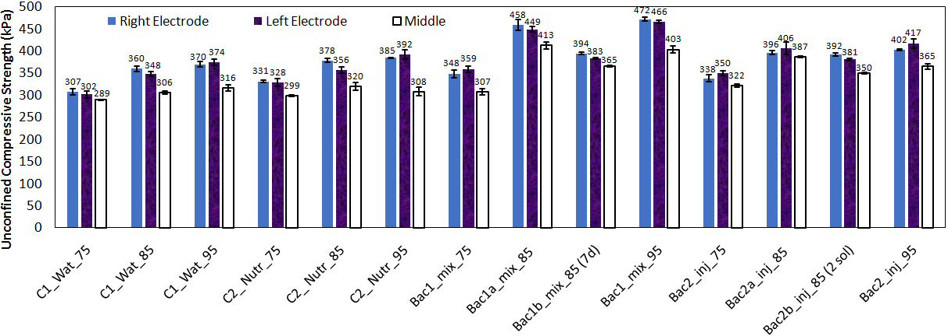
(a)
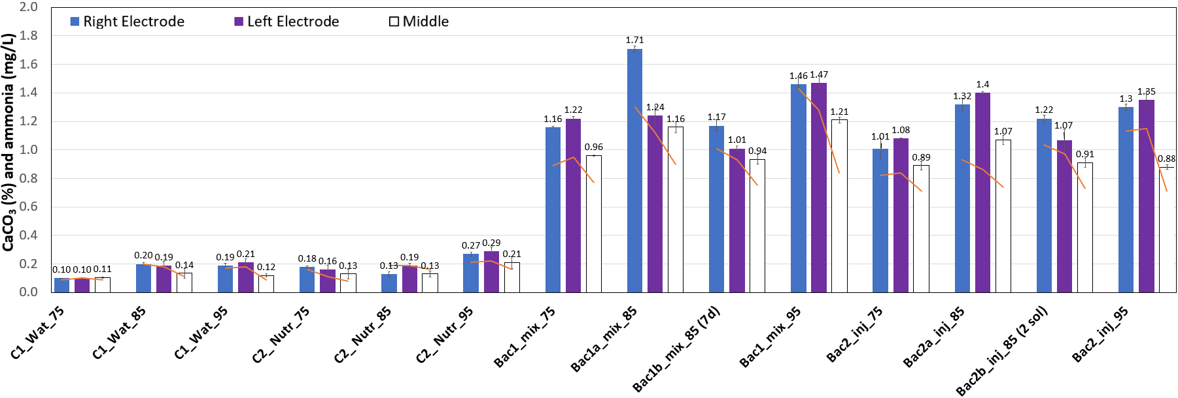
(b)
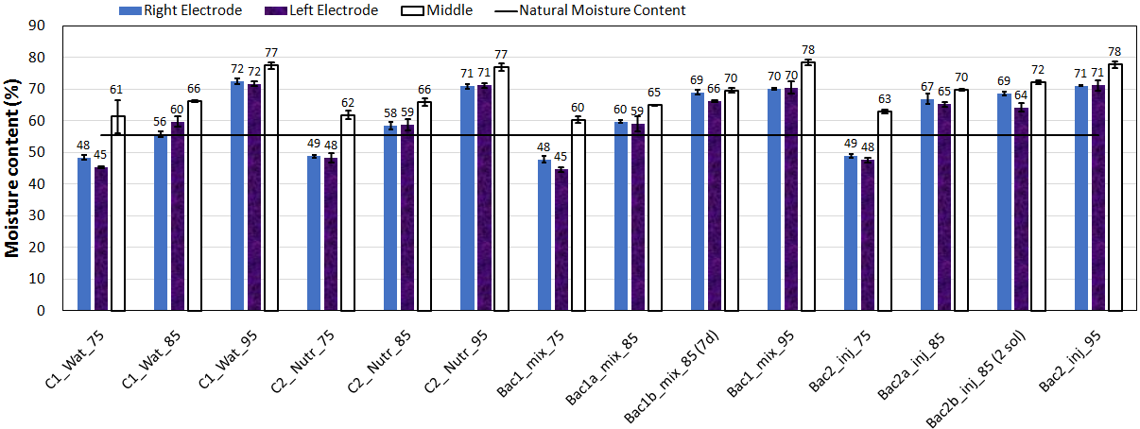
(c)
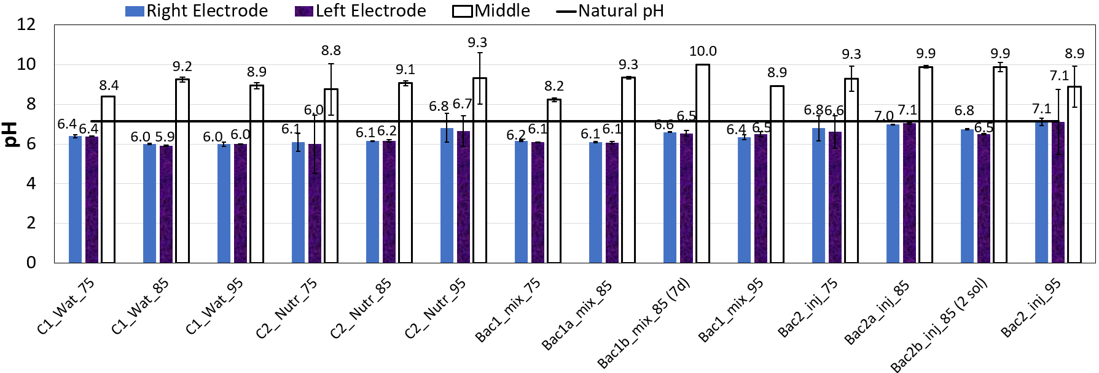
(d)
Figure 2 Measurements based on UCS specimens (end of test): (a) Unconfined compressive strength results; (b) End of test CaCO₃ content and ammonia content (solid orange line); (c) End of test moisture content measurements; (d) end of test pH measurements
3.2 Electrolyte pH measurements during EK treatment
Figure 3 shows indicative pH measurements in the electrolyte compartments during EK testing (based on the Bac1_mix_95 sample test). From the figure it is clear that reversing polarity every 24-hours and supplying the nutrients sequentially in three portions were effective in preventing sharp changes in the pH of both compartments.
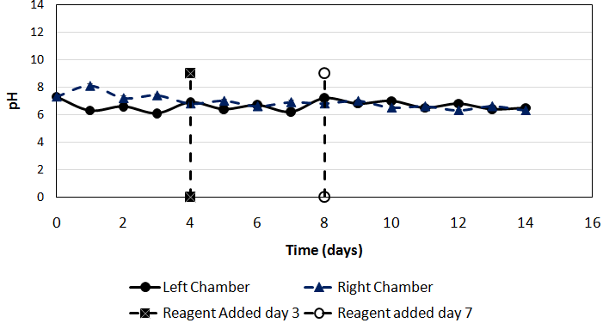
Figure 3 pH measurements in the electrolyte compartments

3.3 Temperature Variation
Figure 4 plots average temperature variations in the right and left chambers for the EK-Bioaugmentation experiments (Bio-augmentation Batch 1 and 2). The figure shows a rapid increase in temperature, especially in the first 7 days of the treatment. The maximum temperature observed during the 14-days of the EK treatment was 37.25º C; although this temperature increase could enhance evaporation from the sample and induce some soil shrinkage and cracking, it is much lower than temperature increases reported elsewhere. For instance, in Keykha et al. (2014) the temperature recorded at the end of 7 days of treatment (175 hours) was close to 55ºC, which corresponded to an increase of 120% from the starting temperature of 25ºC.
. 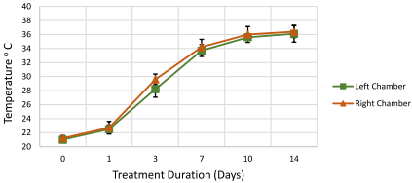
Figure 4 Temperature variation in time (right and left chambers)

3.4 Further considerations
The reported proof-of-concept research focused on the viability of the proposed technique for ground improvement at different degrees of saturation. Further optimisation of the treatments (e.g. different cell concentrations, media and reagents, treatment implementation sequence and duration, anode-cathode spacing, electric ﬁeld strength and electrode conﬁgurations) can be studied for improved results. Most importantly, for the upscaling of the technique towards field application (which is expected to be implemented in collaboration with specialised contractors) a number of challenges need to be considered to make the EK technology implementation feasible, cost-effective and sustainable; for instance, electrolyte management and control (e.g. pH), the treatment of the by-products of the process, the cost of materials, the effectiveness of electric ﬁeld and electrode conﬁgurations, voltage drops on the electrodes and other parts of the domain of high resistance leading to energy losses, energy expenditures and reagent consumption. The sustainability of the technique will need to be thoroughly assessed (e.g. through life-cycle analysis) as it requires considerable electrical energy consumption and this can have high costs and carbon footprint; this assessment is beyond the scope of this paper. Application of the proposed EK treatment on an actual site could take several months. EK can be very useful for the removal of ammonia by-product through the process of electromigration. Although the electromigration is considerably faster than flow under hydraulic gradient (and also faster than electroosmotic flow), the length of this process should also be considered in the estimates of the overall duration of the treatment. On the other hand, viewed in the context of other ground improvement techniques, the recent use of EK to treat highway and railway embankments in the UK was reported to have cost savings of 26-30% and a 46-48% reduction in embodied CO₂ compared to conventional soil nailing or gabion baskets and slope slackening (Jones et al, 2014). The assessment was made accounting for the carbon dioxide associated with direct activities such as plant movement and electricity generation, along with carbon dioxide embedded in materials and services. The use of renewable energy sources (e.g. solar energy) to produce electricity towards which countries are now moving, shows promise to further reduce the carbon footprint of the technique (Hassan et al, 2016). Further investigatory work including modelling is planned before a full-scale trial, to predict the rate of EK transport phenomena and the evolution of geochemical reactions and pH over time, in order to estimate the performance of the system and optimise field treatments. The effect of several treatment parameters such as electric ﬁeld strength and electrode conﬁgurations can also be assessed through numerical simulations. Numerical simulation-based optimisation of ﬁeld-scale EK-biocementation processes are expected to assess many of the above-mentioned effects efficiently and expedite the study towards a science-informed field trial design.

4. Conclusions
The aim of this work was to study the electrokinetic biocementation of an organic soil (Nordelph Peat of East Anglia, UK), and assess the effect of the degree of saturation of the soil, as well as to conduct some investigations on treatment implementation sequence and duration. Selected treatments were used based on previous studies by the authors (in terms of bacterial strains used, their population and the molarity of cementing agents). Undrained shear strength tests and accompanying CaCO₃ measurements proved that biocementation occurred during the EK implementation. This was the case whether bacteria were premixed with the soil prior to the EK implementation of treatment solutions or whether bacteria were injected electrokinetically together with the solutions into the soil. This gives promise for the applicability of the technique under existing earthworks. Parametric studies showed consistently higher strength gains for degrees of saturation in the region of 85%-95%, implying that in situ treatments would be more efficient if planned for certain periods in the year ensuring these soil conditions. Strength gains and increased CaCO₃ contents compared to the control samples were also noted when treatment duration was halved to one week, although strengths increased further by 13-17% after a two-week treatment. Further optimisation of the treatment variables (e.g. different concentration of microorganisms and cementation reagents) could further enhance the efficiency of the treatment. In addition, different sequences in the implementation of the treatments could be investigated.

Some observations regarding the non-uniformity of the conditions across the sample (due to water accumulation in the middle section of the EK cell) will need to be further investigated and addressed by providing suitable drainage and design such provisions for large scale applications. However, although a number of challenges lie ahead towards successful field implementation at real scale, the observed increase in strength and CaCO₃ content show promise that EK biocementation could be a viable technique for treating the organic soil under existing embankments.

The implications of these findings are of particular interest for the UK railway infrastructure owners, who are seeking new, cost effective and potentially more sustainable ground improvement techniques, of paramount importance for this type of works. Successful EK-biocementation treatment could potentially result in great financial saving on a yearly basis and greatly reduce the ongoing maintenance required and the associated Emergency & Temporary speed restrictions, causing significant delays and placing high demand on local track maintenance resources.

Acknowledgements
The authors would like to acknowledge the financial contribution of Network Rail Ltd for this project under research contracts NR-ANG-00164 and ecm_18210_ANG.

References
Ahmad, K., Taha, M.R. & Kassim, K.A. (2011) Electrokinetic treatment on a tropical residual soil. Proceeding of the Institution of Civil Engineers, Ground Improvement,164 (GI1): 3-13.
Al Qabany, A., Soga, K., and Santamarina, C. (2012) Factors affecting efficiency of microbially induced calcite precipitation. Journal of Geotechnical and Geoenvironmental Engineering, 10.1061/(ASCE)GT.1943-5606.0000666, 992-1001.
Alshawabkeh, A.N. & Sheahan, T.C. (2003) Soft soil stabilisation by ionic injection under electric fields. Ground Improvement, 7: 177-185.
Al-Thawadi S.M. (2008) High strength in-situ biocementation of soil by calcite precipitating locally isolated ureolitic bacteria, PhD thesis, Murdoch University, Perth, Western Australia
American Society for Testing and Materials (ASTM) (1997). D 4427 – 92 (Reapproved 1997) Standard Classification of Peat Samples by Laboratory Testing West Conshohocken, PA: ASTM International
American Society for Testing and Materials (ASTM) (1982) ASTM D4187 Standard test methods for zeta potential of colloids in water and waste water, West Conshohocken, PA: ASTM International
American Society for Testing and Materials (ASTM) (2014). ASTM D2974 – 14: Standard Test Methods for Moisture, Ash, and Organic Matter of Peat and Other Organic Soils, West Conshohocken, PA: ASTM International
Asadi, A., Huat, B. B. K., Hanafi, M. M., Mohamed, T. A. and Shariatmadari, N., 2010. Physicochemical sensitivities of tropical peat to electrokinetic environment, Geosciences Journal, 14(1): 67-75
Asadi, A., Huat B.B.K, Moayedi H., Shariatmadari N., Parsaie A. (2011) Electro-Osmotic Permeability Coefficient of Peat with Different Degree of Humification International Journal of Electrochemical Science, 6: 4481 - 4492
Barba, S., Villaseñor, J., Cañizares, P. & Rodrigo, M. (2019) Strategies for the electrobioremediation of oxyfluorfen polluted soils. Electrochimica Acta 297, 137 – 144, https://doi.org/10.1016/j.electacta.2018.11.195.
Bisset K. A. and Street J (1973) Morphological Phases in the Swarm of Bacillus licheniformis
Journal of General Microbiology. 76: 369-373
Botusharova, S., Gardner, D., and Harbottle, M. (2020). Augmenting microbially induced carbonate precipitation of soil with the capability to self-heal. Journal of Geotechnical and Geoenvironmental Engineering 146(4),4020010
BSI (1990). BS 1377:1990: Methods of test for soils for civil engineering purposes. Classification tests. BSI, London, UK.
BSI (2005) BS ISO 10390:2005 Soil quality. Determination of pH, BSI, London, UK
BSI (2012) BS ISO 13099-2:2012, Colloidal systems. Methods for zeta potential determination-Part 2: Optical methods. BSI, London, UK.
BSI (2014) BS EN ISO 17892-1:2014 Geotechnical investigation and testing – Laboratory testing of soil. Determination of water content, BSI, London, UK.
BSI (2017) BS EN ISO 11508:2017 Soil quality. Determination of particle Density, BSI, London, UK
BSI (2018a) BS EN ISO 14688-1:2018 Geotechnical investigation and testing – Identification and classification of soil. Part 1: Identification and description, BSI, London, UK.
BSI (2018b) BS 1377-3:2018 Methods of test for soils for civil engineering purposes. Chemical and electro-chemical testing, BSI, London, UK.
Clements LD, Miller BS, Streipsa UN (2002) Comparative Growth Analysis of the Facultative Anaerobes Bacillus subtilis, Bacillus licheniformis, and Escherichia coli. Systematic and Applied Microbiology, 25(2): 284-286
Esrig, M. I. & Gemeinhardt, J. P. (1967). Electrokinetic stabilization of an illitic clay. Journal of the Soil Mechanics and Foundation Division, ASCE, 93 (SM3): 109–128.
Hassan, I., Mohamedelhassan, E., Yanful, E.K. and Yuan, Z.-C. (2016) A Review Article: Electrokinetic Bioremediation Current Knowledge and New Prospects. Advances in Microbiology, 6, 57-72.http://dx.doi.org/10.4236/aim.2016.61006
Helmi F.M., Elmitwalli H.R., Elnagdy, S.M, El-Hagrassy A.F (2016) Calcium carbonate precipitation induced by ureolytic bacteria Bacillus licheniformis Ecological Engineering 90: 367–371
Gao Y, Hang L, He J., Chu J (2018) Mechanical behaviour of biocemented sands at various treatment levels and relative densities Acta Geotechnica doi:10.1007/s11440-018-0729-3
Gomez, M.G., Anderson, C.M., Graddy, C.M.R., DeJong, J.T., Nelson, D.C., and Ginn, T.R., (2017). Large-Scale comparison of bioaugmentation and biostimulation approaches for biocementation of sands Journal of Geotechnical and Geoenvironmental Engineering, 143(5): 04016124
Islam M, Chittoori B. and Burbank M. (2020) Evaluating the Applicability of Biostimulated Calcium Carbonate Precipitation to Stabilize Clayey Soils, J Mater Civil Eng, 32(3): 04019369
Ivanov V. and Stabnikov V (2017) Construction Biotechnology: Biogeochemistry, Microbiology and Biotechnology of Construction Materials and Processes, Springer Nature, Singapore
Jones C.J.F.P., Lamont-Black J., Glendinning S., White C. and Alder D. (2014) The environmental sustainability of electrokinetic geosynthetic strengthened slopes Proceedings of the Institution of Civil Engineers, Engineering Sustainability 167 (ES3): 95–107
Keykha H. A., Huat B.B.K, Asadi A., Kawasaki S. (2012) Review: Electro-Biogrouting and Its Challenges, International Journal of Electrochemical Science, 7, 1196 – 1204
Keykha H A, Huat BBK and Asadi A (2014) Electrokinetic stabilisation of soft soil using carbonate-producing bacteria. Geotechnical and Geological Engineering 32: 739-747
Keykha, H. A., Mohamadzadeh, H., Asadi, A., Kawasaki, S. (2018) Ammonium-Free Carbonate-Producing Bacteria as an Ecofriendly Soil Biostabilizer, Geotechnical Testing Journal https://doi.org/10.1520/GTJ20170353. ISSN 0149-6115
Krajewska B (2018) Urease-aided calcium carbonate mineralization for engineering applications: A review Journal of Advanced Research 13: 59–67
Lageman R and Godschalk MS. (2007) Electro-bioreclamation. A combination of in situ remediation techniques proves successful at a site in Zeist, the Netherlands. Electrochimica Acta 52(10 SPEC. ISS.):3449-3453.
Lamont-Blank J. and Weltman A. (2010) Electrokinetic strengthening and repair of slopes. Ground engineering, April 2010: 28-31.
Maity JP, Chen GS, Huang YH, Sun AC, Chen CY (2019) Ecofriendly Heavy Metal Stabilization: Microbial Induced Mineral Precipitation (MIMP) and Biomineralization for Heavy Metals within the Contaminated Soil by Indigenous Bacteria, Geomicrobiology Journal, 36:7, 612-623, DOI: 10.1080/01490451.2019.1597216
Marín S, Cabestrero O, Demergasso C, et al. (2021) An indigenous bacterium with enhanced performance of microbially-induced Ca-carbonate biomineralization under extreme alkaline conditions for concrete and soil-improvement industries. Acta Biomaterialia;120:304-317. DOI: 10.1016/j.actbio.2020.11.016.
Mavroulidou M., Safdar MU, Gunn MJ, Payne I., Garelick J., Purchase D (2019) Innovative methods of ground improvement for problematic transport earthwork materials 16th International Conference on Environmental Science and Technology CEST2019, Rhodes 4-7 September 2019
Mena E, Villaseñor J, Cañizares P and Rodrigo MA (2016) Effect of electric field on the performance of soil electro-bioremediation with a periodic polarity reversal strategy. Chemosphere 146: 300-307 DOI:10.1016/j.chemosphere.2015.12.053
Méndez, E., Pérez, M., Romero, O., Beltrán, E.D., Castro, S., Corona, J.L., Corona, A., Cuevas, M.C., Bustos, B. (2012) Effects of electrode material on the efﬁciency of hydrocarbon removal by an electrokinetic remediation process Electrochimica Acta 86: 148-156.
Micic S., Shang J.Q., and Lo K.Y. (2003) Improvement of the load-carrying capacity of offshore skirted foundations by electrokinetics Canadian Geotechnical Journal, 40: 949–963
Mitchell, J.K., Santamarina, J.C. (2005) Biological Considerations in Geotechnical
Engineering. Journal of Geotechnical and Geoenvironmental Engineering 131(10), pp.
1222–1233
Mizuno, A. and Hori, Y. (1988) Destruction of Living Cells by Pulsed High-Voltage Application. IEEE Transactions on Industry Applications, 24, 387-394. http://dx.doi.org/10.1109/28.2886
Montoya B, DeJong J (2015) Stress-strain behavior of sands cemented by microbially induced calcite precipitation. J Geotech Geoenviron Eng 141(6):04015019
Mosavat, N., (2014). Electrokinetic treatment of fine-grained soils with chemical enhancement solutions. PhD thesis, Griffith University.
Mosavat, N., Oh, E., and Chai, G, (2012). A Review of Electrokinetic Treatment Technique for Improving the Engineering Characteristics of Low Permeable Problematic Soils. International Journal of GEOMATE, 2 (2) (Sl. No. 4), 266-272
Nafisi, A., Montoya, B.M., and T. Evans. M., (2020). Shear Strength Envelopes of Biocemented Sands with Varying Particle Size and Cementation Level, Journal of Geotechnical and Geoenvironmental Engineering, 146(3): 04020002
Negassa WC, Guber AK, Kravchenko AN, Marsh TL, Hildebrandt B, Rivers ML (2015) Properties of Soil Pore Space Regulate Pathways of Plant Residue Decomposition and Community Structure of Associated Bacteria PLoS ONE 10(4):e0123999. doi:10.1371/ journal.pone.0123999
Ng, W. S., Lee, M. L., Tan, C. K., and Hii, S. L. (2014). Factors Affecting Improvement in Engineering Properties of Residual Soil through Microbial-Induced Calcite Precipitation J. Geotech. Geoenviron. Eng., 140(5): 04014006
Or D., Smets B.F., Wraith J.M., Dechesne A. Friedman S.P. (2007) Physical constraints aﬀecting bacterial habitats and activity in unsaturated porous media – a review, Advances in Water Resources 30 (6-7): 1505–1527
Ozkan, S., Gale, R.J. and Seals, R.K. (1999) Electrokinetic stabilisation of kaolinite by injection of Al and PO₄³⁻ ions. Ground Improvement, 3: 135-144.
Rebata-Landa V. (2007) Microbial Activity in Sediments: Effects on Soil Behaviour, PhD Thesis, Georgia Institute of Technology
Safdar. M. U. (2020) Biocementation of an Organic Soil with Electrokinetics. PhD Thesis, London South Bank University
Safdar M. U., Mavroulidou, M., Gunn M. J., Garelick J, Payne I., Purchase D., (2020a) “Innovative methods of ground improvement for railway embankment Peat Fens foundation soil”, Géotechnique https://doi.org/10.1680/jgeot.19.SiP.030
Safdar M., Mavroulidou M., Gunn MJ, Garelick J., Payne I., Purchase D., (2020b) Biocementation of an organic soil using indigenous ureolytic bacteria, Proceedings of the 6th International Symposium on Green Chemistry, Sustainable Development and Circular Economy (Greenchem6), Thessaloniki, 20-23 September 2020, ISBN:978-618-5494-13-1
Safdar MU, Mavroulidou M., Gunn MJ, Gray, C., Purchase D., Garelick J., Payne I., (2020c) Implementation of biocementation for a partially saturated problematic soil of the UK railway network, 4th European Conference on Unsaturated Soils (E-UNSAT2020), Lisbon 21-24 October 2020 E3S Web of Conferences 195, 05006 (2020) https://doi.org/10.1051/e3sconf/202019505006
Saffari, R., Nikooee, E., Habibagahi, G., van Genuchten, M.Th., (2019). Effects of Biological Stabilization on the Water Retention Properties of Unsaturated Soils, Journal of Geotechnical and Geoenvironmental Engineering, 145(7): 04019028
Sato A, Kawasaki S, Hata T, Hayashi T. (2016) Possibility for solidification of peaty soil by using microbes, International Journal of GEOMATE, June, 2016, 10 (22):2071-2076
Singhal N, Kumar M, Kanaujia PK and Virdi JS (2015) MALDI-TOF mass spectrometry: an emerging technology for microbial identification and diagnosis. Front. Microbiol. 6:791. doi: 10.3389/fmicb.2015.00791
Tajudin, S. (2012). Electrokinetic Stabilisation of Soft Clay. PhD thesis, University of Birmingham, UK.
Terzis, D., and Laloui, L., (2019). Cell-free soil bio-cementation with strength, dilatancy and fabric characterization, Acta Geotechnica, 14:639–656.
Terzis, D., Hicher P., and Laloui, L. (2020) Direct currents stimulate carbonate mineralization for soil improvement under various chemical conditions, Scientific reports, 10:17014 doi.org/10.1038/s41598-020-73926-z
U.S. Department of Health and Human Services, Centers for Disease Control and Prevention, & National Institutes of Health (CDC/NIH) (2007). Biosafety in microbiological and biomedical laboratories (5th ed.). L. C. Chosewood and D. E. Wilson (Eds.). Washington, DC: U.S. Government Printing Office. Available at: www.cdc.gov/od/ohs/biosfty/bmbl5/bmbl5toc.htm
Venda Oliveira P.J. and Rosa J.A.O. (2020) Conﬁned and unconﬁned behavior of a silty sand improved by the enzymatic biocementation method, Transportation Geotechnics 100400, https://doi.org/10.1016/j.trgeo.2020.100400
Whiffin V.S. (2004) Microbial CaCO₃ Precipitation for the production of Biocement, PhD thesis, Murdoch University, Perth, Western Australia.
Whiffin, V. S., van Paassen, L. A., and Harkes, M. P., (2007) Microbial Carbonate Precipitation as a Soil Improvement Technique, Geomicrobiology Journal, 24 (5): 417-423
Xiao, J., Zhou, S., Chu, L., Liu, Y., Zhang, J., Tian, L., (2020) Electrokinetic remediation of uranium (VI)-contaminated red soil using composite electrolyte of citric acid and ferric chloride, Environmental Science and Pollution Research, 27 :4478–4488.
Yee, J. H. S. (2016) Consolidation of Peat and Organic Soil using Electro-osmosis Treatment PhD Thesis, Curtin University.

