Double‑Tuned Surface ¹H–²³Na Radio Frequency Coils at 7 T: Comparison of Three Decoupling Methods

Francesca Maggiorelli^{1,2,3} · Eddy B. Boskamp⁴ · Gianluigi Tiberi³ · Alessandra Retico² · Mark R. Symms³ · Michela Tosetti³ · Fraser Robb⁴

Received: 31 July 2018 / Revised: 3 December 2018 / Published online: 27 February 2019
© Springer-Verlag GmbH Austria, part of Springer Nature 2019

Abstract
Magnetic Resonance Imaging (MRI) and Spectroscopy (MRS) with nuclei other than protons (X-nuclei) often require the acquisition of proton signal for shimming and co-registration procedures. Double-Tuned Radio Frequency (DT-RF) coils improve these procedures, avoiding the need for movement and repositioning of the subject during the examination. The drawback of DT-RF coils is basically the cou- pling between the two resonant structures, which increases signal losses leading to a degradation of the final MR image. To improve MR signal quality acquired via DT-RF coils, a suitable decoupling strategy should be implemented. For this pur- pose, three DT-RF coil prototypes, which differed only in the decoupling method, were built and their performances were compared through workbench measure- ments. Each prototype consisted of two concentric loops. The inner and outer loops were tuned at sodium (≈ 79 MHz) and proton (≈ 300 MHz) Larmor frequency at 7 Tesla, respectively. Active and passive decoupling designs were compared measur- ing the Q factor and the S₂₁ parameter for each prototype. Active decoupling was tested as an alternative to the standard passive decoupling with a trap circuit, in which a non-negligible amount of current flows at resonance, perturbing the mag- netic field responsible for producing the MR image. Workbench measurements showed satisfactory Q factors and S₂₁ for both active and passive decoupling cases. Thus, active decoupling could be a promising alternative to achieve better MR sig- nal quality. Furthermore, for active decoupling, two circuit elements were examined: PIN diodes and micro-electromechanical system (MEMS) switches.

 Francesca Maggiorelli francesca.maggiorelli@pi.infn.it
1 Department of Physical Sciences Earth and Environment, University of Siena, No 56, Via Roma, 53100 Siena, Italy
2 National Institute for Nuclear Physics, Pisa Division, Pisa 56127, Italy
3 Imago7 Foundation, IRCCS Stella Maris, Pisa 56128, Italy
4 GE Healthcare, Aurora, OH 44202, USA

Introduction

Magnetic Resonance Imaging (MRI) and Spectroscopy (MRS) with nuclei other than protons (X-nuclei) is an attractive technique for a variety of clinical appli- cations. X-nuclei MRI and MRS can considerably benefit from Ultra-High-Field (UHF) scanners that, with their enhanced Signal-to-Noise Ratio (SNR), may offer increased image quality in terms of spatial resolution and/or shorter scanning time compared to lower field systems. In this work, the attention is focused on sodium imaging, but the approaches reported here could be easily extended to the simultaneous detection of proton and other low gyromagnetic ratio nuclei of clinical interest (e.g., 31P, 13C). Since the first in vivo sodium images were created in 1983, continuous effort has been applied to improve this investigative tool. Many human disorders involve disrupted or altered regulation of sodium concen- trations and several studies have been conducted in patient populations to assess the value of sodium imaging and its potential to elucidate and diagnose pathol- ogy. Sodium is involved in many critical cellular functions, e.g., cellular prolif- eration, sodium/calcium exchange mediation, and cellular energy metabolism via active trans-membrane Na+/K+ transport. The difference between intra- and extracellular sodium concentration is essential for the generation and propagation of action potentials, cell volume regulation, and other cellular homeostatic and regulatory functions. 7T MRI enables the analysis of the tissue sodium content in small brain lesions such as in multiple sclerosis and brain tumors. Small tis- sue structures, such as articular cartilage and the Achilles tendon, can also be examined with sufficient SNR and spatial resolution. In addition to signal from X-nuclei, proton signal is often required for shimming and co-registration pro- cedures. Thus, Double-Tuned Radio Frequency (DT-RF) coils are needed. The drawback of DT-RF coils is, basically, the coupling between the two resonant structures, which increases signal losses.
The common decoupling method consists of the insertion of a trap circuit in
one of the two resonant structures, tuned at the resonant frequency of the other structure [3, 4]. A trap circuit is basically a shunt LC circuit that acts as a high impedance (ideally an open circuit) at resonance, achieving passive decoupling. On the other hand, a considerable amount of current flows in the trap inductor at its resonant frequency, generating a “hot spot” and perturbing the magnetic field homogeneity [5]. Furthermore, after the trap insertion, the coil is de-tuned and new tuning steps are required to achieve the final tuning. To simplify the re-tuning steps, we chose a second-order trap circuit (Fig. 1), in which a second capacitor provides an additional degree of freedom in the tuning procedure [8].
To surpass passive decoupling performance, active decoupling methods are proposed. Two active elements are considered: PIN diode and micro-electrome- chanical system (MEMS) switches [7, 8].
A PIN diode is a semiconductor device made of a large intrinsic (un-doped) layer (I) between an N- and a P-doped layer (see Fig. 2). It is similar to a stand- ard PN diode but, because of the large intrinsic region, some charge is stored during forward bias. This allows the control of the flow of high-power RF

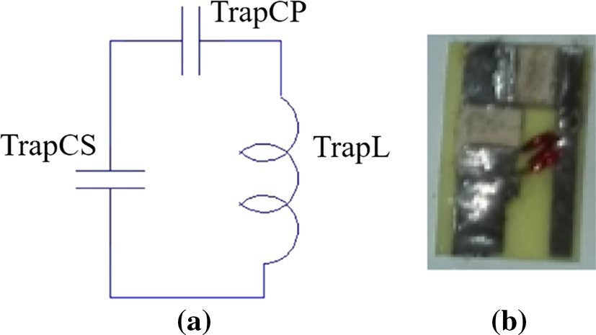
Fig. 1 a Second-order trap equivalent circuit, b second- order trap circuit components

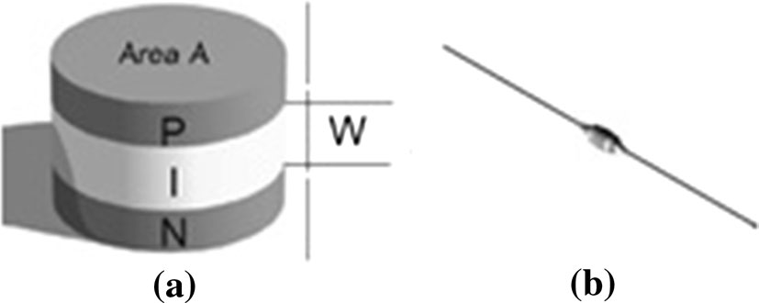
Fig. 2 a PIN diode schema, b
PIN diode device

current with a very small control direct current (DC) [9]. Therefore, the PIN diode can be considered as a current-controlled variable resistor for RF, provid- ing a resistance between 0.1 and 20 kΩ. It is small, and has a fast switching time and can be given non-magnetic packaging [10–12].
MEMS switches have been used in transmit–receive (Tx–Rx) switches [7], needed to decouple the high-power transmit channel from the high-sensitive receive chain in MR systems, and for reconfigurable RF coils [13, 14], allowing of the same RF coil to be adapted for imaging different body parts. However, the use of MEMS switches for DT-RF coil decoupling is currently under investiga- tion [15]. The MEMS switches’ actuation mechanism is fundamentally different to that one of PIN diodes. A MEMS switch is essentially a miniature device that uses a mechanical movement, obtained through electrostatic actuation, to achieve a short or an open circuit. More accurately, the MEMS switch used in the present work, provided by GE Healthcare (Menlo Microsystems, Inc., Irvine, California, USA), consists of an array of beam type structures operating as relays actuated electrostatically by a DC voltage applied between the beam and gate [16]. When the switch is actuated, the beams make contact with the central conductor providing a connection between RF_{a} and RF_{b} in Fig. 3. Thus, it is an active device and a DC voltage around 80 V is needed for driving it. Moreover, it is housed in a non-magnetic package and it is driven through 4 DC lines, con- nected to the MEMS Board (see Fig. 4) [13, 14]. More details on the device structure are provided in [17].
For both the PIN diode and MEMS switch, equivalent circuits in the ON state (switch closed) and OFF state (switch open) are shown in Fig. 5 [11, 18].

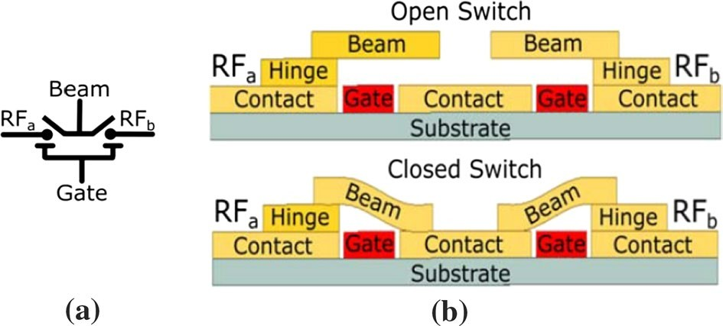

Fig. 3 In a MEMS switch circuital symbol. In b Side view of the MEMS circuit schematic
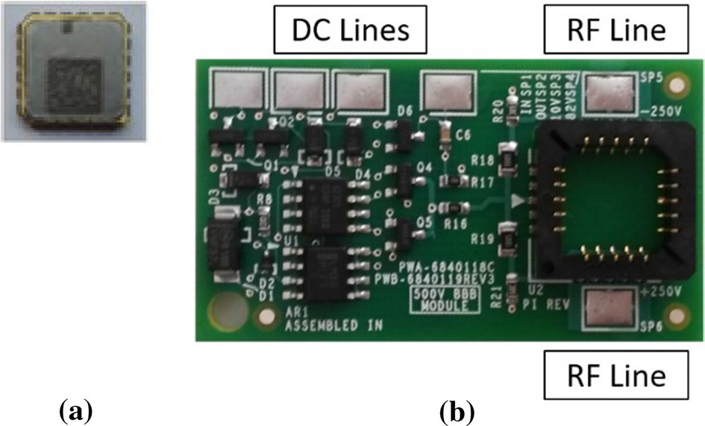
Fig. 4 a MEMS switch, b MEMS switch board
Fig. 5 PIN Diode/MEMS switch equivalent circuit. a In the ON state, the switch is closed and it is equiv- alent to a parasitic series resistance. b In the OFF state, the switch is open and it is equivalent to a para- sitic capacitance

Methods

To compare decoupling circuit performances, three identical DT-RF coils were built. The three prototypes consisted of two concentric loops (see Figs. 6, 7, 8). The exter- nal one was tuned at the proton Larmor frequency (298.03 MHz at 7 T), whereas the internal one was tuned at the sodium Larmor frequency (78.86 MHz at 7 T). The 1H transmit and receive (Tx/Rx) loop was created by etching an external square loop with a length of 110 mm. The 23Na loop was created by etching a rectangular loop of 95 mm × 85 mm (see Fig. 8). The corners of the coils were rounded: the curvature radius was 30 mm for the main loops and 2 mm for the end-point of the strip. To

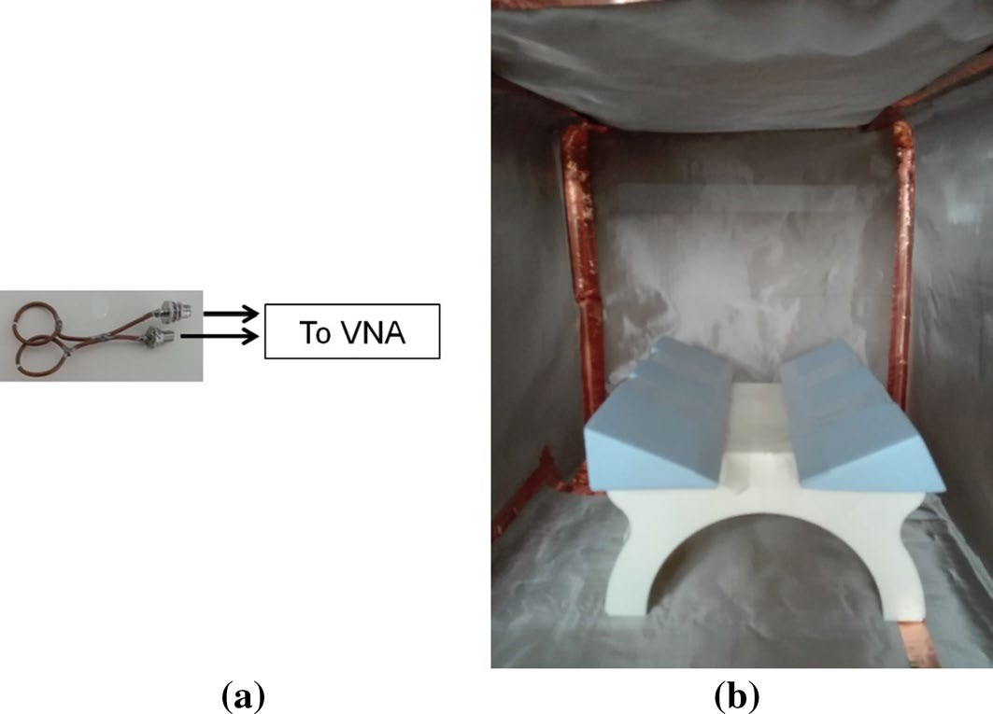

Fig. 6 a Double pick-up loop for Q factor measurements. b Faraday Cage

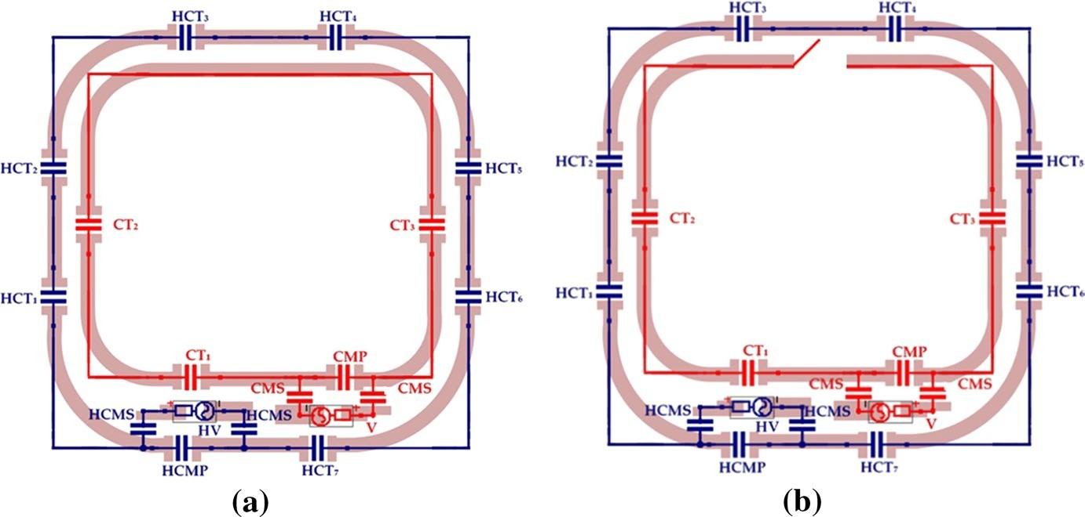
Fig. 7 DT-RF coil model. a Sodium mode, b proton mode

minimize the antenna effect, the number of tuning capacitors was chosen, so that the length of the conductors for both loop was less than λ/10, where λ is the wavelength at the two resonant frequencies. The resonant circuits of the RF coils were mounted on a PCB in FR4 (board thickness 200 μm, copper thickness 35 μm). The other materials used in the design were non-magnetic ATC 100C series chip capacitors (American Technical Ceramics Corp.), and RG-58 cables (Micro-coax, Belden). The holding supports, which are shown in Fig. 8, were designed in AutoCAD and 3D-printed, using Acrilonitrile–Butadiene–Stirene (ABS) as the printing material.
Tuning was achieved by soldering capacitances of appropriate value. In the three prototypes, the decoupling elements act as a switch, which opens the inner loop, tuned

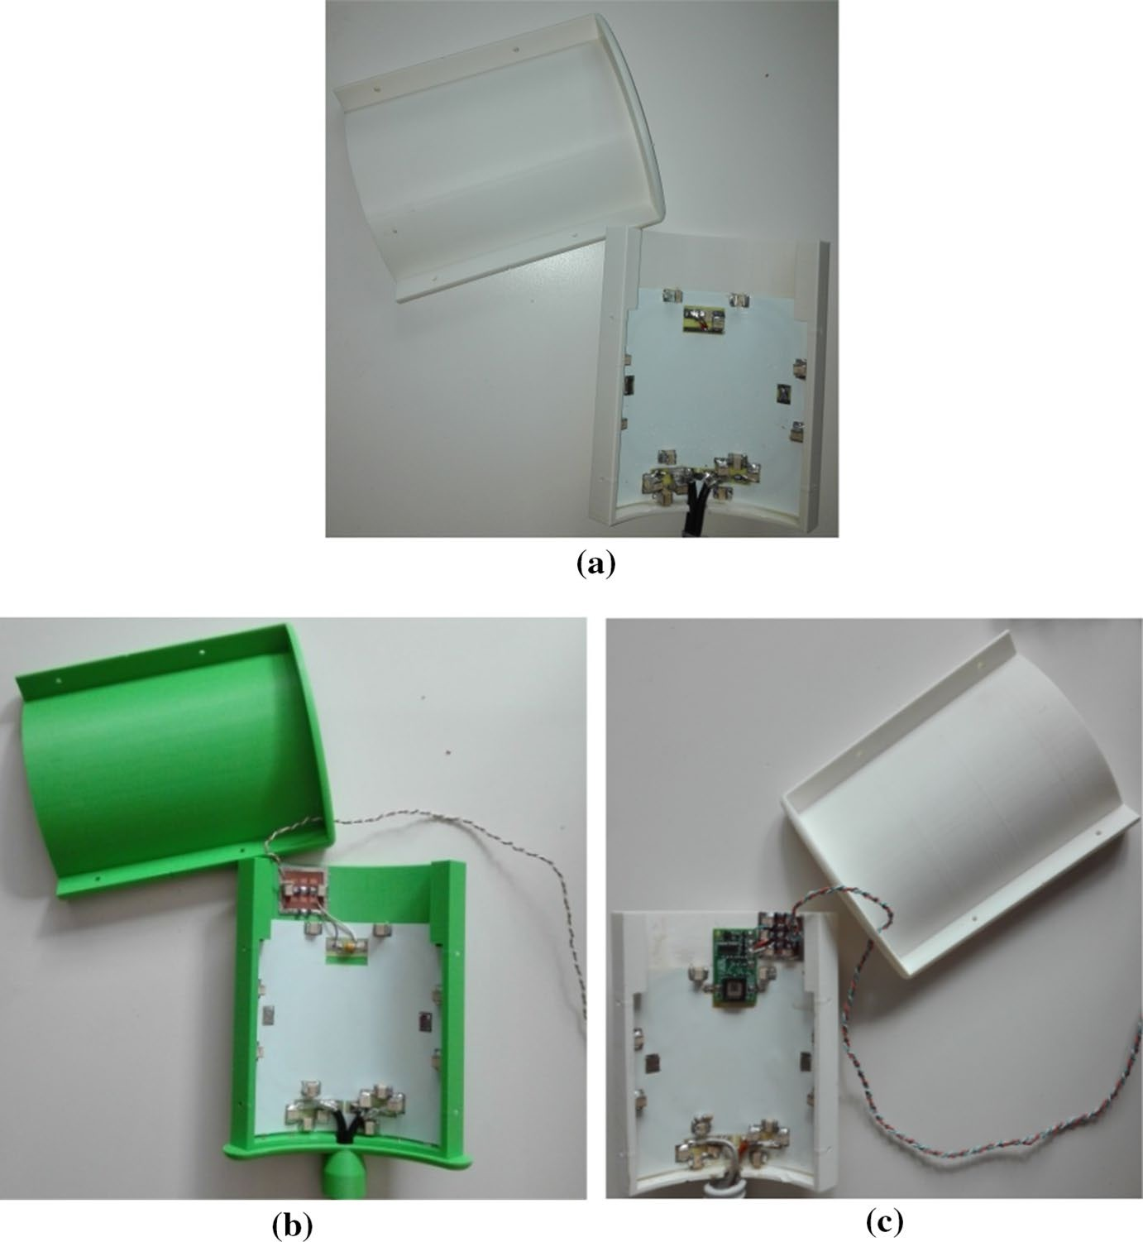
Fig. 8 a Double-tuned 1H/23Na coil with trap circuit. b Double-tuned 1H/23Na coil with PIN diode. c
Double-tuned 1H/23Na coil with MEMS switch

at the sodium Larmor frequency when the proton signal is transmitted/received. The reasoning behind this choice is that the amount of current that flows in the proton loop at the sodium resonant frequency is negligible, because the impedance exhibited by the proton loop capacitances at sodium resonant frequency is high. Indeed, according to XC = 1∕CC , where Xc is the capacitive reactance and ω = 2 πf; at the lower frequency (f_{23Na} = 78.86 MHz), the impedance exhibited by the proton tuning capacitance is rela- tively high, and therefore, the magnetic field generated by the inner sodium loop can- not induce a current in the outer loop, tuned at proton frequency (f_{1H} = 298.03 MHz). The opposite is not true in the condition of proton resonance. At the higher frequency, the impedance exhibited by the sodium tuning capacitance is relatively low; thus, the magnetic field generated by the outer proton loop induces a current in the inner loop,

tuned at the sodium frequency. Therefore, the sodium loop should be opened when the proton signal is transmitted, to avoid coupling at the proton resonant frequency. In case of passive decoupling, the trap circuit acts as a frequency-controlled switch, which ideally opens the inner loop at the proton frequency. In the other two cases, the PIN diode or MEMS switches are opened through DC control lines when the proton signal is transmitted.
For the first prototype, we started tuning the second-order trap circuit [8]. After the trap circuit insertion, the inner loop resonant frequency changed (decreased). Thus, if we tuned the sodium loop once the trap circuit was already inserted, we avoided tun- ing the inner loop twice. We measured the Q factor of the inner loop at the sodium Larmor frequency with the trap circuit already inserted and with the outer loop open. We then tuned the inner loop of the second prototype at the sodium Larmor frequency (78.86 MHz at 7 T), without the active decoupling element inserted. In this condition, we measured the Q factor at the sodium resonant frequency. The previous measurement is useful for the further evaluation of the coil Q factor degradation due to the insertion of the decoupling element. Then, we inserted a PIN diode in series with the second prototype inner loop and we measured the Q factor at sodium Larmor frequency with the PIN diode in the ON state (switch closed). The procedure was repeated for the third prototype, in which an MEMS switch was inserted. In the ON state (switch closed), both the PIN diode and the MEMS switches act as a series resistance, as shown in Fig. 5a; thus, the resonant frequency does not change after the insertion of the active element. When the inner loops of the three prototypes were ready, we tuned the outer loops at the proton Larmor frequency in the presence of the inner loops. The Q factor of the outer proton loop alone, leaving the inner loop open, was also measured.
An RF coil can be modeled as a series RLC circuit. As a consequence, the coil Q
factor can be evaluated using

2лf0L f0
Q = = ,
R Δf

(1)

−3dB
where f₀ is the coil resonant frequency, L is the coil inductance given by the coil geometry, and Δf_{−3dB} is the -3 dB coil bandwidth. R takes into account coil losses [19, 20]. If the coil Q factor is measured in the presence of a sample, R takes into account both coil losses and losses due to the sample. In the following, we refer to the coil Q factor as Q_{unload} and to the coil Q factor measured in the presence of a sample as Q_{load}. In practice, the Q factor was measured with a double pick-up loop (shown in Fig. 6a), connected to a Vector Network Analyser (VNA, E5080A Agilent Technologies) [21], both in the loaded and unloaded conditions. The Q_{unloaded}/Q_{loaded} ratio allows the prediction of the final SNR, though the following relation [22]:

SNR ∝ ,.1 − 1 .
,

(2)

Qunloaded
Qloaded

Each coil was inserted in a Faraday cage (see Fig. 6b), which was home-built by covering a box (53 cm × 53 cm × 53 cm) with a metallic mesh (200 holes per linear inch, wire thickness of 0.04 mm, aperture (hole size) of 0.077 mm).

The matching in the presence of a cylindrical load was obtained with a series capacitive matching network, whose capacitors were determined using a Smith Chart procedure [23–26]. The load was a cylindrical bottle with radius 60 mm, height 200 mm, filled with a 0.05 M saline solution (ε_{r} = 80, σ = 0.60 S/m) and placed 15 mm away from the coil circuit.
Referring to Fig. 7, the list of capacitor values used to achieve the tuning and matching conditions is given in Table 1.
In the case of active decoupling, the PIN diode and the MEMS switches are driven by DC control lines. To avoid coupling between RF signals and DC con- trol lines, a specific circuit was designed and built both for PIN Diode and MEMS switches (see Figs. 9, 10). The difference between the two DC circuits is due to the fact that the PIN diode has only two DC lines, while the MEMS unit has four DC lines.
Once tuned and matched, the three prototypes S₂₁ parameters between the sodium (Port 1) and proton (Port 2) ports were measured with the VNA, to quan- tify the decoupling capability of the three DT-RF coils.

Table 1 Capacitor values used to achieve the tuning and matching conditions: a) coil with trap; b) coil with PIN diode; and c) coil with MEMS

(a) Coil with trap
HCT_{1,4}, | 8.2 pF
HCT2,3,6 | 6.8 pF
CT₁ | 33 pF
HCMP | 4.7 pF
HCMS | 33 pF
CMP | (33 + 10) pF
CMS | 22 pF
(b) Coil with PIN diode
HCT1,…,7 | (6.8 + 2.1) pF
CT₁ | (22 + 10) pF
HCMP | 6.8 pF
HCMS | 33 pF
CMP | (22 + 3.6) pF
CMS | (10 + 5.7) pF
(c) Coil with MEMS
HCT1,…7 | (5.1 + 2.1) pF
CT₁ | (22 + 10) pF
HCMP | 8.2 pF
HCMS | 33 pF
CMP | (22 + 4.7) pF
CMS | (10 + 5.1) pF

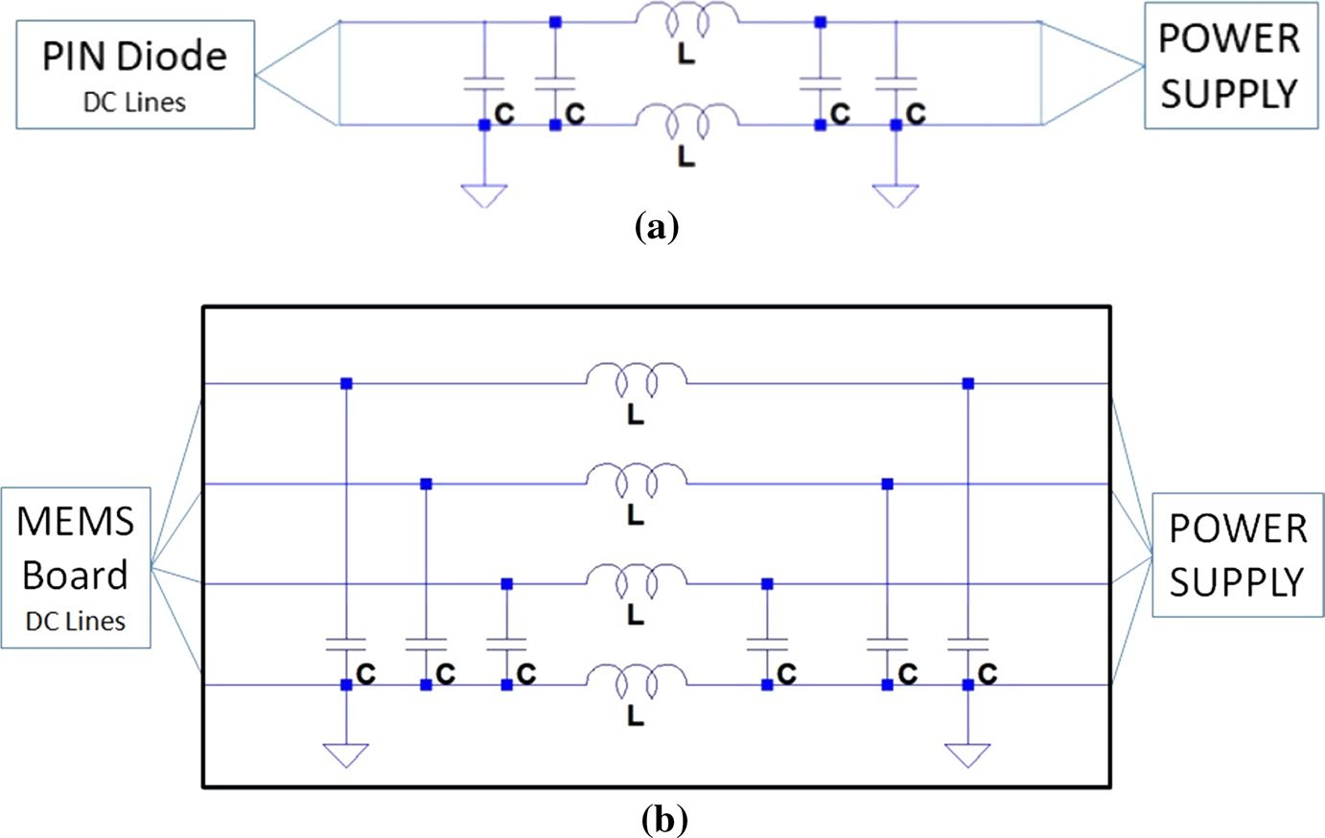

Fig. 9 Schematic of the DC circuit to filter RF signals coupled with a PIN diode DC lines, b MEMS DC lines. In each line, two RF chokes are soldered in series (1008CS from Coilcraft) and a 2.2 nF (100 C from ATC) capacitor is soldered between each line and the ground line

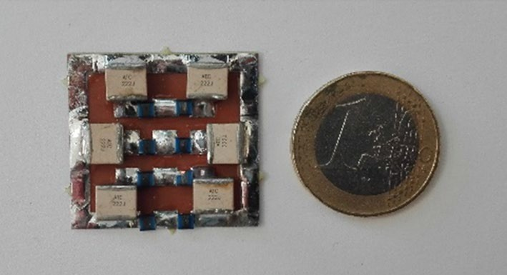
Fig. 10 PCB of the DC circuit to filter RF signals coupled with MEMS DC lines

Results

Results shown in Table 2 refer to the comparison between the inner loop Q factor before and after the decoupling element insertion. The Q factor of the coil with PIN diode is comparable with the Q factor of the coil with trap (> 240—unloaded condi- tion), while the Q factor of the coil with MEMS is lower than the other two. Thus, the degradation due to the PIN diode insertion is comparable with the degradation due to the trap insertion. In case of the MEMS switch the Q factor is lower. This could be due to the MEMS Board soldered on the coil. RF signals could flow into the MEMS Board, leading to additional losses which we measured as an additional Q factor degradation. This drawback could be overcome by separating the MEMS housing from the Board, so then, it would not be necessary to solder the MEMS Board onto the coil.

Table 2 Inner loop Q factors, measured leaving the outer proton loop open. Comparison between the inner loop Q factor without decoupling element
(a) and the inner loop Q factor with trap (b), PIN Diode (c) and MEMS (d)

Q factor—Only sodium loop

- No decoupling
Qunload (f23Na) 413
Qload (f23Na) 293
- Coil with trap
Qunload (f23Na) 246
Qload (f23Na) 194
- Coil with PIN diode
Qunload (f23Na) 246
Qload (f23Na) 188
- Coil with MEMS
Qunload (f23Na) 180
Qload (f23Na) 102

After the inner loop fine tuning, we tuned the outer loop at the proton frequency and we measured the Q factor at both Larmor frequencies. Results are shown in Table 3. All measurements at the sodium frequency are referred to the coil configu- ration, as shown in Fig. 7a. All measurements at the proton frequency are referred to the coil configuration, as shown in Fig. 7b.

Table 3 Q factors of the final prototypes with trap (b), with PIN diode (c), and with MEMS (d), measured both at sodium and proton Larmor frequency and compared with the Q factor of the same prototype without the decoupling element (a)
(a) No decoupling
Qunload (f23Na) | 384
Qload (f23Na) | 247
Qunload (f1H) | 266
Qload (f1H) | 51
(b) Coil with trap
Qunload (f23Na) | 249
Qload (f23Na) | 204
Qunload (f1H) | 106
Qload (f1H)  (c) Coil with PIN diode | 66
Qunload (f23Na) | 242
Qload (f23Na) | 192
Qunload (f1H) | 175
Qload (f1H)  (d) Coil with MEMS | 41
Qunload (f23Na) | 180
Qload (f23Na) | 151
Qunload (f1H) | 102
Qload (f1H) | 67

Q factor—both loops

The decoupling capability was quantified through the S₂₁ parameter (see Table 4). S₂₁ of the coil with the trap is comparable with S₂₁ of the other two coils at sodium frequency (S₂₁(f_{23Na}) < − 8 dB), but S₂₁ of the coil with the PIN Diode at the proton frequency is the best (< − 28 dB).

Conclusions and discussion

The final Q factor of the three prototypes is good (Q_{unloaded}(f_{23Na}) > 180), despite workbench measurements show that all decoupling elements introduce a Q factor degradation. This implies that the number of decoupling elements should be mini- mized. The Q factor of the coils with the trap circuit and the PIN diode are compa- rable and both are better than the Q factor of the coil with the MEMS switch. The lower Q factor of the coil with MEMS is probably due to the presence of the MEMS board directly soldered on the coil. This limitation could be overcome soldering only the MEMS on the coil and taking the board out of the coil circuit. This solution is not available at the moment. The Q_{unloaded}/Q_{loaded} ratio allows the prediction of the coil SNR, through Eq. (2). The coil with the PIN diode has the best Q_{unloaded}/Q_{loaded} ratio (1.26 at 1H frequency, 4.27 at 23Na frequency).
S₂₁ at the sodium frequency is comparable in the three cases, but this is not sur- prising. In the three prototypes the decoupling element acts only at the proton fre- quency, while at the sodium frequency, the three coils consist of two loops closed and tuned at the two working frequencies. Indeed, we suggest that the amount of current that flows in the proton loop at sodium frequency is negligible, and as a con- sequence, coupling at the sodium frequency is negligible. It is possible to increase S₂₁ at the sodium frequency, inserting a decoupling element also in the outer proton loop.

Table 4 S parameters of the

S Parameters (dB)

three prototypes with: (a) trap;

(b) PIN Diode; and (c) MEMS
- Coil with trap
S₁₁ (f_{23Na}) − 13.29
S₂₁ (f_{23Na}) − 9.89
S₂₁ (f_{1H}) − 13.02
S₂₂ (f_{1H}) − 13.25
- Coil with PIN diode
S₁₁ (f_{23Na}) − 12.41
S₂₁ (f_{23Na}) − 8.74
S₂₁ (f_{1H}) − 28.43
S₂₂ (f_{1H}) − 18.51
- Coil with MEMS
S₁₁ (f_{23Na}) − 18.45
S₂₁ (f_{23Na}) − 8.56
S₂₁ (f_{1H}) − 15.55
S₂₂ (f_{1H}) − 26.10

In both cases of decoupling with the PIN diode and with the MEMS switch, the S₂₁ parameter is higher than the S₂₁ achieved in the case of decoupling with trap circuit.
In conclusion, to compare active and passive decoupling strategies, we designed and developed three identical double-tuned 1H–23Na RF coils. Coil performances are compared in terms of Q factor and S₂₁. Results show that both active decoupling with the MEMS and the PIN diode could be interesting alternatives to the traditional passive decoupling with trap circuits. However, the MEMS approach introduces a bigger Q factor degradation with respect to the PIN diode, but this is driver specific. Removing the driver is likely to restore the degradation.

References

- S. Hilal, A.A. Maudsley, H.E. Simon, W.H. Perman, J. Bonn, M.E. Mawad, A.J. Silver, S.R. Ganti,
P. Sane, I.C. Chien, Am. J. Neuroradiol. 4, 245–249 (1983)
- B. Schmitt, S. Zbyn, D. Stelzeneder, V. Jellus, D. Paul, L. Lauer, P. Bachert, S. Trattnig, Radiology
260(1), 257–264 (2011)
- M. Alecci, S. Romanzett, J. Kaffanke, A. Celik, H.P. Wegener, N.J. Shah, J. Magn. Reson. 181(2), 203–211 (2006)
- F. Maggiorelli, G. Buonincontri, A. Retico, J.D. Kaggie, M.J. Graves, L. Biagi, G. Tiberi, M. Tosetti, in Proceedings of the 2017 International Symposium of the Applied Computational Electro- magnetics Society (Florence, Italy, 26–30 March 2017), pp. 1–2
- U. Zavonello, M. Borsero, D. Giordano, L. Ziliberti, F. Maggiorelli, G. Tiberi, IEEE Trans. Instrum. Meas. 66(6), 1208–1216 (2017)
- A. Retico, R. Stara, M.E. Fantacci, A. Toncelli, A. Galante, T. M. Florio, M. Alecci, M. Cosottini,
G. Astrea, R. Battini, G. Tiberi, M. Costagli, M. Tosetti, IEEE-MeMeA, CR 7145175, 74–78 (2015)
- M. Fuentes, E. Weber, S. Wilson, B. Li, S. Crozier, in Proceedings of the 18th Annual Meeting of ISMRM (Stockholm, Sweden, 1–7 May 2010), p. 422
- M. Twieg, M.A. de Rooij, M.A. Griswold, IEEE Trans. Microwave Theory Tech 63(12), 4169–4177 (2015)
- R.H. Caverly, W.E. Doherty, R.D. Watkins, in Proceedings of the 2011 IEEE MTT-S International Microwave Symposium (Baltimore, MD, USA, 5–10 June 2011), pp. 1–4
- S. Ha, M.J. Hamamura, O. Nalcioglu, L. Tugan Muftuler, Phys. Med. Biol. 55, 2589–2600 (2010)
- W.E. Doherty Jr., R. Joos, The PIN Diode Circuit Designers’ Handbook (Microsemi Corporation, Watertown, MA, USA, 1998)
- H. Caverly, G. Hiller, IEEE Trans. Microwave Theory Tech 38(12), 1938–1943 (1990)
- S.B. Bulumulla, K.J. Park, E. Fiveland, J. Iannotti, F. Robb, in Proceedings of the 23rd Annual Meeting of International Society for Magnetic Resonance Imaging (Toronto, Canada, 30 May–5 June 2015), Abstract 1797
- S.B. Bulumulla, K.J. Park, E. Fiveland, J. Iannottil, F. Robb, Rev. Sci. Instrum. 88(2), 253 (2017)
- A. Maunder, M. Rao, F. Robb, J. M. Wild, Magn. Reson. Med. 80(4), 1746–1753 (2018)
- D. Spence, M. Aimi, in Proceedings of the 23rd Annual Meeting of International Society for Mag- netic Resonance Imaging, (Toronto, Canada, 30 May-5 June 2015), Abstract 704
- C. Keimel, B. Claydon, L. Bo, J. Park, M.E. Valdes, IEEE Trans. Ind. Appl. 48, 1163–1169 (2012)
- G.M. Rebeiz, RF MEMS: Theory, Design, and Technology (John Wiley & Sons Inc, New York, 2013)
- J. Jin, Electromagnetic Analysis and Design in Magnetic Resonance Imaging (CRC Press, Boca Raton, 1998)
- G. Giovannetti, G. Valvano, G. Virgili, M. Giannoni, A. Flori, F. Frijia, D. De Marchi, V. Hartwig,
L. Landini, G.D. Aquaro, A. Pingitore, Appl. Magn. Reson. 46(11), 1221–1238 (2015)
- D. Kaifez, E.J. Hwan, IEEE Trans. Microwave Theory Tech 32(7), 666–670 (1984)
- W.A. Edelstein, G.H. Glover, C.J. Hardy, R.W. Redington, Magn. Reson. Med. 3(4), 604–618 (1986)

- J. Mispelter, M. Lupu, A. Briguet, NMR Probeheads for Biophysical and Biomedical Experiments: Theorical Principles and Practical Guidilines, 2nd edn. (Imperial College Press, London, 2006)
- P. Smith, Electronic Applications of the Ssmith Chart, 2nd edn. (SciTech/Noble Publishing, Raleigh, 1995)
- C. Bowick, RF Circuit Design, 2nd edn. (Newnes, Matlock Bath, 2007)
- D.M. Pozar, Microwave Engineering, 4th edn. (John Wiley and Sons Inc, NewYork, 2012)

