A review of BIM integration withbuilding performance analysis in the project life-cycle
Ruoyu Jinª, Botao Zhong^{b}, Ling Ma^{c,}*, Arman Hashemiª, Lieyun Ding^{b}
ªSchool of Environment and Technology, Univ. of Brighton, Brighton BN2 4GJ, U.K.
^{b}School of Civil Engineering and Mechanics, Huazhong University of Science & Technology, Wuhan, 430074, China
^{c}The Bartlett School of Construction and Project Management, University College London, London WC1E 6BT, U.K.

Abstract
Adopting Building Information Modelling (BIM) in Building Performance Analysis (BPA) is becoming an emerging research area in the application of information technology in the Architecture, Engineering, and Construction (AEC) industry. To investigate the current state of research in the adoption of BIM in BPA, this study performed a holistic review consisting of a bibliometric analysis of existing literature, content analysis of selected studies, as well as follow-up qualitative discussion in BIM integration with BPA. The bibliometric analysis identified 60 relevant studies; the content analysis of these studies revealed the research focuses of BIM-enabled BPA, including interoperability, semantics, and sustainability rating systems; the qualitative discussion further highlighted the learning process throughout project delivery stages and addressed the potential gap between ‘as-designed’ building performance and ‘as-built’ performance. Overall, this study contributes to existing research by identifying key input attributes and workflow in BPA, reviewing the state-of-the-art research on BIM integration with BPA, and investigating the major research areas, namely, interoperability issues in BIM-enabled BPA within the context of life-cycle BPA.
Keywords: Building information modelling; Building performance analysis; Interoperability; Level of details; Energy performance.

Introduction
The building sector accounts for 20% to 40% of the overall energy consumption [74,79,97] and one-third of the greenhouse gas emission worldwide[76]. It is vital to evaluate the energy performance of a building in the design stage to ensure minimum building energy consumption and maximum building performance before it is built because any changes to be made later are subject to excessive cost and resource waste. The building performance analysis (BPA) provides feedback on building design and facilitates the design optimisation. BPA in existing studies has been primarily focused on building energy assessment[19,62,88]. However, researchers in this study believe that BPA should cover a more comprehensive list of building performance indicators besides energy performance, such as daylighting [24], carbon footprint [9],and overall sustainability performance [7].
Traditionally, engineers who build the building energy models act as assistants to architects and use professional tools in their domain. Recently, the integration of design tools and building energy modelling tools have changed the way the two types of professional work together. The emerging Building Information Modelling (BIM) technology is becoming part of the design practice. BIM provides more accurate and interoperability capabilities than traditional computer-aided design[65]. Traditionally, the indoor work of information input in translating a geometric model to the simulation model is accomplished by an energy modeller. This progress is complicated and time-consuming. Also, manual input work may lead to low efficiency and limitation of data integration. BIM integrated multidisciplinary information in a model which facilitates the BPA in preliminary design phases. BIM authoring tools not only create geometric models but also can store non-graphical information such as material properties. It could be used as a repository of the information for a building energy analysis, such as the identity, geometry, material and other alphanumeric data of building components [36].
Although BIM-enabled BPA has become an interactive and intuitive process such that a designer without any simulation skill can perform the calculation which leads to analysis reports including charts and diagrams, the reliability of the calculation depends on the richness and accuracy of the information defined in the model. Multiple studies [16,67,75,100] have emphasised that integration of BIM and BPA can optimise the building performance in early design stages. It is also imperative that the designer establishes the knowledge base of the types of BPAs required corresponding to different design stages with different Levels of Development (LoDs). However, it remains a challenge of how to couple building information and building performance models in the design lifecycle [67].It should be noticed that the building information herein does not only include geometric models, but also non-geometric or semantic information as demonstrated in existing studies focusing on transporting information from BIM to BPA.
Although there have been a few studies [42,80,85] providing a review of studies on integration of BIM and BPA, these existing studies were either limited to the review of technological development (e.g., laser scanning) or data acquisition and analytics. For example, the study of Gerrish et al. [32] demonstrated a method to link the data from BIM to building operation through a case study of building design and operation. The feedback on user based issues implementing BIM as a performance management tool [32] was collected through follow-up interviews to stakeholders. So far limited review work has been done to consider different project stages and their significance when applying BIM for BPA. This study aims to investigate the contemporary research focuses and issues in BIM-enabled BPA based on a thorough literature review. Section 2 provides the background of project design stages by illustrating design details related to different building design stages; Section 3 describes the literature review methdology; Section 4illustrates the details of review-based analysis and findings related to BIM integration with BPA; Section 5 summarisesthe content analysis of BIM integration with BPA; Section 6investigates the major research area (i.e., interoperability) identified in the content analysis of the literature; Section 7 provides a further qualitative discussion by incorporating project life cycle into the integrated BIM&BPA; and finally Section 8 concludes the review-based study.

Background
The Royal Institute of British Architects (RIBA) divided a project lifecycle into eight stages which serve as milestones for determining the activities of the project stakeholders and agreeing on information deliverables[45]. Based on RIBA’s definitions, the activities of the conceptual design, preliminary design, and the detailed design stages are summarised herein. The deliverables at each stage include BPA at different LoDs, i.e., LoD100, LoD200, and LoD300. These are shown in Figure 1, Figure 2, and Figure 3.

Conceptual design (LoD100)
In the conceptual design stage, descriptions of internal environmental conditions and seasonal control strategies and systems should be prepared. At this stage, BPA requires the identification of design objectives, desired rooms or spaces, room sizes, relationships between spaces and relationships to the site. The content of BPA and information required in the conceptual design stage are shown in Figure 1.
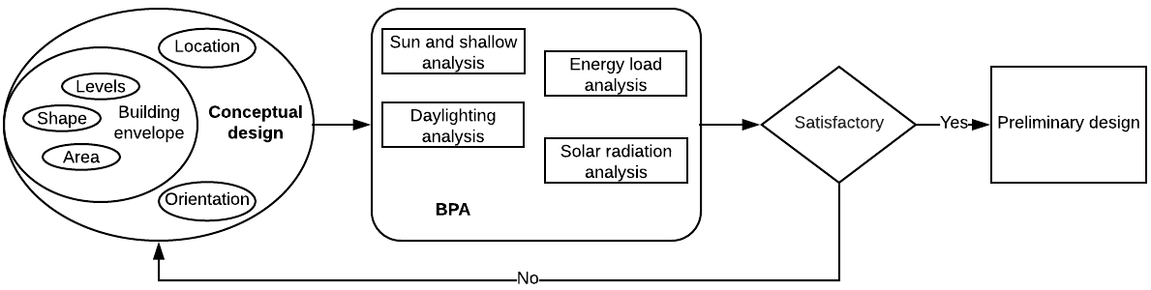
Figure 1 BPA at the conceptual design stage – LoD100
BPA at the conceptual design stage includes:
      - Sun and shadows analysis, which is to simulate the sun moves through the sky and analyse the shade on site;
      - Energy loads analysis, which is to identify the area requires heating and cooling;
      - Solar radiation analysis, which is to quantify the amount of the solar energy that can be used for energy generation on site;
      - Daylighting analysis of conceptual design, which is to quantify the sunlight in the project that can be used to reduce light loads and cooling loads.
Generally, the energy consumption of a building can be affected by several factors, such as daylight harvesting, natural ventilation and thermal mass. There are some significant factors which are essential to energy consumption optimisation, such as the shape and size of a building [12], building orientation [1] and building topology [48].A BIM model that includes all the information is referred as LoD100.

Preliminary design (LoD200)
The preliminary design starts with sketches, floor plan studies, and 3D or physical models. The BPA at this stage requires floor plans, elevations, sections, area analysis, rendering and preliminary cost (Figure 2). A BIM model that includes all the information is referred as LoD200.
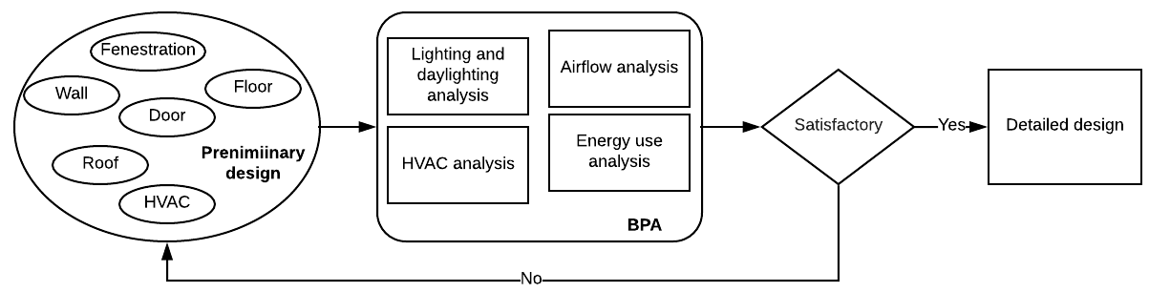
Figure 2. BPA at the preliminary design stage – LoD200
According to Figure 2, Building elements should be defined as general geometric primitives with approximate dimensions, shapes, location, and orientation. BPA at the preliminary design stage includes:
      - Lighting and daylighting analysis, which is to test interior visual comfort with the help of computer simulation and lighting consultants;
      - HVAC analysis, which is to adjust building systems, and compare results to determine the optimal configuration;
      - Airflow analysis, which is to improve the air quality and natural ventilation;
      - Energy use analysis, which is to calculate normal energy use (i.e., fuel and electricity) based on the building's geometry, climate, building type, envelope properties, and active systems (HVAC & Lighting).
Building design at this stage should be associated with a more accurate BPA. It is essential to take into account a comprehensive list of building information to assess building performance at the preliminary stage, including geometric, semantic and topological information [82]. Factors influencing building energy consumption would include building orientation, building layout and form, geometry, building fabrics, building envelope and passive strategies such as solar gain and shading strategies and natural ventilation strategies. Design optimisation could be assisted by building performance simulation through understanding and weighing the critical influence factors (e.g., building fabrics). Decision making during preliminary design stages would have an enormous effect on building energy performance.

Detailed design (LoD300)
The detailed design phase includes finalising the size of the rooms and spaces, refining the appearance, selecting materials, determining the systems, and deciding on the door and window types and locations. A full formal sustainability assessment should be carried out. A design stage carbon/energy declaration need to be undertaken.
At the end of the design development phase, the documents from the preliminary design phase need to be updated in further detail to support BPA. It is common to also have documents including specification outline, key details, interior schedules, and revised cost estimate, as shown in Figure 3. A BIM model that includes all the information is referred as LoD300.
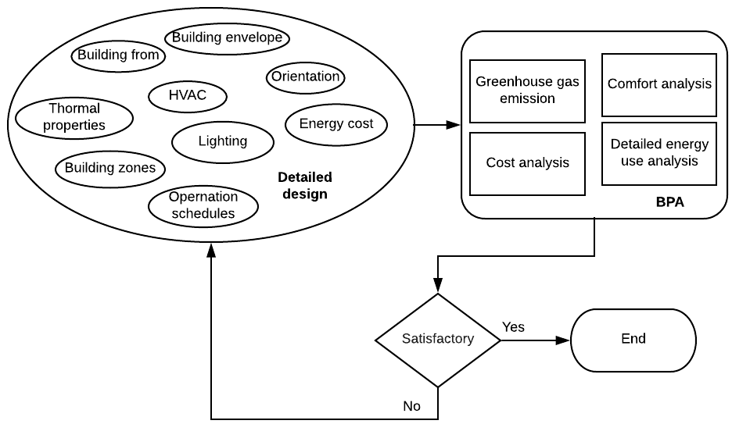
Figure 3 BIM-enabled BPA at the detailed design stage – LoD300
The information specified at this stage should be able to support the generation of construction documents and shop drawings. The geometry of the building elements should be defined using more accurate quantity, size, shape, location, and orientation. Physical characteristics of the building elements should be defined as alphanumeric properties.
Building energy analysis in the detailed design stage includes:
      - Detailed building energy use analysis of the final design and other performance-based analysis in support of detailed information, such as lighting and daylighting analysis, sun and shadow analysis, airflow and ventilation analysis;
      - Greenhouse gas emission and carbon footprint analysis;
      - Living comfort analysis;
      - Cost analysis

The literature review method
The literature review of BIM-enabled BPA followed three steps:
- A bibliometric search and review of Scopus-indexed journal articles followed by categorising keywords focusing on BPA integrated with BIM;
- content analysis of existing studies linking BIM to BPA;
- qualitative discussion for applying LoDs into BIM-assisted BPA following the study of GhaffarianHoseini et al [35].
These research methods used in this paper are illustrated in Figure 4.

Figure 4 Description of the study sections and corresponding research methods

Initial review of BIM integration with BPA
The bibliometric analysis of the literature was carried out using VOSViewer [93]. VOSViewer supports the analysis of clustering solutions with visualisations[92]. Scopus was chosen as the source to search the key published literature on BIM-enabled BPA, as it was identified by Aghaei Chadegani et al. [14] that Scopus has broader coverage of journals in the area of construction IT than other search engines including Web of Science with more recent publications. The following query was used to retrieve recent publications on BIM-enabled BPA.
TITLE-ABS-KEY (“BIM” OR "building information modelling" OR "building information modelling”) AND TITLE-ABS-KEY (“building performance” OR "energy analysis" OR "energy performance")
The query limited the years of publication to recent ten years (from 2009 to 2018), only Articles or Article in Press in Journals were included, and finally it restricted the language to be English.

Content analysis of key studies linking BIM to BPA
Following the bibliometric review assisted by VOSViewer, content analysis, which is the research method that has been adopted in multiple studies [28,91] in the field of engineering and management, was adopted to summarise the research contents within the selected sample of journal articles. Content analysis is a tool to examine trends and patterns in documents, and it allows researchers to sift through a large amount of data with relative ease in a systematic approach. The detailed steps of performing content analysis can be found in several existing studies such as Bogus et al. [10].

Incorporating different project stages into the integrated BIM&BPA
Based on the design stage descriptions illustrated in Figures 1-3, bibliometric review, content analysis, as well as existing studies stressing LoD and project life cycle[2], a follow-up discussion targeting on the integrated BIM and BPA in the context of project stages was initiated and discussed in a qualitative approach. The workflow was demonstrated, highlighting the input of building parameters and outputs within different LoDs.

The bibliometric analysis
Following the bibliometric search in Scopus, manual searching and screening was also conducted to weed out studies that did not fall into the scope of BIM-enabled BPA. For example, the study of Jalaei et al. [46], although adopting BIM in the building conceptual design for decision making of material selection, did not focus on integrating BIM and BPA. Finally, 546 research papers in total were selected from Scopus. These papers have 6,264 keywords; 299 of them, including both Author and Index keywords, were used in at least five papers. Some of the irrelevant or apparent keywords (e.g., BIM or building) were manually removed from the list. Then, some keywords with semantically similar meanings were categorised into the same terminology. For example, air conditioning, heating, and ventilation were categorised as HVAC; Bayesian networks, decision trees, and artificial neural network were all categorised as Machine learning based methods. After removing the irrelevant keywords and categorizing the remaining keywords with semantic similarities, 57 keywords are selected, as shown in Figure 5. These keywords were categorized and visualised to highlight the research focuses in recent years.
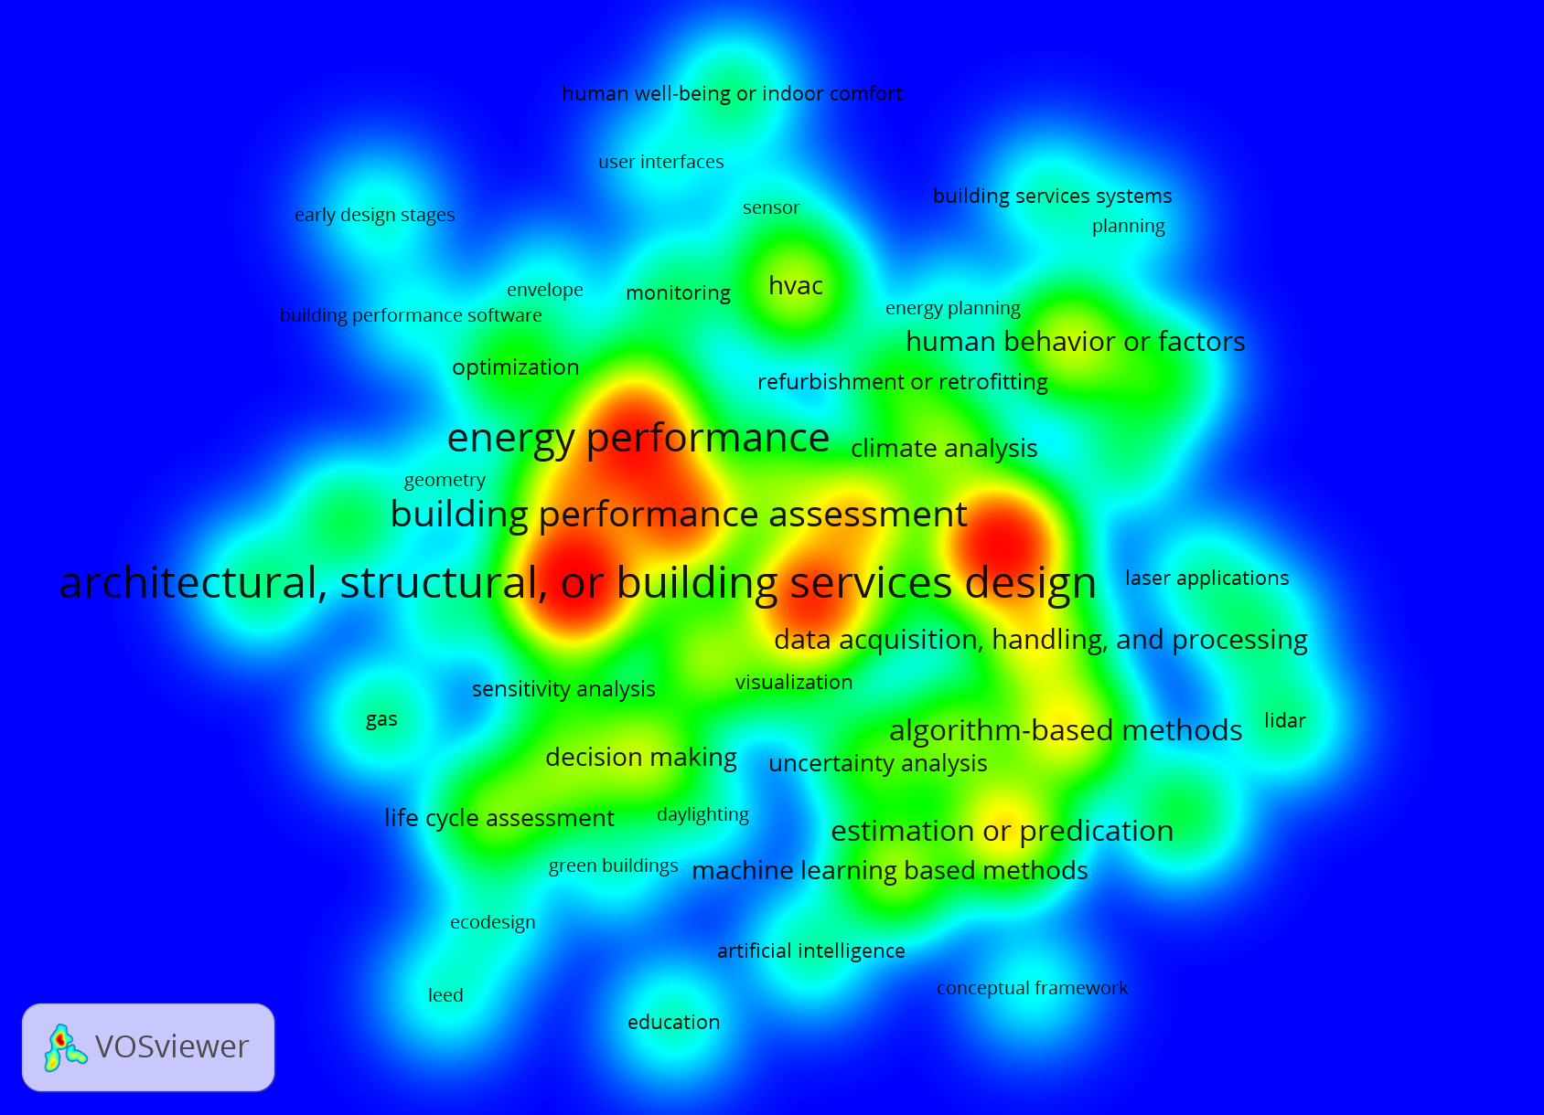
Figure 5 The identified 57 major keywords (not all the 57 keywords are visible)
The font size of keywords indicates the frequency of them in the sample journal articles. The distance between two keywords could infer their closeness. For example, the architectural, structural or building services design is highly relevant to decision making and life-cycle assessment. It can be found that architectural, structural or building services design, energy performance, and building performance assessment are the most frequently studied as the research focuses. These frequently keywords can be found closely connected to the rest keywords (e.g., data acquisition, handling, and processing). The relationships among these keywords can be summarized as below:
- Energy performance of building is one of the widely studied building performance assisted by BPA software, especially in the early design stages [56]. Other building performance studied included, but were not limited to daylighting [24], and thermal comfort;
- Sustainability rating systems (e.g., LEED or Leadership in Energy and Environmental Design) have been embedded in BIM-driven green building design [68];
- Influence factors to BPA that should be considered, for example, the real behaviour of building users [26];
- The linkage between BIM and BPA could be achieved or showcased with certain hardware and software, such as wireless sensor network to monitor thermal conditions in built environment [64]
- Data shared between BIM and BPA need the further handling, processing, and analytics, such as sensitivity analysis as showcased in Ahn et al. [3]. Multiple data analytics approaches have been adopted in the assisting BIM-driven BPA, such as algorithms [37] and programming [48]. These approaches have been applied in achieving optimization [52]in building performance design;
- Interoperability-related data format (e.g., IFC or Industry Foundation Class) would be needed to allow information exchange between BIM and BPA. The information would include both geometric information [44]and semantic data [59].
- Other research focuses, such as utilising integrated BIM and BPA for engineering education purpose [39], have not been widely studied.
These 57 keywords were categorised into six clusters which could be defined as:
- BPA measurements (e.g., energy performance);
- Design-related (e.g., ecodesign);
- Influence factors to BPA ;
- Equipment or hardware needed in BIM or BPA (e.g., laser application);
- Methodologies adopted (e.g., machine learning-based methods);
- Interoperability-related (e.g., IFC).
Not all the initially identified 57 keywords were all related to BIM-enabled BPA, especially discussing the input (e.g., building envelope) and output variables (e.g., energy use) in BPA. Therefore, these 57 keywords were further reduced to 15 according to their relevance to this research. A total of 60 out of the 546 papers which used these 15 keywords were identified for further content analysis. Figure 6 illustrates these 15 main keywords.
Figure 6 Categorized keywords related to BIM integration with BPA
According to Figure 6, BPA can be divided into these few major categories:
- Building energy performance (e.g., energy conservation)
- Environmental sustainability
- Indoor comfort including illumination and daylighting
- Resources (e.g., water and carbon footprint)
Several main input factors in building design that would affect BPA include:
- Thermal characteristics of building elements (insulation, roofs, windows);
- Building envelope including position and orientation information;
- Heating, ventilation and air conditioning (HVAC) system
Besides these BPA categories, Figure 6also indicates that sustainability assessment (e.g., LEED rating system[86]) is one of the key research areas[51]. It was suggested by Chong et al. [22] that new BIM standards and guidelines should include requirements on BIM tools’ compliance with specific sustainability assessment. Interoperability is a crucial issue when linking BIM into BPA. BIM offers interoperability opportunities and integration among different players. Although BIM can provide accurate material quantities and building components [34], insufficient interoperability between BIM and BPA raises barriers to reliable BIM-based BPA such as energy assessment [21].

Content analysis of the literature
Content analysis was conducted to summarize the 60 papers selected in the previous section. BIM-enabled BPA is achieved through BIM authoring tools and BPA analysis tools. Some BIM authoring tools have integrated BPA to deliver lifecycle building performance simulations, including expected energy demand, the projected financial running costs of the energy demand and CO₂ emissions. BIM-enabled BPA allows a fast, accurate, and iterative workflow as the ability to import the building geometry and thermal data from BIM has significant potential to reduce the time and uncertainty in BPA [43]. The potential interoperability between BIM and BPA was tested by Calquin et al. [11] to showcase how the existing BIM authoring tools (e.g., Autodesk Revit) could support BPA.
More statistical details of the totally 60 similar studies listed in Table 1are summarised in Figure 7.
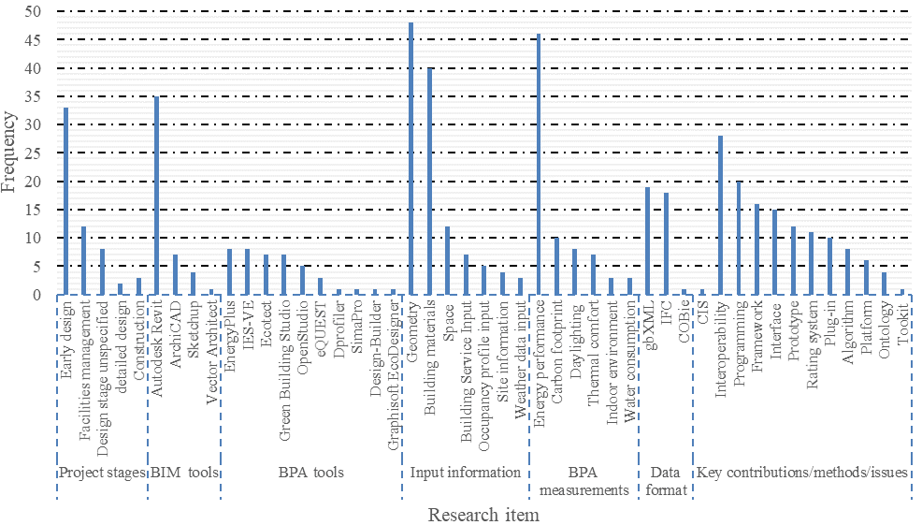
Figure 7 Frequency of research keywords in totally 60 research papers linking BIM to BPA
As the showcases for demonstration purpose, Table 1 lists some typical examples of studies in linking BIM authoring tools to BPA tools.
Table 1 Studies in linking BIM authoring tool to BPA tool
Case study | BIM authoring | BPA tools | Data exchange and format | Information shared from BIM to BPA | Contribution
Eight-  floor residential apartment building in Canada[51] | Autodesk Revit incorporating early stage design (i.e., conceptual design) information | Ecotect and IES-VE for energy analysis and lighting simulation | IFC and gbXML in Ecotect, and gbXML in IES-VE | Building’s 3D geometric information, building components, building services, Place and location | Plug-ins were created to enhance interoperability; The workflow developed in linking BIM to BPA enabled users to compare the select different materials and components for design and performance analysis.
A five-story library building in Korea [3] | ArchiCAD | Energy-  Plus | IFC providing information delivery manual (IDM) and model view definition (MVD) | Geometry and space boundary information | Both the pros and cons of full and semi-automation from BIM to energy simulation were discussed.
A high-rise residential building in the U.S.[75] | Autodesk Revit | Dynamo; Autodesk Green Building Studio | gbXML open schema | Project location, building type,  moreover, building  operating schedule, construction and material properties | A BIM-based framework was proposed and tested for building performance optimisation in the design stage
Five test cases in Modelica-  BIM Structure Example package[57] | Autodesk Revit | Modelica-BIM Structure Example package | Revit2Modelica consisting of Revit Application Programming  Interface (API) | Geometry, materials properties, and location information | BIM-based energy simulation using an Object-Oriented Physical Modelling approach using ModelicaBIM library was developed and validated.
A residential building and an instructional facility in the U.S.[43] | Autodesk Revit | The BPA tool not specified | gbXML | Thermal properties, but the limited geometric information could be transported from BIM to BPA | As-is building thermal properties were tested and updated in gbXML-based BIM for energy analysis.
An office building and a university library building in Korea[21] | Autodesk Revit and ArchiCAD | Energy-  Plus | IFC converted to Input Data Format (IDF) | Building materials with thermal properties, geometry, space type | The BIM-enabled energy performance assessment process, a materials library, and a decision- support  the system was initiated to address the low interoperability issue between BIM and BPA.

These few examples of previous studies are shown in Table 1 to demonstrate the existing research in addressing the gap of interoperability between BIM authoring tools and BPA tools through certain data format (e.g., IFC and gbXML). Although IFC and gbXML are the two major data formats studies on BIM-enabled BPA, researchers have also proposed alternative technical or managerial approaches, such as combination of design tools and visual programming language suggested by Negendahl [67] and Revit2Modelica consisting of Revit Application Programming Interface (API) developed by Kim et al. [57].
The research keywords in these 60 selected studies were divided into seven categories, namely project stages, BIM authoring tools, BPA tools adopted, input information in BIM, outputs in BPA, the data format, and key contributions & issues raised in the studies. Major findings are listed below:
- Interoperability[31,41,43,48,60,72] is one of the most frequently stressed issues in the integration of BIM and BPA. Multiple approaches have been proposed to address the interoperability issue, including algorithms [15,33,48], programming[9,25,55], and plug-ins [23,70,87]. Ontology and semantics[8,15,78]were addressed in some of these selected studies. These key terms, including framework [5,68,83], interface [58,69,77],prototype [13,18,40], and platform [21,27,46],have been frequently highlighted in these studies.
- Building energy performance is the most frequently studied BPA output, followed by carbon footprint, daylighting, thermal comfort, and indoor environmental quality.
- Various BIM authoring tools and BPA tools were adopted in these case studies. Compared to the BIM tools in which Autodesk Revit is the dominating software package, the use of BPA tools tended to vary widely.
- Most studies targeted at the building design stage, especially the early design stage as the phase where BIM can be coordinated with BPA. However, there has still been insufficient studies incorporating LoDs into the design stages. Gourlis and Kovacic [38] stressed the importance of incorporating LoDs in bridging BIM to building energy modelling (BEM) in order the reduce the uncertainties in integrated BIM and BEM, which are not solely an issue of software interoperability but also the redefinition of the design process.
The interoperability issue has been emphasised in the research of BIM integration to BPA. BPA for performance-based design is an area allowing the architects to create and explore different design alternatives [6]. There is a consensus on the need to achieve performance-based design via integrated use of BIM. Lack of integration and low levels of BIM use prevents applying BIM in the early design decisions to improve building energy performance. The issue of interoperability is widely present in many areas if collaboration and data exchange are needed [6]. An open data readable by any software package is considered vital to enhance the multi-party collaboration. Therefore, it is imperative to use an open standard that facilitates the collaborative work allowing any stakeholder to exchange data no matter what software where the data is created. The ISO-registered IFCdata standard can facilitate BIM interoperability by allowing information flow within the AEC industry [96]. IFC is a scheme widely accepted by the AEC industry to exchange BIM-based models [6]. It uses four layers (i.e., resources, core, interoperability and domain) to describe the geometric information, semantic information, and ontology in a BIM-based model. Besides IFC, gbXML is another widely adopted scheme that facilitates the exchange of data between BIM and BPA tools. Previous studies [90,95,98] summarized in Figure6 shared the similar methodology by developing a framework, interface or platform with specific data schema (e.g., IFC or gbXML), defining the scope of input information in BIM (e.g., geometric zones) and BPA output (e.g., energy performance), adopting a building case study for validation, and proposing recommendation for further improvements. In the web service based framework linking BIM to building energy simulation, Cheng and Das [20] highlighted code checking for automating the building design evaluation process. Unfortunately, the full potential of BPA has not been achieved due to lack of integration that prevents collaboration relationships throughout the project life cycle. It could also be indicated from existing studies of linking BIM to BPA that there is a further need of studying the interoperability between BIM and BPA tools when building components are in a higher LoD or when the building is more complex.
The content analysis results showed two major research problemsin BIM integration with BPA: interoperability issues and BPA acrossthe project life-cycle. To further address the interoperability issues in BIM integration with BPA, a total of129 journal articles from the refined literature sample focusing on interoperability issues in BIM-enabled BPA were reviewed. Figure 8 illustrates these keywords within of the 129 BIM-interoperability related articles.
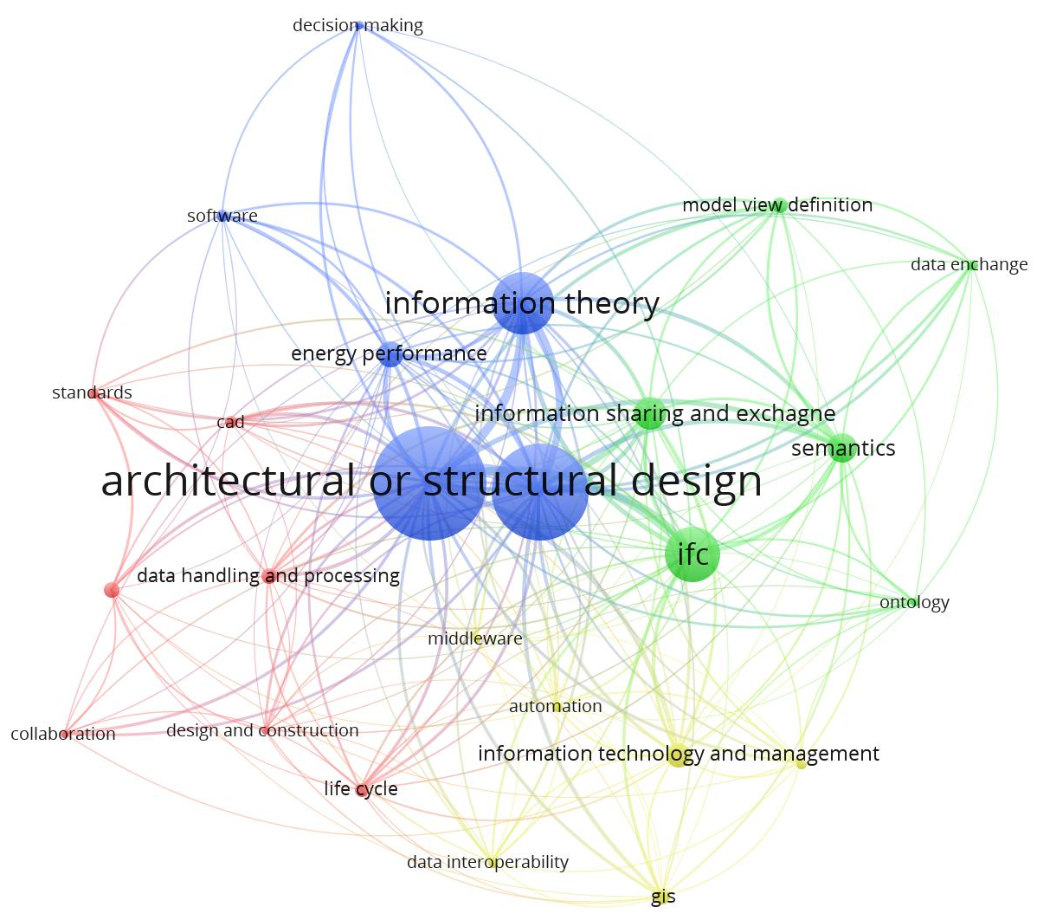
Figure 8 Keywords within interoperability-related issues in BIM
It can be foundthat the design stages, including architectural and structural of buildings, are the keywords most frequently studied in the research. The connection lines convey the information summarisedand evaluated below:
- The interoperability issues encountered in BIM, highlighted in multiple studies [4,71,83], have been more frequently studied in the area of energy performance compared to other areas such as life cycle or GIS (i.e., Geographic Information System). Currently, the interoperability in BIM is still low and limited to 3D coordination, and there have been limited standards guiding performance-based design in BIM [6]. An established standard to allow BIM in a multi-dimensional information transfer would be needed for enhanced multi-stakeholder information interaction. The information interaction should not be limited to design stages when utilizing BIM for BPA, but also construction stages and follow-up phases in the project life cycle. Currently the BPA in existing studies of BIM interoperability has been largely focusing on energy performance. It is expected that a comprehensive coverage of building sustainability be incorporated in an indicator system. This sustainability indicator system assisted by integrated BIM and BPA should not be limited to energy performance, thermal comfort, daylighting, but also resident health and wellbeing indoor;
- Data handling, storage, sharing, exchange in BIM interoperability is the key technical issue, with specific mainstream information flow formats, such as IFC. Interoperability, mainly related to IFC capacity to support information exchange among multiple BIM tools for different applications (e.g., energy simulation) is one of the main BIM-related research focuses according to Santos et al. [81]. Uggla and Horemuz [89] tested the geographic capabilities of IFC and found that the open BIM standard IFC could be improved by adding a separate scale factor for the horizontal plane and support for object-specific map projections. Venugopal et al. [94] found the ambiguous nature of the current IFC definitions and suggested a semantically robust reform in order to extend IFC and to define subsets as model view definitions (MVD).Other work performed to improve the IFC schema can be found in various studies. For example, Sun et al. [29] applied a content-based compression algorithm to reduce the redundant information carried in the existing IFC files for information optimization. It could be envisaged that enhanced IFC scheme or other open data platform will be implemented in the future for seamless information flow in AEC projects;
- Non-graphic information defined by semantics and ontology is one of the researches focuses. The interoperability issue within BIM-BPA integration should include both graphics and semantic aspects. Semantic performance could enhance IFC interoperability to BPA [73] and improve the interoperability between BIM and its synergies [53]. Extending the BIM interoperability at the semantic level is important to link BIM with other geospatial data crossing construction project stages [54]. Karan and Irizarry [54] proposed a methodology to integrate BIM and GIS and applied the semantic web technology for construction site planning, and stated that future work was needed to develop an interoperable framework for linked data;
- Both technological aspects (e.g., data interoperability[47,78]) and managerial (e.g., collaboration among project parties [49,50] and data management [31]) have been studied for the successful integration between BIM and BPA. The interface and BIM-based “green” building platform to enable the information sharing among AEC professionals, end-users and policymakers have been studied by El-Diraby et al. [27] to emphasise both technical and managerial aspects of BIM. Interoperability issues in BIM has not been the widely studied for AEC education and construction project management (e.g., interdisciplinary communication). More studies could be performed to verify how the improved interoperability would affect the AEC project performance, e.g., productivity, cost, and scheduling, etc. From the managerial perspective,case studies could be conducted to verify the effects of enhanced interoperability on project performance.

Qualitative Discussion
This paper finally discusses the integration of BIM and BPA to facilitate a more precise communication between architect/engineer and energy modeller/building performance analyst at different stages of a building project.

At the design stages, the BIM model is enriched continuously. Section 2 has illustrated the capabilities of BIM-enabled BPA with different model LoDs. The LoDs were defined (as shown in Figure 1, Figure 2, and Figure 3) based on the LoD matrix proposed by Abou-Ibrahim1 and Hamzeh[2].Some research has taken into account the LoDs in BIM-enabled BPA[30].
BPA can be conducted across the project life cycle. As the project progresses, the building performance may not meet the original design requirement. As a result, building performance monitoring measures should be taken to identified the gap between the designed building performance and the actual performance, and potential causes of the gaps (e.g., human behaviour related factors studied by Chen et al. [17], Li et al. [99], and Magalhães et al. [63]). The performance gap analysis strengthens the design review and knowledge base proposed in the BIM-IKBMS framework by Ghaffarian et al. [35]. The comparison of building performance and design review form the loop in the framework, which enables the learning process in building design stages to address the gap between actual and designed building performance. The building performance simulation would then be updated adopting the developed deterministic or stochastic models by addressing the causes of performance gaps. One example of the prediction model for building performance is data mining approach studied by Singaravel et al.[84].
The proposed BIM-enabled BPA serve as the case by contributing to the knowledge base – a digital asset. The knowledge base would provide a collection of previous experience, history and operations for building components so that the building maintenance teams could adopt efficient implements in certain similar cases according to Motawa and Almarshad [66]. As indicated by Singaravel et al. [84], deep-learning neural network approach could be one method to allow reliable prediction of BPA using the established cases from the knowledge base. The database could be further developed to apply Big Data for BPA by incorporating more input parameters, such as user profile and building sector, etc.
More future research directions can be proposed following the discussion of BIM-enabled BPA in the context of green buildings. For example, the performance analysis of green buildings adopting integrated photovoltaics in the research of Kuo et al. [61] can be extended by studying BIM-enabled BPA for buildings using renewable energy sources. BIM-enabled BPA for green buildings can also be extended from low energy-based design to other aspects of sustainability, such as low carbon, indoor comfort, and resource consumption.

Conclusions
This study adopted multiple research methods in identifying the major research topics in the area of BIM integration with BPA across the project life-cycle. A bibliometric review was conducted to identify most frequent keywords within BIM integration with BPA. Major categories within BPA (e.g., building energy performance) and corresponding influence factors (e.g., building envelope) were identified through literature review.
The raising issue of interoperability between BIM and BPA was highlighted as one of the main research areas. Through a further bibliometric analysis to narrow the scope of search focusing on interoperability within BIM, it was indicated that 1) most interoperability issues were related to application of BIM in building energy performance analysis; 2) both geographic and semantic information was involved in studying BIM interoperability issues; 3) both technical (e.g., data scheme) and managerial aspects should be considered critical in integrating BIM to BPA.The interoperability issue was further studied using content analysis to summarise 60 existing studies attempting linking BIM to BPA. Approaches to enhancing the interoperability issue between BIM and BPA could be found in these terminologies, including framework, interface, prototype, and platform, with critical methods proposed (e.g., algorithms, programming, and plug-ins). Ontology and semantics have become the research focuses. This research proposed the research directions to incorporate BIM to BPA crossing the building project delivery stages.
Both bibliometric analysis and content analysis also revealed the importance of integrating BIM and BPA in the project life-cycle. The LoDs at different project stages were highlighted which involve essential building information and building performance outcomes. The definition of LoDs enables information exchange and data sharing between BIM and BPA in different design stages. This paper proposed the research direction which allows a more precise communication between architect/engineer and energy modeller/building performance analyst at different stages of a building project. The performance gap analysis, development of knowledge base, and design review in the further discussion drive the ongoing learning process in transporting information in the building design model to the building performance model. Future case studies could be conducted to investigate the information exchange between BIM and BPA crossing different stages in the project life cycle. Future research can also extend the BIM-enabled BPA in a wider scope of green buildings by considering more sustainability measurements or scenarios, such as the adoption of renewable energy sources, indoor comfort, and resource consumptions, etc.

Reference
[1] F.H. Abanda, L. Byers, An investigation of the impact of building orientation on energy consumption in a domestic building using emerging BIM (Building Information Modelling), Energy 97 (2016) 517-527.
[2] H. Abou-Ibrahim, F. Hamzeh, Enabling lean design management: An LOD based framework, Lean Construction Journal 2016 (2016) 12-24.
[3] K.-U. Ahn, Y.-J. Kim, C.-S. Park, I. Kim, K. Lee, BIM interface for full vs. semi-automated building energy simulation, Energy and Buildings 68 (PART B) (2014) 671-678.
[4] O.O. Akinade, L.O. Oyedele, K. Omoteso, S.O. Ajayi, M. Bilal, H.A. Owolabi, H.A. Alaka, L. Ayris, J. Henry Looney, BIM-based deconstruction tool: Towards essential functionalities, International Journal of Sustainable Built Environment 6 (1) (2017) 260-271.
[5] Z. Alwan, J.M. E.D. Love, P. Steve, B.J. Gledson, Towards green building performance evaluation using asset information modelling, Built Environment Project and Asset Management 5 (3) (2015) 290-303.
[6] Y. Arayici, T. Fernando, V. Munoz, M. Bassanino, Interoperability specification development for integrated BIM use in performance based design, Automation in Construction 85 (2018) 167-181.
[7] S. Azhar, W.A. Carlton, D. Olsen, I. Ahmad, Building information modeling for sustainable design and LEED® rating analysis, Automation in Construction 20 (2) (2011) 217-224.
[8] C.A. Balaras, S. Kontoyiannidis, E.G. Dascalaki, K.G. Droutsa, Intelligent services for Building Information Modeling - Assessing variable input weather data for building simulations, Open Construction and Building Technology Journal 7 (2013) 138-145.
[9] L.C. Bank, B.P. Thompson, M. McCarthy, Decision-making tools for evaluating the impact of materials selection on the carbon footprint of buildings, Carbon Management 2 (4) (2014) 431-441.
[10] S.M. Bogus, G.C. Migliaccio, R. Jin, Study of the relationship between procurement duration and project performance in design-build projects: Comparison between water/wastewater and transportation sectors, Journal of Management in Engineering 29 (4) (2013) 382-391.
[11] D.A.L. Calquin, G. Wandersleben, L.S. Castillo, Interoperability map between BIM and BPS software, in: R.R. Issa, I. Flood (Eds.), 2014 International Conference on Computing in Civil and Building Engineering, American Society of Civil Engineers (ASCE), 2014, pp. 601-608.
[12] T. Catalina, J. Virgone, V. Iordache, Study on the impact of the building form on the energy consumption, 12th Conference of International Building Performance Simulation Association Building Simulation 2011, BS 2011, Sydney, NSW, 2011, pp. 1726-1729.
[13] A. Cemesova, C.J. Hopfe, R.S. McLeod, PassivBIM: Enhancing interoperability between BIM and low energy design software, Automation in Construction 57 (2015) 17-32.
[14] A.A. Chadegani, H. Salehi, M.M. Yunus, H. Farhadi, M. Fooladi, M. Farhadi, N.A. Ebrahim, A Comparison between Two Main Academic Literature Collections: Web of Science and Scopus Databases, Asian Social Science 9 (5) (2013) 18-26.
[15] S. Chardon, B. Brangeon, E. Bozonnet, C. Inard, Construction cost and energy performance of single family houses: From integrated design to automated optimization, Automation in Construction 70 (2016) 1-13.
[16] C.-J. Chen, S.-y. Chen, S.-h. Li, H.-t. Chiu, Green BIM-based building energy performance analysis, Computer-Aided Design and Applications 14 (5) (2017) 650-660.
[17] C. Chen, D.J. Cook, A.S. Crandall, The user side of sustainability: Modeling behavior and energy usage in the home, Pervasive and Mobile Computing 9 (1) (2013) 161-175.
[18] L. Chen, W. Pan, A BIM-integrated Fuzzy Multi-criteria Decision Making Model for Selecting Low-Carbon Building Measures, Procedia Engineering 118 (2015) 606-613.
[19] S.Y. Chen, A green building information modelling approach: Building energy performance analysis and design optimization, MATEC Web of Conferences, Vol. 169, 2018.
[20] J.C.P. Cheng, M. Das, A bim-based web service framework for green building energy simulation and code checking, Journal of Information Technology in Construction 19 (2014) 150-168.
[21] J. Choi, J. Shin, M. Kim, I. Kim, Development of openBIM-based energy analysis software to improve the interoperability of energy performance assessment, Automation in Construction 72 (2016) 52-64.
[22] H.-Y. Chong, C.-Y. Lee, X. Wang, A mixed review of the adoption of Building Information Modelling (BIM) for sustainability, Journal of Cleaner Production 142 (Part 4) (2017) 4114-4126.
[23] C.-C. Chou, C.-T. Chiang, P.-Y. Wu, C.-P. Chu, C.-Y. Lin, Spatiotemporal analysis and visualization of power consumption data integrated with building information models for energy savings, Resources, Conservation and Recycling 123 (2017) 219-229.
[24] L. Díaz-Vilariño, S. Lagüela, J. Armesto, P. Arias, Indoor daylight simulation performed on automatically generated as-built 3D models, Energy and Buildings 68 (PARTA) (2014) 54-62.
[25] B. Dong, Z. O'Neill, Z. Li, A BIM-enabled information infrastructure for building energy Fault Detection and Diagnostics, Automation in Construction 44 (2014) 197-211.
[26] M. Eguaras-Martínez, M. Vidaurre-Arbizu, C. Martín-Gómez, Simulation and evaluation of building information modeling in a real pilot site, Applied Energy 114 (2014) 475-484.
[27] T. El-Diraby, T. Krijnen, M. Papagelis, BIM-based collaborative design and socio-technical analytics of green buildings, Automation in Construction 82 (2017) 59-74.
[28] J. Esther Paik, V. Miller, S. Mollaoglu, W. Aaron Sun, Interorganizational Projects: Reexamining Innovation Implementation via IPD Cases, Journal of Management in Engineering 33 (5) (2017).
[29] G. Gao, Y.-S. Liu, M. Wang, M. Gu, J.-H. Yong, A query expansion method for retrieving online BIM resources based on Industry Foundation Classes, Automation in Construction 56 (2015) 14-25.
[30] T. Gerrish, K. Ruikar, M. Cook, M. Johnson, M. Phillip, Using BIM capabilities to improve existing building energy modelling practices, Engineering, Construction and Architectural Management 24 (2) (2017) 190-208.
[31] T. Gerrish, K. Ruikar, M. Cook, M. Johnson, M. Phillip, C. Lowry, BIM application to building energy performance visualisation and management: Challenges and potential, Energy and Buildings 144 (2017) 218-228.
[32] T. Gerrish, K. Ruikar, M. Cook, M. Johnson, M. Phillip, C. Lowry, BIM application to building energy performance visualisation and managementChallenges and potential, Energy and Buildings 144 (2017) 218-228.
[33] P. Geyer, Systems modelling for sustainable building design, Advanced Engineering Informatics 26 (4) (2012) 656-668.
[34] A. GhaffarianHoseini, D. Tien Doan, N. Naismith, J. Tookey, A. GhaffarianHoseini, Amplifying the practicality of contemporary building information modelling (BIM) implementations for New Zealand green building certification (Green Star), Engineering, Construction and Architectural Management 24 (4) (2017) 696-714.
[35] A. GhaffarianHoseini, T. Zhang, O. Nwadigo, A. GhaffarianHoseini, N. Naismith, J. Tookey, K. Raahemifar, Application of nD BIM Integrated Knowledge-based Building Management System (BIM-IKBMS) for inspecting post-construction energy efficiency, Renewable and Sustainable Energy Reviews 72 (2017) 935-949.
[36] N. Ghiassi, F. Tahmasebi, A. Mahdavi, Harnessing buildings’ operational diversity in a computational framework for high-resolution urban energy modeling, Building Simulation 10 (6) (2017) 1005-1021.
[37] G.I. Giannakis, G.N. Lilis, M.A. Garcia, G.D. Kontes, C. Valmaseda, D.V. Rovas, A methodology to automatically generate geometry inputs for energy performance simulation from ifc bim models, 14th Conference of International Building Performance Simulation Association, International Building Performance Simulation Association, Hyderabad, India, 2015, pp. 504-511.
[38] G. Gourlis, I. Kovacic, Building Information Modelling for analysis of energy efficient industrial buildings – A case study, Renewable and Sustainable Energy Reviews 68 (2017) 953-963.
[39] S.J. Guo, T. Wei, Cost-effective energy saving measures based on BIM technology: Case study at National Taiwan University, Energy and Buildings 127 (2016) 433-441.
[40] A. Gupta, A. Cemesova, C.J. Hopfe, Y. Rezgui, T. Sweet, A conceptual framework to support solar PV simulation using an open-BIM data exchange standard, Automation in Construction 37 (2014) 166-181.
[41] E. Guzmán Garcia, Z. Zhu, Interoperability from building design to building energy modeling, Journal of Building Engineering 1 (2015) 33-41.
[42] S. Habibi, The promise of BIM for improving building performance, Energy and Buildings 153 (2017) 525-548.
[43] Y. Ham, M. Golparvar-Fard, Mapping actual thermal properties to building elements in gbXML-based BIM for reliable building energy performance modeling, Automation in Construction 49 (2015) 214-224.
[44] N. Harmathy, Z. Magyar, R. Folić, Multi-criterion optimization of building envelope in the function of indoor illumination quality towards overall energy performance improvement, Energy 114 (2016) 302-317.
[45] W.P. Hughes, A comparison of two editions of the RIBA Plan of Work, Engineering, Construction and Architectural Management 10 (5) (2003) 302-311.
[46] F. Jalaei, A. Jrade, M. Nassiri, Integrating decision support system (DSS) and building information modeling (BIM) to optimize the selection of sustainable building components, Journal of Information Technology in Construction 20 (2015) 399-420.
[47] W. Jeong, K. Kim, A Performance Evaluation of the BIM-Based Object-Oriented Physical Modeling Technique for Building Thermal Simulations: A Comparative Case Study, Sustainability 8 (7) (2016) 1-27.
[48] W. Jeong, J. Son, An Algorithm to Translate Building Topology in Building Information Modeling into Object-Oriented Physical Modeling-Based Building Energy Modeling, Energies 9 (1) (2016).
[49] R. Jin, C. Hancock, L. Tang, C. Chen, D. Wanatowski, L. Yang, Empirical Study of BIM Implementation–Based Perceptions among Chinese Practitioners, Journal of Management in Engineering 33 (5) (2017).
[50] R. Jin, C.M. Hancock, L. Tang, D. Wanatowski, BIM Investment, Returns, and Risks in China’s AEC Industries, Journal of Construction Engineering and Management 143 (12) (2017).
[51] A. Jrade, F. Jalaei, Integrating building information modelling with sustainability to design building projects at the conceptual stage, Building Simulation 6 (4) (2013) 429-444.
[52] D. Jung, D. Lee, J. Shin, B. Song, S. Park, Optimization of energy consumption using BIM-based building energy performance analysis, Applied Mechanics and Materials 281 (2013) 649-652.
[53] E.P. Karan, J. Irizarry, Extending BIM interoperability to preconstruction operations using geospatial analyses and semantic web services, Automation in Construction 53 (Supplement C) (2015) 1-12.
[54] E.P. Karan, J. Irizarry, Extending BIM interoperability to preconstruction operations using geospatial analyses and semantic web services, Automation in Construction 53 (2015) 1-12.
[55] H. Kim, K. Anderson, Energy Modeling System Using Building Information Modeling Open Standards, Journal of Computing in Civil Engineering 27 (3) (2013) 203-211.
[56] I. Kim, J. Kim, J. Seo, Development of an IFC-based IDF converter for supporting energy performance assessment in the early design phase, Journal of Asian Architecture and Building Engineering 11 (2) (2012) 313-320.
[57] J.B. Kim, W. Jeong, M.J. Clayton, J.S. Haberl, W. Yan, Developing a physical BIM library for building thermal energy simulation, Automation in Construction 50 (C) (2015) 16-28.
[58] J.B. Kim, W. Jeong, M.J. Clayton, J.S. Haberl, W. Yan, Developing a physical BIM library for building thermal energy simulation, Automation in Construction 50 (2015) 16-28.
[59] K. Kim, G. Kim, D. Yoo, J. Yu, Semantic material name matching system for building energy analysis, Automation in Construction 30 (2013) 242-255.
[60] S. Kota, J.S. Haberl, M.J. Clayton, W. Yan, Building Information Modeling (BIM)-based daylighting simulation and analysis, Energy and Buildings 81 (2014) 391-403.
[61] H.J. Kuo, S.H. Hsieh, R.C. Guo, C.C. Chan, A verification study for energy analysis of BIPV buildings with BIM, Energy and Buildings 130 (2016) 676-691.
[62] Z. Li, B. Dong, Short term predictions of occupancy in commercial buildings—Performance analysis for stochastic models and machine learning approaches, Energy and Buildings 158 (2018) 268-281.
[63] S.M.C. Magalhães, V.M.S. Leal, I.M. Horta, Modelling the relationship between heating energy use and indoor temperatures in residential buildings through Artificial Neural Networks considering occupant behavior, Energy and Buildings 151 (2017) 332-343.
[64] M. Marzouk, A. Abdelaty, Monitoring thermal comfort in subways using building information modeling, Energy and Buildings 84 (2014) 252-257.
[65] R. Miettinen, S. Paavola, Beyond the BIM utopia: Approaches to the development and implementation of building information modeling, Automation in Construction 43 (Supplement C) (2014) 84-91.
[66] I. Motawa, A. Almarshad, A knowledge-based BIM system for building maintenance, Automation in Construction 29 (2013) 173-182.
[67] K. Negendahl, Building performance simulation in the early design stage: An introduction to integrated dynamic models, Automation in Construction 54 (2015) 39-53.
[68] T.H. Nguyen, S.H. Toroghi, F. Jacobs, Automated Green Building Rating System for Building Designs, Journal of Architectural Engineering 22 (4) (2016).
[69] M. Niknam, S. Karshenas, Sustainable Design of Buildings using Semantic BIM and Semantic Web Services, Procedia Engineering 118 (2015) 909-917.
[70] S. Niu, W. Pan, Y. Zhao, A BIM-GIS Integrated Web-based Visualization System for Low Energy Building Design, Procedia Engineering 121 (2015) 2184-2192.
[71] O. Oduyemi, M.I. Okoroh, O.S. Fajana, The application and barriers of BIM in sustainable building design, Journal of Facilities Management 15 (1) (2017) 15-34.
[72] W. Pan, H. Qin, Y. Zhao, Challenges for energy and carbon modeling of high-rise buildings: The case of public housing in Hong Kong, Resources, Conservation and Recycling 123 (2017) 208-218.
[73] P. Pauwels, D. Van Deursen, R. Verstraeten, J. De Roo, R. De Meyer, R. Van de Walle, J. Van Campenhout, A semantic rule checking environment for building performance checking, Automation in Construction 20 (5) (2011) 506-518.
[74] L. Pérez-Lombard, J. Ortiz, C. Pout, A review on buildings energy consumption information, Energy and Buildings 40 (3) (2008) 394-398.
[75] M. Rahmani Asl, S. Zarrinmehr, M. Bergin, W. Yan, BPOpt: A framework for BIM-based performance optimization, Energy and Buildings 108 (2015) 401-412.
[76] A. Robert, M. Kummert, Designing net-zero energy buildings for the future climate, not for the past, Building and Environment 55 (2012) 150-158.
[77] H.-S. Ryu, K.-S. Park, A Study on the LEED Energy Simulation Process Using BIM, Sustainability 8 (2) (2016) 13.
[78] R. Sacks, L. Ma, R. Yosef, A. Borrmann, S. Daum, U. Kattel, Semantic Enrichment for Building Information Modeling: Procedure for Compiling Inference Rules and Operators for Complex Geometry, Journal of Computing in Civil Engineering 31 (6) (2017).
[79] R. Saidur, Energy consumption, energy savings, and emission analysis in Malaysian office buildings, Energy Policy 37 (10) (2009) 4104-4113.
[80] L. Sanhudo, N.M.M. Ramos, J. Poças Martins, R.M.S.F. Almeida, E. Barreira, M.L. Simões, V. Cardoso, Building information modeling for energy retrofitting – A review, Renewable and Sustainable Energy Reviews 89 (2018) 249-260.
[81] R. Santos, A.A. Costa, A. Grilo, Bibliometric analysis and review of Building Information Modelling literature published between 2005 and 2015, Automation in Construction 80 (Supplement C) (2017) 118-136.
[82] A. Schlueter, F. Thesseling, Building information model based energy/exergy performance assessment in early design stages, Automation in Construction 18 (2) (2009) 153-163.
[83] F. Shadram, T.D. Johansson, W. Lu, J. Schade, T. Olofsson, An integrated BIM-based framework for minimizing embodied energy during building design, Energy and Buildings 128 (2016) 592-604.
[84] S. Singaravel, J. Suykens, P. Geyer, Deep-learning neural-network architectures and methods: Using component-based models in building-design energy prediction, Advanced Engineering Informatics 38 (2018) 81-90.
[85] B. Soust-Verdaguer, C. Llatas, A. García-Martínez, Critical review of bim-based LCA method to buildings, Energy and Buildings 136 (2017) 110-120.
[86] O. Suzer, Analyzing the compliance and correlation of LEED and BREEAM by conducting a criteria-based comparative analysis and evaluating dual-certified projects, Building and Environment 147 (2019) 158-170.
[87] M.M. Tahmasebi, S. Banihashemi, M.S. Hassanabadi, Assessment of the Variation Impacts of Window on Energy Consumption and Carbon Footprint, Procedia Engineering 21 (2011) 820-828.
[88] W. Tian, Y. Heo, P. de Wilde, Z. Li, D. Yan, C.S. Park, X. Feng, G. Augenbroe, A review of uncertainty analysis in building energy assessment, Renewable and Sustainable Energy Reviews 93 (2018) 285-301.
[89] G. Uggla, M. Horemuz, Geographic capabilities and limitations of Industry Foundation Classes, Automation in Construction 96 (2018) 554-566.
[90] F.M. Ugliotti, M. Dellosta, A. Osello, BIM-based Energy Analysis Using Edilclima EC770 Plug-in, Case Study Archimede Library EEB Project, Procedia Engineering 161 (2016) 3-8.
[91] W.P. Utama, A.P.C. Chan, R. Gao, H. Zahoor, Making international expansion decision for construction enterprises with multiple criteria: a literature review approach, International Journal of Construction Management 18 (3) (2017) 221-231.
[92] N.J. van Eck, L. Waltman, Citation-based clustering of publications using CitNetExplorer and VOSviewer, Scientometrics 111 (2) (2017) 1053-1070.
[93] N.J. van Eck, L. Waltman, Software survey: VOSviewer, a computer program for bibliometric mapping, Scientometrics 84 (2) (2010) 523-538.
[94] M. Venugopal, C.M. Eastman, J. Teizer, An ontology-based analysis of the industry foundation class schema for building information model exchanges, Advanced Engineering Informatics 29 (4) (2015) 940-957.
[95] J. Wang, X. Wang, W. Shou, H.-Y. Chong, J. Guo, Building information modeling-based integration of MEP layout designs and constructability, Automation in Construction 61 (2016) 134-146.
[96] J. Wu, J. Zhang, Automated BIM Object Classification to Support BIM Interoperability, in: Y. Lee, R. Harris, C. Wang, C. Harper, C. Berryman (Eds.), Construction Research Congress 2018: Sustainable Design and Construction and Education, CRC 2018, Vol. 2018-April, American Society of Civil Engineers (ASCE), 2018, pp. 706-715.
[97] Y. Xing, N. Hewitt, P. Griffiths, Zero carbon buildings refurbishment––A Hierarchical pathway, Renewable and Sustainable Energy Reviews 15 (6) (2011) 3229-3236.
[98] Z. Yang, A. Ghahramani, B. Becerik-Gerber, Building occupancy diversity and HVAC (heating, ventilation, and air conditioning) system energy efficiency, Energy 109 (2016) 641-649.
[99] L. Yu, Q. Lu, Y. Liu, Influencing factors and prediction model of urban residential building energy consumption based on BIM technology, Boletin Tecnico/Technical Bulletin 55 (6) (2017) 67-73.
[100] M.A. Zanni, R. Soetanto, K. Ruikar, Towards a BIM-enabled sustainable building design process: roles, responsibilities, and requirements, Architectural Engineering and Design Management 13 (2) (2016) 101-129.

