UBE2S is associated with malignant characteristics of breast cancer cells

Akter Khondker Ayesha¹ & Toshinori Hyodo¹ & Eri Asano¹ & Naoki Sato² & Mohammed A. Mansour¹ & Satoko Ito¹ & Michinari Hamaguchi¹ & Takeshi Senga¹

Abstract Ubiquitination is essential for various biological processes, such as signal transduction, intracellular traffick-ing, and protein degradation. Accumulating evidence has demonstrated that ubiquitination plays a crucial role in cancer development. In this report, we examine the expression and function of ubiquitin-conjugating enzyme E2S (UBE2S) in breast cancer. Immunohistochemical analysis revealed that UBE2S is highly expressed in breast cancer. The depletion of UBE2S by siRNA induced disruption of the actin cytoskel-eton and focal adhesions. Interestingly, phosphorylation of FAK at Tyr397, which is important for the transduction of integrin-mediated signaling, was significantly reduced by UBE2S knockdown. We also show that UBE2S knockdown suppressed the malignant characteristics of breast cancer cells, such as migration, invasion, and anchorage-independent growth. Our results indicate that UBE2S could be a potential target for breast cancer treatment.

Keywords UBE2S . Ubiquitination . Breast cancer . FAK . Invasion . Migration . Anoikis

- Takeshi Senga tsenga@med.nagoya-u.ac.jp

- Division of Cancer Biology, 65 Tsurumai, Showa, Nagoya 466-8550, Japan

- Department of Surgical Oncology, Nagoya University Graduate School of Medicine, 65 Tsurumai, Showa, Nagoya 466-8550, Japan

Introduction

Ubiquitination is a reversible biochemical process that at-taches ubiquitin to substrate proteins to regulate multiple cel-lular functions [1, 2]. The process of ubiquitination is mediat-ed by three types of enzymes: E1 ubiquitin-activating enzyme, E2 ubiquitin-conjugating enzyme, and E3 ubiquitin ligase. Ubiquitin proteins are first attached to the active cysteine of E1 and then transferred to the active cysteine of E2 by thioester linkage. E3 ligases mediate the transfer of ubiquitin on the active cysteine of E2 to a specific lysine of specific target proteins [3, 4]. Depending on the types of ubiquitination, substrate proteins are destined for degradation or modulated their functions for numerous biological activi-ties. Polyubiquitinated proteins are generally targeted to the 26S proteasome for degradation, whereas monoubiquitinated proteins are associated with various cellular functions, such as endocytosis, chromatin remodeling, DNA repair, and signal transduction [5, 6].

Accumulating evidence has demonstrated that ubiquitination is associated with the progression of cancer [7]. There are more than 600 E3 ligases in humans, some of which regulate the expression of tumor-suppressor or tumor-promoting proteins. p53 is one of the most frequent-ly mutated genes in cancer, and reduced levels of p53 protein can promote cancer initiation. Mdm2 is an E3 li-gase for p53 and is one of the major regulators of p53 expression [8, 9]. Overexpression of Mdm2 is observed in a variety of cancers, such as breast carcinoma, oral squa-mous cell carcinoma, glioma, lymphoma, and leukemia [10]. COP1 and Pirh1 are also E3 ligases for p53 and they are overexpressed in several cancers [11–15]. There are additional E3 ligases whose mutation or dysregulation is associated with cancer progression. For example, germline mutations of the BRCA1 gene are predictors for the risk of

ovarian and breast cancers [16, 17]. Von Hippel-Lindau (VHL) E3 ligase was originally identified as a tumor sup-pressor, and somatic mutations of the VHL gene are related to the development of clear cell renal carcinoma [18].

In addition to E3 ligases, E2-conjugating enzymes are as-sociated with cancer progression [19]. One of the most studied E2s is UBE2C because of its association with cancer. UBE2C is required for the degradation of mitotic regulators in coop-eration with anaphase-promoting complex/cyclosome (APC/

- [20, 21]. High expression of UBE2C is found in many human cancers of the brain, lung, cervix, colon, liver, thyroid, breast, and nasopharynx [22–25]. Depletion of UBE2C from cancer cells significantly reduced proliferation and induced cellular apoptosis. Transgenic mice overexpressing UBE2C were prone to developing carcinogen-induced lung tumors and a broad spectrum of spontaneous tumors [26]. These re-sults clearly indicate that UBE2C is involved in cancer devel-opment and progression. UBE2S, also known as E2-EPF, is essential for the elongation of ubiquitin chains to target sub-strate proteins to the 26S proteasome [27–29]. Once UBE2C attaches ubiquitin onto the target proteins, UBE2S promotes the elongation of ubiquitin chains for the degradation. Recent studies have shown that UBE2S is also overexpressed in can-cers. High expression of UBE2S was observed in cervical, breast, and kidney cancers [30–33], but the physiological role of UBE2S in cancer still remains uncertain. In this report, we show that UBE2S depletion suppressed migration, spreading, and invasion of breast cancer cells.

Materials and methods

Cells and antibodies

MCF7 cells were cultured in Dulbecco’s modified Eagle’s medium (DMEM) supplemented with 10 % fetal bovine serum (FBS) and 0.01 mg/ml of insulin. Hs578t cells were cultured in RPMI-1640 supplemented with 10 % FBS. Oth-er cell lines were cultured in DMEM with 10 % FBS. To generate anti-UBE2S antibody, the C-terminus of UBE2S (amino acids 158–222) with a glutathione S-transferase (GST) tag was produced in bacteria, and recombinant pro-tein was purified using glutathione agarose beads (Sigma-Aldrich, St. Louis, MO, USA). The protein was mixed with Freund’s adjuvant (Sigma-Aldrich) and injected into a rab-bit for four times every 2 weeks. To purify the anti-UBE2S antibody, we used HiTrap NHS-activated HP columns (GE Healthcare BioScience, Uppsala, Sweden) coupled with re-combinant GST-tagged UBE2S (aa158-222). Anti-focal ad-hesion kinase (FAK), anti-phospho-FAK (Tyr397), and anti-vinculin antibodies were obtained from BD Biosciences (San Jose, CA, USA).

Immunohistochemical analysis

Tissue microarrays were stained with anti-UBE2S (1:100) overnight at 4 °C and incubated with HRP-labeled rabbit sec-ondary antibody. Tissue microarrays for breast cancer were obtained from US Biomax (Rockville, MD, USA). The cata-log numbers of the tissue microarrays that we used are T086c, T087, T088a, and BC08013a. Staining intensity was scored as 0 (no staining), 1 (mild), 2 (moderate), and 3 (strong).

siRNA transfection

Small interfering RNA (siRNA) sequences used to knock down UBE2S are 5′-AGGGCUACUUCCUGACCAATT-3′ (siUBE2S-1) and 5′-CCAUCAAGUGCCUGCUGAUTT-3′ (siUBE2S-2). The sequence of control siRNA targeting lucif-erase is 5′-CUUACGCUGAGUACUUCGATT-3′. siRNAs (20 nM) were transfected using RNAi/Max (Invitrogen) ac-cording to the manufacturer’s protocol.

Immunofluorescence analysis

Cells cultured on cover glass were transfected with siRNAs, and 72 h later, cells were fixed with 4 % paraformaldehyde for 20 min. The cells were blocked with 7 % FBS in PBS for 30 min and then incubated with primary antibodies. After washing with PBS, the cells were incubated with FITC-conjugated anti-rabbit antibody (Invitrogen). Rhodamine-conjugated phalloidin was used to stain actin fibers. Images were acquired using an FV1000 confocal microscope (Olym-pus, Tokyo, Japan).

Preparation of cytoplasmic and nuclear fractions

The subcellular fractionation was performed using a protocol for REAP nuclear/cytoplasmic fractionation [34]. To separate cytoplasmic and nuclear proteins, cells were washed twice with ice-cold phosphate-buffered saline (PBS) and collected with ice-cold PBS (1000 μl per 10-cm-diameter dish) into a 1.5-ml microcentrifuge tube. The tube was allowed to pop-spin for 10 s and supernatant was discarded. The cell pellet was triturated for five times using 0.1 % NP40-PBS. This was considered as whole cell lysate. The remainder in the tube was allowed to pop-spin again for 10 s. The supernatant was col-lected in a new tube as cytoplasmic fraction. The pellet was resuspended with ice-cold 0.1 % NP40-PBS and pop-spun for 10 s. The supernatant was discarded and the resulting pellet was considered as nuclear fraction.

Cell attachment assay

Cells were seeded onto a 24-well plate coated with fibronectin at a density of 1×10⁵ cells per well. After 20, 40, 60, and

120 min, unattached cells were removed by tapping the plate and rinsing the wells with PBS twice. Attached cells were counted in five representative high-power fields. The data are presented as the average of the results from three indepen-dent experiments.

Cell spreading assay

Cells were seeded onto a 24-well plate coated with fibronectin at a density of 1×10⁵ cells per well and fixed 1 h later. Spread and nonspread cells were counted in five representative high-power fields. Nonspread cells were defined as small round cells with few or no membrane protrusions, whereas spread cells were defined as large cells with extensive visible lamellipodia. The results represent the percentage of spread cells in five high-power fields. The data are presented as the average of the results from three independent experiments.

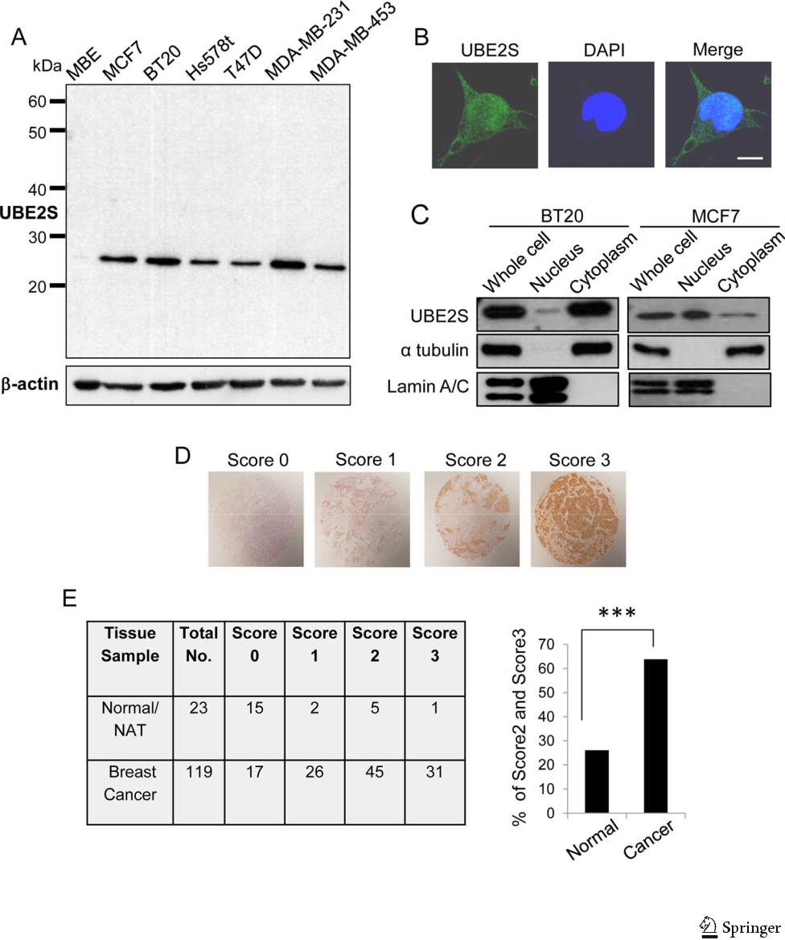
Fig. 1 UBE2S is expressed in breast cancer cells and tissues. a Expression of UBE2S in the indicated cell lines was examined by immunoblot analysis. b BT20 cells cultured on fibronectin-coated glass coverslips were fixed

and stained with anti-UBE2S antibody (scale bar=20 μm). c

Cytoplasmic and nuclear fractions were immunoblotted with the indicated antibodies. d Tissue microarray was stained with anti-UBE2S antibody. Representative images of score0, score1, score2, and score3 are shown. e Semiquantitative scoring of the image intensity of each tissue was performed. The table shows the number of samples in each score. The graph indicates the percentage of score2- and score3-positive samples (***P<0.001)

Migration assay

Cell migration was assessed using 24-well Boyden chambers (8-μm pore size, 6.5-mm membrane diameter). The lower surface of the filter was coated with fibronectin to promote cell migration. Cells (5×10⁴) were seeded onto the upper sur-face of the chamber, and 20 h later, the cells were fixed with 100 % ethanol and stained with 0.5 % crystal violet. Cells that migrated to the lower surface of the chambers were counted under a microscope at ×10 magnification. Five independent fields were randomly selected in each experiment, and three independent experiments were performed.

Invasion assay

To measure cell invasion using 24-well Boyden chambers (8-μm pore size, 6.5-mm membrane diameter), the filter was pre-coated with Matrigel, and 1.5×10⁵ cells were seeded onto

the upper surface of the chamber. After 20 h, the cells were fixed with 100 % ethanol and stained with 0.5 % crystal violet. Cells that invaded the lower surface of the filters were sur-veyed under a microscope at ×10 magnification and five fields were randomly selected. Three independent experiments were performed.

Colony formation assay

Cells (1×10⁴) were mixed with 0.36 % agar in DMEM sup-plemented with 10 % FBS and overlaid onto a 0.72 % agarose layer in six-well plates. After 2 weeks of incubation, colonies in five randomly selected fields were counted. Three indepen-dent experiments were performed.

Anoikis assay

siRNA-transfected cells were mixed with 1.68 % methyl cel-lulose in medium and incubated for 48 h. After incubation, the cells were collected via centrifugation and subjected to termi-nal deoxynucleotidyl transferase dUTP nick end labeling

(TUNEL) assay using the In Situ Cell Death Detection Kit (Roche, Basel, Switzerland) according to the manufacturer’s protocol.

Statistical analysis

Data are expressed as the mean±SD. Comparisons between the groups were performed using unpaired t tests. A chi-square test was performed for the immunohistochemical anal-ysis. P values of <0.05 were considered statistically significant.

Results

UBE2S is expressed in breast cancer tissues

We first generated purified anti-UBE2S antibody to examine the expression level of protein in breast cancer cells as well as tissues. Immunoblot analysis with the antibody detected sin-gle bands at the expected molecular weight. Although UBE2S

Table 1 UBE2S expression in normal and breast cancer patient’s tissue lesions as evaluated by tissue-microarray-based immunohistochemistry

Characteristics | No. of patients |  | UBE2S expression, no. (%)
 |  |  | Low |  | High |  | P value
All study subjects
Normal/NAT | 23 | 17 (73.9) |  |  | 6 | (26.1)
Cancer | 119 | 43 (36.1) |  |  | 76 (63.9) |  | <0.001ª
Cancer patients
Age, year
≥55 | 30 | 7 |  | (23.3) | 23 (76.7) |  | 0.0585^{b}
<55 | 89 | 37 (41.6) |  |  | 52 (58.4)
Pathology diagnosis
Invasive ductal carcinoma | 90 | 22 (24.4) |  |  | 68 (75.6) |  | <0.001^{c}
Medullary carcinoma | 13 | 7 |  | (53.8) | 6 | (46.2) | 0.0171^{d}
Invasive lobular carcinoma | 8 | 8 |  | (100) | 0
Mucinous carcinoma | 4 | 4 |  | (100) | 0
Neuroendocrine carcinoma | 2 | 2 |  | (100) | 0
Aprocrine carcinoma | 2 | 0 |  |  | 2 | (100)
Clinical stage

I–IIa | 51 | 29 (56.9) | 22 (43.1)
IIb–IV | 66 | 19 (28.8) | 47 (71.2) | 0.002e
Unknown | 2 | 2 (100) | 0

Low expression means score 0/1; high expression means score 2/3
- Normal versus cancer

- Patient’s age (year) ≥55 versus <55

- Invasive ductal carcinoma versus invasive lobular carcinoma

- Medullary carcinoma versus mucinous carcinoma

- Clinical stage I–IIa versus IIb–IV

was highly expressed in breast cancer cell lines, a reduced expression of UBE2S was observed in human mammary ep-ithelial cells (MBE) (Fig. 1a). Immunostaining and cell frac-tionation analysis revealed that UBE2S was localized to both the nucleus and cytoplasm (Fig. 1b, c). We next examined the expression of UBE2S in breast cancer. Tissue microarrays of breast cancer were immunostained with the anti-UBE2S anti-body, and signal intensities were scored as 0 (no staining), 1 (mild), 2 (moderate), and 3 (strong) (Fig. 1d). UBE2S expres-sion was increased in breast cancer tissues compared with normal tissues (Fig. 1e). The association between UBE2S ex-pression and clinicopathological variables is shown in Table 1.

UBE2S depletion disrupts organization of actin cytoskeleton and focal adhesions

We next examined the effect of UBE2S depletion on breast cancer cells using siRNAs. Two luminal cell lines, T47D and MCF7, and two basal cell lines, BT20 and MDA-MB-231 cell lines, were transfected with two siRNAs targeting different regions of the gene. We noticed that the morphology of these cells was significantly changed by UBE2S depletion. The cells became significantly round in the absence of UBE2S (Fig. 2a). We speculated that the morphological changes were induced by the disruption of actin cytoskeletal organization.
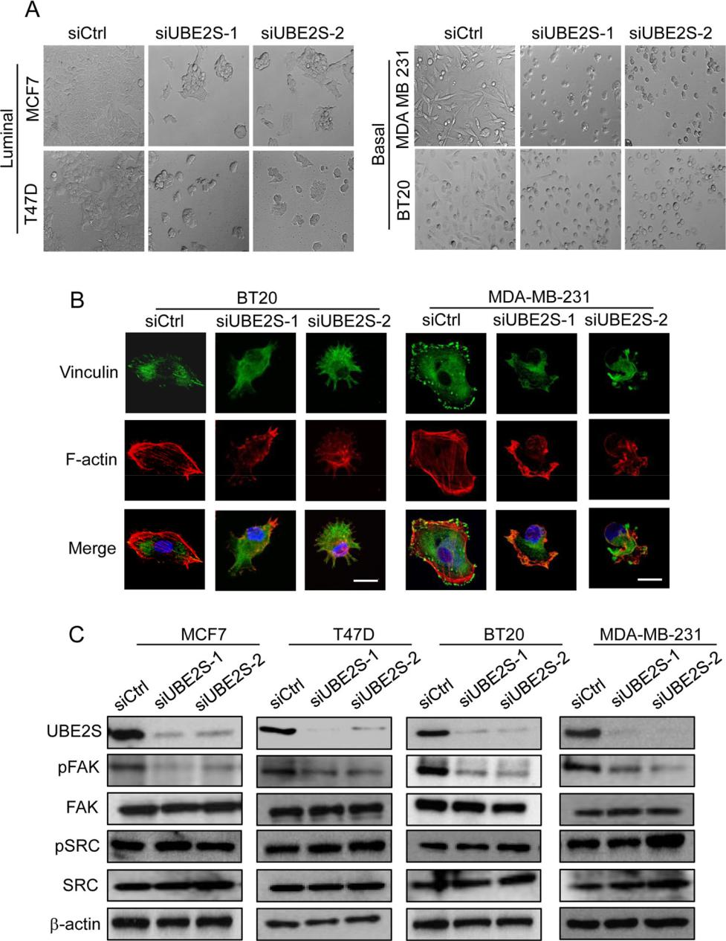

Fig. 2 Depletion of UBE2S induces disruption of actin stress fibers and focal adhesion formation. a Representative images of cells transfected with siRNAs. b BT20 and MDA-MB-231 cells cultured on fibronectin-coated glass coverslips were transfected with siRNAs, and 72 h later, cells were fixed and

immunostained for vinculin and F-actin (scale bar=20 μm). c
Expression of phosphorylated FAK and phosphorylated SRC in siRNA-transfected cells was examined by immunoblot analysis

Immunostaining for actin cytoskeleton and vinculin, a component of focal adhesions, demonstrated a disrupted organization of the actin cytoskeleton and focal adhesions by UBE2S knockdown (Fig. 2b). FAK and SRC non-receptor tyrosine kinase are critical for the organization of focal adhesions and the actin cytoskeleton [35, 36]. We thus checked the expression and activity of FAK and SRC in the absence of UBE2S. To detect the activity of FAK and SRC, we used antibodies that specifically detect

Fig. 3 Cell attachment and spreading were suppressed by UBE2S depletion. a siRNA-transfected cells were seeded onto the fibronectin-coated surface, and the number of attached cells was counted at the indicated time points. b siRNA-transfected cells were seeded onto the fibronectin-coated surface and fixed 60 min later. Representative pictures are shown and the graph shows the percentage of spread cells
(*P<0.05, **P<0.01)

phosphorylation of FAK at Tyr397 and phosphorylation of SRC at Tyr416, respectively. UBE2S knockdown did not affect expression level of FAK but significantly re-duced the phosphorylation of FAK on Tyr397 (Fig. 2c). Expression as well as phosphorylation of SRC was not reduced by UBE2S knockdown (Fig. 2c). We used other luminal and basal cell lines (MDA-MB-453 and Hs578t), but we did not observe changes in cellular morphology and FAK phosphorylation.
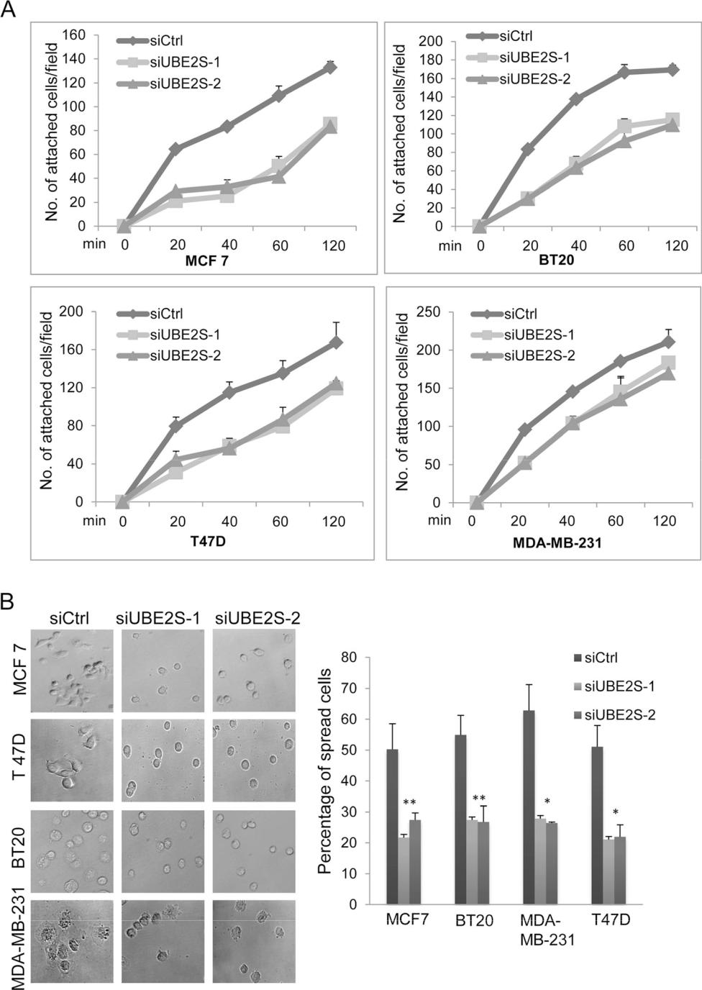

UBE2S knockdown suppresses cell spreading, migration, and invasion

Organization of the actin cytoskeleton and focal adhesions is essential for cell attachment to the extracellular matrix (ECM) and cell spreading. To evaluate cell attachment to the ECM, cells transfected with siRNAs were seeded onto the surface of coverslips coated with fibronectin, and the numbers of at-tached cells were counted at different time points. We found that cell attachment to the fibronectin-coated surface was re-duced by UBE2S depletion (Fig. 3a). To examine cell spread-ing, siRNA-transfected cells were seeded onto the fibronectin-coated surface, and spread cells were counted 60 min later. As shown in Fig. 3b, cell spreading was suppressed by UBE2S knockdown.

We next investigated the migration and invasion of the cells in the absence of UBE2S using transwell chambers. Three luminal cell lines (MCF7, T47D, and MDA-MB-453) and three basal cell lines (BT20, MDA-MB-231, and Hs578t) were transfected with siRNAs, and 72 h later, cells were placed on the upper surface of the filter and allowed to migrate to the bottom surface, which was coated with fibronectin.
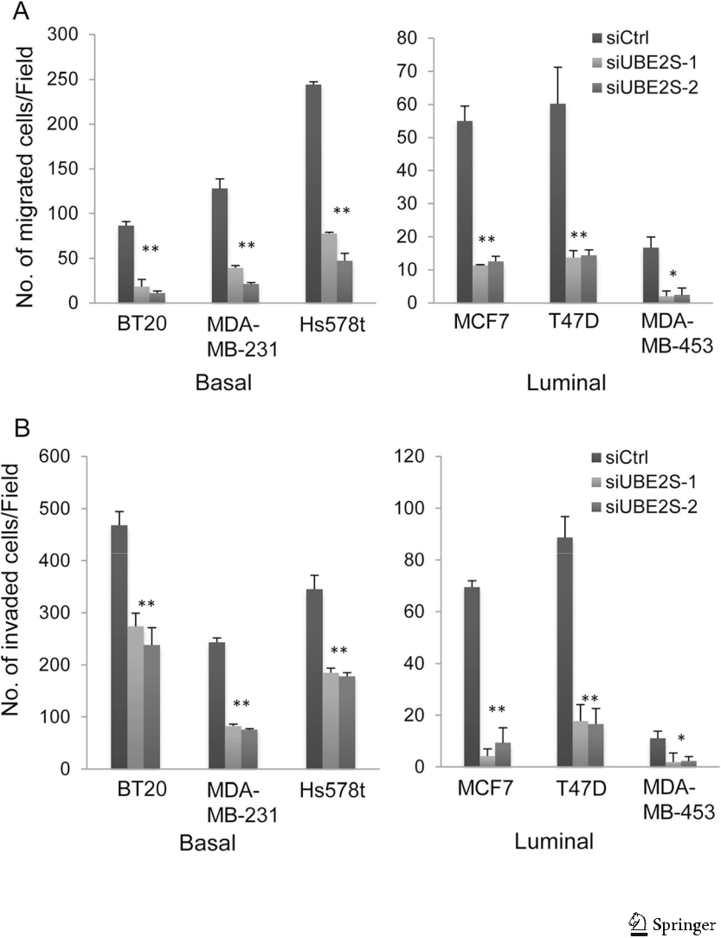
Fig. 4 Cell migration and invasion were suppressed by UBE2S knockdown. a Cells were subjected to a migration assay. The graph indicates the average number of migrated cells per field (*P<0.05, **P<0.01). b Cells were subjected to an invasion assay. The graph indicates the average number of invaded cells per field (*P<0.05, **P<0.01)

Twenty hours later, cells that migrated to the bottom surface were quantified. Cell migration was significantly suppressed by UBE2S depletion (Fig. 4a). To examine cell invasion, we used Matrigel-coated transwell chambers. siRNA-transfected cells were seeded on the Matrigel-coated chamber, and cells that invaded to the lower surface of the filter were counted. As shown in Fig. 4b, UBE2S depletion suppressed invasion of these cell lines (Fig. 4b).

UBE2S knockdown promotes anoikis

Anchorage-independent growth is one of the major character-istics of tumor cells. To determine whether UBE2S depletion affects the anchorage-independent growth of breast cancer cells, siRNA-transfected cells were cultured on agar; 2 weeks later, colony formation was evaluated. MDA-MB-453 cells did not form colonies; thus, we used the other five breast cancer cell lines. The proliferation of cells on the agar was significantly reduced by UBE2S knockdown (Fig. 5a). Anoikis is a form of cell apoptosis that is induced by the detachment of cells from the ECM. We speculated that the suppression of colony formation by UBE2S knockdown was

partly mediated by the promotion of anoikis. Cells transfected with siRNAs were cultured in suspension for 48 h, and apo-ptotic cells were then detected via TUNEL assay. As shown in Fig. 5b, UBE2S knockdown promoted anoikis of breast can-cer cells.

Discussion

Despite significant advances in the techniques used for screen-ing and therapy, breast cancer remains a leading cause of cancer-related deaths in women worldwide. In this report, we examined the expression of UBE2S in breast cancer

Fig. 5 UBE2S knockdown induced anoikis. a siRNA-transfected cells were cultured in soft agar for 2 weeks and then pictures were taken. The representative images of colonies are shown. The graph shows the average number of colonies per field (*P<0.05, **P<0.01). b siRNA-transfected cells were cultured in suspension for 48 h and then subjected to TUNEL assay. Representative images of the TUNEL assay are shown. The graphs indicate the percentage of cells that survived (*P<0.05, **P<0.01)

tissues by immunohistochemical analysis. Consistent with previous findings, we found that the expression of UBE2S was increased in breast cancer tissues. High expression of UBE2S has also been reported in other cancers, such as renal cell carcinoma and cervical carcinoma [31, 34]. These previ-ous reports and our study clearly indicate that UBE2S can be used as a marker for multiple cancers.

UBE2S is involved in the degradation of proteins by APC/ C during mitosis. Once APC/C in combination with UBE2C primes the lysine residues of substrates with ubiquitin, UBE2S promotes elongation of ubiquitin chains via K11-mediated attachment [27, 28]. Ubiquitin chains generated by UBE2S promote degradation of substrate proteins by the proteasome
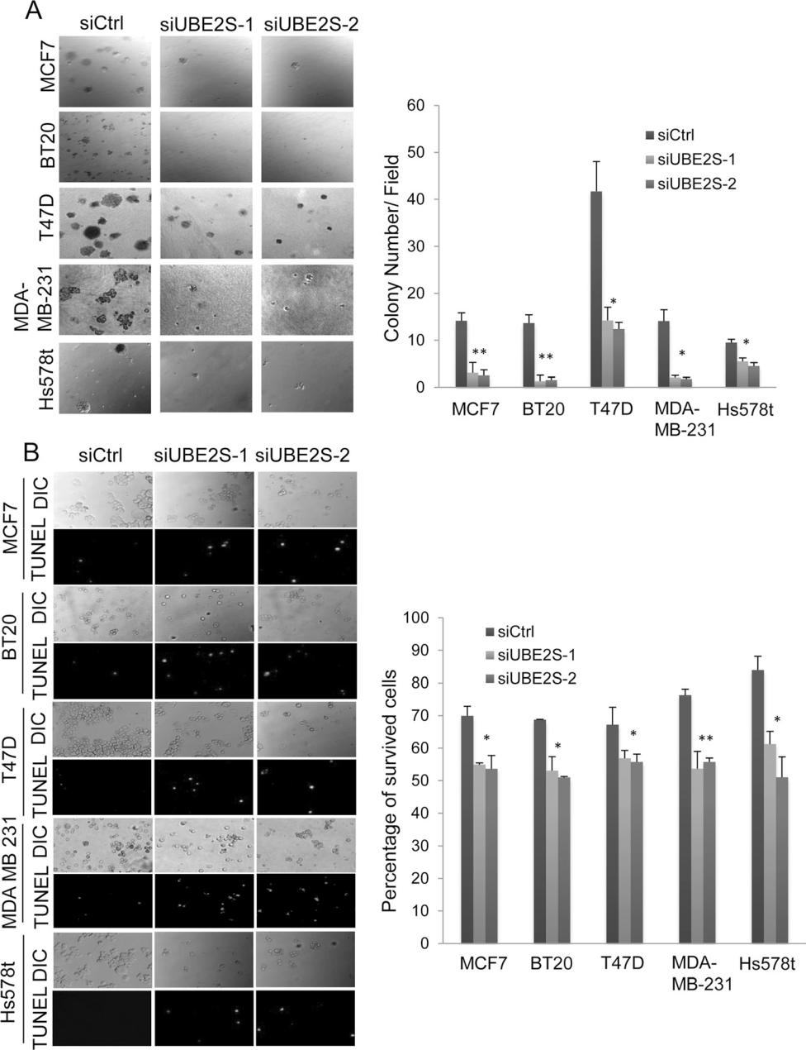

pathway and promote exit from mitosis. In addition to its important functions in mitosis, we found that UBE2S is asso-ciated with regulating the actin cytoskeleton and focal adhe-sions. The depletion of UBE2S induced changes in cellular morphology and significantly disrupted the formation of actin stress fibers and focal adhesions. The actin cytoskeleton plays a critical role in numerous cellular functions, such as cell migration and spreading. We found that both migration and spreading were delayed in the absence of UBE2S. These re-sults suggest that UBE2S is important not only for mitotic progression but also for cell migration and spreading as well as actin cytoskeletal organization.

A number of proteins are associated with the regulation of actin cytoskeletal organization and cell migration. Among these proteins, FAK is one of the most studied proteins, and its inhibitors are being investigated in clinical trials for cancer treatment [35]. FAK is also known to ac-tivate survival signals to prevent anoikis. We found that the phosphorylation of FAK at Tyr397 was reduced in the ab-sence of UBE2S. Suppression of Tyr397 phosphorylation was observed using two different siRNAs. Thus, it is un-likely that the reduced phosphorylation was induced by off-target effects of siRNAs. Although the exact molecular mechanisms of Tyr397 phosphorylation are still not clear, it is believed that integrin binding to ECM promotes dimer-ization of FAK for the phosphorylation of Tyr397 [37, 38]. Src family kinases, which are non-receptor tyrosine kinases, are recruited to the phosphorylated Tyr397, where they phosphorylate other tyrosine residues of FAK for the acti-vation of downstream signals [39, 40]. Therefore, a de-crease in Tyr397 phosphorylation via UBE2S knockdown may suppress numerous signals for cell spreading, migra-tion, and invasion. Further analysis is required to determine whether the functions of FAK or other signal proteins are affected by UBE2S knockdown to suppress cell migration and invasion.

In summary, we have shown that UBE2S is highly expressed in breast cancer tissues, and depletion of UBE2S induced disruption of the actin cytoskeleton and focal adhe-sion organization. In addition, UBE2S depletion suppressed malignant characteristics of cancer cells, such as migration, invasion, and anchorage-independent growth. Further investi-gation to identify target proteins of UBE2S may give novel insight into the regulation of actin cytoskeletal organization and cell migration.

Acknowledgments We would like to thank the members of the divi-sion of cancer biology for their helpful discussions. This research was funded by a grant from the Naito Foundation and the Ministry of Educa-tion, Culture, Sports, Science and Technology of Japan (Nanomedicine Molecular Science, 2306).

Conflict of interest None.

References

  - Hershko A, Ciechanover A. The ubiquitin system. Annu Rev Biochem. 1998;67:425–79.

  - Kerscher O, Felberbaum R, Hochstrasser M. Modification of pro-teins by ubiquitin and ubiquitin-like proteins. Annu Rev Cell Dev Biol. 2006;22:159–80.

  - Pickart CM, Eddins MJ. Ubiquitin: structures, functions, mecha-nisms. Biochim Biophys Acta. 2004;1695:55–72.

  - Neutzner M, Neutzner A. Enzymes of ubiquitination and deubiquitination. Essays Biochem. 2012;52:37–50.

  - Mukhopadhyay D, Riezman H. Proteasome-independent functions of ubiquitin in endocytosis and signaling. Science. 2007;315:201– 5.

  - Chen ZJ, Sun LJ. Nonproteolytic functions of ubiquitin in cell sig-naling. Mol Cell. 2009;33:275–86.

  - Zhou MJ, Chen FZ, Chen HC. Ubiquitination involved enzymes and cancer. Med Oncol. 2014;31:93.

  - Honda R, Tanaka H, Yasuda H. Oncoprotein MDM2 is a ubiquitin ligase E3 for tumor suppressorp53. FEBS Lett. 1997;420:25–7.

  - Olson DC, Marechal V, Momand J, Chen J, Romocki C, Levine AJ. Identification and characterization of multiple mdm-2 proteins and mdm-2-p53 protein complexes. Oncogene. 1993;8:2353–60.

  - Rayburn E, Zhang R, He J, Wang H. MDM2 and human malignan-cies: expression, clinical pathology, prognostic markers, and impli-cations for chemotherapy. Curr Cancer Drug Targets. 2005;5:27– 41.

- Leng RP, Lin Y, Ma W, Wu H, Lemmers B, Chung S, et al. Pirh2, a p53-induced ubiquitin-protein ligase, promotes p53 degradation. Cell. 2003;112:779–91.

- Dornan D, Bheddah S, Newton K, Ince W, Frantz GD, Dowd P, et al. COP1, the negative regulator of p53, is overexpressed in breast and ovarian adenocarcinomas. Cancer Res. 2004;64:7226– 30.

- Dornan D, Wertz I, Shimizu H, Arnott D, Frantz GD, Dowd P, et al. The ubiquitin ligase COP1 is a critical negative regulator of p53. Nature. 2004;429:86–92.

- Duan W, Gao L, Druhan LJ, Zhu WG, Morrison C, Otterson GA, et al. Expression of Pirh2, a newly identified ubiquitin protein li-gase, in lung cancer. J Natl Cancer Inst. 2004;96:1718–21.

- Logan IR, Gaughan L, McCracken SR, Sapountzi V, Leung HY, Robson CN. Human PIRH2 enhances androgen receptor signaling through inhibition of histone deacetylase 1 and is overexpressed in prostate cancer. Mol Cell Biol. 2006;26: 6502–10.

- Venkitaraman AR. Cancer susceptibility and the functions of BRCA1 and BRCA2. Cell. 2005;108:171–82.

- Satija YK, Bhardwaj A, Das S. A portrayal of E3 ubiquitin ligases and deubiquitylases in cancer. Int J Cancer. 2013;133:2759–68.

- Latif F, Tory K, Gnarra J, Yao M, Duh FM, Orcutt ML, et al. Identification of the von Hippel-Lindau disease tumor suppressor gene. Science. 1993;260:1317–20.

- Xie C, Powell C, Yao M, Wu J, Dong Q. Ubiquitin-conjugating enzyme E2C: a potential cancer biomarker. Int J Biochem Cell Biol. 2014;47:113–7.

- Jin L, Williamson A, Banerjee S, Philipp I, Rape M. Mechanism of ubiquitin-chain formation by the human anaphase-promoting com-plex. Cell. 2008;133:653–65.

- Meyer HJ, Rape M. Processive ubiquitin chain formation by the anaphase-promoting complex. Semin Cell Dev Biol. 2011;22:544–50.

- Okamoto Y, Ozaki T, Miyazaki K, Aoyama M, Miyazaki M, Nakagawara A. UbcH10 is the cancer-related E2 ubiquitin-conjugating enzyme. Cancer Res. 2003;63:4167–73.

- Hao Z, Zhang H, Cowell J. Ubiquitin-conjugating enzyme UBE2C: molecular biology, role in tumorigenesis, and potential as a bio-marker. Tumour Biol. 2012;33:723–30.

- Vasiljevic A, Champier J, Figarella-Branger D, Wierinckx A, Jouvet A, Fèvre-Montange M. Molecular characterization of cen-tral neurocytomas: potential markers for tumor typing and progres-sion. Neuropathology. 2013;33:149–61.

- Shen Z, Jiang X, Zeng C, Zheng S, Luo B, Zeng Y, et al. High expression of ubiquitin-conjugating enzyme 2C (UBE2C) corre-lates with nasopharyngeal carcinoma progression. BMC Cancer. 2013;13:192.

- van Ree JH, Jeganathan KB, Malureanu L, van Deursen JM. Overexpression of the E2 ubiquitin-conjugating enzyme UbcH10 causes chromosome missegregation and tumor formation. J Cell Biol. 2010;188:83–100.

- Garnett MJ, Mansfeld J, Godwin C, Matsusaka T, Wu J, Russell P, et al. UBE2S elongates ubiquitin chains on APC/C substrates to promote mitotic exit. Nat Cell Biol. 2009;11:1363–9.

- Williamson A, Wickliffe KE, Mellone BG, Song L, Karpen GH, Rape M. Identification of a physiological E2 module for the human anaphase-promoting complex. Proc Natl Acad Sci U S A. 2009;106:18213–8.

- Meyer HJ, Rape M. Enhanced protein degradation by branched ubiquitin chains. Cell. 2014;15:910–21.

- Tedesco D, Zhang J, Trinh L, Lalehzadeh G, Meisner R, Yamaguchi KD, et al. The ubiquitin-conjugating enzyme E2-EPF is overexpressed in primary breast cancer and modulates sensitivity to topoisomerase II inhibition. Neoplasia. 2007;9:601–13.

- Roos FC, Evans AJ, Brenner W, Wondergem B, Klomp J, Heir P, et al. Deregulation of E2-EPF ubiquitin carrier protein in papillary renal cell carcinoma. Am J Pathol. 2011;178:853–60.

- Liang J, Nishi H, Bian ML, Higuma C, Sasaki T, Ito H, et al. The ubiquitin-conjugating enzyme E2-EPF is overexpressed in cervical cancer and associates with tumor growth. Oncol Rep. 2012;28: 1519–25.

- Clarke C, Madden SF, Doolan P, Aherne ST, Joyce H, O’Driscoll L, et al. Correlating transcriptional networks to breast cancer survival: a large-scale coexpression analysis. Carcinogenesis. 2013;34: 2300–8.

- Suzuki K, Bose P, Leong-Quong RY, Fujita DJ, Riabowol K. REAP: a two minute cell fractionation method. BMC Res Notes. 2010;3:294.

- Bolós V, Gasent JM, López-Tarruella S, Grande E. The dual kinase complex FAK-Src as a promising therapeutic target in cancer. Onco Targets Ther. 2010;3:83–97.

- Serrels A, Canel M, Brunton VG, Frame MC. Src/FAK-mediated regulation of E-cadherin as a mechanism for controlling collective cell movement: insights from in vivo imaging. Cell Adh Migr. 2011;5:360–5.

- Schaller MD, Hildebrand JD, Shannon JD, Fox JW, Vines RR, Parsons JT. Autophosphorylation of the focal adhesion kinase, pp125FAK, directs SH2-dependent binding of pp60src. Mol Cell Biol. 1994;14:1680–8.

- Schlaepfer DD, Broome MA, Hunter T. Fibronectin-stimulated sig-naling from a focal adhesion kinase-c-Src complex: involvement of the Grb2, p130cas, and Nck adaptor proteins. Mol Cell Biol. 1997;17:1702–13.

- Frame MC. Newest findings on the oldest oncogene; how activated src does it. J Cell Sci. 2004;117:989–98.

- Playford MP, Schaller MD. The interplay between Src and integrins in normal and tumor biology. Oncogene. 2004;23:7928–46.

