Title
In-game Intoxication: Demonstrating the Evaluation of the Audio Experience of Games with a focus on Altered States of Consciousness

Authors
Stuart Cunningham, Jonathan Weinel and Richard Picking

Authors’ Affiliation
Glyndŵr University, Wales, UK

Executive Summary
In this work, we consider a particular method of specifically evaluating the user experience of game audio. In order to provide a domain of game audio to evaluate, we focus on an increasingly occurring phenomenon in games; that of the altered state of consciousness. Our approach seeks to evaluate user experience of game audio from normal gameplay and gameplay that features altered states. As such, a brief background to person-centered approaches to user experience evaluation is presented and then we provide a detailed description of the method that has been adopted in this study: the use of personal construct theory via repertory grid interviews.
Subsequently, a scale is proposed, as a product of this investigation that we propose can be utilized for the audio evaluation of games in user testing phases. Results from this process include the formulation of a seven-category scale for quickly and efficiently measuring the user experience of game audio. We apply this in the context of game scenarios that feature altered states of consciousness versus normal gameplay. It is shown that the devised scale is effective in discriminating between these two different categories and that is has potential to be transferred into a wider range of game evaluation tasks.

Organization / Institution Background
The case study took place at Glyndŵr University, which is in Wrexham, Wales, UK. Glyndŵr University has very strong links with the community it serves. Established as a People’s College in 1887 and funded initially by the contributions of individual miners, the organisation has maintained strong links to industry and its communities throughout its history. In 2008 it won full university title, adopting the name Glyndŵr University.

The University is an academic institution that delivers higher education, from first degree to doctoral studies, and has close links with regional, national, and international industries. The University has a strong focus on employability and this is at the heart of everything we do. Our aim is to make our graduates as employable as possible. Our degrees are designed for the world of work, and we are proud of our consistently high employability rate.

In particular, the University runs a successful undergraduate degree programme in the field of Computer Game Development, which includes, among other things, a course focused upon the development and integration of audio in games. As part of this work, and recognising the issues and challenges highlighted by industrial colleagues, we focus our research on applied solutions to their problems.

Case Study Description
A way to address user experience challenges is to be found in a specific application of Personal Construct Psychology (PCP), known as the repertory grid methodology. PCP is broadly attributed to the work of Kelly (1955) and builds upon the principles of constructivism, most typically associated with the work of Piaget (Wadsworth 1996), and constructivism in a group or collaborative context (Vygotsky 2012). PCP advocates that the most valid descriptions of phenomena encountered by humans are those that they form themselves through experience and by testing and validating descriptions and theories in their own heads and in collaboration and discussion with others. Partially, this explains the diverse and challenging subjective nature of measuring any kind of user experience, but also confirms that the greatest validity of user experience comes via these descriptions. The greatest limitation of such investigation is that validity often comes at the cost of reliability of information, since working with users to elicit constructs is a time and, by inference, financially consuming process. By applying the repertory grid approach in this work, we aim to formulate a mechanism and scale that can be applied to evaluate the user experience of game audio.

Audio is a powerful influence and stimulant in games. As will be discussed in this case study, there is significant research about the emotional effect of sound and music and how it contributes to the immersion players perceive in a computer game. It is the direct effects of audio upon the game player that we are interested in evaluating in order to better understand how sound and music can be utilized in games to enhance the user experience.

The repertory grid method is a specific incidence of PCP that has been designed to strike a balance between the open-ended nature of constructs by applying quantitative measures. It is a participant dependent research method that typically involves a researcher working one-to-one with a subject. Traditionally, this takes the form of a semi-structured interview and will often utilize techniques such as card sorting and shuffling to facilitate and encourage participation, although latterly online and electronic research tools have become sophisticated enough to support this process at a distance (Grill, Flexer and Cunningham 2011). It allows participant data to be analyzed and summarized in more efficient ways that balance qualitative descriptions, known as constructs, with quantitative weights, or values, that can be attributed to the subject matter, the domain, under investigation. Particular instances of the domain under investigation, known as elements, are introduced to the subject, which are then described using their constructs and each element rated against each construct using a numerical grade, by way of a semantic differential on a scale with an odd number of points, typically five or seven.

Constructs must be bipolar in nature and so participants are required to define both extremes of the construct; it is common to achieve this through interview and card sorting techniques of triad and differentiation:
The triad technique involves providing a participant with three randomly drawn cards, each containing the name of one of the elements. The participant must then group together the two elements they perceive as being most similar. They are then prompted to describe the common feature that relates the two elements in the group and the feature that separates these two from the third; doing so creates a bipolar construct.

Differentiation is a cruder technique, but it has been found to be effective during interviews where participants struggle with the triad technique or where their responses become repetitive. As the title suggests, differentiation involves the researcher drawing two cards randomly and asking the participant to describe what makes those two elements different from one another. This forms one extreme of a construct and the participation must then be prompted to consider what the opposite term for the construct should be.

To give a brief example of these repertory grid features in action: the domain of investigation is domestic animals; the elements involved are dogs, cats, rabbits, and mice; the bipolar constructs might be quiet—loud, big—small, short hair—long hair, and messy—clean. The ratings of the elements against constructs, on a 1 to 5 scale ordered left to right, by a participant could be as shown in Table I.

Table I: Example Repertory Grid relating to animals

Subjects each arrive at their own grid following their participation in the repertory grid technique. Owing to the quantitative ratings that are applied by participants, it is possible to carry out data analysis on the elements, constructs and relationship between elements and constructs in each grid. This can be done simply by ranking and ordering exercises, or in more detail by the application of cluster analysis, through Principal Component Analysis. This allows the researcher to form theories about the nature of the domain. For example, from the fictitious grid used in Table I, it can be hypothesized that: big animals are loud whilst small animals are quiet (the ratings across the elements differ only slightly for rabbits) or that dogs and rabbits are considered very different from one another (their scores are quite far apart over all constructs).

But perhaps the most useful tool in the analysis of repertory grids is in the drawing together of grids from multiple participants. It is common for the researcher to supply participants with a common set of elements, and this practice is adopted in the research documented here. This facilitates the concatenation of grids from all participants in a study and the analysis, therefore, of a much larger, ultimately more valid and more reliable data set. Most importantly, this process allows the researcher to determine which constructs are most commonly occurring and thus represent an agreed group norm; the best way(s) in which to describe the elements under investigation, although the ratings supplied might not show the same level of agreement across participants due to their own subjective preferences and likes and dislikes.

Case Study Description: Altered States of Consciousness in Games
The representation of Altered States of Consciousness (ASC) is a niche area of video games that has been steadily growing as game developers seek to provide improved levels of realism and exotic gaming experiences. For example, Dead Space 2 (2011) features representations of hallucination as a central feature of the game narrative, while the Grand Theft Auto series contains sequences in which the game character may become psychedelically intoxicated through various methods (Weinel 2010; Demarque and de Lima 2013; and Blake 2013). The approaches used by developers to provide these hallucinatory sequences have been gradually improving in sophistication.

In first-person perspective video games, representations of the virtual game environment are mediated by the use of graphics, sound and game speed. For example, consider a contemporary popular computer game such as Grand Theft Auto 5 (2013), where the player character becomes unknowingly drugged and experiences an extensive ‘trip’. The protagonist character, Michael, experiences a range of strange happenings, which the player is led through by way of cinematic scenes and restricted gameplay. This experience manifests itself as various distorted perceptions of the game-world alongside hallucinations. This segment of the game lasts over five minutes and most notably features the player character being probed by a group of aliens in a spaceship and subsequently falling from the alien craft back to Earth. Most notable in this segment of the game is the distortion and over-saturation of the graphics, which is accompanied by the unusual situation, distorted speech and sounds, and trance-like music. As such, ASC features imitate the senses of the game character. For example, a camera is used to imitate sight; stereo game sound imitates hearing; game speed imitates the passing of time in a manner equivalent to human perception. Adjusting properties of graphics, sound and game speed can therefore allow us to manipulate the way in which sensory perception of the game character is represented.

In previous work, we have been particularly interested in the representation of ASC within games and have sought to deepen our understanding of the phenomenon within games, both from the perspective of the representations themselves and the player’s interaction and immersion (Weinel et al. 2014, Weinel, Cunningham and Griffiths 2014). As such, for the purposes of following through our case study in this work, we evaluate the user experience of game audio that feature both ASC and non-ASC segments.

Challenges: Evaluating Game User eXperience (UX)
The usability of interactive computer systems is a long-established measure of their success, both in terms of utility and commercial value. Traditionally, usability is evaluated using a range of methods that can broadly be classified in two ways: those that involve users, and those that do not. Methods involving users include surveys (Chin et al. 1988; Nielsen 1993; Kirakowski and Corbett 1993), interviews, direct observation and interaction recording (e.g. monitoring user actions). Those methods that do not involve users directly tend to rely on usability experts who conduct studies based on guidelines (Constantine and Lockwood 1999; Shneiderman 1998; Picking et al. 2010) and/or psychological principles (e.g. Wharton et al. 1994). Heuristic guidelines specifically for the usability evaluation of computer games have also been proposed (e.g. Brown 2008). Computer games are also evaluated informally by expert gaming reviewers who usually publish their findings in popular magazines and on gaming websites. However, this approach is arguably ‘unscientific’, not only because of the lack of a methodological approach, but also because of the possibility of personal bias of individual opinions. Nevertheless, such reviews are crucial to the commercial success of computer games.

Whatever methods are employed, a game’s quality and popularity ultimately comes down to the users’ experience of the game. ‘User eXperience’ (or UX) is a phrase synonymous with usability evaluation, and is currently a popular term in common usage in the field. There are many varying definitions of ‘user experience’, largely depending on the domain of interest (see http://www.allaboutux.org/ux-definitions). One that seems appropriate to the user experience of computer games is proposed by Reiss (2009):
“UX = the sum of a series of interactions. User experience (UX) represents the perception left in someone’s mind following a series of interactions between people, devices, and events – or any combination thereof. "Series" is the operative word.”
Reiss goes on to explain the interactions are active (e.g. clicking a button, moving a character on screen), passive (e.g. listening to a beautiful piece of music will cause the user to release dopamine), or secondary to the ultimate experience (e.g. the game experience is good because the designers are talented individuals with a strong track record). He adds that all interactions are open to subjective interpretation. These interactions are constantly experienced by users in real-time environments such as computer game play, and all three types of interaction may exist in parallel, not necessarily in series as Reiss suggests. Such is the immersiveness of computer gaming.

Accurately measuring all user interactions within such a complex experience might be possible, but would probably be inordinately time-consuming and expensive. Therefore, it is important to identify the most important elements of the user experience, and target these to maximise the probability of a valid and reliable evaluation.

In order to do this, it would be sensible to plan carefully a robust approach to any evaluation study. One way of assuring this is to follow a structured process that provides a framework for evaluators to follow. This would enable questions and uncertainties to be identified in advance of the evaluation exercise. For example, which of the aforementioned methods would best be employed to evaluate the user experience of the game of interest? How many users do we need to carry out a credible evaluation? Who are the users – what age, gender, experience, and ability profiles should they have?

One of the simplest established processes for conducting a usability evaluation is known as the ‘DECIDE framework’ (Rogers et al. 2011). DECIDE is an acronym based on the first letter of the first word of each stage of the framework:

- Determine the goals of the evaluation
- Explore the questions
- Choose the evaluation methods and techniques
- Identify the practical issues that must be addressed, such as selecting participants
- Decide how to deal with the ethical issues
- Evaluate, interpret and present the data

Each stage is relatively self-explanatory, where the evaluator starts by identifying the high-level goals of the evaluation. An example might be to identify whether a new audio score in a game is better than the original version. The next stage would focus on what specific questions need to be asked to achieve the overall goal. For example, do the users prefer the new version, do they spend more time playing it, perhaps we might measure their excitement levels by monitoring biometric responses (heart rate, galvanic skin responses etc.)? If these are the questions, then what methods and techniques are going to help us answer them? This is the third stage of the DECIDE framework. In our case, we might use surveys and interviews to evaluate the users’ opinions, and conduct laboratory-based experiments to record excitement levels. It is generally regarded as good practice to employ at least two methods in order to achieve an element of ‘triangulation’ to improve the validity of the overall evaluation. Once the methods are chosen, it is then a case of making it happen within the scope of the resources available. Practical issues such as selecting and identifying the users are covered in phase four of the framework. Other practical issues such as cost, timing, laboratory availability, and importantly the means of recording collected data, must also be considered. One fundamental issue that needs to be addressed in any study involving humans is the ethical dimension. This is described in the penultimate phase of the framework, and needs to be done of course prior to the evaluation studies taking place. Finally, subsequent to conducting a well-planned study, the results can be evaluated, interpreted and reported to the wider community.

Challenges: Evaluating Game Audio
Whilst generic methods such as the DECIDE framework are tried and tested across the usability spectrum, a number of researchers argue that choosing classical methods and techniques (the ‘C’ in DECIDE) does not apply to evaluating computer game experience (Pagulayan et al. 2003; Nacke, Drachen & Goebel 2010). The argument is that game evaluation is more about ‘playability’ than ‘usability’. Nacke et al. (2010) present a comprehensive review of research into playability evaluation. They propose three methodological categories for experiences that surround games: the quality of the product (game system experience), the quality of human-product interaction (individual player experience), and the quality of this interaction in a given social, temporal, spatial or other context.

This multi-dimensional phenomenon raises inherent difficulties in attempting to measure and describe user experience in games, especially the experience of game audio, which is often subliminal and is by definition transient, thereby making its evaluation so much more difficult than the more tangible image. The principal challenges are the subjective experience of each user and the use of qualitative data, in the form of language and semantics, for them to communicate their experiences. Utilizing pre-determined, quantitative measures such as surveys, Likert or semantic differential scales, are common methods to overcome these felt difficulties, but come with their own problems, chiefly the danger of lacking depth and validity. This is especially true where the aspect of evaluation does not benefit from any research or inclusive design led tools for measuring subjective perception.

So far, there does not exist any standardized tool for measuring user perception and experience of audio elements within computer games. There has been research done in this area, although surprisingly little, which explores approaches and methods such as that of Nacke, Grimshaw and Lindley (2010), who consider audio experience specifically, but without any ad-hoc or industry driven standard ever emerging. This is unsurprising, since it can be argued that the field is still relatively in its infancy. This sets user experience of game audio apart, unlike the more technical field perceptual measurement of audio quality, which benefits from a range of application-specific standards (ITU-R 2001; ITU-R 2003; Bech & Zacharov 2007), it does not benefit from an industry, or even ad-hoc, standard. This is not unexpected, but is a noticeable gap. Where research and development has taken place specifically concerned about user experience of audio, this has typically been in the field of interfaces that utilize sound and evaluation tends not to be concerned with the actual effect of the audio, but rather its functionality. For example, the work of Gaver (1989) examined the use of sound as an interaction tool and evaluated user experience of this tool to demonstrate the beneficial effect of audio in this capacity.

The computer game industry has grown rapidly and has been commercially driven. In its infancy, audio was non-existent in games. Its use as a principal driver for interaction, immersion and gameplay has only come to the fore in the last decade (Roden and Parberry 2005; Liljedahl, Papworth and Lindberg 2007; Parker & Heerema 2008; Moustakas, Floros, and Kanellopoulos 2009; Papworth 2010; Chittaro and Zuliani 2013; Östblad et al. 2014). The size of audio teams, focused on design and implementation, in game development are still small compared to their counterparts in departments of animation, graphics, software development, testing, and so on. These factors are compounded by the business critical and deadline driven game development environment, which leaves only a short time for detailed evaluation and testing with players, outside of the audio team. Consequently, audio testing is more concerned with integration aspects, such as levels in the mix and audio fidelity, rather than the levels of immersion and enhanced experience of the player.

The theory behind evaluating a player’s experience of game audio is similarly limited. Much work has been done around the principles of sound and music design and implementation, focusing on pre-production, production, and post-production (Gal et al. 2002; Brandon 2004; Collins 2008; Alves and Roque 2010; Stevens and Raybould 2011). But there is little specifically dealing with measuring a player’s experience of the resultant game audio. It is reasonable to assume that this too is attributable to the deadline-driven nature of the game development industry and the opaque task of evaluating subjective, individual perception of game players.

Recently, specific game audio user experience evaluation has started to emerge. Mandryk, Inkpen, and Calvert (2011) conducted an investigation into the best methods for evaluating emotive response, such as excitement, boredom, and so on, to entertainment technologies. Their study utilised a computer game as the main focus and took the approach of collecting data via electromyography (EMG) and galvanic skin response (GSR) physiological sensors, which were then cross analysed with subjective participant ratings. Whilst the results are interesting, the thrust of the work was not upon the user experience of audio in its own right, but rather the overall experience of the computer game.

Sanders and Cairns (2010) conducted two experiments to measure the effect of music in computer games and how it relates to a player’s sense of immersion within the game world. Their work utilized subjective participant responses, primarily through the form of questionnaires and ratings in a controlled trial configuration. The results of their research indicate the presence of music in a game positively influences indicators of immersion (in this case time perception of the player). The work also suggests that the presence of music that is preferred by the player will enhance this effect. The approach of Sanders and Cairns is particularly relevant to this case study, since it directly addresses measure of game involvement, rather than purely trying to measure the mechanics or functions of the game as a piece of software or as an interface.

Demarque and Lima (2013) carried out a study regarding the fear effects and emotional response to simulated auditory hallucinations. Their work included a case study regarding the implementation of auditory hallucinations in the horror games Silent Hill (1999), Fatal Frame (2001), F.E.A.R. (2005) and Hotel 626 (2008), and an experiment was undertaken with a bespoke simulation of auditory hallucinations created in Unity. The study used a Likert questionnaire to investigate the user experience of the game with regards to fear emotion, fear behaviours and immersion. In the study, each participant played the game with and without auditory hallucinations.

The study as a whole sheds light on a relatively unexplored area, and the results of the user study point towards the efficacy of auditory hallucinations in enhancing the ‘horror’ aspects of games. However from a methodological point of view the user study has some limitations, since it relied on a simplistic prototype game with relatively few gameplay elements. One might expect that any additional element in such a simple game would have a significant impact on the user experience, and that the questionnaire for such a comparative study may well have guided the participants somewhat towards aims of the study. We might therefore judge that the study highlights the need for improved methodological approaches in assessing the diverse qualities which game audio may afford the user, both in the situations produced by actual games and in a less ‘leading’ manner.

The need for more sophisticated means of analysing the effects of game sound are partly the result of the sophistication with which modern games harness audio as an evocative medium. For example, Bridgett (2013) describes the use of dialogue, ambience, sound effects and music in games, in order to support the overall impression of the game in context; in order to “…dramatically heighten emotion and engagement and to cinematize the experience for the player”. Bridgett emphases that the overall design of sound is critically integrated into the context of the game in question, and moreover that often games also can be seen “…more as nodes of popular culture than as isolated cultural entities”. As a result, we can see fundamental limitations in evaluating the efficacy of game audio with binary on/off studies. In order to provide more meaningful analysis of game audio design, we should seek to analyse it as it occurs within actual games, particularly as these themselves are embedded in a broader cultural landscape that includes films and other media which game audio frequently references, pastiches and parodies in order to achieve its effects. Separating the medium from these other factors will certainly have significant effects on the user experience; ways are needed in order to evaluate real-game audio in real-games.

Solutions and Recommendations: The Repertory Grid Study
In this case study, the repertory grid technique, as broadly described above, was implemented with a group of participants in order to elicit constructs that will allow for the description of the user experience as it relates to game audio. The purpose of this is therefore to employ a user-centered methodology to create semantic differential scales, rather than to impose scales that might be misunderstood by the user, for game testing that can be specifically used in the audio domain. To this extent, the domain of investigation was ASC and non-ASC game soundscapes and the elements consisted of eight audio clips, created by recording samples of gameplay audio.

Selections of audio were taken from four commercially available, contemporary game titles, namely: Batman: Arkham Asylum (2009); Max Payne 3 (2012), Far Cry 3 (2012), and Grand Theft Auto 5 (2013). All of the selected games fall into the broad category of action and adventure, with Far Cry 3 specifically being a first-person shooter game, whilst the others are predominantly third person action and/or shooter games. All of the games selected feature segments of gameplay in which the player takes control of their avatar whilst an ASC situation is being represented within the game.

Each audio clip was codified, so as not to influence the constructs produced by participants and to encourage them to focus on listening to the characteristics of the audio. The codes and clip descriptions are shown in Table II.

Table II: Descriptions of Audio Elements used in Repertory Grid Study

Participants were guided through the semi-structured interview by a researcher and utilizing a digital representation of each element that allowed them to hear each sound when the name of the element was clicked. This was clearly preferential over a paper-based card sorting technique given the aural nature of the elements involved. Participants were briefed on the nature of the study and introduced to the concept of construct elicitation and scoring of the selected elements using the scale of 1 to 5 against each construct. A training phase was employed, where participants were able to listen to each of the sound elements and they participated in a scoring exercise on a dislike - like construct, which was later discarded for the purposes of analysis. Emulating the card sorting technique, the choice of sounds was randomized each time a participant was presented with a triad of samples. The sound clips were presented as standalone objects and the participant was not viewing any game footage during this time. The only visual cues available during the interviews were the codified names of the current sample selection. Participants were free to listen to each element as many times as they wished during the process. The average time taken for each interview was in the region of 35 minutes.

A total of six people participated in the repertory grid study. These were mainly university students that consider themselves computer games players. The gender balance was 100% male. A total of 36 constructs were elicited during the process. Participants volunteered each of these constructs during the interviews. The data were analyzed using the OpenRepGrid on Air analysis tool (2014). The resulting repertory grid for all participants is shown in Figure 1, in which ratings are shaded with 1 being lightest and 5 being the darkest shade, elements are indicated by code horizontally along the top of the grid, whilst the obtained constructs are shown vertically, with the construct representing the rating 1 on the far left-hand side and the construct representing 5 on the far right-hand side. Each row of the grid represents a pair of bipolar constructs and set of scores obtained from a participant.
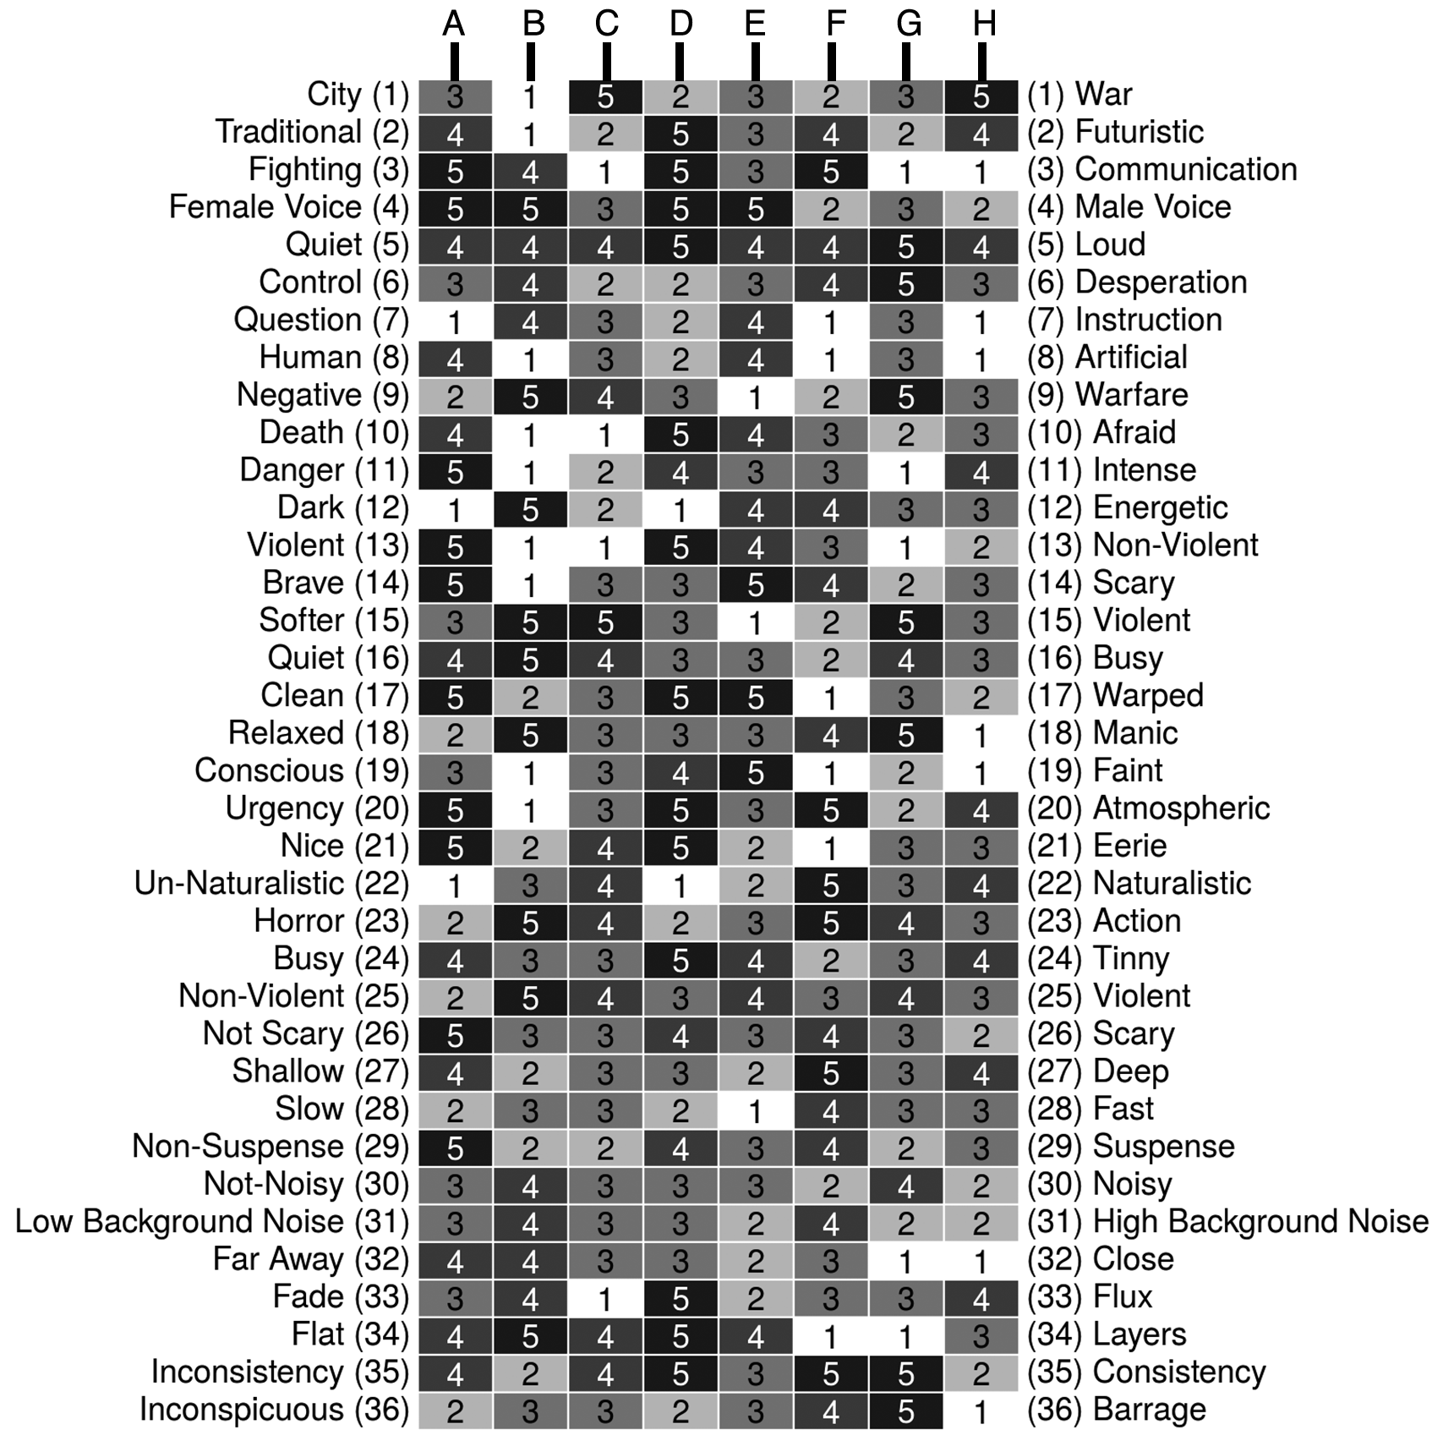
Figure 1: Repertory Grid for all participants

Presented in this initial form, it is not intuitive to make particular judgments about relationships between the elements involved in the study or the constructs. However, this initial view of the data obtained illustrates the variety of constructs that have been elicited from the participants and the variation in language and vocabulary that is utilized to describe the qualities of the audio samples. This early inspection does yields some notable observations, for example, the construct violent has been used on several occasions, similarly, so have the constructs of scary and horror.

To explore the data in a deeper way, and determine constructs that may be being used interchangeably by participants, sorting and analysis of the repertory grid data can be performed. Figure 2 shows a reordered version of the previous grid. In this visualization, a focus analysis (Shaw 1980; Jankowicz 2004) has been utilized that seeks to reorder the repertory grid so that similar constructs appear visually near to one another and the study elements are also ordered using the same technique.
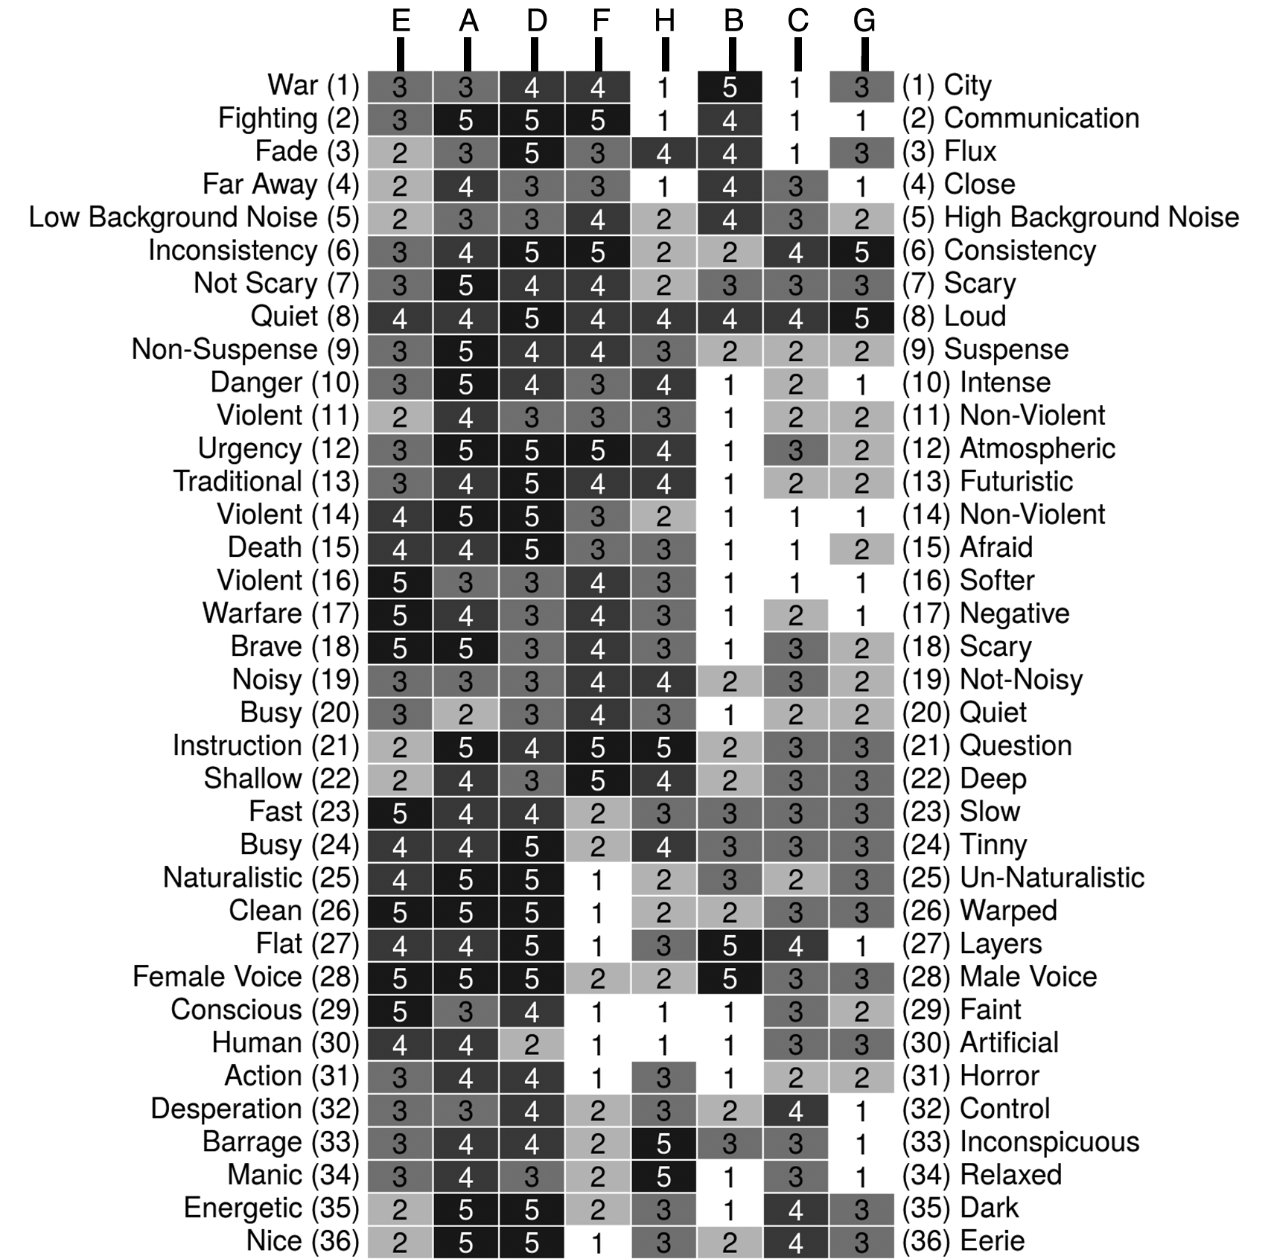
Figure 2: Repertory Grid sorted using FOCUS analysis

This reordering now makes an easier task of identifying constructs that may be describing the same listener experience, since rankings are shuffled clustering relationships between them. For example, consider now the constructs Busy – Tinny; Un-naturalistic – Naturalistic; Clean – Warped; and Flat – Layers. We see that the constructs Non-Violent – Violent; Death – Afraid; and Softer – Violent, exhibit a similar series of scores. There is a reasonable degree of consistency in the way that these constructs have been used to rate the study elements, which would suggest that further investigation into these constructs is warranted. This indicates that it may be possible to consolidate these constructs into one. The researcher may execute this consolidation process either by employing construct descriptors already received (if they are similar or identical) or by summarizing him/herself, the quality that is being described. This has been recognized by others using the repertory grid technique as being a particular strength, which is aptly described by Tan and Hunter (2002) as being able to show “…group norms” within a sample group of participants, which should be indicative of the wider population that they represent.

To explore the structural aspects of this clustering of constructs, the constructs obtained are further analyzed. In the following analysis, construct matches are identified by measuring the Euclidean distance between constructs, over element ratings, and then applying Ward’s method for cluster analysis (Ward Jr. 1963). As a result, it is possible to produce a more structured form of the constructs, now removed from the traditional repertory grid view, and presented as a dendrogram, as illustrated in Figure 3.
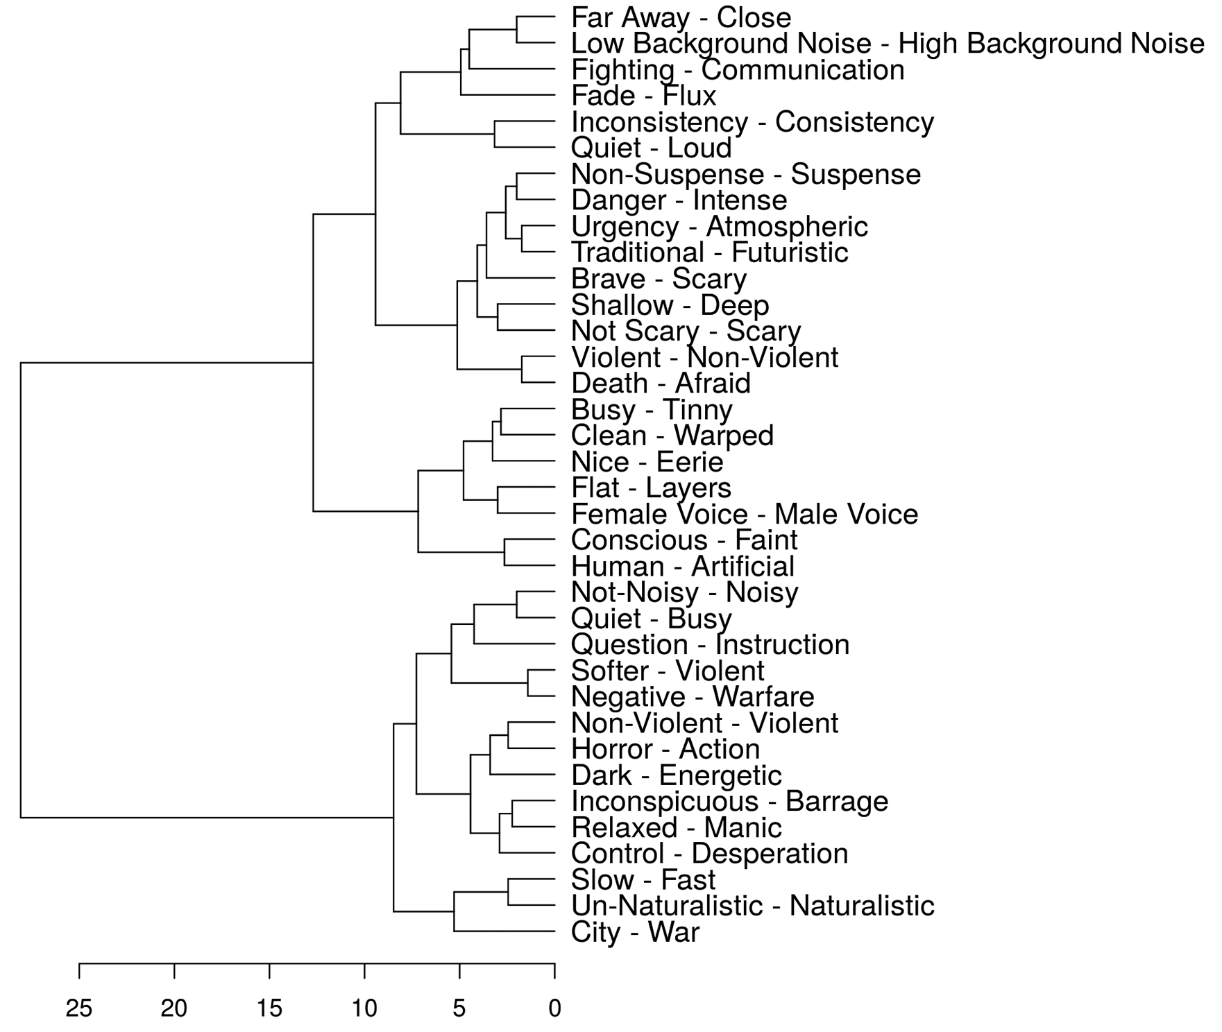
Figure 3: Cluster Analysis of Constructs with Euclidean distance and Ward Clustering

From this analysis, it is possible to begin a systematic reduction of constructs and to distil broad categories and descriptors that can be utilized to develop scales to measure the efficacy and qualities of game sound. However, a decision must be made by the person analyzing the data as to which ‘depth’ to work to when deciding upon membership of groups of constructs. This is particularly true as using a very detailed level of construct matching will yield fewer constructs than obtained from all of the participants, but still result in a significant amount. To assist in this process, there is a final piece of analysis that can be performed upon the original repertory grid data that allows the inclusion of a statistical confidence interval to aid the researcher or developer in identifying significant construct matches. The outcome from this analysis can be seen in Figure 4.
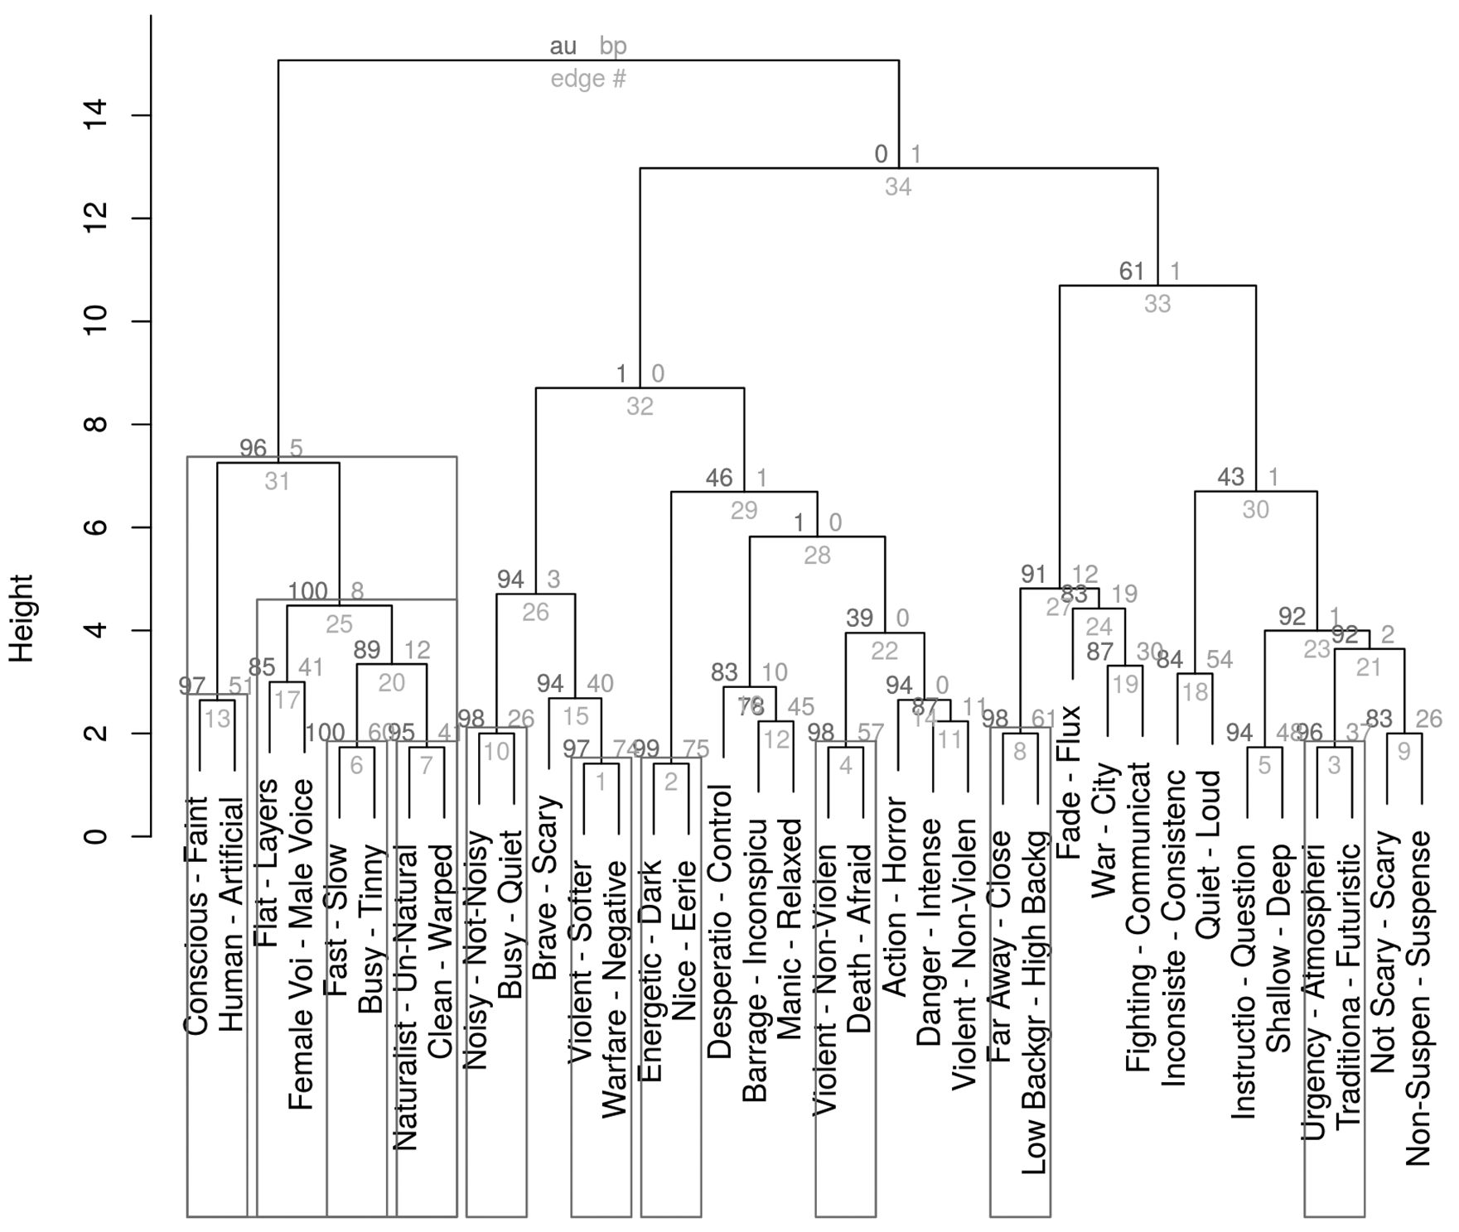
Figure 4: Cluster Analysis of Constructs with AU/BP values (Euclidean distance and Ward Clustering)

This analysis is obtained by the statistical process of bootstrapping, which models a measure of accuracy or reliability of a sample. The consequence of this is that confidence intervals can be set at the analysis phase and the data processed to this criterion. The result is that the dendrogram is modified to show where links between constructs are deemed statistically significant. In the case of this analysis, all constructs and groups of constructs that are modelled to have p < 0.05 are highlighted by having a box placed around them. This is further expressed in Figure 4 by the Approximately Unbiased (AU) p-value being shown on the top-right edge of construct trees, alongside the Bootstrap Probability (BP).

By analysing the data in Figure 3 and Figure 4, it is therefore possible to consolidate the 36 constructs that were originally elicited into a more concise set of constructs. These, it is hypothesized, can be used to form a common, generally understandable and applicable scale for measuring user experience of audio in games. The resultant scales are shown in Table III. This set has been arrived at by consolidating the statistically significant construct groups and making flexible use of the variations in constructs that were elicited, along with some interpretation on the part of the researcher to make the scales more fluid. Additionally, a category name has been added that it is felt summarises the particular game audio characteristics that are being described in each of the new scales.

Table III: Game Audio Rating Scales resulting from Investigation

Solutions and Recommendations: An Efficient Scale to Evaluate Game Audio
It is hypothesized that efficacy of the prototype scales will be evidenced by differences in scoring between the ASC and non-ASC elements within the game but that the scales should be equally applicable to both segments of gameplay and easily understood by the user. To provide an initial demonstration of the newly formulated scale being utilised for analysis, we consider the ratings that were obtained earlier in the original repertory grid.

For the purposes of this analysis, the sound elements used have been separated into two groups: those that are taken from game segments representing ASC and those that do not. The initial constructs are then sorted into the groups associated with the categories presented in Table III. In addition, a number of other constructs with close matching values, or that it seemed should intuitively be mapped, were accounted for within one of the new scale descriptors. The full allocation of all of the original constructs, to the new scales, is shown in Table IV. It should be noted that duplication in the constructs occurs where more than one participant presented an identical construct, such as in the Valence category.

Table IV: Assignment of Constructs to Scale Categories for Modal Analysis

Since the repertory grid data were gathered using a scale of 1 to 5, such data are ordinal in nature. To this extent, we carry out modal analysis across the two groups of audio elements, with the intention that such analysis should indicate a difference between the ASC and non-ASC elements. The results from this analysis are plotted in a polar graph, which is shown in Figure 5.
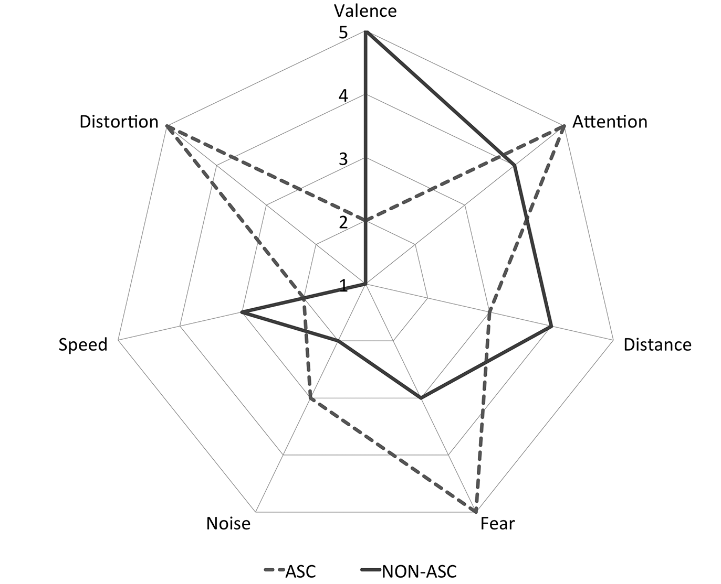
Figure 5: Modal Comparison of ASC and Non-ASC Game Audio Ratings

The results indicated above are particularly promising. There are distinct differences between the two categories of audio elements over all of the ratings that have been devised. As such, the data suggest that the repertory grid approach has been effective in devising a series of scales that are quickly and easily deployed and can be utilized to measure user experience of a range of game audio attributes effectively. Though it is advocated that further refinement of the scale is required, our research has led us to establish a base framework for the evaluation of game audio, which can be built-on in future work from further refining the scale itself and the testing of the efficacy of the scale in gameplay user testing scenarios.

Conclusions
In this work, we have discussed the lack of focus upon user experience testing in games, particularly in relation to game audio, which often takes a lower priority than other factors in the development of a game, such as gameplay. Recognizing the issue that user testing can be an activity that is resource hungry, we aimed to develop a mechanism that would quickly and effectively allow the measurement of user experience of game audio. Such a tool would be particularly useful for sound designers, composers and others working within the sound and music teams who are developing games.

This work has shown the value that can be gleaned from investing in, what is initially, a time and labor-intensive process, of repertory grid interviews with a range of subjects. However, the benefits are quickly yielded by the formulation of a user-centered method of devising scales and metrics for the evaluation of user experience of audio in games. To demonstrate the value of this approach and the scale that was formulated, it was applied to see if it could determine the presence of subtle game audio differences from segments in games that feature ASC. From the data analysis in this work, it was shown that the scale is effective in this capacity.

Although our work here has focused upon game audio as a particular domain of interest, it is anticipated that the process would be easily transferrable to other aspects of measuring game user experience. For example, we suggest there is significant use of this approach in evaluating aspects of the game such as: control system, immersiveness, graphics, gameplay, narrative, longevity, and so on.

References
Alves, V, and L. Roque. 2010. "A pattern language for sound design in games." In Proceedings of the 5th Audio Mostly Conference: A Conference on Interaction with Sound, Piteå, Sweden, September 15-17, 2010. doi: 10.1145/1859799.1859811
Bech, S., and N. Zacharov. 2007. Perceptual Audio Evaluation - Theory, Method and Application. Chichester: John Wiley & Sons.
Blake, A. 2013. Top 10 Hallucinations in Video Games. Leviathyn. http://leviathyn.com/opinion/2013/07/26/top-10-hallucinations-in-video-games/ (accessed May 7, 2014).
Brandon, A. 2005. Audio for Games: Planning, Process, and Production. Berkeley, CA: New Riders Games.
Bridgett, R. 2013. “Contextualizing Game Audio Aesthetics” in Richardson, J., Gorbman, C. and C. Vernallis, eds. The Oxford Handbook of New Audiovisual Aesthetics. New York: Oxford University Press.
Brown, M. 2008. "Evaluating computer game usability: Developing heuristics based on user experience." In Proceedings of IHCI conference, Cork, Ireland, September 19 – 20, 2008. University College Cork.
Chin, J. P., Diehl, V. A. and K. L. Norman. 1988. "Development of an instrument measuring user satisfaction of the human-computer interface." In Proceedings of the ACM SIGCHI conference on Human factors in computing systems, Washington DC, USA, June 15 – 19, 1988.. doi: 10.1145/57167.57203
Chittaro, L. and F. Zuliani. 2013. "Exploring audio storytelling in mobile exergames to affect the perception of physical exercise." In 7th International Conference on Pervasive Computing Technologies for Healthcare (PervasiveHealth), Venice, Italy, May 5 – 8, 2013, IEEE.
Collins, K. 2008. Game Sound: An Introduction to the History, Theory, and Practice of Video Game Music and Sound Design. Cambridge, Mass.: MIT Press.
Constantine, L. L., and L. A. D. Lockwood. 1999. Software for Use: A Practical Guide to the Models and Methods of Usage-centered Design. Reading, Mass.: Addison Wesley.
Demarque, T. C. and E. S. de Lima. 2013. "Auditory Hallucination: Audiological Perspective for Horror Games." In Proceedings of SBGames, São Paulo, Brazil, October 16 – 18, 2013. Mackenzie Presbyterian University
Efron, B., and R. Tibshirani. 1994. An Introduction to the Bootstrap. New York: Chapman & Hall.
Gal, V., Le Prado, C., Merland, J. B., Natkin, S., and L. Vega. 2002. "Processes and tools for sound design in computer games." In Proceedings International Computer Music Conference, Gothenburg, Sweden, September 19 2002. International Computer Music Association.
Gaver, W. W. 1989. The SonicFinder: An interface that uses auditory icons. Human-Computer Interaction 4 (1): 67-94.
Goodby, Berlin & Silverstein. 2008. Hotel 626. Online Flash Game, Doritos.com.
Grill, T., Flexer, A. and S. Cunningham. 2011. "Identification of perceptual qualities in textural sounds using the repertory grid method." In Proceedings of the 6th Audio Mostly Conference: A Conference on Interaction with Sound, Coimbra, Portugal, September 7 – 9, 2011. doi: 10.1145/2095667.2095677
ITU-R. 2003. Recommendation ITU-R BS.1284-1, General methods for the subjective assessment of sound quality. International Telecommunication Union – Radio communication Sector (ITU-R).
ITU-R. 2001. Recommendation ITU-R BS.1387-1, Method for objective measurements of perceived audio quality. International Telecommunication Union – Radio communication Sector (ITU-R).
Jankowicz, D. 2004. The Easy Guide to Repertory Grids. Chichester, West Sussex, England: J. Wiley.
Kelly, G. 1955. The Psychology of Personal Constructs. New York: Norton.
Kirakowski, J, and M. Corbett. 1993. SUMI: The software usability measurement inventory. British journal of educational technology 24 (3): 210-212.
Konami Computer Entertainment Tokyo. 1999. Silent Hill, PlayStation. Konami.
Liljedahl, M., Papworth, N. and S. Lindberg. 2007. "Beowulf: an audio mostly game." In Proceedings of the international conference on Advances in computer entertainment technology, Salzburg, Austria, June 15 – 17, 2007. doi: 10.1145/1255047.1255088
Mandryk, R. L., Inkpen, K. M. and T. W. Calvert. 2006. Using psychophysiological techniques to measure user experience with entertainment technologies. Behaviour & Information Technology 25 (2): 141-158.
Monolith Productions. 2005. F.E.A.R. First Encounter Assault Recon, Windows PC. Vivendi Universal.
Moustakas, N., Floros, A. and N. Kanellopoulos. 2009. "Eidola: An interactive augmented reality audio-game prototype." In Audio Engineering Society Convention 127, New York, USA, October 9 – 12, 2009. Audio Engineering Society.
Nacke, L. E., Grimshaw, M. N. and C. A. Lindley. 2010. More than a feeling: Measurement of sonic user experience and psychophysiology in a first-person shooter game. Interacting with Computers 22 (5): 336-343.
Nacke, L., Drachen, A. and S. Göbel. 2010. Methods for evaluating gameplay experience in a serious gaming context. International Journal of Computer Science in Sport, 9 (2): 1-12.
Nielsen, J. 1993. Usability Engineering. Boston: Academic Press.
OpenRepGrid. 2014. OpenRepGrid on Air. http://www.onair.openrepgrid.org/ (accessed February 6, 2015).
Östblad, P. A., Engström, H., Brusk, J., Backlund, P., and U. Wilhelmsson. 2014. "Inclusive game design: audio interface in a graphical adventure game." In Proceedings of the 9th Audio Mostly: A Conference on Interaction With Sound, Aalborg, Denmark, October 1 – 3, 2014. doi: 10.1145/2636879.2636909
Pagulayan, R. J., Keeker, K., Fuller, T., Wixon, D., Romero, R. L. and D. V. Gunn. 2003. “User centered design in games”. In J. A. Jacko & A. Sears (Eds.), The Human Computer Interaction Handbook: Fundamentals, Evolving Technologies, and Emerging Applications. New York, NY, USA: L. Erlbaum Associates Inc.
Papworth, N. 2010. "iSpooks: an audio focused game design." In Proceedings of the 5th Audio Mostly Conference: A Conference on Interaction with Sound, Piteå, Sweden, September 15-17, 2010. doi: 10.1145/1859799.1859810
Parker, J. R. and J. Heerema. 2008. Audio interaction in computer mediated games. International Journal of Computer Games Technology 2008: 1-8.
Picking, R., Grout, V., McGinn, J., Crisp, J., and H. Grout. 2012. Simplicity, Consistency, Universality, Flexibility and Familiarity: The SCUFF Principles for Developing User. Innovative Applications of Ambient Intelligence: Advances in Smart Systems: Advances in Smart Systems 2012: 179-187.
Reiss, Eric. 2009. A definition of “user experience”. http://www.fatdux.com/blog/2009/01/10/a-definition-of-user-experience/, (accessed January 25, 2015).
Rockstar North. 2013. Grand Theft Auto 5. Xbox 360. Rockstar Games.
Rockstar Studios. 2012. Max Payne 3. Xbox 360. Rockstar Games.
Rocksteady Studios. 2009. Batman: Arkham Asylum. Xbox 360. Eidos Interactive and Warner Bros. Interactive Entertainment.
Roden, T. and I. Parberry. 2005. "Designing a narrative-based audio only 3d game engine." In Proceedings of the ACM SIGCHI International Conference on Advances in computer entertainment technology, Valencia, Spain, June 15 – 17, 2005. doi: 10.1145/1178477.1178525
Rogers, Y., Sharp, H. and J. Preece. 2011. Interaction design: beyond human-computer interaction. New York: John Wiley & Sons.
Sanders, T, and P. Cairns. "Time perception, immersion and music in videogames." In Proceedings of the 24th BCS Interaction Specialist Group Conference, Dundee, Scotland, September 6 – 10, 2010. British Computer Society.
Shneiderman, B. 1998. Designing the User Interface: Strategies for Effective Human-computer-interaction. 3rd ed. Reading, Mass: Addison Wesley Longman.
Shaw, M. L. G. 1980. On Becoming a Personal Scientist: Interactive Computer Programs for Developing Personal Models of the World. PhD thesis. Brunel University (UK).
Stevens, Richard, and Dave Raybould. 2011. The Game Audio Tutorial a Practical Guide to Sound and Music for Interactive Games. Burlington, MA: Focal Press.
Tan, F. B. and M. G.Hunter. 2002. The repertory grid technique: A method for the study of cognition in information systems. MIS Quarterly 26 (1): 39-57.
Tecmo. 2001. Fatal Frame. PlayStation 2. Wanadoo.
Ubisoft. 2010. Far Cry 3. Xbox 360. Ubisoft.
Vygotsky, L. S. Thought and language. 2012. Cambridge: M.I.T. Press, Massachusetts Institute of Technology.
Wadsworth, B. J. 1996. Piaget's Theory of Cognitive and Affective Development: Foundations of Constructivism. 5th ed. New York: Longman.
Ward Jr, J. H. 1963. Hierarchical grouping to optimize an objective function. Journal of the American statistical association 58 (301): 236-244.
Weinel, J. 2010. Quake Delirium: Remixing Psychedelic Video Games. Sonic Ideas/Ideas Sonicas 3 (2).
Weinel, J., Cunningham, S. and D. Griffiths. 2014. "Sound through the rabbit hole: sound design based on reports of auditory hallucination." In Proceedings of the 9th Audio Mostly: A Conference on Interaction With Sound, Aalborg, Denmark, October 1 – 3, 2014. doi: 10.1145/2636879.2636883
Weinel, J., Cunningham, S., Roberts, N., Roberts, S., and D. Griffiths. 2014. "EEG as a Controller for Psychedelic Visual Music in an Immersive Dome Environment." In Proceedings of Conference on Electronic Visualisation and the Arts (EVA 2014), London, UK, July 8 – 10, 2014. British Computer Society.
Wharton, C., Rieman, J., Lewis, C. and P. Polson. 1994. "The cognitive walkthrough method: A practitioner's guide." In Nielsen, J., and Mack, R. L. (eds.), Usability Inspection Methods. New York: John Wiley & Sons, Inc.

List of Additional Sources
Dix, A., Finlay, J., Gregory, A., and B. Russell. 2004. Human-computer interaction. England: Pearson Education Ltd.
Calleja, G. 2011. In-game: from immersion to incorporation. Cambridge, Mass.: MIT Press.
Collins, K. 2013. Playing with sound: A theory of interacting with sound and music in video games. Cambridge, Mass.: MIT Press.
Ekman, I. 2008. "Psychologically motivated techniques for emotional sound in computer games." In Proceedings of AudioMostly 2008, 3rd Conference on Interaction with Sound, Piteå, Sweden, October 22 – 23, 2008. Interactive Institute Sonic Studio.
Fransella, F., Bell, R. and D. Bannister. 2004. A manual for repertory grid technique. New York: John Wiley & Sons.
Grimshaw, M. and T. A. Garner. 2015. Sonic Virtuality: Sound as Emergent Perception. New York: Oxford University Press.
Hobson, J. A. 2002. The Dream Drugstore Chemically Altered States of Consciousness. Cambridge, Mass.: MIT Press.
Horowitz, S. and S. R. Looney. 2014. The Essential Guide to Game Audio the Theory and Practice of Sound for Games. New York: Focal Press, Taylor & Francis Group.
Jørgensen, K. 2007. What are Those Grunts and Growls Over There?: Computer Game Audio and Player Action. PhD diss., Københavns Universitet, Denmark.
Juslin, P. N. and J. A. Sloboda (eds). 2010. Handbook of music and emotion: Theory, research, applications. Oxford: Oxford University Press.
Newell, A. F., Carmichael, A., Morgan, M., and A. Dickinson. 2006. The use of theatre in requirements gathering and usability studies. Interacting with computers 18 (5): 996-1011.
Sonnenschein, D. Sound design. 2001. California: Michael Wiese Productions.

Key Terms and Definitions
ASC: Altered States of Consciousness. Describes a state of human consciousness that is not considered ‘normal’ in some regard. Typically this can be indicated by some kind of enhancement and/or impediment to one or more of the human senses, cognitive, or physical ability. States can be induced, for example, by psychoactive substances (such as hallucinogenic drugs), whilst others may be naturally occurring (such as dreaming).

Game Audio: The presence of any kind of sound or music within a computer game situation. Game audio is notably different from time-based, linear audio such as that found in television or film. This is because of the fact that games are interactive and, although they tend to follow a path or guiding structure, they are non-linear, at least in a time-bound sense. As such, game audio is dynamic and not easy to predict.

Immersion: The notion of the game player, or players, becoming detached from their real-world setting and having the perception that they are actually inside the game world. In essence, the player forgets that they are interacting with the game by way of visual, audio and tactile technologies whilst being in their own environment and believes they are inside the game and interacting with it in a fluid, intuitive manner.

Personal Constructs: The theory of human learning and development that suggests we, as human beings, understand the world around us by our interactions and experiments with it. We formulate our own descriptions and explanations of the features and functions of the world, known as constructs, which are individual to us, though not necessarily unique.

Repertory Grid: A human-centered technique, based upon the theory of personal constructs, which involves participants describing characteristics of a range of elements. These elements typically form a sample from a particular subject or domain of knowledge. Subjects provide a quantitative rating against a series of qualitative constructs to create a matrix of scores and descriptions: the repertory grid.

Quantitative and Qualitative Subjective Testing: Game user testing, by nature, involves the elicitation of subjective opinions and views of the participants involved. This information can be gathered in either a quantitative or qualitative form. Quantitative data includes any information that can be presented or analyzed in numerical form, such as the number of times a user collects an item in the game or a rating they give the game’s usability on a scale of 1 to 5. Qualitative data is any information that takes a descriptive form and will usually be textual (although it could feasibility include pictures, diagrams, or sounds). For example, user descriptions of a game in interviews or focus groups are qualitative.
Table I: Example Repertory Grid relating to animals
1 | Dogs | Cats | Rabbits | Mice | 5
Quiet | 5 | 3 | 1 | 1 | Loud
Small | 5 | 3 | 2 | 1 | Big
Short Hair | 3 | 3 | 4 | 1 | Long Hair
Messy | 1 | 5 | 4 | 3 | Clean

Table II: Descriptions of Audio Elements used in Repertory Grid Study
Code | Game | ASC | Description
A | Batman: Arkham Asylum | Yes | Batman becomes infected by an enemy, Scarecrow’s hallucinogenic toxin, and must complete a specific level in order to return to normal consciousness. This sound most notably features the voice of the Scarecrow character that is warped with pre-delay and reverb effects. In the background there is the presence of some slow, string-based music.
B | Grand Theft Auto 5 | No | One of the game’s main protagonists, Trevor, is in a gunfight with a group of police officers. Multiple instances of incoming and outgoing gunfire are heard, with sirens in the background. The main character is shouting at the police and encouraging them to try to shoot him.
C | Max Payne 3 | No | The scene is largely sound driven and represents a shootout between the main character, Max Payne, and a group of gangsters. There is slow, string-based background music throughout. Multiple voices of the enemy characters can be heard shouting in a foreign (i.e. non-English) language and this is interspersed with gunfire. There is liberal use of reverb over the diegetic sounds, representing the large space the action takes place in.
D | Far Cry 3 | Yes | The main character, Jason, experiences a heavy drug trip, activated by an earlier interaction with hallucinogenic mushrooms in the forest. There is a cacophony of sounds around the listener like glass shattering in the background. Another voice, processed with pre-delays and echo, enquires, “What are you afraid of?”. Screeches are subtly introduced along with a sound similar to a reverse cymbal, which builds to a minor crescendo.
E | Grand Theft Auto 5 | Yes | The player is in control of another main character, Michael, who has been drugged (unknowingly) by his son. The drug takes effect whilst the player is controlling Michael driving a car. The sound features mainly dialogue from the character, asking what has happened to him and has been time-stretched and pitch shifted to make it sound slow and low pitched, although the effect varies over time between the processed speech, normal speech, and back again.
F | Batman: Arkham Asylum | No | There is notable dramatic, orchestral music. A voice on a public announcement system is issuing warnings of security breaches. There are some character movement sounds before the music is ducked as we hear the voice of Batman interact with a rescued prison guard who has recently regained consciousness.
G | Max Payne 3 | Yes | Max Payne is able to harness levels of adrenaline, accumulated during gameplay to trigger the occurrence of an ASC, which has the effect of slowing down the gameplay. The sample is extracted from a shootout with enemy game characters. The sound begins with instances of gunfire that have been subtly time and pitch stretched, to produce a slowed down effect. There are occasional voices of enemy characters in between the gunshots and weapon reloading sounds. Notably, the background ambience, music and enemy voices are lower in the mix than during normal gameplay; with the gunfire being high in the mix.
H | Far Cry 3 | No | There is a brief burst of gunfire, the sound of an animal grunting and then the sounds of movement. There is notable ambience and music, suggesting a jungle scene, before the main character enquires as to the wellbeing of a rescued colleague.

Table III: Game Audio Rating Scales resulting from Investigation
Category Name | Construct / Scale
Valence | Non-Violent | Violent
Attention | Atmospheric | Urgent
Distance | Near | Far
Fear | Nice | Eerie
Noise | Quiet | Noisy
Speed | Slow | Fast
Distortion | Unnatural | Natural

Table IV: Assignment of Constructs to Scale Categories for Modal Analysis
Category Name | Constructs Used in Modal Analysis
Valence | Afraid - Death  Softer - Violent  Non-Violent – Violent  Non-Violent - Violent
Attention | Traditional - Futuristic  Urgency - Atmospheric  Non-Suspense - Suspense
Distance | Low Background Noise - High Background Noise  Far Away - Close  Fade - Flux
Fear | Energetic - Dark  Brave - Scary  Nice - Eerie  Not Scary - Scary
Noise | Quiet – Busy  Not-Noisy – Noisy
Speed | Slow – Fast  Tinny – Busy
Distortion | Human – Artificial  Clean – Warped  Conscious – Faint  Naturalistic – Un-naturalistic  Flat – Layers

