**SINGING AND LOUDNESS: A SHORT STUDY WITH THE ROYAL OPERA HOUSE**

S. Dance School of the Built Environment and Architecture, London South Bank University

J. Bernays Royal Opera House, London

S. Liu Applied Acoustic Design, London

1. **INTRODUCTION**

The Royal Opera House Sound Study Group has recently been involved in a collaborative project with the Royal Opera Chorus, looking to establish the most effective way of moderating individual sound exposure and maximising musical results in their Chorus Rehearsal Room. An experiment was undertaken where the soprano, mezzo, tenor and bass sections of the Chorus were arranged into five different configurations, in which the Easter Hymn from Cavelleria Rusticana was performed. Proximity of one vocal group to another, the measured and perceived effect of increasing space between performers, and the effect of music stands were criteria informing the configurations. A further version was performed in which all choristers were instructed to sing at ‘half volume’. Individual exposure and overall sound levels were measured for each performance, producing some surprising data. In addition, all 45 participating singers completed a written survey of their individual hearing and singing perceptions of the experiment.

1. **REHEARSAL ROOMS**

The acoustics and layout of rehearsal rooms for professional opera choruses have not been investigated to the same degree as those of opera houses. In this section the Chorus Rehearsal Room (CRR) of the Royal Opera House, Covent Garden is detailed, along with the preferred characteristics of rehearsal spaces and details of the room acoustic measurements.

* 1. **Description of the Royal Opera House Choral Rehearsal Room**

The Royal Opera House Chorus is made up of 48 full-time singers frequently supplemented by up to 62 freelance singers or ‘extra choristers’. To this end, the CRR has a maximum capacity of 110 people. The fan-shaped room has a volume of approximately 1252 m3 with dimensions 14.8m wide by 12.5m deep, by 6.8m high. The room has a closed stair riser which is carpeted and covers two-thirds of the floor area, the remained being a flat wooden floor where the piano is positioned. On each of the six risers are18 fixed seats with music stands. The construction of the room is masonry, with the rear wall having a mixture of acoustic perforated panels, plaster and glass, the left hand wall curtains and windows, the right had wall plaster and perforated acoustics panels, and the front wall plaster and fabric covered acoustics panels, see Figure 1. The total area of perforated absorptive panels is 48m2. A multi-stepped angled suspended plasterboard ceiling covers the width of the room.

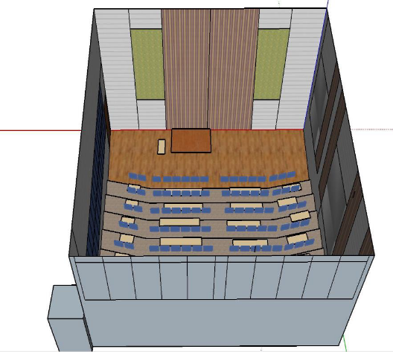

Figure 1. Choral Rehearsal Room at the Royal Opera House with absorbers in green and dark blue

* 1. **Literature on Rehearsal Room for Singing**

There is a lack of literature on designing or acoustically treating rehearsal rooms for choral singing. There is a Norwegian Standard 8178-2014: Music Rehearsal Spaces [1]. It suggests that for large ensembles the ceiling height should be above 5 m (6.8 m), the volume greater than 700 m3 (1252 m3) and there should be 1.5 m2 per people of floor space (1.7 m2). As can be seen the CRR exceeds all of these minimum design criteria.

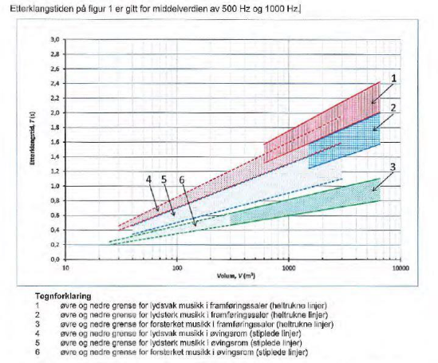

Figure 2. Norwegian 8178 Music Rehearsal Space Preferred Reverberation Time vs Volume

The preferred reverberation time (500+1000Hz averaged) for the CRR was found to be Tmf =1.2 seconds with a possible range of 1.0-1.4 seconds, see Figure 2. This is in broad agreement with Beranek’s book suggestion of 1.3-1.5 seconds [2] and Sinal and Yilmazer formula [3] which gave a value of 1.56 seconds, see equation (1).

(1)

* 1. **Room Acoustic Measurements**

Measurements were taken in the unoccupied CRR using the winMLS computer based system using a Class 1 microphone, a Norsonic hemi-dodec loudspeaker connected to and Norsonic amplifier. The room acoustic measurements themselves were taken in accordance to ISO 3382-1:2009 – Acoustics – Measurement of room acoustic parameters. Part 1: Performance spaces [4]. Measurements for two source positions and six microphone positions were taken and averaged. The averaged reverberation time results in 1/3 octave bands are show in figure 2.

Figure 3. Averaged reverberation time measured in the Choral Rehearsal Room

* 1. **Analysis of the Room Acoustic Measurements**

Through analysis of the reverberation measurements the Tmf was found to be 0.83 seconds, with a bass ratio of 1.2. The Tmf is much lower than would be expected according to Beranek or the Norwegian Standard 8178 in absolute times, 0.83 s compared to 1.3 s and 1.2 s, respectively. The Norwegian Standard also provides the relative reverberation time to Tmf for the spectrum, see Fig 3.

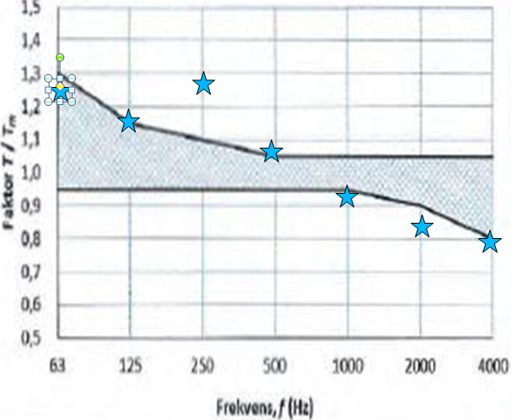

Figure 4. Measured Reverberation Time ratio to Tmf as given in Norwegian 8178 Standard

The Norwegian Standard 8178 suggests that music rehearsal rooms should have a flat frequency response. Upon analysis of Figure 3 the bass ratio should be between 1.0 and 1.07 whereas for the CRR it is 1.2 mainly due to too high a reverberation time at 250 Hz. In addition the measured RT curve is too low at mid and high frequencies and thus produces an unbalanced sound over boosting the low frequencies and over absorbing the mids and high frequencies.

1. **THE SINGING EXPERIMENT**

The singing experiment was initiated by the Royal Opera House after the Choristers gave their feedback on their working environment. This section gives the background to the research including the singing experiment methodology, results, loudness analysis and sound exposure predictions.

* 1. **Background to the Singing Experiment**

The Royal Opera House had undertaken to measure the sound exposure of the Royal Opera Chorus during rehearsals. The singers reported they felt the CRR had an unbalanced acoustic resulting in over-singing which led to increase sound exposure and vocal fatigue. The room was universally disliked for both choral and solo work.

As the CRR has fixed seating it forces the singers to twist to look towards the choral master, see Figure 1. In addition, the fixed seating offers little opportunity for increased separation and hence was removed for the experiments detailed below.

**3.2 The Singing Experiment Methodology**

The Choral singers performed “The Easter Hymm” seven times under the direction of the Assistant Choral Master in the CRR. The piece was selected as it is representative of the choral singers’ repertoire. The song provided two minutes and thirty-five seconds of piano accompanied music which demonstrated all four voice groups – Tenor, Bass, Soprano and Mezzo - equally. During the experiment 45 of the 48 full time Chorus were present. The hymn importantly also provided sufficient vocal and dynamic range. All the singers were standing on the risers, see Figure 5. The sound levels were measured at three positions; the position reported is at the choral master location at the front of the room. Ten choristers were wearing shoulder-mounted Cirrus sound-dose badges, and their individual sound doses were recorded.

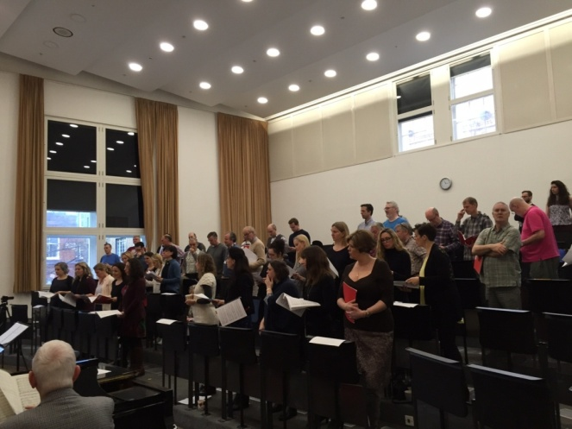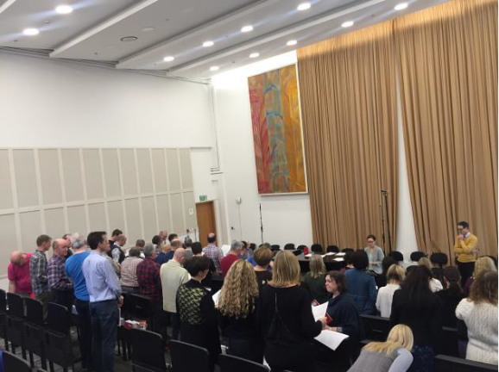

Figure 5. The choral singers in the chorus rehearsal room at the Royal Opera House

The experiment involved changing the choral layout in terms of the vocal groups giving seven different results, see Figure 6:

* Control using regular chorus layout
* Repeat experiment 1 for consistency
* Regular layout but with increase spacing, 1m instead of 0.6 m
* Tenor and Mezzo sections swap location using regular 0.6 m spacing
* Soprano, Mezzo, Tenor and Bass block formation across the room
* Normal positions with vocal effort reduced by 50% whilst maintaining full dynamic
* Normal positions but with music stands open

|  |  |  |  |
| --- | --- | --- | --- |
| Tenor | Soprano | Bass | Mezzo |
|  |  |  |  |

Control Repeat Spread Swap Block Half Volume Open Stands

|  |  |  |  |  |  |  |  |  |  |  |  |  |  |  |  |  |  |  |  |  |  |  |
| --- | --- | --- | --- | --- | --- | --- | --- | --- | --- | --- | --- | --- | --- | --- | --- | --- | --- | --- | --- | --- | --- | --- |
|  |  |  |  |  |  |  |  |  |  |  |  |  |  |  |  |  |  |  |  |  |  |  |
|  |  |  |  |  |  |  |  |  |  |  |  |  |  |  |  |

Figure 6. Chorus layouts used during the seven experiments

* 1. **The Singing Experiment Results**

The singing experiment results are presented in Figure 7 for the full range of frequencies as measured at the front of the auditorium.

Figure 7. The singing levels in the Choral Rehearsal Room for the full time Chorus.

It can be seen Figure 7 that the Chorus could repeat their normal performance during the piece with an overall sound level measured for the control and repeat of 87.8 dBA and 88.0 dBA, respectively. This provided confidence in the method and the further experiments would provide valid results. The sound levels for the next three layouts gave very similar overall sound levels. Then we asked the Choral Master to reduce the performance to half the volume. As can be seen from Figure 7 this resulted in a level of 79.9 dBA, 8 dB lower than the control layout. Finally, the music stands were adjusted to minimise reflections, this again made no difference to the overall sound level.

It should be mentioned that the Royal Opera House regularly assess the choral singers’ exposure to sound. The sound levels measured in seven of the eight experiments would give sound exposure just above the exposure limit value as given in the Control of Noise at Work Regulations 2005 [5].

**3.4 Loudness Analysis**

Focusing on the difference between the control and 50% vocal volume experiment, see Figure 8, it can be seen that the theoretical 10 dB difference was achieved, 8.1 dBA. However, the difference curve in figure 8 shows that the sound level difference seemed to increase with frequency in line with human hearing sensitivity at 2.5-4 kHz.

Figure 8. The singing sound level difference between 100% and 50% choral voice volume

Figure 9. The singing sound level difference compared to network weightings and the 90 Phon equal loudness contour

As the difference in singing sound level appeared to reflect human hearing sensitivity, Figure 9 shows the singing sound level difference against A weightings, B weightings and the 90 Phon equal loudness contour. The 90 Phon equal loudness contour was selected as this was the sound level the chorus were producing, 88 dBA overall. It can be seen from Figure 9 that the shape of the singing sound difference curve was similar although less pronounced than the equal loudness contour at the high frequencies 2.5-4 kHz.

**3. 5 Sound Exposure**

By having the Chorus sing at half volume whilst maintaining a full dynamic range allowed the sound exposure to stay within the Upper Exposure Limit of 85 dBA over 8 hours, assuming a typical day consists of a three hour rehearsal and a three hour performance, see equation (2).



(2)

We know that the stage performance is typically 3 dBA higher than in rehearsals [6], thus would give an LEP,d of 87.9 dBA, just above the Upper Exposure Limit. in the Control of Noise at Work Regulations 2005 [5].

1. **QUESTIONNAIRE**

The questionnaire has become an important tool for assisting in the acoustic design or optimisation of a space. The questionnaire is a method of “joining” the physical aspects of the room to the human perception of the room. In this case, the questionnaire was developed to target the choral singers’ impressions of their performance in different formations and/or spacing, and how comfortable it was singing in the room. The objective of moving the vocal groups can ultimately change what the singers hear.

The results of the ROH questionnaire revealed, the choral singers’ overall preference was Experiment 3 (normal vocal group locations with increased spacing) and the least preferred situation was the Control, Experiment 1. For Experiment 3 the choral group liked the layout with more spacing, the performance was the most comfortable and it was the easiest to hear their own voice as well as the rest of the chorus group. This further supports the design RT of 1.3 seconds as discussed in Section 2.1.

For choral singers it is know that hearing one's own voice and the rest of the choir is important [7,8], the Self to Other Ratio (SOR). The SOR increases with increased spacing meaning that the choral singers will hear less of the direct sound from their neighbours. It has also been found by Daugherty [9] that stronger singers tend to prefer larger spacing again supporting the questionnaire responses [10].

1. **CONCLUSIONS**

The Royal Opera House formed the Sound Study Group in March 2017, a team of experts was bought together to improve the working environment of the Chorus. Both objective and subjective testing was undertaken to establish the acoustic performance of the Choral Rehearsal Room. It was found that little has been written on the acoustics of rehearsal rooms. The room acoustics were measured and found to be drier than ideal for comfortable choral singing. The consequence of the dry space is the chorus would tend to over-sing in the room causing vocal fatigue, discomfort and high sound exposure levels. Hence, it is proposed that by increasing the reverberation in the room at mid frequencies by removing the absorptive panels, Tmf=1.1 s, and replacing them with diffusers the Choral Group will reduce their vocal effort to match the environment. This should resolve all three challenges: vocal fatigue, sound exposure and comfort.

The second part of the research was on the effect of changing the layout of the vocal groups based on measurements and a questionnaire. Firstly, it was found that the chorus could consistently repeat the same performance. Secondly, based on the questionnaire results the most liked layout was that where the spacing was increased between the singers. This would have the effect of increasing the comfort and the self to other ratio. In addition, it was found that when asked to perform at half the volume a reduction in sound level of 8 dBA was achieved. The reduction in sound was primarily at the frequencies where human hearing is most sensitive

1. **ACKNOWLEDGEMENTS**

Thanks go to the Chorus of the Royal Opera House for their full cooperation during the experiments. A vote of thanks goes to the Sound Study Group for their input on the paper. We would all like to give a special thanks to Genevieve Ellis for chorus-mastering the experiment session. The research was supported by the Royal Opera House.

1. **REFERENCES**

1.Norsk Standard, 2014. *NS 8178:2014 Acoustic criteria for rooms and spaces for music rehearsal and performance.* s.l.:Standard Norge.

2.Beranek, L., 1996. *Concert and Opera Halls.* New York: Acoustical Society of America.

3.Sinal, O. & Yilmazer, S., 2015. A Comparative Study on Indoor Sound Quality of the Practice Rooms Upon Classical Singing Trainees' Preference. *Proc*. *EuroNoise.2015, Maastricht 2015*

4. British Standards, 2009. *BS EN ISO 3382-1:2009 Acoustics - Measurement of room acoustic parameters - Part 1 Performance spaces.* London: British Standards.

5. Health and Safety Executive (2005). *Controlling noise at work*. The control of noise at work Regulations 2005, Guidance on Regulations: HSE

6. Zepidou, G., Dance, S. *An orchestra's noise exposure*, Proc IoA 32(3), Ghent 2010.

7. Ternström, S., Cabrera, D. and Davis, P., 2005. Self-to-other ratios measured in an opera chorus in performance. *The Journal of the Acoustical Society of America ,* Volume 118, pp. 3903-3911.

8. Howard, D., 2015. *Choral Singing and Healthy Voice Production.* Tunbridge Wells: Willow Leaf Publishing.

9. Daugherty, J., 2005. *Choir Acoustics,* Kansas: The University of Kansas.

10. Liu, S. Acoustics of the Choral Rehearsal Room at the Royal Opera House, MSc Thesis, London South Bank University, 2018