Supplementary Material

Imaging the Continuous Hydrothermal Flow Synthesis of Nanoparticulate CeO₂ at Different Supercritical Water Temperatures Using in Situ Angle-Dispersive Diffraction

Vesna Middelkoop,^{*a,b} Christopher J. Tighe,ª Suela Kellici,ª Robert I. Gruar,ª James M. Perkins,^{c} Simon D.M. Jacques,^{a,b} Paul Barnes^{*a,b} and Jawwad A. Darr^{*a}

ª Department of Chemistry, University College London, Christopher Ingold Laboratories, 20 Gordon Street, London WC1H 0AJ, UK
^{b} Department of Crystallography, Birkbeck College, Malet Street, London WC1E7HX, UK
^{c} Department of Materials, Imperial College London, South Kensington, London SW7 2AZ, UK

*Authors to whom correspondence should be addressed: v.middelkoop@ucl.ac.uk

Material Synthesis
For all syntheses during the course of this work, cerium ammonium nitrate [Ce(NH₄)₂(NO₃)_{6,} > 98.5%] was used, in a powdered form, purchased from Sigma Aldrich. All aqueous solutions for CHFS were prepared with 10 MΩ deionised water to a given concentration.
The mechanism of the reaction taking place inside the synthesiser mixing zone (under supercritical conditions) can be broken into its two distinct consecutive steps, hydrolysis and dehydration:
- Ce (NH₄)₂ (NO₃)₆ + 2H₂O → Ce(OH)₄ + 6HNO₃ + 2NH₃ (4.3a)
where the right hand side could also be written as:
Ce (NH₄)₂ (NO₃)₆ + 4H₂O → Ce(OH)₄ + 4HNO₃ + 2NH₄NO₃ (4.3b)
- Ce(OH)₄ → CeO₂ + 2H₂O (4.4)
After collection from the CHFS system the CeO₂ product is separated from the ionic residues (NO₃⁻, H⁺, NH₄⁺) in the slurry usually by a triple centrifugation washing procedure.

Experimental Setup
A photograph of the CHFS assembly is shown in Figure S1.
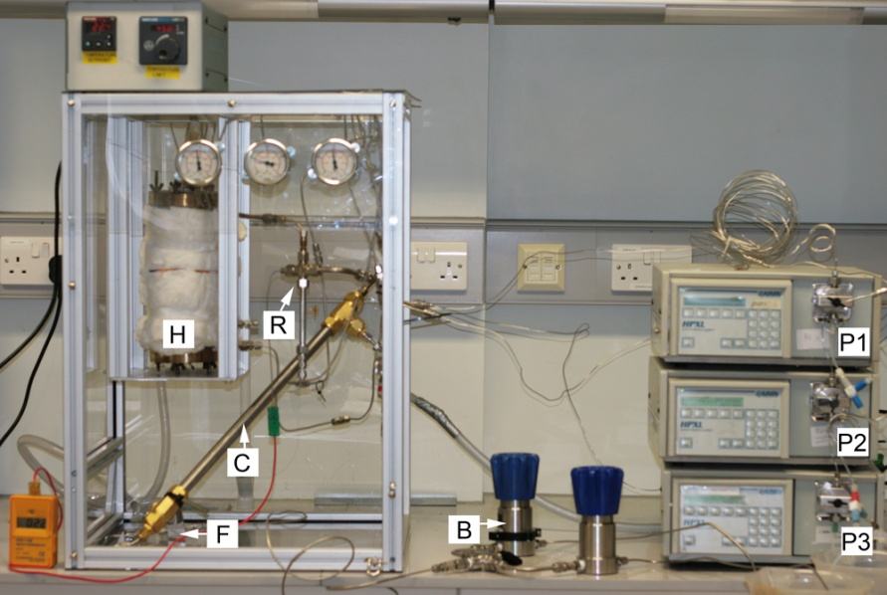

Figure S1 Photograph of the portable continuous hydrothermal flow synthesis (CHFS) system as assembled prior to use . It consists of three 305 Gilson HPLC pumps (P1, P2 and P3), two Tescom back-pressure regulators (B), and a portable lightweight aluminium frame (‘cage’) with Perspex walls. Two pumps were delivering cerium ammonium nitrate solution at a flow rate of 10 ml min⁻¹ and one was delivering de-ionised water to the pre-heater at 20 ml min⁻¹. The components contained within the CHFS aluminium ‘cage’ are: pre-heater (H) and heat controller, counter-current reactor (R), cooler (C), filter (F), fitted pressure gauges, and two thermocouples.

Data Analysis Method
The local geometry in angle-dispersed diffraction from the CHFS reactor is illustrated in Figure S2 (left) depicting a horizontal cross-section. The length of the path the radiation travelled through the fluid was the greatest along the centreline of the outer pipe. This path length decreased as the beam moved horizontally towards the outer edges of the pipe. When above the terminus of the inner pipe, the beam also passed through the stainless steel walls of the inner pipe. Diffraction is liable to occur at any angle and originate from any position along the incident beam path. The geometric effect on peak profile in angle dispersive mode, such as ceria peak broadening, is real, although exaggerated in the schematics in Figure S2 (right). As indicated in the diagram (Figure S2 right), diffraction at any specified angle (i.e. a specified reflection) may originate from one or more points (e.g. P1 and P2) along the incident beam path. Thus, diffraction from ceria 113 recorded at higher 2 may originate from the same points within the reactor as diffraction from ceria 111. In the diagram the red line schematically represents ceria 111 diffraction and the green one ceria 113 diffraction. The powder rings of these two strongest ceria reflections (on the detector image) are highlighted in red and green respectively. To each side, regions of the resulting one-dimensional integrated pattern are shown with the profile of the two reflections. The geometric effect can also be directly observed in the splitting of steel peaks at higher 2θ angles (Figure S4 with, as an example, a pattern collected during one of the test runs). This means that any reliable peak width analysis requires this effect to be accounted for by means of calibration even though this could not have been done ab initio since the distribution of the material in the third (x) direction is not exactly known.

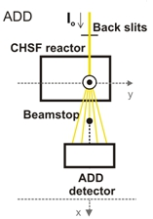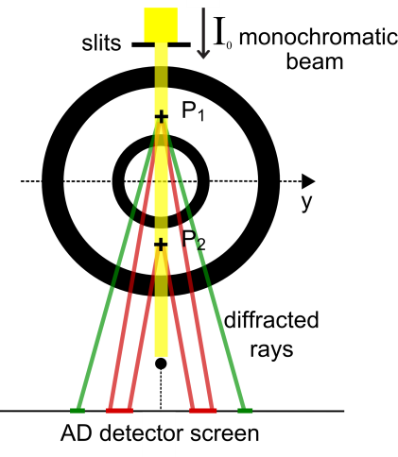
Figure S2 Schematic diagrams of the experimental set-up (shown on the left) for a tomographic angle-dispersive diffraction (TADDI) in situ study of continuous crystallisation of CeO₂ nanoparticles under supercritical conditions on ESRF station ID15A. In the schematic on the left the solid rectangle in the incident beam indicates the components within the CHFS cage which include the CHFS reactor, indicated by two concentric circles (shown on the right). The schematic on the right also illustrates the geometric broadening (exaggerated in the figure) that results from diffraction contributions by different parts of the mixing zone; for example ceria 111 and 113 diffractions emanate from positions P1and P2 within the mixing zone.
B
A
Figure S3 shows selected scan location from the steel pipe walls and the flowing nanoparticle ceria material. The well-defined Debye-Scherrer rings were radially integrated to obtain a 1D diffraction pattern. The quality of the images collected by Pixium 4700 (this ID15A run and ID15B run) is higher and the ceria rings appear clearer and finer if compared to the images collected using the MAR133 CCD detector (Middelkoop et al 2009). The feint and diffuse diffraction rings displayed on the MAR133 detector may be due to the weak intensity of the ceria reflections which was not significantly greater than the adjacent background. One might also argue that the weak intensity of the ceria reflections arises from faster flow rates in the previous ID15A experiment which results in the shorter residence time of the ceria material in the system. See Table S1 for a comparison of the characteristics of the two large-area detectors, MAR133 and Pixium 4700.

Detector | Principle | Field of view | Pixels array | Pixel size | Read-out time
MAR133 | scintillatorCCD | 133 mm  diameter | 2048×2048 | 64×64 µm² | 8 sec
Pixium 4700 | scintillator flat-panel | 294×379 mm² | 2480×1910 | 154 ×154 µm² | a few tens of msec

Table S1 Basic characteristics of MAR133 and Pixium 4700 detectors [1,2].

An example of integration around two steel rings is shown in Figure S4. The resulting profiles for two selected steel peaks show peak splitting caused by a combination of the geometric arrangement (concentric pipes) and the grained texture of the steel. It was not possible to fit such peak profiles and therefore steel peaks could not be effectively used for creating yz maps and for checking the positions of the steel pipe walls.
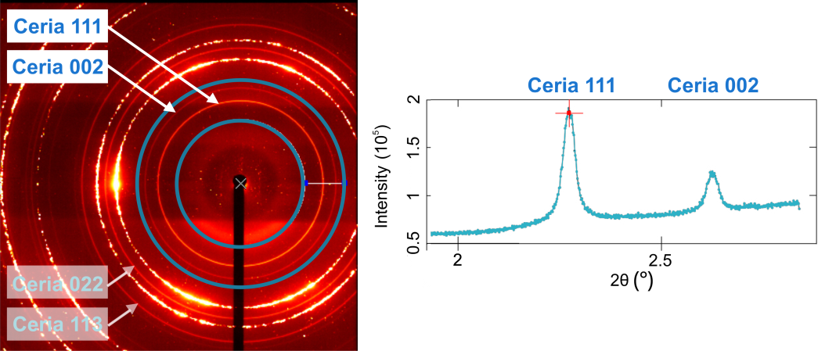

Figure S3 Typical two-dimensional pattern (left) collected on the Pixium 4700 detector. Clear diffraction features (Debye Scherrer rings) are observed: spotty, broken, but intense steel rings, and smooth and sharp ceria rings. Main ceria reflections, 111, 002, 022 and 113 are clearly visible. Incomplete rings (not full-circle) are outside of the range of the image due to off-centering of the detector. The corresponding 2θ diffraction pattern (right) is derived by radial integration of the pixel intensities for the entire, well-defined ceria rings, dominant 111 and less strong 002. The integration limits are highlighted by blue circles.
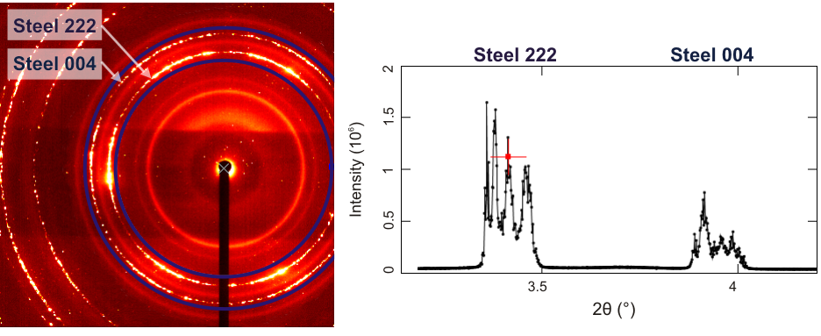
Figure S4 Integration around two discontinuous ‘spotty’ steel diffraction rings gives peak profiles that show splitting mainly due to the pipe geometry and the steel texture, i.e. its statistical orientation of grains.
The recently developed synchrotron data analysis software package, EasyEDD
[3] was used only to visualise the useful unfitted data and confirm the relatively symmetric pipe configuration. Before any fitting was applied and the background subtracted, a total intensity map (Figure S5) was constructed in EasyEDD from the intensities of the two selected ceria peaks, 111 and 002, as integrated in the Datasqueeze software. In comparison to the previous two TADDI scans (see Middelkoop et al., 2009 and the preliminary ID15B results in Figures S7-S10 below), the scanned area of the three TADDI scans in the current paper was extended to an additional 20 scan points (10 mm) higher up in the outflow region.
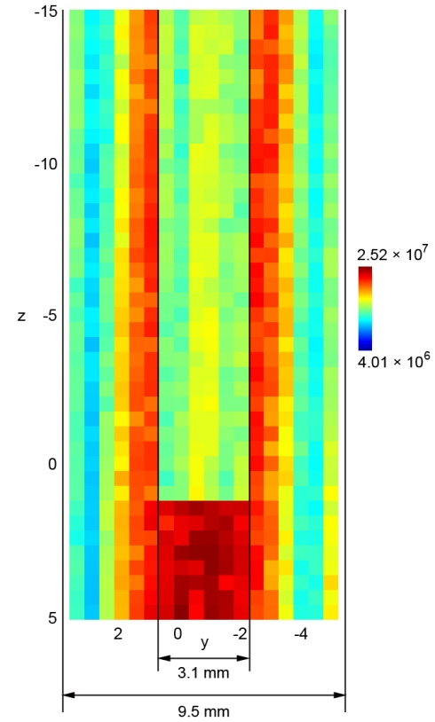
Figure S5 yz-(T)ADDI map based on the total intensity of two unfitted ceria peaks including the background intensity underneath them. This pixelated map serves as a ‘quick scan preview' and a direct confirmation of the symmetrical position of the inner tube. In this case the inner pipe seems still slightly offset from the centre. Positions of the pipe walls are silhouetted against high intensity colours (orange and red). Relative positions of the outer walls of the pipes and their dimensions are marked. An area of 20 × 41 points was scanned at 0.5 × 0.5 mm step size, and the collection time was 10 sec per point. The colour bar represents a pseudo-color scale, ranging from a low intensity (in blue) to a high intensity (in red).
The one-dimensional peak profiles were subjected to the peak fitting routine in the FITYK software package to determine the optimum values for the peak area and the full width of half maximum (FWHM) parameters. Batch fit processing required constant visual inspection since the initial parameter values (together with the two linear background parameters), set to automatically vary, were more likely to fail and yield a less reasonable fit to the data. Therefore the fitting had to be a manual procedure rather than a computationally efficient operation. Figure S6 illustrates how a pseudo-Voigt fit yields good correspondence between the measured and calculated curves. The pseudo-Voigt function is conventionally preferable in synchrotron diffraction data analysis since it is usually found to describe peak shapes well, allowing a flexible variation of its mixing parameter, i.e. the variation of fractions of its Lorentzian and Gaussian components, the two most basic fitting functions. The pseudo-Voigt function used to describe the peak shapes of the two selected reflections, ceria 111 and 002, gave a very good fit (see residual in Figure S6) to the individual peaks in the majority of the patterns in the dataset.

However it should be noted that, although the ceria 111 and 002 peaks were overall well resolved and largely Gaussian in character, at several different scan positions there were some unexpected minor discrepancies between measured and calculated peak shapes due to apparent deviations from a single pseudo-Voigt peak shape. This ambiguous double- or sometimes even triple-peak behaviour with tail features was more obvious for the larger peak, ceria 111. The most likely explanation is that these contributions to peak broadening are linked to geometrical aberrations. To get a more accurate and satisfactory fit result, it was necessary to decompose this kind of complex peaks into their component shapes. As the example in Figure S6 illustrates, the ceria 111 peak, asymmetric to the left, is represented as the sum of two underlying peak shapes, both pseudo-Voigt: the main peak and a separate small peak contribution.

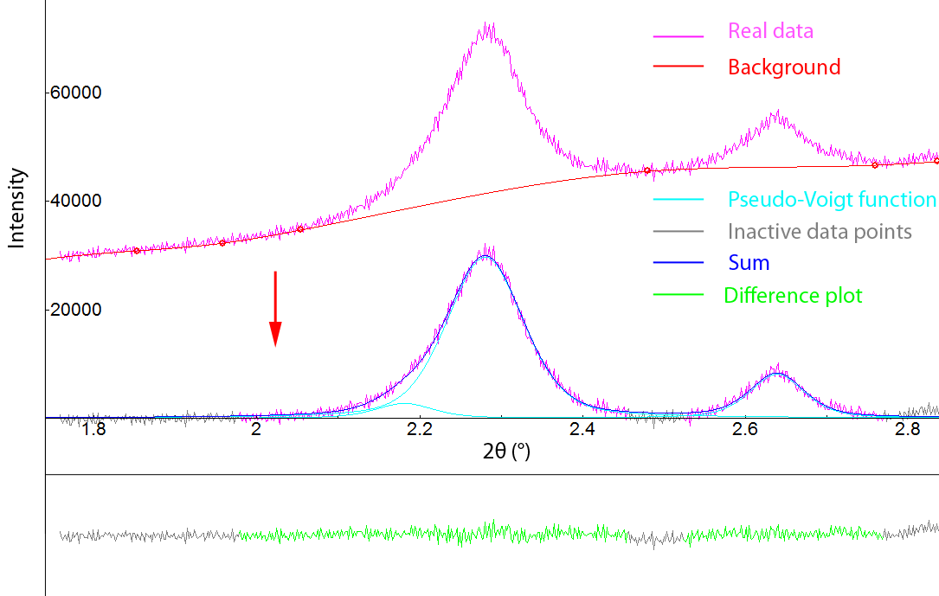

Figure S6 Peak fitting procedure. The individual peaks, ceria 111 and 022, are assigned separate pseudo-Voigt peak-shape functions after the spline function is used for manual subtraction of the background. The asymmetry of the 2.28° peak (ceria 111) is visible and appears as a small tail on a pseudo-Voigt shape. After introducing an additional pseudo-Voigt contribution to the ceria 111 peak, the resultant fit was improved. A flat profile of the residual plot (showing the difference between the data and the sum of fitted functions) exemplifies the goodness-of-fit. (This example is from the synthesis at 350 °C)

The resultant peak parameters were used to construct the tomograms such as shown in the main text of the paper. These tomographic maps represent the spatial intensity distribution of the fitted peak area and FWHM of the selected ceria 111 and 002 reflections. To process these maps, nearest-neighbour interpolation of pixels was applied.
Preliminary TADDI results
The preliminary ‘snapshot’ results obtained at ID15B were a pointer for the experiments to follow.
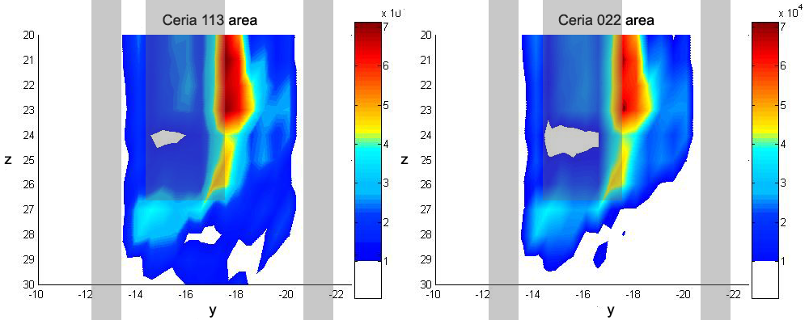

Figure S7 Preliminary TADDI results obtained from the CHFS counter-current mixer: spatial maps of diffracted ceria reflections 113 and 022, where the intensity (peak area) is depicted in the colour bar. The borders of the pipes are outlined. Shaded rectangles representing the dimensions of the outer pipe walls and inner pipe are overlaid on the figure.

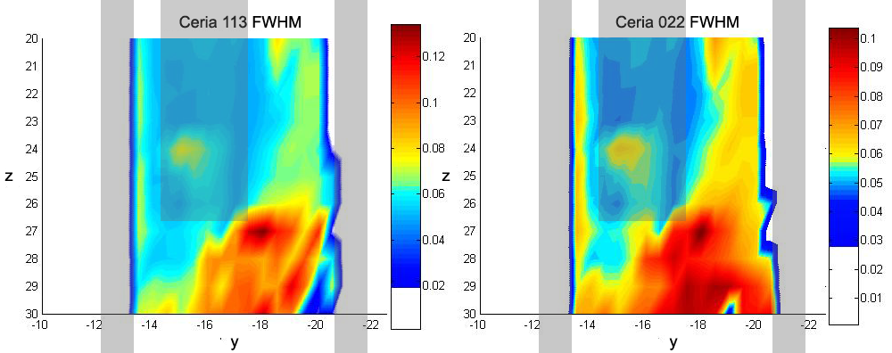

Figure S8 Two-dimensional map of the FWHM from ceria 113 and 022 reflections. The borders of the pipes are outlined. Note that the colour bar scales for the two plots are different. Shaded rectangles representing the dimensions of the outer pipe walls and inner pipe are overlaid on the figure.
Similarly to the above-described procedure for extracting fit parameters from FITYK files, the tomograms were constructed in MATLAB using scripts written for FITYK output files. During the course of this work (of imaging the CeO₂ CHFS systems), the attributes (position, height, width and shape) of each diffraction peak profile determined in FITYK, were used for constructing all the spatial maps. As illustration the following two compatible sets of spatial maps were created: those using the total peak area as an intensity measurement and those based on the FWHM of the selected hkl intensity profile. Figures S9 and S10 represent the initial results and the only hkl intensity map of one of the strongest steel reflections, 044.. The stacked plots of ADD patterns for three selected scanned lines are added on the left side of Figure S9 to better illustrate what information can be provided from the scan grid. These stacked plots (easily viewed in FITYK data-analysis software) depict how each pixel/scan point yields an individual ADD pattern.

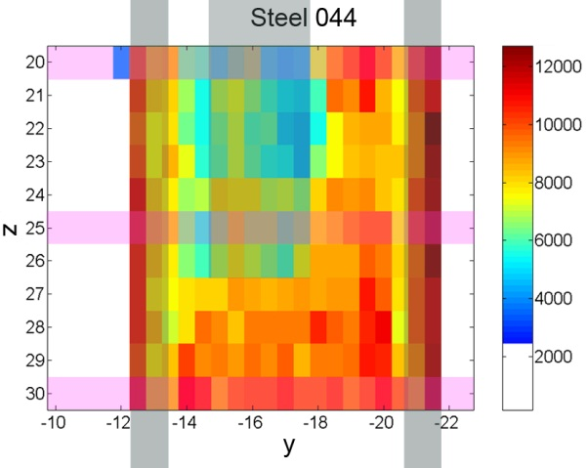
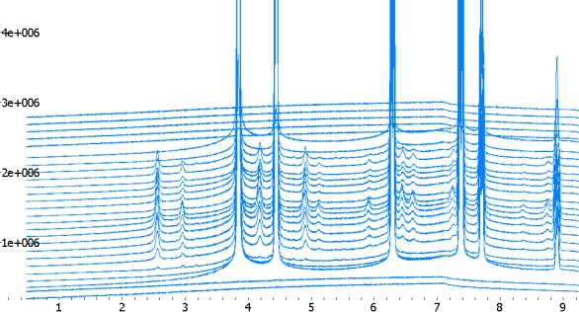
_{I}
_{n}
_{t e n s}
_{i}
_{t}
_{y}
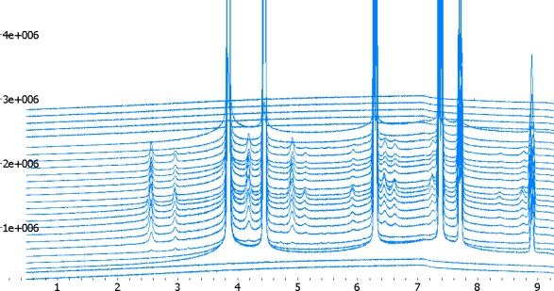
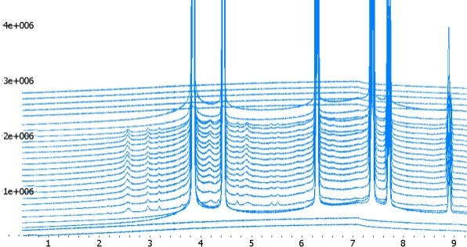
_{2θ}
Figure S9 Three selected (pink) scan lines with stacked plots of typical ADD patterns (left) recorded during the 2D TADDI scan of the counter-current mixer. An ‘unsmoothed’ version of the intensity 2D plot of the steel 044 reflection (right) obtained from a grid of 26 x 11 points (covering 13 x 5.5 mm²), 0.5 x 1 mm step increment, 8 sec per step, count time and 72 min total scan time. The borders of the pipes are outlined.
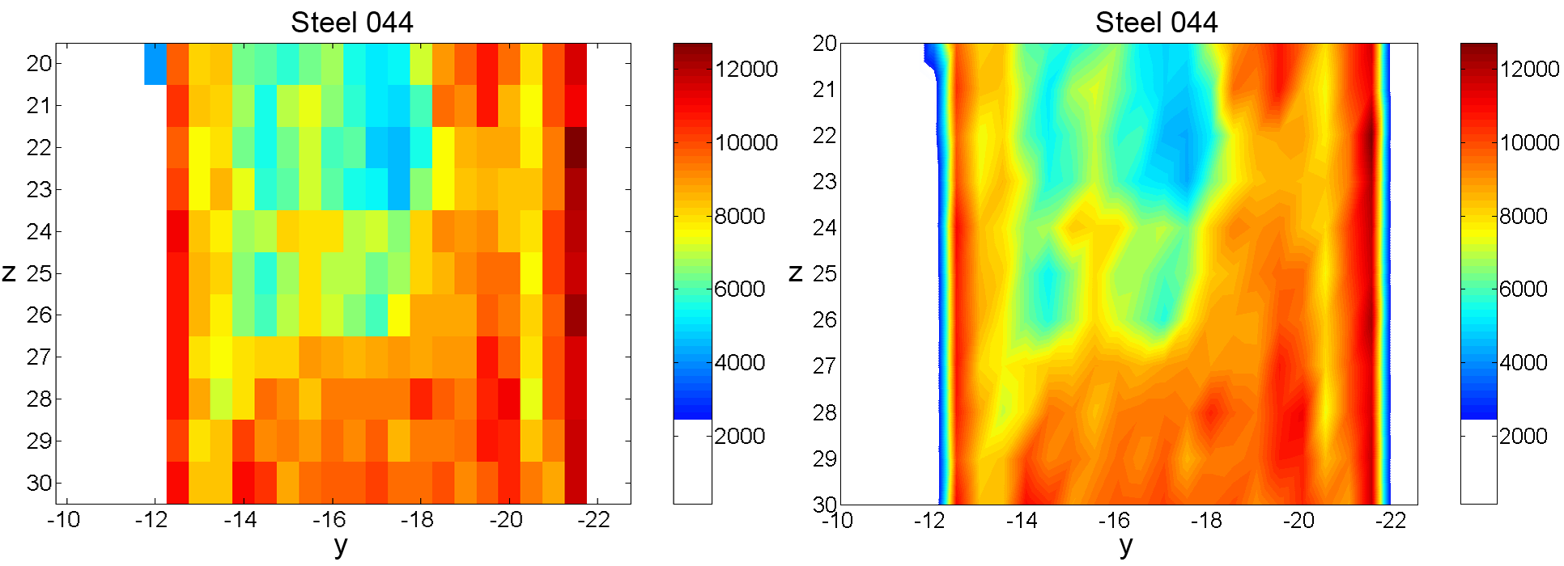
Figure S10 Detail preservation versus justifiable pixel interpolation - two versions of the same intensity map based on the 044 Steel peak area: pixelated or ‘unsmoothed’ two-dimensional plot (left) and the continuous surface plot after the nearest neighbour interpolation algorithm was applied (right). The red areas show high intensity, the blue areas show low intensity and the white areas are where no material is detectable. Low intensity at the position of the inner pipe was expected due to additional X-ray absorption by the steel walls; y and z positions are shown on the x and y axes in mm scale.

Sample Preparation for HRTEM
The nanoparticulate CeO₂ products contained in suspensions (slurries) were collected after each run from the outlet downstream of the BPR. Due to longer runs and there being three different syntheses, a larger quantity of produced material was obtained. All the material had to be washed thoroughly and solids had to be separated by centrifuging and stored for further use and analysis. After collection from the CHFS system, the CeO₂ product is separated from the ionic residues (NO³⁻, H⁺, NH⁴⁺) in the slurry, usually by a triple centrifugation washing
procedure. The resulting suspensions from separate runs were first allowed to settle in a container in order to decant the excess liquid. The remaining solid phase in each suspension was then transferred to centrifuge tubes and dispersed in deionised water prior to centrifuging. This procedure was repeated: the solids were resuspended in deionised water and then subjected to centrifugation a few more times. Centrifugation was performed at 4500 rpm for about 6 min in a Sigma 4K15 centrifuge. At the end the CeO₂ damp sediments were freeze-dried in order to store them optimally for transmission electron microscopy (TEM) analysis. The slurries were frozen in a freezer at -60 °C before being transferred to a Vitris Genesis 35XL freeze dryer where they were dried for ca. 22 h at 1.3 × 10⁻⁷ MPa.

The samples for TEM analysis were prepared by first dispersing all three freeze-dried CeO₂ specimens in ethanol. Vials with the resultant emulsions of CeO₂ particles were held in an ultrasonic bath (at 47 kHz, 60 W) for about 5 min to ensure efficient dispersion of particle agglomerates. After being ultrasonicated the samples were deposited onto holey carbon film grids (400 mesh Cu(50), Agar Scientific). All the samples were examined using a FEI Titan 80-300 (image) aberration corrected (S)TEM microscope operating at a maximum accelerating voltage of 300 kV. The FEI Titan 80-300 being one of the world's foremost electron microscopes and advanced in its operational mode and optical configuration, it enables imaging at the highest resolution possible and exploration of nanomaterials at the atomic scale owing to a revolutionary 80-300kV electron column and stability in the lenses and electronics [4]. These experiments were carried out in collaboration with the Department of Materials, Imperial College London, as part of the TITAN project of the London Centre for Nanotechnology, a joint venture between Imperial College London and University College London for nanomaterials research [5].

Applying an appropriate TEM sample preparation method is essential for later interpretation of the micrographs. For example, in the case of the CeO₂ sample synthesised at 350 °C, the information quality of TEM images was affected by the poor dispersion quality of the sample. The total particle count was low due to the initial suspension and the dispersion quality of this CeO₂ sample.

The contrast variations in TEM images detected at atomic dimensions enable us to determine the spacings in a set of atomic lattice fringes (that are proportional to the atomic planes spacings d_{hkl}). The resolution of the lattice image that is reconstructed depends on certain factors such as specimen thickness and the precise control of electron-optical instrument parameters [6].

CeO₂ Particle Size Distribution

The results of the measurement of the particle size of nanocrystalline ceria using HRTEM are presented in Figure S10. This figure contains the results of particle size distribution for all three syntheses, at 350, 400 and 450 °C. The histograms of the ceria particle size distribution were plotted and the subsequent mean value and standard deviation calculations were extracted using Origin’s [7] statistical capabilities. Due to the dispersion quality of the initial suspension of CeO₂ sample obtained at 350 °C, the total particle count for this sample was lower (121 as opposed to 242 particles counted for the samples at 400 and 450 °C).

CeO₂ particle size distribution at 350 °C
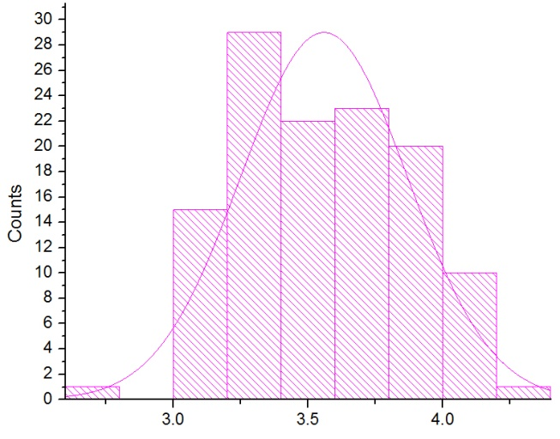

N total 121
Mean 3.56
Standard Deviation 0.31
Variance 0.09
Sum 430.61
Minimum 2.68
Median 3.53
Maximum 4.22

CeO₂ particle size distribution at 400 °C
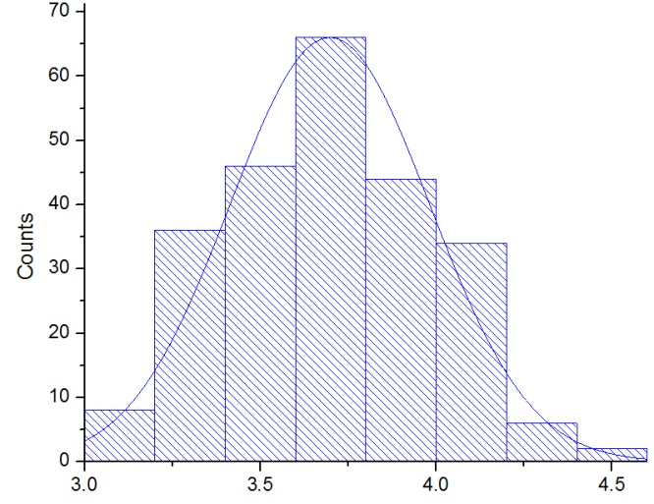

N total 242
Mean 3.69781
Standard Deviation 0.28
Variance 0.08
Sum 894.87
Minimum 3.1 3.1
Median 3.69
Maximum 4.57 4.57

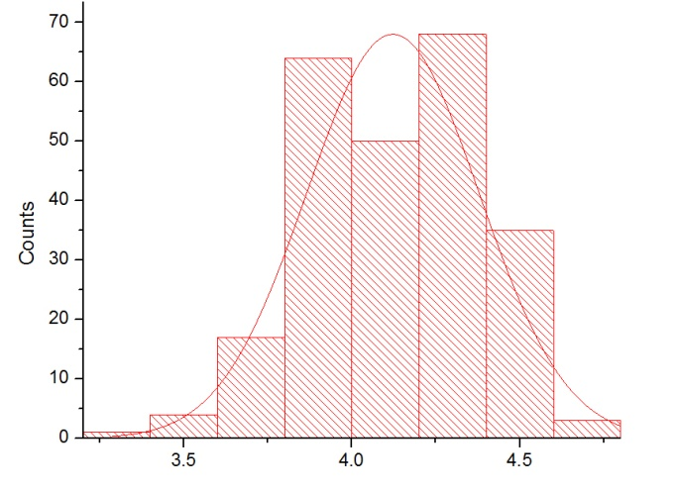
CeO₂ particle size distribution at 450 °C

N total 242
Mean 4.12 4.12218
Standard Deviation 0.26
Variance 0.07
Sum 997.57
Minimum 3.37
Median 4.14 4.14
Maximum 4.68

Figure S11 Histograms and details of particle size distributions obtained by TEM image analysis of N_{total} randomly selected particles.

References

[1] http://www.esrf.eu/UsersAndScience/Experiments/SoftMatter/ID09B/ExperimentsHutch /detector#mar
[2] J.E. Daniels, V. Honkimäki V, Rapid high-energy X-ray powder diffraction using the Pixium 4700 large area detector, 2008. Available from: http://www.ill.eu/fileadmin/users_files/documents/news_and_events/workshops_events/PD2DD/posters/poster_daniels.pdf
[3] T. Sochi, EasyDD. School of Crystallography, Birkbeck College, University of London, 2009
[4] http://www.fei.com/products/families/titan-family.aspx
[5] http://www3.imperial.ac.uk/materials/facilities/em/titan
[6] D.B. Williams, C. B. Carter, Transmission electron microscopy, Plenum Press, New York, 1996, pp. 441-455
[7] OriginLab Corp. Northampton, USA www.originlab.com/

