A heritage-inspired cultural mega event in a stigmatised city: Hull UK City of Culture 2017

Abstract
While the impacts of cultural mega events on a city’s projected image have been extensively explored, less attention has been devoted to their role in relation to territorial stigmatisation. These events have, in some cases, engaged with issues of stigmatisation, as happened in Glasgow (European City of Culture 1990) and Derry-Londonderry (UK City of Culture 2013).
This paper explores how built heritage is mobilised through a cultural mega event in relation to stigma, through a case study of the city of Hull, in Northern England. Despite being among the country’s main ports until the 1930s, Hull suffered from steady structural socio-economic decline, in particular due to the demise of its fishing industry from the 1970s onwards.
Hull UK City of Culture 2017 was understood as an opportunity to counter negative external perceptions. Heritage was mobilised to tell the story of the city, engage residents and visitors in cultural activities and boost civic pride. Events in 2017 and beyond promoted heritage learning in innovative ways, also through the spectacularisation of heritage spaces. However, the official evaluation of Hull 2017 shows how positive immediate results were later scaled down, suggesting that these events are not sufficient on their own to counter stigmatisation.

Keywords: built heritage; cultural mega events; stigmatised cities; UK City of Culture.

Introduction
Mega events, in particular those that do not necessarily require huge amounts of resources (Di Vita and Wilson, 2020), are attractive to policy makers as they may offer national or international visibility, support urban regeneration, attract additional funding and inward investment. These events have been understood as a means to reprofile cities and as a “’quick-fix’ solution” to problems of external image (Quinn, 2005, p. 932). In this context, some cultural mega events (Jones, 2020) such as the European Capital of Culture were in part characterised by attempts to counteract negative external perceptions and preconceptions about the host city. For example, the European City of Culture 1990 challenged the established image of Glasgow as a city affected by deindustrialisation and decline (García, 2005), while the UK City of Culture 2013 in Derry-Londonderry explored post-conflict reconciliation between the Protestant and Catholic communities (Boland et al., 2019). Some of these schemes tend to mobilise local history and heritage as assets to relaunch – often declining – cities as cultural tourism destinations and/or to diversify local economies. However, overall little attention has been devoted by researchers to the relationships between cultural mega events and the stigmatisation of places.
This article makes use of the concept of territorial stigmatisation – i.e. the stigmatisation of a place and of those who inhabit it – to explore how heritage (in particular built heritage) was mobilised within the Hull UK City of Culture 2017 (hereinafter Hull 2017) programme in relation to negative external perceptions and prejudices about Hull as a declining port city. This research is part of the European research project Heritage Opportunities/threats within Mega-Events in Europe (HOMEE).
In the following sections, a brief account of the concept of territorial stigmatisation is provided and is discussed in relation to policy makers’ perceptions of the role of cultural mega events as opportunities to counteract negative external perceptions of a city. The case of Hull 2017 is presented and commented upon with a focus on the role played by heritage as a means to respond to the long-standing stigmatisation of Hull as a deindustrialising port city. Finally, the legacy of the UK City of Culture in Hull and the use of its heritage-inspired approach to culture and regeneration beyond 2017 are discussed in the context of the challenges that the city is facing at the beginning of the 2020s.

Stigmatised places and cultural mega events
The concept of territorial stigmatisation was developed in particular by Wacquant (2007; 2008), drawing on the work of Goffman on ‘social stigma’ (1963) – who had not considered place as a factor fuelling stigmatisation – and on Bourdieu’s theory of ‘symbolic power’ (1991). Wacquant explored territorial stigmatisation in the context of urban marginality and ethnic and social segregation in housing estates and ghettoes in France and the US, blemished as dangerous and infamous places because of poverty, crime, alleged immorality and their ethnic and social composition.
Territorial stigma is closely related to “the stain of poverty, subaltern ethnicity […], degraded housing, imputed immorality, and street crime” (Wacquant et al., 2014, p. 1273). However, preconceptions about a place may also be related to other factors, such as the dominant social status of residents of wealthy neighbourhoods (Walmsley, 1988), or the association of leisure districts with stimulus or of tranquil suburban estates with ennui (Ley, 1983). Territorial stigmatisation is therefore connected to the dominant narrative of a place, as in the case of the conceptualisation of Las Vegas as the ‘Sin City’ (Nedélec, 2017), and can be based on – not necessarily prominent – aspects of its history and heritage.
Dean and Hastings (2000) highlight how poor reputation is the outcome of long-standing beliefs about a neighbourhood and those who live in it, and that this reputation may become a stigma. This makes residents of stigmatised places often feel angry, hurt and upset. With regard to low-income housing estates, Wacquant (2008, p. 173) observes that “the social taint of living” in a place “that has become closely associated with poverty […] affects all realms of existence”. The association of residents with a stigmatised place negatively affects their job opportunities, social relationships and access to public services (Dean and Hastings, 2000; Wacquant, 2008; Slater and Anderson, 2012). Residents often feel that they are subjected to unfair treatment by the media (Dean and Hastings, 2000), which in many cases provide partial and biased accounts of their neighbourhood or city.

Stigmatisation and urban regeneration
Territorial stigmatisation has been connected with urban regeneration, gentrification and displacement. In their analysis of St. Paul’s, in Bristol, Slater and Anderson (2012) show how renewal schemes for the area levered on its stigma to pursue gentrification. Paton et al. (2012) suggest that urban renewal schemes and state-led gentrification may contribute to further pathologising areas that are perceived as ‘problem places’. Kallin and Slater (2014) explore how the active blemishing of working class neighbourhoods may provide the rationale for state-driven extensive demolition and urban regeneration schemes tailored to attract wealthier households. Kirkness and Tijé-Dra (2017) suggest that policy makers may try to profit from stigmatisation by exploiting the ‘extra-territoriality’ of these places or may take impulsive actions to attempt to eradicate the stigma. Speculative practices by real estate developers and financial actors may contribute to reinforce stigmatisation, which can lead to demolition of affordable housing, displacement and renewal schemes targeted at wealthier city residents.
Event-led urban regeneration has been used in similar ways. While the impact of mega events on the internal and external images of host cities has been documented (e.g. Richards and Wilson, 2004), other studies have critically assessed mega events’ links with urban regeneration (Eisinger, 2000; Mooney, 2004). Paton et al. (2012), for example, analyse the 2014 Commonwealth Games in Glasgow as a means to redefine working class people’s lives in some of the city’s deprived areas. Glasgow’s East End was actively stigmatised in policy and media discourses to support the event as a means to pursue gentrification and capital accumulation (Paton, 2018).

Heritage and urban regeneration
In this context, heritage plays a key role in transforming stigmatised places (e.g. De Cesari and Dimova, 2019). However, as observed by Hewison (1987), heritage is mobilised predominantly in relation to nostalgia. This is in part due to the fact that nostalgia is in many cases an essential ingredient of tourism (Chhabra et al., 2003) which many urban regeneration schemes rely on. As a consequence, heritage narratives often display “selectively embellished” accounts (Bélanger, 2000, 386-387), which can fuel feelings of expropriation among the local community. Aspects of local heritage that are contested or problematic – i.e. ‘dissonant’ heritage (Tunbridge and Ashworth, 1996) – are therefore largely neglected. The spectacularisation of urban space, heritage and culture is understood as a means to encourage cultural consumption (Zukin, 1995), tourism and investment and circulate positive media narratives (Ponzini et al., 2019).

Hull UK City of Culture 2017
The case of Hull UK City of Culture 2017 was analysed as part of the HOMEE research project, focusing on the relationships between mega events and built heritage. Initial desk research was followed by the analysis of relevant policy documents, including the event’s bid (Hull UK City of Culture 2017, 2013) and final programme, the 2013 City Plan (Hull City Council, n.d.), the Public Realm Improvement Strategy (Hull City Council, 2014) and the city’s Cultural Strategy 2016-2026 (Hull City Council, 2016). The study also made use of the event’s official evaluation reports (Culture, Place and Policy Institute, 2018; 2019), as well as of the Overview of Heritage Lottery Fund Outcomes (Hull 2017 Ltd, 2019). Semi-structured interviews involved senior staff from Hull City Council, Visit Hull and East Yorkshire, the Heritage Lottery Fund (National Lottery Heritage Fund since 2019), Absolutely Cultured Ltd (the post-event legacy company), the University of Hull and local heritage groups. A review of local and national press articles was undertaken to detect positive and negative media narratives about Hull. The guiding themes informing the analysis of interviews and media items for this article were: heritage learning and civic pride; heritage, regeneration and the city’s image; maritime heritage; preconceptions and pride; the spectacularisation of heritage; the role of cultural and heritage-related partnerships.

A Northern European port city
Kingston upon Hull is a port city in Northern England (Figures 1 and 2). A 2013 study about medium-sized cities in England portrayed Hull as economically isolated, and characterised by a relatively weak and insufficiently diversified economy (Bolton and Hildreth, 2013). However, Hull has been a port city for more than 700 years (Starkey et al., 2017), where trade with Northern Europe was historically the main economic activity, alongside shipbuilding and whaling. Fishing enjoyed a boom in particular between the Second World War and the 1960s.

[Figures 1 and 2]

However, particularly since the 1970s, a combination of factors including the impact of the oil crisis, overfishing and the Cod Wars with Iceland caused the contraction of Hull’s fishing industry (Byrne, 2015), which unfolded alongside some of the processes of deindustrialisation visible in many other European cities. In the last decades, in comparison with the national average, Hull was characterised by relatively low levels of education, and by higher figures for unemployment, deprivation and mental and physical health problems than the national averages.
Hull can be considered as one of the country’s ‘left-behind’ coastal cities. In 2015, 5 of the 10 English local authorities with the highest proportion of neighbourhoods within the 10% most deprived areas in England were coastal cities (Middlesbrough, Hull, Blackpool, Hartlepool and Liverpool). Since the end of the 20th century, Hull suffered from negative external perceptions and preconceptions related to unemployment and deprivation – as many other European port cities (Van Hooydonk, 2007) – and became “a city unusually sensitive to its image” (Atkinson et al., 2002, p. 27). In 2003, it was top-ranked in a satirical publication, The Idler Book of Crap Towns: The 50 Worst Places to live in the UK (Jordison and Kieran, 2003), whose impact on the media gave impetus to prejudices about the city. Hull was also mentioned in media accounts of deprived communities and rustbelt cities (The Economist, 2013; Lehmann, 2016). Economic decline and deprivation were arguably among the key factors behind the local results of the European Union (EU) referendum in June 2016, where 67.6% of Hull residents taking part voted to leave the EU, compared with 51.9% nationally. Media comments about Hull’s vote in the EU referendum underlined the contrast between Hull’s simultaneously inward- and outward-looking attitudes (Clavane, 2017) and the recent £310 million investment by German-based company Siemens in a wind turbine manufacturing plant (Conn, 2017).
Nevertheless, Hull is still an important port city, where maritime activities include trade and food handling. The Green Port initiative – launched in 2010 by Hull City Council, East Riding of Yorkshire Council, Associated British Ports and partner organisations including the University of Hull – aims at promoting the port of Hull as a hub for the development of renewable energies. The 2013 City Plan envisioned the future of Hull as an energy port city and included the very ambitious goal of the city becoming a world-class visitor destination.
Since the 1980s, Hull City Council has pursued urban regeneration across the city centre and waterfront. Junction Dock and Railway Dock were converted into a marina in 1983 (Figure 3). A shopping centre (Princes Quay) was built on Princes Dock in 1991 (Figure 4). Between the late 1980s and the early 2000s, Victoria Dock was redeveloped into a housing estate. The regeneration of the city centre was prioritised in subsequent policies, in order to strengthen the area’s retail offer (Hull City Council, 2000; Hull Citybuild, 2003; Hull City Council, 2008).

[Figures 3 and 4]

The UK City of Culture 2017
Hull City Council bid, unsuccessfully, for the UK City of Culture 2013 and then, this time successfully, for the UK City of Culture 2017. The UK City of Culture (UKCoC), the UK’s quadrennial cultural festival, was launched in 2010 with the aim of allowing other UK cities to access the potential socio-economic benefits of cultural mega-events that were witnessed in Glasgow, European City of Culture 1990, and Liverpool, European Capital of Culture 2008 (DCMS, 2009). Glasgow 1990 was a ‘watershed’ in the history of the European City/Capital of Culture (ECoC; Bianchini et al., 2013) as it was the first ECoC delivering a 365-day programme and displaying a focus on urban regeneration (García, 2004, 2005; Mooney, 2004). Liverpool ECoC 2008 also focused on culture-led urban regeneration (Boland, 2010; García et al., 2010; Cox and O’Brien, 2012; Connolly, 2013). Derry-Londonderry, in Northern Ireland, was the first ever UKCoC in 2013. Hull held the title in 2017, while Coventry will be the next UKCoC in 2021.
The UKCoC is intended, as the ECoC, as a 365-day cultural festival. However, in line with British ECoCs, it has a strong emphasis on urban, economic and/or social regeneration. For example, bidders are asked to describe the “step changes” (DCMS, n.d.) that the event would trigger for the city and the local economy.
UKCoC budgets are on average slightly lower than those of recent ECoCs. The operational budgets of Derry-Londonderry 2013 and Hull 2017 were respectively £18.3 million (€21.53 million, ca €199 per resident, at 2013 exchange rates; Derry City and Strabane District Council, 2014) and £32.8 million (€37.27 million, ca €143 per resident, at 2017 exchange rates; Culture, Place and Policy Institute, 2018). By comparison, the average budget of the ECoC in the period 2005-2011 was €49 million (nearly €200 per resident; Bianchini et al., 2013). More recent ECoCs included Donostia-San Sebastián 2016 (€49.6 million, ca €275 per resident), Pafos 2017 (€8.5m, ca €242 per resident), Aarhus 2017 (€61.9 million, ca €187 per resident), and Leeuwarden 2018 (€104.6 million, ca €870 per resident). ECoC programmes tend to be more international in nature and slightly more effective in attracting international audiences, which accounted for about 1% of total audiences in the case of Hull 2017 (Culture, Place and Policy Institute, 2018), in comparison with 3% for Aarhus ECoC 2017 (Degn et al., 2018) and 7% for Leeuwarden ECoC 2018 (EFECTIV Consortium, 2019).
The factors which led to Hull securing the title included the extensive participatory and consultation programme and the compelling case that was made in the bid of “a city coming out of the shadows” that ‘needed’ the event (Hull UK City of Culture 2017, 2013, pp. 4-5). The bidding process raised initial scepticism (academic1, interview, April 2019) around the idea that Hull could be a cultural capital and could deliver the event. The excitement generated by the designation turned in the planning stage into a mixture of positivity and scepticism (academic4, interview, July 2019), the latter with regard particularly to consultation processes and the implementation of public realm works in the city centre (with Hull being dubbed in the media the “City of Orange Barriers”). The event was delivered by Hull 2017 Ltd, a separate company established by the City Council.
The Preliminary Outcomes Evaluation Report of Hull UK City of Culture 2017 (Culture, Place and Policy Institute, 2018) presents the immediate impacts: more than 2,800 events were held across more than 300 venues; there were 5.3 million audience visits; tourist visits in 2017 were estimated to be 6.2 million, against a baseline of 5.5 million in 2016 and a figure of 6.25 million in 2018.
The report observes that 75% of residents said that they were proud to live in Hull, while 71% of them would speak positively about the city. 3 in 4 visitors said that the UKCoC 2017 changed their perceptions of Hull for the better and 61% of them said that they were likely to return. In terms of external perceptions across the UK, the report suggests that 46% of respondents to a national survey said that their perception of the city had changed for the better. However, the report also highlights the fact that the proportion of respondents perceiving Hull as an appealing place to visit increased by a mere 1% (from 50% to 51%) since 2016.
Positive accounts of Hull were about changing internal and external perceptions of the city, increasing visitor numbers and the richness of the Hull 2017 cultural programme (Barnett, 2017; BBC, 2017a; BBC, 2017b; Wonfor, 2017). The 2016 Rough Guide included Hull among the 10 best cities to visit in the world. As a result of the partnership with the BBC, Hull was also displayed on the national weather map. Press articles about the event show occasional references to the opportunity for Hull to overcome long-standing stigmatisation (English, 2014; Moore, 2016).

Mega events, heritage and stigmatisation: the case of Hull
History and heritage played a pivotal role in Hull’s UKCoC 2017 programme. Of the 465 new commissions, 1 in 2 was inspired by history and heritage (Culture, Place and Policy Institute, 2018). This central role was not initially envisioned in the 2013 bid (academic2, interview, April 2019). A key factor in this shift was the partnership, established in early 2016, with the Heritage Lottery Fund (HLF), a funding body which in 2019 became the National Lottery Heritage Fund (NLHF). HLF contributed £3 million to the funding of the cultural programme, while its officers were involved in discussions with Hull 2017 Ltd about the role of heritage as a source of inspiration (HLF officer, interview, April 2019).
Local history and heritage were a means to challenge internal and external perceptions of Hull. A key aim was to increase awareness and appreciation of Hull’s history and heritage among both residents and visitors (event team member, interview, July 2019). This was achieved through the use of visual arts and theatre projects in particular (Hull 2017 Ltd, 2019). For instance, Look Up involved a number of art installations in heritage spaces, such as Trinity Market or Queen Victoria Square. Residents and visitors were encouraged to ‘look up’ at heritage buildings, which were mobilised ‘as a canvas’ (tourism board officer, interview May 2019), and to experience them from a fresh perspective. Heritage was also mobilised to address social challenges, as a means to encourage engagement and participation and to boost civic pride (academic2, interview, April 2019; heritage group member, interview, March 2019), for example by featuring in cultural programmes in the city’s schools (e.g. No Limits).
For many interviewees the fact that the event connected with local stories and narratives made residents feel enabled and motivated to attend and take part in cultural activities, and to engage with the city’s heritage (academic1, interview April 2019; HLF officer, interview, April 2019; academic2, interview April 2019; event team member, interview, July 2019; NLHF officer, interview, May 2019). Postcode data about 2017 audiences suggest that the UKCoC was successful in engaging residents from deprived neighbourhoods, except for those parts of the city included in the 10% most deprived areas of the country, and that happiness and life satisfaction ratings rose between 2015 and the beginning of 2017 (Culture, Place and Policy Institute, 2018). Some interviewees, however, felt that many heritage-inspired projects tended to engage with well-known historical events and to lever on stereotypes (academic1, interview, April 2019; academic3, interview, August 2019; academic4, interview, July 2019).

Learning and appreciation of heritage
The 2017 Citywide Residents’ survey showed that 65.6% of respondents believed that the UKCoC contributed to increasing their knowledge of the city’s history and heritage. The audiences of 2017 events largely believed that using arts and cultural activities to communicate aspects of local history and heritage made these more interesting (91.3%) and easier to understand (91.4%; Culture, Place and Policy Institute, 2018). However, the 2018 Citywide Residents’ survey (Information by Design, 2019) showed a decrease in the proportion of residents who rated their knowledge of local heritage as high. This may be related either to a superficial learning process in 2017 or to a more self-critical approach by residents in the light of increased awareness (Culture, Place and Policy Institute, 2019).

Urban regeneration and heritage
Urban regeneration and tourism development were viewed by Hull policy makers as a means to counter stigmatisation. The UKCoC 2017 acted as a catalyst for external regeneration projects. The Bonus Arena, a 3,500-seat venue, was built near the Marina. The Fruit Market (a former wholesale fruit and vegetable market consisting of several heritage buildings located between the city centre and the waterfront) is being redeveloped into a mixed-used urban area and a cultural hub, including cultural facilities such as Humber Street Gallery and Stage@The Dock.
Part of the city’s built heritage was showcased through the refurbishment of public space. Public realm improvements in 2015 and 2016 focused on a range of public and heritage spaces in the city centre, such as Queen Victoria Square, Humber Street and Trinity Square (Figures 5, 6 and 7), with the aim of getting the city ready for 2017. These refurbishments helped reconnect heritage assets and made some of them more visible, as in the case of the foundations of the medieval Beverley Gate.
Heritage buildings hosting flagship cultural institutions such as the Ferens Art Gallery and Hull New Theatre also underwent refurbishment and contributed to shaping positive accounts about the city in the media.

[Figures 5, 6 and 7]

The role of maritime heritage
As acknowledged in the city’s Cultural Strategy 2016-2026, despite the fact that local policy makers were beginning to mobilise maritime heritage to rebrand the city, its visibility and interpretation remained problematic (Hull City Council, 2016, p. 21; academic3, interview, August 2019). In addition, the city’s fishing past had been largely overlooked in public policy in the late 20th century (academic2, interview, April 2019). At that time, Hull’s fishing past could be interpreted as an example of dissonant heritage (Tunbridge and Ashworth, 1996), as it recalled painful collective memories related to the many sailors and fishermen who had died at sea and to the decline of the local fishing industry.
Nevertheless, since the end of the 20th century and in particular in 2017, fishing heritage became prominent, overshadowing other aspects of port activity (academic2, interview, April 2019; academic4, interview, July 2019; City Council officer, interview, April 2019). Some projects and cultural events related to fishing had a positive response from residents. One example is the restoration of the Dead Bod, a 1960s sketch of a dead bird painted by trawlerman Len ‘Pongo’ Rood and his engineer Gordon Mason on an iron shed at Alexandra Dock. The painting risked disappearing due to the construction of Siemens’ wind turbine manufacturing plant. A partnership involving Associated British Ports allowed to save the painting, which was restored and put on public display at Humber Street Gallery, where it was seen by approximately 120,000 people in 2017 (Hull 2017 Ltd, 2019). Another example was The Last Testament of Lillian Bilocca, a flagship play performed in the Guildhall as part of the City of Culture programme, which explored activism by a group of local women (led by Lillian Bilocca) against the unsafe and harsh working conditions of Hull’s fishermen and sailors in the late 1960s.

Spectacularising heritage
Many cultural events in Hull generated positive media narratives about the city. For example, Sea of Hull in 2016 contributed to showcasing some of Hull’s heritage spaces and had considerable visibility in the media internationally (BBC, 2016; Perraudin, 2016): it “reached 720 million people in 54 countries putting Hull on the map from Australia, Canada, USA, Mexico and Iceland to Finland, China and the Far East, India and most countries across Europe” (ITV, 2016). Sea of Hull was profiled also during the cultural programme of the UKCoC 2017 through the exhibition SKIN at the newly-refurbished Ferens Art Gallery, where pictures of the event were displayed (BBC, 2017e). At the start of the City of Culture year, Made in Hull involved a spectacular firework display and light shows and projections on heritage buildings. 342,000 people attended the event (Culture, Place and Policy Institute, 2018). Also, in January 2017, the Blade installation consisted in a 75m wind turbine rotor manufactured at Hull’s Alexandra Dock being displayed in Queen Victoria Square. It was estimated that the installation was seen by 1.1 million people, 420,000 of whom interacted with it (Hull 2017 Ltd, 2019). Later in the year, Poppies: Weeping Window was an installation consisting of a cascade of ceramic poppies on the façade of the Maritime Museum, as part of 14-18 NOW, a national programme of art commissions to mark the centenary of the First World War. This heritage-inspired installation contributed to growing media interest in Hull and the UK City of Culture (Parveen, 2017; ITV, 2017b).
However, this spectacularisation of heritage should be further problematised, by considering its broader impacts. In the case of Made in Hull, the spectacularisation of heritage was nonetheless linked to local stories (academic2, interview, April 2019) – for example, aspects of the event explored painful memories related to the city’s fishing history. This generated an emotional response from residents (HLF officer, interview, April 2019), which made it easier to connect with the local population. The success in terms of audience numbers and the visual impact of events involving the spectacularisation of heritage – Made in Hull in particular – played a key role in dissolving the scepticism which had been present before 2017 about the ability of local actors to effectively deliver the UKCoC. These spectacular, highly engaging, outdoor and free of charge cultural events also contributed to the “humanisation of public space” (Culture, Place and Policy Institute, 2018, p. 160). After the widespread refurbishments undertaken within a compressed timescale in 2015 and 2016, such events helped residents reframe in positive terms their relationships with heritage spaces.

Heritage-related partnerships
The role of heritage within the UKCoC programme impacted on external perceptions also in relation to heritage-related partnerships. The work with HLF and Historic England had two main impacts. On the one hand, such partnerships contributed to showcasing the city’s heritage – including assets not immediately thought of as ‘heritage’ (HLF officer, interview, April 2019) – and to generating positive narratives about the city. For example, national newspapers reported that nine new heritage assets were listed during the City of Culture year (BBC, 2017d; Halliday, 2017), including the Humber Bridge (1981) and the Tidal Surge Barrier (1980). The Old Town was also included in the national Heritage Action Zone programme (ITV, 2017a) for economic revitalisation and growth in heritage-rich areas. On the other hand, these partnerships meant that local institutions and organisations established closer relationships with national organisations and that the city acquired a higher-profile track record.

Hull as a heritage (port) city? The legacy of 2017
Heritage-inspired cultural events along the lines of those taking place during the City of Culture year continued in 2018 and 2019, delivered by the legacy company Absolutely Cultured Ltd. Dominoes consisted of a route of large concrete white domino pieces stretching across some of the city centre’s iconic locations (Preston and Winter, 2018). Similarly, Urban Legends: Northern Lights, mobilised public and heritage spaces and less well-known areas of the city, where light shows celebrated Hull’s relationships with Northern Europe and Scandinavia (Young, 2018). These events generated a good response from the public, with audience figures of over 20,000 for the one-day event Dominoes and over 50,000 for Urban Legends: Northern Lights (Culture, Place and Policy Institute, 2019). In early 2018, Hull enjoyed a certain extent of national media coverage also because of a graffiti reportedly by street artist Banksy (e.g. BBC, 2018). In 2019, the local intangible heritage of myths, stories and childhood memories was spectacularised by Absolutely Cultured Ltd through The Witching Hour, which was also staged in Wirral, the Liverpool City Region’s 2019 Borough of Culture (Davis, 2019).
The case of Hull is also an example of the role of heritage in fostering participation and engagement in cultural activities (Ponzini et al., 2019). These events created arts-heritage fusions, hybrids or ‘third spaces’ (Froggett et al., 2019), which encouraged residents and visitors to engage with less well-known heritage assets and spaces (Tommarchi and Bianchini, 2020) and thus to appreciate a broader range of aspects of the city’s history.

Maritime heritage and stigmatisation
The mobilisation of Hull’s maritime heritage in relation to internal and external perceptions of the city is set to be further explored through Hull: Yorkshire’s Maritime City, a heritage-inspired project perceived as another potential game changer (Campbell, 2019). The £27.4 million scheme is led by Hull Culture and Leisure (HCAL) and Hull City Council. The National Lottery Heritage Fund (NLHF) is contributing with £13.6 million to the project. It will restore a number of maritime heritage assets, namely the Maritime Museum, the adjacent Dock Office Chambers, the North End Shipyard, the 1960s trawler Arctic Corsair and the Spurn Lightship. The project aims at creating a coherent, maritime-related cultural offer, to broaden perceptions of the city’s heritage beyond stereotypes and established interpretations and to attract visitors and cruise passengers. In addition, it represents the opportunity to ‘rebalance’ maritime heritage narratives (City Council officer, interview, April 2019). Hull: Yorkshire’s Maritime City is also seen by policy makers as a means to generate positive media narratives about the city (BBC, 2017c; BBC, 2019), in relation to cultural attractiveness, urban regeneration and the delivery of an ambitious project.
This scheme shows how maritime heritage has been shifting from being an element of dissonant heritage linked with stigmatisation – which was initially chosen not to be explored in 2017 – to a cultural resource linked with civic pride, leisure and tourism. However, with regard to its connection with tourism and economic regeneration, the project may potentially raise future issues of authenticity (Jones and Ponzini, 2018; Ponzini et al., 2019), concerning the ways in which Hull’s maritime history and heritage will be explored and mobilised.

Hull’s image in the medium term
The longer-term impacts of the UK City of Culture 2017 need to be problematised. Happiness and life satisfaction indicators rose in the run up to the event, but they returned to pre-2016 levels by the end of the City of Culture year (Culture, Place and Policy Institute, 2018). In 2018, 71% of residents said that they were proud to live in Hull, against a figure of 75% in 2017, nonetheless accounting for a 1% increase since 2016 (Culture, Place and Policy Institute, 2019). Despite the concept of the ‘city as a venue’, which resulted in more than 300 cultural venues in 2017, cultural events tended to be concentrated in the city centre. Understandably, this is a recurrent feature of culture-led urban regeneration and it appears in line with Hull City Council’s long-standing strategy of prioritising the regeneration of the city centre. However, such spatial concentration of cultural activities and investment risks hijacking resources to the detriment of cultural activities and heritage conservation in other parts of the city, as well as opening a reputational gap between the city centre and the periphery.
Some interviewees suggested that, after the event, scepticism among the local population has grown once again, perhaps fuelled by factors that are unrelated to the event itself and not Hull-specific. Due to the local results of the 2016 EU referendum and the upsurge of the Brexit Party in the 2019 European elections, some accounts of Hull as a city which tends to be inward-looking, pro-Brexit, unwelcoming to immigrants and declining – with little trace of City of Culture optimism – began to emerge in the media (e.g. Araujo, 2017; Charles, 2017; Clavane, 2017; Stephenson, 2020). This risks undermining the positive impact on external perceptions of the 2017 UKCoC and of media narratives about the event and its outcomes. The national crisis of retail (Butler, 2019; Simpson, 2019), substantially accelerated by the shift to online shopping related to the COVID-19 pandemic, is not specifically associated with Hull. However, shop closures in the city centre translate into a growing number of unused buildings, including historic ones. This process risks producing fragmentation across the townscape, reversing the regenerative process fuelled by the event, as well as the outcomes of heritage-inspired events and policies aiming at reconnecting urban heritage assets (academic2, interview, April 2019). These negative external factors may have an adverse effect on internal and external perceptions of the city.

Conclusions
This paper has examined a cultural mega event, Hull UK City of Culture 2017, in a heritage-rich city suffering from long-standing stigmatisation due to structural socio-economic challenges emerged in the closing decades of the 20th century. The article aims to show heritage was mobilised within the event and contributed to changing internal and external perceptions of the city.
Hull is an example of how policy makers and event organisers can shape cultural mega events to address territorial stigmatisation, for example by circulating positive narratives about the city across the media and through word of mouth, by reframing aspects of dissonant heritage, and by forming new local or national partnerships to invest in new heritage-led schemes.
The experience of Hull 2017 shows that when arts and cultural activities engage with heritage in creative ways, learning and participation can impact on internal and external perceptions of a city through increased awareness and appreciation of local history and heritage itself. In addition, the reconnection of heritage assets across the townscape had revitalising effects in Hull, with positive impacts on perceptions of the city. The spectacularisation of heritage had more nuanced outcomes beside the mere generation of positive media contents, for example in relation to awareness of and engagement with heritage, challenging scepticism, and humanising refurbished public spaces. Finally, heritage-related partnerships with external or national organisations may have longer-term positive impacts on the reputation of local cultural organisations, their level of ambition and their ability to attract funding.
There are policy implications and research perspectives arising from this case study. One key aspect is the link between the mobilisation of maritime heritage to counter stigmatisation and the risks of cultural standardisation of a port city, where certain aspects of local maritime cultures are neglected or overridden (Tommarchi, 2019). Another issue is the potential conflict between the imaginaries of outward-looking cities of culture – promoted through cultural mega events – and media accounts of inward-looking places due to the rise of right-wing populist and nationalistic political parties locally. In the case of port cities like Hull, there is a contradiction between the allegedly independent and rebellious spirit associated with such places (Van Hooydonk, 2007; Starkey et al., 2017) and emerging anti-immigrant and anti-cosmopolitan political cultures (Bianchini and Tommarchi, 2020). The politicisation and mediatisation of cultural mega events and local heritage in the current political climate (Ponzini et al., 2019) – also in relation to stigmatisation and socio-economic regeneration – therefore need further exploration, in particular by considering contemporary examples of ‘invention of traditions’ (Hobsbawm and Ranger, 1993) at city level.
Finally, an open question concerns the legacy of heritage-inspired cultural mega events in terms of perceptions of the city. The case of Hull shows how cultural mega events on their own are not enough to eradicate the prejudices and preconceptions which lie behind stigmatisation. Without a clear, long-term strategy from the outset, momentum can be lost quickly, and the positive outcomes of the cultural mega event can soon evaporate. Stigmatisation may arise rapidly once again, perhaps fuelled by unrelated and unpredictable external factors.

Acknowledgments
This research is funded via the European Joint Programming Initiative (JPI) in Cultural Heritage, with a grant issued by the UK’s Arts and Humanities Research Council.

Declaration of interest
The authors declare that there are no conflicts of interest regarding this paper.

References
Araujo, F. (2017) Hull revisited: What happens when a Brexit stronghold becomes City of Culture? New Statesman. Retrieved from https://www.newstatesman.com/politics/uk/2017/01/hull-revisited-what-happens-when-brexit-stronghold-becomes-city-culture.
Atkinson, D., Cooke, S., and Spooner, D. J. (2002) Tales from the Riverbank: Place-marketing and maritime heritages. International Journal of Heritage Studies, 8(1), 25-40.
Barnett, D. (2017) Kingston upon Hull: Culture can be a catalyst for real change in any city. The Independent. Retrieved from https://www.independent.co.uk/arts-entertainment/culture-can-be-a-catalyst-for-real-change-in-any-city-a7541656.html.
BBC (2016) Thousands strip for Sea of Hull mass nude photograph. BBC News. Retrieved from https://www.hulldailymail.co.uk/whats-on/whats-on-news/gallery/sea-hull-pictures-21-best-70440.
BBC (2017a) Hull’s 2018 UK City of Culture year ‘life-enhancing’. BBC News. Retrieved from https://www.bbc.co.uk/news/uk-england-humber-42501917.
BBC (2017b) Hull’s City of Culture events ‘raise bar for successor’. BBC News. Retrieved from https://www.bbc.co.uk/news/uk-england-humber-40420313.
BBC (2017c) Hull’s maritime attractions given £27.5m for renovation work. BBC News. Retrieved from https://www.bbc.co.uk/news/uk-england-humber-40408516.
BBC (2017d) Humber Bridge among nine Hull locations to be given listed status. BBC News. Retrieved from https://www.bbc.co.uk/news/uk-england-humber-40623380.
BBC (2017e) Sea of Hull nudes to be flagship City of Culture exhibition. BBC News. Retrieved from https://www.bbc.co.uk/news/uk-england-humber-39052795.
BBC (2018) Latest Banksy graffiti unveiled in Hull. BBC News. Retrieved from https://www.bbc.co.uk/news/uk-england-humber-42841320.
BBC (2019) Images of Hull’s maritime attractions revamp plans unveiled. BBC News. Retrieved from https://www.bbc.co.uk/news/uk-england-humber-48042095.
Bélanger, A. (2000). Sport Venues and the Spectacularization of Urban Spaces in North America. The Case of the Molson Centre in Montreal. International Review for the Sociology of Sport, 35(3), 378–397.
Bianchini, F., Albano, R. with Bollo, A. (2013) The regenerative impacts of the European City/Capital of Culture events. In Leary, M. E., and McCarthy, J. (eds) The Routledge Companion to Urban Regeneration. London: Routledge, 515-525.
Bianchini, F., and Tommarchi, E. (2020) Urban activism and the rethinking of cities’ cultural policies in Europe. In Wimmer, M. (ed) Kann Kultur Politik? – Kann Politik Kultur? Warum wir wieder mehr über Kulturpolitik sprechen sollten. Vienna: De Gruyter, 156-166.
Boland, P. (2010) ‘Capital of Culture—You must be having a laugh!’ Challenging the official rhetoric of Liverpool as the 2008 European cultural capital. Social and Cultural Geography, 11(7), 627-645.
Boland, P., Murtagh, B., and Shirlow, P. (2019) Fashioning a City of Culture: ‘life and place changing’ or ‘12 month party’? International Journal of Cultural Policy, 25(2), 246-265.
Bolton, T., and Hildreth, P. (2013) Mid-sized cities: Their role in England’s economy. London: Centre for Cities.
Bourdieu, P. (1991) Language and Symbolic Power. Cambridge: Polity Press.
Butler, S. (2019) Thousands of UK shops left empty as high street crisis deepens. The Guardian. Retrieved from: https://www.theguardian.com/business/2019/may/02/thousands-of-uk-shops-left-empty-as-high-street-crisis-deepens.
Byrne, J. (2015) After the trawl: Memory and afterlife in the wake of Hull’s distant-water fishing industry. The International Journal of Maritime History, 27(4), 816-822.
Campbell, J. (2019) Hull tourism boost as game-changing maritime history project becomes reality with £13.6m National Lottery grant. Hull Daily Mail. Retrieved from: https://www.hulldailymail.co.uk/news/hull-east-yorkshire-news/hull-tourism-maritime-national-lottery-3380519.
Charles, A. (2017) How Hull went from crap town to City of Culture – and what it says about Brexit Britain. The Conversation. Retrieved from http://theconversation.com/how-hull-went-from-crap-town-to-city-of-culture-and-what-it-says-about-brexit-britain-86818.
Chhabra, D., Healy, R., and Sills, E. (2003) Staged Authenticity and Heritage Tourism. Annals of Tourism Research, 30(3), 702-719.
Clavane, A. (2017) Brexit heartland and City of Culture Hull remains in dangerous waters. The New European. Retrieved from https://www.theneweuropean.co.uk/top-stories/brexit-heartland-and-city-of-culture-hull-remains-in-dangerous-waters-1-5322162.
Conn, D. (2017) Hull after Brexit – will the City of Culture regret voting out? The Guardian. Retrieved from https://www.theguardian.com/politics/2017/apr/02/hull-after-brexit-will-the-city-of-culture-regret-voting-out.
Connolly, M. G. (2013) The ‘Liverpool model(s)’: Cultural planning, Liverpool and Capital of Culture 2008. International Journal of Cultural Policy, 19(2), 162-181.
Cox, T., and O’Brien, D. (2012) The “scouse wedding” and other myths: Reflections on the evolution of a “Liverpool model” for culture-led urban regeneration. Cultural Trends, 21(2), 93-101.
Culture, Place and Policy Institute (2018) Cultural Transformations: The Impacts of Hull UK City of Culture 2017. Preliminary Outcomes Evaluation. March 2018. Hull: University of Hull.
Culture, Place and Policy Institute (2019) Cultural Transformations. The Impacts of Hull UK City of Culture 2017. Main Evaluation Findings and Reflections. November 2019. Hull: University of Hull.
Davis, L. (2019) Witching Hour night time spectacular with pyro coming to Birkenhead Park. Liverpool Echo. Retrieved from https://www.liverpoolecho.co.uk/whats-on/arts-culture-news/witching-hour-night-time-spectacular-16180549.
DCMS (n.d.) UK City of Culture 2017. Guidance for Bidding Cities. Retrieved from https://assets.publishing.service.gov.uk/government/uploads/system/uploads/attachment_data/file/89369/UK_City_of_Culture_2017_Guidance_and_Criteria.pdf.
DCMS (2009) City of Culture. Working Group Report. June 2009. London: DCMS.
De Cesari, C., and Dimova, R. (eds) (2019) Heritage, Gentrification, Participation: Remaking Urban Landscapes in the Name of Culture and Historic Preservation [Special issue]. International Journal of Heritage Studies, 25(9).
Dean, J., and Hastings, A. (2000) Challenging images. Housing estates, stigma and regeneration. Bristol: The Policy Press.
Degn, H. P., Hansen, L. E., Thomsen, N., Nordentoft, L., Xie, J. R., and Hansen, M. D. (2018) Aarhus 2017. Before – During – After. A research-based evaluation of the effects of the European Capital of Culture project. Retrieved from https://projects.au.dk/aarhus2017/research-based-evaluation/main-report/.
Derry City and Strabane District Council (2014) Post Project Evaluation of City of Culture 2013. Retrieved from http://meetings.derrycityandstrabanedistrict.com/documents/s20721/Appendix%202%20Final%20PPE%202018.pdf.
Di Vita, S., and Wilson, M. (eds) (2020) Planning and Managing Smaller Events: Downsizing the Urban Spectacle. London and New York: Routledge.
Directorate-General for Education, Youth, Sport and Culture (2018) European Capital of Culture – 2017 Ex-post Evaluation. Retrieved from https://ec.europa.eu/programmes/creative-europe/sites/creative-europe/files/ecoc_2017_evaluation_-_executive_summary_enwithlo.pdf.
EFECTIV Consortium (2019) Ex-post Evaluation of the 2018 European Capitals of Culture – executive summary. Retrieved from https://op.europa.eu/en/publication-detail/-/publication/93aa14ef-1b67-11ea-8c1f-01aa75ed71a1/language-en.
Eisinger, P. (2000) The politics of bread and circuses: Building the city for the visitor class. Urban Affairs Review, 35(3), 316-353.
English, C. (2014) To Hull and back: the rebirth of Britain’s poorest city. The Guardian. Retrieved from https://www.theguardian.com/cities/2014/sep/11/-sp-to-hull-and-back-the-rebirth-of-britains-poorest-city.
Fox, T., and Rampton, J. (2017) Ex-post Evaluation of the 2016 European Capitals of Culture. Final report. Retrieved from https://ec.europa.eu/programmes/creative-europe/sites/creative-europe/files/files/ecoc-2016-evaluation-en_0.pdf.
Froggett, L., Muller, L., and Bennett, J. (2019) The work of the audience: visual matrix methodology in museums. Cultural Trends, 28(2-3), 162-176.
García, B. (2004) Cultural Policy and Urban Regeneration in Western European Cities: Lessons from Experience, Prospects for the Future. Local Economy, 19(4), 312-326.
García, B. (2005) Deconstructing the City of Culture: The Long-term Cultural Legacies of Glasgow 1990. Urban Studies, 42(5-6), 841-868.
García, B., Melville, R., and Cox, T. (2010) Creating an Impact: Liverpool’s experience as European Capital of Culture. Liverpool: Impact 08, University of Liverpool and Liverpool John Moores University.
Goffman, E. (1963) Stigma: Notes on the Management of Spoiled Identity. New York: Simon and Schuster.
Hajer, M. A. (2003) A frame in the fields: Policymaking and the reinvention of politics. In Hajer, M. A., and Wagenaar, H. (eds) Deliberative Policy Analysis. Understanding Governance in the Network Society. Cambridge: Cambridge University Press, 88-110.
Halliday, J. (2017) Hull landmarks to get listed status in boost to city of culture. The Guardian. Retrieved from https://www.theguardian.com/uk-news/2017/jul/17/hull-landmarks-to-be-listed-boost-city-of-culture-status.
Hewison, R. (1987) The Heritage Industry: Britain in a climate of decline. London: Methuen.
Hobsbawm, E., and Ranger, T. (1994) The Invention of Tradition. Cambridge: Cambridge University Press.
Hull 2017 Ltd (2019) Evaluation Report. Overview of Heritage Lottery Fund Outcomes. Hull UK City of Culture 2017. Hull: Absolutely Cultured Ltd.
Hull Citybuild (2003) The renaissance of Hull city centre. Hull: Hull City Council.
Hull City Council (2000) Hull Cityplan: Adopted May 2000. Hull: Development Plans Team Transportation and Planning Division Regeneration and Development Directorate.
Hull City Council (2008) City Centre Area Action Plan. Incorporating Citywide Policies. Submission Document. July 2008. Hull: Hull City Council.
Hull City Council (2014) Hull City Centre Public Realm Strategy. Hull: Hull City Council.
Hull City Council (2016) Cultural Strategy 2016-2026. Hull: Hull City Council.
Hull City Council (n.d.) Hull City Plan. Retrieved from http://cityplanhull.co.uk/.
Hull UK City of Culture 2017 (2013) Tell the World. Final bid. Hull: Hull City Council.
Information by Design (2019) Residents Survey 2018. Hull: Information by Design.
ITV (2016) Sea of Hull continues to generate exposure for Hull. ITV News. Retrieved from: https://www.itv.com/news/calendar/2016-07-21/sea-of-hull-continues-to-generate-exposure-for-hull.
ITV (2017a) Heritage status for Hull’s Old Town and industrial South Yorkshire village Elsecar. ITV News. Retrieved from https://www.itv.com/news/calendar/2017-03-20/heritage-status-for-hulls-old-town-and-industrial-south-yorkshire-village-elsecar/.
ITV (2017b) Over 300,00 attend Hull City of Culture opening. ITV News. Retrieved from https://www.itv.com/news/calendar/2017-01-08/over-300-00-attend-hull-city-of-culture-opening/.
Jones, Z. M. (2020) Cultural Mega-Events: Opportunities and Risks for Heritage Cities. London: Routledge.
Jones, Z. M., and Ponzini, D. (2018) Mega-events and the Preservation of Urban Heritage: Literature Gaps, Potential Overlaps, and a Call for Further Research. Journal of Planning Literature, 33(4), 433-450.
Jordison, S., and Kieran, D. (2003) The Idler Book of Crap Towns: The 50 Worst Places to live in the UK. London: Boxtree.
Kallin, H., and Slater, T. (2014) Activating territorial stigma: gentrifying marginality on Edinburgh’s periphery. Environment and Planning A, 46, 1351-1368.
Kirkness, P., and Tijé-Dra, A. (2017) Conclusion. Tainted urban spaces at the intersection of urban planning, politics of identity and urban capitalism. In Kirkness, P., and Tijé-Dra, A. (eds) Negative Neighbourhood Reputation and Place Attachment. The Production and Contestation of Territorial Stigma. London and New York: Routledge, 252-256.
Lehmann, A. (2016) The rise of Trump comes as no surprise on England’s disaffected east coast. The Guardian. Retrieved from https://www.theguardian.com/uk-news/2016/nov/12/trumps-rise-no-surprise-englands-disaffected-east-coast-hull-grimsby.
Ley, D. (1983) A Social Geography of the City. New York: Harper and Row.
Mooney, G. (2004) Cultural Policy as Urban Transformation? Critical Reflections on Glasgow, European City of Culture 1990. Local Economy, 19(4), 327-340.
Moore, R. (2016) City of Culture 2017: Will Hull have the last laugh? The Guardian. Retrieved from https://www.theguardian.com/culture/2016/feb/14/hull-uk-city-of-culture-2017-rowan-moore.
Nedélec, P. (2017) The stigmatisation of Las Vegas and its inhabitants. The other side of the coin. In Kirkness, P., and Tijé-Dra, A. (eds) Negative Neighbourhood Reputation and Place Attachment. The Production and Contestation of Territorial Stigma. London and New York: Routledge, 9-26.
Parveen, N. (2017) Fireworks launch Hull’s year as the UK’s City of Culture. The Guardian. Retrieved from https://www.theguardian.com/uk-news/2017/jan/01/fireworks-launch-hull-uk-city-of-culture.
Paton, K. (2018) Beyond legacy: Backstage stigmatisation and ‘trickle-up’ politics of urban regeneration. The Sociological Review Monographs, 66(4), 919-934.
Paton, K., Mooney, G., and McKee, K. (2012) Class, Citizenship and Regeneration: Glasgow and the Commonwealth Games 2014. Antipode, 44(4), 1470-1489.
Perraudin, F. (2016) Thousands strip naked in Hull for Spencer Tunick photographs. The Guardian. Retrieved from https://www.theguardian.com/artanddesign/2016/jul/09/thousands-strip-naked-in-hull-for-spencer-tunick-photographs.
Ponzini, D., Jones, Z. M., Bianchini, F., Tommarchi, E., Georgi-Tzortzi, J.-N. Dova, E., Sivitanidou, A., Purchla, J., Sanetra–Szeliga, J., Knaś, P., Dabrowski, A., and Koziol, A. (2019) HOMEE Literature Review of Mega Events Addressing Cultural Heritage Issues. Retrieved from http://www.tau-lab.polimi.it/homee-literature-review-regarding-mega-events-cultural-heritage/.
Preston, F., and Winter, P. (2018) Relive Hull’s spectacular dominoes fall as thousands enjoy a brilliant day in our great city. Hull Daily Mail. Retrieved from https://www.hulldailymail.co.uk/whats-on/whats-on-news/dominoes-hull-timings-route-traffic-1886588.
Quinn, B. (2005) Arts Festivals and the City. Urban Studies, 42(5-6), 927-943.
Richards, G., and Wilson, J. (2004) The Impact of Cultural Events on City Image: Rotterdam, Cultural Capital of Europe 2001. Urban Studies, 41(10), 1931-1951.
Simpson, E. (2019) High Street: How many UK shops have closed? BBC News. Retrieved from https://www.bbc.co.uk/news/business-49349703.
Slater, T., and Anderson, N. (2012) The reputational ghetto: territorial stigmatisation in St Paul’s, Bristol. Transactions of the Institute of British Geographers, 37(4), 530-546.
Starkey, D.J., Atkinson, D., McDonagh, B., McKeon, S., and Salter, E. (eds) Hull. Culture, History, Place. Liverpool: University of Liverpool Press.
Stephenson, B. (2020) There is nothing happening in Hull to mark Brexit Day on Friday. Hull Daily Mail. Retrieved from https://www.hulldailymail.co.uk/news/hull-east-yorkshire-news/brexit-day-celebrations-european-union-3785544.
The Economist (2013) The urban ghosts. The Economist. Retrieved from https://www.economist.com/britain/2013/10/12/the-urban-ghosts.
Tommarchi, E. (2019) Exploring port-city relationships through event-led urban regeneration. Planning for Transition. Book of Papers. 2019 AESOP Conference, Venice 9-13 July 2019, 3423-3434. Retrieved from https://www.aesop2019.eu/2019/12/01/book-of-papers/.
Tommarchi, E., and Bianchini, F. (2020) Hull UK City of Culture 2017. In Ponzini, D., Bianchini, F., Georgi-Tzortzi, J.-N., and Sanetra–Szeliga, J. (eds) Mega-events and heritage: The experience of five European cities. Krakow: International Cultural Centre, 184-254. Retrieved from www.tau-lab.polimi.it.
Tunbridge, J. E. and Ashworth, G. J. (1996) Dissonant Heritage: The Management of the Past as a Resource in Conflict. Chichester: John Wiley and Sons.
Van Hooydonk, E. (2007) Soft Values of Seaports. A Strategy for the Restoration of Public Support of Seaports. Antwerp: Garant.
Wacquant, L. (2007) Territorial Stigmatization in the Age of Advanced Marginality. Thesis Eleven, 91(1), 66-77.
Wacquant, L. (2008) Urban Outcasts. A Comparative Sociology of Advanced Marginality. Cambridge: Polity Press.
Wacquant, L., Slater, T., and Pereira, V. B. (2014) Territorial stigmatization in action. Environment and Planning A, 46, 1270-1280.
Walmsley, D. J. (1988) Urban Living. The individual in the city. Harlow: Longman Scientific and Technical.
Wodak, R. (2001) What CDA is About – a Summary of its History, Important Concepts and Its Developments. In Wodak, R., and Meyer, M. (eds) Methods of Critical Discourse Analysis. London: Sage, 1-13.
Wonfor, S. (2017) Hull UK City of Culture 2017: What’s worth travelling for? Chronicle Live. Retrieved from https://www.chroniclelive.co.uk/whats-on/arts-culture-news/hull-uk-city-culture-2017-12415904.
Young, A. (2018) Urban Legends: Northern Lights to bring Made in Hull magic back with huge sound and light festival. Hull Daily Mail. Retrieved from https://www.hulldailymail.co.uk/news/hull-east-yorkshire-news/urban-legends-northern-lights-hull-2171937.
Zukin, S. (1995) The Cultures of Cities. Oxford: Blackwell.

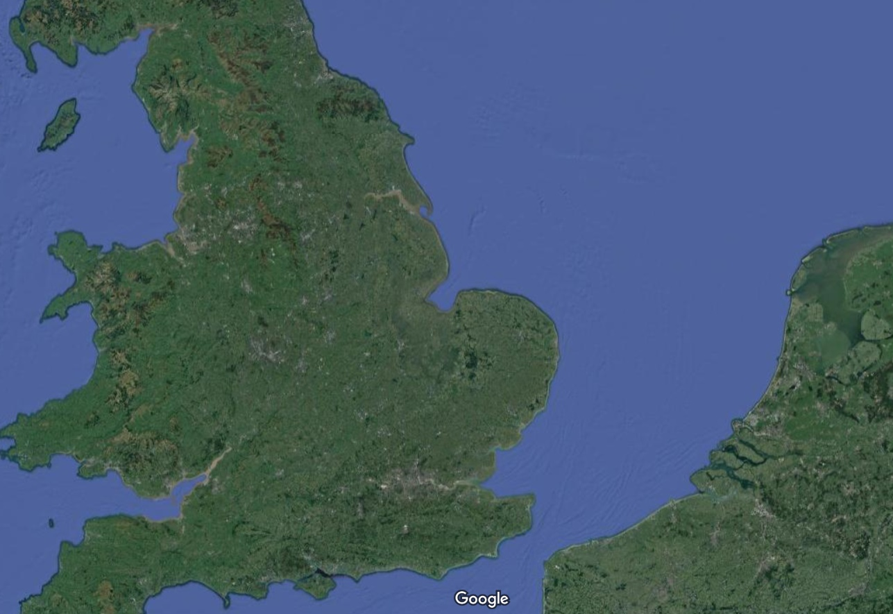
Hull
North Sea
Rotterdam
Liverpool
Manchester
Leeds
Sheffield
London
Newcastle
Amsterdam
Antwerp
Zeebrugge
Major cities
Ports
M62 corridor
London-Edinburgh railway
Ferry connections from/to Hull
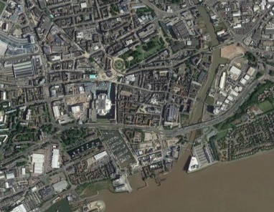
River Hull
Humber Estuary
River Hull
Hull city centre
Bonus Arena
Fruit Market
Hull Marina
Hull Minster / Trinity Square
Old Town
Princes Quay
Queen Victoria Square
Queens Gardens
The Deep aquarium
Victoria Dock Village
1
2
2
4
3
3
4
6
5
5
Humber Estuary
8
6
7
7
9
9
8
1
10
10
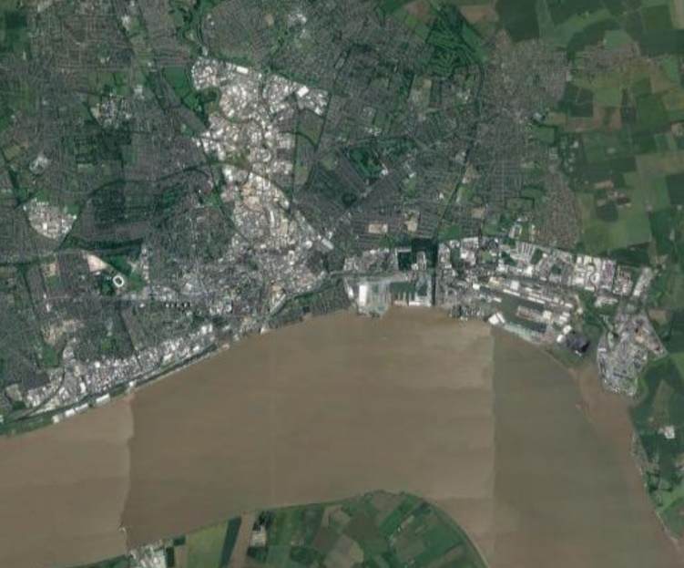

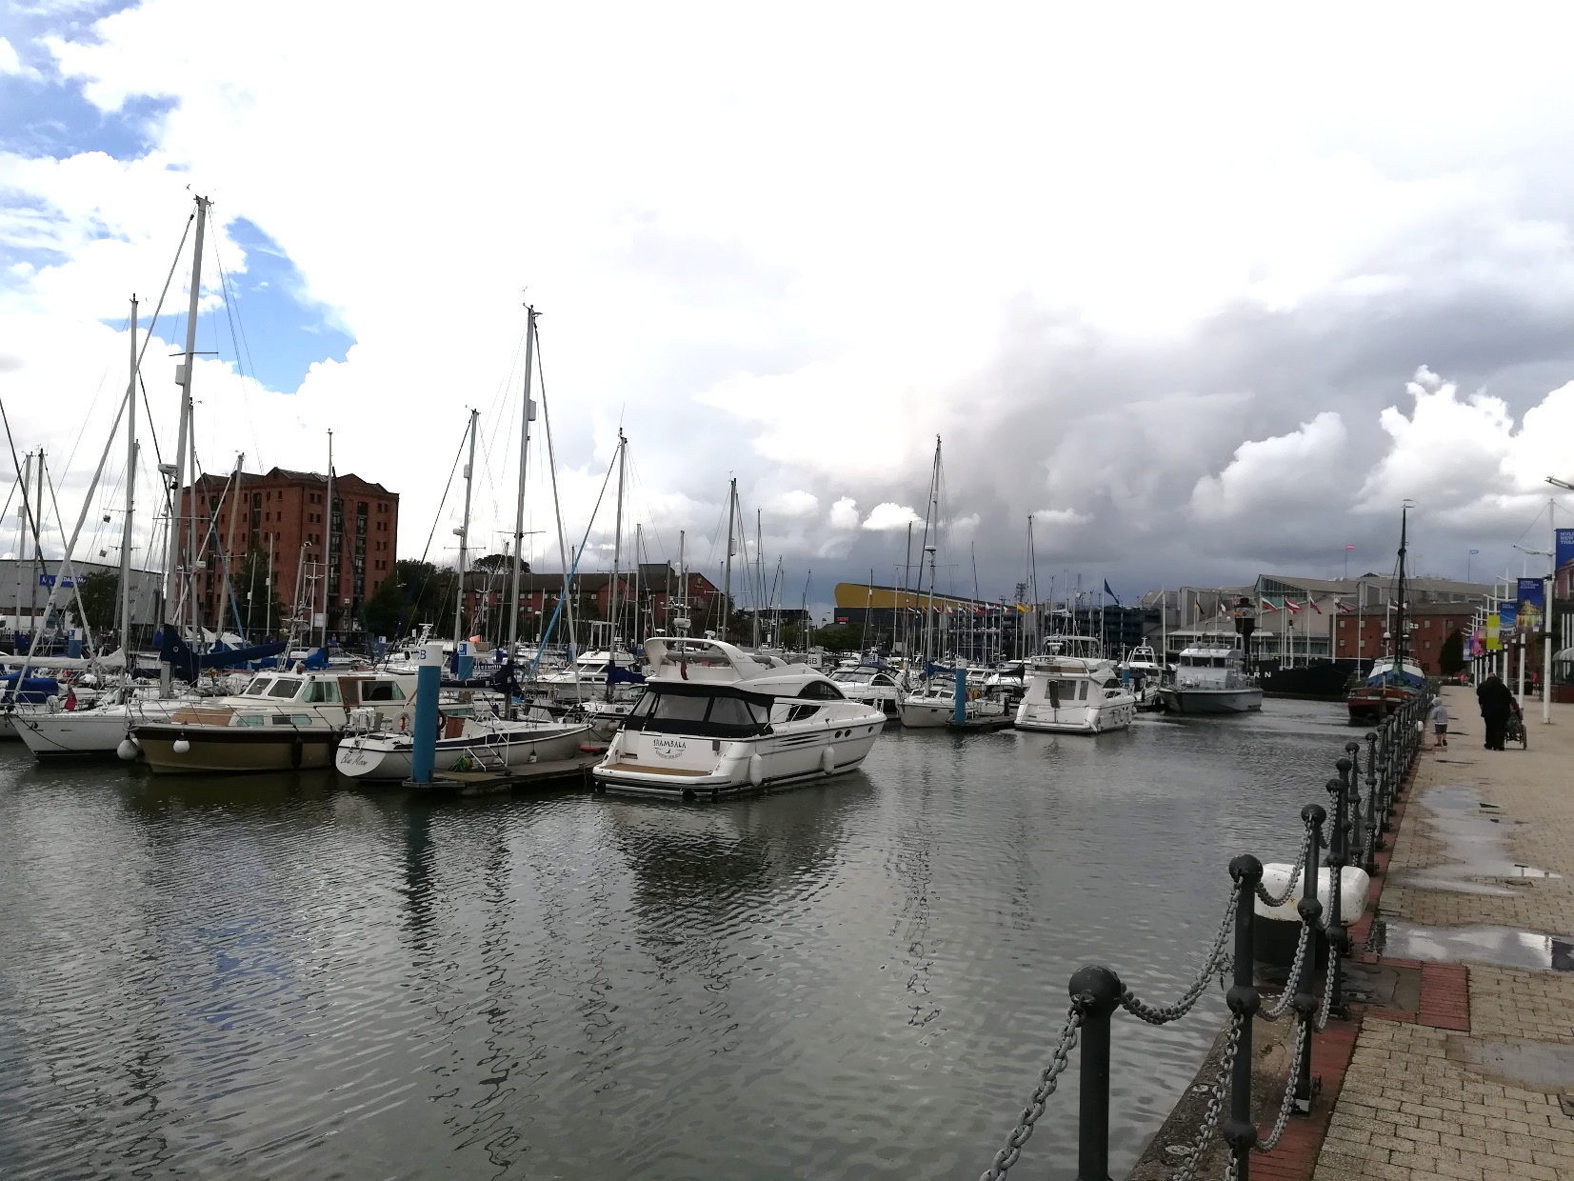

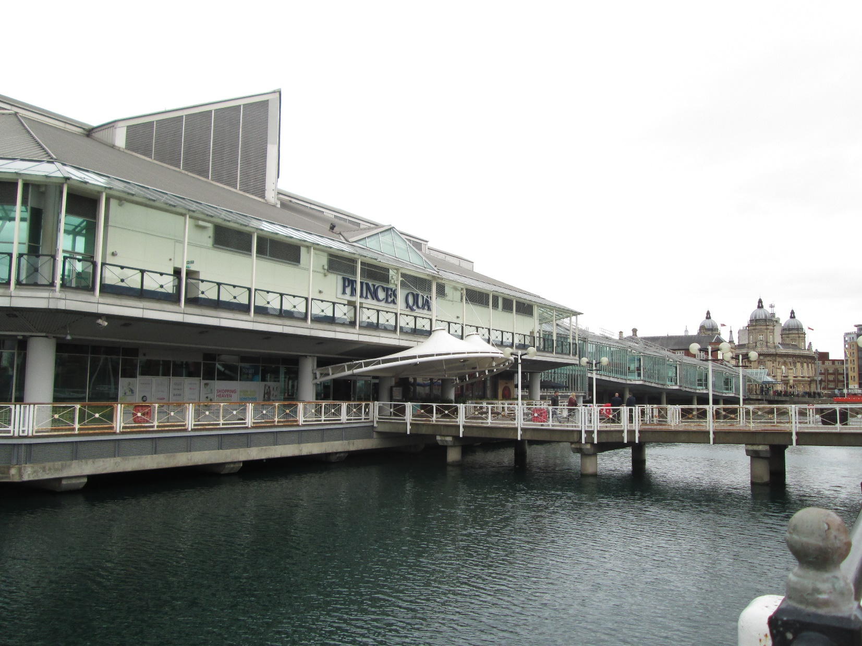

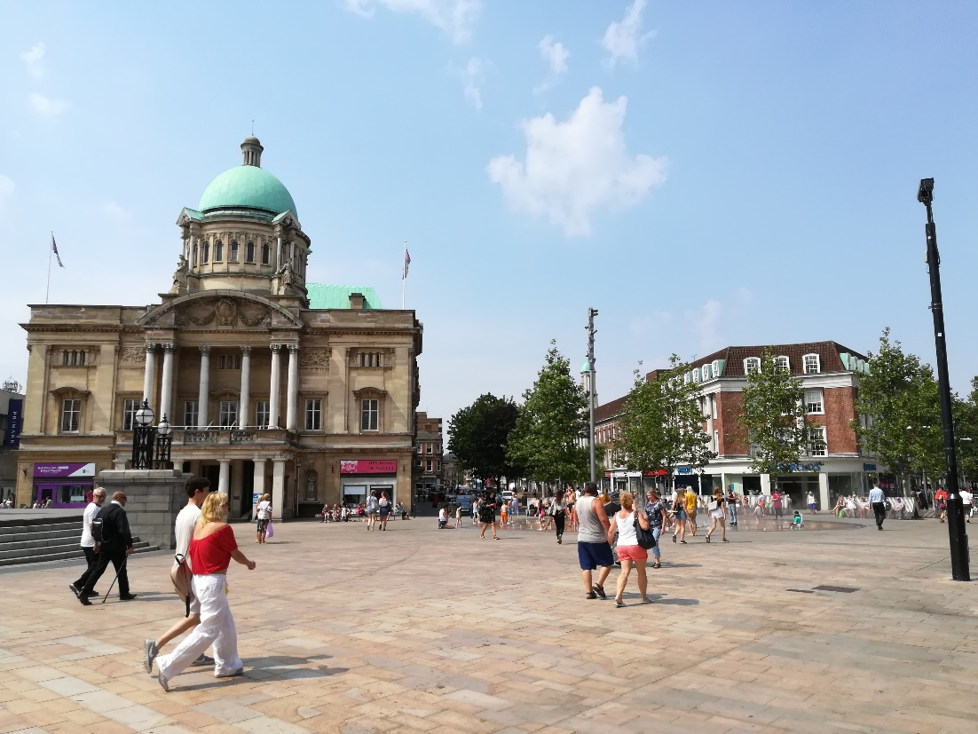

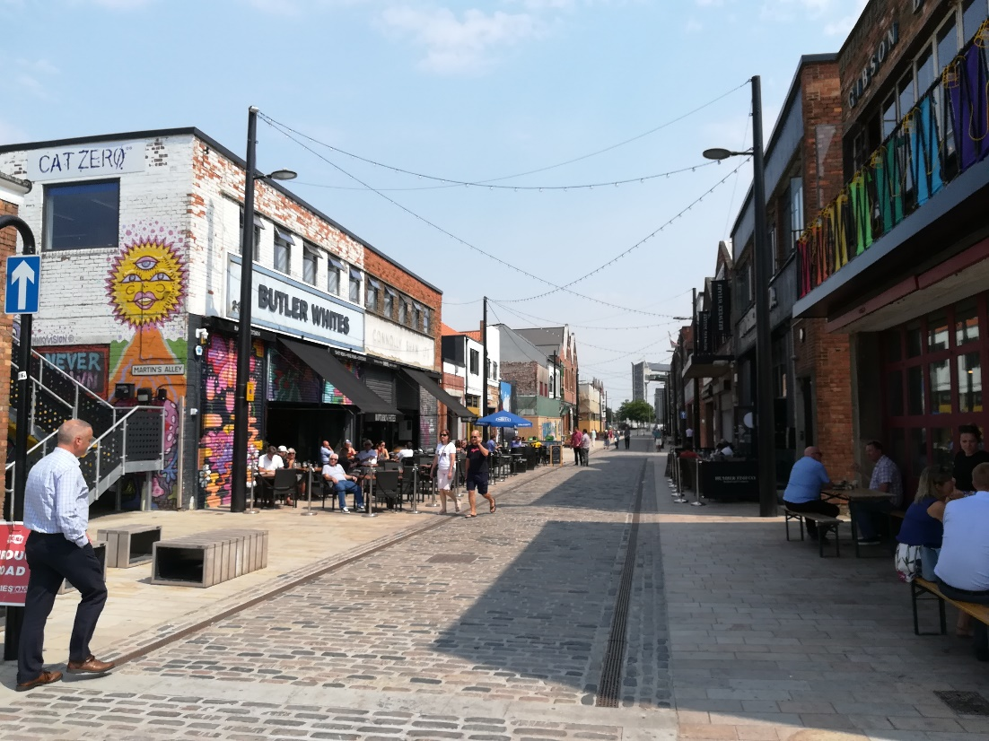

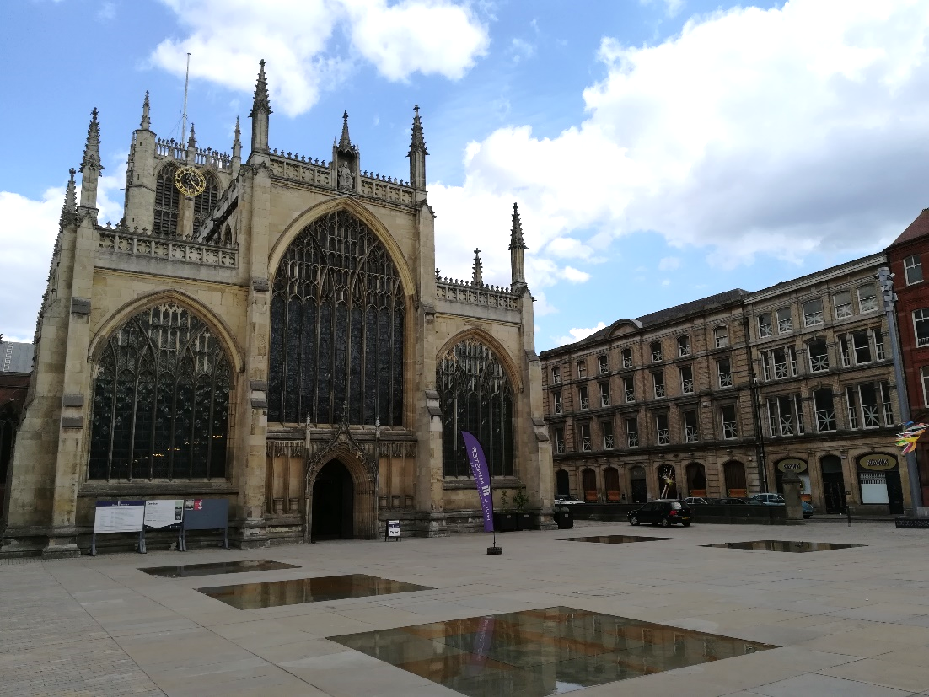

Fig. 1. Hull geographical location. Enrico Tommarchi. Background map: Imagery ©2020 TerraMetrics, Map data ©2020.

Fig. 2. Hull and Hull city centre. Enrico Tommarchi. Background maps: Imagery ©2020 TerraMetrics, Map data ©2020; Imagery ©2020 CNES / Airbus, Getmapping plc, Infoterra Ltd and Bluesky, Landsat / Copernicus, Maxar Technologies, The Geoinformation Group, Map data ©2020.

Fig. 3. Hull Marina was used in 2017 for the Freedom Festival. The Bonus Arena (in the background) was intended as a legacy project of the UKCoC 2017. Enrico Tommarchi.

Fig. 4. Princes Quay, with the Maritime Museum in the background. In 2017, technological installations were displayed in the area as part of the Where Do We Go From Here programme. Enrico Tommarchi.

Fig. 5. The refurbished Queen Victoria Square, one of the areas where public realm investment was concentrated, was the main venue of We Are Hull, as part of the opening Made in Hull programme. The Maritime Museum, the City Hall and the Ferens Art Gallery, key venues in 2017, are located on the square. Enrico Tommarchi.

Fig. 6. Humber Street in the Fruit Market area. A partnership between the City Council and property developer Wykeland Beal made it possible to transform an almost completely abandoned area into a cultural hub. Enrico Tommarchi.

Fig. 7. Hull Minster and Trinity Square were used as venues for art installations and events in 2017 and beyond (e.g. Hall for Hull, Urban Legends: Northern Lights). Public realm improvements included reflective pools which increased the visibility of historic buildings. Enrico Tommarchi.

Ten semi-structured interviews were undertaken in March-August 2019 to prepare a case study about heritage opportunities and threats in relation to Hull 2017 as part of the HOMEE project. The role of heritage in countering negative internal and external perceptions of the city was a key theme emerging from the interviews. This research strand about on heritage, territorial stigmatisation and cultural mega events benefitted from the authors’ work on the evaluation of Hull 2017 (undertaken by the Culture, Place and Policy Institute of the University of Hull).
The media analysis focused on online items from local and national sources issued in 2014-2019. Articles published by the local newspaper (Hull Daily Mail) were analysed alongside others from local newspapers from across Northern England mentioning Hull 2017. The analysis of the national media encompassed national newspapers (The Guardian, The Independent), broadcasters (BBC, ITV), and political magazines (New Statesman, The Economist, The New European). Critical discourse analysis (Wodak, 2001) was used to detect recurrent discourses and storylines (Hajer, 2003).
During the research process, the UK City of Culture 2017 has been perceived as relatively less important for Hull since 2018, mostly due to unrelated factors such as Brexit, the impact of austerity policies and lately the COVID-19 pandemic. Conversely, heritage-led regeneration has become increasingly important, as demonstrated by the interest around the Hull: Yorkshire’s Maritime City project.
In 2019, 27.2% of the local population held a NVQ4 qualification or above, while 8.9% had no qualification, in comparison with 40.3% and 7.7% in Great Britain; the unemployment rate in 2019 was 6.6% against 3.9% nationally (Source: Office for National Statistics). Hull displayed the third highest proportion of neighbourhoods among the 10% most deprived in England (Source: Department for Communities and Local Government, 2015). The proportion of adults diagnosed with chronic mental health problems is above the national average (source: Hull Data Observatory, PHOF and DWP), as are figures for stroke, coronary heart disease and respiratory problems (source: Hull City Council, 2018).
Source: Department for Communities and Local Government, 2015.
As noted by Bianchini et al. (2013) for the 2005-2011 period, ECoCs in the last twenty years have included small and medium-sized cities. Final operational budget figures are from Fox and Rampton (2017), Directorate-General for Education, Youth, Sport and Culture (2018) and EFECTIV Consortium (2019).
Source: Visit Hull and East Yorkshire (2019).
A cruise terminal is planned to be built near the iconic aquarium The Deep, at walking distance from Hull’s Old Town.

