Impacts of Electric Vehicle Fast Charging under Dynamic Temperature and Humidity: Experimental and Theoretically Validated Model Analyses

Peter Makeen^{1,2,}*, Hani A. Ghali¹, Saim Memon^{2,3*}, Fang Duan²

¹ Electrical Engineering Department, Faculty of Engineering, The British University of Egypt (BUE), El-Sherouk, 11837 Egypt; peter.makeen@bue.edu.eg, hani.amin@bue.edu.eg

² London Centre for Energy Engineering, Division of Electrical and Electronic Engineering, School of Engineering, London South Bank University, 103 Borough Road, London, SE1 0AA, UK; besadap@lsbu.ac.uk, S.Memon@lsbu.ac.uk

³ 2 School of Engineering, Arden University, Arden House, Middlemarch Park, Coventry CV3 4FJ, England, UK. ORCID: https://orcid.org/0000-0003-2598-8935 Website: https://saimmemon.com, smemon@arden.ac.uk

*Corresponding Author: Peter Makeen
Address: Electrical Engineering Department, Faculty of Engineering, The British University in Egypt (BUE), El-Sherouk 11837, Cairo, Egypt.
Email: peter.makeen@bue.edu.eg
Tel: +20 1281430604

Abstract
Toward automobile electrification and automation, a smart scenario of DC-charging plug-in electric vehicles (PEVs) at any parking lot equipped with chargers is proposed. In this paper, this scenario is composed of four main stages; In the first stage, an investigation of the temperature or/and relative humidity impact on the charging process of the PEVs is implemented using the constant current-constant voltage (CC-CV) protocol. This was followed by a novel PEV classification model under the impacts of various ambient circumstances. Then an estimation of the charging characteristic parameters at the corresponding conditions is obtained. Finally, the model identification of the battery dynamic behaviour is sufficiently proposed. The feedforward backpropagation neural network (FFBP-NN) as a supervised classification algorithm supported by the statistical analysis of an instant charging current sample is used, which achieves an accuracy of 83.2%. In addition, the FFBP-NN perfectly estimated the charging current, terminal voltage, and charging interval time with a maximum error of 1%. Eventually, a sufficient identification model of the battery dynamic behaviour based on the Hammerstein-Wiener (HW) model is introduced with the best fit of 89.62% and an error of 1.1876%. The experimental and simulated results are within 1%error with the preceding research literature.

Keywords—Electric Vehicles, Fast Charging Process, Online Recognition, Lithium-ion battery, EV Modelling, Constant Current-Constant Voltage protocol, Artificial Intelligent

Introduction
Due to the need for automobile electrification, network integration, and minimizing fuel consumption, Electric vehicles (EVs) have been rapidly developed with their advantages of energy saving and environmental protection and automation improvement capability[1]. Battery packs, which are composed of hundreds of lithium-ion batteries, can provide enough energy for the regular work of EVs[2, 3]. However, there are still some challenges in the safety, cost, and charging operation at different temperatures[2]. In some countries such as Russia, Canada, China, and the USA, winter-driven EVs face a low charge and discharge capacity, lower voltage, and shorter cycle life[4, 5]. Fundamentally, at low temperatures, the rate of chemical reaction in lithium batteries will be slowed down, thus affecting the overall performance of batteries. In addition, lithium-ion batteries face lithium plating at low temperature, which reduces the energy and power capacity and leads to battery degradation [6]. Temperature variation in the battery module occurred primarily due to the temperature rise of coolant along the flow path[7]. It is stated that the well-designed battery module should be capable of confining the battery temperatures between +15°C to +35°C in the different regions, climates, and seasons [7]. It is perceived that the temperature is a main critical barrier in the fast-charging process where lithium-ion batteries are strongly impacted by the temperature change (caused by engines, environment and power electronic drive systems and the battery itself). Temperature change is reflected in the equivalent circuit model (ECM) parameters which depend on the pulse discharging signals and are composed of the internal parameters such as the internal ohmic resistance, the electrochemical polarization internal parameters, and the concentration polarization internal parameters[8-10]. It is stated that the acceptable temperature range of thermal management, performance, and safety of the lithium-ion batteries is from 20°C to 60°C [11]. A very few researchers investigated the relative humidity (RH) effect on lithium-ion batteries, such as Z. Guo et al. [12] investigated the performance of Li-O₂ batteries in pure/dry O₂. The RH affects the performance of the battery where the reactions inside the battery have been analysed in two conditions, Pure O₂ with RH of 15% and ambient air with an RH of 50%. The water can deteriorate the cyclic ability of the battery. In [13] the high temperature and high humidity storage behaviours of LiNi0.6Co0.2O2 cathode material were scrutinized where a great degradation in electrochemical performance after being stored at 55°C and RH of 80%.
The implementation of a lithium-ion battery fast charging protocol in different ambient temperatures requires an accurate representation and modulation of the EV battery dynamic behaviour. Modelling of lithium-ion batteries could be categorized into the electrochemical model, which describes the internal reaction behaviour inside the battery[14, 15]. The electronic equivalent circuit is based on the characteristics of the battery, which can be classified into the Rint model, PNGV model, Thevenin model, RC first-order transient model, RC second-order transient that also called Dual Polarization and the multi-RC transient equivalent circuit [16-19]. There is a significant research gap in identifying a model that can describe the dynamic behaviour of the battery with the minimum percentage of error in determining the battery terminal voltage to ensure high charging efficiency under different ambient conditions (temperature and relative humidity). In [16, 20, 21], a cuckoo optimization algorithm has been introduced to describe and fast charge the polymer lithium-ion battery despite its dynamic behaviour. However, all the internal parameters are measured at the same temperature and relative humidity of the charging process. In[22-25], the authors modelled the lithium-ion battery storage systems using the white-box, black-box and grey-box models with certain ambient conditions. In [26] Adaptive Neuro-Fuzzy Inference System (ANFIS) model has been used as a black box to model the lithium-ion battery. In [27], continuous-time and discrete-time system identification methods represented the internal parameters of the 2RC equivalent circuit model. In [28] Least squares algorithm has been utilized to obtain the unknown coefficients for the normalized battery model. It is observed that no model for the dynamic behaviour of the battery can be utilized under different ambient circumstances (temperatures and relative humidity) and only a few articles proposed models that represent the battery at various temperatures; however, multiple tests and measurements of the internal parameters at all the operating conditions are required.
Consequently, the identification and modulation of the EVs represented in the lithium-ion battery while entering the charging station and during the charging process are considered a challenging problem from many perspectives. Non-linearities, multiple-input variable parameters (charging current, temperature and relative humidity), and high system order are all issues that gather to the complexity of the problem in the charging stations and the home energy management systems (HEMS)[29]. The starting state of charge (SOC), specification of the battery, and the charging interval time are vital prerequisites to designing a plug-in electric vehicle (PEV) charging model [30-33]. Several works have focused on indirect methods for calculating the home charging SOC and charging time, by using the patterns of people’s driving behaviours of daily trip distance, length and time at the end of the trip [34-36]. In Winnipeg, Canada, 76 GPS devices are installed in representative vehicles to predict the electric load profiles as a time function for future plug-in electric vehicles [37]. However, the issues related to GPS communication access and post-processing can jeopardize the process of gathering the vehicle data [30]. The communication between the charging piles with the onboard charger of the existing PEVs to access the information on the battery temperature, relative humidity, and SOC is missing[30, 38]. In [39], a driving pattern recognition using Pondtryagin’s Minimum Principle (PMP) based energy management has been applied to the plug-in hybrid electric bus (PHEB). The authors investigated the impact of the stochastic vehicle mass on energy management, which reflects on the recognition of the co-state. In [40], a recognition method has been used based on monocular vision and non-feature identification where the recognition process combined the Hough circle and Hough line to get the position information of the charging port. The average success rate achieved is 94.8% without considering the different light intensities. An automatic recognition and location system of the electric vehicle charging port have been introduced in [1] using the convolutional neural network (CNN) in different illuminations environments. The recognition has been implemented through image processing and a robot arm that is used to complete the charging gun insertion of the automatic charging link. However, the range of the light intensity used was from 500 lux to 10,000 lux. It is concluded that the highest recognition success rate of 98.9% is achieved at a light intensity of 4,000 lux and the lowest success rate of 84.4% at 500 lux. Herein, Vehicle Logo Recognition (VLR) method provided a critical supplement to the manufacturing version evaluation of the car. In [41], Vehicle Manufacturer Recognition (VMR) eliminated the requirements for identification and analysis of the Convolutional Neural Network (CNN) system. The authors proposed recognition and classification methodologies that depend on the light intensity and vehicle logo recognition however, the dynamic electrical behaviour of EV batteries while charging under different circumstances is not investigated yet.
In summary, fast charging an EV is susceptible to different environmental conditions. Therefore, in large countries, the regional climate can vary from coast to coast, so fast charger deployment requires careful consideration regarding the impact of the regional ambient temperature and relative humidity. Consequently, the rate of charge is variable as it is controlled by the vehicle's onboard battery management system which can be triggered by a variety of internal and external factors[42]. Hence, EV category recognition and identification at various operating ambient conditions is a substantial process to fast charge the EV precisely. In this paper, a novel PEV approach for classification, recognition, charging topology estimation and modelling is proposed. Therefore, this framework minimizes human intervention and is displaced by a smart charging procedure. In the first stage, the experimental influence of different ambient temperatures and relative humidity on the charging process is investigated through the charging interval time, current, and terminal voltage while charging by the Constant Current-Constant Voltage (CC-CV) protocol. The CCCV is easy to implement, has simple requirements, and avoids overcharging due to the constant voltage mode [43]. Then, the proposed novel approach is started when the EV is either connected to residential charging stations or private home charging piles. Hence, classification and recognition of the EV at the charging operating temperature and relative humidity are implemented using the feedforward backpropagation neural network (FFBP-NN). Followed by an artificial estimation of the charging process represented in the total charging interval time, charging current and battery terminal voltage are obtained using the FFBP-NN. Finally, effective identification and recognition of the dynamic behaviour of the battery are obtained using the Hammerstein-Wiener (HW) identification model.

Methodology
This paper proposes a novel approach for electric vehicles with lithium-ion batteries entering the electric vehicle charging station and plugging into the charging point until it is fully charged. The schematic diagram of this approach is introduced in Figure 1. The system must have a sufficient database of various categories of EVs with the DC charging electrical characteristics (voltage and current with respect to the charging interval time) for each category at different ambient conditions (temperature and relative humidity). Once connecting the EV to the charging pile, a 10 secs sample of the charging current will be implemented then the system will be able to classify the category of the EV. In addition, the system will classify the EV category and recognise the corresponding temperature and relative humidity. Classification and recognition will be followed by a full estimation of the charging time, charging current topology and the battery terminal voltage of the corresponding EV. In the last stage, the dynamic behaviour of the battery will be modeled and identified.
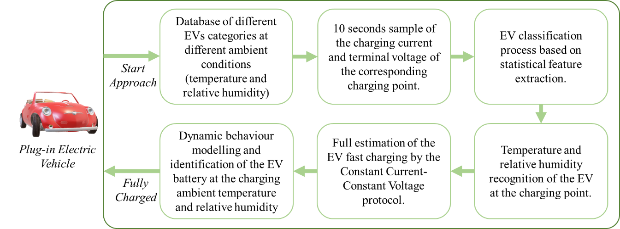
Figure 1. Schematic diagram of the proposed methodology
The battery packs in electric vehicles are built from thousands of cells connected in series and parallel and vary according to the battery type and EV model[21, 44, 45]. In this research, two different lithium-ion batteries of a single cell and battery pack have been used to represent the EVs and are presented in Table 1. The utilized batteries have a nominal capacity of 1000 mAh and 2200 mAh and with recommended working temperature within the range from 0°C to 40°C. However, no data concerning the working or charging relative humidity has been mentioned except for the recommended storage humidity.
Table 1. Specifications of the selected Lithium Polymer ion batteries [46]
Item | Specifications
Type | Polymer lithium-ion single-cell battery | Polymer lithium-ion battery Pack
Nominal Capacity | 1000 mAh | 2200 mAh
Maximum charging current | 1C Amp | 1C Amp
Maximum discharging current | 2C Amp | 2C Amp
Charging cut-off voltage | 4.2 ± 0.05 V | 12.9 V
Discharging cut off voltage | 2.75 V | 8.4 V
Working temperature | 0-40°C | 0-45°C
Storage humidity | 65% ± 20% RH | 65% ± 20% RH
In the following subsections, a description of each stage of the proposed approach will be scrutinized starting from the data collected till the modelling and identification of the EV battery dynamic behaviour.

Experimental Setup
In this paper, a full investigation of the temperature and relative humidity impact on the lithium-ion battery while charging has been implemented to collect the required data. The constant current-constant voltage (CC-CV) protocol has been implemented in charging the EVs as it is simple and commonly used in DC fast-charging stations where is utilized to minimize the queuing delay per EV [21, 43, 47]. A fully controlled temperature and relative humidity chamber have been fabricated as shown in Figure 2 and is composed of a heater, humidifier, microcontroller, switches to ON/Off the sources, blowing and suction fan, and DHT11 temperature/humidity sensor. The operating switches (relays) have been controlled by an Arduino-Uno microcontroller board to set the temperature and relative humidity inside the chamber effectively throughout a closed loop system. The system measures the temperature/humidity in a 1ms sample and feedbacks the relays for further action. The batteries are discharged with 0.9C (A) until the voltage reaches 2.8N (V). C is the rate at which a battery is charged/discharged relative to its maximum capacity; N is the number of packed batteries used in the test. After 10 mins relaxing, the battery is discharged by 0.1C (A) until the voltage reaches 2.8*N (V). After relaxing for 12 hrs, the batteries under test are placed in the Temperature/Humidity chamber for 10 mins at a specific ambient temperature and then charged at different values of temperature and humidity with the CC-CV protocol. This protocol is started with a CC charging process of 0.9C (A) until the voltage reaches 4.2*N (V) followed by a CV process of 4.2*N (V) until the current decays to 0.1C (A) and then relaxing the battery for 12 hrs. This stage is considered the database collection for the next stages.
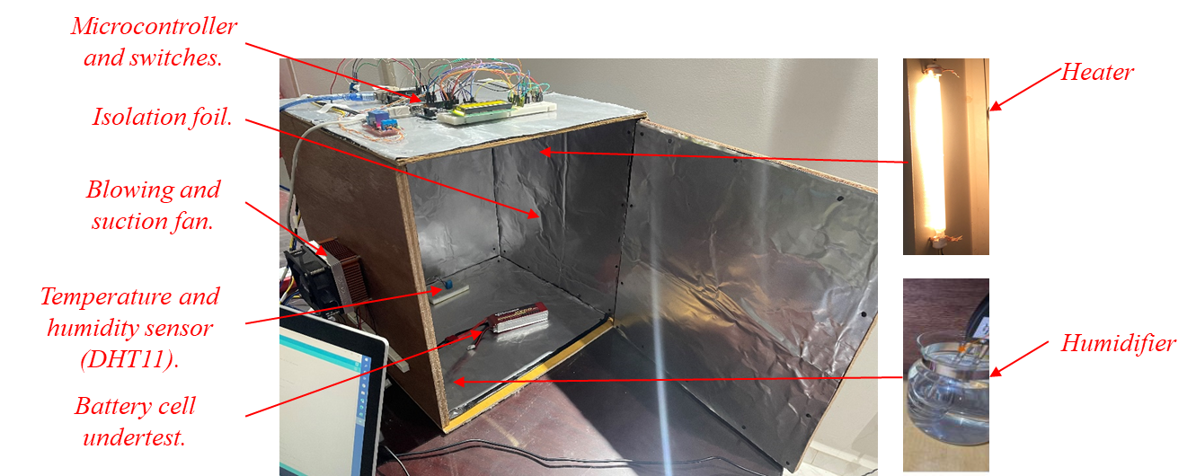
Figure 2. Climatic chamber to control temperature and humidity.

EV classification and recognition process
Our proposed approach starts since the PEV is connected to the charging pile in the charging stations, private homes, or any parking lot equipped with EV chargers. The classification and recognition processes are mandatory to avoid confusion between the different EV categories and different operational temperatures and relative humidity for each EV category connected to any charging pile. Various features have been used to efficiently classify the charging signal's physical nature. Those features have been proposed in various recognition applications concerning speech recognition[48], natural language processing [49], and other pattern recognition introduced in [50-52]. The feature extraction parameters used in this paper have been implemented throughout probability and statistical analysis composed of Skewness, Kurtosis, Variance, Maximum Value, and Arithmetic Mean. The main equations of the feature extraction parameters are
$$Skewness=\frac{\sum_{i=1}^{N}{{(x_{i}-\overline{x})}^{3}}}{(N-1)σ^{3}}$$ | (1)
$$Kurtosis=\frac{\sum_{i=1}^{N}{{(x_{i}-\overline{x})}^{4}}}{(N-1)σ^{4}}$$ | (2)
$$Variance=\frac{\sum_{i=1}^{N}{{(x_{i}-\overline{x})}^{2}}}{(N-1)}$$ | (3)
$$Maximum Value=\sqrt{2}×x_{rms}$$ | (4)
$$Arithmetic Mean=\frac{\sum_{i=1}^{N}{x_{i}}}{N}$$ | (5)
Where $σ$ is the standard deviation, $\overline{x}$ is the distribution mean, and N is the number of sample observations.
A charging current sample of 0.9C (A) was used for a 10 sec interval time to perfectly recognize and classify the type of the battery, its temperature, and relative humidity based on the probability and statistical analysis represented in equations 1-5. The main schematic diagram that declares the main recognition process of the EVs is presented in Figure 3. In the proposed recognition model, a two-layer feedforward backpropagation neural network (FFBP-NN), with sigmoid hidden and SoftMax output neurons has been used to recognize the EV by a sample charging in a very short time interval. The FFBP-NN is trained with scaled conjugate gradient backpropagation Different EVs with different temperatures and relative humidity have been expressed in the first part of Figure 3 and used to train the network with 43,009 samples: 70% for training, 15% for validation, and 15% for testing the network in recognition.
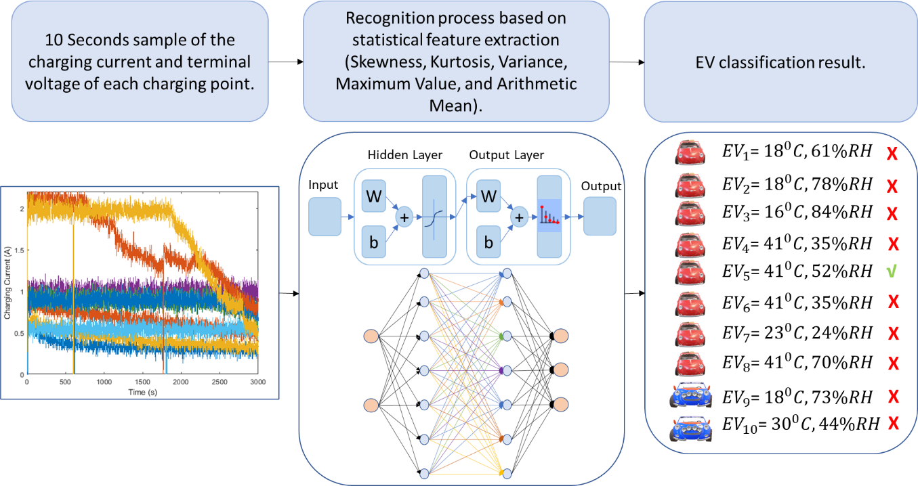
Figure 3. Schematic overview of the proposed classification and recognition process of various electric vehicles with different temperatures and relative humidity.

EV fast-charging parameters estimation by the CC-CV protocol
The classification and recognition results will be fed to and followed by a full estimation of the CC-CV protocol parameters. In the proposed charging estimation stage, the feedforward backpropagation neural networks (FFBP-NN) have been used to represent the non-linear system by mapping the observables to the desired output. In [53, 54], the feedforward neural networks offered fast computational speeds online since, it is composed of a series of matrix multiplications, and other algorithms that contain computationally intensive calculations like partial differential equations.
During the training, the inputs received are multiplied by randomly corresponding weights. The product is summed up and the error is determined and compared with the measured value. The error is backpropagated as an input to the network, with the weights readjusted. The process is repeated till the least error margin has been obtained. The main target of the FFBP-NN is to determine the optimal weights that can predict output proximity to the measured as given in the following equations[55].
$$W^{*}=argmin E_{p}(w)$$ | (6)
$$E\left(w\right)=\sum_{p}{E_{p}(w)}$$ | (7)
$$E_{p}=\frac{1}{2}\sum_{p}{{(d_{pj}-y_{pj}(w))}^{2}}$$ | (8)
$$E\left(w\right)=\frac{1}{2}\sum_{p=1}{\sum_{j=1}{{(d_{pj}-y_{pj}(w))}^{2}}}$$ | (9)
Where $w$ is the weight matrix, $E\left(w\right)$ is an objective function on $w.E\left(w\right)$ is to be minimized and calculated at any point of $w$, $p$ is the number of examples in the training set, $E_{p}(w)$ is the output error for each $p$, $y_{pj}, and d_{pj}$ are the predicted output and measured output, respectively.
This study is based on the premise of the data-driven method, where the FFBP-NN is used based on the Levenberg-Marquardt algorithm as the learning algorithm to model the battery dynamic charging process at different temperatures and relative humidity by a dataset used for learning. The dataset utilized in this study consists of battery parameters (terminal voltage, charging current, temperature, and relative humidity) measured during the charging process. The parameters have been carefully extracted from the battery under a controlled Temperature/Humidity chamber using precisely calibrated sensors, as presented in Figure 4. The output results from this stage are a full estimation of the EV charging current and terminal voltage at the operating ambient corresponding to the EV category.
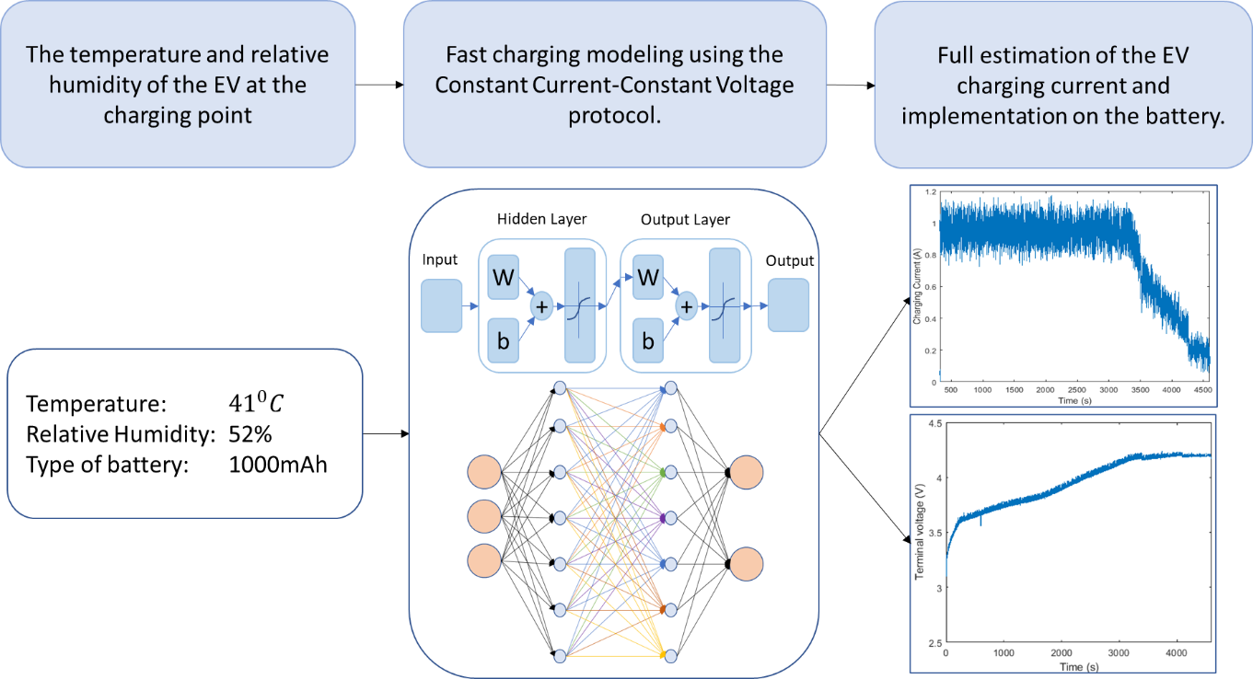
Figure 4. Schematic overview of the estimation stage of the fast charging process using the CC-CV protocol.

Hammerstein-Wiener (HW) modelling of the EV battery dynamic behaviour
The last stage is the sufficient and accurate modelling of the EV battery dynamic behaviour. Instead of the conventional electrical representation of the lithium-ion battery as mentioned in the literature, Hammerstein-Wiener (HW) identification model is utilized to present the nonlinear output dependency of the system on its input. HW model has been widely used for nonlinear industrial systems [56]. This model is cascaded with a nonlinear block either preceding (Hammerstein model) or following (Wiener model) the linear block as expressed in Figure 5 [57]. HW is composed of up to three steps: calculating the linear block input $w(t)$ from the input experimental data using nonlinear equation of $w\left(t\right)=f(u\left(t\right))$, then calculating the output of the dynamic linear box by $x\left(t\right)=\frac{B}{F}w(t)$ then finally the output of the HW model by $y\left(t\right)=h(x\left(t\right))$ has been calculated as expressed in [23, 57, 58]
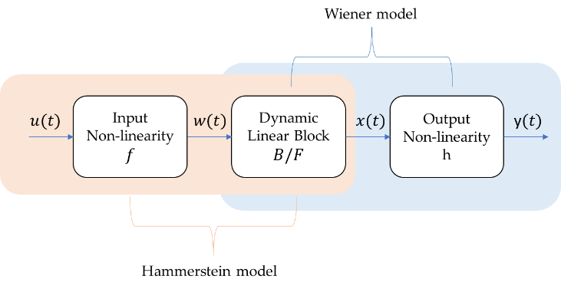
Figure 5. Schematic diagram of Hammerstein-Wiener model block diagram
The overall novel approach of this paper is summarized in Figure 6. Where all the above-mentioned stages are presented in a flowchart with the ascending flow starting from collecting data, classification and recognition, estimating the CC-CV protocol parameters, and finally modelling the EV battery.
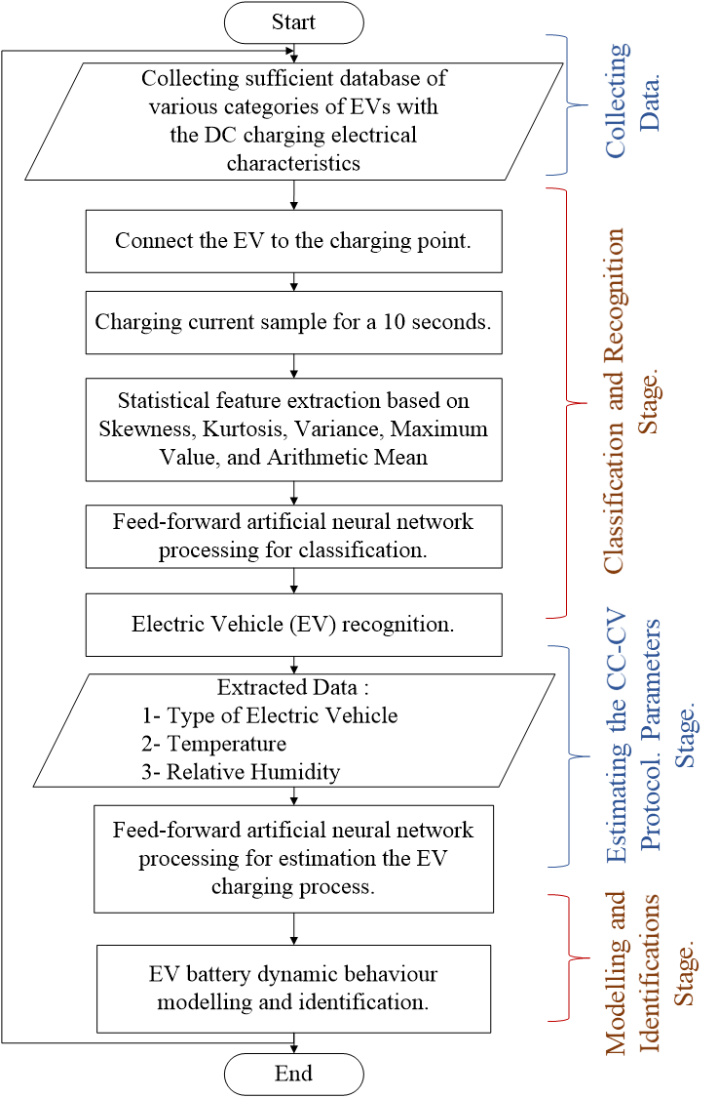
Figure 6. Flowchart of the overall proposed system starting from EV connected to the charging pile till the battery is fully charged.

Results and Discussions
In the following subsections, the effect of different temperatures and relative humidity on the fast charging of lithium-ion batteries using the CC-CV protocol has been presented to be collected and used as a database for the controlled system. Then classification and recognition of the battery cell with the charging specific temperature and relative humidity are utilized. This stage is followed by an estimation of the CC-CV charging protocol parameters. Finally, the dynamic behaviour modulation and identification of the battery cell are implemented. The ascending stages of the proposed approach will be investigated and discussed as follows;

Temperature and Relative Humidity impact the DC charging of the lithium-ion battery

Charging at different ambient temperatures with a fixed relative humidity
The electro-thermal charging behaviour of the proposed batteries of 1000 mAh and 2200 mAh is investigated at 40°C and 30°C with the same relative humidity of 52%. It is observed from Figure 7 that at 30°C the battery reached full capacity faster than 40°C. At 30°C the battery with a capacity of 1000 mAh is fully charged in 4,742 sec (79.0333 min), and at 40°C the battery reaches full capacity in 4,919 sec (81.9833 min). The battery, with a capacity of 2200 mAh, has been fully charged in 3,784 sec (63.0667 min) and 3,845 (64.0667 min) at 30°C and 40°C, respectively. It is concluded that the variation in temperature leads to a change in the total charging interval time process but with a small variation based on the manufacturer's charging specifications reaching around ≈1 to 3 mins.
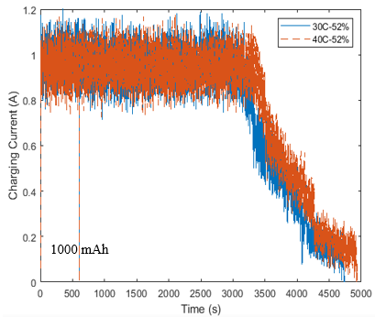 | 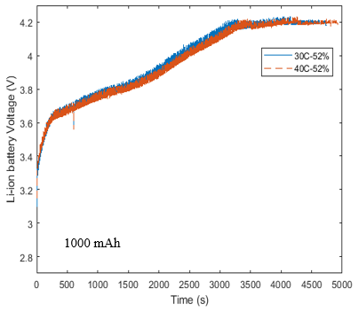
(a) | (b)
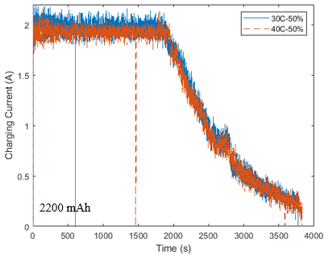 | 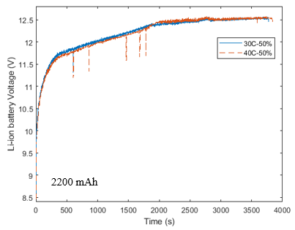
(c) | (d)
Figure 7. Batteries charging topology (a), (b) charging current and terminal voltage of the 1000 mAh polymer lithium-ion battery at two various temperatures (40°C and 30°C) and the same relative humidity (52%), (c) and (d) charging current and terminal voltage of the 2200 mAh polymer lithium-ion battery pack at two various temperatures (40°C and 30°C) and same relative humidity (50%).

Relative humidity impacts the charging process while fixing the temperature
In this section, the electro-thermal charging behaviour is cycled by 0.9C using the CC-CV protocol at the same ambient temperature of 40°C but with different RH (35%, 52%, and 70%). As shown in Figure 8. there is a significant impact of RH on the terminal voltage and charging current. While increasing the humidity, the charging interval time becomes slower than the low humidity. The total charging time for the battery with 1000 mAh at RH-35%, RH-52%, and RH-70% is 4,606 sec (76.7667 min), 4,938 sec (82.3 min), and 5,690 sec (94.8333) respectively and for the other battery with a capacity 2200 mAh at RH-30%, and RH-50% are 3,700 sec (61.6667 min), and 3,845 sec (64.0833 min) respectively.
In the 1000 mAh lithium-ion battery, a significant slow variation in the total interval charging time at both RH-52% and RH-70% with respect to RH-35% reached 7.2% and 23.53%, respectively. And corresponding to a 2200 mAh lithium-ion battery, the slow variation reached 4% between RH-30% and RH-50%. It is observed that whenever the RH increases, the moisture effect reveals the chemical reactions of the battery, where the terminal voltage reaches the cut off value faster than low RH conditions. In addition, the CC charging stage takes a small interval time and the CV stage takes much more time to reach the battery full capacity.
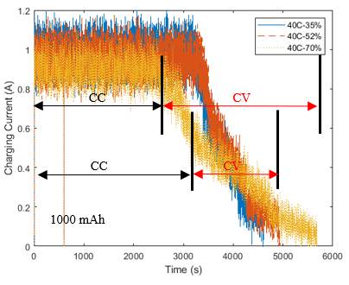 | 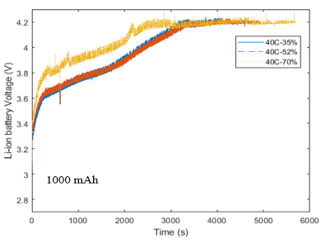
(a) | (b)
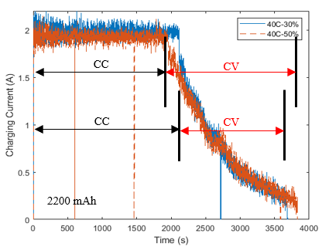 | 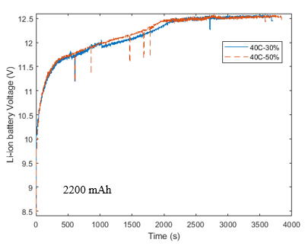
(c) | (d)
Figure 8. The charging topology of the polymer lithium-ion batteries at the same temperature (40⁰C) and various RH (35%, 52%, and 70%) and (30%, and 50%) for 1000 mAh and 2200 mAh, respectively.
It is obvious that any change in the temperature or/and relative humidity directly reflects on the charging performance of the EV, which straightly impacts the overall performance of the charging process. Thus, in this article, full recognition, modelling and fast charging of the plug-in electric vehicles have been presented, starting from connecting the EV to the charging pile till the battery is fully charged.

EV recognition and classification process
A lot of data on two lithium-ion batteries at different ambient conditions (temperature and relative humidity) has been collected from the previous subsection. A charging current sample of 0.9C (A) was used for a 10 sec interval time to recognize the type of the battery, its temperature, and relative humidity. Figure 9-a presents a short charging sample of the proposed classification and recognition model. As concluded from the figure, the challenge is represented in the instant recognition and the tiny variations between the charging current characteristic of the different categories, charging temperatures and relative humidity.
The results of the online recognition are presented in the Confusion matrix in Figure 9-b. The proposed classification ensured a perfect performance of the training, validation, and test samples. However, the complexity of the classification as the amplitude of the charging current is the same as 0.9A for the two types of EVs with different temperatures and relative humidity. The accuracy of the training, validation and testing are 83.2%, 82.9%, and 83.1%, respectively. As shown in Figure 9, the accuracy for the overall network is 83.2% which is acceptable compared to the literature. The increase in the size of the online training database could improve the recognition and classification process. In addition, the statistical analysis of charging current signals at all the charging points daily is explored to detect a new class to be fed to the database.
Despite the different EV types, battery surrounding temperature, and relative humidity, the proposed recognition system based on the artificial FFBP-NN has been implemented on an extra percentage of the initial terminal voltage. Therefore, each terminal voltage is directly reflected on a specific state of charge (SOC) which is considered a practical implementation of the electric vehicle charging station, and the results are expressed in Table 2. As shown, the system can perfectly recognize the type of EV, its temperature, and relative humidity. The numbers represent the probability of each recognition, and the shaded cells express the selection of the classifier to its corresponding EV.
It is observed that in Test_6 however, the values are very close, the proposed neural network recognized the status of the corresponding EV precisely. For future work, it is recommended that for the same test, we can test the network with multiple samples to increase the decision probability.
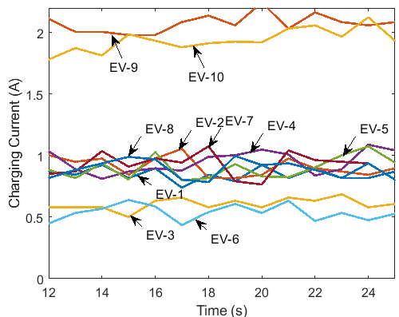 | EV | Temp. | RH
 | 1 | 18°C | 61%
 | 2 | 18°C | 78%
 | 3 | 16°C | 84%
 | 4 | 41°C | 35%
 | 5 | 41°C | 52%
 | 6 | 41°C | 35%
 | 7 | 23°C | 24%
 | 8 | 41°C | 70%
 | 9 | 18°C | 73%
 | 10 | 30°C | 44%
(a)
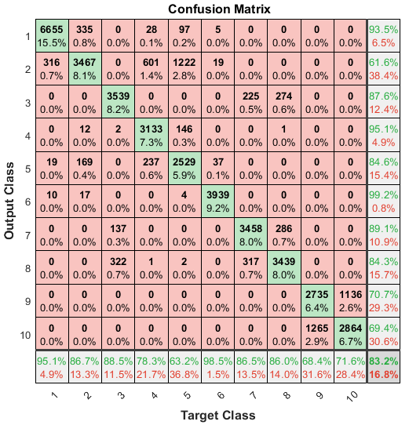
(b)
Figure 9. (a) The charging current of different operating conditions, and (b) The confusion matrix of the overall recognition and classification process.
Table 2. Testing the proposed classification and recognition process.
 | Initial Voltage | EV_1 | EV_2 | EV_3 | EV_4 | EV_5 | EV_6 | EV_7 | EV_8 | EV_9 | EV_10
Test_1 | 4.19 | 0.9705 | 0.0176 | 0 | 0.0049 | 0.0055 | 0.0015 | 0 | 0 | 0 | 0
Test_2 | 4.23 | 0 | 0.4561 | 0 | 0.1411 | 0.3905 | 0.0002 | 0 | 0 | 0.0064 | 0.0056
Test_3 | 4.19 | 0 | 0 | 0.7049 | 0 | 0.0005 | 0 | 0.1732 | 0.1214 | 0 | 0
Test_4 | 3.376 | 0 | 0 | 0 | 0.9657 | 0.0336 | 0 | 0 | 0.0006 | 0 | 0
Test_5 | 3.19 | 0.0001 | 0 | 0 | 0 | 0 | 0.9999 | 0 | 0 | 0 | 0
Test_6 | 11.55 | 0 | 0 | 0 | 0 | 0 | 0 | 0 | 0 | 0.4955 | 0.5045

The CC-CV charging protocol estimation
After the classification of the electric vehicle described in the previous section, the recognition has been fed to the FFBP-NN as three inputs temperature, relative humidity, and the type of EV represented by the lithium-ion battery. The training, validation, test, and overall regressions plots are proposed in Figures 10-a to 10-d. The plots show that the regression coefficients (R) of the training, validation, test, and overall system are 0.99953, 0.99948, 0.99951, and 0.99952, respectively. It is observed that the regression coefficients are in close agreement with unity which validates the accuracy of the FFBP-NN model.
Two graphs for both the proposed charging current and the predicted terminal voltage of the lithium-ion battery will be extracted from the FFBP-NN. As shown in Figure 10-e, the actual measured charging current agrees with the simulated current extracted from the NN. The error between the simulated and measured terminal voltage is expressed in Figure 10-f. It varies between -1% to 1% due to the variation in the applied current, which is considered an acceptable range.
(a) | (b)
(c) | (d)
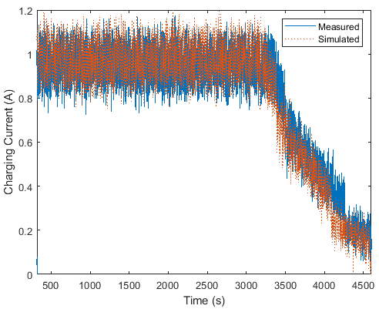 | 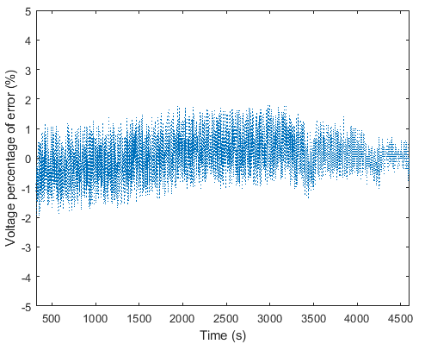
(e) | (f)
Figure 10. Extracted output results from the FFBP-NN (a) the training regression results, (b) validation regression results, (c) test regression results, (d) overall system regression plots, (e) the measured and simulated charging current, and (f) the percentage of error between the measured and simulated terminal voltage of the lithium-ion battery.

Hammerstein-Wiener (HW) charging modelling
Lastly, the modelling and identification of the battery cell dynamic behaviour are obtained using the nonlinear Hammerstein-Wiener (HW) model. HW is used based on the Levenberg-Marquardt (lm) search method with one numerator order and three denominator orders. The measured and simulated model output is expressed in Figure 11-a. As shown, the HW model perfectly predicted the behaviour of the battery using the CC-CV charging protocol parameters with the best fit of 89.62%, which is acceptable as stated in [23]. In addition, the difference between the measured experimental data and the simulated model of the battery terminal voltage is presented in Figure 11-b. The maximum error observed is 0.05 V, representing 1.19%.
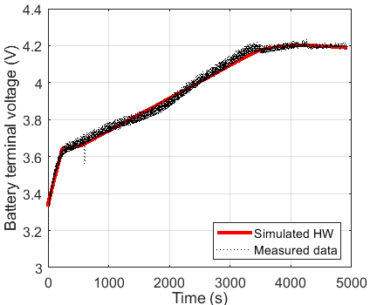 | 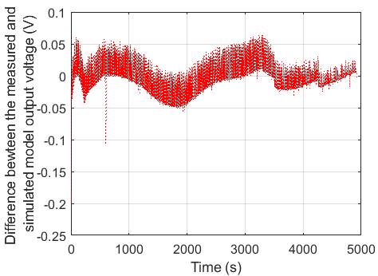
Figure 11. Output from the HW model (a) Measured and simulated model output, and (b) Difference between the measured data and simulated HW model output.

Conclusion
This paper proposed a smart and effective charging scenario, starting from connecting the PEV to the charging pile in the charging stations, private homes, or any parking lot equipped with EV chargers until the PEV is fully charged. This scenario is based on the classification and recognition stage, followed by a full estimation of the charging parameters (current, terminal voltage, and interval time) and finally an identification and modulation of the battery dynamic behaviour. The complexity can be represented in the effect of the temperature and relative humidity on the charging process as examined experimentally by a fully fabricated and controlled chamber. The feedforward backpropagation neural networks (FFBP-NN) algorithm implements the classification and recognition stage. The accuracy for the overall network is 83.2% which is acceptable compared to the literature. This accurate recognition is followed by an accurate estimated charging parameters using the CC-CV protocol at any temperature and relative humidity based on the FFBP-NN. The percentage of error of this stage reached 1%, which is acceptable to the battery specifications. Finally, identification and modulation of the dynamic behaviour of the battery are obtained with the best fit of 89.62% and an error of 1.19%. The experimental and simulated results are in perfect agreement with the literature survey. In addition, the results implicate the next steps of mass manufacturing of smart chargers able to recognise, classify and fast charging estimate the battery dynamic behaviour of the PEV. This work could be improved by considering the degradation and ageing behaviour of the battery EV charging topology in modulation, estimation, and recognition procedures. In addition, the degradation and ageing effect could be included in the database and utilized in the classification stage of the closed loop framework.
Abbreviations and Nomenclature
Abbreviations |  | Nomenclature
ANFIS | Adaptive Neuro-Fuzzy Inference System | $$σ$$ | Standard deviation
CCCV | Constant Current-Constant Voltage | $$\overline{x}$$ | Distribution mean
CNN | Convolutional Neural Network | N | Number of observations of the sample
ECM | Equivalent Circuit Model | $$w$$ | Weight matrix
EV | Electric Vehicle | $$E\left(w\right)$$ | Objective function
HEMS | home energy management systems | $$y_{pj}$$ | Predicted output
HW | Hammerstein-Wiener | $$d_{pj}$$ | Measured output
LM | Levenberg-Marquardt | $$E_{p}(w)$$ | Output error for each $p$
PEV | Plug-in Electric Vehicle | $$p$$ | Number of examples in the training set
PHEV | plug-in hybrid electric bus
PMP | Pondtryagin’s Minimum Principle
FFBP-NN | Feedforward backpropagation neural network
SOC | State of Charge
VLR | Vehicle Logo Recognition
VRM | Vehicle Manufacturer Recognition
Acknowledgements
This work was supported by the Electrical Engineering Department, British University in Egypt (BUE), and the Division of Electrical and Electronic Engineering, London South Bank University (LSBU).
References
[1] Pan M, Sun C, Liu J, Wang Y. Automatic recognition and location system for electric vehicle charging port in complex environment. IET Image Processing. 2020;14(10):2263-72.
[2] Peng X, Chen S, Garg A, Bao N, Panda B. A review of the estimation and heating methods for lithium‐ion batteries pack at the cold environment. Energy Science & Engineering. 2019;7(3):645-62.
[3] Rajendran G, Vaithilingam CA, Misron N, Naidu K, Ahmed MR. A comprehensive review on system architecture and international standards for electric vehicle charging stations. Journal of Energy Storage. 2021;42:103099.
[4] Barnes P, Savva A, Dixon K, Bull H, Rill L, Karsann D, et al. Electropolishing valve metals with a sulfuric acid-methanol electrolyte at low temperature. Surface and Coatings Technology. 2018;347:150-6.
[5] Saccoccio M, Yu J, Lu Z, Kwok SC, Wang J, Yeung KK, et al. Low temperature pulsed laser deposition of garnet Li6. 4La3Zr1. 4Ta0. 6O12 films as all solid-state lithium battery electrolytes. Journal of Power Sources. 2017;365:43-52.
[6] Wang L, Mei T, Liu W, Sun J, Zhou Q, Qian Y. Low temperature chemical synthesis of silicon nanoparticles as anode materials for lithium-ion batteries. Materials Chemistry and Physics. 2018;220:308-12.
[7] Xia G, Cao L, Bi G. A review on battery thermal management in electric vehicle application. Journal of power sources. 2017;367:90-105.
[8] Ye M, Gong H, Xiong R, Mu H. Research on the battery charging strategy with charging and temperature rising control awareness. IEEE Access. 2018;6:64193-201.
[9] Li Y, Li K, Xie Y, Liu J, Fu C, Liu B. Optimized charging of lithium-ion battery for electric vehicles: Adaptive multistage constant current–constant voltage charging strategy. Renewable Energy. 2020;146:2688-99.
[10] Bao Y, Dong W, Wang D. Online internal resistance measurement application in lithium ion battery capacity and state of charge estimation. Energies. 2018;11(5):1073.
[11] Rodrigues M-TF, Babu G, Gullapalli H, Kalaga K, Sayed FN, Kato K, et al. A materials perspective on Li-ion batteries at extreme temperatures. nature energy. 2017;2(8):1-14.
[12] Guo Z, Dong X, Yuan S, Wang Y, Xia Y. Humidity effect on electrochemical performance of Li–O2 batteries. Journal of Power Sources. 2014;264:1-7.
[13] Chen Z, Wang J, Huang J, Fu T, Sun G, Lai S, et al. The high-temperature and high-humidity storage behaviors and electrochemical degradation mechanism of LiNi0. 6Co0. 2Mn0. 2O2 cathode material for lithium ion batteries. Journal of Power Sources. 2017;363:168-76.
[14] Li C, Cui N, Wang C, Zhang C. Reduced-order electrochemical model for lithium-ion battery with domain decomposition and polynomial approximation methods. Energy. 2021;221:119662.
[15] Pramanik S, Anwar S. Electrochemical model based charge optimization for lithium-ion batteries. Journal of Power Sources. 2016;313:164-77.
[16] Makeen P, Ghali H, Memon S. Experimental and theoretical analysis of the fast charging polymer lithium-ion battery based on Cuckoo Optimization Algorithm (COA). IEEE Access. 2020.
[17] Zhang X, Zhang W, Lei G. A review of li-ion battery equivalent circuit models. Trans Electr Electron Mater. 2016;17(6):311-6.
[18] Grandjean T, McGordon A, Jennings P. Structural identifiability of equivalent circuit models for Li-ion batteries. Energies. 2017;10(1):90.
[19] Gao Y, Zhang X, Cheng Q, Guo B, Yang J. Classification and review of the charging strategies for commercial lithium-ion batteries. IEEE Access. 2019;7:43511-24.
[20] Makeen P, Ghali H, Memon S. Controllable Electric Vehicle Fast Charging Approach Based on Multi-Stage Charging Current Methodology. 2020 IEEE International Conference on Power and Energy (PECon). 2020:398-403.
[21] Makeen P, Memon S, Elkasrawy M, Abdullatif SO, Ghali HA. Smart green charging scheme of centralized electric vehicle stations. International Journal of Green Energy. 2021:1-9.
[22] Navid Q, Hassan A. An accurate and precise grey box model of a low-power lithium-ion battery and capacitor/supercapacitor for accurate estimation of state-of-charge. Batteries. 2019;5(3):50.
[23] Khalfi J, Boumaaz N, Soulmani A, Laadissi EM. Nonlinear Modeling of Lithium-Ion Battery Cells for Electric Vehicles using a Hammerstein–Wiener Model. Journal of Electrical Engineering & Technology. 2021;16(2):659-69.
[24] Luzi M, Mascioli FMF, Paschero M, Rizzi A. A white-box equivalent neural network circuit model for SoC estimation of electrochemical cells. IEEE Transactions on Neural Networks and Learning Systems. 2019;31(2):371-82.
[25] Khalfi J, Boumaaz N, Soulmani A, Laadissi EM. Box–Jenkins Black-Box Modeling of a Lithium-Ion Battery Cell Based on Automotive Drive Cycle Data. World Electric Vehicle Journal. 2021;12(3):102.
[26] Jamshidi MB, Jamshidi M, Rostami S. An intelligent approach for nonlinear system identification of a li-ion battery. Conference An intelligent approach for nonlinear system identification of a li-ion battery. IEEE, p. 98-103.
[27] Xia B, Zhao X, De Callafon R, Garnier H, Nguyen T, Mi C. Accurate Lithium-ion battery parameter estimation with continuous-time system identification methods. Applied energy. 2016;179:426-36.
[28] Tsang K, Sun L, Chan WL. Identification and modelling of Lithium ion battery. Energy Conversion and Management. 2010;51(12):2857-62.
[29] Khan AB, Choi W. Optimal charge pattern for the high-performance multistage constant current charge method for the Li-ion batteries. IEEE Transactions on Energy Conversion. 2018;33(3):1132-40.
[30] Danté AW, Agbossou K, Kelouwani S, Cardenas A, Bouchard J. Online modeling and identification of plug-in electric vehicles sharing a residential station. International Journal of Electrical Power & Energy Systems. 2019;108:162-76.
[31] Hu X, Cao D, Egardt B. Condition monitoring in advanced battery management systems: Moving horizon estimation using a reduced electrochemical model. IEEE/ASME Transactions on Mechatronics. 2017;23(1):167-78.
[32] Lin X. Theoretical analysis of battery SOC estimation errors under sensor bias and variance. IEEE Transactions on Industrial Electronics. 2018;65(9):7138-48.
[33] Perez HE, Hu X, Dey S, Moura SJ. Optimal charging of Li-ion batteries with coupled electro-thermal-aging dynamics. IEEE Transactions on Vehicular Technology. 2017;66(9):7761-70.
[34] Ito A, Kawashima A, Suzuki T, Inagaki S, Yamaguchi T, Zhou Z. Model predictive charging control of in-vehicle batteries for home energy management based on vehicle state prediction. IEEE Transactions on Control Systems Technology. 2017;26(1):51-64.
[35] Rassaei F, Soh W-S, Chua K-C. A statistical modelling and analysis of residential electric vehicles' charging demand in smart grids. Conference A statistical modelling and analysis of residential electric vehicles' charging demand in smart grids. IEEE, p. 1-5.
[36] Darabi Z, Ferdowsi M. Extracting probability distribution functions applicable for PHEVs charging load profile. Conference Extracting probability distribution functions applicable for PHEVs charging load profile. IEEE, p. 1-6.
[37] Ashtari A, Bibeau E, Shahidinejad S, Molinski T. PEV charging profile prediction and analysis based on vehicle usage data. IEEE Transactions on Smart Grid. 2011;3(1):341-50.
[38] Bayram IS, Papapanagiotou I. A survey on communication technologies and requirements for internet of electric vehicles. EURASIP Journal on Wireless Communications and Networking. 2014;2014(1):1-18.
[39] Guo H, Hou D, Du S, Zhao L, Wu J, Yan N. A driving pattern recognition-based energy management for plug-in hybrid electric bus to counter the noise of stochastic vehicle mass. Energy. 2020;198:117289.
[40] Quan P, Lin H, Liang Z, Di S. Research on fast identification and location of contour features of electric vehicle charging port in complex scenes. IEEE Access. 2021.
[41] Ma L, Zhang Y. Research on vehicle license plate recognition technology based on deep convolutional neural networks. Microprocessors and Microsystems. 2021;82:103932.
[42] Motoaki Y, Yi W, Salisbury S. Empirical analysis of electric vehicle fast charging under cold temperatures. Energy Policy. 2018;122:162-8.
[43] Makeen P, Ghali HA, Memon S. A Review of Various Fast Charging Power and Thermal Protocols for Electric Vehicles Represented by Lithium-Ion Battery Systems. Future Transportation. 2022;2(1):281-301.
[44] Castelvecchi D. Electric cars and batteries: how will the world produce enough? Nature. 2021;596(7872):336-9.
[45] Chen W, Liang J, Yang Z, Li G. A review of lithium-ion battery for electric vehicle applications and beyond. Energy Procedia. 2019;158:4363-8.
[46] 063450, LI-POLYMER BATTERY PACKS Specification. https://wwwsparkfuncom/datasheets/Batteries/UnionBattery-1000mAhpdf. MAR 16, 2006.
[47] Blasius E, Wang Z. Effects of charging battery electric vehicles on local grid regarding standardized load profile in administration sector. Applied energy. 2018;224:330-9.
[48] Richardson F, Reynolds D, Dehak N. Deep neural network approaches to speaker and language recognition. IEEE signal processing letters. 2015;22(10):1671-5.
[49] Vaswani A, Shazeer N, Parmar N, Uszkoreit J, Jones L, Gomez AN, et al. Attention is all you need. Advances in neural information processing systems. 2017;30.
[50] Attallah B, Serir A, Chahir Y. Feature extraction in palmprint recognition using spiral of moment skewness and kurtosis algorithm. Pattern Analysis and Applications. 2019;22(3):1197-205.
[51] Li P, Benezeth Y, Macwan R, Nakamura K, Gomez R, Li C, et al. Video-based pulse rate variability measurement using periodic variance maximization and adaptive Two-window peak detection. Sensors. 2020;20(10):2752.
[52] Jain AK, Duin RPW, Mao J. Statistical pattern recognition: A review. IEEE Transactions on pattern analysis and machine intelligence. 2000;22(1):4-37.
[53] Chemali E, Kollmeyer PJ, Preindl M, Emadi A. State-of-charge estimation of Li-ion batteries using deep neural networks: A machine learning approach. Journal of Power Sources. 2018;400:242-55.
[54] Hannan MA, Lipu MSH, Hussain A, Saad MH, Ayob A. Neural network approach for estimating state of charge of lithium-ion battery using backtracking search algorithm. Ieee Access. 2018;6:10069-79.
[55] Asante-Okyere S, Xu Q, Mensah RA, Jin C, Ziggah YY. Generalized regression and feed forward back propagation neural networks in modelling flammability characteristics of polymethyl methacrylate (PMMA). Thermochimica Acta. 2018;667:79-92.
[56] Xu K-K, Yang H-D, Zhu C-J. A novel extreme learning machine-based Hammerstein-Wiener model for complex nonlinear industrial processes. Neurocomputing. 2019;358:246-54.
[57] Wills A, Schön TB, Ljung L, Ninness B. Identification of hammerstein–wiener models. Automatica. 2013;49(1):70-81.
[58] Nadimi ES, Green O, Blanes-Vidal V, Larsen JJ, Christensen LP. Hammerstein-Wiener model for the prediction of temperature variations inside silage stack-bales using wireless sensor networks. Biosystems engineering. 2012;112(3):236-47.

