Fast Acoustic Wave Sparsely Activated Localization Microscopy (fast-AWSALM) using Octafluoropropane Nanodroplets
Ge Zhang¹, Sevan Harput¹, Hanyu Hu¹, Kirsten Christensen-Jeffries², Jiaqi Zhu¹, Jemma Brown², Chee Hau Leow¹, Chris Dunsby³*, Robert J. Eckersley²*, Meng-Xing Tang¹*
¹Department of Bioengineering, Imperial College London, London, UK, SW7 2AZ, United Kingdom
²Biomedical Engineering Department, School of Biomedical Engineering and Imaging Sciences, Kings College London, London, SE1 7EH, UK
³Department of Physics and Centre for Pathology, Imperial College London, London, SW7 2AZ, UK
* These authors contributed equally to this work
Email: Mengxing.Tang@Imperial.ac.uk

Abstract — A crucial challenge in the application of ultrasound super-resolution imaging using microbubbles to the clinic is the long acquisition time together with the motion during the data acquisition. In this study, fast acoustic wave sparsely activated localization microscopy (fast-AWSALM) is developed to simultaneously image, activate and deactivate octafluoropropane nanodroplets during high-frame-rate plane-wave ultrasound imaging to achieve ultrasound super-resolution images on a sub-second timescale.
This work demonstrates in vitro fast-AWSALM of a non-flow 200-micron-tube phantom. Firstly, experimental results show that the octafluoropropane nanodroplets can be activated by the plane-wave pulses, whereas acoustic droplet vaporization has only been achieved using focused single element transducers or linear-array probes with focus-wave transmission in previous literature. The activation of nanodroplets via plane-waves without the need of using focused-transmit waves enables a faster imaging and activation acquisition. Second, the results show the fast-AWSALM can give a better estimation of the tube diameter (190 µm) where standard B-mode ultrasound image cannot (550 µm). In summary, this study demonstrates the potential of fast-AWSALM, a super-resolution techniques using nanodroplets, which can generate super-resolution images in milliseconds and does not require flow or a precise control of contrast agent concentration.
Keywords— Super-Resolution, Octafluoropropane Nanodroplets, High Frame Rate, Flow Independent, Microbubbles

Introduction
Ultrasound super-resolution imaging techniques have shown the capability of breaking the diffraction limit in spatial resolution . However, these current localization-based ultrasound super-resolution imaging techniques rely on a low concentration of active flowing microbubble signals. This means that, for slow flows associated with the micro-vasculature, a longer acquisition time is required for the microbubbles to replenish. During this long acquisition time, motion is very likely to be introduced to lower the imaging quality of super-resolution imaging . Therefore, there is a need to develop a super-resolution imaging technique to acquire images sufficiently rapidly in order to avoid motion artefacts.
Nanodroplets, also called ‘phase-change contrast agents’, have been widely investigated in the field of medical ultrasound imaging . In localization-based super-resolution imaging, there are three main advantages of using nanodroplets compared with the conventional microbubble contrast agents. First, the diameter of a nanodroplet is much smaller than a microbubble: previous theoretical work calculated that nanodroplets are being 3-6 times smaller than microbubbles . Their smaller size makes it possible for nanodroplets to flow into smaller vessels or extravasate into tumour tissue where microbubbles cannot. Second, the in vivo circulation time of nanodroplets has been shown to be at least 3-5 times longer than that of microbubbles . This can potentially allow the scanning session to last longer and the nanodroplet dose to be smaller. Third, the nanodroplets can be manipulated/activated by an ultrasound pulse sequence at a specific time or spatial location to become microbubbles to provide contrast signals. This provides more control and flexibility to the real-time scanning.
The use of high and low boiling-point nanodroplets for super-resolution have been reported by the other groups and ours respectively. The imaging of repeated activation and re-condensation of high-boiling-point perfluorohexane (boiling-point=56°C) nanodroplets can be used to generate super-resolution ultrasound imaging. However, the optical activation of the high-boiling-point nanodroplets via laser pulses was required, which restricts its penetration depth to regions that can be illuminated optically.
An acoustic counter-part of optical localization microscopy , which we called acoustic sparsely activated localization microscopy (AWSALM), has been proposed in our previous study which utilised low-boiling-point decafluorobutane (boiling-point=-2°C) nanodroplets. AWSALM is a flow-independent technique and it does not require a low concentration of contrast agents. Compared to high-boiling-point nanodroplets, low-boiling-point nanodroplets have a much lower activation threshold and can be activated by diagnostic ultrasound pulses at depth.
It has been found that, the octafluoropropane (boiling-point=-37°C) nanodroplets can be activated by the pulses with mechanical index larger than 0.6 . This acoustic pressure is also achievable for plane-wave pulses, which represents that the octafluoropropane nanodroplets have the potential to be activated by the plane-wave pulses.
The aim of this study is to demonstrate that fast-AWSALM can be used to simultaneously image, activate and deactivate octafluoropropane nanodroplets by high-frame-rate plane-wave transmit pulses on a sub-second time scale.

Methods and Experiment

Nanodroplet Preparation
The preparation of the nanodroplet solution has been adapted from previously described methods . The lipid shell was generated by dissolving 1,2-dipalmitoyl-sn-glycero-3-phosphocholine (DPPC) and 1,2-distearoyl-sn-glycero-3-phosphoethanolamine-N-[amino(polyethylene glycol)-2000] (DSPE-PEG-2000) into a solution of phosphate-buffered saline (PBS), propylene glycol, and glycerol. All the lipids described above were purchased from Avanti Polar Lipids, Inc., USA. The lipid solution was added to a glass vial and the headspace of vial was exchanged with octafluoropropane gas (Fluoromed, USA) via an inlet needle along with a vent needle. Mechanical agitation was sufficient to produce the formation of lipid-shell octafluoropropane-core microbubbles. In order to condense microbubbles into nanodroplets, the headspace of the vial was pressurised while the vial immersed in the ice-water bath according to the previously described method .

Experimental Setup
A 200 µm cellulose tube (Hemophan®, Membrana) phantom was fixed and immersed in a water tank where the walls were covered with acoustic absorbers. A L11-4v transducer equipped with ultrasound research platform (Verasonics Vantage 128, Kirkland, USA) was held 20 mm above the center of the tube. The water temperature was maintained at 24 ℃. A concentration of diluted nanodroplet solution (~ 1.35×10⁷ PCCAs/mL) was prepared.

Image Acquisition
A customised ‘Imaging/Activation’ sequence was implemented on an ultrasound research platform (Verasonics Vantage 128, Kirkland, USA) with a L11-4 38-mm linear array probe (ATL, USA).. Briefly, a 1-cycle single-angle plane-wave pulse at 3.5 MHz with a peak-negative-pressure (PNP) of 1.42 MPa was transmitted in order to simultaneously image, activate, and deactivate the octafluoropropane nanodroplets. The frame rate was 5000Hz and 1000 frames were acquired in 200ms.

Image Analysis
Singular value decomposition (SVD) processing was used to obtain the changing contrast signals. The SVD thresholds were automatically determined from the location of the largest gradient on the energy versus singular value order curve. After SVD processing, super-localization was performed to reject the noise and detect potential vaporized droplets as described in . The location of single isolated vaporized droplets was calculated by the “centroid” method. The resulting super-resolution map was created from all the localizations detected over all the imaging frames.

RESULTS AND DISCUSSIONS

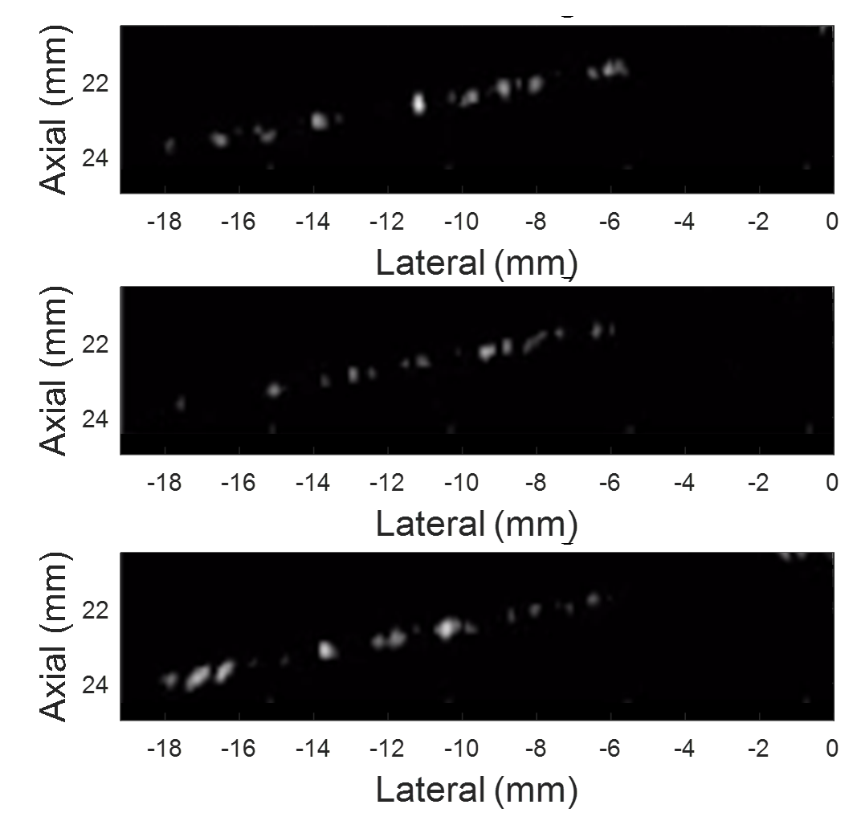
Fig. 1. Three representative successive SVD-filtered image frames shows that octafluoropropane nanodroplets were sparsely activated or activated octafluoropropane nanodroplets were sparsely deactivated. Images were acquired with no flow in the tubes.

Fig 1 shows three representative successive image frames after SVD filtering. It can be seen that the octafluoropropane nanodroplets were sparsely activated or deactivated by plane-wave pulses in the tube without any flow. Acoustic droplet vaporization has only been performed using focused single element transducers or linear-array probes with focus-wave transmissions in previous literature. The activation of nanodroplets via plane-waves without the need of using focus-wave enables a faster imaging and activation acquisition.
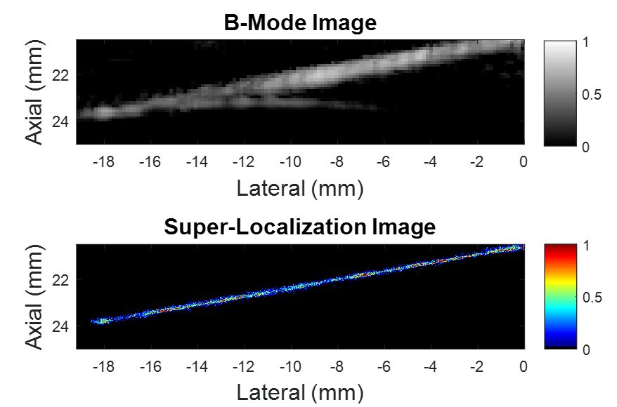

Fig. 2. (a) The summation of 1000 conventional B-mode image frames acquired in 200 ms (b) Super-resolution image superimposes all the localization events in 1000 frames acquired in 200 ms. Note that there is no flow in the tube.

Fig 2 shows the comparison between the summation of 1000 conventional B-mode image frames acquired in 200 ms and the corresponding super-resolution image which superimposes all the localization events in these 1000 frames. It can be seen that, in the super-resolution imaging, it not only has a better resolution but also help to remove some imaging artefacts appeared on the B-mode image.
Fig. 3. Full-width-half-maximum (FWHM) resolution measurement of the B-mode and super-resolution images at same lateral region of interest (ROI) from -8.6 to -8.4 mm.

Fig 3 shows the resolution measurement of the B-mode and super-resolution image at the same lateral ROI from -8.6 to 8.4 mm. According to the measurement, the super-resolution image gives a FWHM of 190 µm whereas the B-mode image shows a FWHM value of 550 µm.

CONCLUSION

In summary, this study demonstrates fast-AWSALM - the high-frame-rate plane-wave transmit pulses can be used to sparsely activate the octafluoropropane nanodroplets and deactivate the activated droplets in a 200-micron cellulose tube phantom without any flow. Furthermore, the use of this pulse sequence enables simultaneous imaging, activation and deactivation of the octafluoropropane nanodroplets in 200 ms to perform the super-resolution imaging. The imaging frequency used in this study (3.5 MHz) indicates that this technique can be used for deep-tissue imaging. The acoustic pressure of the plane-wave pulses was well within the FDA-approved safety range (mechanical index<1.9). This study shows fast-AWSALM, a faster version of AWSALM, which is also flow independent and does not require a precise control on contrast agent concentration.

Acknowledgment

This work was supported by the EPSRC under Grant EP/N015487/1 and EP/N014855/1, in part by the King's College London (KCL) and Imperial College London EPSRC Centre for Doctoral Training in Medical Imaging (EP/L015226/1), in part by the Wellcome EPSRC Centre for Medical Engineering at KCL (WT 203148/Z/16/Z), in part by the Department of Health through the National Institute for Health Research comprehensive Biomedical Research Center Award to Guy's and St Thomas' NHS Foundation Trust in partnership with KCL and King's College Hospital NHS Foundation Trust, in part by the Graham-Dixon Foundation and in part by NVIDIA GPU grant. This work is also supported by the CRUK Multidisciplinary Project Award (No. C53470/A22353), and Imperial-ICR CRCE pump-priming awards.

References
1. Viessmann, O.M., et al., Acoustic super-resolution with ultrasound and microbubbles. Phys Med Biol, 2013. 58(18): p. 6447-58.
2. Christensen-Jeffries, K., et al., 3-D In Vitro Acoustic Super-Resolution and Super-Resolved Velocity Mapping Using Microbubbles. IEEE Trans Ultrason, Ferroelectr, Freq Control, 2017. 64: p. 1478-1486.
3. Christensen-Jeffries, K., et al., In Vivo Acoustic Super-Resolution and Super-Resolved Velocity Mapping Using Microbubbles. Ieee Transactions on Medical Imaging, 2015. 34(2): p. 433-440.
4. Lin, F., et al., 3-D Ultrasound Localization Microscopy for Identifying Microvascular Morphology Features of Tumor Angiogenesis at a Resolution Beyond the Diffraction Limit of Conventional Ultrasound. Theranostics, 2017. 7(1): p. 196-204.
5. Errico, C., et al., Ultrafast ultrasound localization microscopy for deep super-resolution vascular imaging. Nature, 2015. 527(7579): p. 499-502.
6. Couture, O., et al., Ultrasound Localization Microscopy and Super-Resolution: A State of the Art. IEEE Transactions on Ultrasonics, Ferroelectrics, and Frequency Control, 2018. 65(8): p. 1304-1320.
7. Song, P., et al., Improved Super-Resolution Ultrasound Microvessel Imaging with Spatiotemporal Nonlocal Means Filtering and Bipartite Graph-Based Microbubble Tracking. IEEE transactions on ultrasonics, ferroelectrics, and frequency control, 2018. 65(2): p. 149-167.
8. Harput, S., et al., Two-Stage Motion Correction for Super-Resolution Ultrasound Imaging in Human Lower Limb. IEEE Transactions on Ultrasonics, Ferroelectrics, and Frequency Control, 2018. 65(5): p. 803-814.
9. Zhang, G., et al., Acoustic wave sparsely activated localization microscopy (AWSALM): Super-resolution ultrasound imaging using acoustic activation and deactivation of nanodroplets. Applied Physics Letters, 2018. 113(1): p. 014101.
10. Zhang, G., et al. Investigation of Nanodroplet Adhesion to Endothelial Cells under Atheroprone Flow Conditions in 2018 IEEE International Ultrasonics Symposium (IUS). 2018.
11. Toulemonde, M., et al. Flow Visualization through Locally Activated Nanodroplets and High Frame Rate Imaging. in 2018 IEEE International Ultrasonics Symposium (IUS). 2018.
12. Sheeran, P.S., et al., Methods of Generating Sub-Micron Phase-Shift Perfluorocarbon Droplets for Applications in Medical Ultrasonography. IEEE Trans Ultrason Ferroelectr Freq Control, 2016.
13. Sheeran, P.S., et al., Contrast-enhanced ultrasound imaging and in vivo circulatory kinetics with low-boiling-point nanoscale phase-change perfluorocarbon agents. Ultrasound Med Biol, 2015. 41(3): p. 814-31.
14. Luke, G.P., A.S. Hannah, and S.Y. Emelianov, Super-Resolution Ultrasound Imaging in Vivo with Transient Laser-Activated Nanodroplets. Nano Lett, 2016. 16(4): p. 2556-9.
15. Dudok, B., et al., Cell-specific STORM super-resolution imaging reveals nanoscale organization of cannabinoid signaling. Nat Neurosci, 2015. 18(1): p. 75-86.
16. Betzig, E., et al., Imaging Intracellular Fluorescent Proteins at Nanometer Resolution. Science, 2006. 313: p. 1643-1645.
17. Choudhury, S.A., et al., Acoustic Behavior of a Reactivated, Commercially Available Ultrasound Contrast Agent. J Am Soc Echocardiogr, 2016.
18. Lin, S., et al., Imaging of vaporised sub-micron phase change contrast agents with high frame rate ultrasound and optics. Physics in Medicine and Biology, 2018.
19. Lin, S., et al., Effects of microchannel confinement on acoustic vaporisation of ultrasound phase change contrast agents. Physics in Medicine & Biology, 2017. 62(17): p. 6884.
20. Zhang, G., et al. Acoustic response of targeted nanodroplets post-activation using high frame rate imaging. in 2017 IEEE International Ultrasonics Symposium (IUS). 2017.
21. Lin, S., et al. Vaporising phase change ultrasound contrast agent in microvascular confinement. in 2016 IEEE International Ultrasonics Symposium (IUS). 2016.
22. Zhang, G., et al. Super-Localisation Ultrasound Imaging using Sparse Activation of Low-Boiling-Point Nanodroplets. in The 23rd European Symposium on Ultrasound Contrast Imaging. 2018. Rotterdam, Netherlands.
23. Lin, S., et al. High frame rate ultrasound imaging of vaporised phase change contrast agents. in 2017 IEEE International Ultrasonics Symposium (IUS). 2017.

