Moving Beyond Myths and Realities: Impact of the 5C’s Strategies on the Internationalization of Higher Education in the Context of COVID-19

Riaz Ahmed^{*, a}, Simon P. Philbin^{b}

* Correspondence Author (riazutm@gmail.com)
ªBahria Business School, Bahria University, Islamabad, Pakistan
^{b}School of Engineering, London South Bank University, UK

Abstract
The COVID-19 pandemic impacted almost all areas of our lives, including the internationalization of higher education. Therefore, enabling the internationalization of higher education is one of the biggest challenges for academic institutions, and in this context, there is a need to move beyond myths and realities. Owing to the scarcity of research in the domain, this study aims to identify various critical strategies and empirically examine their impact on the internationalization of higher education. For this purpose, a comprehensive literature review was conducted to explore strategies and develop a theoretical framework. To test research hypotheses, this study employed an explanatory research design utilizing a survey instrument methodology to collect data from 253 respondents from both the public and private sector universities in Pakistan. The measures of the internationalization of higher education were adopted from earlier studies while an instrument was developed to measure strategies on a 5-point Likert scale. The reliability and validity of data were ensured, and correlation and regression analyses were utilized to test hypotheses, in addition to validation of hypotheses through AMOS and PLS-SEM. Findings revealed a significant and positive impact of communicating, cooperating, coordinating, collaborating, and continuing strategies (5C’s) in enhancing the internationalization of higher education. Also, the finding implies that an integrated policy through the adoption of the 5C’s strategies needs to be implemented by academic institutions to overcome the challenges of the internationalization of higher education.

Keywords: Internationalization, higher education, strategies, technologies, COVID-19.

Introduction
The internationalization of higher education (IHE) is "a process of incorporating an international, intercultural, or global dimension into the purpose, functions, and delivery of post-secondary education” (Knight, 2008; p. 21), to “improve the quality of education and research for all students and staff, to make a significant contribution to society” (De Wit and Hunter, 2015; p.3). However, recent events across the world, the effects of the COVID-19 pandemic on international higher education are manifested in various aspects while the debate is continuing among some scholars on whether the pandemic will bring an end to the internationalization of higher education (Helms, 2020; Mok, Xiong, Ke, & Cheung, 2021). Indeed, the COVID-19 pandemic has brought many challenges to higher education in terms of teaching, learning, research collaborations, and institutional governance, which have resulted in the slowing down of internationalization in the higher education sector (Tesar, 2020), including dramatic changes to the traditional education system of all academic institutions, where more than 850 million students worldwide faced the suspension of classes. The COVID-19 pandemic impacted 1.2 billion students across the globe due to school and university closures. For instance, almost all higher education institutions (HEIs) have been impacted in Europe (95%). The levels of impact are also high in the Americas (91%) and Asia & Pacific (85%), and a little lower in Africa (78%) (Marinoni et al., 2020).

Over the last three decades, there has been much research on the apparent realities of globalization and internationalization of higher education (Rasolwato et al., 2021; SO, 2021). Recently, the internationalization of higher education faced a paradigm shift because of the COVID-19 pandemic, where a strong focus on students, faculty, administrators, and programs has shifted from internationalization abroad towards internationalization at home for the whole academic community. All of these shifts are likely to make the internationalization of higher education more challenging (de Wit & Altbach, 2021), requiring the adoption of consistent strategies to increase the contribution of internationalization to society (Jones, Leask, Brandenburg, & de Wit, 2021). Indeed, the challenging aspects of information and communication need to be reconsidered by HEIs engaged in international programs and online learning, which have been highlighted by the students and faculty members during the pandemic (Herman, 2020). To overcome such challenges, effective strategies need to be identified and investigated to promote international higher education (Sharma, 2020).

The challenges of the internationalization of higher education in the post COVID-19 era are being discussed and debated frequently. For instance, Ma (2021) found that the COVID-19 outbreak had a significant impact on student mobility and international cooperation. Nevertheless, there remains a paucity of systematic strategies enabling internationalization to meet both national and institutional objectives (Sok & Bunry, 2021). Several researchers argue that scholars of HEIs must be proactive to strategize and operationalize the international dimensions of academic programs and institutions, including prioritizing international activities through future research initiatives (Knight & de Wit, 2018; Ryu & Nguyen, 2021; Sok & Bunry, 2021). Furthermore, HEIs should rethink and reshape consistent internationalization and management strategies, and redesign the role of cooperating and collaborative programs to launch a more agile financial model in a well-coordinated environment. Consequently, the internationalization of higher education requires rigorous coordination and consistent cooperation between departments and educational institutions to consistently attract high-quality students. However, there is a notable gap in the literature regarding concrete strategies for coordinating and cooperating in internationalization efforts (Ryu & Nguyen, 2021).

The motivation and originality of this research can be related to the literature indicating that internationalization of higher education is still a top priority in many countries, and there is a need to identify effective strategies (i.e. communicating, cooperating, collaborating, coordinating, and continuing) for the internationalization of higher education. Currently, the effects of COVID-19 on HEIs are on the agenda of many researchers but there remains a lack of overall strategies that are effective in maximizing the potential of the internationalization of higher education (Amoah & Mok, 2020; Aristovnik, Keržič, Ravšelj, Tomaževič, & Umek, 2020; Aucejo, French, Araya, & Zafar, 2020; Browning et al., 2021; Fantini, 2020; Mukherjee & Hasan, 2020; Tasci, 2021; Woicolesco, Morosini, & Marcelino, 2021). Moreover, the study by Amoah and Mok (2020) was limited to using the critical paradigm and focusing on the issue of the ‘inequality of opportunity’ as a result of internationalization. Furthermore, the study by Tasci (2021) was restricted to examining the impact of COVID-19 on the internationalization of higher education through the lens of ‘thinking behind the iceberg’. Likewise, the study by Hines and Dockiao (2021) was confined to identifying the issues influencing the future strategy of higher education internationalization. Hence, due to the scarcity of research on identifying effective strategies, i.e. communicating, cooperating, collaborating, coordinating, and continuing (5C’s) for the internationalization of higher education, this empirical study aims to answer the following question: Do 5C’s strategies impact on internationalization of higher education from a post COVID-19 perspective?

This study contributes to the body of knowledge and practices by examining the impact of the 5C’s strategies on the internationalization of higher education in the context of post-COVID-19 pandemic. Nevertheless, existing research has primarily focused on specific dimensions or models of internationalization, overlooking the comprehensive impact of diverse strategies, For instance, Strotmann and Kunschak (2022) study was limited to examining the five-component model (i.e. knowledge, interpreting, and relating skills, critical cultural awareness, skills of discovery and interaction, attitudes); Fantini (2020) model was limited to attributes, abilities, dimensions, language proficiency, and development; and Ryu and Nguyen (2021) study was limited to seeking an understanding of the country's existing situations, policies, and obstacles in the process of internationalizing its higher education. Yet there is a lack of research exploring the impact of different strategies on the internationalization of higher education (Strotmann & Kunschak, 2022) and much research is needed to analyze the impact of various strategies (such as communicating, cooperating, collaborating, coordinating, and continuing) to contribute to a deeper understanding of effective approaches to internationalizing higher education, in the post-COVID-19 era (Marić & Gama-Araujo, 2022). Therefore, this study seeks to fill the aforementioned research gaps — the empirical study aims to examine the impact of 5C’s strategies on the internationalization of higher education in a post-COVID-19 scenario.

The subsequent sections of the article delve into a synthesis of the literature on 5C’s strategies, the theoretical framework, research hypotheses formulation, and the research model. Subsequently, research methods including measures, population, sampling, respondents, and data collection procedures are outlined. Thereafter, data analysis and findings are discussed. Finally, key findings, implications, limitations, future research directions, and conclusions are presented.

Literature review and research hypotheses
In the past, the myths and realities about the internationalization of higher education were high on the research agenda (Knight, 2011). However, many studies have focused on expanding the activities of higher education internationalization due to the consequences of the COVID-19 pandemic (Rasikawati et al., 2021; SO, 2021), where, one of the biggest challenges to educational activities was the need for an effective process to maintain teacher-student contact as the base of formal education (Daniel, 2020). Although, the extant literature has highlighted the importance and significance of communicating, cooperating, coordinating, collaborating, and continuing strategies (namely the 5 C’s) to bolster the internationalization efforts, however, their impact on the internationalization of higher education remains largely unexplored (Costa & Canen, 2021; Hines & Dockiao, 2021; Ramaswamy, Marciniuk, Csonka, Colò, & Saso, 2021; Sok & Bunry, 2021; Strotmann & Kunschak, 2022). Based on a comprehensive literature review, the strategies critical for enhancing the internationalization of higher education are synthesized (see Table 1).

Table 1. Summary of literature on strategies critical for the internationalization of higher education
Author (Year) | Communicating | Cooperating | Coordinating | Collaborating | Continuing
Aydinli and Mathews (2021) | √ | - | √ | √ | -
Bamberger (2021) | √ | √ | - | √ | √
Costa and Canen (2021) | √ | √ | √ | √ | √
de Wit and Altbach (2021) | - | √ | √ | √ | √
Dias et al. (2021) | √ | √ | - | - | √
Hines and Dockiao (2021) | √ | √ | √ | √ | √
Li and Eryong (2021) | √ | √ | √ | - | √
Marić and Gama-Araujo (2022) | √ | - | √ | - | √
Ramaswamy et al. (2021) | √ | √ | √ | √ | √
Ryu and Nguyen (2021) | - | √ | √ | √ | √
Sok and Bunry (2021) | √ | √ | √ | √ | √
Strielkowski et al. (2021) | √ | √ | - | - | √
Strotmann and Kunschak (2022) | √ | √ | - | √ | √
Tasci (2021) | √ | - | - | - | √
Woicolesco, Morosini, and Marcelino | √ | √ | √ | √ | -
Zheng and Kapoor (2021) | √ | √ | - | √ | √

The COVID-19 pandemic drastically disturbed life across the globe in just a few months, including affecting the way students are educated (Aristovnik et al. 2020). Moreover, the challenges of continuous learning reaffirmed possible flaws in higher education during this pandemic. To establish how HEIs may effectively respond to such challenges, scientific evidence needs to be gathered (Mukherjee & Hasan, 2020). Indeed, the internationalization of higher education is seen as an unavoidable feature resulting from unprecedented levels of cross-border communication and cross-cultural interactions. In the online teaching phase, students need to be encouraged to participate in discussions because group discussion work can provide deeper knowledge of a topic. Furthermore, there is a need for educators to use various methods to evaluate students learning, including formative and summative assessments. In this perspective, institutions need to provide continuous performance responses along with constructive feedback to ensure higher education learning outcomes are achieved (Sá & Serpa, 2020). Consequently, effective communication among educators and students can promote the internationalization of higher education. Therefore, the following hypothesis is synthesized:
H₁. The communicating strategy has a significant impact on enhancing the internationalization of higher education.

Higher education is viewed as a national strategy as well as a strategic imperative for universities and colleges around the world (Li & Eryong, 2021). Nevertheless, the unexpected shock of the COVID-19 pandemic has compelled education systems across the world to extend cooperation and adapt to new areas of technology with the advancement of information and communication technologies (ICTs). However, the worldwide exchange and cooperation among HEIs continue to face unprecedented challenges and difficulties as a result of the impact of the COVID-19 pandemic. In particular, the internationalization of higher education is confronted with several issues including; a lack of cooperation in value-based guidance and new international innovative practices at the institutional level (Li & Eryong, 2021). To achieve international competitiveness, universities across the world need to set aside funds to promote international communication and cooperation and improve the environment of international learning. Moreover, Woicolesco et al. (2021) stress the necessity to facilitate the internationalization of higher education and foster cooperative networks for strengthening the internationalization in academic institutions of higher learning. Therefore, the following hypothesis is synthesized:
H₂. The cooperating strategy has a significant impact to enhance the internationalization of higher education.

The COVID-19 pandemic has wreaked havoc on practically every aspect of society including higher education (Aucejo et al. 2020). Many students had to adjust quickly to the transition from face-to-face to online courses, as well as closed libraries, new contact dynamics with professors and administrative staff, new evaluation systems, and different workloads (Marić & Gama-Araujo, 2022). This shift in education and learning, on the other hand, has significantly impacted students' lives, including their academic achievement, educational plans, current labor market engagement, and future employment expectations (Aucejo et al., 2020). Consequently, there is a need to utilize all internal resources to increase the quality of education (Means, 2017). Furthermore, organizational strategies are important, which aim to ensure the sustainability of the internationalization process as suggested by Knight (2011). Similarly, Li and Eryong (2021) emphasize the importance of coordinating approaches of internationalization strategies in adapting to deliver and enhance higher education initiatives. Therefore, the following hypothesis is synthesized:
H₃. The coordinating strategy has a significant impact to enhance the internationalization of higher education.

The COVID-19 pandemic led to negative effects on the international higher education sector, and this included the role of educators, administrators, and policymakers in international collaborative activities and programs. On the other hand, the pandemic also provides an opportunity to enhance regional collaborations (Sá & Serpa, 2020), where HEIs collaborate to find solutions to provide and acquire improved learning opportunities for the internationalization of higher education (Marinoni et al., 2020). Furthermore, international collaborations between partner universities can help other countries boost higher education and scientific research while also preventing the ‘brain-drain effect’ that typically occurs as a result of exchange programs (Strielkowski et al., 2021). Therefore, educational institutions need to be ready to collaborate and commit to the digital revolution's transformation of teaching and learning methodologies (Seke 2020). Besides, until the pandemic was completely over, academic institutions had to collaborate and continue their educational work through both face-to-face and online platforms. Addressing these challenges therefore required a systematic approach of collaboration to strengthen the internationalization of higher education. Therefore, the following hypothesis is synthesized:
H₄. The collaborating strategy has a significant impact on enhancing the internationalization of higher education.

Due to the COVID-19 pandemic, uncertainty and fear produced a great deal of stress within the university community, which could have negative consequences on learning and mental health. Therefore, institutions and academicians need to continuously address future lecture system transition plans, including ways to identify and help students who are at high risk of negative psychological and other deleterious consequences during the epidemic (Aucejo et al., 2020). Moreover, continuously implementing online education requires an increase in the quality of distance teaching and learning. Furthermore, due to a lack of appropriate and continuous professional training, educators and students have faced difficulty in implementing learning technologies (Seke, 2020). Also, universities in developing nations are continuously confronting more obstacles than their counterparts in wealthy countries, including a shortage of competent educators, the need for updated textbooks, and teaching materials, insufficient network infrastructure, and a lack of IT skills (Gillett-Swan, 2017). To foster cross-cultural development in internationalization, HEIs require a continued and systematized approach to enhance effective outcomes of internationalization (Li & Eryong, 2021). Therefore, the following hypothesis is synthesized:
H₅. The continuing strategy has a significant impact on enhancing the internationalization of higher education.

Methods
Population and sampling
This empirical study followed an explanatory research paradigm and a deductive approach. The population of the study included universities from both the public and private sectors. To qualify as a participant, respondents needed to be key informants of the concepts and theory being investigated and have meaningfully been involved in the activities being studied. Therefore, the participants were selected from student cohorts from different universities in the public and private sectors in Pakistan. This approach maximizes the generalizability of the study and minimizes the chances of bias in the sample data. Furthermore, the sample included those involved in teaching, research, international accreditation, international exchange programs of students, and wider internationalization of higher education activities. The sample for this study was calculated using the formula [n = N*X / (X + N – 1)] of Daniel & Cross (2018), which resulted in a sample size of N=368. This sample size is consistent with recent studies on the internationalization of higher education (Marić & Gama-Araujo, 2022; Strotmann & Kunschak, 2022).

Operationalization of variables
To measure the internationalization of higher education, 22 measurement items anchored on a 5-point Likert scale (1=Strongly Disagree, 2=Disagree, 3=Neutral, 4=Agree, 5=Strongly Agree) were adopted from Chang and Lin (2018). For the measurement of the 5C’s strategies, an instrument was developed based on various studies (de Wit & Altbach, 2021; Ramaswamy et al., 2021; Rosyidah & Rosyidi, 2020; Zolfaghari, Sabran, & Zolfaghari, 2009) and following the guidelines of Chan and Luk (2021), for instrument development process (see Appendix A).

Data collection and responses
The survey questionnaire was comprised of three parts. The demographic information of participants was covered in the first section, the measurement items of internationalization of higher education were covered in the second section, and the third section comprised questions related to the 5C’s strategies. To collect cross-sectional data, an online survey questionnaire was developed and disseminated among 368 participants from public and private sector universities in Pakistan. In response, a total of 253 students participated in the survey with a response rate of 68.75% which was used for data analysis, and a summary of demographic data is presented in Table 2.
Table 2. Summary of demographic data

Demographic | Characteristic | Frequency | Percentage
Gender
 | Male | 167 | 57.2
 | Female | 125 | 42.8
Age Group
 | 18-25 Year | 224 | 76.7
 | 26-33 Year | 33 | 11.3
 | 34-40 Year | 18 | 6.2
 | 41-49 Year | 15 | 5.1
 | 50 Years and above | 2 | 0.7
Program of study

 | Bachelor Degree | 185 | 2.6
 | MS/MPhil Degree | 58 | 58.9
 | PhD Degree | 10 | 38.5
Sector
 | Public | 129 | 44.2
 | Private | 163 | 55.8

Results
Before performing reliability and validity analysis, a scatterplot was used to identify outliers in the data. The scatterplot is a graph that compares each respondent's score on one variable to their score on another to visualize the relationship between the variables (Field, 2013), however, no outlier was detected in the data. Further, the analysis of descriptive statistics was performed, which is a set of descriptive coefficients that summarize a given data set representing an entire or sample population, a summary of which is presented in Appendix B. To examine the amount of multivariate skewness and multivariate kurtosis independently, Mardia (1970) proposed and then modified (Mardia, 1974) a test of normality for distribution normalcy. Accordingly, we employed Mardia’s test using the online Web Power ‘Statistical power analysis online’ calculator to check multivariate normality based on the normalized estimate of multivariate skewness and kurtosis, a summary of which is presented in Appendix C.

Reliability and validity
Reliability analysis was carried out through the use of Cronbach's Alpha (α) technique, where the value is normally between 0 and 1, and a cut-off value of 0.70 is used (Roberts & Priest, 2006). The validity of sample data was carried out through exploratory factor analysis (EFA) by using the principal component analysis (PCA) method and adopting the varimax rotation technique (Field, 2009). The EFA was performed both for the 5C’s strategies and internationalization of higher education by loading their respective items, and the PCA value of 0.40 was used as a threshold (Conway & Huffcutt, 2003). As a result, the values of all 38 items were greater than the threshold value of 0.4, therefore, all items were valid and retained for further analysis and hypothesis testing. In addition, Kaiser–Meyer–Olkin (KMO) and Bartlett’s Test of Sphericity were performed to test the sampling adequacy and homogeneity of sample data, where the KMO value ≥0.60 is acceptable (Norusis, 1985) and Bartlett’s Test of Sphericity’s p-value of <0.05 is acceptable. Accordingly, the value of KMO was greater than 0.60 (0.917) and the value of Bartlett’s Test of Sphericity was significant (i.e., p<0.05), thus, the sample data was suitable and homogenized. A summary of the reliability and validity analysis is presented in Table 3.

Table 3. Summary of reliability and validity analyses
Variables of Study | Item | EFA Loadings | Eigen- value | Cronbach’s Alpha
5C’s Strategies |  |  |  | 0.94
Communicating | COM1 | 0.63 | 0.60 | 0.81
 | COM2 | 0.69 | 0.68
 | COM3 | 0.72 | 0.64
 | COM4 | 0.54 | 0.49
Cooperating | COP1 | 0.68 | 0.66 | 0.86
 | COP2 | 0.69 | 0.68
 | COP3 | 0.74 | 0.75
 | COP4 | 0.66 | 0.65
Coordinating | COD1 | 0.68 | 0.59 | 0.85
 | COD2 | 0.67 | 0.64
 | COD3 | 0.84 | 0.82
 | COD4 | 0.69 | 0.68
Collaborating | COL1 | 0.88 | 0.81 | 0.86
 | COL2 | 0.66 | 0.62
 | COL3 | 0.80 | 0.76
 | COL4 | 0.52 | 0.50
Continuing | CTN1 | 0.86 | 0.82 | 0.81
 | CTN2 | 0.69 | 0.67
 | CTN3 | 0.88 | 0.81
 | CTN4 | 0.66 | 0.62
Internationalization of higher education |  |  |  | 0.91
Context | CNT1 | 0.73 | 0.61 | 0.83
 | CNT2 | 0.81 | 0.60
 | CNT3 | 0.75 | 0.69
 | CNT4 | 0.71 | 0.65
Input | INP1 | 0.66 | 0.62 | 0.81
 | INP2 | 0.65 | 0.63
 | INP3 | 0.55 | 0.50
 | INP4 | 0.67 | 0.66
 | INP5 | 0.75 | 0.68
Process | PCS1 | 0.73 | 0.56 | 0.87
 | PCS2 | 0.71 | 0.70
 | PCS3 | 0.71 | 0.71
 | PCS4 | 0.73 | 0.69
 | PCS5 | 0.70 | 0.65
 | PCS6 | 0.73 | 0.67
 | PCS7 | 0.72 | 0.64
Outcome | OTM1 | 0.72 | 0.65 | 0.82
 | OTM2 | 0.69 | 0.63
 | OTM3 | 0.64 | 0.61
 | OTM4 | 0.55 | 0.54
 | OTM5 | 0.79 | 0.79
 | OTM6 | 0.77 | 0.66

Both factor analysis and principal component analysis (PCA) were used, which aim to reduce a set of variables to a smaller set of dimensions that are known as ‘factors’ in factor analysis and ‘components’ in PCA (Field, 2013). When evaluating factor loading coefficients, researchers often rely on a general rule of thumb that the absolute value of a factor loading should be ≥0.30 (Chumney, 2012; Grimm & Yarnold, 1995) to be retained as an item on the component and included in the interpretation of the latent variable represented by the component. However, this rule of thumb may not be appropriate in all situations. This is because it is known that the level of significance associated with a correlation coefficient is influenced by sample size, and since the factor loading coefficient is a correlation, the point at which a factor loading indicates a significant relationship between the item and component is determined by sample size. Retaining factors in the original data set are therefore contingent upon the factor's eigenvalue exceeding the average eigenvalue of its random equivalent, and if a coefficient's value is 0.40 or above, it is kept (Pituch & Stevens, 2015a, p. 346).

Parallel analysis

Parallel analysis was used to estimate the number of components in EFA. The underlying rationale is that the eigenvalues of salient factors from real data with a genuine latent component structure should be greater than the eigenvalues of similar factors created from random data (Liu et al., 2008; Lautenschlager, 1989). Parallel analysis necessitates the creation of several correlation matrices of random variables using the same sample size and number of variables from the real data set. The mean eigenvalues of random correlation matrices are compared to those of the real data correlation matrix. For example, the average of the first eigenvalues from random data is compared to the first eigenvalue from real data, whereas the average of the second eigenvalues from random data is compared to the second eigenvalue from actual data. Specifically, the eigenvalues observed in real data should be greater than the equivalent average eigenvalues in random data. Otherwise, the reported eigenvalues are interpreted as the result of sampling error (Glorfeld, 1995).

Besides parallel analysis, other factor retention methods exist to determine the number of factors, such as the Kaiser-Guttman rule (Guttman, 1954; Kaiser, 1960), the Scree test (Cattell, 1966), the minimum average partial (MAP) method (Velicer, 1976), and maximum likelihood (ML) estimation. The Kaiser-Guttman rule and the Scree test are arguably the most popular eigenvalue-based approaches. The Kaiser-Guttman rule states that the number of factors retained equals the number of eigenvalues greater than one. Brown (2006) argues that when an eigenvalue is less than one, the variation explained by the component is less than that explained by a single indicator. Because of its simplicity, many major software programs, including SPSS, use the Kaiser-Guttman rule as the default option. To select an appropriate extraction procedure, both scales were tested for normality (Fabrigar, Wegener, MacCallum, & Strahan, 1999). Kurtosis and skewness values revealed no normality breaches. To assess how many components should be preserved in the exploratory factor analysis, we performed a parallel analysis (PA) using O'Connor's SPSS script (2000, 2020). We chose a principal component factor analysis approach, eigenvalue, and scree plot for factor retention (Hagl & Kouabenan, 2020). The number of common factors to maintain was determined by Fabrigar et al. (1999), who stated that "a model is specified with the same number of common factors as real eigenvalues that are greater than the eigenvalues expected from random data" (p. 279). Details of principal component factor analysis and eigenvalue are presented in Table 3 and scree plot in Appendix D.

Confirmatory factor analysis
Following Lisak (2013), confirmatory factor analysis (CFA) was performed through AMOS software where a two-factor model was applied to confirm the factor structure of 5C’s strategies and internationalization of higher education. All the items significantly loaded on corresponding factors of 5C’s strategies and internationalization of higher education (P<0.001) and fit indices provided evidence of a good fit (χ2(CMIN/DF)=3.320, p<0.001; Tucker Lewis Index=0.866; Comparative Fit Index=0.887; and Root Mean Square Residual (RMR)=0.048), as suggested in the literature, the values are higher than 0.90 for CFI and TLI, and lower than 0.07 for RMR (Browne et al., 1993, Hu and Bentler, 1999). Consequently, CFA suggested that the model is a good fit for the data. Furthermore, we employed covariance-based structural equation modeling (CB-SEM), which is a statistical approach to estimating structural equation models (Hair et al., 2017; Kline, 2023). CB-SEM employs a statistical model to calculate and test correlations between dependent and independent variables (see Figure 1)
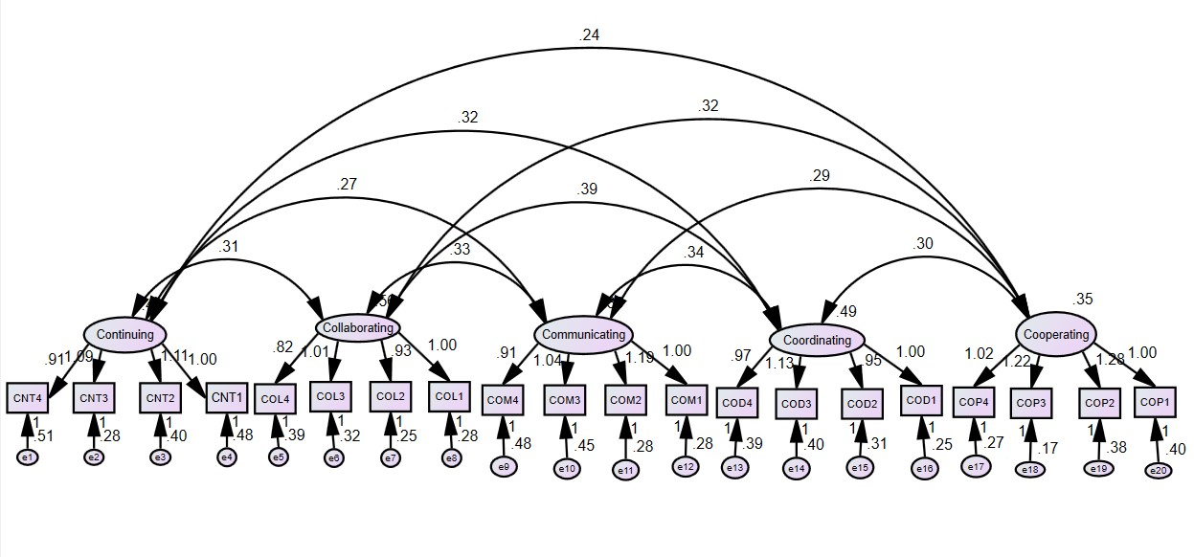
Figure 1: Factor model analysis
Correlation analysis
The normality of the data was checked by comparing the normal distribution curve with a histogram of residuals, and a normal distribution line without violation of any assumption was observed (Hair, Black, Anderson, & Babin, 2018). Moreover, the Pearson correlation was used to check the strength of the relationship between the dimensions of the 5C’s strategies and the internationalization of higher education, which revealed a significant and positive relationship (p<0.01) between the variables (see Table 4).

Table 4. Summary of mean, standard deviation, and correlation analysis among the variables
Sr. | Variables | Mean | SD | 1 | 2 | 3 | 4 | 5 | 6 | 7 | 8 | 9
1 | Context | 3.79 | .778 | 1
2 | Input | 4.09 | .700 | .718** | 1
3 | Process | 4.03 | .666 | .570** | .655** | 1
4 | Outcome | 3.92 | .613 | .628** | .665** | .700** | 1
5 | Communicating | 4.02 | .704 | .517** | .594** | .590** | .697** | 1
6 | Cooperating | 4.06 | .734 | .487** | .567** | .569** | .625** | .665** | 1
7 | Coordinating | 3.98 | .744 | .551** | .581** | .562** | .627** | .657** | .643** | 1
8 | Collaborating | 3.92 | .759 | .519** | .524** | .467** | .571** | .593** | .616** | .660** | 1
9 | Continuing | 3.95 | .737 | .580** | .587** | .541** | .620** | .663** | .686** | .870** | .890** | 1
**. Correlation is significant at the 0.01 level (2-tailed).

Hypothesis testing

Regression analysis was performed to examine how much variance is explained by the predictor variable of each strategy in the dependent variable of internationalization of higher education. The p-value of 0.000 (<0.001) indicates that every unit of change in the dimensions of 5C’s strategies results in a significant change in the internationalization of higher education. The value of R² explains the percentage of variation in the dependent variable (IHE), indicating the closeness of data to the regression line also known as the coefficient of determination. The results of H₁ revealed that communicating strategy explains 48.6% of the variance in the internationalization of higher education (ΔF=273.947, p<0.001). The standardized beta value for communicating strategy was also positive and significant (β =0.697, p<0.001). For H₂, the regression analysis yielded significant and positive results indicating that cooperating strategy explains 38.7% of the variance in the internationalization of higher education (ΔF=183.268, p<0.001), with a positive and significant standardized beta value of cooperating strategy was also (β =0.622, p<0.001).

The findings for H₃ revealed that the coordinating strategy explains 46.2% of the variance in the internationalization of higher education (ΔF=249.328, p< 0.001). The standardized beta value of the coordinating strategy was also positive and significant (β =0.680, p < 0.001). For H₄, the analysis yielded significant and positive results, where collaborating strategy explains 36.4% of the variance in the internationalization of higher education (ΔF=166.290, p<0.001), with a positive and significant standardized beta value of collaborating strategy was also (β = 0.604, p<0.001). In addition, the results for H₅ revealed that continuing strategy explains 46.2% of the variance in the internationalization of higher education (ΔF=249.041, p<0.001). The standardized beta value of the continuing strategy was also positive and significant (β =0.680, p<0.001). Moreover, multicollinearity diagnostics were performed due to high values of correlation among a few variables of the study. Based on the thresholds of VIF (<10) and tolerance (>0.10), no issue of multicollinearity was found (see Table 5), as per the guidelines of Hair et al. (2018).

Table 5. Summary of regression analysis for testing research hypotheses and multicollinearity diagnostics
Hyp. | Variables |  |  | Internationalization of Higher Education
 |  | Coefficients |  |  |  | Model Summary |  |  | ANOVA |  | Multicollinearity
 |  | β |  | t | Sig | R | R² | Adj R² | ΔF | Sig. |  | Tolerance (>.10) | VIF  (<10)
1 | Communicating | 0.581 |  | 15.099 | 0.000 | 0.690 | 0.476 | 0.474 | 227.987 | 0.000 |  | 0.523 | 1.911
2 | Cooperating | 0.524 |  | 13.462 | 0.000 | 0.6482 | 0.419 | 0.417 | 181.236 | 0.000 |  | 0.516 | 1.939
3 | Coordinating | 0.535 |  | 14.359 | 0.000 | 0.672 | 0.451 | 0.449 | 206.174 | 0.000 |  | 0.175 | 5.720
4 | Collaborating | 0.471 |  | 11.970 | 0.000 | 0.603 | 0.363 | 0.361 | 143.276 | 0.000 |  | 0.153 | 6.549
5 | Continuing | 0.543 |  | 14.491 | 0.000 | 0.675 | 0.456 | 0.453 | 210.001 | 0.000 |  | 0.115 | 5.731

Further to hypotheses testing, discriminant validity was evaluated where three measures were employed to determine the degree to which the constructs varied from one another: Hetrotrait-Monotrait ratio (HTMT), cross-loadings, and the Fornell and Lacker criterion. SmartPLS, which is frequently utilized in research, was also employed in this study to evaluate data for the discriminant validity assessment criteria. However, when a measuring model's construct's square root of AVE is greater than the inter-item correlation, discriminant validity is demonstrated. Accordingly, discriminant validity criteria of HTMT, cross-loadings, and Fornell and Lacker were satisfied. The measurement analysis was performed through SmartPLS and the measurement model of the study is presented in Figure 2.

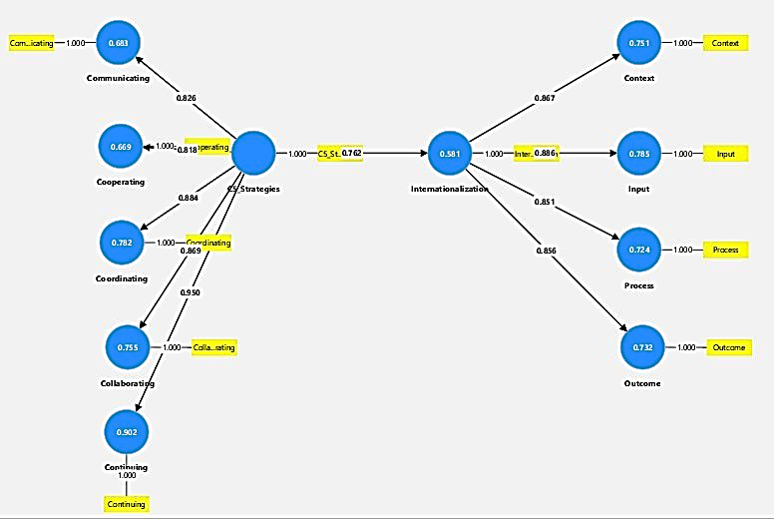
Figure 2: Measurement model

Discussion of findings

The findings substantiate the research hypotheses indicating all the 5C’s strategies have significant and positive contributions to the internationalization of higher education, based on the correlation and regression analyses. The significance of these results is presented in a schematic view of 5C’s strategies for the internationalization of higher education (see Figure 3). Further, correlation analysis showed significant relations of the participant type (i.e. student /faculty) with communication strategy as well as the process and outcome of international higher education. Moreover, communication strategy has a significant influence (F =273.947, p<0.001) in attracting foreign students and faculty, grasping foreign investments, and imparting quality teaching material to promote the internationalization of higher education. Also, effective communication increases the chances of an effective linkage between international development agencies and educational institutions to enhance the internationalization of higher education (Sok & Bunry, 2021). To achieve the benefits of internationalization, HEIs and key stakeholders need to focus on effective communication, otherwise, the lack of communication and language barriers can be a critical hindrance in enhancing the internationalization of higher education. Indeed, the rise of communications technology (ICT) can also enable close and focused interaction between international stakeholders involved in the internationalization of higher education, which is in agreement with Bamberger (2021).

The cooperating strategy has shown a significant and positive effect on the internationalization of higher education (F=183.268, p<0.001). To capitalize on the activities of higher education internationalization, both local and global cooperative support is required to build short-term and long-term relationships as well as enhance learning opportunities with the international community. Although the differences among cultures, values, languages, and countries are factors that can hinder cooperation among institutions of higher education. However, cooperation is required to establish an environment of supportive understanding in addition to developing cooperative models for the internationalization of higher education. This finding is in support of the propositions of de Wit and Altbach (2021), which identify the role of the cooperative environment in enhancing internationalization activities.

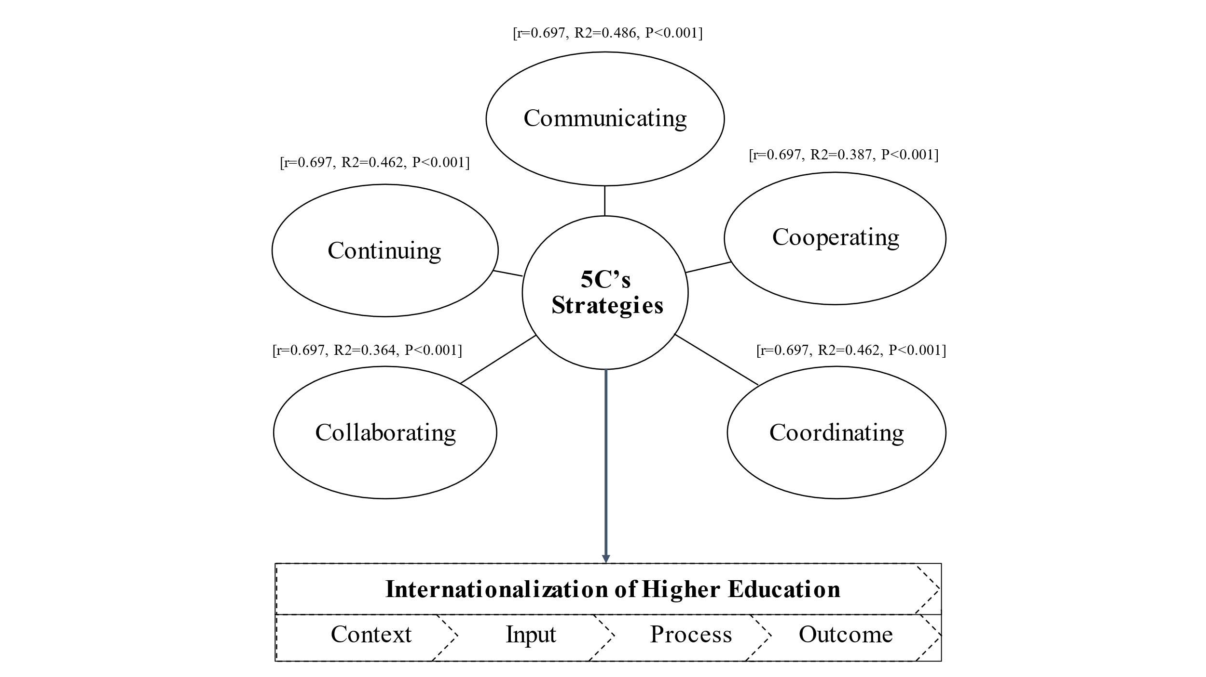
Figure 3. Schematic view of 5C’s strategies

The results indicate that the coordinating strategy in both public and private institutions has a significant and positive influence on the internationalization of higher education (F=249.328, p<0.001). Indeed, coordinated efforts are often required to export standardized academic material, and organize international training of faculty, in addition to the opening of new campuses across borders for expanding the activities of internationalization. Yet organizational structures and systems are often inadequate to track the changes and coordinate responses made for the improvement of higher education internationalization, as suggested by Hines and Dockiao (2021). To overcome such challenges, coordinated efforts are essential to avoid unnecessary duplication of work and maximize the efforts of individuals and institutions concerning the enhancement of internationalization activities. Moreover, improved coordination between the academic departments and research units of partnering institutions requires more strategic focus on the internationalization of higher education through capacity-building programs, international research policies, and systems which is in line with de Wit and Altbach (2021).

The findings demonstrated that collaboration strategy has a significant and positive impact on the internationalization of higher education (ΔF=166.290, p<0.001). However, more efforts are required to collaborate for joint research activities, franchising academic programs and institutions, and initiate joint ventures for enhancing internationalization events. Indeed, collaborative training programs faced serious hurdles among other challenges related to the COVID-19 pandemic In line with Ryu and Nguyen (2021), international collaborative activities need to be increased, in addition to accelerating the level of training, collaborative programs, and joint research activities among prestigious institutions. Furthermore, collaborative networking contributes to strategic thinking that leads to innovative ideas, encourages research collaboration, and opens new avenues of learning, thereby promoting global research and the internationalization of higher education.

Finally, the continuing strategy also has a significant and positive impact on the internationalization of higher education (F=249.041, p<0.001), which can be achieved through a continuous exchange of teaching material, exchange of students and faculty, and continuity in joint ventures to facilitate the activities of internationalization of higher education. For such purposes, educational institutions need to continue to develop and update organizational frameworks for enhancing the internationalization of higher education. The challenges of learning with continuity during the COVID-19 pandemic highlighted numerous possible shortcomings of higher education, which can be mitigated through continuous collaborative and supportive efforts as part of the internationalization of higher education.

Implications of the study

The study has both theoretical and practical implications for the implementation of internationalization strategies for higher education. Although some theoretical outcomes are straightforward and based on the results, it can be expected that these strategies (i.e. communicating, cooperating, coordinating, collaborating, and continuing) effectively contribute to enhancing the activities of internationalization of higher education. Otherwise, a lack of communication among key stakeholders including academic institutions, and a lack of continuation of bringing together international students and faculty as well as joint research initiatives may affect the performance of higher education internationalization. To avoid such occurrences, effective cooperation, innovative collaboration, and harmonized coordination strategies are required to increase the engagement of overseas students, faculty exchange, and joint research ventures. At the same time, faculty and students of both public and private universities require further support and guidance to capitalize on the internationalization of higher education. From this perspective, there is a need to develop the competencies and skills of individuals involved in the activities of internationalizing higher education through short-term and long-term training programs.
From a practical perspective, the findings also imply that internationalization activities undertaken by HEIs depend on effective communication to attract foreign students, exchange of teaching material, and engagement of foreign experts. Accordingly, HEIs need to establish strong linkages with other international institutions to enhance internationalization activities through the exchange of students, faculty, and programs, and the sharing of library and equipment resources. To further enhance such initiatives, institutions need to collaborate on joint academic and research ventures, and franchising of programs as well as overseas campuses, in addition to updating teaching material, retaining skilled faculty, and investing in the establishment of overseas branches. Indeed, internationalization is not a one-time process, rather it requires continuous improvement in terms of acquiring material and methods, consistently improving the ratio of students and teachers involved in the exchange process, and strengthening the joint ventures, franchised programs, and collaborative initiatives. Thus, HEIs need to define clear strategies for carefully managing their operational plans and maximizing the potential benefits of the internationalization of higher education. Indeed, the maturity of internationalization capabilities at HEIs can be considered in regard to the level of plans, resources, funding, and partnerships that are in place to underpin the delivery of internationalization strategies.

The COVID-19 pandemic had a major impact on worldwide educational systems, where some countries attempted to cope with this concern through virtual educational delivery, while others were unable to manage the situation due to socioeconomic and technological infrastructure issues. In this context, there is a greater need for universities to focus on the internationalization of higher education by developing and adopting enabling strategies to disseminate and acquire knowledge; adopt innovative educational practices; establish joint degrees; develop standardized curriculum and teaching material; and enhance technological capabilities; and attract more international students and faculty. Therefore, an integrated policy to overcome the challenges of internationalization of higher education is required, which can be supported through the adoption of the 5C’s strategy. Furthermore, institutions can work together to enhance the quality of curriculum and joint research outputs through the exchange of students and faculty members worldwide.

Conclusion, limitations, and future research directions

Due to the worldwide impact of the COVID-19 pandemic, there is a pressing need to think beyond the myths and realities of internationalization to reshape the modern world and promote the internationalization of higher education. Consequently, while the adoption of the 5C’s strategy can help HEIs pursue a trajectory of higher education internationalization, such an approach can also support institutions to cope with the turbulence caused by future pandemics and other critical events. Therefore, enabling strategies are required for effective and efficient management of activities towards the internationalization of higher education. This approach will provide a platform for supporting activities that collectively and synergistically support HEIs to be more robust and durable regarding the challenges associated with unforeseen events such as global pandemics. This empirical study explored the 5C’s strategies based on a comprehensive literature review and synthesis of hypotheses to examine the impact on the internationalization of higher education. This was achieved through cross-sectional data collected from both public and private universities. From a post-pandemic perspective, the findings suggest that communicating, cooperating, coordinating, collaborating, and continuing strategies significantly contribute to enhancing the internationalization of higher education.

This study was limited to exploring five effective strategies (5C’s) and investigating their impact on the internationalization of higher education. Therefore, future studies may explore further relevant strategies in addition to the 5C’s model, which includes but are not limited to consistency, commitment, and concentration. Furthermore, the study developed and operationalized the 5C’s strategies instrument (5C-SI), which may be validated through future research studies for more generalizability. Although the sample data of 253 responses from both public and private sector universities in Pakistan have some international coverage the respondents have experience and insights of the internationalization of higher education. However, it would be interesting for future researchers to validate the findings of this study with a larger sample of data from different stakeholders (i.e. students, faculty, and other staff) of various higher education institutions from multiple countries.

References

Amoah, P., & Mok, K. J. O. O. J., Banbury Road, Great Britain. Preuzeto. (2020). Weekend reading: The Covid-19 pandemic and internationalization of higher education: International students’ knowledge, experiences and wellbeing. 7, 20-21.
Aristovnik, A., Keržič, D., Ravšelj, D., Tomaževič, N., & Umek, L. (2020). Impacts of the COVID-19 pandemic on life of higher education students: A global perspective. Sustainability, 12(20), 8438.
Aucejo, E. M., French, J., Araya, M. P. U., & Zafar, B. (2020). The impact of COVID-19 on student experiences and expectations: Evidence from a survey. Journal of Public Economics, 191, 104271.
Aydinli, E., & Mathews, J. (2021). Searching for larger status in global politics: Internationalization of higher education in Turkey. Journal of Studies in International Education, 25(3), 247-265.
Bamberger, A. (2021). From human capital to marginalized other: a systematic review of diaspora and internationalization in higher education. British Journal of Educational Studies, 1-23.
Browning, M. H., Larson, L. R., Sharaievska, I., Rigolon, A., McAnirlin, O., Mullenbach, L., . . . Reigner, N. (2021). Psychological impacts from COVID-19 among university students: Risk factors across seven states in the United States. PloS one, 16(1), e0245327.
Cattell, R. B. (1966). The scree test for the number of factors. Multivariate behavioral research, 1(2), 245-276.
Chan, C., & Luk, L. (2021). Development and validation of an instrument measuring undergraduate students’ perceived holistic competencies. Assessment Evaluation in Higher Education, 46(3), 467-482.
Chang, D.-F., & Lin, N.-J. (2018). Applying CIPO indicators to examine internationalization in higher education institutions in Taiwan. International Journal of Educational Development, 63, 20-28.
Chumney, F. (2012). Principal components analysis, exploratory factor analysis, and confirmatory factor analysis. Reading and understanding multivariate statistics. Washington, DC: American Psychological Association, 99-136.
Conway, J., & Huffcutt, A. (2003). A review and evaluation of exploratory factor analysis practices in organizational research. Organizational research methods, 6(2), 147-168.
Costa, R. P., & Canen, A. G. (2021). Internationalization of Higher Education Institutions: perceptions of scholars. Ensaio: Avaliação e Políticas Públicas em Educação, 30, 94-115.
Daniel, S. J. (2020). Education and the COVID-19 pandemic. Prospects, 49(1), 91-96.
de Wit, H., & Altbach, P. G. (2021). Internationalization in higher education: global trends and recommendations for its future. Policy Reviews in Higher Education, 5(1), 28-46.
Dias, G. P., Barbosa, B., Santos, C. A., Pinheiro, M. M., Simões, D., & Filipe, S. (2021). Between promises and pitfalls: the impact of mobility on the internationalization of higher education. Journal of Further Higher Education, 45(1), 79-94.
Fantini, A. E. (2020). Reconceptualizing intercultural communicative competence: A multinational perspective. Research in Comparative International Education, 15(1), 52-61.
Field, A. (2013). Discovering statistics using IBM SPSS statistics. sage.
Glorfeld, L. W. (1995). An improvement on Horn's parallel analysis methodology for selecting the correct number of factors to retain. Educational and psychological measurement, 55(3), 377-393.
Grimm, L. G., & Yarnold, P. R. (1995). Reading and understanding multivariate statistics. American psychological association.
Guadagnoli, E., & Velicer, W. F. (1988). Relation of sample size to the stability of component patterns. Psychological bulletin, 103(2), 265-274.
Guttman, L. (1954). Some necessary conditions for common-factor analysis. Psychometrika, 19(2), 149-161.
Gillett-Swan, J. (2017). The challenges of online learning: Supporting and engaging the isolated learner. Journal of Learning Design, 10(1), 20-30.
Hagl, M., & Kouabenan, D. R. (2020). Safe on the road–does advanced driver-assistance systems use affect road risk perception?. Transportation research part F: traffic psychology and behaviour, 73, 488-498.
Hair Jr, J. F., Matthews, L. M., Matthews, R. L., & Sarstedt, M. (2017). PLS-SEM or CB-SEM: updated guidelines on which method to use. International Journal of Multivariate Data Analysis, 1(2), 107-123.
Hair, J., Black, W., Anderson, R., & Babin, B. (2018). Multivariate Data Analysis (8, ilustra ed.). Cengage Learning EMEA.
Helms, R. M. (2020). Can internationalization survive coronavirus? You need to see my data. Higher Education Today, 4(1), 1-12.
Herman, P. C. (2020). Online learning is not the future. Inside Higher Ed, 1, 1-7.
Hines, A., & Dockiao, L. (2021). Key issues influencing the future internationalization of higher education: the case of Thailand. On The Horizon-The Strategic Planning Resource for Education Professionals, 29(3), 77-100.
Jones, E., Leask, B., Brandenburg, U., & de Wit, H. (2021). Global Social Responsibility and the Internationalisation of Higher Education for Society. Journal of Studies in International Education, 25(4), 330-347.
Kaiser, H. F. (1960). The application of electronic computers to factor analysis. Educational and psychological measurement, 20(1), 141-151.
Kline, R. B. (2023). Structural equation modeling in neuropsychology research. In APA handbook of neuropsychology, Volume 2: Neuroscience and neuromethods, Vol. 2 (pp. 681-698). American Psychological Association.
Knight, J. (2008). Higher Education in Turmoil: The Changing World of Internationalization. In Higher Education in Turmoil: Sense Publishers.
Knight, J. (2011). Five myths about internationalization. International Higher Education(62).
Knight, J., & de Wit, H. (2018). Internationalization of higher education: past and future. International Higher Education(95), 2-4.
Lautenschlager, G. J. (1989). A comparison of alternatives to conducting Monte Carlo analyses for determining parallel analysis criteria. Multivariate behavioral research, 24(3), 365-395.
Li, J., & Eryong, X. (2021). New directions towards internationalization of higher education in China during post-COVID 19: A systematic literature review. Educational Philosophy Theory, 1-10.
Liu, O. L., & Rijmen, F. (2008). A modified procedure for parallel analysis of ordered categorical data. Behavior Research Methods, 40, 556-562.
Mardia, Kanti V. "Measures of multivariate skewness and kurtosis with applications." Biometrika 57, no. 3 (1970): 519-530.
Mardia, K. V. (1974). Applications of some measures of multivariate skewness and kurtosis in testing normality and robustness studies. Sankhyā: The Indian Journal of Statistics, Series B, 115-128.
Marić, J., & Gama-Araujo, I. (2022). Implications of the COVID-19 pandemic in education and vaccine hesitancy among students: a cross-sectional analysis from France. International Journal of Logistics Research Applications, 5(2), 1-20.
Means, A. J. (2017). Education for a post-work future: Automation, precarity, and stagnation. Knowledge Cultures, 5(01), 21-40.
Mok, K. H., Xiong, W., Ke, G., & Cheung, J. O. W. (2021). Impact of COVID-19 pandemic on international higher education and student mobility: Student perspectives from mainland China and Hong Kong. International Journal of Educational Research, 105(1), 101718.
Mukherjee, D., & Hasan, K. K. (2020). Challenges in Learning Continuity during the COVID-19 Pandemic: A Methodological and Thematic Review. South Asian Journal of Management, 27(3).
Norusis, M. (1985). Advanced statistics guide SPSSX. Chicago: SPSS Inc.
Pituch, K. A., & Stevens, J. P. (2015). Exploratory factor analysis. In Applied Multivariate Statistics for the Social Sciences (pp. 339-390). Routledge.
Ramaswamy, M., Marciniuk, D. D., Csonka, V., Colò, L., & Saso, L. (2021). Reimagining internationalization in higher education through the United Nations sustainable development goals for the betterment of society. Journal of Studies in International Education, 25(4), 388-406.
Rasikawati, I., Shea, M., Zhou, S., Pattiwael, A., Wicks, D., & Sulastri, M. (2021). Sustaining Internationalization in Higher Education: Before and After the COVID-19 Pandemic. Virtually Hosted, Florida, USA, 151.
Roberts, P., & Priest, H. (2006). Reliability and validity in research. Nursing standard, 20(44), 41-46.
Rosyidah, N., & Rosyidi, U. (2020). Internationalization in Higher Education: University's Effective Promotion Strategies in Building International Trust. European Journal of Educational Research, 9(1), 351-361.
Ryu, J. H., & Nguyen, A. T. (2021). Internationalization of higher education in Vietnam: current situations, policies, and challenges. International Journal of Comparative Education Development, 23(3), 227-241.
Sá, M. J., & Serpa, S. (2020). The COVID-19 pandemic as an opportunity to foster the sustainable development of teaching in higher education. Sustainability, 12(20), 85-105.
Seke, M. M. (2020). Would We Be Able to Absorb the New Normal Brought by COVID-19 as Another Educational Revolution? International Journal of Advanced Corporate Learning, 13(4).
Sharma, Y. (2020). Disaster preparedness would improve he pandemic response. University World News, 18, 1-7.
SO, K. Y. (2021). A study of higher education internationalization in Hong Kong: Myths and realities.
Sok, S., & Bunry, R. (2021). Internationalization of higher education in Cambodia: toward an agenda for higher education development. International Journal of Comparative Education Development, 23(3), 193-211.
Strielkowski, W., Grebennikova, V., Razinkina, E., & Rudenko, E. (2021). Relationship between globalization and internationalization of higher education. Paper presented at the E3S Web of Conferences.
Strotmann, B., & Kunschak, C. (2022). Toward the internationalization of higher education: developing university students’ intercultural communicative competence in Spain. Language Intercultural Communication, 1-20.
Tasci, G. (2021). The impact of COVID-19 on Higher Education: Rethinking internationalization behind the iceberg: COVID-19 and Higher Education. International Journal of Curriculum Instruction, 13(1), 522-536.
Tesar, M. (2020). Towards a post-Covid-19 ‘new normality?’: Physical and social distancing, the move to online and higher education. Policy Futures in Education, 18(5), 556-559.
Velicer, W. F. (1976). Determining the number of components from the matrix of partial correlations. Psychometrika, 41, 321-327.
Woicolesco, V. G., Morosini, M., & Marcelino, J. M. (2021). COVID-19 and the crisis in the internationalization of higher education in emerging contexts. Policy Futures in Education, 14782103211040913.
Zheng, J., & Kapoor, D. (2021). State formation and higher education (HE) policy: An analytical review of policy shifts and the internationalization of higher education (IHE) in China between 1949 and 2019. Higher Education, 81(2), 179-195.
Zolfaghari, A., Sabran, M. S., & Zolfaghari, A. (2009). Internationalization of higher education: challenges, strategies, policies and programs. Online Submission, 6(5), 1-9.

Appendix A

Measures of variables
Internationalization

Context:
C1: Increase in the number of international students
C2: Focus on the distribution of international students’ countries
C3: Increase in the number of overseas students
C4: Focus on the distribution of overseas students and their increase among various countries

Input:
I1: Setting up international aﬀairs oﬃces in universities
I2: Skilled staﬀ in the international aﬀairs oﬃces
I3: Developing and implementing a strategic plan for internationalization
I4: Monitoring the process of internationalization through SOPs
I5: Funding for promoting internationalization

Process:
P1: Establishing overseas branch campuses
P2: Establishing distance-learning programs
P3: Promoting international research cooperation
P4: Developing and offering internationalization-related courses
P5: Promoting international learning activities
P6: Promoting international student recruitment
P7: Promoting international internships and accreditations

Outcome:
O1: Focusing on the ratio of outbound students
O1: Focusing on the ratio of international students on campus
O3: Focusing on the ratio of foreign staﬀ on campus
O4: Focusing on several international cooperation programs
O5: Focusing on several articles published in international journals
O6: Focusing on several papers in international conference proceedings

Strategies

Communicating:
CM1: Communicating to attract foreign students
CM2: Communicating to import teaching material
CM3: Communicating to employ foreign experts
CM4: Communicating to grasp foreign investment

Cooperating:
CP 1: Cooperate for the exchange of students
CP 2: Cooperate for the exchange of teachers
CP 3: Cooperate for the exchange of programs
CP 4: Cooperate in sharing of library resources

Coordinating:
CD 1: Coordinate for exporting teaching material
CD 2: Coordinate for sending domestic experts
CD 3: Coordinate to establish overseas branches
CD 4: Coordinate for investing in schools

Collaborating:
CB 1: Collaborate for joint academic research
CB 2: Collaborate on franchising programs
CB 3: Collaborate with franchising institutions
CB 4: Collaborate on joint venture

Continuing:
CT 1: Continue exporting teaching material
CT 2: Continue exchanging students and teachers
CT 3: Continue franchising programs and institutions
CT 4: Continue strengthening the joint venture

Appendix B

Summary of descriptive statistics

Descriptive Statistics
 | N | Minimum | Maximum | Mean | Std. Deviation | Skewness |  | Kurtosis
 | Statistic | Statistic | Statistic | Statistic | Statistic | Statistic | Std. Error | Statistic | Std. Error
CNT1 | 253 | 1.00 | 5.00 | 3.6877 | .96431 | -.731 | .153 | .512 | .305
CNT2 | 253 | 1.0 | 5.0 | 3.735 | .9785 | -.652 | .153 | .079 | .305
CNT3 | 253 | 1.00 | 5.00 | 3.7036 | .92746 | -.700 | .153 | .551 | .305
CNT4 | 253 | 1.00 | 5.00 | 4.0474 | .96245 | -1.172 | .153 | 1.361 | .305
INP1 | 253 | 1.00 | 5.00 | 4.2016 | .90571 | -1.249 | .153 | 1.562 | .305
INP2 | 253 | 1.00 | 5.00 | 4.1462 | .83473 | -.941 | .153 | .968 | .305
INP3 | 253 | 1.00 | 5.00 | 4.2095 | .85889 | -1.327 | .153 | 2.249 | .305
INP4 | 253 | 1.00 | 5.00 | 3.9960 | .97386 | -.927 | .153 | .631 | .305
INP5 | 253 | 1.00 | 5.00 | 3.9170 | 1.03367 | -.876 | .153 | .252 | .305
PCS1 | 253 | 1.00 | 5.00 | 3.8340 | 1.08201 | -1.010 | .153 | .535 | .305
PCS2 | 253 | 1.00 | 5.00 | 4.1779 | .86142 | -1.253 | .153 | 2.025 | .305
PCS3 | 253 | 1.00 | 5.00 | 4.0870 | .84065 | -.974 | .153 | 1.116 | .305
PCS4 | 253 | 1.00 | 5.00 | 4.1502 | .80251 | -1.114 | .153 | 1.828 | .305
PCS5 | 253 | 1.00 | 5.00 | 4.0158 | .93422 | -1.179 | .153 | 1.610 | .305
PCS6 | 253 | 1.00 | 5.00 | 4.2134 | .88747 | -.982 | .153 | .355 | .305
PCS7 | 253 | 1.00 | 5.00 | 3.7391 | .90146 | -.444 | .153 | .093 | .305
OTM1 | 253 | 1.00 | 5.00 | 3.7866 | .78799 | -.191 | .153 | -.161 | .305
OTM2 | 253 | 1.00 | 5.00 | 3.8340 | .86609 | -.706 | .153 | .549 | .305
OTM3 | 253 | 1.00 | 5.00 | 3.7826 | .94919 | -.871 | .153 | .929 | .305
OTM4 | 253 | 1.00 | 5.00 | 4.0474 | .77519 | -.700 | .153 | .716 | .305
OTM5 | 253 | 1.00 | 5.00 | 4.0672 | .89055 | -.880 | .153 | .668 | .305
OTM6 | 253 | 1.00 | 5.00 | 4.0316 | .78109 | -.559 | .153 | .299 | .305
COM1 | 253 | 1.00 | 5.00 | 4.1462 | .82997 | -1.161 | .153 | 2.323 | .305
COM2 | 253 | 1.00 | 5.00 | 4.0237 | .91256 | -.868 | .153 | .673 | .305
COM3 | 253 | 1.00 | 5.00 | 3.9644 | .91435 | -.840 | .153 | .630 | .305
COM4 | 253 | 1.00 | 5.00 | 3.9486 | .86449 | -.829 | .153 | .998 | .305
COP1 | 253 | 1.00 | 5.00 | 4.0672 | .85880 | -.698 | .153 | .069 | .305
COP2 | 253 | 1.00 | 5.00 | 3.9051 | .99148 | -.916 | .153 | .479 | .305
COP3 | 253 | 1.00 | 5.00 | 4.0632 | .84278 | -.682 | .153 | .134 | .305
COP4 | 253 | 2.00 | 5.00 | 4.2174 | .80928 | -.824 | .153 | .115 | .305
COD1 | 253 | 1.00 | 5.00 | 4.0632 | .82373 | -.805 | .153 | 1.027 | .305
COD2 | 253 | 1.00 | 5.00 | 4.0158 | .87273 | -.861 | .153 | .976 | .305
COD3 | 253 | 1.00 | 5.00 | 3.8261 | 1.00069 | -.890 | .153 | .607 | .305
COD4 | 253 | 1.00 | 5.00 | 4.0237 | .89500 | -.750 | .153 | .372 | .305
COL1 | 253 | 1.00 | 5.00 | 3.8775 | .92839 | -.893 | .153 | .869 | .305
COL2 | 253 | 1.00 | 5.00 | 4.0751 | .86275 | -.930 | .153 | .833 | .305
COL3 | 253 | 1.00 | 5.00 | 3.8103 | .95721 | -.761 | .153 | .523 | .305
COL4 | 253 | 1.00 | 5.00 | 3.9051 | .87224 | -.538 | .153 | .037 | .305
CTN1 | 253 | 1.00 | 5.00 | 3.8261 | 1.00069 | -.890 | .153 | .607 | .305
CTN2 | 253 | 1.00 | 5.00 | 4.0237 | .89500 | -.750 | .153 | .372 | .305
CTN3 | 253 | 1.00 | 5.00 | 3.8775 | .92839 | -.893 | .153 | .869 | .305
CTN4 | 253 | 1.00 | 5.00 | 4.0751 | .86275 | -.930 | .153 | .833 | .305

Appendix C
Mardia’s Univariate and Multivariate Skewness & Kurtosis

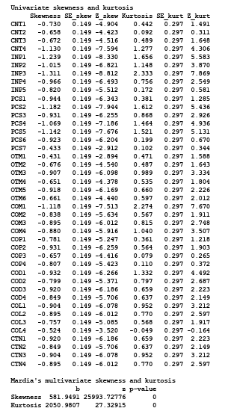

Appendix D

Scree plot

5C’s strategies

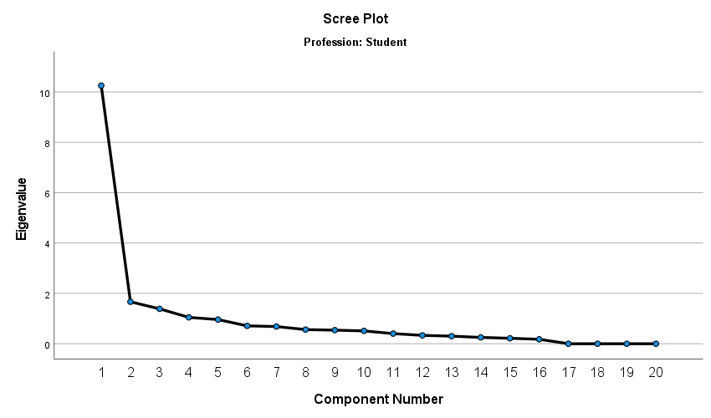

Internationalization

