Dielectric Characterization of Biological Samples by Using an Open-ended Coaxial Probe

Eliana Canicattì^{1,2}, Danilo Brizi^{1,2}, Agostino Monorchio^{1,2}
¹Department of Information Engineering
University of Pisa
²RaSS National Laboratory, CNIT
Pisa, Italy
eliana.canicatti@phd.unipi.it, danilo.brizi@ing.unipi.it, agostino.monorchio@unipi.it
Nunzia Fontana³
³Department of Energy, Systems, Territory and Construction Engineering (DESTEC)
University of PisaPisa, Italy
nunzia.fontana@unipi.it
Gianluigi Tiberi⁴
³School of Engineering, London South Bank University, London, UK,
g.tiberi@iet.unipi.it

Abstract—The present work proposes the use of a miniaturized open-ended coaxial probe to perform the detection of normal and malignant biological tissues, typically resulting from an excisional biopsy. The system has been numerically designed by analyzing a biological specimen having spherical shape and by varying its diameter, accordingly. The dielectric properties characterization has been carried out by using an open-ended coaxial probe combined with the virtual line transmission model reconstruction algorithm. The minimum size of the biological specimen to obtain an acceptable characterization has been assessed.
Keywords—open-ended coaxial probe; biological specimen biopsy; malignant tissues detection; dielectric properties.

Introduction
An excisional biopsy is a medical procedure in which a small amount of tissue is surgically removed in order to be analyzed by a pathologist. As soon as the tissue sample is removed, it is sent to a laboratory for testing and this process could take weeks. As reported in literature [1], the dielectric properties of normal and its corresponding malignant tissue are different. Both dielectric permittivity and electrical conductivity are generally greater in malignant tissues due to the higher water content than in normal one. Therefore, the electromagnetic characterization of the tissues made through an open ended coaxial probe can be used as an advantageous rapid procedure to evaluate if the biological specimen under analysis is malignant or healthy. Several works are present in literature regarding the use of an open ended-coaxial probe for the detection of healthy and malignant tissues like breast [2], colon and liver [3] due to its simple feasibility and not necessary sample preparation. An accurate reconstruction of the dielectric parameters can be obtained from the measurement of the probe reflection coefficient under the hypothesis in which the size of sample is considered semi-infinite. However, in the case of biopsy the dimensions cannot clearly fulfill this last assumption, due to the very typical small size of the sample, which is in the order of millimeters. In literature, only few works report the effect of using an open-ended coaxial probe to characterize biological specimen of finite size. In [4], the minimum biological specimen size that yields accurate measurements by comparing two different probes have been investigated starting from a large amount of liquids simulating the biological healthy and malignant tissues. We propose a systematic work in order to find the minimum optimal size of biological specimen that can be characterized with our custom-designed open-ended coaxial probe and the associated inversion algorithm described in our previous work by resorting a numerical phantom having a realistic shape with respect to an excisional biopsy tissue sample [5].

Method
In our previous work, we designed an optimized open-ended coaxial probe as a good compromise between the physical feasibility and the combined use with the VTLM (Virtual Transmission Line Model) algorithm [5]. The small diameter of the probe we obtained allows to obtain high accuracy, thus making it suitable for the detection of healthy and malignant tumor tissue. In this work, we aim to assess the smallest finite size of the sample the system is able to characterize.
In order to obtain the minimum optimal size of the biological specimen, a numerical analysis with CST Studio Suite 2019 has been performed (Fig.1). Two spherical numerical phantoms have been designed by taking into account the dispersive characteristics of the normal and malignant liver. The first order Debye model of the previous tissues has been used in the simulations [3]. The numerical tests have been performed in the frequency range between 500 MHz and 3 GHz as defined in the adopted model.
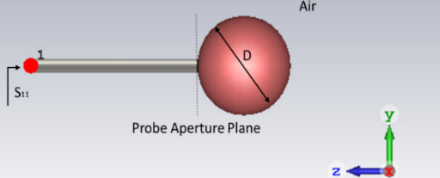
Fig. 1 3D Numerical CST Model of the open ended coaxial probe with the sferical numerical phantom of liver.
Since the actual excised tissue specimens can considerably vary in physical size from 7 to 15 mm, we acquired the reflection coefficient of the two numerical tissues having diameters in the range 4 mm to 20 mm. The cable of 0.05 mm is inserted inside the spherical sample in order to simulate the contact with the material under test and to ensure a good mechanical coupling, thus avoiding air gaps.

Numerical Results
By applying the VLTM reconstruction algorithm to the numerical reflection coefficients that we obtained from tissues under test, we reconstructed their dielectric properties. In Fig. 2, it is possible to observe that, as the diameter of the sphere grows, the algorithm accurately reconstructs the dielectric properties of both healthy and malignant liver.

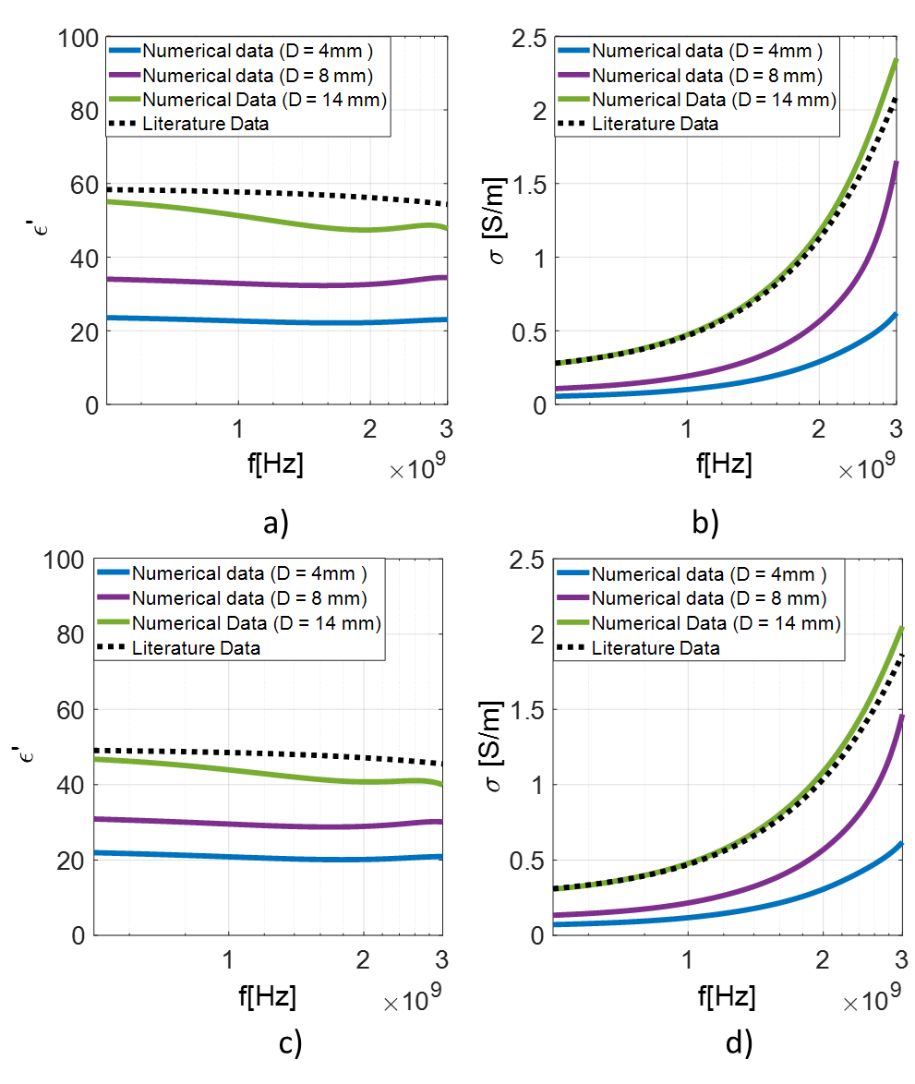
Fig. 2 Dielectric properties extracted from numerical reflection coefficient: a) real part of dielectric permittivity of malignant liver; b) electrical conductivity of malignant liver; c) real part of dielectric permittivity of normal liver; d) electrical conductivity of normal liver.

The Mean Percentage Error (MPE) was calculated in order to evaluate the deviation from theoretical model.
Since the mean percentage error obtained in both tissues is less than 13%, the obtained results for a sphere with a diameter equal to 14 mm can be considered significant and acceptable (Table I and Table II). In all the cases in which diameters are smaller than 14 mm, the obtained percentage error is higher than 13%, thus cannot be considered acceptable for the proposed system.
TABLE I
MPE calculated for real part of permittivity
 | εr (D =4mm) | εr (D= 8mm) | εr (D= 14mm)
Malignant Liver | 60% | 41.35% | 12.67%
Normal Liver | 56.54% | 37.83% | 11.17%

TABLE II
MPE calculated for electrical conductivity
 | σ (D =4mm) | σ (D= 8mm) | σ (D= 14mm)
Malignant Liver | 75.43% | 49.99% | 4.43%
Normal Liver | 71.82% | 45.85% | 4.39%

Conclusions
In this work, an evaluation of the minimum specimen size which allows to obtain accurate results in the detection of the dielectric properties of biological tissues - and to distinguish between normal and its malignant homologous tissue - has been proposed. Firstly, numerical simulations were performed with spherical numerical phantoms by taking into account the dispersive characteristics of the two different tissues. From the numerical reflection coefficients, the dielectric characteristics have been obtained in order to derive the minimum diameter that provides acceptable results in terms of accuracy. Although the semi-infinite medium condition is not fully satisfied, the system proposed in our previous work is able to extract the dielectric properties of biological tissues in good agreement with respect to the theoretical models (with a MPE equal to 13%). Future developments of the study will be directed to overcome the present limitation so to obtain a good characterization of the tissues with the same system also for samples smaller than 14 mm.

References
- K. R. Foster e J. L. Schepps, «Dielectric Properties of Tumor and Normal Tissues at Radio through Microwave Frequencies», Journal of Microwave Power, vol. 16, n. 2, pagg. 107–119, gen. 1981.
- M. J. Kuhn, M. Awida, M. R. Mahfouz, e A. E. Fathy, «Open-ended coaxial probe measurements for breast cancer detection», in 2010 IEEE Radio and Wireless Symposium (RWS), New Orleans, LA, USA, 2010, pagg. 512–515.
- A. P. O’Rourke et al., «Dielectric properties of human normal, malignant and cirrhotic liver tissue: in vivo and ex vivo measurements from 0.5 to 20 GHz using a precision open-ended coaxial probe», Phys. Med. Biol., vol. 52, n. 15, pagg. 4707–4719, ago. 2007.
- D. M. Hagl, D. Popovic, S. C. Hagness, J. H. Booske, e M. Okoniewski, «Sensing volume of open-ended coaxial probes for dielectric characterization of breast tissue at microwave frequencies», IEEE Trans. Microwave Theory Techn., vol. 51, n. 4, pagg. 1194–1206, apr. 2003.
- N. Fontana, E. Canicatti, A. Monorchio, «An application of the virtual transmission line model of an open-ended coaxial probe for dielectric properties characterization of biological tissues», in 2019 IEEE International Symposium on Antennas and Propagation and USNC-URSI Radio Science Meeting, Atlanta, GA, USA, 2019, pagg. 341–342

