Cite as: de Oliveira, R.F., Billington, J., Wann, J.P. (2014). Optimal use of visual information in adolescents with developmental coordination disorder. Experimental Brain Research, 232(9), 2989-2995. doi: 10.1007/s00221-014-3983-0

Optimal use of visual information
in adolescents and young adults with developmental coordination disorder

Rita F. de Oliveira
Department of Applied Sciences, London South Bank University
103 Borough Road, London SE1 0AA, UK

Jac Billington

Institute of Psychological Sciences, Faculty of Medicine and Health, University of Leeds
Woodhouse Lane, Leeds LS2 9JT, UK

John P. Wann
Department of Psychology, Royal Holloway, University of London
Egham Hill, Egham TW20 0EX, UK

Correspondence should be addressed to:
Rita F. de Oliveira
Email: r.oliveira@lsbu.ac.uk
Tel: +44 (0)20 7815 7959
Fax: +44 (0)20 7815 7699

Abstract
Aim. Recent reports offer contrasting views on whether or not the use of online visual control is impaired in individuals with developmental coordination disorder (DCD). This study explored the optimal temporal basis for processing and using visual information in adolescents and young adults with DCD.

Method. Participants were 22 adolescents and young adults (12 males and 10 females; M = 19 years, SD = 3). Half had been diagnosed with DCD as children and still performed poorly on the Movement Assessment Battery for Children (DCD group; n = 11) and half reported typical development (TD group; n = 11) and were age- and gender- matched with the DCD group. We used performance on a steering task as a measure of information processing and examined the use of advance visual information. The conditions varied the duration of advance visual information: 125, 250, 500, 750, 1000 ms.

Results. With increased duration of advance visual information, the TD group showed a pattern of linear improvement. For the DCD group, however, the pattern was best described by a U-curve where optimal performance occurred with about 750 ms of advance information.

Interpretation. The results suggest that the DCD group has an underlying preference for immediate online processing of visual information. The exact timing for optimal online control may depend crucially on the task, but too much advance information is detrimental to performance.

Keywords: dyspraxia, visual processing, movement planning, visuomotor control.
Short title: Optimal use of visual information

What this paper adds:
- Individuals with DCD do not show a generalised deficit in visuomotor control, instead they show a pattern where their use of visual information is more temporally constrained than typically developing controls.
- When individuals with DCD were able to operate within their optimal time window, we found no group differences in online control of an ongoing action.
- Increasing the amount of relevant advance information benefits the performance of typically developing individuals but it does not benefit individuals with DCD.
- Together this pattern of performance may explain why individuals with DCD struggle to cope with a range of tasks requiring online control of motion towards an end goal.

Optimal use of visual information in adolescents with developmental coordination disorder

Individuals with developmental coordination disorder (DCD) show very poor motor coordination, not attributable to a medical condition or another disorder (APA 1994). DCD interferes with activities of daily living and its symptoms often persist throughout adolescence and adulthood (Cantell et al. 2003; Losse et al. 1991). Although its aetiology is still unknown, there is a general consensus in the literature that the disorder is related to deficits in processing visuo-spatial information, even in tasks which do not include a motor component (Wilson and McKenzie 1998). Despite this general consensus research is still inconclusive as to the processes, mechanisms, and systems involved in the poor coordination displayed by individuals with DCD (Wann 2007). Efficient visuomotor control requires information processing at different timescales For instance, visual information acquired before an action is initiated can be used for the purpose of planning an initial movement, but visual information appearing during a movement can be used for online error correction via the use of visuomotor feedback loops (Desmurget and Grafton 2000; Hyde and Wilson, 2011; Wing 2002). In addition, a rapid motor online correction system is also used based on the (efferent) predicted body position and the (afferent) sensory signals from the ongoing body position. Most activities of daily living rely on the integrated use of visual and sensory information at these three different timescales. For example, in tasks as varied as drawing shapes or steering a car there is the visual information about future targets, the task of continuously monitoring the current trajectory, and the small rapid online corrections (eg, de Oliveira & Wann 2011, 2012). This requires continuous integration of environmental cues with visual and sensory information in order to execute the appropriately timed motor response.
The integration of information across different timescales was investigated in this population by de Oliveira and Wann (2010). They found that a group of DCD adolescents was poorer than typically developing controls on a simple tracking task where they reacted to the display with an average delay of 400 ms. The group differences dissipated, however, when participants had access to short-timescale (500 ms) information which allowed participants to see the upcoming directional changes while tracking. Importantly, the differences between groups returned when participants were also presented with long-timescale (1-2 s) information (in addition to tracking and short-timescale information). This result showed that, in this steering task, using short-timescale information was problematic in the presence of long-timescale information, suggesting a problem with integrating these two timescales of information. This interpretation is supported by the fact that there were no group differences with long-timescale information where the route remained visible throughout the trial and was identical between trials. Although the study identifies 500 ms as a timescale of information that the DCD group can cope with, it does not explore whether this or another timescale is optimal for their performance or whether such optimal might be identified.
Other studies have reported differences in movement corrections that occurred during movement execution (Hyde and Wilson 2011; Kagerer et al. 2006), which were regarded as deficits in online control. Such studies, however, have not considered that such tasks involve more than online control and therefore have not addressed how individuals with DCD cope with integrating information which is relevant to the movement beyond the current action. In a task such as steering, when the full course is available this prompts path planning beyond the current action. This information needs to be stored until the appropriate time to initiate the action, and it can also change based on information gathered during the movement. In such cases both short- and long-timescales of information are available but if it is the integration of different timescales that is problematic it may be that the systems involved in online control per se are not affected. This would have implications for the fundamental understanding of the mechanisms behind the coordination difficulties seen in DCD but also for developing therapeutic strategies for learning new skills.
Here we explore the use of both short and longer timescales of visual information in adolescents and young adults with DCD. Based on previous findings (de Oliveira and Wann 2010) we expect that performance with 500 ms of advance information will be similar to matched-controls. We also expect the increased durations of advance information to have different effects on the two groups: that the control group improves performance with the increase of advance information, and that a performance peak is visible for the DCD group that indicates the optimal timescale for this group on this task.

Method
Participants
The study comprised two groups of participants aged between 16 and 26 years (N = 22; 10 females and 12 males; M = 19.1 years, SD = 2.5; see Table 1). The DCD group consisted of 11 participants who had previously been diagnosed with developmental coordination disorder as children, and who continued to experience coordination difficulties as tested in the M-ABC₂ (Henderson et al. 2007). They had no known medical condition or other disorder, and reported continued coordination difficulties which interfered with their academic/professional activities. The typically developing (TD) group consisted of 11 participants with no history of coordination difficulties who were above the 16th percentile on the M-ABC₂. They were gender-matched to the participants in the DCD group and had similar ages. All participants followed mainstream education and had no car driving/steering experience. Written informed consent was obtained before the study. The procedures passed departmental ethics approval and kept with the Declaration of Helsinki’s ethical standards.
– Table 1 about here –
Apparatus
We set a simulator chair 2.2 m away from a large projector screen (2 × 1.5 m) such that participants had a 49° × 38° field of view. Participants used an adjustable steering wheel set without force feedback (Game Racer Elite Driving Simulator). Images were back-projected onto the screen at 60 Hz (XGA resolution; Python to WorldViz) and the coordinates of steering behaviour was recorded at the same frequency. For the movement coordination assessment we set the activities of M-ABC₂ in a separate room.
Display and task
The stimulus comprised of a white ball and a sinusoidal line of varying extents (according to condition) both continuously moving upward on the display. Participants controlled the sideways velocity of the ball by steering while its vertical velocity was constant. The task was for participants to steer such as to keep the ball on the tail of the moving line (Figure 1, Panel A).
On five different conditions, the extent of the sinusoidal line was manipulated such that it showed 125, 250, 500, 750, or 1000 ms ahead of the participant’s momentary position (Figure 1, Panel B). The shortest condition (125 ms) was included to elicit a reactive type of control. The conditions 250, 500, and 750 ms were included, following de Oliveira and Wann’s (2010) 500 ms condition, to explore the boundaries of online control. The longest condition (1000 ms) was included to elicit a combination of online control with more distal preparation. Each trial lasted 8.3 s and the display included 6 bends. Besides the temporal extent of the stimuli, other characteristics contributed to isolate the type of control: (1) the task required continuous control during the whole trial; (2) participants were sat and used both hands to steer which enhanced stability; (3) both the tail end of the line and the ball were displayed on one screen which enhanced the possibility of a direct mapping between the steering action and the visual stimuli. Participants took 20 practice trials, followed by one practice trial before each condition. The five conditions were presented in a random order and 4 trials were recorded for each condition.
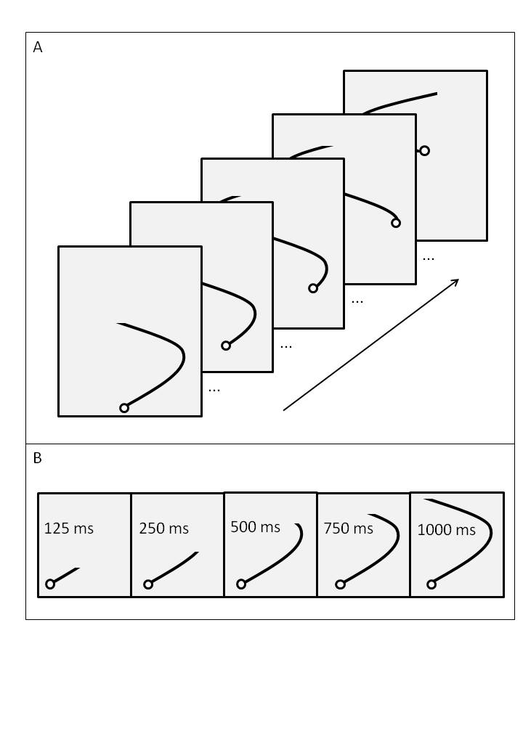
Fig 1 Experimental display. Panel A shows five frames of the 1000 ms condition. Both the sinusoidal line and the ball move upwards at a constant rate. The participant is to steer the white ball sideways such that it remains at the tail of the moving line. The moving line extends for 1000 ms ahead of the current position of the white ball. Panel B shows the initial frame for each of the five conditions (125, 250, 500, 750, 1000 ms). Note that the 500 ms condition discloses the location of the upcoming bend

Data analyses
The steering data were inspected and filtered (Butterworth low-pass filter, 2nd order, 10Hz) before the stimulus and response data were compared. Since the data were sinusoidal the measures of interest were phase and gain. We calculated phase and gain by first identifying the local maxima of the response which corresponded with the local maxima of the stimulus. Phase was calculated by taking the difference in time between the local maxima of the stimulus and the local maxima of the response. It expressed the delay of the response in respect to the stimulus and was a measure of timing accuracy or synchronisation. Gain was calculated by taking the difference between two consecutive local maxima of the stimulus and similarly of the response and then calculating the ratio between them. It expressed the ratio of amplitudes and was a measure of spatial accuracy. Because some steering data contained reversals, this procedure proved more accurate than other methods (cf, de Oliveira and Wann 2010). We calculated the average and standard deviation of phase and gain as well as the average number of reversals for each participant and trial. We used Matlab for all data analyses (The MathWorks Inc., version 7.5, 2007).
Phase and gain were submitted to repeated measures ANOVAs with factors condition (5 levels: 125, 250, 500, 750, 1000 ms) and group (2 levels: TD, DCD). The data were normally distributed and degrees of freedom were corrected with the Huynh-Feldt procedure for violations of sphericity. Importantly, to address our hypothesis we contrasted adjacent conditions using planned repeated contrasts for repeated-measure designs. To analyse differences in the number of reversals we used non-parametric testing. We report Zs for Mann-Whitney U independent samples, and for Wilcoxon Signed Rank test for two related samples. Significance level was set at p < .05. To complement figure 2 we also computed the regression curve that best fitted the average phase and gain data, using the resulting coefficients to calculate the vertex of the second-order polynomials. We used SPSS for all statistical analyses (SPSS Inc., version 14.0.2, 2006).

Results
Phase (steering synchronisation)
There was a significant effect of condition on phase, F(3.1, 62) = 29.58, p < .001, η_{p}² = .60, and this was reflected on the different conditions 250 and 500 ms, F(1, 20) = 99.45, p = .001, η_{p}² = .83. There was a significant effect of group, F(1, 20) = 6.40, p < .02, η_{p}² = .24, because overall the TD group performed with smaller delays than the DCD group. Overall, there was no significant Condition × Group interaction, F(4, 80) = 1.08, p = .37. However, planned contrasts showed a significant Condition × Group interaction between conditions 750 and 1000 ms, F(1, 20) = 5.23, p < .05, η_{p}² = .21, because with more information available the TD group improved whereas the DCD group worsened their performance. The first- and second-order polynomials in the upper panel of Figure 2 illustrate this effect further.
We determined the optimal timing for the DCD group with 757 ms of advanced information whereas the TD group improved linearly with more advanced information. [We determined this by fitting the data with the best-fitting polynomial. This was a 2nd-order polynomial for the DCD group, R² = 0.19, which allowed the calculation of its vertex at 757 ms. For the TD group, it was a 1st-order polynomial, R² = 0.50, representing continuous improvement].

Gain (amplitude matching)
There was a significant effect of condition on gain, F(4, 80) = 28.78, p < .001, η_{p}² = .59, in the absence of a group effect, F(1, 20) = 1.69, p = .21, or a Condition × Group interaction, F(4, 80) = 0.34, p = .85. Planned contrast analysis showed significant differences between conditions 250 and 500 ms, F(1, 20) = 27.40, p = .001, η_{p}² = .58, and between conditions 500 and 750 ms, F(1, 20) = 4.77, p = .05, η_{p}² = .19, but there was no Condition × Group interaction, F(1, 20) <1.52, p > .05 (lower panel of Figure 1).

Variability
There was no significant effect of condition on the variability of phase, F(4, 80) = 1.92, p = .12, and no Condition × Group interaction, F(4, 80) = 0.37, p = .83. A significant main effect of group, F(1, 20) = 7.12, p < .02, η_{p}² = .26, occurred because the DCD group was more variable than the TD group across conditions (DCD: overall M = 0.16, SD = 0.1; TD overall M = 0.12, SD < 0.1).
Similarly, there was no significant effect of condition on the variability of gain, F(4, 80) = 0.92, p = .46, and no Condition × Group interaction, F(4, 80) = 0.43, p = .79. A significant main effect of group, F(1, 20) = 5.64, p < .03, η_{p}² = .22, occurred because the DCD group was more variable than the TD group across conditions (DCD: overall M = 0.19, SD = 0.1; TD overall M = 0.15, SD < 0.1). 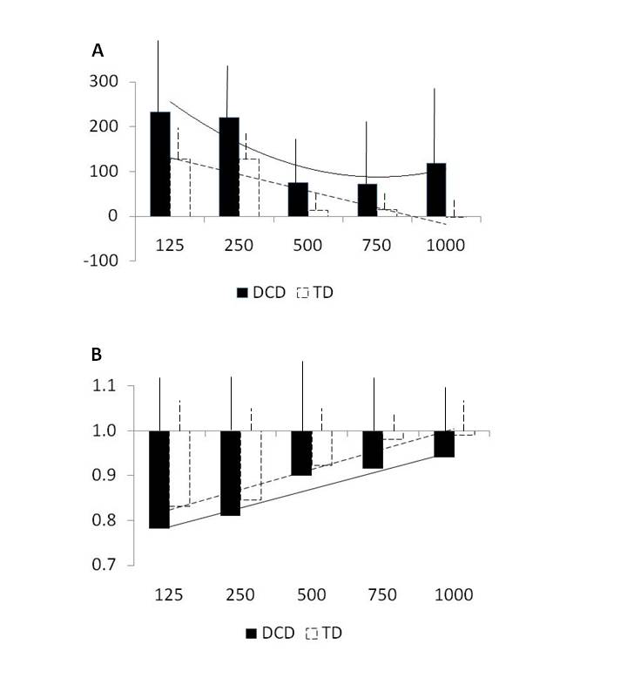
Fig 2 Panel A shows the average phase of the two groups (phase or steering synchronisation is expressed in ms of delay along the y-axis) on the five conditions of advanced information (on the x-axis). Standard deviations are shown above the bars. Panel B shows the average gain of the two groups (gain or ratio of amplitude matching along the y-axis) on the five conditions of advanced information (on the y-axis). Standard deviations are shown above the bars

Steering reversals
Overall, the DCD group used more steering reversals than the TD group (DCD: overall M = 34; TD overall M = 4). The group difference was statistically significant in condition 250 ms, U = 27.50, p < .01, r = -.59. Within the DCD group there was a significant difference between the 250 ms and 500 ms conditions, W_{s} = -2.12, p < .05, r = -.64, but this was not the case in the TD group. As illustrated in Figure 3, steering reversals were least in the 500 ms condition which indicates this is where the DCD group performed the best.
Fig 3 Average number of steering reversals on the five conditions of advanced information. The TD group is represented by white columns and dashed lines. Standard deviations are shown above the bars

Discussion
The results of this study show that individuals with DCD can use online control when visual information specifies the upcoming movement requirements. While the TD group showed a pattern of continuous improvement with more visual information (from 125 ms to 1000 ms), the performance of the DCD group was best described by a U-shaped curve with its vertex of best performance at about 750 ms. It is noteworthy that the major impact of conditions was upon the temporal coordination of the action (phase), rather than the encoding of the spatial target (gain). In the 500 ms condition, participants could have steered continuously based on the emerging visual information (pure online control) but, crucially, there was no advance information available for distal preparation (in contrast with the 1000 ms condition) and no requirements for fast reactions (in contrast with the 125 ms condition). These characteristics allowed participants to use continuous online control. The similarity of performance between the two groups in the 500 ms and 750 ms conditions further suggests that the DCD group was able to factor in the appropriate delay between the pick-up and use of information. These results demonstrate that individuals with DCD can use pure online visuomotor control as effectively as their peers in a tracking task.
Previous tasks have not examined pure online control. [To be clear, we define pure online control as the type of control that is required in our 500 ms tracking condition where neither the final target nor the path are visible, and where reaction time does not play a key role.] For instance, in discrete pointing, participants acquire the target before movement initiation which elicits movement preparation. In sequential pointing or double-step reaching, where individuals with DCD show poor performance, participants first acquire one target before movement initiation which elicits movement preparation, and then need to integrate the online information with that movement preparation (Devini et al. 2004; Henderson et al. 2007; Hyde and Wilson 2011; Kagerer et al. 2006; Wilmut et al. 2006). In perturbation studies there is either an unexpected target change requiring immediate correction to the on-going movement (Hyde and Wilson 2011), or a rotation of the visual feedback requiring adaptation of movement over multiple trials (Kagerer et al 2006). This is a crucial distinction between tasks because authors have asserted that online control is impaired in DCD (Hyde and Wilson 2010, 2011, 2013). For instance, Hyde and Wilson (2010) mention that rapid online corrections observed in double-step perturbation require in-flight modulation of the motor command. While we agree with this statement, we also note that in addition to online control there is also longer-term planning involved in this task. Our results show that pure online control is not impaired and instead it is the integration of online control with planning that is impaired. This interpretation is in line with previous work that showed that individuals with DCD have difficulties integrating distal preparatory visual information with the visual information that arises during movement execution (de Oliveira and Wann 2010). It is also in accordance with a recent tracking study which showed that additional information is not always useful but can in fact hinder accuracy (Raab et al. 2013. Thus the present results show that pure online control is unimpaired in DCD but also demonstrate that there is an optimal timing for effectively using this type of ongoing information.
The DCD group performed poorer than the TD group on the conditions requiring faster responses. The shortest conditions (125 ms and 250 ms) elicited a type of control that is influenced by the visuomotor delays inherent to the system (80 - 120 ms; eg, Carlton, 1992). Our results suggest that these delays may be larger in individuals with DCD, but this interpretation would require further examination. Note that the shortest conditions (125 and 250 ms), added to the delays observed (circa 230 ms), and added to the visuomotor delay (circa 100 ms) result in circa 500 ms. Although indirectly, this is in accordance with our suggestion that 500 ms constitutes pure online control for the DCD group. Taken together, the findings for the shortest conditions reinforce previous suggestions that individuals with DCD may require more time to process visual information, but the errors that then arise with longer lead times (1000 ms) highlight that this is not just a processing delay. It seems that individuals with DCD are constrained as to the time-windows in which they are able to effectively use online visual information and this may explain the difficulties they exhibit in a range of tasks where information becomes available over a wide and varied set of temporal windows (e.g., learning to drive – de Oliveira and Wann 2011, 2012).
Why this pattern might arise is not clear at this stage but this may reflect the early development of online control. Several areas of the dorsal visual stream are engaged when using visual information about impending changes in heading in order to improve steering responses when driving (Billington, Field, Wilkie, & Wann 2010). Most notable is the parietal lobe which plays a general role in spatial coding and inhibition (Pollmann et al. 2003). Activations in both the superior parietal lobe (SPL) and the medial intra-parietal sulcus (mIPS) have been found during tasks which require hand movements towards a target (Grefkes & Fink 2005) even when those movements have to be sustained for a short period of time but not actually executed (Fernandez-Ruiz, Goltz, DeSouza, Vilis, & Crawford 2007). Such findings suggest that the mIPS and the SPL have neural properties which enable them to store intended motor actions until such time as the motor response is appropriate and, thus, are likely to be engaged during an action such as steering. Motor coordination problems in DCD populations could potentially arise from either a deficit in storing spatial coordinates and/or a deficit in inhibiting impending actions.
Other work has highlighted the engagement of the cerebellum in online steering tasks and in eye-hand tracking tasks (Miall et al. 2001). Both the parietal lobe and the cerebellum play a role in correcting on-going motor movements via visual-motor feedback (Ogawa, Inui, & Sugio 2006, Seidler, Noll, & Thiers 2004). This cortical network may be involved in forward or inverse modelling. Forward modelling comprises estimating the position and velocity of and effector following a motor command while inverse modelling may generate error signals for conversion by the cerebellum into a corrective motor command (Desmurget & Grafton 2000). Previous studies have suggested that immaturity in the parietal-cerebellar feedback system may be at the root of impairments in DCD to correct movements during reaching tasks (Hyde & Wilson 2013). However, the gain results in this study suggest that participants are capable of correcting errors based on visual input. The fact that the deficits are most apparent in the phase data of the long latency condition suggests that problems lie within the storage and timely execution of the motor response, more indicative of a deficit in parietal lobe functioning.

Acknowledgements
The work of de Oliveira was supported by a Rubicon fellowship to conduct postdoctoral research from the Netherlands Organisation for Scientific Research (NWO). We are sincerely grateful to the adolescents, young adults and their families for their willingness and enthusiasm in participating in this study.
The authors would like to thank two anonymous reviewers for their helpful comments.
References
APA (1994) DSM-IV-TR diagnostic and statistical manual of mental disorders. Washington, DC: American Psychiatric Association.
Billington J, Field DT, Wilkie RM, Wann JP (2010) An fMRI stuty of parietal cortex involvement in the visual guidance of locomotion. J Exp Psychol Hum Percept Perform 36(6):1495-507. doi: 10.1037/a0018728
Brookes RL, Nicolson RI, Fawcett AJ (2007) Prisms throw light on developmental disorders. Neuropsychologia 45(8):1921-30. doi: 10.1016/j.neuropsychologia.2006.11.019
Cantell MH, Smyth MM, Ahonen TP (2003) Two distinct pathways for developmental coordination disorder: Persistence and resolution. Hum Mov Sci 22:413-31. doi: 10.1016/j.humov.2003.09.002
Carlton, L.G. (1992). Visual processing time and the control of movement. In L. Proteau & D. Elliott (Eds.), Vision and motor control (pp. 3-31). Amsterdam: Elsevier Science. ISBN:0444888160
de Oliveira RF, Wann JP (2010) Integration of dynamic information for visuomotor control in young adults with developmental coordination disorder. Exp Brain Res 250(3):387-94. doi: 10.1007/s00221-010-2373-5
de Oliveira RF, Wann JP (2012) Driving skills of young adults with developmental coordination disorder: Maintaining control and avoiding hazards. Hum Mov Sci 31(3):721-9. doi: 10.1016/j.humov.2011.06.010
de Oliveira RF, Wann JP (2011) Driving skills of young adults with developmental coordination disorder: Regulating speed and coping with distraction. Res Dev Disabil 32:1301-08. doi: 10.1016/j.ridd.2010.12.021
Desmurget M, Grafton S (2000) Forward modelling allows feedback control for fast reaching movements. Trends Cogn Sci 4(11):423-31. doi: 10.1016/S1364-6613(00)01537-0
Devini A, Leanne J, Yvonne B (2004) Goal-directed upper limb movements by children with and without DCD: a window into perceptuo- motor dysfunction? Physiother Res Int 9(1):1–12. doi: DOI: 10.1002/pri.295
Fernandez-Rui, J, Goltz HC, DeSouza JFX, Vilis T, Crawford JD (2007) Human parietal “reach region” primarily encodes intrinsic visual direction, not extrinsic movement direction, in a visual-motor dissociation task. Cereb Cortex 17(10): 2283-92. doi: 10.1093/cercor/bhl137
Grefkes C, Fink GR (2005) The functional organization of the intraparietal sulcus in humans and monkeys. J Anat 207(1): 3-17. doi: 10.1111/j.1469-7580.2005.00426.x
Henderson SE, Sugden DA, Barnett AL (2007) Movement assessment battery for children - 2. Manual. London: Pearson.
Hyde CE, Wilson PH (2011) Dissecting online control in Developmental Coordination Disorder: A kinematic analysis of double-step reaching. Brain Cogn 75(3):232-41. doi: 10.1016/j.bandc.2010.12.004
Hyde CE, Wilson PH (2013) Impaired online control in children with developmental coordination disorder reflects developmental immaturity. Dev Neuropsychol 38(2): 91-97. doi: 10.1080/87565641.2012.718820
Hyde CE, Wilson PH (2010) Online motor control in children with developmental coordination disorder: Chronometric analysis of double-step reaching performance. Child Care Health Dev 37(1): 111-122. doi:10.1111/j.1365-2214.2010.01131.x
Kagerer FA, Contreras-Vidal JL, Bo J, Clark JE (2006) Abrupt, but not gradual visuomotor distortion facilitates adaptation in children with developmental coordination disorder. Hum Mov Sci 25(4-5):622-33. doi: 10.1016/j.humov.2006.06.003
Losse A, Henderson SE, Elliman D, Hall D, Knight E, Jongmans M (1991) Clumsiness in children-do they grow out of It? A 10-year follow-up study. Dev Med Child Neurol 33(1):55-68. doi: 10.1111/j.1469-8749.1991.tb14785.x
Miall RC, Reckess GZ, Imamizu H (2001) The cerebellum coordinates eye and hand tracking movements. Nat Neurosci 4(6):638-44. doi: 10.1038/88465
Ogawa K. Inui T, Sugio T (2006) Separating brain regions involved in internally guided and visual feedback control of moving effectors: An event-related fMRI study. Neuroimage 32(4): 1760-70. doi:10.1016/j.neuroimage.2006.05.012
Pollmann S, Weidner R, Humphreys GW, Olivers CN, Müller K, Lohmann G, Wiggins CJ, Watson DG (2003) Separating distractor rejection and target detection in posterior parietal cortex--an event-related fMRI study of visual marking.Neuroimage 18(2): 310-23. doi:10.1016/S1053-8119(02)00036-8
Raab M, de Oliveira RF, Schorer J, Hegele M. (2013) Adaptation of motor control strategies to environmental cues in a pursuit-tracking task. Exp Brain Res, 228(2), 155-160. doi: 10.1007/s00221-013-3546-9
Seidler RD, Noll DC, Thiers G (2004) Feedforward and feedback processes in motor control. Neuroimage 22(4): 1775-83. doi:10.1016/j.neuroimage.2004.05.003
Wann JP (2007) Current approaches to intervention in children with developmental coordination disorder. Dev Med Child Neurol 49(6):405. doi: 10.1111/j.1469-8749.2007.00405.x
Wilmut K, Wann JP, Brown JH (2006) Problems in the coupling of eye and hand in the sequential movements of children with Developmental Coordination Disorder. Child Care Health Dev 32(6):665-78. doi: 10.1111/j.1365-2214.2006.00678.x
Wilson PH, McKenzie BE (1998) Information processing deficits associated with developmental coordination disorder: A meta-analysis of research findings. J Child Psychol Psyc 39(6):829-40. doi: 10.1111/1469-7610.00384
Wing AM (2002) Voluntary timing and brain function: An information processing approach. Brain Cogn 48(1):7-30. doi: 10.1006/brcg.2001.1301
Wolbers T, Hegarty M, Buchel C, Loomis JM (2008) Spatial updating: how the brain keeps track of changing object locations during observer motion. Nat Neurosci 11(10):1223-30. doi:10.1038/nn.2189

