**Derivatisation-free characterisation and supercritical conversion of free fatty acids into biodiesel from high acid value waste cooking oil**

Omar Aboelazayem a,b, Mamdouh Gadalla c,b and Basudeb Saha a,1

a Centre for Energy and Environment Research, School of Engineering, London South Bank University, 103 Borough Road, London, SE1 0AA, UK.

b Department of Chemical Engineering, The British University in Egypt, Misr-Ismalia Road, El-Shorouk City 11837, Cairo, Egypt.

c Department of Chemical Engineering, Port Said University, 42526, Port Fouad, Egypt.

**ABSTRACT**

In this study, a simple and robust derivatisation-free method has been developed using a gas chromatograph (GC), which has been validated as a suitable analysis for free fatty acids (FFAs) of waste cooking oil (WCO). As biodiesel synthesis from high acid value WCO involves pre-treatment steps, a non-catalytic approach has been employed for biodiesel production. This work has focused on the esterification of FFAs of high acidity feedstock for fatty acid methyl esters (FAME) production. The effect of four independent controllable factors, i.e. methanol to oil (M:O) molar ratio, temperature, pressure and time on FFAs conversion has been investigated. Response Surface Methodology (RSM) *via* Central Composite Design (CCD) has been implemented for designing experimental runs and optimising the process variables for maximum FFAs conversion. Four quadratic regression models have been developed representing an empirical relationship between reaction variables and responses. The adequacy of the predicted models has been checked by numerous statistical validation techniques including analysis of variance (ANOVA) at 95% confidence level. The developed optimum conditions have been reported at 25:1,   
256 °C, 110 bar and 16.6 min for M:O molar ratio, temperature, pressure and time, respectively. The predicted optimal conditions have been validated experimentally with 0.22% relative error.

**KEYWORDS**

Biodiesel; free fatty acid; waste cooking oil; supercritical esterification; process optimisation; response surface methodology.

**HIGHLIGHTS**

* Development of derivatisation-free method for direct analysis of FFAs.
* Development of regression models representing the process responses and variables.
* Effect of reaction variables and their interactions have been discussed in detail.
* Multivariate optimisation has been implemented to minimise the process variables.

**1. INTRODUCTION**

The global energy demand is continuously increasing due to the rapid industrial development and urbanisation. The expected depletion of fossil fuels has boosted the research on alternative renewable energy resources [1]. In addition, the emission of greenhouse gases, particularly CO2, from fossil fuels has made the replacement of fossil fuels with green fuels an essential need. Although most of the energy demands are supplied using fossil fuels, up to 19% of the worldwide energy is supplied using renewable energies [2].

Among the available renewable resources, biodiesel is considered as a promising substitute for petroleum diesel fuel. In addition, biodiesel is of great prominence over petroleum diesel as it is biodegradable, non-toxic, has higher cetane number and higher engine lubricity [3]. Further, biodiesel reduce the emissions of carbon monoxide, unburned hydrocarbons and particulates [4]. However, biodiesel has higher density and viscosity, lower calorific value, higher fuel consumption and high emissions of nitrogen oxides [5]. Consequently, biodiesel is blended with petroleum diesel with different percentages to improve its properties and could be used without significant modification in the diesel engine [6].

Biodiesel is derived from biological renewable resources including vegetable oils, animal fats and microalgae. It is mainly produced through transesterification/esterification of fatty acids through methanolysis or ethanolysis process. The industrial biodiesel production process is mostly catalysed using alkaline catalysts, i.e. sodium methoxide (CH3ONa) and potassium methoxide (CH3OK), yielding fatty acids alkyl esters (biodiesel) and glycerol [7]. However, the feedstocks used for the conventional biodiesel production process should have specific properties where the FFAs content should not exceed 1% by mass. Hence, refined vegetable oils have been used extensively during the last decades for biodiesel production. In fact, using refined vegetable oils has generated a great competition between food and biodiesel industries, resulting in increasing the cost of vegetable oil [8].

The overall cost of biodiesel depends mainly on the price of the feedstock as it represents about 60-80% of the production cost [9]. Hence, the overall cost reduction should be considered using two pathways including process energy integration [10] and utilising lower cost feedstocks i.e. non-edible and waste oils [11]. However, the alternative feedstocks usually contain high acid and water content and hence are not suitable for the conventional biodiesel production processes. Several pre-treatment processes have been employed prior to biodiesel production to prevent saponification side reaction; which lowers the biodiesel yield and create difficulties in product separation [12].

Alternative production methods for such feedstocks have been recently reported including microwave assisted [13,14], ultrasonic assisted [7,15] and non-catalytic methods [16]. Among the alternative methods for biodiesel production, non-catalytic production of biodiesel using supercritical technology has been considered as an ideal technique for high acidity feedstock. Simultaneous transesterification of triglycerides and esterification of FFAs occur during the supercritical reaction. Hence, the high content of FFAs is not considered as an obstacle as it could be esterified during the reaction without any pre-treatment for the feedstock [12].

Supercritical production of biodiesel has been introduced by Saka and Kusdiana [17], where they have produced high quality biodiesel using catalyst-free supercritical methanolysis. Later, the technique has been extended dramatically and included variety of feedstocks including WCOs and other high acidity feedstocks. In addition to methanol and ethanol, supercritical propanol and butanol have been used for non-catalytic production of biodiesel [18,19]. Recently, Aboelazayem et al. have studied the valorisation of both low and high acid value WCOs into biodiesel using supercritical methanolysis [20,21]. They have reported high yields of biodiesel from both feedstocks. They have also applied RSM to optimise four reaction variables including M:O molar ratio, temperature, pressure and time. It is worth mentioning that higher biodiesel yields have been reported from feedstocks with higher acidity than from lower ones [18,19,22] .

Supercritical methanolysis has been reported as an economically viable process for biodiesel production from high acidity feedstock [9]. A comparative techno-economic study between single step (supercritical) and two-steps (catalysed) processes has been reported [23]. The study has analysed the cost of biodiesel from two simulated plant with annual production rate of 15,000 and 30,000 tonnes[23]. The study has reported that two-steps conventional process requires higher process energy requirements per unit of biodiesel output. The costs of biodiesel produced from supercritical and two-steps process have been projected as 0.824 and 0.786 EUR/kg, respectively. Additionally, Sakdasri et al. [24] have reported that lowering the methanol ratio in supercritical methanolysis, contributes significantly in lowering the production cost of biodiesel.

The focus on esterification reaction of FFAs using supercritical methanolysis would exemplify the ability of this technique to convert the existing FFAs into FAMEs. Several studies on esterification of FFAs have been reported using various techniques including ultrasonic-assisted [25], microwave-assisted [26] and catalysed processes [27]. However, very few researchers have considered studying the conversion of FFAs using supercritical technology. Jin et al. [28] have studied the esterification of FFAs (specifically oleic acid) using supercritical methanol. They have reported pseudo-first order reaction for the esterification reaction. Aboelazayem et al. [29] have reported similar results for the kinetics of the supercritical esterification of FFAs. Mostly, the conversion of FFAs into FAMEs is determined using titration method. The chromatographic analysis for FFAs concentration is mostly reported through derivatisation of FFAs into FAMEs or using HPLC. Recently, Zhang et al. [30] have developed and validated a robust method for derivatisation-free analysis of FFAs using GC *via* FID.

This study is a logical extension of our research on biodiesel production from high acid value WCO. In the present study, esterification of FFAs of a high acidity WCO into biodiesel has been critically studied. A derivatisation-free method for specific FFAs characterisation has been developed to evaluate the concentration of each FFA in the feedstock and the products. The conversion of four main FFAs have been considered as process responses including myristic, palmitic, oleic and linoleic acids. The influence of four independent reaction variables and their interaction, i.e. methanol to oil (M:O) molar ratio, temperature, pressure, time have been critically discussed. Graphical and numerical optimisation have been applied to optimise the reaction variables for maximum conversion of FFAs into FAMEs.

**2. MATERIAL AND METHODS**

**2.1. Materials**

WCO was purchased from various restaurants and industries in Egypt. In an attempt to provide a realistic mixture, the collected WCOs were mixed together. The standard fatty acids that represents the feedstock. i.e. myristic acid (C14:0), palmitic acid (C16:0), oleic acid (C18:1), linoleic acid (C18:2), and heptadecanoic acid (C17:0) as an internal standard, were purchased from Merck, UK. Methanol 99% (MeOH) and *iso*-propanol 99% were purchased from Fisher Scientific UK. The liquid CO2 cylinder (99.9%) equipped with dip tube was purchased from BOC Ltd., UK.

**2.2. Experimental procedures**

The fatty acids composition of the feedstock were calibrated through derivatisation of triglycerides and FFAs into FAMEs using the standard methylation process (BS EN ISO 12966-2:2017). The composition and physicochemical properties of the feedstock are shown in Tables 1 and 2. The detailed analysis and composition of the feedstock were reported elsewhere [21].

Table 1. Composition of the fatty acids in WCO

|  |  |
| --- | --- |
| Fatty Acid | Wt (%) |
| Oliec acid | 48.2 |
| Palmitic acid | 41.6 |
| Linoleic acid | 9.3 |
| Myristic acid | 0.8 |

Table 2. Physicochemical properties of WCO

|  |  |  |
| --- | --- | --- |
| Property | Calibration Method | Results |
| Kinematic viscosity | ASTM D-455 | 60.5 cSt |
| Density | ATM D-4052 | 0.931 g/cm3 |
| TAN | ASTM D-947 | 18 mg KOH/ g oil |

**2.2.1. Preparation of standard solutions**

The pure standards, i.e. myristic acid, palmitic acid, oleic acid and linoleic acid, were dissolved in *iso*-propanol that was used as a solvent. For calibration curves analysis, five different concentrations of each standard were prepared at 2, 4, 6, 8 and 10 g/L. Each standard sample was accompanied with a constant concentration of heptadecanoic acid as an internal standard (4.5 g/L). A 2 mL sample of each standard was prepared for chromatographic injections.

**2.2.2. FFAs conversion calculations**

The conversion of FFA has been calculated based on the change in concentration between the feedstock and the produced biodiesel as shown in Equation 1. The concentration of FFA at both reactants and products was calculated as discussed in Section 3.2.

*Conversion = (C i WCO – C i S / C i WCO) × 100%*  (1)

Where C*i WCO* and *C i S* represents the concentration of ith fatty acid in WCO and each biodiesel sample, respectively.

**2.2.3. Biodiesel reaction procedures**

The detailed experimental procedures were reported elsewhere [21]. In summary, WCO was filtered using simple stainless-steel strainer. The filtered WCO was weighted and mixed with methanol at a specific molar ratio and then fed to a 100-mL high pressure reactor made of stainless steel (model 4590, Parr Instrument Company, USA). The reactor was fitted with a thermocouple (type J), heating mantle, controller (model 4848) and a mechanical stirrer. The reactants were heated to a specific temperature and then pressurised with CO2 using a supercritical fluid pump (model SFT-10, Analytix Ltd., UK) to the desired pressure. The reaction time starts once the reactants reach the required temperature and pressure. After completing the reaction time, the reactor was quenched with water until 80 oC followed by further cooling using an ice bath. The reactor was then depressurised and methanol was recovered using simple distillation at 80oC for 30 min. Finally, the glycerol was separated from biodiesel using a centrifuge (1500 rpm, 3 min/cycle).

**2.4. Experimental design**

The experiments were designed using RSM based on CCD method. Four controllable independent process variables were included through the experimental design procedures i.e. M:O molar ratio, temperature, pressure and time. Based on CCD, five levels of each variable have been identified as centre, axial and star points. The levels have been coded as -2, -1, 0, +1 and +2, as shown in Table 3. The levels of each variables have been chosen as recommended previously [20] and as a logical extension for a previous study [21]. As per using four variables, the CCD has created 30 randomised experiments as shown in Table 4, where the number of experiments has been calculated as shown in Equation 2.

*Total number of runs = 2n + 2n + m*  (2)

Where *n* is the number of controllable variables and *m* is number of replicated centre points.

Table 3. Experimental design variables and their coded levels

|  |  |  |  |  |  |  |
| --- | --- | --- | --- | --- | --- | --- |
| Factor | Code | Levels | | | | |
|  | | -2 | -1 | 0 | +1 | +2 |
| M:O (molar ratio) | A | 20 | 25 | 30 | 35 | 40 |
| Temperature (oC) | B | 240 | 250 | 260 | 270 | 280 |
| Pressure (bar) | C | 85 | 110 | 135 | 160 | 185 |
| Time (min) | D | 7 | 12 | 17 | 22 | 27 |

Table 4. Experimental design matrix with the actual and predicted yields

|  |  |  |  |  |  |  |  |  |  |  |  |  |
| --- | --- | --- | --- | --- | --- | --- | --- | --- | --- | --- | --- | --- |
| Run | M:O ratio (A) | Temperature (oC) (B) | Pressure (bar) (C) | Time (min) (D) | Actual  M-Acid Conv. (%) | Predicted M-Acid Conv. (%) | Actual  P-Acid Conv. (%) | Predicted P-Acid Conv. (%) | Actual  O-Acid Conv. (%) | Predicted O-Acid Conv. (%) | Actual  L-Acid Conv. (%) | Predicted L-Acid Conv. (%) |
| 1 | 30 | 260 | 135 | 17 | 99.09 | 99.23 | 99.03 | 99.09 | 98.20 | 98.35 | 99.53 | 99.59 |
| 2 | 35 | 250 | 160 | 22 | 98.81 | 98.79 | 98.80 | 98.77 | 97.92 | 97.89 | 99.42 | 99.37 |
| 3 | 35 | 250 | 110 | 22 | 98.69 | 98.57 | 98.70 | 98.70 | 97.80 | 97.70 | 99.32 | 99.32 |
| 4 | 35 | 270 | 160 | 22 | 98.99 | 99.03 | 98.93 | 98.97 | 98.10 | 98.16 | 99.48 | 99.52 |
| 5 | 35 | 270 | 110 | 12 | 99.10 | 99.11 | 98.90 | 98.91 | 98.10 | 98.17 | 99.45 | 99.47 |
| 6 | 35 | 250 | 160 | 12 | 98.60 | 98.60 | 98.60 | 98.62 | 97.57 | 97.64 | 99.13 | 99.15 |
| 7 | 25 | 270 | 160 | 22 | 99.00 | 98.97 | 99.00 | 98.96 | 98.14 | 98.11 | 99.50 | 99.48 |
| 8 | 30 | 260 | 135 | 17 | 99.23 | 99.23 | 99.10 | 99.09 | 98.40 | 98.35 | 99.60 | 99.59 |
| 9 | 25 | 250 | 110 | 22 | 98.94 | 99.01 | 98.94 | 98.96 | 98.05 | 98.13 | 99.65 | 99.63 |
| 10 | 25 | 250 | 160 | 22 | 99.09 | 99.01 | 98.96 | 98.95 | 98.20 | 98.11 | 99.54 | 99.55 |
| 11 | 30 | 260 | 85 | 17 | 99.09 | 99.07 | 99.00 | 98.97 | 98.20 | 98.17 | 99.54 | 99.52 |
| 12 | 25 | 270 | 110 | 12 | 98.91 | 98.99 | 98.80 | 98.84 | 98.02 | 98.09 | 99.42 | 99.45 |
| 13 | 25 | 250 | 160 | 12 | 98.54 | 98.54 | 98.66 | 98.66 | 97.65 | 97.63 | 99.26 | 99.24 |
| 14 | 30 | 260 | 135 | 17 | 99.25 | 99.23 | 99.10 | 99.09 | 98.36 | 98.35 | 99.60 | 99.59 |
| 15 | 35 | 250 | 110 | 12 | 98.59 | 98.68 | 98.75 | 98.80 | 97.70 | 97.77 | 99.23 | 99.24 |
| 16 | 30 | 240 | 135 | 17 | 98.49 | 98.57 | 98.68 | 98.67 | 97.60 | 97.66 | 99.30 | 99.33 |
| 17 | 30 | 260 | 185 | 17 | 99.01 | 99.03 | 99.02 | 99.04 | 98.12 | 98.13 | 99.50 | 99.50 |
| 18 | 35 | 270 | 160 | 12 | 99.08 | 99.07 | 99.00 | 98.99 | 98.19 | 98.15 | 99.51 | 99.52 |
| 19 | 30 | 260 | 135 | 17 | 99.25 | 99.23 | 99.10 | 99.09 | 98.36 | 98.35 | 99.60 | 99.59 |
| 20 | 30 | 260 | 135 | 27 | 98.59 | 98.65 | 98.68 | 98.70 | 97.70 | 97.78 | 99.26 | 99.28 |
| 21 | 30 | 260 | 135 | 7 | 98.59 | 98.53 | 98.71 | 98.68 | 97.70 | 97.61 | 99.13 | 99.09 |
| 22 | 25 | 270 | 160 | 12 | 98.69 | 98.74 | 98.84 | 98.84 | 97.80 | 97.87 | 99.35 | 99.38 |
| 23 | 20 | 260 | 135 | 17 | 99.02 | 99.06 | 98.90 | 98.94 | 98.13 | 98.19 | 99.61 | 99.61 |
| 24 | 25 | 250 | 110 | 12 | 98.95 | 98.84 | 98.95 | 98.91 | 98.06 | 97.97 | 99.46 | 99.45 |
| 25 | 30 | 280 | 135 | 17 | 99.03 | 98.96 | 98.80 | 98.79 | 98.14 | 98.06 | 99.54 | 99.49 |
| 26 | 30 | 260 | 135 | 17 | 99.29 | 99.23 | 99.10 | 99.09 | 98.40 | 98.35 | 99.61 | 99.59 |
| 27 | 40 | 260 | 135 | 17 | 99.00 | 98.96 | 98.88 | 98.83 | 98.11 | 98.04 | 99.46 | 99.44 |
| 28 | 25 | 270 | 110 | 22 | 99.00 | 98.93 | 98.73 | 98.71 | 98.11 | 98.02 | 99.41 | 99.42 |
| 29 | 30 | 260 | 135 | 17 | 99.29 | 99.23 | 99.10 | 99.09 | 98.40 | 98.35 | 99.60 | 99.59 |
| 30 | 35 | 270 | 110 | 22 | 98.69 | 98.76 | 98.62 | 98.64 | 97.80 | 97.86 | 99.33 | 99.34 |

(M-Acid: myristic; P-Acid: palmitic; O-Acid: oleic; L-Acid: linoleic)

**2.5. Statistical Analysis**

The general quadratic equation was used for model development as shown in Equation 3.

$Y=b_{o}+\sum_{i=1}^{n}{b_{i}x_{i}}+\sum_{i=1}^{n}{b_{ii}x_{i}^{2}}+\sum_{i=1}^{n-1}{\sum_{j>1}^{n}{b_{ij}}x_{i}x_{j}}+ ℇ$ (3)

Where *Y* represents the process predictive response, *bo* represents the model coefficient constant, *bi*, *bii*, *bij*, represent the coefficients for intercept of linear, quadratic, interactive terms respectively, while *xi*, *xj* represent independent variables *(i≠j)*. Finally, *n* represents number of independent variables and *ɛ* represents the random error.

The adequacy of the predicted models was mainly checked using ANOVA at 95% confidence levels. In addition, ANOVA was used to check the significant of the process variables and their interactions. Design Expert 11 software (Stat-Ease Inc., Minneapolis, MN, USA) was used to design the experiments, model development and optimisation.

**3. RESULTS AND DISCUSSION**

**3.1. Chromatographic method development**

The present method has been developed as a modification for the previously reported derivatisation-free method for FFAs characterisation by Zhang et al. [31]. In the present study, the GC column that has been used for analysis is TR-FFAP (30 m × 0.32 mm id, 0.25 µm film thickness, Thermo-Scientific, Cheshire, UK) with a stationary phase consists of a modified Polyethylene Glycol (PEG) bonded terephthalic acid (TPA).

The starting column temperature programming for the GC method has been implemented as reported previously [30] where the initial oven temperature is 120 oC and ramped directly to 245 oC with rate of 30 oC/min with a flow rate of the carrier gas of 2.8 mL/min and injection temperature of 230 oC. However, an overlap between oleic and linoleic acid has been detected as shown in Figure 1. In addition to a combined peak of myristic acid and palmitic acid. Hence, systematic modifications have been applied for the method in order to produce separate and easily defined peaks.

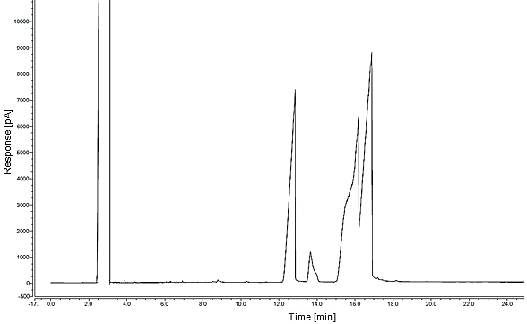

a: Solvent

b: Palmitic acid

c: Internal Standard

d: Oleic acid

e: Linoleic acid

e

c

Overlapped peaks

d

b

a

Figure 1. Chromatographic results of the standard fatty acids before method modification

The modification process has included three main aspects i.e., the optimal carrier gas flow, the optimal temperature ramp in the column programming and the optimal injection temperature. A multivariate optimisation technique using RSM has been established to determine the optimal combination of variables to achieve the best GC method in terms of sensitivity, specificity and precision. Three levels of each variable have been investigated as shown in Table 5. Box-Behnken Design (BBD) has been used to design randomised 17 runs at different variables. At each run the peaks of the standard fatty acids were calibrated and checked for sensitivity and specificity. Using Design Expert 11 software (Stat-Ease Inc., Minneapolis, MN, USA), the optimal conditions have been identified at 40 oC/min, 4.5 mL/min and 245 oC for temperature ramp, carrier gas flow and injection temperature, respectively. Additionally, it has been observed that the peaks have been accurately separated when the column remains at constant temperature of 240 oC for several minutes at constant flow rate of 4.5 mL/min. Hence, high ramp has been preferred prior to 240 oC to minimise the overall method time.

Table 5. Experimental design variables and their coded levels

|  |  |  |  |  |
| --- | --- | --- | --- | --- |
| Factor | Code | Levels | | |
|  | | -1 | 0 | +1 |
| Ramp (oC/min) | A | 30 | 40 | 50 |
| Carrier gas flow (mL/min) | B | 2.5 | 4.5 | 6.5 |
| Injection temperature (oC) | C | 205 | 230 | 245 |

In summary, the GC method has been identified based on the developed optimal conditions. The temperature programme has started from 40 oC and ramped with 40 °C/min to 240 °C and remained for 7 min. Finally, the temperature was ramped to 245 °C with 40 °C/min and remained for 5 min. Both injector and detector temperatures were adjusted at 245 oC. The flow rate of the helium carrier gas has been adjusted at 4.5 mL/min. While modifying the method, the previously overlapped peaks have been separated and viewed in an accurate position as shown in Figure 2.

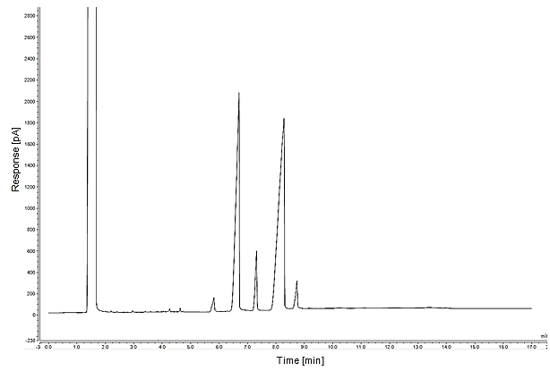

a: Solvent

b: Myristic acid

c: Palmitic acid

d: Internal Standard

e: Oleic acid

f: Linoleic acid

f

e

d

c

b

a

Figure 2. Chromatographic results of the standard fatty acids after method modification

Upon injecting the WCO and/or biodiesel samples, the FFAs are easily detected and identified. Using the standard samples, the retention time of each fatty acid has been defined as shown in Table 6. The concentration of each fatty acid has been calculated based on the response factor of each component as discussed in section 3.2.

Table 6. A chromatographic data of the retention time for each fatty acid

|  |  |
| --- | --- |
| Fatty Acid | Retention time (min) |
| Myristic | 5.8 |
| Palmitic | 6.6 |
| Heptadecanoic (IS) | 7.1 |
| Oleic | 8.1 |
| Linoleic | 8.6 |

**3.2. Calibration curves for standards**

The internal standard analytical method has been used to identify the concentration of each fatty acids in the samples. Heptadecanoic acid has been used as an internal standard and has been added with a constant concentration for each analysed sample. For each component, the response factor (RF) has been used to determine the concentration of the components in the sample. For RF, a division between area ratios (ARi) and concentration ratios (CRi) of each component has been applied as shown in Equation 4 [32]. The ratio between the concentration of the analyte (Ci) and the internal standard concentration (Cis) is defined as the concentration ratio. In addition, the ratio between the analyte area (Ai) and internal standard area (Ais) is defined as area ratio. Equations 5 and 6 have been used to calculate both AR and CR, respectively.

${RF}_{i}= \frac{Area ratio of i^{th}component, {AR}_{i}}{Concentration ratio of i^{th}component, {CR}_{i}}$ (4)

${Ar}_{i}= \frac{Area of i^{th}component, A_{i}}{Area of the internal standard, A_{is}}$ (5)

${Cr}_{i}= \frac{Concentration of i^{th}component, A_{i}}{Concenetration of the internal standard, A_{is}}$ (6)

A plot between AR and CR for each sample (at different concentrations) has been used to calculate the response factor. The calibration curves of fatty acids standards have been illustrated in Figure 3. It is clearly shown that the RF of myristic, palmitic, oleic and linoleic acids are 0.9757, 0.9788, 0.9697 and 0.9743, respectively. The uniformity of the results has been illustrated with high coefficient of determination (R2), where all the values are greater than 0.99. Consequently, the concentration of each component (ith component) in the biodiesel or WCO sample (jth sample) has been calculated as shown in Equation 7 [32].

$C_{ij}= \frac{Area ratio of i^{th}component in the j^{th}sample , {AR}_{ij} ×C_{is}}{Response factor of i^{th}component, {RF}_{i}}$ (7)

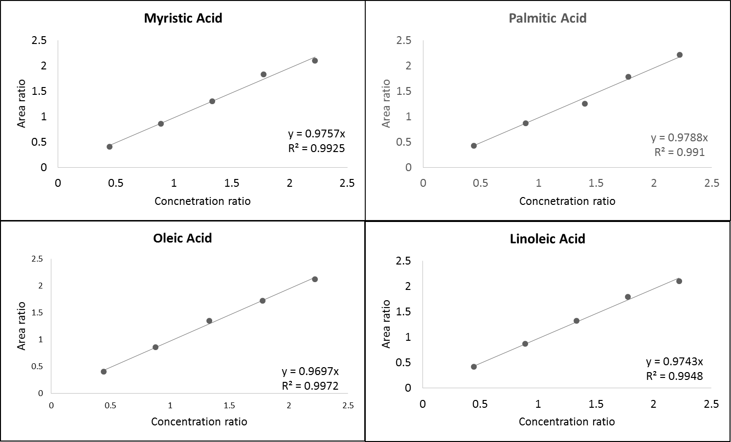

Figure 3. Calibration curves of fatty acids standards

**3.3. Development of regression model equation**

Using the 30 experimental results for myristic, palmitic, oleic and linoleic acids conversion, four polynomial regression models have been developed to represent each response function in the experimental variables. The experimental results of each response have been fitted for four different mathematical models including linear, two factors interactions (2FI), quadratic and cubic polynomial models. The most fitted model has been identified using different statistical analysis including adjusted coefficient of determination (R2adj), predicted coefficient of determination (R2pred) and associated aliased coefficients. For the four regression models, the quadratic polynomial equation has been suggested by the software as the most fitted model in predicting the experimental results. Consequently, four quadratic models have been developed for the experimental responses function in the process variables as shown in Equations 8-11.

*Y1 = 99.23 - 0.025 A + 0.097 B - 0.009 C + 0.031 D + 0.068 AB + 0.050 AC   
- 0.071 AD + 0.012 BC + 0.095 BD + 0.076 CD - 0.055 A2 - 0.118 B2 - 0.045 C2   
- 0.161 D2* (8)

*Y2 = 99.09 - 0.026 A + 0.029 B + 0.018 C + 0.005 D + 0.046 AB + 0.020 AC   
+ 0.036 AD + 0.064 BC - 0.043 BD + 0.062 CD - 0.051 A2 - 0.089 B2 - 0.021 C2   
- 0.101 D2* (9)

*Y3 = 98.35 - 0.037 A + 0.1 B - 0.012 C + 0.048 D + 0.062 AB + 0.052 AC   
- 0.057 AD + 0.029 BC + 0.059 BD + 0.072 CD - 0.060 A2 - 0.124 B2 - 0.051 C2   
- 0.166 D2* (10)

*Y4 = 99.59 - 0.043 A + 0.038 B - 0.006 C + 0.045 D + 0.056 AB + 0.031 AC   
- 0.024 AD + 0.034 BC - 0.053 BD + 0.033 CD - 0.016 A2 - 0.048 B2 - 0.017 C2   
- 0.121 D2* (11)

Where *Y1*, *Y2*, *Y3*and *Y4*represent conversion of myristic acid, palmitic acid, oleic acid and linoleic acid, respectively. While, A, B, C and D represent the process variables including M:O molar ratio, temperature, pressure and time, respectively.

**3.4. Model adequacy checking**

For simplicity and length restrictions of the paper, the discussion has only included the adequacy checking of oleic acid conversion regression model (Equation 10). The adequacy of the predicted model has been processed through different checking methods including coefficient of correlation (R2), lack of fit and ANOVA. The coefficients of correlation analysis include three parameter named as R2, R2adj,R2pred, where adjusted and predicted parameters have been included. The higher value of the correlation coefficient up to unity, represent the high accuracy of the model in predicting the actual data. It has been reported that the values of R2, R2adj andR2pred for the predicted model are 0.989, 0.969 and 0.932, respectively. The significance of the predicted model has been assessed using ANOVA as shown in Table 7.

Table 7. Analysis of variance for FFA conversion of the developed model

|  |  |  |  |  |  |  |
| --- | --- | --- | --- | --- | --- | --- |
| Source | Sum of Squares | df | Mean Square | F-value | P-value | Significance |
| Model | 1.70 | 14 | 0.1217 | 12.88 | < 0.0001 | HS |
| A-MeOH:Oil | 0.0330 | 1 | 0.0330 | 3.49 | 0.0812 | NS |
| B-Temperature | 0.2380 | 1 | 0.2380 | 25.20 | 0.0002 | HS |
| C-Pressure | 0.0022 | 1 | 0.0022 | 0.2334 | 0.6360 | NS |
| D-Time | 0.0442 | 1 | 0.0442 | 4.68 | 0.0471 | S |
| AB | 0.0743 | 1 | 0.0743 | 7.86 | 0.0134 | S |
| AC | 0.0431 | 1 | 0.0431 | 4.56 | 0.0497 | S |
| AD | 0.0518 | 1 | 0.0518 | 5.48 | 0.0335 | S |
| BC | 0.0138 | 1 | 0.0138 | 1.46 | 0.2454 | NS |
| BD | 0.0564 | 1 | 0.0564 | 5.97 | 0.0274 | S |
| CD | 0.1008 | 1 | 0.1008 | 10.67 | 0.0052 | HS |
| A2 | 0.0998 | 1 | 0.0998 | 10.56 | 0.0054 | HS |
| B2 | 0.4137 | 1 | 0.4137 | 43.80 | < 0.0001 | HS |
| C2 | 0.0694 | 1 | 0.0694 | 7.35 | 0.0161 | S |
| D2 | 0.7496 | 1 | 0.7496 | 79.36 | < 0.0001 | HS |
| Residual | 0.1417 | 15 | 0.0094 |  |  |  |
| Lack of Fit | 0.1115 | 10 | 0.0112 | 1.85 | 0.2577 | NS |
| Pure Error | 0.0301 | 5 | 0.0060 |  |  |  |
| Cor Total | 1.84 | 29 |  |  |  |  |

The predicted model is highly significant with p-value less than 0.0001 and F-value of 12.88 as shown in Table 7. Further, lack of fit analysis has been implemented to determine the accuracy of the model in fitting the experimental data. The insignificant lack of fit means that the model is successfully representing the actual data. As shown in Table 7, the p-value of lack of fit analysis is 0.257 which is higher than 0.05 and hence, not significant. Finally, the predicted values have been plotted *versus* the experimental value on a 45o line, where the closer the points to the line indicates the similarity between both values (experimental and predicted values) as shown in Figure 4. The observed points are very close to the 45o line, which indicates the high similarity between the predicted and the actual (experimental) results.

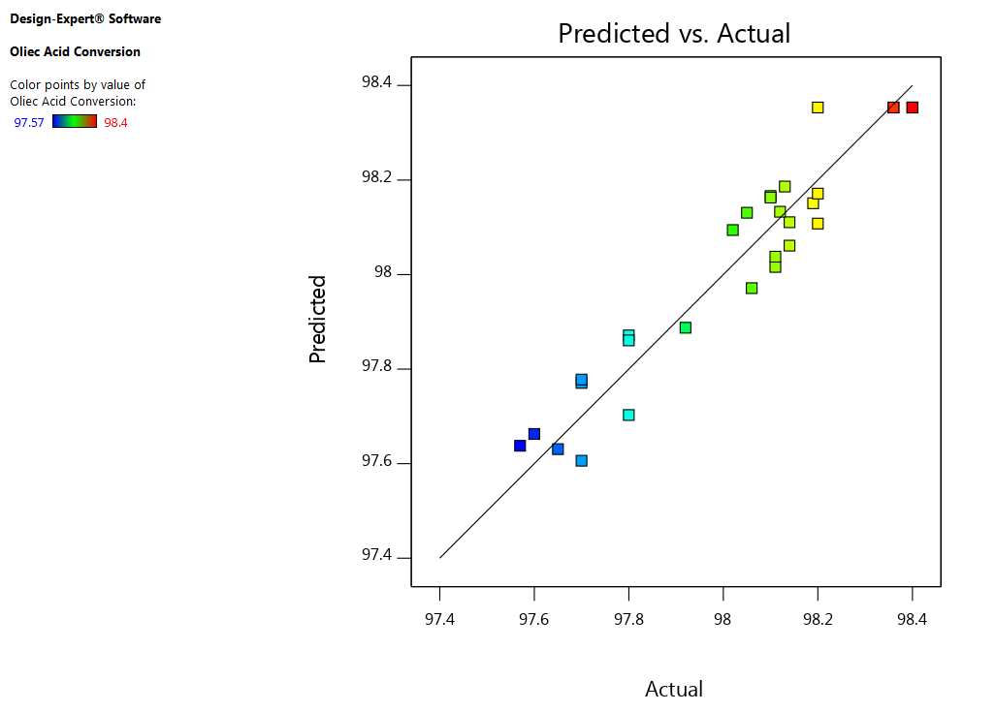

Figure 4. Predicted *versus* actual values for oleic acid conversion model

**3.5. Effect of process variables and their interactions**

The present study has investigated the conversion of four different FFAs including myrisitic, palmitic, oleic and linoleic acid. As the oleic acid represent the majority of the FFAs in the feedstock, its model has been checked for adequacy. This section is a continued study for the effect of reaction parameters on the conversion of oleic acid into FAMEs. The present study has included four process variables i.e. M:O molar ratio, temperature, pressure and time. The effect of process variables and their interactions on the conversion of oleic acid has been extensively discussed in this section. It is clearly shown in Table 4 that the conversion of FFAs are in the range between 96.5 and 98.8%. This indicates that using supercritical methanol, most of the oleic free acids have been converted into FAMEs.

**3.5.1. Effect of M:O molar ratio**

The stoichiometry of the esterification reaction of oleic acid into methyl oleate included the reaction of 1 mole of oleic acid with one mole of methanol to produce 1 mole of methyl oleate and water as shown in Equation 12. However, using supercritical methanolysis for biodiesel production usually requires large excess of methanol. Using excess of methanol shifts the reaction equilibrium towards the products (biodiesel) and decrease the critical conditions of the mixture.

$C_{18}H_{34}O_{2}+CH_{3}OH ↔ C_{19}H_{36}O_{2}+H_{2}O$ (12)

In the present study, a non-significant influence of increasing methanol ratio on oleic acid conversion has been reported as shown in Table 7. In addition, an antagonistic effect has been observed for the linear effect of increasing M:O molar ratio as shown in Equation 10 with a negative sign coefficient. However, the excess usage of methanol has a significant antagonistic effect as shown in Equation 10 with a negative sign for (A2) coefficient. This indicates that with an increase in M:O molar ratio decreases the conversion of oleic acid. Additionally, Figure 5 illustrates the effect of M:O molar ratio on the conversion of oleic acid conversion where non-significant impact has been observed at low reaction time. In addition, a negative influence has been observed for increasing M:O molar ratio on oleic acid conversion at longer reaction time.

Lokman et al. [33] has reported similar results where for the esterification of FFAs using methanol range between 1:1 and 15:1. They have observed that increasing the ratio of methanol decreases the FAME yield beyond 9:1 M:O molar ratio. In addition, they have reported insignificant change in FAME yield between 6:1 and 9:1 and hence, they have considered 6:1 as the optimum M:O molar ratio. Similarly, Alenzi et al. [34] have reported decreasing effect of M:O molar ratio using supercritical methanol at ratios higher than 1.6:1. They have referred to the complete solubility of supercritical methanol where large excess of methanol ratios would act to inhibit the esterification reaction. However, other researchers have reported increasing effect of M:O molar ratio on biodiesel yield [12,28,35]. In conclusion, M:O molar ratio is a very important parameter that affects the esterification reaction. This ratio should exceed the stoichiometric 1:1 ratio. Mostly, increasing the M:O molar ratio would increase the overall biodiesel yield, which includes esterification and transesterification reactions. However, increasing M:O molar ratio beyond certain limits would decrease the conversion of specific components including FFAs.



Figure 5. Response surface and contour plot for M:O molar ratio and reaction time *versus* oleic acid conversion

**3.5.2. Effect of reaction time**

Reaction time reduction is considered as one of the major advantageous of supercritical methanolysis over conventional catalysed methods. In the present study, the reaction time has showed a significant influence on oleic acid conversion as shown in Table 7. Furthermore, an increasing effect of high level reaction time has shown a highly significant effect on oleic acid conversion. It has been exemplified in Figure 5 that increasing reaction time (at high and low levels of temperature) has positive impact on oleic acid conversion up to 18 min. However, longer reaction time has negative impact on the conversion.

**3.5.3. Interactive effect of M:O molar ratio and reaction time**

According to the ANOVA results, the interaction effect between M:O molar ratio and reaction time has shown a significant effect on oleic acid conversion as shown in Table 7. In order to assess the interactive effect between M:O molar ratio and reaction time, an interaction plot between the two variables and FFA conversion has been analysed. As shown in Figure 6, a visible interaction is demonstrated as the effect of M:O molar ratio on FFA conversion at 12 min reaction time is different than its effect at 22 min. The interaction is also illustrated in Figure 5, where at 12 min reaction time, the effect of increasing effect of M:O molar ratio on oleic acid conversion changes at longer reaction time.



Figure 6. Interaction plot showing interactive effect of methanol ratio and temperature on FFA conversion

**3.5.4. Effect of reaction pressure**

By implementing supercritical methanolysis technique, the minimum reaction pressure is 80 bar, which reflects to the critical pressure of methanol. In this paper, the effect of reaction pressure on oleic acid conversion has been investigated between 85 and 185 bar as shown in Table 3. Increasing the reaction pressure has been performed using CO2 gas, which also acts as a co-solvent for the reaction by enhancing the solubility of methanol in oil [36].

In the present study, increasing the reaction pressure has negative effect on oleic acid conversion as shown in Equation 10 with a negative sign for the pressure coefficient. However, the only high level of pressure has significant effect on oleic acid conversion while the linear effect of pressure in not significant as shown in Table 7. The insignificant effect of pressure on oleic acid conversion is illustrated in Figure 7 as the variation of FFA conversion at different levels of reaction pressure is minor. Similar results have been reported by Liu et al. [37], they have reported insignificant effect of increasing the reaction pressure. Further, it is reported that increase in reaction pressure enhances the formation of two-phases reaction, which decreases the production of FAMEs [38].



Figure 7. Response surface and contour plot for reaction pressure and time *versus* FFA conversion

**3.5.5. Effect of reaction temperature**

Elevated temperatures have been used for non-catalytic production of biodiesel using supercritical methanol. It is widely accepted that increasing temperature enhance the reaction rate of supercritical methanolysis and increase the conversion of the reactants [38]. However, at elevated temperatures, thermal degradability should be considered as an important constraint that would breakdown the bonds of FAMEs and hence the biodiesel yield is reduced. The reaction temperature should be kept below 280 oC to avoid any possibilities for thermal degradation [10]. In addition, the critical temperature of methanol is 240 oC which is considered as the minimum temperature for supercritical methanolysis. Consequently, the present study has investigated the effect of reaction temperature between 240 and 280 oC as shown in Table 3.

In the present study, reaction temperature has been reported as a highly significant parameter affecting the conversion as shown in Table 7. As demonstrated in Figure 7, the increasing effect of temperature increase the conversion up to 265 oC, where the conversion starts to decrease beyond this temperature. Similar researchers have reported the increasing effect of FFAs conversion while increasing the reaction temperature [33,37,39,40].

**3.5.6. Interactive effect of reaction pressure and time**

As shown in Table 7, the interaction effect between reaction temperature and pressure has a non-significant effect on the conversion. It has been illustrated in Figure 8, parallel effects of both temperature and pressure on the response. This means that effect of each variable is not affected by varying the other parameter. This conclusion is clearly demonstrated in Figure 7, where the effect of increasing the temperature on the conversion is similar at both 110 and 160 bar. Hence, the pressure level does not affect the increasing effect of temperature on the conversion.



Figure 8. Interaction plot showing interactive effect of reaction pressure and time on FFA conversion

**3.6. Process optimisation**

Numerical and graphical optimisation using RSM method has been reported extensively during the last years for either biodiesel production [4,41,42] or different applications [43]. In the present study, both numerical and graphical optimisation have been employed to minimise the process variables and to maximise the process responses using Design Expert software. The optimisation targets for process variables and responses have been demonstrated in Table 8. A rank for each variable has been defined based on a scale from 1 to 5 for the importance of each target.

Table 8. Optimisation constraints used to predict optimum conditions for biodiesel production

|  |  |  |  |  |  |
| --- | --- | --- | --- | --- | --- |
| Factor | Code | Goal | Importance | Limits | |
|  | | | Scale 1-5 | Lower | Upper |
| M:O (molar ratio) | A | Minimise | 3 | 25 | 35 |
| Temperature (oC) | B | Minimise | 4 | 250 | 270 |
| Pressure (bar) | C | Minimise | 3 | 110 | 160 |
| Time (min) | D | Minimise | 4 | 12 | 22 |
| Myristic acid conversion | Y1 | Maximise | 5 | 98.5 | 100 |
| Palmitic acid conversion | Y2 | Maximise | 5 | 98 | 100 |
| Oleic acid conversion | Y3 | Maximise | 5 | 97.5 | 100 |
| Linoleic acid conversion | Y4 | Maximise | 5 | 99 | 100 |

The software has used the combination of the targets and developed 68 solutions with different desirabilities. Hence, the solution with the highest desirability has been chosen as the optimal process variables for this study. The predicted optimum conditions with highest desirability of 92.3% have achieved conversion percentages of 99.2%, 99.1%, 98.35% and 99.65% for myrisitic, palmitic, oleic and linoleic acids, respectively. The optimal conditions have been reported at 25:1, 256.5 oC, 110 bar and 17 min for M:O molar ratio, temperature, pressure and time, respectively.

It is worth mentioning that using graphical optimisation has effectively exemplified the wide range of desirabilities at different variables levels. This demonstrate the difference between one factor at a time (OFAT) and multivariable optimisation. For instance, the optimal point could have different possibilities; it could be observed at a low or high levels of variables as shown in Figure 9. The optimal conditions could also be developed at the axial level of a variable and in-between range of other variables as shown in Figure 10. Finally, the last option that the predicted optimal point could be located in-between range of both variables where it would be difficult to be predicted using OFAT as shown in Figure 11.

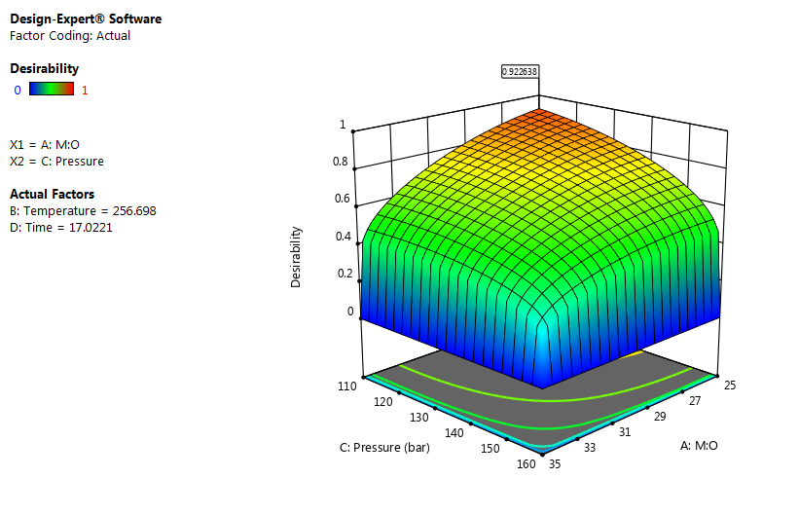

Figure 9. Surface plot showing the interactive effect of M:O molar ratio and reaction pressure on optimisation desirability

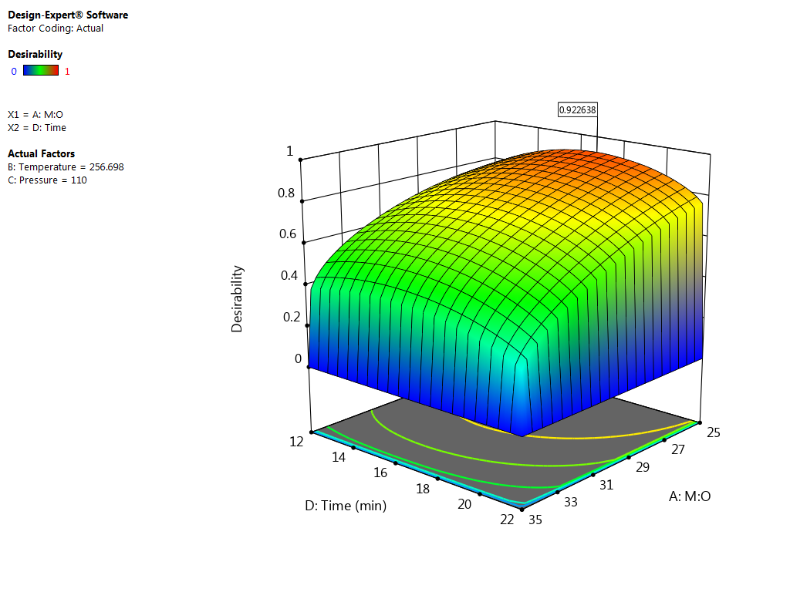

Figure 10. Surface plot showing the interactive effect of M:O molar ratio and reaction time on optimisation desirability

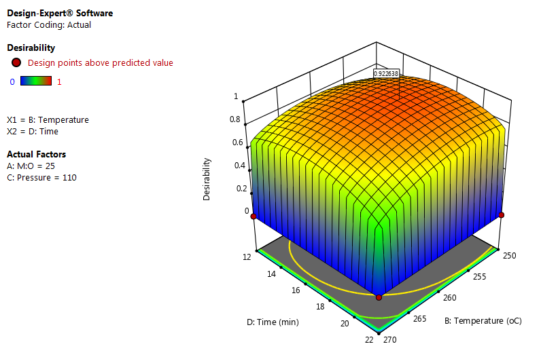

Figure 11. Surface plot showing the interactive effect of reaction temperature and time on optimisation desirability

The predicted optimal conditions have been validated experimentally by performing 3 experimental runs at the same predicted conditions. The experimental average results have reported 99.15%, 99.12%, 98.4% and 99.7% conversion for myrisitic, palmitic, oleic and linoleic acids, respectively. Consequently, the predicted optimal conditions have been confirmed experimentally with a relative error range between 0.05 and 0.2% for all responses.

**4. CONCLUSIONS**

This study has developed a simple conversion route for different FFAs using supercritical esterification. In addition, the analysis of FFAs in the feedstock and products has been performed using a simple derivatisation-free characterisation method. The developed method has resulted in high quality accurately separated peaks for each FFA. The effect of four independent variables and their interactions have been investigated. A significant interactive effect of M:O molar ratio and reaction time on FFA conversion has been observed. The analyses of the interactive effects of reaction variables have been discussed and employed for precise process optimisation. Finally, numerical and graphical optimisation have been employed to optimise the reaction variables for maximum conversion of FFAs. The optimum conditions have been reported at 25:1 M:O molar ratio, 256.5 oC, 110 bar within 17 min resulting in 99.2%, 99.1%, 98.35% and 99.65% conversion for myrisitic, palmitic, oleic and linoleic acids, respectively. The predicted optimal conditions have been validated experimentally with very low relative errors.

**ACKNOWLEDGMENT**

The authors would like to acknowledge The British Council UK and STDF Egypt for funding this research through the Newton Institutional Links Programme (Project IDs 261862377 and 27738).

**REFERENCES**

[1] H.H. Mardhiah, H.C. Ong, H.H. Masjuki, S. Lim, H.V. Lee, A review on latest developments and future prospects of heterogeneous catalyst in biodiesel production from non-edible oils, Renew. Sustain. Energy Rev. 67 (2017) 1225–1236. doi:10.1016/j.rser.2016.09.036.

[2] D. Bessières, J.P. Bazile, X.N.T. Tanh, F. García-Cuadra, F.G. Acien, Thermophysical behavior of three algal biodiesels over wide ranges of pressure and temperature, Fuel. 233 (2018) 497–503. doi:10.1016/j.fuel.2018.06.091.

[3] S.Z. Abidin, K.F. Haigh, B. Saha, Esterification of free fatty acids in used cooking oil using ion-exchange resins as catalysts: An efficient pretreatment method for biodiesel feedstock, Ind. Eng. Chem. Res. 51 (2012) 14653–14664. doi:10.1021/ie3007566.

[4] O. Aboelazayem, N.S. El-Gendy, A.A. Abdel-Rehim, F. Ashour, M.A. Sadek, Biodiesel production from castor oil in Egypt: Process optimisation, kinetic study, diesel engine performance and exhaust emissions analysis, Energy. 157 (2018) 843–852. doi:10.1016/j.energy.2018.05.202.

[5] M.M. Hasan, M.M. Rahman, Performance and emission characteristics of biodiesel–diesel blend and environmental and economic impacts of biodiesel production: A review, Renew. Sustain. Energy Rev. 74 (2017) 938–948. doi:10.1016/j.rser.2017.03.045.

[6] M.A. Vieira da Silva, B. Lagnier Gil Ferreira, L.G. da Costa Marques, A. Lamare Soares Murta, M.A. Vasconcelos de Freitas, Comparative study of NOx emissions of biodiesel-diesel blends from soybean, palm and waste frying oils using methyl and ethyl transesterification routes, Fuel. 194 (2017) 144–156. doi:10.1016/j.fuel.2016.12.084.

[7] K. Jookjantra, T. Wongwuttanasatian, Optimisation of biodiesel production from refined palm oil with heterogeneous CaO catalyst using pulse ultrasonic waves under a vacuum condition, Energy Convers. Manag. 154 (2017) 1–10. doi:10.1016/j.enconman.2017.10.050.

[8] D. Zhou, B. Qiao, G. Li, S. Xue, J. Yin, Continuous production of biodiesel from microalgae by extraction coupling with transesterification under supercritical conditions, Bioresour. Technol. 238 (2017) 609–615. doi:10.1016/j.biortech.2017.04.097.

[9] F.J. Gutiérrez Ortiz, P. de Santa-Ana, Techno-economic assessment of an energy self-sufficient process to produce biodiesel under supercritical conditions, J. Supercrit. Fluids. 128 (2017) 349–358. doi:10.1016/j.supflu.2017.03.010.

[10] O. Aboelazayem, M. Gadalla, B. Saha, Design and simulation of an integrated process for biodiesel production from waste cooking oil using supercritical methanolysis, Energy. 161 (2018) 299–307. doi:10.1016/j.energy.2018.07.139.

[11] M. Suresh, C.P. Jawahar, A. Richard, A review on biodiesel production, combustion, performance, and emission characteristics of non-edible oils in variable compression ratio diesel engine using biodiesel and its blends, Renew. Sustain. Energy Rev. 92 (2018) 38–49. doi:10.1016/j.rser.2018.04.048.

[12] A.A. de Jesus, D.F. de Santana Souza, J.A. de Oliveira, M.S. de Deus, M.G. da Silva, E. Franceschi, S.M. da Silva Egues, C. Dariva, Mathematical modeling and experimental esterification at supercritical conditions for biodiesel production in a tubular reactor, Energy Convers. Manag. 171 (2018) 1697–1703. doi:10.1016/j.enconman.2018.06.108.

[13] C. Mazzocchia, G. Modica, A. Kaddouri, R. Nannicini, Fatty acid methyl esters synthesis from triglycerides over heterogeneous catalysts in the presence of microwaves, Comptes Rendus Chim. 7 (2004) 601–605. doi:10.1016/j.crci.2003.12.004.

[14] V. Lertsathapornsuk, R. Pairintra, K. Aryusuk, K. Krisnangkura, Microwave assisted in continuous biodiesel production from waste frying palm oil and its performance in a 100 kW diesel generator, Fuel Process. Technol. 89 (2008) 1330–1336. doi:10.1016/j.fuproc.2008.05.024.

[15] M. Aghbashlo, S. Hosseinpour, M. Tabatabaei, A. Dadak, Fuzzy modeling and optimization of the synthesis of biodiesel from waste cooking oil (WCO) by a low power, high frequency piezo-ultrasonic reactor, Energy. 132 (2017) 65–78. doi:10.1016/j.energy.2017.05.041.

[16] O. Farobie, Y. Matsumura, State of the art of biodiesel production under supercritical conditions, Prog. Energy Combust. Sci. 63 (2017) 173–203. doi:10.1016/j.pecs.2017.08.001.

[17] S. Saka, D. Kusdiana, Biodiesel fuel from rapeseed oil as prepared in supercritical methanol, Fuel. 80 (2001) 225–231. doi:10.1016/S0016-2361(00)00083-1.

[18] O. Farobie, Z.Y.M. Leow, T. Samanmulya, Y. Matsumura, New insights in biodiesel production using supercritical 1-propanol, Energy Convers. Manag. 124 (2016) 212–218. doi:10.1016/j.enconman.2016.07.021.

[19] S. Ponnusamy, C. Li, P.D. Patil, Y. Sun, S. Deng, L. Jiang, T. Muppaneni, H.K. Reddy, Optimization of high-energy density biodiesel production from camelina sativa oil under supercritical 1-butanol conditions, Fuel. 135 (2014) 522–529. doi:10.1016/j.fuel.2014.06.072.

[20] O. Aboelazayem, M. Gadalla, B. Saha, Biodiesel production from waste cooking oil via supercritical methanol: Optimisation and reactor simulation, Renew. Energy. 124 (2018) 144–154. doi:10.1016/j.renene.2017.06.076.

[21] O. Aboelazayem, M. Gadalla, B. Saha, Valorisation of high acid value waste cooking oil into biodiesel using supercritical methanolysis: Experimental assessment and statistical optimisation on typical Egyptian feedstock, Energy. 162 (2018) 408–420. doi:10.1016/j.energy.2018.07.194.

[22] S.M. Ghoreishi, P. Moein, Biodiesel synthesis from waste vegetable oil via transesterification reaction in supercritical methanol, J. Supercrit. Fluids. 76 (2013) 24–31. doi:10.1016/j.supflu.2013.01.011.

[23] F.L. Martinovic, F.E. Kiss, R.D. Micic, M. Simikić, M.D. Tomić, Comparative techno-economic analysis of single-step and two-step biodiesel production with supercritical methanol based on process simulation, Chem. Eng. Res. Des. 132 (2018) 751–765. doi:10.1016/j.cherd.2018.02.024.

[24] W. Sakdasri, R. Sawangkeaw, S. Ngamprasertsith, Techno-economic analysis of biodiesel production from palm oil with supercritical methanol at a low molar ratio, Energy. 152 (2018) 144–153. doi:10.1016/j.energy.2018.03.125.

[25] D.C. Boffito, F. Galli, C. Pirola, C.L. Bianchi, G.S. Patience, Ultrasonic free fatty acids esterification in tobacco and canola oil, Ultrason. Sonochem. 21 (2014) 1969–1975. doi:10.1016/j.ultsonch.2014.01.026.

[26] D. Kim, J. Choi, G.J. Kim, S.K. Seol, S. Jung, Accelerated esterification of free fatty acid using pulsed microwaves, Bioresour. Technol. 102 (2011) 7229–7231. doi:10.1016/j.biortech.2011.04.074.

[27] R. Vengalil, R. Suresh, G.E. Kochimoolayil, R. Joseph, J.V. Antony, Esterification of free fatty acids in non- edible oils using partially sulfonated polystyrene for biodiesel feedstock, Ind. Crops Prod. 95 (2016) 66–74. doi:10.1016/j.indcrop.2016.09.060.

[28] T. Jin, B. Wang, J. Zeng, C. Yang, Y. Wang, T. Fang, Esterification of free fatty acids with supercritical methanol for biodiesel production and related kinetic study, RSC Adv. 5 (2015) 52072–52078. doi:10.1039/c5ra03709c.

[29] O. Aboelazayem, M. Gadalla, B. Saha, Optimising Bidiesel Production from High Acid Value Waste Cooking Oil Using Supercritical Methanol, in: Eur. Biomass Conf. Exhib. Proceedings, EUBCE2017, (12-15 June), 2017: pp. 57–66. doi:10.18690/978-961-286-048-6.7.

[30] H. Zhang, Z. Wang, O. Liu, Development and validation of a GC-FID method for quantitative analysis of oleic acid and related fatty acids, J. Pharm. Anal. 5 (2015) 223–230. doi:10.1016/j.jpha.2015.01.005.

[31] H. Zhang, Z. Wang, O. Liu, Development and validation of a GC-FID method for quantitative analysis of oleic acid and related fatty acids, J. Pharm. Anal. 5 (2015) 223–230. doi:10.1016/j.jpha.2015.01.005.

[32] S.Z. Abidin, D. Patel, B. Saha, Quantitative analysis of fatty acids composition in the used cooking oil (UCO) by gas chromatography-mass spectrometry (GC-MS), Can. J. Chem. Eng. 91 (2013) 1896–1903. doi:10.1002/cjce.21848.

[33] I.M. Lokman, M. Goto, U. Rashid, Y.H. Taufiq-Yap, Sub- and supercritical esterification of palm fatty acid distillate with carbohydrate-derived solid acid catalyst, Chem. Eng. J. 284 (2016) 872–878. doi:10.1016/j.cej.2015.08.102.

[34] R. Alenezi, G.A. Leeke, J.M. Winterbottom, R.C.D. Santos, A.R. Khan, Esterification kinetics of free fatty acids with supercritical methanol for biodiesel production, Energy Convers. Manag. 51 (2010) 1055–1059. doi:10.1016/j.enconman.2009.12.009.

[35] R.C. Narayan, G. Madras, Esterification of Sebacic Acid in Near-Critical and Supercritical Methanol, Ind. Eng. Chem. Res. 56 (2017) 2641–2649. doi:10.1021/acs.iecr.6b04769.

[36] H. Han, W. Cao, J. Zhang, Preparation of biodiesel from soybean oil using supercritical methanol and CO2 as co-solvent, Process Biochem. 40 (2005) 3148–3151. doi:10.1016/j.procbio.2005.03.014.

[37] L.L. Tavlarides, X. Huang, J.Q. Bond, Y. Nan, J. Liu, Continuous esterification of oleic acid to ethyl oleate under sub/supercritical conditions over γ-Al 2 O 3, Appl. Catal. B Environ. 232 (2018) 155–163. doi:10.1016/j.apcatb.2018.03.050.

[38] A.T. Quitain, E.G. Mission, Y. Sumigawa, M. Sasaki, Supercritical carbon dioxide-mediated esterification in a microfluidic reactor, Chem. Eng. Process. - Process Intensif. 123 (2018) 168–173. doi:10.1016/j.cep.2017.11.002.

[39] P.R.S. dos Santos, F.A.P. Voll, L.P. Ramos, M.L. Corazza, Esterification of fatty acids with supercritical ethanol in a continuous tubular reactor, J. Supercrit. Fluids. 126 (2017) 25–36. doi:10.1016/j.supflu.2017.03.002.

[40] O. Nur Syazwani, M. Lokman Ibrahim, Wahyudiono, H. Kanda, M. Goto, Y.H. Taufiq-Yap, Esterification of high free fatty acids in supercritical methanol using sulfated angel wing shells as catalyst, J. Supercrit. Fluids. 124 (2017) 1–9. doi:10.1016/j.supflu.2017.01.002.

[41] M.D. Kostić, A. V. Veličković, N.M. Joković, O.S. Stamenković, V.B. Veljković, Optimization and kinetic modeling of esterification of the oil obtained from waste plum stones as a pretreatment step in biodiesel production, Waste Manag. 48 (2016) 619–629. doi:10.1016/j.wasman.2015.11.052.

[42] C. Muthukumaran, R. Praniesh, P. Navamani, R. Swathi, G. Sharmila, N. Manoj Kumar, Process optimization and kinetic modeling of biodiesel production using non-edible Madhuca indica oil, Fuel. 195 (2017) 217–225. doi:10.1016/j.fuel.2017.01.060.

[43] R. Saada, O. AboElazayem, S. Kellici, T. Heil, D. Morgan, G.I. Lampronti, B. Saha, Greener synthesis of dimethyl carbonate using a novel tin-zirconia/graphene nanocomposite catalyst, Appl. Catal. B Environ. 226 (2018) 451–462. doi:10.1016/j.apcatb.2017.12.081.