Measurement of 4-hydroxynonenal (4-HNE) protein adducts by ELISA
Kosha Mehta¹ and Vinood B. Patel^{2*}

¹School of Applied Sciences, London South Bank University, 103 Borough Rd, London SE1 0AA, UK
²School of Life Sciences, Faculty of Science & Technology, University of Westminster, 115 New Cavendish Street, W1W 6UW, UK
*Corresponding author:
Vinood B. Patel, PhD, FHEA, FRSC. Phone: +44 (0) 2035064138; E-mail: v.b.patel@westminster.ac.uk

Running head: HNE-protein adduct measurement by ELISA

Summary
Enzyme linked immunosorbent assay (ELISA) is a widely used technique for the measurement of antigens and antibodies alike. We describe here procedures, indirect ELISA and sandwich ELISA for the detection of 4-hydroxynonenal protein adducts. These adducts are stable compounds formed within cells and bodily fluids under conditions of oxidative stress. They can act as sensitive biomarkers of oxidative stress and are directly linked to disease pathology.

Key words: ELISA, 4-hydroxynonenal; 4-HNE, anti-HNE antibodies, HRP-labelled antibodies, dot blot, indirect ELISA, sandwich ELISA

- Introduction
4-Hydroxynonenal (4-HNE) is an aldehyde end product of lipid peroxidation. This highly reactive electrophile binds avidly to proteins with a cysteine, histidine or lysine residues, forming stable protein adducts [1]. 4-HNE-protein adducts are elevated in conditions involving oxidative stress [2,3,4], suggesting they can be a useful biomarker of disease pathology, but also due to its’ immunogenic properties, may directly lead to disease pathogenesis [5]. Protein modification can also directly alter a protein’s function [6]. In addition, 4-HNE has been implicated as a signaling molecule in apoptosis and through binding of glutathione may affect the cellular redox state [7]. Therefore, measurement of 4-HNE protein adducts may indicate general oxidative stress and/or disease pathology.

Enzyme linked immunosorbent assay (ELISA) involves colorimetric or fluorimetric detection and measurement of proteins or antibodies of interest in an unknown sample and is the most commonly used biochemical assay in diagnostic laboratories. It can be classified into various types and subtypes such as competitive, non-competitive, direct, indirect, displacement and sandwich ELISA; the type is chosen based on the application and specificity required. While the protocols differ slightly, the main principle of ELISA remains the same across all types, i.e. binding of either the antigen (sample/protein) or the antibody to a solid surface and measurement of the intensity of the interaction between the antigen and the antibody. In the following method, we describe indirect and sandwich ELISA using the colorimetric horseradish peroxidase (HRP) system for the measurement of HNE-protein adducts.

It is important to note that while the indirect format measures total HNE in a sample (i.e. general oxidative stress), the sandwich format is more specific and detects HNE conjugated to a specific protein of interest.

In the indirect ELISA, the unknown sample (or HNE-conjugated protein standard) is absorbed on the surface of the ELISA plate. This is incubated with an anti-HNE antibody (referred as primary antibody) that binds to the HNE moiety on the sample. Further, a HRP-labeled detection antibody (referred as the secondary antibody) is added, which binds to the primary antibody (i.e., the anti-HNE antibody). Subsequent addition of the HRP-specific substrate tetramethylbenzidine (TMB) to this complex allows formation of a yellow-colored product that elicits a chromogenic signal, which is read by the microplate reader (Fig. 1a).

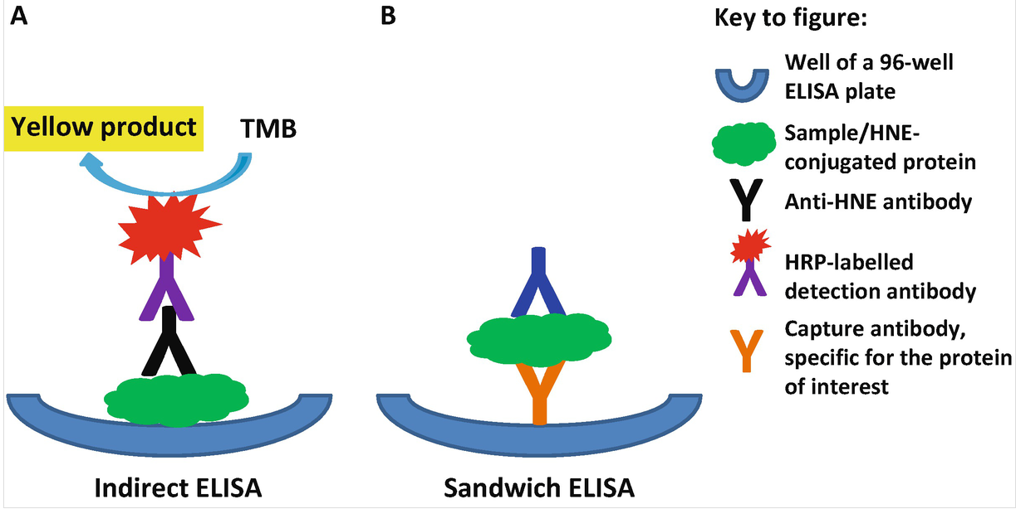

Fig. 1 Schematic representation of ELISA.
A schematic representation of indirect ELISA (a) and sandwich ELISA (b) has been shown. Addition of the HRP-specific substrate TMB produces a yellow color, the intensity of which is measured by the ELISA plate reader. The sandwich ELISA involves binding of two antibodies to different epitopes on the sample, where the capture antibody is specific for the protein of interest. Thus, it is more specific than the indirect ELISA

In the sandwich format, a “sandwich” is created with at least two antibodies that bind to different and distal epitopes on the sample. Typically, one antibody is for capture of the protein of interest and the second antibody is an anti-HNE antibody that is HRP-labeled to facilitate detection. First, the protein-specific antibody is absorbed on the surface of the ELISA plate (referred as the capture antibody) to which the unknown sample or a known concentration of HNE-conjugated protein standard is added. Following this,
HRP-labeled anti-HNE detection antibody is added, which binds to a different distal epitope on the sample/standard. Similar to the indirect ELISA, addition of TMB mediates the formation of a yellow-colored product, which is detected by the plate reader and the absorbance is recorded (Fig. 1b). In both indirect and sandwich ELISA, the presence of HNE-protein adducts in the sample is confirmed by comparing the readings of the sample with those of the HNE-protein standard curve (Fig. 2).

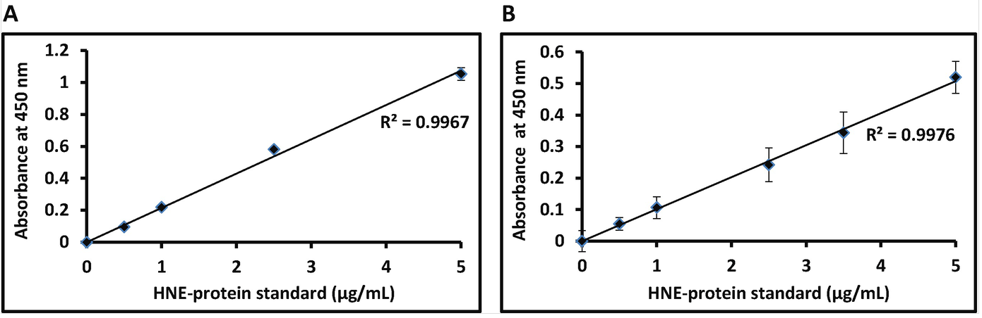
Fig. 2 Typical ELISA standard curves.
Typical examples of the standard curves obtained following an indirect ELISA (a) and a sandwich ELISA (b) are shown. The average absorbance reading of each concentration of the HNE-protein standard is subtracted from the reading of the blank (without standard) and plotted on a graph. The concentration of HNE in unknown samples is interpolated from the graph by using the equation of the line of regression

2. Materials
2.1. Preparation of Antibodies
1. Antibodies: Procure antibodies for the indirect/sandwich ELISA (see Notes 1 and 2).
2. Anti-HNE antibodies (see Note 2).
3. HRP-labeled detection antibodies for the indirect ELISA (see Notes 3 and 4).
4. Capture antibodies for sandwich ELISA: Polyclonal or monoclonal antibodies are produced against your protein of interest (antigen) by immunizing the desired species using highly purified (˃99 %) protein.
5. For the sandwich ELISA the generated anti-HNE antibodies (see Note 1) require labeling with HRP, which can be carried out by AbD Serotec (Bio-Rad) or Abcam.

2.2. ELISA Assay Components
1. Protein standards: HNE-conjugated protein standards are commercially available or can be prepared ‘in house’ [8] (see Note 5).
2. ELISA plates: 96-well, High Bind plates suitable for ELSA application (see Note 6).
3. Disposable plate sealers.
4. Phosphate buffered saline (PBS).
5. Coating buffer: 0.35 M sodium bicarbonate, 0.15 M sodium carbonate (pH 9.6) in deionized water.
6. Wash buffer A: 0.05% PBS-Tween (T) (v/v) (see Note 7).
7. Wash buffer B: 0.1% PBS-T (v/v) (see Note 7).
8. Blocking buffer: Casein (see Note 8).
9. Substrate solution: TMB Substrate solution.
10. Stop solution: 2 M sulphuric acid.
11. Reagent reservoirs, timer, a well-calibrated multichannel pipette and microplate reader.
12. West Pico chemiluminescent kit.

3. Methods
All antibodies should be stored at 4 °C or −20 °C, as suggested by the manufacturer (see Note 2). All buffers and antibody preparations should be equilibrated at room
Temperature (RT) before addition to the wells and all procedures should be carried out at RT, unless stated otherwise. Buffers for coating, blocking and washing are commercially available or can be prepared “in house” in deionized Milli-Q grade water using analytical grade reagents and stored at RT.

3.1. Optimization of Antibodies, Standards, and Sample
Prior to performing the ELISA with samples, it is important to confirm the binding of the anti-HNE antibody to an HNE-labeled protein and binding of the capture antibody to the ELISA plate. In addition, it is important to determine the optimal concentrations of antibodies and the optimal range of standards for the ELISA.
1. To confirm that the commercially produced anti-HNE antibody binds to a HNE-labeled protein, the dot blot method can be used. Briefly, a known amount (e.g., 30 μg) of a HNE-conjugated protein (i.e., a standard can be used) is blotted on a nitrocellulose membrane, allowed to dry for 10 min and probed with selected concentrations of anti-HNE antibody made in wash buffer A (see Note 9). Following washing with buffer B, the complex is detected by a species compatible HRP-labeled detection antibody by using the West PICO chemiluminescent kit, as suggested by the manufacturer (see Note 9).
2. For the sandwich ELISA, it is important to confirm first that the capture antibody binds to the ELISA plate. Here the wells are coated with 5 μg/mL and 15 μg/mL of capture antibody, followed by detection using a species compatible HRP-labeled
detection
antibody, typically between 0.01 μg/mL and 0.04 μg/mL. For this assay, the protocol mentioned in Subheading 3.4, should be followed.
3. To optimize the antibody-concentrations and the concentration range of standards, titrations of various combinations of antibody-concentrations should be performed with a wide range of HNE-conjugated protein standards. An example of the titration board for the sandwich format is suggested in Fig. 3. Following this, the most linear range of the concentration of standards is chosen (Fig. 2).
4. To optimize the sample concentration, different dilutions of the sample in PBS can be used, for example neat sample, 1:1, 1:10, and 1:100.

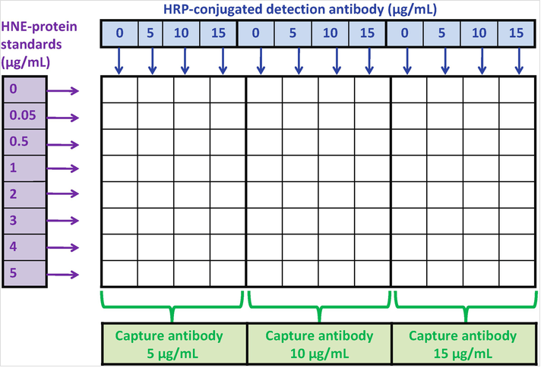
Fig. 3 Representative titrations of antibodies for sandwich ELISA.
The figure is a representative schematic of a 96-well ELISA Plate. It shows combinations of different antibody concentrations probed with a range of known HNE-protein standards to optimize the sandwich ELISA

3.2 Selecting Control Samples
The following experimental controls are added in triplicate to each assay plate.
1. Positive control: A previously assessed sample that showed a positive reaction or a known concentration of HNE-protein that shows a positive result.
2. Negative controls for indirect ELISA:
(a) Blank-1: wells with the known HNE-conjugated protein standard and anti-HNE antibody, but without HRP-labeled detection antibody. Use wash buffer B instead of the detection antibody.
(b) Blank-2: wells without HNE-conjugated protein standard, but with anti-HNE antibody and HRP-labeled detection antibody. Use coating buffer instead of protein standard.
3. Negative controls for sandwich ELISA:
(a) Blank-A: wells with capture antibody and known HNE-conjugated protein standard, but without the HRP-labeled anti-HNE antibody. Use the wash buffer B instead of the anti-HNE antibody.
(b) Blank-B: for sandwich ELISA: wells with the capture antibody and HRP-labeled anti-HNE antibody, but without HNE-conjugated protein standard. Use PBS instead of the protein standard.

3.3. Indirect ELISA Method
1. Plan the layout of the plate and note the wells in which the HNE-conjugated protein standards, samples and controls will be added (see Note 10).
2. Prepare the sample and the optimized range of HNE-conjugated protein standards in the coating buffer (as previously determined through Subheading 3.1, steps 3 and 4).
3. Add 50 μL/well and incubate at RT for 2 h.
4. Aspirate the solution from the wells and wash wells with wash buffer B (see Note 11).
5. Add blocking buffer (300 μL/well) and incubate at RT for 1 h (see Note 12).
6. Wash wells with PBS.
7. Add the optimized concentration of anti-HNE antibody prepared in wash buffer A (50 μL/well).
8. Incubate at RT for 1 h.
9. Aspirate the solution from the wells and wash wells thrice with wash buffer B (see Note 11).
10. Prepare the optimized concentration of HRP-labeled detection
antibody in wash buffer B and immediately wrap the tube in silver foil.
11. Add 50 μL of HRP labeled detection antibody per well, seal the plate with the plate sealer and immediately wrap it in a foil.
12. Incubate at RT for 1 h in dark.
13. Aspirate the solution from the wells and wash wells thrice with wash buffer B and once with PBS (see Note 11).
14. Add TMB (100 μL/well) andincubate at RT for 20 min in dark.
15. Add 2 M sulfuric acid (100 μL/well) to stop the reaction (see Note 13).
16. Gently tap the plate to ensure thorough mixing.
17 .Read the absorbance at 450 nm on a plate reader within 30 min of stopping the reaction. A positive sample develops a yellow color whereas a negative sample is colorless.
18. Compare the readings of the samples with the negative controls to confirm the presence of HNE in the sample and/or read off the concentration of HNE in the sample from the standard curve (see Note 14).

3.4. Sandwich ELISA Method
1. Plan the layout of the plate and note the wells in which the HNE-conjugated protein standards, samples and controls will be added (see Note 10).
2. Dilute the capture antibody in coating buffer and immediately add 100 μL/well.
3. Seal the plate with the plate sealer and incubate overnight at 4 °C or at 37 °C for 1 h 30 min.
4. Aspirate the solution from the wells and wash wells thrice with wash buffer A (see Note 11).
5. Add the blocking buffer (300 μL/well) and incubate at RT for 1 h (see Note 12).
6. Remove all blocking solution by inverting the plate in the sink and then wash wells gently with PBS.
7. Prepare the optimized range of HNE-conjugated protein standards in PBS (as determined previously through Subheading 3.1, step 3).
8. Add the standards and the optimized concentration of samples (as determined previously through Subheading 3.1, step 4) to the wells (50 μL/well).
9. Seal the plate with the plate sealer and incubate at 37 °C for 2 h.
10. Aspirate the solution from the wells and wash wells twice with wash buffer A and once with PBS (see Note 11).
11. Prepare fresh HRP-labeled anti-HNE detection antibody in wash buffer B (at an optimized concentration as previously determined through Subheading 3.1, step 3) just before addition to wells and immediately wrap the tube in a foil (see Note 15).
(a) Add the HRP-labeled detection antibody (50 μL/well).
(b)Seal the plate, cover with foil and incubate 1 h at 37 °C.
(c)Aspirate the solution from the wells and wash wells thrice with wash buffer B and once with PBS (see Note 11).
12. Add TMB (100 μL/well) and incubate at RT for 20 min in dark.
13. Add 2 M sulfuric acid to stop the reaction (100 μL/well). (see Note 13)
14. Gently tap the plate to ensure thorough mixing.
15. Read the absorbance at 450 nm on a plate reader within 30 min of stopping the reaction. A positive sample develops yellow color whereas a negative sample is colorless.
16. Compare the readings of the samples with the negative controls to confirm the presence of HNE in the sample or read off the concentration of HNE in the sample from the standard curve (see Note 14).

4. Notes
  - Procurement can be carried out by a variety of companies.
  - If the recommended storage temperature for the antibodies is -20 °C, then aliquot the stock in small aliquots to avoid repeated free-thaw cycles. These can be raised in a host species of choice such as rabbit, sheep or goat using HNE-KLH (keyhole limpet hemocyanin) as the antigen. The anti-HNE antibodies can be used as primary antibodies in indirect ELISA.
  - These are commercially available from several companies and should be against the host species in which the primary antibody (anti-HNE) is raised
  - If the detection antibody is conjugated to alkaline phosphatase, then p-nitrophenyl phosphate is used as a substrate and 3 M sodium hydroxide as a stop solution. The reaction is read at 405 nm. The volumes of the substrate and stop solution and the other procedures in the protocol remain unaltered.
  - Aliquot the stock solution of the HNE-protein standard in small volumes and store at -20 °C. Avoid repeated freeze-thaw cycles.
  - Using special ELISA-grade plates is essential. Plates with curved bottoms allow efficient washing between steps and therefore reduced background.
  - To prepare the wash buffers, Tween should be added to PBS and allowed to mix on a shaker at RT for at least 1 h.
  - Alternative blocking buffer can be used such as 1 % BSA in 0.05 % PBS-T (w/v).
  - Generally, detection of the antigen using the West PICO chemiluminescent kit recommends that the concentration of anti-HNE antibody be from 0.2 µg/mL to 1 µg/mL and the concentration of HRP-labelled detection antibody is from 0.01 µg/mL to 0.04 µg/mL. The secondary HRP-labelled detection antibody must be raised against the host species in which the anti-HNE antibody is raised.
  - To enable easy view of the wells during the addition of small volumes of antibody solutions, a coloured piece of uniformly flat cardboard can be placed under the ELISA plate.
  - During all the washing steps, use 300 μL/well of the wash buffer i.e. fill the wells up to the brim. During each washing step, the plate should be first inverted in the sink to remove most liquid. Then, the plate should be firmly blotted several times on a dry clean tissue paper until no liquid is visibly seen on the tissue. Complete removal of liquid from wells is essential before proceeding further to avoid poor reproducibility of results.
  - The volume of the blocking solution should be higher (at least double) than the volumes of the antibody solutions to allow complete and effective blocking.
  - The volume of stop solution should be equal to the volume of substrate solution.
  - Readings of the samples should be three times higher than the readings of the blank to obtain statistically significant differences. Determine the average absorbance readings for each set of triplicate standards, controls and samples
Normalise the readings to the blank i.e. subtract the reading of the blank (blank-2 and blank-B in indirect ELISA and sandwich ELISA, respectively) from that of the standards and samples. Construct a standard curve by plotting the concentration on the x-axis and the subtracted average absorbance for each standard on the y-axis. Draw a line of best fit through the points on the graph and determine the concentration of the unknown samples by using the equation of the line of regression. If diluted samples were used, then the concentration deduced from the standard curve should be multiplied by the dilution factor. Alternatively, a computer-based curve-fitting statistical software could be used to calculate the concentration of the sample.
  - In the sandwich ELISA format, if the anti-HNE antibody is not labelled with HRP, then an HRP-labelled antibody is required for detection. Thus, this format will involve three antibodies; capture, anti-HNE and the HRP-labelled detection antibody. The HRP-labelled antibody should be raised against the host species in which the anti-HNE antibody is raised and should bind exclusively to the anti-HNE antibody. It should be confirmed through indirect ELISA that this detection antibody does not bind to the capture antibody. For optimisation of concentrations of the three antibodies, titrations should first be carried out with the capture and the anti-HNE antibody (Fig.3), followed by optimisation of the HRP-labelled detection antibody.
References
1. Petersen DR, Doorn JA.(2004) Reactions of 4-hydroxynonenal with proteins and cellular targets. Free Radic Biol Med. 37,937–45.
2. Lovell MA, Ehmann WD, Mattson MP, Markesbery WR. (1997) Elevated 4-hydroxynonenal in ventricular fluid in Alzheimer’s disease. Neurobiol Aging. 18,457–61.
3. Kamimura S, Gaal K, Britton RS, Bacon BR, Triadafilopoulos G, Tsukamoto H (1992). Increased 4-hydroxynonenal levels in experimental alcoholic liver disease: association of lipid peroxidation with liver fibrogenesis. Hepatol Baltim Md. 16, 448–53.
4. Shoeb M, Ansari NH, Srivastava SK, Ramana KV. (2014) 4-hydroxynonenal in the pathogenesis and progression of human diseases. Curr Med Chem21, 230–7.
5. Li CJ, Nanji AA, Siakotos AN, Lin RC. Acetaldehyde-modified and 4-hydroxynonenal-modified proteins in the livers of rats with alcoholic liver disease. (1997) HepatolBaltim Md. 26,650–7.
6. Patel VB, Spencer CH, Young TA, Lively MO, Cunningham CC. (2007) Effects of 4-hydroxynonenal on mitochondrial 3-hydroxy-3-methylglutaryl (HMG-CoA) synthase. Free Radic Biol Med. 43,1499–507.
7. Awasthi YC, Yang Y, Tiwari NK, Patrick B, Sharma A, Li J, Awashi S.(2004) Regulation of 4-hydroxynonenal-mediated signaling by glutathione S-transferases. Free Radic Biol Med. 37,607–19.
8. Weber D, Milkovic L, Bennett SJ, Griffiths HR, Zarkovic N, Grune T. (2013) Measurement of HNE-protein adducts in human plasma and serum by ELISA-Comparison of two primary antibodies. Redox Biol. 1, 226–33.

