Transforming Construction with Offsite Methods and Technologies (TCOT) Conference: Designing Tomorrow's Construction, Today

August 20-22, 2024, Fredericton, New Brunswick, Canada
________________________________________________________________________________

Offsite Manufacturing for Housing in Emerging Economies: An Evaluation of Current Implementation Levels
Dimka, N.^{1,2*}, Gyoh, L. ¹, Daniel, E. ¹, and Momoh, J. ²
¹ School of Architecture and the Built Environment, University of Wolverhampton, UK.
² School of the Built Environment and Architecture, London South Bank University, UK
* n.dimka@wlv.ac.uk; dimkan@lsbu.ac.uk

Abstract: Housing supply is at critical limits globally despite being enshrined as a fundamental human right. The implication of this remains nearly oblivious to fostering adequate supply. Compounding that is the added quality requirement for housing to be climate resilient. Offsite manufacturing has been identified as a viable solution to increase the supply of climate-resilient housing; however, there is a contextual gap as implementation in Emerging Economies (EE) where population growth and urbanization are rapidly occurring is less represented in literature. Additionally, while offsite manufacturing is rooted in prefabrication, an evolution of its use in EE is less documented. This study employs a quantitative methodology through a survey questionnaire of 68 construction professionals operating as Small and Medium Enterprises (SMEs) in the housing sector in a typified EE. Participants were selected using stratified random sampling across demographic variables. The study provides insights into technology adoption and design for manufacturing, which show limited adoption of contextual offsite-enhancing technologies. However, other vital aspects crucial to the increased adoption of offsite processes, such as supply chain relations between stakeholders, are established, albeit with room for improvement to attain strategic partnerships. This study's findings suggest a pragmatic approach - leveraging current practices as a starting point and formulating a roadmap for gradually integrating more sophisticated OMPs over time. Further, it contributes to a deeper understanding of how offsite manufacturing can be harnessed to enhance the efficiency and sustainability of housing construction in EE, thereby advancing climate-responsive housing development in these regions.

Keywords: Climate Resilient; Construction Innovation; Offsite Construction; Emerging Economies

1. INTRODUCTION
Climate change has intensified the housing crisis. Without swift and decisive adoption of offsite methods and processes (OMP) for housing delivery, the risk of exacerbated catastrophic environmental disasters is high. Because human rights are intrinsic and interconnected, an undermined right to adequate housing weakens the ability to fulfil other human rights, further jeopardizing populations in emerging economies (EEs) facing rapid growth and urbanization (Mireles 2019).

Compounding the housing shortage is the imperative for climate-resilient housing, which amplifies the challenge of meeting the demands of housing. Seminal literature has established that OMPs are effective in addressing this problem (Luo et al. 2021, Wuni and Shen, 2020). However, the literature is limited in addressing this intersection in the context of EEs.

This study examines the potential of OMPs to address the challenge of supplying climate-resilient housing in a typical EE. It focuses on two key aspects: firstly, the current level of OMP implementation by small and medium-sized enterprises (SMEs) within the housing sector, and secondly, the opportunities for expanding this approach to mitigate the housing shortage while ensuring climate resilience.
Investigating the use of OMPs in EEs is crucial for scaling up their adoption (Lu et al. 2018). This is particularly important due to the projected surge in housing demand within these regions and the limited existing research on OMP implementation in such contexts (Abubakar 2020). By addressing this knowledge gap, this study aims to contribute a more comprehensive understanding of how existing construction practices can be strategically adapted to integrate more sophisticated innovative approaches to drive sustainable housing development in regions often facing significant socio-economic and environmental challenges.

Following this introduction, the literature review examines existing housing shortages, demand, supply, and contextual gap in the literature relevant to the study. The methodology section outlines the rational and approach to data collection, target population, sampling technique and analytical approaches. Subsequently, the results section presents the findings of the study. The discussion section interprets these findings in the context the literature. Finally, the conclusion summarises the main insights, highlights the study's contributions, and suggests areas for future research.

2. LITERATURE REVIEW
Housing shortages pose a significant global challenge affecting developed and emerging economies. In nations like the United States and Australia, the repercussions of inadequate housing extend beyond economic concerns to encompass social cohesion, evidenced by declining affordability and its adverse effects, particularly on younger demographics (Ong et al. 2017; Clark 2019). Similarly, substantial housing deficits persist in emerging economies like India and Nigeria, disproportionately affecting economically disadvantaged segments of society (Kumar and Shukla, 2022; Clark, 2019). The magnitude of this challenge is underscored by estimations suggesting a global housing shortage of approximately 1.6 billion homes, exacerbated by the imperatives of the climate crisis(UN-Habitat 2020). Conventional construction practices further compound this issue through heightened energy consumption and carbon emissions, necessitating the adoption of sustainable construction methodologies to reconcile housing demand with environmental preservation(Cao et al. 2015). Addressing these multifaceted challenges requires innovative solutions that transcend traditional approaches, emphasizing the critical need to foster sustainable housing solutions on a global scale.

The traditional construction approach, characterized by onsite activities, confronts multifaceted challenges that hinder both efficiency and sustainability. Predominantly reliant on labor-intensive models, this method grapples with skills shortages and inefficiencies, leading to project delays, escalated costs, and diminished productivity (Nazir et al. 2021). Moreover, its pronounced resource intensity, marked by excessive consumption of materials, energy, and water, contributes significantly to environmental degradation and resource depletion (Cao et al. 2015). Waste generation further exacerbates these challenges, encompassing material waste and inefficient labor utilization. The absence of robust quality control measures within traditional approaches fosters inconsistencies in construction standards and heightens the risk of defects and errors in the final product (Zhang et al., 2020). Concurrently, the environmental footprint of traditional construction methods is substantial, encompassing elevated carbon emissions, deforestation, and ecological disruptions (Teng et al. 2018). Ultimately, the lack of technological innovation emphasizes the need for resource-efficient and climate-responsive methodologies.

Offsite manufacturing, interchangeably known as modular construction or prefabrication, embodies a construction methodology wherein building components are fabricated away from their final installation site and subsequently assembled onsite. This concept has its origins in the historical practice of prefabrication, wherein building elements were preconstructed and then assembled at the construction site. Over time, offsite manufacturing technologies have undergone significant evolution, propelled by technological advancements such as digital design, robotics, automation, and digital fabrication (Jin et al., 2018). These technological strides have revolutionized the efficiency and quality control standards of offsite manufacturing processes. For instance, the integration of robotics and automation has streamlined manufacturing operations, expediting production timelines, and mitigating human factors (Chea et al., 2020). Consequently, the construction industry has increasingly embraced offsite manufacturing as a solution to circumvent inherent challenges in traditional onsite construction. However, it is imperative to acknowledge the varied evolution of offsite manufacturing practices across different regions, underscored by differences in technological adoption and implementation. Developed economies such as the United States have witnessed widespread adoption, with considerable investments in cutting-edge facilities and technology, resulting in highly efficient and cost-effective offsite manufacturing techniques (Razkenari et al. 2020). In contrast, emerging economies have exhibited a more gradual uptake due to constraints such as limited access to advanced machinery and technical expertise. Nonetheless, there exists a growing recognition of the potential benefits of offsite manufacturing in these regions, signalling a burgeoning shift towards its incorporation into construction practices (Bendi et al., 2021). This paper argues that while advocating for increased adoption of offsite manufacturing to address housing supply challenges, it is imperative to consider the contextual variations in its evolution and implementation, necessitating a nuanced assessment of current industry practices from a conceptual level.
Empirical studies consistently highlight the efficacy of offsite manufacturing in bolstering productivity and efficiency within the construction industry. A plethora of case studies and real-world exemplars underscore the successful implementation of offsite manufacturing across diverse contexts. van Oorschot, Halman, and Hofman (2019)conducted exploratory interviews with stakeholders in the Dutch construction sector, including social housing associations, project developers, architects, contractors, and municipalities across various case studies. Their research revealed successful outcomes achieved over a 30-year period. Likewise, within the residential construction domains of Australia and China, offsite manufacturing has gained considerable traction, evidenced by increasing adoption rates (Navaratnam et al. 2019; Xu, Zayed, and Niu 2020). Scholarly investigations extensively illuminate both the advantages and challenges associated with offsite manufacturing, with particular emphasis on cost reduction, enhanced quality control, and the promotion of sustainability and safety within construction sites (Wuni and Shen, 2020). However, ongoing scholarly endeavors are increasingly directed towards addressing the persisting barriers and challenges hindering the widespread adoption of offsite manufacturing, albeit with a nuanced focus on its evolved iterations, particularly within developed economies (see figure below).
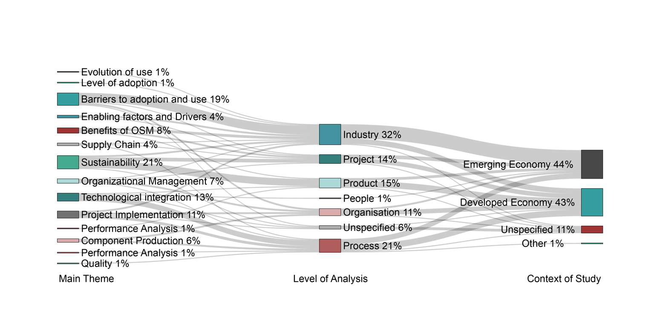
Figure 1: Meta -analysis of a systematic literature review on offsite manufacturing in housing published between 2008 -2022.
The Sankey diagram (figure 1) reveals a significant research gap concerning the level of adoption and evolution of use at the organizational level in emerging economies. With "Evolution of use" and “Level of Adoption” comprising only 1% of the main theme of scholarly papers, this topic is minimally explored. The diagram shows no connection between "Evolution of use" or “Level of Adoption” and the "Organisation" level of analysis, nor does either theme link to the context of "Emerging Economy" (44%). This indicates that research on how use evolves within organizations in emerging economies is less discussed in the literature.
A discernible gap persists within the extant literature regarding the application of offsite construction methodologies within emerging economies. The limited representation of emerging economies in existing literature underscores the pressing need for further scholarly inquiry into this domain. Quantification of the projected housing demand in these regions, propelled by rapid population growth and urbanization, accentuates the exigency of investigating offsite construction within emerging economies. Notably, seven out of the eight countries anticipated to account for approximately half of the world's projected population increase by 2050 belong to the category of emerging economies (Hoornweg and Pope 2017). For instance, Nigeria, typifying an emerging economy, contends with a staggering housing deficit of 17 million units. The magnitude of these housing challenges is exacerbated by projections indicating a population increase of 400 million in Nigeria by 2050, further intensifying the demand for housing. These circumstances underscore the imperativeness of augmenting the supply of affordable and sustainable housing within these regions (Ebekozien, Abdul-Aziz, and Jaafar 2021; United Nations (UN) 2022). The gap in the literature pertaining to offsite construction within emerging economies is concerning, given the magnitude of housing deficits, proliferate demand projections, and the profound implications of rapid urbanization on housing infrastructure. The housing sector within emerging economies necessitates innovative solutions to effectively address the escalating demand and ensure sustainable urban development.
The prevailing economic landscape of emerging economies is characterized by a notable prevalence of small and medium-sized enterprises (SMEs), which are organisation that exert substantial influence within the construction sector. Reports from the International Labour Organization (2022) indicate that SMEs account for a significant portion of employment and gross domestic product (GDP) in most developing countries, underscoring their pivotal role in driving economic activity. However, the adoption and integration of offsite manufacturing techniques within SMEs exhibit considerable variation across regions and countries. In emerging economies like India, Arif et al. (2012) observed a persistent reliance on traditional construction methods among SMEs, citing factors such as cost and time constraints as critical determinants of adoption dynamics. Despite this, SMEs play a crucial role in facilitating infrastructure development, residential projects, and various construction-related activities within the construction industry (Durdyev and Ismail 2019; Ofori 2015). Their adaptability, local expertise, and capacity for engaging in labor-intensive projects render them well-suited to address the unique challenges and demands prevalent in emerging markets.
In conclusion, the imperative of addressing the housing supply gap in rapidly urbanizing emerging economies necessitates a comprehensive understanding of the role and potential of SMEs in driving innovation and technology adoption within the construction sector. A critical knowledge gap persists regarding the specific offsite construction needs of SMEs operating within these contexts. Bridging this gap requires a nuanced examination of the evolution and current utilization of prefabrication techniques within SMEs, serving as a catalyst for accelerating adoption and fostering innovation in the sector. By harnessing the inherent adaptability and standardization potential associated with prefabrication, SMEs hold the key to significantly improving the housing supply deficit in emerging economies.
3. RESEARCH METHODOLOGY
This study aims to investigate how SMEs in the housing sector use offsite manufacturing practices in a typical emerging economy. The study used a quantitative approach through a survey questionnaire that was answered by 68 construction professionals working in SME organizations in the housing sector in Nigeria. The participants were selected using stratified random sampling, considering their years of experience and use of prefabrication. A representative sample was chosen from each subgroup.
The survey questionnaire was designed to assess the baseline knowledge and exposure of respondents in the first part, questions such as, "How familiar are you with various offsite manufacturing technologies?" and "Which offsite technologies have you used in your projects?". These questions aimed to understand the respondents' awareness and prior experience with different offsite technologies. The second part of the survey focused on identifying the factors that influence the adoption of OMPs. Questions such as, "What are the primary barriers to adopting offsite manufacturing in your organization?" and "Which factors most influence your decision to implement offsite manufacturing?" were included. The rationale behind these questions was to uncover the critical challenges and motivators affecting the adoption of offsite practices among SMEs in the housing sector. Understanding these factors is essential for identifying potential areas for intervention and support to enhance adoption rates. The third part assessed the levels of implementation of offsite manufacturing in the respondents' practices. Questions like, "To what extent has your organization integrated offsite manufacturing in your projects?" and "What specific offsite manufacturing techniques have been adopted and to what degree?" were used to determine the practical application and integration of these technologies. These questions aimed to gather a detailed understanding of the practical implementation and progression of OMPs within SMEs, addressing the noted gap in research at the organizational level in emerging economies.
The study adopts a categorization model that evaluates the extent of implementation and fulfillment of the critical tenets of OMP in the housing sector, according to Lessing, Stehn, and Ekholm (2015). The model allows for a thorough assessment of the foundational aspects of OMP housing that have been realized and integrated in each context. To assess the levels of implementation and achievement across different areas, it is imperative to delineate the key factors that drive the development of these areas. Each area required for innovation and development was presented with ordinal measurement as illustrative examples for each level, wherein complexity and implementation progressively increase with higher levels. By employing ordinal measurement, this study distinguishes between various levels of attainment based on their inherent differences.
It is important to acknowledge certain limitations. Potential biases in survey responses may exist due to self-reporting, which can affect the accuracy of the data collected. Additionally, the sample size, although sufficient for exploratory analysis, may not fully represent the entire population of SMEs in the housing sector. Furthermore, the stratified random sampling approach, while robust, might not eliminate sampling bias.
4. RESULTS AND FINDINGS
This section presents some of the findings of the research survey. Descriptive statistics was used to analyze the quantitative data. Statistical values were examined to explore individual variables and establish patterns that could be presented graphically. Nominal and ordinal measurements are presented below.
Figure 2 illustrates the distribution of employee size among participating organizations. This data helps us understand the makeup of the survey sample. Nearly half (48.8%) of respondents worked in companies with 10-15 employees. Another significant portion (28.4%) came from organizations with 1-9 employees. Larger companies were less prevalent, with only 17.9% of respondents working in firms with 50-250 employees and a mere 8.96% in organizations exceeding 250 employees. In total, over 93% of respondents belonged to SMEs company classification according to World Bank classifications.
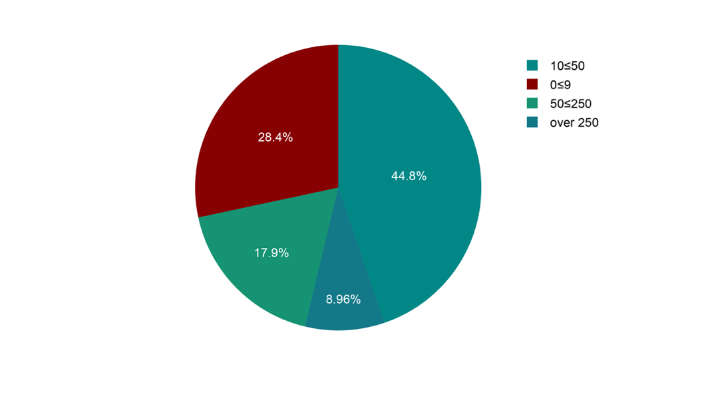
Figure 2: Size of respondents' organization
The results shown in figure 3 reveal a greater insight into the makeup of the respondents' organization based on their years of experience in the industry. Respondents with over 20 years of experience made up 15% of the total sample, while those with 15-20 years of experience accounted for 30%. Respondents with 10-15 years of experience represented 16.67% of the sample, while those with 0-5 years of experience comprised 6.67%. The figure also provided information on the size of organizations that the respondents worked for. Among respondents from smaller organizations (10-50 employees), those with over 20 years of experience made up 13.33% of the total, followed by those with 10-15 years of experience at 25%. On the other hand, respondents from larger organizations (over 50 employees) with 15-20 years of experience represented 28.33% of the sample, while those with 0-5 years of experience accounted for 8.33%. The survey findings revealed a diverse range of experience levels across different organizational sizes.
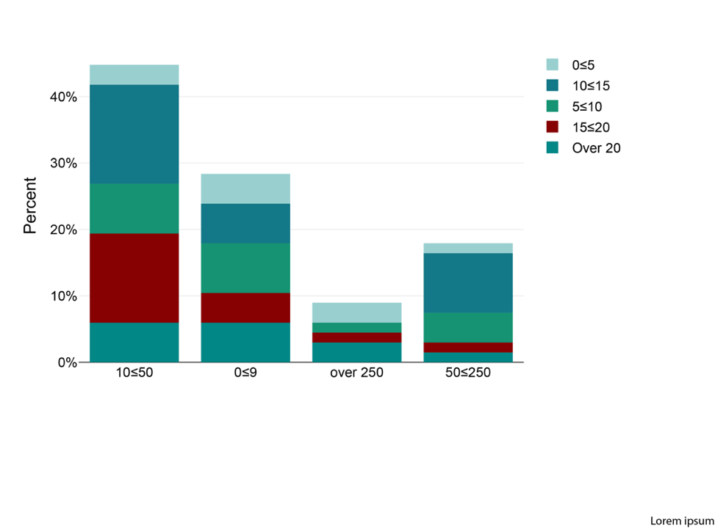
Figure 3: Respondents year of experience and organizational size
The data in figure 4 suggests a correlation between the size of the organization and the number of housing projects undertaken using offsite manufacturing processes. Companies sized between 10 and 50 employees have undertaken the most significant number of housing units delivered on a project at 29, followed by those sized between 50 and 250 employees with 12 housing units where OMPs were utilized. Companies with fewer than 9 employees or more than 250 employees have delivered comparatively fewer housing units at 17 and 6, respectively. The fact that smaller organizations may be more flexible and adaptable, allowing them to adopt new technologies and processes more easily, could explain the findings. Smaller organizations may have a greater need to find cost-effective construction methods, as they may have tighter budgets than larger companies. Larger organizations may have more complex approval processes and bureaucracies that can slow down the adoption of new technologies.
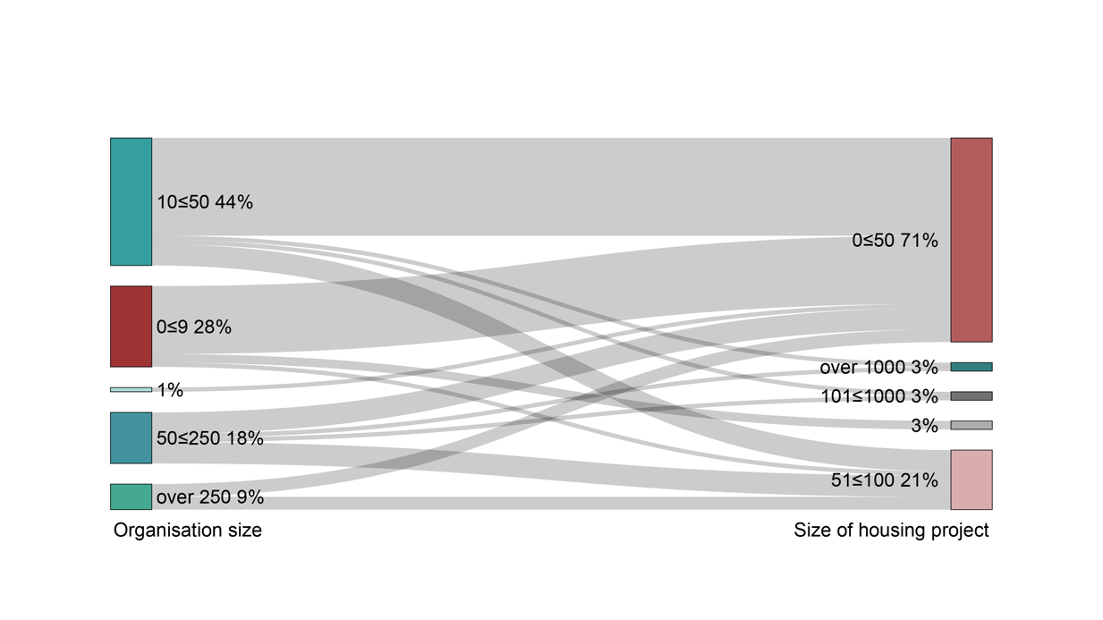
Figure 4: Organizational size and size of housing projects where OMPs used.
Established by Gibb (1999), respondents were asked about their familiarity with the categories in relation to their project experience to facilitate a determination of the most common prefabrication category as well as the evolution of prefabrication use. An analysis of respondents' familiarity with OMPs shown in table 1 reveals a clear hierarchy of familiarity with different Offsite Manufacturing Processes (OMPs). Respondents demonstrated the highest level of knowledge with "Components," with 28 (46.67%) reporting being "extremely familiar." This suggests a strong understanding of individual prefabricated elements within the concept of offsite construction and, consequently, its utilization on housing projects. Following closely behind was "non-volumetric assembly," where 33 (55%) indicated at least moderate familiarity (scores of 3 or higher). Conversely, lower familiarity was evident for categories requiring higher levels of integration. "Volumetric assembly," which involves prefabricating entire modules, and "Hybrid" approach combining volumetric and non-volumetric elements, both received a lower proportion of "extremely familiar" responses (12 each, at 20%). The least familiar category was "Modular building," where only 10 (16.67%) felt entirely comfortable.
Table 1: Ranking of knowledge of categories of OMPs; scale 0=extremely unfamiliar to 5=extremely familiar
 | 0 | 1 | 2 | 3 | 4 | 5
Components | 5 | 4 | 6 | 10 | 12 | 28
Non-volumetric assembly | 9 | 11 | 12 | 12 | 11 | 10
Volumetric assembly | 17 | 7 | 10 | 8 | 9 | 12
Hybrid | 21 | 9 | 6 | 7 | 11 | 9
Modular building | 26 | 6 | 4 | 9 | 10 | 10
To further assess the levels of implementation of OMPs, critical areas required for innovation and development in the house-building process were assessed (Lessing, Stehn, and Ekholm 2015). Ordinal measurement is particularly suitable for determining qualitative or subjective measures, as it allows for the categorization and ordering of variables based on their extent or degree of implementation.
Figure 5 shows findings on 3 out 8 key areas required for innovation and development according to Lessing et al., 2015. The results revealed a trend towards moderate adoption across three key categories. The highest level of implementation was found in "Technology Adoption," with 24% of respondents reporting "Medium" use and 9% reporting "High" or "Very High" use. "Supply Chain Integration" followed a similar pattern, with 23% indicating "Medium" implementation. "Design for Manufacturing" showed the lowest overall adoption, with only 15% of respondents utilizing "Medium" practices and a combined 15% reporting "High" or "Very High" use. These findings suggest that while companies are increasingly incorporating technology and integrating their supply chains for offsite manufacturing, optimizing product design for this approach remains a less prevalent practice.
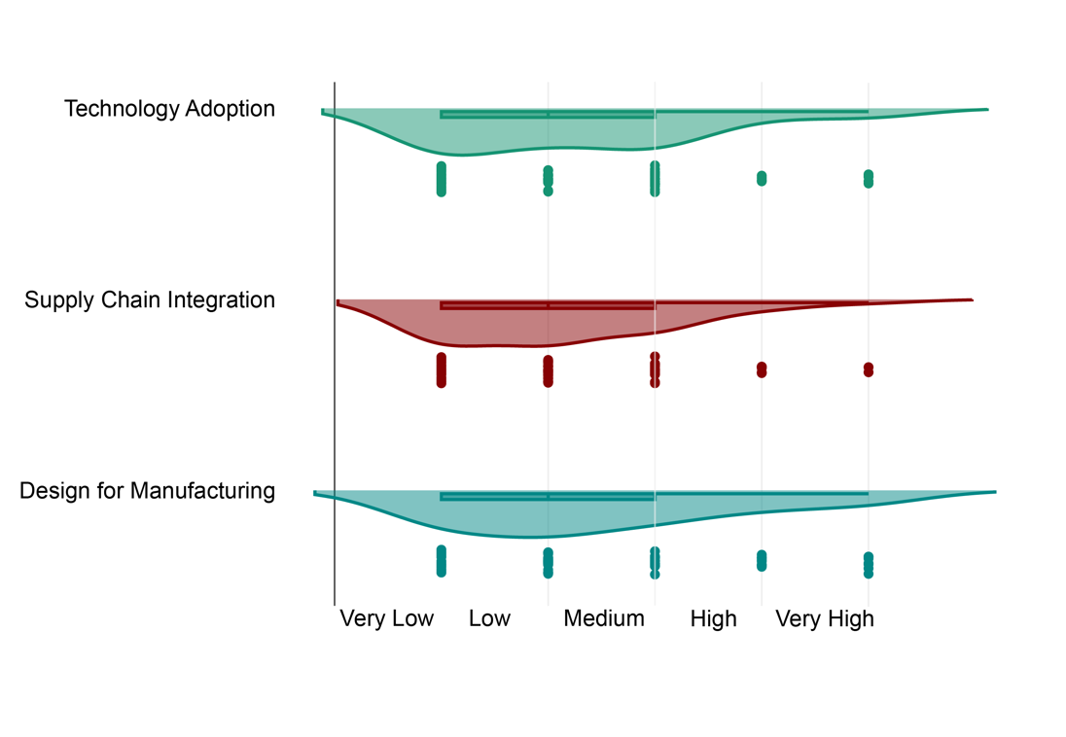
Figure 5: Respondents' level implementation of key areas of innovation and development
5. DISCUSSIONS
In emerging economies, the construction industry is predominantly comprised of SMEs, organizations employing less than 250 persons as defined by the World Bank. This finding aligns with Ofori’s (2015) assertion that a high proportion of SMEs are in the housing sector of emerging economies. The survey respondents who work for SMEs reflect this industry landscape. Notably, SMEs are often characterized by their ability to innovate and develop new approaches (Rosenbusch, Brinckmann, and Bausch 2011), which makes them a positive indicator for exploring ways to increase the adoption of OMPs at any level of sophistication. The existing practices demonstrated by the respondents suggest a familiarity with utilizing OMPs with lower levels of integration, as such indicates an evolution of current use could positively lead to increased uptake (Jaillon and Poon 2009). This optimism is established from the number of housing projects reported by the respondents as having been delivered using OMPs.
The study identified a notable proportion of housing projects delivered by SMEs utilizing offsite methods and processes (table 1). This demonstrates the feasibility of offsite manufacturing within the constraints of an Emerging Economy, (where building components are produced elsewhere and then assembled onsite. Furthermore, the successful implementation of OMPs by SMEs in Nigerian housing projects suggests a positive inclination towards adopting innovative construction techniques. This adoption has the potential to scale further, increasing the current rate of OMP use. Lu et al. (2018) support this notion, emphasizing the importance of considering contextual factors when setting OMP targets. Their research suggests that even with less sophisticated OMPs, significant increases in housing supply can be achieved within the context of an EE. This aligns with Jaillon and Poon's (2009) findings in Hong Kong, where a correlation was established between technological advancements and the increased use of prefabricated elements in housing delivery. They attributed this to a rise in both the precast volume and the number of precast elements employed. These findings combined suggest that a significant boost in housing supply might be achievable within an EE context, even without deploying the most advanced OMP technologies.
This study investigated the familiarity of construction professionals with OMPs; respondents ranked components highest among OMP categories (Table 1), suggesting the projects reported were likely delivered using this prefabrication method. This aligns with the growing trend of DfMA (Design for Manufacturing and Assembly) observed by (Lu et al. 2021). They highlight the resurgence of prefabrication, driven by the need for increased housing supply. Coupling DfMA and prefabrication at early-stage design, leveraging technologies like BIM (Building Information Modelling) to achieve significant benefits (Wasim, Vaz Serra, and Ngo 2022). These benefits include reduced costs, time, environmental impact, and improved quality. Similarly, research by Gao, Jin, and Lu (2020) demonstrates the positive effects of DfMA and prefabrication in Singapore's construction industry. They observed increased productivity, innovation, and the adoption of advanced construction methods, highlighting the industry's technological advancements.
BIM is a versatile technology utilized across various construction stages, from design to information management, and is crucial for integrating processes like structured handling of building components (Lessing and Stehn 2019). The survey investigated respondents' technology adoption (figure 4) as a critical aspect to innovation (Lessing, Stehn, and Ekholm 2015). The findings indicated a moderate adoption of BIM in prefabrication processes, suggesting its potential for increasing OMPs incorporation. These findings are consistent with Saka, Chan, and Siu (2020) on SMEs' adoption of BIM and the positive impacts of BIM on OMPs adoption (Vernikos et al. 2014). The responses suggest that evolving BIM usage could positively influence OMP adoption in the construction industry, aligning with the innovative nature of SMEs and presenting opportunities for integrating BIM and OMPs in emerging economies.
Supply chain integration plays a critical role in the adoption of offsite manufacturing processes for prefabricated buildings. According to Rehan Masood et al. (2022), prefabricated house construction is becoming increasingly reliant on the performance of its supplier network, due to the industry's dependence on these suppliers. The respondents described the current level of supply chain integration used for OMP buildings and the current level as an established relationship. Formulating long-term relationships with supply chain partners and leveraging integrated information technology systems can support the development of an integrated production system (R. Masood et al. 2019; Okafor, Ani, and Ugwu 2022). Strong supply chain relations between stakeholders are essential for improving and attaining strategic partnerships; consequently, fostering the adoption of manufacturing processes is a critical factor to success.
This research contributes to a deeper understanding of how offsite manufacturing can be harnessed to enhance the efficiency and sustainability of housing construction in EE, thereby advancing climate-responsive housing development in these regions.
6. CONCLUSION

The housing crisis in emerging economies necessitates innovative solutions that can rapidly increase the supply of climate-resilient housing. While advanced offsite manufacturing processes (OMPs) have shown promise, their adoption in emerging economies faces contextual challenges like limited infrastructure and technical expertise. This study's findings suggest a pragmatic approach - leveraging current practices as a starting point and formulating a roadmap for gradually integrating more sophisticated OMPs over time.

The existing use of lower levels of prefabrication among SMEs in the housing sector demonstrates a contextual interpretation of offsite principles that can be built upon. By dynamically identifying optimal OMPs for the short-term based on project needs and constraints, then increasing implementation percentages and complexity over a mid-to-long term roadmap, emerging economies can systematically enhance climate-responsive housing supply. Strategic road mapping supported by BIM, supply chain integration, and scenario planning can guide this evolution. Further research mapping specific transition pathways calibrated to local conditions is recommended to holistically adopt OMPs and address the acute housing shortage through sustainable construction innovation.

References
Abubakar, Ibrahim. 2020. “The Future of Migration, Human Populations, and Global Health in the Anthropocene.” The Lancet 396 (10258): 1133–34. https://doi.org/10.1016/S0140-6736(20)31523-3.
Arif, M, D Bendi, A Sawhney, and A. C Iyer. 2012. “State of Offsite Construction in India-Drivers and Barriers.” Journal of Physics: Conference Series 364 . https://doi.org/10.1088/1742-6596/364/1/012109.
Bendi, Deepthi, Muhammad Qasim Rana, Mohammed Arif, Jack Steven Goulding, and Amit Kant Kaushik. 2021. “Understanding Off-Site Readiness in Indian Construction Organisations.” Construction Innovation 21 (1): 105–22. https://doi.org/10.1108/CI-02-2020-0016.
Cao, Xinying, Xiaodong Li, Yimin Zhu, and Zhihui Zhang. 2015. “A Comparative Study of Environmental Performance between Prefabricated and Traditional Residential Buildings in China.” Journal of Cleaner Production 109 (December):131–43. https://doi.org/10.1016/j.jclepro.2015.04.120.
Chea, Cheav Por, Yu Bai, Xuebei Pan, Mehrdad Arashpour, and Yunpeng Xie. 2020. “An Integrated Review of Automation and Robotic Technologies for Structural Prefabrication and Construction.” Transportation Safety and Environment 2 (2): 81–96. https://doi.org/10.1093/tse/tdaa007.
Clark, William A.V. 2019. “Millennials in the Housing Market: The Transition to Ownership in Challenging Contexts.” Housing, Theory and Society 36 (2): 206–27. https://doi.org/10.1080/14036096.2018.1510852.
Durdyev, Serdar, and Syuhaida Ismail. 2019. “Offsite Manufacturing in the Construction Industry for Productivity Improvement.” EMJ - Engineering Management Journal 31 (1): 35–46. https://doi.org/10.1080/10429247.2018.1522566.
Ebekozien, Andrew, Abdul Rashid Abdul-Aziz, and Mastura Jaafar. 2021. “Low-Cost Housing Policies and Squatters Struggles in Nigeria: The Nigerian Perspective on Possible Solutions.” International Journal of Construction Management 21 (11): 1088–98. https://doi.org/10.1080/15623599.2019.1602586.
Gao, Shang, Ruoyu Jin, and Weisheng Lu. 2020. “Design for Manufacture and Assembly in Construction: A Review.” Building Research and Information 48 (5): 538–50. https://doi.org/10.1080/09613218.2019.1660608.
Gibb, A. G. 1999. Off-Site Fabrication: Prefabrication, Pre-Assembly and Modularisation. John Wiley & Sons. Caithness, Scotland: Whittles Publishing.
Hoornweg, Daniel, and Kevin Pope. 2017. “Population Predictions for the World’s Largest Cities in the 21st Century.” Environment and Urbanization 29 (1): 195–216. https://doi.org/10.1177/0956247816663557.
International Labour Office (ILO). 2022. “World Employment and Social Outlook: Trends 2022.”
Jaillon, Lara, and C. S. Poon. 2009. “The Evolution of Prefabricated Residential Building Systems in Hong Kong: A Review of the Public and the Private Sector.” Automation in Construction. https://doi.org/10.1016/j.autcon.2008.09.002.
Jin, Ruoyu, Shang Gao, Ali Cheshmehzangi, and Emmanuel Aboagye-Nimo. 2018. “A Holistic Review of Off-Site Construction Literature Published between 2008 and 2018.” Journal of Cleaner Production 202:1202–19. https://doi.org/10.1016/j.jclepro.2018.08.195.
Kumar, Abhay, and Sudheer Kumar Shukla. 2022. “Affordable Housing and the Urban Poor in India.” Social Change 52 (1): 58–75. https://doi.org/10.1177/00490857211040249.
Lessing, Jerker, and Lars Stehn. 2019. “Industrialised House Building : Concepts and Its Application in Sweden.” Offsite Production and Manufacturing for Innovative Construction, June, 86–110. https://doi.org/10.1201/9781315147321-5.
Lessing, Jerker, Lars Stehn, and Anders Ekholm. 2015. “Industrialised House-Building - Development and Conceptual Orientation of the Field.” Construction Innovation 15 (3): 378–99. https://doi.org/10.1108/CI-06-2014-0032.
Lu, Weisheng, Ke Chen, Fan Xue, and Wei Pan. 2018a. “Searching for an Optimal Level of Prefabrication in Construction: An Analytical Framework.” Journal of Cleaner Production 201:236–45. https://doi.org/10.1016/j.jclepro.2018.07.319.
———. 2018b. “Searching for an Optimal Level of Prefabrication in Construction: An Analytical Framework.” Journal of Cleaner Production 201 (November):236–45. https://doi.org/10.1016/j.jclepro.2018.07.319.
Lu, Weisheng, Tan Tan, Jinying Xu, Jing Wang, Ke Chen, Shang Gao, and Fan Xue. 2021. “Design for Manufacture and Assembly (DfMA) in Construction: The Old and the New.” Architectural Engineering and Design Management 17 (1–2): 77–91. https://doi.org/10.1080/17452007.2020.1768505.
Luo, Ting, Xiaolong Xue, Yuna Wang, Weirui Xue, and Yongtao Tan. 2021. “A Systematic Overview of Prefabricated Construction Policies in China.” Journal of Cleaner Production 280:124371. https://doi.org/10.1016/j.jclepro.2020.124371.
Masood, R., V. Gonzalez, J. B.P. Lim, and G. Cabrera. 2019. “Trends in Housing Offsite Manufacturing Supply Chain Management (HOSCM) Research.” In Proceedings of 22nd International Conference on Advancement of Construction Management and Real Estate, CRIOCM 2017, 763–71.
Masood, Rehan, James B.P. Lim, Vicente A. González, Krishanu Roy, and Khurram Iqbal Ahmad Khan. 2022. “A Systematic Review on Supply Chain Management in Prefabricated House-Building Research.” Buildings 12 (1): 40. https://doi.org/10.3390/buildings12010040.
Mireles, Izzak. 2019. “Housing Is a Human Right.” Planning. Vol. 85.
Navaratnam, Satheeskumar, Tuan Ngo, Tharaka Gunawardena, and David Henderson. 2019. “Performance Review of Prefabricated Building Systems and Future Research in Australia.” Buildings 9 (2): 1–14. https://doi.org/10.3390/buildings9020038.
Nazir, Falaq Assad, David John Edwards, Mark Shelbourn, Igor Martek, Wellington Didibhuku Didibhuku Thwala, and Hatem El-Gohary. 2021. “Comparison of Modular and Traditional UK Housing Construction: A Bibliometric Analysis.” Journal of Engineering, Design and Technology 19 (1): 164–86. https://doi.org/10.1108/JEDT-05-2020-0193.
Ofori, George. 2015. “Nature of the Construction Industry, Its Needs and Its Development: A Review of Four Decades of Research” 20 (January):115–35.
Okafor, Chigozie Collins, Ugochukwu Sydney Ani, and Onuegbu Ugwu. 2022. “Evaluation of Supply Chain Management Lapses in Nigeria’s Construction Industry.” International Journal of Construction Education and Research 18 (2): 103–22. https://doi.org/10.1080/15578771.2020.1869122.
Ong, Rachel, Tony Dalton, Nicole Gurran, Christopher Phelps, Steven Rowley, and Gavin Wood. 2017. “Housing Supply Responsiveness in Australia: Distribution, Drivers and Institutional Settings Inquiry into Housing Policies, Labour Force Participation and Economic Growth.” https://doi.org/10.18408/ahuri-8107301.
Oorschot, Johannes A.W.H. van, Johannes I.M. Halman, and Erwin Hofman. 2019. “The Continued Adoption of Housing Systems in the Netherlands: A Multiple Case Study.” Journal of Construction Engineering, Management & Innovation 2 (4): 167–90. https://doi.org/10.31462/jcemi.2019.04167190.
Razkenari, Mohamad, Andriel Fenner, Alireza Shojaei, Hamed Hakim, and Charles Kibert. 2020. “Perceptions of Offsite Construction in the United States: An Investigation of Current Practices.” Journal of Building Engineering 29 (May). https://doi.org/10.1016/j.jobe.2019.101138.
Rosenbusch, Nina, Jan Brinckmann, and Andreas Bausch. 2011. “Is Innovation Always Beneficial? A Meta-Analysis of the Relationship between Innovation and Performance in SMEs.” Journal of Business Venturing 26 (4): 441–57. https://doi.org/10.1016/J.JBUSVENT.2009.12.002.
Saka, Abdullahi B., Daniel W.M. Chan, and Francis M.F. Siu. 2020. “Drivers of Sustainable Adoption of Building Information Modelling (BIM) in the Nigerian Construction Small and Medium-Sized Enterprises (SMEs).” Sustainability (Switzerland) 12 (9). https://doi.org/10.3390/su12093710.
Teng, Yue, Kaijian Li, Wei Pan, and Thomas Ng. 2018. “Reducing Building Life Cycle Carbon Emissions through Prefabrication: Evidence from and Gaps in Empirical Studies.” Building and Environment 132 (October 2017): 125–36. https://doi.org/10.1016/j.buildenv.2018.01.026.
UN-Habitat. 2020. “UN-Habitat Sub-Saharan Africa Atlas.” Regional Office for Africa.
United Nations (UN). 2022. “World Population Prospects 2022: Summary of Results.”
Vernikos, Vasileios K., Chris I. Goodier, Timothy W. Broyd, Peter C. Robery, and Alistair G.F. Gibb. 2014. “Building Information Modelling and Its Effect on Off-Site Construction in UK Civil Engineering.” Proceedings of Institution of Civil Engineers: Management, Procurement and Law 167 (3): 152–59. https://doi.org/10.1680/mpal.13.00031.
Wasim, Muhammad, Paulo Vaz Serra, and Tuan Duc Ngo. 2022. “Design for Manufacturing and Assembly for Sustainable, Quick and Cost-Effective Prefabricated Construction – a Review.” International Journal of Construction Management 22 (15): 3014–22. https://doi.org/10.1080/15623599.2020.1837720.
Wuni, Ibrahim Yahaya, and Geoffrey Qiping Shen. 2020. “Barriers to the Adoption of Modular Integrated Construction: Systematic Review and Meta-Analysis, Integrated Conceptual Framework, and Strategies.” Journal of Cleaner Production 249 (March):119347. https://doi.org/10.1016/j.jclepro.2019.119347.
Xu, Zhao, Tarek Zayed, and Yumin Niu. 2020. “Comparative Analysis of Modular Construction Practices in Mainland China, Hong Kong and Singapore.” Journal of Cleaner Production 245 (February):118861. https://doi.org/10.1016/j.jclepro.2019.118861.
Zhang, Ziyao, Zhenmin Yuan, Guodong Ni, Han Lin, and Yujie Lu. 2020. “The Quality Traceability System for Prefabricated Buildings Using Blockchain: An Integrated Framework.” Frontiers of Engineering Management 7 (4): 528–46. https://doi.org/10.1007/s42524-020-0127-z.

