Henry Wood Hall:
The Creation of a Flexible Acoustic Using Airbeds.

Shearer, Douglas John¹; Gomez-Agustina, Luis; Ballestero, Eric; Dance, Stephen²

London South Bank University
103 Borough Road, London, SE1 0AA

ABSTRACT
Henry Wood Hall is a former church in central London repurposed as an orchestral rehearsal space. Its success in this role since the 1970s is testament to its suitability for this purpose. However, the trustees of the hall wanted a more flexible use of the space and in March 2018 instructed the Acoustics Group to develop, test and install a solution which would create a balanced acoustic suited to smaller ensembles such as those used in Operatic productions. This would require the reduction of the natural reverberation boost that the hall provides at low frequencies. The solution should, for a modest budget, be flexible enough to be changed within the hour-long break between sessions. Laboratory tests were undertaken on inflated airbeds in the LSBU reverberation chamber to determine the low frequency absorption potential of these consumer goods. An airbed model was selected with the most promising performance and optimum positioning was determined. Room acoustic measurements were taken in the hall before and after the airbeds were installed, showing significant reduction in reverberation time in the lower frequency bands.
Keywords: Music, Room Acoustics, Absorbing Materials
I-INCE Classification of Subject Number: 35

1.1 INTRODUCTION
Holy Trinity Church in Borough, Central London was built in 1842, but suffered bomb damage during the Second World War and was subsequently abandoned. It was refurbished in the 1970s for use as a rehearsal and recording venue for the London Symphony Orchestra (LSO) and London Philharmonic Orchestra (LPO) and other ensembles. As Henry Wood Hall, it remains a busy venue in these roles, as well as for occasional public concerts. The hall has a volume of approximately 6000m³ and comprises a main area with four rostra of increasing height, plus elevated choir stalls at the rear of the main space. The walls are made from Bath stone, the ceiling is lightly
_______________________________
¹ shearerd@lsbu.ac.uk
² dances@lsbu.ac.uk
coffered with a plaster finish and the floor construction is wood parquet [1]. The recessed windows are covered by floor-to-ceiling curtains which can be used to adjust the acoustics to the users’ preference. The condition with some or all curtains open is generally preferred by users of the hall. It is thought this choice is made mainly due to the preference for natural light while playing, rather than for acoustic reasons. (See Figure 1).
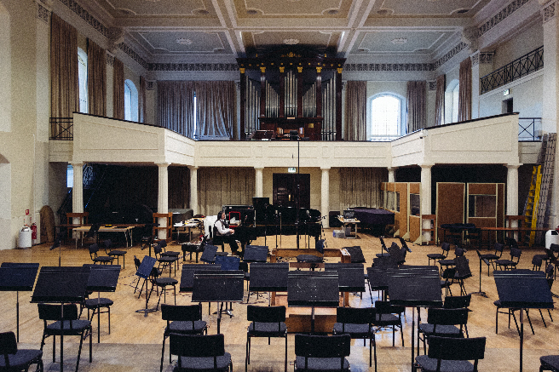
Figure 1: Henry Wood Hall as in [2]
2 THE HALL
The hall’s room acoustic parameters have been measured in accordance with ISO3382-1 [3] on several occasions and in several configurations. The baseline Reverberation Time (RT) of the hall, the effect of closing all curtains and a condition where some curtains are closed but most open (the most common usage condition) are shown in Figure 2. This shows the curtains are a useful absorber in the mid and high frequency ranges and also somewhat at low frequencies but only when all are closed, by which point high frequencies are attenuated substantially.

Figure 2: Baseline RT (T20) showing dependency on curtains

2.1 Comparison with Standards
The latest guidance on music rehearsal and performance spaces comes from the Norwegian Standard NS8178:2014 [4]. It divides acoustic musical spaces into those for “loud” music (orchestras and larger ensembles) and “quiet” music (smaller chamber ensembles). The guidance therein suggests that Henry Wood Hall is large for a rehearsal space, being more the size of a performance space. However, extrapolating the standards data to the larger volume suggests that the halls midrange reverberation time makes it (for its size) suitable for both “loud” and “quiet” acoustic music, although it is used mostly for the former (see Figure 3). Frequency dependency is also within the guidance limits of the standard, although high frequencies are close to or at the lower acceptable limit depending on curtain deployment. (See Figure 4)
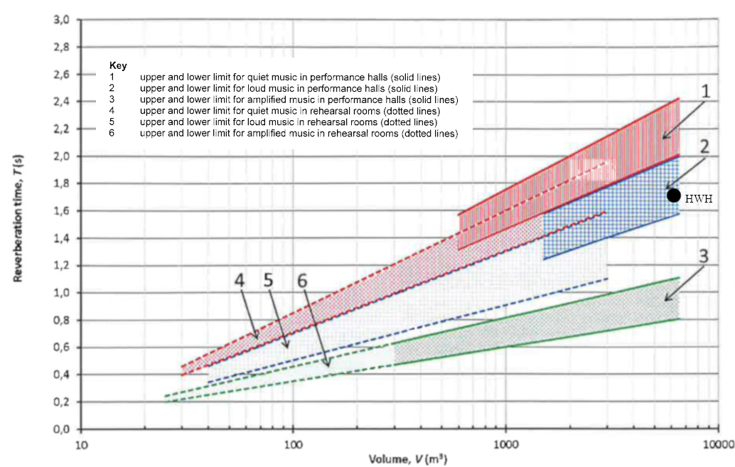
Figure 3: Midrange T20 of Henry Wood Hall’s baseline measurement in relation to NS8178 ranges for “loud” and “quiet” acoustic music (Areas 4 and 5 above) [4]

Figure 4: T20/T_{midrange} frequency dependency of Henry Wood Hall baseline measurements in relation to NS8178 minimum (green) and maximum (red) limits. [4]
2.2 Subjective Quality
The acoustic of the hall is generally considered good, as its ongoing success testifies. It does, however have a “warm” character, which is not to everyone’s taste, and there have been some comments alluding to “boominess”, and indeed there is a distinct peak in the RT curve around 125Hz as shown in Figure 2.

3. THE BRIEF
In 2018 the hall’s management were looking to expand its use, notably for opera rehearsals, and asked the LSBU Acoustics Group to provide an affordable, flexible solution to improve the hall’s suitability for voice, one which could be installed or removed within an hour, the changeover time between sessions at the hall, as a typical day’s schedule could include vocal and orchestral sessions on the same day.
NS8178 lists operatic singing among “loud” acoustic sources, for which the hall is considered suitable, but the question of intelligibility arises when considering opera. Barron suggests midrange RT values intermediate between speech and music are appropriate, suggesting between 1.3 and 1.8s for performance spaces [5].
3.1 Limitations and Challenges
The hall is a busy space and there was limited access time for measurement and installation, hence the demand for an easily portable solution. In addition, the hall is Grade II listed historic building and as such, could not be changed structurally. Guidance from the management also suggested that big changes to the space visually were not desired. [6]
3.2 The Proposed Solution
The existing curtains in the hall were suitable for adjusting mid-range and high frequency reverberation so it was decided to provide a complimentary solution to target the lower frequency “boominess”, in this case using off-the-shelf airbeds.
Pneumatic structures have been used in architecture since the 1940s and continue to be popular, mostly for temporary structures such as pavilions and Expos, and even for temporary performance spaces [7] [8]. In this case, airbeds were attractive for their cost, availability, light weight and ease and speed of deployment, where no fixing to walls is required and there was space behind the rosta and on the balcony to deploy them.

3.3 Inflatables as Absorbers
In the most reductive analysis of an airbed it will act as a membrane absorber, with the outer surface acting as a mass and the air trapped inside as a spring. The resonant frequency can be predicted using the following relation.
$f=\frac{60}{\sqrt{md}}$Eq 1
where f is the resonant frequency in Hz, m is the unit mass of the membrane in kg/m² and d the depth of the absorber in metres.
It is known that this expression (a much-simplified analysis of membrane resonance itself) can be inaccurate, even in simple membrane designs, especially where the nature of any damping materials can change the resonant frequency [9]. Neither are airbeds truly simple membranes, but have a certain portion of their area constrained by internal members which help the bed keep a planar shape, rather than allowing it to approach a sphere when fully inflated. These constraining elements, whether simple ties or plane elements can act to add extra moving mass or damping and lead the structure to be quite different from the archetype of simple membrane analysis.
Adelman-Larsen et al tested air mattresses during the development of the Flex Acoustic inflatable absorbers used in large venues for amplified music [10]. They noted this divergence from classical membrane behaviour, suggesting the resonant frequency to be around four times that given by Eq. 1, while recognising that the complexity of construction renders the concept of a single resonant frequency as being reductive [11].

4. LABORATORY TESTS
Standard ISO354 tests were undertaken in LSBU’s Reverberation Chamber to measure the absorption performance of two available airbed types. The first (the “thin” model) being made by Bestway and being 0.22m thick and measuring 1.91 by 1.37m. The second “thick” design is made by Livivo and is 0.47m thick and measuring 1.96 by 1.45m [12].
As shown in previous tests, the airbeds’ absorption was quite broad, but contained a number of resonant peaks, with the higher frequency peak also being present when the airbeds were deflated, indicating that the material used in their construction could be partially responsible. The lower peak was closer to that predicted by Eq 1, around 200Hz as opposed to the predicted 150Hz. This prediction was, however based on measurements of the total mass of the airbed and an estimate of what portion of that was an effective mass. The airbed contains a built-in electric air pump for inflation and deflation.

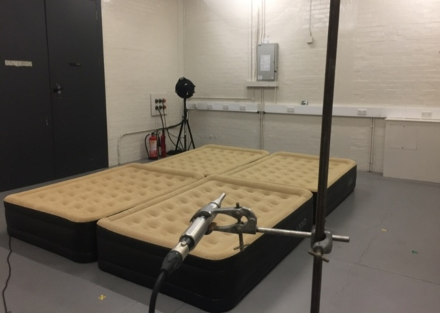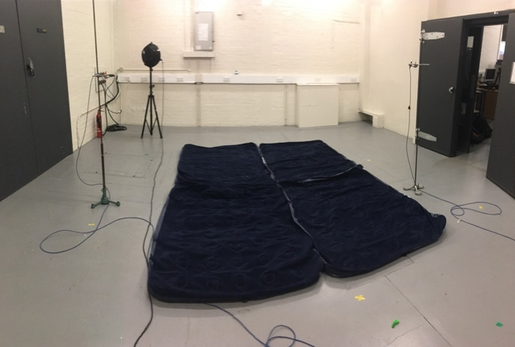
Figure 5: The two types of airbed undergoing testing in the LSBU reverberation chamber
The thicker of the two airbed designs was chosen for use in Henry Wood Hall as it displayed strong absorption at lower frequencies and a broader range of absorption. (see Figure 6) A further test was undertaken to compare the absorption achieved with mounting of these airbeds propped around the corners and edges of the room as opposed to standard mounting in the centre of the reverberation room, showing a little more absorption at lower frequencies, see Figure 7.

Figure 6: Comparison of Absorption Coefficients of Thin and Thick Airbeds
The expected use of the airbeds was for a single morning or afternoon rehearsal session, so maintaining operating pressure over time was not envisioned as a problem. Although difficult to measure precisely, pressure dependency was estimated in the reverberation chamber. The built-in pump in the thick airbeds took around 2.5 minutes to achieve full inflation. Absorption was measured at this inflation and again at 1/2, 1/4 and 1/8 of this inflation time.

Figure 7: Dependency on mounting position within the reverberation room
Figure 8 shows the dependency on inflation. At 1/8 inflation, the absorption approaches that of the empty beds, while peak absorption increases with inflation. Interestingly, at 1/2 inflation, absorption at 125 Hz was more than at full inflation. Since precise targeting of the “boom” in the hall was not immediately possible, broad low frequency absorption was decided as the best aim, so hyperinflation was avoided.

Figure 8: Dependency on inflation, 4 airbeds in reverberation chamber

5. INSTALLATION IN HENRY WOOD HALL
Although a practical, affordable, portable absorber had been identified and tested, ultimately the space limitations in the hall were the constraining factor in the amount of absorption which could be achieved. The available space around the rear of the rostra and the choir stalls was calculated to accommodate 30 airbeds. By comparison of room volumes between the reverberation chamber and Henry Wood Hall suggested that 30 airbeds in the hall was equivalent to one airbed in the reverberation room, as opposed to the four used in the ISO354 tests; a modest but meaningful amount of absorption could be achieved. The airbeds were installed by 4 people and this was achieved within the target time of one hour. This was facilitated by the built-in pumps with automatic cut-off in the chosen airbeds; each person could inflate 4 airbeds simultaneously.

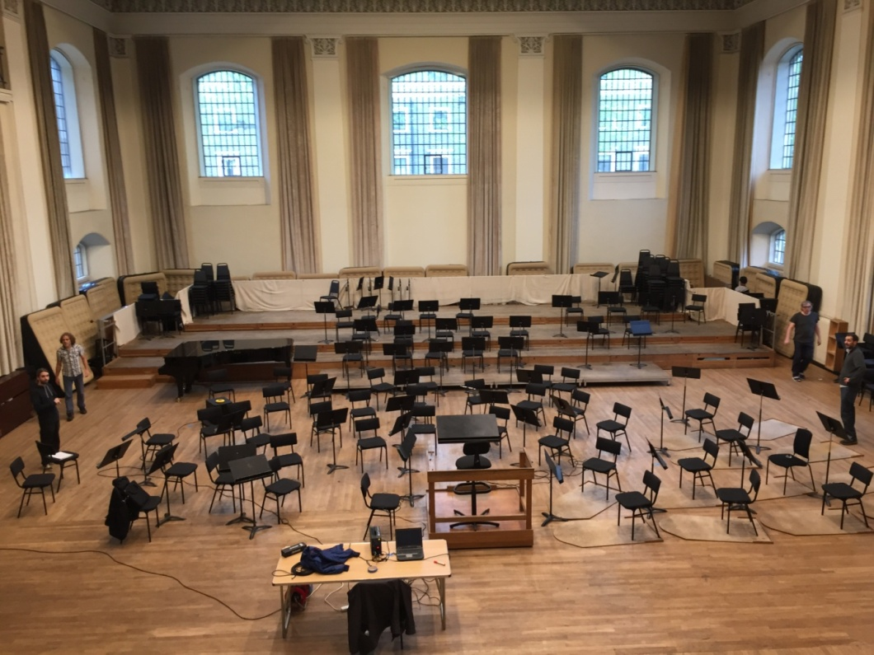
Figure 9: Airbeds upon installation in Henry Wood Hall

6. RESULTS
ISO3382-1 results for reverberation time before and after installation of the 30 airbeds is shown in Figure 10. As predicted, the absorption achieved was fairly modest, but this was expected given the relatively small area available for absorption when compared with the volume of the hall. The most effected frequency bands were the 63-250Hz octave bands, showing that the absorption behaviour was in line with that predicted by the ISO 354 tests on these airbeds. Absorption was well spread over several of the lower octave bands, however absorption above 1kHz was minimal as was required.

Figure 10: Measured RT with and without 30 Inflated Airbeds

7. CONCLUSIONS
Airbeds were selected for use in a music rehearsal space, with expected behaviour akin to that of a membrane absorber, albeit one with behaviour less easily predictable using analytical methods. Therefore, ISO 354 tests were undertaken to assess their effectiveness. Having selected an appropriate airbed type, and of appropriate number, they were installed and tested using ISO3382-1. The result was a small but significant reduction of reverberation time in lower frequency bands.
The response from users of the hall was very positive; a Conductor who is a regular user of the hall, after conducting Strauss’s ‘Der Rosenkavalier’, noted that the hall was “drier in the lower register”, while Glyndebourne Musical Director Robin Ticciati appreciated that “[the] solution is not visible to the orchestra or conductor”. Interestingly, some comments mentioned that the hall seemed less harsh in tutti passages; Charles Strickland, manager of Henry Wood Hall commented that “…I have to say I can hear a difference; it seems less harsh when large forces are playing all at once”
This solution was intended to be affordable, flexible and portable, and intended only for occasional use. However, and somewhat unexpectedly, the airbeds have remained deployed in the hall for all rehearsals since installation and appear to be popular for all repertoire, although they are now laid on their side.

8. ACKNOWLEDGEMENTS
This work was supported by Henry Wood Hall, The UK Acoustics Network (UKAN) and The Royal Academy of Music, London.

9. REFERENCES

[1] | Historic England, The Henry Wood Hall, including gate piers and railings [Online]. Available: https://historicengland.org.uk/listing/the-list/list-entry/1385999. [Accessed 19th February 2019].
[2] | Farewell to the old prince of acoustic engineers, Derek Sugden 25th January 2016. [Online]. Available: http://britainisnocountryforoldmen.blogspot.com/2016/01/. [Accessed 27th February 2019].
[3] | BS3382-1, Measurement of room acoustic parameters: part 1: performance spaces, British Standards Institute, London, 2009.
[4] | NS8178:2014: Acoustic criteria for rooms and spaces for music rehearsal and performance, Standard Norge, Lysaker, 2014.
[5] | M. Barron, Auditorium acoustics and architectural design, 2nd ed., London & New York: Spon Press, 2010, p. 30.
[6] | Arup, Henry Wood Hall: feasibility study on the use of Helmholtz resonators 2008.
[7] | T. Herzog, Pneumatic structures: a handbook for the architect and engineer, Crosby Lockwood Staples, 1977.
[8] | A. Frearson, Ark Nova by Arata Isozaki and Anish Kapoor, 23rd September 2011. [Online]. Available: https://www.dezeen.com/2011/09/23/ark-nova-by-arata-isozaki-and-anish-kapoor/. [Accessed 21st February 2019].
[9] | T. J. Cox and P. D'Antonio, Acoustic absorbers and diffusers: theory, design and application, Second Edition ed., London, New York: Taylor & Francis, 2009.
[10] | Flex Acoustics, Flex Acoustics, [Online]. Available: http://flexac.com/. [Accessed 26th February 2019].
[11] | N. W. Larsen, E. R. Thompson and A. C. Gade, Variable Low-Frequency Absorber for Multi Purpose Concert Halls, in Forum Acusticum, Budapest, 2005.
[12] | BS ISO 354: 2003: Measurement of sound absorption in a reverberation room, British Standards Institute, 2003.

