Biological Basis to Child Health: The Endocrine System

Kate Davies RN (Child), Dip HE, BSc (Hons), MSc, PGCert, PGDip
Children’s Advanced Nurse Practitioner
Senior Lecturer in Non Medical Prescribing
London South Bank University
Honorary Research Fellow in Paediatric Endocrinology
Queen Mary University of London / Barts and The London NHS Trust

Sinead Bryan RGN, RSCN, MSc, PGCert
Independent Endocrine Nurse
Quality Assurance Manager
Enviva Paediatric Care and Enviva Complex Care

Abstract
This CPD article focusing on the endocrine system is the nth article in the Biological Basis to Child Health series. The Endocrine system includes various glands which produces hormonal messages that, via the bloodstream, act on other organs and systems. Growth, puberty, metabolism and bone health are amongst the many systems which are under control of the endocrine system, which can have an impact on other body systems. It is essential for children's nurses to have an understanding of the role of the endocrine system in maintaining health and the feedback mechanisms which may impact on other conditions and their outcomes. This CPD article will explore the anatomy and physiology of the glands, and the impact the hormones have on the body, alongside common clinical conditions seen in children.

Keywords
Hormone; gland; pituitary; growth; metabolism; secretion

Aims and Outcomes
This article will enhance the reader’s knowledge of the Endocrine system, its mechanisms of action and conditions likely to be encountered in children and young people when the endocrine system is not functioning as expected.
After reading this article and completing the time out activities, the children and young people’s nurse should be able to:-
- Identify the glands of the endocrine system, and the hormones they produce
- Understand the impact of hormones on the normal metabolic functions of the body
- Explain the effects of excess or lack of particular hormones.
- Identify the potential for endocrine dysfunction and appropriate management

The Role of the Endocrine System
The endocrine system (Figure 1) works alongside the nervous system to co-ordinate the functions of other body systems (Boore, Cook, & Shepherd, 2016), by using chemical mediators called hormones. Hormones are secreted into blood or the extracellular fluid and have an effect on other target cells. Clinical conditions seen in endocrinology are either due to not enough hormone being made, too much hormone being made, or sometimes a kind of resistance to the message being able to reach the target gland.

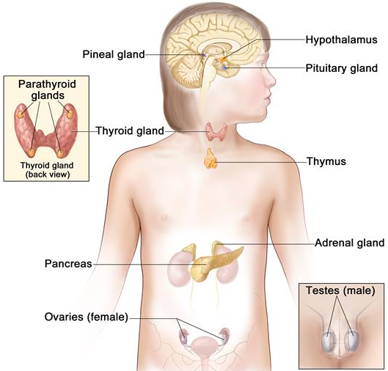

Figure 1: Anatomy of the Endocrine System
Hormones are classified into two different categories: water-soluble hormones, or lipid-soluble hormones. (Petty, 2015).

Water soluble hormones cannot diffuse through the plasma membrane of cells, and bind to the receptors on the outer surfaces of plasma membranes. Water soluble hormones cannot be replaced orally – for example, insulin, adrenaline, growth hormone and oxytocin - and need to be administered parenterally

Lipid soluble hormones can pass directly through the phospholipid bilayer of the plasma cell membrane. They include thyroid hormones and the steroid hormones, including testosterone, oestrogens, glucocorticoids and mineralocorticoids.

Endocrine glands release hormones in response to:
- Hormonal control from the hypothalamus and pituitary gland
- Chemical regulation and other internal factors, for example, calcium levels, blood glucose levels, or electrolyte levels (Petty, 2015).
- External factors such as heat, cold, exercise or stress, and
- Positive feedback mechanisms, where the output actually reinforces the original stimulus, for example, the release of oxytocin during childbirth (Waugh & Grant, 2018).

However, the effects can cease in a number of ways:
- If inhibiting hormones are present
- Environmental factors
- Negative feedback mechanisms. Most hormone maintenance is controlled by negative feedback, so when higher levels of the hormone are detected, it leads further production to slow down

Finally, hormonal secretion can be regulated by rhythmic variations, such as adrenocortical circadian rhythms, which follows a 24 hour cycle, or the monthly menstrual cycle, or growth hormone, which is secreted in a pulsatile fashion, with an increase in pulses at night time (Moore, Whitehead, & Davies, 2019).

The Hypothalamus and the Pituitary Gland
The hypothalamus and the pituitary gland orchestrate the endocrine system (Boore et al., 2016)

Table 1 details the hormones produced by the hypothalamus and the pituitary gland.

Hormone | Stimulates release of | Function | Target
Growth hormone (somatotropin) releasing hormone (GHRH) | Growth hormone (GH) from the anterior pituitary gland (APG) | Growth and reproduction of body cells | Bone and muscle
Thyrotropin-releasing hormone TRH) | Thyroid stimulating hormone (TSH) to be released from the APG | Controls secretion of Thyroxine (T4) and Triiodothyronine | Thyroid
Gonadotrophin (luteinizing hormone) releasing hormone (GnRH or LHRH) | LH (luteinizing hormone) and FSH (follicle stimulating hormone) from the APG | Female: LH stimulates ovulation, prepares uterus for implantation, stimulates breasts to make milk. FSH initiates ova development and oestrogen secretion  Males: LH stimulates testosterone production. FSH stimulates sperm production | Ovary, Uterus, Breasts  Testes
Prolactin releasing hormone (PRH) | Prolactin to be released from the APG | Initiates and maintains milk secretion | Breasts
Corticotrophin releasing hormone (CRH) | ACTH (adrenocorticotrophin hormone) from the APG | Controls secretion of glucocorticoids | Adrenal glands
Growth hormone inhibiting hormone (Somatostatin) | Inhibits the release of growth hormone from the APG |  | Pituitary gland
Prolactin inhibiting hormone | Inhibits the release of prolactin from the APG |  | Pituitary gland
Anti-diuretic hormone (Vasopressin) (ADH) | Made in the hypothalamus, and then stored in the posterior pituitary gland to be released when required | Increases water permeability, promoting water reabsorption and increasing blood volume | Kidney
Oxytocin | Made in the hypothalamus and then stored in the posterior pituitary gland, and released when required | Stimulates uterine contraction, and the ‘let down’ reflex in milk production | Uterus  Breasts

Table 1: Hypothalamic, pituitary hormones and their target glands (Adapted from (Petty, 2015).

The Hypothalamus
The hypothalamus is part of the midbrain, sitting above the pituitary gland (Petty, 2015) .
As well as endocrine control, the hypothalamus also governs thermoregulation and fever, feeding and energy metabolism, and also sleep and wakefulness. From three weeks gestation, three vesicles develop in the cranial end of the neural tube: the prosencephalon (forebrain), the mesencephalon (midbrain) and the rhombencephalon (hindbrain). It is from forebrain tissue that the hypothalamus will develop. Hypothalamic disease is rare, but can stem from malnutrition, head trauma, cranial irradiation, tumours, or genetic disorders (Petty, 2019). Hypothalamic obesity is a complex neuroendocrine disorder, where energy regulation is affected (Haliloglu & Bereket, 2015). Prader Willi Syndrome (PWS) is a genetic disorder, caused by dysfunction on chromosome 15q11-13 and features can include hyperphagia, with food seeking behaviours and excessive weight thought to be due to hypothalamic dysfunction. The incidence is approximately 1 in every 22,00 births, with around 2000 people affected in the United Kingdom (UK) (PWS, 2020).

Anti-diuretic hormone (ADH) is made in the hypothalamus, but stored in the posterior pituitary gland, and it controls urine output. It acts on the distal convoluted tubules and collecting ducts in the kidneys, increasing their permeability to water (Waugh & Grant, 2018), and depends on negative feedback. However, a decreased production of ADH results in Central (or Cranial) Diabetes Insipidus (not to be confused with Type 1 or Type 2 Diabetes). Children will present with extreme polydipsia and polyuria, and will try to drink from any means possible, for example, outside taps or toilets, and will get up frequently throughout the night to pass urine. There are various reasons why DI occurs, although pituitary tumours, head trauma, or recent neurosurgery are the principle causes. DI can be transient after neurosurgery, but if permanent, can be managed with ADH replacement (Desmopressin).

The Pituitary Gland
The pituitary gland is a pea sized gland, and is found below the hypothalamus. Both lobes produce hormones, which are seen in Table 1.
Hypopituitarism is the inability of the pituitary gland to provide the hormones required (Petty, 2019). Hypopituitarism may be congenital, associated with genetic disorders, or it can be acquired, for example, from head trauma, infection, or post cranial irradiation (Urquhart & Collin, 2016)

Isolated growth hormone deficiency (GHD) is the most common pituitary endocrinopathy, and is the most common reason why a child presents with short stature, occurring in around 1 in every 4000 children in the UK (Collin, Whitehead, & Walker, 2016). The diagnosis of GHD is often missed in early childhood, as the child tends to be otherwise healthy, except being shorter than their peers, and it is not until the child is at school that size differences are more noticeable (Moore et al., 2019). As growth hormone is released in ‘pulses’, to test for GHD a stimulation test needs to be carried out, enabling a sample to be obtained following a ‘stress response pulse’ of hormone release (Yedinak & Davies, 2019), requiring a day case admission to hospital. GH is a water soluble hormone, so replacement is with a daily subcutaneous injection at night time, until linear growth is complete

TIME OUT 1
The effects of GH are not instant, and some children become frustrated that they do not grow as quickly as they want. Visit the Child Growth Foundation website www.childgrowthfoundation.org to read more about growth disorders and review personal stories.
Tumours of the pituitary gland can also cause pituitary dysfunction. Although rare and usually benign, they can still cause problems, usually resulting in an excess of the relevant hormone production. Prolactinomas secrete prolactin, and usually present around puberty, with common symptoms including headache, delayed puberty and galactorrhea – inappropriate production of milk: treatment is by using dopamine agonists (ie Cabergoline). (Hoffmann, Adelmann, Lohle, Claviez, & Muller, 2018). Cushings disease (different from Cushings Syndrome) refers to an ACTH secreting pituitary adenoma, resulting in excess glucocorticoid production (Storr & Savage, 2015). Craniopharyngiomas are benign tumours that also develop near the pituitary gland (Petty, 2019), and account for 80% of tumours that disrupt the hypothalamic-pituitary pathway (Rosenfeld et al., 2014). Quality of life tends to be impaired, with most children presenting initially with either visual deficits . Management of pituitary tumours depends on the specific site, but surgery is usually first line treatment, alongside radiotherapy (Petty, 2019).

The Pineal Gland
The pineal gland produces the hormone melatonin (Petty, 2015), which regulates the circadian rhythm, and is stimulated by light. It is fully developed by 7 years of age, when it is less than 1cm long, although it does tend to atrophy after puberty (Waugh & Grant, 2018). Melatonin plays a vital role in sleep, although it also plays a part in normal behaviour, including learning, short term memory, pain perception and the stress response. There is a likely link with abnormal melatonin secretion in children with disorders, such as ADHD (attention deficit hyperactivity disorder), or autism, and synthetic melatonin replacement is well tolerated in these children (Bunn, 2013). 25% of healthy children and adolescents also experience difficulty with sleep, and melatonin can also be prescribed with regular follow up and insomnia evaluation (Janjua & Goldman, 2016).

The Thymus Gland
The thymus gland is found in the anterior mediastinum (Boore et al., 2016), and is derived from the endoderm of the pharyngeal pouches, alongside the parathyroid glands. By the 10th week of gestation, more than 95% of it’s cells are engaged in T-lymphocyte production (Palumbo, 2008). At birth, it weighs around 15g, growing until it reaches its’ maximum weight of around 40g of puberty, after which it decreases in size (Palumbo, 2008). The thymus produces thymosin, which is a hormone integral in T cell development (Petty, 2015), so the thymus plays a role in both the endocrine and immune systems. Children with Di George Syndrome – 22q11.2 deletion syndrome – are born with a hypoplastic thymus, or athyma, with associated hypoparathyroidism (Kreins et al., 2020), resulting in a vulnerability to infection and low calcium levels, alongside cardiac abnormalities, and distinctive facial features.

The Thyroid and Parathyroid Glands
The Thyroid Gland
The thyroid is a butterfly shaped gland, and is situated at the front of the neck, wrapped around the trachea. It has two lobes connected by a stalk (isthmus) and lies just below the larynx. It is one of the largest glands, and produces Thyroxine (T4), Triiodothyronine (T3) and calcitonin into the blood stream as a direct response to Thyroid Stimulating Hormone (TSH) The thyroid hormones are the body’s major metabolic hormones and affect almost all bodily tissues, but also play a part in the maturation of the brain during foetal development . It starts to develop around the 4th week of gestation, and over the next three weeks, it descends to the hyoid bone to reach the lower part of the neck.

Iodine is essential for the formation of T3 and T4, usually found in our diet, such as seafood, salt, and vegetables grown in iodine-rich soil (Waugh & Grant, 2018). The production is controlled by the hypothalamic-pituitary-thyroid axis, being controlled by TRH from the hypothalamus, and then TSH from the pituitary, moderated by a negative feedback loop. Thyroid hormones also play a part in normal growth and development, and also stimulate heat generation (Boore et al., 2016). Parafollicular cells also in the thyroid secrete calcitonin, which lowers calcium levels by accelerating calcium absorption by bone osteoblasts (Petty, 2015), and work with parathyroid hormone in calcium metabolism (Boore et al., 2016).

The most common conditions seen in children with a thyroid condition are hypothyroidism or hyperthyroidism. Congenital hypothyroidism is the most common condition of the thyroid, affecting 1 in every 3000 newborn children. Neonatal screening for congenital hypothyroidism on day 5 of life has been practiced in developed countries over the last 30 years, and normal cognitive function is possible with early detection and treatment (Ahmad, Irfan, & Al Saedi, 2017).
TIMEOUT 2
Although screening for congenital hypothyroidism is not mandatory in the UK, it is strongly encouraged. Visit https://www.nhs.uk/conditions/pregnancy-and-baby/newborn-blood-spot-test/ (NHS, 2018) for further information and guidance.

Clinically, if not identified, babies can present with lethargy, sleepiness, poor feeding, constipation and also prolonged jaundice. Positive results of screening – raised TSH levels – require imaging of the thyroid (Mondal, Mukhopadhyay, & Ghosh, 2017). Treatment for hypothyroidism is levothyroxine.

Clinical signs and symptoms are seen in Figures 2

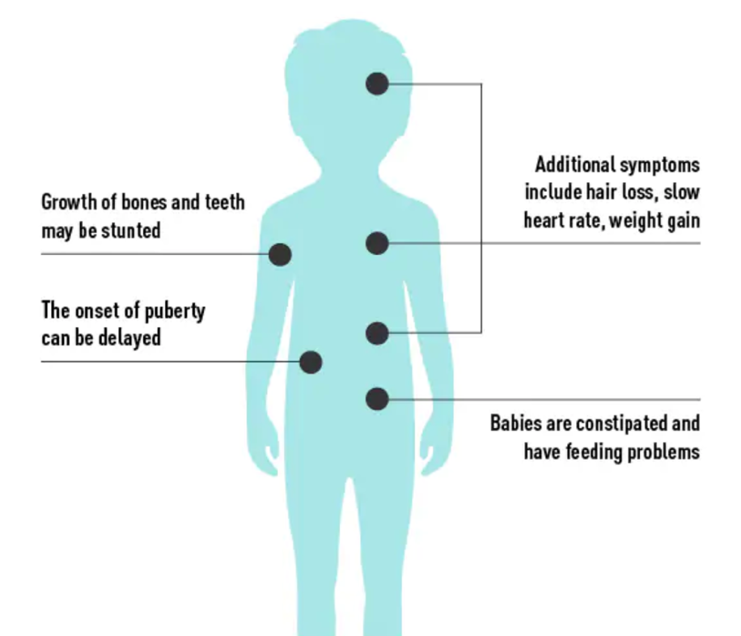

Figure 2: Symptoms of Hypothyroidism in children

The Parathyroid Glands
The parathyroid glands are small masses of glandular tissue found on the back of the thyroid gland, and they release Parathyroid hormone (PTH) PTH is a principle regulator of calcium concentration in the blood: its’ release is governed by low calcium levels (Markowitz, Underland, & Gensure, 2016), and stimulates Vitamin D production. Key targets of PTH are skin, kidney and bone, which acts directly on osteoclasts to induce the formation of bone. PTH and calcitonin from the thyroid gland work together to maintain blood calcium levels, which are essential for enzyme action, blood clotting, muscle contraction and nerve impulse transmission (Waugh & Grant, 2018).

Hypoparathyroidism occurs when not enough PTH is made by the parathyroid glands, or the PTH itself is not working properly (Petty, 2019), which would result in hypocalcaemia and hyperphosphatemia (Snyder, 2015). The most common cause is due to damage or loss of the glands , including irradiation to the head or neck, or after a thyroidectomy. Signs and symptoms are related to hypocalcaemia, including tetany, convulsions, cardiomyopathy, or respiratory arrest (Musson & Collin, 2015), although the severity of symptoms is dependent on the degree of hypocalcaemia. Treatment focuses on managing the symptoms, and replacement with calcium salts and vitamin D (Snyder, 2015).

Hyperparathyroidism occurs when there is too much PTH, which can cause calcium levels to increase and phosphate levels to fall (Petty, 2019), and is usually due to a defect in the gland, with genetic / familial causes. Hyperparathyroidism is commonly seen in children with multiple endocrine neoplasias (MEN) types 1 and 2 (Davies, 2018a), and familial hyperparathyroidism.

The Pancreas
The pancreas is located in the abdomen below the stomach and above the duodenum. It plays key parts in both the endocrine and digestive systems, playing major roles in the regulation of blood glucose, and also digestion, releasing pancreatic polypeptides into the duodenum to help digest food. The main pancreatic duct is formed in the 7th week of gestation (Webster & de Wreede, 2016). The endocrine cells make up only 1% of the pancreas, and are found in small groups called the Islets of Langerhans, forming in the 3rd month, with insulin being secreted from the 4th /5th month of gestation.

Within these islets are two principle types of cells, alpha and beta cells:
Alpha cells produce Glucagon. Glucagon’s role is to raise blood sugar levels if they fall too low, by targeting the liver to break down glycogen into glucose, and speeds up the conversion of lipids and proteins to make glucose in the liver. Beta cells secrete Insulin: Targets cells to take up and utilise free glucose, to convert glucose to glycogen (glycogenesis), to then increase lipids and protein synthesis from glucose and then slow down the breakdown of glycogen into glucose, thus decreasing blood glucose levels

Insulin concentrations in the blood will increase after eating. When the glucose from food is absorbed into the intestine, and blood glucose levels fall back to normal, the insulin levels will also fall low again, as seen in Figure 3. A normal blood glucose level should be between 4 – 7mmol/L (Hanas, 2015).

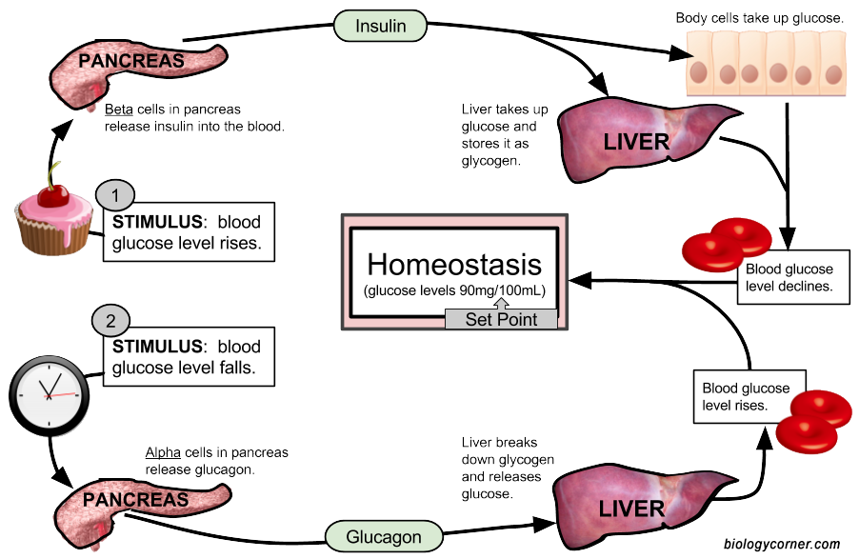
Figure 3: Negative feedback loop controlling blood glucose levels
Re Fig 14 – should be redrawn and the blood glucose level in the centre to be UK levels ie 4 – 7mmol / L not the American levels shown.

Type 1 Diabetes (T1D) is characterised by persistent raised blood glucose levels, due to the pancreas being unable to produce insulin and it is estimated that 96,000 children under the age of 15 worldwide are diagnosed with T1D every year (Mayer-Davis et al., 2018) The inability to produce insulin is due to the autoimmune destruction of the beta cells, although children with a relative with T1D have a 15% increased chance of developing it themselves (Couper et al., 2018) T1D is characterised by persistent hyperglycaemia – either random testing would indicate a blood glucose level >11.1mmol/L, or a fasting sample would be >7.7mmol/L, with the accompanying signs of weight loss, increased thirst, polyuria, recurrent infections, and, if not diagnosed, abdominal pain and coma (Petty, 2019).This emergency presentation will also include dehydration, vomiting, smell of acetone on breath, hyperventilation, shock, and hypotension (Petty, 2015), indicating Diabetic Ketoacidosis (DKA). DKA is due to an absolute deficit of insulin, resulting in a lack of intra-cellular insulin in insulin dependant tissues, namely muscle, fat and the liver, resulting in high levels of ketones causing acidosis. DKA is a clinical emergency, and if not treated, the child will lose consciousness, so it is important that children’s nurses are aware of their Trust’s policies for DKA management and paediatric advanced life support (PALS) guidelines (Wolfsdorf et al., 2018)

Children diagnosed with T1D need to be commenced on insulin therapy: insulin is a water soluble drug and so has to be administered subcutaneously or intravenously. Children need to be started on basal bolus or multiple daily subcutaneous injections, with long acting boluses being given daily and fast acting insulins given prior to meals (Eggleton, 2012), although more children are being prescribed continuous subcutaneous insulin infusion (CSII) via a pump – known as ‘pump therapy’ (Ziegler et al., 2020). (BSPED, 2020; NICE, 2008)

TIME OUT 3
Children who are newly diagnosed with T1D have to be educated on recognising and managing ‘hypos’ and ‘hypers’. What do you think the signs for hypoglycaemia and hyperglycaemia are, and what would you advise?
Type 2 Diabetes in children is becoming a public health concern internationally and obesity is a major contributing factor to the development of this disease (Mayer-Davis et al., 2018) In T2D, insulin cannot be used effectively, meaning blood glucose levels are high, resulting in features associated with insulin-resistance syndrome: hyperlipidaemia, hypertension, ovarian hyperandrogenism and non alcoholic fatty liver disease. Family history is also a risk factor, as well as being female, and of non white ethnicity: overall incidence is nearly 1 child per 100,000 in the UK (Candler et al., 2018).Treatment can be through lifestyle management, although biguanides such as Metformin, or insulin may be required.

The Adrenal Glands
The adrenal glands are a pair of triangular shaped glands that are superior to the kidneys, consisting of two layers: the adrenal cortex, and the adrenal medulla. At 9 weeks gestation, the cortex begins to develop into two distinct zones: the definitive zone and the foetal zone. The foetal cortex predominantly produces androgens – sex hormones – which, along with gonads’ hormones and certain genes – will help influence the sex differentiation of the foetus, which occurs around week 6 – 7 of gestation (Davies, 2019).

Adrenal Medulla
The medulla is completely surrounded by the cortex, and when stimulated by the sympathetic nervous system, releases adrenaline (80%) and noradrenaline (20%), known as catecholamines (Waugh & Grant, 2018). The main functions are involved in the ‘fight or flight’ response, mimicking the effects of the autonomous nervous system during times of stress (Petty, 2015) (see Figure 4).

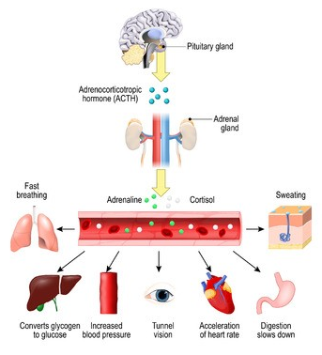

Figure 4: The Stress Response

Absence of the adrenal gland, either due to congenital causes or surgery, will result in a reduction of catecholamines being produced although this rarely invokes a ‘deficiency’ as the catecholamines are also produced in the autonomic nervous system. Increased catecholamines can be due to rare tumours, predominantly phaeochromocytomas (Davies, 2018b), invoking episodic release of catecholamines and hypertension, which will need to be surgically removed.

Adrenal cortex
The cortex is made up of three layers. The outer layer is the zona glomerulosa and is responsible for producing mineralocorticoids, namely aldosterone – known as the ‘salt hormone’ – and focuses on maintaining water and electrolyte balance. It stimulates the reabsorption of sodium through a negative feedback loop, and excretion of potassium in the urine (Waugh & Grant, 2018).

Hyperaldosteronism – referred to as Primary Aldosteronism – is the most common cause of secondary hypertension, affecting up to 13% of patients with hypertension. (Dutta, Soderkvist, & Gimm, 2016) Mineralocorticoid excess in children is extremely rare, caused by either Fludrocortisone overdosage, specific gene mutations, or aldosterone-secreting adrenal adenomas – Conn’s Syndrome. Mineralocorticoid deficiency is related to Congenital Adrenal Hyperplasia (CAH), Addison’s disease, enzyme disorders and aldosterone resistance – pseudohypoaldosteronism (Donaldson, Gregory, Van-Vliet, & Wolfsdorf, 2019). This results in salt wasting hyperkalaemia and metabolic acidosis, and children usually present in the neonatal period, with failure to thrive and dehydration.

The next layer is the zona fasciculata, producing cortisol. The hypothalamus monitors levels of circulating glucocorticoids and secretes CRH which stimulates the pituitary to release ACTH if levels need to be raised. ACTH acts on the adrenal cortex and stimulates glucocorticoid production. Cortisol is the main glucocorticoid and is a steroid hormone, and is essential for life, regulating metabolism, inflammatory and immune responses, and also the stress response (Waugh & Grant, 2018). Cortisol secretion has a marked circadian rhythm, peaking between 0400 – 0900, and then being at its lowest level around midnight.

The adrenal cortex also produces adrenal androgens - ‘sex hormones’ from the zona reticularis. Production is regulated by ACTH, and they are precursors to testosterone and oestrogen. Adrenarche is part of the pubertal process which usually occurs before the development of secondary sexual characteristics, and involves pubic and axillary hair growth, acne and body odour.

Adrenal Insufficiency (AI) – Cortisol deficiency
The most common cause of primary adrenal insufficiency in children is congenital adrenal hyperplasia (CAH), accounting for 70% of all cases, whereas Addison’s disease only accounts for around 15% of cases (Bowden & Henry, 2018). Secondary AI accounts for central causes, due to lack of ACTH from the pituitary, through trauma, cranial irradiation, brain tumours, or congenital conditions. CAH affects around 1 in every 18,000 live births in the UK, (Webb & Krone, 2015)resulting in reduced aldosterone and cortisol production, and excessive androgen production. Girls are usually diagnosed shortly after birth, presenting with genital virilisation due to the excess androgens (Davies, 2019). Boys will usually present in the emergency department around two weeks later, with failure to thrive, vomiting , and poor feeding, with hypoglycaemia and hyponatraemia, due to a salt wasting crisis. Glucocorticoid replacement is essential and lifelong, with oral hydrocortisone, and also fludrocortisone replacing the aldosterone (Moloney, Murphy, & Collin, 2015). Infants will also need salt supplementation until they are fully weaned. Medication regimes need to be strictly adhered to in order to reduce side effects – either insufficient dosing (lethargy and hypoglycaemia) or over dosing (weight gain, and Cushings syndrome effects). Families are educated regarding illness and/or injury and the need to increase the amount of hydrocortisone by doubling doses when unwell. Patients should carry an emergency kit containing injectable hydrocortisone (intra-muscular) in the case of severe vomiting and diarrhoea (unable to absorb the oral medication) or in the case of severe injury or collapse. Patients are advised to wear a medical identity bracelet and carry a steroid card.

Cushing’s Syndrome – Cortisol Excess
Hypercortisolaemia – Cushing’s Syndrome – is when the child has excess levels of cortisol, resulting in truncal obesity, impaired linear growth, a rounded ‘moon’ face, changes in the skin (acne, stretchmarks, bruising), hypertension and fatigue. Cushings in children usually is a result from exogenous administration of glucocorticoids (Keil, 2013), and children receiving high dose steroids as part of their treatments, eg in oncology, respiratory, inflammatory bowel disease and cardiac care. Other causes can be due to ACTH secreting tumours – pituitary adenomas as discussed earlier (Cushing’s Disease), or adrenal tumours. The most common presentation in children is persistent weight gain alongside lack of height gain, and treatment will be either surgical to remove the tumour, or a reduction of the exogenous medical treatment.

The Gonads
The gonads – ovaries in females, and testes in males – are responsible for the onset and progression of puberty, development and maintenance of secondary sexual characteristics and reproductive capability (Davies, 2020) In both sexes, the hypothalamus produces Gonadotrophin Releasing Hormone (GnRH) which in turn stimulates the Pituitary Gland to release both Luteinising Hormone (LH) and Follicle stimulating Hormone (FSH). Secretion is pulsatile and in females also cyclical. Puberty commences when GnRH levels increase – although the exact mechanism which triggers this is not yet understood.

Delayed and early puberty are commonly seen in paediatric endocrine clinics. Delayed puberty is more common in boys, with constitutional delay being the most common cause (Wei & Crowne, 2016). Other causes include hypergonadotrophic hypogonadism, where there are raised levels of LH and / or FSH, but the gonads cannot receive the message, due to sex chromosome abnormalities (eg Turner Syndrome), damage to the gonads from, for example, chemotherapy (van Santen, van den Heuvel-Eibrink, van de Wetering, & Wallace, 2019), or cryptorchidism (Cho, Thomas, Perera, & Cherian, 2019). Conversely, hypogonadotrophic hypogonadism (HH) could be a cause, due to pituitary lesions, cranial irradiation, idiopathic HH, or anosmic HH, known as Kallmann Syndrome. Delayed puberty in girls is classified as absent breast development >13 years, and absent testes development >14 years in boys. Treatment is aimed at developing secondary sexual characteristics and maturing gonadal function for future fertility, with oestrogen and testosterone replacement. Transition into adult services for children with delayed puberty needs to be managed sensitively, as the young person’s emotional needs need to be considered alongside their physical needs.

Conclusion
The Endocrine System is a complex system, and it is important to understand how the various systems combine to maintain many of the fundamental functions in the human body. It is important that children’s nurses are aware of the impact hormone deficiency can have, especially with regards to their development, and understand the implications on illness and treatments that these deficiencies may have. This article has outlined the main functions and hormones of the system. Certain systems, such as the adrenal cortisol axis and the reproductive system are complex and only a brief explanation has been undertaken here. It is hoped that by completing the Time Outs you will be begin to understand what an impact an imbalance in the endocrine system can have.

References

Ahmad, N., Irfan, A., & Al Saedi, S. (2017). Congenital hypothyroidism: Screening, diagnosis, management, and outcome. Journal of Clinical Neonatology, 6(2), 64. doi:10.4103/jcn.JCN_5_17
Boore, J., Cook, N., & Shepherd, A. (2016). Essentials of anatomy and physiology for nursing practice. London: Sage.
Bowden, S. A., & Henry, R. (2018). Pediatric Adrenal Insufficiency: Diagnosis, Management, and New Therapies. Int J Pediatr, 2018, 1739831. doi:10.1155/2018/1739831
BSPED. (2020). Guideline for the Management of Children and Young People under the age of 18 years with Diabetic Ketoacidosis. Retrieved from https://www.bsped.org.uk/media/1798/bsped-dka-guideline-2020.pdf
Bunn, R. (2013). Melatonin and its use in children The Pharmaceutical Journal, 290, 147 - 150.
Candler, T. P., Mahmoud, O., Lynn, R. M., Majbar, A. A., Barrett, T. G., & Shield, J. P. H. (2018). Continuing rise of Type 2 diabetes incidence in children and young people in the UK. Diabet Med, 35(6), 737-744. doi:10.1111/dme.13609
Cho, A., Thomas, J., Perera, R., & Cherian, A. (2019). Undescended testis. British Medical Journal, 364, 1 - 5. doi:10.1136/bmj.l926
Collin, J., Whitehead, A., & Walker, J. (2016). Educating children and families about growth hormone
deficiency and its management: part 1. Nursing children and young people, 28(1), 32 - 36.
Couper, J. J., Haller, M. J., Greenbaum, C. J., Ziegler, A. G., Wherrett, D. K., Knip, M., & Craig, M. E. (2018). ISPAD Clinical Practice Consensus Guidelines 2018: Stages of type 1 diabetes in children and adolescents. Pediatr Diabetes, 19 Suppl 27, 20-27. doi:10.1111/pedi.12734
Davies, K. (2018a). Multiple Endocrine Neoplasia in Children and the Importance of Screening: Part 1. J Pediatr Nurs. doi:10.1016/j.pedn.2018.04.014
Davies, K. (2018b). Multiple Endocrine Neoplasia in Children and the Importance of Screening: Part 2. J Pediatr Nurs, 42, 129-131. doi:10.1016/j.pedn.2018.04.015
Davies, K. (2019). Disorders of Sex Development. In S. Llahana, C. Follin, C. Yedinak, A. Grossman, K. Davies, & M. F. Keil (Eds.), Advanced Practice in Endocrinology Nursing (Vol. 1, pp. 39 - 61). Switzerland: Springer.
Davies, K. (2020). Biological basis of child health 7: growth, development and the reproductive system. Nurs Child Young People. doi:10.7748/ncyp.2020.e1308
Donaldson, M. D. C., Gregory, J. W., Van-Vliet, G., & Wolfsdorf, J. I. (2019). Practical Endocrinology and Diabetes in Children (4th ed.). Oxford: Wiley Blackwell.
Dutta, R. K., Soderkvist, P., & Gimm, O. (2016). Genetics of primary hyperaldosteronism. Endocr Relat Cancer, 23(10), R437-454. doi:10.1530/ERC-16-0055
Eggleton, A. (2012). Insulin therapy following diabetic ketoacidosis in children. Nurse Prescribing, 10(6), 292.
Haliloglu, B., & Bereket, A. (2015). Hypothalamic obesity in children: pathophysiology to clinical management. J Pediatr Endocrinol Metab, 28(5-6), 503-513. doi:10.1515/jpem-2014-0512
Hanas, R. (2015). Type 1 Diabetes in children, adolescents and young adults (6th ed.). Somerset: Class Health.
Hoffmann, A., Adelmann, S., Lohle, K., Claviez, A., & Muller, H. L. (2018). Pediatric prolactinoma: initial presentation, treatment, and long-term prognosis. Eur J Pediatr, 177(1), 125-132. doi:10.1007/s00431-017-3042-5
Janjua, I., & Goldman, R. D. (2016). Sleep related melatonin use in healthy children. Canadian Family Physician, 62, 315 - 317.
Keil, M. F. (2013). Quality of life and other outcomes in children treated for Cushing syndrome. J Clin Endocrinol Metab, 98(7), 2667-2678. doi:10.1210/jc.2013-1123
Kreins, A. Y., Junghanns, F., Mifsud, W., Somana, K., Sebire, N., Rampling, D., . . . Davies, E. G. (2020). Correction of both immunodeficiency and hypoparathyroidism by thymus transplantation in complete DiGeorge syndrome. Am J Transplant, 20(5), 1447-1450. doi:10.1111/ajt.15668
Markowitz, M. E., Underland, L., & Gensure, R. (2016). Parathyroid disorders. Pediatrics in Review, 37(12), 524 - 535.
Mayer-Davis, E. J., Kahkoska, A. R., Jefferies, C., Dabelea, D., Balde, N., Gong, C. X., . . . Craig, M. E. (2018). ISPAD Clinical Practice Consensus Guidelines 2018: Definition, epidemiology, and classification of diabetes in children and adolescents. Pediatr Diabetes, 19 Suppl 27, 7-19. doi:10.1111/pedi.12773
Moloney, S., Murphy, N., & Collin, J. (2015). An overview of the nursing issues involved in caring for a child with adrenal insufficiency. Nursing children and young people, 27(7), 28 - 36.
Mondal, S., Mukhopadhyay, P., & Ghosh, S. (2017). Clinical approach to congenital hypothyroidism. Thyroid Research and Practice, 14(2), 45. doi:10.4103/trp.trp_5_17
Moore, B., Whitehead, A., & Davies, K. (2019). Short stature, growth hormone deficiency, and primary IGF-1 deficiency. In S. Llahana, C. Follin, C. Yedinak, A. Grossman, K. Davies, & M. Keil (Eds.), Advanced Practice in Endocrinology Nursing (Vol. 1, pp. 13 - 37). Cham: Springer.
Musson, P., & Collin, J. (2015). Management of Vitamin D deficiency in childhood and adolescence. Nursing children and young people, 27(9), 27 - 35.
NHS. (2018). Newborn Blood Spot Test. Retrieved from https://www.nhs.uk/conditions/pregnancy-and-baby/newborn-blood-spot-test/
NICE. (2008). Insulin pump therapy for diabetes.
Palumbo, C. (2008). Embryology and Anatomy of the Thymus Gland. In C. Lavini, C. A. Moran, U. Morandi, & R. Schoenhuber (Eds.), Thymus Gland Pathology. Milano: Springer.
Petty, J. (2015). The Endocrine System. In I. Peate & E. Gormley-Fleming (Eds.), Fundamentals of Children’s Anatomy and Physiology: A Textbook for Nursing and Healthcare Students (pp. 233 - 255). Chichester: Wiley Blackwell.
Petty, J. (2019). Disorders of the endocrine system. In E. Gormley-Fleming & I. Peate (Eds.), Fundamentals of Children’s Applied Pathophysiology: An Essential Guide for Nursing and Healthcare Students (pp. 233 - 256). Chichester: Wiley Blackwell.
PWS. (2020). What is Prader Willi Syndrome? Retrieved from https://www.pwsa.co.uk/what-is-pws
Rosenfeld, A., Arrington, D., Miller, J., Olson, M., Gieseking, A., Etzl, M., . . . Kaplan, A. (2014). A review of childhood and adolescent craniopharyngiomas with particular attention to hypothalamic obesity. Pediatr Neurol, 50(1), 4-10. doi:10.1016/j.pediatrneurol.2013.09.003
Snyder, C. K. (2015). Hypoparathyroidism in Children. J Pediatr Nurs, 30(6), 939-941. doi:10.1016/j.pedn.2015.09.005
Storr, H. L., & Savage, M. O. (2015). MANAGEMENT OF ENDOCRINE DISEASE: Paediatric Cushing's disease. Eur J Endocrinol, 173(1), R35-45. doi:10.1530/EJE-15-0013
Urquhart, T., & Collin, J. (2016). Understanding the endocrinopathies associated with the treatment of childhood cancer: part 1. Nurs Child Young People, 28(8), 37-44. doi:10.7748/ncyp.2016.e735
van Santen, H. M., van den Heuvel-Eibrink, M. M., van de Wetering, M. D., & Wallace, W. H. (2019). Hypogonadism in Children with a Previous History of Cancer: Endocrine Management and Follow-Up. Horm Res Paediatr, 91(2), 93-103. doi:10.1159/000495943
Waugh, A., & Grant, A. (2018). Ross & Wilson: Anatomy and Physiology in Health and Illness (13th ed.). Edinburgh: Elsevier.
Webb, E. A., & Krone, N. (2015). Current and novel approaches to children and young people with congenital adrenal hyperplasia and adrenal insufficiency. Best Pract Res Clin Endocrinol Metab, 29(3), 449-468. doi:10.1016/j.beem.2015.04.002
Webster, S., & de Wreede, R. (2016). Embryology at a glance (2nd ed.). Oxford: Wiley Blackwell.
Wei, C., & Crowne, E. C. (2016). Recent advances in the understanding and management of delayed puberty. Arch Dis Child, 101(5), 481-488. doi:10.1136/archdischild-2014-307963
Wolfsdorf, J. I., Glaser, N., Agus, M., Fritsch, M., Hanas, R., Rewers, A., . . . Codner, E. (2018). ISPAD Clinical Practice Consensus Guidelines 2018: Diabetic ketoacidosis and the hyperglycemic hyperosmolar state. Pediatr Diabetes, 19 Suppl 27, 155-177. doi:10.1111/pedi.12701
Yedinak, C., & Davies, K. (2019). Dynamic investigations and Diagnostic Testing. In S. Llahana, C. Follin, C. Yedinak, A. Grossman, K. Davies, & M. Keil (Eds.), Advanced Practice in Endocrinology Nursing (Vol. 1, pp. 277 - 303). Cham: Springer.
Ziegler, R., Waldenmaier, D., Kamecke, U., Mende, J., Haug, C., & Freckmann, G. (2020). Accuracy assessment of bolus and basal rate delivery of different insulin pump systems used in insulin pump therapy of children and adolescents. Pediatr Diabetes. doi:10.1111/pedi.12993

