Figure 6. Forest-Plot for Affective/NT Outcome

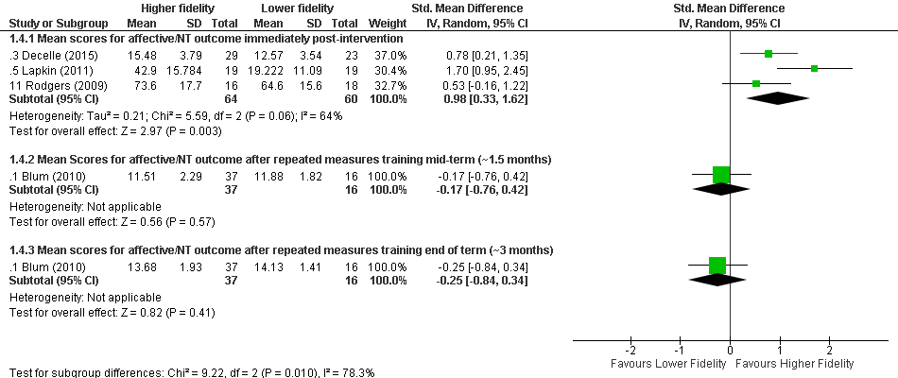

Statistical Package: Review Manager (RevMan-5.3).The Cochrane Collaboration (2014).

