Numerical Investigation of the Thermal Performance of Water Based Closed Loop Oscillating Heat Pipe (CLOHP)
Yeboah S. K.
University of Nottingham Ningbo China
siegfried.yeboah@nottingham.edu.cn
Darkwa J.
University of Nottingham, UK
jo.darkwa@nottingham.ac.uk

Oscillating Heat Pipes (OHPs) offer enhanced heat transfer via the oscillating movement of working fluid and phase change phenomena. They are capable of providing passive cooling for a gamut of devices ranging from electronics to other heat emitting devices. However their optimum performance largely rests on a host of factors including their design parameters and operating conditions. Although developing experimental prototypes through trial and error appears feasible, this approach could be costly especially as their optimum thermal performance cannot be ascertained a priori.
To this end, a Five-turn water based Closed Loop Oscillating Heat Pipe (CLOHP) system has been designed and numerically investigated using the Eulerian Volume of Fluid (VOF) model coupled with the Level-Set Method. The model includes an implicit body force formulation, mass transfer effects via an evaporation-condensation model, surface tension effects and parameters such as the average static contact angle for water obtained from published literature. At a constant input temperature, the thermal performance of the CLOHP was investigated for volume fractions of 0.3, 0.5 and 0.7 and at horizontal and vertical orientations.
The results obtained are analysed and presented in terms of the fluid volume fraction, interface condition, pressure distribution and Nusselt number. The overall cooling capacity of the CLOHP system and its overall thermal performance would be compared with those of other theoretical studies in literature.

Abstract
Abstract: The enhanced capabilities of Oscillating/Pulsating Heat Pipes (OHPs/PHPs) are often curtailed by a gamut of factors that affects their optimum thermal performance. These factors ranging from their design parameters to operating conditions may not make it feasible to develop experimental prototypes through trial and error as optimum thermal performance cannot be ascertained a priori.
In this study, an Eulerian Volume of Fluid (VOF) model coupled with a Level Set Method has been used to numerically investigate the thermal performance of a five-turn water based CLOHP with volume fractions 0.3, 0.5 and 0.7 in vertical and horizontal modes. The capabilities of this computational fluid dynamics (CFD) approach to help predict the optimum thermal performance of OHP/PHPs is shown to be well established in literature.
A summary of the results from this investigations show that more convective heat transfer rate occurs from the liquid phase than from the vapour phase. Also orientation was found to significantly influence pressure distribution within the CLOHPs. Finally it was observed that thermal resistance was significantly influenced by volume fraction/fill ratio rather than by orientation of the device.
Keywords: Closed Loop Oscillating Heat Pipe, Volume of Fluid (VOF), Computational Fluid Dynamics (CFD)

Introduction
Oscillating/Pulsating heat pipes (PHP/OHP) developed by Akachi in the early 1990s are two-phase heat transfer devices that rely on the oscillatory flow of liquid slug and vapour plug in a long miniature tube (capillaries) bent into many turns. Capable of transporting heat without any additional power input, they offer enhanced heat transfer through passive, two-phase heat transfer mechanism [(Zhang and Faghri, 2008) (Lin et al, 2011) (Bhuwakietkumjohn and Rittidech, 2010)]. Unlike conventional heat pipes they have no wick structure to transport the liquid or pumps to operate other than the heat being rejected. Their overall resistance is typically greater than that of traditional heat pipes and can operate at higher heat fluxes as they utilize boiling and are not limited by a boiling limit other than the critical heat flux (Bejan and Kraus, 2003).
A typical system consists of an evaporating section, an adiabatic section, and a condensing section. As heat is added on the evaporating section, the liquid is vaporized, causing vapour volume expansion. Vapour in the condensing section is condensed into liquid, causing volume contraction. The volume expansion and contraction excite an oscillation motion of the liquid plugs and vapour bubbles in the miniature channels. Through forced convection and phase-change, heat is transferred from the evaporating section to the condensing section (Ma et al, 2008). Continuous heating then sustains the oscillatory flow hence fluid transported from the evaporator section to the condenser section transfers heat from the higher temperature zone to the lower temperature zone (Song and Xu, 2009).
As efficient heat transfer devices, their extensive application range is widely reported in literature [Rittidech et al (2005), Meena et al (2007), Meena et al (2007) Meena and Rittidech (2008), Nuntaphan et al (2010) Supirattanakul et al (2011)]. However their performance is also well documented to be dependent on a host of parameters and properties including the working fluid type, filling ratio, channel geometry, number of serpentine-arranged turns, operating orientation and heating/cooling areas (Thompson et al, 2011). For instance, start-up behaviour for these devices is known to be dependent on the working fluid type (Qu et al, 2012). At higher or lower heating power input start-up behaviour is found to be quite diﬀerent (Xu and Zhang, 2005). Yin and Ma (2014) found that the heat transfer coefficient of oscillating flow in the capillary tube depends on the fluid properties and oscillating waveform, with triangular waveform of oscillating motion showing higher heat transfer coefficient. Fill ratio is also found to have significant impact on their thermal performance. For instance Senjaya and Inoue, (2013) found that high heat transfer rate occurs when OHPs are charged at optimum filling ratios of 50–60%, which are higher than those of conventional heat pipes. Yang et al (2008) observed that a fill ratio of 50% was optimum to obtain best performances in all orientations for closed loop pulsating heat pipes. Borgmeyer et al (2010) also found that fill ratio has an inverse effect on both the fluid motion and heat transfer. According to Dobson and Swanepoel (2010), the moving liquid plugs of a PHP with 50% fill ratio leaves behind at their trailing ends a thin layer of fluid of finite thickness on the pipe surface and at the leading front take up liquid left behind by the preceding liquid plugs. Hence at any one time 50% of the heat transfer (ignoring any axial heat transfer) is associated with liquid plugs.
For these devices, surface tension predominate the two-phase flow, hence a critical diameter, $D_{crit}$ is required to be satisfied in their design (Qu, and Wang, 2013). The $D_{crit}$ ensures that the surface tension forces dominates gravitational forces for distinct vapour bubbles and liquid slugs to form (Jiao et al, 2009). Other than that the working fluid will settle down by gravity and the device will no longer be a pulsating/oscillating heat pipe but instead, it will function as an interconnected array of two-phase gravity assisted thermosyphons, with pool boiling dynamics primarily governing its performance (Khandekar et al, 2003b). Lin et al (2013) for instance found that the inner diameter has a greater impact on the thermal performance than the heat transfer length.
The wickless structure does not make it susceptible to entrainment limit. However boiling limit is likely and can manifest itself through overheating of the evaporator due to the lack of cooling working fluid tending to a dry-out eventually. Hence to enhance the heat transfer rate and sustain higher heat loads without dry-out, the evaporator length should in principle be no larger than that of the condenser (Qu, and Wang, 2013). According to Qu and Wang (2013) for the same heat load on a CLOHP, a shorter evaporator length translates to higher heat flux and higher evaporator temperature, increasing the temperature difference between the evaporator and condenser. The adiabatic length is also found to have considerable effect on thermal performance (Dilawar and Pattamatta (2013). For instance, Arab et al (2012) found the adiabatic length an important parameter that needs to be decreased. Sukchana and Jaiboonma (2013) on the other hand found that filling ratios have significant effect on the thermal efficiency than adiabatic length. According to Chiang et al (2012) for closed-loop pulsating heat pipes the adiabatic region between the evaporating and condensing region is optional in terms of practical application as the evaporating and condensing regions are the regimes of the received and removed heat, respectively during normal operation.
Studies carried out by Khandekar et al (2003b) shows that when the number of turns is less than a critical value, Closed Loop Pulsating Heat Pipes (CLPHP) cannot satisfactorily operate in the horizontal orientation and vice versa. Charoensawan et al (2003) concluded that a certain critical number of turns are required to make horizontal operation possible and also to bridge the performance gap between vertical and horizontal operation attributed to the increase in the level of internal perturbations. Khandekar and Groll (2004) explained that if the number of turns of a CLPHP is small, then the heat handled by each turn will be quite high. If it is increased at constant fill ratio and heat power input, then the net heat handled by each CLPHP turn reduces. Mameli et al (2012) also observed many advantages of the their nine turn CLPHP over their three turn one in terms of its ability to also work in the horizontal heating mode, lower thermal resistance and less evident differences between different fluids in terms of overall efficiency. Mameli et al (2014) concluded that the performance of PHP with simple geometry, especially the low number of turns, is heavily affected by the inclination of the device with respect to gravity.
The effect of inclination angle essentially reflects the influence of gravity on OHPs/PHPs (Qu et al, 2012). Qu et al (2012) found that the effect of gravity cannot be ignored as they observed the best thermal performance occurring at the vertical bottom heating mode orientation with thermal resistance increasing as their micro pulsating heat pipes (MPHP) moved towards horizontal orientation. Jahani et al (2013) also showed that the thermal resistance increases in the horizontal heating mode in comparison to the vertical heating mode since in the horizontal heating mode the gravitational force modifies the shape of the bubbles and drops inside the tube and disarranges their symmetry. Smoot et al (2011) tested OHPs vertically with the evaporator at the bottom and found that the heat transfer performance was much better than that tested horizontally. Lin et al (2011) observed lowest thermal resistance for an aluminum plate OHP at vertical bottom heating mode and the worst performance for top heating mode. Thompson et al (2011) found that when the heating area is larger at the same input power, the heat pipe is less orientation-dependent and when the heating area was decreased, the thermal resistance and peak-to-peak amplitudes of temperature oscillations in the evaporator increased.
The varied considerations needed to be made in the design of an effective CLOHP that can achieve optimum thermal performance makes it crucial for theoretical studies to be carried out. This is perceived to invariably limit the trial and error development of experimental prototypes which may have its own associated material cost especially as optimum thermal performance cannot be ascertained a priori. To this end, a computational fluid dynamics approach is proposed for the numerical investigation of the thermal performance of a CLOHP. In this present paper, a five-turn water based CLOHP is numerically investigated using the Eulerian Volume of Fluid Model coupled with the Level-Set Method.
Physical Model
Figure 1a and 1b shows a simple annotated 2D geometry and 3D model in the z-x plane of a five turn Closed Loop Oscillating Heat Pipe (CLOHP) system designed using Rhinoceros 5 and imported into ANSYS Fluent R15.0 respectively. The CLOHP is made of copper tube with internal diameter 2mm. The actual diameter value determined from equation (1) was around 1.5mm but for simplicity in modelling a round off value of 2mm is used in the investigations. Heat input at the evaporator section is rejected at the condenser section. Table 1 provides the typical dimensions of the model.
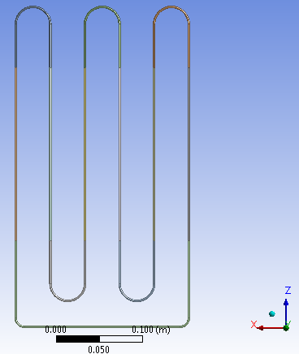
Figure 1 (a) Annotated 2D Geometry of CLOHP in Rhinoceros 5 (b) A 3D Model in ANSYS R15.0 in z-x Plane
Table 1 CLOHP Specification
Parameter | Value | Units
Inner Diameter | 2 | mm
Thickness | 1 | mm
Condenser Length | 11 | cm
Adiabatic Length | 20 | cm
Evaporator Length | 7 | cm
Number of Turns | 5

Meshed Model
The meshed CLOHP model and its statistics are shown in Figure 2 and Table 2 respectively. The mesh is an automatic mesh generated in ANSYS R15.0 mesher. The number of elements was 28158 with 33660 nodes. The various sections were named and the model loaded in ANSYS Fluent.
Figure 2 Meshed Model of CLOHP in ANSYS R15.0 with its statistics
Table 2 Statistics
Nodes | 33660
Elements | 28158
Mesh Metric | Orthogonal Quality
Min | 0.670518736161991
Max | 0.998067824412707
Average | 0.946947189440636
Standard Deviation | 6.48441916779425E-02

Mathematical Models
The working fluid in the CLOHP system forms the liquid slugs and vapour plugs in the entire tube if the diameter does not exceed the critical diameter (Panyoyai et al, 2009)(Jiao et al, 2009). Since surface tension predominate the two-phase flow in a CLOHP, the inner diameter should satisfy (Qu, and Wang, 2013) equation (1).
$D_{crit}=2L=2\sqrt{\frac{σ}{g\left(ρ_{l}{-ρ}_{v}\right)}}$ (1)
To enhance the heat transfer rate and sustain higher heat loads without dry-out, the evaporator length of a CLOHP should in principle be no larger than that of the condenser (Qu, and Wang, 2013). The effective length of the system is determined by equation (2).

$L_{eff}=\frac{1}{2}\left(L_{e}+L_{c}\right)+L_{a}$ (2)
The Volume of Fluid (VOF) Model used in this simulation tracks the interface between phases via a continuity equation for the volume fraction given by (ANSY Fluent);
$\frac{1}{ρ_{q}}\left[\frac{∂}{∂t}\left(α_{q}ρ_{q}\right)+∇.\left(α_{q}ρ_{q}{\vec{v}}_{q}\right)=S_{αq}+\sum_{p=1}^{n}{\left({\dot{m}}_{pq}-{\dot{m}}_{qp}\right)}\right]$ (3)
The density in each cell is given by;
$ρ=α_{2}ρ_{2}+\left(1-α_{2}\right)ρ_{1}$ (4)
In the general form, the volume fraction averaged density is $ρ=\sum{α_{q}ρ_{q}}$ (5)
ANSYS Fluent solves the Momentum equation by:
$\frac{∂}{∂t}\left(ρ\vec{v}\right)+∇.\left(ρ\vec{v}\vec{v}\right)=-∇p+∇.\left[μ\left(∇\vec{v}+∇{\vec{v}}^{T}\right)\right]+ρ\vec{g}+\vec{F}$ (6)
The energy equation for the phases is given by:
$\frac{∂}{∂t}\left(ρE\right)+∇.\left(\vec{v}\left(ρE+p\right)\right)=∇.\left(k_{eff}∇T\right)+S_{h}$ (7)
For the VOF model, energy E and temperature T are mass averaged variables determined as follows:
$E=\frac{\sum_{q=1}^{n}{α_{q}ρ_{q}E_{q}}}{\sum_{q=1}^{n}{α_{q}ρ_{q}}}$ (8)
The VOF model can also include the effects of surface tension along the interface between each pair of phases. For the Continuum Surface Force (CSF) Model in ANSYS Fluent, the pressure drop across the surface depends on the surface tension coefficient and the surface curvature measured by two radii in orthogonal directions
$p_{2}-p_{1}=σ\left(\frac{1}{R_{1}}+\frac{1}{R_{2}}\right)$ (9)
The CSF is computed from local gradients in the surface normal (n)
$n=∇α_{q}$ (10)
The curvature $κ$ is
$κ=∇.\hat{n}$ (11)
Where
$\hat{n}=\frac{n}{\left|n\right|}$ (12)
The Coupled Level-Set and VOF Model
The level-set function, the signed distance to the interface is given by
$φ\left(x,t\right)=\left\{\begin{aligned}+\left|d\right| if x∈the primary phase \\ 0 if x∈Γ \\ -\left|d\right|if x∈the secondary phase\end{aligned}\right.$ (13)
Where
- $Γ=\left\{x\left|φ\left(x,t\right)=0\right.\right\}$ in a two phase system
- $d$ is the distance from the interface
For the surface tension force, the normal and curvature of the interface are needed;
$\overset{⃑}{n}={\left.\frac{∇φ}{\left|∇φ\right|} \right|}_{φ}=0$ (14)
$ĸ=∇.{\left.\frac{∇φ}{\left|∇φ\right|} \right|}_{φ}=0$ (15)
The evolution of the level set is given by
$\frac{∂φ}{∂t}+∇.\left(\overset{⃑}{u}φ\right)=0$ (16)

The momentum equation is therefore written as
$\frac{∂}{∂t}\left(ρ\overset{⃑}{u}\right)+∇.\left(ρ\overset{⃑}{u}\overset{⃑}{u}\right)=-∇p+∇.μ\left[∇\overset{⃑}{u}+{\left(∇\overset{⃑}{u}\right)}^{T}\right]-σĸδ\left(φ\right)+ρ\overset{⃑}{g}$ (17)
$δ\left(φ\right)=\frac{1+cos\left({πφ}/a\right)}{2a}$ $if \left|φ\right|<a$, otherwise $δ\left(φ\right)=0.σ$ (18)
Where
- $a=1.5h$
- $h$ is the grid spacing
- $\overset{⃑}{u}$ is the underlying velocity field
The Evaporation – Condensation Model
The liquid-vapour mass transfer (evaporation and condensation) is governed by the vapour transport equation (ANSYS Fluent):
$\frac{∂}{∂t}\left(αρ_{v}\right)+∇.\left(αρ_{v}{\overset{⃑}{V}}_{v}\right)={\dot{m}}_{l→v}-{\dot{m}}_{v→l}$ (19)

$if T_{l}>T_{sat}$then the mass transfer can be described by
${\dot{m}}_{l→v}=coeff×α_{l}ρ_{l}\frac{\left(T_{l}-T_{sat}\right)}{T_{sat}}$ (20)
$if T_{v}<T_{sat}$then the mass transfer can be described by
${\dot{m}}_{v→l}=coeff×α_{v}ρ_{v}\frac{\left(T_{v}-T_{sat}\right)}{T_{sat}}$ (21)
The thermal Performance according to Hao et al (2014) is determined by the Thermal Resistance (R) in equation (22)
$R=\frac{{\overline{T}}_{e}{-\overline{T}}_{c}}{Q_{e}}$ (22)
Methodology for CLOHP Modelling and Simulation
The CLOHP model was designed in Rhinoceros 5 as a closed loop 3D pipe with five turns. A profile for the geometry was initially created using several curves and polylines followed by the generation of 3D solid pipe. This 3D pipe geometry was then imported into ANSYS Design Modeler where it was cleaned and new parts consisting of the condenser, adiabatic and evaporator sections formed. The cleaned imported CAD geometry was then automatically meshed in ANSYS Mesher and loaded into Fluent for simulation. The meshed model mainly consisted of hexahedral and quadrilateral cell zones and periodic faces recommended for simulations involving the level set function. This enabled geometric reconstruction of the vapour-liquid interface for the level set method during the simulation.
The VOF model was chosen because in the ANSYS Fluent literature it is outlined as the most suitable model for this type of system. Basically it has the capability to model two or more immiscible fluids by solving a single set of momentum equations whilst tracking the volume fraction of each of the fluids throughout the domain (ANSYS Fluent Theory Guide). This is also evident in literature where Nagwase and Pachghare (2013) for instance carried out thermal performance of Closed Loop Pulsating Heat Pipe with DI-Water using an experimental model and VOF simulation model and found that the performance of CLPHP can be predicted with the simulation model without the need for an experiment. Liu and Chen (2014) also simulated the vapour–liquid two-phase flow pattern in a flat-plate oscillating heat pipe (FP-OHP) using the VOF model in ANSYS Fluent in order to describe the motions and evolutions of vapour–liquid interface.
For this present study, a pressure based transient model with gravity was used. For the flow, laminar viscous model was selected and viscous heating activated. The chosen working fluid was water hence the two phases in this model are water liquid and water vapour. Since the physical model is a closed loop and oscillation of fluid within the loop was expected, translational periodic boundary conditions were created for the evaporator and condenser sections using sliding meshes generated in Fluent. Phase interaction was enabled with parameters for surface tension coefficient and mass transfer interaction. Surface tension was initiated using a text command so the relevant surface tension equations would be activated during the simulation. At the walls, contact angle of 67.42° for water in a capillary tube obtained from literature (Kumar et al, 2014) was used.
The level set (LS) method was coupled with the VOF model in order for the interface of the two phases to be tracked. This is because the VOF method has weakness which lies in the calculation of its spatial derivatives, since it is discontinuous across the interface. In Fluent, this problem can be resolved with the inclusion of the level-set method, an interface-tracking method for computing two-phase flows with topologically complex interfaces (ANSYS FLUENT). According to Sun and Tao (2010) by using the level set function the disadvantages of VOF method, inaccuracy of curvature and bad smoothness of discontinuous physical quantities near interfaces, can be overcome. Lv et al (2010) for instance developed a novel hybrid coupled level set and volume of fluid method for sharp interface capturing on tetrahedral unstructured grids. Wang et al (2013) used the combination of the VOF method and the level set method implemented on an adaptive quadtree grid system to capture interface deformations. They used the VOF method to capture the interface, and the LS function, which is solved by a geometric method to calculate the surface tension force. Ningegowda and Premachandran (2014) developed a Coupled Level Set and Volume of Fluid (CLSVOF) interface capturing method using a multi-dimensional advection algorithm for non-uniform grids for two phase flows with and without phase change for two-dimensional problems. A finite volume method with a collocated grid arrangement was used for solving the governing equations and the SIMPLE algorithm used for velocity and pressure coupling. The performance of present phase change model was evaluated using the one-dimensional Stefan problem and the two-dimensional saturated horizontal film boiling flows and it was found that the saturated film boiling flow model developed with the proposed CLSVOF model agree well with the experimental correlations and numerical results. Sun and Tao (2010) used a coupled volume-of-fluid and level set (VOSET) method, which combines the advantages and overcomes the disadvantages of volume-of-fluid (VOF) and Level Set (LS) methods, for computing incompressible two-phase flows without heat transfer and found that this VOSET is more accurate than VOF and LS methods on their own.
The periodic condition which was translational was set in the z and y directions respectively for the two orientations applied for this study. The relevant pressure gradient, bulk temperature and actual reference pressure locations were updated. The maximum velocity for the translational motion was set to 1m/s. The Pressure-Implicit with Splitting of Operators (PISO) algorithm coupled with pressure-velocity scheme was then used to solve the related transport equations. Since the model involved the level set method, a geometric reconstruction scheme capable of obtaining the face fluxes was selected and other competing schemes disabled using text commands.
Text commands were also used to activate time dependent parameters and velocity based time step. The volume fraction/fill ratio of the liquid water was then patched to the condenser, adiabatic and evaporator cell zones created in each model for the two orientations. The solver was then initialized at volume fractions of 0.3, 0.5 and 0.7 for respective models. Convergence monitoring was set to absolute criteria where residuals were expected to go below 0.001 for all transport equation and 1e-06 for energy. 120 time steps of size 0.0002791947 empirically determined was used for a maximum iteration of 40 per time step.
The case and data files from the simulation which had results of the geometry and simulation were loaded in ANSYS CFD Post for quantitative analysis. Here expressions and locations were created for the numerical processing of results and the qualitative display of variables for analysis. Transient data was generated via CFD Post for analysis.
Results and Discussions
The Eulerian Volume of Fluid (VOF) model coupled with the Level-Set Method in ANSYS Fluent has been used to evaluate the performance of a five-turn water based closed loop oscillating heat pipe (CLOHP). The CLOHP performance was evaluated for volume fractions/fill ratios of 0.3, 0.5 and 0.7 under vertical and horizontal orientations. Geometry interfaces were converted to vapour and liquid interfaces by creating sliding mesh in order to generate translational periodic boundaries for the models. The vapour and liquid were modelled as immiscible fluids by solving a single set of momentum equations and tracking the volume fraction of each of the fluids throughout the domain using the Level-Set Method. The evaporator was initiated at a constant temperature of 393K whilst the condenser and adiabatic sections were maintained at the default temperature of 300K. Upstream bulk temperature of 300K and a pressure gradient were specified for the translational periodic boundary conditions.
The results presented provide a perspective of the transient performances of the CLOHP device under the chosen fill ratios and orientations. On the x-axis of the graphs shown in the figures, ctstep created through expressions in ANSYS CFD Post represents the current time step for the simulation whilst the variables of interest are represented on the y-axis. Three graphs per figure headed with the respective volume fractions (VF) are plotted for relevant thermal properties.
Evaporator Temperature
Figure 3a and 3b shows a relatively constant input temperature at the evaporator sections of the CLOHPs under the two orientations considered. Here the typical trend shows a sharp rise in temperature from about 320K to a steady temperature of 393K throughout the simulation. For both orientations and all volume fractions, the figures show that the steady 393K input temperature is reached after 5 time steps.
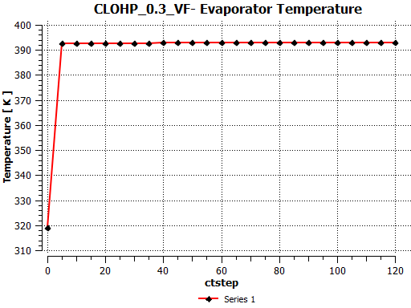 | 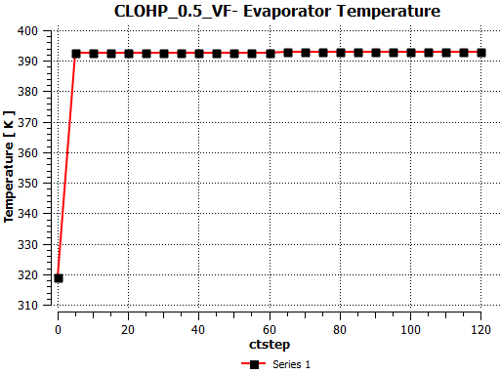 | 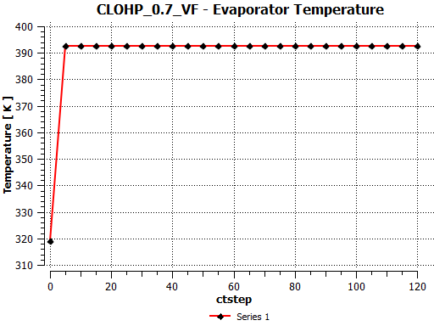
Figure 3a Transient Evaporator Temperature – Vertical Orientation

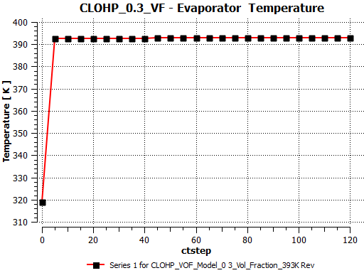 | 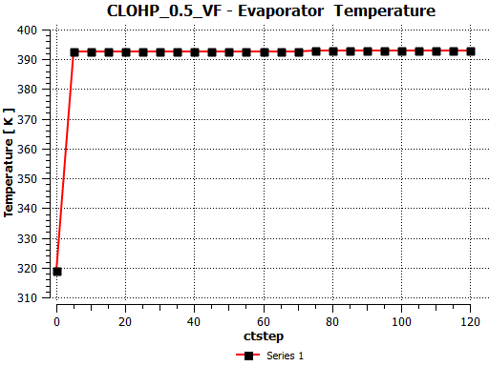 | 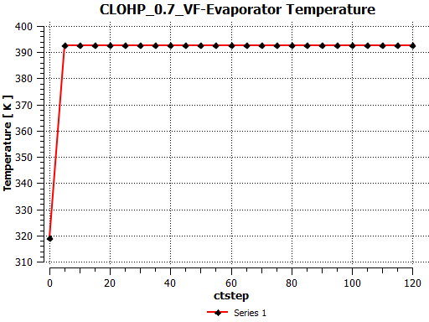
Figure 3b Transient Evaporator Temperature – Horizontal Orientation
Condenser Temperature
The condenser section on the other hand provides an entirely different perspective of the working condition of the CLOHPs. At the beginning of the simulation, the condenser temperature was left at the default 300K. From Figures 4a and 4b, it can be seen that the condenser temperature varied significantly for each CLOHP under the two orientations during the simulation as compared to the general steady trend of the evaporator section. For Figure 4a, the profiles clearly shows different activities at different fill ratios for the condensers. What is common to the CLOHPs in Figure 4a is that before the 30th time steps they were relatively at the same temperature and at the end of the simulation they all settled to the same temperature. Other than that in their transient histories it is evident that different fill ratios peaked at different temperatures. It is however important to note that these temperature variations, although appear wide, are variations within a small temperature range. The profiles in Figure 4a also show that the lower fill ratio CLOHP condenser had a wider variation of temperature and the only CLOHP that stayed at its peak condenser temperature momentarily.
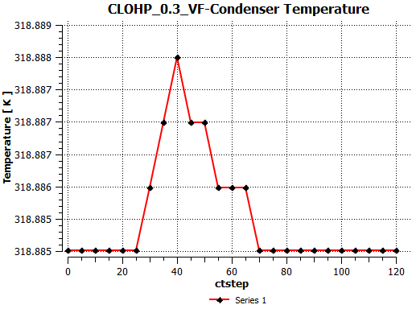 | 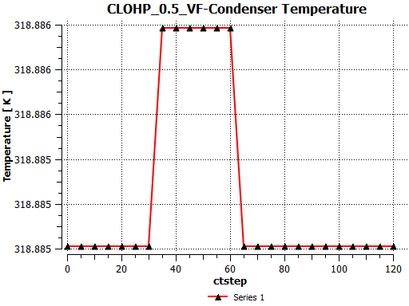 | 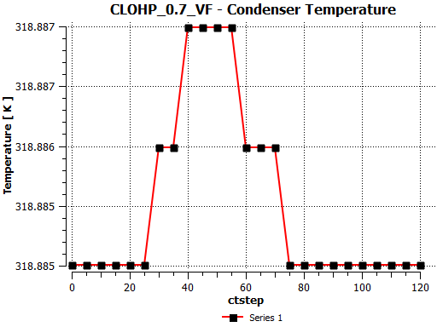
Figure 4a Transient Condenser Temperature – Vertical Orientation

The profiles shown in Figure 4b are generally different for corresponding fill ratios in Figure 4a. However, an oddity in condenser performance shows up for the CLOHP with fill ratio of 0.7 in Figure 4b and the CLOHP with fill ratio of 0.5 in Figure 4a. A closer look shows that these two CLOHPs share a similar condenser performance. The profiles for the other two in Figure 4b are also similar although their values vary slightly. They both seem to show a sharp decline in temperature after the 60th time step.

Figure 4b Transient Condenser Temperature – Horizontal Orientation

Evaporator Wall Heat Flux
The trends for the wall heat flux shown in Figure 5a and 5b were similar in profile for all the CLOHPs and same for specific fill ratios. From the beginning of the simulation till time step 5, the input flux profile sharply increased to a peak value for all fill ratios and orientations capturing a similar trend as their temperature profiles. For the same evaporator temperature for all fill ratios, the wall flux plots in Figure 5a and 5b shows varying input flux for each fill ratio. It is evident from the plots that the input flux increased with fill ratio for the same input temperature requirement.
Figure 5a Evaporator Wall Heat Flux– Vertical Orientation

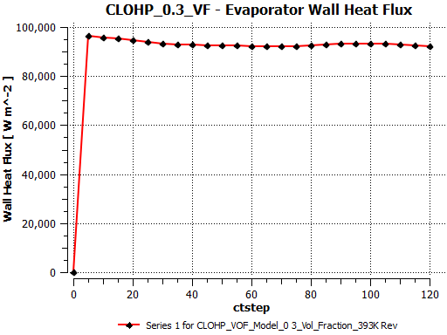 | 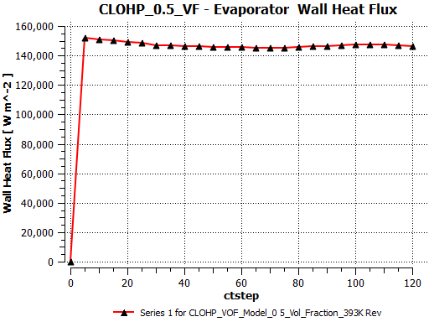 | 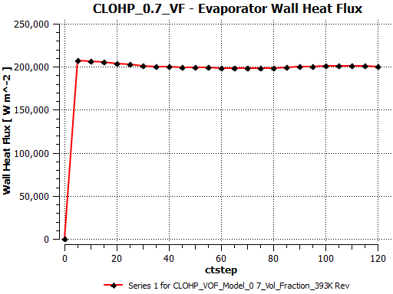
Figure 5b Evaporator Wall Heat Flux – Horizontal Orientation

Condenser Wall Heat Flux
The negative heat fluxes shown for the condenser section for the CLOHPs in Figure 6a and 6b signifies the opposite direction of heat flow or heat rejection by the CLOHP. This typically reflects the cooling capacity of the CLOHPs studied. The plots indicated an initial sharp decline of the wall heat flux to a lower value until a gradual rise from the 5th time step. From the plots it is evident that the condenser wall heat flux decreases with increasing fill ratio for both orientations.
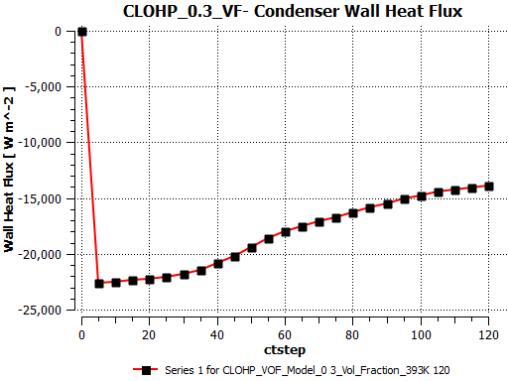 | 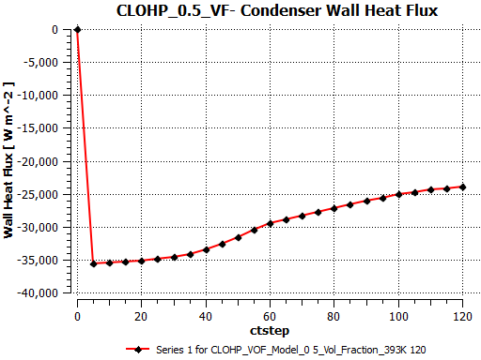 | 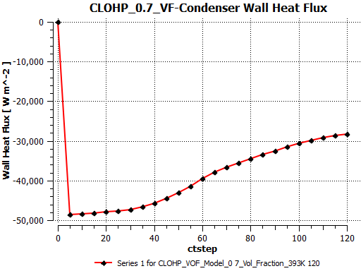
Figure 6a Condenser Wall Heat Flux – Vertical Orientation
However on further iterations, it can be seen from both figures that the condenser wall heat flux remains at a lower value when horizontally inclined than when vertically inclined. In fact the difference after 40 time steps is very significant between the two orientations.
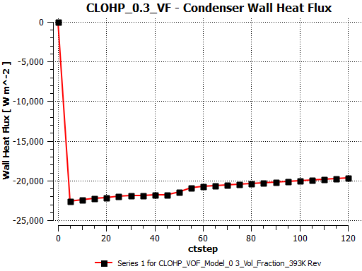 | 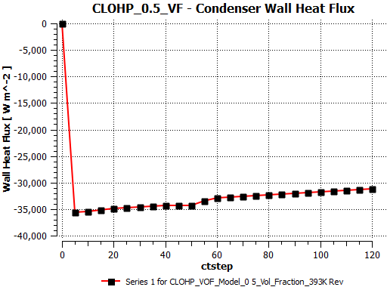 | 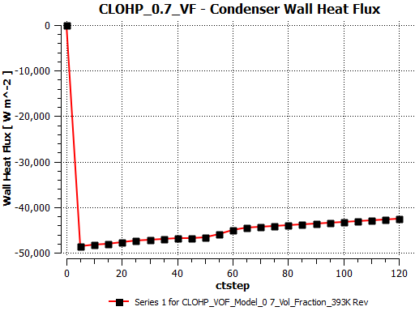
Figure 6b Condenser Wall Heat Flux – Horizontal Orientation

Evaporator Surface Heat Transfer Coefficient
The evaporator surface heat transfer coefficient increased with increasing fill ratio. This is evident from Figures 7a and Figure 7b, as the values are typically higher for CLOHPs with greater proportion of liquid volume fraction demonstrating that more convective heat transfer rate is expected from the liquid phase than from the vapour phase. For both orientations, surface heat transfer coefficient for the evaporator section increased with increasing fill ratios.
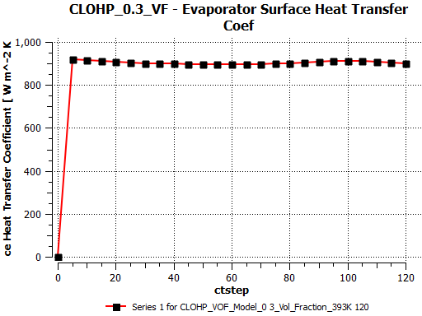 | 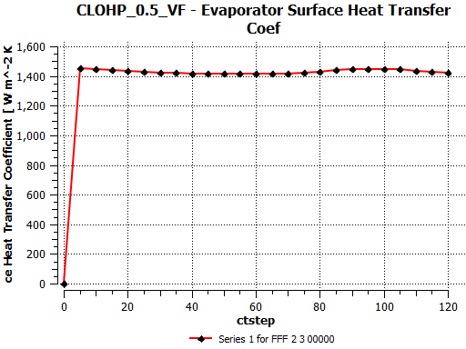 | 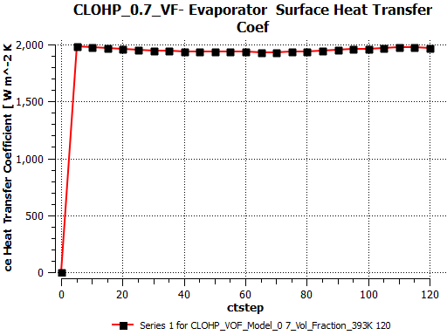
Figure 7a Evaporator Surface Heat Transfer Coefficient – Vertical Orientation

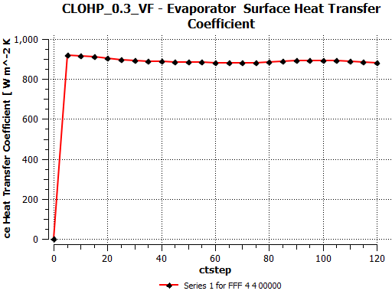 | 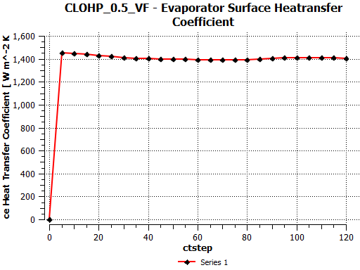 | 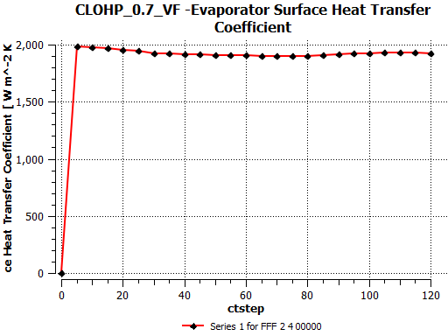
Figure 7b Evaporator Surface Heat Transfer Coefficient – Horizontal Orientation

Condenser Surface Heat Transfer Coefficient
The condenser surface heat transfer coefficient as related to the wall heat flux also reflected heat rejection (See Figure 8a and 8b). The trends once again were similar showing an initial sharp decline to a lower value before a steady rise for all fill ratios and orientations.
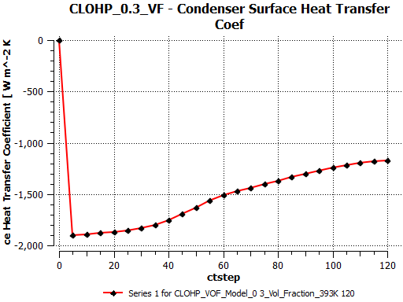 | 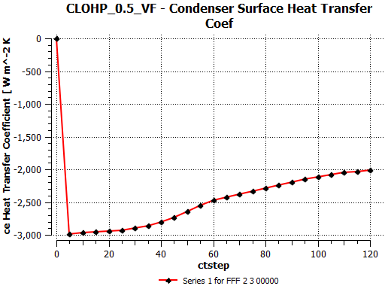 | 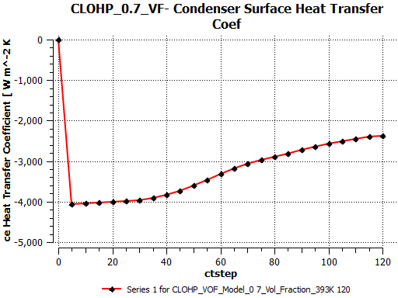
Figure 8a Condenser Surface Heat Transfer Coefficient – Vertical Orientation
Similar to the wall heat flux, this parameter for both orientations decreased with fill ratio. The significant differences can be seen for respective volume fractions between the vertically inclined and horizontally inclined CLOHPs.
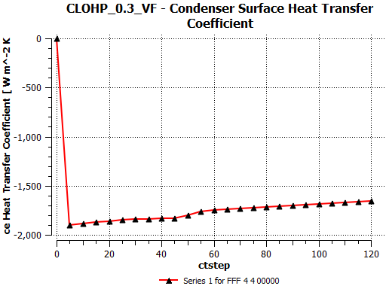 | 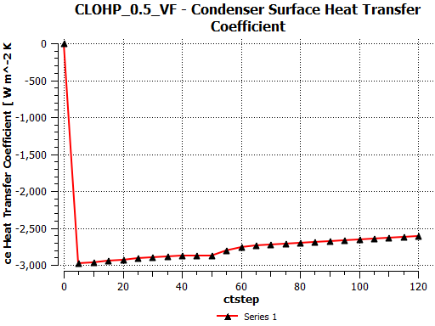 | 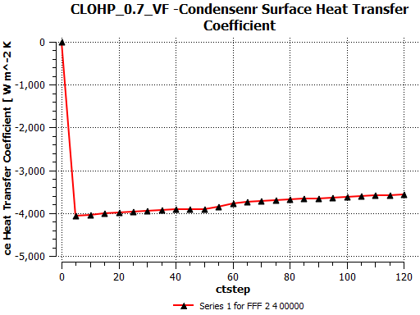
Figure 8b Condenser Surface Heat Transfer Coefficient – Horizontal Orientation
Evaporator Pressure
For the vertical orientation, the pressure within the evaporator section increased with decreasing fill ratio as can be seen in Figure 9a. At the beginning of the simulation, the pressure increases sharply to a high value on input of energy into the evaporator. From Figure 9a it is evident that the pressure in the evaporator is largely due to the vapour phase as the pressure in the CLOHP with fill ratio of 0.7 is about half the pressure in the CLOHP with fill ratio of 0.3.
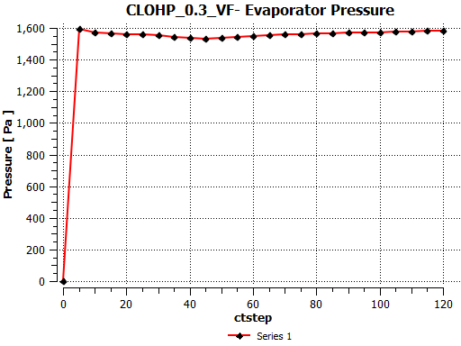 | 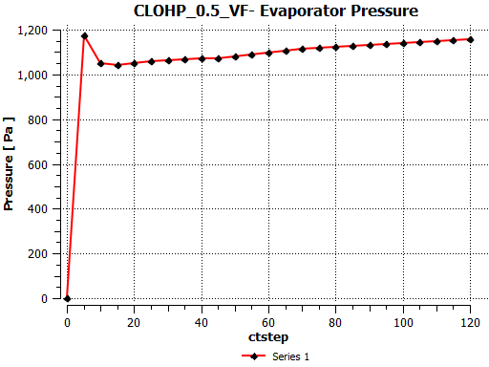 | 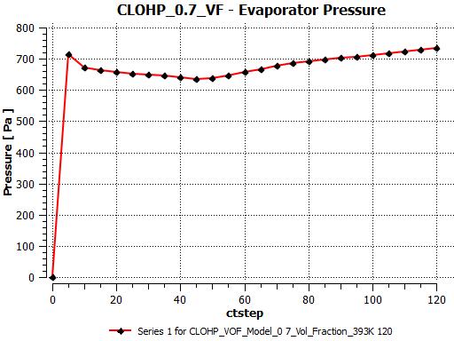
Figure 9a Evaporator Pressure – Vertical Orientation
For the horizontally oriented CLOHPs (Figure 9b), the trend is somewhat opposite that of the vertically oriented ones. Here the pressure declines sharply on commencement of the simulation. It is however evident from both Figures 9a and 9b that the sharp increase or decline in pressure gradually enters a steady regime from the 5th time step possibly demonstrating the time at which oscillations begun in the CLOHPs.
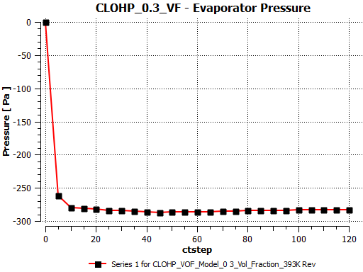 | 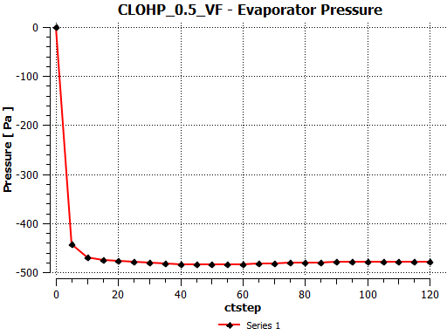 | 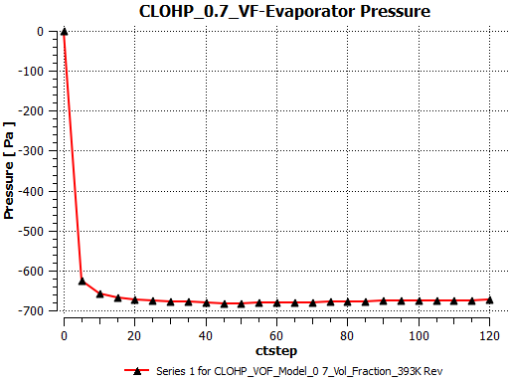
Figure 9b Evaporator Pressure – Horizontal Orientation

Condenser Pressure
The condenser pressure for the vertically oriented CLOHPs follows a similar trend as their evaporator (see Figure 10a). However for the CLOHPs with fill ratios 0.5 and 0.7, it is evident from the plots that on further iterations the pressure in the condenser increases slight above their respective evaporator pressures.
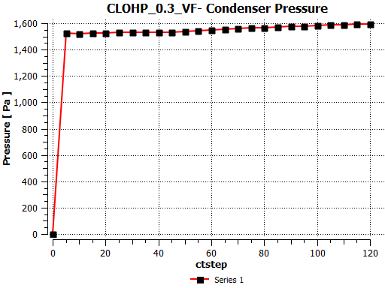 | 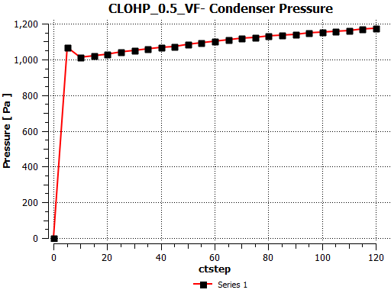 | 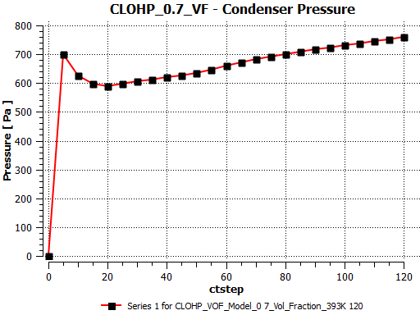
Figure 10a Condenser Pressure – Vertical Orientation
For the horizontally inclined CLOHPs, the pressures in the condensers are opposite that of their evaporator pressures. In Figure 10b it can be seen that the condenser pressure increases with increasing volume fraction/fill ratio. This is also the opposite of the condenser pressure in the vertically inclined where the pressure decreases with fill ratio (see Figure 10a).
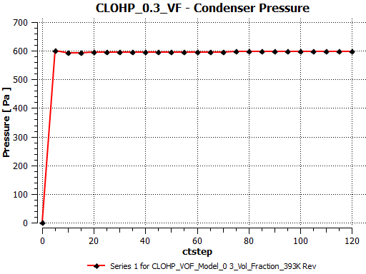 | 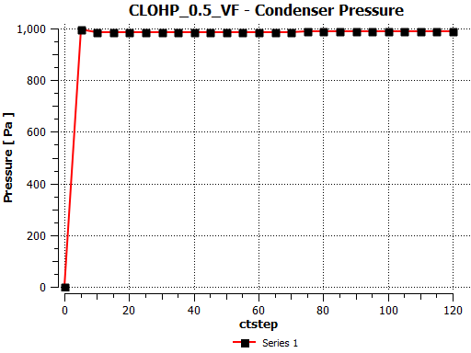 | 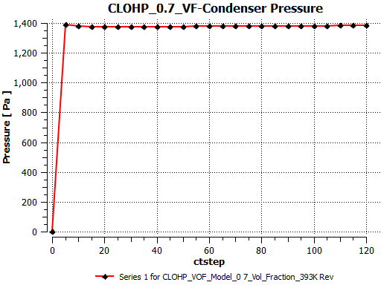
Figure 10b Condenser Pressure – Horizontal Orientation

Influence of Orientation on Pressure Distribution
Contours shown in Figures 11a and 11b clearly shows the influence of gravity on pressure distribution for the two orientations. In Figure 11a, it can be seen that the influence of gravity does not allow the even distribution of pressure across the various sections namely the evaporator, condenser and adiabatic sections.
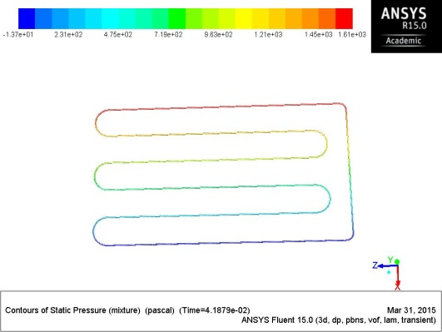 | 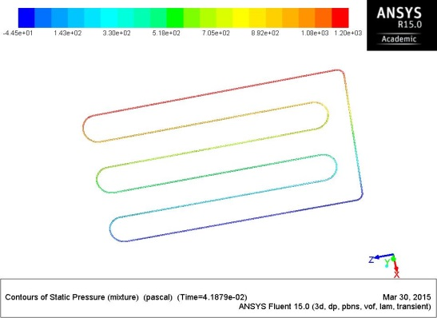 | 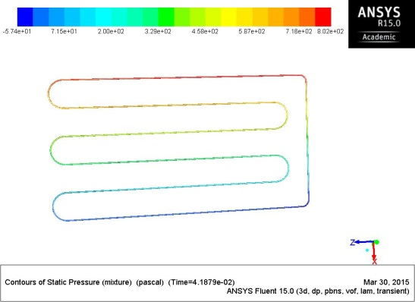
0.3 | 0.5 | 0.7
Figure 11a Contours of Static Pressure – Vertical Orientation
Contrary to the trend demonstrated for the vertically inclined CLOHP, for the horizontally inclined, the pressure distribution is even across the CLOHP sections. In Figure 11b, it can be seen that the highest pressure is at the condenser section whilst the least pressure is shown at the evaporator section. It is also evident from the two orientations that volume fraction only has influence on the pressure values but not the distribution.
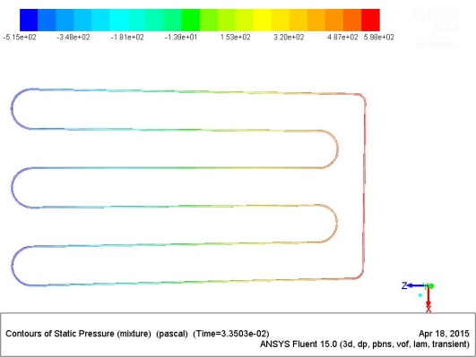 | 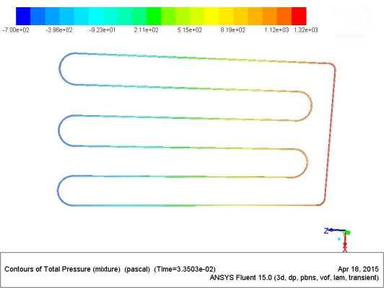 | 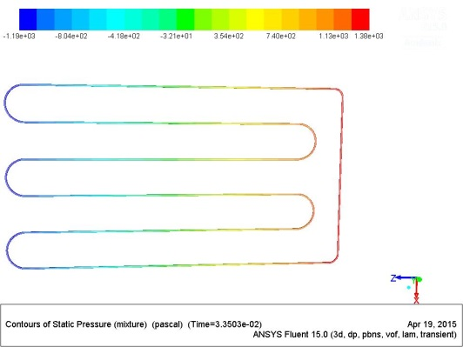
0.3 | 0.5 | 0.7
Figure 11b Contours of Static Pressure – Horizontal Orientation

CLOHP Thermal Performance
The thermal Performance of the vertically and horizontally oriented CLOHPs was calculated using equations (22) and plotted on Figure 12. It is evident from the plot that thermal resistance decreases with increasing volume fraction/fill ratio.

Figure 12 Thermal Resistance Plots of CLOHPs
Between CLOHPs of same volume fraction but different orientations, the results show that the vertically inclined CLOHPs had a higher thermal resistance than their horizontal counterpart.
Table 3 Thermal Performance of CLOHP – Vertical Orientation
Parameter | Value | Units
Fill Ratio | 0.3
Maximum Value of Evaporator Temperature | 392.762 | K
Maximum Value of Condenser Temperature | 318.885 | K
Maximum Value of Wall Heat Flux on Wall Evaporator | 92220.7 | W m⁻²
Thermal Resistance (R) | 8.011e-04 | m² K/W

Table 4 Thermal Performance of CLOHP– Vertical Orientation
Parameter | Value | Units
Fill Ratio | 0.5
Maximum Value of Evaporator Temperature | 392.623 | K
Maximum Value of Condenser Temperature | 318.885 | K
Maximum Value of Wall Heat Flux on Wall Evaporator | 149023 | W m⁻²
Thermal Resistance (R) | 4.948e-04 | m² K/W

Table 5 Thermal Performance of CLOHP – Vertical Orientation
Parameter | Value | Units
Fill Ratio | 0.7
Maximum Value of Evaporator Temperature | 392.53064 | K
Maximum Value of Condenser Temperature | 318.885 | K
Maximum Value of Wall Heat Flux on Wall Evaporator | 200938 | W m⁻²
Thermal Resistance (R) | 3.665e-04 | m² K/W

Table 6 Thermal Performance of CLOHP – Horizontal Orientation
Parameter | Value | Units
Fill Ratio | 0.3
Maximum Value of Evaporator Temperature | 392.888 | K
Maximum Value of Condenser Temperature | 318.885 | K
Maximum Value of Wall Heat Flux on Wall Evaporator | 94307.1 | W m⁻²
Thermal Resistance (R) | 7.847e-04 | m² K/W

Table 7 Thermal Performance of CLOHP – Horizontal Orientation
Parameter | Value | Units
Fill Ratio | 0.5
Maximum Value of Evaporator Temperature | 392.825 | K
Maximum Value of Condenser Temperature | 318.885 | K
Maximum Value of Wall Heat Flux on Wall Evaporator | 148611 | W m⁻²
Thermal Resistance (R) | 4.975e-04 | m² K/W

Table 8 Thermal Performance of CLOHP – Horizontal Orientation
Parameter | Value | Units
Fill Ratio | 0.7
Maximum Value of Evaporator Temperature | 392.765 | K
Maximum Value of Condenser Temperature | 318.885 | K
Maximum Value of Wall Heat Flux on Wall Evaporator | 206056 | W m⁻²
Thermal Resistance (R) | 3.585e-04 | m² K/W

Conclusions
An Eulerian Volume of Fluid (VOF) model coupled with a Level Set Method has been used to numerically investigate the performance of a five-turn water based CLOHP. Volume fractions 0.3, 0.5 and 0.7 were studied in vertical and horizontal modes. Form the results; the following major observations have been made:
- At a constant evaporator temperature of 393K, the condenser temperature varied significantly for each CLOHP under the two orientations although their temperature ranges were largely common per orientation. The CLOHP with volume fraction of 0.5 in vertical orientation and the one with volume fraction of 0.7 in horizontal orientation shared similar temperature profile.
- For both orientations the evaporator wall heat flux increased with fill ratio for the same input temperature requirement. For the condenser, the wall heat flux decreased with increasing fill ratio for both orientations although values were reasonably lower in the respective horizontally inclined CLOHPs.
- The surface heat transfer coefficient for the evaporator also increased with increasing fill ratios for both orientations. The trends were similar for the condenser section as their respective wall heat fluxes.
- For the vertically orientated CLOHPs, the pressure within the evaporator section increased with decreasing fill ratio whereas in horizontal orientation the opposite was true.
- The pressure profile was similar for the condenser section and its corresponding evaporator section in vertically oriented mode whilst the opposite occurred in the horizontal mode.
- The pressure distribution within the CLOHPs appeared not be influenced by their fill ratios. However, orientation was found to have profound influence. In horizontal mode, the condenser was found to have the maximum pressure whereas in vertical mode the pressure distribution was uneven for each section.
- For the thermal performance, the simulations show that thermal resistance decreases with increasing volume fraction. In terms of orientation, the study shows that the differences are slight but the thermal resistance was higher in vertically oriented mode than in the horizontally oriented mode for the same fill ratio.
Overall, it can be concluded that, more convective heat transfer rate occurs from the liquid phase than from the vapour phase. Also orientation significantly influences pressure distribution within the CLOHPs with thermal performance significantly influenced by volume fraction/fill ratio than by orientation.

Nomenclature
- D_{crit} - Critical diameter (m)
- $\vec{F}$ is a body force
- g – Acceleration due to gravity (m/s²)
- L - Laplace constant which represents the bubble diameter at departure for pool nucleate boiling
- ${\dot{m}}_{pq} and{\dot{ m}}_{qp}$ are the mass transfer between phase q and p
- ${\dot{m}}_{l→v}-{\dot{m}}_{v→l}$ is the rates of mass transfer due to evaporation and condensation, respectively ($\frac{kg}{s}/m^{3}$)
- n is the number of phases
- $p_{2} and p_{1}$ are the pressures in the two fluids on either side of the interface
- $Q_{e}$ - The input power.
- $R$ - Thermal Resistance
- $S_{αq}$ is the mass source
- ${\overline{T}}_{e}$ - the average surface temperature of the evaporation section,
- ${\overline{T}}_{c}$ - the average surface temperature of condensation section,
- ${\overline{T}}_{v}$ - the vapour temperature, which can be replaced by the average adiabatic section temperature ${\overline{T}}_{a}$
- ${\overset{⃑}{V}}_{v}$ is the vapour phase velocity
- ${\vec{v}}_{m}$ is the mass averaged velocity
- ${\vec{v}}_{dr,k}$ is the drift velocity for the secondary phase k; ${\vec{v}}_{dr,k}={\vec{v}}_{k}-{\vec{v}}_{m}$
- $v$ is the vapour phase
- $α_{k}$ is the volume fraction of phase k
- $α$ is the vapour volume fraction
- ρ_{L} – Density of saturated liquid (kg/m³)
- $ρ_{m}$ is the mixture density; $ρ_{m}=\sum_{k=1}^{n}{α_{k}ρ_{k}}$
- ρ_{v} - Vapour density (kg/m³)
- $ρ_{v}$ is the vapour density
- σ – Surface tension (N/m)
- $μ_{m}$ is the viscosity of the mixture; $μ_{m}=\sum_{k=1}^{n}{α_{k}μ_{k}}$
- $coeff$ is a coefficient that needs to be fine-tuned and can be interpreted as a relaxation time.

References
- Akachi, H. (1990) “Structure of a heat pipe”, U.S. Pat., 4921041.
- Zhang, Yuwen and Faghri, Amir (2008) 'Advances and Unsolved Issues in Pulsating Heat Pipes', Heat Transfer Engineering, 29:1, 20 – 44
- Lin, Zirong. Wang, Shuangfeng. Huo, Jiepeng. Hu, Yanxin. Chen, Jinjian. Zhang, Winston and Lee, Eton (2011) Heat transfer characteristics and LED heat sink application of aluminum plate oscillating heat pipes Original Research Article. Applied Thermal Engineering, Volume 31, Issues 14–15, October 2011, Pages 2221-2229
- Bhuwakietkumjohn, N. and Rittidech, S. (2010) Internal flow patterns on heat transfer characteristics of a closed-loop oscillating heat-pipe with check valves using ethanol and a silver nano-ethanol mixture Original Research Article. Experimental Thermal and Fluid Science, Volume 34, Issue 8, November 2010, Pages 1000-1007
- Bejan, Adrian. and Kraus, Allan D. (2003). Heat Transfer Handbook. John Wiley & Sons. Online version available at:http://www.knovel.com/web/portal/browse/display?_EXT_KNOVEL_DISPLAY_bookid=725&VerticalID=0
- Ma, H. B. Borgmeyer, B. Cheng, P. and Zhang, Y. (2008) Heat Transport Capability in an Oscillating Heat Pipe. J. Heat Transfer 130(8), 081501 (May 29, 2008) (7 pages) doi:10.1115/1.2909081
- Song, Yanxi. and Xu, Jinliang. (2009) Chaotic behaviour of pulsating heat pipes. Original Research Article. International Journal of Heat and Mass Transfer, Volume 52, Issues 13-14, Pages 2932-2941
- Rittidech, S. Dangeton, W. and Soponronnarit, S. (2005) Closed-ended oscillating heat-pipe (CEOHP) air-preheater for energy thrift in a dryer. Applied Energy. Volume 81, Issue 2, Pages 198-208
- Meena, P., Rittidech, S. and Poomsa-ad, N. (2007) Application of closed-loop oscillating heat-pipe with check valves (CLOHP/CV) air-preheater for reducing relative humidity in drying systems, Applied Energy 84, pp. 553–564.
- Meena, P. and Rittidech, S. (2008) Waste Heat Recovery by Closed-Loop Oscillating Heat Pipe with Check Valve from Pottery Kilns for Energy Thrift. American J. of Engineering and Applied Sciences 1 (2): 126-130, ISSN 1941-7020
- Nuntaphan, Atipoang. Vithayasai, Sanparwat. Vorayos,Nat. Vorayos, Nattanee. and Kiatsiriroat, Tanongkiat (2010) Use of oscillating heat pipe technique as extended surface in wire-on-tube heat exchanger for heat transfer enhancement Original Research Article. International Communications in Heat and Mass Transfer, Volume 37, Issue 3, Pages 287-292
- Supirattanakul, P. Rittidech, S. and Bubphachota, B. (2011) Application of a closed-loop oscillating heat pipe with check valves (CLOHP/CV) on performance enhancement in air conditioning system. Energy and Buildings. Volume 43, Issue 7, Pages 1531-1535
- Thompson, S.M. Cheng, P. and Ma, H.B. (2011) An experimental investigation of a three-dimensional flat-plate oscillating heat pipe with staggered microchannels Original Research Article. International Journal of Heat and Mass Transfer, Volume 54, Issues 17–18, August 2011, Pages 3951-3959
- Qu, Jian. Wu, Huiying, and Cheng, Ping. (2012) Start-up, heat transfer and flow characteristics of silicon-based micro pulsating heat pipes Original Research Article. International Journal of Heat and Mass Transfer, Volume 55, Issues 21–22, October 2012, Pages 6109-6120
- Xu J. L. and Zhang, X. M. (2005) Start-up and steady thermal oscillation of a pulsating heat pipe. Heat Mass Transfer (2005) 41: 685–694. DOI 10.1007/s00231-004-0535-3
- Yin, D. and Ma, H.B. (2014) Analytical solution of heat transfer of oscillating flow at a triangular pressure waveform .Original Research Article. International Journal of Heat and Mass Transfer, Volume 70, March 2014, Pages 46-53
- Senjaya, Raffles and Inoue, Takayoshi (2013) Oscillating heat pipe simulation considering bubble generation Part I: Presentation of the model and effects of a bubble generation Original Research Article. International Journal of Heat and Mass Transfer, Volume 60, May 2013, Pages 816-824
- Yang, Honghai. Khandekar, S. and Groll, M. (2008) Operational limit of closed loop pulsating heat pipes. Original Research Article. Applied Thermal Engineering, Volume 28, Issue 1, Pages 49-59
- Borgmeyer, B. Wilson, C. Winholtz, R. A. Ma, H. B. Jacobson, D. and Hussey, D. (2010) Heat Transport Capability and Fluid Flow Neutron Radiography of Three-Dimensional Oscillating Heat Pipes. J. Heat Transfer 132(6), 061502 (Mar 31, 2010) (7 pages) doi:10.1115/1.4000750
- Dobson, R.T. and Swanepoel, G. (2010) An Experimental Investigation Of The Thickness Of The Liquid-Film Deposited At The Trailing End Of A Liquid Plug Moving In The Capillary Tube Of A Pulsating Heat Pipe. Frontiers in Heat Pipes (FHP), 1, 013004 (2010). DOI: 10.5098/fhp.v1.1.3004.Global Digital Central. ISSN: 2155-658X
- Qu, Jian and Wang, Qian (2013) Experimental study on the thermal performance of vertical closed-loop oscillating heat pipes and correlation modeling Original Research Article. Applied Energy, Volume 112, December 2013, Pages 1154-1160
- Jiao, A.J. Ma, H.B. and Critser, J.K. (2009) Experimental investigation of cryogenic oscillating heat pipes Original Research Article. International Journal of Heat and Mass Transfer, Volume 52, Issues 15–16, July 2009, Pages 3504-3509
- Khandekar, Sameer. Charoensawan, Piyanun. Groll, Manfred., and Terdtoon. Pradit (2003)b Closed loop pulsating heat pipes Part B: visualization and semi-empirical modeling. Original Research Article. Applied Thermal Engineering, Volume 23, Issue 16, November 2003, Pages 2021-2033
- Lin, Zirong, Wang, Shuangfeng, Shirakashi, Ryo. and Zhang, L. Winston (2013) Simulation of a miniature oscillating heat pipe in bottom heating mode using CFD with unsteady modeling. Original Research Article. International Journal of Heat and Mass Transfer, Volume 57, Issue 2, February 2013, Pages 642-656
- Dilawar, Mahendra and Pattamatta, Arvind (2013) A parametric study of oscillatory two-phase flows in a single turn Pulsating Heat Pipe using a non-isothermal vapor model. Applied Thermal Engineering, Volume 51, Issues 1–2, March 2013, Pages 1328-1338
- Arab, M. Soltanieh, M. and Shafii, M.B.(2012) Experimental investigation of extra-long pulsating heat pipe application in solar water heaters. Experimental Thermal and Fluid Science, Volume 42, October 2012, Pages 6-15
- Sukchana, Thanaphol and Jaiboonma, Chaiyun (2013) Effect of Filling Ratios and Adiabatic Length on Thermal Efficiency of Long Heat Pipe Filled with R-134a. Energy Procedia, Volume 34, 2013, Pages 298-306
- Chiang, Ching-Ming. Chien, Kuo-Hsian. Chen, Han-Ming. and Wang, Chi-Chuan (2012) Theoretical study of oscillatory phenomena in a horizontal closed-loop pulsating heat pipe with asymmetrical arrayed minichannel. International Communications in Heat and Mass Transfer, Volume 39, Issue 7, August 2012, Pages 923-930
- Charoensawan, Piyanun. Khandekar, Sameer. Groll, Manfred. and Terdtoon, Pradit. (2003) Closed loop pulsating heat pipes: Part A: parametric experimental investigations Original Research Article. Applied Thermal Engineering, Volume 23, Issue 16, November 2003, Pages 2009-2020
- Khandekar, S. and Groll, M. (2004) An insight into thermo-hydrodynamic coupling in closed loop heat pipes. International Journal of Thermal Sciences, 43 (2004), pp. 13–20
- Mameli, M., Marengo, M. and Zinna, S. (2012) Numerical model of a multi-turn Closed Loop Pulsating Heat Pipe: Effects of the local pressure losses due to meanderings. Original Research Article. International Journal of Heat and Mass Transfer, Volume 55, Issue 4, 31 January 2012, Pages 1036-1047
- Mameli, Mauro. Marengo, Marco. and Khandekar, Sameer. (2014) Local heat transfer measurement and thermo-fluid characterization of a pulsating heat pipe. Original Research Article. International Journal of Thermal Sciences, Volume 75, January 2014, Pages 140-152
- Qu, Jian. Wu, Huiying, and Cheng, Ping. (2012) Start-up, heat transfer and flow characteristics of silicon-based micro pulsating heat pipes Original Research Article. International Journal of Heat and Mass Transfer, Volume 55, Issues 21–22, October 2012, Pages 6109-6120
- Jahani, Kambiz. Mohammadi, Maziar. Shafii, Mohammad Behshad. and Shiee, Zahra. (2013)Promising Technology for Electronic Cooling: Nanofluidic Micro Pulsating Heat Pipes. Journal of Electronic Packaging Copyright VC 2013 by ASME JUNE 2013, Vol. 135 / 021005-1
- Smoot, C. D. Ma, H. B. Wilson, C. A. and Greenberg, L. (2011) Heat Conduction Effect on Oscillating Heat Pipe Operation. Journal of Thermal Science and Engineering Applications JUNE 2011, Vol. 3 / 024501-5
- Lin, Zirong. Wang, Shuangfeng. Chen, Jinjian. Huo, Jiepeng. Hu, Yanxin. and Zhang, Winston (2011) Experimental study on effective range of miniature oscillating heat pipes Original Research Article. Applied Thermal Engineering, Volume 31, Issue 5, Pages 880-886
- Panyoyai, N. Terdtoon, P. and Sakulchangsatjatai, P. (2009) Effects of aspect ratios and number of meandering turns on performance limit of an inclined closed – loop oscillating heat pipe. International Conference on Science, Technology and Innovation for Sustainable Well-Being (STISWB), 23-24 July 2009, Mahasarakham University, Thailand.
- Hao, Tingting. Ma, Xuehu. Lan, Zhong. Li, Nan. Zhao,Yuzhe and Ma, Hongbin. (2014) Effects of hydrophilic surface on heat transfer performance and oscillating motion for an oscillating heat pipe. Original Research Article. International Journal of Heat and Mass Transfer, Volume 72, May 2014, Pages 50-65
- Senjaya, Raffles and Inoue, Takayoshi (2014) Effects of non-condensable gas on the performance of oscillating heat pipe, part I: Theoretical study. Original Research Article. Applied Thermal Engineering, Volume 73, Issue 1, 5 December 2014, Pages 1387-1392

- Nagwase, Subhash Y. and Pachghare, Pramod R. (2013) Experimental and CFD Analysis of Closed Loop Pulsating Heat Pipe with DI-Water. Energy Efficient Technologies for Sustainability (ICEETS), 2013 International Conference, Page(s):185 - 190. Print ISBN: 978-1-4673-6149-1, INSPEC Accession Number: 13582562, Digital Object Identifier: 10.1109/ICEETS.2013.6533380, Publisher: IEEE
- Liu, Xiangdong and Chen, Yongping (2014) Fluid flow and heat transfer in flat-plate oscillating heat pipe. Original Research Article. Energy and Buildings, Volume 75, June 2014, Pages 29-42
- ANSYS, Inc. (2012) ANSYS Fluent Theory Guide. February 2012. Release 14.5 - © SAS IP, Inc. All rights reserved.

- Kumar, Sushant. Mehta, Balkrishna. Bajpai, Ashish. and Khandekar, Sameer (2014) LOCAL THERMO-HYDRODYNAMICS OF A LIQUID PLUG PULSATING INSIDE A DRY CAPILLARY TUBE. Proceedings of the 4th European Conference on Microfluidics - Microfluidics 2014 - Limerick, December 10-12, 2014.
- Sun, D.L .and Tao, W.Q.(2010) A coupled volume-of-fluid and level set (VOSET) method for computing incompressible two-phase flows. Original Research Article. International Journal of Heat and Mass Transfer, Volume 53, Issue 4, 31 January 2010, Pages 645-655
- Lv, Xin. Zou, Qingping. Zhao,Yong and Reeve, Dominic (2010)A novel coupled level set and volume of fluid method for sharp interface capturing on 3D tetrahedral grids. Original Research Article. Journal of Computational Physics, Volume 229, Issue 7, 1 April 2010, Pages 2573-2604

- Wang, Tai. Li, Huixiong. Feng, Yongchang. and Shi, Dongxiao. (2013) A coupled volume-of-fluid and level set (VOSET) method on dynamically adaptive quadtree grids. International Journal of Heat and Mass Transfer, Volume 67, December 2013, Pages 70-73
- Ningegowda, B.M. and Premachandran, B. (2014) A Coupled Level Set and Volume of Fluid method with multi-directional advection algorithms for two-phase flows with and without phase change. Original Research Article. International Journal of Heat and Mass Transfer, Volume 79, December 2014, Pages 532-550\

