1 Experimental Research on the Operation Characteristics of Solar
2
3 Chimney Power Plant Combined with Distillation (SCPPCD) 4 ^{, a}, Ziyang Yan ª, Pengzhan Dai ª, Tian Zhou ª, Bo Qu ª, Yue Yuan ª, Yunting Ge ^{b}
5 Lu Zuo
6
7 ª College of Energy and Electrical Engineering, Hohai University, Nanjing, China
8

9 ^{b} School of the Built Environment and Architecture, London South Bank University, London, UK 10
11 ABSTRACT: In this paper, a comprehensive test platform for solar chimney power 12
13 plant combined with distillation (SCPPCD) that can realize water-electricity 14
15 cogeneration was designed and built. Experimental research on SCPPCD was carried
16
17
18 out under actual meteorological conditions to explore the system operation performance
19
20 and the laws of freshwater production and power generation. The interaction 21
22 mechanism between parameters such as seawater temperature, airflow temperature, 23
24 temperature difference between seawater and solar still cover, freshwater yield and 25
26 generated power was revealed. The results show that the daily water yield of solar stills
27
28 decreases from the heat collector inlet to the chimney. Solar stills are recommended to
29
30
31 be arranged in the area from collector inlet to the one-third radius of the collector. The
32
33 high-water yield period occurs between sunset and 1-3 a.m., and it contributes most of
34
35 the freshwater produced. Temperature difference is the main factor affecting water 36
37 production during the rising period of freshwater production, and seawater temperature 38
39 is the main factor affecting freshwater production during the decline period. The 40
41 maximum temperature rise of airflow in the chimney is 17 , and the temperature rise
42
43
44 is maintained above 5 at night. The variation of generator power is similar to that of
45
46 airflow temperature rise, and the maximum power reaches 0.71 mW. This study
47
48 provides detailed experimental data and theoretical reference for future mathematical
49
50 simulation research and commercial application of SCPPCD.
51
52 Keywords: Solar chimney; Solar desalination; Water-electricity cogeneration; Freshwater yield; 53 54 Turbine

1. Introduction
The rapid growth of the world's population places a serious burden on the environment. The growing demand for energy and freshwater in developing countries results in even greater environmental damage. As a renewable energy generation 8
9 technology with simple structure and low operating cost, solar chimney power plant 10
11 (SCPP) technology [1-3] is particularly suitable for developing countries and regions. 12
13 It can make effective use of the abundant local solar energy resources and cheap land
14
15 to provide electricity to local residents in a clean way.
16
17
18 Many experimental studies on SCPP have been reported around the world, such as
19
20 in Florida, USA [4], Wuhan, China [5], University of Zanjan, Iran [6], Damascus 21
22 University, Syria [7], Aswan, Egypt [8], Warangal, India [9] and other regions. These 23
24 studies have proved the theoretical feasibility of SCPP technology and made some 25
26 optimizations on the influencing parameters of SCPP. But the studies also pointed out 27
28 that SCPP is too inefficient. Raising the chimney height is the key to improving the
29
30
31 efficiency of SCPP [10], but it brings construction difficulties and raise the investment
32
33 cost. Under the dual background of the difficulty in improving the efficiency of SCPP
34
35 and the global shortage of freshwater resources, the concept of SCPP technology for
36
37 seawater desalination has been put forward one after another, so that the system can 38
39 produce freshwater while generating electricity, and improve the utilization rate of solar 40
41 energy.
42
43
44 The concept of humidification-dehumidification is widely used in the desalination
45
46 process of integrated SCPP systems. Seawater desalination can be effectively achieved
47
48 by humidifying the hot air in the system and condensing the hot and humid air in the 49
50 chimney area. It is a common practice to arrange open seawater pools under the heat 51
52 collector of the SCPP. Wang et al. [11] designed to transform the ground below the heat 53
54 collector of SCPP into a large open seawater storage tank, and arranged a high-
efficiency condensing device on the chimney top to condense hot and humid air to produce freshwater by the way of indirect condensation. The feasibility of the water production principle was verified by simulation experiments of the condensing device. Zhou et al. [12] developed a mathematical model based on energy balance to evaluate the performance and economy of the system proposed by Wang et al. [11] and the conventional SCPP, and made a comparison. Azad et al. [13] also conducted a 8
9 numerical simulation research on such hybrid solar chimney systems. The genetic 10
11 algorithm optimization was used to determine the optimal geometric design variables. 12
13 Kiwan et al. [14] proposed to transform part of the ground thermal storage layer into an 14
15 open annular pool, so that the airflow carried water vapor after passing over the pool,
16
17
18 and then condensed on the inner wall of the chimney. A mathematical model was
19
20 established to explore the effect of operating parameters and geometric parameters on 21
22 system performance. Abdelsalam et al. [15] proposed to combine the cooling tower and 23
24 traditional SCPP technology for electricity generation and seawater desalination. A bi25
26 directional turbine was installed in the hybrid system, allowing the system to operate 27
28 as a cooling tower at night and as an SCPP during the day. The theoretical calculation
29
30
31 showed that the total utilization rate of the hybrid system was 0.73%, 1.4 times that of
32
33 the traditional SCPP. Abdelsalam et al. [16] explored the performance parameters of
34
35 the hybrid system, such as electricity output, freshwater production, and carbon dioxide 36
37 emissions, based on the environmental conditions in Doha, Qatar. The cash flow 38
39 analysis showed a high return on investment for the system. Abdelsalam et al. [17] also 40
41 analyzed the performance of the hybrid system in 16 cities in the Kingdom of Saudi
42
43
44 Arabia to select the optimal location for installation. Salameh et al. [18] studied the
45
46 electrical power and distilled water of the hybrid SCPP system under the geographic
47
48 location and metrological data of Sharjah and Alain (in UAE), and explored the effect
49
50 of wind speed on system performance.
51
52 In some systems, sprayers were designed to be installed at the entrance of the heat 53
54 collector or at the chimney base to increase the humidity of the hot air. Niroomand et
al. [19] designed to set up seawater sprayers and dehumidification tubes in the inlet section of the SCPP heat collector, so as to obtain freshwater in the humidification and dehumidification process of the airflow within the system. The feasibility of the system was verified by the established mathematical model. Ming et al. [20] proposed a SCPP system without heat collector by replacing the heat collector roof with black spiral pipes filled with hot water. The hot airflow in the system was humidified by a warm water 8
9 shower at the bottom of the chimney. Then the hot and humid air in the chimney reaches 10
11 the dew point and precipitation occurs if the chimney is high enough. The effectiveness 12
13 of freshwater generation of the system was evaluated by the developed flow and heat 14
15 transfer mathematical model. Subsequently, Ming et al. [21] considered adding air
16
17
18 turbine generators and water generators to the system to achieve power output, and
19
20 further analyzed the system performance parameters. It was found that the total energy 21
22 efficiency of the system was close to 7% when the chimney height was 3 km. Ming et 23
24 al. [22] designed to spray seawater droplets at the chimney base to humidify the thermal 25
26 airflow, thereby reducing the chimney height. Numerical simulation results showed that 27
28 humidification helped to improve the desalination efficiency.
29
30
31 Multi-stage flash technology and membrane distillation technology also have
32
33 certain applications in the desalination process of integrated SCPP systems. Méndez et
34
35 al. [23] proposed a multigeneration system with solar chimney and wind turbine 36
37 integration for hybrid desalination and power generation. In the system, multi-stage 38
39 flash technology was used in a cascaded manner to produce freshwater, utilizing the 40
41 heat source of the solar chimney thermal storage. Zuo et al. [24] designed an air gap
42
43
44 membrane distillation module and installed it vertically in the disc distiller of the SCPP
45
46 system. Water vapor could pass through the vertical hydrophobic membrane under the
47
48 action of pressure difference. It then passed through a narrow air gap to the surface of
49
50 the condensation plate and condensed into droplets.
51
52 Another commonly used method for seawater desalination of is to arrange closed 53
54 disc solar stills on the ground under the heat collector, and use the principle of disc
distillation to produce freshwater. Zuo et al. [1425] designed to install closed solar stills under the heat collector roof, and proposed a solar chimney power plant combined with seawater desalination (SCPPCSD). This design realized the water-electricity cogeneration and the improvement of land resource utilization rate. The conventional SCPP and SCPPCSD were evaluated by the mathematical model based on energy balance and the economic analysis model. The results showed that SCPPCSD had a 8
9 higher solar energy daily utilization rate and better economic benefits. Asayesh et al. 10
11 [1526] utilized the particle swarm optimization to optimize the design of the SCPPCSD, 12
13 and verified the existence of the optimal ratio between the seawater thermal storage 14
15 layer and the rock thermal storage layer in the system. Zuo et al. [1627, 1728]
16
17
18 introduced a wind supercharger device into the SCPPCSD to provide negative pressure
19
20 for the chimney outlet. It was found by numerical simulation that the wind supercharger
21
22 device made up for the loss of power generation caused by the coupling of seawater
23
24 desalination technology. For the purpose of reducing atmospheric pollution caused by 25
26 industrial waste heat and realizing energy recovery, Zuo et al. [1829, 1930] proposed to 27
28 combine the thermal power plant chimney with the solar chimney. High temperature
29
30
31 flue gas from the thermal power plant was introduced into the SCPPCSD through the
32
33 spiral heat exchange pipe under solar stills to heat the seawater in the solar still.
34
35 Theoretical analysis showed that the system power output and water production was 36
37 greatly improved, and the stability of system operation was also improved. Rahdan et 38
39 al. [2031] utilized the CFD method to optimize the inclination angle of the chimney, 40
41 heat collector and solar still cover in a hybrid system of solar chimney and water
42
43
44 desalination. Rahbar et al. [32] proposed a solar chimney power plant integrated with
45
46 transparent photovoltaic cells and desalination (PVDSCP), and established a one-
47
48 dimensional mathematical model of the system. In the system, part of the solar radiation 49
50 was absorbed by the heat collector roof composed of transparent photovoltaic cells for 51
52 power generation, and the rest of the radiation energy was used to heat the seawater in 53
54 the solar still for desalination. The calculation results showed the heat collection
efficiency of the heat collector in PVDSCP was 26.13% higher than that in traditional
SCPP. Kiwan et al. [33] designed to install photovoltaic panels in the traditional SCPP
to increase the system power generation, and install solar stills to achieve freshwater production. The calculation results showed that the total utilization rate of the improved system increased from 0.51% to 4.37%, and the cost of producing freshwater was 1.6
US$/m³, 46.3% cheaper than other similar systems.
8
9 Niroomand et al. [21] designed to set up seawater sprayers and dehumidification 10
11 tubes in the inlet section of the SCPP heat collector, so as to obtain freshwater in the 12
13 humidification and dehumidification process of the airflow within the system. The 14
15 feasibility of the system was verified by the established mathematical model. Ming et
16
17
18 al. [22] proposed a SCPP system without heat collector by replacing the heat collector
19
20 roof with black spiral pipes filled with hot water. The hot airflow in the system was 21
22 humidified by a warm water shower at the bottom of the chimney. Then the hot and 23
24 humid air in the chimney reaches the dew point and precipitation occurs if the chimney 25
26 is high enough. The effectiveness of freshwater generation of the system was evaluated 27
28 by the developed flow and heat transfer mathematical model. Subsequently, Ming et al.
29
30
31 [23] considered adding air turbine generators and water generators to the system to
32
33 achieve power output, and further analyzed the system performance parameters. It was
34
35 found that the total energy efficiency of the system was close to 7% when the chimney 36
37 height was 3 km. Ming et al. [24] designed to spray seawater droplets at the chimney 38
39 base to humidify the thermal airflow, thereby reducing the chimney height. Numerical 40
41 simulation results showed that humidification helped to improve the desalination
42
43
44 efficiency. Kiwan et al. [25] proposed to transform part of the ground thermal storage
45
46 layer into an open annular pool, so that the airflow carried water vapor after passing
47
48 over the pool, and then condensed on the inner wall of the chimney. A mathematical 49
50 model was established to explore the effect of operating parameters and geometric
51
52 parameters on system performance.
53
54 Rahbar et al. [26] proposed a solar chimney power plant integrated with
transparent photovoltaic cells and desalination (PVDSCP), and established a onedimensional mathematical model of the system. In the system, part of the solar radiation was absorbed by the heat collector roof composed of transparent photovoltaic cells for power generation, and the rest of the radiation energy was used to heat the seawater in the solar still for desalination. The calculation results showed the heat collection efficiency of the heat collector in PVDSCP was 26.13% higher than that in traditional 8
9 SCPP. Kiwan et al. [27] designed to install photovoltaic panels in the traditional SCPP 10
11 to increase the system power generation, and install solar stills to achieve freshwater 12
13 production. The calculation results showed that the total utilization rate of the improved 14
15 system increased from 0.51% to 4.37%, and the cost of producing freshwater was 1.6 16
- ³, 46.3% cheaper than other similar systems. Abdelsalam et al. [28] proposed to
- US$/m
19
20 combine the cooling tower and traditional SCPP technology for electricity generation 21
22 and seawater desalination. A bi-directional turbine was installed in the hybrid system, 23
24 allowing the system to operate as a cooling tower at night and as an SCPP during the 25
26 day. The theoretical calculation showed that the total utilization rate of the hybrid 27
28 system was 0.73%, 1.4 times that of the traditional SCPP.
29
30
31 At present, there are many theoretical studies on seawater desalination-SCPP
32
33 technologies and their optimization and improvement, indicating that the concept of
34
35 SCPP integrated with seawater desalination has received recognition and research 36
37 interest from scholars, but the experimental studies on this technology are relatively 38
39 few. Maia et al. [29] compared and summarized several seawater desalination-SCPP 40
41 technologies mentioned above and also pointed out that although this technology had
42
43
44 shown considerable commercial potential, there was still a lack of sufficient
45
46 experimental data to prove the authenticity of the simulation calculation results of the
47
48 proposed systems.
49
50 At present, seawater desalination-SCPP technologies have shown considerable 51
52 commercial potential [34]. But most of the studies on these technologies are limited to 53
54 theoretical calculations and simulations, and the experimental studies are relatively few. Zuo et al. [3035] established a small experimental device of solar chimney power plant integrated with seawater desalination. The device was mainly composed of a chimney,
a heat collector roof and a solar still, and no wind turbine and generator were installed. An unsteady no-load test was carried out on the device to investigate the operation law of the airflow temperature in the device and freshwater production, as well as the energy utilization characteristics. Cao et al. [3136] proposed a solar humidification 8
9 dehumidification seawater desalination system combined with the chimney solely for
10
11 freshwater production. Hot and humid air was generated by mixing the hot air from the 12
13 horizontal collector with the wet air from the inclined collector. It was then condensed 14
15 into freshwater by the condenser in the chimney. A small experimental device was
16
17
18 designed and constructed to simulate the production of freshwater, and to explore the
19
20 main factors affecting the freshwater production.
21
22 In conclusion, the existing experimental devices for seawater desalination-SCPP
23
24 technologies are small in size and simplified in structure, and more importantly, they 25
26 do not realize water-electricity cogeneration. At present, in the actual weather, the 27
28 operation performance, water production laws and power generation laws of the SCPP
29
30
31 integrated with seawater desalination under load are still unknown. And there There is
32
33 also currently a lack of experimental results to confirm the function of water-electricity
34
35 cogeneration of the integrated system. This hinders the verification and in-depth
36
37 understanding of the system simulation calculation results, and is not conducive to the 38
39 optimal design and commercial application of seawater desalination-SCPP 40
41 technologies. In addition, the operation mechanism and performance, water production
42
43
44 characteristics and power generation characteristics of the SCPP integrated with
45
46 seawater desalination under load are still unknown.
47
48 In this paper, a comprehensive test platform for solar chimney power plant 49
50 combined with distillation (SCPPCD) that can realize water-electricity cogeneration 51
52 was designed and built. The wind turbine and generator were installed in the SCPPCD 53
54 of the test platform. Multiple independent basin solar stills were arranged radially inside
the heat collector in a modular design, so as to provide a reference for the modular design, manufacture and installation of solar stills in large-scale SCPPCD. The measured data of SCPPCD under actual meteorological conditions were analyzed, and the following research was done.
(1) The variation and distribution characteristics of the temperature inside the heat collector and hot airflow temperature rise were explored.
8
9 (2) The temporal characteristics and radial distribution characteristics of freshwater
10
11 production in solar stills were studied. 12
13 (3) The variation law of system power output and energy conversion conditions in the
14
15 system were explored.
16
17
18 (4) The interaction mechanism between parameters such as seawater temperature,
19
20 airflow temperature, temperature difference between seawater and solar still cover,
21
22 freshwater yield and generated power was revealed.
23

24 2. Experimental setup and measuring instruments
25
26 2.1 Experimental site
27
28 Fig.1 shows the physical figure of the comprehensive test platform, including three
29
30
31 test devices of SCPPCD and three independent basin solar stills used for comparative
32
33 study. The test platform was installed at Hohai University, Nanjing, China.
34
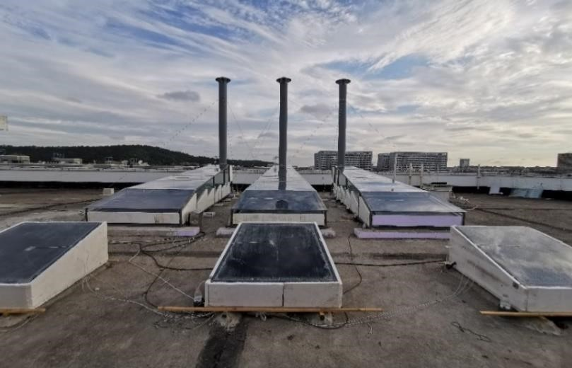
35
36
37
38
39
40
41
42
43
44
45
46
47
48
49 50
51
52 Fig.1 Test devices of SCPPCD and independent basin solar stills
53
54 2.2 Device structure and dimensions

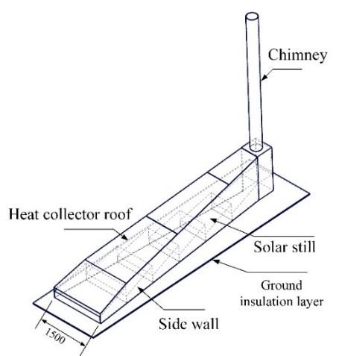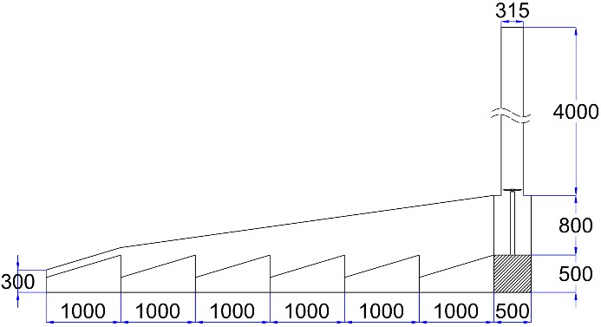
(a) Structural composition of SCPPCD (b) Dimensions of SCPPCD
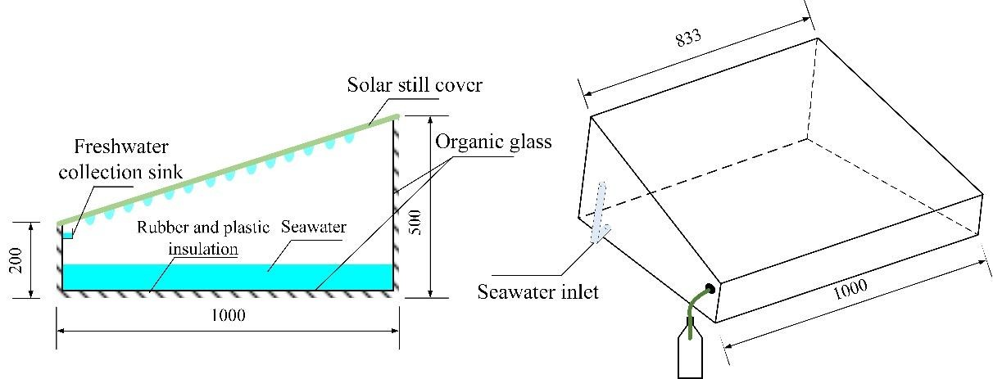
(c) Structure and dimensions of the independent basin solar still
Fig.2 Structure and dimensions of test devices (unit: mm)
The basic structure and main dimensions of the SCPPCD test device and the independent basin solar still are shown in Fig.2. The SCPPCD is mainly composed of seven parts:
- Heat collector roof: The material used is 5 mm thick transparent polycarbonate hollow sheet. The density is 1200 kg/m³, the thermal conductivity is 0.19 W/(m∙K), the specific heat capacity is 1170 J/(kg∙K), the transmittance is 0.8 and the emittance is 0.9.
- Ground insulation layer: The materials used are 5 mm thick polyvinyl chloride (PVC) plate and 20 mm thick black rubber and plastic insulation material. The density of the PVC plate is 1380 kg/m³, and the thermal conductivity is 0.16 W/(m∙K). The thermal conductivity of the rubber and plastic insulation material is 0.034-0.041
W/(m∙K).
- Side walls: The material used is double glazing with air gap. The glass thickness is 3.5 mm×2 and the air gap thickness is 3 mm. The outer side of the side wall was insulated with a 30 mm thick polystyrene foam plate.
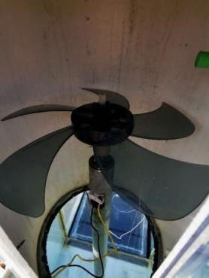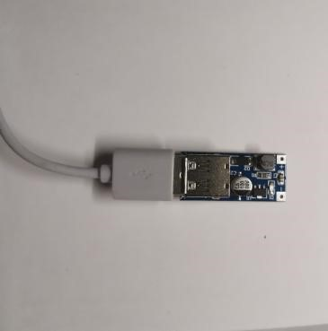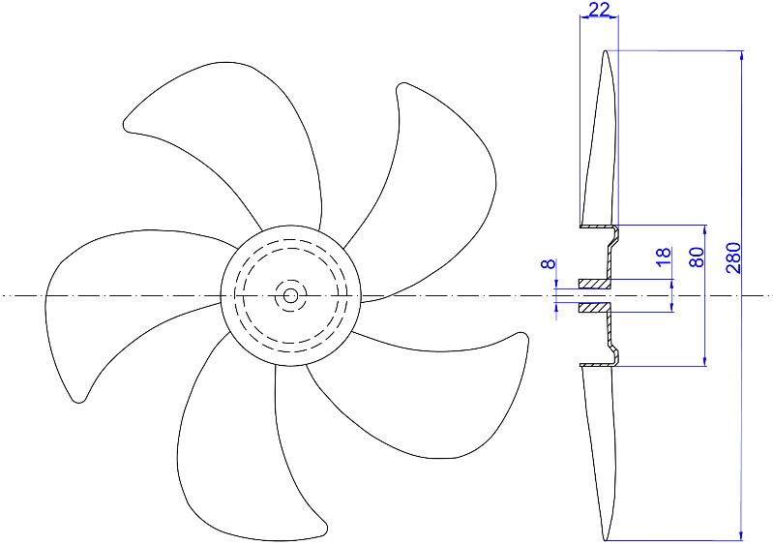

Fig
.
3

Wind t
urbine
set

and
v
oltage regulator module

Fig.4
S
hape and dimension
s

of
wind
turbine (
unit:
mm)

- Solar stills: The material used for the bottom plate and walls of the solar still is 8 mm thick organic glass. 20 mm thick black rubber and plastic insulation material was laid on the periphery and bottom of the solar still. Six solar stills of different sizes were set up in the integrated system, numbered 1-6 from the collector entrance to the bottom of the chimney. The structure and dimensions of the No. 4 solar still is the same as that of the independent solar still, as shown in Fig.2(c). The seawater in the distiller was made by mixing water and sea crystals.
- Solar still cover: The material used is 3.5 mm thick ordinary transparent glass. The density is 2500 kg/m³, the thermal conductivity is 0.75 W/(m∙K), the specific heat capacity is 837 J/(kg∙K), the transmittance is 0.8 and the emittance is 0.9.
- Chimney: The material used is a grey PVC water pipe with an outer diameter of 315 mm and a length of 4 m. To prevent rainwater from entering the chimney, the

chimney was equipped with an umbrella-like rain cap on top.
- Wind turbine and generator: Fig.3 shows the wind turbine set and generator. Fig.4 shows the shape and dimensions of the wind turbine. The number of turbine blades is 5 and the diameter of the turbine is 280 mm. The output of the generator was 8
9 terminated with a 5 V regulator module and a LED (or a resistance of 150 Ω) to facilitate
10
11 reading the voltage across the resistor and testing the output power. 12
¹³ 2.3 Data measurement
14
¹⁵16 The solar irradiance, ambient temperature and humidity, ambient wind speed,
17
₁₈ airflow velocity in the chimney and the temperature of each measuring point in the
19
20 system were collected by automatic measurement system. The solar irradiance, ambient 21
22 temperature and humidity and ambient wind speed were measured by photoelectric 23
24 solar radiation sensor, temperature and humidity transmitter and three-cup wind speed 25
²⁶ sensor, respectively. The platinum resistance with high precision for low temperature 27
²⁸29 measurement was selected to measure the air temperature and seawater temperature in
30
₃₁ the device. The sensor information used in the test is shown in Table.1.
32
33 Six solar stills were set up under the heat collector of each integrated system,
34
35 numbered 1-6 from the collector entrance to the bottom of the chimney. A temperature 36
37 measuring point system (six in total) was arranged in the center of each solar still. The 38
39 measurement point arrangement of the acquisition system is shown in Fig.54. The 40
⁴¹ temperature measurement point systems were numbered ①-⑥ from the collector inlet
42
43
₄₄ to the bottom of the chimney.

⁴⁵ Table.1 Sensor information
Equipment | Model | Measuring range | Accuracy and error
Solar radiation sensor | RS-RA-*-JT | 0~1800 W/m² | 1 W/m², ±2%
Temperature and humidity transmitter | RS-WS-N01-SMG | −40 ~+120  0% RH~80% RH | ±0.5 , (25 )  ±3% RH
Three-cup wind speed sensor | RS-FSJT-* | 0~30 m/s | ±(0.2+0.03V) m/s
Pipeline wind speed transmitter | RS-FS-*-9TH | 0~15 m/s | ±(0.2+2%FS) m/s
Temperature sensor | WZP-PT100 | −40 ~+200 | ±(0.15+0.002T)
46 47
48
49
50
51
52
53
54
Each temperature measuring point system is composed of the temperature

measuring point of each thermometric layer arranged on the vertical line in the center of the solar still. The thermometric layer includes the inner surface of the cover plate of the heat collector, the hot airflow, the outer surface and inner surface of the glass cover of the solar still and seawater. In addition, an airflow temperature measurement point
8
9 was also arranged at the chimney base.
10
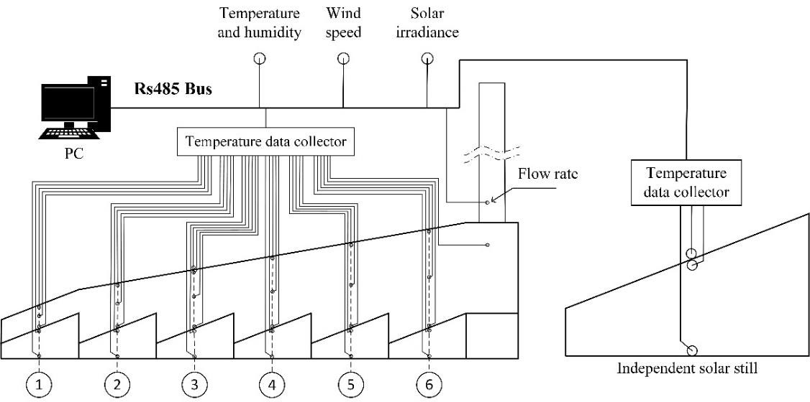
11
12
13
14
15
16
17
18
19
20
21
22
23
24
25 26
27
28 Fig.54 Measuring point arrangement and the composition of acquisition system
29
30
₃₁ The output signals of all sensors were converted to digital signals and connected
32
33 to an RS485 communication bus, which was then connected to the monitoring computer
34
35 via a USB converter. The measured data were recorded in real time by the self36
37 developed performance testing software. The above parts constitute a real-time data 38
39 acquisition system. In this experiment, the interval of automatic data collection was 5 40
⁴¹ minutes.
42
43
₄₄ The freshwater produced in the test flowed into a mineral water bottle with a
45
₄₆ capacity of 500 ml and a mass of 18 g through a drainage tube. The water bottle was
47
48 weighed with an electronic scale every 60 min, and the freshwater was sent back to the 49
50 solar still after the measurement, keeping the brine concentration and seawater layer 51
52 thickness in the solar still unchanged. The electronic scale has a measuring range of 053
⁵⁴ 5000 g and an accuracy of 1 g.
The voltage across the generator load and the current through the load were measured with a multimeter every 60 minutes.
2.4 Uncertainty analysis
The experiment was conducted from July to August 2021, during the summer in Nanjing, China. The work done during the test included the calibration and installation of measuring instruments, the operation of the test equipment and the data acquisition. 8
9 To ensure the accuracy of the measurement results, the data were measured 10
11 continuously for 4 days after the stable operation of the device under each working 12
13 condition.
14
15 All measurement results were inevitably uncertain, so uncertainty analysis of the
16
17
18 measured parameters in the test was carried out to verify the accuracy of measured
19
20 parameters. The arithmetic mean of N numbers is:
21
- 1 N
- x  N i1 x_{i} (1)
24
25
26 In turn, the standard deviation is:
27
28
- 1 N x_{i}  x² (2)
-  N 1i1 
31
32
33 The standard error of the mean is:
34
35
- S  (3)
- N1
38

39 Table.2 Uncertainty analysis results of the experimental data
Parameters | Standard error
Ambient temperature | ±0.117
Ambient humidity | ±0.461
Pt100 temperature | ±0.254
Ambient wind speed | ±0.025 m/s
Airflow velocity in chimney | ±0.028 m/s
Solar irradiance | ±14.625 W/m²
40
41
42
43
44
45
46
47
48
49
50
51 Uncertainty analysis was performed on the parameters measured in the test, 52
- including temperature, flow rate, and solar irradiance. The data used were the measured
- data from 6:00 to 18:00 on August 1, 2021. The results of uncertainty analysis are shown in Table.2.

3. Results and discussion
3.1 Weather conditions
The daily operating characteristics of the integrated system were analyzed using the experimental data of August 1 and 2, 2021 as an example. The seawater thickness
8
9 hw in the solar still was 8 cm.
10
11 Fig.6 5 shows the variation curves of solar irradiance I, ambient temperature T_{a}
12
13 and relative humidity  from August 1 to 2. From the figure, the selected test days 14
¹⁵16 were typical sunny days in summer.
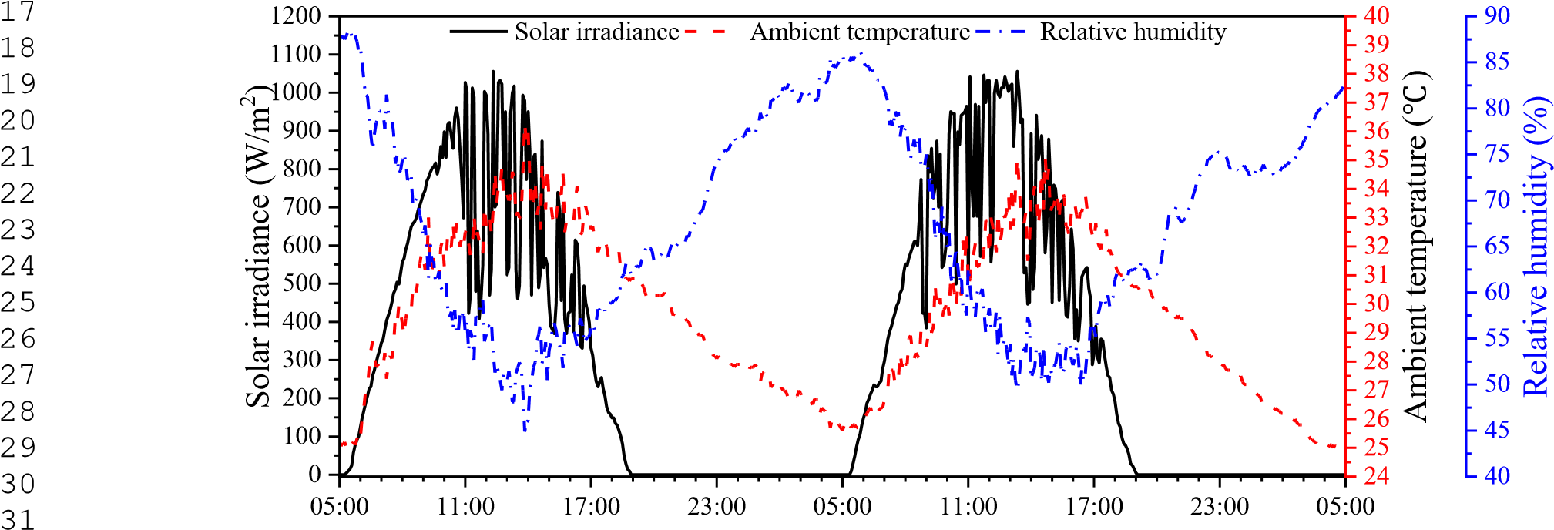

₃₂ Time (h)
33 Fig.6 5 Variation curves of solar irradiance, ambient temperature and relative humidity
34
35 3.2 Temperature variation and distribution
36
37
38
39
40
41
42
43
44
45
46
47
48
49
50
51
52
53
54
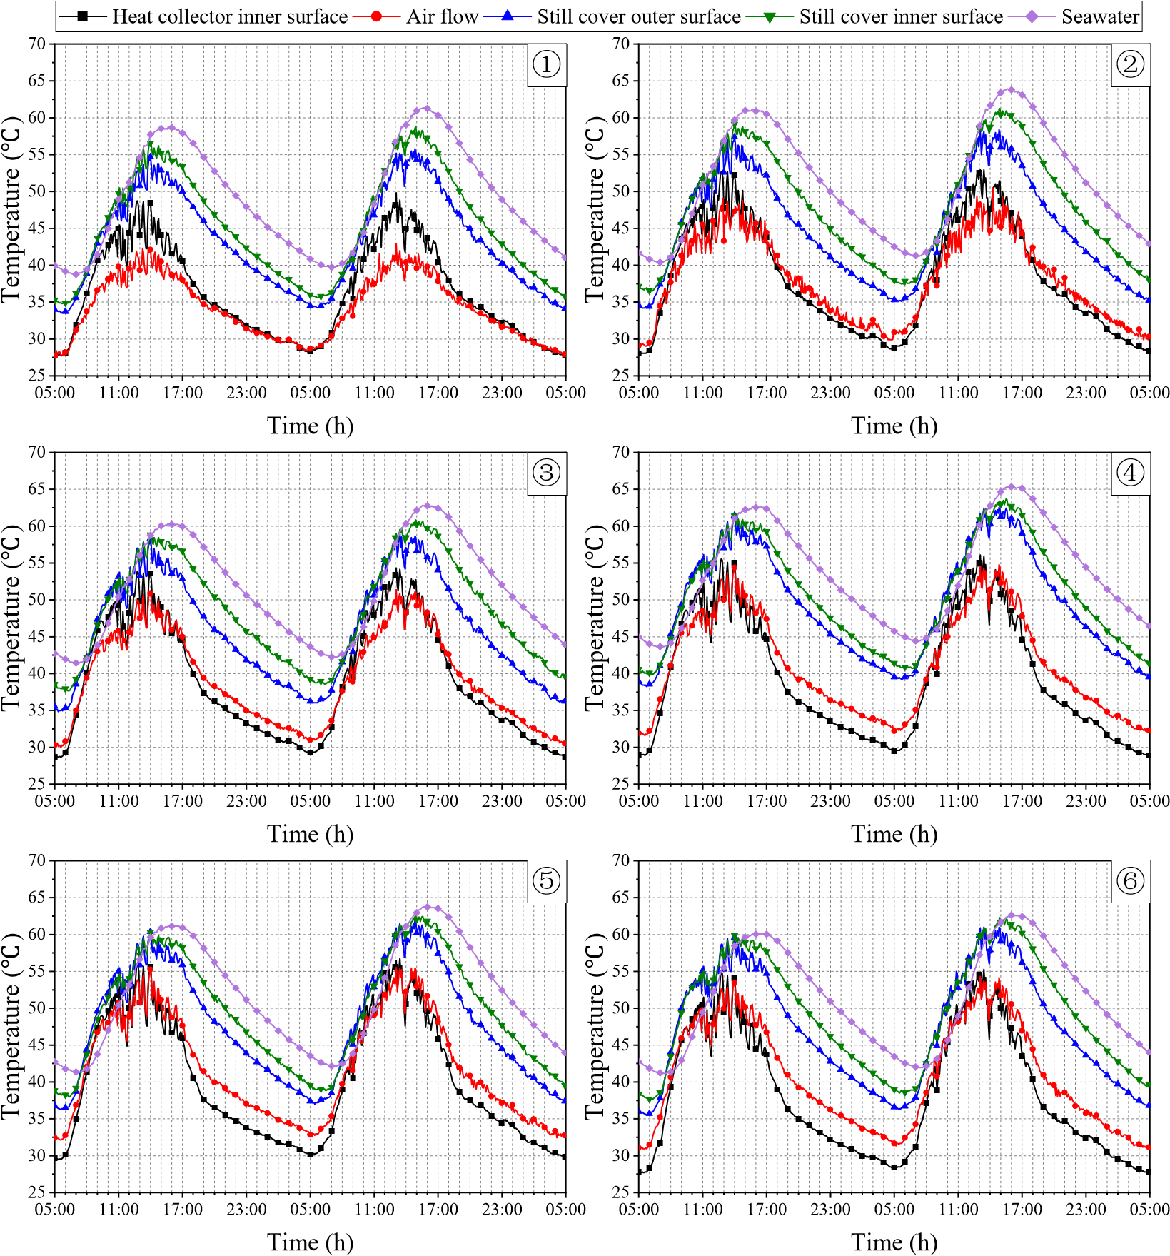
8
9
10
11
12
13
14
15
16
17
18
19
20
21
22
23
24
25
26
27
28
29
30
31
32
33
34
35
36
37
38
39 Fig.7 6 Temperature variation curves of the integrated system
40
41 Fig.7 6 shows the temperature change curves of the six temperature measurement
42
43 point systems in the test device with time. Fig.8 7 shows the radial distribution of 44
45 different thermometric layers every 3 hours. From Fig.7 6 and Fig.87, the temperature 46
47 change characteristics of the six measurement point systems (①-⑥) were similar, but 48
49 the temperature peak time was different. The airflow temperature and collector roof 50
51 temperature reached the peak first, and the seawater temperature reached the peak last.
52
53
54 Along the radial direction from collector entrance to chimney, the temperature of each
thermometric layer was first increased and then decreased. And the seawater temperature and surface temperature inside and outside the still glass cover of the No.4 solar still were basically the highest. Most of the time the temperature of seawater was the highest of the five thermometric layers, and only around 9:00-12:00, it might be lower than the temperature of the solar still cover. The temperature of the inner and outer surfaces of solar still cover was almost the same during this period.
Along the radial direction, both the airflow temperature and collector roof 8
9 temperature rose first, reached the peak at position ⑤ and then decreased. In the 10
11 process of the air flowing along the radial direction, the airflow temperature rose greatly 12
13 from position ① to position ② and dropped significantly from position ⑤ to 14
15 position ⑥. As the cold air first entered the heat collector, its temperature was low,
16
17
18 approximately equal to the ambient temperature. During the radial flow of air, it
19
20 transferred very little heat to the environment by convection and absorbed more heat 21
22 due to the large temperature difference between the seawater and the airflow. Therefore, 23
24 the temperature rise range in the flow segment from position ① to position ② was 25
26 the largest. In the area of position ⑥, the heating surface of the airflow was greatly
27
28 reduced, and the flow section was reduced, resulting in an increase in flow velocity.
29
30
31 As a result, the heating time of the airflow was shortened, and the heat loss of the hot
32
33 air flowing from position ⑤ to position ⑥ was greater than the heat gain. Therefore,
34
35 the temperature of the airflow fell back and there was a significant cooling.
36
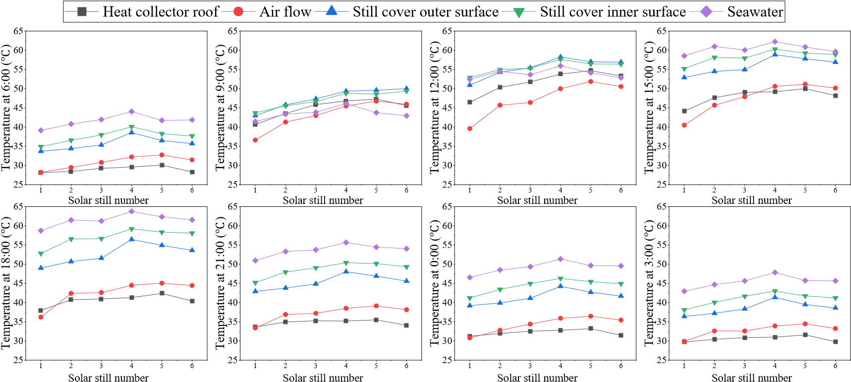
37
38
39
40
41
42
43
44
45
46
47
48
49
50
51
52
53
54
Fig.8 7 Temperature radial distribution of the integrated system
Between 9:00 and 15:00, the hot airflow temperature was lower than the seawater temperature and collector roof temperature. This meant that the airflow was heated by both seawater and collector roof during this period, so it was heated up rapidly and it had a higher temperature. In other periods, the airflow temperature was higher than the collector roof temperature, and the collector roof was heated by the airflow. The airflow lost the heat it carried through the collector roof, so its temperature was at a medium or 8
9 low level. The temperature difference between the airflow and collector roof gradually 10
11 increased along the radial direction, and it reached the maximum in position ⑥. This 12
¹³ showed that the heat loss of the airflow in position ⑥ was the most serious, and the
14
¹⁵16 airflow in this position was significantly affected by environmental factors.
17
₁₈ It can also be found from Fig.7 6 and Fig.8 7 that the temperature of each
19
20 thermometric layer in each measuring point system was much higher than the ambient 21
22 temperature, even at night. For one thing, the seawater in the solar still had a good heat
23
24 storage effect. It released a lot of heat at night to maintain the temperature of the system.
25
²⁶ For another, the test device had a good thermal insulation performance and this reduced 27
²⁸29 the heat loss of the system at night.
30
₃₁ Then, the measurement point system ④ is used as an example to analyze the
32
33 temperature change characteristics of each thermometric layer, as shown in Fig.7 6 and
34
35 Fig.87. The overall temperature change trend of each thermometric layer in the 36
37 measurement point system ④ showed a sinusoidal distribution, and it was similar to 38
39 the change characteristics of solar radiation. However, the temperature peak time of 40
⁴¹ seawater and solar still cover was later than that of solar radiation, and the delayed time
42
43
₄₄ of seawater temperature was longer. On August 1, the peak time of the seawater
45
₄₆ temperature was 16:00, and the peak time of the internal surface temperature of solar
47
48 still cover was 14:00. This was because most of the solar radiation after sunrise was 49
50 absorbed by the bottom plate of the solar still. Seawater absorbed only a small part of 51
52 the solar radiation, but it also absorbed the heat of the still bottom plate in the form of 53
⁵⁴ convective heat transfer. So, most of the solar radiation was absorbed and stored in
seawater, resulting in the highest peak temperature of seawater. The seawater was heated up slowly due to its large specific heat capacity, which is 4096 J/(kg∙K), causing the peak time of seawater temperature to lag behind that of solar radiation. At noon, the heating of solar still cover mainly depended on the absorption of the latent heat of condensation released by water vapor. The specific heat capacity of the glass cover is
small, which is 837 J/(kg ∙K), so the heating time required for glass cover was shorter 8
9 than that of seawater, and the peak time of glass cover temperature was earlier than that
10
11 of seawater temperature.
12
¹³ From the temperature change curves of the measurement point system ④ in 14
¹⁵16 Fig.76, it was found that the temperature of the inner and outer surfaces of the glass
17
₁₈ cover was close during the period from 7:00 to 14:00 on August 1, and these two
19
20 temperatures were higher than seawater temperature for a period of time. This was 21
22 because seawater temperature was low during this period and the evaporation of 23
24 seawater was small. So, little condensation heat was absorbed by the inner surface of 25
²⁶ the glass cover, resulting in almost the same temperature on the inner and outer surface 27
²⁸29 of the glass cover. In addition, the glass cover of the solar still had a small specific heat
30
₃₁ capacity. After absorbing solar radiation, the glass cover was heated up quickly and its
32
33 temperature exceeded the seawater temperature. The temperature difference between
34
35 the seawater and the inner surface of the glass cover became negative, which was not
36
37 conducive to the evaporation of seawater in the solar still. After 14:00, the seawater 38
39 temperature exceeded the glass cover temperature, and a large amount of seawater 40
⁴¹ evaporated and condensed on the inner surface of the glass cover. The inner surface of
42
43
₄₄ the solar still glass cover absorbed a large amount of condensation latent heat, and its
45
₄₆ temperature was significantly higher than the temperature of the outer surface.
47
48 After sunrise on August 1, the collector roof temperature and airflow temperature 49
50 rose rapidly. The airflow temperature was higher than the collector roof temperature, 51
52 but the collector roof temperature rose faster. At about 9:00, the collector roof 53
⁵⁴ temperature exceeded the airflow temperature, and it was not until 14:00 that the
collector roof temperature was lower than the airflow temperature again. The specific heat capacity of air can be calculated by equation (4). The specific heat capacity of the collector roof is 1170 J/(kg∙K), and it is slightly larger than that of air. During the period from 5:00 to 14:00, the temperature of the solar still cover was not high. The heat obtained by the airflow from the glass cover by convective heat transfer was less than the heat absorbed by collector roof from solar radiation. Therefore, although the 8
9 specific heat capacity of the airflow was a little smaller, the heating speed of the airflow 10
11 was less than that of the collector roof. After 14:00, the temperature of the solar still 12
13 cover was significantly increased, and it increased the convective heat transfer to the 14
15 airflow, resulting in a higher temperature of the airflow than that of the collector roof.
16
17
18 From 14:00 to 8:00 the next day, the airflow temperature was higher than the collector
19
20 roof temperature. At this time, the airflow heated the collector roof and lost heat to the 21
22 environment through the collector roof. This further exacerbated the reduction in the 23
24 airflow temperature. The valley temperature of the airflow appeared at sunrise at 5:00.
25
26 C_{p air,} 10070.04T_{air} (4)
27
28
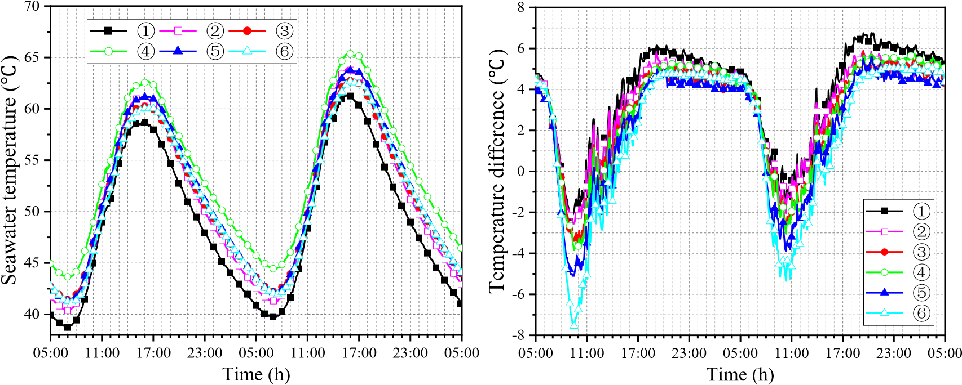
29
30
31
32
33
34
35
36
37
38
39
40
41
42
43
44
- (a) Seawater temperature (b) Temperature difference between seawater and
- inner surface of solar still glass cover
- Fig.9 8 Change curves of seawater temperature and the temperature difference between 48
49 seawater and inner surface of solar still cover
50
51 Fig.9 8 shows the change of the seawater temperature and the temperature
52
53
54 difference between seawater and the inner surface of the solar still cover T_{wc} of the
six temperature measurement point systems. The seawater temperature of the six solar stills basically exceeded 40 , as shown in Fig.98(a). Along the direction from collector entrance to chimney, the seawater temperature rose first and then fell, and the seawater temperature of the No.4 solar still was the highest. There was little difference in seawater temperature in the No.2, No.3, No.5 and No.6 solar still. The seawater temperature in the No.1 solar still was the lowest. For one thing, it was located at the 8
9 collector entrance, and the airflow temperature above the solar still cover was the lowest. 10
11 So, the seawater transferred more heat to the airflow, and the seawater itself lost more 12
¹³ heat. For another, although insulation layer was laid outside the side walls of the solar 14
¹⁵16 still, the heat loss caused by the heat conduction from seawater to the external
17
₁₈ environment still existed.
19
20 From Fig.98(b), the positive temperature difference of the No.1 solar still was the 21
22 largest. The maximum temperature difference T_{wc} on August 1 reaches 6 , and the
23
24
25 maximum T_{wc} on August 2 exceeded 6 . The period with the positive temperature
26
27
₂₈ difference greater than 4 was the longest. The absolute value of the negative
29
30 temperature difference in the No.1 solar still was the smallest, only 2.2 , and the 31
32 negative temperature difference lasted the shortest time. As the temperature difference 33
³⁴35 T_{wc} was less than or equal to 4 °C, the temperature difference line of the No.6 solar
36
37 still was at the bottom of all the temperature difference lines. The absolute value of the 38
39 negative temperature difference in the No.6 still was much greater than that of other 40
⁴¹ stills, with a maximum of 7.5 °C, and its negative temperature difference lasted the
42
43
₄₄ longest time. In the period with the positive temperature difference greater than 4 ,
45
46 the temperature difference T_{wc} in the No.6 still was basically the same as that in the
47
48
₄₉ No.3 still, and was slightly higher than that in the No.5 still.
50
51 It was also found from Fig.9 8 that in the period with the positive temperature 52
53 difference greater than 4 , the difference in temperature difference T_{wc} between the
54
six solar stills was not large, and the difference between the maximum T_{wc} and the minimum T_{wc} was within 2 °C. But in the negative temperature difference period, the difference in temperature difference T_{wc} between the six solar stills was large.
The difference between the maximum and the minimum negative temperature difference on August 1 reached 5.3 °C. The literature [3035] pointed out that only when
8 the water surface temperature exceeds 40 °C and the temperature difference T_{wc} is
9
10 positive, can seawater evaporate significantly, and a considerable amount of freshwater
11
12
13 can be received. All six solar stills met the condition of water surface temperatures
14
15 exceeding 40 °C, and the seawater temperature in the No.4 solar still was the highest.
16
17 In addition, considering the analysis of the variation characteristics of temperature 18
19 difference T_{wc} , the following conclusions can be drawn. The location of the No.1
20
21
22 solar still is the most favorable for water production, and the water yield of the solar
23
24 still in the position 4 is also considerable. But the location of the No.6 solar still is not 25
26 conducive to the water production of the still.
27
28
29 3.3 Water yield variation and distribution
30
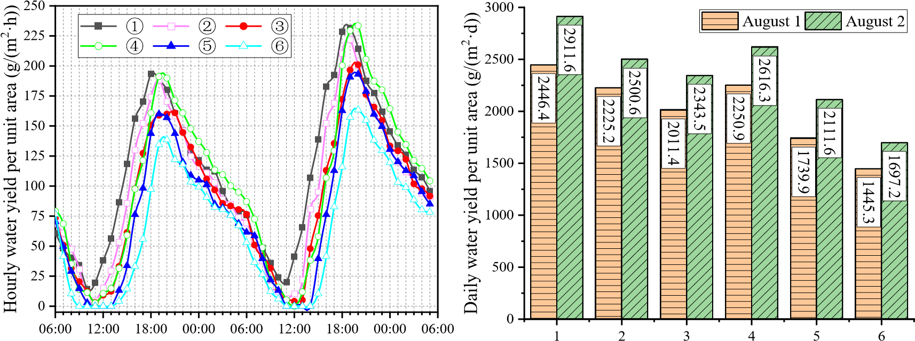
31
32
33
34
35
36
37
38
39
40
41
42
43
44 Time (h) Solar still number
45
46 Fig.10 9 Variation curves of freshwater yield Fig.11 10 Radial distribution of daily water yield
47
- per unit area
- Fig.10 9 shows the variation curves of the water yield of six solar stills in the
50
51
52 integrated system. The variation characteristics of the freshwater yield of all the stills
53
54 were similar, but the amount of the water produced was different. Along the radial
direction from the collector entrance to the chimney, the valley and peak value of the hourly water yield per unit area of the solar still gradually decreased. The valley value of the water yield even dropped to zero, which meant that no water was received. It was not desirable that the low water production period and no water production period of the solar still gradually increased along the radial direction.
The water yield of the six solar stills varied significantly during the recovery 8
9 period of water production. In the order of solar still number 1 to 6, the water yield of 10
11 the six solar stills began to rise sequentially. The No.1 solar still produced the most 12
¹³ freshwater per hour per unit area. It was the first to reach the peak water yield and the
14
¹⁵16 peak value was the largest. Due to the superior seawater temperature and moderate
17
₁₈ temperature difference, the water yield of the No.4 still exceeded that of the No.2 and
19
20 No.3 solar still, and its peak water yield was close to that of the No.1 solar still. The 21
22 No.5 solar still had a lower water yield than that of No.1-4 still, and the No.6 still had 23
24 the lowest water yield. The valley water yield of No.6 still was zero, and its period of 25
²⁶ no water received was the longest.
27
²⁸29 During the decline period of water production after the peak water yield, the No.4
30
₃₁ solar still had the largest water yield, the No.1, No.2, No.3 and No.5 solar stills had
32
33 little difference in water yield, and the No.6 solar still had the smallest water yield.
34
35 Fig.11 10 shows the radial distribution of the daily water yield per unit area of the
36
37 six solar stills. From the figure, the daily water yield per unit area of the No.1 solar still 38
39 had the most advantage. The daily water yield of the solar still showed an overall 40
⁴¹ decreasing trend with the increase of the solar still number, but there was a sudden
42
43
₄₄ increase in the water yield of the No.4 still, which even exceeded the water yield of the
45
₄₆ No.2 still. This was because the seawater temperature of No.4 still was high, and its
47
48 hourly water yield per unit area in the peak water yield period was large. The daily 49
50 water yield per unit area of the No.1 solar still was 1.69 times and 1.72 times that of
51
52 No.6 still on August 1 and August 2, respectively. 53
⁵⁴ In conclusion, solar stills should be arranged as far as possible in the area from the
collector inlet to the one-third radius of the heat collector.
3.4 Analysis of the intrinsic relationship between freshwater yield, seawater
temperature and temperature difference T_{wc}
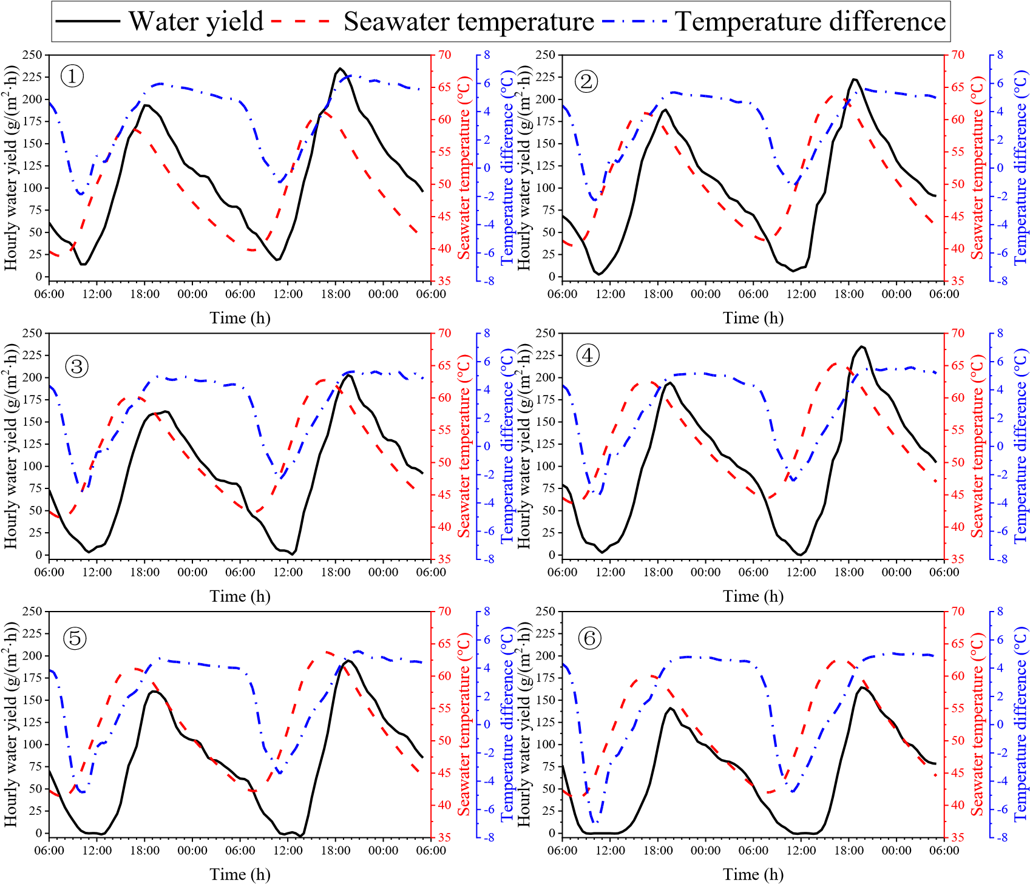
8
9
10
11
12
13
14
15
16
17
18
19
20
21
22
23
24
25
26
27
28
29
30
31
32
33
- Fig.12 11 Hourly average variation curves of water yield per unit area, seawater temperature and temperature
- difference between seawater and the inner surface of the solar still cover
36
37
38 Although the water production of the solar still was mainly affected by seawater
39
40 temperature and the temperature difference between the seawater and the inner surface 41
42 of solar still cover T_{wc} , changes in seawater temperature and temperature difference
43
44
45 T_{wc} were not synchronized, as seen in Fig.98. To understand the effect of the coupling
46
47
48 of the two on the water yield of the solar still, these three parameters were plotted in 49
50 the same graph for re-analysis. Fig.12 11 shows the hourly average variation curves of 51
52 water yield per unit area, seawater temperature and temperature difference T_{wc} of the
53
54 six solar stills. Here are the common features shown in the six graphs. (1) During the recovery period of water production, seawater temperature and temperature difference
T_{wc} were increasing, and the starting time of the recovery period of water production
coincided with that of T_{wc} . (2) During the decline period of water production, the seawater temperature continued to drop. But the T_{wc} changed very little at the beginning, and then it quickly decreased. (3) The valley value and peak value of water
8 yield appeared around the time corresponding to the valley value and peak value of the
9
10
11 T_{wc} .
12
13 The differences shown in Fig.12 11 are as follows. The No.1 solar still had the 14
15 lowest seawater temperature, but the highest water yield. The No.4 still had the highest
16
17
18 seawater temperature, but produced slightly less water than the No.1 still. These
19
20 features illustrated that although freshwater production was the result of a combination 21
22 of seawater temperature and temperature difference T_{wc} , the extent of their effect on
23
24
25 water production was different in different periods. Temperature difference was the 26
27 main factor affecting water production during the rising period of water production. As 28
29 the positive temperature difference during the rising period of water production 30
31 increased slightly, the water yield increased significantly. But the sharp increase in 32
33 seawater temperature had little impact on the increase in water yield. Seawater
34
35
36 temperature was the main factor affecting water production during the decline period
37
38 of water production. Especially at the beginning of the decline of water yield, the value 39
40 of temperature difference T_{wc} was always large. But the freshwater yield in this
41
42
43 period was decreasing, and the decreasing trend was consistent with the trend of 44
45 seawater temperature decline. This phenomenon and assertion can be further illustrated
46
47 by the following correlation analysis in statistics. 48
49 In this paper, the correlation analysis method was used to study the intrinsic 50
51 relationship between the water yield, seawater temperature and temperature difference
52
53
54 T_{wc} . In correlation analysis, the correlation coefficient r was used to describe the
correlation between two variables. The meaning of the r is as follows.
(1) Positive correlation: If the variables x and y change in the same direction, it is
generally believed that if r  0.95, there is a significant correlation. If r  0.8，there is a high correlation. If 0.5 r 0.8, there is a moderate correlation. If 0.3 r 0.5, there is a low correlation. If r  0.3, the correlation is extremely weak and the two
8
9 variables are considered unrelated.
10
11 (2) Negative correlation: If the variables x and y change in the opposite direction, 12
13 r 0.
14
15 (3) No linear correlation: r 0.
16
17
18 Considering that seawater is the main energy carrier of the solar still, the seawater
19
20 temperature has a great impact on the temperature of solar still cover. According to the 21
22 rise and decrease of seawater temperature, the water production period was divided into 23
24 rising period and falling period. In these two periods, the intrinsic relationship between 25
26 freshwater yield and seawater temperature and between freshwater yield and
27
28
29 temperature difference T_{wc} was discussed. The experimental data were collected 30
31 from the six solar stills on August 1 and 2. Data points that did not meet the 32
33 requirements were eliminated. Since the experimental data did not meet the normal
34
35
36 distribution, Spearman correlation coefficient was used to describe the correlation of
37
- variables, and the calculation formula is as follows.
- n
- 6(R_{i} Q_{i} )²
- ^{i1} (5)
- r_{s}  1 n n( ₂ ₁₎
43
44
45 Where, R_{i} represents the rank of x_{i} , and Q_{i} represents the rank of y_{i} .
46
47
48 Fig.13 12 shows how freshwater yield varies with seawater temperature and 49
50 temperature difference T_{wc} , respectively. From Fig.1312(a), freshwater yield was
51
52
53 mainly affected by temperature difference during the rising period of seawater
54
temperature, and the relationship between the two was a quadratic function. The fitting
formula between the two was m_{w}  4.91T_{wc}² 18.37 T_{wc} 24.23 , R²  0.847 .
Where, m_{w} represents the hourly freshwater yield per unit area, g/(m²∙h). The correlation coefficient r between m_{w} and temperature difference T_{wc} and between m_{w} and seawater temperature T_{w} in this period was 0.891 and 0.544, respectively.
8
9 This indicated that freshwater yield was highly correlated with the temperature 10
11 difference T_{wc} , and moderately correlated with the seawater temperature. Therefore,
12
13
14 the water yield in this period was mainly determined by the temperature difference
15
16
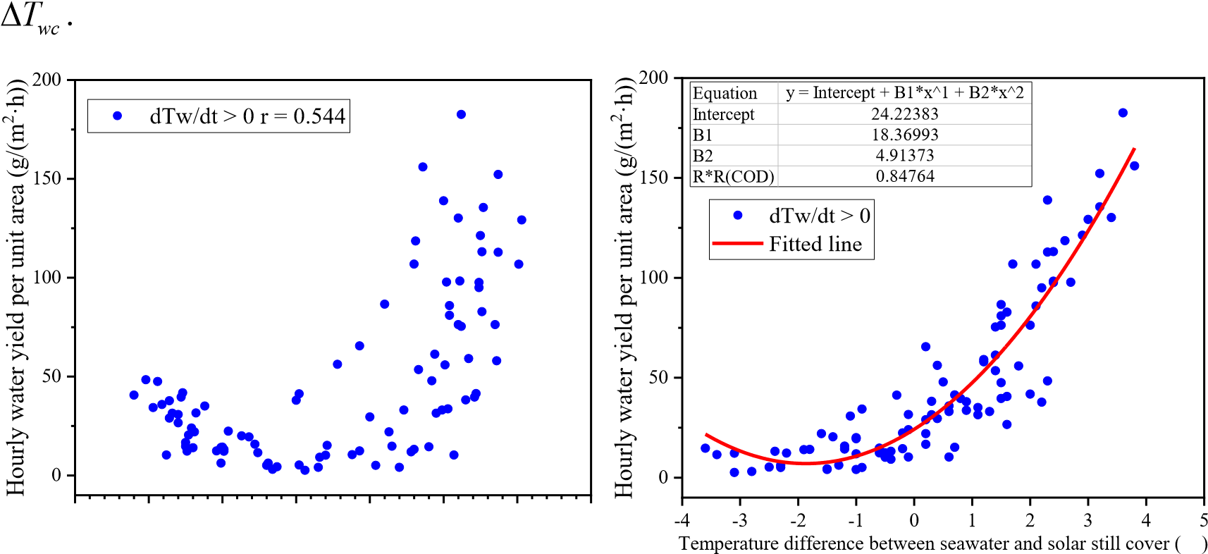
17
18
19
20
21
22
23
24
25
26
27
28
29
30
31
32
33
34 (a) Rising period of seawater temperature
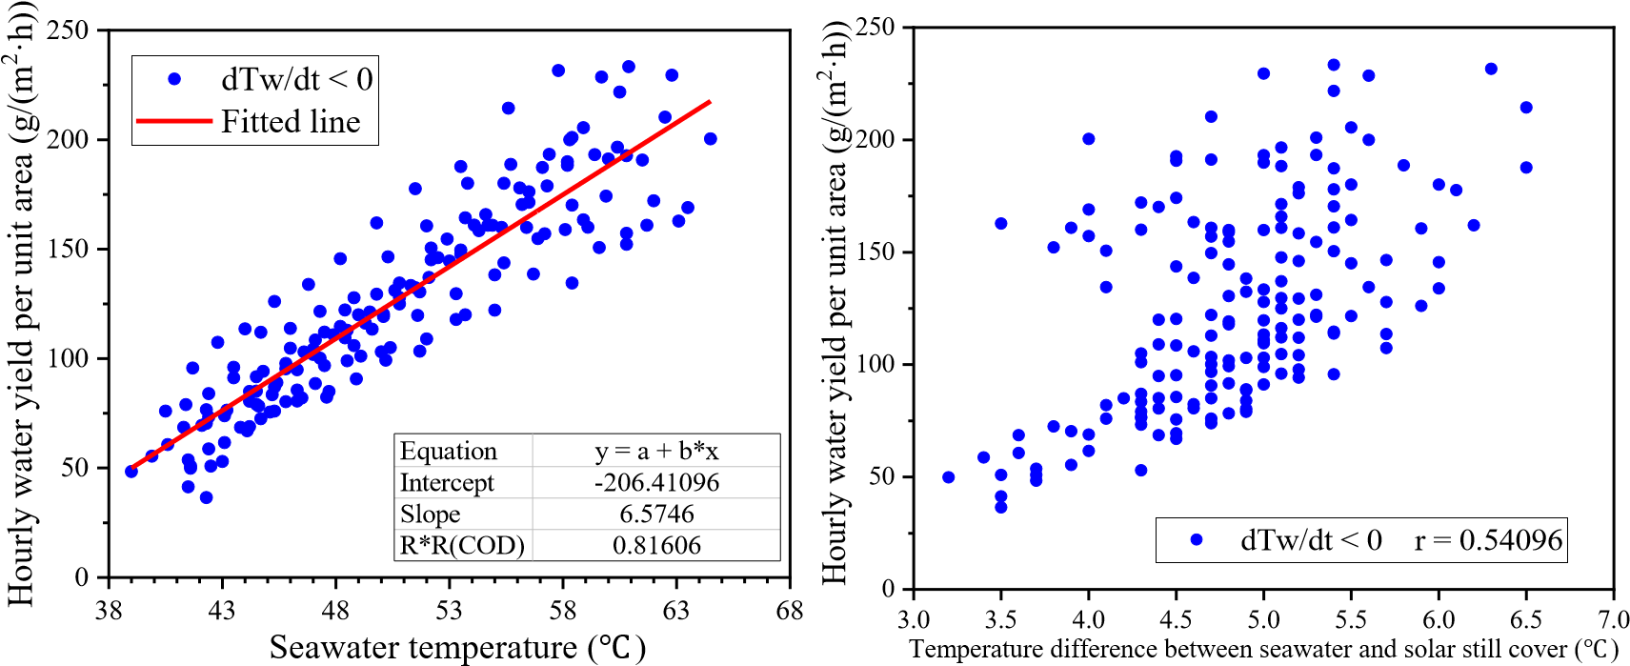
35
36
37
38
39
40
41
42
43
44
45
46
47
48
49
50
- (b) Falling period of seawater temperature
- T_{wc}
- Fig.13 12 Changes in freshwater yield with seawater temperature and temperature difference 
54
From Fig.1312(b), the freshwater yield and seawater temperature showed an obvious linear relationship during the falling period of seawater temperature. The fitting formula was m_{w}  6.57T_{w} 206.41, R²  0.816. The correlation coefficient r between m_{w} and seawater temperature T_{w} and between m_{w} and temperature difference
T_{wc} in this period was 0.920 and 0.541, respectively. This indicated that freshwater yield was highly correlated with the seawater temperature, and moderately correlated
8
₉ with the temperature difference T_{wc} . Therefore, the water yield in this period was
10
11 mainly determined by seawater temperature.
12
13
₁₄ The above results show that the temperature difference T_{wc} drives the 15
16 evaporation of seawater and is the driving force of water production. Also, seawater 17
¹⁸ temperature has an important influence on the amount of evaporation. During the test,
19
20
₂₁ seawater temperature in the integrated device maintained at a very high level (> 44),
22
₂₃ and evaporation occurred throughout. Therefore, maintaining a high temperature 24
25 difference T_{wc} is a necessary condition for the system to produce a large amount of
26
27
₂₈ freshwater in summer.
29
30 3.5 Temporal characteristics analysis of water production
31
32 It is of guiding significance for the operation and management of the integrated 33
34 system to understand the characteristics of freshwater production in different periods.
35
³⁶ Fig.14 13 shows the freshwater yield of the six solar stills (average value) in the system 37
³⁸39 for one day and night. Taking the hourly water yield per unit area of 100 g/(m²∙h) as the
40
₄₁ dividing line, the water production period was divided into high-water yield period and
42
43 low-water yield period, as shown in Fig.1413. The high-water yield period on August 44
45 1 (17:00 to 1:00 the next day) accounted for only 33.3% of the total duration of the test 46
47 day, but it contributed 61.97% of the total water yield. The low-water yield period on 48
⁴⁹ August 1 accounted for 66.7% of the total duration of the test day, but it only contributed 50
⁵¹52 37.03% of the total water yield. The high-water yield period on August 2 (16:00 to 3:00
53
₅₄ the next day) accounted for 45.83% of the total duration of the test day, and it
contributed 77.12% of the total water yield. The low-water yield period on August 2 accounted for 54.17% of the total duration of the test day, but it only contributed 22.88% of the total water yield. The operating characteristics in different water production periods showed that the high-water yield period generally occurred between sunset and 1-3 a.m. Although this period accounted for a small proportion of the day's operating time, it contributed most of the water produced. Therefore, it is necessary to strengthen the management of this operation period, reducing the failure rate of the device and
8
9 manual error rate to ensure the efficient water production of the device.
10
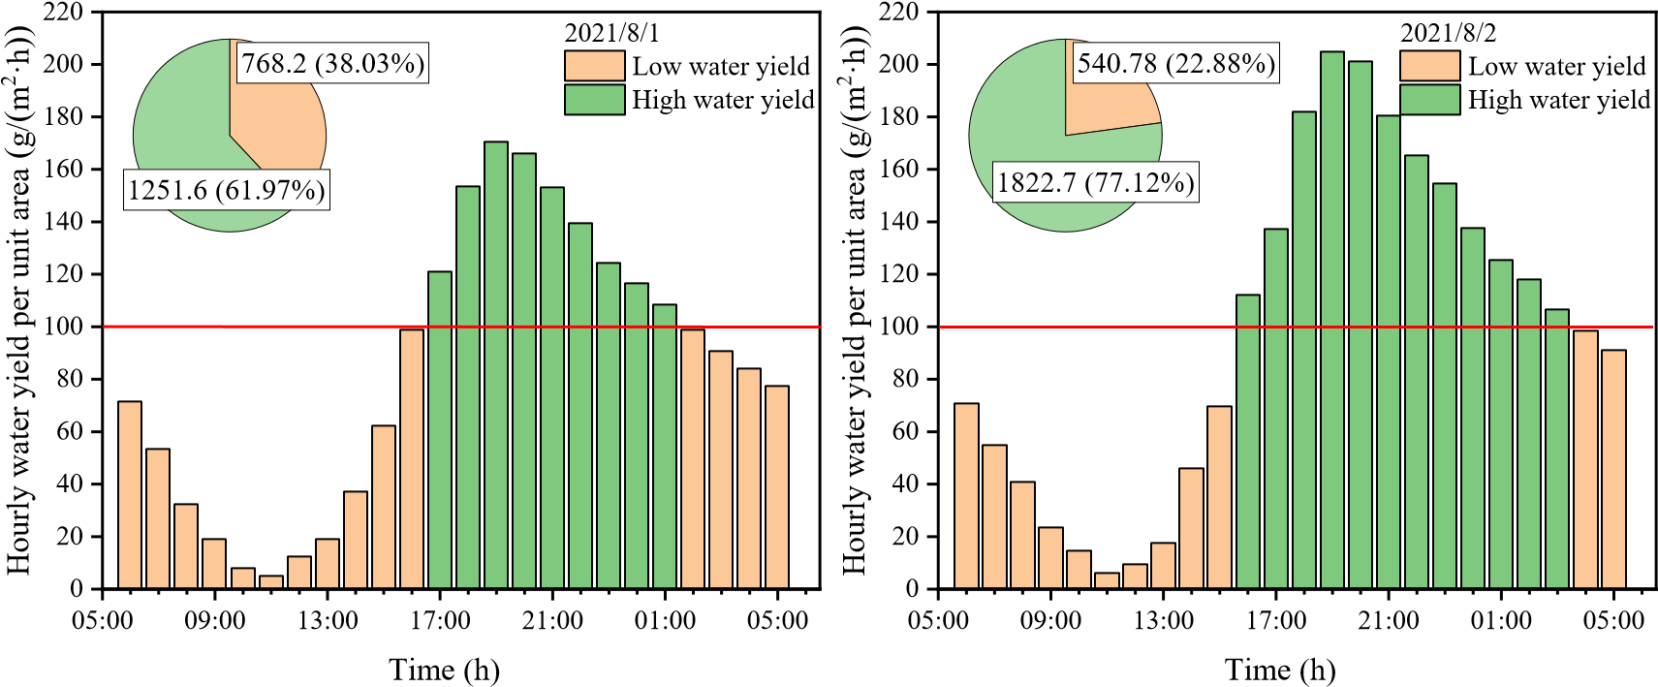
11
12
13
14
15
16
17
18
19
20
21
22
23
24
25
26
- (a) High and low water yield period on Augest 1 (b) High and low water yield period on Augest 2
- Fig.14 13 Temporal characteristics of freshwater production of the integrated system
29
30
31 Referring to Fig.1211, it was found that the seawater temperature and temperature
32
33 difference T_{wc} in the high-water yield period were both at a high level. This once
34
35
36 again showed that a high seawater temperature and a high temperature difference T_{wc} 37
38 were the guarantee for the efficient water production of the device.
39
40
41 3.6 Power output
42
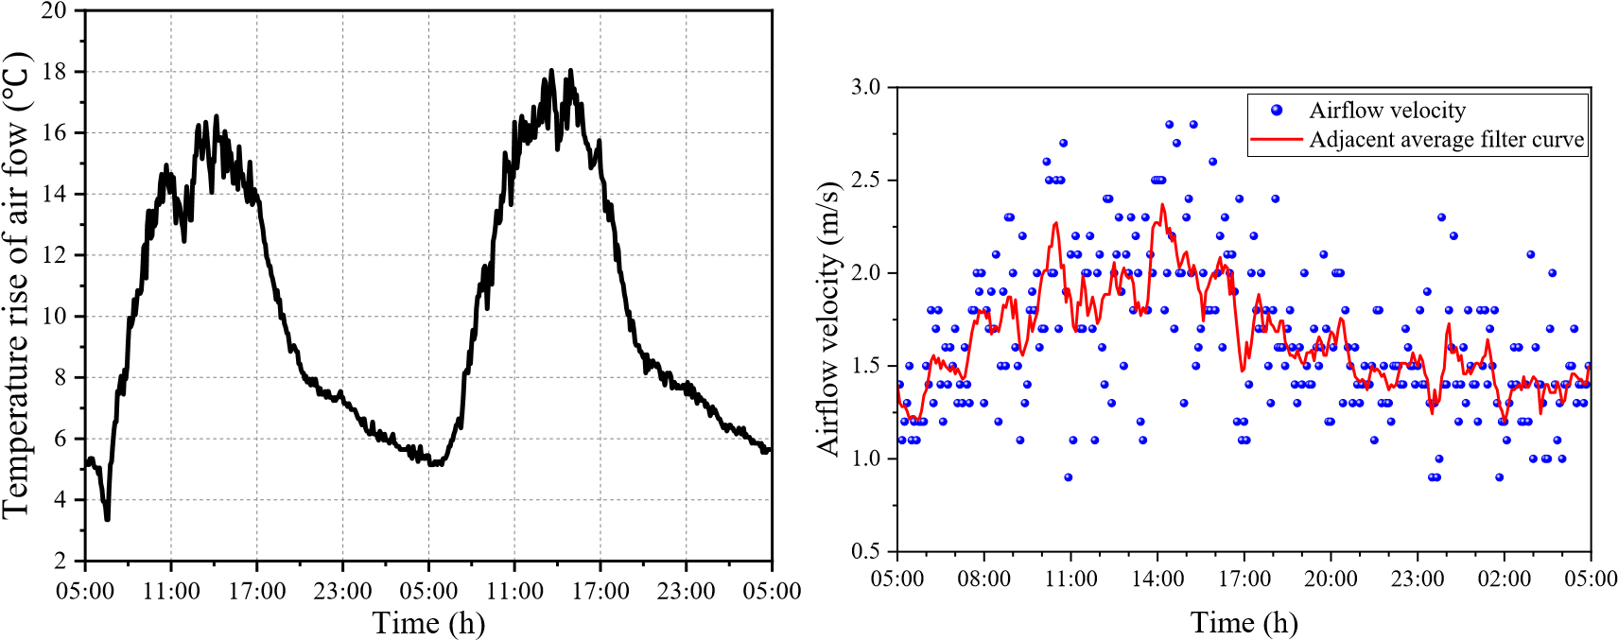
43
44
45
46
47
48
49
50
51
52
53
54
Fig.15 14 Changes in airflow temperature rise Fig.16 15 Variation curve of airflow velocity in the chimney
The airflow temperature rise is defined as the temperature difference between the airflow at the chimney base and the environment. Fig.15 14 shows that the maximum and minimum temperature rise of the airflow in the chimney were 17 and 5 , respectively. The airflow temperature rise obtained was considerable, and the minimum 8
9 temperature rise was 5 even at night. This highlighted the advantage of the thermal
10
11 storage effect of seawater in the system. 12
¹³ Fig.16 15 shows the change of airflow velocity in the chimney on August 1. The 14
¹⁵16 hot airflow in the chimney was affected by turbine rotation and ambient wind speed, so
17
₁₈ the airflow velocity fluctuated greatly. The filtering curve of the airflow velocity
19
20 approximately conformed to the sine curve, and its distribution profile was 21
22 approximately a sinusoidal region. The peak period of the airflow velocity was at noon, 23
24 and the airflow velocity at night was maintained at about 1.5 m/s. The variation 25
²⁶ characteristics of the airflow velocity during the daytime were similar to those of the 27
²⁸29 solar irradiance. At night, the seawater in the solar still dissipated heat to the outside to
30
₃₁ maintain a certain airflow temperature and airflow velocity.
32
33 The hot airflow in the chimney drove the wind turbine to rotate, which in turn
34
35 drove the DC generator to rotate and generate electricity. In order for the output power 36
37 to drive the LED, the output voltage of the generator was raised to 5 V through a 38
39 regulator module. During the test operation of the device, the turbine drove the 40
⁴¹ generator to light up the LED. This experimental phenomenon demonstrates that the
42
43
- SCPPCD can realize the water-electricity cogeneration.
- 0.8
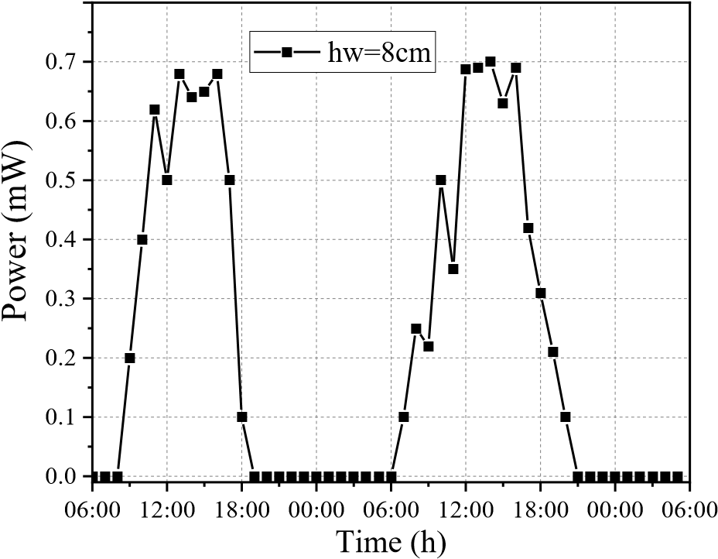
46
47
48
49
50
51
52
53
54
Fig.17 16 Variation curve of generator power output
Fig.17 16 shows the change curve of the generator power output. The change of generator power output was similar to that of the airflow temperature rise. The maximum generator power appeared at noon, about 0.70 ×10⁻³ W. Although the airflow 8
9 temperature rise was considerable at noon (Fig.1514), the output power of the test
10
11 device was small. This was because compared with the Spanish SCPP [2], the test 12
¹³ device constructed in this paper was still too small in scale, and the heat collector was 14
¹⁵16 only a fan-shaped area. The small size of the device resulted in increased heat
17
₁₈ dissipation, shortened the time the air was heated in the collector and increased the
19
20 pressure losses in the system. After sunset, the airflow in the chimney was still flowing 21
22 due to the temperature rise. However, due to the small scale of the device and thin heat 23
24 storage water layer, the heat storage was insufficient, the airflow temperature rise 25
²⁶ dropped a lot, and the airflow velocity was decreased. The pressure potential energy 27
²⁸29 and kinetic energy of the airflow were not enough to overcome the energy consumption
30
₃₁ caused by factors such as frictional resistance and generator electromagnetic resistance.
32
33 Therefore, the hot airflow could not drive the turbine to rotate in this period, and the
34
35 generator output power was 0 W.
36
37 The daily utilization efficiency of solar energy of the integrated system can be
38
39 calculated by the following formula: 40
41 24 6 24
24
,
,
,,,
1
1
1
,
288
1
12
esij
sj
ei
fg
i
j
i
sols
col
i
i
Shm
t
P
t
t
I
S











4243 i 1 j 1 S h ms j, fg e s i j, , , i1 Pe i,
44 _{sol s,}  ₂₈₈ (6)
4546 Scol i1 Ii
47
48 6 24
49
50
51 (6)
52
53
54
Where, t stands for an hour. The sampling interval for freshwater production
and power generation was one hour, and the sampling interval for solar irradiance was
five minutes. h_{fg} represents the latent heat of water vaporization, J/g. S_{col} represents the area of the heat collector, m². S_{s j,} represents the area of the No.j solar still, m².
m_{e s i j, , ,} represents the water yield of the No.j solar still, g/(m²·h). I represents the solar
8
⁹ 10 irradiance, W/m². P_{e} represents the output power of the generator, W.
11
12 It was calculated that the daily utilization efficiency of solar energy of the 13
14 integrated system on August 1 and 2 was 19.6% and 21.8%, respectively. Limited by
15
16 thermodynamic properties, the solar energy utilization efficiency of the conventional 17
¹⁸ solar chimney power plant is generally less than 1% [2,3,10,1425,3237]. Compared
19
20
₂₁ with the traditional solar chimney power plants, the solar energy utilization efficiency
22
₂₃ of SCPPCD was significantly improved.
24
25 In the SCPPCD, since the latent heat of vaporization released by the condensation 26
27 of water vapor was recycled and freshwater was produced, the solar energy utilization 28
29 efficiency and land utilization rate were greatly improved, which was the meaning of 30
³¹ integrating the freshwater generation with electricity generation. The SCPPCD is
32
³³34 suitable for construction in desolate tidal flat areas along the coast.
35

36 4. Conclusion
37
38 In this paper, a comprehensive test platform for solar chimney power plant 39
40 combined with distillation (SCPPCD) that can realize water-electricity cogeneration 41
42 was designed and successfully built. The operation and output characteristics of 43
44 SCPPCD were tested and analyzed, and the following findings were obtained.
45
⁴⁶ (1) The temperature variation of thermometric layers in each measuring point
47
48
₄₉ system was similar, but the peak time of temperatures was different. The temperature
50
51 of each thermometric layer at the same moment increased first and then decreased from
52
- the collector entrance to the chimney. The seawater temperature and solar still cover
- temperature of the No.4 solar still were basically the highest. In the same measurement point system, seawater temperature was the highest most of the time. The airflow temperature was lower than collector roof temperature most of the time, and it lost heat
through the collector roof.
(2) Freshwater production was the result of a combination of seawater temperature
T_{w} and temperature difference T_{wc} , but the extent of their effect on water production
8 was different in different periods. Temperature difference T_{wc} was the main factor
9
10 affecting water production during the rising period of water production. Seawater
11
12
13 temperature T_{w} was the main factor affecting water production during the decline 14
15 period of water production.
16
17
18 (3) The daily water yield per unit area of the solar still basically decreased from
19
20 the heat collector entrance to the chimney. The No.1 solar still had the highest daily 21
22 water yield per unit area, and the water yield of the No.4 still was second only to the 23
24 No.1 still. The daily water yield of the No.1 still on August 1 and 2 was 1.69 times and 25
26 1.72 times that of the No.6 still, respectively. Solar stills should be arranged as far as 27
28 possible in the area from the collector inlet to the one-third radius of the heat collector.
29
30
31 (4) The high-water yield period generally occurs between sunset and 1-3 a.m. It
32
33 accounted for a small proportion of the day's operating time, but contributed most of
34
35 the water produced.
36
37 (5) The maximum temperature rise of hot airflow in the chimney was 17, and 38
39 the temperature rise was maintained above 5 during night operation. The variation 40
41 law of generator power was similar to that of airflow temperature rise, and the
42
43
44 maximum output power reached 0.71 mW in the daytime. But the power generation
45
46 could not be realized at night limited by the scale of the test device. The daily utilization
47
48 efficiency of solar energy on August 1 and 2 was 19.6% and 21.8%, respectively.
49

50 Acknowledgment
51
52 This research was financially supported by National Natural Science Foundation 53
54 of China (No. 51976053).

Reference
- J. Schlaich, R. Bergermann, W. Schiel, G. Weinrebe, Design of Commercial Solar
Updraft Tower Systems—Utilization of Solar Induced Convective Flows for Power Generation, Journal of Solar Energy Engineering 127(1) (2005).
- W. Haaf, K. Friedrich, G. Mayr, J. Schlaich, Solar chimneys part I: principle and construction of the pilot plant in Manzanares, International Journal of Solar Energy
8
9 2(1) (1983) 3-20.
10
11 [3] W. Haaf, Solar chimneys: part ii: preliminary test results from the Manzanares 12
13 pilot plant, International Journal of Sustainable Energy 2(2) (1984) 141-161.
14
15 [4] N. Pasumarthi, S.A. Sherif, Experimental and theoretical performance of a
16
17
18 demonstration solar chimney model—Part II: experimental and theoretical results
19
20 and economic analysis, International Journal of Energy Research 22(5) (1998)
21
22 443-461.
23
24 [5] X. Zhou, J. Yang, B. Xiao, G. Hou, Experimental study of temperature field in a 25
26 solar chimney power setup, Applied Thermal Engineering 27(11-12) (2007) 204427
28 2050.
29
30
31 [6] A.B. Kasaeian, E. Heidari, S.N. Vatan, Experimental investigation of climatic
32
33 effects on the efficiency of a solar chimney pilot power plant, Renewable and
34
35 Sustainable Energy Reviews 15(9) (2011) 5202-5206.
36
37 [7] S. Kalash, W. Naimeh, S. Ajib, Experimental investigation of the solar collector 38
39 temperature field of a sloped solar updraft power plant prototype, Solar Energy 98 40
41 (2013) 70-77.
42
43
44 [8] M. Fathy Cidek Esmail, T. Mekhail, Investigations of the instantaneous
45
46 performance of a solar chimney power plant installed in Aswan using IoT, IET
47
48 Renewable Power Generation 13(12) (2019) 2261-2266.
49
50 [9] R. Balijepalli, V.P. Chandramohan, K. Kirankumar, Development of a small scale
51
52 plant for a solar chimney power plant (SCPP): A detailed fabrication procedure, 53
54 experiments and performance parameters evaluation, Renewable Energy 148
(2020) 247-260.
- P. Guo, T. Li, B. Xu, X. Xu, J. Li, Questions and current understanding about solar
chimney power plant: A review, Energy Conversion and Management 182 (2019) 21-23.
- Y. Wang, Z. Fang, L. Zhu, Z. Yang, J. Wang, L. Han, Study on the integrated utilization of seawater by solar chimney, Acta Energiae Solaris Sinica 04 (2006)
8
9 382-387.
10
11 [12] X. Zhou, B. Xiao, W. Liu, X. Guo, J. Yang, J. Fan, Comparison of classical solar 12
13 chimney power system and combined solar chimney system for power generation
14
15 and seawater desalination, Desalination 250(1) (2010) 249-256.
16
17
18 [13] A. Azad, E. Aghaei, A. Jalali, P. Ahmadi, Multi-objective optimization of a solar
19
20 chimney for power generation and water desalination using neural network,
21
22 Energy Conversion and Management 238 (2021) 114152.
23
24 [14] S. Kiwan, M.d. Al-Nimr, Q.I. Abdel Salam, Solar chimney power-water 25
26 distillation plant (SCPWDP), Desalination 445 (2018) 105-114. 27
28 [15] E. Abdelsalam, F. Kafiah, M. Tawalbeh, F. Almomani, A. Azzam, I. Alzoubi, M.
29
30
31 Alkasrawi, Performance analysis of hybrid solar chimney–power plant for power
32
33 production and seawater desalination: A sustainable approach, International
34
35 Journal of Energy Research 45(12) (2020) 17327-17341.
36
37 [16] E. Abdelsalam, F. Almomani, F. Kafiah, et al. A New Sustainable and Novel 38
39 Hybrid Solar Chimney Power Plant Design for Power Generation and Seawater 40
41 Desalination, Sustainability 13(21) (2021) 12100.
42
43
44 [17] E. Abdelsalam, F. Almomani, S. Ibrahim, A novel hybrid solar chimney power
45
46 plant: Performance analysis and deployment feasibility, Energy Science and
47
48 Engineering (2022) 1-21. doi:10.1002/ese3.1240
49
50 [18] T. Salameh, A.G. Olabi, M.K.H. Rabaia, et al. Economic and environmental 51
52 assessment of the implementation of solar chimney plant for water production in 53
54 two cities in UAE, Thermal Science and Engineering Progress 33 (2022) 101365.
- N. Niroomand, M. Amidpour, New combination of solar chimney for power generation and seawater desalination, Desalination and Water Treatment 51(40-42) (2013) 7401-7411.
- T. Ming, T. Gong, R.K.d Richter, W. Liu, A. Koonsrisuk, Freshwater generation from a solar chimney power plant, Energy Conversion and Management 113 (2016)
189-200.
8
9 [21] T. Ming, T. Gong, R.K.d Richter, Y. Wu, W. Liu, A moist air condensing device 10
11 for sustainable energy production and water generation, Energy Conversion and 12
13 Management 138 (2017) 638-650.
14
15 [22] T. Ming, T. Gong, R.K.d Richter, C. Cai, S.A. Sherif, Numerical analysis of
16
17
18 seawater desalination based on a solar chimney power plant, Applied Energy 208
19
20 (2017) 1258-1273.
21
22 [23] C. Méndez, Y. Bicer, Integrated system based on solar chimney and wind energy 23
24 for hybrid desalination via reverse osmosis and multi-stage flash with brine 25
26 recovery, Sustainable Energy Technologies and Assessments 44 (2021) 101080.
27
28 [24] L. Zuo, Z. Yang, N. Qu, P. Dai, T. Zhou, Y. Zheng, Y. Ge, Solar chimney power
29
30
31 plant combined with membrane distillation (SCPPMD), part I: Principle and
32
33 operation characteristics, Energy Conversion and Management 258 (2022) 115501.
34
35 [25] L. Zuo, Y. Zheng, Z. Li, Y. Sha, Solar chimneys integrated with sea water
36
37 desalination, Desalination 276(1-3) (2011) 207-213.
38
39 [26] M. Asayesh, A. Kasaeian, A. Ataei, Optimization of a combined solar chimney for 40
41 desalination and power generation, Energy Conversion and Management 150
42
43
44 (2017) 72-80.
45
46 [27] L. Zuo, L. Ding, J. Chen, X. Zhou, B. Xu, Z. Liu, Comprehensive study of wind
47
48 supercharged solar chimney power plant combined with seawater desalination,
49
50 Solar Energy 166 (2018) 59-70.
51
52 [28] L. Zuo, L. Ding, J. Chen, Z. Liu, N. Qu, X. Zhou, Y. Yuan, The effect of different 53
54 structural parameters on wind supercharged solar chimney power plant combined
with seawater desalination, Energy Conversion and Management 176 (2018) 372383.
[29] L. Zuo, Z. Liu, L. Ding, N. Qu, P. Dai, B. Xu, Y. Yuan, Performance analysis of a wind supercharging solar chimney power plant combined with thermal plant for power and freshwater generation, Energy Conversion and Management 204 (2020)
112282.
8
9 [30] L. Zuo, P. Dai, Z. Liu, N. Qu, L. Ding, B. Qu, Y. Yuan, Numerical analysis of wind 10
11 supercharging solar chimney power plant combined with seawater desalination 12
13 and gas waste heat, Energy Conversion and Management 223 (2020) 113250.
14
15 [31] P. Rahdan, A. Kasaeian, W. Yan, Simulation and geometric optimization of a
16
17
18 hybrid system of solar chimney and water desalination, Energy Conversion and
19
20 Management 243 (2021) 114291.
21
22 [32] K. Rahbar, A. Riasi, Performance enhancement and optimization of solar chimney 23
24 power plant integrated with transparent photovoltaic cells and desalination method, 25
26 Sustainable Cities and Society 46 (2019) 101441. 27
28 [33] S. Kiwan, M.d. Al-Nimr, I. Salim, A hybrid solar chimney/photovoltaic thermal
29
30
31 system for direct electric power production and water distillation, Sustainable
32
33 Energy Technologies and Assessments 38 (2020) 100680.
34
35 [34] C.B. Maia, F.V.M. Silva, V.L.C. Oliveira, L.L. Kazmerski, An overview of the use
36
37 of solar chimneys for desalination, Solar Energy 183 (2019) 83-95.
38
39 [35] L. Zuo, Y. Yuan, Z. Li, Y. Zheng, Experimental research on solar chimneys 40
41 integrated with seawater desalination under practical weather condition,
42
43
44 Desalination 298 (2012) 22-33.
45
46 [36] F. Cao, Q. Liu, H. Xiao, Experimental study of a humidification-dehumidification
47
48 seawater desalination system combined with the chimney, International Journal of
49
50 Photoenergy (2020), https://doi.org/10.1155/2020/1937040.
51
52 [37] E. Gholamalizadeh, M. Kim, Thermo-economic triple-objective optimization of a 53
54 solar chimney power plant using genetic algorithms, Energy 70 (2014) 204-211.
- L. Zuo, Y. Zheng, Z. Li, Y. Sha, Solar chimneys integrated with sea water desalination, Desalination 276(1-3) (2011) 207-213.
- M. Asayesh, A. Kasaeian, A. Ataei, Optimization of a combined solar chimney for desalination and power generation, Energy Conversion and Management 150 (2017) 72-80.
- L. Zuo, L. Ding, J. Chen, X. Zhou, B. Xu, Z. Liu, Comprehensive study of wind 8
9 supercharged solar chimney power plant combined with seawater desalination,
10
11 Solar Energy 166 (2018) 59-70. 12
13 [17] L. Zuo, L. Ding, J. Chen, Z. Liu, N. Qu, X. Zhou, Y. Yuan, The effect of different 14
15 structural parameters on wind supercharged solar chimney power plant combined
16
17
18 with seawater desalination, Energy Conversion and Management 176 (2018) 372-
19
20 383.
21
22 [18] L. Zuo, Z. Liu, L. Ding, N. Qu, P. Dai, B. Xu, Y. Yuan, Performance analysis of a 23
24 wind supercharging solar chimney power plant combined with thermal plant for 25
26 power and freshwater generation, Energy Conversion and Management 204 (2020) 27
28 112282.
29
30
31 [19] L. Zuo, P. Dai, Z. Liu, N. Qu, L. Ding, B. Qu, Y. Yuan, Numerical analysis of wind
32
33 supercharging solar chimney power plant combined with seawater desalination
34
35 and gas waste heat, Energy Conversion and Management 223 (2020) 113250.
36
37 [20] P. Rahdan, A. Kasaeian, W. Yan, Simulation and geometric optimization of a 38
39 hybrid system of solar chimney and water desalination, Energy Conversion and 40
41 Management 243 (2021) 114291.
42
43
44 [21] N. Niroomand, M. Amidpour, New combination of solar chimney for power
45
46 generation and seawater desalination, Desalination and Water Treatment 51(40-42)
47
48 (2013) 7401-7411.
49
50 [22] T. Ming, T. Gong, R.K.d Richter, W. Liu, A. Koonsrisuk, Freshwater generation 51
52 from a solar chimney power plant, Energy Conversion and Management 113 (2016) 53
54 189-200.
- T. Ming, T. Gong, R.K.d Richter, Y. Wu, W. Liu, A moist air condensing device for sustainable energy production and water generation, Energy Conversion and Management 138 (2017) 638-650.
- T. Ming, T. Gong, R.K.d Richter, C. Cai, S.A. Sherif, Numerical analysis of seawater desalination based on a solar chimney power plant, Applied Energy 208
(2017) 1258-1273.
8
9 [25] S. Kiwan, M.d. Al-Nimr, Q.I. Abdel Salam, Solar chimney power-water
10
11 distillation plant (SCPWDP), Desalination 445 (2018) 105-114. 12
13 [26] K. Rahbar, A. Riasi, Performance enhancement and optimization of solar chimney
14
15 power plant integrated with transparent photovoltaic cells and desalination method,
16
17
18 Sustainable Cities and Society 46 (2019) 101441.
19
20 [27] S. Kiwan, M.d. Al-Nimr, I. Salim, A hybrid solar chimney/photovoltaic thermal 21
22 system for direct electric power production and water distillation, Sustainable
23
24 Energy Technologies and Assessments 38 (2020) 100680.
25
26 [28] E. Abdelsalam, F. Kafiah, M. Tawalbeh, F. Almomani, A. Azzam, I. Alzoubi, M. 27
28 Alkasrawi, Performance analysis of hybrid solar chimney–power plant for power
29
30
31 production and seawater desalination: A sustainable approach, International
32
33 Journal of Energy Research 45(12) (2020) 17327-17341.
34
35 [29] C.B. Maia, F.V.M. Silva, V.L.C. Oliveira, L.L. Kazmerski, An overview of the use
36
37 of solar chimneys for desalination, Solar Energy 183 (2019) 83-95.
38
39 [30] L. Zuo, Y. Yuan, Z. Li, Y. Zheng, Experimental research on solar chimneys 40
41 integrated with seawater desalination under practical weather condition,
42
43
44 Desalination 298 (2012) 22-33.
45
46 [31] F. Cao, Q. Liu, H. Xiao, Experimental study of a humidification-dehumidification
47
48 seawater desalination system combined with the chimney, International Journal of
49
50 Photoenergy (2020), https://doi.org/10.1155/2020/1937040.
51
52 [32] E. Gholamalizadeh, M. Kim, Thermo-economic triple-objective optimization of a 53
54 solar chimney power plant using genetic algorithms, Energy 70 (2014) 204-211.

Revised Manuscript with No Changes Marked Click here to access/download;Revised Manuscript with No Changes Marked;Revised Manuscript with no Changes
Click here to view linked References

1 Experimental Research on the Operation Characteristics of Solar
2
3 Chimney Power Plant Combined with Distillation (SCPPCD) 4 ^{, a}, Ziyang Yan ª, Pengzhan Dai ª, Tian Zhou ª, Bo Qu ª, Yue Yuan ª, Yunting Ge ^{b}
5 Lu Zuo
6
7 ª College of Energy and Electrical Engineering, Hohai University, Nanjing, China
8

9 ^{b} School of the Built Environment and Architecture, London South Bank University, London, UK 10
11 ABSTRACT: In this paper, a comprehensive test platform for solar chimney power 12
13 plant combined with distillation (SCPPCD) that can realize water-electricity 14
15 cogeneration was designed and built. Experimental research on SCPPCD was carried
16
17
18 out under actual meteorological conditions to explore the system operation performance
19
20 and the laws of freshwater production and power generation. The interaction 21
22 mechanism between parameters such as seawater temperature, airflow temperature, 23
24 temperature difference between seawater and solar still cover, freshwater yield and 25
26 generated power was revealed. The results show that the daily water yield of solar stills
27
28 decreases from the heat collector inlet to the chimney. Solar stills are recommended to
29
30
31 be arranged in the area from collector inlet to the one-third radius of the collector. The
32
33 high-water yield period occurs between sunset and 1-3 a.m., and it contributes most of
34
35 the freshwater produced. Temperature difference is the main factor affecting water 36
37 production during the rising period of freshwater production, and seawater temperature 38
39 is the main factor affecting freshwater production during the decline period. The 40
41 maximum temperature rise of airflow in the chimney is 17 , and the temperature rise
42
43
44 is maintained above 5 at night. The variation of generator power is similar to that of
45
46 airflow temperature rise, and the maximum power reaches 0.71 mW. This study
47
48 provides detailed experimental data and theoretical reference for future mathematical
49
50 simulation research and commercial application of SCPPCD.
51
52 Keywords: Solar chimney; Solar desalination; Water-electricity cogeneration; Freshwater yield; 53 54 Turbine

1. Introduction
The rapid growth of the world's population places a serious burden on the environment. The growing demand for energy and freshwater in developing countries results in even greater environmental damage. As a renewable energy generation 8
9 technology with simple structure and low operating cost, solar chimney power plant 10
11 (SCPP) technology [1-3] is particularly suitable for developing countries and regions. 12
13 It can make effective use of the abundant local solar energy resources and cheap land
14
15 to provide electricity to local residents in a clean way.
16
17
18 Many experimental studies on SCPP have been reported around the world, such as
19
20 in Florida, USA [4], Wuhan, China [5], University of Zanjan, Iran [6], Damascus 21
22 University, Syria [7], Aswan, Egypt [8], Warangal, India [9] and other regions. These 23
24 studies have proved the theoretical feasibility of SCPP technology and made some 25
26 optimizations on the influencing parameters of SCPP. But the studies also pointed out 27
28 that SCPP is too inefficient. Raising the chimney height is the key to improving the
29
30
31 efficiency of SCPP [10], but it brings construction difficulties and raise the investment
32
33 cost. Under the dual background of the difficulty in improving the efficiency of SCPP
34
35 and the global shortage of freshwater resources, the concept of SCPP technology for
36
37 seawater desalination has been put forward one after another, so that the system can 38
39 produce freshwater while generating electricity, and improve the utilization rate of solar 40
41 energy.
42
43
44 The concept of humidification-dehumidification is widely used in the desalination
45
46 process of integrated SCPP systems. Seawater desalination can be effectively achieved
47
48 by humidifying the hot air in the system and condensing the hot and humid air in the 49
50 chimney area. It is a common practice to arrange open seawater pools under the heat 51
52 collector of the SCPP. Wang et al. [11] designed to transform the ground below the heat 53
54 collector of SCPP into a large open seawater storage tank, and arranged a high-
efficiency condensing device on the chimney top to condense hot and humid air to produce freshwater by the way of indirect condensation. The feasibility of the water production principle was verified by simulation experiments of the condensing device. Zhou et al. [12] developed a mathematical model based on energy balance to evaluate the performance and economy of the system proposed by Wang et al. [11] and the conventional SCPP, and made a comparison. Azad et al. [13] also conducted a 8
9 numerical simulation research on such hybrid solar chimney systems. The genetic 10
11 algorithm optimization was used to determine the optimal geometric design variables. 12
13 Kiwan et al. [14] proposed to transform part of the ground thermal storage layer into an 14
15 open annular pool, so that the airflow carried water vapor after passing over the pool,
16
17
18 and then condensed on the inner wall of the chimney. A mathematical model was
19
20 established to explore the effect of operating parameters and geometric parameters on 21
22 system performance. Abdelsalam et al. [15] proposed to combine the cooling tower and 23
24 traditional SCPP technology for electricity generation and seawater desalination. A bi25
26 directional turbine was installed in the hybrid system, allowing the system to operate 27
28 as a cooling tower at night and as an SCPP during the day. The theoretical calculation
29
30
31 showed that the total utilization rate of the hybrid system was 0.73%, 1.4 times that of
32
33 the traditional SCPP. Abdelsalam et al. [16] explored the performance parameters of
34
35 the hybrid system, such as electricity output, freshwater production, and carbon dioxide 36
37 emissions, based on the environmental conditions in Doha, Qatar. The cash flow 38
39 analysis showed a high return on investment for the system. Abdelsalam et al. [17] also 40
41 analyzed the performance of the hybrid system in 16 cities in the Kingdom of Saudi
42
43
44 Arabia to select the optimal location for installation. Salameh et al. [18] studied the
45
46 electrical power and distilled water of the hybrid SCPP system under the geographic
47
48 location and metrological data of Sharjah and Alain (in UAE), and explored the effect
49
50 of wind speed on system performance.
51
52 In some systems, sprayers were designed to be installed at the entrance of the heat 53
54 collector or at the chimney base to increase the humidity of the hot air. Niroomand et
al. [19] designed to set up seawater sprayers and dehumidification tubes in the inlet section of the SCPP heat collector, so as to obtain freshwater in the humidification and dehumidification process of the airflow within the system. The feasibility of the system was verified by the established mathematical model. Ming et al. [20] proposed a SCPP system without heat collector by replacing the heat collector roof with black spiral pipes filled with hot water. The hot airflow in the system was humidified by a warm water 8
9 shower at the bottom of the chimney. Then the hot and humid air in the chimney reaches
10
11 the dew point and precipitation occurs if the chimney is high enough. The effectiveness 12
13 of freshwater generation of the system was evaluated by the developed flow and heat 14
15 transfer mathematical model. Subsequently, Ming et al. [21] considered adding air
16
17
18 turbine generators and water generators to the system to achieve power output, and
19
20 further analyzed the system performance parameters. It was found that the total energy
21
22 efficiency of the system was close to 7% when the chimney height was 3 km. Ming et 23
24 al. [22] designed to spray seawater droplets at the chimney base to humidify the thermal 25
26 airflow, thereby reducing the chimney height. Numerical simulation results showed that 27
28 humidification helped to improve the desalination efficiency.
29
30
31 Multi-stage flash technology and membrane distillation technology also have
32
33 certain applications in the desalination process of integrated SCPP systems. Méndez et
34
35 al. [23] proposed a multigeneration system with solar chimney and wind turbine 36
37 integration for hybrid desalination and power generation. In the system, multi-stage 38
39 flash technology was used in a cascaded manner to produce freshwater, utilizing the 40
41 heat source of the solar chimney thermal storage. Zuo et al. [24] designed an air gap
42
43
44 membrane distillation module and installed it vertically in the disc distiller of the SCPP
45
46 system. Water vapor could pass through the vertical hydrophobic membrane under the
47
48 action of pressure difference. It then passed through a narrow air gap to the surface of
49
50 the condensation plate and condensed into droplets.
51
52 Another commonly used method for seawater desalination of is to arrange closed 53
54 disc solar stills on the ground under the heat collector, and use the principle of disc
distillation to produce freshwater. Zuo et al. [25] designed to install closed solar stills under the heat collector roof, and proposed a solar chimney power plant combined with seawater desalination (SCPPCSD). This design realized the water-electricity cogeneration and the improvement of land resource utilization rate. The conventional SCPP and SCPPCSD were evaluated by the mathematical model based on energy balance and the economic analysis model. The results showed that SCPPCSD had a 8
9 higher solar energy daily utilization rate and better economic benefits. Asayesh et al. 10
11 [26] utilized the particle swarm optimization to optimize the design of the SCPPCSD, 12
13 and verified the existence of the optimal ratio between the seawater thermal storage 14
15 layer and the rock thermal storage layer in the system. Zuo et al. [27, 28] introduced a
16
17
18 wind supercharger device into the SCPPCSD to provide negative pressure for the
19
20 chimney outlet. It was found by numerical simulation that the wind supercharger device
21
22 made up for the loss of power generation caused by the coupling of seawater
23
24 desalination technology. For the purpose of reducing atmospheric pollution caused by 25
26 industrial waste heat and realizing energy recovery, Zuo et al. [29, 30] proposed to 27
28 combine the thermal power plant chimney with the solar chimney. High temperature
29
30
31 flue gas from the thermal power plant was introduced into the SCPPCSD through the
32
33 spiral heat exchange pipe under solar stills to heat the seawater in the solar still.
34
35 Theoretical analysis showed that the system power output and water production was 36
37 greatly improved, and the stability of system operation was also improved. Rahdan et 38
39 al. [31] utilized the CFD method to optimize the inclination angle of the chimney, heat 40
41 collector and solar still cover in a hybrid system of solar chimney and water desalination.
42
43
44 Rahbar et al. [32] proposed a solar chimney power plant integrated with transparent
45
46 photovoltaic cells and desalination (PVDSCP), and established a one-dimensional
47
48 mathematical model of the system. In the system, part of the solar radiation was
49
50 absorbed by the heat collector roof composed of transparent photovoltaic cells for 51
52 power generation, and the rest of the radiation energy was used to heat the seawater in 53
54 the solar still for desalination. The calculation results showed the heat collection
efficiency of the heat collector in PVDSCP was 26.13% higher than that in traditional
SCPP. Kiwan et al. [33] designed to install photovoltaic panels in the traditional SCPP
to increase the system power generation, and install solar stills to achieve freshwater production. The calculation results showed that the total utilization rate of the improved system increased from 0.51% to 4.37%, and the cost of producing freshwater was 1.6
US$/m³, 46.3% cheaper than other similar systems.
8
9 At present, seawater desalination-SCPP technologies have shown considerable 10
11 commercial potential [34]. But most of the studies on these technologies are limited to 12
13 theoretical calculations and simulations, and the experimental studies are relatively few. 14
15 Zuo et al. [35] established a small experimental device of solar chimney power plant
16
17
18 integrated with seawater desalination. The device was mainly composed of a chimney,
19
20 a heat collector roof and a solar still, and no wind turbine and generator were installed. 21
22 An unsteady no-load test was carried out on the device to investigate the operation law 23
24 of the airflow temperature in the device and freshwater production, as well as the energy 25
26 utilization characteristics. Cao et al. [36] proposed a solar humidification27
28 dehumidification seawater desalination system combined with the chimney solely for
29
30
31 freshwater production. Hot and humid air was generated by mixing the hot air from the
32
33 horizontal collector with the wet air from the inclined collector. It was then condensed
34
35 into freshwater by the condenser in the chimney. A small experimental device was
36
37 designed and constructed to simulate the production of freshwater, and to explore the
38
39 main factors affecting the freshwater production.
40
41 In conclusion, the existing experimental devices for seawater desalination-SCPP
42
43
44 technologies are small in size and simplified in structure, and more importantly, they
45
46 do not realize water-electricity cogeneration. There is currently a lack of experimental
47
48 results to confirm the function of water-electricity cogeneration of the integrated system. 49
50 This hinders the verification and in-depth understanding of the system simulation 51
52 calculation results, and is not conducive to the optimal design and commercial 53
54 application of seawater desalination-SCPP technologies. In addition, the operation
mechanism and performance, water production characteristics and power generation characteristics of the SCPP integrated with seawater desalination under load are still unknown.
In this paper, a comprehensive test platform for solar chimney power plant combined with distillation (SCPPCD) that can realize water-electricity cogeneration was designed and built. The wind turbine and generator were installed in the SCPPCD 8
9 of the test platform. Multiple independent basin solar stills were arranged radially inside
10
11 the heat collector in a modular design, so as to provide a reference for the modular 12
13 design, manufacture and installation of solar stills in large-scale SCPPCD. The 14
15 measured data of SCPPCD under actual meteorological conditions were analyzed, and
16
17
18 the following research was done.
19
20 (1) The variation and distribution characteristics of the temperature inside the heat
21
22 collector and hot airflow temperature rise were explored.
23
24 (2) The temporal characteristics and radial distribution characteristics of freshwater 25
26 production in solar stills were studied.
27
28 (3) The variation law of system power output and energy conversion conditions in the
29
30
31 system were explored.
32
33 (4) The interaction mechanism between parameters such as seawater temperature,
34
35 airflow temperature, temperature difference between seawater and solar still cover,
36
37 freshwater yield and generated power was revealed.
38

39 2. Experimental setup and measuring instruments 40
41 2.1 Experimental site
42
43
44 Fig.1 shows the physical figure of the comprehensive test platform, including three
45
46 test devices of SCPPCD and three independent basin solar stills used for comparative
47
48 study. The test platform was installed at Hohai University, Nanjing, China.
49
50
51
52
53
54

Fig.1 Test devices of SCPPCD and independent basin solar stills
2.2 Device structure and dimensions
(a) Structural composition of SCPPCD (b) Dimensions of SCPPCD
(c) Structure and dimensions of the independent basin solar still
Fig.2 Structure and dimensions of test devices (unit: mm)
The basic structure and main dimensions of the SCPPCD test device and the independent basin solar still are shown in Fig.2. The SCPPCD is mainly composed of seven parts:

    - Heat collector roof: The material used is 5 mm thick transparent polycarbonate hollow sheet. The density is 1200 kg/m³, the thermal conductivity is 0.19 W/(m∙K), the specific heat capacity is 1170 J/(kg∙K), the transmittance is 0.8 and the emittance is 0.9.
    - Ground insulation layer: The materials used are 5 mm thick polyvinyl chloride 8
9 (PVC) plate and 20 mm thick black rubber and plastic insulation material. The density 10
11 of the PVC plate is 1380 kg/m³, and the thermal conductivity is 0.16 W/(m∙K). The
12
13 thermal conductivity of the rubber and plastic insulation material is 0.034-0.041
14
15
16 W/(m∙K).
17
18 (3) Side walls: The material used is double glazing with air gap. The glass
19
20 thickness is 3.5 mm×2 and the air gap thickness is 3 mm. The outer side of the side wall
21
22 was insulated with a 30 mm thick polystyrene foam plate.
23
24

25
26
27
28
29
30
31
32
33
34 35
36
- Fig.3 Wind turbine set and voltage regulator module
- (4) Solar stills: The material used for the bottom plate and walls of the solar still is
39
40
41 8 mm thick organic glass. 20 mm thick black rubber and plastic insulation material was
42
43 laid on the periphery and bottom of the solar still. Six solar stills of different sizes were 44
45 set up in the integrated system, numbered 1-6 from the collector entrance to the bottom 46
47 of the chimney. The structure and dimensions of the No. 4 solar still is the same as that 48
49 of the independent solar still, as shown in Fig.2(c). The seawater in the distiller was
50
51 made by mixing water and sea crystals.
52
53
54 (5) Solar still cover: The material used is 3.5 mm thick ordinary transparent glass. The density is 2500 kg/m³, the thermal conductivity is 0.75 W/(m∙K), the specific heat capacity is 837 J/(kg∙K), the transmittance is 0.8 and the emittance is 0.9.
- Chimney: The material used is a grey PVC water pipe with an outer diameter
of 315 mm and a length of 4 m. To prevent rainwater from entering the chimney, the chimney was equipped with an umbrella-like rain cap on top.
- Wind turbine and generator: Fig.3 shows the wind turbine set and generator.
The number of turbine blades is 5 and the diameter of the turbine is 280 mm. The output 8
9 of the generator was terminated with a 5 V regulator module and a LED (or a resistance 10
11 of 150 Ω) to facilitate reading the voltage across the resistor and testing the output 12
13 power.
14
15 2.3 Data measurement
16
17
18 The solar irradiance, ambient temperature and humidity, ambient wind speed,
19
20 airflow velocity in the chimney and the temperature of each measuring point in the 21
22 system were collected by automatic measurement system. The solar irradiance, ambient 23
24 temperature and humidity and ambient wind speed were measured by photoelectric 25
26 solar radiation sensor, temperature and humidity transmitter and three-cup wind speed 27
28 sensor, respectively. The platinum resistance with high precision for low temperature
29
30
31 measurement was selected to measure the air temperature and seawater temperature in
32
33 the device. The sensor information used in the test is shown in Table.1.
34
35 Six solar stills were set up under the heat collector of each integrated system, 36
37 numbered 1-6 from the collector entrance to the bottom of the chimney. A temperature 38
39 measuring point system (six in total) was arranged in the center of each solar still. The 40
41 measurement point arrangement of the acquisition system is shown in Fig.4. The
42
43
44 temperature measurement point systems were numbered ①-⑥ from the collector inlet
45
46 to the bottom of the chimney.

47 Table.1 Sensor information
Equipment | Model | Measuring range | Accuracy and error
Solar radiation sensor | RS-RA-*-JT | 0~1800 W/m² | 1 W/m², ±2%
Temperature and humidity transmitter | RS-WS-N01-SMG | −40 ~+120  0% RH~80% RH | ±0.5 , (25 )  ±3% RH
Three-cup wind speed sensor | RS-FSJT-* | 0~30 m/s | ±(0.2+0.03V) m/s
Pipeline wind speed transmitter | RS-FS-*-9TH | 0~15 m/s | ±(0.2+2%FS) m/s
Temperature sensor | WZP-PT100 | −40 ~+200 | ±(0.15+0.002T)
48 49
50

51
52
53
54

Each temperature measuring point system is composed of the temperature measuring point of each thermometric layer arranged on the vertical line in the center of the solar still. The thermometric layer includes the inner surface of the cover plate of the heat collector, the hot airflow, the outer surface and inner surface of the glass cover of the solar still and seawater. In addition, an airflow temperature measurement point was also arranged at the chimney base.
Fig.4 Measuring point arrangement and the composition of acquisition system
The output signals of all sensors were converted to digital signals and connected to an RS485 communication bus, which was then connected to the monitoring computer via a USB converter. The measured data were recorded in real time by the selfdeveloped performance testing software. The above parts constitute a real-time data acquisition system. In this experiment, the interval of automatic data collection was 5 minutes.
The freshwater produced in the test flowed into a mineral water bottle with a capacity of 500 ml and a mass of 18 g through a drainage tube. The water bottle was weighed with an electronic scale every 60 min, and the freshwater was sent back to the solar still after the measurement, keeping the brine concentration and seawater layer thickness in the solar still unchanged. The electronic scale has a measuring range of 05000 g and an accuracy of 1 g.
The voltage across the generator load and the current through the load were

measured with a multimeter every 60 minutes.
2.4 Uncertainty analysis
The experiment was conducted from July to August 2021, during the summer in
Nanjing, China. The work done during the test included the calibration and installation 8
9 of measuring instruments, the operation of the test equipment and the data acquisition. 10
11 To ensure the accuracy of the measurement results, the data were measured 12
13 continuously for 4 days after the stable operation of the device under each working
14
15 condition.
16
17
18 All measurement results were inevitably uncertain, so uncertainty analysis of the
19
20 measured parameters in the test was carried out to verify the accuracy of measured
21
22 parameters. The arithmetic mean of N numbers is:
23
- 1 N
- x  N i1 x_{i} (1)
26
27
28 In turn, the standard deviation is:
29
30
- 1 N 2
-  _{N 1}i1 x_{i}  x (2)
33
34
35 The standard error of the mean is:
36
- 
- S (3)
- N1
40

41 Table.2 Uncertainty analysis results of the experimental data
Parameters | Standard error
Ambient temperature | ±0.117
Ambient humidity | ±0.461
Pt100 temperature | ±0.254
Ambient wind speed | ±0.025 m/s
Airflow velocity in chimney | ±0.028 m/s
Solar irradiance | ±14.625 W/m²
42
43
44
45
46
47
48
49
50
51
52
- Uncertainty analysis was performed on the parameters measured in the test,
- including temperature, flow rate, and solar irradiance. The data used were the measured data from 6:00 to 18:00 on August 1, 2021. The results of uncertainty analysis are shown in Table.2.

3. Results and discussion
3.1 Weather conditions
The daily operating characteristics of the integrated system were analyzed using the experimental data of August 1 and 2, 2021 as an example. The seawater thickness
8
9 hw in the solar still was 8 cm.
10
11 Fig.5 shows the variation curves of solar irradiance I, ambient temperature T_{a} and
12
13 relative humidity  from August 1 to 2. From the figure, the selected test days were 14
15 typical sunny days in summer.
16
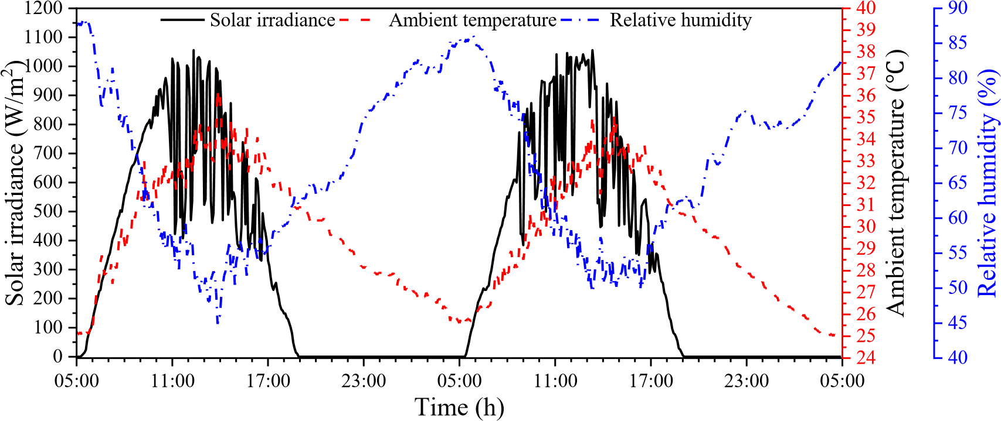
17
18
19
20
21
22
23
24
25
26
27
28
29
30
31
32
33 Fig.5 Variation curves of solar irradiance, ambient temperature and relative humidity
34
35 3.2 Temperature variation and distribution
36
37 Fig.6 shows the temperature change curves of the six temperature measurement 38
39 point systems in the test device with time. Fig.7 shows the radial distribution of different 40
41 thermometric layers every 3 hours. From Fig.6 and Fig.7, the temperature change
42
43
44 characteristics of the six measurement point systems (①-⑥) were similar, but the
45
46 temperature peak time was different. The airflow temperature and collector roof
47
48 temperature reached the peak first, and the seawater temperature reached the peak last. 49
50 Along the radial direction from collector entrance to chimney, the temperature of each 51
52 thermometric layer was first increased and then decreased. And the seawater 53
54 temperature and surface temperature inside and outside the still glass cover of the No.4
solar still were basically the highest. Most of the time the temperature of seawater was the highest of the five thermometric layers, and only around 9:00-12:00, it might be

lower than the temperature of the solar still cover. The temperature of the inner and outer surfaces of solar still cover was almost the same during this period.
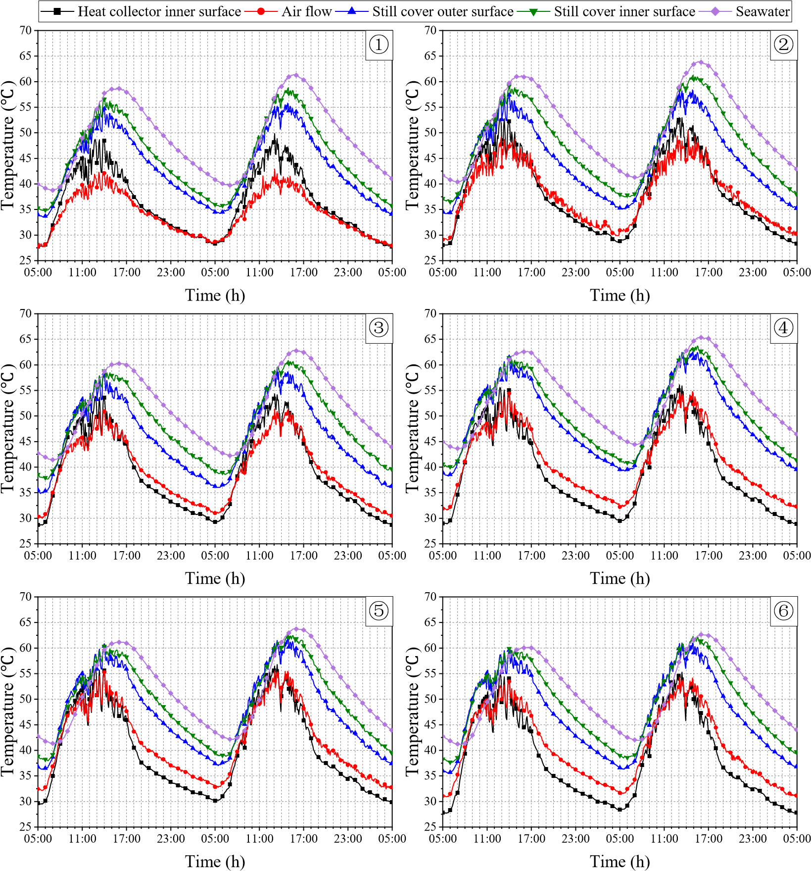
Fig.6 Temperature variation curves of the integrated system
Along the radial direction, both the airflow temperature and collector roof temperature rose first, reached the peak at position ⑤ and then decreased. In the process of the air flowing along the radial direction, the airflow temperature rose greatly from position ① to position ② and dropped significantly from position ⑤ to position ⑥. As the cold air first entered the heat collector, its temperature was low, approximately equal to the ambient temperature. During the radial flow of air, it transferred very little heat to the environment by convection and absorbed more heat due to the large temperature difference between the seawater and the airflow. Therefore, the temperature rise range in the flow segment from position ① to position ② was the largest. In the area of position ⑥, the heating surface of the airflow was greatly reduced, and the flow section was reduced, resulting in an increase in flow velocity. As a result, the heating time of the airflow was shortened, and the heat loss of the hot air flowing from position ⑤ to position ⑥ was greater than the heat gain. Therefore, the temperature of the airflow fell back and there was a significant cooling.
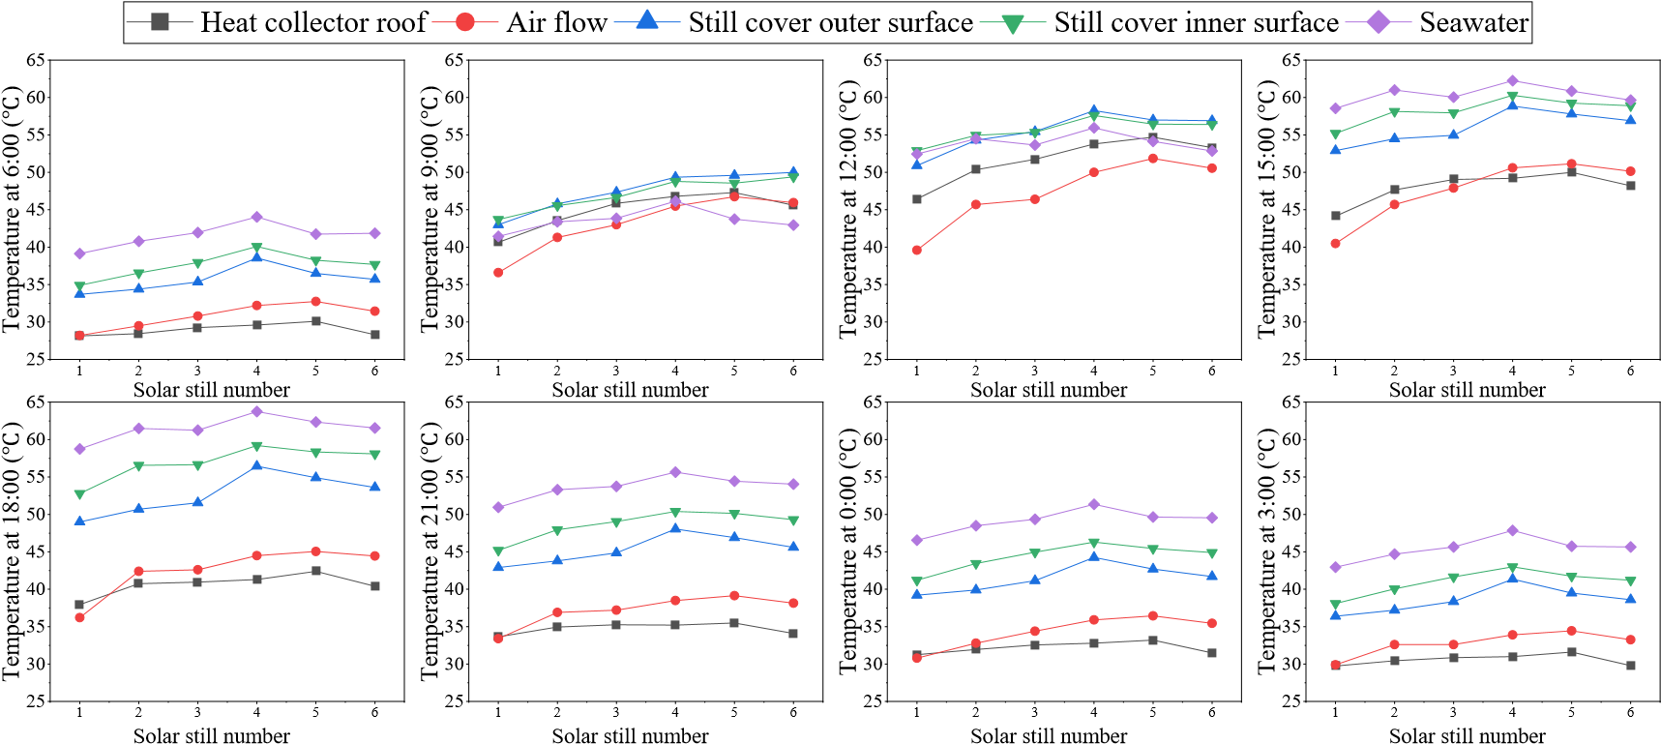
Fig.7 Temperature radial distribution of the integrated system
Between 9:00 and 15:00, the hot airflow temperature was lower than the seawater temperature and collector roof temperature. This meant that the airflow was heated by both seawater and collector roof during this period, so it was heated up rapidly and it had a higher temperature. In other periods, the airflow temperature was higher than the collector roof temperature, and the collector roof was heated by the airflow. The airflow lost the heat it carried through the collector roof, so its temperature was at a medium or low level. The temperature difference between the airflow and collector roof gradually increased along the radial direction, and it reached the maximum in position ⑥. This showed that the heat loss of the airflow in position ⑥ was the most serious, and the airflow in this position was significantly affected by environmental factors.
It can also be found from Fig.6 and Fig.7 that the temperature of each thermometric layer in each measuring point system was much higher than the ambient temperature, even at night. For one thing, the seawater in the solar still had a good heat

storage effect. It released a lot of heat at night to maintain the temperature of the system.
1
2
3 For another, the test device had a good thermal insulation performance and this reduced
4
5 the heat loss of the system at night.
6
7 Then, the measurement point system ④ is used as an example to analyze the 8
9 temperature change characteristics of each thermometric layer, as shown in Fig.6 and 10
11 Fig.7. The overall temperature change trend of each thermometric layer in the 12
13 measurement point system ④ showed a sinusoidal distribution, and it was similar to 14
15 the change characteristics of solar radiation. However, the temperature peak time of
16
17
18 seawater and solar still cover was later than that of solar radiation, and the delayed time
19
20 of seawater temperature was longer. On August 1, the peak time of the seawater 21
22 temperature was 16:00, and the peak time of the internal surface temperature of solar 23
24 still cover was 14:00. This was because most of the solar radiation after sunrise was 25
26 absorbed by the bottom plate of the solar still. Seawater absorbed only a small part of 27
28 the solar radiation, but it also absorbed the heat of the still bottom plate in the form of
29
30
31 convective heat transfer. So, most of the solar radiation was absorbed and stored in
32
33 seawater, resulting in the highest peak temperature of seawater. The seawater was 34
35 heated up slowly due to its large specific heat capacity, which is 4096 J/(kg∙K), causing 36
37 the peak time of seawater temperature to lag behind that of solar radiation. At noon, the 38
39 heating of solar still cover mainly depended on the absorption of the latent heat of 40
41 condensation released by water vapor. The specific heat capacity of the glass cover is
42
43
44 small, which is 837 J/(kg ∙K), so the heating time required for glass cover was shorter
45
46 than that of seawater, and the peak time of glass cover temperature was earlier than that
47
48 of seawater temperature.
49
50 From the temperature change curves of the measurement point system ④ in Fig.6, 51
52 it was found that the temperature of the inner and outer surfaces of the glass cover was 53
54 close during the period from 7:00 to 14:00 on August 1, and these two temperatures 55
56 were higher than seawater temperature for a period of time. This was because seawater
57
58
59 temperature was low during this period and the evaporation of seawater was small. So,
60
61
62
63
64
65
little condensation heat was absorbed by the inner surface of the glass cover, resulting in almost the same temperature on the inner and outer surface of the glass cover. In addition, the glass cover of the solar still had a small specific heat capacity. After absorbing solar radiation, the glass cover was heated up quickly and its temperature 8
9 exceeded the seawater temperature. The temperature difference between the seawater 10
11 and the inner surface of the glass cover became negative, which was not conducive to 12
13 the evaporation of seawater in the solar still. After 14:00, the seawater temperature 14
15 exceeded the glass cover temperature, and a large amount of seawater evaporated and
16
17
18 condensed on the inner surface of the glass cover. The inner surface of the solar still
19
20 glass cover absorbed a large amount of condensation latent heat, and its temperature
21
22 was significantly higher than the temperature of the outer surface.
23
24 After sunrise on August 1, the collector roof temperature and airflow temperature 25
26 rose rapidly. The airflow temperature was higher than the collector roof temperature, 27
28 but the collector roof temperature rose faster. At about 9:00, the collector roof
29
30
31 temperature exceeded the airflow temperature, and it was not until 14:00 that the
32
33 collector roof temperature was lower than the airflow temperature again. The specific
34
35 heat capacity of air can be calculated by equation (4). The specific heat capacity of the
36
37 collector roof is 1170 J/(kg∙K), and it is slightly larger than that of air. During the period 38
39 from 5:00 to 14:00, the temperature of the solar still cover was not high. The heat
40
41 obtained by the airflow from the glass cover by convective heat transfer was less than
42
43
44 the heat absorbed by collector roof from solar radiation. Therefore, although the
45
46 specific heat capacity of the airflow was a little smaller, the heating speed of the airflow
47
48 was less than that of the collector roof. After 14:00, the temperature of the solar still 49
50 cover was significantly increased, and it increased the convective heat transfer to the 51
52 airflow, resulting in a higher temperature of the airflow than that of the collector roof. 53
54 From 14:00 to 8:00 the next day, the airflow temperature was higher than the collector
roof temperature. At this time, the airflow heated the collector roof and lost heat to the environment through the collector roof. This further exacerbated the reduction in the

airflow temperature. The valley temperature of the airflow appeared at sunrise at 5:00.
C_{p air,} 10070.04T_{air} (4)
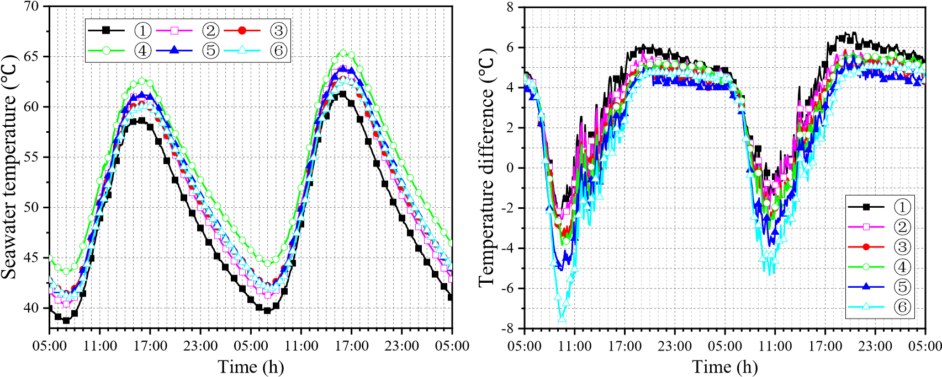
(a) Seawater temperature (b) Temperature difference between seawater and inner surface of solar still glass cover Fig.8 Change curves of seawater temperature and the temperature difference between
seawater and inner surface of solar still cover
Fig.8 shows the change of the seawater temperature and the temperature difference between seawater and the inner surface of the solar still cover T_{wc} of the six temperature measurement point systems. The seawater temperature of the six solar stills basically exceeded 40 , as shown in Fig.8(a). Along the direction from collector entrance to chimney, the seawater temperature rose first and then fell, and the seawater temperature of the No.4 solar still was the highest. There was little difference in seawater temperature in the No.2, No.3, No.5 and No.6 solar still. The seawater temperature in the No.1 solar still was the lowest. For one thing, it was located at the collector entrance, and the airflow temperature above the solar still cover was the lowest. So, the seawater transferred more heat to the airflow, and the seawater itself lost more heat. For another, although insulation layer was laid outside the side walls of the solar still, the heat loss caused by the heat conduction from seawater to the external environment still existed.
From Fig.8(b), the positive temperature difference of the No.1 solar still was the largest. The maximum temperature difference T_{wc} on August 1 reaches 6 , and the

maximum T_{wc} on August 2 exceeded 6 . The period with the positive temperature difference greater than 4 was the longest. The absolute value of the negative temperature difference in the No.1 solar still was the smallest, only 2.2 , and the
8 negative temperature difference lasted the shortest time. As the temperature difference
9
10 T_{wc} was less than or equal to 4 °C, the temperature difference line of the No.6 solar
11
12
13 still was at the bottom of all the temperature difference lines. The absolute value of the
14
15 negative temperature difference in the No.6 still was much greater than that of other
16
17 stills, with a maximum of 7.5 °C, and its negative temperature difference lasted the 18
19 longest time. In the period with the positive temperature difference greater than 4 , 20
21 the temperature difference T_{wc} in the No.6 still was basically the same as that in the
22
23
24 No.3 still, and was slightly higher than that in the No.5 still. 25
26 It was also found from Fig.8 that in the period with the positive temperature
27
28
29 difference greater than 4 , the difference in temperature difference T_{wc} between the
30
31
32 six solar stills was not large, and the difference between the maximum T_{wc} and the
33
34 minimum T_{wc} was within 2 °C. But in the negative temperature difference period,
35
36
37 the difference in temperature difference T_{wc} between the six solar stills was large.
38
39
40 The difference between the maximum and the minimum negative temperature 41
42 difference on August 1 reached 5.3 °C. The literature [35] pointed out that only when 43
44 the water surface temperature exceeds 40 °C and the temperature difference T_{wc} is
45
46
47 positive, can seawater evaporate significantly, and a considerable amount of freshwater 48
49 can be received. All six solar stills met the condition of water surface temperatures 50
51 exceeding 40 °C, and the seawater temperature in the No.4 solar still was the highest.
52
53
54 In addition, considering the analysis of the variation characteristics of temperature
difference T_{wc} , the following conclusions can be drawn. The location of the No.1 solar still is the most favorable for water production, and the water yield of the solar

still in the position 4 is also considerable. But the location of the No.6 solar still is not conducive to the water production of the still.
3.3 Water yield variation and distribution
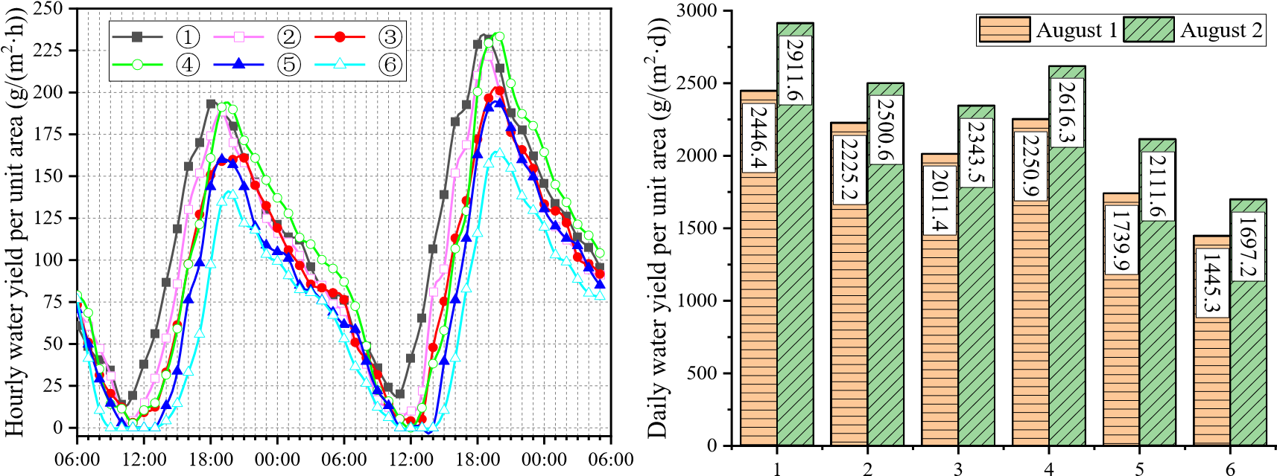
Time (h) Solar still number
Fig.9 Variation curves of freshwater yield Fig.10 Radial distribution of daily water yield
per unit area
Fig.9 shows the variation curves of the water yield of six solar stills in the integrated system. The variation characteristics of the freshwater yield of all the stills were similar, but the amount of the water produced was different. Along the radial direction from the collector entrance to the chimney, the valley and peak value of the hourly water yield per unit area of the solar still gradually decreased. The valley value of the water yield even dropped to zero, which meant that no water was received. It was not desirable that the low water production period and no water production period of the solar still gradually increased along the radial direction.
The water yield of the six solar stills varied significantly during the recovery period of water production. In the order of solar still number 1 to 6, the water yield of the six solar stills began to rise sequentially. The No.1 solar still produced the most freshwater per hour per unit area. It was the first to reach the peak water yield and the peak value was the largest. Due to the superior seawater temperature and moderate temperature difference, the water yield of the No.4 still exceeded that of the No.2 and
No.3 solar still, and its peak water yield was close to that of the No.1 solar still. The
No.5 solar still had a lower water yield than that of No.1-4 still, and the No.6 still had

the lowest water yield. The valley water yield of No.6 still was zero, and its period of no water received was the longest.
During the decline period of water production after the peak water yield, the No.4 solar still had the largest water yield, the No.1, No.2, No.3 and No.5 solar stills had
8
9 little difference in water yield, and the No.6 solar still had the smallest water yield.
10
11 Fig.10 shows the radial distribution of the daily water yield per unit area of the six
12
13 solar stills. From the figure, the daily water yield per unit area of the No.1 solar still had 14
15 the most advantage. The daily water yield of the solar still showed an overall decreasing
16
17
18 trend with the increase of the solar still number, but there was a sudden increase in the
19
20 water yield of the No.4 still, which even exceeded the water yield of the No.2 still. This 21
22 was because the seawater temperature of No.4 still was high, and its hourly water yield 23
24 per unit area in the peak water yield period was large. The daily water yield per unit 25
26 area of the No.1 solar still was 1.69 times and 1.72 times that of No.6 still on August 1 27
28 and August 2, respectively.
29
30
31 In conclusion, solar stills should be arranged as far as possible in the area from the
32
33 collector inlet to the one-third radius of the heat collector.
34
35 3.4 Analysis of the intrinsic relationship between freshwater yield, seawater
36
37 temperature and temperature difference T_{wc}
38
39
40 Although the water production of the solar still was mainly affected by seawater 41
42 temperature and the temperature difference between the seawater and the inner surface
43
44
45 of solar still cover T_{wc} , changes in seawater temperature and temperature difference
46
47 T_{wc} were not synchronized, as seen in Fig.8. To understand the effect of the coupling
48
49
50 of the two on the water yield of the solar still, these three parameters were plotted in 51
52 the same graph for re-analysis. Fig.11 shows the hourly average variation curves of 53
54 water yield per unit area, seawater temperature and temperature difference T_{wc} of the
six solar stills. Here are the common features shown in the six graphs. (1) During the recovery period of water production, seawater temperature and temperature difference

T_{wc} were increasing, and the starting time of the recovery period of water production coincided with that of T_{wc} . (2) During the decline period of water production, the seawater temperature continued to drop. But the T_{wc} changed very little at the
8
9 beginning, and then it quickly decreased. (3) The valley value and peak value of water 10
11 yield appeared around the time corresponding to the valley value and peak value of the
12
13
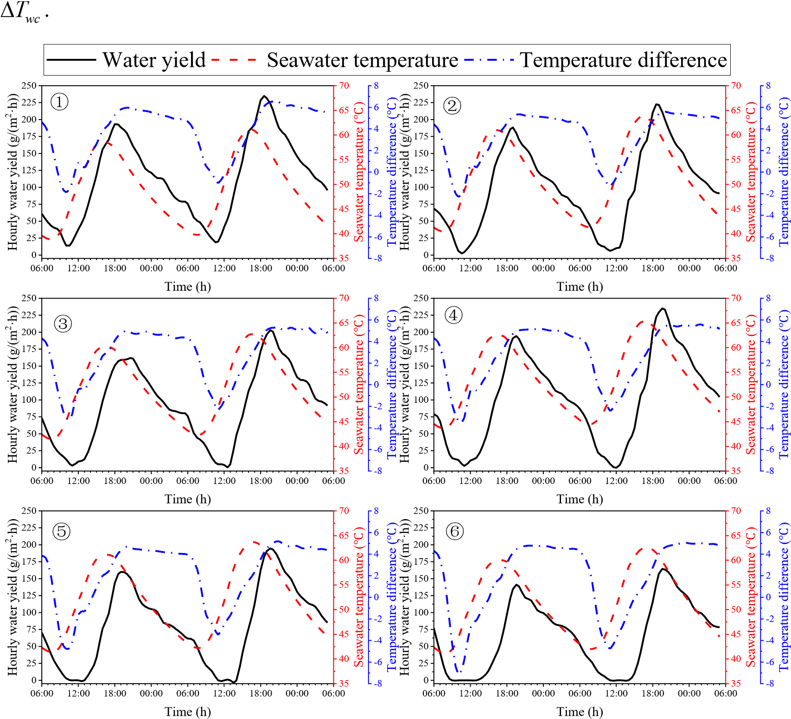
14
15
16
17
18
19
20
21
22
23
24
25
26
27
28
29
30
31
32
33
34
35
36
37
38
39
40
41
42
43
44
45
46
47 Fig.11 Hourly average variation curves of water yield per unit area, seawater temperature and temperature
48
49 difference between seawater and the inner surface of the solar still cover 50
51 The differences shown in Fig.11 are as follows. The No.1 solar still had the lowest 52
- seawater temperature, but the highest water yield. The No.4 still had the highest
- seawater temperature, but produced slightly less water than the No.1 still. These features illustrated that although freshwater production was the result of a combination
of seawater temperature and temperature difference T_{wc} , the extent of their effect on water production was different in different periods. Temperature difference was the main factor affecting water production during the rising period of water production. As
8 the positive temperature difference during the rising period of water production
9
10 increased slightly, the water yield increased significantly. But the sharp increase in
11
12 seawater temperature had little impact on the increase in water yield. Seawater 13
14 temperature was the main factor affecting water production during the decline period 15
16 of water production. Especially at the beginning of the decline of water yield, the value
17
18
19 of temperature difference T_{wc} was always large. But the freshwater yield in this 20
21 period was decreasing, and the decreasing trend was consistent with the trend of 22
23 seawater temperature decline. This phenomenon and assertion can be further illustrated
24
25
26 by the following correlation analysis in statistics.
27
28 In this paper, the correlation analysis method was used to study the intrinsic
29
30 relationship between the water yield, seawater temperature and temperature difference 31
32 T_{wc} . In correlation analysis, the correlation coefficient r was used to describe the
33
34
35 correlation between two variables. The meaning of the r is as follows.
36
37 (1) Positive correlation: If the variables x and y change in the same direction, it is 38
39 generally believed that if r  0.95, there is a significant correlation. If r  0.8，there
40
41
42 is a high correlation. If 0.5 r 0.8, there is a moderate correlation. If 0.3 r 0.5,
43
44
45 there is a low correlation. If r  0.3, the correlation is extremely weak and the two
46
47
48 variables are considered unrelated.
49
50 (2) Negative correlation: If the variables x and y change in the opposite direction,
51
52 r 0.
53
54 (3) No linear correlation: r 0.
Considering that seawater is the main energy carrier of the solar still, the seawater temperature has a great impact on the temperature of solar still cover. According to the rise and decrease of seawater temperature, the water production period was divided into rising period and falling period. In these two periods, the intrinsic relationship between freshwater yield and seawater temperature and between freshwater yield and
temperature difference T was discussed. The experimental data were collected
8 _{wc}
9
10 from the six solar stills on August 1 and 2. Data points that did not meet the
11
12 requirements were eliminated. Since the experimental data did not meet the normal
13
14 distribution, Spearman correlation coefficient was used to describe the correlation of
15
16 variables, and the calculation formula is as follows.
17
- n ²
- 6(R_{i} Q_{i} )
- r_{s}  1 ^{i}n n¹ ( ₂ ₁₎ (5)
21
22
23
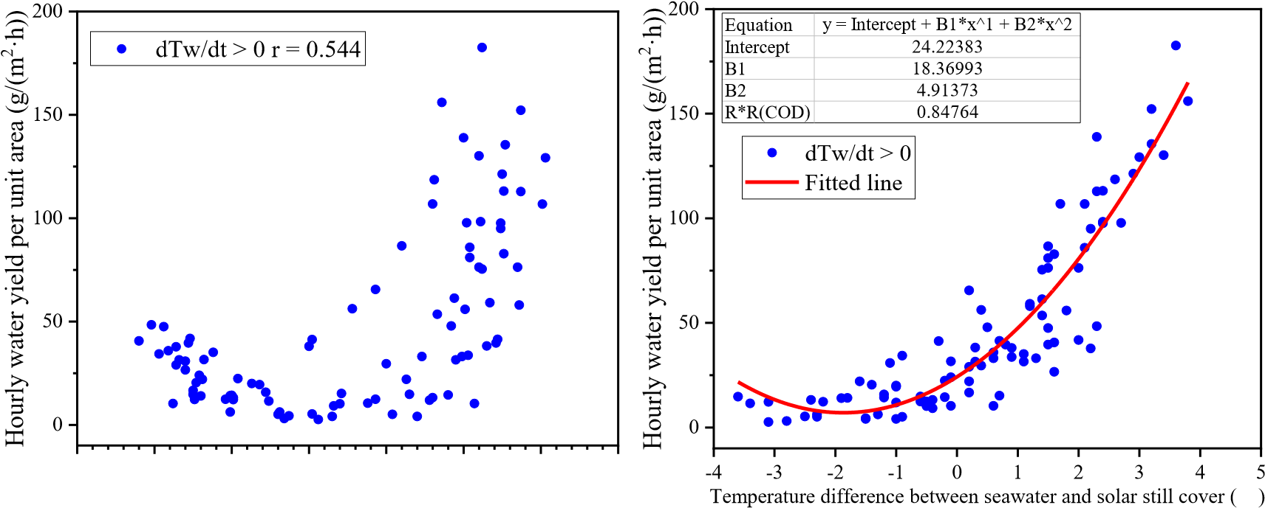
24 Where, R_{i} represents the rank of x_{i} , and Q_{i} represents the rank of y_{i} .
25
26
27
28
29
30
31
32
33
34
35
36
37
38
39
40
41 (a) Rising period of seawater temperature
42
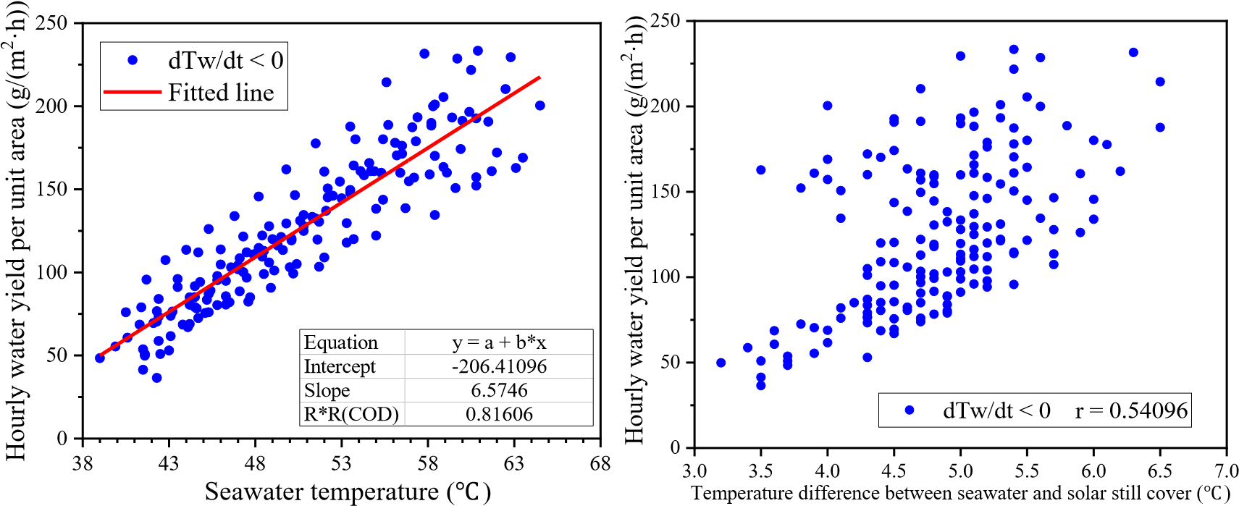
43
44
45
46
47
48
49
50
51
52
53
54
(b) Falling period of seawater temperature
Fig.12 Changes in freshwater yield with seawater temperature and temperature difference T_{wc}
Fig.12 shows how freshwater yield varies with seawater temperature and temperature difference T_{wc} , respectively. From Fig.12(a), freshwater yield was mainly affected by temperature difference during the rising period of seawater
8 temperature, and the relationship between the two was a quadratic function. The fitting 9
10 formula between the two was m_{w}  4.91T_{wc}² 18.37 T_{wc} 24.23 , R²  0.847 .
11
12
13 Where, m_{w} represents the hourly freshwater yield per unit area, g/(m²∙h). The
14
15
16 correlation coefficient r between m_{w} and temperature difference T_{wc} and between
17
18
19 m_{w} and seawater temperature T_{w} in this period was 0.891 and 0.544, respectively. 20
21 This indicated that freshwater yield was highly correlated with the temperature
22
23
24 difference T_{wc} , and moderately correlated with the seawater temperature. Therefore, 25
26 the water yield in this period was mainly determined by the temperature difference
27
28
29 T_{wc} .
30
31 From Fig.12(b), the freshwater yield and seawater temperature showed an obvious 32
33 linear relationship during the falling period of seawater temperature. The fitting formula
34
35
36 was m_{w}  6.57T_{w} 206.41, R²  0.816. The correlation coefficient r between m_{w}
37
38
39 and seawater temperature T_{w} and between m_{w} and temperature difference T_{wc} in
40
41 this period was 0.920 and 0.541, respectively. This indicated that freshwater yield was
42
43
44 highly correlated with the seawater temperature, and moderately correlated with the
45
46 temperature difference T_{wc} . Therefore, the water yield in this period was mainly
47
48
49 determined by seawater temperature.
50
51 The above results show that the temperature difference T_{wc} drives the
52
53
54 evaporation of seawater and is the driving force of water production. Also, seawater
temperature has an important influence on the amount of evaporation. During the test, seawater temperature in the integrated device maintained at a very high level (> 44), and evaporation occurred throughout. Therefore, maintaining a high temperature

difference T_{wc} is a necessary condition for the system to produce a large amount of freshwater in summer.
3.5 Temporal characteristics analysis of water production

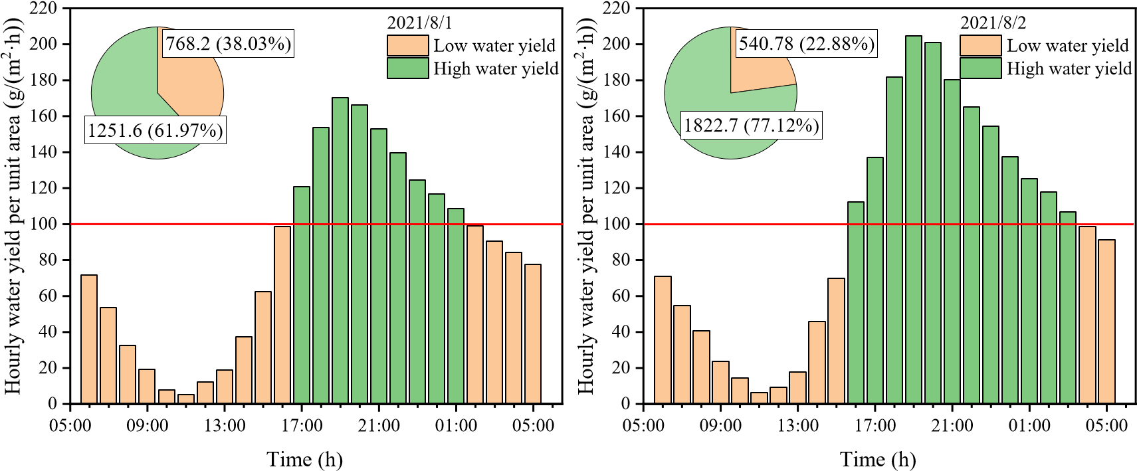
(a) High and low water yield period on Augest 1 (b) High and low water yield period on Augest 2
Fig.13 Temporal characteristics of freshwater production of the integrated system
It is of guiding significance for the operation and management of the integrated system to understand the characteristics of freshwater production in different periods. Fig.13 shows the freshwater yield of the six solar stills (average value) in the system for one day and night. Taking the hourly water yield per unit area of 100 g/(m²∙h) as the dividing line, the water production period was divided into high-water yield period and low-water yield period, as shown in Fig.13. The high-water yield period on August 1 (17:00 to 1:00 the next day) accounted for only 33.3% of the total duration of the test day, but it contributed 61.97% of the total water yield. The low-water yield period on August 1 accounted for 66.7% of the total duration of the test day, but it only contributed 37.03% of the total water yield. The high-water yield period on August 2 (16:00 to 3:00 the next day) accounted for 45.83% of the total duration of the test day, and it contributed 77.12% of the total water yield. The low-water yield period on August 2
accounted for 54.17% of the total duration of the test day, but it only contributed 22.88% of the total water yield. The operating characteristics in different water production periods showed that the high-water yield period generally occurred between sunset and
1-3 a.m. Although this period accounted for a small proportion of the day's operating

time, it contributed most of the water produced. Therefore, it is necessary to strengthen the management of this operation period, reducing the failure rate of the device and manual error rate to ensure the efficient water production of the device.
Referring to Fig.11, it was found that the seawater temperature and temperature 8
9 difference T_{wc} in the high-water yield period were both at a high level. This once
10
11
12 again showed that a high seawater temperature and a high temperature difference T_{wc}
13
14
15 were the guarantee for the efficient water production of the device.
16
17 3.6 Power output
18
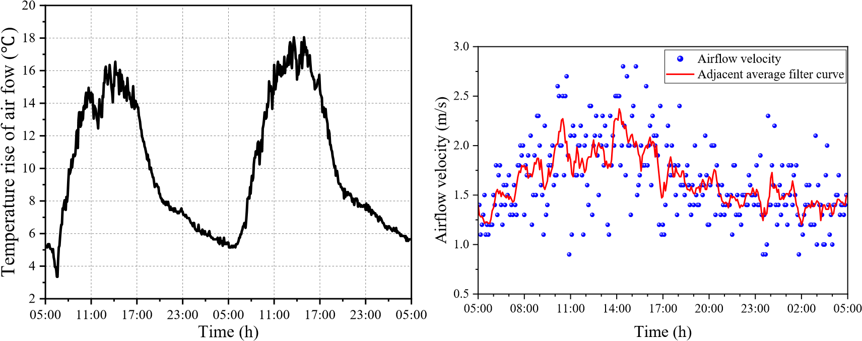
19
20
21
22
23
24
25
26
27
28
29
30
31
32
33
34
35 Fig.14 Changes in airflow temperature rise Fig.15 Variation curve of airflow velocity in the chimney
36
37 The airflow temperature rise is defined as the temperature difference between the 38
39 airflow at the chimney base and the environment. Fig.14 shows that the maximum and 40
41 minimum temperature rise of the airflow in the chimney were 17 and 5 ,
42
43
44 respectively. The airflow temperature rise obtained was considerable, and the minimum
45
46 temperature rise was 5 even at night. This highlighted the advantage of the thermal
47
48 storage effect of seawater in the system.
49
50 Fig.15 shows the change of airflow velocity in the chimney on August 1. The hot 51
52 airflow in the chimney was affected by turbine rotation and ambient wind speed, so the 53
54 airflow velocity fluctuated greatly. The filtering curve of the airflow velocity
approximately conformed to the sine curve, and its distribution profile was approximately a sinusoidal region. The peak period of the airflow velocity was at noon, and the airflow velocity at night was maintained at about 1.5 m/s. The variation characteristics of the airflow velocity during the daytime were similar to those of the solar irradiance. At night, the seawater in the solar still dissipated heat to the outside to maintain a certain airflow temperature and airflow velocity.
8
9 The hot airflow in the chimney drove the wind turbine to rotate, which in turn 10
11 drove the DC generator to rotate and generate electricity. In order for the output power 12
13 to drive the LED, the output voltage of the generator was raised to 5 V through a 14
15 regulator module. During the test operation of the device, the turbine drove the
16
17
18 generator to light up the LED. This experimental phenomenon demonstrates that the
19
20 SCPPCD can realize the water-electricity cogeneration.
21
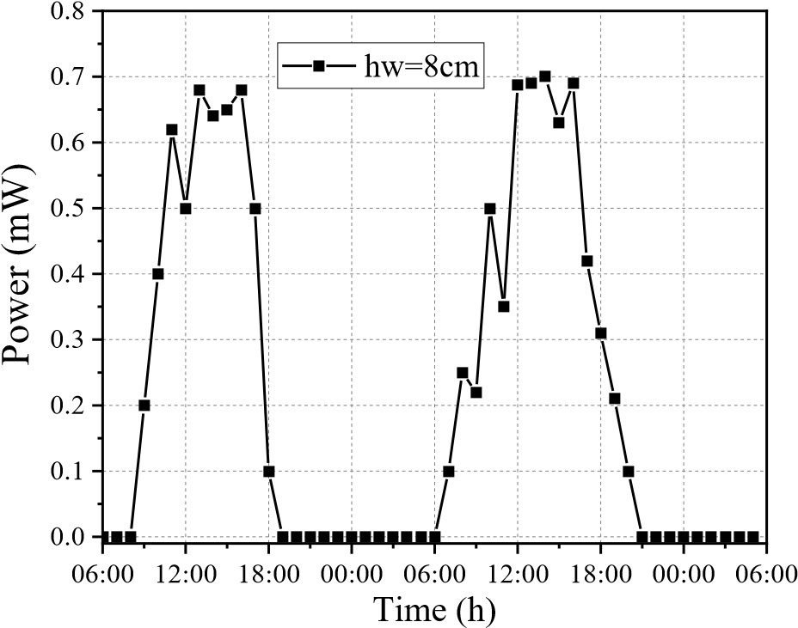
22
23
24
25
26
27
28
29
30
31
32
33
34
35
36
37 Fig.16 Variation curve of generator power output
38
39
40 Fig.16 shows the change curve of the generator power output. The change of 41
42 generator power output was similar to that of the airflow temperature rise. The 43
44 maximum generator power appeared at noon, about 0.70 ×10⁻³ W. Although the airflow 45
46 temperature rise was considerable at noon (Fig.14), the output power of the test device
47
48
49 was small. This was because compared with the Spanish SCPP [2], the test device
50
51 constructed in this paper was still too small in scale, and the heat collector was only a
52
- fan-shaped area. The small size of the device resulted in increased heat dissipation,
- shortened the time the air was heated in the collector and increased the pressure losses in the system. After sunset, the airflow in the chimney was still flowing due to the temperature rise. However, due to the small scale of the device and thin heat storage
water layer, the heat storage was insufficient, the airflow temperature rise dropped a lot, and the airflow velocity was decreased. The pressure potential energy and kinetic energy of the airflow were not enough to overcome the energy consumption caused by factors such as frictional resistance and generator electromagnetic resistance. Therefore, 8
9 the hot airflow could not drive the turbine to rotate in this period, and the generator
10
11 output power was 0 W.
12
13 The daily utilization efficiency of solar energy of the integrated system can be
14
15 calculated by the following formula:
16
17
- 24 6 24
- S h ms j, fg e s i j, , ,  t Pe i, t
- _{sol s,}  i 1 j 1 ₂₈₈ t i1 (6)
2122 Scol i1 Ii 12
23
24
25 Where, t stands for an hour. The sampling interval for freshwater production 26
27 and power generation was one hour, and the sampling interval for solar irradiance was 28
29 five minutes. h_{fg} represents the latent heat of water vaporization, J/g. S_{col} represents
30
31
32 the area of the heat collector, m². S_{s j,} represents the area of the No.j solar still, m².
33
34
35 m_{e s i j, , ,} represents the water yield of the No.j solar still, g/(m²·h). I represents the solar
36
37
38 irradiance, W/m². P_{e} represents the output power of the generator, W.
39
40
41 It was calculated that the daily utilization efficiency of solar energy of the
42
43 integrated system on August 1 and 2 was 19.6% and 21.8%, respectively. Limited by 44
45 thermodynamic properties, the solar energy utilization efficiency of the conventional 46
47 solar chimney power plant is generally less than 1% [2,3,10,25,37]. Compared with the 48
49 traditional solar chimney power plants, the solar energy utilization efficiency of
50
51 SCPPCD was significantly improved.
52
53
54 In the SCPPCD, since the latent heat of vaporization released by the condensation
of water vapor was recycled and freshwater was produced, the solar energy utilization efficiency and land utilization rate were greatly improved, which was the meaning of integrating the freshwater generation with electricity generation. The SCPPCD is suitable for construction in desolate tidal flat areas along the coast.

4. Conclusion
In this paper, a comprehensive test platform for solar chimney power plant combined with distillation (SCPPCD) that can realize water-electricity cogeneration 8
9 was designed and successfully built. The operation and output characteristics of
10
11 SCPPCD were tested and analyzed, and the following findings were obtained.
12
13 (1) The temperature variation of thermometric layers in each measuring point 14
15 system was similar, but the peak time of temperatures was different. The temperature
16
17
18 of each thermometric layer at the same moment increased first and then decreased from
19
20 the collector entrance to the chimney. The seawater temperature and solar still cover 21
22 temperature of the No.4 solar still were basically the highest. In the same measurement 23
24 point system, seawater temperature was the highest most of the time. The airflow
25
26 temperature was lower than collector roof temperature most of the time, and it lost heat 27
28 through the collector roof.
29
30
31 (2) Freshwater production was the result of a combination of seawater temperature
32
33 T_{w} and temperature difference T_{wc} , but the extent of their effect on water production
34
35
36 was different in different periods. Temperature difference T_{wc} was the main factor 37
38 affecting water production during the rising period of water production. Seawater
39
40
41 temperature T_{w} was the main factor affecting water production during the decline
42
43
44 period of water production.
45
46 (3) The daily water yield per unit area of the solar still basically decreased from
47
48 the heat collector entrance to the chimney. The No.1 solar still had the highest daily 49
50 water yield per unit area, and the water yield of the No.4 still was second only to the 51
52 No.1 still. The daily water yield of the No.1 still on August 1 and 2 was 1.69 times and 53
54 1.72 times that of the No.6 still, respectively. Solar stills should be arranged as far as
possible in the area from the collector inlet to the one-third radius of the heat collector.
- The high-water yield period generally occurs between sunset and 1-3 a.m. It
accounted for a small proportion of the day's operating time, but contributed most of the water produced.
- The maximum temperature rise of hot airflow in the chimney was 17, and the temperature rise was maintained above 5 during night operation. The variation 8
9 law of generator power was similar to that of airflow temperature rise, and the 10
11 maximum output power reached 0.71 mW in the daytime. But the power generation 12
13 could not be realized at night limited by the scale of the test device. The daily utilization
14
15 efficiency of solar energy on August 1 and 2 was 19.6% and 21.8%, respectively.
16
17

18 Acknowledgment
19
20 This research was financially supported by National Natural Science Foundation
21
22 of China (No. 51976053).
23

24 Reference
25
26 [1] J. Schlaich, R. Bergermann, W. Schiel, G. Weinrebe, Design of Commercial Solar 27
28 Updraft Tower Systems—Utilization of Solar Induced Convective Flows for
29
30
31 Power Generation, Journal of Solar Energy Engineering 127(1) (2005).
32
33 [2] W. Haaf, K. Friedrich, G. Mayr, J. Schlaich, Solar chimneys part I: principle and
34
35 construction of the pilot plant in Manzanares, International Journal of Solar Energy
36
37 2(1) (1983) 3-20.
38
39 [3] W. Haaf, Solar chimneys: part ii: preliminary test results from the Manzanares 40
41 pilot plant, International Journal of Sustainable Energy 2(2) (1984) 141-161.
42
43
44 [4] N. Pasumarthi, S.A. Sherif, Experimental and theoretical performance of a
45
46 demonstration solar chimney model—Part II: experimental and theoretical results
47
48 and economic analysis, International Journal of Energy Research 22(5) (1998)
49
50 443-461.
51
52 [5] X. Zhou, J. Yang, B. Xiao, G. Hou, Experimental study of temperature field in a 53
54 solar chimney power setup, Applied Thermal Engineering 27(11-12) (2007) 20442050.
- A.B. Kasaeian, E. Heidari, S.N. Vatan, Experimental investigation of climatic
effects on the efficiency of a solar chimney pilot power plant, Renewable and Sustainable Energy Reviews 15(9) (2011) 5202-5206.
- S. Kalash, W. Naimeh, S. Ajib, Experimental investigation of the solar collector temperature field of a sloped solar updraft power plant prototype, Solar Energy 98
8
9 (2013) 70-77.
10
11 [8] M. Fathy Cidek Esmail, T. Mekhail, Investigations of the instantaneous 12
13 performance of a solar chimney power plant installed in Aswan using IoT, IET
14
15 Renewable Power Generation 13(12) (2019) 2261-2266.
16
17
18 [9] R. Balijepalli, V.P. Chandramohan, K. Kirankumar, Development of a small scale
19
20 plant for a solar chimney power plant (SCPP): A detailed fabrication procedure, 21
22 experiments and performance parameters evaluation, Renewable Energy 148
23
24 (2020) 247-260.
25
26 [10] P. Guo, T. Li, B. Xu, X. Xu, J. Li, Questions and current understanding about solar 27
28 chimney power plant: A review, Energy Conversion and Management 182 (2019)
29
30
31 21-23.
32
33 [11] Y. Wang, Z. Fang, L. Zhu, Z. Yang, J. Wang, L. Han, Study on the integrated
34
35 utilization of seawater by solar chimney, Acta Energiae Solaris Sinica 04 (2006)
36
37 382-387.
38
39 [12] X. Zhou, B. Xiao, W. Liu, X. Guo, J. Yang, J. Fan, Comparison of classical solar 40
41 chimney power system and combined solar chimney system for power generation
42
43
44 and seawater desalination, Desalination 250(1) (2010) 249-256.
45
46 [13] A. Azad, E. Aghaei, A. Jalali, P. Ahmadi, Multi-objective optimization of a solar
47
48 chimney for power generation and water desalination using neural network,
49
50 Energy Conversion and Management 238 (2021) 114152.
51
52 [14] S. Kiwan, M.d. Al-Nimr, Q.I. Abdel Salam, Solar chimney power-water 53
54 distillation plant (SCPWDP), Desalination 445 (2018) 105-114.
- E. Abdelsalam, F. Kafiah, M. Tawalbeh, F. Almomani, A. Azzam, I. Alzoubi, M. Alkasrawi, Performance analysis of hybrid solar chimney–power plant for power production and seawater desalination: A sustainable approach, International Journal of Energy Research 45(12) (2020) 17327-17341.
- E. Abdelsalam, F. Almomani, F. Kafiah, et al. A New Sustainable and Novel
Hybrid Solar Chimney Power Plant Design for Power Generation and Seawater
8
9 Desalination, Sustainability 13(21) (2021) 12100.
10
11 [17] E. Abdelsalam, F. Almomani, S. Ibrahim, A novel hybrid solar chimney power 12
13 plant: Performance analysis and deployment feasibility, Energy Science and
14
15 Engineering (2022) 1-21. doi:10.1002/ese3.1240
16
17
18 [18] T. Salameh, A.G. Olabi, M.K.H. Rabaia, et al. Economic and environmental
19
20 assessment of the implementation of solar chimney plant for water production in 21
22 two cities in UAE, Thermal Science and Engineering Progress 33 (2022) 101365. 23
24 [19] N. Niroomand, M. Amidpour, New combination of solar chimney for power 25
26 generation and seawater desalination, Desalination and Water Treatment 51(40-42) 27
28 (2013) 7401-7411.
29
30
31 [20] T. Ming, T. Gong, R.K.d Richter, W. Liu, A. Koonsrisuk, Freshwater generation
32
33 from a solar chimney power plant, Energy Conversion and Management 113 (2016)
34
35 189-200.
36
37 [21] T. Ming, T. Gong, R.K.d Richter, Y. Wu, W. Liu, A moist air condensing device 38
39 for sustainable energy production and water generation, Energy Conversion and 40
41 Management 138 (2017) 638-650.
42
43
44 [22] T. Ming, T. Gong, R.K.d Richter, C. Cai, S.A. Sherif, Numerical analysis of
45
46 seawater desalination based on a solar chimney power plant, Applied Energy 208
47
48 (2017) 1258-1273.
49
50 [23] C. Méndez, Y. Bicer, Integrated system based on solar chimney and wind energy 51
52 for hybrid desalination via reverse osmosis and multi-stage flash with brine 53
54 recovery, Sustainable Energy Technologies and Assessments 44 (2021) 101080.
- L. Zuo, Z. Yang, N. Qu, P. Dai, T. Zhou, Y. Zheng, Y. Ge, Solar chimney power plant combined with membrane distillation (SCPPMD), part I: Principle and operation characteristics, Energy Conversion and Management 258 (2022) 115501.
- L. Zuo, Y. Zheng, Z. Li, Y. Sha, Solar chimneys integrated with sea water desalination, Desalination 276(1-3) (2011) 207-213.
- M. Asayesh, A. Kasaeian, A. Ataei, Optimization of a combined solar chimney for 8
9 desalination and power generation, Energy Conversion and Management 150
10
11 (2017) 72-80.
12
13 [27] L. Zuo, L. Ding, J. Chen, X. Zhou, B. Xu, Z. Liu, Comprehensive study of wind 14
15 supercharged solar chimney power plant combined with seawater desalination,
16
17
18 Solar Energy 166 (2018) 59-70.
19
20 [28] L. Zuo, L. Ding, J. Chen, Z. Liu, N. Qu, X. Zhou, Y. Yuan, The effect of different 21
22 structural parameters on wind supercharged solar chimney power plant combined 23
24 with seawater desalination, Energy Conversion and Management 176 (2018) 37225
26 383.
27
28 [29] L. Zuo, Z. Liu, L. Ding, N. Qu, P. Dai, B. Xu, Y. Yuan, Performance analysis of a
29
30
31 wind supercharging solar chimney power plant combined with thermal plant for
32
33 power and freshwater generation, Energy Conversion and Management 204 (2020)
34
35 112282.
36
37 [30] L. Zuo, P. Dai, Z. Liu, N. Qu, L. Ding, B. Qu, Y. Yuan, Numerical analysis of wind 38
39 supercharging solar chimney power plant combined with seawater desalination 40
41 and gas waste heat, Energy Conversion and Management 223 (2020) 113250.
42
43
44 [31] P. Rahdan, A. Kasaeian, W. Yan, Simulation and geometric optimization of a
45
46 hybrid system of solar chimney and water desalination, Energy Conversion and
47
48 Management 243 (2021) 114291.
49
50 [32] K. Rahbar, A. Riasi, Performance enhancement and optimization of solar chimney
51
52 power plant integrated with transparent photovoltaic cells and desalination method, 53
54 Sustainable Cities and Society 46 (2019) 101441.
- S. Kiwan, M.d. Al-Nimr, I. Salim, A hybrid solar chimney/photovoltaic thermal system for direct electric power production and water distillation, Sustainable Energy Technologies and Assessments 38 (2020) 100680.
- C.B. Maia, F.V.M. Silva, V.L.C. Oliveira, L.L. Kazmerski, An overview of the use of solar chimneys for desalination, Solar Energy 183 (2019) 83-95.
- L. Zuo, Y. Yuan, Z. Li, Y. Zheng, Experimental research on solar chimneys 8
9 integrated with seawater desalination under practical weather condition,
10
11 Desalination 298 (2012) 22-33. 12
13 [36] F. Cao, Q. Liu, H. Xiao, Experimental study of a humidification-dehumidification 14
15 seawater desalination system combined with the chimney, International Journal of
16
17
18 Photoenergy (2020), https://doi.org/10.1155/2020/1937040.
19
20 [37] E. Gholamalizadeh, M. Kim, Thermo-economic triple-objective optimization of a 21
22 solar chimney power plant using genetic algorithms, Energy 70 (2014) 204-211.
23

24
25
26
27
28
29
30
31
32
33
34
35
36
37
38
39
40
41
42
43
44
45
46
47
48
49
50
51
52
53
54

Supplementary MATLAB .fig files

Click here to access/download
Supplementary MATLAB .fig files Supplementary File.docx

Corresponding author. E-mail address: zuoluhhu@163.com (L. Zuo).
Corresponding author. E-mail address: zuoluhhu@163.com (L. Zuo).

