To Formulate a Conceptual Model for Innovation: Reframing theoretical constructs of BIM adoption within SMEs Organisations

The Construction industry is facing a paradigm shift in the adoption of new innovative ways of designing and delivering of projects. This innovative process includes building information modelling (BIM) which have shown significant impact on efficiency and effectiveness during a project development process within the construction industry. However, the shift to its acceptance, adoption and implementation in the emerging markets has brought distortion in the organisational culture, behaviour, and business processes of small medium enterprises (SMEs). This is often associated to the lack of clear orientation of the impact of BIM adoption to the firms. Although several theories have explained different concept relating to acceptance of innovative technologies within an organisation, however, it is crucial to understand this concept through the lens of BIM. Thus, this paper identifies the different theories concerning BIM acceptance within organisations and highlights the relationship between different factors that influence BIM acceptance within organisations. This was achieved by identifying the key factors that influence the acceptance of innovation and the process of adopting an innovation within organisations. The study involved a two-step analysis; systematic literature review and theoretical formulation. The systematic literature review was used to identify various theories and models that explains the acceptance process and behaviour of individuals during adoption of new innovations within SMEs organisations. The theoretical formulation was achieved by synthesizing the key influencing factors and indicators identified from the systematic literature review. The output from the systematic literature review and theoretical formulation was consolidated to form the conceptual model that would be the basis of further research and will help in understanding the relationship between factors that influence BIM acceptance process within SMEs organisation in the construction industry.
Keywords: building information modelling (BIM), conceptual model, construction industry, innovation adoption, organizations, small and medium enterprise (SME), theoretical construct.

Introduction
The construction industry possesses a unique status in the development of a nation’s economy, report by Latham, (1994) has shown that the construction industry has been attributed with the lack of productivity and inefficiency in construction project delivery due to poor communication between construction stakeholders and the fragmented nature of the industry. Egan, (2002) also reiterated in his report the need for effective processes of design and construction throughout lifecycle processes. Among the study made in response to the above accusations ranges from new contractual/procurement arrangements like partnering, concurrent engineering, integrated project delivery (Ibrahim, Price, & Dainty, 2006; Y.-W. Kim & Dossick, 2011) to innovations in ways to design and deliver construction processes such as three-dimensional computer aided design and modelling (Underwood & Isikdag, 2011). However, building information modelling (BIM) is among such innovative process that promises to bring about continuous improvement and desired change within the construction industry.
Building information modelling has various definition. According to buildingSMART International, (2016), it is defined as “the digital representation of the physical and functional characteristics of a facility”. Therefore, this aids in obtaining reliable information from a shared knowledge resource about a facility which can serve as a basis for decision making during the project lifecycle (Arayici et al., 2011). BIM technologies benefits as claimed by its advocates includes improved data exchange and communication, improved collaboration and coordination of documents used in construction, improved design visualization and quantification, clash detection and cost reduction among others (Eastman, Teicholtz, Sacks, & Liston, 2012; Ghaffarianhoseini et al., 2017; Liu, van Nederveen, & Hertogh, 2017). Furthermore, countries that have adopted BIM at various level of their construction projects and documented substantial evidence of improvement in project delivery (Liu et al., 2017; Mollasalehi et al., 2017; Wong, 2018).
The nature of BIM will not allow firms to do the same things in a new way and therefore it is difficult to come up with a single model of BIM adoption for the AEC industry. According to Aranda-Mena, Crawford, Chevez, & Froese, (2008) ‘In order for a business case to be reliable, it must be developed to achieve specific objectives or outcomes taking into consideration the particular needs and characteristics of the company. The clearer the objectives are defined, and the specific circumstances of the company analysed, the better the business case will be.' It is especially true with the small and medium enterprises considering their nature and culture. Thus, the aim of this paper is to develop a conceptual model of BIM acceptance that will have the power to demonstrate acceptance and usage behaviour of BIM within SME’s through; (a) identifying the key research trends of BIM adoption within SME, (b) identifying the theoretical models related to innovation adoption with a focus on BIM and, (c) identifying the key factors that influence BIM adoption within organization. A Thorough understanding of the model will help practitioners to analyse the reasons for resistance toward the BIM and will also help to take efficient measures to improve BIM usage and acceptance within SME.

Innovation diffusion theories
Crucial to examining the prospects of BIM adoption in a given context, particularly amongst the small and medium size firms, it is important to establish the level of how similar technologies are adopted in that context and identify the specific factors that affect it. According to Rogers, (2010),the level of innovation adoption can be determined or gauged by several factors. Perhaps most important among them are subjective perceptions derived from personal experiences. These perceptions and how they are shared across networks are shown to drive the innovation diffusion process. BIM is a complex tool that requires fundamental changes in existing methods. These qualities are likely to produce subjective perceptions and personal experiences that seriously impact the diffusion process. Rogers continues to define five stages involved in the adoption process, knowledge, persuasion, decision, implementation, and confirmation as seen in the Figure 4 below. These stages provides a basis to formulate a theoretical framework for investigating adoption process of BIM in the small and medium-sized firms. Theories of Diffusion of Innovation by Rogers, (2010) is, therefore, crucial to this research, which is determining emerging models in the wake of ICT adoption in the Nigerian context. The unit of analysis for this study will be the small and medium size architectural firm as an organisation.
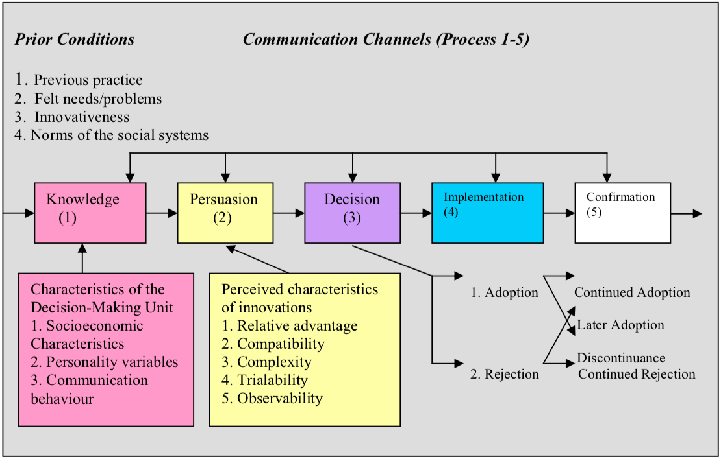 Figure 1: A model of innovation diffusion theory (Rogers, 1995).

Technology acceptance model
One of the key measures of identifying level of BIM adoption is achieving the intended level of usage of the technology. Kim, Lee, Mun, & Johnson, (2017) claimed that users’ positive attitude and belief in technology are related to user tendencies in accepting technology and therefore, technology usage is a reflection of acceptance by users. Similarly, while BIM usage has many benefits for information management in the AEC, the usage of BIM as new technology causes increased BIM user’s resistance. The factors causing BIM user resistance are rather not necessary technological but environmental factors and organization-related factors of the users. That is, if organizations are not ready for these factors, it is difficult for a BIM user to obtain the expected positive effects from BIM usage.
Technology acceptance model (TAM) introduced by Davis, Bagozzi, & Warshaw, (1989) is an adaptation of the theory of reasoned action (TRA) and the theory of planned behaviour (TPB) specifically tailored for modelling this user behaviour in acceptance of technology. The goal of TAM is to provide an explanation of the determinants of technology acceptance that is capable of explaining user behaviour across a broad range of end-user computing technologies and user populations, while at the same time being both parsimonious and theoretically justified. In this model, perceived usefulness and perceived ease of use are of primary relevance for Information Systems (IS) acceptance behaviour as seen in Figure below.
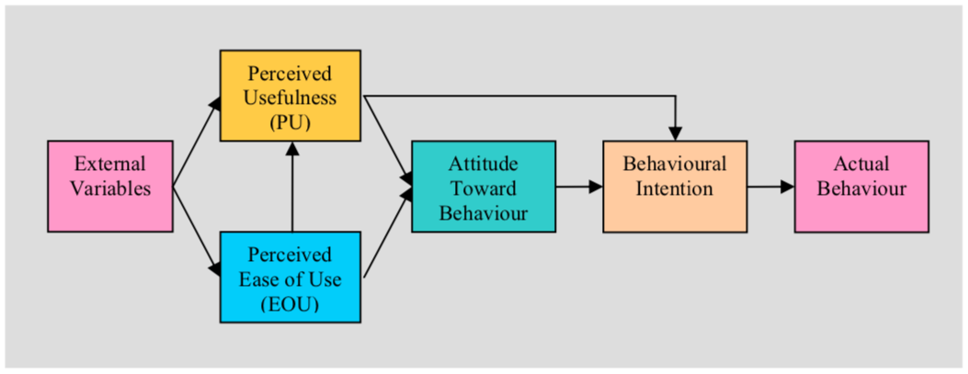 Figure 2: Technology acceptance model (Davis, Bagozzi, & Warshaw, 1989)

METHODS
There are different methods to carry out systematic literature review (SLR) which are all explicit, rigorous and comprehensive (Albliwi, Antony, & Lim, 2015). According Pinho, Franco, & Mendes, (2018), the most quoted method of SLR in the area of Social Sciences are, (1) Planning the review, (2) Carrying out the review and (3) Disseminating the results obtained. This research adopted similar method.
The databases that were used to carry out the search are namely; Scopus, Web of Science, EBSCO host and Emerald Insight. The search expression as detailed below is existing on the topic or title, keywords and abstract. The area of the search was restricted to research papers, articles, reviews, conference papers and conference reviews that are written in English language within the last decade. After this process the Scopus database produced a total of 93 articles, the Web of Science produced 6, the EBSCO host produced 7 and the Emerald Insight produced 5, making a total of 111 articles. Subsequently, using Mendeley Desktop referencing tool version (1.19.3), 3 duplicate articles were removed leaving a total of 108. The selected articles was further presented using VOS viewer which is a computer program developed for constructing and viewing bibliometrics mapping using graphical representation.
The table below shows the number of documents retrieved from each step of the search process. Step I, Step II and Step III are different search strings as shown below while Step IV involved additional criteria to ensure that only articles relevant to the study are selected. The search strings are as follows:
- Step I: ("building information modelling" AND bim)
- Step II: ("building information modelling" AND bim) AND (adoption* OR implementation*)
- Step III: ("building information modelling" AND bim) AND (adoption* OR implementation*) AND ("SME")
- Step IV: Excluding the irrelevant document types and restricted the number of years to (2010 -2019).

Table 1: Number of articles retrieved from various databases.
 | Step I | Step II | Step III | Step IV
Scopus | 4,174 | 2,296 | 108 | 93
Web of Science | 1,125 | 528 | 6 | 6
EBSCO host | 8,290 | 720 | 8 | 7
Emerald Insight | 329 | 281 | 12 | 5

RESults
Analysis of BIM adoption research trends based on bibliographic coupling
Studying the bibliographic network among 108 publications in our dataset, three distinct clusters can be identified. The figure below illustrates a relative coherent bibliographic network on BIM adoption within SME publication published between 2010 and 2019.
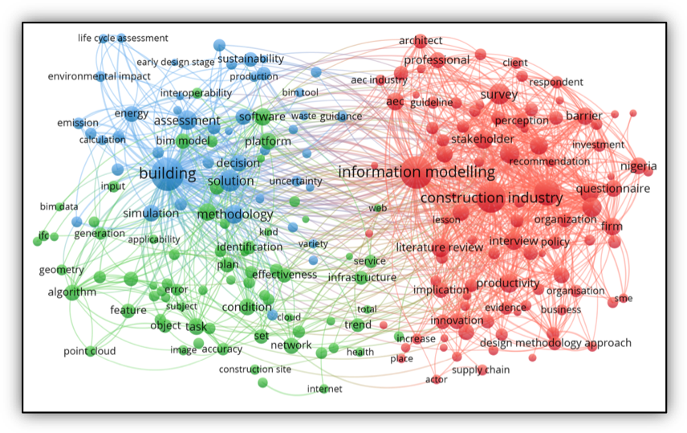
Figure 3: Network of BIM adoption within SME publications published between 2010-2019

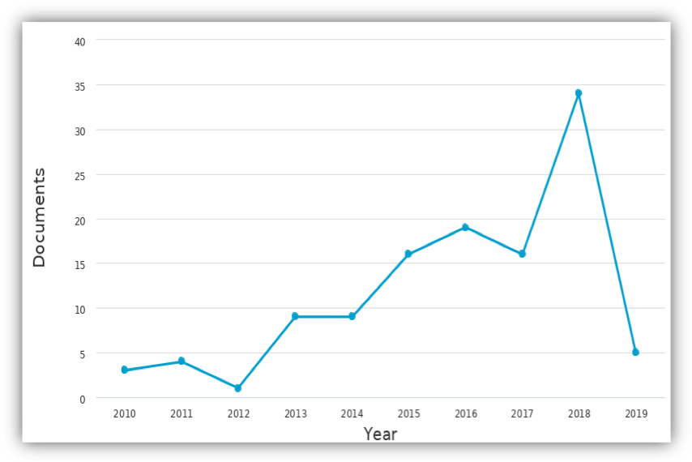 Figure 4: Number of articles published between 2010 and 2019 related to BIM adoption within SME.

Conceptual model
The figure below shows a proposed conceptual model which contains two major components. The first component is adapted from the technology acceptance model which include perceived ease of use, perceives usefulness, attitude towards usage and intention to use. This are identified as factors that influence the acceptance of technology in this case, BIM. The second factors identified from literature are categorised into four. Studies have identified the compatibility of technology, the competency of the firm, the behaviour control and the quality of technology as external factors that influence BIM acceptance (Lee, Yu, & Jeong, 2015).
TAM proposes that external variables indirectly affect attitude toward use, which ultimately leads to actual system use by influencing perceived usefulness and perceived ease of use. However, several studies later proposed extended version of Davis’s TAM by adding external variables in it with the aim of exploring the effects of external factors on users' attitude, behavioural intention and actual use of technology. Several factors have been examined so far. For example, perceived self-efficacy, facilitating conditions, and systems quality (Fathema, Ross, & Witte, 2014). However, Revised Roger’s theory of innovation diffusion (Rogers, 2010) also mentioned five (5) factors as external variables of acceptance and perception; Relative Advantage, Compatibility, Complexity, Trialability, Observability. This factors provided the principal theoretical perspective on technology acceptance which has been applied at both individual and organisational levels of analysis while its primary intention is to provide an account of the manner in which any technological innovation moves from the stage of the invention to widespread use (or not) (Dillon & Morris, 1996). Integrating both the theories of the Innovation diffusion by Rogers and that of technology acceptance model by Davis is essential for achieving the aim of this study.
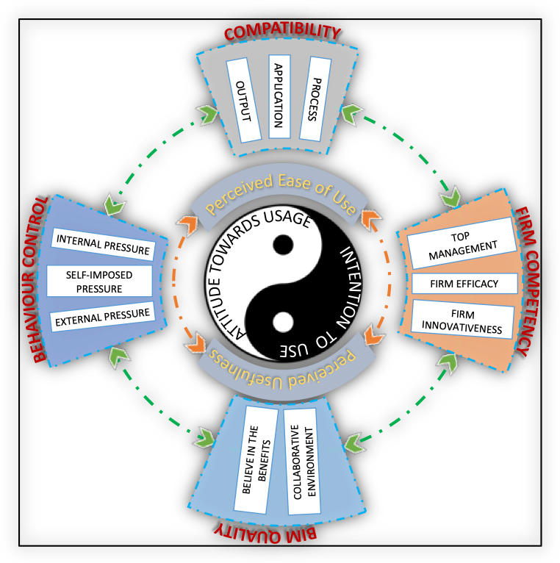
Figure 5: Conceptual model adapted from different models.

Conclusions
The aim of this paper is to develop a conceptual model of BIM acceptance that will have the power to demonstrate acceptance and usage behaviour of BIM within SME’s. A systematic and comprehensive review of literature (including 108 articles) was presented to identifying the key research trends of BIM adoption within SME and the theoretical models related to innovation adoption with a focus on BIM. From the selected articles, the key factors that influence BIM adoption were identified. A conceptual model was then constructed by consolidating the all the results. This will form the basis of further research towards improving BIM usage and acceptance within SME.

References
Albliwi, S. A., Antony, J., & Lim, S. A. halim. (2015). A systematic review of Lean Six Sigma for the manufacturing industry. Business Process Management Journal, 21(3), 665–691. https://doi.org/10.1108/BPMJ-03-2014-0019
Aranda-Mena, G., Crawford, J., Chevez, A., & Froese, T. (2008). Building Information Modelling Demystified: Does It Make Business Sense To Adopt Bim? International Journal of Managing Projects in Business, 2(Lessing 2006), 419–434.
Arayici, Y., Coates, P., Koskela, L., Kagioglou, M., Usher, C., & O’Reilly, K. (2011). BIM adoption and implementation for architectural practices. Structural Survey, 29(1), 7–25. https://doi.org/doi:10.1108/02630801111118377
buildingSMART International. (2016). buildingSMART Technical Vision. Retrieved from http://buildingsmart.org/standards/technical-vision/
Davis, F. D. (1989). Perceived usefulness, perceived ease of use, and user acceptance of information technology. MIS Quarterly, 319–340.
Davis, F. D., Bagozzi, R. P., & Warshaw, P. R. (1989). User acceptance of computer technology: a comparison of two theoretical models. Management Science, 35(8), 982–1003.
Dillon, A., & Morris, M. G. (1996). User acceptance of information technology: Theories and models. Annual Review of Information Science and Technology, 31, 3–32.
Eastman, C., Teicholtz, P., Sacks, R., & Liston, K. (2012). BIM Handbook: A guide to Building Information Modeling for owners, managers, designers, engineers and contractors. Australasian Journal of Construction Economics and Building (2nd ed., Vol. 12). John Wiley & Sons. https://doi.org/10.5130/ajceb.v12i3.2749
Egan, J. (2002). Accelerating Change–A Consultation Paper by the Strategic Forum for Construction. Hospitals & Health Networks / AHA, 84(10), 76. Retrieved from http://www.ncbi.nlm.nih.gov/pubmed/24948804
Fathema, N., Ross, M., & Witte, M. M. (2014). Student Acceptance of University Web Portals. International Journal of Web Portals, 6(2), 42–58. https://doi.org/10.4018/ijwp.2014040104
Ghaffarianhoseini, A. A., Tookey, J., Naismith, N., Azhar, S., Efimova, O., & Raahemifar, K. (2017). Building Information Modelling (BIM) uptake: Clear benefits, understanding its implementation, risks and challenges. Renewable and Sustainable Energy Reviews, 75, 1046–1053. https://doi.org/https://doi.org/10.1016/j.rser.2016.11.083
Ibrahim, A. D., Price, A. D. F., & Dainty, A. (2006). The analysis and allocation of risks in public private partnerships in infrastructure projects in Nigeria. Journal of Financial Management of Property and Construction, 11(3), 149–164. Retrieved from https://www.emeraldinsight.com/doi/pdfplus/10.1108/13664380680001086
Kim, H.-Y., Lee, J. Y., Mun, J. M., & Johnson, K. K. P. (2017). Consumer adoption of smart in-store technology: assessing the predictive value of attitude versus beliefs in the technology acceptance model. International Journal of Fashion Design, Technology and Education, 10(1), 26–36.
Kim, Y.-W., & Dossick, C. S. (2011). What makes the delivery of a project integrated? A case study of Children’s Hospital, Bellevue, WA. Lean Construction Journal, 53–66.
Latham, M. (1994). Constructing the Team. HMSO London Department of the Environment, 129. https://doi.org/978-0-11-752994-6
Lee, S., Yu, J., & Jeong, D. (2015). BIM acceptance model in construction organizations. Journal of Management in Engineering, 31(3), 04014048. https://doi.org/10.1061/(ASCE)ME.1943-5479.0000252
Liu, Y., van Nederveen, S., & Hertogh, M. (2017). Understanding effects of BIM on collaborative design and construction: An empirical study in China. International Journal of Project Management, 35(4), 686–698. https://doi.org/10.1016/j.ijproman.2016.06.007
Mollasalehi, S., Rathnayake, A., Aboumoemen, A. A., Underwood, J., Fleming, A., Kulatunga, U., & Coates, P. (2017). How BIM-Lean Integration Enhances the Information Management Process in the Construction Design (pp. 531–538). https://doi.org/10.24928/2017/0130
Pinho, C., Franco, M., & Mendes, L. (2018). Web portals as tools to support information management in higher education institutions: A systematic literature review. International Journal of Information Management, 41, 80–92. https://doi.org/https://doi.org/10.1016/j.ijinfomgt.2018.04.002
Rogers, E. M. (1995). Diffusion of Innovations: Modifications of a Model for Telecommunications. In Die Diffusion von Innovationen in der Telekommunikation (pp. 25–38). Springer. https://doi.org/10.1007/978-3-642-79868-9_2
Rogers, E. M. (2010). Diffusion of innovations. Simon and Schuster.
Underwood, J., & Isikdag, U. (2011). Emerging technologies for BIM 2.0. Construction Innovation, 11(3), 252–258. https://doi.org/10.1108/14714171111148990
Wong, S. S. Y. (2018). A review on the execution method for BIM projects in Hong Kong. Proceedings of Institution of Civil Engineers: Management, Procurement and Law, 171(3), 100–110. https://doi.org/10.1680/jmapl.17.00055

