Developing novel 5th generation district energy networks

Akos Revesz, Phil Jones, Chris Dunham, Gareth Davies, Catarina Marques Rodrigo Matabuena, Jim Scott, Graeme Maidment

Keywords: Thermal; Power; Mobility; Smart; Integrated; Networks
ABSTRACT
Integrated smartly controlled energy networks have the potential to deliver significant reductions in carbon emissions, improve air quality and reduce energy costs for end-users across the world. This paper introduces a novel methodology for the development of integrated thermal, power and mobility 5th generation (5G) smart energy networks. The proposed 5G concept builds on the state of the art by connecting flexible electricity demands such as heat pumps, and electric vehicles to intermittent, renewable and secondary energy sources and storage using artificial intelligence to facilitate optimal control and to maximise revenue and carbon savings. The proposed innovative method is being applied in central London through the development of two independent 5G smart energy schemes. The proposed schemes will incorporate a range of different renewables and secondary energy sources, for example waste heat from local data centres and the London Underground that will supply a large proportion of the energy demand of the overall district network capacity. Both networks will operate at close to ambient temperature, approximately 15-25°C as a so called ‘ambient loop’ system, with individual heat pumps for each end user or building connected to the network. The system also integrates thermal and electrical storage to create additional flexibility for the network and smart control for demand-side management. A smart management system flexibly controls individual assets such as heat pumps and electric vehicles in response to price signals reflecting the intermittency of renewable energy sources on the electricity grid. The ambient district thermal loop will distribute low carbon energy to a range of end users. Results presented in this paper provide an understanding of capital costs associated with integrated smart energy systems and the relative performance of individual technologies in a complex system using a techno-economic modelling approach. Overall, this paper demonstrates that the implementation of the 5G concept results in lower energy costs to consumers whilst at the same time transforming a large existing urban area to a near zero carbon energy system in terms of heating, cooling, electricity and transport.

- INTRODUCTION

  - Challenge ahead for decarbonising the energy sectors
Countries around the globe will need to greatly reduce future carbon emissions from the built environment in order to meet their legally binding carbon reduction targets. These targets are generally becoming more ambitious as it is recognized that dramatic change in our climate is occurring. For example, the UK government recently committed to reach net zero emissions by 2050, making the UK the first major industrial economy to legislate in this way (GOV.UK, 2019). However, significant challenges remain to meet the 2050 goals. Key transformation is required in the way how homes are heated and vehicles are powered.
Heat is the largest use of energy both in the UK and globally and is a significant contributor to global CO₂ emissions. Heat accounted for over 50% of global energy consumption in 2015, with 60% of this heat consumed by industry (including agriculture) with the remaining 40% used for heating in buildings (IEA, 2018). Domestic, commercial and industrial heating is responsible for around a third of the UK’s overall emissions (BEIS, 2018). The transport sector is also a significant-emitting sector of the UK economy. In 2018 transport accounted for 33% of all CO₂ emissions and the large majority of emissions from transport are from road transport (BEIS, 2019). According to Ofgem (2020) the use of electric vehicles (EVs) may need to grow from 230,000 today to 46 million by 2050. This significant level of deployment of EVs now being supported by the UK Government through the recent announcement on the ban of selling new petrol, diesel and even hybrid cars from 2035 (BBC, 2020).
So far, the UK has made good progress in reducing greenhouse gas emissions such that emissions have fallen by over 40% since 1990. In particular, power sector emissions have been reduced by almost two-thirds, due to increased use of renewable generation such as wind and solar (Ofgem, 2020). Since the power generation sector has already achieved significant decarbonisation through the large increase of renewable generation in recent years, there is now increasing focus on electrification of heating and transport sectors, which provide a great opportunity for further significant reductions in greenhouse gas emissions enabling us to approach net-zero targets.
Electrification of these sectors also provides the prospect for using smart and flexible integration of multi vector energy assets and integrated heat, power and mobility energy systems to facilitate the UK’s transition towards a flexible, low-carbon energy economy. One potential drawback to electrification of energy supply in the UK, however, is that the price of natural gas in the UK is significantly cheaper than the cost of electricity. Consequently, electrification of the heating and mobility sectors could result in increased energy costs for consumers unless appropriate energy efficiency measures are implemented at the same time. One way of increasing efficiency is to make the best use of locally available renewable or secondary energy sources, for example, by adopting integrated smartly controlled local energy systems, which are able to deliver cleaner and cheaper energy services. This includes: (a) new technologies, especially behind the meter generation, storage, smart home devices; (b) new platforms for demand side response and energy trading (i.e. peer to peer); and (c) new business models focusing on (cross vector) services rather than units of kWh. Increasing decentralisation is also driving a shift towards more localised scales of energy management practices [45]. In the UK, this is exemplified by the ongoing DNO (Distribution Network Operator) -DSO (Distribution System Operator) transition, encouraging more active management on distribution networks and the provision of ancillary services at increasingly localised levels [8]. As discussed by [45], the decentralised nature of renewable energy has also seen the emergence of new types of stakeholders, including community groups and grassroots organisations, local authorities, and local enterprise partnerships working alongside private sector businesses.
Decentralised local energy systems can result in a number of benefits for the local community. Such as local participants be able to (i) generate, consume and sell locally owned low carbon energy, (ii) share energy within the community (iii) reduce energy bills. For example, the results of a Dutch case study of a local energy system which was presented by Reijnders et al. (2020) showed that batteries can have a significant effect on reducing energy bills for local users as well as benefits for the electrical network operator by reducing current peaks in demand, hence removing stress from the grid, avoiding the need for reinforcement. The authors also highlighted that load shifting can result in additional benefits which is a subject for their future investigations. Similar case studies related to the control, management and ultimately the benefits of integrated local energy systems for worldwide application were presented by Chen et al. (2013); van der Kam and van Sark (2015); Nwulu and Xia (2017); Pavić et al. (2019); Drysdale et al. (2019); Veilleux et al. (2020) and Aziz et al. (2020). These studies differ in terms of their geographic locations and therefore in local commercial and technological constraints, however they all aimed to analyse the techno-economic and environmental feasibility of micro grids making use of locally available energy sources, and most showed significant benefits for the whole energy system. There are also studies which have looked at the commercial aspects of local energy systems i.e. new energy services and trading mechanisms e.g. peer to peer (P2P) (Zhang et al., 2016). Of course, implementing decentralised local energy systems will have an impact on the existing energy infrastructure and energy markets. The issue of how to re-design existing electricity and gas markets in relation to the deployment of sustainable smart energy systems has been discussed by Sorknæs et al. (2020).
The energy transition will also require consumers to be engaged and encourage them to participate through demand side response i.e. change the way how and when energy is used. There is extensive academic literature around demand side engagement in future energy systems including the work of (Nyborg and Røpke, 2013)); Goulden et al. (2014); Ballo (2015); Throndsen (2017); Skjølsvold et al. (2018); Wallsten and Galis (2019).
Whilst, there are a range of approaches to the smart local energy topic, this paper focuses on the concept level technical design and techno-economic assessment for an urban local energy system in Central London. A densely populated area with many low carbon secondary energy sources that could be used within a smart local energy system which integrates heat, power and mobility energy vectors through a 5th generation smart energy network.
5th Generation Energy Network Concept
District heating and cooling networks will have an important role in helping to decarbonise the energy sector. Typically, heat networks (district heating) have comprised a centralised heat generation plant located in an energy centre, supplying heat outwards to a number of buildings within a neighbourhood. For traditional type district heat networks (DHNs), heat energy was distributed through pressurised hot water well above 100°C, while more recently third generation (3G) were supplying heated water at temperatures as low as 80°C. These systems were generally centralised with one or few energy centres, mainly supported by fossil fuels and often had large heat losses along the distribution. However, since then the heat network industry has improved significantly. The key development stages of heat networks are illustrated in Figure 1. Each of these development stages up to the 4th generation (4G) are discussed in detail by Lund et al. (2014). The status of the 4G network concept has been reviewed by Lund et al. (2018), while a more recent short paper presented a number of cutting edge studies related to the design and implementation of these type of networks (Lund et al., 2020). The challenges and potentials for low temperature networks were discussed in detail by Nord et al. (2018). Most of these papers highlighted that the future for district heating is likely to involve the use of lower temperature networks and the use of heat pumps. 4G is fundamentally the same topology/structure as a 3G design with a single energy centre and pre-insulated pipework supplying heat outwards to the demands. However, 4G differs significantly in having lower operating temperatures than 3G, and is therefore able to capture waste heat e.g. from industrial sources. The potential for integrating industrial excess heat in DHNs has been discussed by Lygnerud and Werner (2018).
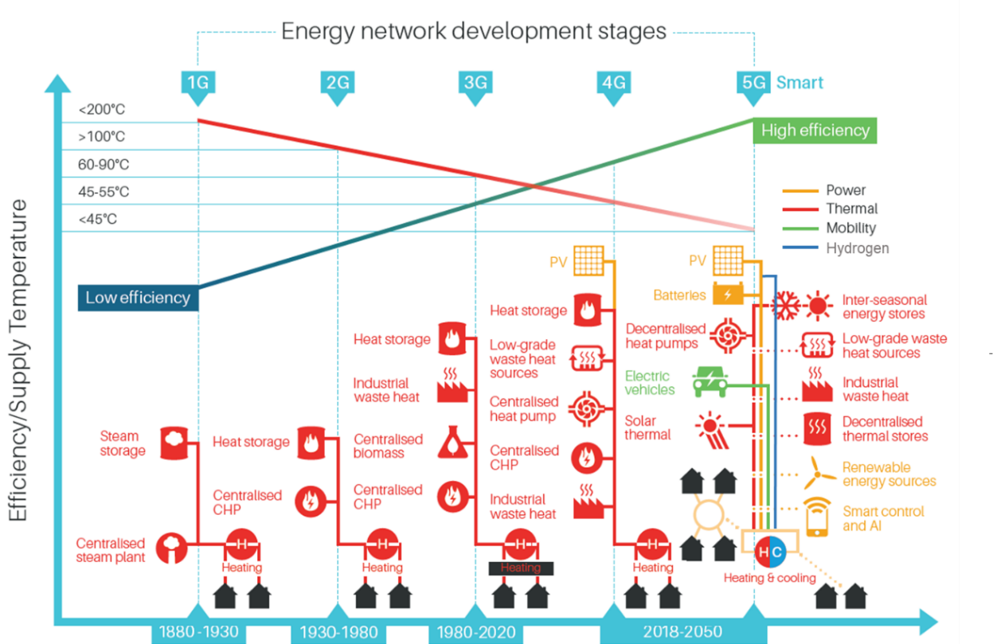
Figure 1 Energy network development stages including 5G concept (Adapted from Lund et.al. 2014)
The concept of 5th generation (5G) DHC networks is novel and has not been described extensively in literature until recently e.g. Jones (2019), (Buffa et al., 2019) and Jones et al. (2019). It can be seen in Figure 1 that there is a gradual move to lower temperature heat networks, for example 4G supplying at around 55°C. The next step is a move to a 5G approach, sometimes referred to as an ambient loop. These 5G schemes have a very different topology, comprising decentralised heat pumps rather than a single large energy centre, giving opportunities for sharing (prosuming) heating and cooling across an ultra-low temperature loop. Dynamic modelling of district energy schemes with prosumers was presented as a case study by Kauko et al. (2018). The results of the case study showed that the heat production by the prosumers (data centre and supermarket cooling system) is sufficient to cover the entire heating demand for the network. These schemes are often best implemented where there is a balance of heating and cooling demands, and can offer high CoP’s with any prosuming being an additional large benefit.
The ultra-low temperature ‘ambient loop’ also offers a more direct opportunity to capture low temperature waste streams that even a 4G scheme could not. In urban areas there are many opportunities to capture low grade heat sources that could be integrated into 5G networks. In London for example, the Mayor’s office has produced a number of reports investigating the potential for using secondary waste heat in London. It estimates that the total waste heat that could be delivered from secondary sources in London is of the order of 71 TWh/year (GLA, 2014). This is greater than the city’s total heat demand which was estimated to be 66 TWh/year in 2010. Making use of these locally available alternative energy sources could not only improve efficiencies of heating and cooling systems but could also result in significant operational cost and carbon savings compared to traditional systems. For instance, a recent paper on the use of secondary heat from a London Underground (LU) ventilation shaft identified potential cost savings of 50% compared to the use of gas fired CHP (Davies et al., 2019). In addition, other research investigating the recovery of heat from data centres showed great potential as a secondary heat source (Davies et al., 2016). Using seawater as a heat source for a 4G network has been introduced in a case study by Volkova et al. (2019) and the theoretical potential of waste heat from sewage systems was discussed by Pelda and Holler (2019). ReUseHeat (EUROHEAT&POWER, 2017) is another European research project focusing specifically on applications for the recovery of urban excess heat.
It can be seen in Figure 1 that the transition towards lower temperature district heating (moving from 1G towards 4G and 5G as shown in Figure 1) results in increased system efficiency. Alongside the better utilisation of renewable heat and recycled low temperature heat, by means of lower supply temperature, it is possible to reduce distribution heat losses compared to more traditional high temperature systems. This has a great effect on economic savings as well as on the environmental impact of the network, increasing overall system performance. However, the integration of secondary and renewable energy sources into the network must meet the challenge of coordinating the fluctuating and intermittent energy production with the rest of the energy system. The integration can be facilitated by different energy storage technologies as well as intelligent control mechanisms. The 5G approach also requires a means of balancing the heat and coolth in the headers, when all buildings are in heating mode for instance. In a case study in Heerlen (BRGM, 2019), mine water was used to balance the ‘backbone’ but other balancing mechanisms are possible for example aquifer thermal energy stores (ATES). Fundamental to 5G is the use of large long-term thermal storage as part of the balancing mechanism. 5G is the supply of heat along a spine with interchange of heating and cooling between buildings and a balancing mechanism including seasonal thermal storage.
Smart control presents a great opportunity to balance the thermal and electricity grid, maximising the use of renewable energy and facilitating effective Demand Side Management (DSM). Demand side management in DH networks in terms of thermal peak shaving was studied by Guelpa et al. (2019). Simulation results from the study showed that reduction up to about 35% of peak request could be achieved through DSM.
By implementing a control system that produces and exploits reliable forecasts of electricity grid demands and costs, alongside individual end-user demand it is possible to optimise cost and even carbon emissions on an hourly basis. These intelligent control systems can be used to flex the heat pumps in relation to grid electricity prices and carbon content. They can also flex storage facilities such as EV batteries, large centralised batteries etc. to maximise economic and carbon benefits. Decentralised heat pumps at the end-user sites within 5G networks can also be used to reduce the temperature of the water in the distribution loop to provide cooling for end users and this can be a great advantage compared to the previous generations of networks. Cooling demand is growing significantly in the UK and using 5G heating/cooling sharing is an efficient way to meet this need. 5G smart energy networks will also help supply the growing needs for Electric Vehicles (EV’s) charging and renewable supplies like PV and wind. The use of hybrid systems and the use of hydrogen will also present innovation opportunities that could be integrated into 5G networks. Therefore, these new innovative 5G energy networks have great potential to become the most efficient local energy systems of the future. However, the decision on the appropriate systems for energy supply distribution and consumption is often not straightforward, since it depends on many technical and non-technical conditions, as well as the individual behaviour of the relevant stakeholders.
As a consequence, the planning, design and adaption of a 5G smart energy network is challenging. The next sections of this paper discuss the design method developed and the preliminary results gained from a conceptual feasibility of a future 5G Smart energy network in the London Borough of Islington (LBI), UK.
- CONCEPT DESIGN FOR 5G SMART ENERGY NETWORKS

  - Project GreenSCIES
A feasibility study investigating the design and development of a 5G smart energy network that will supply sustainable energy to the local residents and business, has been carried out as part of the project called GreenSCIES - Green Smart Community Integrated Energy Systems (LSBU, 2019). GreenSCIES aimed to bring together a range of secondary and renewable energy sources with innovative conversion, storage and smart control technologies integrated through a 5G network. The study looked at a specific area in the LBI to investigate its potential for implementing an innovative energy network. LBI has the highest population density of local authorities in England and Wales with 13,875 people per km² which made it an interesting challenge to deliver significant energy savings and carbon emissions. This paper presents the methodology applied for evaluating the network components, layouts and optimal operation of two independent 5G schemes within LBI. Key results from a series of techno-economic models developed for both schemes are also presented.
  - Design methodology
The key design questions considered during the feasibility study were related to the (i) type and size of the network, (ii) type of energy sources, (iii) which buildings (demands) to connect, (iv) pipe routes and energy centres, (vi) what technologies to use, (vii) how best to integrate thermal elements of the schemes with power and mobility sectors, and (viii) how best to control the integrated network in order to achieve optimal operation.
The GreenSCIES design methodology included the following steps:
- Identify physical boundaries in the area e.g. major roads, railways
- Establish initial energy network clusters with high energy density
- Map energy sources and demands
- Identify low carbon technologies suitable in the study area
- Establish flexible smart control strategies to integrate the whole scheme
- Develop network outline designs
- Develop CAPEX model
- Develop techno-economic models and modelling scenarios
- Sensitivity analysis
2.2.1 Energy mapping
Following establishing initial high energy density clusters within LBI without any major physical barriers, extensive heat mapping was carried out to assess the heating and cooling density across a wide area in Islington. This identified the local areas with most prospect for a 5G scheme, in particular around key energy sources like data centres and London Underground ventilation shafts - also areas with a good mix of heating and cooling to promote prosuming. Major buildings and housing estates were then identified as key energy demands, gradually focusing red-line boundaries around areas likely to result in actual 5G schemes. Five possible schemes were identified, three were then discounted in consultation with LBI around the future for the buildings and connectability. Two schemes were carried forward into a more detailed assessment process to establish practical schemes. Both schemes were based within the boundary of LBI, a GreenSCIES partner. Many of the building demands identified were ‘anchor load’ housing estates owned and managed by LBI, currently supplied by centralised gas boilers making them easy to connect to the proposed 5G network.
2.2.2 Energy sources and technologies
The generic potential for a range of secondary and renewable energy sources in the study area considered factors such as temperature, magnitude, diurnal and annual variability, ease of capture and utilisation, permanence, etc. Table 1 shows some of the low carbon energy sources considered and each of these were evaluated against the criteria above. Energy sources within each area identified as most suitable for a possible 5G scheme are: groundwater and secondary thermal sources of energy such as waste heat from the ventilation system of local underground railway and two data centres.
Table 1 Assessment of energy sources
Energy sources | To provide |  | Typical heat available (MW) | Heat source temperature  (°C) | Permanence of heat source
Ground water (open loop aquifers) | H&C |  | 1-2 | 14 | Theoretically unlimited
Surface water (open loop rivers, canals) | H&C |  | 1-2 | 2-20 | Theoretically unlimited
Ground coupled arrays (closed loops) | H&C |  | Depending on array size | 12 | Theoretically unlimited
Electricity cable tunnels | H | 0.2-0.4 |  | Up to 35 | >50 years
Electricity substations | H | 04.-1 |  | Up to 70 | >20 years
Sewers | H&C | 04-1 |  | 10-22 | Hundreds of years
Sewage farms | H&C | 1-3 |  | 14-33 | >20 years
Underground railways | H | 0.6-1 |  | 17-28 | Hundreds of years
Supermarkets | H | 0.5-1 |  | 32 | Likely to be >10 years
Data centers | H | 1-4 |  | 25-35 | Likely to be >20 years
H: Heating, C: Cooling
In a similar manner, the generic potential for a range of low carbon technologies in the study area were considered based on comparing their strengths and weaknesses in LBI. A range of low carbon technologies have been considered and each of these were evaluated against their strengths and weaknesses in LBI. The technologies which were taken forward for the concept design are heat pumps, solar PV, batteries and EVs with vehicle to grid (V2G). The overall concept for the proposed GreenSCIES schemes (including secondary and renewable sources reviewed and key technologies selected to take forward) are illustrated in Figure 2. It is to be noted that only underground railways and data centres as low carbon energy sources for the 5G network have been taken forward at this conceptual design stage of the schemes. It is proposed that other resources and technologies will be revisited at the detailed design phase of the project.
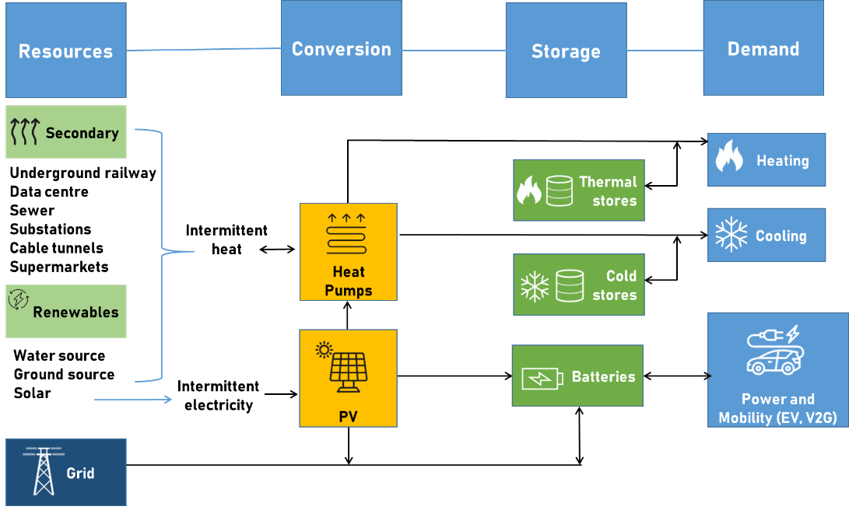
Figure 2 GreenSCIES Smart Local Energy System Concept for the London Borough of Islington
2.2.3 Flexibility and smart control strategy considerations in the GreenSCIES concept
The control and dispatch of equipment in and connected to the network is an important part of realising the economic and environmental benefits of the technology. Unique constraints that must be considered for the ambient temperature energy networks are the volume of thermal energy that can feasibly be drawn out and put into the network. These constraints exist for the heating and cooling transactions between heat pumps and the network. In addition, there are constraints associated with the consumption and generation of electricity, these are normally classified as electrical constraints which relate to the power throughout of a transformer and voltage constraints which relates to voltage limit exceedance within the local network. Thermal and voltage constraints, as well as fault level constraints which are not part of this work, are managed by local power distribution companies using a variety of management approaches all of which incentivise or require loads and generators to be constrained in their operation in some way. The introduction of heat pumps and electric vehicle (EV) charging introduces a complex and large time dependent load to the local power network.
The conventional approach to solving micro-grid or local neighbourhood time varying i.e. dynamic, energy problems is to use a centralised controller which attempts to find a good solution that meets all constraints and provides the maximum amount of utility to users of the energy system. This has the advantage of being a reliable and centralised scheme where all information is known by one actor and all control sits in one location. This works well where there is a single system owner, for instance an isolated military base, a boat or a university campus but is not usually an acceptable solution for real world neighbourhoods where there are many different customer types and many different assets.
The proposed approach to overcome potentially conflicting interests and time requirements placed on the system is to allow each independent agent to have their own optimisation mechanism whilst also agreeing to the terms of the constraints imposed by the heat and power networks. Therefore, each heat pump could be on a different supply tariff and can optimise its demand to meet the local, behind the meter, heat demand against that variable tariff. Whilst also being required to participate in the management schemes that allow the network level constraints to be met. The optimisation therefore operates as a negotiation between the local consumer level asset and the network level constraints where each asset connected to the network is asked to help contribute to supporting and maintaining a stable system. The advantage of this approach is that the more assets that connect the more reliably the thermal network constraints can be met as each asset adds diversity and time of use storage to the demand profile. The more thermal storage available in the whole system the more readily the electrical constraints are likely to be met.
  - The proposed 5G schemes
Figures 3 and Figure 4 illustrate the concept design for the proposed schemes. It can be seen in Figure 3 that Scheme A’s main, low carbon energy source is waste heat energy recovered from the London Underground (subway) ventilation shaft. The design capacity for the ventilation shaft heat exchanger, whether operating in supply or exhaust mode, is 900 kWth, providing a total annual heat supply of 7,880 MWh to the network. The other energy source for Scheme A is a series of open-loop boreholes. These boreholes are bi-directional, to allow aquifer replenishment and provide ~14°C flow, ~4°C return primary at around 10 l/s yield supplying approximately 500kWth per abstraction-discharge doublet. Figure 4 shows the concept design for Scheme B that supplies secondary heat recovered from two local data centres. The scheme also includes boreholes to supplement and balance the network as they provide a constant 14°C into the ambient loop.
Although the ventilation shaft could supply 900 kWth throughout the year, its efficiency will vary across the year, as year as the air temperatures (ambient and ventilation exhaust air) vary. However, by reducing the capacity for the ventilation shaft when air temperatures are lowest, efficiency can be maximised. The reduction in heat from the ventilation shaft heat at these times can be compensated by the boreholes, which have sufficient capacity to supply the whole system, if necessary.
Similarly, for Scheme B, although data centre cooling demand is fairly constant throughout the year, there will be some seasonal variation in potential heat recovery due to variation in ambient air temperatures, and also with variation in data centre work load from day to day. However, as for the ventilation shaft, any variations in cooling demand or recovered heat can be compensated by the additional capacity provided by the boreholes, ensuring that the overall heat and cooling demand for the system can be met.

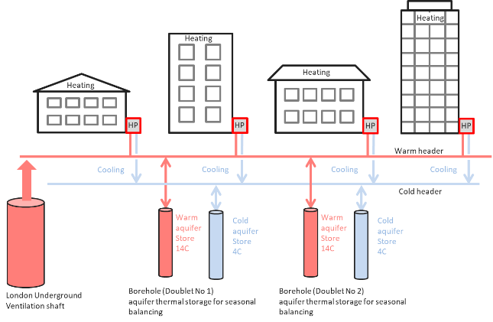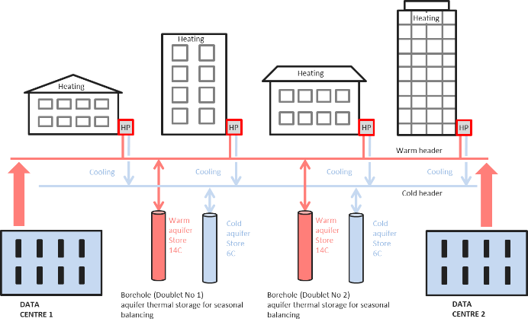
Figure 3 Scheme A concept Figure 4 Scheme B concept

2.3.1 Energy demands of the schemes
In Scheme A, there are 12 buildings connected to the network which are mainly social housing estates, plus two primary schools and a leisure centre. The peak heat demand of Scheme A is approximately 6MW and the total heat demand of the network is approximately 13,000 MWh/year with a relatively small cooling demand of approximately 4,000 MWh/year, and is therefore much more a heat-only based scheme. Scheme B, however, is a larger scheme which includes 19 buildings, a mix of social housing estates and two university campuses. The total heat demand of the network is about 30,000 MWh/year with a peak of 15 MW. The cooling demand is also significant due to the connected data centres, which require approximately 38,000 MWh/year, with a constant cooling demand of 5 MW. Scheme B is much more balanced in terms of heating and cooling and that is significant factor in making it more viable than Scheme A as is shown in the results section of the paper.
2.3.2 Network routes, energy centres and technologies
Both Scheme A and B are two-pipe ultra-low temperature networks, each around 2 km in length. Figure 5 illustrates the proposed network routes of both Schemes. It can be seen in the figure that the number of decentralised energy centres (EC) i.e. 11 for Scheme A and 16 for Scheme B, indicate the very different topology of a 5G system, compared to previous generations of heat networks. It was proposed that each of these ECs include localised heat pumps supplying the energy demand of the connected buildings and sharing heating/cooling across the network where possible. Each of these schemes will be a 'smart grid' allowing the heat pumps within the ECs to be used in a flexible way in relation to electricity tariffs, providing a 'demand side response' approach to cost and carbon saving. The Smart Grid will also include PV and EV connected to each of the Heat Pump plant rooms. The EV's will help meet the increasing needs of local residents for charging EV's.

Figure 5 Outline 5G network designs for Scheme A (left) and Scheme B (right)
  - Techno-economic modelling of the schemes
In order to estimate the capital and operational expenditure (CAPEX and OPEX) and carbon savings of the proposed 5G network schemes, techno-economic modelling was carried out. This section describes the choice of software used, the overall model structure and key individual components and modelling scenarios used.

2.4.1 Description of energyPRO software
A commercial software modelling tool, energyPRO (EMD, 2014) was utilised to investigate the local energy system. energyPRO is a Danish software product developed to allow the techno-economic modelling of complex energy systems. It was originally developed in the context of the Danish developed networks of district heating and cooling systems from the 1970s onwards but has subsequently has been adapted to allow the modelling of virtually any energy system. In the 1990's modules were added in collaboration with the World Bank to allow financial outputs to be investigated also. In the model heat, process heat, cooling and electricity demands can be simulated down to a resolution of 1 minute intervals together with their supply by whatever system is specified. Energy system components that can be modelled include: Combined heat and power, Heat pumps, Solar thermal, Solar photovoltaics, Hybrid energy systems, Wind turbines, Batteries, Electric boilers, Electric/Absorption chillers, Thermal stores, Geothermal energy, Biomass, biogas and other fuel, etc. It uses half hourly supply/demand data alongside complex electricity tariffs, control strategies and Demand Side Management (DSM). The tool has a capability to optimise the operation of any combination of energy supply and demand including the modelled system in accordance to all preconditions such as weather conditions, technical properties of the different units, maintenance costs, fuel prices, electricity tariffs, taxes, subsidies, etc. The software offers a range of technical and economic reports including graphical presentation of the simulated operation which provides an overview and in-depth understanding of the dynamics in a complex energy system.

2.4.2 Overall model structure and key individual components

This section describes the overall model structure developed as well as how key individual components have been simulated and controlled.

The model allows half hourly demand data to be entered separately for each of the individual connections. Where half hourly heat data was available this was entered directly into energyPRO. Where annual data or benchmark data was the only source, an hourly profile was created within energyPRO by use of an ambient temperature profile for the location obtained from the EU Copernicus project ERA5 data combined with a typical daily profile based on the likely control regime for the building type in question. A similar approach was used for cooling demands. Solar PV generation was based on energyPRO’s in built simulation using ERA5 hourly aggregated solar radiation and temperature data for the location.

A schematic of the overall energyPRO model used in the analysis for Scheme B is shown in Figure 6. The two schemes were modelled in separate project files. Variations of the core model were then created as tabs within the software allowing direct comparison of different scenarios. The individual heat pumps were modelled as a 3 combined units initially for the Limitless Aquifer scenario. These were:
- A combined heating and cooling heat pump
- A heating only heat pump
- A (free) cooling only unit
Dependency was set so the combined heating and cooling heat pump could not operate when the 2 other units were operational and vice versa. Furthermore the cooling only heat pump could only operate when the heating only heat pump could operate. The purpose of these 3 units was to simulate the possible modes of operation – simultaneous heating and cooling and heating only. In the limitless aquifer scenario (free) cooling only is not possible – because without heating, cooling cannot be created at the correct temperature and – as the aquifer is deemed limitless - it cannot store heat or coolth.
In the ATES scenario only 2 units are required because of the ability to create hot and cold wells. Further in this scenario a limit was placed on the annual amount of coolth that could be created by the heat pumps. This was calculated from the sum of the annual heating demands – minus the compressor power input. The result was such that in Scheme B some use of conventional electric chillers would be required.

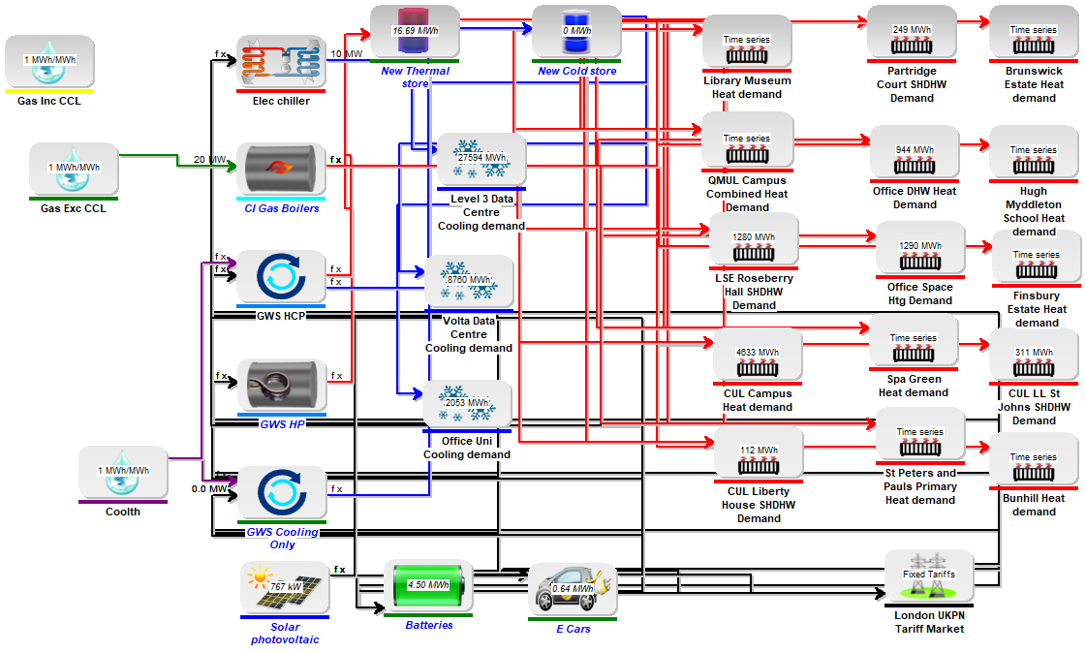
Figure 6 energyPRO Schematic for Scheme B
In order to size the heat pumps and stores for each energy centre a more detailed model was developed where each energy centre was modelled as a separate site. The model above shows the heat pumps and thermal stores combined.
2.4.2.1 Modelling of storage and EV
Various forms of the storage were modelled both thermal and electrical – depending on the scenario. These were:
- Thermal stores in each plant room
- Aquifer thermal energy storage (ATES)
- Dedicated battery storage
- EV battery storage/V2G

2.4.2.2 Thermal Stores
These were assumed to be operating at 77/55°C and energyPRO calculates and with 90% of the volume useable. The software calculates the energy storage potential. Losses were modelled from these stores at an assumed ambient temperature of 20°C.

2.4.2.3 Aquifer Thermal Energy Storage
In the ATES scenario it was assumed that by injecting cold water into the cold well and warm water into the hot well – whenever there was a surplus of heat or coolth – that cold and hot wells could be created. By doing so heat could be stored interseasonally. It wasn’t considered necessary to model this in detail within the software on an hourly basis but simply to ensure that the overall annual balance was maintained so that heat rejected equals heat supplied minus heat pump compressor power.
2.4.2.4 Dedicated battery storage
This was modelled by energyPRO’s inbuilt battery form. This allows the user to specify the capacity and the charging and discharging capacity and efficiency. A 90% “round trip” efficiency was assumed.

2.4.2.5 EV battery storage
This was modelled using energyPRO’s inbuilt form for “e-cars”. It allows exactly the same constraints to be modelled as the battery form and indeed behaves in an identical manner except that the user may add a driving demand pattern in MW. This represents both the availability of the cars for use for V2G but also the energy used by driving that must be replenished. This driving demand pattern was created from an EV car hire company E-car club’s booking data for a year for 40 cars, for which data has been obtained through personal communication.

2.4.2.6 The use of smart controls
energyPRO is essentially a dynamic dispatch model – in that it decides which energy conversion unit to dispatch in each calculation step. It does this based on a priority number that is calculated for each unit in each step. For a heat pump the cost of heat would be calculated based on the efficiency of the heat pump - which might vary with source of sink temperatures – and the price of electricity which varies according to wholesale prices, distribution and transmission charges (and any other payments the user decides to apply). The cost of heat becomes the priority number. The user can determine whether to optimise over a month or a year. In the either case energyPRO assumes perfect knowledge about the entire period and assigns the unit with the lowest priority numbers (lowest cost) first – but starting with the lowest number in the entire period. It continues, picking progressively more expensive units, until either demand is met or - if storage is present - until storage is full. energyPRO’s analytic method has been shown to have similar accuracy to solver methods (Andersen and Østergaard, 2019).

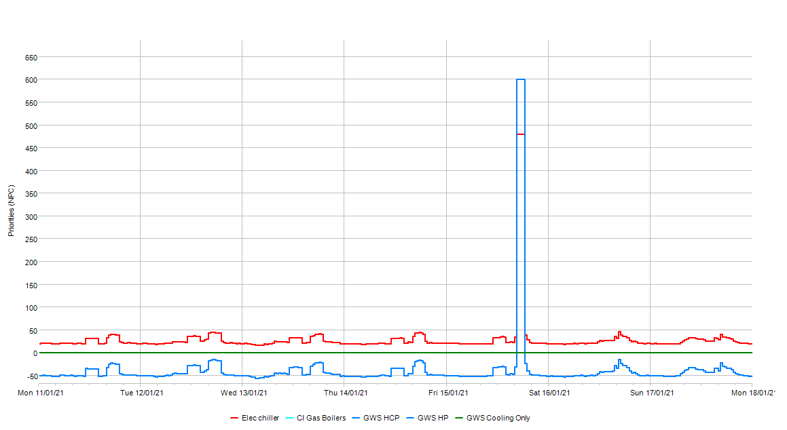
Figure 7 An example of energyPRO’s priority calculation
An example of the production priority numbers (the lower the number the higher priority) are shown in Figure 7 for a week in February. It can be seen that the cost of heat/priority number for the Heat Pump (blue) is actually negative because of the Renewable Heat Incentive subsidy and the value of the cooling sales. The large spike in cost is because of the UK’s Triad charge system which is used to recover the transmission system costs. In this period it would have been cheaper to operate a gas boiler but for the present application i.e. Scheme A and B, energyPRO will only do so if the storage options are empty.
Further complexity arrives where one unit can supply another unit or where a unit is consuming electricity and it could take electricity from either the grid or from a battery. Or, from the point of view of the battery, the battery could supply another unit or export electricity. Here energyPRO determines priority consumption numbers so that a unit can only consume energy from another unit if the priority production number of the producing unit is lower than the consumption priority number of the consuming unit.

2.4.3 Key Assumptions
Key technical assumptions within the techno-economic models for both schemes were the following:

- Business as Usual (BAU) base case of existing gas fired boilers
- Electricity prices based on half hourly spot market prices plus levies in London
- Carbon factors based on diminishing figures using predicted decarbonisation published by BEIS (GOV.UK, 2019a)
- Heat and Cooling Price to customers 25% lower than that for existing gas boilers or chillers
- Existing gas boilers will provide backup only and not top-up therefore avoiding the use of natural gas under normal operating conditions
- Heat pumps operate ~4,500 full load hours per year (approx.) and supply 75/55°C to the connected buildings
- 100m³/MW storage in heat pump plant rooms - to smooth heat pump load and avoid expensive electricity tariffs
- All options are based on electricity connections ‘behind the existing building meter’ i.e. sub metered rather than private wired schemes
- Scheme A - Ventilation shaft is the lead heat source in summer when tunnel temperatures are high
- Scheme A - Boreholes are the lead heat source in winter as they provide a constant ~14°C into the ambient loop
- Scheme B – two large data centres act as a year-round constant heat demand (cooling load)

    - Modelling scenarios
Separate models of Schemes A and B were constructed. Variations of the core models were then created as tabs within the software allowing direct comparison of different scenarios. Table 3 shows the different modelling scenarios implemented and gives a description of each of them. Each of the scenarios listed in Table 3 were compared to a reference BAU base case scenario of existing gas fired boilers.
Table 3 Techno-economic modelling scenarios
 | Scenario | Description
1 | Limitless aquifer | Assumes that the aquifer heat replenishes itself but therefore it cannot be used for thermal storage
2 | Aquifer thermal energy storage (ATES) | Assumes that the aquifer heat cannot replenish itself and therefore it can be used for seasonal or inter seasonal thermal storage
3 | ATES and solar PV | Solar PV is added and operates behind the meter alongside each heat pump
4 | ATES and V2G | V2G is added at each energy centre. Both the PV and the batteries operate behind the meter alongside the heat pumps
5 | ATES, solar PV and V2G | In addition to ATES, both solar PV and V2G is added at each energy centre. These operate behind the meter alongside the heat pumps
6 | ATES, solar PV, V2G and bespoke batteries | In addition to ATES, solar PV is added at each energy centre. In addition to V2G bespoke batteries are added. Both the PV and the batteries operate behind the meter alongside the heat pumps

- RESULTS AND DISCUSSION
This section -describes some typical results with visual outputs of the results e.g. graphs of operation highlighting significant characteristics as well as a summary of the scenario results in terms of energy and capital cost and carbon emissions. It also includes a discussion of the results.

Typical results
The typical results shown in Figure 8 are for Scheme B during a winter week with ATES, PV, V2G and Batteries included. The top chart shows the heat pumps operating for most of the hours supplying the demand shown as red line. The heat supply doesn’t follow the heat demand precisely because of the use of thermal storage (4th chart down).
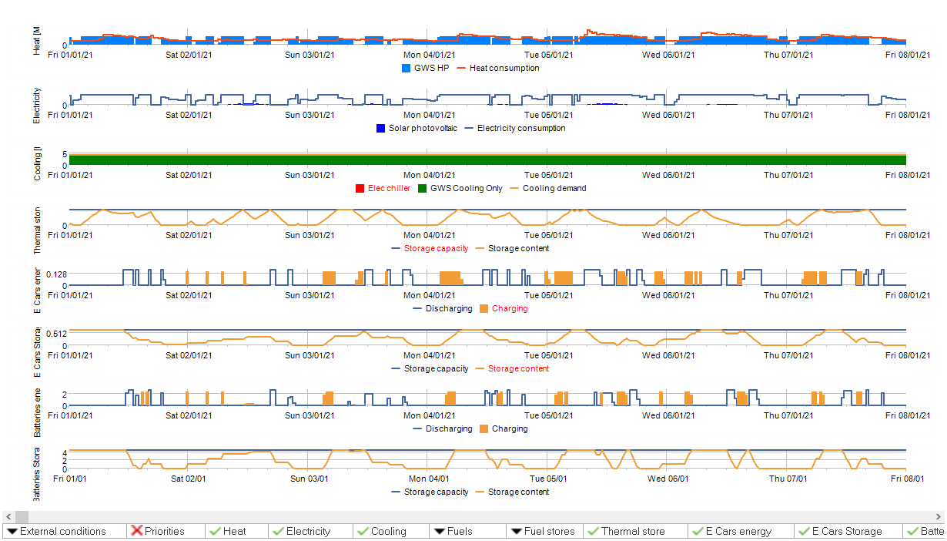
Figure 8 Winter Week energyPRO simulation ATES, PV, V2G & Batteries
The scheme electricity demand is represented by the second chart down. This is largely the heat pump & pumping consumption – with the solar PV production shown in blue on the same chart. As solar radiation is low in this winter week solar production is rather small. Cooling demand is shown supplied by free cooling either generated simultaneously by the heat pumps or drawn from the cold well. The next 2 charts show the operation of the EV V2G systems. The final 2 show the dedicated batteries. The batteries in both can be seen charging at night using lower cost electricity and discharging during the day to avoid need to import from the grid to supply the heat pumps at peak times. A similar picture appears in the summer as shown in Figure 9, although here the heat demand is much lower and the cooling demand higher. Not all of the cooling demand can be met from free cooling because the cold wells would be depleted and out of balance.
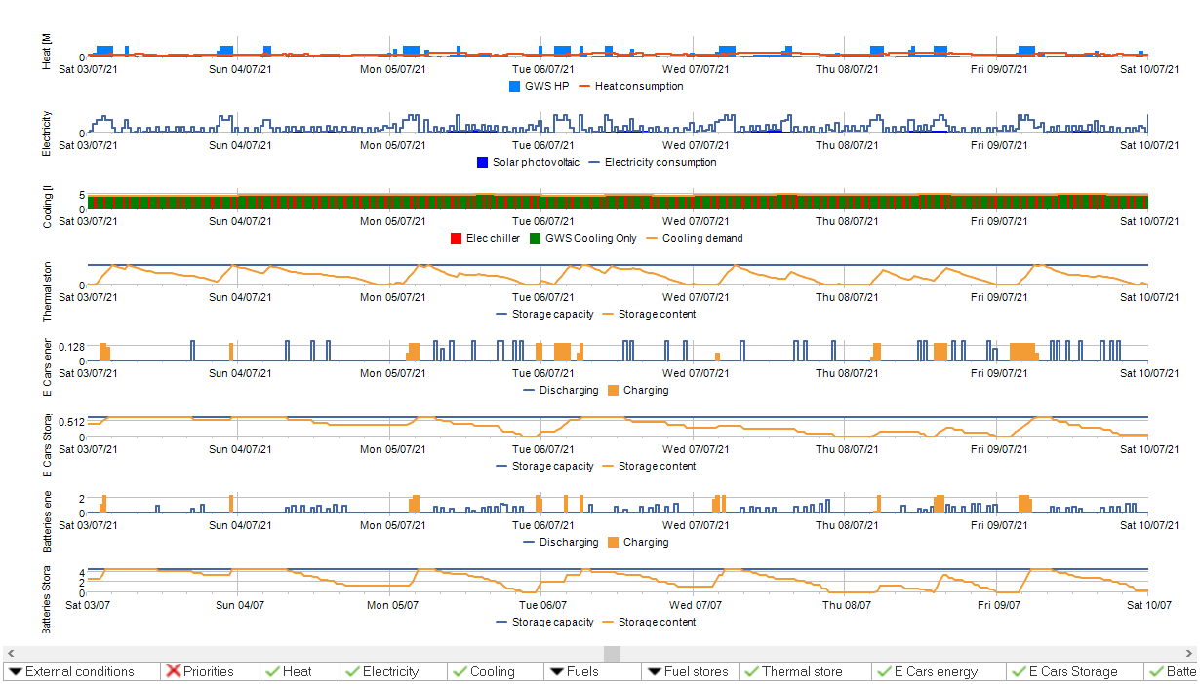
Figure 9 Summer Week energyPRO simulation ATES, PV, V2G & Batteries
The techno-economic modelling investigated operational cost (OPEX) and carbon emission savings of both schemes compared to a reference case scenario which is a traditional gas fired boiler based system. In addition, capital expenditure (CAPEX) of the integrated smart energy systems as well as the Net Present Values (NPV), Internal Rate of Return (IRR) and payback periods of both schemes were estimated. Additional benefits of the schemes for the local area if implemented are also discussed.
3.1 Operational cost for all scenarios
The graphs in Figure 10 show the estimated difference in annual operational surplus expressed against the base case between the scenarios modelled for both Schemes A and B. The best performing scenario is the final scenario modelled with ATES, solar PV, V2G and batteries. The worst performing schemes are the scenarios without any additional plant in the way of PV, V2G and batteries. In scheme A there is no difference between the limitless aquifer where the boreholes cannot be used as seasonal heat/coolth store and ATES where they can. This is because of the very small amount of cooling. The benefit of the ATES assumption is that cooling can be provided even when heating or insufficient heating is operational. V2G on its own adds just £1000 per car. Because of the very limited number of cars assumed to be available the absolute improvement in OPEX is relatively small. The improvement in operating surplus over base case for Scheme B is shown in Figure 10 (right). Unsurprisingly a similar picture emerges. Again batteries with PV and V2G is the leading solution in terms of improved OPEX. This is because solar PV adds to export revenues and offsets imported selectricity. Furthermore, batteries and V2G have the impact of being able to store electricity so that expensive periods can be avoided. In theory the thermal storage on the system alongside larger heat pumps could provide a cheaper source of storage than batteries but in practice larger heat pumps and thermal stores would also have required more boreholes which represent a costlier solution.
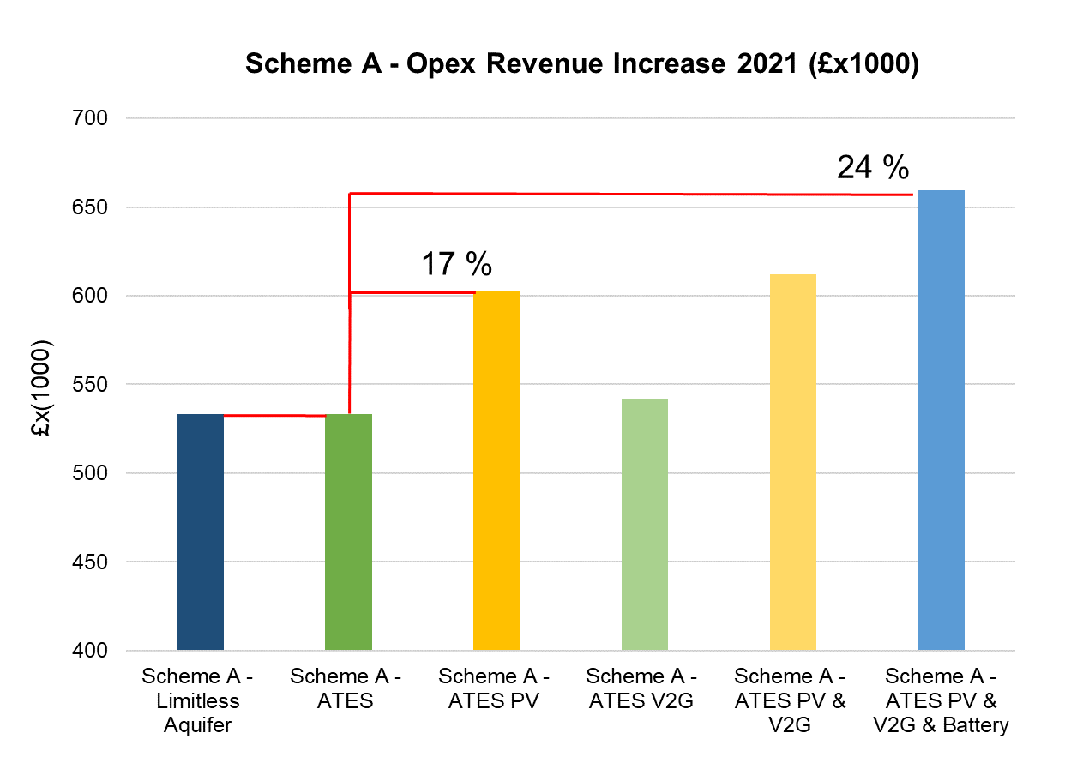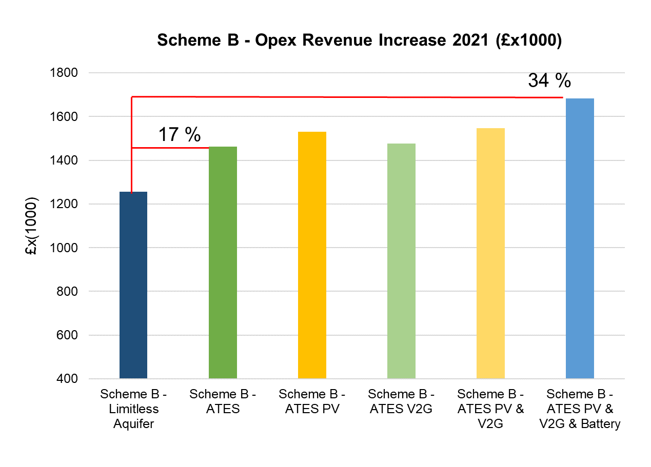
Figure 10 Opex revenue increase for Scheme A (left) and Scheme B (right)
3.2 Carbon emissions for all scenarios
The graphs in Figure 11 show the CO2 savings expressed as 25 year averages for Scheme A against the current arrangement of gas boilers, chillers and grid electricity. The largest savings are for the ATES scheme with solar PV. This is simply because the PV generates additional savings by displacing grid electricity which will still have significant, though declining carbon content over the 25 years projected. The CO2 projections are taken from the Treasury Independent Advisory Group (IAG). Batteries in the form of V2G or stationary batteries reduce the savings slightly – at least in this model – over their counterpart scenario. That’s because of the losses involved in charging and discharging. These might in reality be offset by the use of hourly carbon factors rather than the annual official government factors used here.
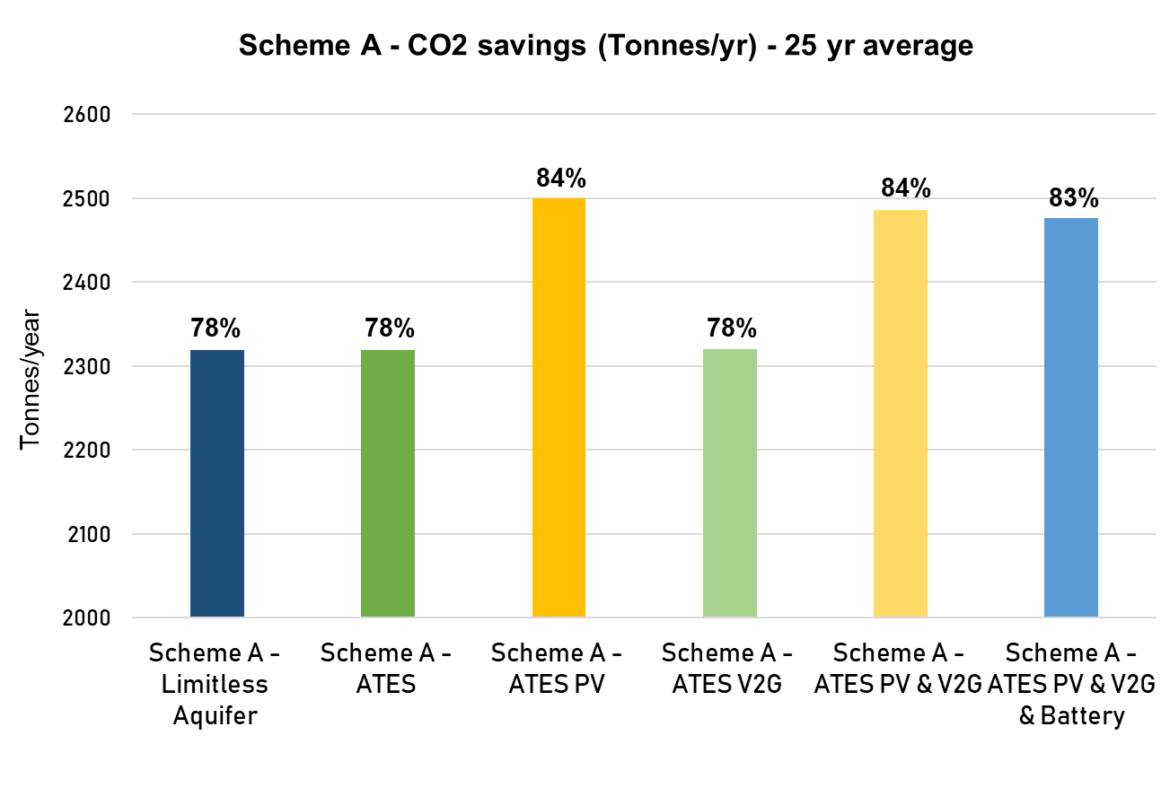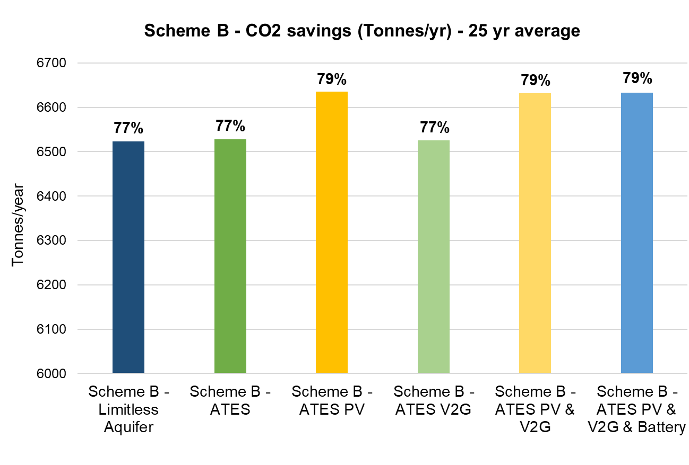
Figure 11 CO2 savings for Scheme A (left) and for Scheme B (right)
A similar picture emerges in scheme B though with slightly increased savings for the ATES scenario over the limitless aquifer scenario. The magnitude of the savings in Scheme B is much higher reaching almost 7000 tonnes per year – whereas scheme A is just under 2500 tonnes.
3.3 Capital costs NPV, IRR and payback periods for all scenarios
Table 4 summarises CAPEX, NPV and IRR for Schemes A and B. It can be seen in the table that a discount rate of 3.5% both schemes are viable even with a 25% reduction in heating and cooling sales revenue and resulting in IRRs between 5.9 and 9%. The payback period for both schemes were estimated at approximately 10 years. It can be seen in Table 4 that, scenario 6 with all the technologies has the best NPV – despite the largest capital investment required.
Table 4 Summary of Capex, IRR and NPV for the different techno-economic modelling scenarios
Scenario | INITIAL CAPEX  (£ x 1000) |  | IRR  (25 years) |  | NPV (£ x 1000)  (25 years) - Improvement Over Base Case
 | Scheme A | Scheme B | Scheme A | Scheme B | Scheme A | Scheme B
1 | 5834 | 12666 | 6.8% | 5.9% | 1419 | 2215
2 | 5806 | 12382 | 6.9% | 9.1% | 1456 | 5848
3 | 6779 | 13253 | 6.5% | 8.9% | 1577 | 6052
4 | 5948 | 12609 | 6.8% | 9.0% | 1452 | 5838
5 | 6921 | 13480 | 6.5% | 8.8% | 1598 | 6090
6 | 7347 | 14661 | 7.8% | 8.7% | 3121 | 6714

The capex breakdown of the proposed schemes is illustrated in Figure 12. It can be seen in the figure that the highest costs have been found in the network infrastructure which is the trenching of the pipework of the ambient loop with the drilling of boreholes and the energy centres and mechanical and electrical plant room’s infrastructure and connection costs forming the remainder. Therefore, the one the next steps of the GreenSCIES project will include value engineering of the prosed schemes which will develop ways to control costs associated with pipework, energy centres etc.
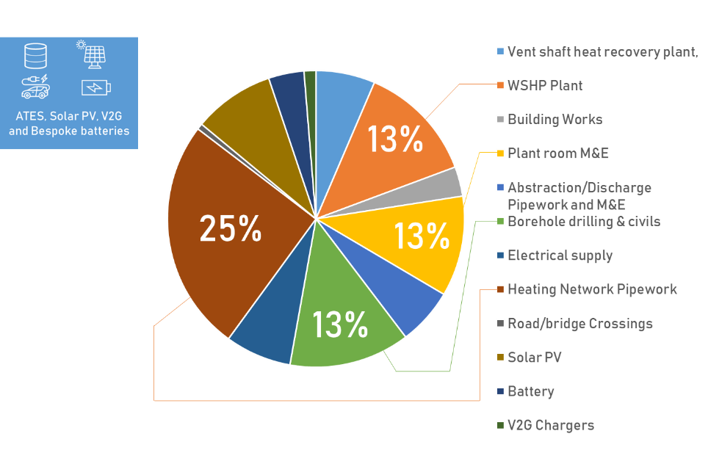
Figure 12 CAPEX breakdown of the proposed GreenSCIES schemes
3.4 Discussion of results
Typical results from the energyPro simulations for a winter and summer week for Scheme B, with all of the selected energy sources/technologies i.e. ATES, solar PV, V2G and bespoke batteries, are shown in Figures 8 and 9. It is shown that the predicted variation in heating and cooling demand can be met for the Scheme B system, with the energy source capacities used. The only exception was for the cooling demand (for the data centres) in summer, whereby free cooling only using the cold borehole wells was insufficient, due to the lower heat demand for the network. Therefore, some additional cooling e.g. using chillers would be needed for part of the time. The operational cost for each of the energy source combinations i.e. scenarios, for both schemes, expressed in terms of OPEX revenue increase compared to the base case i.e. gas boilers, chillers and grid electricity, is shown in Figure 10. It is seen that the greatest OPEX revenue increase was achieved for the scenario where all of the energy source technologies were used, with an increase of 24% for Scheme A and 34% for Scheme B. However, when comparing the 25 year CO₂ savings, similar % saving values were obtained for 3 of the scenarios, namely the ATES and solar PV; ATES, solar PV and V2G; and ATES, solar PV, V2G and bespoke batteries technologies, for both Schemes A and B. The main reason for this is considered to be that the main contributor to the carbon savings obtained is the solar PV electricity component.
In terms of initial CAPEX, the scenario including all of the technologies was highest, as expected, however, the net present value (NPV) compared to the base case was also greatest for this scenario for both Schemes A and B.
Overall, the modelling shows that both schemes are financially viable against a case where the current case of gas boilers, electric chillers, and grid electricity are the counterfactual. This is despite a reduction in heat and cooling sales prices of 25% - which was the criteria for further development support from the UK research agency Innovate UK. It should be noted that this assessment includes two major subsidies in the form of the Renewable Heat Incentive and the Heat Network Investment Programme. Without these the scheme would not be economic at these heat/cooling prices. These subsidies are, however, themselves in place to correct market distortions in the pricing of gas and electricity. Electricity faces £70 per MWh of levies which are almost exclusively made up of the costs of decarbonising electricity. Gas, on the other hand, faces almost no levies. The government has chosen to fund the RHI from general taxation in contrast to previous policy where all programmes have been funded through a utility level.
One question that arises from the analysis is how to determine the correct level of storage to be built into the scheme. We have used current mechanisms and prices to assess this.
Since the assessment was conducted, Ofgem, the UK energy markets regulator, has announced its intention to overhaul the charging system for distribution and transmission charges. These are to be shifted from a variable kWh based charge to fixed kVA based charge. This move severely undermines the market for “flex”. In public statements Ofgem have stated that they are looking at how this might be addressed and have suggested that Distribution Network Operator (DNO), offerings will help redress the balance. These could be in the form of payments to turn down demand in peak periods to avoid the need for reinforcement. These are already being offered by DNOs across the UK. The area of Islington in question is not yet an area where capacity is constrained and where the DNO is inviting bids. However, as electrification progresses the need for reinforcement and therefore the value of being able to provide services to avoid constraints is likely to grow.
3.5 Limitations of the modelling
There are a number of limitations of the model which the authors plan to address in future work. Temperatures play a significant role in the efficiency of the system. The use of the analytic energyPRO method permits the effect of temperatures to be modelled but only as a static input - or output. An output dynamically generated in the model in one half hour cannot be transferred and used as an input for the next. This means that the optimisation of the loop temperatures has not yet been conducted – as would be required to determine the temperatures that the loop should be operated at to maximise the COP of heating and cooling units on the network. Other questions to be addressed include whether the temperature of the loop should be allowed to float. An alternative solver based method has recently been added to energyPRO. Utilising the solver, it should soon be possible to overcome this limitation.
A further limitation is that the behaviour of the aquifer has yet to be modelled – its possible behaviour was simply represented as two alternative scenario extremes: “limitless” – as if it were a flowing body of water like a river or “ATES” - as if it were a static lake. This is largely due to the uncertainty as to the behaviour of the London aquifer - but again partly due to the non-chronological analytical energyPRO method.
- CONCLUSIONS AND NEXT STEPS
The paper has introduced a novel concept a smart energy system that is based around a 5th generation (5G) ambient-temperature loop, integrating thermal, power and mobility energy vectors. The paper highlighted that energy system integration with an ambient loop network offers significant advantages compared to higher temperature networks, including exploitation of a wider range of waste-heat sources, sharing of heating and cooling between buildings, and flexible access to renewable energy through storage and smart controls. However, there have not been design methodologies introduced to date for such complex integrated energy systems. This paper introduced a novel methodology for implementing a low-carbon integrated whole energy system. The methodology has been introduced by a concept design based on a dense urban area, in the London Borough of Islington (LBI). Although the paper used LBI as a case study, the approach could be implemented anywhere around the world. The paper also presented results from techno economic modelling of the proposed 5G schemes. The modelling has shown that the novel 5G concept can be both economic and carbonomic, giving affordable heating, cooling, and EV charging. It was shown that significant carbon savings can be achieved if the 5G concept is implemented with around 80% reduction in carbon emissions over the base case. However, future predicted carbon savings are even higher as the electricity grid decarbonises further in many countries across the world. In addition, the integrated 5G approach introduced in this paper also encourages the use of EV’s and V2G charging technologies, resulting in improved air quality in the network localities. Overall, the results of this paper have shown that the 5G concept is practical, buildable and highly investable. 5G Smart energy networks can provide a community based approach to energy solutions around the globe and is in tune with climate change awareness/expectations. The next phase of the research will deliver a detailed design study for an integrated, smart, local energy network for a large community in the London Borough of Islington, and a clear path to demonstrate the design and replicate it in the UK and globally.
ACKNOWLEDGEMENT
Project GreenSCIES is being funded by InnovateUK, with significant support from all project partners and from EPSRC (Engineering Physical Sciences Research Council) via the Lot-NET (Low Temperature Heat Recovery and Distribution Network Technologies) programme grant in the UK.
REFERENCES
Andersen, A. N. and Østergaard, P. A. (2019) Analytic versus solver-based calculated daily operations of district energy plants, Energy, 175, pp. 333–344. DOI:10.1016/j.energy.2019.03.096.
Aziz, A. S., Tajuddin, M. F. N., Adzman, M. R., Mohammed, M. F. and Ramli, M. A. M. (2020) Feasibility analysis of grid-connected and islanded operation of a solar PV microgrid system: A case study of Iraq, Energy, 191, pp. 116591. DOI:10.1016/j.energy.2019.116591.
Ballo, I. F. (2015) Imagining energy futures: Sociotechnical imaginaries of the future Smart Grid in Norway, Energy Research & Social Science, 9, pp. 9–20.
BBC (2020) Ban on petrol and diesel car sales brought forward, BBC News. Available from: https://www.bbc.co.uk/news/science-environment-51366123 [Accessed 14 February 2020].
BEIS (2018) Clean Growth - Transforming Heating - Overview of Current Evidence, pp. 136.
BEIS (2019) 2018 UK Greenhouse Gas Emissions, Provisional Figures, Statistical Release: National Statistics. Available from: https://assets.publishing.service.gov.uk/government/uploads/system/uploads/attachment_data/file/790626/2018-provisional-emissions-statistics-report.pdf [Accessed 10 February 2020].
BRGM (2019) D2GRIDS: deploying new 5th generation local energy loops in North-West Europe | BRGM. Available from: https://www.brgm.eu/project/d2grids-deploying-new-5th-generation-local-energy-loops-north-west-europe [Accessed 11 February 2020].
Buffa, S., Cozzini, M., D’Antoni, M., Baratieri, M. and Fedrizzi, R. (2019) 5th generation district heating and cooling systems: A review of existing cases in Europe, Renewable and Sustainable Energy Reviews, 104, pp. 504–522. DOI:10.1016/j.rser.2018.12.059.
Chen, Y.-H., Lu, S.-Y., Chang, Y.-R., Lee, T.-T. and Hu, M.-C. (2013) Economic analysis and optimal energy management models for microgrid systems: A case study in Taiwan, Applied Energy, 103, pp. 145–154. DOI:10.1016/j.apenergy.2012.09.023.
Davies, G., Boot-Handford, N., Curry, D., Dennis, W., Ajileye, A., Revesz, A. and Maidment, G. (2019) Combining cooling of underground railways with heat recovery and reuse, Sustainable Cities and Society, 45, pp. 543–552.
Davies, G. F., Maidment, G. G. and Tozer, R. M. (2016) Using data centres for combined heating and cooling: An investigation for London, Applied Thermal Engineering, 94, pp. 296–304.
Drysdale, D., Vad Mathiesen, B. and Lund, H. (2019) From Carbon Calculators to Energy System Analysis in Cities, Energies, 12 (12), pp. 2307. DOI:10.3390/en12122307.
EMD (2014, August 12) energyPRO - Simulate, analyze and optimize operations of energy plants, EMD International A/S. Available from: https://www.emd.dk/energypro/
ENA (2019) Open Networks Project – DSO Transition: Roadmap to 2030. Available from: http://www.energynetworks.org/assets/files/electricity/futures/Open_Networks/DSO%20Roadmap%20v6.0.pdf [Accessed 26 November 2019].
EUROHEAT&POWER (2017, December 14) ReUseHeat: Recovery of Urban Excess Heat, Euroheat & Power. Available from: https://www.euroheat.org/our-projects/reuseheat-recovery-urban-excess-heat/ [Accessed 10 February 2020].
GLA (2014, May 13) Secondary Heat Study – London’s Zero Carbon Energy Resource, London City Hall. Available from: https://www.london.gov.uk//WHAT-WE-DO/environment/environment-publications/secondary-heat-study-londons-zero-carbon-energy [Accessed 26 June 2019].
Goulden, M., Bedwell, B., Rennick-Egglestone, S., Rodden, T. and Spence, A. (2014) Smart grids, smart users? The role of the user in demand side management, Energy Research & Social Science, 2, pp. 21–29.
GOV.UK (2019a) Green Book supplementary guidance: valuation of energy use and greenhouse gas emissions for appraisal, GOV.UK. Available from: https://www.gov.uk/government/publications/valuation-of-energy-use-and-greenhouse-gas-emissions-for-appraisal [Accessed 24 October 2019].
GOV.UK (2019b) Spring Statement 2019: what you need to know, GOV.UK. Available from: https://www.gov.uk/government/news/spring-statement-2019-what-you-need-to-know [Accessed 26 June 2019].
Guelpa, E., Marincioni, L., Deputato, S., Capone, M., Amelio, S., Pochettino, E. and Verda, V. (2019) Demand side management in district heating networks: A real application, Energy, 182, pp. 433–442.
IEA (2018) Renewable Heat Policies, Delivering clean heat solutions for the energy transition, pp. 57.
Jones, P. (2019) A roadmap to achieve 5th generation heat networks in the UK, 2019 CIBSE Technical Symposium, Sheffield, UK.
Jones, S. R., Gillott, M., Boukhanouf, R., Walker, G., Tunzi, M., Tetlow, D., Rodrigues, L. and Sumner, M. (2019) A System Design for Distributed Energy Generation in Low-Temperature District Heating (LTDH) Networks, Future Cities and Environment, 5 (1), pp. 2. DOI:10.5334/fce.44.
Kauko, H., Kvalsvik, K. H., Rohde, D., Nord, N. and Utne, Å. (2018) Dynamic modeling of local district heating grids with prosumers: A case study for Norway, Energy, 151, pp. 261–271. DOI:10.1016/j.energy.2018.03.033.
LSBU (2019) Smart Energy Network study launches at London South Bank University. Available from: http://www.lsbu.ac.uk/about-us/news/smart-energy-network-study-launches [Accessed 26 June 2019].
Lund, H., Duic, N., Østergaard, P. A. and Mathiesen, B. V. (2020) Perspectives on Smart Energy Systems from the SES4DH 2018 conference, Energy, 190, pp. 116318. DOI:10.1016/j.energy.2019.116318.
Lund, H., Østergaard, P. A., Chang, M., Werner, S., Svendsen, S., Sorknæs, P., et al. (2018) The status of 4th generation district heating: Research and results, Energy, 164, pp. 147–159. DOI:10.1016/j.energy.2018.08.206.
Lund, H., Werner, S., Wiltshire, R., Svendsen, S., Thorsen, J. E., Hvelplund, F. and Mathiesen, B. V. (2014) 4th Generation District Heating (4GDH): Integrating smart thermal grids into future sustainable energy systems, Energy, 68, pp. 1–11.
Lygnerud, K. and Werner, S. (2018) Risk assessment of industrial excess heat recovery in district heating systems, Energy, 151, pp. 430–441. DOI:10.1016/j.energy.2018.03.047.
Nord, N., Nielsen, E. K. L., Kauko, H. and Tereshchenko, T. (2018) Challenges and potentials for low-temperature district heating implementation in Norway, Energy, 151, pp. 889–902.
Nwulu, N. I. and Xia, X. (2017) Optimal dispatch for a microgrid incorporating renewables and demand response, Renewable Energy, 101, pp. 16–28. DOI:10.1016/j.renene.2016.08.026.
Nyborg, S. and Røpke, I. (2013) Constructing users in the smart grid—insights from the Danish eFlex project, Energy Efficiency, 6 (4), pp. 655–670.
Ofgem (2020) Ofgem’s Decarbonisation Action Plan, Ofgem. Available from: https://www.ofgem.gov.uk/publications-and-updates/ofgem-s-decarbonisation-action-plan [Accessed 11 February 2020].
Pavić, I., Luburić, Z., Pandžić, H., Capuder, T. and Andročec, I. (2019) Defining and Evaluating Use Cases for Battery Energy Storage Investments: Case Study in Croatia, Energies, 12 (3), pp. 376.
Pelda, J. and Holler, S. (2019) Spatial distribution of the theoretical potential of waste heat from sewage: A statistical approach, Energy, 180, pp. 751–762.
Reijnders, V., van der Laan, M. and Dijkstra, R. (2020) Energy communities: a Dutch case study, in: Behind and Beyond the Meter Digitalization, Aggregation, Optimization, Monetization.
Skjølsvold, T. M., Throndsen, W., Ryghaug, M., Fjells\aa, I. F. and Koksvik, G. H. (2018) Orchestrating households as collectives of participation in the distributed energy transition: New empirical and conceptual insights, Energy Research & Social Science, 46, pp. 252–261.
Sorknæs, P., Lund, H., Skov, I. R., Djørup, S., Skytte, K., Morthorst, P. E. and Fausto, F. (2020) Smart Energy Markets - Future electricity, gas and heating markets, Renewable and Sustainable Energy Reviews, 119, pp. 109655. DOI:10.1016/j.rser.2019.109655.
Throndsen, W. (2017) What do experts talk about when they talk about users? Expectations and imagined users in the smart grid, Energy Efficiency, 10 (2), pp. 283–297.
van der Kam, M. and van Sark, W. (2015) Smart charging of electric vehicles with photovoltaic power and vehicle-to-grid technology in a microgrid; a case study, Applied Energy, 152, pp. 20–30. DOI:10.1016/j.apenergy.2015.04.092.
Veilleux, G., Potisat, T., Pezim, D., Ribback, C., Ling, J., Krysztofiński, A., et al. (2020) Techno-economic analysis of microgrid projects for rural electrification: A systematic approach to the redesign of Koh Jik off-grid case study, Energy for Sustainable Development, 54, pp. 1–13. DOI:10.1016/j.esd.2019.09.007.
Volkova, A., Krupenski, I., Pieper, H., Ledvanov, A., Latõšov, E. and Siirde, A. (2019) Small low-temperature district heating network development prospects, Energy, 178, pp. 714–722. DOI:10.1016/j.energy.2019.04.083.
Wallsten, A. and Galis, V. (2019) The discreet charm of activeness: the vain construction of efficient smart grid users, Journal of Cultural Economy, 12 (6), pp. 571–589.
Zhang, C., Wu, J., Cheng, M., Zhou, Y. and Long, C. (2016) A bidding system for peer-to-peer energy trading in a grid-connected microgrid, Energy Procedia, 103, pp. 147–152.
R. Ford, C. Maidment, M. Fell, C. Vigurs, M. Morris A framework for understanding and conceptualising smart local energy systems, University of Strathclyde Publishing, UK (2019)

