Assessment of Silent T1-weighted head imaging at 7 T
Mauro Costagli^{1,2} • Mark R. Symms³ • Lorenzo Angeli ⁴ • Douglas A. C. Kelley⁵ • Laura Biagi ² • Andrea Farnetani ^{6,7} • Catarina Rua⁸ • Graziella Donatelli ⁹ • Gianluigi Tiberi ^{1,2} • Michela Tosetti^{1,2} • Mirco Cosottini ^{1,4}

Abstract
Objectives This study aimed to assess the performance of a BSilent^ zero time of echo (ZTE) sequence for T1-weighted brain imaging using a 7 T MRI system.
Methods The Silent sequence was evaluated qualitatively by two neuroradiologists, as well as quantitatively in terms of tissue contrast, homogeneity, signal-to-noise ratio (SNR) and acoustic noise. It was compared to conventional T1-weighted imaging (FSPGR). Adequacy for automated segmentation was evaluated in comparison with FSPGR acquired at 7 T and 1.5 T. Specific absorption rate (SAR) was also measured. Results Tissue contrast and homogeneity in Silent were re- markable in deep brain structures and in the occipital and temporal lobes. Mean tissue contrast was significantly (p < 0.002) higher in Silent (0.25) than in FSPGR (0.11),

* Mauro Costagli me@maurocostagli.info

¹ Imago7 Foundation, Calambrone, Pisa, Italy
² Laboratory of Medical Physics and Biotechnologies for Magnetic Resonance, IRCCS Stella Maris, Pisa, Italy
³ GE Applied Science Laboratory, Pisa, Italy
⁴ Department of Translational Research and New Technologies in Medicine and Surgery, University of Pisa, Pisa, Italy
⁵ GE Healthcare Technologies, San Francisco, CA, USA
⁶ Engineering Department, University of Ferrara, Ferrara, Italy
⁷ Materiacustica s.r.l., Ferrara, Italy
⁸ Department of Physics, University of Pisa, Pisa, Italy
⁹ Neuroradiology Unit, Department of Diagnostic and Interventional Radiology, Azienda Ospedaliero-Universitaria Pisana (AOUP), Pisa, Italy
which favoured automated tissue segmentation. On the other hand, Silent images had lower SNR with respect to conven- tional imaging: average SNR of FSPGR was 2.66 times that of Silent. Silent images were affected by artefacts related to pro- jection reconstruction, which nevertheless did not compro- mise the depiction of brain tissues. Silent acquisition was 35 dB(A) quieter than FSPGR and less than 2.5 dB(A) louder than ambient noise. Six-minute average SAR was <2 W/kg. Conclusions The ZTE Silent sequence provides high-contrast T1-weighted imaging with low acoustic noise at 7 T.
Key Points
- BSilent^ is an MRI technique allowing zero time of echo acquisition
- Its feasibility and performance were assessed on a 7 T MRI system
- Image quality in several regions was higher than in conven- tional techniques
- Imaging acoustic noise was dramatically reduced compared with conventional imaging
- BSilent^ is suitable for T1-weighted head imaging at 7 T
Keywords Magnetic resonance imaging . Neuroimaging . Technology assessment, Biomedical . Patient satisfaction . Brain

Abbreviations
MRI Magnetic resonance imaging TE Time of echo
TI Time of inversion
TD Time of delay
ZTE Zero time of echo SNR Signal-to-noise ratio
FSPGR Fast spoiled gradient-recalled ROI Region of interest

WM White matter
GM Gray matter
TC Tissue contrast
WMIV White matter intensity variability GMCR Gray matter cortical ribbon
OT Other tissues
SAR Specific absorption rate
TPR True-positive rate (sensitivity) SPC Specificity
PPV Positive predictive value (precision) NPV Negative predictive value

Introduction

In recent years, magnetic resonance imaging (MRI) sequences that allow data acquisition with a sub-millisecond time of echo (TE) have been developed [1–12]. Among these sequences, some perform both radiofrequency excitation and acquisition in the presence of spatial encoding gradients, including rotat- ing ultra-fast imaging sequence (RUFIS) [2], water- and fat- suppressed proton projection (WASPI) [4] and pointwise encoding time reduction with radial acquisition (PETRA) [11], and they are commonly referred to as Bzero^ time of
echo (ZTE) techniques [9, 10, 13]. The absence of gradient
switching during signal encoding, with high receiver band- width during readout, provides high robustness against eddy current and off-resonance effects [9], and in the presence of a 3D k-space sampling scheme with smoothly varying radial trajectories, it allows the application of minimal gradient var- iations, resulting in dramatically reduced acoustic noise [3, 10, 14]. This last property is a major advantage, considering that recent surveys of patient tolerability reveal that acoustic noise is the most significant cause of discomfort during MRI exam- inations at 7.0 Tesla (7 T) [15, 16]. Furthermore, ZTE imag- ing, based on projection reconstruction, lacks the problems commonly associated with Cartesian sampling schemes, such as geometrical distortion and image blurring in the phase- encode direction, as well as flow-related artefacts [2, 17, 18]. Recent reports in brain imaging [19, 20] have also shown that ZTE techniques are capable of generating images with T1 contrast and revealing tissues with short transverse relaxation time. Considering that conventional inversion-prepared imag- ing at 7 T suffers from contrast loss due to greater B1 hetero- geneity than at lower field strengths, improved adiabatic pulses are an increasingly active field of study [21–23], and ZTE sequences employing such pulses are a promising alternative.
In this work, a BSilent^ ZTE sequence optimized for T1- weighted brain imaging on a 7 T MRI system was used. Its tissue contrast, homogeneity and signal-to-noise ratio (SNR) were quantified. For reference, conventional T1-weighted im-
aging at 7 T was performed as well, with the same spatial
resolution. The quality of Silent images was also measured in terms of how well the cortical gray matter could be seg- mented by a standard automated procedure. To this aim, con- ventional T1-weighted images acquired at 1.5 T were used as reference, as they are less affected by heterogeneities than those acquired at 7 T [24–27]. Finally, the reduction in acous- tic noise offered by ZTE was measured, and the specific ab- sorption rate (SAR) during imaging was monitored.

Materials and methods

Human subjects

Ten human volunteers (mean age 51.7 years, range 22–81 years, 3 women) participated in this study, with their under- standing and written consent obtained in accordance with the protocol approved by the competent ethics committee and in compliance with national legislation and the Declaration of Helsinki.

Imaging hardware and acquisition sequences

Data were acquired with both ZTE and conventional T1- weighted imaging sequences using a Discovery MR950 7 T MRI system (GE Healthcare, Milwaukee, WI, USA) equipped with a 2-channel transmit / 32-channel receive coil (Nova Medical, Wilmington, MA, USA). Data of conventional T1- weighted images were acquired as well, using a 1.5 T Signa HDxt MR scanner (GE Healthcare) equipped with an 8- channel array coil (Invivo Corporation, Gainesville, FL, USA).
The ZTE imaging technique used in this work was the Silent sequence provided by the scanner manufacturer. Its scheme is depicted in Fig. 1. It is an inversion recovery (IR) technique using a 3D radial acquisition scheme [2], with a hyperbolic secant-squared (HS2) adiabatic inversion pulse [28, 29] and an optimized fat suppression pulse [30]. Imaging parameters were similar to those used in recent optimization studies [19, 30]: receiver bandwidth (RBW)=31.3 kHz, time of inversion (TI)=600 ms, time of repetition (TR) of ZTE block=5 25 ms, time of echo (TE)=16 μs, flip angle (FA)= 4°, spokes per segment= 384, post-segment time of delay (TD)=2000 ms. In the current implementation, the Silent se- quence is constrained to acquire a cubic field of view (FOV), whose side was set to 192 mm; images were reconstructed at a resolution of 1×1×1 mm³.
Conventional T1-weighted imaging sequences were fast spoiled gradient-recalled (FSPGR), prescribed axially. On the 7 T MRI system, FSPGR sequence parameters were sim- ilar to those reported in the recent literature [31–33]: RBW= 50 kHz, TI=450 ms, TR=6 ms, TE=2200 μs, FA=12°, array
coil spatial sensitivity encoding (ASSET) acceleration factor=

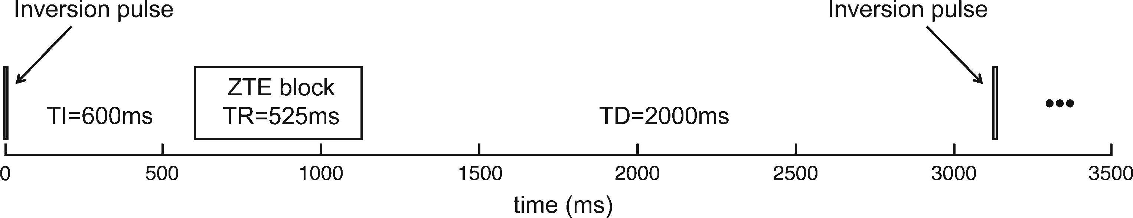
Fig. 1 Scheme of T1-weighted Silent. The sequence starts with an HS2 inversion pulse. After 600 ms, a ZTE acquisition block is performed, followed by a TD of 2 s before the next inversion pulse is applied

2, spatial resolution= 1 × 1 × 1 mm³. FSPGR acquisition allowed a non-cubic FOV, and therefore the phase encode direction (left/right) and the third dimension (inferior/superi- or) in most subjects were limited to reduce scan time. Four subjects underwent standard FSPGR on the 1.5 T MRI system using the following parameters: RBW= 15.6 kHz, TI= 700 ms, TR=12.4 ms, TE=5200 μs, FA=10°, ASSET accel-
eration factor=2; spatial resolution=1×1×1 mm³.

Qualitative assessment

Two neuroradiologists (24 and 5 years of experience) visually inspected and qualitatively evaluated the Silent and FSPGR images according to a four-point scale (1=unsatisfactory qual- ity, 4=satisfactory quality). The two readers jointly performed the qualitative assessment, and graded 1) image quality in different regions of the cerebral parenchyma, 2) extra- parenchymal structures, and 3) number of artefacts. In the cerebral parenchyma, the readers evaluated the anatomical details and contrast between gray matter (GM) and white matter (WM) in the frontal, temporal, parietal and occipital lobes, in the limbic system, and in the deep brain structures (basal ganglia). Extraparenchymal structures included the orbits, the bones of the cranial vault and basis, and the intra- cranial vessels. The radiologists evaluated the anatomical details of eyes, ocular muscles and optic nerves, the ability to distinguish the diploic bone from the inner and outer layers of the compact bone, and the amount of visible vasculature. Artefacts that were considered included flow, susceptibility, bounce-point and truncation artefacts [34].

Measurement of tissue contrast and spatial homogeneity

Data from ten subjects were acquired at 7 T with both FSPGR and Silent sequences. In each subject, and in both FSPGR and Silent images, six pairs of 5-mm² regions of interest (ROIs) were defined, as follows: 1) in the frontal lobe, GM in the fronto-mesial gyrus and adjacent WM; 2) in the parietal lobe, GM and adjacent WM of the superior parietal lobule; 3) in the occipital lobe, GM and adjacent WM of the occipital pole; 4) in the temporal lobe, GM and adjacent WM of the planum temporale; 5) hippocampal body and adjacent white matter; and 6) in deep brain structures, head of the caudate nucleus and splenium of the corpus callosum. For each pair of ROIs,
the tissue contrast (TC) was defined as follows: TC≜(I_{WM}− I_{GM})/(I_{WM}+ I_{GM}) [35], where I_{GM} and I_{WM} are the average intensities of GM and WM, respectively, within individual
ROIs. TC=0 indicates no contrast, and increasing values of TC indicate higher tissue contrast. The standard deviation of WM signal intensity across the six above-referenced WM ROIs was used to measure WM intensity variability (WMIV).

Assessment of segmentation capability

The overall quality of a T1-weighted image can also be mea- sured in terms of how well the gray matter cortical ribbon (GMCR) can be extracted by a standard automated procedure. Silent and FSPGR images of four subjects acquired at 7 T were fed to the FreeSurfer standard surface segmentation pipe- line [36, 37] after spatial heterogeneity pre-filtering [38]. No manual edits were applied to segmented data for correction. Two masks of automatically segmented tissues were created from the registered datasets: one representing GMCR, and the other including all other tissues (OT). FSPGR images of the same subjects were also acquired at 1.5 T, and were segment- ed using the same pipeline [36, 37]. After quality assessment performed by experienced operators, the segmentation obtain- ed with FSPGR at 1.5 Twas considered the reference. The two pairs of masks (GMCR and OT) obtained with Silent and FSPGR at 7 T were co-registered to the FSPGR segmented data acquired at 1.5 T by affine registration [39]. Measures of goodness of segmentation with respect to the assumed refer- ence are the sensitivity (or true-positive rate, TPR), specificity (SPC), precision (or positive predictive value, PPV) and neg- ative predictive value (NPV) of GM segmentation: TPR=tp/ (tp + fn); SPC = tn/(tn + fp);PPV= tp/(tp + fp); NPV = tn/(tn + fn), where tp are true positives (voxels that are classified as GMCR in both test and reference datasets), tn are true nega- tives (voxels that are classified as OT in both test and reference datasets), fp are false positives (voxels classified as GMCR in the test dataset but are OT in the reference dataset), and fn are false negatives (voxels classified as OT in the test dataset but are GMCR in the reference dataset) [40].

Measurement of signal-to-noise ratio

Two of ten subjects underwent both Silent and FSPGR se- quences twice within the same scanning session in order to

compute SNR using the Bdifference method^ [27]. To this end, images were visually inspected in order to exclude the presence of any relevant artefacts. Images of the same kind
(the two Silent images on the one hand, and the two FSPGR images on the other) were co-registered using FSL-FLIRT
[41] with nearest-neighbour interpolation to exclude interpo- lation smoothing. Images of the same kind were then added and subtracted voxel-wise, to generate the following data:

SILENTSUM ¼ SILENTacquisition#1 þ SILENTacquisition#2 SILENTDI F F ¼ SILENTacquisition#1 – SILENTacquisition#2 FSPGRSUM ¼ FSPGRacquisition#1 þ FSPGRacquisition#2
FSPGRDI F F ¼ FSPGRacquisition#1 – FSPGRacquisition#2
Eight ROIs (in temporal, occipital, parietal and frontal lobes, in both hemispheres) with area=25 mm² were drawn
in homogeneous regions of white matter in each subject. With- in each ROI, SNR was defined as SNR_{ROI} p2μ=2σ,
¼ ﬃﬃﬃ
where μ is the mean intensity in the ROI in the BSUM^ image,
and σ is the standard deviation in the ROI in the BDIFF^
image [27].

Measurement of acoustic noise

Acoustic noise was measured by an omnidirectional MK 2 microphone equipped with a CMC 6 preamplifier (SCHOEPS GmbH, Karlsruhe, Germany), positioned in the scanner room at a distance of 4.5 m from the front of the bore. Data acqui- sition and analysis were conducted using AudioTools soft- ware (Studio Six Digital LLC, Boulder, CO, USA) for iPad iOS 8 (Apple Inc., Cupertino, CA, USA) equipped with an iAudioInterface2 board (Studio Six Digital LLC). Before measurement, the system was calibrated using a B&K Acous- tic Calibrator Type 4231 (Brüel & Kjær Sound and Vibration Measurement A/S, Nærum, Denmark).
Sound pressure level as a function of time was measured during FSPGR and Silent scanning, as well as in the absence of scanning, for evaluation of ambient noise (cold heads and ventilation system). Sound equivalent levels (time average sound pressure level across 30 s) as a function of frequency (fast Fourier transform) in the three conditions (FSPGR scan- ning, Silent scanning, no scan) were also measured.

Specific absorption rate

Global SAR must be continuously monitored to ensure that MRI acquisition is performed within the limits imposed by the International Electrotechnical Commission standard (IEC 60601-2-33). The SAR limit for the head is 3.2 W/kg during any 6-min time average. The built-in SAR monitor of the MR system estimates the radiofrequency power deposited in the subject through an empirical formulation, which takes into
account information including the difference between the transmitted and reflected power, as well as patient data (e.g. patient weight and whether the patient is a baby or an adult, to scale patient weight to head weight when using a transmitting head coil) [42]. The routine returns both the 6-min and 10-s SAR averages. The SAR estimates are continuously updated during acquisition, in real time.

Statistical analysis

Statistical significance in differences between Silent and FSPGR images was assessed by two-tailed Wilcoxon rank- sum tests. The level of significance was set to 5 %.

Results

Qualitative assessment

Representative images of Silent and FSPGR acquisitions at 7 T are shown in Fig. 2. The mean scores assigned by the two neuroradiologists to Silent and FSPGR images are report- ed in Table 1. In the cerebral parenchyma, the overall scores were significantly higher (p<0.001) in Silent (mean score= 3.5) than in FSPGR (mean score=2.7). The scores in individ- ual regions of the cerebral parenchyma were significantly dif- ferent among the temporal lobes (Silent score=3.1>FSPGR score=1.7; p<0.007), the limbic system (Silent score=3.4> FSPGR score= 2.4; p < 0.02) and the basal ganglia (Silent score=3.9>FSPGR score=2.8; p<0.001). The scores in the occipital lobe were greater for Silent (=2.9) than for FSPGR (=2.2), but their difference did not reach the level of signifi- cance level (p<0.09).
Scores were significantly different among all the extraparenchymal structures, i.e. the orbits (Silent score =1< FSPGR score= 1.9; p < 0.01), bones (Silent score= 1.2 < FSPGR score = 2.8; p < 0.003), and vasculature (Silent score=2.8>FSPGR score=1.6; p<0.01). In particular, Silent images provided an MRA-like depiction of intracranial ves- sels, with a white blood representation of both Willis circles and distal intracranial branches (Fig. 2a and c).
All evaluated artefacts were significantly different between Silent and FSPGR: the former imaging sequence was devoid of flow artefacts (for comparison with FSPGR, see the regions indicated by red arrows in Fig. 2b), while it was more prone to truncation (B-^ symbols in Fig. 2a, c, e) and susceptibility
artefacts near the air–bone interface of the paranasal sinuses.
A peculiarity of T1-weighted Silent images was the presence of a hypointense line between cerebrospinal fluid and gray matter (Fig. 2e, rectangular box and inset). This phenomenon has been previously described as Bbounce-point artefact^ [34]
and Btissue border enhancement^ [32].

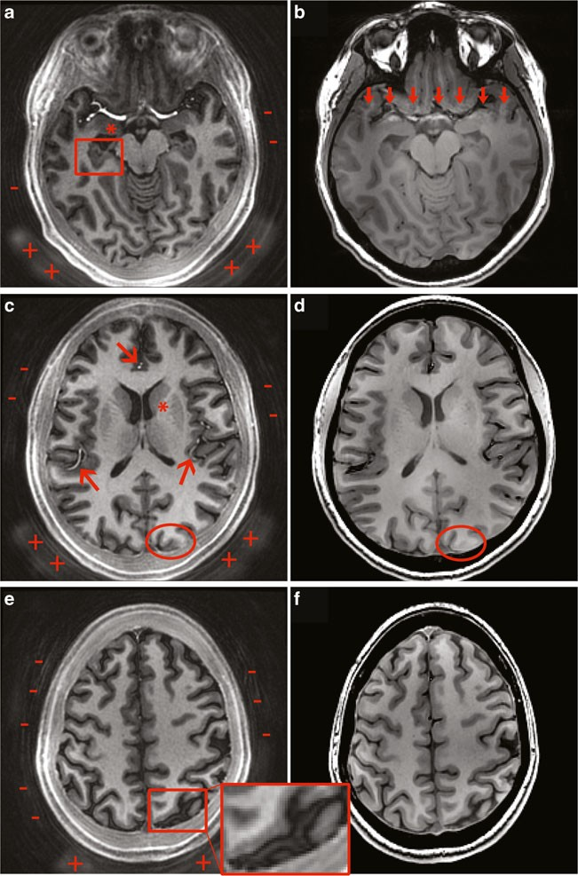
Fig. 2 (colour figure) Representative images acquired at 7 T using Silent (a, c, e) and SPGR (b, d, f). The WM–GM
contrast is higher in Silent than in FSPGR images, especially in the limbic system (e.g. in the amygdala and hippocampus, indicated in a by the asterisk and rectangular box, respectively), in deep structures (indicated in c by the asterisk) and in the posterior part of the brain (compare, in particular, the region indicated by the oval in c and d). In general, Silent images provide a better representation of the vasculature (arrows in c) and are devoid of flow artefacts that are commonly observed in FSPGR images, especially in the temporal lobe (arrows in b). On the contrary, Silent images are often affected by bounce-point artefacts/tissue border enhancement between GM and cerebrospinal fluid (e.g. see rectangular box in e). Radial truncation artefacts are present in
all Silent images outside the skull (B−^ symbols in a, c, e); however, image quality in the brain region does not seem affected. The foam padding supporting the back of
the head is visible in Silent (B+^ symbols in a, c, e)

In Silent, the foam padding supporting the back of the head was also visible (B+^ symbols in Fig. 2a, c, e).

Tissue contrast, signal homogeneity and signal-to-noise ratio

Silent sequence provided significantly higher contrast than FSPGR (Wilcoxon rank-sum test, p <0.002 in all pairs of ROIs across subjects). Mean TC was 0.25 in Silent and 0.11 in FSPGR. In particular, with Silent, TC was substantially improved in regions where FSPGR images exhibited poor quality: TC was 4 times as high in occipital regions, and over

1.9 times as high in the hippocampal region and in deep struc- tures (Fig. 3).
The intensity variability of white matter in the six ROIs was less in Silent (mean WMIV across subjects=16.2) than in FSPGR (mean WMIV across subjects=39.3).
On average, SNR in Silent was 31.88, and it was higher in frontal regions (average SNR=37.15) than in temporal re- gions (average SNR=24.72). The average SNR of FSPGR images was 2.66 times that of Silent. It should also be noted that for acquisitions with the same inferior/superior coverage, the imaging time in Silent was 6’01^, while in FSPGR it was 5’02^. Silent imaging was therefore ~1.2 times as long as FSPGR. Since SNR in FSPGR increases with the square root

Table 1 Mean scoresª of  neuroradiological qualitative | Description | Mean score |  | Statistical significance
evaluation of Silent and FSPGR  images acquired at 7 T |  |  | Silent | FSPGR
 | Cerebral parenchyma | Frontal lobe | 3.8 | 3.7 | Not significant
 |  | Parietal lobe | 3.7 | 3.2 | Not significant
 |  | Occipital lobe | 2.9 | 2.2 | p<0.09
 |  | Temporal lobe | 3.1 | 1.7 | p<0.007
 |  | Limbic | 3.4 | 2.4 | p<0.02
 |  | Basal ganglia | 3.9 | 2.8 | p<0.001
 |  | Overall cerebral parenchyma | 3.5 | 2.7 | p<0.001
 | Extracerebral tissues | Orbital | 1 | 1.9 | p<0.01
 |  | Bone | 1.2 | 2.8 | p<0.003
 |  | Vasculature | 2.8 | 1.6 | p<0.01
 | Artefacts | Flow | 4 | 1.9 | p<0.001
 |  | Truncation | 1 | 4 | p<0.001
 |  | Susceptibility | 1.7 | 2.9 | p<0.001
 |  | Bounce-point | 1 | 4 | p<0.001
ª Scores range from 1 (not satisfactory image quality) to 4 (satisfactory image quality)

of the number of acquisitions (i.e. time), a theoretical SNR ratio assuming equal acquisition time would be
SNRtheor ¼ SNRFSPGR=SNRSilent × qﬃTﬃﬃSﬃilﬃeﬃnﬃt=ﬃﬃTﬃﬃﬃﬃﬃﬃﬃﬃﬃﬃﬃ¼ﬃﬃﬃﬃﬃﬃ2ﬃﬃ:ﬃ6ﬃﬃﬃ6ﬃﬃﬃ×ﬃﬃﬃﬃﬃpﬃﬃﬃﬃ1ﬃﬃﬃﬃﬃ:ﬃﬃ2ﬃﬃﬃﬃﬃﬃ¼ﬃﬃﬃﬃﬃ2ﬃﬃﬃ:ﬃ9ﬃﬃﬃ:ﬃ
the meninges and in the posterior regions. In conventional T1- weighted images, these areas exhibited severe intensity and contrast inhomogeneities, and therefore cortical thickness was
underestimated (Fig. 4c). Numerical results indicated that the

ratio
FSPGR
automated segmentation of the cortical ribbon at 7 T held higher sensitivity (TPR), precision (PPV) and negative predic-

Assessment of segmentation capability

The overall quality of Silent images was also measured in terms of how well the cortical gray matter could be segmented by a standard automated procedure (Fig. 4). Radiological in- spection asserted that automated segmentation was particular- ly precise in Silent (Fig. 4b), especially in the cortex close to
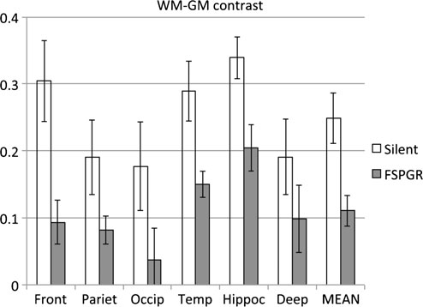
Fig. 3 WM–GM tissue contrast measured in Silent and FSPGR at 7 T. Bars indicate the mean of tissue contrast across subjects in different brain regions (frontal, parietal, occipital, temporal, hippocampus and basal ganglia), as well as the grand average. Error bars indicate±one standard deviation. All differences are statistically significant (p<0.0005)
tive value (NPV) in Silent than in FSPGR (Table 2).

Acoustic noise

Sound pressure levels and average sound levels are shown in Fig. 5. Gray curves represent FSPGR imaging, while Silent imaging is represented by black curves. Dashed gray curves indicate ambient noise. The acoustic noise in Silent is compa- rable to ambient noise: the periodic 2-Hz signal depicted in gray in Fig. 5a, present in both Silent and ambient noise, is the sound produced by the water pumps of the magnet cooling system. Sound levels (mean±standard deviation) were 52.7±
0.1 dB(A) for ambient noise, 89.9±0.7 dB(A) for FSPGR and
54.9±0.2 dB(A) for Silent. Silent acquisition was therefore less than 2.5 dB(A) louder than ambient noise, and 35 dB(A) quieter than FSPGR. The spectra of average sound levels for Silent and ambient noise largely overlap, with the most pronounced differences in the band 500–1250 Hz and for frequencies >10 kHz (Fig. 5b).

Specific absorption rate

In Silent, 10-s average SAR measured by the MR system ranged from 1.1 W/kg to 2.3 W/kg, and 6-min average SAR never exceeded 2 W/kg. In FSPGR, 6-min average SAR never exceeded 1.1 W/kg. Ten-second average SAR ranged from

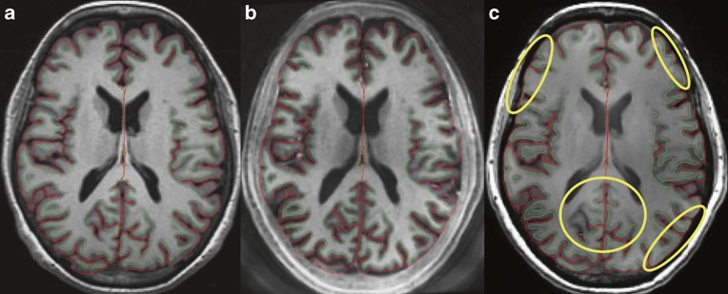
Fig. 4 (colour figure) Automated tissue segmentation examples obtained at 1.5 T (a: Breference^ FSPGR) and at 7 T (b: Silent; c:
FSPGR). Outer and inner boundaries of cortical ribbon are displayed in red and green, respectively. Ovals indicate the most representative regions where the cortical ribbon was missed by automated tissue segmentation on the FSPGR images acquired at 7 T

0.6 W/kg to 1.1 W/kg, and was significantly lower than in Silent (Wilcoxon rank-sum test, p<0.0005).

Discussion

This work has described the performance of an inversion- prepared BSilent^ ZTE sequence for T1-weighted imaging at 7 T. In relation to conventional T1-weighted imaging, and similarly to other ZTE implementations [2, 4, 10, 11], Silent is less demanding in terms of gradient hardware, and is virtu-
ally insensitive to gradient infidelity. The low imaging noise in Silent acquisition is another important feature, as the major cause of patient discomfort is the loud acoustic noise during 7 T MR examination [15, 16].
Radiological inspection ascertained satisfactory image quality in the cerebral parenchyma. Quantitative measure- ments indicated that Silent imaging exhibited higher tissue contrast (TC), which in the occipital lobe was four times as great as that in FSPGR. The lower TC in FSPGR could have been determined by the shorter TI (450 ms) in comparison to that used in Silent (600 ms), and by the presence of the delay time in Silent. The impact of TI on tissue contrast was studied by also acquiring FSPGR images with TI=600 ms to match that used in Silent. Quantitative measurements revealed that
WM–GM contrast in FSPGR was higher for TI=450 ms than for TI=600 ms in all the six regions considered (frontal, pari- etal, occipital, temporal, hippocampus and basal ganglia; av- erage TC was 17 % higher for TI= 450 ms than for TI= 600 ms). The neuroradiological qualitative evaluation con- firmed that TI=600 ms would not have provided better con- trast than TI=450 ms in FSPGR. The impact of TD could not be investigated, as this parameter cannot be controlled in the FSPGR sequence.
Silent imaging also exhibited improved homogeneity (WMIV). For typical dielectric constants found in biological samples, the radiofrequency wavelength in MR systems oper- ating at magnetic fields≥7.0 Tesla is comparable to the size of
the object under investigation, and therefore images are more
prone to undesired variations in intensity and tissue contrast [24–26]. In conventional imaging, these artefacts can be mit- igated by applying advanced acquisition strategies [35, 43]. However, Silent was only marginally affected by such heterogeneities.
Flow artefacts in Silent were absent, which allowed a sat- isfactory depiction of the limbic system and temporal lobe. Further optimization might improve the visualization of vas- culature in Silent, allowing the acquisition of angiographic data without resorting to time-of-flight strategies [44] that,
on systems operating at magnetic fields≥7 T, are limited by

Table 2 Evaluation of automated segmentation performance of gray matter cortical ribbon using Silent and FSPGR at 7 T

 |  | Subject 1 | Subject 2 | Subject 3 | Subject 4 | Mean±SD | Significance
TPR | Silent | 0.7502 | 0.7609 | 0.7640 | 0.7661 | 0.760 3±0.0071 | p<0.03
 | FSPGR | 0.6766 | 0.6016 | 0.6434 | 0.5309 | 0.6131±0.0628
SPC | Silent | 0.9924 | 0.9942 | 0.9941 | 0.9929 | 0.9934±0.0009 | NS
 | FSPGR | 0.9938 | 0.9938 | 0.9942 | 0.9924 | 0.9936±0.0008
PPV | Silent | 0.7070 | 0.7415 | 0.7592 | 0.7690 | 0.7442±0.0273 | p<0.12
 | FSPGR | 0.7288 | 0.6817 | 0.7314 | 0.6829 | 0.7062±0.0276
NPV | Silent | 0.9939 | 0.9947 | 0.9942 | 0.9928 | 0.9939±0.0008 | p<0.03
 | FSPGR | 0.9921 | 0.9913 | 0.9913 | 0.9856 | 0.9901±0.0030
TPR true-positive rate (sensitivity), SPC specificity, PPV positive predictive value (precision), NPV negative predictive value, NS not significant

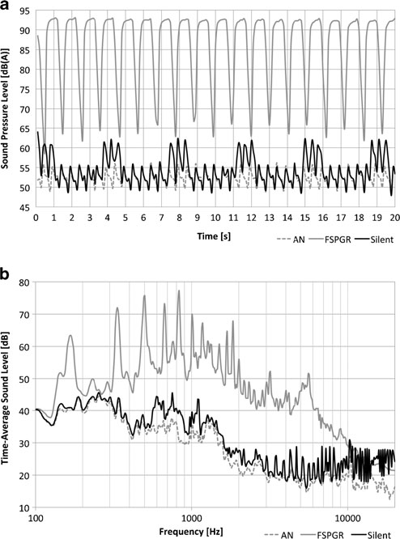
Fig. 5 Acoustic noise sound pressure level as a function of time (a) and time average sound level spectrum (b). Black, gray and dashed gray lines indicate Silent scanning, FSPGR scanning, and ambient noise (AN), respectively

SAR constraints. Moreover, the sensitivity to short transverse relaxation times may be exploited for a better visualization of alterations in myelination [30].
SNR in Silent was lower than that in FSPGR. However, Silent exhibited an overall superior quality in the cerebral parenchyma, as confirmed by the outcome of automated seg- mentation procedures, which indicated that better tissue clas- sification was obtained using Silent. The capability of im- proved automated tissue segmentation might promote the use of voxel-based analysis techniques (such as voxel-based morphometry [45, 46] and surface-based analysis [36, 37, 47]) on MR systems operating at ultra-high static fields.
Despite their short TE, Silent images appeared prone to susceptibility effects, which might be attributable to a geomet- rical mismatch between the theoretical and actual radial trajectories. Susceptibility artefacts were observed near the air–bone interface of the paranasal sinuses. Ethmoid air cells in particular often degraded the image quality of the inferior frontal cortex. Moreover, the depiction of some extracerebral regions, such as the orbits, was not satisfactory. Projection reconstruction caused radial trun- cation artefacts at the periphery of the image, similar to
the case of x-ray computed tomography [48]. However, these artefacts did not seem to significantly affect image quality in the brain. Silent images were also affected by the bounce-point artefact [34], an effect that can be ob- served in inversion-recovery imaging on the boundary between two tissues with opposite magnetization: voxels with a mixture of these tissues thus appear hypointense. This effect might be mitigated by improving the adiabat- ic pulse or, more simply, by modifying the acquisition parameters (for instance, by increasing the TI).
Several important options for sequence optimization are not yet supported by the current version of Silent. For example, most conventional sequences, including FSPGR, are not constrained to acquire a cubic FOV, and offer the possibility of reducing scan time by acquir- ing an asymmetric FOV (for non-square in-plane matrix with fewer phase-encode steps) and by limiting the ex- tent of the third dimension. It should also be noted that Silent, in its current implementation, does not support any accelerated imaging schemes, such as array coil spa- tial sensitivity encoding/sensitivity encoding (ASSET/ SENSE) [49] or generalized autocalibrating partial paral- lel acquisition/autocalibrating reconstruction for Carte- sian imaging (ARC/GRAPPA) [50].
Six-minute average SAR during Silent scanning (using the parameters illustrated in this work) never exceeded the limits imposed by the International Electrotechnical Commission standards. Power deposition was higher in Silent than in FSPGR, as the two sequences use different pulses and acqui- sition schemes. While FSPGR uses an asymmetric sinc pulse to excite a slab once per TR and a conventional inversion pulse, Silent applies hundreds of high-amplitude hard excita- tion pulses per TR, and HS2 pulses for inversion. On the basis of both analytical calculations [51] and numerical simulations
- that account for the architecture of the transmitting birdcage coil used in this study, it appears reasonable to assume that SAR<2 W/kg provides a safeguard against local hotspots that could harm the patient.
In conclusion, Silent allows T1-weighted imaging with acoustic noise close to ambient level. Its imaging performance in the cerebral parenchyma is superior to that of FSPGR, and it is worthy of consideration as a first-choice sequence for 3D T1-weighted imaging at 7 T.

Acknowledgments The scientific guarantor of this publication is Mirco Cosottini. Authors #2 and #4 of this manuscript declare relationships with the following companies: GE Healthcare. This study has received funding by the Italian Ministry of Health and the Health Service of Tuscany (RF- 2009-1546281), and by the FP7 Marie Curie Actions of the European Commission (FP7-PEOPLE-2012-ITN-316716). No complex statistical methods were necessary for this paper. Institutional review board approv- al was obtained. Written informed consent was obtained from all subjects in this study. Methodology: assessment/evaluation of technique, per- formed at one institution.

References

  - Bergin CJ, Pauly JM, Macovski A (1991) Lung parenchyma: pro- jection reconstruction MR imaging. Radiology 179:777–781
  - Madio DP, Lowe IJ (1995) Ultra‐fast imaging using low flip angles and fids. Magn Reson Med 34:525–529
  - Idiyatullin D, Corum C, Park J-Y, Garwood M (2006) Fast and quiet MRI using a swept radiofrequency. J Magn Reson 181:342– 349
  - Wu Y, Dai G, Ackerman JL et al (2007) Water- and fat-suppressed proton projection MRI (WASPI) of rat femur bone. Magn Reson Med 57:554–567
  - Tyler DJ, Robson MD, Henkelman RM et al (2007) Magnetic res- onance imaging with ultrashort TE (UTE) PULSE sequences: Technical considerations. J Magn Reson Imaging 25:279–289
  - Du J, Bydder M, Takahashi AM, Chung CB (2008) Two- dimensional ultrashort echo time imaging using a spiral trajectory. Magn Reson Imaging 26:304–312
  - Qian Y, Boada FE (2008) Acquisition‐weighted stack of spirals for fast high‐resolution three‐dimensional ultra‐short echo time MR imaging. Magn Reson Med 60:135–145
  - Du J, Bydder M, Takahashi AM et al (2011) Short T2 contrast with three-dimensional ultrashort echo time imaging. Magn Reson Imaging 29:470–482
  - Weiger M, Pruessmann KP, Hennel F (2011) MRI with zero echo time: hard versus sweep pulse excitation. Magn Reson Med 66: 379–389
  - Weiger M, Brunner DO, Dietrich BE et al (2013) ZTE imaging in humans. Magn Reson Med 70:328–332
  - Grodzki DM, Jakob PM, Heismann B (2012) Ultrashort echo time imaging using pointwise encoding time reduction with radial acqui- sition (PETRA). Magn Reson Med 67:510–518
  - Johnson KM, Fain SB, Schiebler ML, Nagle S (2013) Optimized 3D ultrashort echo time pulmonary MRI. Magn Reson Med 70: 1241–1250
  - Weiger M, Stampanoni M, Pruessmann KP (2013) Direct depiction of bone microstructure using MRI with zero echo time. Bone 54: 44–47
  - Weiger M, Hennel F, Pruessmann KP (2010) Sweep MRI with algebraic reconstruction. Magn Reson Med 64:1685–1695
  - Heilmaier C, Theysohn JM, Maderwald S et al (2011) A large-scale study on subjective perception of discomfort during 7 and 1.5 T MRI examinations. Bioelectromagnetics 32:610–619
  - Cosottini M, Frosini D, Biagi L et al (2014) Short-term side-effects of brain MR examination at 7 T: a single-centre experience. Eur Radiol 24:1923–1928
  - Glover GH, Pauly JM (1992) Projection reconstruction techniques for reduction of motion effects in MRI. Magn Reson Med 28:275– 289
  - Madio DP, Gach HM, Lowe IJ (1998) Ultra-fast velocity imaging in stenotically produced turbulent jets using RUFIS. Magn Reson Med 39:574–580
  - Kelley DAC, McKinnon GC, Sacolick LI et al (2014) Optimization of a Zero Echo Time (ZTE) Sequence at 7T with Phased Array Coils. Proceedings of International Society for Magnetic Resonance in Medicine ISMRM
  - Weiger M, Brunner DO, Wyss M et al (2014) ZTE Imaging with T1 Contrast. Proceedings of International Society for Magnetic Resonance in Medicine ISMRM
  - Hurley AC, Al-Radaideh A, Bai L et al (2010) Tailored RF pulse for magnetization inversion at ultrahigh field. Magn Reson Med 63: 51–58
  - Wrede KH, Johst S, Dammann P et al (2012) Caudal image contrast inversion in MPRAGE at 7 Tesla: problem and solution. Acad Radiol 19:172–178
  - O'Brien KR, Magill AW, Delacoste J et al (2014) Dielectric pads and low- B1+ adiabatic pulses: complementary techniques to opti- mize structural T1 w whole-brain MP2RAGE scans at 7 tesla. J Magn Reson Imaging 40:804–812
  - Belaroussi B, Milles J, Carme S et al (2006) Intensity non- uniformity correction in MRI: existing methods and their valida- tion. Med Image Anal 10:234–246
  - Van de Moortele P-F, Akgun C, Adriany G et al (2005) B(1) de- structive interferences and spatial phase patterns at 7 T with a head transceiver array coil. Magn Reson Med 54:1503–1518
  - Vaughan JT, Garwood M, Collins CM et al (2001) 7T vs. 4T: RF power, homogeneity, and signal-to-noise comparison in head im- ages. Magn Reson Med 46:24–30
  - Dietrich O, Raya JG, Reeder SB et al (2007) Measurement of sig- nal‐to‐noise ratios in MR images: Influence of multichannel coils, parallel imaging, and reconstruction filters. J Magn Reson Imaging 26:375–385
  - Tannús A, Garwood M (1997) Adiabatic pulses. NMR Biomed 10: 423–434
  - Sacolick LI, Wiesinger F, Hancu I, Vogel MW (2010) B1 mapping by Bloch-Siegert shift. Magn Reson Med 63:1315–1322
  - Kelley DAC, McKinnon GC, Sacolick LI et al (2014) Depiction of Multiple Sclerosis Lesions with Zero Echo Time (ZTE) Imaging at 7T. Proceedings of International Society for Magnetic Resonance in Medicine ISMRM
  - Tourdias T, Saranathan M, Levesque IR et al (2014) Visualization of intra-thalamic nuclei with optimized white-matter-nulled MPRAGE at 7T. NeuroImage 84:534–545
  - Costagli M, Kelley DAC, Symms MR et al (2014) Tissue Border Enhancement by inversion recovery MRI at 7.0 Tesla. Neuroradiology 56:517–523
  - De Ciantis A, Barkovich AJ, Cosottini M et al (2015) Ultra-high- field MR imaging in polymicrogyria and epilepsy. AJNR Am J Neuroradiol 36:309–316
  - Pusey E, Lufkin RB, Brown RK et al (1986) Magnetic resonance imaging artifacts: mechanism and clinical significance. Radiographics 6:891–911
  - Van de Moortele P-F, Auerbach EJ, Olman C et al (2009) T1 weighted brain images at 7 Tesla unbiased for Proton Density, T2⁎ contrast and RF coil receive B1 sensitivity with simultaneous vessel visualization. NeuroImage 46:432–446
  - Dale AM, Fischl B, Sereno MI (1999) Cortical surface-based anal- ysis. I. Segmentation and surface reconstruction. NeuroImage 9: 179–194
  - Fischl B, Sereno MI, Dale AM (1999) Cortical surface-based anal- ysis. II: Inflation, flattening, and a surface-based coordinate system. NeuroImage 9:195–207
  - Ueno K, Cheng K (2014) Model-Free Spatial Intensity Non- Uniformity Correction Algorithm for MR Images. Proceedings of International Society for Magnetic Resonance in Medicine ISMRM
  - Jenkinson M, Bannister P, Brady M, Smith S (2002) Improved optimization for the robust and accurate linear registration and mo- tion correction of brain images. NeuroImage 17:825–841
  - Klauschen F, Goldman A, Barra V et al (2009) Evaluation of auto- mated brain MR image segmentation and volumetry methods. Hum Brain Mapp 30:1310–1327
  - Jenkinson M, Beckmann CF, Behrens TEJ et al (2012) FSL. NeuroImage 62:782–790
  - van Osch MJP, Webb AG (2014) Safety of ultra-high field MRI: what are the specific risks? Curr Radiol Rep 2:1–8
  - Marques JP, Kober T, Krueger G et al (2010) MP2RAGE, a self bias-field corrected sequence for improved segmentation and T1- mapping at high field. NeuroImage 49:1271–1281
  - Nishimura DG (1990) Time‐of‐flight MR angiography. Magn Reson Med 14:194–201

  - Ashburner J, Friston KJ (2000) Voxel-based morphometry–the methods. NeuroImage 11:805–821
  - Whitwell JL (2009) Voxel-based morphometry: an automated technique for assessing structural changes in the brain. J Neurosci 29:9661–9664
  - Fischl B, Rajendran N, Busa E et al (2008) Cortical folding patterns and predicting cytoarchitecture. Cereb Cortex 18:1973–1980
  - Gatehouse PD, Bydder GM (2003) Magnetic resonance imaging of short T2 components in tissue. Clin Radiol 58:1–19
  - Pruessmann KP, Weiger M, Scheidegger MB, Boesiger P (1999) SENSE: sensitivity encoding for fast MRI. Magn Reson Med 42: 952–962
  - Griswold MA, Jakob PM, Heidemann RM et al (2002) Generalized autocalibrating partially parallel acquisitions (GRAPPA). Magn Reson Med 47:1202–1210
  - Tiberi G, Costagli M, Stara R, Cosottini M (2013) Electromagnetic characterization of an MR volume coil with multilayered cylindri- cal load using a 2-D analytical approach. J Magn Reson 230:186– 197
  - Tiberi G, Fontana N, Costagli M et al (2015) Investigation of max- imum local specific absorption rate in 7 T magnetic resonance with respect to load size by use of electromagnetic simulations. Bioelectromagnetics 36:358–366

