Received 00th January 20xx,
- Polymers & Functional Materials Division, CSIR-Indian Institute of Chemical Technology, Hyderabad-500007, T.S., India.
- Academy of Scientific and Innovative Research (AcSIR), Anusandhan Bhawan, 2 Rafi Marg, New Delhi, 110001, India.
- Centre for Advanced Materials &Industrial Chemistry, School of Science RMIT University, Melbourne-1 Vitoria Australia.
- School of Science, RMIT University, Melbourne VIC3000, Australia.
- Southbank University, 103 Borough Rd, London SE1 0AA, UK.
Email of corresponding (*) authors: islavathnanaji@gmail.com, giribabu@iict.res.in, Phone number: +91-040-27191724, Fax number: +91-40-27193186
† Footnotes relating to the title and/or authors should appear here.
Electronic Supplementary Information (ESI) available: [details of any supplementary information available should be included here]. See DOI: 10.1039/x0xx00000x
Accepted 00th January 20xx
DOI: 10.1039/x0xx00000x
www.rsc.org/
Ambient Stable, Hydrophobic, electrically conductive Porphyrin Hole-Extracting Materials for Printable Perovskite Solar Cells
Govind Reddy,^{ac} Ramakrishna Katakam,ª Koteshwar Devulapally,^{ab} Lathe A.Jones,^{c} Enrico Della Gaspera,^{d} Hari M. Upadhyaya,^{e} Nanaji Islavath,*ª and Lingamallu Giribabu,*^{ab}
Fundamental properties of organic molecules such as symmetry and conjugation have a major impact on their functional properties and applications. In this study, we designed and synthesized hydrophobic, electrically conductive porphyrin derivatives using N-octyl phenothiazine as donors and porphyrin as π-spacer in a D-π-D configuration. These materials are candidates for hole transport layers (HTL) within optoelectronic devices, and specifically perovskite solar cells (PSC). Detailed optical, electrical and electrochemical characterization of porphyrin molecules were used to assess their properties, revealing good conductivity, clear electronic transitions and HOMO energy levels well aligned with the valence band of methylammonium lead iodide, the archetypal absorber in PSCs. We fabricated all-solution processed perovskite devices through screen-printing of the various layers, and adopting a carbon nanoparticle-graphene composite cathode, achieved a high photocurrent density of >19.5 mA.cm⁻² and power conversion efficiency of >11% for our porphyrin derivatives. In addition, by the introduction of hydrophobic octyl groups on porphyrin substituents, we could achieve excellent water stability of our devices without the need for encapsulation, confirming the promise of these materials for stable HTLs. Such, hydrophobic porphyrin systems will have broad academic and industrial interest for use in photovoltaics, light emitting diodes, photodetectors and other optoelectronic devices.

Introduction
Organometallic-trihalide perovskites have recently emerged as light-harvesting materials for photovoltaics. Within a short period of time, perovskite has reached a power conversion efficiency from 3 to above 10% without a hole-extraction layer.¹ However, the metal electrode layer which is usually deposited using thermal evaporation can diffuse into the perovskite and reach the electron transport layer (TiO₂), causing a reduction in the overall device performance.²⁻⁴ Hence, to protect the perovskite layer from moisture and to avoid direct contact with the metal electrode, Grätzel and co-workers developed a hole transport layer (HTL) between the perovskite and metal electrode layer, mimicking the architecture of dye-sensitized solar cells. After deposition of N2,N2,N2′,N2′,N7,N7,N7′,N7′-octakis(4-methoxyphenyl)-9,9′-spirobi[9H-fluorene]-2,2′,7,7′-tetramine (Spiro-OMeTAD), efficient hole-extraction from the light-active material is achieved. This results in marginal electron recombination at the interface and improved device performance –allowing the power conversion efficiency to jump from 10 to above 20%.⁵ Due to this high-power conversion efficiency, Perovskite materials have been extensively studied in recent years due to their broad light-absorption, tunable band-gap, ambipolar charge transport, high charge carrier mobility and ease of fabrication on arbitrary substrates. Therefore, perovskites are considered a promising alternative to commercial photovoltaic devices.^{6,7} However, it is a challenging task to utilize these devices for practical application because of some issues, including the toxicity of lead, the poor stability of the perovskite phase and also the cost of Spiro-OMeTAD based HTLs. Focusing on the HTL, the synthesis of Spiro-OMeTAD on the gram scale is very difficult and therefore this material increases the cost of the device. Many research groups worldwide have been developing new organic molecule (FDT, SDF-OMeTAD) based layers with similar properties to Spiro-OMeTAD to be used as HTLs, achieving similar efficiency in perovskite-based devices.^{8,9} However, these HTLs still face problems of stability and cost. Due to the stability issue of PSCs, a few groups started to use inorganic materials as a HTLs, including CuSCN,¹⁰ NiO,¹¹ and CuI/Cu.¹² With these materials, the device shows lower efficiency than organic HTLs, but the stability is improved significantly. Therefore, even if the high efficiency of perovskite solar cells is appealing, they still suffer from poor stability and the cost of the HTLs, which may impede their commercialization.¹³
Generally, the porphyrin sensitizers in the form of Donor-π-Acceptor system as light-harvesting materials in dye-sensitized solar cells have improved device efficiency from 10.5 to 13%,¹⁴⁻¹⁶ but these devices still face the problem of electrolyte leakage and are difficult to scale-up. Donor-π-Acceptor porphyrin systems have good band alignment with perovskite and also have higher thermal stability and favourable electrical properties compared to organic molecule based HTLs. But, Donor-π-Acceptor porphyrin systems adopted as HTLs for perovskite solar cells have led to device efficiencies of 7%.¹⁷ However, Donor-π-Acceptor porphyrin systems were modified to Donor-π-Donor porphyrin systems to increase π-π molecular stacking, and to tune their HOMO level so that it is appropriately positioned with the valence band of perovskite absorbers and the work-function of cathode materials. Recently, X. Zhu group and H.K. Kim co-workers Donor-π-Donor porphyrin systems applied as HTM layer in perovskite solar cells, the performance of device reached to 12.6 % (SGT-061) and 17.7% (ZnP) respectively. In these reports, all layers of solar cells were deposited via spin coating process¹⁸⁻²⁰and the high performance was achieved by the addition of the additives; but devices facing stability issue at ambient condition. Based on above strategies, we have designed phenothiazine-porphyrin functionalized with alkyl chains, namely 3,3'-((10,20-bis(2,6-bis(octyloxy)phenyl)porphyrin-5,15-diyl)bis(ethyne-2,1-diyl))bis(10-octyl-10H phenothiazine) [HPPHT], and 3,3'-((10,20-bis(2,6-bis(octyloxy)phenyl)porphyrin-5,15-diyl)bis(ethyne-2,1-diyl))bis(10-octyl-10H-phenothiazine)-Zn(II) [ZPPHT] and used them as HTLs in perovskite solar cells. Here, we fabricated dopant free HTM based perovskite devices using the screen-printing process and it will offer layer area and reduces the materials wastages.²¹ It was found that HPPHT has lower conductivity and water contact angle in comparison with the ZPPHT, due to the presences of free amines. Screen-printed ZPPHT based perovskite solar cells with carbon nanoparticle-graphene composite as a cathode exhibited a high-power conversion efficiency of 11.26% under 1sun condition, compared with a power conversion efficiency of 9.47% for HPPHT and 8.84% for devices without HTLs. From steady-state photoluminescence and photovoltage measurements, we conclude that (i) the lower HOMO level of ZPPHT compared to HPPHT offers a higher open-circuit voltage (Voc); and (ii) the higher conductivity of ZPPHT resulted in faster charge-extraction in the device. The ZPPHT based solar cells have good long-term stability due to its more hydrophobic nature, and the cells retained their initial efficiencies even after storage in ambient conditions without encapsulation. Henceforth, from the above experimental results and observations, screen-printed ZPPHT materials have been proven to be a successful alternative to Spiro-OMeTAD. The hydrophobic ZPPHT materials are also promising for preparing hole conducting layers for a variety of other applications including photodetectors and LEDs.
Result and discussions
Previously, numerous organic moieties including azulenes,²² carbazoles,²³ fluorene,²⁴ phenothiazine,²⁵ squaraines,²⁶tetrathiafulvalenes²⁷ and triphenylamine²⁸ have been used as the sensitizer in dye-sensitized solar cells. Among these moieties, phenothiazines are commercially available, that possess an easily tunable structure to function as the sensitizer in dye-sensitizer solar cells.²⁵ Phenothiazine based organic solar cells have exhibited efficiencies of around 9.8%.²⁹ Recently, our group has used phenothiazine as a donor in porphyrin-based dye-sensitizer solar cells, achieving device efficiencies of around 10.5%.¹⁵ However, phenothiazine and its derivatives used as a hole-extracting layer in perovskite solar cells have reached more than 19% efficiency.³⁰ As such, here we have designed and optimized phenothiazine-porphyrin-phenothiazine (D-π-D) molecular systems (Figure S1), and used DFT analysis to calculate their HOMO/LUMO levels along with electron density distribution. Figure 1(a) shows the continuous electron density distribution along the D-π-D molecular systems. The HOMO position is well suitable to extract holes from perovskite absorbers. Following these promising results, we synthesized D-π-D molecular systems with zinc metal (ZPPHT) and without metal (HPPHT) using low-cost starting materials via simple condensation and coupling reactions, as shown in Figure 1(b). After completion of all the synthetic steps, we successfully obtained the desired molecules, as confirmed using ¹H NMR, MALDI-TOF, and FTIR (see Figures S(2-5)). The optical absorption and emission spectra of these molecules both in solution (toluene) and as thin films are presented in Figure 1(c, d). Both ZPPHT and HPPHT exhibit bathochromic absorption shifts between the solution and thin film due to the inter molecular interactions and tendency to form J-type aggregates in film states (absorption onsets at 682 nm for solution, 750 nm for film for ZPPHT; absorption onsets at 725 nm for solution, 744 nm for film for HPPHT).³¹ Emission spectra were collected at RT intoluene by exciting at 464 nm and both materials show intense photoluminescence. ZPPHT

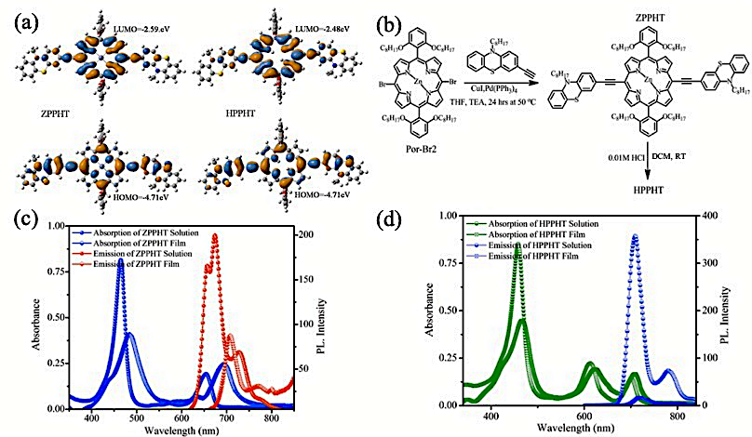

Figure 1.(a) Frontier molecular orbital of ZPPHT and HPPHT (calculated at B3LYP 6-31G (d, p) level theory in Toluene as solvent), (b) molecular structure, (c, d) absorption and emission spectra (λ_{ex}= 464nm) of ZPPHT and HPPHT (3μM), respectively.
shows a more intense vibrational shoulder and HPPHT exhibits an intense peak in the solution state at the higher wavelength. Both thin films exhibit less intense, single peak emission at lower energies. These results suggest J-type aggregation and π-π stacking in both the D-π-D molecular systemsin the films.³¹
UV-Vis and photoluminescence spectroscopies were adopted to investigate the molecular aggregation of these newly designed D-π-D porphyrin molecular systems in toluene solvent (Figure S6(a)). When the temperature is varied from 30 to 80 ºC, the intensity of photoluminescence spectra is slightly decreased and red-shifted (Figure 2(a) and circle with down arrow) due to the thermal deactivation of the excited state and/or molecule to molecule aggregation (excitation wavelength of HPPHT, ZPPHT at 464nm).³² In this case, our molecular systems are active under ambient light and temperature conditions. With the aggregation, there is a possibility to enhance π-π stacking which results in a quenched singlet excited state life-time. We recorded the singlet excited state life-time of these molecular systems by time‐correlated single photon counting (TCSPC) at different temperatures, as shown in Figure 2(b) and fitted with mono-exponential decay. Here, we noticed that by the substitution of Zn metal into the HPPHT molecular system and with temperature, the time-resolved PL decay is decreased from 6.2 ns to 1.8 ns; due to the occurrence of charge trap state and relaxation in molecular systems. Finally, metal-based porphyrin system (ZPPHT) has shorter average lifetime compared to metal-free porphyrin system (HPPHT) probably due to more triplet quantum yields by intersystem crossing. The dissolved molecules in toluene could be deposited on patterned FTO glass substrate and the electrical properties of the films were measured at different temperatures. Increasing the temperature of solutions commonly causes molecules to aggregate,³³ whereas in thin films molecular stacking occurs. Molecular stacking helps to obtain a uniform surface morphology, which increases the conductivity of films. The electrical properties of MAPbI₃, HPPHT and ZPPHT films were qualitatively analyzed using two-probe measurements. The results (Figure 2(c)) indicate that the conductivity of HPPHT only marginally improved compared with the MAPbI₃ film (Figure S6(b)) and was much lower than that of the ZPPHT film measured under similar experimental conditions (inset in Figure 2(c): digital-photographs and electrical property schematic diagram).³⁴ From these observations we can conclude that HPPHT and ZPPHT molecules are suitable for hole-extraction in perovskite solar cells. We analyzed the optical properties of our MAPbI₃ films before and after depositing the porphyrin-based HTLs, and the results are shown in Figure S6(c) and Figure 2(d). The MAPbI₃/nc-TiO₂³⁵, D-π-D porphyrin molecular systems /MAPbI₃/nc-TiO₂ of emission spectra (Figure 2(d)) and the onset absorption enhanced up to the 900 nm region due to optical band gap quenching (Figure S6(c)). We also investigated the hole-transfer ability at the interface of MAPbI₃/TiO₂ and porphyrin/MAPbI₃/TiO₂ layers using emission spectra. The MAPbI₃/TiO₂ sample shows strong photoluminescence emission as expected. The deposition of porphyrin (ZPPHT and HPPHT) materials on the MAPbI₃ layer drastically quenches the emission due to efficient hole-extraction from the perovskite layer, therefore inhibiting recombination.³⁶ To support these results, we carried-out differential pulse voltammetry (DPV) measurements³⁷ to measure the oxidation potentials of HPPHT and ZPPHT, which show that the ZPPHT has a lower oxidation potential value than the HPPHT (Figure S7), therefore providing a larger driving force for the hole-transfer from the MAPbI₃ to the porphyrin layer. We can conclude that ZPPHT materials have a suitable HOMO level for perovskite, and it is expected they will contribute in increasing the open circuit voltage of the device.³⁵ The device performance of these materials will be discussed later in Figure 5.

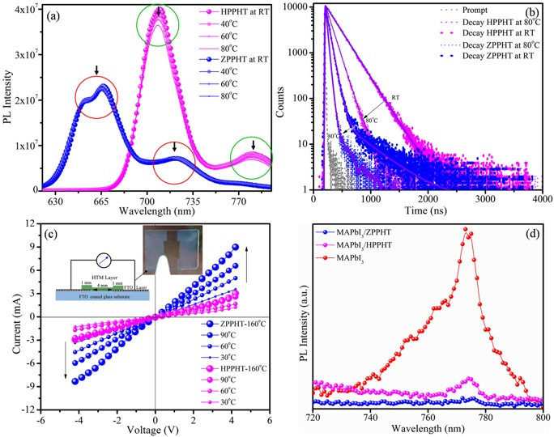

Figure 2. Temperature dependence (a) emission, (b) time-resolved photoluminescence spectra (λ_{ex}= 464nm) and (c) electrical property of HPPHT and ZPPHT. (d) Photoluminescence spectra of PbI₂, MAPbI₃ film with/out HTMs (λ_{ex}= 464nm for PbI₂ and MAPbI₃ for 565 nm).

The morphology of our samples was analysed using scanning electron microscopy (SEM) and the images are presented in Figure 3. The perovskite layer shows tightly packed cuboid-shaped crystals which are 150 – 400 nm in size. The thickness of the layer is around 200 nm (Figure 3(a, d)). This morphology is markedly different compared to the PbI₂ layer before the reaction with Methylammonium Iodide (MAI) (see Figure S8(a)). As discussed earlier, porphyrin hole-extracting materials were deposited on the MAPbI₃ layer by screen printing, and SEM images show their smooth surface with a thickness around 40 nm. We believe that the porphyrin materials fill the pores between the grains of MAPbI₃, therefore acting as a barrier offering protection from moisture (see below). The D-π-D porphyrin molecular systems are hydrophobic in nature, due to the presence of long alkyl chains which are also useful for increasing the solubility, film formation, hydrophobicity and π-π stacking. The SEM image of the complete device with carbon nanoparticle-graphene composite (as cathode layer) is shown in Figure 3(c, f). The carbon nanoparticle-graphene composite layer has been deposited by screen printing as well and it has a smooth morphology with layer thickness around 10 μm (Figure S8(b)). We tested all of our layers for their hydrophobic properties using water contact angle measurements (Figure 3(a-c)). The MAPbI₃ film exhibited the smallest water contact angle of around 27.9° (Figure 3(a)), revealing the affinity to water of MAI and its hygroscopic properties under ambient conditions. To protect the MAPbI₃ layer, here we have used the hydrophobic nature of the alkyl chain of our porphyrin molecular systems. The D-π-D porphyrins (HPPHT, ZPPHT) and the cathode layer showed higher water contact angles of around 91.3°, 114.2° and 116.7° respectively (see also Figure S8(c)). Therefore, it is believed that these layers can efficiently protect the MAPbI₃ layer from moisture and increase the durability of the devices.

Figure 3.Surface (a-c) and Cross-sectional (d-f) SEM images of MAPbI₃, MAPbI₃/ZPPHT and MAPbI₃/ZPPHT/Carbon perovskite solar cells. The insets in (a-c) show the respective water contact angle measurements.

The majority of lab-scale perovskite solar cells are deposited using spin-coating, except for the top electrode which is deposited by thermal evaporation. Spin-coating is simple, fast and produces reasonably uniform layers, however it has a limitation in substrate dimension,^{21,36} Therefore, here we have fabricated perovskite solar cells using a screen-printing process, both on laboratory scale (0.16 cm²) and as a mini-module (64 cm²). After deposition, each layer was dried and annealed at the required temperature and the procedure was repeated for the subsequent layer. The digital photographs of the different layers (active area 64 cm²) are shown in Figure 4(a-d), 0.16 cm² area devices not shown here; because large-area electrodes are more interesting visually than small. With the deposition of the porphyrin hole-extracting layer on MAPbI₃, the reddish-brown colour changed to dark-green. These devices were immersed into water for up to120 hours (see also Supporting Video 1) to assess the water stability of out porphyrin-coated perovskite. The ZPPHT based devices are highly stable both in water and under ambient conditions (Figure 4(e-h)) when compared to the MAPbI₃ and HPPHT based solar cells. In addition to this, we recorded the absorption spectra of the water, before and after the immersion of the devices for different durations of time (Figure S9). MAPbI₃ is known to react with water, decomposing into PbI₂. The absorption spectra of the ZPPHT based solar cells didn't show any peak for PbI₂, MAI or porphyrin; but MAPbI₃ and HPPHT show the corresponding PbI₂ peak. The absorption spectra of the ZPPHT based solar cell reveals a greater stability in water under ambient conditions compared with HPPHT and MAPbI₃. When covered with HPPHT, MAPbI₃ is still unstable due to the presence of free amine in HPPHT (indicated with circle in Figure S1), and their relative hydrophobicity.³⁸ In the case of symmetric ZPPHT, the absence of basic functional groups and the more hydrophobic nature of the molecule (see Figure 3) enables protection of the underlying perovskite from moisture. Therefore, ZPPHT materials provide suitable hole extraction properties, and high-water stability, compared to HPPHT and Spiro-OMeTAD. The preparation of the ZPPHT/HPPHT and overall yield and cost is described in supporting information Table S (7.1-7.5).

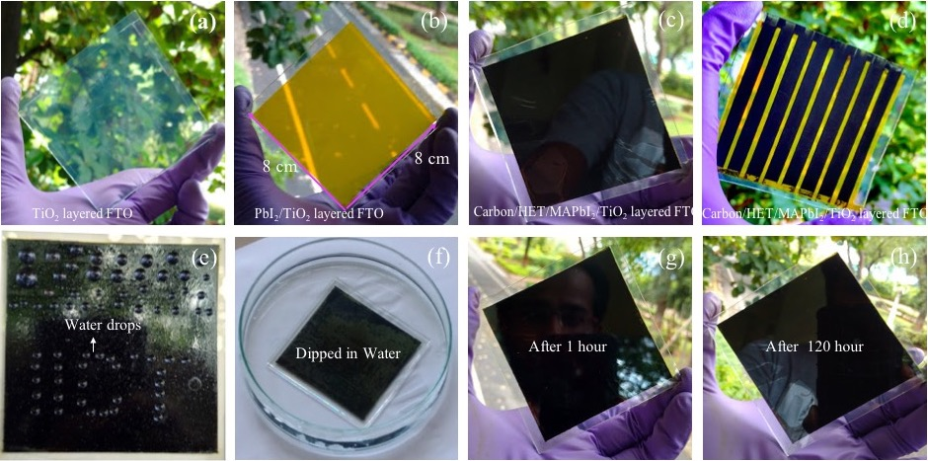

Figure 4.(a-d) Digital photographs of screen printed 64 cm² large area-PSC with ZPPHT/HPPHT as HTL and carbon-graphene composite as the cathode layer, and (e-h) moisture stability of ZPPHT based PSCs tested in water (at ambient condition) with different time durations (see also video in SI).

After analysis of the microstructural, electrical and optical properties of D-π-D porphyrin molecular system, and applied as a hole-extraction layer in perovskite solar cells. Here, we fabricated regular meso-perovskite solar cells both with/out a dopant free-hole-extraction layer and measured their performance under ambient conditions (30ºC RT, 65 ~ 75% RH, Hyderabad, India; 100 mW.cm⁻², Air Mass 1.5G) as shown in Figure 5(a). Perovskite solar cells using ZPPHT as the HTL exhibited a higher photo-current density (Jsc) of 19.66 mA.cm⁻² and open-circuit-voltage (Voc) of 1.000 V compared to the solar cell using HPPHT as the HTL (16.59 mA.cm⁻²,0.954V). Furthermore, HTL-free devices showed lower performance (15.88 mA.cm⁻² , 0.932V). The detailed device parameters are listed in Table 1. HPPHT films, as well as pure MAPbI₃ have low conductivity (Figure S6(b), Figure 2(c)) resulting in devices with a higher series resistance (Rs). The Rs affects the charge transport and junction properties of the device.³⁴ The Voc of device highly depends on the HOMO energy levels and charge carrier transportation, so here, ZPPHT based solar cells followed a higher charge transportation moment as a result it shows the higher Voc.³⁹ Additionally, we observed specific changes in dark-current characteristics of these devices as shown in Figure 5(b). The dark current onset of the MAPbI₃/carbon device occurred at a forward bias voltage (V_{FWB}) of 945 mV and the device exhibited a dark current density of -4.1 mA.cm⁻². After deposition of the HPPHT HTL in between the MAPbI₃ and carbon nanoparticle-graphenecomposite, the dark-current density is decreased from -4.1 to -1.01 mA.cm⁻² at the onset potential.⁴⁰ The ZPPHT based PSC exhibits a similar onset potential to MAPbI₃ and HPPHT; however, the magnitude of the dark current increased from -1.01 to -2.5 mA cm⁻² (Figure 5(b)). The dark-current density is directly dependent on the interface and electrical properties of the hole-extraction materials. We assessed the charge carrier transport and recombination within our devices using electrochemical impedance spectroscopy (EIS). Figure. 5(c) shows the Nyquist plot of all-ambient-processed PSCs measured in the dark at open-circuit voltage bias. We can recognize two RC components for all samples. The component in the high-frequency range is assigned to the charge transport and recombination in perovskite/hole-extraction layers while the one in the low-frequency range represents the perovskite/TiO₂ interface. The Nyquist plots are fitted using the equivalent circuit and the estimated Rs values are provided in Table 1. The low Rs of 15.28-ohm cm⁻² obtained for the ZPPHT based PSC indicates relatively better carrier transport which is responsible for the high-power conversion efficiency compared to HPPHT (28.23-ohm cm⁻²) and HTL-free (36.91-ohm cm⁻²) devices. Furthermore, we assessed the long-term stability of our solar cells. The devices were kept under ambient conditions and measurements were carried out at regular intervals over time. Figure 5(d) compares the normalized power conversion efficiencies of PSCs with and without hole-extracting materials. HTL-free devices show a drastic decrease in efficiency over time, and devices using HPPHT as HTL show only a negligible improvement. However, a notable improvement was observed in devices using ZPPHT as HTL, with a performance loss of only 20% after 120 hours of exposure. These observations are consistent with the contact angle measurements reported earlier. It is worth to mention that, we fabricated conventional perovskite solar cells using the carbon-graphene composites as cathode layer and dopant-free Spiro-OMeTAD as HTL. The devices exhibit lower

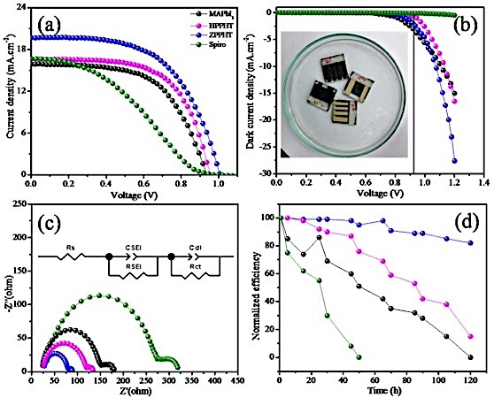

Figure 5.Characterization of 0.16 cm² active area dopant free
HTM based perovskite solar cells fabricated in ambient conditions (75%, Humidity): (a) Under illumination, (b) Dark current-voltage characteristics (the inset shows a digital photograph of the devices), (c) Electrochemical impedance spectra, (d) Normalized power conversion efficiencies for PSCs without and with HTL as a function of time.
performance (5.91%)⁴¹ compared to all our devices under our experimental conditions. Further strengthen our work; we measured electrical property of dopant-free Spiro-OMeTAD using the two-probe I-V characteristics. The results (shown as Fig.S10 in Supporting Information) indicates, the dopant-free spiro-OMeTAD film have much lower electrical property than the ZPPHT and HPPHT films. Then, we tried reproducibility in performance and stability using these materials, the device resulted approximately similar performance. All the mentioned device performance value is average of 8 devices. The mini-module also fabricated as followed processor of the 0.16 cm² device and the device characteristics and parameter are shown in Figure S11. Increasing the active-area of the device, the efficiency diminished; due to the charge carrier recombination. Presently, we are working on boosting the performance of the mini-module and other activities.

Table 1. Device parametersª of all-ambient-processed dopant free HTM based PSCs under 1sun illumination.^{b}

Devices | HOMO (eV) | Rs (Ω.cm⁻²) | V_{OC} [V]^{d} | J_{SC} [mA cm⁻²] ^{d} | FF ^{d} | ɳ [%)]
MAPbI₃ | 5.40^{c} | 25.23 | 0.932 | 15.88 | 0.599 | 8.846
Spiro | 5.22^{c} | 37.91 | 0.999 | 16.75 | 0.353 | 5.913
HPPHT | 5.10 | 19.82 | 0.954 | 16.59 | 0.614 | 9.676
ZPPHT | 5.05 | 14.28 | 1.000 | 19.66 | 0.573 | 11.26
ªDevice active area:0.16 cm²,^{b}100mW/cm2, Air Mass 1.5G. ^{c}Ref^{39,42}. ^{d}Error limits: Jsc ± 0.20 mA/cm², Voc = ± 0.30 mV, FF = ± 0.03.

Conclusions
In this work, we have designed and synthesized D-π-D porphyrin hole-extraction materials with and without a metal center (ZPPHT, HPPHT) using a high yield solution-based approach. The introduction of Zn into the D-π-D porphyrin molecular system improves the planarity and hydrophobicity of the molecule. A detailed comparison of the electrochemical and electrical properties of ZPPHT and HPPHT revealed that ZPPHT has a lower HOMO energy level and higher conductivity. Perovskite solar cells fabricated by screen printing and employing ZPPHT as HTL achieved over 11% efficiency under 100 mW cm⁻², which is the highest reported efficiency so far with the combination of a D-π-D porphyrin hole-extraction layer and carbon-graphene composite as a cathode. These solar cells exhibited high open-circuit voltage (Voc) due to the rapid hole-extraction at the interface of MAPbI₃ and ZPPHT, which has been confirmed by photoluminescence quenching. The ZPPHT devices are also more stable under ambient conditions than HTL-free devices and devices using HPPHT or Spiro-OMeTAD as HTL. Therefore, we can conclude that hydrophobic, electrically conductive D-π-D porphyrin molecular systems are very effective as hole transport materials and may be useful for optoelectronic applications including photovoltaics and LEDs.
Experimental Section
Materials
Methylamine (40% in methanol), Hydroiodic acid (HI), PbI₂, 2-propanol and acetonitrile were purchased from TCI Chemicals. 4-tert-butyl pyridine (4−tBP), N, N- dimethyl formamide (DMF) were obtained from Sigma-Aldrich and used as received. Methylammonium iodide (CH₃NH₃I) was synthesized as specified in the literature¹⁹ and stored under ambient conditions. Other analytical reagent (AR) grade solvents and laboratory reagent (LR) grade solvents were purchased from Avra. ACME silica gel (100–200 mesh) was used for column chromatography and thin-layer chromatography (TLC) was performed with Merck-precoated silica gel 60-F254 plates.

Methods
Optimized gaussian structures, materials, synthetic steps^{[15]}, final product yield/cost,⁹ optical and morphological studies, hydrophobicity,⁴³ electrical property measurements, electrochemical/ impedance, perovskite solar cells fabrication and photovoltaic characterization (1sun and dark I-V, stability, device optical-spectra)^{34,40,44} are described in the supplementary information.

Synthesis
The vital intermediate 5,15-dibromo-10,20-bis(2,6-dioctoxy phenyl)porphyrin zinc(II) [Por-Br₂] was prepared as per literature methods.¹⁴⁻¹⁶

Synthesis of 3,3'-((10,20-bis(2,6-bis(octyloxy)phenyl)porphyrin-5,15-diyl)bis(ethyne-2,1-diyl))bis(10-octyl-10H-phenothiazine)-Zn(II) (ZPPHT): under N₂ atmosphere Por-Br₂ (1.00g, 0.84 mmol) was dissolved in 10ml triethylamine (TEA) and 10 ml of dry tetrahydrofuran (THF) in a 50 ml RBF. The resulting solution was purged with N₂ gas for about 20 min followed by addition of CuI (0.023 g), and Tetrakis(triphenylphosphine)palladium(0) (Pd(PPh₃)₄) (0.14 g) which were heated to 50-60ºC. Next, 3-ethyl-10-octyl-10H-phenothiazine (C8-Ptz-E (0.84 g, 2.51 mmol)) was dissolved in 5ml THF and added slowly with the help of a syringe, and a spontaneous colour change (brown to green) was observed. We monitored the TLC until the starting materials were consumed. Then, the reaction mixture was cooled down to RT and the solvent was removed through rotary evaporation. Then the material was dissolved in DCM, filtered and dried over Na₂SO₄. Furthermore, the reaction mixture was purified by column chromatography using Hexane: DCM (3:1 v/v) and recrystalized with methanol/DCM yielded 89% as green powder. Anal.Calcd. For C₁₀₈H₁₃₀N₆O₄S₂Zn% (1702.89): C,76.05; H,7.68; N,4.93; Found C,76.10; H,7.58; N,4.88. MALDI-TOF: m/z [M]+calcd (1702.89): For C₁₀₈H₁₃₀N₆O₄S₂; found, 1702.96. 1H NMR (400 MHz, CDCl₃) δ 9.62 (d, J = 4.6 Hz, 4H), 8.84 (d, J = 4.6 Hz, 4H), 7.72 (dt, J = 23.1, 8.4 Hz, 6H), 7.19 (t, J = 7.1 Hz, 4H), 7.01 – 6.91 (m, 10H), 3.94 (t, J = 7.2 Hz, 4H), 3.84 (t, J = 6.4 Hz, 8H), 1.49 (s, 16H), 1.25 (s, 8H), 1.02 – 0.93 (m, 8H), 0.89 (t, J = 6.9 Hz, 8H), 0.84 – 0.75 (m, 8H), 0.60 (dt, J = 14.6, 7.1 Hz, 8H), 0.50 (t, J = 7.3 Hz, 26H), 0.46 – 0.40 (m, 8H). FT–IR (CHCl_{3,} abs): 2930, 2864, 1736, 1586, 1465, 1251, 1103cm⁻¹.

Synthesis of 3,3'-((10,20-bis(2,6-bis(octyloxy)phenyl)porphyrin-5,15-diyl)bis(ethyne-2,1-diyl))bis(10-octyl-10H phenothiazine) (HPPHT): We synthesized the free-base porphyrin from ZPPHT by demetallation. 0.5g (0.30 mmol) of ZPPHT was dissolved in 25 ml of DCM, aqueous 0.01M HCl was added dropwise and the TLC monitored until the reaction completed. Then after quenching with water, the material was dried through rotary evaporation and recrystalized with Methanol and Dichloromethane to get the title compound as dark green power in 92% yield. Anal.Calcd. For C₁₀₈H₁₃₂N₆O₄S₂ % (1641.98): C, 78.98; H,8.10; N,5.12. Found; C, 79.13; H, 8.39; N,4.93. 1H NMR (400 MHz, CDCl₃) δ 9.51 (d, J = 4.5 Hz, 4H), 8.74 (d, J = 4.3 Hz, 4H), 7.76 – 7.67 (m, 6H), 7.20 – 7.18 (m, 4H), 7.01 – 6.91 (m, 10H), 3.94 (t, J = 7.1 Hz, 4H), 3.84 (t, J = 6.3 Hz, 8H), 1.55 (s, 16H), 1.26 (s, 12H), 1.02 – 0.94 (m, 10H), 0.89 (s, 10H), 0.82 (dt, J = 14.9, 7.3 Hz, 10H), 0.64 (dt, J = 14.1, 7.2 Hz, 10H), 0.56 (s, 8H), 0.50 (dd, J = 14.8, 7.3 Hz, 16H), -1.80 (s, 2H). MALDI-TOF: m/z [M]+calcd. For C₁₀₈H₁₃₂N₆O₄S₂, 1641.98; found, 1641.97. FT–IR (CHCl₃,abs cm⁻¹): 2925, 2859, 1588, 1464, 1384, 1339, 1250, 1102, 804, 756. (Figure S3-6).
Conflicts of interest
There are no conflicts to declare.
Acknowledgement
Authors are grateful for financial support from Newton Prize grant and SUNRISE programme. N. Islavath is grateful to Department of Science and Technology, Government of India for providing financial support through SERB-NPDF (PDF/2017/000925), Govind Reddy acknowledged the financial support from the IICT-RMIT joint research centre PhD program (CLP-0102), and RK thanks to DST-SERI for financial support.
Notes and References
(1) L.Etgar, MRS Bull. 2015, 40, 674–680.
(2) S.Aharon, S. Gamliel, B. E. Cohen and L. Etgar,Phys. Chem. Chem. Phys.2014, 16, 10512–10518.
(3) P. Calado,A. M. Telford, D. Bryant, X. Li, J. Nelson, B. C. O. Regan and P. R. F. Barnes, Nature Commun. 2016, 1–10.
(4) L. K. Ono and Y. Qi, J. Phys. Chem. Letts. 2016, 7, 4764-4794.
(5) D. Bi, W. Tress, M. I. Dar, P. Gao, J. Luo, C. Renevier, K. Schenk, A. Abate, F. Giordano andJ. P. Correa Baena, Sci. Adv. 2016, 2, e1501170–e1501170.
(6) C. Ma, H. Wang, W. Hu, W. Yu, A. D. Sheikh, F. Li and T. Wu, Nat. Commun. 2015, 6, 1–8.
(7) W. Zhang, G. E. Eperon and H. Snaith,Nature Eng. 2016, 1, 16.
(8) Z. Li, J. Chen, H. Li, Q. Zhang, Z. Chen, X. Zheng, G. Fang,H. Wang and Y. Hao, RSC Adv. 2017, 7, 41903–41908.
(9) P. Gao, R. Scopelliti, E. Mosconi, M. Graetzel and M. K. Nazeeruddin, Nat. Energy 2016, 1, 1–7.
(10) N. Arora, M. I. Dar, A. Hinderhofer, N. Pellet, F. Schreiber, S. M. Zakeeruddin and M. Grätzel, Science 2017, 771, 768–771.
(11) Z. Liu, A. Zhu, F. Cai, L. Tao, Y. Zhou, Z. Zhao, Q. Chen, Y. Cheng H. Zhou, J. Mater. Chem. A2017, 6597–6605.
(12) P. Nazari, F. Ansari, B. AbdollahiNejand, V. Ahmadi, M. Payandeh and M. Salavati-Niasari, M. J. Phys. Chem. C 2017, 121, 21935–21944.
(13) M. Saliba, T. Buonassisi, M. Grätzel, A. Abate, W. TressandA. Hagfeldt, Science 2017, 744, 739–744.
(14) N. V. Krishna, J. V. S. Krishna, S. P. Singh, L. Giribabu, L. Han, I. Bedja, R. K. Gupta and A. Islam, J. Phys. Chem. C 2017, 121, 6464-6477.
(15) L. Giribabu, J. V. S. Krishna, N. V. Krishna, T. H. Chowdhury, S. P. Singh, I. Bedja and A. Islam, J. Mater. Chem. C 2018,6, 11444-11456.
(16) S. Mathew, A. Yella, P. Gao, R. Humphry-Baker, B. F. E. Curchod, N. Ashari-Astani, I. Tavernelli, U. Rothlisberger, M. K. Nazeeruddin and M. Grätzel, Nat. Chem. 2014, 6, 242–247.
(17) D. Sygkridou, A. Apostolopoulou, A. Charisiadis, V. Nikolaou, G. Charalambidis, A. G. Coutsolelos, E. Stathatos, Chem. Select 2018, 3, 2536–2541.
(18) S. H. Kang, C. Lu, H. Zhou, S. Choi, J. Kim and H. K. Kim, Dye. Pigment. 2019, 163, 734–739.
(19) S. Chen, P. Liu, Y. Hua, Y. Li, L. Kloo, X. Wang, B. Ong, W. K. Wong and X. Zhu, ACS Appl. Mater. Interfaces 2017, 9, 13231–13239.
(20) G. Reddy, K. Devulapally, N. Islavath and L. Giribabu, Chem. Rec., 2019, 19, 1–22
(21) F. De Rossi, J. A. Baker, D. Beynon, K. E. A. Hooper, S. M. P. Meroni, D. Williams, Z. Wei and A. Yasin, Adv. Mater. Technol. 2018, 3, 1–9.
(22) P. Cowper, A. Pockett, G. Kociok-Köhn, P. J. Cameron andS. E. Lewis, Tetrahedron 2018, 74, 2775–2786.
(23) N. Duvva, R. K. Kanaparthi, J. Kandhadi, G. Marotta, P. Salvatori, F. De Angelis and L. Giribabu, J. Chem. Sci. 2015, 127, 383–394.
(24) A. Yella, R. Humphry-Baker, B. F. E. Curchod, N. AshariAstani, J. Teuscher, L. E. Polander, S. Mathew, J. E. Moser, I. Tavernelli, U. Rothlisberger, U.; et al. Chem. Mater. 2013, 25, 2733–2739.
(25) Y. Hua, S. Chang, D. Huang, X. Zhou, X. Zhu and J. Zhao, Chem. Mater. 2013, 25, 2146–2153.
(26) G. H. Rao, A. Venkateswararao, L. Giribabu and S. P. Singh, Photochem. Photobiol. Sci. 2016, 15, 287–296.
(27) L. Giribabu, N. Duvva, S. P. Singh, L. Han, I. Bedja, R. K. Gupta and A. Islam, Mater. Chem. Front. 2017, 1, 460–467.
(28) F. Zhang, Y. Luo, J. Song, J. sheng, X. Guo, W. Liu, W. li; Ma, C. ping; Huang, Y.; Ge, M. fa; Bo, Z.; Meng, Q. B. Dye. Pigment. 2009, 81, 224–230.
(29) Z. S. Huang, H. Meier andD. Cao, J. Mater. Chem. C 2016, 4, 2404–2426.
(30) F. Zhang, S. Wang, H. Zhu, X. Liu, H. Liu, X. Li, Y. Xiao and S. M. Zakeeruddin, ACS Energy Lett. 2018, 3, 1145-1152.
(31) M. Más-Montoya and R. A. J. Janssen, Adv. Funct. Mater. 2017, 27, 1605779.
(32) H. Hu, P. C. Y. Chow, G. Zhang, T. Ma, J. Liu, G. Yang and H. Yan, Acc. Chem. Res. 2017, 50, 2519–2528.
(33) J. R. Gong, L. J. Wan, S. Lei, C. L. Bin, X. H. Zhang andS. T. Lee, J. Phys. Chem. B 2005, 109, 1675–1682.
(34) N. Islavath, S. Saroja, K. S. Reddy, P. C. Harikesh, G. Veerappan, S. V. Joshi and E. Ramasamy, J. Energy Chem. 2017, 26, 584-591.
(35) S. M. Jain, B. Philippe, E. M. J. Johansson, B. W. Park, H. Rensmo, T. Edvinsson and G. Boschloo, J. Mater. Chem. A, 2016, 4, 2630–2642.
(36) J. Zhang, B. Xu, M. B. Johansson, N. Vlachopoulos, G. Boschloo, L. Sun, E. M. J. Johansson and A. Hagfeldt, ACS Nano 2016, 10, 6816–6825.
(37) S. Paek, I. Zimmermann, P. Gao, P. Gratia, K. Rakstys, G.Grancini, M. K. Nazeeruddin, M. A. Rub, S. A. Kosa, andK. A. Alamry, et al. Chem. Sci. 2016, 7, 6068–6075.
(38) M. O. Senge, ECS Trans. 2015, 66, 1–10.
(39) J. Jiménez-López, W. Cambarau, L. Cabau andE. Palomares, Sci. Rep. 2017, 7, 1–10.
(40) N. Islavath and L. Giribabu,Sol. Energy 2018, 170, 158–163.
(41) Q. Luo, Y. Zhang, C. Liu, J. Li, W. Wang, H. Lin, J. Mater. Chem. A 2015, 3, 15996–16004.
(42) A. Krishna, D. Sabba, H. Li, J. Yin, P. P. Boix, C. Soci, S. G. Mhaisalkar and A. C. Grimsdale, Chem. Sci. 2014, 5, 2702–2709.
(43) K. –Y. Law, J. Phys. Chem. Lett. 2014, 5, 686–688.
(44) N. Islavath, D. Das, S. V. Joshi and E. Ramasamy, Mater. Des. 2017, 116, 219–226.

