**Fingermark visualisation on metal surfaces: An initial investigation of the influence of surface condition on process effectiveness**

**Abstract**

Fingermark recovery from metal surfaces is an area of operational interest, both from the association of metals with weapons used in violent crime and from the increasing incidence in metal theft. This paper reports a feasibility study into the effectiveness of a range of fingermark visualisation processes in developing fingermarks on clean metals (brass, bronze and stainless steel), and on the same metals after prolonged exposure to an outdoor environment. Scanning electron microscopy (SEM) was used to investigate how the surface type and condition could influence the development of fingermarks for each of the processes used. It was found that the behaviour observed varied between each of the processes (cyanoacrylate fuming, Lumicyano™, gun blueing and carbon-based powder suspension). In some cases the chemical composition of the surface affected the development of the mark more than the surface condition, and in other cases the reverse was true. The best performing processes differed according to the surface type and condition, with cyanoacrylate fuming processes working best on brass and bronze, and powder suspensions being better on stainless steel. These preliminary results reinforce the need to take into account both surface type and condition before selection of the most effective fingermark visualisation process and demonstrate the value of techniques such as SEM in developing a fundamental understanding of the interactions between fingermarks and surfaces.

**Keywords:** Fingermarks, metal composition, surface condition, scanning electron microscopy, visualisation

1. **Introduction**

Metals play a significant part in everyday life. They are used in pure form or as alloys to produce a variety of objects, including tools, machinery, weapons, jewellery and decorative art objects, and because of their value, metals are commonly encountered in theft.

Rises in metal prices on the world’s commodity market has contributed to a significant increase in the number of offences over the last few years, causing damage to critical national infrastructure including power, transport, telecommunications and water supply [1,2]. According to the UK Home Office, there are over 7,000 police reported metal thefts a month that cost UK economy at least £220 million each year, although the estimated total cost could be up to £777 million according to The Association of Chief Police Officers [1].

The metals commonly stolen are copper, brass, bronze, steel, aluminium, lead and cast iron due to their scrap value. Targets for metal theft include copper wire and cable from transport and utility networks causing disruption to connected networks, theft of lead from churches and other heritage buildings, bronze memorial plaques, thefts of catalytic converters and theft of street furniture such as aluminium road signs and cast iron drain covers.

The consequences of these thefts are much higher than the metal value, such as destroying valuable statues and war memorials, disrupting railway traffic or causing long power interruptions:

* In December 2011, the theft of copper cable cut the power to a Llandough hospital in Wales resulting in 80 operations being cancelled [1], [2].
* In December 2005 a bronze statue worth £3 million made by Henry Moore was stolen from his Foundation in Much Hadham, Hertfordshire is believed to have been melted down for its scrap value of no more than £1,500 [3].
* A copper pipe worth just £15 on a black market stolen from a high school in Droitwich Spa caused damage worth £250,000 [4].

Despite the high profile of such incidents and the resultant focus on metal theft, the recovery rates for fingerprints on such surfaces are reportedly poor. This is partly due to the fact that many of these metals are exposed to outdoor environmental conditions, and become weathered over time. Deterioration of metals induced by outdoor environmental factors is due to a complex interaction of climate and local meteorological characteristics, pollutants and natural constituents from the surrounding environment. It is a result of different chemical and physical factors including [5]:

#### Contaminants and Pollutants

Several such substances may accelerate metal corrosion, including sulphur-containing gases (polluted air), cleaning chemicals (especially aerosols), soot, dust, and dirt, and degrading plastics.

#### Humidity & Temperature

Humidity plays the most important role in outdoor metal corrosion due to a prolonged time that the surface remains wet and a higher rate of deposition of pollutants. When a critical humidity of 60-80% (10-14 g H­­2O/m3 at 20oC) is exceeded it leads to a formation of a thick electrolyte film essential for the corrosion reactions. In a polluted environment, an increase in ambient temperature can accelerate metal damage due to an increased rate of chemical reactions on the surface.

#### Water

Corrodes metals and comes from rain, melting ice, floods, condensation. Water aggressiveness (and pH) is influenced by several substances it may contain e.g. carbon dioxide, sulphur dioxide, ammonium, chlorides, the amount of dissolved salts, presence of organic substances and microorganisms, and content of solid particles.

#### Handling and other physical forces

Corrosion from salts and acids on bare hands, damage by application of stress or foreign objects by mechanisms including abrasion, wear and fatigue.

It can therefore be seen that a weathered metal surface may differ significantly in character to one that has not been subjected to such conditions. The effect of metal surface condition on fingermark recovery has been explored through a collaborative exercise conducted across several countries with membership of the European Network of Forensic Science Institutes (ENFSI). In this exercise samples of weathered metal bearing fingermarks were sent to participants for processing using whichever processes and processing sequences they thought appropriate, and low recovery rates were observed. This prompted further work to explore processes that had potential to improve these recovery rates including the development of Natural Yellow 3, a lipid specific reagent, that was capable of staining the water insoluble constituents of fingermarks and was also fluorescent to provide contrast with the weathered metal surfaces [6].

A majority of non-porous surfaces received into fingerprint laboratories are effectively chemically inert, which is not the case for many untreated metal surfaces. In the case of metals and alloys, chemical reactions may occur between constituents of the fingermark (e.g. salts) and the metal surface, the extent of this being dependent on the composition of the metal/alloy and the fingermark. In extreme circumstances this can result in a permanent record of the fingermark being etched into the metal surface. The interactions that occur are also dependent on the previous environmental exposure of the metal/alloy, which will influence formation of surface oxide films. To date, the principal focus of research into techniques specifically designed for visualising fingermarks on metal surfaces has been driven by requirement to recover fingermarks from brass cartridge casings. A range of techniques have explored for such surfaces, which include gun blueing [7,8], cold patination fluid [9], palladium deposition [10], cyanoacrylate fuming [11], scanning Kelvin probe [12], electrostatic powdering [13] and thermal development [14]. Techniques that have been proposed for other classes of metal include electrodeposition, which is more specific to stainless steel surfaces [15]. However, the exhibits that may be associated with metal theft are often significantly larger than the small scale of cartridge casings, and many of the processes above may not be suitable for such large items.

The objective of this study was twofold: firstly, to evaluate, at an initial feasibility level, the effectiveness of a range of processes with different methods of development in terms of their ability to visualise fingermarks on a range of metal surfaces in both ‘clean’ and ‘weathered’ conditions. Secondly, to conduct a microscopic study into the modes of development on the clean and weathered parts of the metal sample to see if any differences observed in development effectiveness could be related to surface condition and its associated microstructure.

1. **Materials and methods**

2.1 Materials

Three metals representative of those commonly encountered in indoor and outdoor crime scenes (e.g. points of entry, tools, stolen metallic goods) were chosen as target surfaces:

* Bronze (approx. 88% copper and 12% tin)
* Brass (approx. 70% copper and 30% zinc)
* Stainless Steel (grade 304 – iron, with carbon 0.08% max, chromium 18-20%, nickel 8-12%, traces of manganese, phosphorus, sulphur, silicon, nitrogen)

All metals for this study were purchased from Alloy Sales Ltd (Hatfield, Hertfordshire, UK).

The samples used in the study were 75 x 25 mm in size. One set were cut from sheets of metals that had been newly received and stored indoors, and a further set from equivalent sheets of metal that had been naturally weathered by leaving them outdoors for 2 years and exposed to UK weather conditions. The samples left outdoors were placed in racks holding the samples between 20 - 30˚ to vertical, allowing rain water to run down the uppermost face. The panels were not placed in direct contact with the ground.

2.2 Sample preparation

Four sets of metals were prepared, one for each of the visualisation processes under evaluation. Each set contained 3 samples of each of the ‘new’ metals (bronze, brass, stainless steel) and 3 samples of each of the weathered metals (bronze, brass, stainless steel), a total of 18 metal samples. Each of the metal samples contained half of a natural, half of a sebaceous and half of an eccrine fingermark after deposition. A total of 27 latent fingermarks were deposited per set of samples, as illustrated in Figure 1. The weathered samples were always placed at the top of the set of two samples during deposition.



*Figure 1. Schematic diagram showing the fingermark deposition scheme used for each set of samples.*

2.3 Fingermark Deposition

Because this was an initial feasibility study, and the primary aim was to explore the role of the surface in development, only one ‘good’ donor was used in this study. The use of further donors to build data would be desirable but this had not been passed by the relevant ethics committee at the time of the study. A single male donor deposited fingermarks across the boundary of the two metal samples – weathered metal (top sample) and new metal (bottom sample). Marks were deposited by gently holding a finger in contact with the surface for about 2 seconds. Natural, sebaceous and eccrine-rich fingerprints were deposited as illustrated in Figure 1 and described below.

Natural fingermarks: the donor washed their hands with soap and water and dried them with a paper towel. They were asked to carry out normal activities but not handle any potential contaminants such as foodstuffs for 1 hour. After that time the donor rubbed their fingers together to ensure even distribution of the secretion and deposited the fingermarks.

Sebaceous fingermarks: the donor first rubbed their fingers on their nose, and then rubbed them together to ensure even distribution of a sebaceous material and deposited the fingermarks.

Eccrine fingermarks: the donor placed their clean hand in a clean plastic bag for 30 minutes. After that time the donor rubbed their fingers together to ensure even distribution of eccrine secretions and deposited the fingermarks.

The standard protocols above were employed with the aim of providing a degree of consistency and reproducibility between the latent fingermarks. However, there is still likely to be a natural variation between the fingermarks due to a range of factors, e.g. emotional or physical state or ambient temperature. This study used only the first mark deposited by the donor because the samples were too small to use depletion series, although it is recognised that this would be desirable in a more comprehensive study [16,17].

Three ageing times were chosen: 1 day, 1 week and 2 weeks. Fingermarks were deposited on six of the metal samples in each set two weeks prior to development, on the next six samples in each set one week before development, and the final set was deposited one day prior to development. After deposition, metal samples were placed in a cardboard box with a lid which was stored in a dry and ventilated cupboard at room temperature (humidity was not controlled). All samples within a set were therefore processed on the same day.

Developed fingermarks were visually inspected and graded according to Table 1, where grades 3 and 4 describe identifiable fingerprints. This allows the appearance of a developed fingerprint to be converted into a numerical value that can be used to compare the relative effectiveness of development techniques.

|  |  |
| --- | --- |
| **Score** | **Level of detail** |
| 0 | No evidence of fingermark |
| 1 | Weak development; evidence of contact but no ridge detail |
| 2 | Limited development; about 1/3 of ridge details are present but probably cannot be used for identification purposes |
| 3 | Strong development; between 1/3 and 2/3 of ridge details; identifiable finger mark |
| 4 | Very strong development; full ridge details; identifiable mark |

*Table 1. Outline grading scheme used in these studies [16,17].*

Examples of each grade obtained during this study are illustrated in Figure 2.

 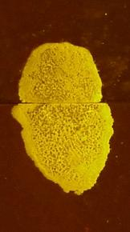 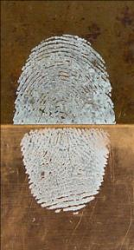 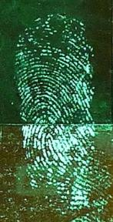 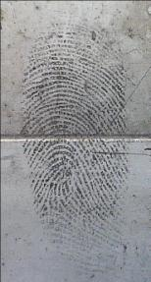

Score = 0 Score = 1 Score = 2 Score = 3 Score = 4

*Figure 2. Examples of latent fingermarks developed on metals (weathered - top, ‘new’ - bottom samples) representing grades: 0 - developed with gun blueing on stainless steel, 1 - developed with Lumicyano on stainless steel, 2 - developed with cyanoacrylate fuming on bronze, 3 - developed with cyanoacrylate fuming /Basic Yellow 40 on brass, 4 - developed with carbon-based black powder suspension on stainless steel*

2.4 Processing

*2.4.1 Cyanoacrylate fuming/Basic Yellow 40*

Cyanoacrylate fuming was conducted using a ‘Sandridge’ superglue cabinet (Mason Vactron, London, UK) under the optimum conditions of relative humidity (80%) and hot plate temperature (120oC) [18]. The cyanoacrylate used in this study was Cyanobloom (Foster and Freeman, Evesham, UK). Approximately 3g of Cyanobloom was used in each run, and after 30 minutes of fuming time, or when good contrast between mark and background was achieved, development was halted by turning off the heater and activating the extraction system.

The following day, the marks were stained with ethanol-based Basic Yellow 40 (BY40) dye consisting of 2 g of Basic Yellow 40 in 1 litre of ethanol [18]. Fluorescence examination was performed using a Quaser 2000/30 light source (Mason Vactron, Evesham, UK) with the camera filters and goggles outlined in Table 2.

|  |  |
| --- | --- |
| **Excitation band (nm) /**  **Colour** | **Viewing filter cut on (nm)/**  **Filter colour** |
| 400-469  (violet/blue) | 476  (yellow) |

*Table 2. Fluorescence examination conditions used for the marks developed using cyanoacrylate fuming/BY40*

*2.4.2 Lumicyano™*

Before use, Lumicyano™ liquid (Crime Scene Technology, Loos, France) was taken out of the fridge and allowed to reach ambient temperature. Then it was shaken vigorously for 45 seconds to homogenize the product so it could work to its best potential. Lumicyano™ formulations have changed since its introduction to the market, at the time of this study the product consisted of a pre-mixed solution composed of 99% cyanoacrylate and 1% fluorophore. 3 g of Lumicyano™ was used for each run, using the same fuming methodology outlined for cyanoacrylate/BY40 above.

Any fingermarks visualised were photographed within 4 hours from completion of the fuming cycle, in accordance with the manufacturer’s recommendation to image within 24 hours in order to retain the intensity of the fluorescence. Fluorescence examination was performed using a Quaser 2000/30 light source (Mason Vactron, Evesham, UK) with the camera filters and goggles outlined in Table 3. The UV band used does not fully correspond with the optimum excitation wavelength for the Lumicyano™ product (325 nm) but was found to have sufficient overlap with the wavelengths of the excitation spectrum to produce fluorescence.

|  |  |
| --- | --- |
| **Excitation band (nm) /**  **Colour** | **Viewing filter cut on (nm)/**  **Filter colour** |
| 340-413  (UV) | 415  (pale yellow) |
| 468-526  (blue/green) | 529  (orange) |

*Table 3. Fluorescence examination conditions used for the marks developed using Lumicyano™*

*2.4.3 Gun Blueing*

The concentrated gun blue solution used in this study was the commercial product ‘Perma Blue® Liquid Gun Blue’ (Birchwood-Casey, Eden Prairie, USA).

Two different working solutions were prepared by diluting Perma Blue® with distilled water in order to slow down the ‘blueing’ reaction and make it easier to control:

* + - 1. **1 : 32.3** (3 mL of Perma Blue® and 97 mL of distilled water)
      2. **1 : 1** (50 mL of Perma Blue® and 50 mL of distilled water)

Metal samples were immersed in the working solution of gun blue and monitored closely for development, which typically occurred in less than a minute in the concentrated solution and up to 20 minutes in the dilute solution. Overdevelopment of fingermarks is sometimes experienced with gun blue (especially with higher concentrations) so care was taken not to keep the samples in the solution for too long. When sufficient fingermark contrast was observed development was stopped by immersing metals in distilled water. Samples were then air dried and any developed marks photographed.

*2.4.4 Carbon-based Black Powder Suspension*

The carbon-based BPS used in this study was pre-mixed ‘Wet Powder™ Black’ (Kjell Carlsson Innovation, Sundbyberg, Sweden). The container was shaken before use to achieve paint-like consistency.

Carbon-based BPS was painted onto the metal samples with a soft, pre-wetted animal hair fingerprint brush, ensuring that it was well loaded with the mixture to avoid damage to the marks and streakiness in background development. It was left in situ for approximately 15 seconds and then washed away under slowly running tap water until all the excess powder was removed from the background. Samples were then air dried and any developed marks photographed.

2.5 Scanning Electron Microscopy

The scanning electron microscope (SEM) was utilised for analysing the interactions between the fingermark and the surface it was deposited onto. The equipment used in this study was a Hitachi S-2500 Scanning Electron Microscope.

Several of the development processes used in this study produce marks that are either non-conductive or imperfectly conducting. To prevent these charging in the electron microscope and causing issues during imaging, a gold coating was first sputtered onto the samples using an E5100 sputter coating unit (Polaron Equipment Limited).

The SEM was used to obtain microstructural information about the metal surfaces prior to deposition of the fingermarks, and also to study the microstructure of developed fingermarks on both new and weathered samples of the same metal.

1. **Results and discussion**

3.1 Surface analysis

Each of the surfaces used in the study were photographed under white light, and then placed into the SEM for more detailed analysis of the surface structure. The observations for each metal are given below.

*3.1.1 Bronze*

The appearance of the bronze sample in the ‘new’ condition is shown in Figure 3.

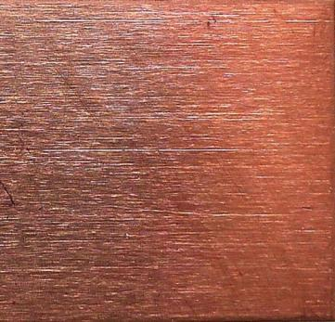 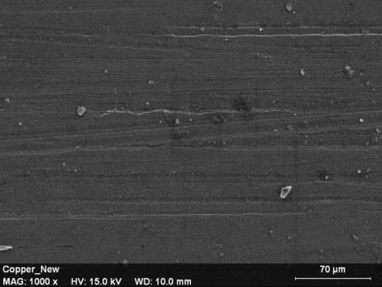

*Figure 3. ‘New’ bronze, a) photographed under white light, and b) SEM image, x1000*

On initial examination with the unaided eye, the sample has a shiny, reflective appearance with the copper-brown colour characteristic of bronze. At higher magnifications fine striations originating from the rolling of the sheet can be seen, and the scale of these features is more easily distinguished under the SEM.

The appearance of an equivalent sample after weathering is illustrated in Figure 4.

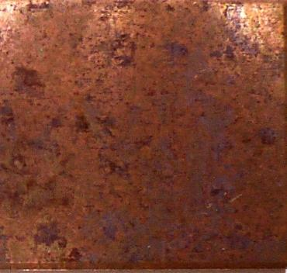 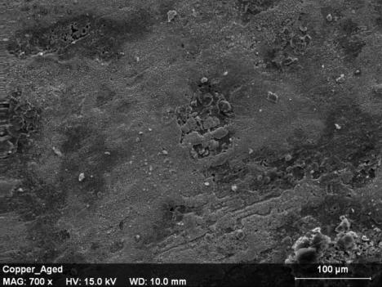

*Figure 4. Weathered bronze, a) photographed under white light, and b) SEM image, x700*

The weathered sample has a much duller appearance, with darker, matt brown areas across the surface that could be associated with the drying of water droplets on the surface. The SEM image shows the surface to be rougher and more deeply pitted than the original surface with shallow striations.

*3.1.2 Brass*

The appearance of the brass sample in the ‘new’ condition is shown in Figure 5.

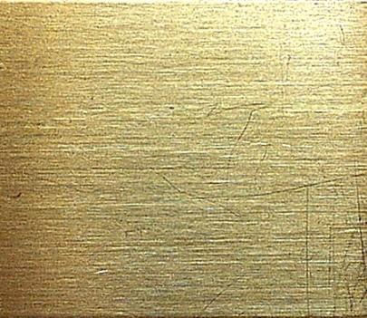 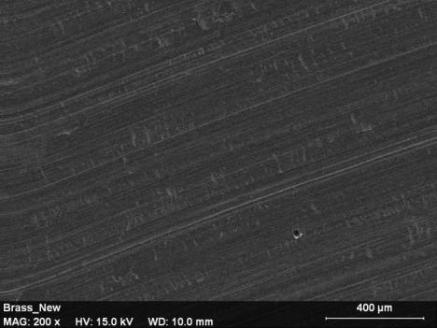

*Figure 5. ‘New’ brass, a) photographed under white light, and b) SEM image, x200*

Similarly to bronze, the sample has a shiny, reflective appearance to the unaided eye with fine striations originating from the rolling of the sheet seen at higher optical magnifications and under the SEM.

The appearance of an equivalent sample after weathering is illustrated in Figure 6.

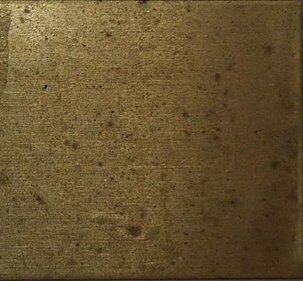 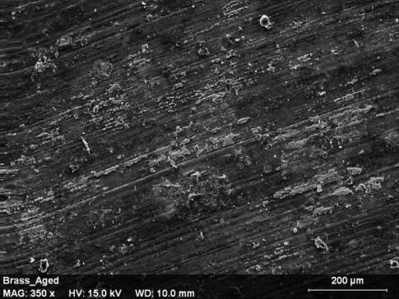

*Figure 6. Weathered brass, a) photographed under white light, and b) SEM image, x350*

The weathering process has resulted in the brass becoming duller, but there is no evidence of the coarser pitting seen for the bronze sample. The SEM shows some deposition or formation of material on the surface, but the original striations are still visible and unchanged in scale. In general the surface microstructure is less visibly affected by environmental exposure than seen for weathered bronze.

*3.1.3 Stainless steel*

The appearance of the stainless steel sample in the ‘new’ condition is shown in Figure 7.

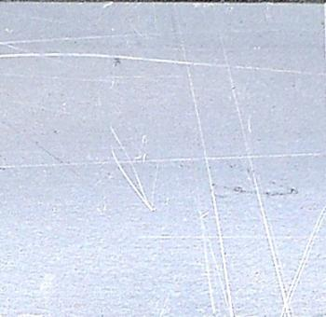 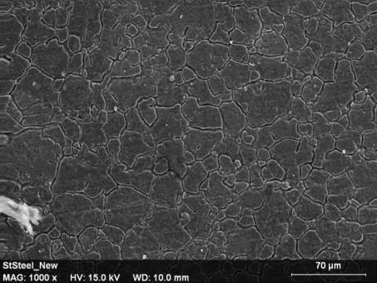

*Figure 7. ‘New’ stainless steel, a) photographed under white light, and b) SEM image, x1000*

The visible appearance of the stainless steel is silvery in colour, with a semi-shiny finish. The SEM reveals a fine granular structure on the surface, which is assumed to be the thin, protective chromium oxide layer that gives this grade of stainless steel its ‘stainless’ properties. There are gaps visible between individual grains, which may mean that this surface layer may not be truly ‘non-porous’ in nature in terms of interactions with fingermarks.

The equivalent images for the weathered samples are shown in Figure 8.

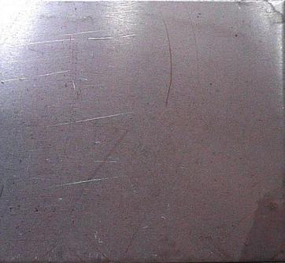 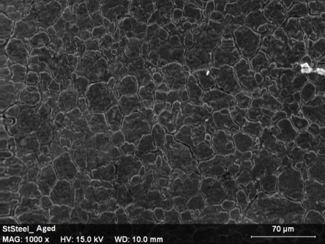

*Figure 8. Weathered stainless steel, a) photographed under white light, and b) SEM image, x1000*

As expected, the stainless steel sample is least affected by the weathering process, and appears only marginally duller after prolonged environmental exposure. The SEM shows that the granular structure is still present on the surface. However, there is an indication that the surface of the grains is more uneven and the grain boundaries less crisp with shallower gaps between them than those seen for the ‘new’ sample.

3.2 Processing results

*3.2.1 Cyanoacrylate fuming/BY40*

The results of the grading of the developed marks are shown in Figure 9, which records the percentage of the developed marks graded 3 or 4, recorded before and after the application of BY40 dye.



*Figure 9. Percentage of identifiable marks developed using cyanoacrylate fuming followed by dyeing with Basic Yellow 40 on the different metal surfaces*

On the coloured metals (bronze and brass), cyanoacrylate fuming was reasonably effective with over 60% of the deposited marks being of an identifiable quality, Figure 9. In most cases, the subsequent application of BY40 dye had little effect on the quality of the mark observed. The quality of marks developed on the weathered samples were slightly lower than that on the ‘new’ samples, Figure 10, but still generally visible by eye and fluorescence examination. The increased roughness of the surface (for bronze in particular) and presence of oxidation products (for both metals) may influence what happens to the fingermark after deposition, and contribute to this observed difference in quality.

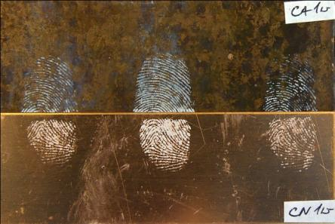 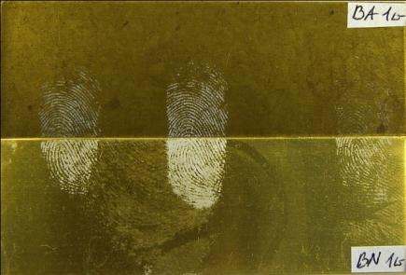

*Figure 10. Marks developed using cyanoacrylate fuming and visualised under white light on a) bronze, marks aged for 1 week, and b) brass, marks aged for 1 week*

Cyanoacrylate fuming was considerably less effective on stainless steel, with an appreciable number of marks containing no ridge detail because of apparent diffusion of the mark across the surface, Figure 11a. This effect appeared to be less pronounced on the weathered samples than on the new samples. Staining with BY40 enhanced the contrast of the developed fingermarks with the grey coloured background and made more marks identifiable, Figures 11b-c, but also revealed differences between the features in the background.

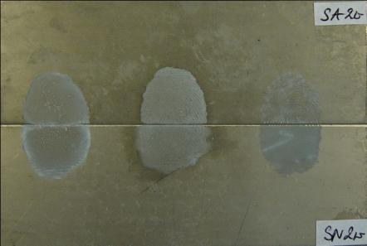

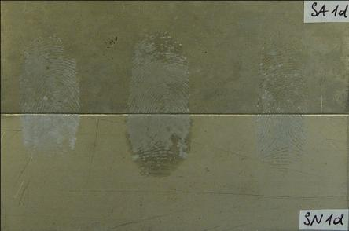 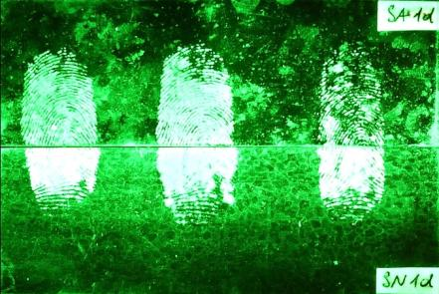

*Figure 11. Marks developed using cyanoacrylate fuming on stainless steel a) marks aged for 2 weeks visualised under white light and showing diffusion, b) marks aged for 1 day visualised under white light, and c) marks aged for 1 day visualised using fluorescence examination, showing improved contrast and dyeing of background features*

In the case of the ‘new’ sample, the semi-porous nature of the surface appears to be confirmed by the uptake of dye in the background, which reveals the grain structure of the surface as the dye is absorbed along the boundaries between grains. On the weathered surface background features are also revealed but these may be associated with the drying of water on the surface during environmental exposure, as proposed for the pitted areas on the weathered bronze surface. It is possible that the slightly better results seen on the weathered surface compared to the ‘new’ surface are associated with the weathering process depositing material and ‘filling in’ the gaps between grains (as indicated in Figure 8). This may make it more difficult for fingermark residue to migrate across the surface by flowing into and along the channels between grains. Another possible explanation is that the weathering process has altered the surface properties, in particular the wettability. A change in the surface behaviour of this grade of stainless steel has been observed by other researchers [19], who found that the surface changed from a hydrophilic to a hydrophobic nature over time. The change to a more hydrophobic surface may limit the spreading of the fingermark residue across the surface, whereas migration of the residue may be preferred on a hydrophilic surface. Figure 11 shows that the portion of the mark on the weathered part of the sample generally has better defined ridge detail. The diffusion of the ridge detail was consistently more noticeable for the natural and sebaceous marks.

When examined using the SEM, both bronze and brass samples show a very high and homogeneous concentration of long fibrous deposits (noodle-type polycyanoacrylate polymer) on the ridges and low levels of polymer development in between the ridges. This was observed for both all types of mark (natural, sebaceous and eccrine) across the range of ages studied (1 day and 2 weeks). The noodle-type morphology of the polymer observed is characteristic of development under desired conditions of 80% relative humidity [20] and corresponds to a good macroscopic development of the latent fingermarks. This structure of polymer is also effective in retaining the fluorescent dye used to enhance fingermarks developed with cyanoacrylate fuming. The formation of the noodle structure is not obviously inhibited by the condition of the surface, with similar polymer structures formed on ‘new’ and weathered surfaces, Figures 12 and 13.

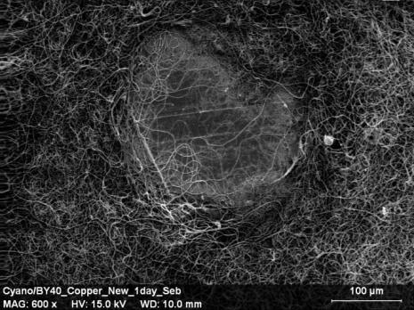 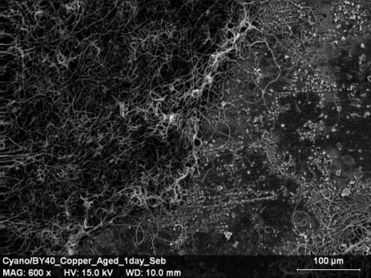

*Figure 12. Sebaceous marks on bronze, aged for 1 day and developed using cyanoacrylate fuming/BY40, a) on ‘new’ bronze (x600), and b) on weathered bronze (x600)*

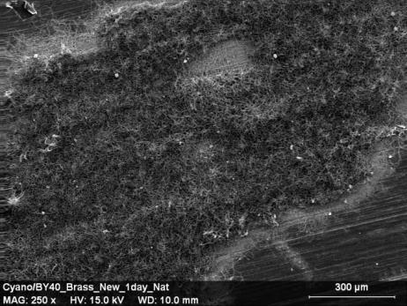 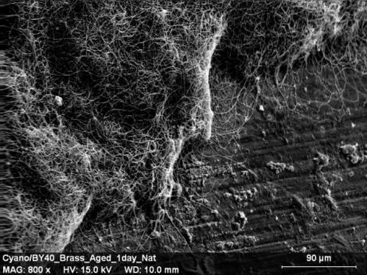

*Figure 13. Natural marks on brass, aged for 1 day and developed using cyanoacrylate fuming/BY40, a) on ‘new’ brass (x250), and b) on weathered brass (x800)*

Although the structure of the developed polymer is similar for all types of mark on brass and bronze, it was noted that the ridges of sebaceous marks tended to have a thicker and more defined appearance, especially when the samples were tilted in the SEM. This may be because the sebaceous-rich mark retains moisture in the residue better than the natural or eccrine marks, increasing topography and also providing more material to contribute to initiation of polymerisation. This is consistent with what was observed during grading, where although the actual grades of the natural, sebaceous and eccrine marks tended to be very similar, the eccrine marks generally had less contrast with the background.

The marks developed on stainless steel samples show a very different morphology of the developed polymer to those of bronze and brass, Figure 14.

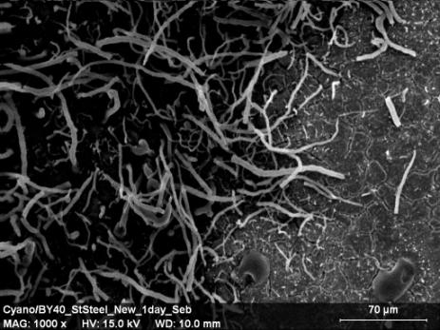 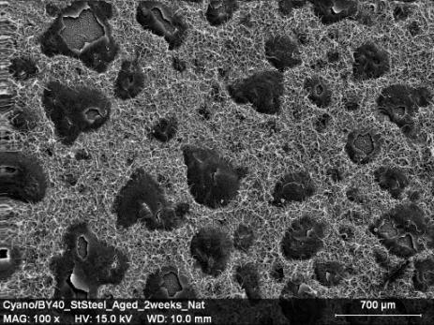

*Figure 14. Fingermarks on stainless steel developed using cyanoacrylate fuming/BY40, a) sebaceous mark aged for 1 day on ‘new’ stainless steel (x1000), and b) natural mark aged for 2 weeks on weathered stainless steel (x100)*

The polymer structure within marks where ridge detail could be seen took the form of ‘broken noodles’ (Figure 14a) and the concentration of polymer fibres is not as high as that in the noodle structure. This corresponded to poor macroscopic development of the latent fingermarks, which were not generally of identifiable quality. For marks where no ridges could be seen and the mark appeared to have diffused across the surface, SEM shows a general development of the short ‘broken noodles’ across the surface with islands where a flat polymer structure is seen, Figure 14b. The underlying grain structure of the stainless steel is not visible, implying the constituents have migrated across the surface before development takes place, as opposed to development starting on individual ridges which subsequently merge into each other.

*3.2.2 Lumicyano™*

The results of the grading of the developed marks are shown in Figure 15.

*Figure 15. Percentage of identifiable marks developed using Lumicyano on the different metal surfaces*

The results indicate similar trends in the effectiveness of Lumicyano™ to those observed for cyanoacrylate fuming/BY40 on all types of metal, although the process is more effective overall on the ‘new’ brass and bronze surfaces. Effectiveness is reduced on weathered brass and bronze, Figure 16, with this being most noticeable for eccrine marks aged for longer than 1 day.

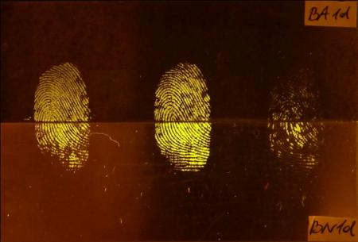 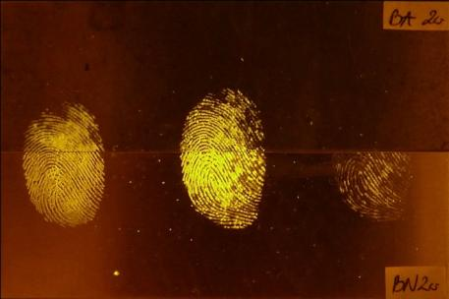

*Figure 16. Marks developed using Lumicyano™ and visualised under fluorescence examination (blue/green excitation) on a) brass, marks aged for 1 day, and b) brass, marks aged for 2 weeks. From left to right: Natural, sebaceous, eccrine marks*

In common with cyanoacrylate fuming/BY40, Lumicyano™ did not perform well on ‘new’ or weathered stainless steel and only developed about 10% of fingermarks of identifiable quality. Diffusion of the mark across the surface remained the principal reason for the poor results obtained, but the use of a ‘one step’ process instead of a liquid stain did appear to significantly reduce the staining of the grain structure of the ‘new’ stainless steel. However, features possibly associated with drying water were still developed on the weathered sample.

In the case of ‘new’ and weathered bronze and brass, SEM images show very high and homogeneous development of a noodle-type polymer in the ridges. The ridges have a well-defined appearance and there seems to be less polymer development in between the ridges when compared to fingerprints developed with cyanoacrylate/BY40. The polymer fibres developed with Lumicyano™ are also finer in appearance. Eccrine fingermarks in general (but especially deposited on weathered samples) did not develop as well as natural and sebaceous marks. This is most probably attributed to the loss of moisture from the marks, which results in poorer development and becomes more pronounced as marks age and more moisture is lost. A representative image of the noodle structure observed is shown in Figure 17.

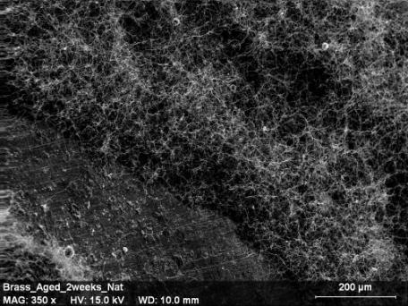

*Figure 17. Natural marks aged for 2 weeks and developed using Lumicyano™ on weathered brass (x350)*

In the case of stainless steel, the SEM images show the concentration of the fibrous material in the developed mark is lower and the fibres have much shorter appearance then those developed on bronze and brass, Figure 18.

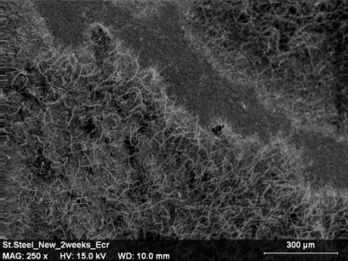

*Figure 18. Eccrine marks aged for 2 weeks and developed using Lumicyano™ on ‘new’ stainless steel (x250)*

There was no obvious influence of the surface condition on the development mode of the Lumicyano™ on bronze and brass. It is proposed that instead of influencing development mode, the surface condition primarily influences what happens to the constituents in the mark once they have been deposited on the surface. In this case, the weathering either causes the mark to dry quicker and/or corrosion/oxidation products on the surface to interact with constituents in the mark, leaving less residue available to interact with the Lumicyano™ vapour and producing weaker development.

All metals were treated at the same time, in the same fuming chamber and under the same development conditions. Fingermarks deposited on stainless steel reacted differently to those deposited on bronze and brass, and again it was observed that heavy marks deposited on stainless steel seem to ‘flow’ across the surface.

*3.2.3 Gun Blueing*

The development time varied for different dilutions of gun blue, with the 1:32.3 dilution giving a development time of approximately 20 minutes for the brass and bronze samples. For the 1:1 dilution, development was much quicker and different metals were found to require different times of treatment, typically between 30-60 seconds. Gun blueing was not effective on stainless steel, which was as expected. This metal did not corrode and stayed intact even when left in the 1:1 working solution of gun blue for 2 hours. The reason for that is that stainless steel is protected by a chromium oxide layer which prevents the iron and nickel present participating in reactions with the selenium in the gun blueing solution.

It is reported in Ramotowski [21] that ‘the rate of the development can be increased or decreased by adjusting the concentration of the Gun Blue in the final dilution’. Although the higher concentration of the gun blue in the working solution (1:1) used in this study may lead to overdevelopment and extra care needs to be taken during development process, the lower concentration of the gun blue in the final dilution (1:32.3) did not develop as many fingermarks as the higher concentration, 20 minutes immersion was required, and after that time only sebaceous prints developed. The 1:1 dilution was therefore preferred, and the results obtained are summarised in Figure 19.

*Figure 19. Percentage of identifiable marks developed using gun blueing on the different metal surfaces*

Gun blueing did not develop any fingermarks of identifiable quality on weathered bronze or on weathered brass. The reason for that could be that corrosion has already commenced on those metals and the fingermark material could not act as a mask and ‘protect’ the surface against further corrosion or reaction with the gun blue solution. The weathered surfaces therefore uniformly darkened in the gun blue solution, making any marks that may be present difficult to discriminate, Figure 20.

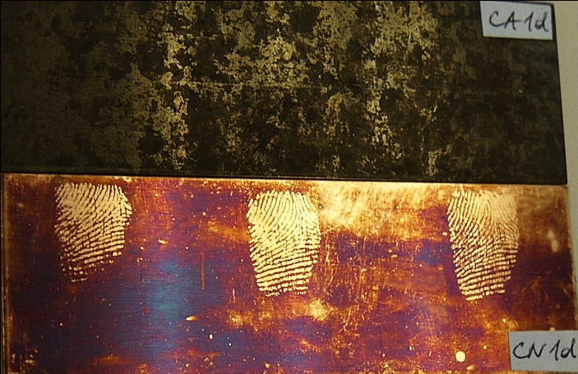 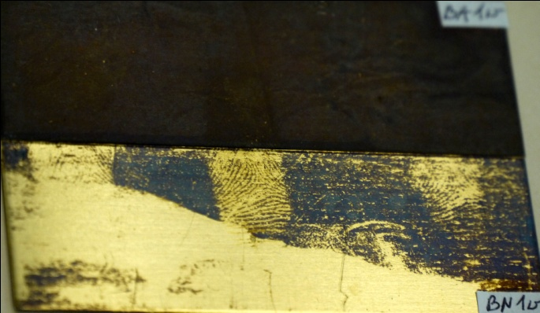

*Figure 20. Marks developed using gun blueing (1:1 dilution) and visualised under white light on a) bronze, marks aged for 1 day, and b) brass, marks aged for 1 week. From left to right: Natural, sebaceous, eccrine marks*

Gun blueing worked best on ‘new’ bronze and developed 100% of latent fingermarks, although tilting at different lighting angles was required to see all marks. It did not work as well on ‘new’ brass. This result was not expected as gun blueing has been recommended for development of latent fingermarks on brass cartridge casings [8,21] and was expected to work best on brass samples. However, this result should be taken in the context that only a single donor has been used in this study, and this result would need to be replicated across a range of donors for this to be considered significant.

SEM analysis of ‘new’ brass, Figure 21, shows that the darker shades correspond to the pristine regions of the metal that have been protected by the fingermark residue and correspond to the ridges of the fingermark. The regions of brass exposed to gun blue solution have reacted, resulting in visible deposition of CuSe in the form of white particulate matter. The results observed for bronze were very similar.

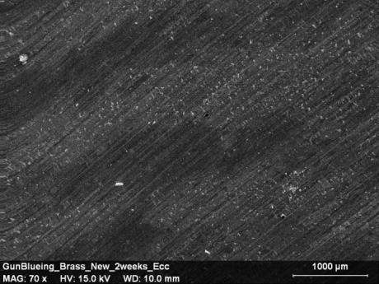 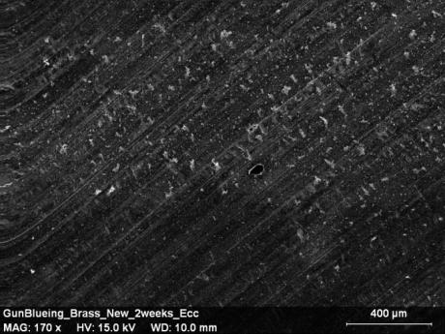

*Figure 21. Eccrine marks aged for 2 weeks and developed using gun blueing on ‘new’ brass, a) x70, showing fingermark ridges, and b) x170, showing CuSe deposition*

Weathered bronze after immersion in gun blue solution was heavily coated with CuSe and no ridge details could be observed. Weathered brass was also heavily coated with CuSe, although slight ridge details were visible as darker shades in the SEM images but the mark was not readily visible under white light and not of identifiable quality.

*3.2.4 Carbon-based Black Powder Suspension*

The results of the grading of the developed marks are shown in Figure 22.

*Figure 22. Percentage of identifiable marks developed using carbon-based black powder suspension on the different metal surfaces*

Carbon-based black powder suspension (BPS) was not very effective on either bronze or brass and did not develop any identifiable quality marks on weathered bronze. Carbon-based BPS worked best on stainless steel samples, in both weathered and ‘new’ conditions, Figure 23.

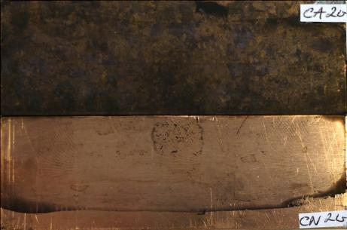 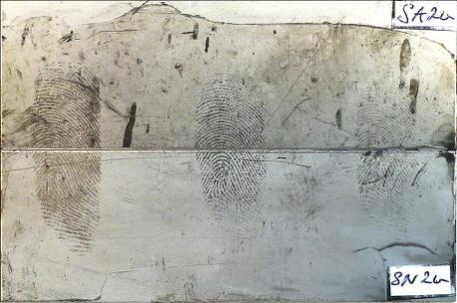

*Figure 23. Marks developed using carbon-based BPS and visualised under white light on a) bronze, marks aged for 2 weeks, and b) stainless steel, marks aged for 1 week. From left to right: Natural, sebaceous, eccrine marks*

The SEM analysis of marks developed on stainless steel show lighter regions corresponding to the ridges of the fingermark, with pores present along the ridges, Figure 24. However, even at the highest magnification achieved (x4000) at which sharpness could be maintained with this microscope it was not possible to fully resolve the ~1 m particles that adhere to the ridges.

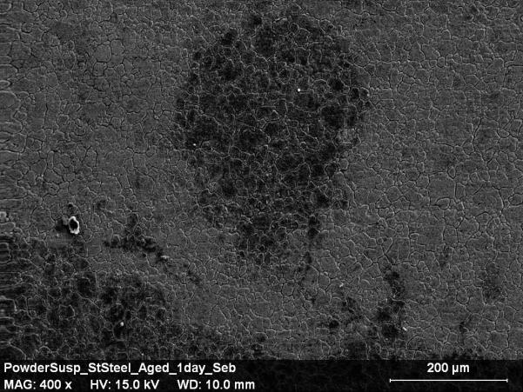

*Figure 24. Sebaceous marks aged for 1 day and developed using carbon-based BPS on weathered stainless steel, a) x400, showing fingermark ridge and a pore*

In this study, SEM examination of the fingermarks developed with carbon-based BPS does not offer an explanation of the mechanism for development of fingermarks by powder suspension, nor why this may vary between the different metal types and conditions. This is primarily because the distribution of individual carbon particles cannot be seen. However, it confirms that powder suspension preferentially adheres to the ridges of a latent fingermark, and it appears that the nature of the underlying metal does affect whether powders will adhere or not. One possible explanation for the preferential deposition of powder suspensions is an electrical interaction between constituents in the fingermark and the particles in suspension, and certain filler particles, when close to the surface, have been shown to act as deposition sites for carbon particles [22], again possibly due to an electrical interaction.

For bronze and brass, which are good electrical conductors, it is possible that the electrical interactions required for particle deposition do not occur or are swamped by conduction within the metal, and consequently fingermark development on these surfaces is poor. For stainless steel, which has a thin, non-conducting oxide layer on the surface, the underlying conductive metal may be sufficiently separated from the fingermark to not interfere with interaction required for deposition and therefore fingermarks are developed. Further work would be required to test this theory.

In summary, for cyanoacrylate fuming and Lumicyano™ on brass and bronze the mode of development seemed the same regardless of whether the surface was new or weathered. However, the condition of the surface may have affected how much residue was available to initiate polymerisation. The mode of development is different on stainless steel, with a different polymer structure formed, and the semi-porous surface oxide coating potentially contributing to increased diffusion of marks on the surface and uptake of fluorescent dye. Weathering of the stainless steel surface, with a corresponding reduction in the depth of the surface features, may slightly reduce the detrimental impact of these phenomena, although this may also be attributable to changes in surface wettability.

For gun-blueing, only the copper-based metals used in this study could react with the gun-blueing solution. Surface condition also plays a critical role on these surfaces because if corrosion/oxidation of the surface has already commenced before deposition of the fingermark, the process is ineffective because the mark can no longer act as a ‘mask’ over clean regions of the metal while deposition occurs on the background, and the contrast required to visualise the mark is not achieved. Gun-blueing was therefore found to be ineffective on weathered metal surfaces.

For carbon-based powder suspensions, the composition (and possibly the resultant electrical properties) of the surface seems more important than its condition. The process was found to be ineffective on the conductive, copper-based alloys, and worked well on stainless steel with its non-conductive surface layer, regardless of if the surface had been weathered or not.

1. **Conclusions**

This feasibility study has shown that cyanoacrylate fuming and Lumicyano™ are capable of developing latent fingermarks on a range of naturally weathered copper-based metals representative of those that can be recovered from outdoor crime scenes. Carbon-based black powder suspension was not effective on copper-based metals but performed well on stainless steel in both new and weathered conditions.

The surface type and condition were found to influence the development of fingermarks, although the effect did vary according to the development process being applied. Given the differences in composition and different properties of the metals used there was no single method that was optimum for developing latent fingermarks on all metals under examination. Many good quality fingermarks could be observed on some of the metals and there was no metal where fingermarks could not be developed at all. This reinforces the need to assess both the type of metal and its surface condition prior to selection of the optimum development technique. A summary of the best performing techniques for each metal and surface condition is given below.

New bronze: Lumicyano™, gun blueing

Weathered bronze: Cyanoacrylate fuming/BY40, Lumicyano™

New brass: Lumicyano™

Weathered brass: Cyanoacrylate fuming/BY40, Lumicyano™

New stainless steel: Carbon-based BPS

Weathered stainless steel: Carbon-based BPS

Although it was observed that each of these techniques was capable of developing a reasonable proportion of deposited marks in this study, it should be noted that the same techniques were used by several participants in the ENFSI collaborative exercise where far lower fingermark recovery rates were observed. This discrepancy between the effectiveness of the techniques may be due to the time elapsed between fingermark deposition and development (which was longer in the ENFSI exercise) and/or to variability between donors. The current study only used one donor who was likely to leave marks that could be studied in the SEM. To build a better picture of overall effectiveness for each process on weathered metals it is essential that this work be expanded to include a wider pool of donors and depletion series of marks.

The SEM was found to be an effective tool in the exploration of the microstructure of the surfaces and the developed marks, providing useful information regarding the interaction of the fingermark with the surface, and its subsequent development.

1. **References**
2. Great Britain. Home Office. 2012. *To amend the law relating to dealers in scrap metal*. Impact Assessment No: HO0074. [Online] Available from: http://www.gov.uk [Accessed 20 June 2014].
3. The Fourteenth Report from the Transport Committee, *Cable theft on the railway*, HC 1690, [Online] Available from: http://www.publications.parliment.uk [Accessed 20 June 2014].
4. The Guardian. 2009. *Mystery of the stolen Moore solved*. [Online] Available from: http://www.theguardian.com [Accessed 20 June 2014].
5. Droitwich Standard (2013), *School faces £250,000 repair bill after 315 copper theft*. [Online] Available from: http://www.droitwichstandard.co.uk [Accessed 20 June 2014].
6. Moncmanova, A. 2007, *Environmental deterioration of materials*, WIT Press
7. Perry, H., and Sears, V. G., ‘The Use of Natural Yellow 3 (Curcumin) for the Chemical Enhancement of Latent Friction Ridge Detail on Naturally Weathered Materials’, *J. Forens. Ident.,* vol 65(1), (2015), pp 46-66
8. Belcher, G. L. ‘Methods of Casting and Latent Print Recovery’, *Fingerprint Ident. Mag.*, vol. 59 (1), (1977), pp 14–15.
9. Saunders, G. C. and Cantu, A. A ‘Evaluation of Several Techniques for Developing Latent Fingerprints on Unfired and Fired Cartridge Cases’, *Proceedings of the International Symposium on Fingerprint Detection and Identification*, June 26–30, 1995, pp 155–160. Israel: Ne’urim
10. James, R M, Altamimi, M J, ‘The enhancement of friction ridge detail on brass ammunition casings using cold patination fluid’, Forens Sci Int, vol 257, (2015), p385–392
11. Migron Y, Mandler D, ‘Development of Latent Fingerprints on Unfired Cartridges by Palladium Deposition: A Surface Study’, J Forens Sci, vol 42(6), (1997), p986-992
12. Girelli C M A, Lobo B J M, Cunha A G, Freitas J C C, Emmerich F G, ‘Comparison of practical techniques to develop latent fingermarks on fired and unfired cartridge cases’ , Forens Sci Int, vol 250, (2015), p17-26
13. Williams G, McMurray N, ‘Latent Fingerprint Visualisation Using a Scanning Kelvin Probe’, Forens Sci Int, vol 167, (2007), p102-9
14. Bond J W, ‘Visualisation of latent fingerprint corrosion of metallic surfaces’, J Forens Sci, vol 53 (4), (2008), p812-822
15. Wightman, G, O’Connor, D. ‘The thermal visualisation of latent fingermarks on metallic surfaces’. Forens Sci Int. vol 204(1-3), (2011), p88-96
16. Beresford A L, Hillman A R. ‘Electrochromic Enhancement of Latent Fingerprints on Stainless Steel Surfaces’. Anal Chem, vol 82, (2010), p483-486
17. IFRG, ‘Guidelines for the Assessment of Fingermark Detection Techniques’, J. Forens. Ident., vol. 64 (2), 2014, p174-200
18. Sears, V.G., Bleay, S.M., Bandey, H.L., Bowman, V.J. ‘A methodology for finger mark research’, Sci Justice. vol 52(3), 2012, p145-60
19. Bandey, H.(ed) Fingermark Visualisation Manual, ISBN 978-1-78246-234-7 London: Home Office, 2014
20. Kim, D, Kim, J G, Chu C N, ‘Aging effect on the wettability of stainless steel’, Materials Lett., vol 170, 2016, p18-20
21. Paine M, Bandey H L, Bleay S M, Willson H, ‘The effect of relative humidity on the effectiveness of the superglue fuming process for fingermark development and on the microstructure of the developed marks’, Forens Sci. Int., vol 212(1), (2011), 130-142
22. Ramotowski, R.S., Leben, D.A., Evaluation of Gun Blueing Solutions and Their Ability to Develop Latent Fingerprints on Cartridge Casings. FDIAI NEWS
23. Bacon, S. R., Ojeda, J. J., Downham, R., Sears, V. G. and Jones, B. J. ‘The effects of polymer pigmentation on fingermark development techniques’, J Forens. Sci. vol 58(6), (2013), pp 1486-1494