Experimental investigation of oscillating heat pipe efficiency for a novel condenser by using Fe₃O₄ nanofluid

Hadi Davari¹, Hamid Reza Goshayeshi^{2, *}, Hakan F. Öztop³ and Issa Chaer⁴
^{1, 2}Department of Mechanical Engineering, Mashhad Branch,
Azad University, Mashhad, Iran
³Department of Mechanical Engineering, Technology Faculty, Fırat University, Elazig, Turkey
⁴Centre for Civil and Building Service Engineering, School of the Built Environment and Architecture, London South Bank University, London, England

Abstract
This paper presents a novel study on the performance of closed loop oscillating heat pipe (CLOHP) using iron oxide (Fe₃O₄) as the working fluid for three types of condensers. The tested CLOHP consists of six turns made of copper tubes, 4.5 mm outer diameter and 3 mm inner diameter with heating power input in a range of 0–200 W.
The experimental results showed that the thermal performance of the CLOHPs has been improved when the corrugated horizontal condenser was used compare to straight and corrugated vertical condensers. Based on 800 sets of available experimental data, the results show that, the CLOHPs with corrugated horizontal condenser had better thermal performance when charged with Fe₃O₄/water at 2% weight concentration.

Key words: Oscillating heat pipe, Heat resistant, Thermal efficiency, nanofluid, corrugated horizontal condenser.

*Corresponding Auhtor: e-mail: goshayshi@yahoo.com

Nomenclature
A | area (m²)
D | diameter (mm)
I | electric current(A)
V | electrical voltage (V)
$q^{"}$ | heat flux (W m⁻² K⁻¹)
q | heating power (W)
h | heat transfer coefficient (W m⁻² K⁻¹)
L | length (m)
T | temperature (K)
R | thermal resistance (KW⁻¹)
ŋ | efficiency (%)
Greek symbols
Δ | uncertainty
ρ | density (kg m⁻³)
Subscripts
ad | adiabatic
c | condenser
e | evaporator
i | inner
in | input
out  sat | output  saturation

- Introduction
Heat pipe (HP) is a high thermal conductivity device which has been widely used in many fields. Oscillating heat pipe was first introduced into literature by Akachi in the 1990s [1]. Compared with conventional heat pipes, the OHP has a serpentine structure made from capillary tube without wick [2]. Actually, the structure with multiple turns makes an OHP seems like an array of single conventional heat pipes and it is two-dimensional. Without capillary force, the high effective heat transfer ability of OHP was mainly achieved through the oscillation movement of vapor plugs and liquid slugs driven by the pressure imbalance in adjacent tube between the evaporation section and condensation section [3-5]. However, the start-up and maintain of the oscillation movement was influenced by many factors such as surface tension, latent heat and vaporization temperature of working fluid, inner diameter of the capillary tube, heat and cooling conditions [6-8].
The working fluid is a popular research topic in the domain compared to the conventional working fluids. Nanofluids can significantly enhance the heat-transfer. To study more about the influence of these factors, researchers did some experimental and numerical works. In this context, Shi and Pan [9] have studied the influence of filling ratio on the start-up and heat transfer performance of closed loop plate OHP with acetone and ethanol as working fluid. They found that the acetone as the working fluid could start-up more easily than ethanol and filling ratio 50% could start-up early than 70%. Mehta et al. [10] have studied the influence of working fluids on start-up mechanism and thermal performance of an oscillating heat pipe. The results showed that the acetone had a lower start-up power and better performance compared to methanol, ethanol and water.

Tung et al. [11] studied nanoparticles in an oscillating heat pipe with different volume percentages of nanoparticles. Their results suggested that the best ratio of density was 60%. They also changed the suspension of nanoparticles in the fluid. Moreover, the results showed that thermal resistance has been reduced using the nanoparticles more than pure water. Ma et al. [12-14] used water - nanofluid in relation to the distilled water showed a dramatic reduction in thermal resistance. Heat resistance and heat transfer coefficient of heat pipes have apparently improved after using nanofluids and enhanced productivity. However, although increasing weight percentage of particles in the suspension fluid leads to enhancing the heat transfer rate, the bubbles reduction can block ducts and the pressure drop is increased in the system [15-18]. Haghayegh et al. [19] investigated the length of evaporator in heat pipe evaporator area. They showed that elongation is increased the efficiency of heat pipe. Senjaya and Inoue [20] presented the simulations of closed and open PHPs and so many researchers worked in other field of OHPs.

A novel magnetically variable conductance thermosiphon heat pipe was investigated experimentally by [21]. The possibility of deactivating a portion of evaporator length and subsequently altering heat pipe resistance by positioning a steel ball inside the evaporator and moving it by an external magnet was studied. The effect of various ball positions in the evaporator and inclination angles on heat pipe performance was studied at 30, 60, 90 and 120 Watts. The results indicated that at a given heat input, moving the ball away from the beginning of the evaporator of heat pipe increases its thermal resistance. The best performance among 30, 60 and 90 inclination angles was achieved at 90.

A desired circulatory flow in flat-plate closed-loop pulsating heat pipes, ameliorate was achieved by using the new idea of interconnecting channels (ICs) to decrease flow resistance in one direction and increase the total heat transfer of fluid by [22]. The OHPs were charged with ethanol as working fluid with filling ratios of 35%, 50%, 65%, and 80% by volume. It has been observed that the most efficient performance occurred at the filling ratio of 65%. The experimental and numerical investigation of using pulsating heat pipes as substitutes for fins in a typical air-cooled heat exchanger has been done by [23]. The results indicated that using pulsating heat pipes as fins have a significant effect on improving the heat transfer.

The impact of geometrical configuration in pulsating heat pipe structure was investigated by [24] . Intended geometrical alteration contained an extra branch in the evaporator section as the secondary bubble pump. At first, a glass prototype of the innovated system was made and then the impact of the extra branch was visually analyzed.
Afterwards, two copper prototypes were fabricated for thermal performance comparison purposes. One of them was made with the ordinary structure of pulsating heat pipe and the other one was made with an extra branch (secondary bubble pump) in the evaporator section. The main idea of this investigation was to increase heat transfer rate by increasing flow circulation of working fluid. Results showed that the thermal performance of the new PHP is considerably (up to 51%) better than the conventional PHP in the vertical orientation using filling ratios of 40% and 70%. To better understand the effect of the additional branch in the new PHP, a Pyrex heat pipe similar to the copper type was fabricated and the flow circulation was visually analyzed.

Looking into the available literature, it can be seen that fifteen major thermo-mechanical parameters have emerged as the primary design parameters affecting the OHP systems. These are:
- Three dimensional oscillating heat pipe [25],
- thermal performance of oscillating heat pipe [26-29],
- filling ratio [30],
- number of turns [31,33],
- inclination angle [34-36],
- magnetic field [37- 40],
- shape and length of evaporator, condenser sections [41,43],
- internal diameter and material of the OHP tube [44],
- shape of channel [45],
- orientation of OHPs [46,47],
- bubble generation [48]
- effect of thermophysical properties [49, 50],
- external forces [51],
- flow visualization [52],
- shape and size of particles [53].
The main aim of this work is to investigate the effects of the iron oxide-nanofluids’ convection heat transfer in different shaped of condensers for an OHP. A novel design is performed and its thermal efficiency is analyzed. The changes of thermal resistances, difference in vapor temperature between the evaporator and the condenser as well as heat transfer coefficient in different shape of condenser at a filling ratio of 50% were analyzed. The outcomes of the current investigation are expected to assist the readers to design more efficient OHPs, charged with nanofluid. In our recent work, a novel study on efficiency of oscillating heat pipe using Fe₃O₄/water as working fluid was experimented [54]. Application of ferrofluids such as Fe₃O₄ in other fields of technology such as aerospace, electronic packing and micro- scale heat exchangers makes it one of the most significant novel technology branches. In our previous paper we found the Fe₃O₄/water with the concentration of 2 vol% has good result for oscillating heat pipe also reviewing the literature makes it clear that although many investigators have considered different types of surfaces and nanofluids in OHPs, there is no study has qualitatively described the OHPs behavior with detailed characterizations for different shape of condensers with using Fe₃O₄. This paper will investigate the effect of shape of the condenser for first time on OHPs. Firstly, the experimental set up and procedures are introduced and then, the temperature fluctuation of the condenser and evaporator are presented, and operating characteristic for different shape of condenser are detailed. Lastly, the thermal resistance is analyzed, on behalf of the performance of Fe₃O₄ for OHPs with three types of condensers.

2. Experimental
2. 1 Thermophysical properties
Iron oxide (Fe₃O₄) was purchased from Merck company (Gernsheim, Germany), with purity of 98% was employed as the nanofluid. The specification of iron oxide (Fe₃O₄) nanoparticles are shown in Table 1.
Table 1: Thermal properties of iron oxide (Fe₃O₄).
Thermophysical Property | Specification
Particle | Fe₃O₄
Color | Black
Diameter | 25 nm
Purity | $$98 \%$$
Bulk density | 0.84 g/cm³
Morphology | Spherical

2. 2 Preparation of the nanofluid
Used iron oxide and Fe₃O₄/water can be seen in Fig 1. The main disadvantage of

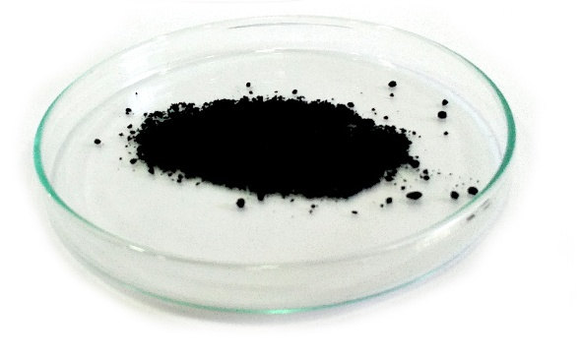 | 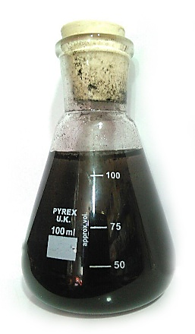
Figure 1: a) Fe₃O₄ powder, b) Fe₃O₄/water
nanoparticles are that they are unstable. Preparation of stable nanofluid is critical to measure the thermophysical. For stabilization Fe₃O₄, ultrasonic or magnetic vibrator was applied which is used for steady of nanofluids. In this work, iron oxide (Fe₃O₄) with the concentration of 2% weight was used to control the heat transfer coefficient. No stabilization procedure is used during this process because of powerful pulsating motions in CLOHP also no surfactant has been used according to suggestion by [55,58]. The preparation steps of iron oxide + water nanofluid can be seen in Fig 2.
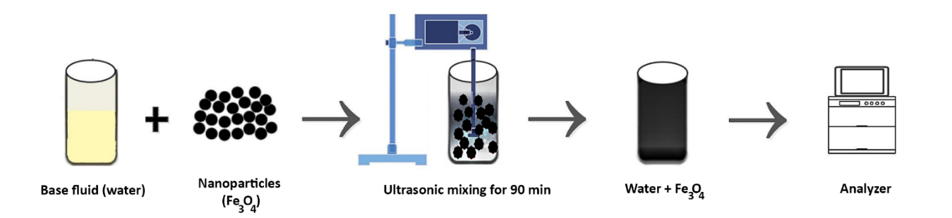
Figure 2: Preparation steps of iron oxide + water.

The XRD of Fe₃O₄ nanoparticles is presented in Fig 3a also Fig 3b shows diameter distribution for Fe₃O₄. This information is obtained by using Dynamic Light Scattering (DLS) technique. According to this figure, the average diameter of Fe₃O₄ in our experiment was approximately 25 nm.
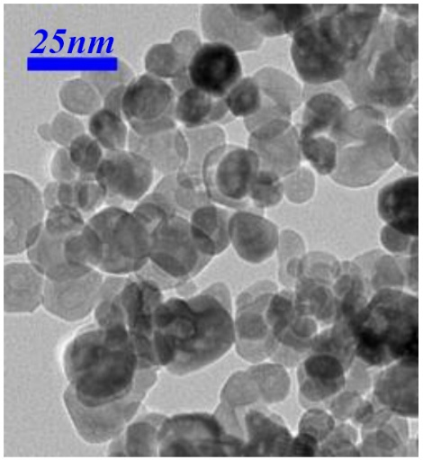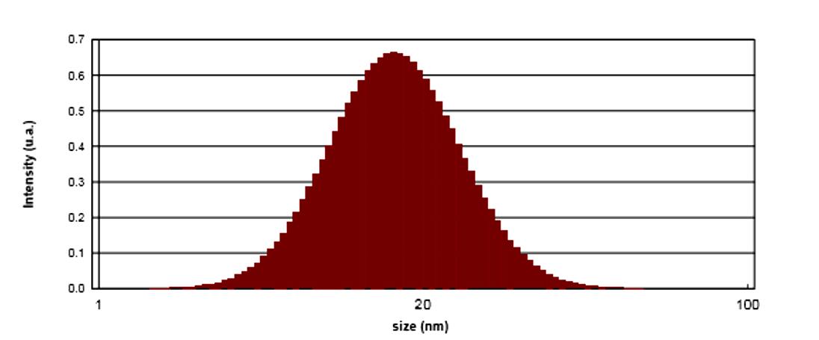
Figure 3: a) XRD of Fe₃O₄ nanoparticles, b) diameter distribution for Fe₃O₄.
2. 3 Experimental Apparatus
Fig 4, presents a picture of the experimental apparatus of the closed-loop OHP setup. To explore the effect of different heat loads on the evaporator segment of the closed-loop OHP, an electric heater connected to a Variac and standard current and volt meters were used to simulate the different heat inputs (10 to 140 Watts) on the evaporator of the vertical OHP. The device was emptied before charging the ﬂuid into the OHP by applying 0.1 Pa suction pressure for 30 min via a vacuum pump joined to a 3-way valve. Next, the vacuum pump was isolated using the 3-way valve to charge the ﬂuid into the OHP (see Figs 4 ,5 and 6). To explore eﬀect of diﬀerent heat loads on the evaporator segment, an electrical monitoring system and a Variac were used to connect an electric heater to the source of electricity. The standard current and volt meter data were used to calculate the heat input. Tests were done under diﬀerent heat inputs of 10–120 W. Table 2 shows the heat pipe configuration.
Table 2: Heat pipe configuration
OHP material | Copper
Number of turn | 6
OHP length | 300mm
Straight condenser length | 100mm
Adiabatic length | 100mm
Evaporator length | 100mm
Outer diameter | 4.5mm
Wall thickness | 1. 5mm
Inner diameter | 3mm
Liquid filled ratio | 50%
Total length of OHP | 4.00 m
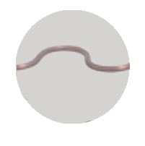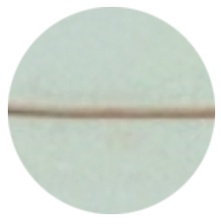
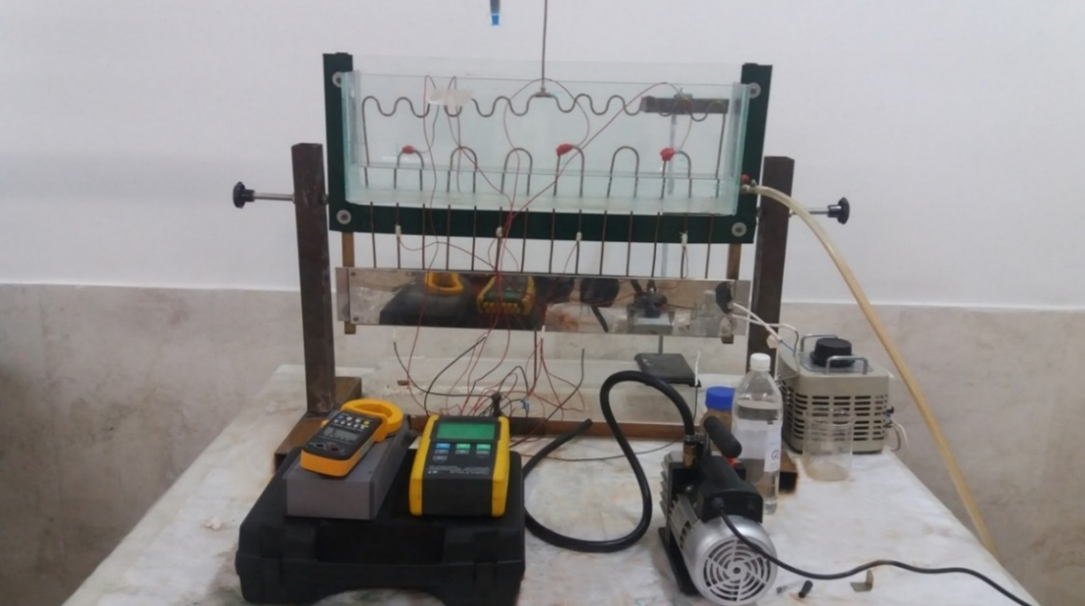
Figure 4: Experimental set-up with three used condensers.
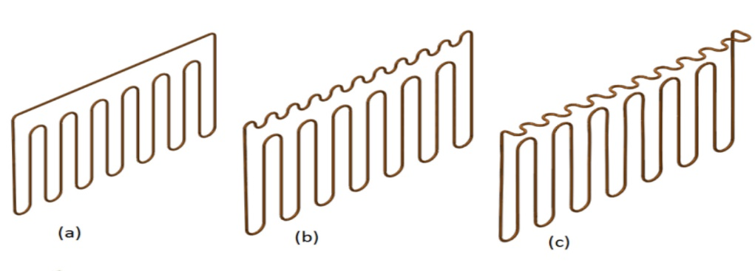
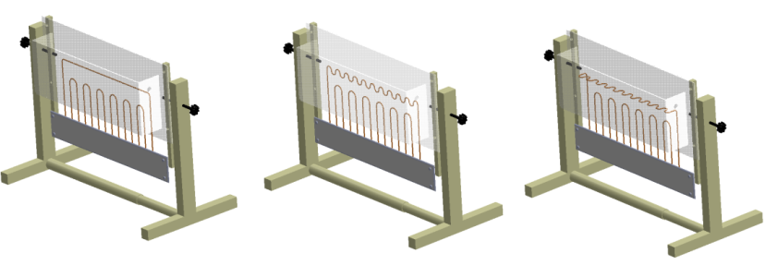
Figure 5: A schematic of an oscillating heat pipe (a) with straight condenser, (b) corrugated vertical condenser (c) corrugated horizontal condenser.
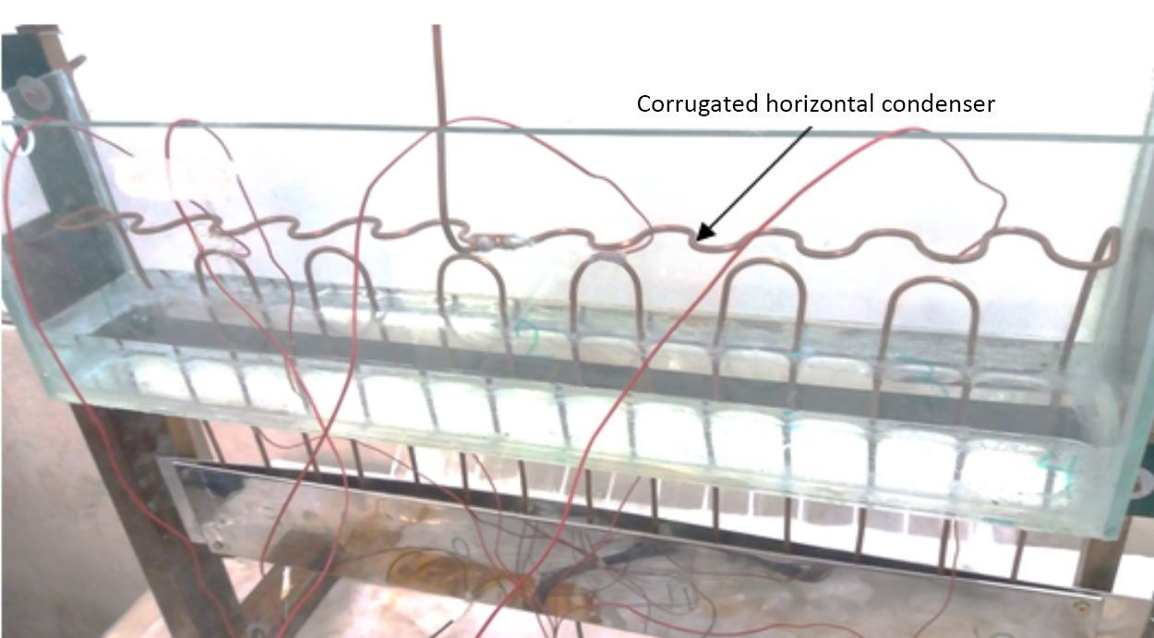
a)
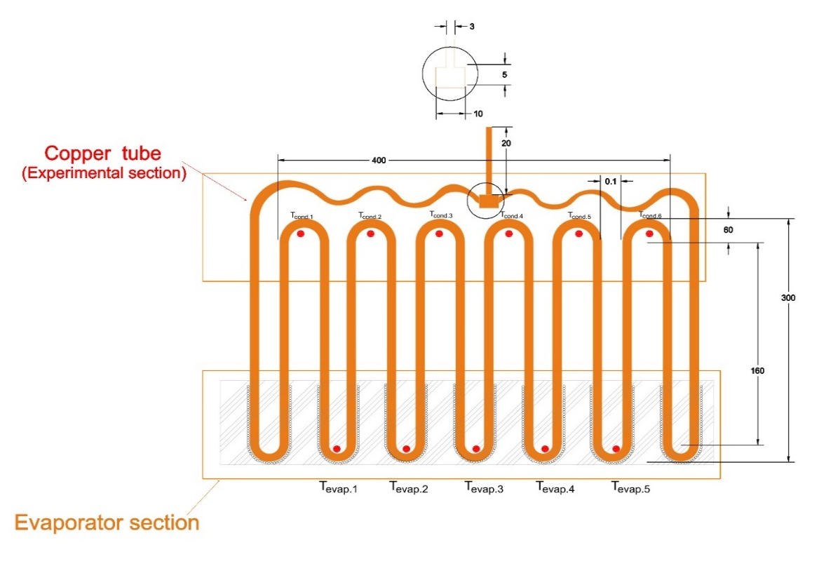
b)
Figure 6: a) Experimental set-up with corrugated horizontal condenser. b) schematic of corrugated horizontal condenser.
The temperature in five points of condenser and evaporator section by the thermometer recorded and temperature of five parts in adiabatic section can be obtained through the following formula as
$P_{in put}=q=VI$ (1)
Voltage (V) and current (I) were the electrical parameters measured in our experiments. The input power, P_{input}, can be calculated, according to Eq 1. The accuracy of the voltage and current readings were 0.1% for both parameters respect to the instruments readings. Plugging the values for V, I, receptivity into Eqs. 1, the maximum uncertainty value for $q$ was calculated to be 6%.
Five thermocouples were placed in evaporator section to measure the average evaporator temperature.
$T_{e}=\frac{T_{e1}+T_{e2}+T_{e3}+T_{e4}+T_{e5}}{5} (2)$ Also five thermocouples were placed in condenser section to measure the average condenser temperature.
$T_{c}=\frac{T_{c1}+T_{c2}+T_{c3}+T_{c4}+T_{c5}}{5} (3)$
Te₁ to Te₅ are the temperatures of different evaporator parts and Tc₁ to Tc₅ are temperatures of the condenser. All these thermocouples were connected to a PC via the data logger so that the temperatures could be recorded and saved in a spreadsheet on the PC. Each experimenting runtime with the oscillating heat pipe takes around 40 minutes and nanofluid at this time is quite stable. Thermal resistance of each stage is achieved by following as:
$R=\frac{ΔT}{Q} (4)$
Where the temperature difference between the evaporator and condenser is $ΔT$ and R shows thermal resistance of the system.
$$R=\frac{1}{hA} (5)$$

In this equation h is the coefficient of total heat transfer and A_{c} is the total surface area. The heat transfer coefficient for three different condensers is calculated by below equation:
$$h_{c}=\frac{q}{A_{c}∆T_{c}} (6)$$

where A_{c} is the condenser area and $∆T_{c}=T_{c,sat}-T_{c,s }$,because the sides of the condenser show higher vapor temperature than the surface temperature due to the direct contact between the surface area of the OHP and the cooling water supplied into the condenser.

The Eq. (7) shows how we calculated the heat transfer coefficient for the evaporator, where $∆T_{e}=T_{e,s}-T_{e,sat }$ is the temperature difference between the evaporator surface temperature and saturated temperature and A_{e} is the evaporator area. In this investigation the evaporator area is constant.
$$h_{e}=\frac{q}{A_{e}∆T_{e}} (7)$$

2. 3 Uncertainties
Based on Holman [59] method, the input power was obtained from the voltage drop. Also, the heat flux and current were computed based on the evaporator’s effective heated area and the input power. The average heat transfer coefficient was computed as follows:
$$\frac{∆Q}{Q}=\sqrt{\left[{\left(\frac{∆V}{V}\right)}^{2}+{\left(\frac{∆I}{I}\right)}^{2}\right]} (8)$$
$$\frac{∆R}{R}=\sqrt{\left[{\left(\frac{∆Q}{Q}\right)}^{2}+{\left(\frac{∆\left(∆T\right)}{∆T}\right)}^{2}\right]} \left(9\right)$$
Variable device accuracy of 0.05 volts and amps 0.001 ampere meter and thermometer device is about 1 °C. The average error for Q were approximately obtained 8.5% and 9.2% for thermal resistance.

3. Results and Discussion
Experimental studies were performed to investigate the thermal performance of three oscillating heat pipes with straight, corrugated vertical and corrugated horizontal condenser operating with heating power input in a range of 0–200 W with water and Fe₃O₄/water with concentration of 2% wt. According to Eq. 4, higher temperature difference means higher thermal resistance.
According to Fig 7 experiment with pure water, thermal resistance for the same heat input in the heat pipe condenser at corrugated horizontal area is lower than other heat pipes. Highest thermal resistance is occurred in heat pipe with vertical corrugated condenser area. It is clear that increasing the thermal resistance reduces heat transfer coefficient of the system.

Figure 7: The effect of condenser shape on heat pipe resistance for input power for CLOHP with water.
The increase of heat load increased the heat transfer coefficient of the condenser for water as shown in Fig 8. As we can see the increase of heat transfer coefficient in corrugated horizontal condenser is much high than straight condenser and vertical corrugated condenser.

Figure 8: Variation of the condensers heat transfer coeﬃcient versus heat load for water.
The effect of using Fe₃O₄/water instead of water can be seen in Fig 9. As we can see lowest thermal resistance belongs to corrugated horizontal condenser. The average reduction of thermal resistance for corrugated horizontal condenser is about 11%.

Figure 9: The effect of condenser shape on heat pipe resistance for input power for CLOHP Fe₃O₄/water.

The increase of heat load increased the heat transfer coeﬃcient of the evaporator for Fe₃O₄/water as shown in Fig 10. As we can see the increase of heat transfer coefficient in corrugated horizontal condenser is much high than straight condenser and vertical corrugated condenser.

Figure10: Variation of the condensers heat transfer coefficient versus heat load for Fe₃O₄/water.
The efficiency changes compared to straight condenser can be shown as:
$η=\frac{{\overline{R}}_{b}-\overline{R}}{{\overline{R}}_{b}}×100\% (10)$
Figure 11 shown the efficiency changes compared to straight condenser with the working fluid of pure water. As we can see the efficiency of corrugated horizontal condenser is better than corrugated vertical condenser.

Figure 11: Efficiency changes towards the straight condenser with the working fluid of pure water.
Figure 12 is shown the efficiency changes compared to straight condenser with the working fluid of Fe₃O₄/water. Also from this figure we can see that the efficiency of corrugated horizontal condenser is much better than corrugated vertical condenser.

Figure 12: Efficiency changes towards the straight condenser with the working fluid of Fe₃O₄/water.
The reason for reducing the thermal resistance as the result higher efficiency for corrugated horizontal condenser can be explained. Because the major thermal resistance on a closed loop oscillating heat pipe caused by the formation of liquid drops at the liquid-solid interface. By using corrugated surface especially horizontal in our case and the presence of nanoparticles the collision between the heating surface and the particles increase, creating more liquid drops and as a result, higher heat transfer coefficients. The corrugated of the horizontal condenser causes the formation of more small liquid drops. This is very good achievement in boiling and to the best of the knowledge of the authors this has not been reported earlier. Maybe, a more acceptable description of the flow near the horizontal surface is shown in Fig 13. The horizontal corrugated surface causes the higher heat transfer coefficient and more droplet of liquids. This is due to the fact that horizontal corrugated surfaces can cause an increase in thermal efficiency and more pressure fluctuations with greater amplitude in the closed loop oscillating heat pipe (CLOHP).
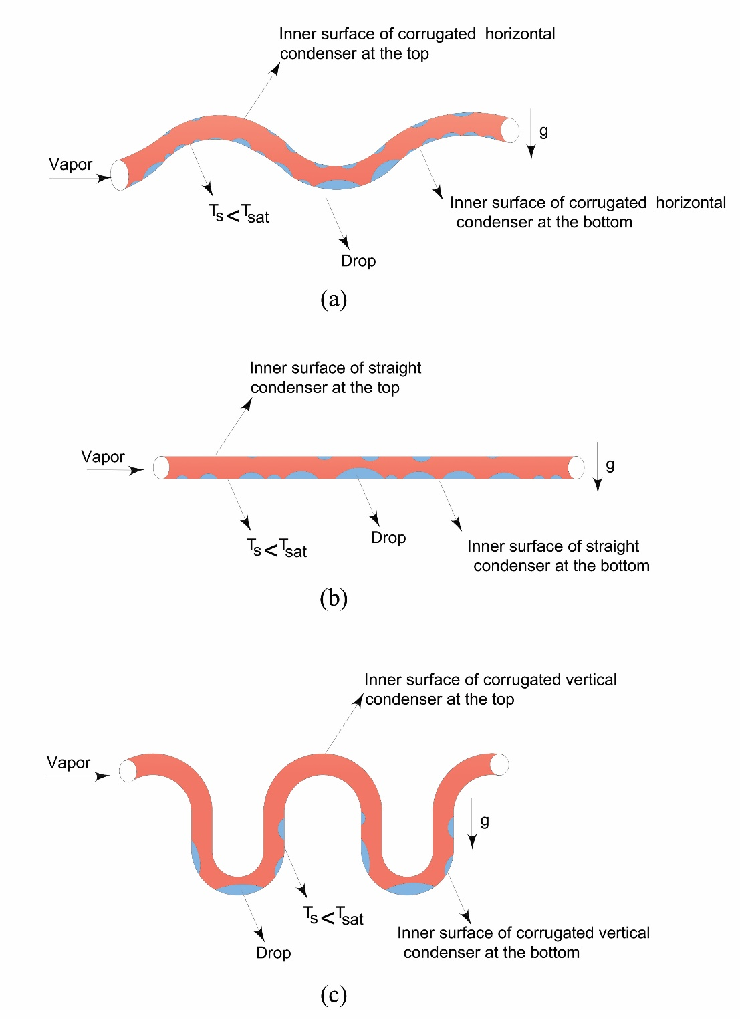
Figure 13: Schematic of the pattern of flow for a) corrugated horizontal condenser b) straight condenser c) corrugated vertical condenser.
4. Conclusions
In this paper, a novel study on the performance of a closed loop oscillating heat pipe (CLOHP) using iron oxide(Fe₃O₄) as the working fluid for three types of condensers is experimented. The followings conclusions have been achieved:
- The heat transfer coefficient of the heat pipe increased when the input heat was increased.
- The experimental results revealed that the thermal performance of the oscillating heat pipe improved when the nano-fluid Fe₃O₄ /water was used as compared to pure water. This improvement could be attributed to the low thermal resistance, indicating that the heat can be transferred from the evaporator to the condenser much better. The average percentage of heat transfer improvement is about 11%.
- The thermal resistance of horizontally corrugated condenser heat pipe decreased compared to straight and vertically corrugated condenser. The result of this is an increase in the efficiency.
- Due to the small size of iron oxide (Fe₃O₄) the Brownian motion of the ferrofluid mainly in the horizontally corrugated condenser creates several active nucleation sites that will improve the heat transfer coefficient.
- By using corrugated cofiguration especially horizontally corrugated and the presence of nanoparticles the collision between the heating surface and the particles increase, creating more drops and as a result, higher heat transfer coefficients. The corrugating of the horizontal condenser causes the formation of more small drop.
g) Oscillating heat pipe with corrugated condenser in horizontal configuration has higher efficiency compare to the heat pipe with straight condenser and much better than vertically corrugated condenser. This is very good achievement and to the best of the knowledge of the authors this has not been reported earlier.

References
1. Akachi H, Polášek F, Štulc P. Pulsating heat pipes, Proc. 5th International Heat Pipe Symposium, Melbourne, Australia. 1996: 208-217.
2. Sun Q, Qu J, Li X, Yuan J. Experimental investigation of thermo-hydrodynamic behavior in a closed loop oscillating heat pipe. Experimental Thermal and Fluid Science, 2017;82: 450-458.
3. Taft BS, Rhodes M. Experimental investigation of oscillating heat pipes under direct current and pulse width modulation heating input conditions. Applied Thermal Engineering. 2017; 126:1018-1022.
4. Qu J, Li X., Cui Y, Wang Q. Design and experimental study on a hybrid flexible oscillating heat pipe, International Journal of Heat and Mass Transfer. 2017; 107: 640-645.
5. Zhao J, Qu J, Rao Z. Experiment investigation on thermal performance of a large-scale oscillating heat pipe with self-rewetting fluid used for thermal energy storage. International Journal of Heat and Mass Transfer. 2017;108: Part A 760-769.
6. Yin D, Wang h, Ma HB, Ji YL. Operation limitation of an oscillating heat pipe. International Journal of Heat and Mass Transfer. 2016; 94:366-372.
7. Hao T, Ma X, Lan, Zhao Y, Ma H. Effects of hydrophilic surface on heat transfer performance and oscillating motion for an oscillating heat pipe, International Journal of Heat and Mass Transfer. 2014; 72: 50-65.
8. Mameli M, Marengo M, Zinna S. Numerical model of a multi-turn closed loop pulsating heat pipe: Effects of the local pressure losses due to meanderings, International Journal of Heat and Mass Transfer. 2012; 55: 1036-1047.
9. Shi W, Pan L. Influence of filling ratio and working fluid thermal properties on starting up and heat transferring performance of closed loop plate oscillating heat pipe with parallel channels. Journal of Thermal Science, 2017;26: 73-81.
10. Patel VM, Gaurav H, Mehta HB. Influence of working fluids on start-up mechanism and thermal performance of a closed loop pulsating heat pipe. Applied Thermal Engineering. 2017; 110: 1568-1577.
11. Tong BY, Wong TN, Ooi KT. Closed-loop pulsating heat pipe, Applied Thermal Engineering. 2001; 21:1845-1862.
12.. Ma HB, Qu W. Theoretical analysis of startup of a pulsating heat pipe, Int. J. Heat Mass Transfer. 2006;50:2309-2316.
13. Ma. HB, Yin D, Rajab H. Theoretical analysis of maximum filling ratio in an oscillating heat pipe. International Journal of Heat and Mass Transfer. 2014; 74: 353-357.
14. Ma H, Peng H, Pai PF. Nonlinear thermomechanical finite-element modeling, analysis and characterization of multi-turn oscillating heat pipes, International Journal of Heat and Mass Transfer. 2014; 69: 424-437.
15. Han H, Cui X, Zhu Yue, Xu T, Sui Y, Sun S. Experimental study on a closed-loop pulsating heat pipe (CLPHP) charged with water-based binary zoetrope and the corresponding pure fluids. Energy.2016; 109:724-736.
16. Xu JL, Li YX., Wong TN. High speed ﬂow visualization of a closed loop pulsating heat pipe. International Journal of Heat Mass Transfer. 2005;48: 3338-3351.
17. Mohammadi M, Taslimifar M, Saidi MH, Shafii MB, Afshin H, Hannani SK, Ferrofluidic open loop pulsating heat pipes: Efficient candidates for thermal management of electronics, Experimental Heat Transfer, 2014; 27: 296-312.
18. Daimaru T, Nagai H, Operational Characteristics of the Oscillating Heat Pipe with Noncondensable Gas. Journal of Thermophysics and Heat Transfer. 2015; 29(3):563-571.
19. Haghayegh S, Mohammadi M, Taslimifar M, Hannani SK, Shafii MB, Saidi M.H., Afshin H. Open-Loop Pulsating Heat Pipes Charged With Magnetic Nanofluids: Powerful Candidates for Future Electronic Coolers, Nanoscale and Microscale Thermophysical Engineering, 2014;18: 18-38.
20. Senjaya R, Inoue T. Oscillating heat pipe simulation considering bubble generation Part I: Presentation of the model and effects of a bubble generation. International Journal of Heat and Mass Transfer, 2013;816–824.
21. Shafii MB, Ahmadi H, Faegh M. Experimental investigation of a novel magnetically variable conductance thermosiphon heat pipe. Applied Thermal Engineering. 2017;126: 1-8.
22. Ebrahimi M, Shafii MB, Bijarchi MA. Experimental investigation of the thermal management of flat-plate closed-loop pulsating heat pipes with interconnecting channels. Applied Thermal Engineering. 2015; 90: 838-847.
23. Mosleh HJ, Bijarchi MA, Shafii MB. Experimental and numerical investigation of using pulsating heat pipes instead of fins in air-cooled heat exchangers. Energy conversion and management. 2019;181: 653-662.
24. Sedighi E, Amarloo A, Shafii MB. Experimental investigation of the thermal characteristics of single-turn pulsating heat pipes with an extra branch. International Journal of Thermal Sciences. 2018; 134: 258-268.
25. Jie Q, Jiateng Z, Zhonghao R. Experimental investigation on the thermal performance of three dimensional oscillating heat pipe. International Journal of Heat and Mass Transfer. 2017; 109: 589-600.
26. Wang J, Li G, Zhu H, Luo J, Sundén B, Experimental investigation on convective heat transfer of ferrofluids inside a pipe under various magnet orientations. International Journal of Heat and Mass Transfer. 2019; 132: 407–419.
27. Ji Y, Liu G, Ma H, Li G, Sun Y. An experimental investigation of heat transfer performance in a polydimethylsiloxane (PDMS) oscillating heat pipe, Applied Thermal Engineering. 2013;61: 690–697.
28. Mehrali M, Sadeghinezhad E, Azizian R, Akhiani AR, Latibari ST, Mehrali M, Metselaar HSC. Eﬀect of nitrogen-doped graphene nanoﬂuid on the thermal performance of the grooved copper heat pipe. Energy Convers. Manag. 2016;118: 459–473.
29. Sadeghinezhad E, Mehrali M, Rosen MA, Akhiani AR, Latibari ST, Mehrali M, Metselaar HC. Experimental investigation of the eﬀect of graphene nanoﬂuids on heat pipe thermal performance, Applied Thermal Engineering. 2016; 100:775–787.
30. Yin D, Rajab H, Ma HB. Theoretical analysis of maximum filling ratio in an oscillating heat pipe. International Journal of Heat and Mass Transfer, 2014;74: 353-357.
31. Yin D, Rajab H, Ma HB. Theoretical analysis of maximum ﬁlling ratio in an oscillating heat pipe. International Journal of Heat Mass Transf. 2014; 74: 353–357.
32. Peng H, Pai PF, Ma H, Nonlinear thermomechanical finite-element modeling, analysis and characterization of multi-turn oscillating heat pipes. International Journal of Heat and Mass Transfer. 2014; 69: 424-437.
33. Peng H, Pai PF, Ma H. Nonlinear thermomechanical ﬁnite-element modeling, analysis and characterization of multi-turn oscillating heat pipes, International Journal of Heat Mass Transf. 2014; 69: 424–437.
34. Goshayeshi HR, Goodarzi M, Safaei MR, Dahari M. Experimental study on the effect of inclination angle on heat transfer enhancement of a ferrofluid in a closed loop oscillating heat pipe under magnetic field, Experimental Thermal and Fluid Science. 2016; 74: 265-270.
35. Yousefi T, Mousavi S, Farahbakhsh B, Saghir M. Experimental investigation on the performance of CPU coolers: Effect of heat pipe inclination angle and the use of nanofluids, Microelectronics Reliability, 2013;53:1954-1961.
36. Yanxi S, Jinliang X, Chaotic behavior of pulsating heat pipes. International Journal of Heat and Mass Transfer. 2009; 52:2932-2941.
37. Mohammadi M, Taslimifar M, Haghayegh S., Hannani S.K, Shafii MB, Saidi MH, Afshin H. Open-loop pulsating heat Pipes charged with magnetic nanofluids: Powerful candidates for future electronic coolers, Nanoscale and Microscale Thermophysical Engineering. 2014;18: 18-38.
38. Taslimifar M, Mohammadi M, Afshin H, Saidi MH, Shafii MB. Overall thermal performance of ferrofluidic open loop pulsating heat pipes: An experimental approach, International Journal of Thermal Sciences, 2013; 65:234-241.
39. Malvandi A, Moshizi S, Ganji D. Effect of magnetic fields on heat convection inside a concentric annulus filled with Al₂O₃–water nanofluid. Advanced Powder Technology. 2014; 25 :1817-1824.
40. Zarei Saleh Abad M, Ebrahimi‐Dehshali M, Bijarchi MA, Shafii MB, Moosavi A. Visualization of pool boiling heat transfer of magnetic nanofluid. Heat Transfer—Asian Res. 2019;1‐14. https://doi.org/10.1002/htj.21498.
41. Reay DA, Kew PA, McGlen RJ, Chapter 6 - Special Types of Heat Pipe, Heat Pipes: Theory, Design and Applications, Butterworth-Heinemann, Oxford, 2014: 135-173.
42. Ji Y, Liu G, Ma H., Li G, Sun Y, An experimental investigation of heat transfer performance in a polydimethylsiloxane (PDMS) oscillating heat pipe. Applied Thermal Engineering.2013; 61:690-697.
43. Sedighi, E, Amarloo A, Shafii B. Numerical and experimental investigation of flat-plate pulsating heat pipes with extra branches in the evaporator section. International Journal of Heat and Mass Transfer. 2018; 126: 431-441.
44. Yang H, Khandekar S, Groll M. Performance characteristics of pulsating heat pipes as integral thermal spreaders, International Journal of Thermal Sciences, 2009; 48:815-824.
45. Mehrali M, Sadeghinezhad E, Azizian R, Akhiani A.R, Latibari ST, Mehrali M, Metselaar HSC. Effect of nitrogen-doped graphene nanofluid on the thermal performance of the grooved copper heat pipe. Energy Conversion and Management. 2016;118 459-473.
46. Li Y, Wang Q, Chen S, Zhao B, Dai Y. Experimental investigation of the characteristics of cryogenic oscillating heat pipe. International Journal of Heat and Mass Transfer. 2014; 79: 713-719.
47. Bandarra Filho EP, Mendoza OSH, Beicker CL.L, Menezes A, D. Wen A. Experimental investigation of a silver nanoparticle-based direct absorption solar thermal system. Energy Conversion and Management. 2014; 84 261-267.
48. Senjaya R, Inoue T. Oscillating heat pipe simulation considering bubble generation Part I: Presentation of the model and effects of a bubble generation. International Journal of Heat and Mass Transfer. 2013;816–824.
49. Sadeghinezhad E, Mehrali M, Rosen MA, Akhiani AR, Latibari ST, Mehrali M, Metselaar HSC. Experimental investigation of the effect of graphene nanofluids on heat pipe thermal performance. Applied Thermal Engineering 2016;100775-787.
50. Hao T, Ma H, Ma X. Heat transfer performance of polytetrafluoroethylene oscillating heat, pipe with water, ethanol, and acetone as working fluids. International Journal of Heat and Mass Transfer. 2019; 131:109–120.
51. Chiang YC, Kuo WC, Ho CC, Chieh JJ. Experimental study on thermal performances of heat pipes for air-conditioning systems influenced by magnetic nanofluids, external fields and micro wicks. International Journal of Refrigeration. 2014; 43: 62-70.
52. Xian H, Xu W, Zhang Y, Du X, Yang Y. Thermal characteristics and flow patterns of oscillating heat pipe with pulse heating. International Journal of Heat and Mass Transfer. 2014; 79: 332-341.
53. Goshayeshi HR, Safaei MR, Goodarzi M, Dahari M. Particle size and type effects on heat transfer enhancement of Ferro- nanofluids in a pulsating heat pipe. Journal of Powder Technology. 2016; 1218-1226.
54. Goshayeshi HR, Izadi F, Bashirnezhad K. Comparison of heat transfer performance on closed pulsating heat pipe for Fe₃O₄ and γFe₂O₃ for achieving an empirical correlation. Physica E:Low-dimensional Systems and Nanostructures. 2017; 89: 43-49.
55. Syam Sunder L, Singh M K, Sousa A. Investigation of thermal conductivity and viscosity of Fe₃O₄ nanofluid for heat transfer application. International Communication in Heat and Mass Transfer. 2013;44: 7-14.
56. Ghasemian M, Najafian Ashrafi Z, Goharkhah M, Ashjaee M. Heat transfer characteristic of Fe₃O₄ ferrofluid flowing flow in a mini channel under constant and alternating magnetic fields. Journal of Magnetism and Magnetic Materials. 2015; 381: 158-167.
56. Selimefendigil, F, Öztop, HF, Al-Salem, K Natural convection of ferrofluids in partially heated square enclosures, Journal of magnetism and magnetic materials 2014;372:122-133.
57. Oztop, HF, Abu-Nada, E. Numerical study of natural convection in partially heated rectangular enclosures filled with nanofluids, International journal of heat and fluid flow 2008;29:1326-1336.
58. Holman J, Heat Transfer. Eighth SI Metric Edition. McGraw-Hill Inc. 2001.

