Synthesis of SnSe quantum dots by successive ionic layer adsorption and
reaction (SILAR) method for efficient solar cells applications
D. Kishore Kumar,^{1,2*} J. Loskot², J. Kříž², N. Bennett,¹ H. M. Upadhyaya³, V. Sadhu⁴, K. R. Reddy^{5*}
¹Energy Conversion Lab (ECL), Institute of Mechanical Process and Energy Engineering (IMPEE), School of Engineering and Physical Sciences, Heriot-Watt University, Riccarton, Edinburgh, EH14 4AS, UK.
²Department of Physics, University of Hradec Králové, Rokitanského 62, 500 03 Hradec Králové, Czech Republic.
³Advanced Materials Centre, School of Engineering, London South Bank University, 103, Borough Road, London- SE10 AA, UK.
⁴School of Engineering, University of Coimbra, 3030-290 Coimbra, Portugal.
⁵School of Chemical and Biomolecular Engineering, The University of Sydney, Sydney, NSW 2006, Australia.

Corresponding authors at: School of Chemical and Biomolecular Engineering, The University of Sydney, Sydney, 2006 NSW, Australia (K. R. Reddy). Department
of Physics, University of Hradec Králové, Rokitanského 62, 500 03 Hradec Králové, Czech Republic (D. Kishore Kumar).
E-mail addresses: nanokishore@gmail.com (D. Kishore Kumar), reddy.chem@gmail.com (K. R. Reddy).
Abstract
Quantum dots (QDs) are one of the promising materials in the development of third-generation photovoltaics. QDs have the advantage of multiple exciton generation (MEG), high absorption coefficient and tuneable bandgap, low cost and easy synthesis. The QDs act as analogues to dye molecules in QD sensitized solar cells (QDSSCs) when compared with traditional dye sensitized solar cells (DSSCs). Extending the absorption range of quantum dots is one of potential solutions for enhancing photoconversion efficiencies. The sensitization of SnSe quantum dots on theTiO₂ mesoporous layers is carried by a successive ionic layer adsorption and reaction (SILAR) method in a glove box. The advantages of SILAR method are a high loading rate and wide coverage of the TiO₂ matrix by the quantum dots. The device has exhibited a photoconversion efficiency of 0.78 % which is the known best among the SnSe quantum dot-based solar cells.
Keywords: Solar cell, SnSe Quantum dots, SILAR method, Photovoltaic efficiency, Sulphide-polysulphide, Light trapping, QDSSC
1. Introduction

Over the last few years, quantum dots (QDs) have attracted widespread attention due to their excellent optoelectronic properties, tunable bandgap and multiple exciton generation. The synthesis of QDs was cheap because of low-temperature processes and a solution-based approach. Being good band-gap absorbers, quantum dots perform better than dyes and molecule absorbers having good stability. To overcome the difficulties of dye molecules, QDs can act as analogue of the dye molecules. The current state of the art for liquid junction quantum dot sensitized solar cells (QDSSC) photoconversion efficiency is 13.85 % with Zn-Cu-In-Se sensitized over TiO₂ matrix. Different methods were reported for sensitization of TiO₂ layers with QDs. Most commonly used methods are chemical bath deposition (CBD), successive ionic layer adsorption and reaction (SILAR), linker assisted and direct adsorption (DA). Among them, the methods which use cadmium and lead are widely studied and have achieved high efficiencies, but these two elements are a source of serious health consequences in human life and this inhibits their usage.
In liquid junction QDSSC, the sulfide /polysulfide redox electrolyte is most favourable due to its stability and better photoconversion efficiencies. The iodide/triiodide redox electrolyte is not useful in QDSSC because of the corrosive nature of iodides towards the quantum dots. The photocorrosion of iodides, inefficient regeneration in polysulfide and the volatile nature of solvents are still ongoing issues to be resolved for QDSSC. In solid-state QDSSC, polymers and inorganic hole transport semiconductor materials such as P3HT, PEDOT: PSS, Spiro-OMeTAD, and CuSCN, have been studied. The photoconversion efficiencies are also dependent on the performance of the counter electrode (CE). Generally, noble metals such as platinum and gold were best choices as the counter electrodes for QDSSCs. For the fabrication of low cost and high-efficiency QDSSCs, carbon, graphene oxide, copper sulphide, cobalt sulphide graphene quantum dots and lead sulphide are good catalysts for both DSSC and QDSSC redox couples. Among them, the copper sulphide exhibits superior efficiencies.¹⁴ However, highly effective catalysts of CEs need to be developed to improve the catalytic activity further, as well as to enhance the performance of the QDSSCs.
QDs can be promising materials for low cost, scalable and efficient solar cells. A tunable bandgap by varying the size and solution processing are the key parameters in the development of quantum dot sensitized solar cells (QDSSCs). The photo quantum yield can be increased by minimizing non-radiative recombinations and increasing the carrier mobility. Currently, metal chalcogenides are getting attention in the research community. Among them, tin selenide (SnSe) is a promising candidate due to its excellent optoelectronic properties and a bandgap of 1.0 eV. SnSe quantum dots find applications in photovoltaic devices, memory switching devices, and infrared devices. We are interested in exploring new materials, such as SnSe, as sensitizers in QDSSCs. These are free from toxic and heavy metals like cadmium and lead, and also abundant and cheap.
In literature, various methods have been reported for the synthesis and sensitization of QDs to the wide bandgap photoanode surface. The QDs sensitisation is categorized into two: in-situ fabrication and attachment of pre-synthesized colloidal QDs. In-situ fabrication methods include chemical bath deposition (CBD) and successive ionic layer adsorption and reaction (SILAR). The only limitation has been the non-uniform size distribution of QDs synthesized via these in-situ methods. The other approach involves attachment of pre-synthesized (colloidal synthesis) QDs on a photoanode surface using molecular linkers or direct adsorption.¹⁸ This method enables precise control of size, but the distribution of QDs decoration on the photoanode is less when compared to in-situ methods. The most efficient cells have been made using these two methods.
Till now, only a few reports on the photovoltaic applications of SnSe QDs have been available. In these reports, SnSe QDs are synthesized by hot-injection, chemical bath deposition , and electro-deposition. The current state of the art for liquid junction SnSe QDs solar cells photoconversion efficiency is 0.33 % and the photoconversion is increased to 1.4 % when the photoanode is made with SnSe films on CdS window layer on ITO substrates.²⁶ The results published in literature are summarized in Table. 1. In this work, we report for the first time the deposition of SnSe quantum dots on TiO₂ by the SILAR technique with Cu₂S as CE, the achieved photoconversion efficiency was 0.55 %.
Table. 1: Photoconversion efficiencies of different SnSe quantum dots sensitized solar cells.
S.No | Structure of cell | V_{oc}(V) | J_{sc}(mA/cm²) | FF % | η % | Electrolyte | Preparation of QDs | ref.
1 | FTO/TiO₂/SnSe/electrolyte/Pt | 0.49 | 0.95 | 71.0 | 0.33 | I⁻/I₃⁻ | Hot injection | ²⁴
2 | FTO/CdS/SnSe/Graphite | 0.22 | 1.70 | 26.0 | 0.1 | - | Chemical bath deposition | ²⁵
3 | ITO/CdS/SnSe/electrolyte/Pt | 0.63 | 6.34 | 34.0 | 1.4 | S²⁻/S_{n}²⁻ | Electro-deposition | 26
4 | ITO/CdS/SnSe/Au | 0.37 | 5.37 | 30.0 | 0.8 | - | Electro-deposition | 26

2. Experimental section

2.1. Preparation of Cu₂S CE electrodes
Brass metal pieces (Good Fellow, UK) were polished with sand paper on both sides until the surface appeared shiny. Then the brass metal pieces were immersed in conc. HCl and heated at 70 °C for 30 min and after cooling washed with DI water and dried. Then a sulfide/polysulfide solution (1-2 drops) was added on them, which turned their surface into black. After that, the films were heated to 80 °C for 2 min. This step was repeated twice to ensure the complete formation of Cu₂S.
2.2. Sulfide - Polysulfide electrolyte
The electrolyte was prepared by adding sulphur powder (12.6 mg), sodium sulphide (95 mg) and potassium chloride (29.8 mg) into 1.4 mL of methanol and 0.6 mL of DI water.
2.3. SnSe QD preparation and device fabrication
Prior to screen printing, the FTO glass substrates were cleaned with soap, Iso-propanol and methanol. The FTO substrates were treated with 40 mM TiCl₄ solution at 80 °C for 30 min. This process was repeated twice. After the TiCl₄ treatment, the FTO substrates were cleaned with DI water and then they were ready for the screen printing. The TiO₂ films of thickness (4 µm + 2 µm) were screen printed using TiO₂ transparent paste (Dye-sol) and with light scattering TiO₂ paste (Dyesol) and annealed at a cycle of temperatures 325 °C for 5 min, 375 °C for 5 min, 450 °C for 15 min, 500 °C for 15 min. After cooling, the TiO₂ films were treated in 40mM TiCl₄ solution for 30 min at 80 °C again. After washing with DI water, the films were subjected to heat treatment at 450 °C for 30 min.
The precursor solution of selenium was prepared as follows. Sodium borohydride (NaBH₄) and selenium dioxide (SeO₂) were added into 30 mL of ethanol to prepare a concentration of 0.3 M and the contents were mixed thoroughly. The solution slowly turned into orange and later it turned into a brownish colour as the stirring continued. After a couple of minutes, the solution turned from the brownish to a blackish colour. Tin precursor solution of concentration 0.3 M was prepared using tin chloride in ethanol. The TiO₂ films deposited on the FTO substrate were immersed in Sn²⁺ precursor solution for 30 sec and then in Se²⁻ precursor solution for 30 sec. Each time, the TiO₂ films were cleaned in ethanol after immersion in each precursor solution. One-time dipping in both precursor solutions is called one SILAR cycle. Nine SILAR cycles were made to ensure the complete distribution of SnSe quantum dots on the TiO₂ films. Finally, the films were dipped in Zn²⁺ and S²⁻ solutions for 2 SILAR cycles to restrict the recombination of excitons through dangling bonds of SnSe. The TiO₂ films sensitized with SnSe QDs were coupled with Cu₂S CE using Surlyn (Solaronix, SA). The sulphide/polysulfide electrolyte was then injected through the hole drilled in the brass substrate. The schematic architecture of the device is shown in Fig. 1
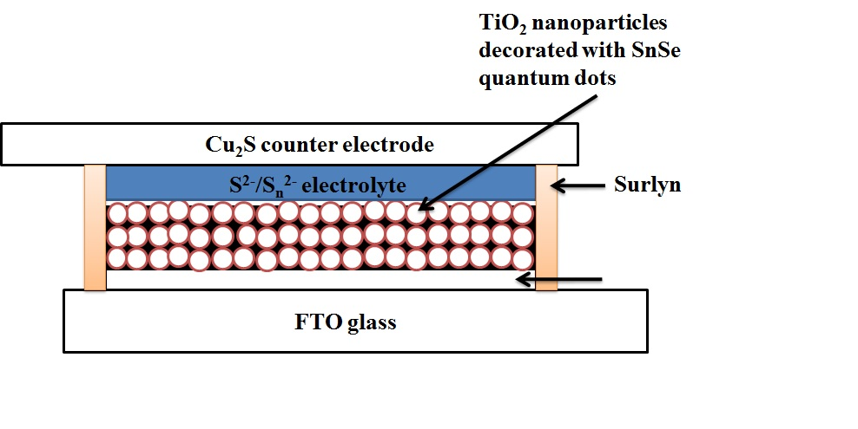
Fig. 1: Schematic representation of SnSe quantum dot sensitized TiO₂ solar cell.
2.4 Working Mechanism
The working principle of a DSSC and a QDSSC is quite similar. Electron-hole pairs are generated when a QD sensitized photoanode is exposed to sun light. electron is excited into the conduction band (CB) of the QD and a hole is created in the valence band (VB). The excited QD injects the electron from the CB of QD into the CB of a wide band gap semiconductor material and is oxidized with the hole remaining in the VB. The injected electron travels through a porous network of the wide bandgap material and reaches the conductive glass. From there it travels through the external load and the electron completes the circuit by diffusing back into the electrolyte through a counter electrode. The generated voltage corresponds to the difference between the quasi-Fermi level of the electron in the photoelectrode and the redox potential of the electrolyte. In the electrolyte, the electron recombines with the hole and restores the oxidized QD to the ground state. The voltage generated is perceived as evidence of the solar energy conversion into electrical energy. The following chemical reactions take place during the oxidation and reduction at the photoelectrode-electrolyte interface.
At anode
S²⁻ + 2h⁺ → S…………………………….. (1)
S + S_{2n}⁻¹ → S_{2n}²⁻………………………...… (2)
and at the counter electrode, S_{2n}²⁻ reduced to S²⁻
S_{2n}²⁻ + 2e⁻ → S_{2n}²⁻ + S²⁻………………...... (3)
The working mechanism of the QDSSC is shown in the Fig. 2.
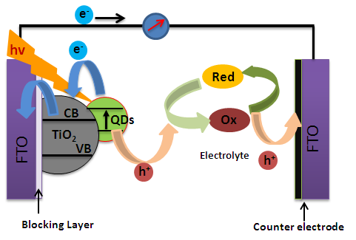
Fig. 2: Schematic representation of a QDSSC.
2.5. Characterization techniques
The crystallinity and phase purity of the SnSe decorated TiO₂ samples were characterized by X-ray diffraction (Bruker D8 Advance diffractometer) using Cu-Kα radiation. The absorption spectra of the SnSe QDs were recorded using XXX. The morphology of the SnSe QDs was investigated using scanning electron microscopy (Hitachi SU8020). Photovoltaic properties were measured by a computer-controlled digital source meter (Keithley 2400) under a simulated one sun illumination at AM 1.5G (100 mW/cm²) from a solar simulator (92250 A, Newport, USA).
3. Results and discussion
3.1. X-ray diffraction spectra of SnSe
Fig. 2: XRD spectra of SnSe quantum dots decorated on the TiO₂ matrix by SILAR method.
The XRD pattern of the SnSe quantum dots decorated on the TiO₂ matrix is shown in Fig. 2. Some of the peaks correspond to signature peaks of the SnSe quantum dots (JCPDS card no. 89-0232, Pnma 62) and in addition to SnSe quantum dots, the XRD pattern also contains the peaks from the TiO₂ (the SnSe QDs are decorated on the TiO₂ matrix) and the FTO (the transparent conductive oxide substrate is denoted with *). The presence of sharp SnSe peaks was observed, this may be due to SnSe decorated on TiO₂ is highly crystalline in nature. Signature peaks of TiO₂ were also evident from XRD patterns. Peaks from unknown phase are denoted with # symbol.
3.2. Optical studies of SnSe QD
The absorption spectra of as prepared SnSe QDs on TiO2 matrix recorded. The absorption was shown in Fig 3. From the spectra, it was evident that the absorption range lies in the visible region.

3.3. SEM analysis of SnSe QD
The morphology of SnSe decorated TiO₂ matrix was subjected to FESEM studies, representative images are presented here. SEM micrographs of the SnSe quantum dots grown with the SILAR technique on the TiO₂ matrix are shown in Fig 4. In the FESEM micrographs, we can observe grains of different shapes and sizes inside the whole film cross-section hence the SILAR method may facilitate the growth of the QD all over the TiO₂ matrix.
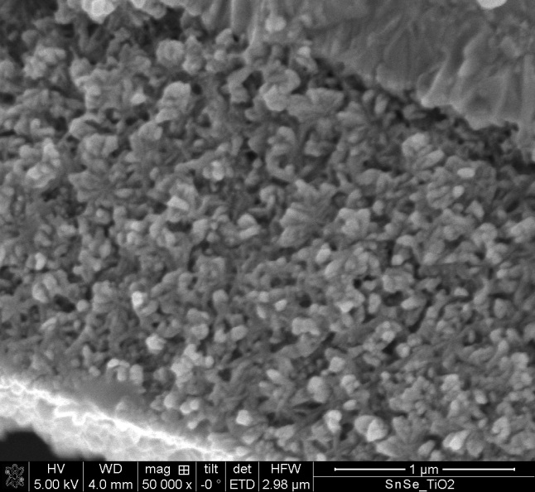
Fig. 4: Cross-sectional SEM micrograph of the SnSe-QD decorated on the TiO₂ matrix.
3.4. J-V characteristics of SnSe based quantum dot solar cell

S.No | Voc (V) | Jsc (mA/cm²) | FF % | η %
1 | 0.61 | 5.83 | 0.2 | 0.75
2 | 0.58 | 4.8 | 0.26 | 0.76
3 | 0.51 | 6.08 | 0.24 | 0.76
4 | 0.57 | 6.94 | 0.19 | 0.78

Fig. 5: J-V characteristics of SnSe sensitized solar cells.
The J-V characteristics of SnSe sensitized solar cell was shown in Fig 4. Respectively. The photoconversion parameters of the best SnSe sensitized solar cells were V_{oc} = 0.57 V, J_{sc} = 6.94 mA/cm², FF = 0.19 % and photoconversion efficiency (η) = 0.78 %. The devices fabricated with the SnSe quantum dots were synthesized with the hot-injection method and exhibited PCE of 0.33 % with V_{oc} = 0.49 V, J_{sc} = 0.95 mA/cm² and FF= 71.0 %. The photovoltaic parameters of the SnSe QD device made from the SILAR method exhibited a higher photoconversion efficiency compared to the hot-injection method because, in the SILAR method, the distribution of quantum dots is higher due to the solution synthesis. On the other hand, quantum dots synthesized by the hot-injection method need linker molecules to anchor the TiO₂ matrix. As a result of this anchoring of QDs with linker molecules, all the TiO₂ nanoparticles can’t be anchored with the linker molecules and the distribution of the quantum dots over the TiO₂ matrix is low.

4. Conclusions
In summary, we have successfully prepared SnSe quantum dots by the SILAR method and fabricated SnSe quantum dots-based solar cells. The device has exhibited a photoconversion efficiency of 0.78 % which is the known best among the SnSe quantum dots-based solar cells. The XRD spectrum reveals that much optimization is needed for the preparation of SnSe quantum dots decoration on a TiO₂ matrix. From the results, it could be concluded that with sophisticated equipment (such as a glovebox for the preparation of SnSe quantum dots on the TiO₂ matrix by the SILAR method which may provide phase pure SnSe quantum dots), the photoconversion parameters might be superior to the existing values.
Acknowledgments
The authors thank the EPRSC-DST APEX consortium grant number EP/H040218/1 and “International mobilities for research activities of the University of Hradec Králové”, CZ.02.2.69/0.0/0.0/16_027/0008487 for the financial support.
Declaration of interests
The authors declare no competing interests.

References

R. Vogel, K. Pohl. H. Weller. Sensitization of highly porous, polycrystalline TiO₂ electrodes by quantum sized CdS, Chemical Physics Letters, 174 (1990) 241-246.
S. Maiti, F. Azlan, Y. Jadhav, J. Dana, P. Anand, S. K. Haram, G. R. Dey, H. N. Ghosh, Efficient charge transport in surface engineered TiO₂ nanoparticulate photoanodes leading to improved performance in quantum dot sensitized solar cells, Solar Energy 181 (2019) 195-202.
L-Y. Chang, R. R. Lunt, P. R. Brown, V. Bulović, and M. G. Bawendi, Low-Temperature Solution-Processed Solar Cells Based on PbS Colloidal Quantum Dot/CdS Heterojunctions, Nano Letters, 13 (2013) 994-999.
H. Zhang, W. Fang, W. Wang, N. Qian, X. Ji, Highly Efficient Zn-Cu-In-Se Quantum Dot Sensitized Solar Cells through Surface Capping with Ascorbic Acid, ACS Applied and Materials Interfaces, 11 (2019) 76927-6936.
X. Song, Z. Liu, T. Tian, Z. Ma, Y. Yan. X. Li, X. Dong, Y. Wang, C. Xia, Lead sulfide films synthesized by microwave-assisted chemical bath deposition method as efficient counter electrodes for CdS/CdSe sensitized ZnO nanorod solar cells, Solar Energy, 177 (2019) 672-678.
D. H. Phuc, H. T. Tung, Quantum dot sensitized solar cell based on the different photoelectrodes for the enhanced performance, Solar Energy Materials and Solar Cells, 196 (2019) 78–83.
S. Higashimoto, T. Nakase, S. Mukai, M. Takahashi, Copper-indium-sulfide colloids on quantum dot sensitized TiO2 solar cell: Effects of capping with mercapto-acid linker molecules, Journal of Colloid and Interface Science, 535 (2019) 176–181.
K. Lv, C. Shi, C. Ma, Q. Wang, W. Chen, Introduction of polysulfide anions to increase the loading quantity of PbS quantum-dots for efficient solid-state quantum-dot sensitized TiO₂ nanorod array solar cells, Journal of Nanoparticle Research, 21 (2019) 2.
K. Gopinath, R. K. Balasubramanayam, D. K. Kumar, K. R. Reddy, et al. Novel anisotropic ordered polymeric materials based on metallopolymer precursors as dye sensitized solar cells, Chemical Engineering Journal 358 (2019) 1166-1175.
S. Dowland, T. Lutz, A. Ward, S. P. King, A. Sudlow, M. S. Hill, K. C. Molloy, S. A. Haque, Direct Growth of Metal Sulfide Nanoparticle Networks in Solid‐State Polymer Films for Hybrid Inorganic–Organic Solar Cells, Advanced Materials, 23 (2011) 2739-2744.
C. Ma, C. Shi, K. Lv, C. Ying, S. Fan, Y. Yang, Gradient-band-gap strategy for efficient solid-state PbS quantum-dot sensitized solar cells, Nanoscale, 11 (2019) 8402-8407
Y. Itzhaik, O. Niitsoo, M. Page, G. Hodes, Sb₂S₃-Sensitized Nanoporous TiO₂ Solar Cells, Journal of Physical Chemistry C, 113 (2009) 4254-4256.
A. Kaniyoor, S. Ramaprabhu, Gold Nanoparticle Decorated Multi-Walled Carbon Nanotubes as Counter Electrode for Dye Sensitized Solar Cells, Journal of Nanoscience and Nanotechnology, 12 (2012) 8323-8329 & C. J. Raj, K. Prabakar, A. D. Savariraj, H-J. Kim, Surface reinforced platinum counter electrode for quantum dots sensitized solar cells, Electrochimica Acta, 103 (2013) 231-236.
V. Ramar, S. Moothattu, K. Balasubramanian, Metal free, sunlight and white light based photocatalysis using carbon quantum dots from Citrus grandis: A green way to remove pollution, Solar Energy 169 (2018) 120-127.
K. Mohan, A. Bora, R. S. Roy, B. C. Nath, S. K. Dolui, Polyaniline nanotube/reduced graphene oxide aerogel as efficient counter electrode for quasi solid state dye sensitized solar cell, Solar Energy 186 (2019) 360-369.
W. Wang, L. Zhao, Y. Wang, W. Xue, F. He, Y. Xie, Y. Li, Facile Secondary Deposition for Improving Quantum Dot Loading in Fabricating Quantum Dot Solar Cells, Journal of American Chemical Society, 141 (2019) 4300-4307.
D. Punnoose, H-J. Kim, S. Srinivasa Rao, CH.S.S. Pavan Kumar, Cobalt sulfide counter electrode using hydrothermal method for quantum dot-sensitized solar cells, Journal of Electroanalytical Chemistry, 750 (2015) 19-26.
D Kishore Kumar, Damaris Suazo-Davila, Desiree García-Torres, Nathan P Cook, Aruna Ivaturi, Min-Hung Hsu, Angel A Martí, Carlos R Cabrera, Baixin Chen, Nick Bennett, Hari M Upadhyaya, Low-temperature titania-graphene quantum dots paste for flexible dye-sensitised solar cell applications, Electrochimica Acta, 305 (2019) 278-284.
Z. Tachan, M. Shalom, I. Hod, S. Rühle, S. Tirosh, and A. Zaban, PbS as a Highly Catalytic Counter Electrode for Polysulfide-Based Quantum Dot Solar Cells, Journal of Physical Chemistry C, 115 (2011) 6162.
D. K. Kumar, S. R. Popuri, O. R. Onuoha, J-W. Bos, B. Chen, N. Bennett, and H. M. Upadhyaya, Screen printed tin selenide films used as the counter electrodes in dye sensitized solar cells, Solar Energy, 190 (2019) 28-33.
C. P. A. Vermeulen, D. T. Yimam, M. A. Loi, B. J. Kooi, Multilevel reflectance switching of ultrathin phase-change films, Journal of Applied Physics 125 (2019) 193105.
A. C. Bernardes-Silva, A. F. Mesquita, E. de Moura Neto, A. O. Porto, G. M. de Lima, J. D. Ardisson, Tin selenide synthesized by a chemical route: the effect of the annealing conditions in the obtained phase, Solid State Communications, 135 (2011) 677-682.
S. Ruhle, M. Shalom, A. Zaban, Quantum‐Dot‐Sensitized Solar Cells, ChemPhysChem, 11 (2010) 2290-2304.
X-F. Gao, H-B. Li, W-T. Sun, Q. Chen, F-Q. Tang, L-M. Peng, CdTe Quantum Dots-Sensitized TiO₂ Nanotube Array Photoelectrodes, Journal of Physical Chemistry C, 113 (2009) 7531-7535.
L. Ling, Q. Zhang, L. Zhu, C-F. Wang, S. Chen, Interfacial synthesis of SnSe quantum dots for sensitized solar cells, RSC Advances, 5 (2015) 2155-2158.
E. Barrios-Salgado, M. T. S. Nair, P. K. Nair, Chemically Deposited SnSe Thin Films: Thermal Stability and Solar Cell Application, ECS Journal of Solid State Science and Technology, 3 (2014) Q169.
D. V. Shinde, S-K. Min, M-M. Sung, N. K. Shrestha, R. S. Mane, S-H. Han, Photovoltaic properties of nanocrystalline SnSe–CdS, Materials Letters, 115 (2014) 244-247.

