Thermal Enhancement of Solid Desiccant Packed Bed Dehumidifier Under Forced Convection in Subsonic Flow Regime
Yeboah S. K¹. and Darkwa J².
The University of Nottingham Ningbo China
Ningbo 315100, Zhejiang Province
P. R China¹

The University of Nottingham,
University Park, Nottingham,
NG7 2RD, UK²

A theoretical study on an alternative technique of extensively filling sections of packed beds for thermal enhancement has been carried out. Three packed beds of solid desiccants with different configurations but similar material properties were used for this investigation. The beds were modelled and simulated under forced convection in subsonic flow regime using porous media model with energy and transport equations solved under local thermal equilibrium conditions in ANSYS Fluent. The results show that the presence of clear fluid sections within porous media significantly reduces the overall bed temperature. It is also observed that narrowing the clear fluid sections between porous inserts impacts on the bed flow behaviour and thermal enhancement although it is found to cause considerable pressure drop.

Keywords: Heat Transfer, Porous Media, Thermal Enhancement, Computational Fluid Dynamics

Nomenclature

- $c_{p}$ –specific heat capacity (J/kg-K)
- $d_{p}$ – particle diameter (m)
- $E_{f}$– total fluid energy (J)
- $E_{s}$– total solid medium energy (J)
- $h$ -convective heat transfer coefficient (W / m²K )
- $h_{f}$- the fluid-side local heat transfer coefficient (W / m²K )
- $k_{eff}$ – effective thermal conductivity of the medium
- $k_{f}$ – fluid thermal conductivity (W/m K)
- $k_{s}$- solid thermal conductivity (W/m K)
- L – length of the bed (m)
- $∆p$ – pressure drop (Pa)
- $p_{s}$ – static pressure (Pa)
- $p_{o}$ – total pressure (Pa)
- $p_{op}$ – Operating pressure (Pa)
- n - the local coordinate normal to the wall
- q_{rad} - the radiative heat flux (W/m²)
- R - the universal gas constant
- Re - Reynolds number
- $S_{f}^{h}$- fluid enthalpy source term
- T - the temperature (K)
- T_{f} - the local fluid temperature (K)
- T_{w} - the wall surface temperature (K)
- $u$ – velocity (m/s)
Greek Letters
- ε – porosity of the medium
- $ε_{p}$-particle emissivity (dimensionless)
- $σ$ -Stefan-Boltzmann constant (5.67 x −8 W/ m²K4)
- $ρ_{f}$– fluid density
- $ρ_{s}$– solid medium density
- $ρ_{p}$ is the density of the particle
- μ - the molecular viscosity of the fluid

- γ - the ratio of specific heats $\left(c_{p}/c_{v}\right)$
- $\overline{τ}$ - Tortuosity, characteristic of pore structure

¹Assistant Professor, Centre for Sustainable Energy Technologies (CSET), 199 Taikang East Road Ningbo siegfried.yeboah@nottingham.edu.cn
²Professor, Department of Architecture and Built Environment, University Park, Nottingham, J.Darkwa@nottingham.ac.uk

introduction

A major portion of the energy used in dehumidification by physical adsorption takes place during regeneration and subsequent cooling of the solid desiccant to reduce it surface vapour pressure. Physical adsorption of water vapour by solid desiccants is spontaneous and exothermic releasing the heat of adsorption. This heat released significantly increases the surface vapour pressure of the solid desiccant particles and for packed beds the bed temperature, resulting in a reduced bed adsorption capacity. The reduced bed adsorption capacity leads to a change in the exit process airstream humidity ratio and also the cooling load requirement of the packed bed dehumidification system. As a consequence, a higher regeneration temperature is then required for desorption as the heat of adsorption released does not make the adsorption process isothermal ¹⁻⁶.
Packed beds are the simplest of the solid desiccant dehumidification system configurations. They are typically cylindrical vessels with adsorbent particles in a fixed and closely but randomly packed arrangement for fluid-solid contact ⁷. Hence local velocity distribution within them are crucial to their overall performance in terms of pressure drop, residence time distribution, heat and mass transfer ^{8, 9}. The heat and mass transfer are critical processes and occur simultaneously under the influence of temperature gradient existing radially in the beds. Adsorption fundamentally involves the simultaneous heat and mass transfer coupled with the equilibrium properties of the solid desiccant of which thermal energy is generated as a consequence of the mass transfer ^{10, 11}.

In-situ management of the heat transfer within packed beds has been extensively studied and it is seen as a means of improving the adsorption process. Several authors including Rady et al ², Meljac et al ¹², Rady ¹³ and Ramzy et al ¹⁴ have used a number of approaches including the investigation and testing of packed beds with a small tube to particle diameter ratio aimed at dissipating the heat via the walls of the bed, the embedding of cooling coils within the adsorbent beds to remove the heat and the integration with inert particles such as phase change materials (PCMs) to act as heat sinks. Though some levels of success were achieved significant limitations were also encountered. For instance the melting of the PCM when the packed bed temperature started increasing, the increased level of channelling (wall) effects when the tube to particle diameter ratio is small and the increased pressure drop when other elements were introduced in the bed.

With the limitations associated with the in-situ heat transfer management approaches cited above, it is necessary that other options are explored to identify possible efficient alternatives to enhancing packed bed heat transfer. A cylindrical vessel packed with solid desiccant particles typically represents a simple case of a pipe with porous media insert ¹⁵. Several studies ¹⁶ ⁻ ²¹ have shown that partially ﬁlling a duct with porous media enhances the heat transfer per unit pressure gradient with the Nusselt number increase an indicator of thermal enhancement. For a partially filled duct with porous media, forced convection is found to potentially enhance the heat transfer rate with the pressure drop much less than that of a duct fully filled with porous media^{19, 20}. Forced convection greatly augments the heat transfer process due to the presence of the particles with the local and average heat transfer coefficients increasing with increasing Reynolds number, particle diameter and particle thermal conductivity ²³. The variation in fluid velocity about the mean velocity in porous media causes thermal dispersion, the heat spreading phenomenon comprised of both molecular diffusion and spatial velocity deviations from the average Darcy velocities at the pore scale. This is a very important characteristic of the flow in porous media and one of the main reasons for the enhanced heat transfer ²⁴ ⁻²⁸.

Usually for adsorption packed beds, extensive filling is carried out in order to maximise the fluid-solid interaction for the adsorption process to be effective. From the perspective of thermal enhancement, this is found to block the fluid particles channelling through the small gap formed between the wall and the porous core interface ¹⁷. Mahmoudi and Karimi ¹⁹ found that once a tube is fully filled with porous media the temperature difference between the two phases reaches its maximum value with the temperature difference between the solid and fluid phases independent of Darcy number. Here an increasing Darcy number is shown to lead to lower values of Nusselt number ^{21.} However, generally for porous inserts, boundary conditions at the interface between the porous domain and adjacent clear fluid is crucial regarding heat and mass transport and also in the development of accurate porous media models ^{29,30}.

The level of fluid–solid interaction required for effective water vapour adsorption in dehumidification packed beds makes the partial filling approach cited above not feasible as an enhancement technique. This is because in most of the studies the approach was largely characteristic of the undesirable wall effect which implies low fluid-solid contact in those local areas ⁹. To this end, and on the basis of the crucial heat and mass transport condition at the interface between porous domain and adjacent clear fluid section, we investigate an alternative technique of extensively filling sections of packed beds and its capacity to thermally enhance the heat transfer process. In the present study, we approach this investigation by using three solid desiccant packed beds of different configurations. Two of the beds are segmented to create clear fluid sections where the influence of the domain interface and clear fluid sections can be observed whilst the other bed is fully packed to act as a control model. Each of the segmented beds has two clear fluid sections. The clear fluid sections of one bed are formed into a narrow throat and that for the other formed into a uniform throat of similar diameter as the porous insert. This is to enable the investigation of the influence of the clear fluid section diameter and the general bed configuration on thermal enhancement and airflow dynamics. A porous media model with the energy equation solved under local thermal equilibrium in ANSYS Fluent is used. For simplicity, water vapour adsorption to indicate dehumidification is ignored with only the thermal effects and airflow dynamics through the beds considered.

Physical Models

Description

The three packed beds are described as fully packed bed, uniform throat bed and narrow throat bed. 2D wire frame geometry of three packed bed models sketched using Rhinoceros 5 is shown in Figures 1, 2 and 3. The beds were designed to have packed sections of porous media diameter 8cm. The inlets and outlets diameters are 4cm respectively. Each bed has an inlet and outlet length of 15cm connected to reducers of angle 158.20° to the horizontal.

The fully packed in Figure 1 has a total length of 85cm, 45 cm of which is the total length of the porous media insert.

Figure 1 Physical models of the fully packed bed
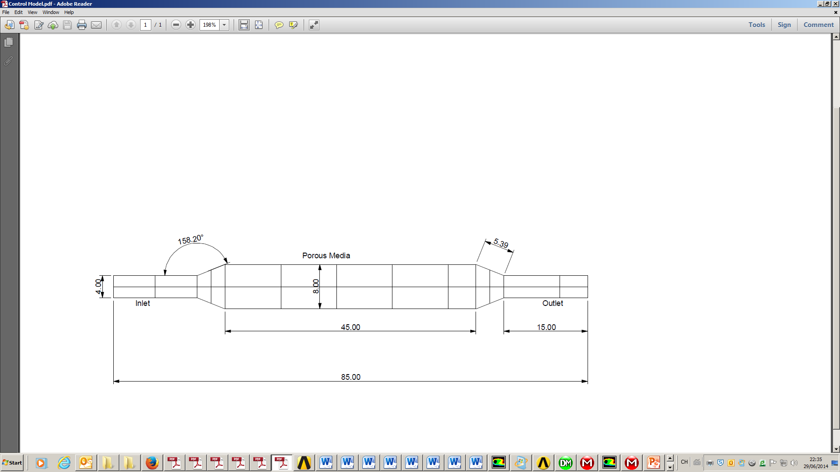
Figure 2 shows the physical model of the uniform throat bed having a total length of 105cm. It also has 3 porous inserts 10cm apart. The diameter of the porous inserts and the clear fluid sections are 8cm. The thicknesses of the porous inserts are 15cm each. The inlet and outlet are each 15cm long with respective diameters of 4cm.

Figure 2 Physical models of the Segmented Packed Bed with Uniform Throat Diameter
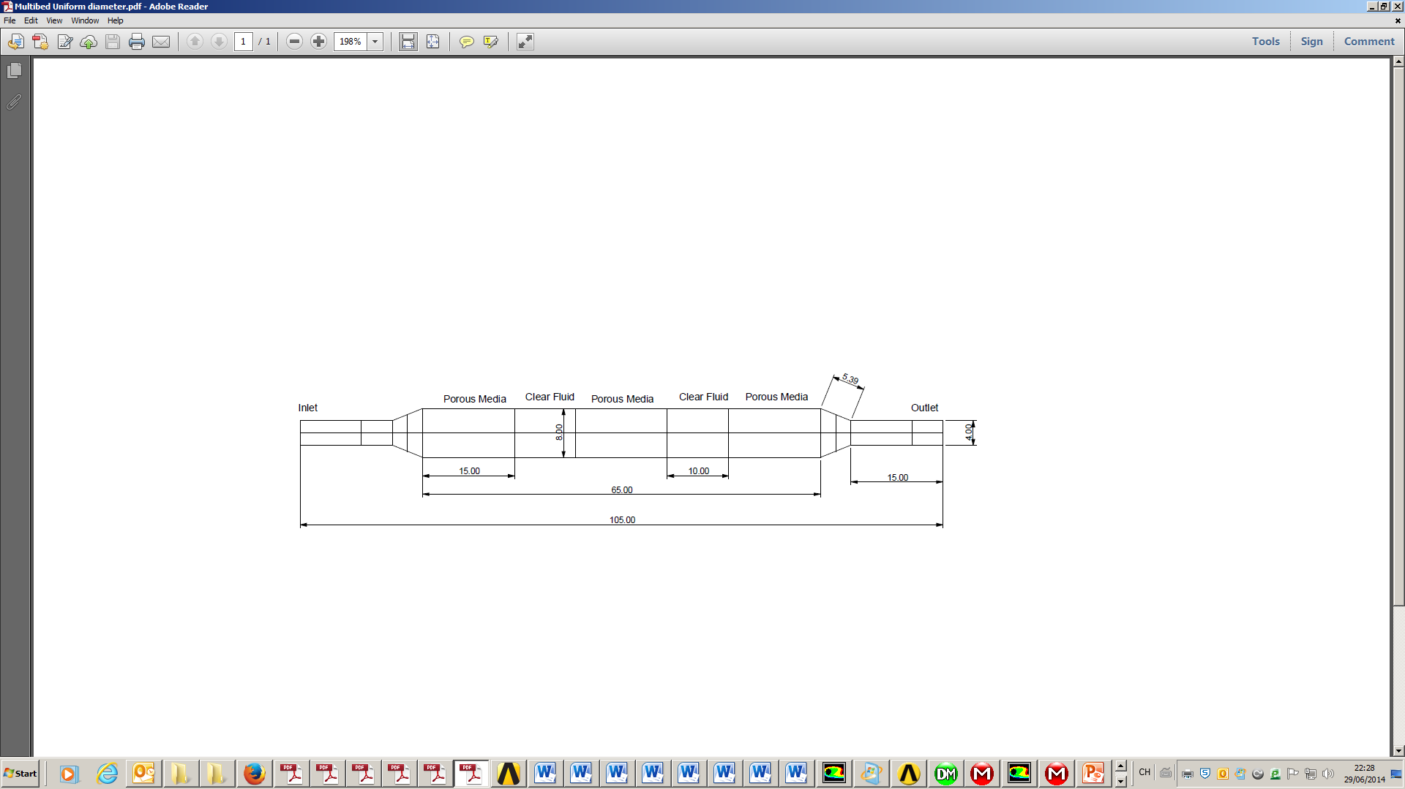

Figure 3 shows the physical model of the narrow throat bed having a total length 125cm. It has 3 porous inserts each of thickness 15cm and diameter 8cm. Each clear fluid section between porous inserts has a diameter of 4cm and horizontal length of 10cm connected to reducers of angle 158.20° to the horizontal. Each reducer has an inclined length of about 5.39cm and horizontal length of 5cm making the total clear fluid distance between porous inserts 20cm.

Figure 3 Physical models of the Segmented Packed Bed with Narrow Throat Diameter
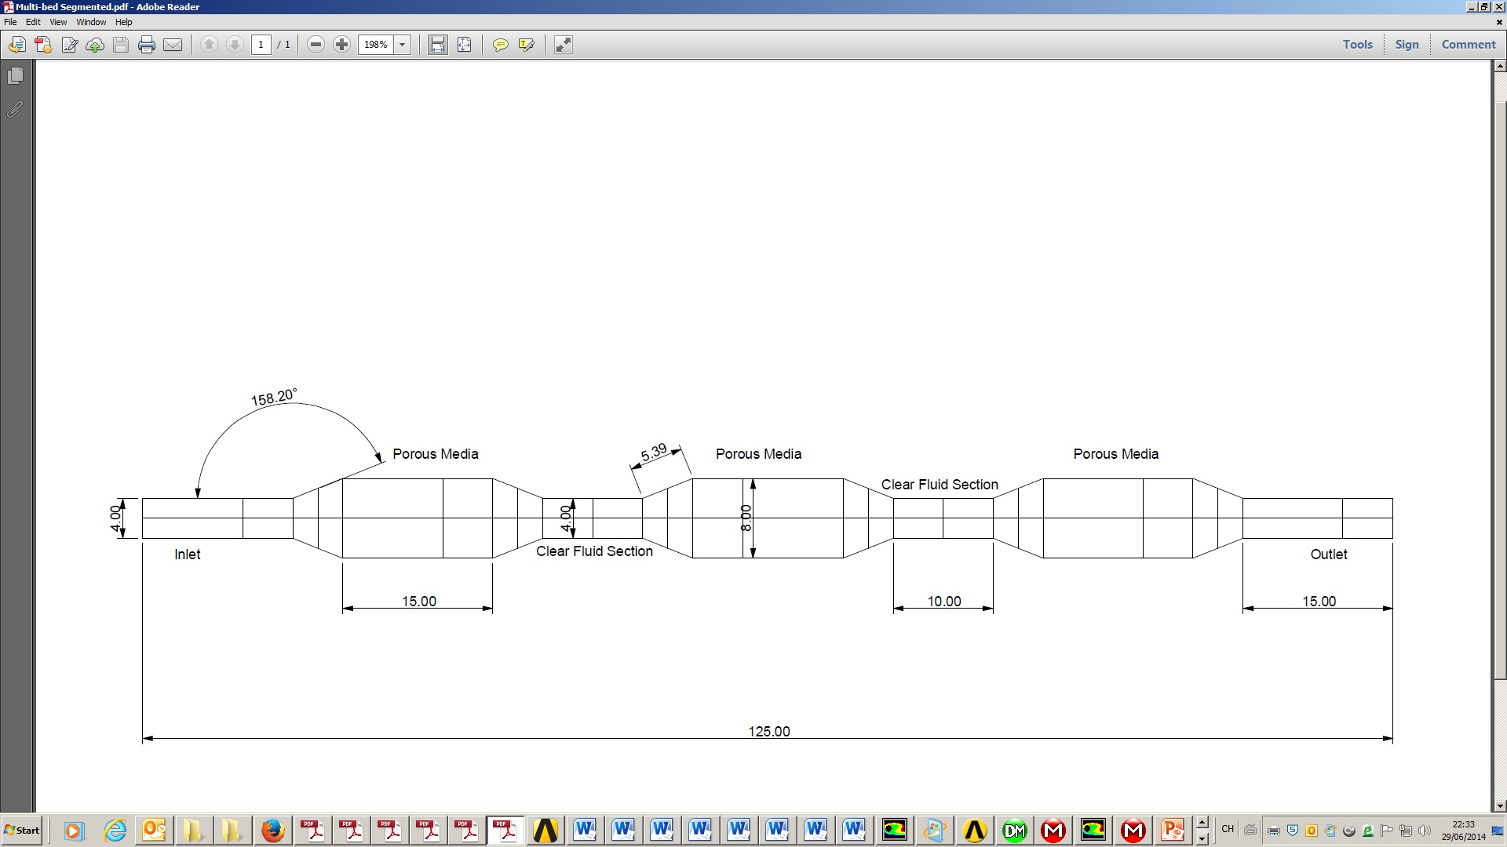

Mathematical Models

Porous Media Model

ANSYS Fluent defines the inertial resistance (C₂) in the porous media in units of 1/m as: $C_{2}=\frac{3.5}{d_{p}}\frac{\left(1-ε\right)}{ε^{3}}$ (1)
The permeability coefficient (α) in m² is determined by: $α=\frac{d_{p}^{2}}{150}\frac{ε^{3}}{{\left(1-ε\right)}^{2}}$ (2)
The viscous coefficient therefore becomes $\frac{1}{α}$ (3)
The pressure drop is determined from the Ergun equation as follows:
$\frac{\left|∆p\right|}{L}=\frac{150μ}{d_{p}^{2}}\frac{{\left(1-ε\right)}^{2}}{ε^{3}}v_{∞}+\frac{1.75ρ}{d_{p}}\frac{\left(1-ε\right)}{ε^{3}}v_{∞}^{2}$ (4)
In porous media ANSYS Fluent solves standard energy transport equations with modifications to the conduction flux and transport terms only. The thermal equilibrium model applies an effective conductivity term as follows:
$\frac{∂}{∂t}\left({ερ}_{f}E_{f}+\left(1-ε\right)ρ_{s}E_{s}\right)+∇.\left(\vec{u}\left(ρ_{f}E_{f}+p\right)\right)=S_{f}^{h}+∇.\left[k_{eff}∇T-\left(\sum_{i}{h_{i}j_{i}}\right)+\left(\overline{τ}.\vec{u}\right)\right]$ (5)
For the thermal equilibrium model, ANSYS Fluent computes the effective thermal conductivity in the porous media as follows:
$k_{eff}=εk_{f}+\left(1-ε\right)k_{s}$ (6)

Porous Media Volumetric Sources

ANSYS Fluent allows the specification of the following volumetric sources in the porous zone
For mass sources $\frac{\dot{m}}{V}=\frac{ρ_{j}A_{j}v_{j}}{V}$ (7)
For momentum source $\frac{\dot{m}v}{V}=\frac{{\dot{m}v}_{j}}{V}$ (8)
The energy source $\frac{∂}{∂t}\left(ρE\right)+∇.\left(\vec{v}\left(ρE+p\right)\right)=∇.\left(k_{eff}∇T-\left(\sum_{j}{h_{j}{\vec{j}}_{j}}\right)+\left({\overset{̿}{τ}}_{eff}.\vec{v}\right)\right)+S_{h}$ (9)
$E=h-\frac{p}{ρ}+\frac{v^{2}}{2}$ (10)

Boundary Conditions

The mass flow rate entering a fluid cell adjacent to a velocity inlet boundary is computed in ANSYS Fluent as:
$\dot{m}=\int{ρ\vec{u}}.d\vec{A}$ (11)

The estimation of the inlet distributions for k and ε terms was obtained from the turbulent intensity, I and characteristic length scale, L ²⁷: $k=\frac{3}{2}{\left(u_{avg}I\right)}^{2}$ (12)

The turbulent intensity I is the average root mean square velocity divided by a reference mean flow velocity $u_{avg}$ linked to the turbulent kinetic energy k 27by:
$I=\frac{{\left(\frac{2}{3}k\right)}^{1/2}}{u_{avg}} typical range 1\%<I<10\%$ (13)
$ε=C_{μ}^{3/4}\frac{k^{3/2}}{l}$ (14)

Turbulent length scale, $l=0.07L$. Hydraulic diameter D_{h} was determined from $l=0.07D_{h}$
ANSYS Fluent defines turbulence intensity, as the ratio of the root-mean-square of the velocity fluctuations, $u^{'}$to the mean flow velocity, $u_{avg}$ ²⁸.
$I≡\frac{u^{'}}{u_{avg}}=0.16 {\left(ReD_{h}\right)}^{{-1}/8}$ (15)

For compressible fluid with constant c_{p} ANSYS Fluent defines the total pressure as:
$p_{o}=p_{s}{\left(1+\frac{γ-1}{2}M^{2}\right)}^{γ/{γ-1}}$ (16)

Where the Mach number (M) for compressible flows is: $M=u/c$ (17)

And the speed of sound: $c=\sqrt{γRT}$ (18)

For compressible flows, ANSYS Fluent applies isentropic relations for an ideal gas to relate total pressure, static pressure,$p_{s}$, and velocity at a pressure inlet boundary. The density at the inlet plane is defined by the ideal gas law in the form ²⁸.

$ρ=\frac{p_{s}+p_{op}}{RT_{s}}$ (19)

However in this study, due to the low Mach numbers for the flow, the fluid was treated as an incompressible flow.
At the walls the thickness, material type and temperature were specified. By specifying a fixed temperature condition at the wall, ANSYS Fluent computes the heat flux to the wall from a fluid cell as:

$q=h_{f}\left(T_{w}-T_{f}\right)+q_{rad}$ (20)

For laminar flows, ANSYS Fluent computes the fluid side heat transfer at walls using Fourier’s law in its discrete form:

$q=k_{f}{\left(\frac{∂T}{∂n}\right)}_{wall}$ (21)

Methodology

Decomposition And Meshing

The physical models were generated in Rhinoceros 5 and imported into ANSYS Workbench Design Modeler as 3D solid models which were then decomposed to generate the porous sections and clear fluid sections (See Figure 4). The generated models were then automatically meshed in ANSYS R15.0 Workbench Meshing platform where relevant sections and bodies were named for recognition by the ANSYS Fluent solver.
Figure 4 Decomposed 3D Geometry Models
- Fully packed bed | - Uniform throat bed | - Narrow throat bed
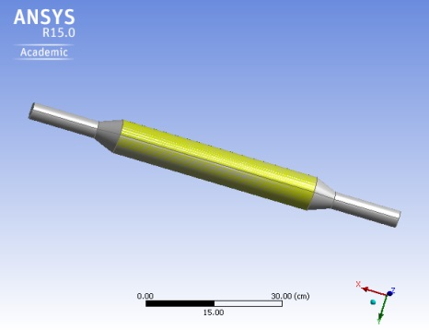 | 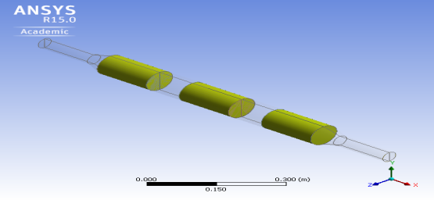 | 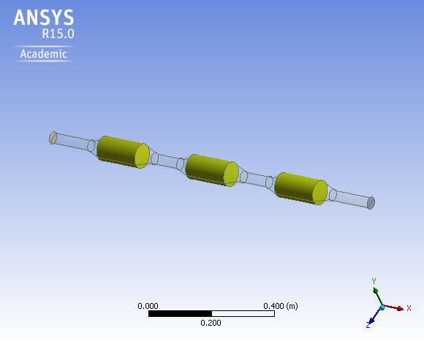

Materials

The packed bed vessels were of copper of thickness 0.001m. The packing material was silica gel with constant porosity of 0.63. The fluid flowing through the beds was air. Tables 1, 2 and 3 present their thermal properties.

Table 1 Thermal Properties of silica-gel (solid)
Property | Units | Value
Density | kg/m³ | 670
Specific Heat Capacity | J/kg-k | 880
Thermal Conductivity | W/m-k | 0.198

Table 2 Thermal Properties of copper (solid)
Property | Units | Value
Density | kg/m³ | 8978
Specific Heat Capacity | J/kg-k | 381
Thermal Conductivity | W/m-k | 387.60001

Table 3 Thermal Properties of air (fluid)
Property | Units | Value
Density | kg/m³ | 1.225
Specific Heat Capacity | J/kg-k | 1006.43
Thermal Conductivity | W/m-k | 0.0242
Viscosity | kg/m-s | 1.7894e-05
Molecular Weight | kg/kgmol | 28.966
Thermal Expansion Coefficient | 1/k | 0

Simulation Method

The three packed beds with the same porosity and thermophysical properties were modelled and simulated using the porous media model in ANSYS Fluent R15.0.The principal aim was to determine the thermal enhancement capacity of extensively filling sections of a packed bed and also the configuration that best augments the heat transfer process as a result of the influence of the porous media domain interface and its adjacent clear fluid section. The solver used was the density based coupled implicit solver which solves the governing equations of continuity, momentum and energy coupled together ²⁶. The heat transfer in the porous media was solved under thermal equilibrium conditions and the gradients evaluated using the Least Squares Cell Based method where Fluent assumes the solution varies linearly.
The boundary conditions were empirically determined using relevant governing equations. At the porous inserts, constant mass and momentum sinks and energy source were included, determined from Equations (7) to (10). A realizable k-ε model was used with standard wall conditions. Turbulent kinetic and dissipation rates were calculated for the velocity inlet and pressure outlet boundaries. Acceleration due to gravity was in the y-direction. The solution was then initialized from the inlet conditions. The number of time steps for the simulation was 2000 and for the transient calculation it was saved after every 5 times steps which were equivalent to a time of 0.025s.

Results and Discussion

The simulation involved forced convection of air at 300K and 5m/s through the silica gel beds of constant porosity 0.63. The Mach number determined for the flow using Equation (17) was 0.083505 hence making the flow regime subsonic. The results presented provide a perspective of the transient performance of the beds and their general flow dynamics particularly focused on their porous media inserts. Some static contour and vector plots are also presented to provide a visual perspective of the results at time 1.00e+01s. On the x-axis of the graphs presented, t(s) created through expressions in ANSYS CFD Post represents the time in seconds. On the y-axis are the variables of interest for the study.

Thermal Enhancement

The energy source in the model caused the porous media to generate heat which was transferred out of the system, invariably making the process exothermic. From the background it is established that the value of the dimensionless Nusselt Number indicates the degree of thermal enhancement of the packed beds. In ANSYS Fluent²⁸ the surface heat transfer coefficient which is used in the calculation of the surface Nusselt number is determined using the heat transferred out of the porous media, wall temperature and a reference temperature typically a default software value. Negative surface heat transfer coefficient was obtained from the simulation. The local thermal equilibrium approach required all the simulation boundary conditions to be at the same temperature; hence the negative values generated for the surface heat transfer coefficient can only be attributed to the direction of heat transfer or non-uniform wall temperature during the simulation³¹. Overall, the negative surface heat transfer coefficient values leading to the negative surface Nusselt numbers appears to give credence to Moffat’s³¹ argument on invariant descriptors of the convection process and whether conventionally defined heat transfer descriptors and their accuracies have the capacity to handle present problems. Due to the relationship between the surface Nusselt number and the surface heat transfer coefficient their characteristic plots were similar (See Figures 5 and 6).
Figure 5 Plots of Surface Heat Transfer Coefficient
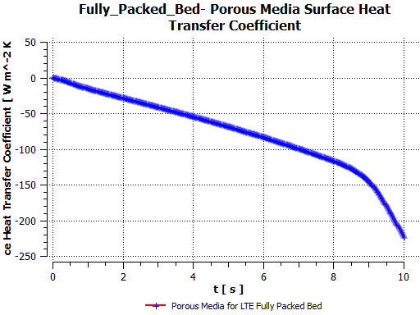 | 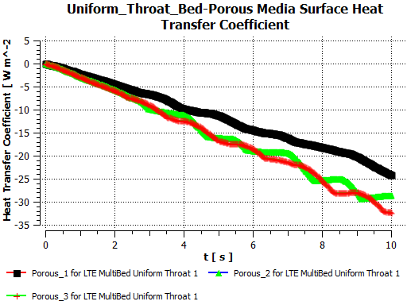 | 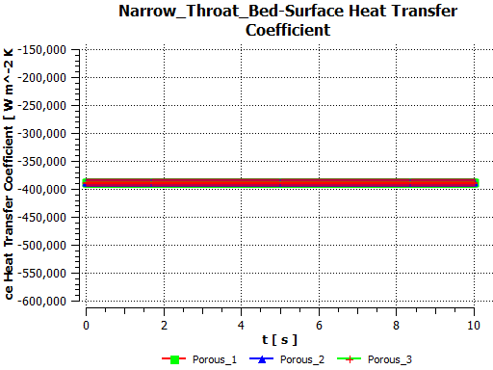
For the three configurations, the fully packed and uniform throat beds show steady decline of the Nusselt number from the beginning of the simulation till the end. For the uniform throat bed, the plot shows lower Nusselt number values for the porous media inserts in the flow direction. The narrow throat diameter on the other hand exhibited relatively constant Nusselt number values for all three porous inserts. If the negative sign is seen as a matter of sign convention and not representing lower values then it can be safely said that narrowing the clear fluid sections thermally enhances the bed.
Figure 6 Plots of Nusselt Number
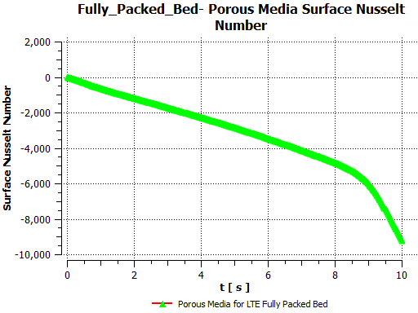 | 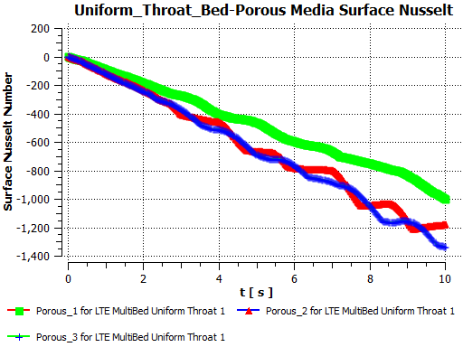 | 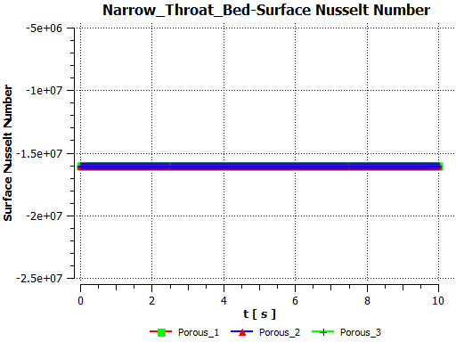

Wall Heat Flux

The plots in Figure 7 show the wall heat flux for the three bed configurations. Common to all of them is the general steady decline of the heat flux for the porous media walls and the negative wall heat flux indicating the direction of heat flow or heat being released from the beds. For the fully packed bed the wall heat flux decreases significantly more than the other two bed configurations. For the uniform throat bed, the decline of the wall heat flux increased from the first porous insert to the third. In the narrow throat bed, the decline for the first and second porous inserts was similar and significantly higher than for the third porous insert. For both the uniform and narrow throat beds, the decline occurred between 240-380Wm⁻².
Figure 7 Plots of Wall Surface Heat Flux
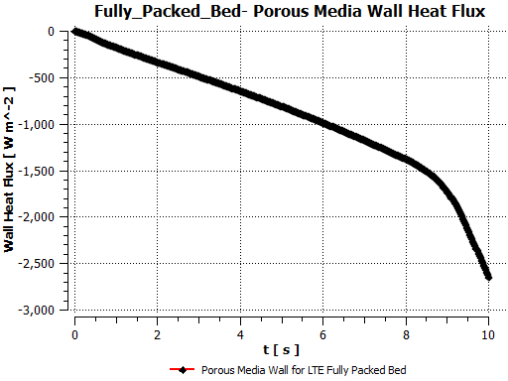 | 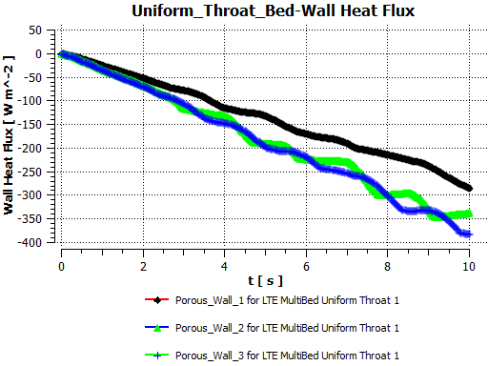 | 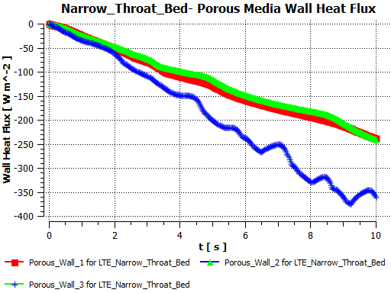

Porous Media Temperature

The porous media temperature for all three beds show steady rise with time. From Figure 8, it is evident that over the same period the fully packed bed achieves the highest temperature in this case a little over 350K whilst the bed temperature for the other two averaged around 318K. The critical difference between the three beds in terms of their porous inserts are the fact that with the narrow and uniform throat beds, the porous media are separated by roughly 0.1m clear fluid sections creating three porous media inserts of 0.15m thickness totalling up to 0.45m thickness per bed equivalent to that of the fully packed bed. From the plots, it can be seen that there is roughly over 30K bed temperature difference between the fully packed bed and the segmented beds.
Figure 8 Plots of Porous Media Temperature
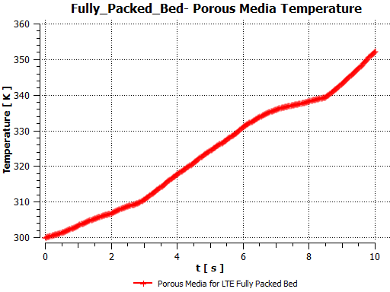 | 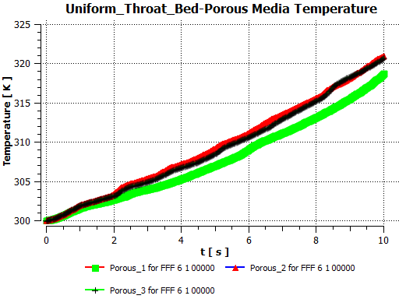 | 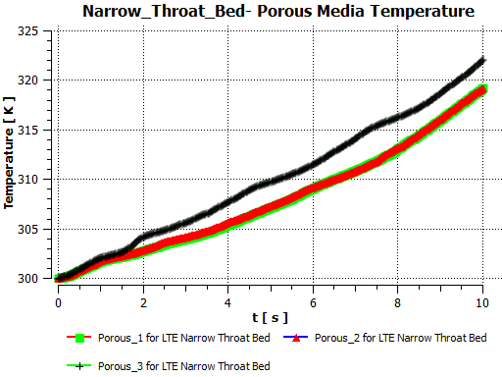
For the uniform throat bed, the plots show slightly higher temperatures for the second and third porous media insert than the first. A closer look also reveals an overall slightly higher temperature for the second porous insert to the rest. For the narrow throat bed, the situation is somewhat different. The plot shows that the temperature for the third porous insert is significantly higher than the first and second porous inserts. Between the two segmented beds, the plots on an average show a slightly higher bed temperature for the narrow throat bed than the uniform throat bed. Between the fully packed and segmented beds, it is obvious that having clear fluid sections adjacent to the porous media domain significantly reduces the overall bed temperature under similar conditions.

Effective Thermal Conductivity

Under local thermal equilibrium, ANSYS Fluent computes the effective thermal conductivity in the porous medium, as the volume average of the fluid conductivity and the solid conductivity (See Equation (6)). In this study, the same porosity and packing material were used for the three beds making it convenient to evaluate the influence of the different bed configurations on their thermal performances. Figure 9 shows the maximum effective thermal conductivity value to be slightly higher for the uniform throat bed and least for the fully packed bed. In the fully packed bed, the values gradually increase with few dips and maximum peaks around 6.6s and 10s. For the uniform throat bed, there were significant variations exhibited by the three porous inserts. Here the second porous insert appears to show effective thermal conductivity values at three peaks at around 1.8s, 3.4s and 5s. Subsequent peaks in this value were exhibited by the first porous insert at around 2.2s, 4.2s and4.8s. For this bed, the effective thermal conductivity was significantly lower in the third porous insert overall. At the end of the simulation, the plots show the values for all three porous inserts to be around 27 Wm⁻¹K⁻¹.
Figure 9 Plots of Effective Thermal Conductivity
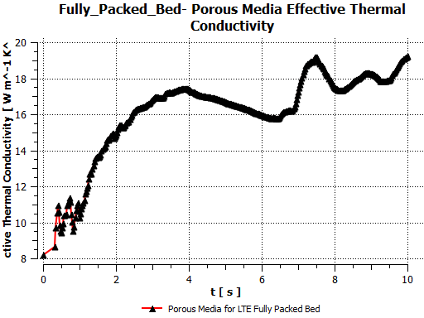 | 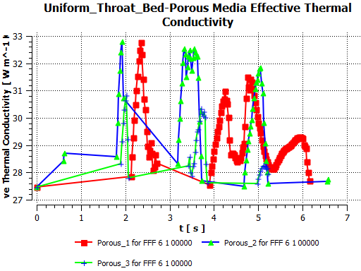 | 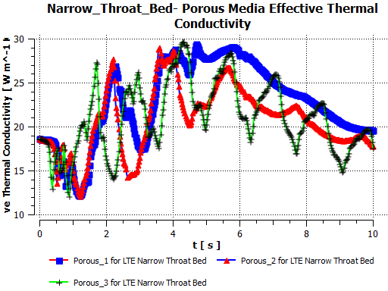
For the narrow throat bed, there were numerous peaks and troughs for the effective thermal conductivities for the three porous inserts. Overall it appears that slightly higher values were recorded for the first and third porous inserts than for the second. At the end of the simulation, the effective thermal conductivity values for the narrow throat bed were between 18-20Wm⁻¹K⁻¹ significantly lower than that of the uniform throat bed but similar to the fully packed bed. These results obviously reflect the airflow distribution within the various bed configurations. It is apparent that the fluid-solid contact within the uniform throat bed appears to be more than the other two beds. Using the maximum and minimum values of the effective thermal conductivity as indicator of the level of fluid-solid contact, it appears from the results that in the fully packed bed the interaction is lower than the other two. This then suggests that the high bed temperature registered for the fully packed bed may be largely due to conduction between the solid desiccant particles.
The static contour plots for the three packed bed configurations shown in Figure 10 also provides a perspective of the flow distribution within the beds at time 1.00e+01s. For all three configurations, the static contour plots show higher values of effective thermal conductivity mainly in the core of the beds. For the fully packed bed, the effective thermal conductivity is shown to increase with the direction of the airflow. For the narrow throat bed the maximum values are shown in the first porous insert. For the uniform throat bed, the contours also show maximum values in the first porous insert.
Figure 10 Contours of Effective Thermal Conductivity in the Y-Plane
Fully Packed Bed | Uniform Throat Bed | Narrow Throat Bed
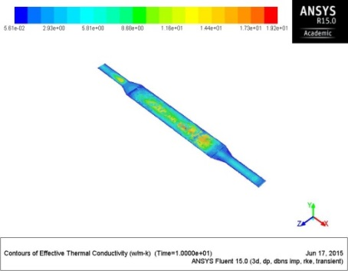 | 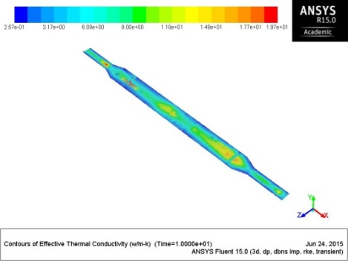 | 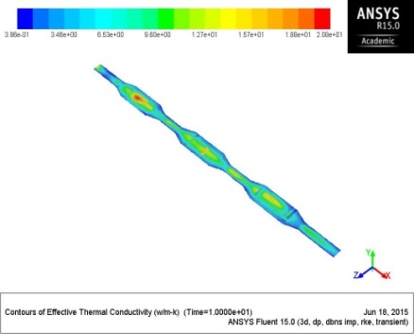

Total Pressure Distribution

The pressure within the three bed configurations all increased sharply at the beginning of the simulation and started a steady decline after about 0.3s (See Figure 11). For the fully packed bed, the plot shows a constant decline after the initial sharp pressure increase from 0Pa. For both the uniform and narrow throat beds, although they also exhibit constant decline, their trends show significant peaks and troughs. For the uniform throat bed, the first and third porous inserts show maximum drop in pressure over time. For the narrow throat bed the pressure drop was significantly higher than the other two. It generally picks up a similar trend as the uniform throat bed however in this case over time; the first and second porous inserts exhibit significantly higher pressure drop than the third.
Figure 11 Plots of Porous Media Pressure
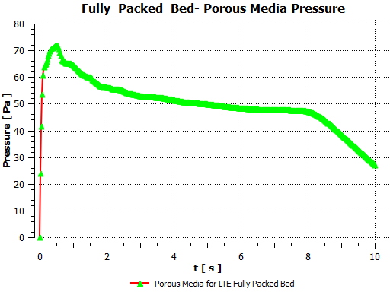 | 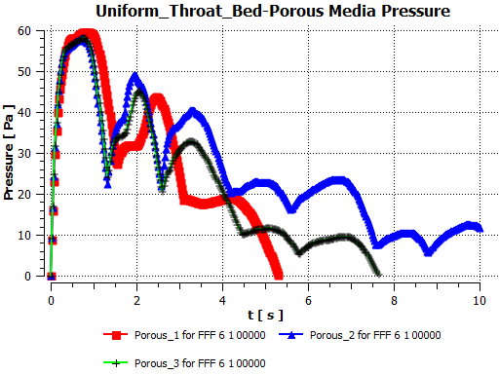 | 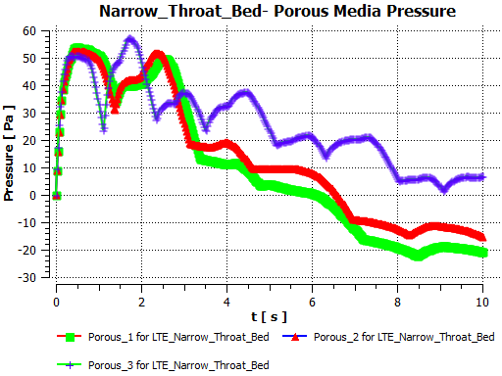
From the static contour plots of total pressure at time 1.00e+01s shown in Figure 12, significant pressure build up occurs between the inlet and the porous insert for all three bed configurations due to the sudden expansion and the forced flow to the porous media. For the fully packed and the uniform throat beds, the contour plots show a gradual decline in pressure with flow. For the narrow throat bed on the other hand, it can be seen that the pressure builds up again at the narrow clear fluid sections. This is fundamentally due to the sudden expansion and contraction of the sections with the porous media also impeding the air flow.
Figure 12 Contours of Total Pressure in the Y-Plane
Fully Packed Bed | Uniform Throat Bed | Narrow Throat Bed
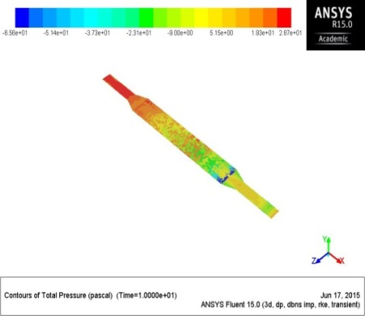 | 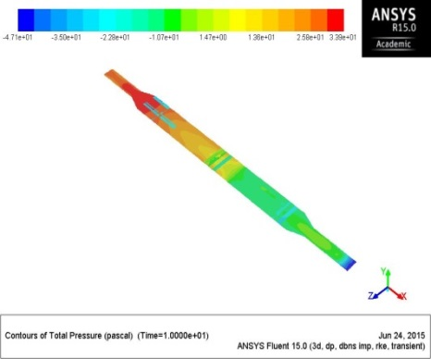 | 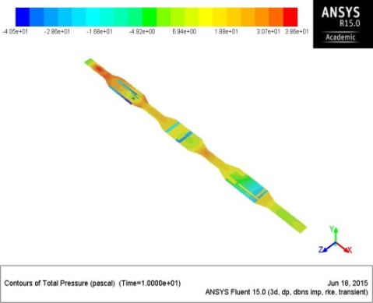

Velocity Distribution

All three bed configurations were initialized at an inlet velocity of 5ms⁻¹. The plots in Figure 13 show very different porous media velocity for the three beds principally influenced by their configurations. Common to all the three configurations is a significant rise in velocity of the airflow through the porous media. For the fully packed bed the velocity steadily increase to about 5.9ms⁻¹ in 4s until it steadily declines to the initialized velocity of 5ms⁻¹. For the uniform throat bed, the trend is generally similar for all its porous inserts. Here, the velocity significantly peaks for all three porous inserts between 1 and 1.6s. For the narrow throat bed on the other hand, the plot shows a different outcome over time. Here the velocity in the porous media initially increases at the beginning of the simulation and then steadily declines to lower values. For the three porous media inserts for this configuration, the third porous insert seems to show slightly higher velocity with the second porous media insert showing a slightly lower velocity than the rest.
Figure 13 Plots of Porous Media Velocity
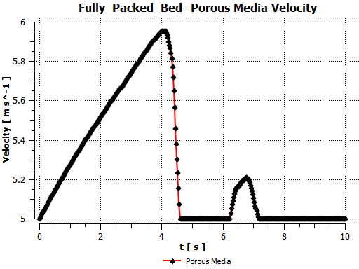 | 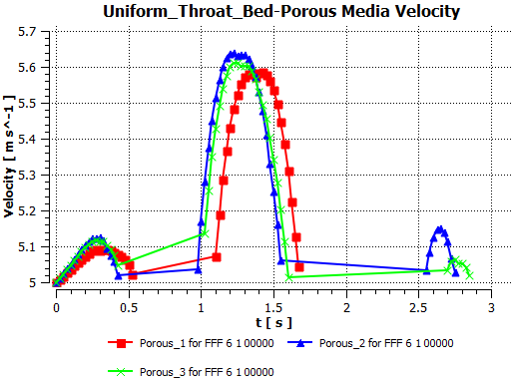 | 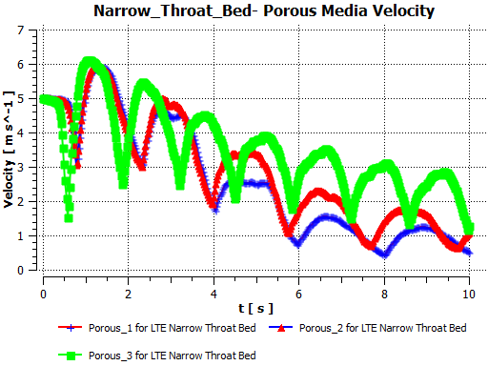

The static velocity vectors of the three bed configurations in Figure 14 provide a perspective of the flow dynamics within the beds at time 1.00e+01s. The plots clearly show the distinction in the flow behaviour within the three configurations at that time. The fully packed and uniform throat beds for instance shows relatively high average static outlet velocity of slightly over 6ms⁻¹. Whilst for the narrow throat bed a high static inlet velocity slightly over 5ms⁻¹ can be observed on the vector plot with a relatively low outlet static velocity of about 4ms⁻¹ recorded. The velocity distribution within the beds is also different for the three configurations. For the fully packed bed, an average static velocity between 3 and 4ms⁻¹ can be observed in the porous section. For the uniform throat bed, the averages are slightly lower overall with the second porous insert showing slightly higher average than the first and third. The narrow throat bed on the other hand shows significant increase in velocity in the clear fluid sections unlike the uniform throat bed. This is due to the sudden contraction of the flow after it has left the porous media and its encounter with the next porous media.

Figure 14 Vectors of Velocity Magnitude in the Y-Plane
Fully Packed Bed | Uniform Throat Bed | Narrow Throat Bed
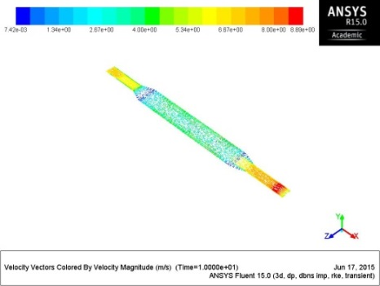 | 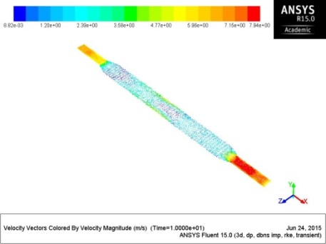 | 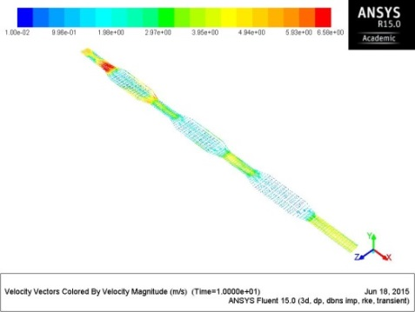

Conclusion
An alternative technique of extensively filling sections of packed beds for thermal enhancement was carried out using three packed beds of different configurations. The theoretical model was simulated under forced convection in subsonic flow regime. The investigation was to determine the effectiveness of this approach and the bed configuration that best enhances the heat transfer process as a result of the influence of the porous media domain interface and its adjacent clear fluid section. From the results; the following major observations were made:
- Due to the heat generated by the porous media, negative surface Nusselt numbers indicating the direction of heat transfer was observed. Larger negative surface Nusselt numbers were observed for the narrow throat bed. Hence if the negative sign is seen as a matter of sign convention and not representing lower values then it can be safely concluded that narrowing the clear fluid sections considerably enhances the bed thermally.
- Segmenting the packed bed to generate clear fluid sections adjacent to the porous media domain was observed to significantly reduce the overall bed temperature compared to a fully packed bed with the same amount of packing and bed properties.
- The dimensions of the clear fluid sections influence the reduction in bed temperature and other flow conditions. The clear fluid section generally increased the pressure drop across the bed and narrowing it increased it further.
- The velocity distributions within the beds were significantly influenced by the bed configurations with the sudden contraction and expansion in the narrow throat bed reducing the overall velocity in the porous media.

References

- 2009 ASHRAE Handbook - Fundamentals (SI Edition). American Society of Heating, Refrigerating and Air-Conditioning Engineers, Inc. Online version available at: http://knovel.com/web/portal/browse/display?_EXT_KNOVEL_DISPLAY_bookid=2809&VerticalID=0

- Rady, M.A. Huzayyin, A.S. Arquis, E. Monneyron, P. Lebot, C. and Palomo, E. (2009) Study of heat and mass transfer in a dehumidifying desiccant bed with macro-encapsulated phase change materials. Renewable Energy, Volume 34, Issue 3, Pages 718-726

- Lu, G.Q. and Zhao, X.S. (2004) Nanoporous Materials - Science and Engineering.. World Scientific. Online version available at: http://knovel.com/web/portal/browse/display?_EXT_KNOVEL_DISPLAY_bookid=1311&VerticalID=0
- IUPAC (1976) Manual of symbols and terminology for physicochemical quantities and units- Appendix II. Pure & AppL Chem., VoL 46, pp. 71—90. Pergamon Press, Printed in Great Britain.
- Gandhidasan, P.; Al-Farayedhi, Abdulghani A. and Al-Mubarak, Ali. A. (2001) Dehydration of natural gas using solid desiccants. Source: Energy, v 26, n 9, p 855-868. Database: Compendex
- Golubovic, Mihajlo N.; Hettiarachchi, H.D.M.; and Worek, William M. (2006) Sorption properties for different types of molecular sieve and their influence on optimum dehumidification performance of desiccant wheels. Source: International Journal of Heat and Mass Transfer, v 49, n 17-18, p 2802-2809. Database: Compendex.

- LeVan, M. Douglas, Carta, Giorgio and Yon, Carmen M. (1997) Adsorption and Ion Exchange. In: Green, Don W. and Perry, Robert H. (2007). Perry's Chemical Engineers' Handbook (7th Edition). McGraw-Hill. Retrieved from www.knovel.com
- Di Felice, R. and Gibilaro, L. G. (2004) Wall effects for the pressure drop in fixed beds. Chemical Engineering Science, Volume 59, Issue 14, Pages 3037-3040
- Atmakidis, Theodoros. and Kenig, Eugeny. Y. (2009) A numerical study on the residence time distribution in low. Chemical engineering transactions. Vol 18. AIDIC Servizi S.r.l, ISBN 978-88-95608-04-4 ISSN 1974-9791. DOI:103303/CET0918094
- Fahien, R. W. and Smith, J. M. (1955), Mass transfer in packed beds. AIChE Journal, 1: 28–37. doi: 10.1002/aic.690010104
- Barlow, Robert. S. (1982) Analysis of the Adsorption Process and of Desiccant Cooling Systems - A Pseudo- Steady-State Model for Coupled Heat and Mass Transfer. Solar Energy Research Institute. A Division of Midwest Research Institute. Prepared Under Task No. 1131.00 and l f 32.11. WPA Nor 01-256 and 01-315. SERI/TR-631-1330. UC Category: 59c
- Meljac, L.; Goetz, V.; and Py, X. (2007) Isothermal composite adsorbent. Part I: Thermal characterisation. Source: Applied Thermal Engineering, v 27, n 5-6, p 1009-1016,Database: Compendex

- Rady, M.A. (2009) Experimental and numerical investigations on the performance of dehumidifying desiccant beds composed of silica-gel and thermal energy storage particles. Source: Heat and Mass Transfer/Waerme- und Stoffuebertragung, v 45, n 5, p 545-561,Database: Compendex

- Ramzy, A. K.,Kadoli, R. and Ashok Babu, T.P. (2010) Improved utilization of desiccant material in packed bed dehumidifier using composite particles. Renewable Energy, Volume 36, Issue 2, Pages 732-742

- Rong, Fumei. Zhang, Wenhuan. Shi, Baochang. and Guo, Zhaoli (2014) Numerical study of heat transfer enhancement in a pipe filled with porous media by axisymmetric TLB model based on GPU. International Journal of Heat and Mass Transfer, Volume 70, Pages 1040-1049

- Yang, Chen. Nakayama, Akira. and Liu, Wei. (2012) Heat transfer performance assessment for forced convection in a tube partially filled with a porous medium. International Journal of Thermal Sciences, Volume 54, Pages 98-108
- Yang, C. Liu, W. and Nakayama, A. (2009) Forced Convective Heat Transfer Enhancement in a Tube with its Core Partially Filled with a Porous Medium. The Open Transport Phenomena Journal, 1, 1-6. 1877-7295/09
- Delavar, Mojtaba Aghajani and Mohammadvali, Farzane (2013) Numerical Simulation of Force Convection in a Channel with Porous Part. Int. J. of Thermal & Environmental Engineering. Volume 6, No. 1. 7-14
- Mahmoudi, Yasser. and Karimi, Nader. (2014) Numerical investigation of heat transfer enhancement in a pipe partially filled with a porous material under local thermal non-equilibrium condition. International Journal of Heat and Mass Transfer, Volume 68, Pages 161-173

- Poulikakos D D, and Renken KK. (1987) Forced Convection in a Channel Filled With Porous Medium, Including the Effects of Flow Inertia, Variable Porosity, and Brinkman Friction. J. Heat Transfer.; 109(4):880-888. doi:10.1115/1.3248198.
- Shokouhm and, H, Jam, F. and Salimpour, M.R. (2011) The effect of porous insert position on the enhanced heat transfer in partially ﬁlled channels. International Communications in Heat and Mass Transfer 38 1162–1167
- Mahmoudi, Yasser. and Maerefat, Mehdi. (2011) Analytical investigation of heat transfer enhancement in a channel partially filled with a porous material under local thermal non-equilibrium condition. International Journal of Thermal Sciences, Volume 50, Issue 12, Pages 2386-2401

- Mahgoub, S.E. (2013) Forced convection heat transfer over a flat plate in a porous medium. Ain Shams Engineering Journal, Volume 4, Issue 4, Pages 605-613
- Mohamad, A.A. (2003) Heat transfer enhancement in heat exchangers fitted with porous media. Part I: constant wall temperature. Int. J. Therm. Sci., 42, pp. 385–395

- Xu, H.J. Qu, Z.G. and Tao, W.Q. (2011) Analytical solution of forced convective heat transfer in tubes partially filled with metallic foam using the two-equation model. International Journal of Heat and Mass Transfer, Volume 54, Issues 17–18, Pages 3846-3855
- Jiang, Pei-Xue. Li, Meng. Ma, Yong-Chang. and Ren, Ze-Pei . (2004) Boundary conditions and wall effect for forced convection heat transfer in sintered porous plate channels. International Journal of Heat and Mass Transfer, Volume 47, Issues 10–11, Pages 2073-2083

- Yang, C. and Nakayama, A. (2010) A synthesis of tortuosity and dispersion in effective thermal conductivity of porous media. International Journal of Heat and Mass Transfer, Volume 53, Issues 15–16, Pages 3222-3230
- Alshare, A.A. Strykowski, P.J. and Simon, T.W. (2010) Modeling of unsteady and steady fluid flow, heat transfer and dispersion in porous media using unit cell scale. International Journal of Heat and Mass Transfer, Volume 53, Issues 9–10, Pages 2294-2310

- Tan, Hua and Pillai, Krishna M. (2009) Finite element implementation of stress-jump and stress-continuity conditions at porous-medium, clear-fluid interface. Computers & Fluids, Volume 38, Issue 6, Pages 1118-1131
- Chandesris, M. and Jamet, D. (2007) Boundary conditions at a fluid–porous interface: An a priori estimation of the stress jump coefficients. International Journal of Heat and Mass Transfer, Volume 50, Issues 17–18, Pages 3422-3436
- ANSYS, Inc. (2012) ANSYS Fluent Theory Guide. February 2012. Release 14.5 - © SAS IP, Inc. All rights reserved.

- Versteeg, H. K. and Malalasekera, W. (2007) An Introduction to Computational Fluid Dynamics: The Finite Volume Method. 2nd Edition. Pearson Prentice Hall. Essex England.

- ANSYS, Inc. (2014) ANSYS Fluent User's Guide. February 2014. Release 15.0 - © SAS IP, Inc. All rights reserved.

- Copyright 1997, Microelectronics Heat Transfer Laboratory. http://www.mhtl.uwaterloo.ca/old/onlinetools/airprop/airprop.html
- Chua, Hui T. Ng, Kim C. Chakraborty, Anutosh. Oo, Nay. M. and Othman, Mohamed A. (2002) Adsorption Characteristics of Silica Gel + Water Systems. Journal of Chemical & Engineering. Data 47 (5), 1177-1181http://pubs.acs.org/doi/pdf/10.1021/je0255067
- Moffat, Robert J. (1998) What's new in convective heat transfer? International Journal of Heat and Fluid Flow, Volume 19, Issue 2, Pages 90-101

