PCNA as a Molecular Biomarker for Spermatogenesis in PTU- Induced Hypothyroidism of Rats
¹٭Ehab Tousson, PhD; ²Ehab M. Ali PhD; ³Wafaa Ibrahim PhD; and ² Mohammed A. Mansour, BSc
¹Department of Zoology, ²Biochemistry Section, Department of Chemistry, Faculty of Science, ³Department of medical Biochemistry, Faculty of Medicine, Tanta University, Egypt.

٭Corresponding author:
Dr. Ehab Tousson
Phone: 0020193905527
Email: toussonehab@yahoo.com

Abstract:
In previous studies, the thyroid hormone has few serious effects on the testes except during the neonatal stage. Further, there is little knowledge concerning the prolonged effect of thyroid hormone deficiency throughout the rat’s life span and its effect on spermatogenesis. Proliferating cell nuclear antigen (PCNA) is a well-known 36-kD nuclear matrix protein which is essential for multiple cell-cycle pathways, including DNA replication, DNA elongation and DNA excision repair. Twenty rats were equally divided into two groups; the 1st group was the control group while the 2nd group was the experimental group in which rats were fed 0.05% 6-n-propyl thiouracil (PTU) in drinking water for six weeks. Heir we used PCNA immunohistochemistry as a marker to differentiate between the testes of control and hypothyroid rats. Immunohistochemistry using an antibody against PCNA, showed at least three differences in the pattern of PCNA-ir. First, PCNA-ir was not detected in Sertoli and leydig cells in the testes of control rats and detected in some of hypothyroid rats. Second, in the control group more than 96% of spermatogonia were PCNA-positive cells, however hypothyroidism caused a reduction to approximately 25% PCNA staining in spermatogonia. The third difference was in the abnormal distribution of spermatogonia seen in the hypothyroid rat testis not in the control one. These results suggest that prepubertal hypothyroidism affects the proliferation of spermatogenic cells leading to impaired spermatogenesis and that PCNA index is a useful marker for assessing germ cell kinetics and spermatogenesis in prepubertal hypothyroidism.
Keywords: Testes; hypothyroidism; PTU; Spermatogenesis; PCNA; Rats.

Introduction
Appropriate level of thyroid hormone is essential for normal development and metabolism in most vertebrate tissues and altered thyroid status impacts adversely on them (Maran et al., 2001; Toshihiro, 2009). For many years the testis was regarded as a thyroid hormone unresponsive organ, but consistent evidence accumulated in the past two decades has definitively changed this classical view.
The testes are mainly regulated by the gonadotrophin follicle-stimulating hormone (FSH) and luteinizing hormone (LH), the latter acting through the intermediate testosterone secreted by the Leydig cells (Bay et al., 2006; Ge et al., 2006). It is well accepted that these systemic hormones and local testicular paracrine-autocrine factors work together to initiate and maintain testicular function and sperm production (Wagner et al., 2009). Apart from gonadotrophins, thyroid hormone has also been shown to play an important role in testicular physiology (Cooke et al., 2004; Holsberger and Cooke, 2005; Toshihiro, 2009). It is now established that tri-iodothyronine (T3) regulates the maturation and growth of testis, in rats and other mammal species, by inhibiting immature Sertoli cells proliferation and stimulating their functional differentiation (Van Haaster et al., 1993; Tarulli et al., 2006; Jansen et al., 2007). Similarly, thyroid hormone has also been shown to play a critical role in the onset of Leydig cell differentiation and stimulation of steroidogenesis in postnatal rat testis (Mendis-Handagama and Ariyaratne, 2005; Lin et al., 2009).
Although the basic mechanisms involved in the regulatory actions of thyroid hormone in testicular cells are still undefined, the presence of thyroid hormone receptors (TRs) in human and rat testis throughout development and in adulthood implies that T3 may act directly via the classical genomic pathway in this organ (Jansen et al., 2007; Gereben et al., 2008; Toshihiro, 2009).
Altered thyroid status, experimentally induced or occurring in adult life, is frequently associated with some kind of sexual dysfunction and/or morphological testicular degeneration (Faraone-Mennella et al., 2008; Krassas et al., 2008a, b; Wagner et al., 2008). Because most experimental studies to date have focused on thyroid hormone effects on the developing testes, only limited data are available on its role in spermatogenesis.
Proliferating cell nuclear antigen (PCNA) is a well-known 36-kD nuclear matrix protein which is essential for multiple cell-cycle pathways, including DNA replication, DNA elongation (leading strand synthesis), and DNA excision repair (Waseem et al., 1992; Madsen and Celis, 1995). It is also utilized in cell-cycle control through direct interaction with cyclin/cdk complexes, allowing progression through the G1/S boundary of the cell cycle (Zhang et al., 1993). PCNA is an essential component of the DNA replication machinery, acting as the processing factor for polymerases (Hindges and Hubscher, 1997). In addition to its role in replication, PCNA is also required for nucleotide excision repair and plays a role in one pathway of base excision repair (Shivji et al., 1992). Analysis of proteins which interact with PCNA has shown that it not only interacts with enzymes involved in the mechanics of DNA repair and replication but also binds to cell-cycle regulatory proteins such as p21 and Gadd45 (Waga et al., 1994; Hall et al., 1995). The efficiency of spermatogenesis depends on the proliferative activity of spermatogonia and the loss of germ cells during meiosis and spermiogenesis (Toshihiro, 2009). PCNA is useful for the diagnosis of germinal arrest because there are significantly reduced PCNA levels in germinal arrest, which is an indication of DNA synthesis deterioration (Zeng et al., 2001). In this study, a detailed histopathological examination was performed, including PCNA immunohistochemistry of rat testicular tissue to analyze the proliferation rate of the germ cells and to examine the effects of PTU-induced hypothyroidism on the proliferative aspects of spermatogenesis.
Materials and methods
The experiments were performed on twenty male albino rats (Rattus norvigicus) weighing 120 g (±10g) and of 6-7 week’s age. They were obtained from Helwan laboratory farms for the Egyptian Organization for Vaccine and Biologic Preparations. The rats were kept in the laboratory for one week before the experimental work and maintained on a standard diet and water available ad libitum. The temperature in the animal room was maintained at 23±2^{Ο}C with a relative humidity of 55±5%. Light was on a 12:12 hr light -dark cycle. The experimental protocol was approved by Local Ethics Committee and Animals Research. The rats were equally divided into two groups; the 1st group was the control group in which rats never received any treatment while the 2nd group was the experimental group in which rats were received 0.05% 6-n-propyl thiouracil (PTU) in drinking water for 6 weeks (Sahoo et al., 2008).
At the end of the experimental period, five rats from each group were euthanized with intravenous injection with sodium pentobarbital and subjected to a complete necropsy. Blood samples were individually collected from each rat in non heparinized glass tubes. Serum was separated by centrifugation at 3000 rpm for 15 minutes. The collected serum was stored at -18 °C until analysis. Serum was analyzed to determine the T3 and TSH levels.
Determination of serum T3 and TSH concentrations: Serum T3 was assayed by using commercial test supplied by the Diagnostic systems Laboratories (DSL), Taxes, USA. Serum TSH was assayed by using commercial Kit supplied by Coat-A-Count TSH IRMA, Los Angeles, USA.
PCNA immunohistochemistry: The other five rats from each group were anesthetized with Thiopental. The thorax was opened with surgical incision on the sternum and the perfusion was done from left ventricle and right atrium. A rinsing solution was perfused before the fixation solution (Bouin′s fluid). Due to the narrow testicular artery branches from the abdominal aorta near the renal artery, it is probably constricted and occluded during the perfusion process. Perfusion with rinsing solution helped overcome this problem. To make rinsing solution, 9.0 g NaCl, 25g Polyvinyl Pyrrolidone, 0.25g Heparin, and 5.0g Procain-HCL were dissolved in one liter of water by thorough stirring. The pH was adjusted to 7.35 with 1 N NaOH and twice filtered through Millipore filters of 3.0 μm or less pore size. The perfusion of both solutions was performed by using a scalp vein attached to a 50cc syringe. Testes were immediately removed taking care to handle specimens gently to minimize trauma to the delicate seminiferous tubules prior to placement of each testis into fixative solution. The tunica albuginea was shallowly pierced at each pole 5 times with a 21-gauge needle to aid in the penetration of the fixative solution. Fixation time was limited to 24 hours and tissues were transferred to 70% ethyl alcohol. Alcohol was changed 3 times daily for 2 days before transferring the specimens to a saturated solution of 70% ethyl alcohol and lithium carbonate to neutralize the picric acid in Bouin’s fluid. The ethyl alcohol-lithium carbonate solution was changed 3 or more times until the yellow color of Bouin’s fluid was almost completely depleted from the tissue. Testes were stored in 70% ethyl alcohol until they were processed (Latendresse et al., 2002). The fixed testis were dehydrated through a graded series of ethanol and embedded in paraffin according to standard procedures. Paraffin sections (5μm thick) were mounted on gelatin chromalum–coated glass slides and stored at room temperature until further processing. The 5μm thick paraffin sections were used for PCNA immunohistochemical staining method (Taghavi et al., 2009).
Testicular distribution of PCNA receptor subunits were examined in deparaffinized sections (5 µm) of Bouin's fixed testes of rats using an Avidin-Biotin-Peroxidase (ABC) immunohistochemical method (Elite–ABC, Vector Laboratories, CA, USA) against PCNA (dilution 1:100, DAKO Japan Co, Ltd, Tokyo, Japan) were employed. Briefly, sections were deparaffinized, rehydrated, washed in phosphate buffered saline (PBS) (3 x 5 min) and peroxidase activity was quenched using 0.3% H₂O₂ in methanol for 30 min. Subsequently, samples were washed in PBS and incubated with blocking solution at room temperature for 10 min. After rinsing with PBS, sections were incubated with biotinylated mouse anti-PCNA primary antibody in moist chamber for 30-60 min and then rinsed with PBS. Samples were incubated with Streptavidin Peroxidase at room temperature for 10 min and washed with PBS. The antibody-peroxidase complex was developed using DAB chromogen at 18-24◦C for 2-5min. Finally, the sections were washed with PBS, counterstained with Hematoxylin for 1 min, washed with tap water then PBS for 30 seconds, dehydrated through ascending grades of alcohol, delipidated in xylene, and cover-slipped with Mount-Quick (Daido Sangyo, Tokyo). All stained slides were viewed by using Olympus microscope and images were captured by a digital camera (Cannon 620). Brightness and contrast of the images were adjusted using Adobe Photoshop software (version 4.0.1; Adobe Systems, Mountain View, CA).
PCNA-Labeling Index (PCNA-LI): Slides were examined under the light microscope with a magnification X 200 and then sections were evaluated for PCNA immunostaining. Microscopic fields were chosen at random. Five fields per slide were evaluated. Only the basal germ cells of the seminiferous tubules were counted, as they are the cells where active DNA synthesis took place (Heller and Clermont, 1964). The PCNA-LI for each seminiferous tubule was estimated as a percentage of immuno-labeled cells (cells with brown nuclear staining PCNA+) to all basal cells (Abdel-Dayem, 2009). The average PCNA index in each case was obtained by dividing the sum of all PCNA indices by the number of seminiferous tubules in which the calculation was carried out. For each specimen the mean±SD was calculated.
Statistical Analysis: Data were expressed as mean values ± SD and statistical analysis was performed using one-way analysis of variance (ANOVA) to assess significant differences among treatment groups. The criterion for statistical significance was set at p < 0.05. All statistical analyses were performed using SPSS statistical version 16 software package (SPSS® Inc., USA).
Results
Serum T3 levels were significantly lower hypothyroid rats compared with the control. On the other hand serum TSH levels in rats were significantly higher than those found in the control rats (Table 1).

Table 1: Serum T3 and TSH levels and PCNA index in testes tissues of control and hypothyroid rats.
Parameters  Groups | Total T3  (ng/dl) | TSH  (µIU/ml) | PCNA-LI
G₁ (Control)  Mean ± SD | 155.8±30.335 | 0.014±0.00548 | 96.33±5.59
G₂ (PTU-Induced hypothyroidism)  Mean ± SD | 56±11.023* | 4.1±0.7* | 19.45±3.55
*p<0.001. Vs control rats.

The light microscopy examination of the testis of the control rats showed a normal structure completely enveloped by a thick capsule, tunica albuginea, which is composed mainly of dense collagenous fibrous connective tissue. The structural components of the testis are the seminiferous tubules and interstitial tissues (Figure 1A). The interstitial cells (Leydig cells) of control rats are found in the connective tissue between the seminiferous tubules and showed a negative reaction for PCNA-immunoreactivity (PCNA-ir; Figure 1B). The seminiferous tubules are two types of cells, the Sertoli cells, resting on the thin basal lamina (basement membrane) and the spermatogenic cells. Figure (1F) showed a negative reaction for PCNA-ir in Sertoli cells of control rats, that can be identified by their oval or pear shaped vesicular nuclei lying perpendicular on basement membrane of seminiferous tubules. The spermatogenic cells are arranged in many layers, namely, the spermatogonia, primary and secondary spermatocytes; spermatoids and finally mature spermatozoa. Only the spermatogonia in control animals showed a positive strong reaction for PCNA-ir (Figure 1) while the other spermatogenic cell types showed negative reaction (Figures 1C and 1D). The lumen of the seminiferous tubules in the control group was fully packed with sperms that showed a negative reaction for PCNA-ir (Figures 1A-1C).
The testes of hypothyroid rats showed many immunohistochemical changes in testicular tissues (Figure 2). Table (1) showed the number of PCNA-ir positive germ cells per tubule cross-section significantly decreased following PTU treatment (19.45±3.55) in comparison to the control group (96.33±5.59). The number of spermatozoa is less in hypothyroid rats where the lumen of some seminiferous tubules was clear and the spermatozoa were not seen (Figures 2A and 2B). Some of the Sertoli cells in seminiferous tubules of hypothyroid rats showed positive reaction for PCNA in contrast to the control group (Figure 2C). Figure 2D showed positive reaction for PCNA in some Leydig interstitial cells lying between seminiferous tubules of hypothyroid rats in contrast to the control group. The distribution of spermatogonia in seminiferous tubules of hypothyroid rats is not homogenous as in control animals (Figures 2E and 2F). Some of spermatogonia in testes of hypothyroid rats were observed in the lumen of the seminiferous tubules and between the spermatocytes (Figures 2E and 2F).

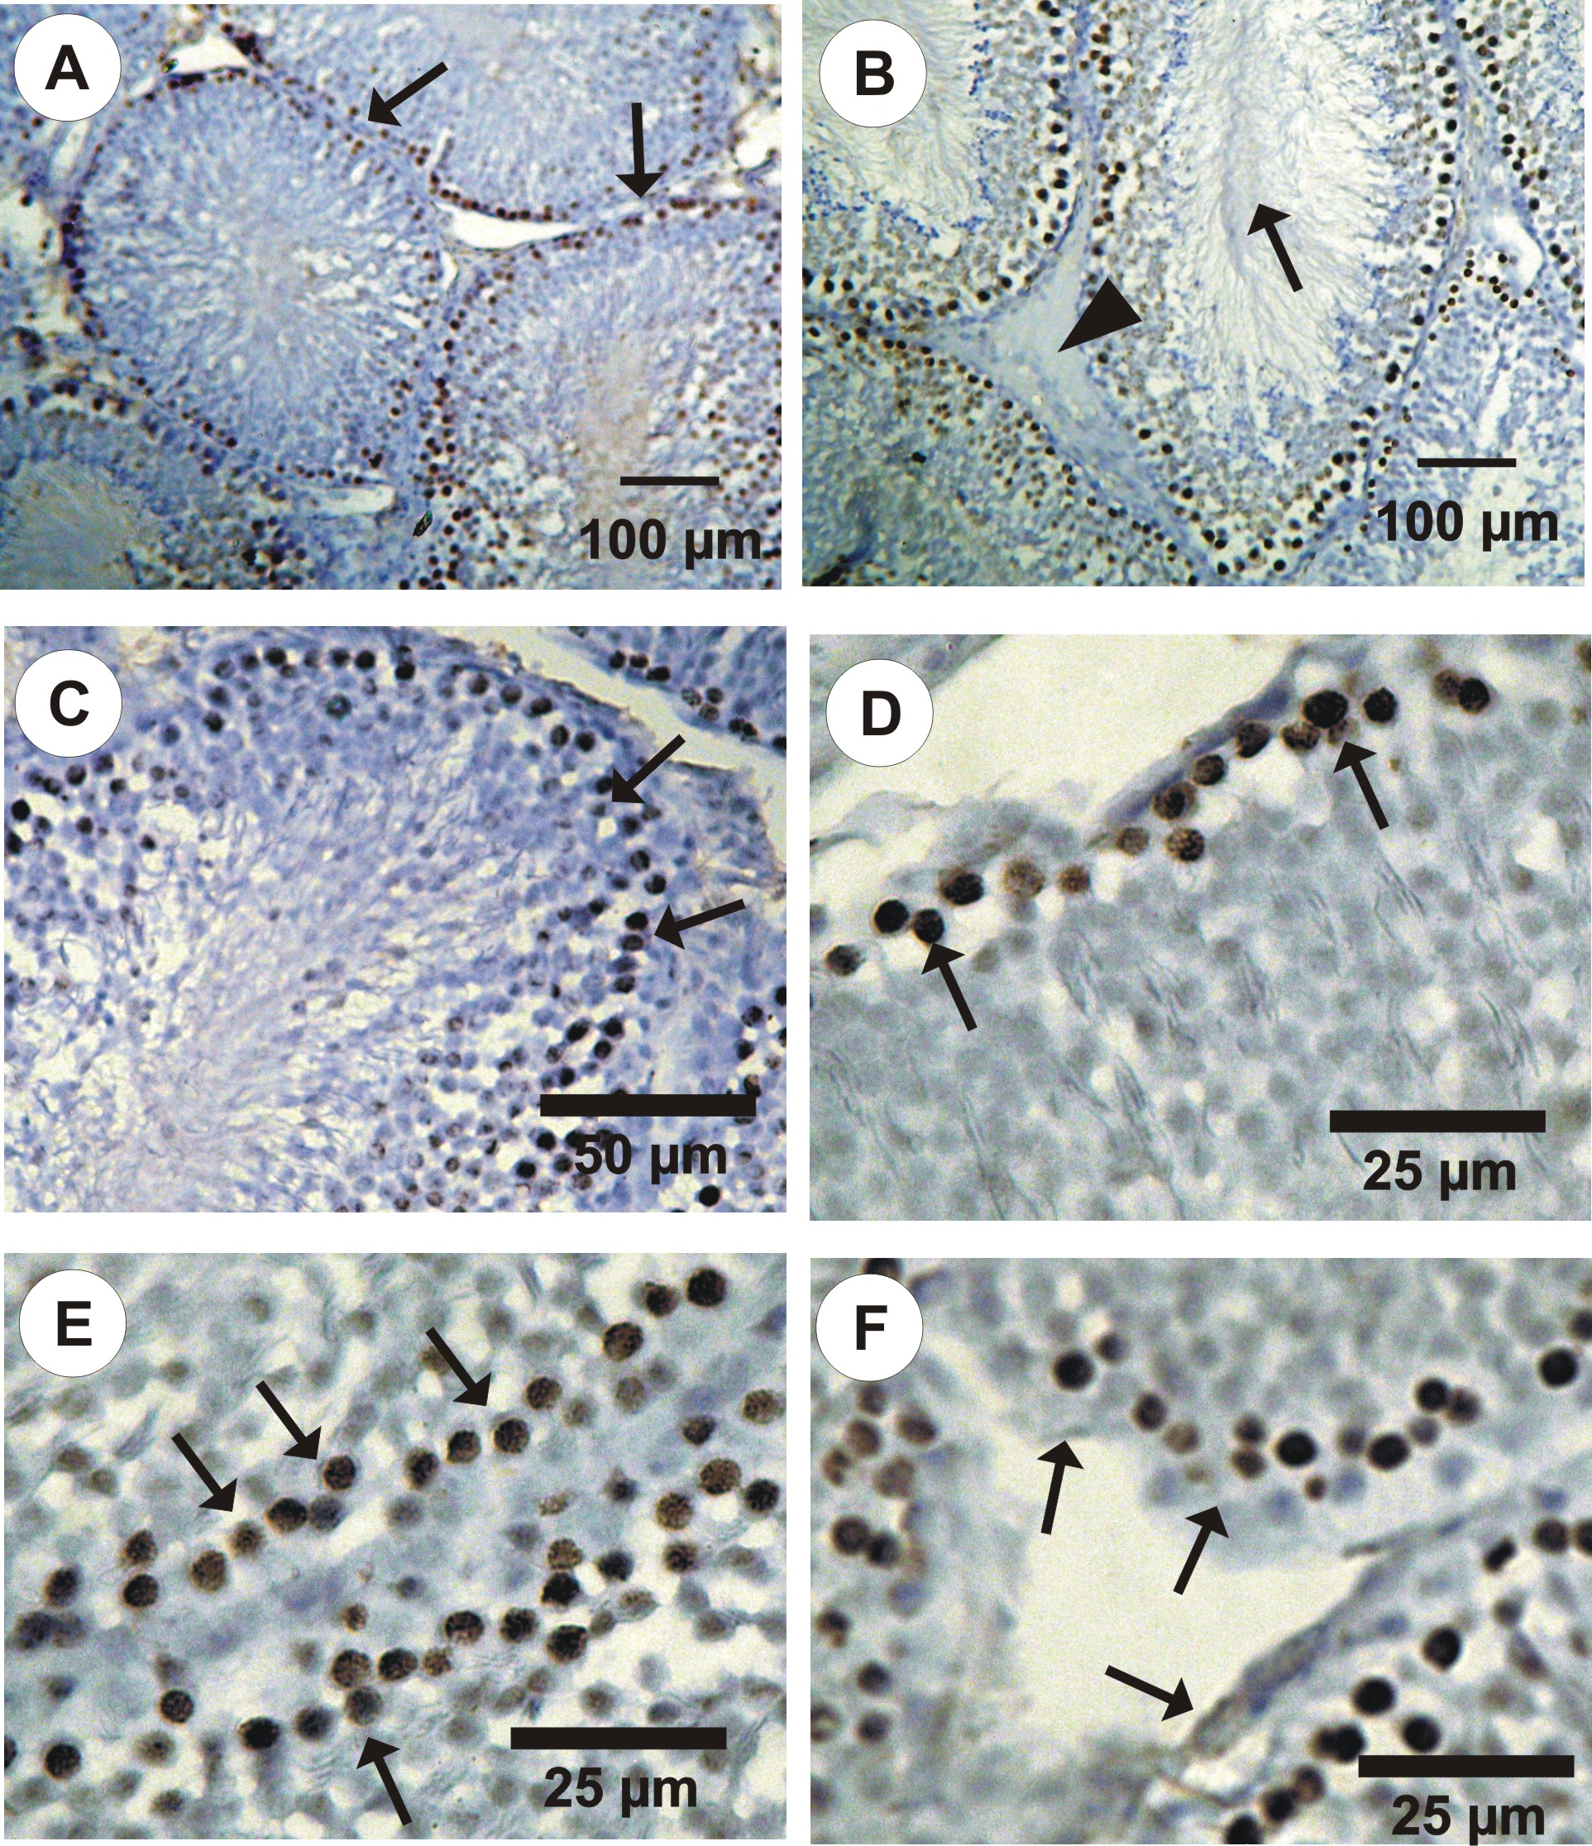
Figure 1: Photomicrographs of PCNA-ir (immunoperoxidase labelling) through in the testis cross sections in control rats. A. different stages of spermatogenic cells in the seminiferous tubules (arrows) showing the distribution of PCNA-ir positive cells in spermatogonia. B. The lumen of the somniferous tubules has fully packed with sperms (arrows) and the negative reaction for PCNA-ir in Leydig cells (triangle). C-E. Positive reaction of PCNA-ir in spermatogonia (arrows). F. Negative reaction for PCNA-ir in Sertoli cells (arrows).
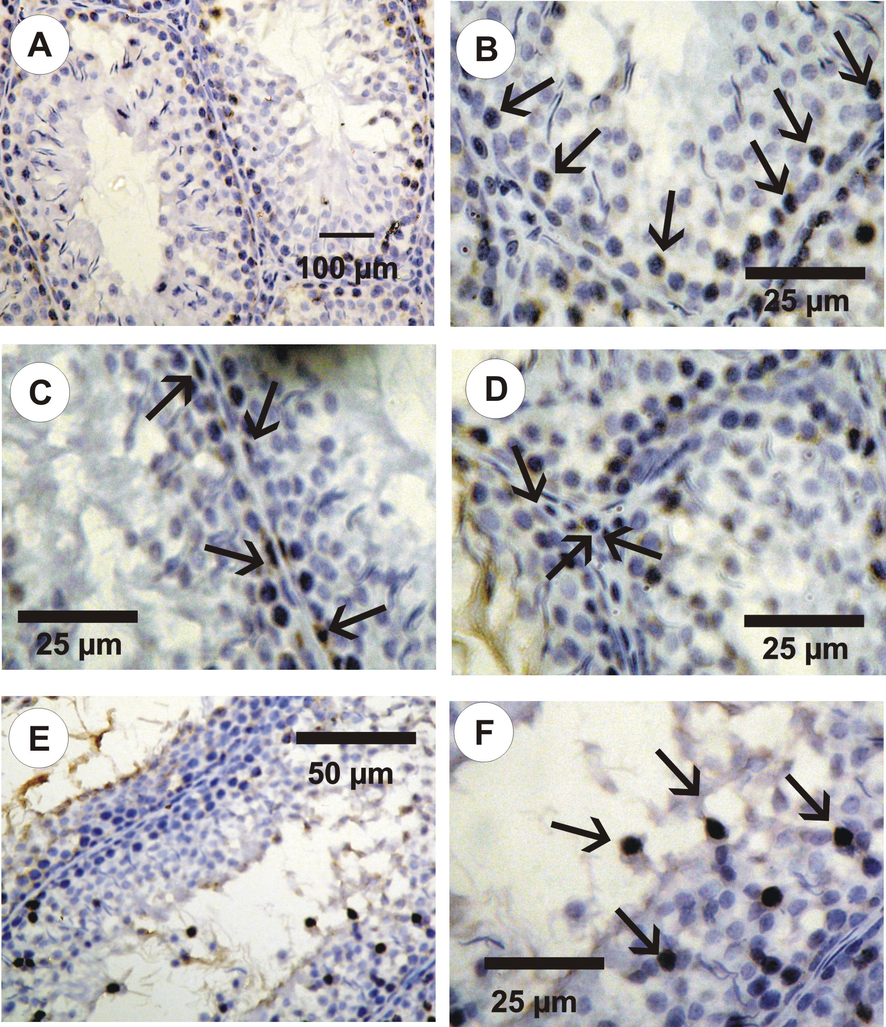
Figure 2: Photomicrographs of PCNA-ir (immunoperoxidase labelling) in the testes cross sections in hypothyroid rats. A. Different stages of spermatogenic cells in the seminiferous tubules. Only a few numbers of spermatogonia have positive reaction for PCNA-ir. Note that the lumen of the tubules was clear and the spermatozoa were not seen. B. A few numbers of the spermatogonia in the seminiferous tubules have positive reaction for PCNA (arrows). C. A few numbers of the Sertoli cells (arrows) having a positive reaction for PCNA. D. A few numbers of the Leydig cells (arrows) having a positive reaction for PCNA. E and F. Abnormal distribution of spermatogonia (arrows) in seminiferous tubules of hypothyroid rats.

Discussion
The thyroid hormone is essential for the development and maintenance of the testes. In previous studies, the thyroid hormone has few serious effects on the testes except during the neonatal stage when the thyroid hormone receptor is mainly present. However, there is little knowledge concerning the prolonged effect of thyroid hormone deficiency throughout the rat’s life span. We designed our study to investigate the role of thyroid hormone on the testicular function at the prepubertal stage of rats. In order to achieve this target we made a deficient state of thyroid hormones by a reversible goitrogen (PTUl). PTU is known to decrease the conversion of peripheral T4 to T3 and thereby reduces serum T3 concentration. PTU has been linked with several side effects such as transient leukopenia, jaundice, hepatomegaly and vasculitis (Chiao et al., 2002). It was administered to the rats in the drinking water within a period of six weeks to investigate the changes through a complete spermatogenic cycle (de Kretser, 1982).
In order to ensure the hypothyroid state we regularly determined the serum T3 and TSH through the dose period where serum T3 concentration is depressed and serum TSH concentration is significantly elevated. During normal spermatogenesis controlled cell proliferation is of fundamental importance, assuming highly coordinated mechanisms between the mitotically inactive Sertoli cells and the germ cells undergoing mitosis and meiosis. Efficiency of spermatogenesis depends on the proliferative activity of spermatogonia and the loss of germ cells during meiosis and spermiogenesis. Mitosis counts, tritiated thymidine ([3H] Thy) or 5-bromodeoxyuridine (BrdU) labeling have traditionally been used for the assessment of cell proliferation. However, these methods are less suitable for use under certain experimental conditions. For instance, [3H]Thy labeling requires use of radioisotopes, visualization by autoradiography, and in vivo administration, thus not enabling the use of this method in post mortem tissue (Linden et al., 1992). With the development of monoclonal antibodies to DNA-incorporated BrdU (Gratzner, 1982), the use of radioisotopes and autoradiographic visualization was eliminated. However variability in BrdU concentration during the incubation period can affect the quality of labeling and thus influence the labeling index value (Linden et al., 1992). Moreover, these methods require long fixation and development periods. Recently, the use of immunocytochemical assays, based on antibodies to cell proliferation-related antigens, has been shown to be effective in the assessment of cell proliferation (Kurki et al., 1988). One such cell proliferation-related protein is PCNA that has been identified as an auxiliary protein of DNA polymerase δ (Bravo et al., 1987), is found in the nuclei of proliferating cells. This antigen, which is differentially expressed during the cell cycle, reaches its maximum level of expression during late G1/S phase and begins to decrease during late G2/M to G1 phase (Celis and Celis, 1985). Comparisons of PCNA and BrdU labeling indices have shown that not only does PCNA labeling produce similar results to that of BrdU labeling, but it is a faster and easier method to use for detection of cell proliferation (Van Dierendonck et al., 1991). In addition, because the PCNA method is based on an antigen-antibody reaction it can be performed in situ, on routinely processed tissue sections. Quantitation of PCNA expression is becoming routinely used as a diagnostic tool in clinical pathology, for the assessment of tumour cell proliferation. However, we believe that because PCNA expression and synthesis is linked to cell proliferation (Kurki et al., 1988), and its presence subsequent to immunohistochemical processing can be observed microscopically, this technique may be used for the purpose of providing direct visual evidence of cell proliferation under various experimental conditions.
The seminiferous epithelium contains two distinct cell populations, namely somatic Sertoli cells and spermatogenic cells. Spermatogonia undergo successive rounds of mitotic divisions and later the resulting daughter cells enter meiotic division to provide sperm. In the current study, we used immunohistochemistry to map the distribution of PCNA immunoreactivity in the testes of the control and hypothyroid rats. PCNA has been used extensively in the identification of proliferating spermatogonia and spermatocytes, which we observed as brownish black stained cells in our samples.
Our results indicate that hypothyroidism adversely affects spermatogenesis, suggesting that thyroid hormone might play an important role not only in controlling normal testicular development, but also in maintaining normal testicular function and spermatogenesis. These results indicate at least four differences in the pattern of PCNA immunoreactivity in the testes of hypothyroid rats in comparison to control ones. First, PCNA -ir were not detected in Sertoli cells in the testes of control rats and detected in hypothyroid rats. This finding confirmed what stated by Cooke and Meisami (1991), Van Haaster et al. (1993), Tarulli et al. (2006) and Jansen et al. (2007) about the role of thyroid hormone in regulating the maturation and growth of testis, in rats and other mammal species, by inhibiting immature Sertoli cells proliferation and stimulating their functional differentiation. Secondly, PCNA-ir were not detected in Leydig cells in the testes of control rats and were detected in hypothyroid rats confirming what mentioned by Mendis-Handagama and Ariyaratne (2005) and Lin et al. (2009) about the critical role of thyroid hormones in the onset of Leydig cell differentiation and stimulation of steroidogenesis in postnatal rat testis. The third difference was in the number of spermatogonia that have a positive reaction for PCNA-ir in control and hypothyroid rats, all spermatogonia in control animals showed a positive reaction for PCNA-ir while the number was smaller in hypothyroid rats as counted by PCNA-LI indicating a germinal arrest in the hypothyroid status (defected spermatogenesis). The fourth difference was in the abnormal distribution of spermatogonia seen in the hypothyroid rat testis in contrast to the control one indicating a role of thyroid hormone in maintaining the normal distribution of the spermatogenic cells in the seminiferous tubules.

References:
Bay K, Matthiesson KL, McLachlan RI, Andersson AM. The effects of gonadotropin suppression and selective replacement on insulin-like factor 3 secretion in normal adult men. J Clin Endocrinol Metab. 2006; 91: 1108–1111.
Bravo R, Frank R, Blundell PA, Macdonald-Bravo H. Cyclin/PCNA is the auxillary protein DNA polymerase delta. Nature, 1987; 26: 515–517.
Casasco A, Giordano M, Danova M, Casasco M, Icaro Cornaglia A. PC10 monoclonal antibody to proliferating cell nuclear antigen as probe for cycling cell detection in developing tissues. A combined immunocytochemical and flow cytometric study. Histochem. 1993; 99: 191–199.
Celis JE, Celis A. Cell cycle dependent variations in the distribution of the nuclear protein cyclin/proliferating cell nuclear antigen in cultured cells: sub-division of S phase. Proc Natl Acad Sci USA, 1982; 82: 3262–3266.
Chiao YC, Cho WL, Wang PS. Inhibition of testosterone production by propylthiouracil in rat Leydig cells. Biol Reprod. 2002; 67: 416–422.
Cooke PS, Holsberger DR, Witorsch RJ, Sylvester PW, Meredith JM, Treinen KA, Chapin RE. Thyroid hormone, glucocorticoids and prolactin at the nexus of physiology, reproduction, and toxicology. Toxicol Appl Pharmacol. 2004;194: 309–335.
de Kretser DM. Sertoli cell-Leydig cell interaction in the regulation of testicular function. Int J Androl. 1982; 5: 11-17.
Duncan DB. Multiple ranges and multiple F-test. Biometrics.1955; 11: 1-42.
Faraone-Mennella MR, Ferone A, Marino L, Cardone A, Comitato R, Venditti P, Di Meo S, Farina B. Poly (ADP-ribosyl) ation of proteins and germ cell development in hyperthyroid rat testes. Mol Cell Biochem. 2008; 323: 119–129.
Ge RS, Dong Q, Sottas CM, Papadopoulos V, Zirkin BR, Hardy MP. In search of rat stem Leydig cells: identification, isolation, and lineagespecific development. Proc Natl Acad Sci USA 2006; 103: 2719–2724.
Gereben B, Zavacki AM, Ribich S, Kim BW, Huang SA, Simonides WS, Zeold A, Bianco AC. Cellular and molecular basis of deiodinase- regulated thyroid hormone signaling. Endocr Rev. 2008; 29: 898–938.
Gratzner, HG, 1982. Monoclonal antibody to 5-bromo- and 5-iododeoxyuridine: A new reagent for detection of DNA replication. Science 218: 474–475.
Hall PA, Kearsey JM, Coates PJ, Norman DG, Warbrick E, Cox S. Characterisation of the interaction between PCNA and Gadd45. Oncogene 1995; 10: 2427–2433.
Heller CH, Clermont Y. Kinetics of the germinal epithelium in man. Recent Prog Horm Res.1964; 20: 545-575.
Hindges R, Hubscher U. DNA polymerase delta, an essential enzyme for DNA transactions. Biol Chem. 1997; 378: 345–362.
Holsberger DR, Cooke PS. Understanding the role of thyroid hormone in Sertoli cell development: A mechanistic hypothesis. Cell Tissue Res. 2005; 322: 133–140.
Jansen HT, Kirby J, Cooke PS, Arambepola N, Iwamoto G. Impact of neonatal hypothyroidism on reproduction in the male hamster, Mesocricetus auratus. Physiology Behavior, 2007; 90: 771–781.
Krassas GE, Papadopoulou F, Tziomalos K, Zeginiadou T, Pontikides N. Hypothyroidism has an adverse effect on human spermatogenesis: A prospective, controlled study. Thyroid, 2008a; 18: 1255–1259.
Krassas GE, Tziomalos K, Papadopoulou F, Pontikides N, Perros P. Erectile dysfunction in patients with hyper- and hypothyroidism: How common and should we treat? J Clin Endocrinol Metab, 2008b; 93: 1815–1819.
Kurki P, Ogata K, Tan EM. Monoclonal antibodies to proliferating cell nuclear antigen (PCNA)/cyclin as probes for proliferating cells by immunofluorescence microscopy and flow cytometry. J Immunol Methods 1988; 109: 49–59.
Latendresse JR, Warbrittion AR, Jonassen H, Creasy DM. Fixation of testes and eyes using a modified Davidson's fluid: comparison with Bouin's fluid and conventional Davidson's fluid. Toxicol Pathol. 2002; 30: 524-533.
Lin H, Hu G, Dong L, Dong Q, Mukai M, Chen B, Holsberger D, Sottas M, Cooke S, Lian Q, Li X, and Ge R. Increased Proliferation but Decreased Steroidogenic Capacity in Leydig Cells from Mice Lacking Cyclin-Dependent Kinase Inhibitor 1B1. Biology Reprod. 2009; 80: 1232–1238
Linden MD, Torres FX, kubus J, Zarbo RJ. Clinical application of morphologic and immunocytochemical assessments of cell proliferation. Am J Clin Pathol. 1992; 97 [Suppl]: S4–S13.
Madsen P, Celis JE. S-Phase patterns of cyclin (PCNA) antigen staining resemble topographical patterns of DNA synthesis. FEBS Lett. 1995; 193: 5–11.
Maran R, Ravichandran K, Arunakaran J, Aruldhas MM. Impact of neonatal hypothyroidism on Leydig cell number, plasma, and testicular interstitial .uid sex steroids concentration. Endocrin Res. 2001; 27, 119–141.
Menna MA. Histological and immunohistochemical changes in the adult rat testes after left experimental varicocele and possible protective effects of resveratrol. Egypt J Histol. 2009; 32: 81-90.
Mendis-Handagama SM, Siril Ariyaratne HB. Leydig cells, thyroid hormones and steroidogenesis. Indian J Exp Biol. 2005; 43: 939–962.
Sahoo D, Roy A, Bhanja S, Chainy G. Hypothyroidism impairs antioxidant defence system and testicular physiology during development and maturation. General and Comparative Endocrinology, 2008; 156: 63–70
Shivji MK, Kenny M, Wood RD. Proliferating cell nuclear antigen is required for DNA excision repair. Cell, 1992; 69: 367–374.
Taghavi M, Moallem S, Alavi S. The Evaluation of Single Dose Effects of Methamphetamine on Proliferation and Apoptosis of Sperm Germ Cells in Mature Rat. J Isfahan Medical School. 2009; 27(97): 100-109.
Tarulli G, Stanton P, Lerchl A, Meachem S. Adult Sertoli Cells Are Not Terminally Differentiated in the Djungarian Hamster: Effect of FSH on Proliferation and Junction Protein Organization. Biology Reprod. 2006; 74: 798–806.
Toshihiro I. Thyroid hormone and atherosclerosis. Vascul Pharmacol, 2009; doi:10.1016/j.vph.2009.09.004
Waga S, Hannon GJ, Beach D, Stillman B. The p21 inhibitor for cyclin-dependent kinases controls DNA replication by interaction with PCNA. Nature 1994; 369: 574–578.
Wagner SM, Wajner S, Maia A. The role of thyroid hormone in testicular development and function. J Endocrinol. 2008; 199: 351–365.
Wagner SM, Wajner S, Maia A. Is There a Role for Thyroid Hormone on Spermatogenesis? Microscopy Res Technique, 2009; 72: 796–808.
Waseem NH, Labib K, Nurse P, Lane DP. Isolation and analysis of the fission yeast gene encoding polymerase delta accessory protein PCNA. EMBO J. 1992; 11: 5111–5120.
Van Dierendonck JH, Wijsman JH, Keijzer R, van de Velde C, Corneliss C. Cell-cycle-related staining patterns of anti-proliferating cell nuclear antigen monoclonal antibodies. Comparison with BrdU labeling and Ki67 staining. Am J Pathol. 1991; 138: 1165–1172.
Van Haaster LH, de Jong FH, Docter R, de Rooij DG. High neonatal triiodothyronine levels reduce the period of Sertoli cell proliferation and accelerate tubular lumen formation in the rat testis, and increase serum inhibin levels. Endocrinol. 1993; 133:755–760.
Zeng L, Kong XT, Su JW, Xia TL, Na YQ, Guo YL. Evaluation of germ-cell kinetics in infertile patients with proliferating cell nuclear antigen proliferating index. Asian J Androl. 2001; 3: 63–66.
Zhang, H, Xiong, Y, and Beach, D. (1993). Proliferating cell nuclear antigen and p21 are components of multiple cell cycle kinase complexes. Mol. Biol. Cell 4, 897–906.

