Michael Sampson
Antiarrhythmic drugs. Part 1: overview
British Journal of Cardiac Nursing [online] 14(9)1–10. https://doi.org/10.12968/bjca.2019.0057
This is the accepted manuscript version of a published work that appeared in final form in the British Journal of Cardiac Nursing, copyright (c) MA Healthcare, after technical editing by the publisher. To access the final edited and published work see https://www.magonlinelibrary.com/doi/full/10.12968/bjca.2019.0057. Originally published September 2019.

Abstract
Antiarrhythmic drugs are a broad class of medicines with a variety of indications, mechanisms and unique features. Some are widely used because of their relatively benign nature, whilst others require careful supervision because of a greater potential for adverse effects. In this first in a series of three articles, we examine the mechanisms that underpin antiarrhythmic drug therapy, discuss classification, and identify commonly used drugs. Important principles for the use of this type of drug are also identified. The importance of careful patient selection, assessment and monitoring are emphasised, as well as the implications of drug choice.

Key words
Antiarrhythmic drug; arrhythmia management; proarrhythmia; ion channel blocker; rate control; rhythm control

Key points
- Antiarrhythmic drugs are a broad class of medicines that are used to manage arrhythmias in both acute and outpatient settings. Common mechanisms of action include blockade of cellular ion channels, and slowing of AV node conduction.
- Complications of therapy include hypotension, bradycardia, heart block and new arrhythmia. Careful patient selection, assessment and monitoring are therefore important.
- In the acute setting, thorough history taking, structured assessment, and continuous ECG monitoring are key aspects that promote safe drug administration. Frequent observation is essential.
- In outpatient settings, history taking should be complemented by serial 12-lead ECGs and ambulatory monitoring. Regular follow up is essential and patients should be educated on when and how to seek help if adverse events occur, especially syncope.
- The ECG is central to both baseline assessment, and monitoring for effect and adverse events. Echocardiography is also useful in excluding underlying heart disease, and in guiding drug choice.

CPD questions
- Which antiarrhythmic drugs are commonly used in your practice area? Make notes on how they work, the usual dose ranges, cautions, contraindications and side effects.
- Would you recognise abnormal electrical function on a cardiac monitor or 12-lead ECG? If not, make a plan to improve your ECG interpretation skills. Options include local study days, articles, books and internet resources. Colleagues can also be a good source of knowledge.
- What information does a patient need when starting an antiarrhythmic drug? Make a list of key counselling points, and identify useful resources (for example websites).

Introduction
Arrhythmias are a common cause of cardiovascular morbidity and mortality, affecting individuals with both normal and abnormal hearts (Bennett, 2013). Although catheter ablation and implanted cardiac devices offer important therapies to some patients, drug therapy remains the cornerstone of arrhythmia management (Fogoros and Mandrola, 2018). Medicines used to control abnormal heart rhythms are described as antiarrhythmic drugs; they form a broad class of pharmaceuticals with a variety of indications, mechanisms and unique features. Some are widely used because of their relatively benign nature, whilst others require careful supervision because of a greater potential for adverse effects (Dan et al, 2018). Because of their potential for harm, their use demands careful patient selection to ensure that the risks of therapy do not outweigh the benefits. Careful surveillance of individuals receiving drug therapy is also essential, to ensure that complications are detected early.
In this first in a series of three articles, we take an overview of the drugs that are used to manage arrhythmias, consider how they are classified according to their physiological effects, and highlight important practice points relevant to the drug class as a whole. In subsequent articles in the series, we examine commonly used drugs in more detail. As rapid heart rhythms, as opposed to bradycardia, are the most common indication for drug therapy, drugs to treat tachyarrhythmia will form the focus of the series.

Drug mechanisms
Like all medicines, antiarrhythmic drugs exert their effects by altering physiological processes (Opie and Gersh, 2013). To understand how they work, we need to identify the key features of cardiac electrical function, and consider how these might be altered. Two concepts are central in this respect; ion channel function, and the role of the atrioventricular (AV) node.

Ion channel function
All cells in the human body have an electrical charge across their cell membrane, created largely by the relative concentration of ions inside and outside of the cell (Klabunde, 2012). At rest, there are high concentrations of sodium and calcium outside the cell, and a high concentration of potassium inside (see figure 1). Electrical activity is created when ions enter the cell along their concentration gradients, causing the cell membrane to depolarise. In cardiac myocytes (muscle cells), this is brought about by sodium entry, whilst in pacemaker cells calcium entry is largely responsible (see figures 2 and 3). In both cell types, potassium egress is responsible for repolarisation (the return to resting electrical state) (Pappano and Weir, 2013). The movement of ions occurs through channels in the cell membrane that open and close in response to external stimuli and cellular conditions (Grandi et al, 2017). The speed at which depolarisation occurs determines how quickly pacemaker cells fire, and how fast the electrical wavefront is propagated across the myocardium, whilst the speed of repolarisation determines how soon the myocardium can be stimulated again (Fogoros and Mandrola, 2018). The speed of both depolarisation and repolarisation is influenced by the number of ion channels that open during the action potential.
Conduction speed and repolarisation become particularly important during arrhythmias. Although arrhythmias are caused by a variety of mechanisms, the most common cause is re-entry (Antzelevitch and Burashnikov, 2011). Re-entry is often compared to an electrical short-circuit; it describes a phenomenon in which cardiac electrical activity circulates continuously around a circuit within the myocardium, rather than spreading through the heart in the normal manner (Fogoros and Mandrola, 2018). Re-entry circuits can be quite small, and limited to one area of myocardium (micro re-entry), or much larger, involving large areas or multiple chambers (macro re-entry). Movement of the electrical impulse around a re-entry circuit is typically rapid, resulting in tachyarrhythmias such as atrial flutter and ventricular tachycardia. Perpetuation of the circuit demands relatively constant electrical conditions within the myocardium; altering conduction speed or refractory period within the circuit may therefore abolish re-entry, terminate the arrhythmia, and prevent its recurrence (Bennett, 2013).
Many anti-arrhythmic drugs alter the depolarisation or repolarisation properties of cardiac cells by blocking ion channels, and therefore change the electrical properties of re-entry circuits (Dan et al, 2017). Common examples include flecainide (sodium channel blocker), sotalol (potassium channel blocker) and amiodarone (multiple channel blocker) (Opie and Gersh, 2013). Unfortunately, altering the electrical properties of the heart in this way can also create new arrhythmia substrates, a tendency referred to as proarrhythmia. Proarrhythmia is an important limitation of all anti-arrhythmic drugs, especially those that block sodium or potassium ion channels (Konstantopoulou et al, 2013). Antiarrhythmic drugs that terminate arrhythmias or prevent their recurrence are commonly referred to as rhythm control drugs.

Role of the atrioventricular node
The other important concept to consider is the role of the AV node. During sinus rhythm, an electrical impulse generated by the sinoatrial node propagates across the atria, causing depolarisation of the upper chambers (Hampton, 2013). This wavefront also reaches the AV node, which conducts it to the ventricles via the bundle of His, left and right bundle branches, and Purkinje fibres (see figure 4). In the normal heart, the AV node is the only electrical connection between the atria and ventricles. Because it conducts very slowly, it plays an important role in delaying the electrical wavefront (Klabunde, 2012). Mechanically, this allows atrial contraction and ventricular filling to complete before depolarisation reaches the ventricles; electrically, it limits how quickly impulses can be transmitted through the AV node.
Slow AV node conduction becomes important during atrial tachyarrhythmias; in atrial fibrillation (AF), for example, atrial impulses commonly exceed 500 per minute (Bennett, 2013). If this atrial activity was conducted to the ventricles in a 1:1 fashion, cardiac arrest would occur. Fortunately, the AV node is unable to conduct this rapidly, and physiological block occurs; some beats are conducted while others are blocked (Klabunde, 2012). The ventricular rate is therefore slower than the atrial rate. This aspect of AV node physiology can be exploited by slowing conduction even further using drugs. This approach to arrhythmia management is referred to as rate control; the arrhythmia is not terminated, but the ventricular rate is controlled. Rate control drugs include beta-blockers, non-dihydropyridine calcium channel blockers (diltiazem and verapamil), and digoxin (Van Gelder et al, 2016). While these drugs may not be considered antiarrhythmics in the same way as the rhythm control drugs discussed above, they are included in classifications of antiarrhythmic drugs, and are widely used in clinical practice.

Classification
Various systems of classification have been proposed for antiarrhythmic drugs. The most commonly used is the Vaughan-Williams system, which groups drugs together according to their principal mode of action (Fogoros and Mandrola, 2018). The original system included four drug classes, I to IV, however as more drugs became available class I was subdivided into three (IA to IC). Class V was added later to accommodate drugs that did not fit into the original system. The system is imperfect; many drugs have effects from several classes, and classification does not necessarily predict clinical utility (Dan et al, 2018). Nonetheless, it remains widely used and understood. Table 1 shows how drugs are categorized using the Vaughan-Williams system, and gives drug examples. This list is not exhaustive; nonetheless, it can be readily appreciated that a large number of different drugs can be used to manage arrhythmias. In practice, not all of these drugs are available in the UK, and fewer still are in common use. Most clinicians prescribe from a limited range of drugs; those most commonly used in UK practice are described in table 2.

Safety
As with all medications, anti-arrhythmic drugs are associated with adverse effects, and as such the safety profile, cautions, contra-indications and drug interactions should be considered when prescribing or administering these agents. The unique features of commonly used drugs are considered in subsequent articles in this series, however; several issues are common to the drug class as a whole, and are worthy of mention. Firstly, all antiarrhythmic drugs affect automaticity and/or conduction speed through the heart (Fogoros and Mandrola, 2018). Bradycardia and heart blocks are therefore common complications, and are especially likely if there is conduction disease at baseline (Vogler et al, 2012). Antiarrhythmic drugs are contraindicated if significant electrical disease is demonstrated, for example sinus node disease, second or third-degree AV block, or bi/trifascicular block, unless a pacemaker is present (Joint Formulary Committee, 2018).
Secondly, many drugs are negatively inotropic and/or have vasodilator properties; they can therefore cause a decline in cardiac output and a reduction in blood pressure (Opie and Gersh, 2013). This is a particular concern in the acute setting, where severe haemodynamic impairment can result from injudicious drug administration (Pitcher and Nolan, 2015). Careful patient assessment and drug choice is therefore essential.
Finally, many drugs have proarrhythmic potential, as discussed above (Konstantopoulou et al, 2013). The extent of this risk was realized in the 1980s when the Cardiac Arrhythmia Suppression Trial (CAST) demonstrated increased mortality in individuals taking flecainide following myocardial infarction (CAST Investigators, 1989). The cause of death was thought to be ventricular arrhythmia, and was linked to the presence of heart disease in the trial population. In contemporary practice, flecainide is widely used in the management of atrial arrhythmias, but only in individuals who do not have structural heart disease or coronary artery disease (Kirchof et al, 2016). There are similar concerns with other antiarrhythmic drugs, although the degree of risk and limitations to use are variable. Importantly, there is no evidence that antiarrhythmic drugs reduce mortality; the indication for their use is therefore symptom control, although prevention of tachycardia induced cardiomyopathy may also be an important treatment goal (Dan et al, 2018; Van Gelder et al, 2016).

Patient assessment
Given their potential for adverse effects, careful patient assessment is essential before, during and after prescription or administration of antiarrhythmic drugs (Dan et al, 2018). In the acute setting, history taking is essential to identify known structural, electrical or familial heart disease, and should be combined with a structured assessment to evaluate haemodynamic stability (Resuscitation Council UK, 2016). The results of a recent echocardiogram are useful as evidence of structural heart disease will preclude the use of some drugs. Drug history and known intolerance or allergy are also important. A baseline 12-lead electrocardiogram (ECG) should be recorded to assess heart rate, rhythm and conduction intervals (PR interval, QRS duration, corrected QT), and to look for evidence of structural heart disease or conduction system abnormalities, for example T-wave inversion or bundle branch block (Houghton and Gray, 2014). During intravenous (IV) drug administration or oral loading, continuous ECG monitoring should be performed to identify changes in heart rate, rhythm or electrical conduction (Sandau et al, 2017). Frequent observations should be recorded to evaluate changes in haemodynamic and symptom status. Significant changes should prompt a re-evaluation of therapy, and there should be a low threshold for drug discontinuation if significant adverse effects are detected (Bennett, 2013).
In outpatient drug initiation, history taking, physical examination and baseline investigations are equally important. In addition to echocardiography and 12-lead ECG, Holter monitoring provides a useful baseline and helps to exclude occult bradycardia or heart block (Steinberg et al, 2017). Repeat 12-lead ECG should be evaluated in the first few weeks after drug initiation to check rate, rhythm and conduction intervals. Depending on the drug in question, bradycardia, heart block, QRS widening, QT prolongation and new arrhythmia are possible complications, and may require dose adjustment or drug discontinuation (Dan et al, 2018). Further ambulatory monitoring is useful to monitor the response to treatment and to detect electrical complications (Zimetbaum and Goldman, 2010). Regular follow-up should be arranged, and individuals carefully assessed for a change in symptoms. Any patient taking antiarrhythmic drugs should be taught to recognise symptoms that suggest an adverse drug effect, and advised to seek urgent evaluation if they suspect one. Red flag events such as syncope should prompt Emergency Department attendance (Brignole et al, 2018). The overall success rate for antiarrhythmic drugs in outpatient care is somewhere in the region of 50%, and it should be borne in mind that drugs can increase arrhythmia burden as well as reducing it (Bennett, 2013).

Conclusion
A range of drugs are used to manage arrhythmias in both inpatient and outpatient settings. They alter cardiac electrical function by blocking ion channels or slowing conduction through the AV node, and can be divided broadly into rhythm control and rate control drugs. Drug therapy aims to relieve the symptoms of arrhythmia, but comes with a risk of adverse events including bradycardia, heart block, and ventricular arrhythmia. This risk is increased in individuals with underlying heart disease, and with the use of sodium or potassium channel blockers; careful patient assessment and drug selection are therefore important. Monitoring in acute settings should include continuous ECG, as well as frequent observation and assessment of haemodynamic stability. In the outpatient setting, regular follow-up with 12-lead ECG and ambulatory monitoring are essential in the early weeks following initiation. In all cases, patients should be aware of potential complications, and be able to recognise them and act appropriately. There should be a low threshold for drug discontinuation if serious complications are suspected.
In the second article in this series, we explore common rhythm control drugs in more detail and consider the practical issues that arise when using them. The final part of the series examines rate control drugs.

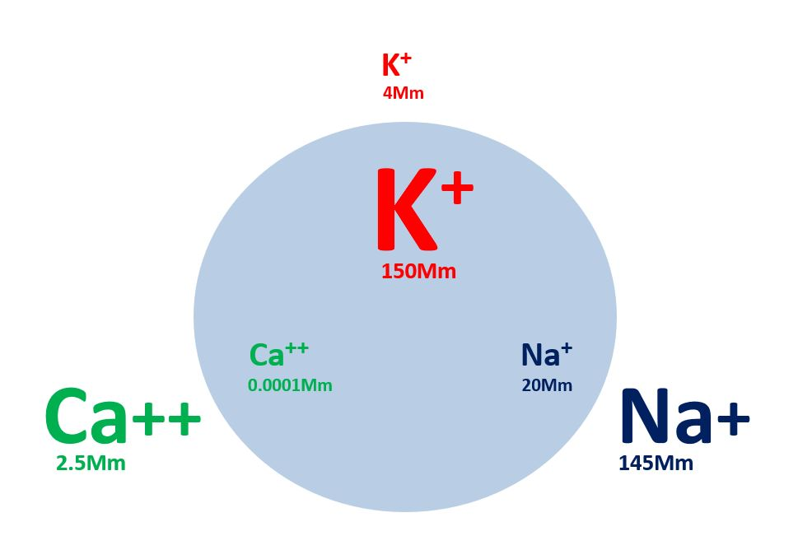
Figure 1. Ion concentrations inside and outside of the cell

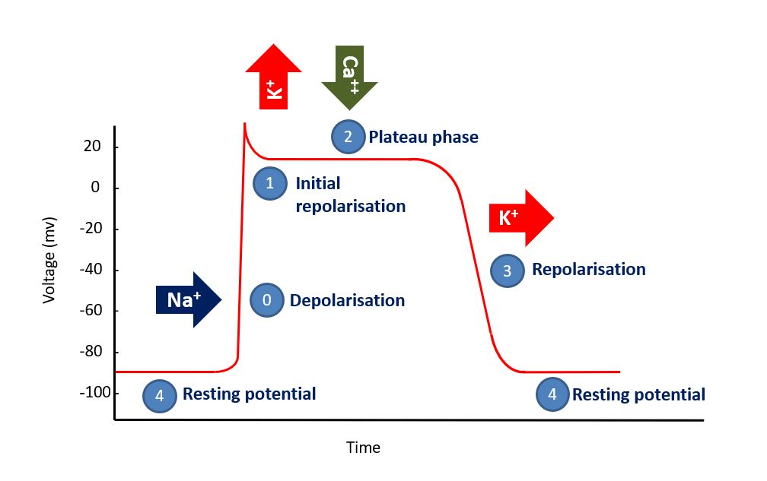
Figure 2. The action potential in a cardiac myocyte

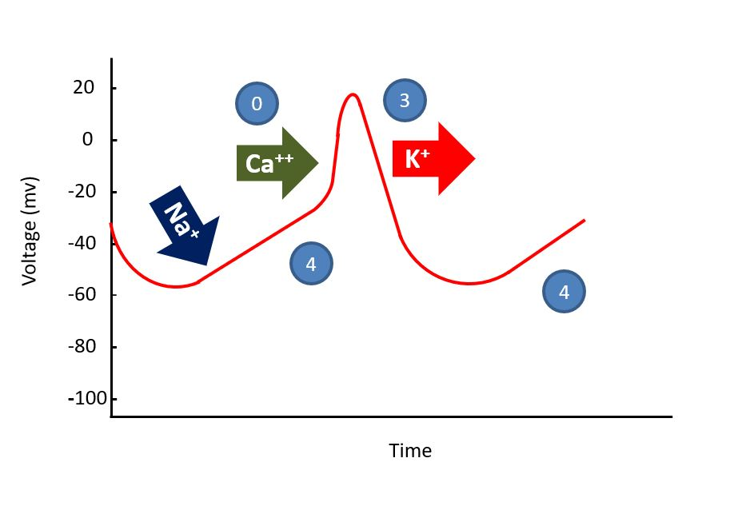
Figure 3. The action potential in a pacemaker cell.

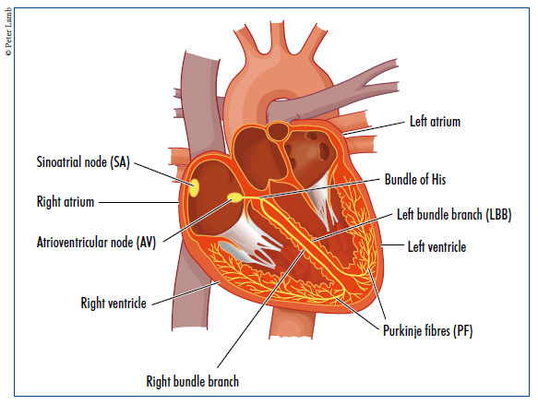
Figure 4. The cardiac conduction system.

Class | Description | Drug examples | Actions
IA | Sodium channel blockers with intermediate offset kinetics | Ajmaline  Disopyramide  Procainamide  Quinidine | - Block sodium ion channels  - Prolong the action potential  - Decrease conduction velocity  - Increase the refractory period  - Effective in atria and ventricles
IB | Sodium channel blockers with fast offset kinetics | Lignocaine  Mexiletine  Phenytoin | - Block sodium ion channels  - Shorten the action potential  - Decrease the refractory period  - Effective in ventricles only
IC | Sodium channel blockers with slow offset kinetics | Flecainide  Propafenone | - Block sodium ion channels  - Marked slowing of conduction velocity  - Little effect on action potential duration or refractory period  - Effective in atria and ventricles
II | Beta-blockers | Atenolol  Bisoprolol  Esmolol  Metoprolol | - Block beta-adrenoceptors on the heart (and elsewhere)  - Decrease sympathetic tone to the heart  - Decrease SA and AV node automaticity and conduction velocity
III | Potassium channel blockers | Amiodarone  Dronedarone  Dofetilide  Sotalol | - Block potassium ion channels  - Increase duration of action potential by prolonging repolarisation
IV | Calcium channel blockers | Diltiazem  Verapamil | - Block calcium ion channels  - Decrease SA and AV node automaticity and conduction velocity
V | Other | Adenosine  Atropine  Digoxin  Ivabradine  Ranolazine  Vernakalant | - Various mechanisms that do not fit into the original classification

Table 1. The Vaughan Williams classification system (Fogoros and Mandrola, 2018; Dan et al, 2018)

Drug | Usual dose | Arrhythmia indication | Comments | Possible adverse effects
Adenosine  (class V) | IV: 6mg followed by further doses of 12mg if first dose ineffective | Termination of Atrioventricular or AV nodal reentrant tachycardias (AVRT or AVNRT) | Avoid in asthma and heart failure. Warn patient of unpleasant but transient side effects | AVB/ventricular standstill; transient but severe chest pain / breathlessness.
Amiodarone  (class III) | IV: Loading dose of 300mg over 20-60 mins, followed by maintenance infusion of 900mg over 23 hours.  Oral: 200mg once daily | Atrial and ventricular arrhythmias. Widely used to maintain sinus rhythm after DC cardioversion. | Potentiates digoxin and warfarin. Causes phlebitis – use central line if available. Hypotension more likely with rapid administration. Little negative inotropy – useful in heart failure. | Hypotension; AVB ; bradycardia; QT prolongation and proarrhythmia rare;  with long term use -thyroid and hepatic dysfunction,  pulmonary fibrosis,  photosensitivity .
Bisoprolol  (class II) | Oral: 1.25 – 10mg once daily | Rate control of narrow complex arrhythmias. Suppression of arrhythmias and ectopy. | Contraindicated in asthma, negative inotrope. Avoid in acute heart failure, but recommended in stable chronic heart failure. | Hypotension; AVB; bradycardia; symptom provocation in asthma, COPD, diabetes, and peripheral vascular disease.
Digoxin  (class V) | IV loading: 0.5-1mg in divided doses at 4-8 hour intervals  Oral loading: 0.75 -1.5mg in divided doses over 24 hours  Oral maintenance: 125-250 micrograms daily | Rate control of narrow complex arrhythmias, especially AF and atrial flutter. | Narrow therapeutic index and renal excretion; risk of toxicity increases in renal impairment, elderly and hypokalaemia. Mild positive inotrope - useful in heart failure. | Bradycardia; AVB; Proarrhythmic at toxic levels.
Diltiazem  (class IV) | Oral: 180 to 360mg daily in divided doses. Sustained release and once daily formulations available. | Rate control of narrow complex arrhythmias, especially AF and atrial flutter. | Useful alternative if beta-blockers contraindicated or not tolerated. Contraindicated in acute and chronic heart failure. | Hypotension; AVB; bradycardia.
Flecainide  (class IC) | IV: 2mg/kg over 10-30 mins (150mg max), followed by reducing dose infusion if necessary  Oral: 100 – 300mg daily in divided doses | Supraventricular and  ventricular arrhythmias, pre-excited AF. | Avoid in structural heart disease (increased risk of proarrhythmia). Negative inotrope. Increases pacing stimulation threshold. | Hypotension; AVB; bradycardia; QRS prolongation; proarrhythmia.
Metoprol  (class II) | IV: up to 5mg over 1-2 mins, repeated after 5 mins if needed.  Oral: 100-300mg daily in divided doses. | Rate control of narrow complex arrhythmias, termination of SVT. | Contraindicated in asthma, negative inotrope. Short duration of action and IV formulation make it useful for acute rate control. | As for bisoprolol.
Sotalol  (class III) | Oral: 80 – 320mg daily in two divided doses | Supraventricular and ventricular arrhythmias. | Highest risk drug for QT prolongation and torsades de pointes - QTc monitoring recommended. Negative inotrope. Avoid in significant renal impairment. | As for bisoprol; QT prolongation; proarrhythmia.
Verapamil  (Class IV) | IV: 5–10 mg over 2-3 mins, a further 5mg after 5-10 mins if needed.  Oral: 120-360mg daily in divided doses. Sustained release formulations available. | Rate control of narrow complex arrhythmias. Termination of SVT and some normal heart VT. | Potentiates digoxin. More negatively inotropic than diltiazem. Contraindicated in heart failure. | Hypotension; AVB; bradycardia.

Table 2. Commonly used anti-arrhythmic drugs. All drugs should be avoided in significant conduction system disease unless a pacemaker is fitted. AVB = atrioventricular block (Dan et al, 2018; Fogoros and Mandrola, 2018; Joint Formulary Committee, 2018; Opie and Gersh, 2013; Pitcher and Nolan, 2015)

References
Antzelevitch C, Burashnikov A. (2011) Overview of basic mechanisms of cardiac arrhythmia. Cardiac electrophysiology clinics. 3(1):23-45.

Bennett DH (2013) Bennett’s Cardiac Arrhythmias: Practical notes on interpretation and treatment. 8th ed. London: Hodder Arnold.

Brignole M, Moya A, de Lange FJ, Deharo JC, Elliott PM, Fanciulli A, Fedorowski A, Furlan R, Kenny RA, Martín A, Probst V. (2018) 2018 ESC Guidelines for the diagnosis and management of syncope. European Heart Journal. 39(21):1883-948.

Cardiac Arrhythmia Suppression Trial (CAST) Investigators (1989) Preliminary report: Effect of encainide and flecainide on mortality in randomized trial of arrhythmia suppression after myocardial infarction, New England Journal of Medicine, 32I, 406-4I2.
Dan GA, Martinez-Rubio A, Agewall S, Boriani G, Borggrefe M, Gaita F, van Gelder I, Gorenek B, Kaski JC, Kjeldsen K, Lip GY (2018) Antiarrhythmic drugs–clinical use and clinical decision making: a consensus document from the European Heart Rhythm Association (EHRA) and European Society of Cardiology (ESC) Working Group on Cardiovascular Pharmacology, endorsed by the Heart Rhythm Society (HRS), Asia-Pacific Heart Rhythm Society (APHRS) and International Society of Cardiovascular Pharmacotherapy (ISCP). Europace. Feb 9.

Fogoros RN, Mandrola JM (2018) Fogoros' electrophysiologic testing. 6th ed. Oxford: Wiley Blackwell; 2018.

Grandi E, Sanguinetti MC, Bartos DC, Bers DM, Chen‐Izu Y, Chiamvimonvat N, Colecraft HM, Delisle BP, Heijman J, Navedo MF, Noskov S (2017) Potassium channels in the heart: structure, function and regulation. The Journal of physiology. 595(7):2209-28.

Hampton JR (2013) The ECG made easy, 8th ed. London: Churchill Livingstone.

Houghton AR & Gray D (2014) Making sense of the ECG: A hands-on guide, 4th edition, Boca Raton: CRC Press.

Joint Formulary Committee (2018) British National Formulary, 75th edition, London: BMJ Group and Pharmaceutical Press.

Kirchhof P, Benussi S, Kotecha D et al (2016) ESC Guidelines for the management of atrial fibrillation developed in collaboration with EACTS, Eur Heart J, 37, 2893–2962.
Klabunde RE (2012) Cardiovascular physiology concepts. 2nd ed. Philadelphia: Lippincott, Williams & Wilkins.

Konstantopoulou A, Tsikrikas S, Asvestas D, Korantzopoulos P, Letsas KP (2013) Mechanisms of drug-induced proarrhythmia in clinical practice. World Journal of Cardiology. 5(6):175.

Opie LH, Gersh BJ (2013) Drugs for the heart. 8th ed. Philhadelphia: Elsevier Saunders

Pappano AJ & Wier WJ (2013) Cardiovascular physiology, 10th edition, Philadelphia, PA: Elsevier/Mosby.

Pitcher D, Nolan J (2015) Peri-arrest arrhythmias. Resuscitation Council UK, London..
Resuscitation Council (UK) (2016) Advanced Life Support. Seventh edition. RCUK, London.

Sandau KE, Funk M, Auerbach A et al (2017) Update to Practice Standards for Electrocardiographic Monitoring in Hospital Settings: A Scientific Statement From the American Heart Association, Circulation, 136:e273–e344.

Steinberg JS, Varma N, Cygankiewicz I, Aziz P, Balsam P, Baranchuk A, Cantillon DJ, Dilaveris P, Dubner SJ, El-Sherif N, Krol J (2017) ISHNE-HRS expert consensus statement on ambulatory ECG and external cardiac monitoring/telemetry, Heart Rhythm, 14(7):e55-96.
Van Gelder IC, Rienstra M, Crijns HJ, Olshansky B (2016) Rate control in atrial fibrillation. The Lancet. 388(10046):818-28.

Vogler J, Breithardt G & Eckardt (2012) Bradyarrhythmias and conduction blocks, Rev Esp Cardiol, 65, 656-667.

Zimetbaum P, Goldman A (2010) Ambulatory arrhythmia monitoring: choosing the right device. Circulation, 122:1629e1636.

