Quality Assurance of Cross-border Construction Logistics and Supply Chain during the COVID-19 Pandemic: Evidence from the Hong Kong–Mainland China Links
Frank Ato Ghansah^{a*}, Weisheng Lu^{b} and Benjamin Kwaku Ababio^{c}
ª PhD Candidate, Real Estate and Construction Department, Faculty of Architecture, The University of Hong Kong, Hong Kong
^{b} Professor, Real Estate and Construction Department, Faculty of Architecture, The University of Hong Kong, Hong Kong
^{c} PhD Candidate, Real Estate and Construction Department, Faculty of Architecture, The University of Hong Kong, Hong Kong

*Corresponding author, email: fghansah@connect.hku.hk

Abstract
Quality assurance (QA) of Cross-border construction logistics and supply chain (Cb-CLSC) is anticipated to promote regional connectivity of country borders. However, the complexities involved have been worsened amid the coronavirus (COVID-19) pandemic. Among the ongoing academic discourses concerning the impact of the pandemic on relevant areas in construction, previous studies have not paid attention to the impact of the pandemic on the QA of Cb-CLSC. This study, therefore, aims to examine the QA practices of Cb-CLSC amid the pandemic by adopting an embedded mixed method design involving a comprehensive desk literature review and experts across the Hong Kong–Mainland China links, a typical Cb-CLSC context. The study revealed 10 critical QA practices of Cb-CLSC, with the top five comprising the “understanding requirements, norms, and standards of quality”, “assigning clear responsibilities to qualified workers”, “recording and documenting work processes, steps, project routine, and seamless implementations”, “keeping close contact with clients to realise their demands”, and “strategic planning based on client requirements and corporate capability”. This attained a 55% agreement percentage, a relatively good agreement between experts in the industry and academia based on their ranking of the QA practices. Sentiment analysis of the QA practices of Cb-CLSC amid the pandemic denoted the impacts of the pandemic to be largely neutral, i.e., the created opportunities neutralise the negative impacts. This study then contributes theoretically and practically by empirically revealing the critical QA practices of Cb-CLSC and deepening the understanding of the pandemic’s impacts on them to practitioners, researchers, and policymakers. This may help develop innovative approaches and make effective operational decisions to adequately position the QA practices of Cb-CLSC for the post-pandemic era and endure the risks of future pandemics.

Keywords: COVID-19, Construction, Cross-border construction logistics and supply chain, Hong Kong–Mainland China links, Quality assurance.

1 Introduction
The pursuit for regional connectivity of countries/borders has promoted Cross-border construction logistics and supply chain (Cb-CLSC), which is the interrelated processes and activities involving contractors and suppliers between two countries/borders, requiring one to perform construction services in other countries (Mawhinney, 2008). The Hong Kong–Mainland China links have been no different since 1979, largely due to the global economic restructuring in the post-Fordist era, where the enclave of Hong Kong plays an indispensable role in the process (Chan, 1998). As such, performing quality assurance (QA) on projects has been critical as it assures confidence in the project to perform satisfactorily during the entire service life, as well as meeting pre-stated standards and requirements (International Organisation for Standardisation [ISO], 1994). With QA being integrated into Cb-CLSC, it regulates the construction processes and services (i.e., process-oriented) to prevent side-stepping (Chung, 2022) depending on management’s effective review of events. This distinguishes QA from quality control (ReQtest, 2016), though sometimes used in tandem. QA is process-oriented and focuses on improving processes and methodologies to develop a quality project by engaging every member of an organisation toward avoiding defects (proactive measure), whereas quality control is product-oriented and focuses on improving the end products by identifying the defects and fixing them (reactive measure), which involves the engagement of specific teams that test the products (ReQtest, 2016; Hamilton, 2023). However, quality control may be a significant part of the QA processes toward a project, where individual completed sub-works are inspected and tested to ensure quality before moving to the next sub-works (ASQ, 2015). QA and quality control, therefore, work together to satisfy the quality expectations of a project, but they have different focuses. To achieve adequate QA of Cb-CLSC, there must be effective collaboration and communication among all stakeholders, in and outside a specific border. This has been noted with complexities that must be considered when conducting QA on cross-border projects.

The sudden occurrence of the coronavirus pandemic disease (COVID-19) (World Health Organisation [WHO], 2020) has worsened the complexities in conducting the QA of Cb-CLSC by disrupting the supply chain in the construction sector. The COVID-19 mitigation measures, though they have helped achieve steady recovery (Office for National Statistics [ONS], 2021; Eurostat, 2022), have also impeded the movement between countries/borders during QA; hence, disrupting the close coordination and interaction of workers, communication, work execution, material supply, manufacturing, and the human resource availability (McKinsey and Company, 2020; Morris, 2020; Li et al., 2022). As the COVID-19 impact is significant, it is worth noting that the QA of Cb-CLSC has been problematic, varying from organisation to organisation. Nonetheless, the baseline can be drawn toward the ISO 9000/9001, which stipulates the model for QA in design, development, production, installation, and service. As the QA is critical in the study’s context, the academia could report critical QA practices, which have been an existential issue, based on effective collaborations with the industry.

Furthermore, since the pandemic’s debut, there have been ongoing discourses about the pandemic not being wholly negative in the construction industry but rather having positive impacts depending on how organisations capitalise on the opportunities (Ghansah and Lu, 2023). For instance, Onubi et al. (2022) examined the impacts of the pandemic on health and safety management by moderating the effects of the project size on the relationship between the safety protocols and the economic performance of projects. Soliman et al. (2022) also examined the pandemic’s impact on workforce management by considering labour’s motivational factors and construction productivity. Sharma et al. (2022) focused on the survivability of sustainable supply chains during the pandemic and post-pandemic by developing an enhancement framework. Other studies have also generally considered the impact of the pandemic on the construction project management lifecycle (Simpeh and Amoah, 2021; Niroshana et al., 2022; Artpairin and Pinmanee, 2022; Gupta and Singh, 2021). However, among the ongoing discourses concerning areas in construction, previous studies have not paid attention to the impact of the pandemic on the QA of Cb-CLSC, which the pandemic has severely disrupted. Tackling this issue commences with identifying and understanding the critical QA practices of Cb-CLSC, which has also been an existential problem. By bringing this problem into light, this study could help position the QA practices adequately for the post-pandemic era and endure the risks of future pandemics by harnessing the created opportunities to devise innovative approaches and make effective operational decisions.

This study thus aims to examine the QA practices of Cb-CLSC amid the pandemic by achieving two main objectives: (1) identify the critical QA practices of Cb-CLSC and (2) perform sentiment analysis on the critical QA practices. The objectives are achieved by adopting an embedded mixed method design consisting of a literature review, survey, and interview from experts within the Hong Kong-Mainland China links, which is a typical case. The embedded mixed method design is a good approach due to the study’s limited time in taking the data (Yu and Khazanchi, 2017; Creswell and Clarke, 2017), and it allows one method to lead the analysis with the secondary method providing addition and complementary information (Edmond and Kennedy, 2017). The study, thus, not only contributes to a better understanding of the QA practices and their sentiments amid the pandemic but is also important to the QA front-liners, such as quality engineers, quality managers, etc., and policymakers in developing innovative and operational decisions to position the QA of Cb-CLSC adequately for the post-pandemic era and to endure the risks of future pandemics. Also, the results of this study can be used as a basis for further research to identify the critical challenges and resultant impacts of the pandemic on the QA of Cb-CLSC toward developing an effective managerial framework to adequately position the QA systems for the post-pandemic era and endure the risks of future pandemics. The paper is therefore structured as follows. Following the introduction are the literature review, research method, data analyses and results, discussion, and conclusion.

2 Literature Review

2.1 QA of Cb-CLSC
Cb-CLSC promotes regional connectivity of countries/borders, encouraging international trade and the construction market. It includes interrelated construction services such as border crossing, duties, track record, and proper transportation (Pilatowska, 2021). Cb-CLSC is jointly mentioned with terms such as cross-border construction, logistics and supply chain; thus, important to acknowledge the differences (Pilatowska, 2021). In literature, different terms have been adopted to refer to the concept of Cb-CLSC, and these include “cross-border project” (European Commission, 2001), “international construction” (Gizaw, 2021), and “foreign construction market” (Arditi and Gutierrez, 1991). However, for this study, the definition of Cb-CLSC by Mawhinney (2008) is adopted due to its clarity and simplicity to the “layman” and is defined as “where one company, resident in one country, performs construction works in another country”.

Cb-CLSC has the characteristics of long-distance transportation, usually multimodal transportation. It is complex but critical for improving the regional connectivity of countries/borders and promoting international trading and construction. Cb-CLSC consists of interrelated stages, including the designing, construction, and the other stages involving project delivery to the client (Behera et al., 2015). This is typical of traditional construction. For modular construction projects, an alternative to traditional construction projects, the interrelated phases may involve the designing, production, storage, cross-border logistics, onsite storage and assembly (Yang et al., 2021). For Cb-CLSC, Construction work and services are carried out by various subjects from different countries, where the subjects may refer to legal persons or multinational firms (Gizaw, 2021). Due to the various subjects involved at different stages in handling the projects under Cb-CLSC, QA must be conducted.

The project management body of knowledge (PMBOK, 2017) termed QA as part of an organisation’s quality system that ensures project deliverables meet planned quality standards and requirements. Thus, termed “manage quality”, though it could be a broad term in non-project works. QA ensures that projects meet all quality requirements consisting of client, statutory, and organisational requirements (ISO, 1994). QA is process-oriented as specified in ISO 9001:2015, and it maintains consistent quality in construction by avoiding mistakes and errors in the first instance. Such preventive measures must be ensured in an organisation from the top-down and the bottom-up levels by minimising managerial risks and communication issues that affect project quality. For this study, it is important to acknowledge the significant difference between QA and quality control, mostly used in conjunction in literature, considering a set of specific factors as shown in Table 1. Quality control may be a significant part of the QA processes toward a mega project, where individual completed sub-works are inspected and tested to ensure quality before moving to the next sub-works (ASQ, 2015). QA and quality control, therefore, work together to satisfy the quality expectations of a project under Cb-CLSC, but they have a different focus. Consequently, this study adopts the definition of QA by the PMBOK (2017), supported by the ISO because of its international acceptance.
Table 1: Similarities and Differences Between QA and QC
Factor | QA | Quality Control
Definition | Implementation of processes, methodologies and standards that ensure that the product developed will be up to the required quality standards. | Set of activities that are carried out to verify the developed product meets the required standards.
Target | Focuses on the improvement of processes and methodologies used to develop a product. | Focuses on the improvement of the product by identifying the bugs and issues.
Orientation | Process-oriented. | Product-oriented.
Nature of process | A preventive process as it establishes the methods which prevent the bugs. | A corrective process as it focuses on identifying the bugs and getting them fixed.
Verification and validation | Verifies you are doing the right thing in the right manner. | Validates the product against the requirements.
Measurements | Creates the systems to measure and control quality to create confidence that quality products will be produced. | Measures the quality level of individual products and accepts/rejects them based on the criteria developed by QA.
Persons involved | All the persons involved in the project, starting from the requirements. | Responsibility of the quality control inspector or the testing team that finds the issues.
Tools and techniques | Defining processes, quality audit, selection of tools, and training.
Examples | Include process checklists, process standards, process documentation and project audit. | Include inspection, deliverable peer reviews and the software testing process.
Source: (ReQtest, 2016; Roseke, 2022; Hamilton, 2023)

Conducting QA of Cb-CLSC is highly dependent on the quality management system of an organisation, and this embraces the organisational resources, structure, and procedures (ISO, 1994; Lee et al., 2022). Chung (2002) asserted that QA integration into the supply chain of Cb-CLSC regulates operations and services, preventing side-stepping and errors from quality requirements. A concerted effort is needed for an effective QA of Cb-CLSC by ensuring everyone knows what they are expected to perform and what their colleagues are doing (Chung, 2002; Thorpe and Sumner, 2017; Montoya-Torres et al., 2021). This denotes that QA, though there are front-liners like quality engineers, quality managers, etc., is a collective responsibility of all workers in an organisation. However, the QA of Cb-CLSC has been challenging, varying from organisation to organisation. Many researchers, in collaboration with the industry, have reported on the quality management practices in the construction industry (Nyakala, 2017; Thorpe and Summer et al., 2017), but none have tailored the study to the unique QA practices of Cb-CLSC. A comprehensive desk literature review of mostly peer-reviewed articles identified 14 potential QA practices of Cb-CLSC, as illustrated in Appendix S1. Among the potential QA practices, it is noted that the baseline can be drawn toward ISO 9000/9001, which stipulates the model for QA in design, development, production, installation, and service (Kafetzopoulos and Gotzamani, 2014; Budayan and Okudan, 2022). The study adopted Deming’s management model to define the potential QA practices in adequately fitting the Cb-CLSC (Deming, 1986; Anderson et al., 1994; Barone, 2022). However, there could be correlations among the potential QA practices of Cb-CLSC.

In a typical Cb-CLSC, the consultant, the inspector, the client representative, the government-authorised agencies, and other qualified personnel may need to travel offshore to foresee the quality of the construction project/material. Lu et al. (2022) demonstrated a specific case for modular construction between Hong Kong and the Guangdong Province of Mainland China, where authorised persons and client representatives are dispatched offshore to verify and accept the quality of modular components. This process becomes problematic, especially when there is a black swan event, which is beyond what is normally expected of a situation and potentially has severe consequences. This may include pandemics, wars, and the like.

2.2 COVID-19 Outbreak and its Effects on Construction: Pandemic Era
COVID-19 was declared a pandemic in March 2020 (WHO, 2020) and has gained a global transmission rate, recording nearly 600,000,000 confirmed cases and 6,436,519 deaths (WHO, 2022). Countries worldwide have recorded their shares in this global transmission, which has impacted the travel rate from one country to another due to death, fear, and panic. Thanks to visionary stakeholders, the transmission rate of the pandemic has been understood, and appropriate strategies and restrictions have been devised to ensure a safe workplace environment (WHO, 2020). As a result, some countries have noted the pandemic to be normal and have eased restrictions, while others are still adhering to restrictions and continue to handle the spread of the virus.

The COVID-19 mitigation measures, while stabilising the spread of the pandemic, have caused disruptions in activities across industries. Specifically, the construction industry has been severely hit by the pandemic (McKinsey and Company, 2020; Li et al., 2022), along with mitigation measures such as the lockdown, travel restrictions, etc. This is due to the nature of activities, which requires interactions with co-workers and construction materials on sites (American Industrial Hygiene Association [AIHA], 2020). A study published in April 2020 reported that 8.3% of the 5.9 million construction workers were exposed to the virus once a month (Baker et al., 2020). The high risk of getting infected (Karwasra et al., 2021) has raised fear and panic in the construction industry during task execution. As such, Morris (2020) reported on challenges such as delay and suspension of projects, cancellation of planned and new projects, supply chain disruptions, operational restrictions, labour shortages, and financial problems. Greater concerns have been raised on cross-border projects, affecting related construction practices such as QA.

2.3 Knowledge Gap
Overall, studies on the pandemic’s impacts on the construction industry have been limited by not considering the systematic based research regarding the pandemic’s impacts on the QA practices of Cb-CLSC. For instance, Onubi et al. (2022) examined the impacts of the pandemic on health and safety management by moderating the effects of the project size on the relationship between the safety protocols and the economic performance of projects. Soliman et al. (2022) also examined the pandemic’s impact on workforce management by considering labour’s motivational factors and construction productivity. Sharma et al. (2022) focused on the survivability of sustainable supply chains during the pandemic and post-pandemic by developing an enhancement framework. Other studies have also generally considered the impact of the pandemic on the construction project management lifecycle (Simpeh and Amoah, 2021; Niroshana et al., 2022; Artpairin and Pinmanee, 2022; Gupta and Singh, 2021). However, existing empirical studies have not yet examined the QA practices of Cb-CLSC amid the pandemic to position it appropriately. Tackling this issue commences with identifying and understanding the critical QA practices of Cb-CLSC, which has been an existential problem. This is a vital part of research if a researcher wants to understand the pandemic’s impact on the QA in the study context. As such, there is a current need to identify the critical QA practices of Cb-CLSC based on the experts’ views and examine their sentiments on the QA practices amid the pandemic. Therefore, this study aims to identify and examine the critical QA practices of Cb-CLSC amid the pandemic by engaging experts in the Hong Kong–Mainland China links. This knowledge would assist in devising strategies to make the QA of Cb-CLSC adequate for the post-pandemic era and to endure the risks of future pandemics (Liu et al., 2022; Ghansah and Lu, 2023).

3 Research Methods
This study adopted the embedded mixed method design, where qualitative and quantitative data are collected and analysed within traditional quantitative research design (Creswell and Clarke, 2017), following a four-step research process, as shown in Figure 1.
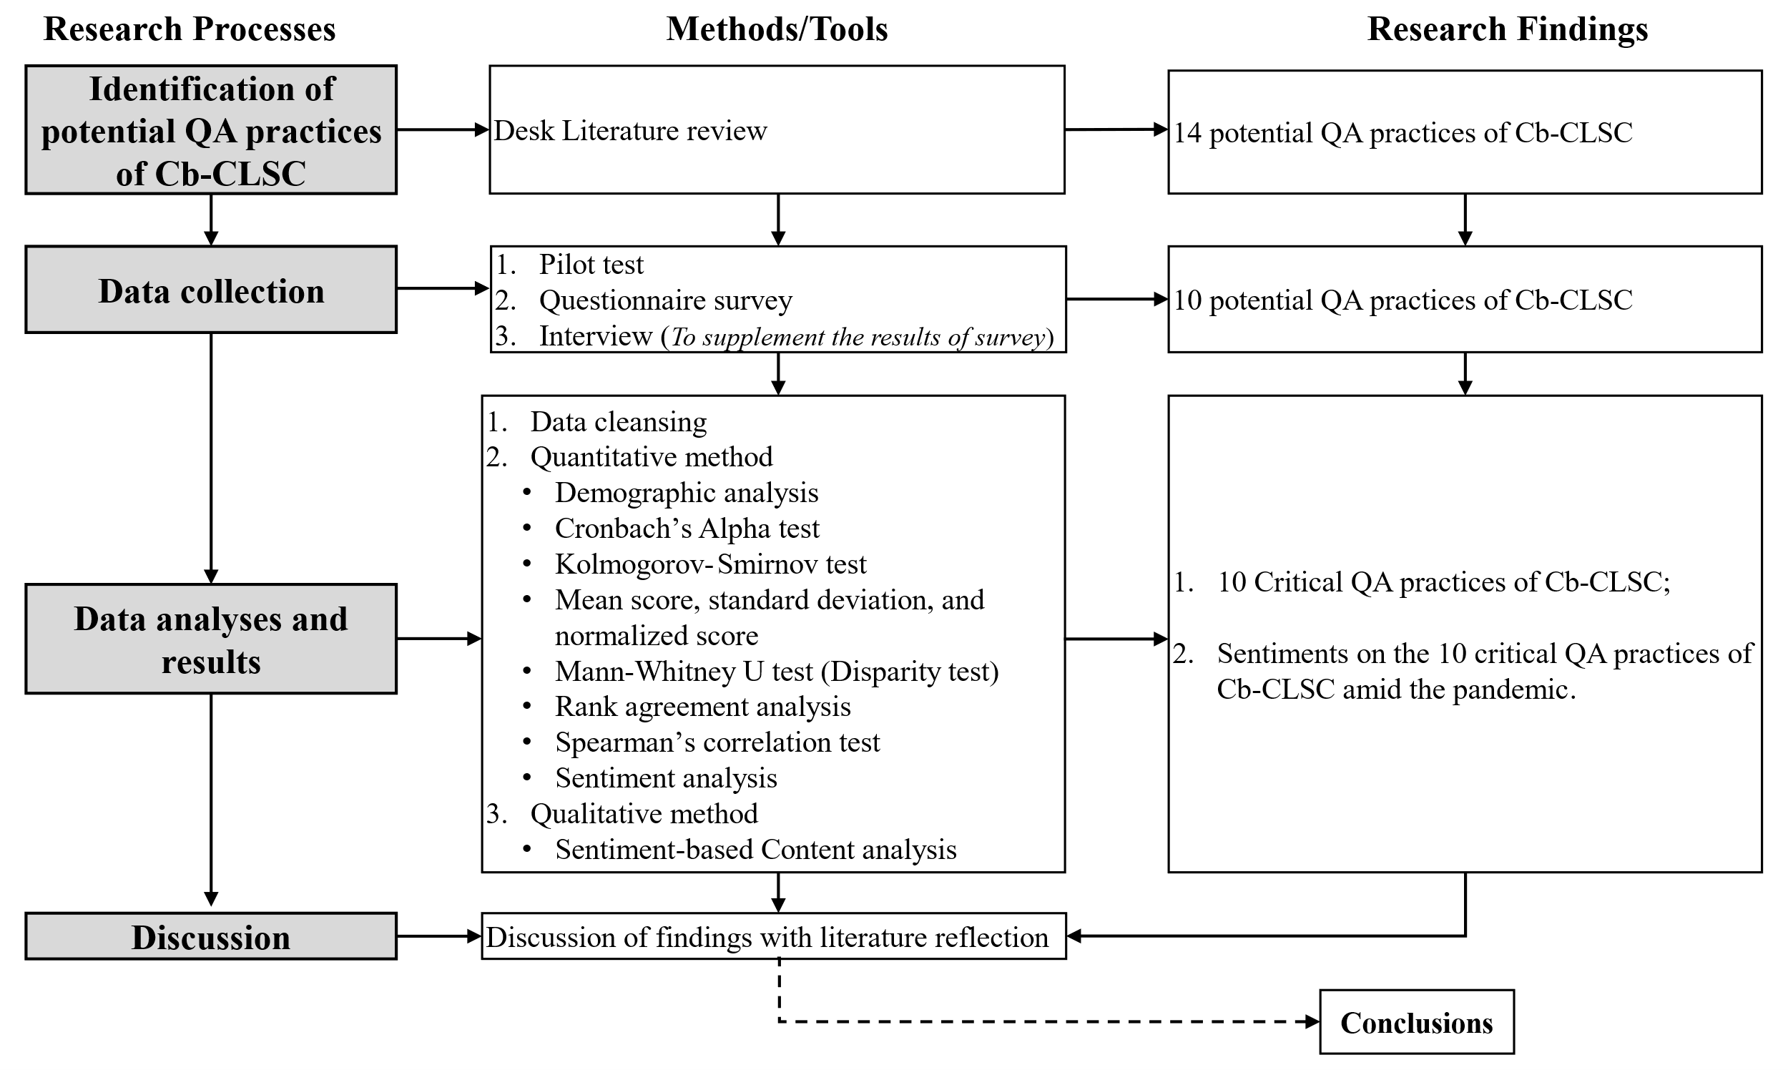
Figure 1: Research Workflow

3.1 Identification of Potential QA Practices of Cb-CLSC
Desk study engaging literature review was adopted for this study following two rounds. The first round included keywords (see Appendix S1) which were entered to find relevant literature in Google Scholar, Scopus, and Web of Science databases. However, research on the QA practices of Cb-CLSC was lacking as well as its status in the pandemic era. In this preliminary search, it is necessary to identify the possible QA practices of Cb-CLSC. Thus, the second round of research was performed to identify the QA practices among collected studies and tailor them to fit in the context of Cb-CLSC. To attain a comprehensive list of QA practices for Cb-CLSC, ISO 9001:2015 was engaged due to its international institutionalisation. Deming’s management model also aided in understanding the best QA practices needed for Cb-CLSC. Consequently, 14 potential QA practices of Cb-CLSC were proposed (see Appendix S1), and these would be tested to understand the impacts of COVID-19 based on experts’ views.

3.2 Data Collection
Grounded on a comprehensive desk literature review, an initial questionnaire survey was developed, capturing the 14 potential QA practices of Cb-CLSC. The intention is to determine the consensus level on the potential QA practices in the context of Cb-CLSC, considering the experts’ views from academia and the industry, and subsequently, determine their sentiments amid the pandemic. A questionnaire allowed empirical data to be collected from the Hong Kong–Mainland China links, ensuring experts’ anonymity and data confidentiality. The Likert Scale was adopted to rank the potential QA practices in terms of agreement and sentiment level due to its introduction of minimal response bias, viz: level of agreement (1=strongly disagree, 2=disagree, 3=neutral, 4=agree, 5=strongly agree) and level of sentiment (1=negative, 2=neutral, 3=positive).

A pilot study was conducted to check the comprehensiveness and relevance of the QA practices for Cb-CLSC by involving valuable responses from five experts (two quality inspectors [one from Hong Kong and the other from Mainland China] and three academicians [two Assistant Professors from Hong Kong and one Professor from Mainland China]). The valuable comments helped redefine the 14 potential QA practices into 10 (see Table 2), informing the final questionnaire (see Appendix S4). The interview questions were also piloted to have refined questions to attract experts’ participation (see Appendix S5).

Table 2: Redefined list of Potential QA practices of Cb-CLSC after the Pilot Test
No | Proposed QA practices | References
QAP1 | Clearly defining responsibilities based on the quality requirements. | 1,2,3
QAP2 | Assigning clear responsibilities to qualified workers. | 1,3,4,5
QAP3 | Understanding requirements, norms, and standards of quality. | 6,7
QAP4 | Keeping close contact with clients to realise their demands. | 8,9,10,11
QAP5 | Providing quality training for workers toward project execution. | 6,12,13,14,15,16
QAP6 | Maintaining quality standards. | 6,7
QAP7 | Recording and documenting work processes, steps, project routine, and seamless implementations. | 17,18
QAP8 | Communicating and coordinating with other workers to obtaining information about the project. | 6,19,20,21
QAP9 | Strategic planning based on client requirements and corporate capability. | 1,8,9,3,22
QAP10 | Analysing results of work operations and quality records. | 6,12
For detailed references, see Appendix S2

The study population consisted of construction QA experts (both academia and industry practitioners) with relevant practical experience within Hong Kong and Mainland China. As QA is a collective effort in construction organisations, experts such as project managers and construction managers were also engaged. This follows the concept of “expert” as defined by Cabaniss (2022). Because there is no central database for construction QA, a non-probability sampling technique known as purposive sampling was adopted by targeting the experts with knowledge and experience in the subject matter.

Experts were considered if (1) they had extensive experience and were theoretically versed in the construction QA processes, (2) they had sufficient direct hands-on experience in construction QA, and (3) they had been involved in at least QA processes in their organisation. Overall, the expert must be in either Hong Kong or Mainland China. The academic experts were also identified from highly recognised peer-reviewed journals which have contributed to the field of QA in the construction industry, whereas the industry practitioners were identified from construction companies in Hong Kong and Mainland China. Websites of some professional associations in Hong Kong and Mainland China were searched via LinkedIn and direct company webpage to retrieve contact addresses of industry practitioners. Also, the snowball sampling technique was engaged for practitioners to help direct the researcher to other potential experts. The questionnaire survey was then distributed online using “Qualtrics XM” via personalised emails to allow online responses. This was conducted along with the interview questions and consent forms to pave the way for the interview session via a virtual platform using Zoom and WeChat. The duration for data collection lasted five to six months. Several reminders were sent throughout the data collection period, prompting the experts to respond to the survey and attend an interview session if available.

The total number of questionnaires distributed within the enclave of Hong Kong and Mainland China was not determined as humble appeals were requested to pass on the questionnaire to any other appropriate experts who know the study’s context. However, an approximate value of 200 online questionnaires could be estimated for the distribution. Fifty-two (52) responses were finally retrieved from the experts. A limitation of this approach is the accurate estimation of the response rate, as the survey was possibly forwarded to other potential experts by some of the respondents. Nonetheless, it is generally suggested scientifically and agreed among scholars that a minimum sample size of 30 could be appropriate for analysis (Ott and Longnecker, 2015). Thus, the 52 responses could be considered relatively high for analysis in this study. Nonetheless, six interviews were conducted to derive deep insight into the impacts of the pandemic on the QA practices of Cb-CLSC, meeting the minimum requirement required for a qualitative study: 5-50 participants (Dworkin, 2012).

4 Data Analyses and Results
The collected data was first cleansed to remove uncompleted responses. Data analysis was conducted using the Statistical Package for the Social Sciences (IBM–SPSS), version 27. The analysis techniques include Cronbach’s Alpha test, normality test, descriptive analysis, inferential analysis (Mann-Whitney U test, rank agreement test, Spearman’s correlation test), and sentiment analysis. Before that, a preliminary demographic analysis is performed to understand the profile of respondents using frequency and percentages.

4.1 Demographic Profile of Experts
Figure 2 details the profile of the experts engaged in the survey, whereas Table 3 presents the profile of the interviewees. Overall, in the Hong Kong–Mainland China links, the experts constituted 44.23% from Mainland China and 55.77% from Hong Kong. The response rate of experts from the academia was 23.09%, a good survey response reflecting the consent of the academia (Cleave, 2020), while the industry was 76.92%, across Hong Kong–Mainland China links with specialities, such as academics, quality auditing, and quality engineering. It also engaged authorised persons from the governments, client representatives, and others. The “others” included other team members deemed essential in the QA process, i.e., project managers, construction managers, and site supervisors. Most experts had years of work experience from 1–10 years either by research or industry experience, and few had work experience from 11–20 years. The detail of their distribution across the Hong Kong-Mainland China link is illustrated in Figure 2. With the interviewees, experts were noted to be highly qualified with academic certificates and work experience from two to ten years across Hong Kong and Mainland China.
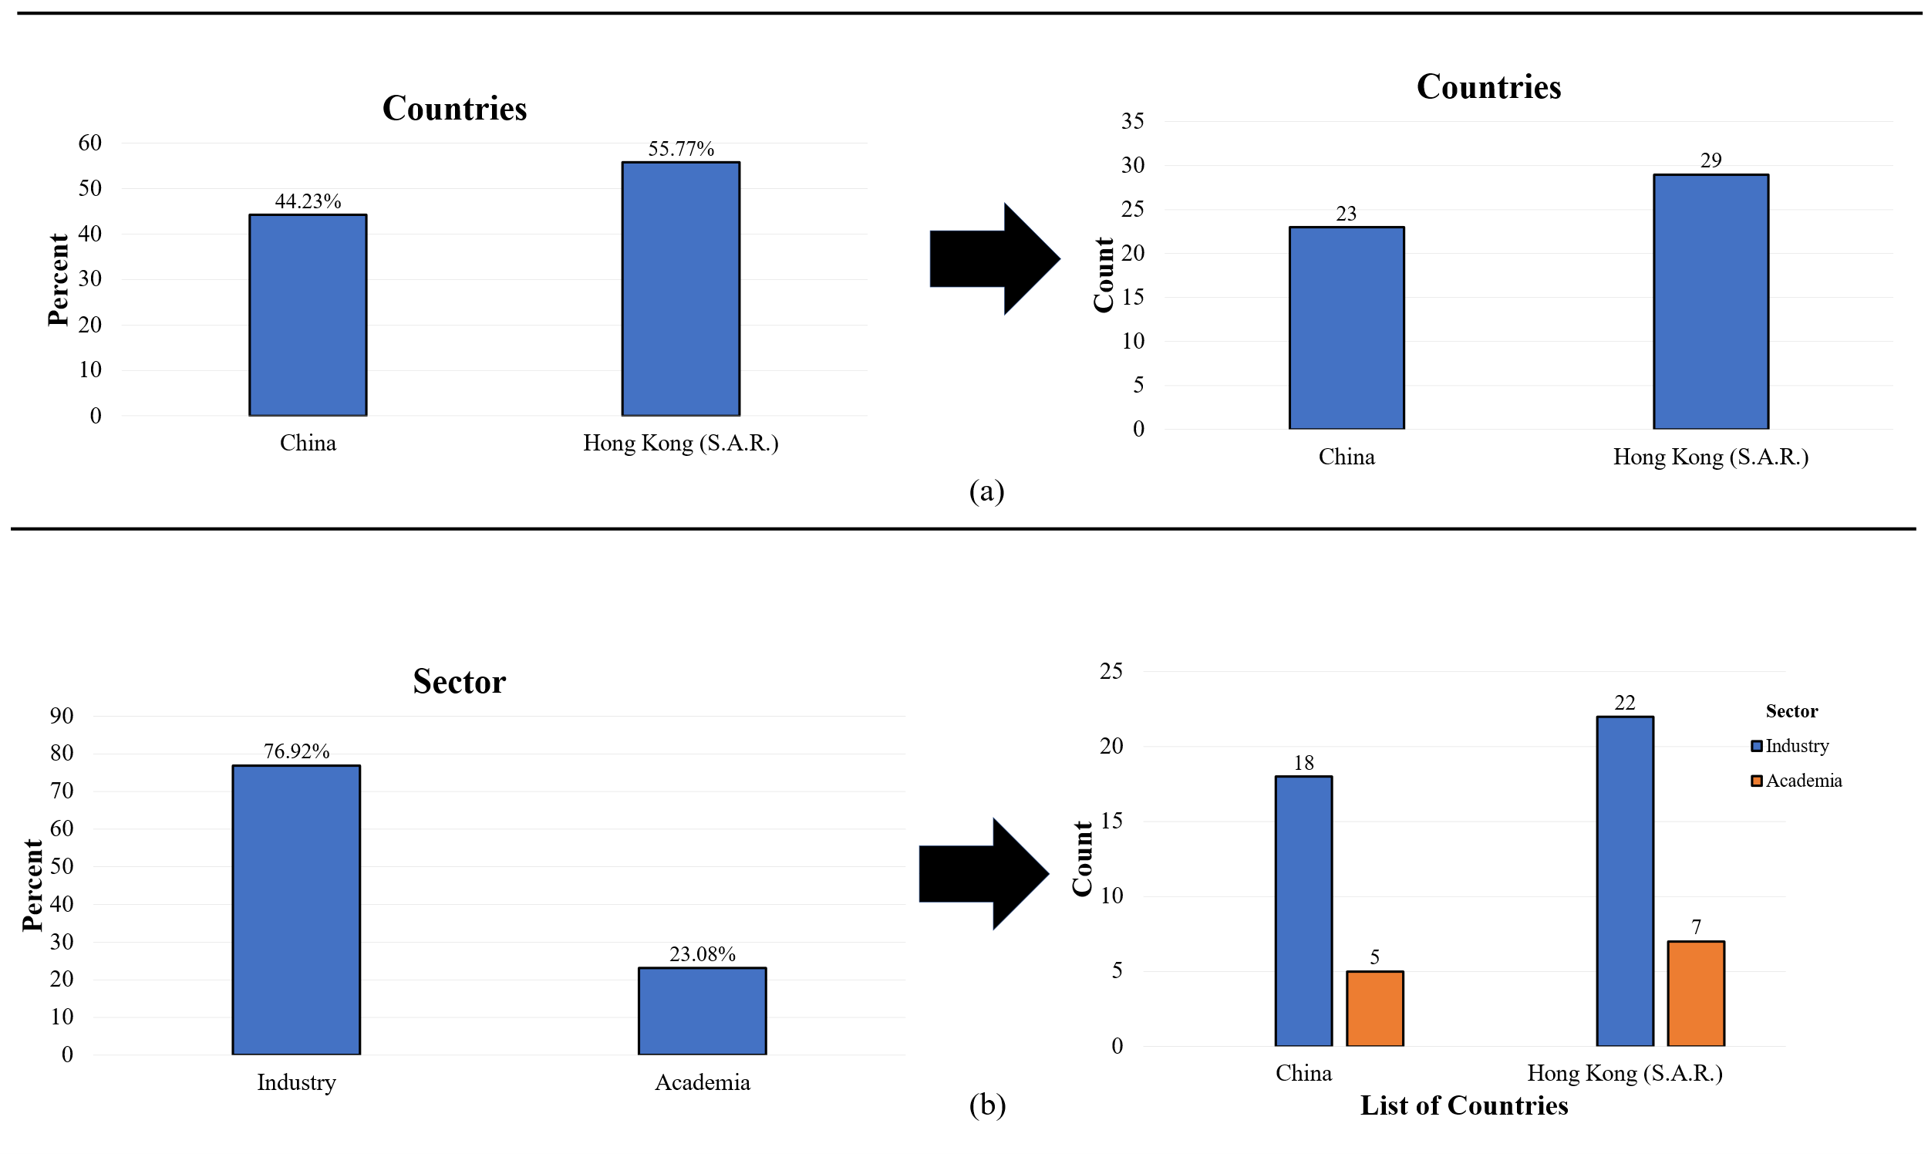
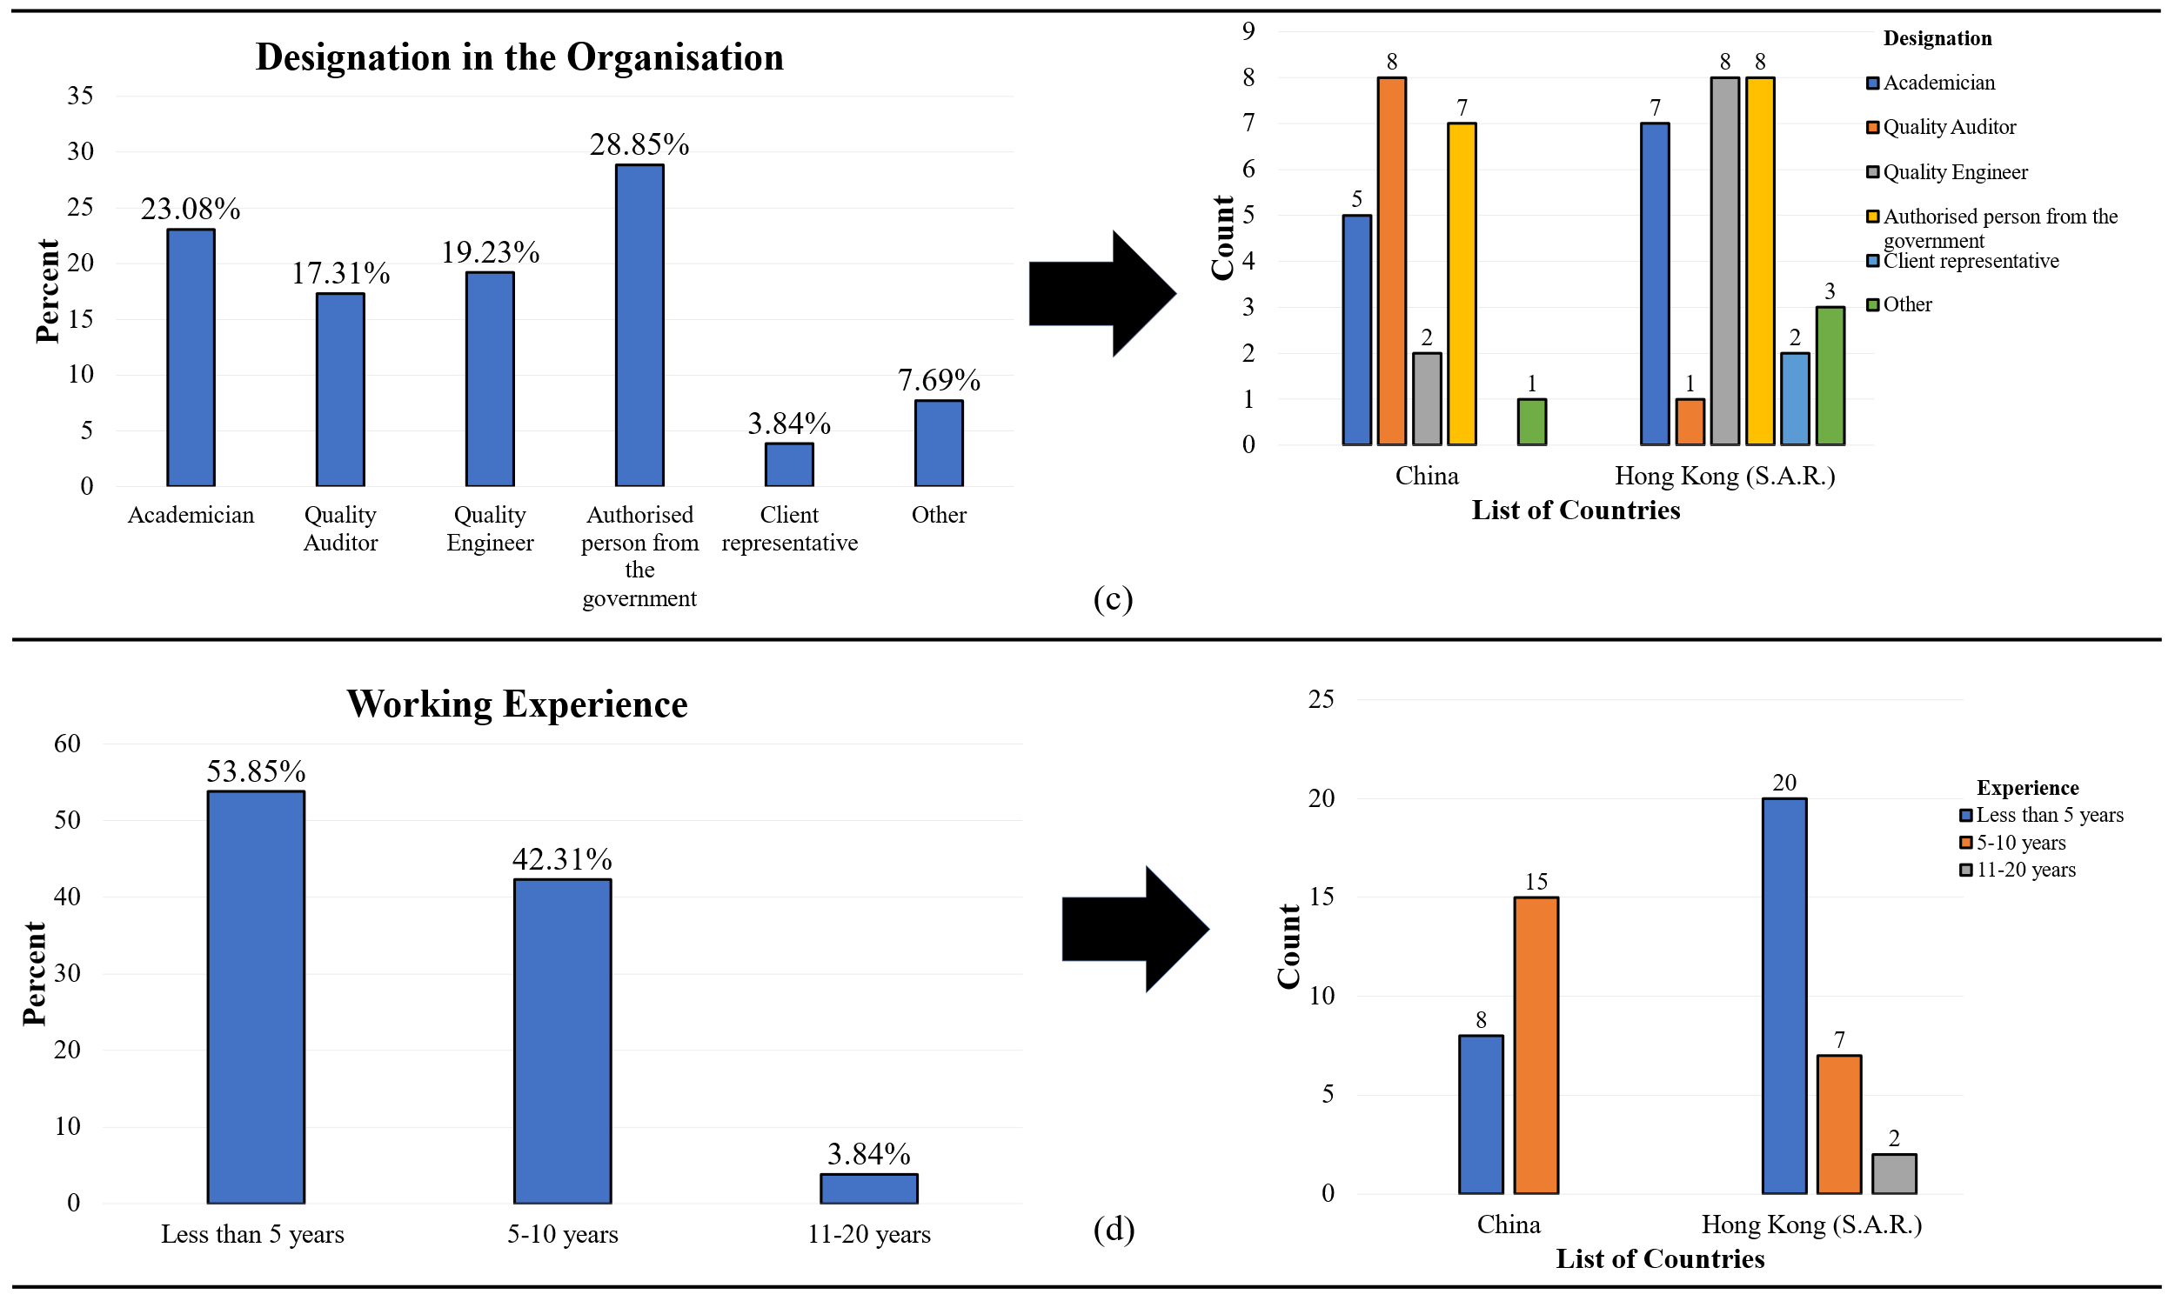
Figure 2: Demographic Profile of Experts from the Survey

Table 3: Profile of Interviewees
Interviewee | Position | Qualification | Years of Experience | Interview type | Country
A | Quality inspection officer | BSc | Five years | Virtual_(WeChat) | China
B | Quality inspection officer | MSc | Two years | Virtual_(WeChat) | Hong Kong
C | Quality manager | MSc | Ten years | Virtual_(Zoom) | Hong Kong
D | Director of Quality Management System Department | MSc | Four years | Virtual_(WeChat) | China
E | Quality officer (In charge of logistics) | BSc | Two years | Virtual_(WeChat) | China
F | Quality Engineer | BSc | Seven years | Virtual_(Zoom) | Hong Kong

4.2 Cronbach’s Alpha (CA) Test,
With the main data, the reliability test was conducted using CA to measure the internal consistency of the data by comparing the results to the rule of thumb: a CA value<6.00 connotes low reliability, and it is unacceptable; 0.60-0.80 means moderate and acceptable; and finally, 0.80-1.00 connotes very good, depicting higher internal consistency and validity of the data (Pallant, 2001). The CA for this study’s measurement scale was estimated: level of agreement (0.91) and level of sentiment (0.83). This depicts an excellent internal consistency among the data. Hence, further analysis can be conducted.

4.3 Normality Test and Descriptive Analysis
The Kolmogorov-Smirnov (K-S) test, with the associated thumb rule (Mishra et al., 2019) adopted for this study, denoted the dataset not to be normally distributed (see Table 4). A descriptive analysis using the mean score was adopted to measure the central tendency of the QA practices, whilst the standard deviation (SD) measured the level of variability and dispersion among the expert responses (Kenton, 2019). The lower SD prevails when there is an equal mean score among two or more QA practices. Based on the mean score, the normalised score was calculated to determine the level of criticality of the QA practices based on the experts’ responses. Hence, a normalised score ≥0.50 is deemed more critical (Adabre et al., 2020). Table 4 depicts the descriptive analysis outcome, whilst the mean confidence level at 95% is shown in Appendix S6.

4.4 Disparity Test
Due to the non-parametric nature of the dataset, the Mann-Whitney U (M-WU) test was adopted to assess the degree of association of the experts’ rankings of the QA practices of Cb-CLSC based on the level of agreement from the perspective of academia and industry practitioners within Hong Kong–Mainland China links. Using the M-WU test, the null hypothesis, H₀, is that there is no significant disparity vis-à-vis the level of agreement on the QA practices of Cb-CLSC among the two groups (academia and industry). The H₀ can be rejected if the P-value is less than or equal to the significant level of 0.05. Table 4 summarises the results of the disparity test between academia and the industry.
Table 4: Descriptive, Kolmogorov-Smirnov, and Mann-Whitney test statistics
Code |  | Overall |  |  |  |  | China |  |  |  | Hong Kong |  |  |  | Kolmogorov-Smirnovª (KS) |  |  | Mann-Whitney U
 |  | Mean | SD | Ns | Rank |  | Mean | SD | Ns |  | Mean | SD | Ns |  | KS stat. | Sig.,  P-value |  | U stat | W | Z | P-value
QAP1 |  | 4.06 | 1.09 | 0.69 | 7 |  | 4.26 | 1.10 | 0.75 |  | 3.90ª | 1.08^{c} | 0.63 |  | 0.31 | 0.00 |  | 202.50 | 1022.50 | -0.871 | 0.38
QAP2 |  | 4.08 | 1.06 | 0.77 | 2 |  | 4.35ª | 1.07 | 0.84^{b} |  | 3.86 | 1.03 | 0.62 |  | 0.29 | 0.00 |  | 234.50 | 1054.50 | -0.128 | 0.90
QAP3 |  | 4.21 | 1.04 | 0.80 | 1 |  | 4.35ª | 0.98 | 0.84^{b} |  | 4.10 | 1.08^{c} | 0.78 |  | 0.28 | 0.00 |  | 229.50 | 1049.50 | -0.249 | 0.80
QAP4 |  | 3.92 | 0.99 | 0.73 | 4 |  | 3.96 | 0.83 | 0.74 |  | 3.90ª | 1.11 | 0.73^{b} |  | 0.33 | 0.00 |  | 232.50 | 1052.50 | -0.178 | 0.86
QAP5 |  | 3.75 | 1.12 | 0.69 | 9 |  | 3.52 | 0.99 | 0.63 |  | 3.93 | 1.19 | 0.73^{b} |  | 0.30 | 0.00 |  | 179.00 | 999.00 | -1.383 | 0.17
QAP6 |  | 4.02 | 0.90 | 0.67 | 10 |  | 3.87ª | 0.87 | 0.62 |  | 4.14 | 0.92 | 0.71 |  | 0.24^{d} | 0.05 |  | 238.00 | 1058.00 | -0.046 | 0.96
QAP7 |  | 3.94 | 0.99 | 0.74 | 3 |  | 3.87ª | 0.97 | 0.72 |  | 4.00 | 1.00 | 0.75 |  | 0.24^{d} | 0.00 |  | 213.50 | 1033.50 | -0.608 | 0.54
QAP8 |  | 3.77 | 1.04 | 0.69 | 8 |  | 3.43 | 0.90 | 0.61 |  | 4.03ª | 1.09 | 0.76 |  | 0.27^{d} | 0.00 |  | 218.50 | 1038.50 | -0.489 | 0.63
QAP9 |  | 3.88 | 0.94 | 0.72 | 5 |  | 3.78 | 0.95 | 0.70 |  | 3.92 | 0.94^{c} | 0.73 |  | 0.27^{d} | 0.00 |  | 201.00 | 279.00 | -0.901 | 0.37
QAP10 |  | 3.79 | 1.04 | 0.70 | 6 |  | 3.48 | 1.08 | 0.62 |  | 4.03ª | 0.94^{c} | 0.68 |  | 0.30 | 0.00 |  | 230.00 | 1050.00 | -0.227 | 0.82
Note: Ns=Normalisation score=(actual mean–minimum mean)/(maximum mean-minimum mean), only normalisation scores ≥0.5 are deemed critical by the experts; SD=Standard deviation; W=Wilcoxon; Ranking based on the normalised score; P-value (Asymp. Sig. (2-tailed)≤0.05; degree of freedom for KS(df)=52 for all variables; ªEqual mean; ^{b}Equal normalised score, wherein “QA practice” with low SD is ranked higher; ^{c}Equal SD; ^{d}Equal KS scores.

Table 5: Agreement Analysis
Code |  | Academia |  |  |  | Industry |  |  |  | Agreement Analysis
 |  | Mean | SD | Rank |  | Mean | SD | Rank |  | R_{i} | ∣ (R_{i1} – R_{i2})∣ | ∣R_{i} – R_{j2}∣
QAP1 |  | 4.00 | 1.09 | 4 |  | 4.25ª | 1.14^{b} | 1 |  | 5 | 3 | 5.8
QAP2 |  | 4.05 | 1.11 | 2 |  | 4.17 | 0.98 | 4 |  | 6 | 2 | 4.8
QAP3 |  | 4.20 | 1.02 | 1 |  | 4.25ª | 1.14^{b} | 1 |  | 2 | 0 | 8.8
QAP4 |  | 3.93ª | 0.94 | 7 |  | 3.92 | 1.17 | 7 |  | 14 | 0 | 3.2
QAP5 |  | 3.63 | 1.17 | 10 |  | 4.17 | 0.84 | 3 |  | 13 | 7 | 2.2
QAP6 |  | 4.03 | 0.86 | 3 |  | 4.00ª | 1.04 | 5 |  | 8 | 2 | 2.8
QAP7 |  | 3.93ª | 0.92 | 6 |  | 4.00ª | 1.21 | 6 |  | 12 | 0 | 1.2
QAP8 |  | 3.75 | 1.03 | 9 |  | 3.83ª | 1.12 | 8 |  | 17 | 1 | 6.2
QAP9 |  | 3.95 | 0.93 | 5 |  | 3.67 | 0.99 | 10 |  | 15 | 5 | 4.2
QAP10 |  | 3.78 | 1.03 | 8 |  | 3.83ª | 1.12 | 8 |  | 16 | 0 | 5.2
Total |  |  |  |  |  |  |  |  |  | $$\sum_{i=1}^{n}{\left(Ri\right)=108}$$  R_{j} = $\frac{108}{10}=10.8$ | $$\sum_{i=1}^{n}{∣\left(Ri1-Ri2\right)∣=20}$$ | $$\sum_{i=1}^{n}{∣\left(Ri1-Rj2\right)∣=44.4}$$
ªEqual mean; ^{b}Equal SD, where QA practices with equal SD are ranked the same.

4.5 Rank Agreement Analysis
Rank agreement analysis was then deployed in this study to determine the level of consensus between the two experts (academia and the industry) on the ranking of the QA practices of the Cb-CLSC. This approach has been adopted in construction management literature for similar situations (Zhang, 2005; Adabre and Chan, 2019). The rank agreement is a quantitative method that uses the “rank agreement factor” (RAF) (Zhang, 2005). The RAF shows “the absolute difference in the ranking of factors between two groups” (Zhang et al., 2005). Relating to the two groups of respondents: the academia (Group 1) and the industry practitioners (group 2). Let the rank of a QA practice within group one be R_{i1} while the same QA practice within group two be R_{i2.} N is the number of QA practices in each component, and the number of groups (which in this case is 2) is represented by k. Then, (R_{i1}-R_{i2}) of a QA practice is the difference in ranks obtained from the two groups – academia and industry. R_{i} of a QA practice is the sum of the ranks of the QA practices from academia and the industry. The following equations could be used to determine the RAF (Okpala and Aniekwu, 1988; Zhang, 2005; Adabre and Chan, 2019):

R_{i} = $\sum_{i=1}^{N}{Rij}$ (1)

Where R_{ij} = sum of the ranks given to QA practice by the two different groups.

The mean value of the total ranks (R_{j2}) is given by
R_{ij} = $\frac{1}{N}\sum_{i=1}^{N}{Rij}$ (2)

RAF = $\frac{\sum_{i=1}^{n}{∣\left(Ri1-Ri2\right)∣}}{N}$ (3)

The maximum rank agreement factor (RAF_{max}) is given by
RAF_{max} = $\frac{\sum_{i=1}^{n}{∣\left(Ri1-Rj2\right)∣}}{N}$ (4)

The percentage disagreement (PD) is given by
PD = $\frac{\sum_{i=1}^{n}{∣\left(Ri1-Ri2\right)∣}}{\sum_{i=1}^{n}{∣\left(Ri1-Rj2\right)∣}} ×100$ (5)

The percentage agreement (PA) is given by
PA = 100 – PD (6)

For this study,
PD = $\frac{20}{44.4}×100$ = 45.045 = 45%

Therefore, PA = 55%
Table 5 provides the rank agreement analysis on the ranking of the QA practices of Cb-CLSC. Overall, the PA for the 10 critical QA practices of Cb-CLSC is 55%, showing a relatively good agreement between the experts from academia and the industry in the Hong Kong–Mainland China links.

4.6 Spearman’s Correlation Test
Due to the non-parametric nature of the dataset, Spearman’s correlation test was conducted to measure how the QA practices in this context correlate among themselves based on the rankings by the experts. With this, the rule of thumb states that the coefficient should be between a value of +1 and -1, where -1 indicates a perfect negative correlation and +1 indicates a perfect positive correlation (Sloan and Angell, 2015). This is situated at a statistical significance of P-value≤0.05. Table 6 summarises the results of Spearman’s correlation test for this study.

Table 6: Spearman’s correlation (ρ) Matrix
Code | QAP1 | QAP2 | QAP3 | QAP4 | QAP5 | QAP6 | QAP7 | QAP8 | QAP9 | QAP10
QAP1 | 1.00
QAP2 | 0.78** | 1.00
QAP3 | 0.53** | 0.71** | 1.00
QAP4 | 0.46** | 0.50** | 0.57** | 1.00
QAP5 | -0.07 | 0.08 | 0.27 | 0.25 | 1.00
QAP6 | 0.17 | 0.30* | 0.49** | 0.728** | 0.423** | 1.00
QAP7 | 0.21 | 0.45** | 0.62** | 0.66** | 0.53** | 0.67** | 1.00
QAP8 | 0.195 | 0.22 | 0.44** | 0.62** | 0.51** | 0.64** | 0.647** | 1.00
QAP9 | 0.32* | 0.55** | 0.64** | 0.54** | 0.34* | 0.56** | 0.52** | 0.60** | 1.00
QAP10 | 0.07 | 0.20 | 0.41** | 0.55** | 0.47** | 0.78** | 0.72** | 0.76** | 0.60** | 1.00
For P-values [Sig. (2-tailed)], see Appendix S7.
**Correlation is significant at the 0.01 level (2-tailed).
*Correlation is significant at the 0.05 level (2-tailed).

4.7 Sentiment Analysis
Finally, sentiment analysis is conducted on the critical QA practices of Cb-CLSC amid COVID-19 by testing the experts’ views and feelings. This adopted the negative-neutral-positive model (Ferrara and Yang, 2015), as illustrated in Figure 3. Sentiment score based on mean score analysis is conducted to determine the central tendency sentiments on the QA practices of Cb-CLSC. The normalised sentiment score is then calculated to determine the level of criticality (≥0.5) of the sentiment level by the experts on the QA practices amid the pandemic (Adabre et al., 2020).
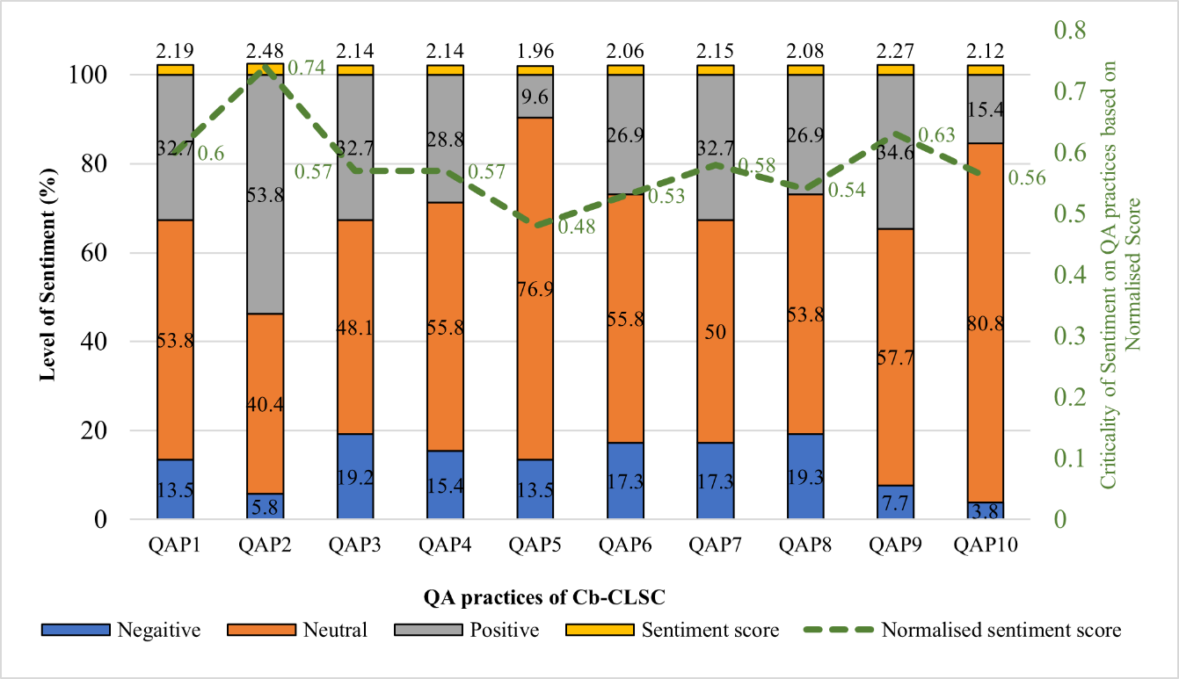
Figure 3: Sentiment Analysis of Experts’ View Based on the Survey.

Content analysis of the interview data supplements the results of the survey-based sentiment analysis of this study to get a deeper insight into the real impacts of COVID-19 on the QA practices of Cb-CLSC. The valuable responses from interviewees on the QA of Cb-CLSC have been evaluated and summarised in Table 7.

Table 7: Sentiment Analysis from the Interview Data
Interviewee | Response | Remarks
A | - “Engineering materials transport depends on epidemic prevention and control measures in different countries or areas; this affected the continuity of our testing, increasing the time cost”
 | - “The pandemic has stimulated the application of intelligent detection, Internet, Internet of things and other technologies in quality management, and promotes the development of construction project quality management”
B | - “The project was suspended, so the project quality testing was not carried out”
 | - “The rise of prefabricated buildings will replace the traditional architectural model, which also puts forward higher requirements for the building quality, such as standing out in the same architectural environment”
C | - “The slower pace of production operations has increased project quality monitoring cycles, increased risk of schedule defaults and difficulties in delivering raw materials”
 | - “The pandemic has contributed to the digital transformation of the way quality management is carried out and improves the automation of quality monitoring”
D | - “The current quality testing work is more complicated than the previous testing work, with more related requirements, such as the need to disinfect cross-border prefabricated components”
 | - “Under the epidemic prevention and control policy, if the management personnel cannot be present, fully automated digital quality management is necessary”
E | - “Our experts are unable to directly travel between the territories (Hong Kong and Mainland China). If we must travel, we need to be quarantined according to the policy, which increases the labour cost in the factory”
 | - “If the epidemic continues, online monitoring of logistics movement may be the future”
F | - “In particular to the off-site fabrication factory/yard in China, there is a critical impact that the quality check to items fabricated in the factory/yard could not be checked because of the lockdown”
 | - “The positive effect mainly goes to the “flexibility” in terms of time when performing the quality inspection”
Note: =Negative; =Positive

5 Discussion of Results
The discussion is twofold and premised upon the study’s objectives and the analysis.

5.1 Identification of the Critical QA Practices of Cb-CLSC
The inferences made by the experts proved that the QA practices of Cb-CLSC are critical in ensuring that the quality of cross-border projects meets all requirements, including from the clients, statutory, and organisations (ISO, 1994). However, such typical practices are missing among the scholarly reports in the research domain. Experts’ responses on ten refined potential QA practices of Cb-CLSC, after being computed using means, SD, and normalised scores, denoted interesting findings. Using the mean, the experts had a relatively good level of agreement on the QA practices, with the highest central tendency being on QAP3 (understanding requirements, norms, and standards of quality) (scores=4.21) and QAP5 (providing quality training for workers towards project execution) having the lowest central tendency. The degree of variation/deviation in the experts’ responses was acceptable as there was no outrageous deviation compared to the rule of thumb (George and Mallery, 2018): the SD value not greater than ±2 is closer to the true value. Hence, all the QA practices were considered highly adequate for this study’s context. Also, all the 10 QA practices were revealed to be critical (with normalised scores ≥0.5) for the context of Cb-CLSC across the Hong Kong–Mainland China links. However, the top five critical QA practices of Cb-CLSC include QAP3(score=0.80), followed by QAP2(score=0.77), QAP7 (score=0.74), QAP4(score=0.73), and QAP9 (score=0.72). Limiting and analysing the experts’ responses to specific borders denoted that: in Mainland China, the most critical QA practices of Cb-CLSC are QAP2(score=0.84) and QAP3(score=0.84), whilst, in Hong Kong, the most critical QA practice is QAP3 (score=0.78). The criticality of other QA practices based on individual borders can be inferred from Table 4. The results showed that understanding the requirements, norms, and standards of quality is critical regardless of the border or jurisdiction, and this must align with an organisation’s quality management system to effectively achieve quality products (Mane and Patil, 2015; Pambreni et al., 2019).

As all the 10 QA practices (QAP1 to QAP10) are critical in the context of Cb-CLSC, the degree of association of the experts’ responses from the groups of academia and industry using the M-WU test denoted that there is no significant difference and disparity. The result showed that the experts’ responses from both the academia and industry across the Hong Kong and Mainland China links are the same on all the QA practices of Cb-CLSC. This is due to the relatively close mean values among the experts for all the QA practices, confirming the fit quality of the collected data and reliable findings (Darko et al., 2017). In the previous section, the agreement analysis denoted a percentage agreement (PA) on the critical QA practices of Cb-CLSC to be 55%, which shows a relatively good agreement between the experts from academia and the industry across Hong Kong and Mainland China. This also confirms how the experts foresee the significance of QA practices in achieving the quality of cross-border construction projects. Furthermore, the result gives firm grounds to the QA teams (quality audit, quality engineers, project managers, etc.) of construction organisations on specific cross-border construction projects by providing the best practices capable of helping to achieve the required quality of cross-border construction projects (Tummala and Tang, 1996; Nyakala, 2017). These include the 10 critical QA practices of Cb-CLSC that have been identified via this study.

Using the Spearman correlation test, the correlation matrix among the 10 critical QA practices of Cb-CLSC denoted some significant relationship among themselves, as earlier made aware in Section 2.1. For instance, the strongest significant positive correlation was found between QAP2 and QAP1 (ρ=0.78, P=0.00), denoting that defining clear responsibility based on quality requirements and assigning them clearly to the qualified workers have a strong interrelationship, and this may help in producing quality construction product (Pambreni et al., 2019), specifically in the context of Cb-CLSC. However, a low negative insignificant correlation was noted between QAP1 and QAP5 (ρ=-0.07, P=0.61), signifying that providing quality training for workers does not mean top management has already clearly assigned defined responsibility to qualified experts based on quality requirements. Thus, after training workers towards project execution, top management must define clear responsibilities to qualified experts based on the quality requirement, norms, and standards (Kraft and Molenaar, 2014; Mane and Patil, 2015; Bhattacharjee, 2018). Overall, there is a fairly positive correlation among the established QA practices of Cb-CLSC, depicting that a pragmatic strategy can be undertaken by combining the QA practices towards achieving quality cross-border construction projects, though there may be significant and insignificant relationships.

5.2 Sentiment on the QA Practices of Cb-CLSC Amid the Pandemic
Sentiment analysis in the study’s context denoted that the COVID-19 pandemic has severely impacted the QA practices of Cb-CLSC. However, along with this is also the positive effects, regarded as the opportunities that, if appropriately harnessed, could position the QA of Cb-CLSC to be adequate for the post-pandemic era and may survive risks of future pandemics. This study revealed that the QA practices of Cb-CLSC have had sentimental experiences based on the negative-neutral-positive model. The QA practices have largely experienced a neutral effect of the COVID-19 pandemic, i.e., the experts have a neutral sentiment across all the QA practices, connoting that the pandemic effect has not been as negative as it may seem. For instance, the most critical QA practice, QAP3, recorded a sentiment level of 48.1% on neutral, 19.2% on negative, and 32.7% on positive. This means understanding requirements, norms, and quality standards has been accelerated to a new level in the pandemic era, where experts used different pragmatic and innovative means to understand requirements without physical presence. This aligns with the view of interviewees A, B, C, and D regarding such positive effects as an opportunity created by the pandemic. The positivity in this action neutralises the negativity to a larger extent and positions the QA of Cb-CLSC to be adequate for the post-pandemic era (Ling et al., 2022). QA practices such as QAP5, QAP8, and QAP10 that require physical presence have been positioned to be carried out without physical presence. Similar inferences can be made to all the QA practices of Cb-CLSC amid the pandemic (see Figure 3). Overall, the QA practices of Cb-CLSC have migrated to a different level amid the pandemic. Though there have been negative impacts (Morris, 2020; Interviewee A, B, C, D, E, F), the positive impacts have neutralised negative ones (Chigara and Moyo, 2021). Thus, the impacts of the pandemic on QA practices in this context are affirmed to have been largely neutral, ensuring the continuity of QA in construction, particularly cross-border construction projects.

Though the sentiment levels on the QA practices have been established to be largely neutral, how critical are they? The results depicted the central tendency of the sentiment levels to be largely on QAP2 (score=2.48) based on the sentiment score, depicting the assignment of clear responsibility to qualified workers, which has experienced a high positive effect of the pandemic because experts adopt technology-enabled management style (Elrefaey et al., 2022). This was affirmed by interviewees A, B, C, D, E, and F, as they emphasised the application of digital technology into quality management to be the breakthrough amid the pandemic. The criticality of the sentiment levels on the QA practices still sits on the head of QAP2 (score=0.74), which denoted how experts noted the sentiments on QAP2 to be critical in the QA process of Cb-CLSC. This aligns with the experts in Mainland China choosing QAP as critical along with QAP3 in the QA processes of Cb-CLSC, as revealed in Table 4. Overall, the sentiments on the QA practices are all critical except for QAP5 (score=0.48). However, this does not prevent QAP5 from being an essential practice in the QA process of Cb-CLSC). Thus, to achieve the quality of cross-border construction projects, workers must be trained and oriented to the work execution processes of the specific projects (Kraft and Molenaar, 2014; Faeq et al., 2021).

In summary, examining the sentiment on QA practices of Cb-CLSC amid the pandemic is crucial in understanding the impacts of the pandemic, and this could assist in appreciating how experts are harnessing the possible opportunities amid the negativity. It raises the morale and the fulfilment that the “quality” experts in the construction, specifically on cross-border projects, need to be pragmatic with management solutions and innovations to ensure that QA processes are conducted adequately and could be sustained for post-pandemic as well as enduring the risks of future pandemics. The results of this study add to the ongoing discourses in construction that COVID-19 has not entirely been negative (Chigara and Moyo, 2021), but rather the experts, such as the QA experts, have positioned the QA adequately to harness the opportunities to ensure the smooth inspection and recording of works, work supervision and monitoring, etc. This, in practice, can be referenced from the interviewees’ responses: A, B, C, D, and E, where digital technologies have become the central focus to ensure the continuity of construction operation and quality management, especially cross-border projects (Osunsanmi et al., 2022). For example, in addition to automated monitoring, coordination, and supervision, data records, which are critical in Cb-CLSC QA processes, can be integrated with blockchain to ensure data transparency throughout information sharing among experts (Lu et al., 2021; Wu et al., 2022ab). Overall, the sentiment on the QA practices of Cb-CLSC amid the pandemic has revealed a significant leap in QA in construction by adopting digital technologies and innovative management to ensure the continuity of QA and its effectiveness. Thus, the impacts of the pandemic on the QA of Cb-CLSC have been largely neutral, i.e., the created opportunities can neutralise the negative impacts if appropriately harnessed by organisations.

6 Conclusions
This study examined the QA practices of Cb-CLSC amid the pandemic, which has been missing among scholarly reports for the past three years. However, understanding this could pave the way to capitalise on the created opportunities, and devise innovative approaches and operational decisions to adequately position the QA of Cb-CLSC for the post-pandemic era and endure the risks of future pandemics. Through an embedded mixed method design consisting of a comprehensive desk literature review, survey, and interview, data were collected from 52 experts across the Hong Kong–Mainland China links.

The study findings revealed 10 critical QA practices of Cb-CLSC, with the top five critical QA practices comprising the “understanding requirements, norms, and standards of quality”, followed by “assigning clear responsibilities to qualified workers”, “recording and documenting work processes, steps, project routine, and seamless implementations”, “keeping close contact with clients to realise their demands”, and “strategic planning based on client requirements and corporate capability”. Overall, there was a relatively good agreement (55%) between experts from industry and academia on their ranking of the QA practices in the study’s context. Sentiment analysis of the experts’ responses on the QA practices of Cb-CLSC amid the pandemic showed that the impacts of the pandemic have been largely neutral, i.e., the opportunities (positive impacts) created can neutralise the negative impacts. The sentiment level was noted to be critical for all the QA practices except “providing quality training for workers toward project execution (QAP5)”. However, that does not avert the significance of QAP5 in the QA process toward the quality of cross-border construction projects. Based on the interview data, the opportunities created in the pandemic era have been centred on digital technologies and innovative management, ensuring the continuity of QA and its effectiveness.

This study has limitations worth mentioning in terms of interpretation and results generalisation. The study’s outcome relied on a relatively small sample size, which could affect the generalisation of the findings. Thus, future research could adopt a much larger sample size from the Hong Kong–Mainland China links and extend the research to include identifying the critical challenges imposed and the resultant impacts of the pandemic on the QA of Cb-CLSC. This could reveal many insights into the study’s context. Future studies could also consider other countries/borders and employ rigorous analytical tools to test the criticality and relationships among the QA practices of Cb-CLSC amid the pandemic. However, the relevance and deep insights of this study’s outcome remain due to the rigorous embedded mixed approach adopted.

Albeit the aforesaid limitation, the outcome of this study has theoretical and practical contributions. Theoretically, the study contributes to the QA and Cb-CLSC literature by reviewing the QA of Cb-CLSC, empirically identifying the critical QA practices in the study context, and further examining them amid the pandemic era. As academia and industry researchers continue to research the impacts of the pandemic on construction activities, this study provides a reference frame from the perspective of QA of Cb-CLSC amid COVID-19 for more understanding. This could direct researchers toward devising innovative management strategies to ensure construction business continuity in achieving quality. Overall, the results of this study can be used as a basis for further research to identify the critical challenges and resultant impacts of the pandemic on the QA of Cb-CLSC toward developing an effective managerial framework to adequately position the QA systems for the post-pandemic era and endure the risks of future pandemics. Practically, this study deepens the understanding of the COVID-19 impacts on the QA of Cb-CLSC to the construction quality management front-liners and policymakers. This knowledge may help industry practitioners devise innovative management strategies enabled by digital technologies to adequately assure quality throughout the QA process of cross-border construction projects. Overall, the study not only contributes to a better understanding of the QA practices and their sentiments amid the pandemic but is also important to the QA front-liners, such as quality engineers, quality managers, etc., and policymakers in developing innovative and operational decisions to position the QA of Cb-CLSC adequately for the post-pandemic era and to endure the risks of future pandemics.

Data Availability Statement
Some or all data, models, or code that support the findings of this study are available from the corresponding author upon reasonable request.

Disclosure statement
“No potential competing interest was reported by the authors.”

Acknowledgment
This paper forms part of a broader PhD research on Quality Assurance of Cross-border Construction Logistics and Supply Chain amid the COVID-19 pandemic. The research is sponsored by the University of Hong Kong (HKU), under the HKU presidential PhD scholarship. We are extremely grateful to the Editor-in-Chief and Reviewers who provided constructive and invaluable comments and suggestions to significantly improve the quality of this paper.

References
Adabre, M.A., Chan, A.P., Darko, A., Osei-Kyei, R., Abidoye, R. and Adjei-Kumi, T., 2020. Critical barriers to sustainability attainment in affordable housing: International construction professionals’ perspective. Journal of Cleaner Production, 253, p.119995.
Adabre, MA and Chan, A.P., 2019. Critical success factors for sustainable affordable housing. Building and Environment, 156, pp.203-214.
AIHA, 2020, Focus on Construction Health: COVID-19 Guidance Document, Version 1, AIHA, VA.
Anderson, J.C., Rungtusanatham, M. and Schroeder, R.G., 1994. A theory of quality management underlying the Deming management method. Academy of management Review, 19(3), pp.472-509.
Arditi, D. and Gutierrez, A.E., 1991. Performance of US contractors in foreign markets. Construction Management and Economics, 9(5), pp.431-449.
Artpairin, A. and Pinmanee, S., 2022. Critical success factors in the management of petrochemical construction projects for contractors and subcontractors during the COVID-19 pandemic. International Journal of Construction Management, pp.1-13.
ASQ 2015, Quality Assurance & Quality Control, https://asq.org/quality-resources/quality-assurance-vs-control#:~:text=Quality%20control%20can%20be%20defined,inspection%20aspect%20of%20quality%20management, Assessed: 11/04/2023
Baker, M.G., Peckham, T.K. and Seixas, N.S., 2020. Estimating the burden of United States workers exposed to infection or disease: a key factor in containing risk of COVID-19 infection. PloS one, 15(4), p.e0232452.
Barone, A. 2022, What Is Total Quality Management? https://www.investopedia.com/terms/t/total-quality-management-tqm.asp#:~:text=TQM%20oversees%20all%20activities%20and,control%20and%20quality%20improvement%20measures, Assessed: 11/04/2023.
Behera, P., Mohanty, R.P. and Prakash, A. 2015. Understanding construction supply chain management. Production Planning & Control, 26(16), pp.1332-1350.
Bhattacharjee, J., 2018. Quality control and quality assurance in building construction. Int. Res. J. Manag. Sci. Technol, 9(4), pp.10-16.
Budayan, C. and Okudan, O., 2022. Roadmap for the implementation of total quality management (TQM) in ISO 9001-certified construction companies: Evidence from Turkey. Ain Shams Engineering Journal, 13(6), p.101788.
Cabaniss, K., 2002. Computer-related technology use by counselors in the new millennium: A Delphi study. Journal of Technology in Counseling, 2(2).
Chan, R.C., 1998. Cross-border regional development in Southern China. GeoJournal, 44(3), pp.225-237.
Chigara, B. and Moyo, T., 2021. Factors affecting the delivery of optimum health and safety on construction projects during the covid-19 pandemic in Zimbabwe. Journal of Engineering, Design and Technology.
Chung, H.W., 2002. Understanding quality assurance in construction: a practical guide to ISO 9000 for contractors. Routledge.
Cleave, P. 2020, What Is a Good Survey Response Rate? https://www.smartsurvey.co.uk/blog/what-is-a-good-survey-response-rate#:~:text=By%20contrast%2C%20a%20survey%20response,relationship%20between%20the%20business%20and, Assessed: 11/04/2023.
Creswell, J.W. and Clark, V.L.P., 2017. Designing and conducting mixed methods research. Sage publications.
Darko, A., Chan, A.P., Owusu-Manu, D.G. and Ameyaw, E.E., 2017. Drivers for implementing green building technologies: An international survey of experts. Journal of cleaner production, 145, pp.386-394.
Deming, W.E.,1986. Out of the Crisis, Cambridge University Press, Cambridge.
Dworkin, S.L., 2012. Sample size policy for qualitative studies using in-depth interviews. Archives of sexual behaviour, 41(6), pp.1319-1320.
Edmonds, W., and Kennedy, T. 2017. Embedded Approach. SAGE Publications, Inc, https://doi.org/10.4135/9781071802779.
Elrefaey, O., Ahmed, S., Ahmad, I. and El-Sayegh, S., 2022. Impacts of COVID-19 on the Use of Digital Technology in Construction Projects in the UAE. Buildings, 12(4), p.489.
European Commission, 2001, definition of cross-border sections of priority projects, https://ec.europa.eu/inea/sites/default/files/download/calls_2010/definition_cross_border_sections_en.pdf, Accessed on 23/11/2022.
Eurostat, 2022. Impact of Covid-19 crisis on construction, https://ec.europa.eu/eurostat/statistics-explained/index.php?title=Impact_of_Covid-19_crisis_on_construction. Accessed: 12/07/2022.
Faeq, D.K., Garanti, Z. and Sadq, Z.M., 2021. The Effect of Total Quality Management on Organizational Performance: Empirical Evidence from the Construction Sector in Sulaymaniyah City, Kurdistan Region–Iraq. UKH Journal of Social Sciences, 5(1), pp.29-41.
Ferrara, E. and Yang, Z., 2015. Measuring emotional contagion in social media. PloS one, 10(11), p.e0142390.
George, D. and Mallery, P., 2018. Descriptive statistics. In IBM SPSS Statistics 25 Step by Step (pp. 126-134). Routledge.
Gizaw, G. 2021. The Role of International Construction for the Development of Economy and the Challenges Involved, https://ijesc.org/upload/92513f3cf1453b78cf3fff0277852eb5.The%20Role%20of%20International%20Construction%20for%20the%20Development%20of.pdf, Accessed on 23/11/2022.
Ghansah, F.A. and Lu, W., 2023. Responses to the COVID-19 pandemic in the construction industry: a literature review of academic research. Construction Management and Economics, pp.1-23. https://doi.org/10.1080/01446193.2023.2205159.
Gupta, A. and Singh, R.K., 2021. Applications of emerging technologies in logistics sector for achieving circular economy goals during COVID 19 pandemic: analysis of critical success factors. International Journal of Logistics Research and Applications, pp.1-22.
Hamilton, T. 2023, Quality Assurance vs Quality Control – Difference Between Them, https://www.guru99.com/quality-assurance-vs-quality-control.html, Assessed: 11/04/2023.
ISO 9001:2015. Quality Management Systems—Requirements. Available online: https://www.iso.org/standard/62085.html, Accessed on 02/09/2022.
ISO, 1994, Quality management and quality assurance—Vocabulary, International Organization for Standardization.
Kafetzopoulos, D.P., Gotzamani, K.D. and Psomas, E.L., 2014. The impact of employees’ attributes on the quality of food products. International Journal of Quality & Reliability Management. 31(5), pp. 500-521. https://doi.org/10.1108/IJQRM-05-2012-0057.
Karwasra, K., Soni, G., Mangla, S.K. and Kazancoglu, Y., 2021. Assessing dairy supply chain vulnerability during the Covid-19 pandemic. International Journal of Logistics Research and Applications, pp.1-19.
Kenton, W. 2019, Descriptive Statistics, Investopedia,
https://www.investopedia.com/terms/d/descriptive_statistics.asp, Accessed: 15/10/2022.
Kraft, E. and Molenaar, K., 2014. Fundamental project quality assurance organisations in highway design and construction. Journal of Management in Engineering, 30(4), p.04014015.
Lee, J.H., Mistur, E., Liu, L. and Ashuri, B., 2022. Determining contract requirements for quality assurance program in innovative project delivery. In Construction Research Congress 2022 (pp. 179-188).
Li, Z., Sheng, Y., Meng, Q. and Hu, X., 2022. Sustainable supply chain operation under COVID-19: influences and response strategies. International Journal of Logistics Research and Applications, pp.1-27.
Ling, F.Y., Zhang, Z. and Yew, A.Y., 2022. Impact of COVID-19 pandemic on demand, output, and outcomes of construction projects in Singapore. Journal of Management in Engineering, 38(2), p.04021097.
Liu, W., Liang, Y., Bao, X., Qin, J. and Lim, M.K., 2022. China’s logistics development trends in the post COVID-19 era. International Journal of Logistics Research and Applications, 25(6), pp.965-976.
Lu, W., Wu, L., Xu, J. and Lou, J., 2022. Construction E-Inspection 2.0 in the COVID-19 Pandemic Era: A Blockchain-Based Technical Solution. Journal of Management in Engineering, 38(4), p.04022032.
Lu, W., Wu, L., Zhao, R., Li, X. and Xue, F., 2021. Blockchain technology for governmental supervision of construction work: Learning from digital currency electronic payment systems. Journal of construction engineering and management, 147(10), p.04021122.
Mane, P.P. and Patil, J.R., 2015. Quality management system at construction projects. In Proceedings of the Civil Engineering PG Conference-2015 (Vol. 5, p. 24).
Mawhinney, M., 2008. International construction. John Wiley & Sons.
McKinsey and Company. 2020. “How construction can emerge stronger after coronavirus.” https://www.mckinsey.com/industries/capital-projects-and-infrastructure/our-insights/how-construction-can-emerge-stronger-after-coronavirus, Accessed on 23/11/2022.
Mishra, P., Pandey, C.M., Singh, U., Gupta, A., Sahu, C. and Keshri, A., 2019. Descriptive statistics and normality tests for statistical data. Annals of cardiac anaesthesia, 22(1), p.67.
Montoya-Torres, J.R., Muñoz-Villamizar, A. and Mejia-Argueta, C., 2021. Mapping research in logistics and supply chain management during COVID-19 pandemic. International Journal of Logistics Research and Applications, pp.1-21.
Morris, G. D. L. 2020. “Six critical COVID-19 risks for the construction industry.” https://riskandinsurance.com/6-critical-covid-19-risks-for-the-construction-industry/, Accessed on 14/11/2022.
Niroshana, N., Siriwardana, C. and Jayasekara, R., 2022. The impact of COVID-19 on the construction industry and lessons learned: a case of Sri Lanka. International Journal of Construction Management, pp.1-18.
Nyakala, K.S., 2017. Developing a road construction quality assurance process measurement tool: The case of Mopani District Municipality. University of Johannesburg (South Africa).
Ogunnusi, M., Hamma-Adama, M., Salman, H. and Kouider, T., 2020. COVID-19 pandemic: the effects and prospects in the construction industry. International journal of real estate studies, 14(Special Issue 2).
Okpala, D.C. and Aniekwu, A.N., 1988. Causes of high costs of construction in Nigeria. Journal of Construction Engineering and Management, 114(2), pp.233-244.
ONS, 2021, Construction output in Great Britain: December 2020, new orders and Construction Output Price Indices, October to December 2020: December 2020, https://www.ons.gov.uk/businessindustryandtrade/constructionindustry/bulletins/constructionoutputingreatbritain/december2020#annual-construction-output-growth-in-2020. Accessed: 29/07/2022.
Onubi, H.O., Hassan, A.S., Yusof, N.A. and Bahdad, A.A.S., 2022. Moderating effect of project size on the relationship between COVID-19 safety protocols and economic performance of construction projects. Engineering, Construction and Architectural Management.
Osunsanmi, T.O., Aigbavboa, C.O., Thwala, W.D.D. and Molusiwa, R. 2022, Modelling construction 4.0 as a vaccine for ensuring construction supply chain resilience amid COVID-19 pandemic, Journal of Engineering, Design and Technology, 20, 1, pp. 132-158. https://doi.org/10.1108/JEDT-07-2021-0384 .
Ott, R. L., and M. T. Longnecker. 2015. An introduction to statistical methods and data analysis. Toronto: Nelson Education.
Pallant, J., 2001. SPSS survival manual: A step-by-step guide to data analysis using SPSS for Windows (versions 10 and 11): SPSS student version 11.0 for Windows. Open University Press.
Pambreni, Y., Khatibi, A., Azam, S. and Tham, J.J.M.S.L., 2019. The influence of total quality management toward organisation performance. Management Science Letters, 9(9), pp.1397-1406.
Pilatowska, J. 2021, How is cross-border logistics helping e-commerce to grow? https://linkercloud.com/blog/ecommerce/how-cross-border-logistics-is-helping-e-commerce-to-grow#:~:text=What%20is%20cross%2Dborder%20logistics,international%20legal%20and%20tax%20regulations, Accessed on 23/11/2022.
PMBOK, 2017, A Guide to the Project Management Body of Knowledge (PMBOK Guide) (Project Management Institute), Project Management Institute, 6th Edition, Inc. USA.
ReQtest. 2016. Quality Assurance vs Quality Control: Know the Differences, https://reqtest.com/testing-blog/quality-assurance-vs-quality-control-differences-2/#:~:text=Quality%20assurance%20focuses%20on%20the,to%20the%20product%20being%20developed, Accessed on 13/11/2022.
Roseke, B. 2022, Project Quality Assurance According to the PMBOK, https://www.projectengineer.net/project-quality-assurance-according-to-the-pmbok/, Accessed: on 13/11/2022.
Salami, B.A., Ajayi, S.O. and Oyegoke, A.S., 2021. Tackling the impacts of Covid-19 on construction projects: An exploration of contractual dispute avoidance measures adopted by construction firms. International Journal of Construction Management, pp.1-9.
Sharma, M., Luthra, S., Joshi, S. and Kumar, A., 2022. Developing a framework for enhancing survivability of sustainable supply chains during and post-COVID-19 pandemic. International Journal of Logistics Research and Applications, 25(4-5), pp.433-453.
Simpeh, F. and Amoah, C., 2021. Assessment of measures instituted to curb the spread of COVID-19 on construction site. International Journal of Construction Management, pp.1-19.
Sloan, L., and Angell, R. (2015). Learn about Spearman’s-order correlation coefficient in SPSS with data from the general social survey (2012): income and political influence. In SAGE Research Methods Datasets Part 1. SAGE Publications, Ltd. https://dx.doi.org/10.4135/9781473937987.
Soliman, E., Al-Tabtabai, H., Almusalam, A. and Hussein, M., 2022. Impact of COVID-19 on labor’s motivational factors and construction productivity. International Journal of Construction Management, pp.1-10.
Thorpe, B. and Sumner, P., 2017. Quality assurance in construction. Routledge.
Tummala, V.R. and Tang, C.L., 1996. Strategic quality management, Malcolm Baldrige and European quality awards and ISO 9000 certification: Core concepts and comparative analysis. International Journal of Quality & Reliability Management, 13(4), pp.8-38.
WHO, 2020. “Coronavirus disease.” Accessed November 20, 2020. https://www.who.int/emergencies/diseases/novel-coronavirus-2019/question-and-answers-hub/q-a-detail/coronavirus-disease-covid-19. Accessed on 17/11/2022.
WHO, 2022, WHO COVID-19 Dashboard, https://covid19.who.int/?adgroupsurvey={adgroupsurvey}&gclid=CjwKCAjwo_KXBhAaEiwA2RZ8hGbOJrWQlQO-vuj6G41YFNxnmXcrPi7BHCdLYewY-J53XXU1asK9choCmi8QAvD_BwE, Accessed on 217/11/2022.
Wu, L., Li, X., Zhao, R., Lu, W., Xu, J. and Xue, F., 2022. A blockchain-based model with an incentive mechanism for cross-border logistics supervision and data sharing in modular construction. Journal of Cleaner Production, 375, p.133460.
Wu, L., Lu, W., Zhao, R., Xu, J., Li, X., Xue, F., Wu, L., Lu, W., Zhao, R., Xu, J. and Li, X., 2022. Using blockchain to improve information sharing accuracy in the onsite assembly of modular construction. Journal of Management in Engineering, 38(3), p.04022014.
Yang, Y., Pan, M., Pan, W. and Zhang, Z. 2021. Sources of uncertainties in offsite logistics of modular construction for high-rise building projects. Journal of Management in Engineering, 37(3), p.04021011.
Yu, X. and Khazanchi, D., 2017. Using embedded mixed methods in studying is phenomena: Risks and practical remedies with an illustration. Using Embedded Mixed Methods in Studying IS Phenomena: Risks and Practical Remedies with an Illustration, 41.
Zhang, X., 2005. Critical success factors for public-private partnerships in infrastructure development. Journal of construction engineering and management, 131(1), pp.3-14.

