Application Acoustic Emission Techniques in Helicopter Main Gearbox Bearing Defect Identification

**Fang Duana *, Faris Elashab, Matthew Greavesc, and David Mbaa**

a School of Engineering, London South Bank University, London, SE1 0AA, UK

b School of Energy, Enviroment and Agrifood, Cranfield University, Bedford, MK43 0AL, UK

c School of Aerospace, Transport, and Manufacturing, Cranfield University, Bedford, MK43 0AL, UK

|  |
| --- |
| * Corresponding author. Tel.: +44-207-815-7578; e-mail: duanf@lsbu.ac.uk  ABSTRACT- Helicopter transmission integrity is critical to the safety operation. Among all mechanical failures in helicopter transmission, the main gearbox (MGB) failures occupy approximately 16%. Great effort has been paid in early prevention and diagnosis of MGB failures. As a commonly employed monitoring technology, vibration analysis suffers from strong background noise due to variable transmission paths from the bearing to the receiving externally mounted vibration sensor. The background noise can mask the signal signature of interest. This paper reports on an investigation to identify the presence of a bearing defect in a CS‐29 ‘Category A’ helicopter main gearbox with acoustic emission (AE) technologies. This investigation involved performing the tests for fault‐free condition, minor bearing damage and major bearing damage conditions under different power levels. The bearing faults were seeded on one of the planet gears of the second epicyclic stage. To overcome the issue of low signal to noise ratio (SNR), AE sensor was directly attached on the dish of planet carrier. The AE signal was transferred wireless to avoid complex wiring inside MGB. The analysis results proved the feasibility of using AE sensor as in-suit bearing defect identification. |

Keywords: Helicopter Main gearbox, Acoustic Emission, bearing defect diagnostics

**1. Introduction**

The main gearbox (MGB) is one of the most critical parts of helicopter. During flight, MGB suffers from high temperature and stress as a substantial amount of frictional heat is generated when the input high rotation speed of gas turbines is converted to low speed, high torque within MGB. The malfunction of the MGB can cause serious disaster due to the lack of redundancy of transmission system in helicopter (1). The operating condition of MGB is usually monitored by using vibration and temperature sensors in helicopter Health and Usage Monitoring Systems (HUMS). These sensors are usually mounted on casing to avoid complex wiring. However, vibration signal might be significantly attenuated if target bearing or gear is far from gearbox housing. The indirect measurement could not provide accurate temperature as previous research showed the large thermal gradients between the gear and ambient (2).

Recently, acoustics emissions (AE) technology based defect identification attracted extensive research attention due to the benefits of detecting early stages of crack initiation (3,4). When stress wave propagates through crack surface, the frequency of the stress wave increases, which can be detected by the AE sensor. The early detection of faults in MGB can significantly reduce the risk of accident and injury or loss of life. Nevertheless, it is impractical to install AE sensor on the MGB casing because of the strong background noise level. In order to solve the aforementioned issues of indrect measurement and complex wiring inside MGB, AE sensor was directly attached on the target bearing and the acquired signal was wirelessly transmitted in this study. Minor and major faults were seeded on the outer race and inner race of second-stage planet gears of a CS-29 Category ‘A’ helicopter gearbox. The test was conducted under low, medium and high power conditions. The resutls clearly showed defect frequencies for all defect conditions and power conditions.

2. Experimental rig

A SA 330 Puma helicopter MGB was utilized to investigate the feasibility of bearing defect detection using AE sensor. The MGB consists of five reduction gear modules (RGMs), left hand (LH) and right hand (RH) forward (Fwd) RGMs, after (Aft) RGM, main RGM and 2-stage epicyclic (Epi) RGM, as shown in figure 1(a). It converts the engine power from high speed and low torque to low speed and high torque to drive the main rotor and tail rotor systems.

The test was devised under three conditions: an undamaged planet bearing, a slightly damaged planet bearing and a heavily damaged planet bearing. The defect was seeded on one of the planetary gears bearing of the second epicyclic stage, which is shown in figure 1(b). The slightly damage was simulated by machining a rectangular slot of 10 mm wide and 0.3 mm deep across the bearing outer race, as shown in figure 1(c). The heavily damage was the combination of both damaged an outer race (about 30mm wide, 0.3mm deep) and inner race (natural spalling around half of the circumference, as shown in figure 1(c)

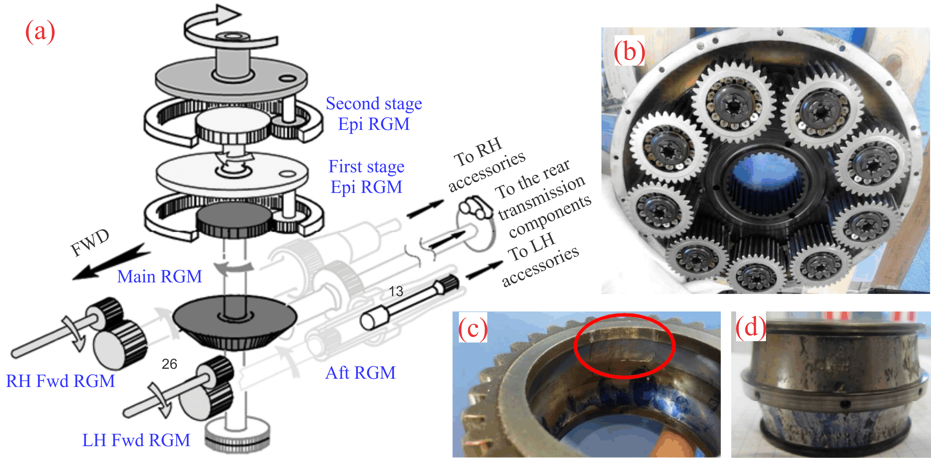

Figure 1. (a) The sketch of helicopter MGB internal parts; (b) Second stage epicyclic gears; (c) Slot across the bearing outer race; (d) Inner race natural spalling.

Most commercial AE sensors are assembled in sturdy metal case. The metal case might cause serious problems if sensor dislodges inside gearbox. To this end, piezoelectric wafer active sensor (PWAS) is the most suitable AE sensor for in-situ applications. The normal operational temperature range of gearbox is -10˚C to +130˚C. Hence, the OMEGADYNE TT300 cement (working limit of 200 ˚C) was used to bond the sensor to the planet carrier, as shown in figure 2.

The internal AE sensor was connected to the internal signal conditioning board, transmitted wirelessly, demodulated then passed to the data acquisition system over BNC cable. The wireless transmission is realized by using two coils, moving coil and stationary coil. The moving coil comprised two single turn brass copper tracks of approximately 400mm. The moving coil and the signal conditioning board were attached to a circular mounting ring which was in turn mounted on top of the oil caps on the second stage planet carrier, as shown in figure 2. The stationary coil was suspended from two clamping rings which were attached to the top case of the gearbox with a spacer through the holes to retain location. The acquisition card was a NI 6115 card, connected to a BNC 2110 connector block. The signal was sampled at 5 MHz.

Zoomed in

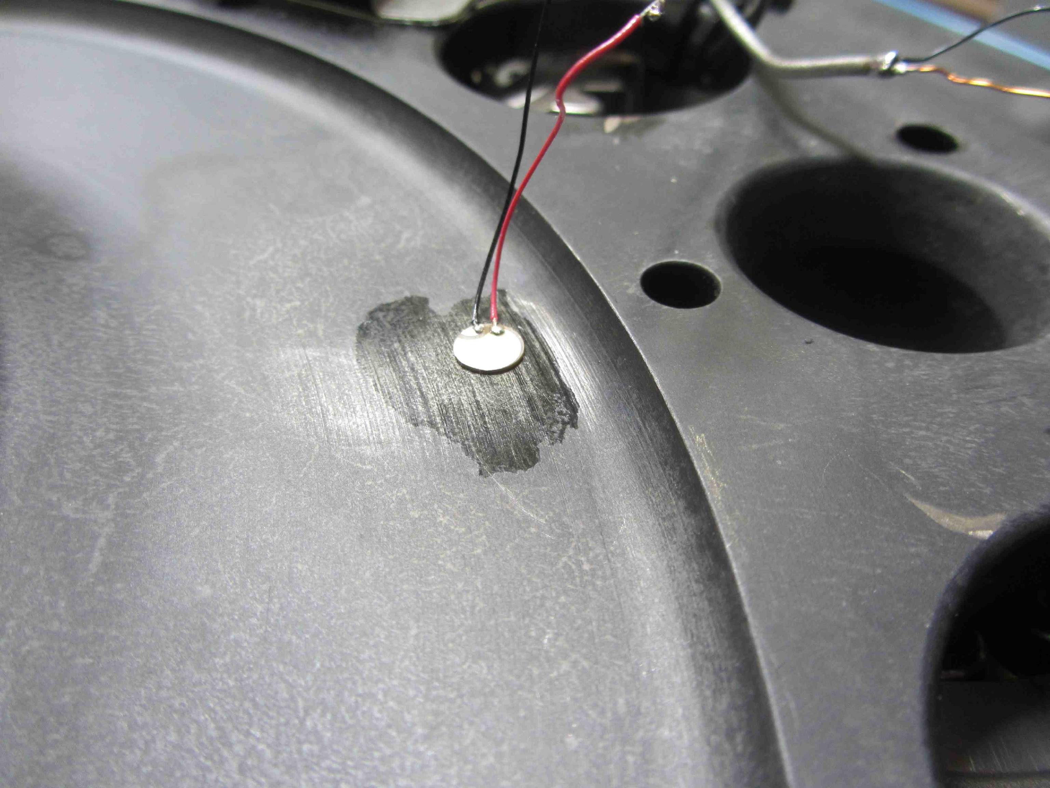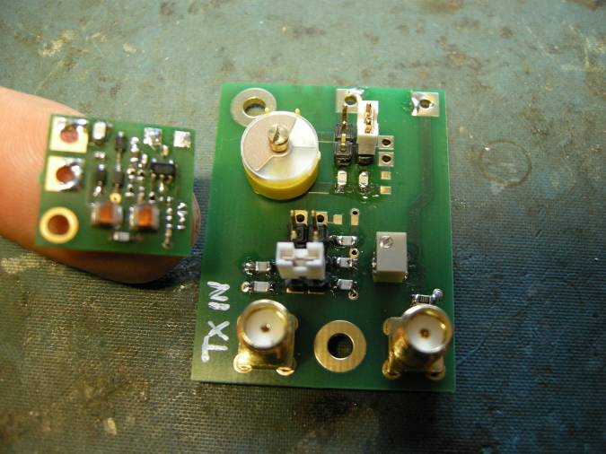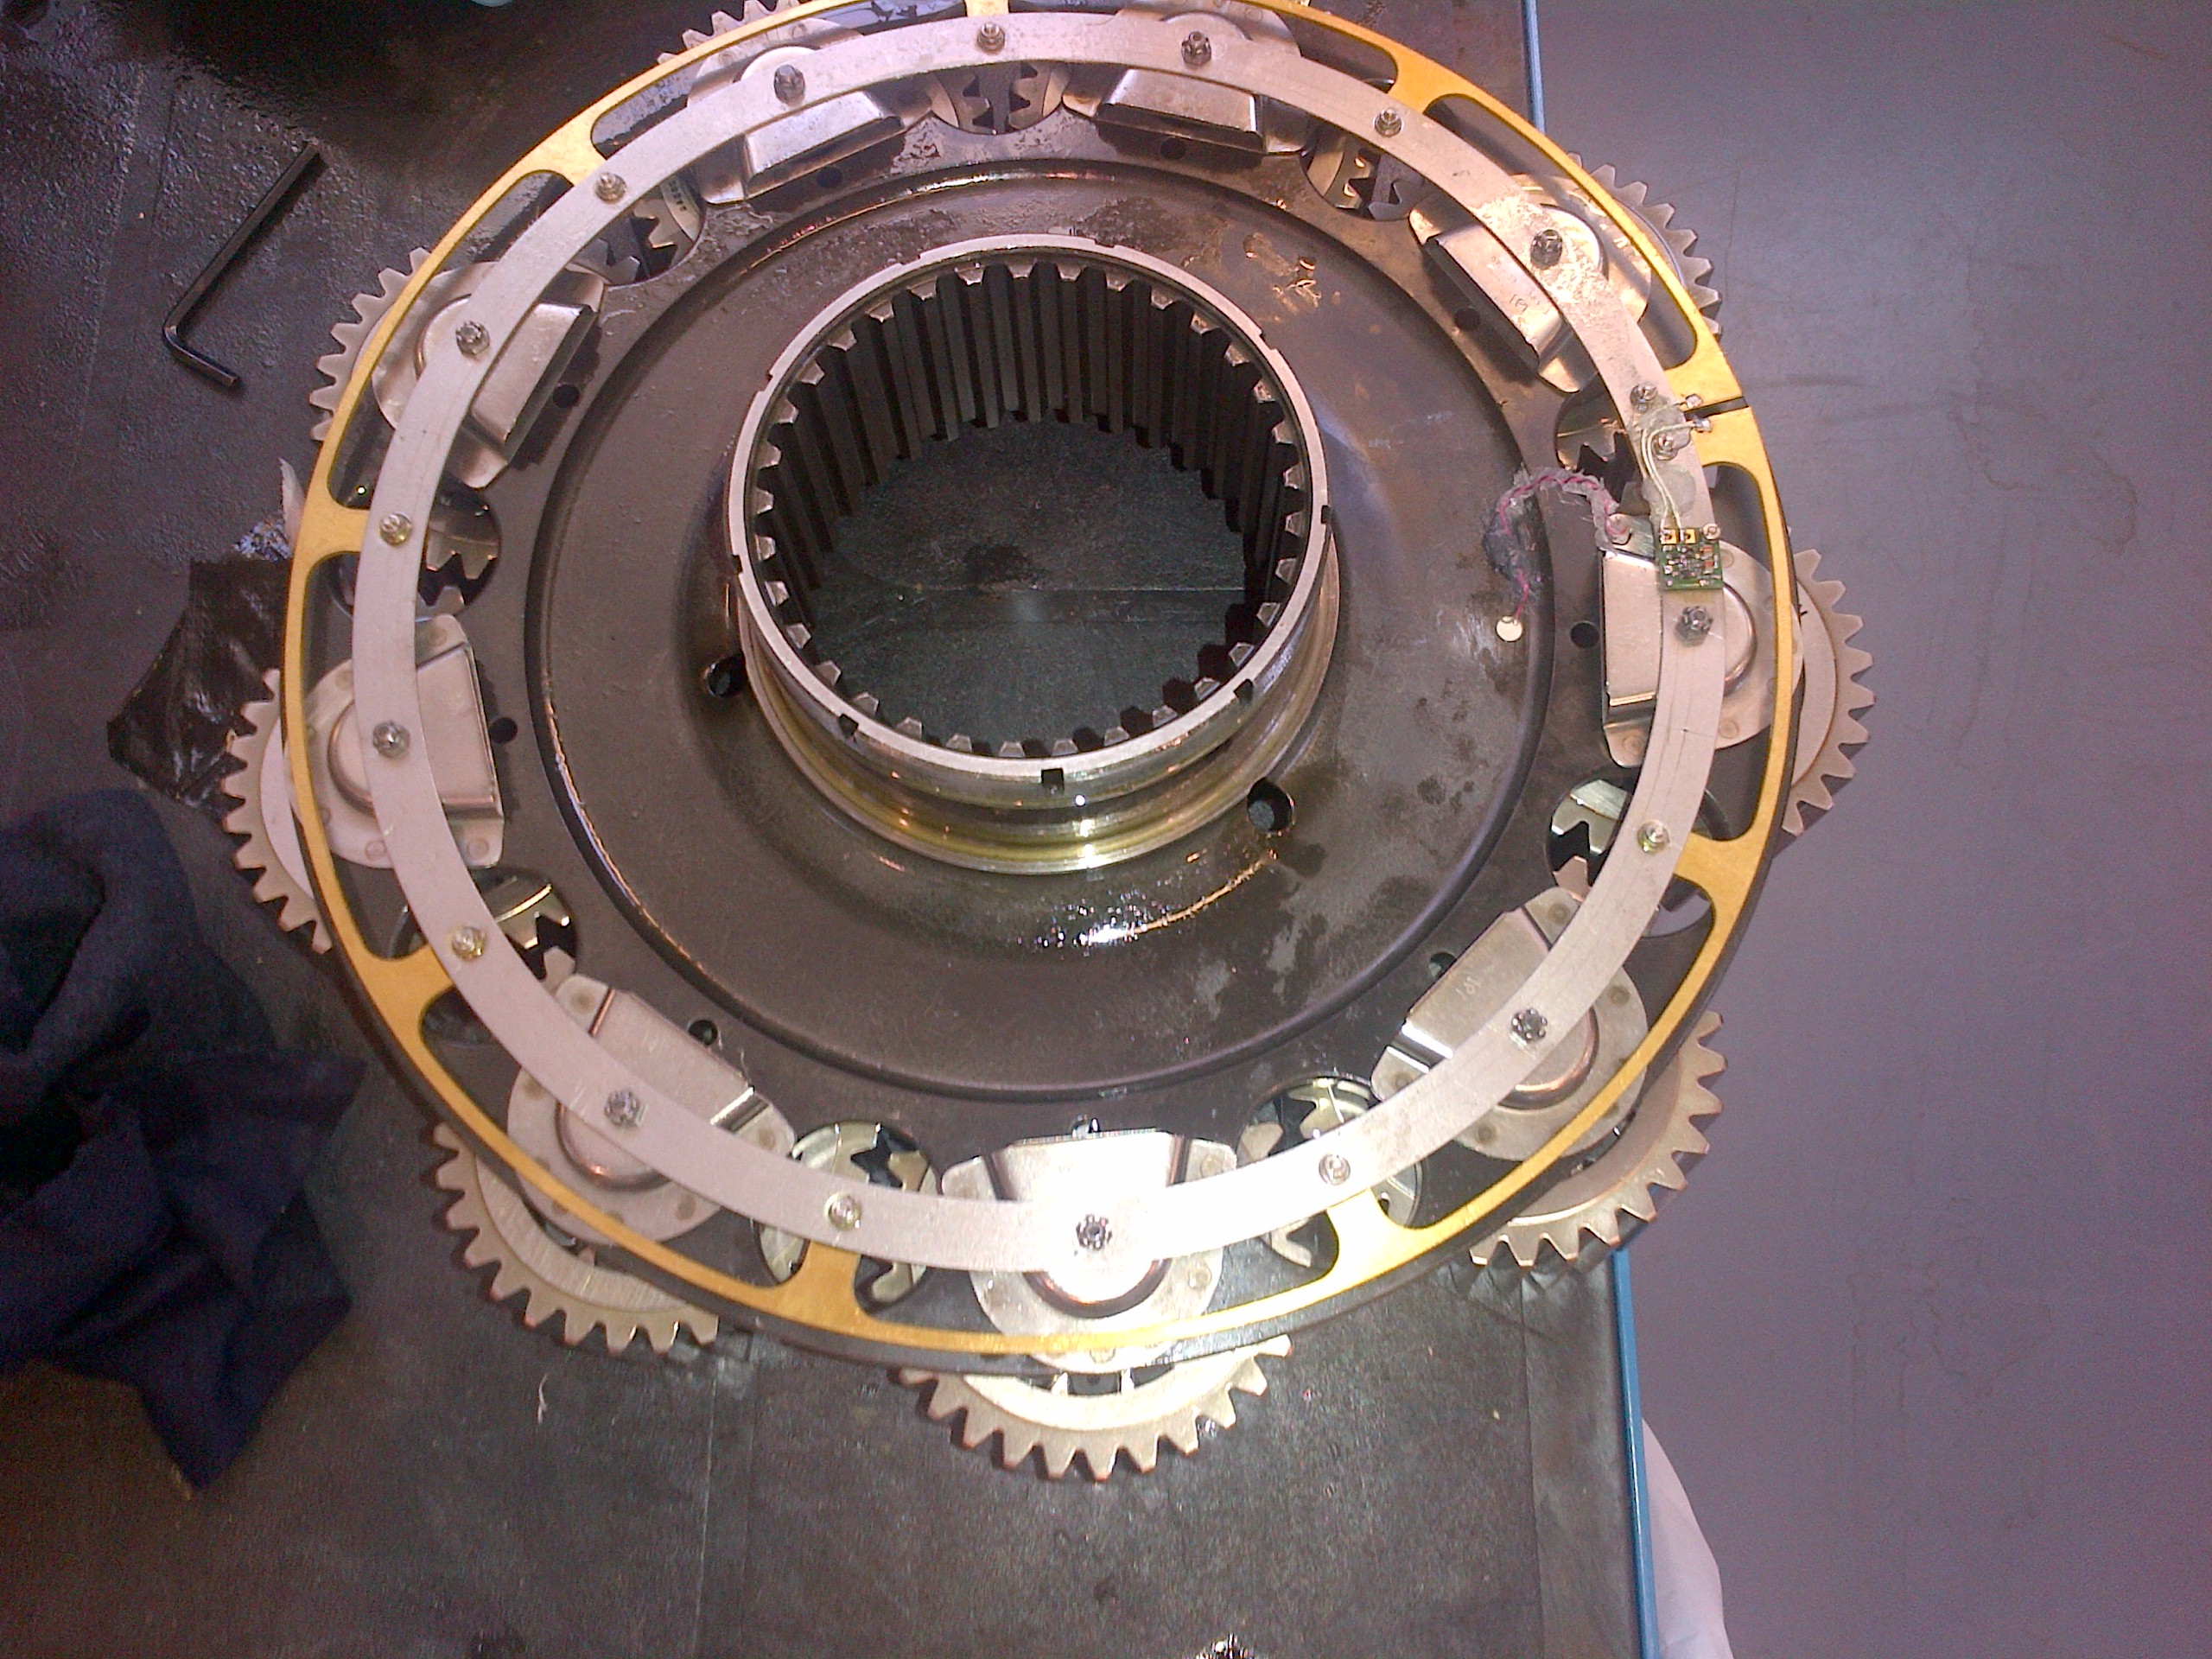

Figure 2. PWAS located on the dish of planet carrier.   
Insert: Sensor board (right top); PWAS (right bottom)

2. Experimental results and discussion

Each fault condition was tested under three load conditions, 100% and 80% of maximum continuous power and, 110% of maximum take-off power. The power, speed and torque characteristics of these load conditions are summarised in table 1.

Table 1. Test Load conditions characteristics

|  |  |  |  |  |
| --- | --- | --- | --- | --- |
| Load Condition | Power  (kW) | Rotor speed  (RPM) | Right input torque (Nm) | Left input  Torque (Nm) |
| 80% Max continuous power | 936 | 265 | 196 | 196 |
| 100% Max continuous power | 1300 | 265 | 272 | 272 |
| 110% Max take-off power | 1760 | 265 | 368 | 368 |

Envelope analysis has been extensively utilized in vibration analysis for diagnosing bearings and gearboxes defects (5,6). Envelope analysis is based on the principle of identifying frequencies of the impacts, which results from defects excited resonance. Vibration signal is firstly filtered at high frequencies (structural resonance frequencies). Then, the signal is passed through an envelope detector and a low pass filter. Using the same approach, the enveloped AE signal is presented in the frequency domain to identify fault frequency components. Figures 3 (a), (b) and (c) show enveloped spectra of AE signal recorded from, fault-free, minor and major bearing defects at 80% maximum continuous power, respectively. Observations of figures (b) and (c) clearly indicate the presence of the bearing outer race defect (ORD) frequency (96 Hz) and its harmonic (192 Hz) for both minor and major damages. The ORD frequency and its harmonic are also observed at minor and major damages under 100% maximum continuous power and 110% maximum take-off power conditions in figures 4 and 5.

3. Conclusions

The AE sensor was used in this paper to detect seeded bearing faults in a helicopter MGB. In order to increase signal to noise level under strong background noise, the PWAS was attached on the surface the dish of planet carrier. The complex wiring was avoided by using advanced wireless transmission technique. The observations of AE enveloped spectra showed that AE analysis was able to identify the presence of the bearing outer race defect frequency and its harmonic for both minor and major damaged under three different loading conditions.

ORD & harmonic

ORD & harmonic



Figure 3. Enveloped spectra of AE signal (a) fault-free, (b) minor and (c) major bearing defects at 80% maximum continuous power

ORD & harmonic

ORD & harmonic



Figure 4. Enveloped spectra of AE signal (a) fault-free, (b) minor and (c) major bearing defects at 100% maximum continuous power

ORD & harmonic

ORD & harmonic



Figure 5. Enveloped spectra of AE signal (a) fault-free, (b) minor and (c) major bearing defects at 110% maximum take-off power

References

1. Department for Transport, 'Report on the accident to aerospatiale (Eurrocopter) AS332 L2 Super Puma, registration G-REDL 11 nm NE of Peterhead Scotland, on 1 April 2009', Air Accident Investigation Branch, Aldershot, UK, 2011.

2. N Goodman, A Bayoumi, V Blechertas, R Shah and Y Shin, 'CBM Component Testing at the University of South Carolina: AH-64 Tail Rotor Gearbox Studies', in American Helicopter Society Technical Specialists’ Meeting on Condition Based Maintenance, 2009.

3. D Mba, 'Prognostic opportunities offered by acoustic emission for monitoring bearings and gearboxes', Twelfth International Congress on Sound and vibration Lisbon, Portugal, 2005.

4. D Mba and R B Rao, 'Development of Acoustic Emission Technology for Condition Monitoring and Diagnosis of Rotating Machines; Bearings, Pumps, Gearboxes, Engines and Rotating Structures', The Shock and Vibration Digest, Vol. 38, No. 1, pp. 3-16, 2006.

5. W Wang, 'Early detection of gear tooth cracking using the resonance demodulation technique', Mechanical Systems and Signal Processing, Vol. 15, No. 5, pp. 887-903, 2001.

6. R Randall and J Antoni, 'Rolling element bearing diagnostics - A tutorial', Mechanical Systems and Signal Processing, Vol. 25, No. 2, pp. 485-520, 2011.