Smart Techno-Economic Operation of Electric Vehicle Charging Station in Egypt
Peter Makeen^{a,b} (0000-0003-2907-9800)*, Hani A. Ghaliª (0000-0001-8525-551X), Saim Memon^{b,c,1} (0000-0003-2598-8935)**, Fang Duan ^{b} (0000-0002-6598-1917)
ª Electrical Engineering Department, Faculty of Engineering, The British University of Egypt (BUE), El-Sherouk, 11837 Egypt (peter.makeen@bue.edu.eg); (hani.amin@bue.edu.eg)
^{b} Electrical and Electronic Engineering Division, School of Engineering, London South Bank University, 103 Borough Road, London, SE1 0AA, UK (besadap@lsbu.ac.uk);(smemon@arden.ac.uk) ;(duanf@lsbu.ac.uk )
^{c} School of Engineering, Arden University, Arden House, Middlemarch Park, Coventry CV3 4FJ, England, UK (smemon@arden.ac.uk)
*Corresponding author: besadap@lsbu.ac.uk
**Corresponding author: smemon@arden.ac.uk
¹ https://saimmemon.com/

Abstract
Stochastic fast-charging of electric vehicles (EVs) affect the security and economic operation of the distribution power network. Aggregator awareness in the electric power industry is fast growing in tandem with the growing number of EVs. This paper proposes a novel smart techno-economic operation of the electric vehicle charging station (EVCS) in Egypt controlled by the aggregator based on a hierarchal model. The deterministic charging scheduling of the EVs is the upper stage of the model to balance the generated and consumed power of the station and flat the surplus power supplied to the utility grid. Mixed-integer linear programming (MILP) is used to solve the first stage where the peak demand value is reduced to 48.17%(4.5kW) without using any extra battery storage systems. The second challenging stage is to maximize the charging station profit whilst minimizing the EV charging tariff, which needs a trade-off. In this stage, MILP and Markov Decision Process Reinforcement Learning (MDP-RL) resulted an increase in EVCS revenue by 28.88% and 20.10%, respectively. However, the EVs charging tariff is increased by 21.19%, and 15.03%, respectively. Hence, MDP-RL is an adequate algorithm for such a complex model. The outcomes reveal a sufficient techno-economic hierarchal model concerning the normal operation stated in the literature.
Keywords—Aggregators, Electric Vehicles, Electric Vehicle Charging Station, DC Fast Charging, Lithium-ion battery

Introduction
The electric vehicle revolution has enabled a complicated security and economic challenges to the distribution power network by a substantial drive towards electrification of transportation, spurred not only by growing carbon emissions but also by rising fossil fuel prices[1, 2]. Electric vehicles (EVs) are replacing conventional internal engine vehicles (ICEVs) using the state of art power electronics, motor drives, energy storage technologies, renewable energy power generation, and smart grids[3]. However, ensuring this transition required addressing several grid integration challenges supported by distributed generators (DGs)[4]. DGs, especially renewable energy sources (RESs) are providing higher efficiency and ensure green electricity with low environmental pollution. However, the fluctuation of RESs made challenges to the operation of the distribution network[5]. Demand response (DR) is considered the key to improve system flexibility, maintaining the balance between the generated and demand power, and enhancing system reliability [5, 6]. One of the substantial participants in DR is the EVs which are considered a viable solution for resolving microgrid distribution networks [7]. However, due to the uncertainty and random behaviour during the charging and discharging operations, EVs may negatively affect the system efficiency and reliability [5] where the uncoordinated EV charging could significantly change the shape of the aggregate residential demand[8]. Hence, EV charging and discharging operations need to be aggregated by an EV aggregator to qualify the market entrance criteria [9] and actively participate in the DR balancing between the supply and demand sides[5].
Aggregators are considered as the interface between the distribution network and electric vehicle charging station (EVCS) which combine multiple EVs [5] and coordinate and schedule the charging of the plug-in electric vehicle (PEV)[10]. So, the EVCS represented and controlled by the aggregator (operator) has main challenges concerning the balance of generated and consumed power, minimizing EVs’ charging tariff, and maximizing the EVCS’s revenue by electricity trading. Recent studies, in the field of charge scheduling of the EVs, reported the minimization of the charging time and maximization of the charging State-Of-Charge (SOC) capacity by changing the charging rates (AC Level 1, AC Level 2, AC Level 3, and DC fast charging) [11-14]. However, the technical impact of the different charging methodologies and rates on the utility grid has not been considered. The EV charging process presents a major challenge to utility grid security, particularly at the local distribution network level which is represented in peak load [15]. A conventional approach involving capacity addition is widely used to supply the peak load. However, this approach is insufficient and not economically concerning generator usage since the utilities need to maintain the generation capacity that will be used a few hours per day [16]. This approach revealed several disadvantages, such as high fuel consumption and carbon dioxide (CO₂) emission, increase in transportation and maintenance costs and faster deterioration of equipment[16, 17]. Thus, the peak load shaving methodology is becoming a vital area of active research which is targeting to flatten the load curve by reducing the peak load power and shifting it to times of lower load [16]. This methodology has benefits for the grid operator and End-User and carbon emission reduction. The virtual time of use rate dynamic programming (vTOU-DP) approach has been used to flatten the load profile of the transformer and reduce the peak power demand based on utilizing the advantage of the vehicle to grid (V2G) property, however, this property requires a proper infrastructure and control systems for EVs integration with the utility grid which considered as a great challenge, especially in the developing countries where EVs are initiating in the transportation market. The time of rising pricing method has been used to minimize the peak load charging, whereas the pricing incentive method based on the energy price during the day is implemented in New South Wales, Denmark, Finland, Norway, and Sweden [1, 2]. Time-of-Use (ToU) tariff pricing motivation is used in charging EVs across the day [18]; however, additional control is required to minimize the effect of sudden load ramping up at the same time instance[18]. In [19] a virtual battery pool is proposed to charge and discharge the EVs based on a genetic algorithm to control the demand and supply processes. Peak-shifting and peak-cutting are achieved by using the charging (G2V) and discharging (V2G) capability of the EVs in [5, 20-22]. In [23], the peak demand for all the week charging period has been reduced to 45% using RESs supplied from PV panels installed on a roof parking area and wind turbines supported by a battery energy storage system (BESS) of the Nissan-Leaf model EV with 24kWh lithium-ion battery capacity. EVs have been charged during the off-peak to reduce the peak demand without being tied to renewable generation. In [24] different charging strategies have been proposed to improve the system load factor (the ratio between the average load to the peak load of the system) by shifting the charging process out of peak hours where all EVs are not allowed to charge between the time 17:00 and 19:00 which considered as a drawback for EVs’ fast charging.
Hence, the aggregator has another vital role represented in maximizing the profit of the station [25, 26]. Private aggregators are directed to maximize their profit by including additional services and selling secondary reserves in the electricity market[27]. The charging and discharging operations capability of EVs in the parking lots was investigated in [28] to maximize the profit of vehicles and parking. A reinforcement-learning (RL) approach was used in [29] for the EVCS pricing and scheduling strategies. However, some EVs may be parked at the station for a very long time till the electricity price is very low where the charging and pricing decisions are made each time. A decentralized profit maximization algorithm (DPMA) was introduced in [30] in the city of Ottawa, Canada to help a decentralized electric vehicle supply equipment (D-EVSE) supported with a solar energy system of 11.5 to 19 MW and equipped with a BESS of 30 MW to fast charge the EVs with 180 kWh as a charging rate. However, the operation time of the station was set from 06:00 am to 12:00 am and based on the ToU pricing without considering the stochastic behaviour of the PV system. A marginal price-based coordination optimization model has been proposed in [31] to coordinate electric vehicle charging stations and electric vehicles using mixed-integer linear programming (MILP). MILP has been widely adopted to model the number of charging and discharging EVs, the charging and discharging status of EVS, and charging interval time[32]. An islanded microgrid scheduling policy of RESs represented by a solar system of 100 kW and BESS of 319 kWh with the minimal operational cost of a diesel generator of 100 kW has been provided in [33] using the dynamic programming method (DPM). However, the minimum allowable state of charge was set at 40% for each EV. The joint admission and pricing (JoAP) operation mechanism has been proposed in [34] to maximize the charging station’s profit where the profit is defined as the difference between the revenue and penalty corresponding to the average charging waiting time. An optimization algorithm for commercial sectors has been proposed in [35] to find the optimum EV charging/discharging profile considering the maximum demand tariff. A case study of DC fast charging (DCFC) stations at the highway service centres in Ontario and Alberta (Canada) has been declared in [36]. The station economy has been improved by reducing utility charges and maximizing the utilization of PV systems in the presence of the BESS. However, the capital cost of the PV and battery cannot be recovered within a reasonable period where the BESS has longer payback periods than those of the PV systems only[36]. The profit of the distribution system operator has been maximized in [37] using the Markov decision process reinforcement learning technique (MDP-RL) while guaranteeing only the voltage security.
Based on the literature survey stated above, this paper proposes a novel hierarchal framework model for the electric vehicle charging station aggregators. The model is responsible for achieving a high EVCS revenue and minimum charging tariff while balancing the generated power with the consumed power during the fast charging process. The balancing issue has been solved without using any electrical energy storage system (ESS) or extra batteries or using the discharging capability of the EV itself (V2G) or demand side management (DSM) which is considered a suitable solution for automobile electrification in developing countries. In addition, the maximum profit of the station is obtained without using the ToU pricing method or any BESS. The main contributions of this paper are represented by the hierarchal roles of the aggregators, which could be summarized in the following points
- The upper stage is organizing and scheduling the EVs while entering the station during the day using MILP to satisfy the balance between the generated and consumed powers. The proposed methodology is based on selecting an appropriate and accurate time to plug in the electric vehicle to be fully charged (94% SOC) according to the specification of the battery to ensure the satisfaction of the driver.
- Minimizing the peak load demand occurred due to the DC fast charging and consequently flatting the difference between the power generated from the RESs and power consumed by the EVCS. As the peak demand is reduced, the generation capacity of the RESs and utility grid will not be overstretched, and system stability would be improved.
- The second stage is maximizing the profit of the DC fast-charging electric vehicle station while minimizing the EVs’ charging tariff which is considered a conflicting objective function using the manoeuvring capability of the switches between the renewable energy sources and the utility grid. The status of each switch is perfectly predetermined using the Markov decision process reinforcement learning technique (MDP-RL) and compared with MILP and traditional operation.

Elements of the System Understudy
Egypt is considered a prime strategic location for renewable energy projects due to the sunny weather and high wind speed. Egypt aims to increase the generated electricity from RESs to 20% by 2022 and 42% by 2035 with the corresponding providing ratio; of 14% wind energy, 2% hydro, 22% PV, and 3% concentrating solar power (CSP) [38]. Part of Egypt's vision for 2030 is to increase the local content in all fields. The Ministry of Electricity and Renewable Energy (MOERE) ensured 30% local content for wind farms in 2018 and is expected to increase the remaining share to 70% by the end of 2022. In addition, the ministry is expected to reach 50% of the CSP by the end of 2022.
Due to the impact of the different local conditions such as weather, and structure on the economic results across the country, various scenarios based on the geographic locations are necessary to be implemented. In this paper, the electric vehicle charging station understudy is located in Egypt at the Cairo-Alexandria desert highway road (30°23.8'N, 30°23.1'E) as shown in Figure1. This area has been chosen as it is considered the main road to the coastal sea area of Alexandria, reflecting the station's high EV density across the year. In this study, no electrical battery energy storage systems (BESS) have been used, Due to the high investment cost, and the number of charges and discharges is limited[39]. In addition, the state of health constraints is considered a problem extending the lifetime of these facilities[39].
The availability of the renewable energy sources with their characteristics and EVs flow density and datasheet specifications will be represented in the following subsections
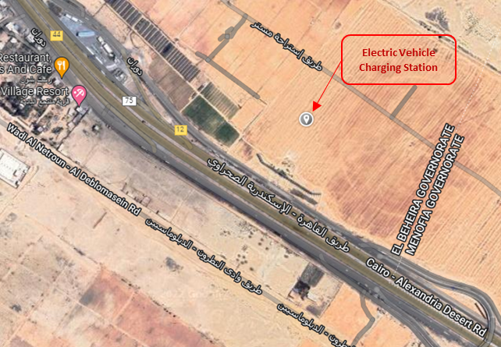
(a)
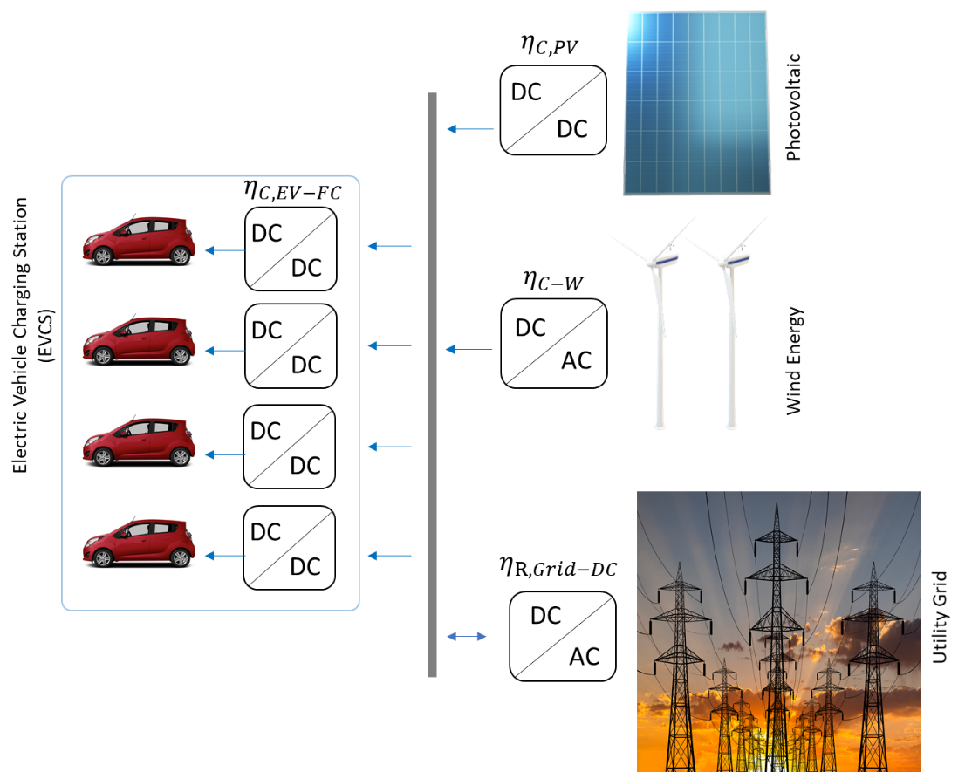
(b)
Figure 1. The system under study is (a) real place at the Cairo-Alexandria desert road, Egypt, and (b) Implemented schematic diagram of the proposed system.

Photovoltaic system
In this study, An On-Grid solar system is utilized with 8.2 kW output power. The input data for the Homer simulation model is 25 years lifetime and the derating factor of 96% which minimized the output of the PV system by 4%. The PV output power can be expressed by the following equation [40-42]
$$P_{pv}=G_{i}A_{pv}η_{pv}\left(1-c_{T}\left(T_{PV}-T_{STC}\right)\right)$$ | (1)
Where, $G_{i}$ is the global solar irradiance(W/m²), $A_{pv}$ is the installed PV module surface (m²), $η_{pv}$ is the reference module efficiency (%), $c_{T}$ is the temperature coefficient of the PV module and it is suggested to be 0.0048 ${°C}^{-1}$ for silicon, $T_{PV}$ is the PV cell temperature, which depends on the surrounding ambient conditions ($°C$), and $T_{STC}$ is the standard test condition (STC) temperature ($°C$).
The scaled data of the global radiation of the EVCS area all over the year 2017 is displayed in Figure 2-a., and the PV output power for one day in May is expressed in Figure 2-b. The PV system capital, replacement, and operation and maintenance costs (O&M) are estimated to be 296,000 LE, 121,000 LE, and 185 LE, respectively. The prices used in the model have been stated according to [43, 44]. The revenue of selling the PV energy to the grid in Egypt is 1.0858 LE/kWh [45, 46] and it is assumed that the charging by PV is 2.1716 LE/kWh, including all the controllers and protection facilities. However, the tariff for using electrical energy from the grid is 3.75 LE/kWh [45, 46].

Wind Energy System
In this study, a 20 kW wind turbine is used with a rotor diameter of 15.81 m, class III, cut-in wind speed of 2.75 m/s, cut-out speed of 20 m/s, and 20 years lifetime. The output power from the wind turbine could be approximately computed through the parametric technique as expressed in [47, 48]
$$P_{a}(u)=\left\{\begin{aligned}P(u), \\ P_{r}, \\ 0,\end{aligned}\right.$$ | $$\begin{matrix}V_{c-i}≤V≤V_{r} \\ V_{r}≤V≤V_{c-o} \\ V_{c-o}≤V or V≤V_{c-i}\end{matrix}$$ | (2)
Where, $P_{a}(u)$ is the wind turbine generator output power (kW), $P(u)$ is the linear variable region between the cut-in and cut-out speed (kW), $P_{r}$ is the rated output power of the wind turbine (kW), $V$ is the wind speed (m/s), $V_{r}$ is the rated wind speed (m/s), $V_{c-o}$ is the cut-out wind speed (m/s), and $V_{c-i}$ is the cut-in wind speed (m/s).
The wind speed information for the year 2017 of the EVCS area is displayed in Figure 2-c., and the wind turbine generator output power for one day in May is expressed in Figure 2-d. The wind turbine capital, replacement, and operation and maintenance costs (O&M) are estimated to be 760,000 LE, 500,000 LE, and 1,850 LE, respectively. The prices used in the model have been stated according to the reference. The revenue for selling wind energy to the grid in Egypt is 1.4646 LE/kWh [45, 46] and it is assumed that the charging by the wind energy is 2.9292 LE/kWh, including all the controllers and protection facilities.

Electric Vehicles (EVs) charging demand and density in the station
The total number of EVs that enters the EVCS during the day is estimated by Monte Carlo in our previous paper with a maximum of 12 EVs at 5:00 pm [11]. However, in this study, the maximum number of EVs that enters the station is assumed to be 4 vehicles to be a moderate station size with high intensity. It is assumed that this station consists of 4 ports for DC fast charging based on the pros mentioned in [12, 49, 50]. The distribution of EVs all over the day is expressed in Figure 2-e, where a maximum of 4 EVs enter the station hourly from 6:00 am to 10:00 pm.
It is considered that all the EVs are in the same category 2015 Chevrolet Spark EV with the same technical statistics expressed in Table 1. The required charging power for DC fast charging is represented in Figure 2-f and the data is quoted from the vehicle battery testing datasheet of the EV[51] where the maximum state of charge (SOC) is 94%.
Table 1. Statistics of 2015 Chevrolet Spark EV battery
Battery Nominal Cell Voltage | 3.7 V
Nominal System Voltage | 355.2 V
Rated Pack Capacity | 52 Ah
Rated Pack Energy | 19 kWh
Rated DC Charge Power | 50 kW

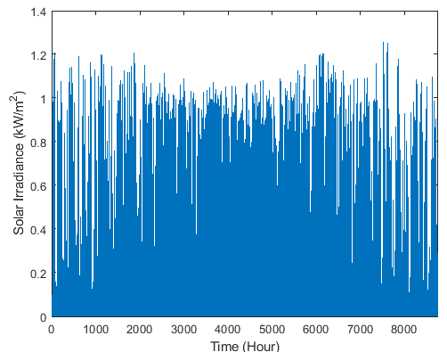 | 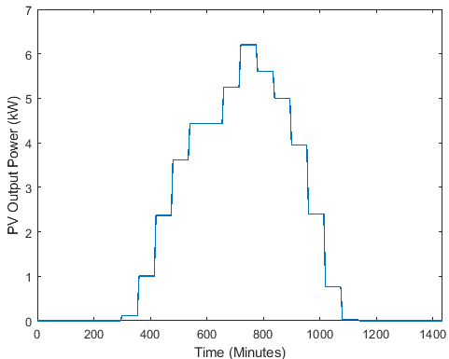
(a) | (b)
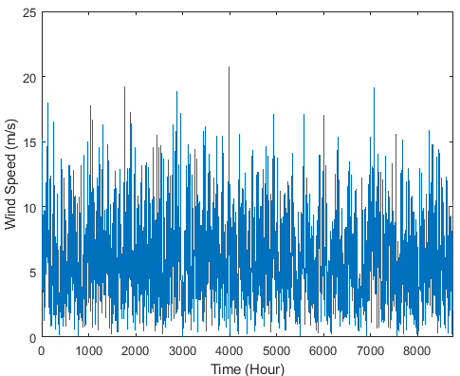 | 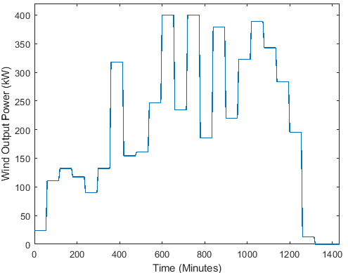
(c) | (d)
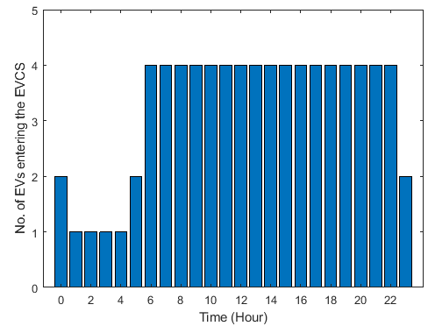 | 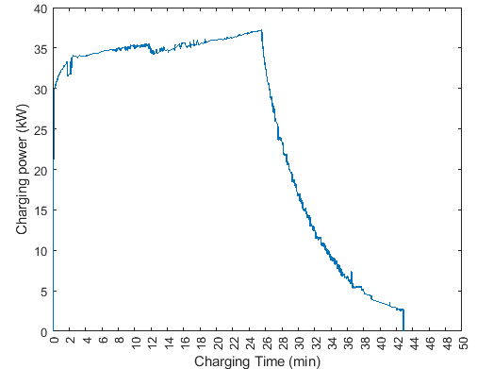
(e) | (f)
Figure 2. Overall RESs and EVCS characteristics (a)Solar irradiance all over the year (W/m²), (b)PV output power on the 15th of May 2017, (c) Wind speed over the year (m/s), (d) wind energy system output power on the 15th of May 2017, (e) Distribution of the EVs entering the EVCS daily, and (f) DC fast charging curve of the 2015 Chevrolet Spark EV battery.

Proposed Hierarchal Roles of the Aggregator (Operator)

EVs Charging Redistribution in the Station (Upper Stage)
In this paper, the system operator has a substantial upper role in the reliable matching of the electric generation and demand at the lowest possible operation cost during the day; however, the intermittency of RESs. This role is implemented by the smart scheduling of the EVs inside the EVCS. All the EVs will be charged by DC fast charging methodology to reach 94% SOC based on the datasheet and charging report stated before based on standard deviation statistics analysis. In addition, the load factor (LF) indicator has been used to measure the variability of consumption where it is the ratio between average real power demand and peak real power demand. A higher load factor is preferable and results in low energy costs [16]. It is assumed that the aggregator will select the charging point plugging-in time at a specific time in HH: MM for each EV based on its corresponding entering time. The allowable waiting time varies from 6 to 18 minutes in steps of 6 minutes to ensure the electric vehicle is parked and connected to its corresponding charging point. However, it is stated in the literature survey that the maximum waiting time of the suburban station with 4 ports maybe reaches 30 minutes [52]. The proposed system in this paper calculates the standard deviation of all available alternatives (probabilities) as expressed in equation 3. This equation has been solved as a mixed-integer linear programming (MILP) problem. The main advantage of the MILP is that the linear programming sub-problems can be solved quickly, and the linear constraints result in a convex feasible region to obtain the global optimum [53].
$$σ_{i}=\sqrt{\frac{1}{N-1}\sum_{m=0}^{M=60}{{(\left(P_{W_{m, h}}+P_{{PV}_{m, h}}\right)-(\frac{\sum_{m=0}^{M=60}{P_{{EV}_{m, h}}}}{N}))}^{2}}}$$ | (3)
Where, $P_{{PV}_{m, h}},P_{W_{m, h}}, P_{{EV}_{m, h}}$ are the active power of the PV system, wind energy system, and the power required for EV charging respectively in (kW) at the corresponding charging minute and hour.
In order to make the methodology clear, we can present an example with 2 EVs entering the charging station at 05:00 am, based on Figure 2 and the illustration in Figure 3. The system has ten alternatives presented from time 05:06 to 05:24 where 1 or 2 EVs may be connected simultaneously or with a maximum delayed interval time of 18 minutes in steps of 6 minutes to ensure the required time for the EV to be parked and connected to its corresponding charging point. All the allowable probabilities are expressed by the green colour box in Figure 3. The hierarchal model based on MILP will choose the most flatted curve according to the standard deviation concept according to the starting time of charging. In the presented example, the optimum solution is the 7th alternative $(σ_{7})$ based on equation (3) where EV_1 will be connected at 05:06 am and EV_2 will be connected at 05:24 am.
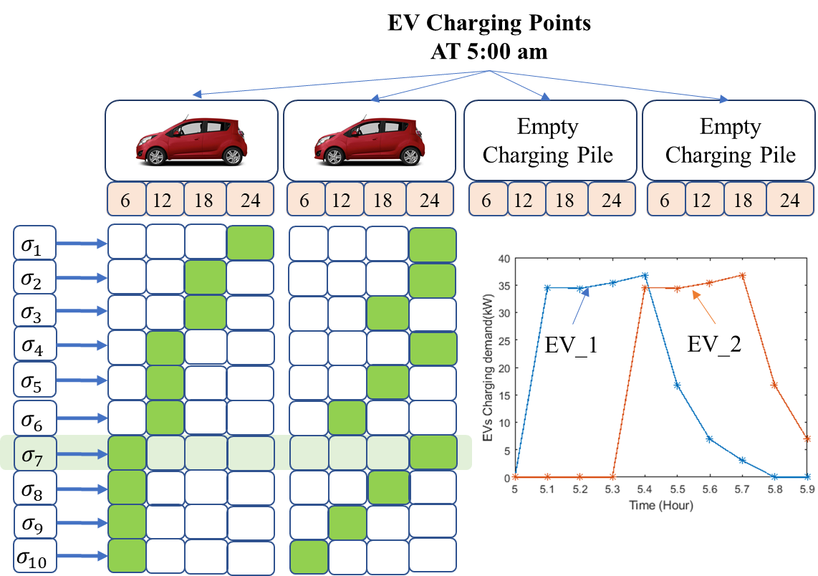
Figure 3. Schematic diagram of the probability of the upper stage hierarchal model.

Maximizing the EVCS Revenue and Minimizing the EVs Charging tariff (Second Stage)
One of the prevalent techniques due to the integration between RESs in the distribution networks is distribution feeder recognition (DFR). DFR is used to maximize certain objective functions subject to all operational constraints[54, 55]. It is noteworthy that the DFR has ignored the daily load variation and has been solved during a predetermined time interval. The DFR is carried out by managing the on/off states of tie switches and sectionalizing switches in a distribution feeder without islanding any buses[55]. Reconfiguration has been used in [56] to change the topology of the network by repositioning switches. In [57], the authors emphasized that system reconfiguration using sectionalizing and tie switches ensures the optimal and efficient operation of the microgrid.
In this subsection, the second stage of the proposed modelling is implemented based on multiple equations, each equation describes a specific available scenario. The equations have been extracted from [36]. This stage is applied using the data obtained from the PV system, wind energy system, and EV charging curve. The data is collected at the start of each hour and the decision has been taken to be implemented in steps of 6 minutes for manoeuvring the switches. The system can choose between the different scenarios based on restricted constraints corresponding to the available power in each step. The corresponding scenarios can be expressed as follows:
- In the 1st scenario, the PV system can charge the EVs at the corresponding interval time based on the constraint in equation 4 where the PV output power must be more than the EV charging demand. The objective function of this scenario can be represented in equation 5, where the target is minimizing the EVs’ tariff and maximizing the total revenue of the EVCS.
$$P_{{PV}_{m, h}}≥P_{{EV}_{m, h}}$$ | (4)
$$Ψ_{PV}=ρ_{S,PV}\left(P_{{PV}_{m, h}}.η_{C,PV}-\frac{P_{{EV}_{m, h}}}{η_{C,EV-FC}}\right)+ρ_{S,W}.P_{W_{m, h}}.η_{C-W}-ρ_{B,EV-PV}\frac{P_{{EV}_{m, h}}}{η_{C,EV-FC}}$$ | (5)
Where, $ρ_{S,PV}, ρ_{S,W}$ are the prices of selling the power to the utility grid from the PV system and wind energy turbine generator in (LE) respectively, $ρ_{B,EV-PV}$ is the EV charging tariff using the PV system in (LE), and $η_{C,PV}, η_{C-W},η_{C,EV-FC}$are the efficiencies of the DC/DC PV converter, AC/DC wind converter, and DC/DC EV fast-charging converter, respectively. In this paper, all converters’ efficiency is considered as 90%.
- In the 2nd scenario, EVs’ demand will be supplied from the utility grid based on the constraint in equation 6 and the objective function in equation 7 where the surplus power of the grid must cover the charging demand of the EV.
$$P_{G_{m, h}}≥P_{{EV}_{m, h}}$$ | (6)
$$Ψ_{G}=ρ_{S,PV}.P_{{PV}_{m, h}}.η_{C,PV}+ρ_{S,W}.P_{W_{m, h}}.η_{C-W}-ρ_{B,EV-G}.\frac{P_{{EV}_{m, h}}}{η_{R,Grid-DC}.η_{C,EV-FC}}$$ | (7)
Where, $η_{R,Grid-DC}$ is the efficiency of the grid rectifier and assumed to be 90% efficiency, and $ρ_{B,EV-G}$ is the EV charging tariff using the utility grid in (LE).
- In the 3rd scenario, the wind turbine generator can supply the EVs without any integration with the other suppliers based on the constraint in equation 8 and the objective function in equation 9 where the wind generator turbines must be greater than the EVs’ charging load.
$$P_{W_{m, h}}≥P_{{EV}_{m, h}}$$ | (8)
$$Ψ_{W}=ρ_{S,W}\left(P_{W_{m, h}}.η_{C,W}-\frac{P_{{EV}_{m, h}}}{η_{C,EV-FC}}\right)+ρ_{S,PV}.P_{{PV}_{m, h}}.η_{C,PV}-ρ_{B,EV-W}\frac{P_{{EV}_{m, h}}}{η_{C,EV-FC}}$$ | (9)
Where, $ρ_{B,EV-W}$ is the EV charging tariff using the wind turbine generator in (LE).
- In the 4th scenario, the generated power from the PV is not sufficient to charge the EVs, and also the power generated from the wind turbine is not sufficient to charge the EVs on its own, so both the RESs are integrated to fully charge the EVs in the station based on the constraint in equation 10 and the objective function in equation 11.
$P_{{PV}_{m, h}}<P_{{EV}_{m, h}}$,  $P_{W_{m, h}}<P_{{EV}_{m, h}}$,  $$P_{W_{m, h}}+P_{{PV}_{m, h}}≥P_{{EV}_{m, h}}$$ | (10)
$$Ψ_{PV+W}=ρ_{S,W}\left(P_{W_{m, h}}.η_{C,W}+P_{{PV}_{m, h}}.η_{C,PV}-\frac{P_{{EV}_{m, h}}}{η_{C,EV-FC}}\right)-\left(ρ_{B,EV-PV}.P_{{PV}_{m, h}}.η_{C,PV}+ρ_{B,EV-W}.η_{C,W}\left(\frac{P_{{EV}_{m, h}}}{η_{C,EV-FC}}-P_{PV}.η_{C,PV}\right)\right)$$ | (11)
- In the 5th scenario, EVs could be charged through the integration between the PV system and utility grid where PV can't charge the EV on its own based on equations 12, and 13.
$P_{{PV}_{m, h}}<P_{{EV}_{m, h}}$,  $$P_{{PV}_{m, h}}+P_{G_{m, h}}≥P_{{EV}_{m, h}}$$ | (12)
$$Ψ_{PV+G}=ρ_{S,W}.P_{W_{m, h}}.η_{C,W}-\left(ρ_{B,EV-G}.η_{R,Grid-DC}.\left(\frac{P_{{EV}_{m, h}}}{η_{C,EV-FC}}-P_{{PV}_{m, h}}.η_{C,PV}\right)+ρ_{B,EV-PV}.\frac{P_{{PV}_{m, h}}.η_{C,PV}}{η_{C,EV-FC}}\right)$$ | (13)
- In the 6th scenario, EVs could be charged based on the integration between the wind energy and utility grid where the output power from the wind energy cannot charge the EVs on its own based on equations 14, and 15.
$P_{W_{m, h}}<P_{{EV}_{m, h}}$,  $$P_{W_{m, h}}+P_{G_{m, h}}≥P_{{EV}_{m, h}}$$ | (14)
$$Ψ_{W+G}=ρ_{S,PV}.P_{{PV}_{m, h}}.η_{C,PV}-\left(ρ_{B,EV-G}.η_{R,Grid-DC}.\left(\frac{P_{{EV}_{m, h}}}{η_{C,EV-FC}}-P_{W_{m, h}}.η_{C,W}\right)+ρ_{B,EV-W}.\frac{P_{W_{m, h}}.η_{C,W}}{η_{C,EV-FC}}\right)$$ | (15)
- In the 7th scenario, both the RESs could not supply the station even by the integration Therefore the grid must support the system as a third supplier, based on equations 16 and 17.
$$P_{{PV}_{m, h}}<P_{{EV}_{m, h}}$$  $$P_{W_{m, h}}<P_{{EV}_{m, h}}$$  $$P_{{PV}_{m, h}}+P_{W_{m, h}}<P_{{EV}_{m, h}}$$  $$P_{W_{m, h}}+P_{{PV}_{m, h}}+P_{G_{m, h}}≥P_{{EV}_{m, h}}$$ | (16)
$$Ψ_{PV+W+G}=0-\left(ρ_{B,EV-G}.η_{R,Grid-DC}.\left(\frac{P_{{EV}_{m,h}}}{η_{C,EV-FC}}-P_{{PV}_{m, h}}.η_{C,PV}-P_{W_{m, h}}.η_{C,W}\right)+ρ_{B,EV-PV}.\frac{P_{{PV}_{m, h}}.η_{C,PV}}{η_{C,EV-FC}}+ρ_{B,EV-W}.\frac{P_{W_{m, h}}.η_{C,W}}{η_{C,EV-FC}}\right)$$ | (17)
The implemented programming methodologies will be discussed in the following section

Mixed Integer Linear Programming (MILP)
Mixed-integer linear programming (MILP) has been used widely in the EV optimization problems as in [58] the operation of a fleet of E-mobile assets has been introduced based on the MILP to minimize the charging cost. In [59], bidirectional EV property represented in vehicle-to-home (V2H) and vehicle-to-grid (V2G) has been used to maximize revenues for the user using linear programming (LP) and MILP. MILP ensured a revenue reached 30% higher than LP. In [60], ESONE, a MILP, is used to optimize the operational schedule and optimal power flow hourly in power system generation and transmission infrastructure in the presence of transport electrification. The scheduling issue in the centralized EVCS is designed as a MILP issue in [11, 61]. In addition, the MILP has been used in the charging coordination in unbalanced electrical distribution systems in[62]. The maximum amount of renewable energy sources and optimal operation time for EVs and appliances have been developed by MILP [63]. Hence, MILP has been used widely in EV optimization problems, as mentioned in the literature review. The integer variables are obtained using the branch and bound algorithm.
The objective function that describes the proposed model can be stated in equation 18, as concluded from equations 4 to 17
$$δ=\sum_{h=0}^{H}{\sum_{m=0}^{M}{{α_{1}Ψ}_{PV}+α_{2}Ψ_{G}+α_{3}Ψ_{W}+α_{4}Ψ_{PV+W}+α_{5}Ψ_{PV+G}+α_{6}Ψ_{W+G}+α_{7}Ψ_{PV+W+G}}}$$ | (18)
In the previous equation, 𝛼 is the status of the switching scenario, where $α=1 or 0$. $α=1$ means that this scenario will be implemented in its corresponding minute $m$ and time $h$ which will reflect on the concerning switches between the RES, EVs, and grid in Figure 1.

Markov Decision Process Reinforcement Learning (MDP-RL)
Sequential decision problems evolve probabilistically based on a finite and discrete set of states and are solved using MDP-RL which is considered a mathematical method for modelling sequential decision processes[64]. RL has been utilized in many scopes such as game theory, swarm intelligence, operations research, learning robot control, and statistics [65]. RL proved its effectiveness to reformulate and solve optimization problems as in [66]. At each time slot of MDP-RL, the agent observes the state of the process, then selects and executes an action that is optional at this state; then, the agent receives a reward according to the action. The next time, the process moves to a new state and the probability of the process from the current state to a new state is affected by the chosen action. The decision is made based on the state, action, transition function, and reward function of the MDP-RL introduced in [29].
At the beginning of each time slot represented by an hour and minute $h and m$, the aggregator determines the charging demand, the RESs generated power, charging prices using the different alternative sources, the revenue from selling the power to the utility grid, and the time that the EV will be connected to the charging point. The EVs charging schedule system can be expressed as an agent which completes the DC fast charging of all EVs by making a sequence of the decision on the selection of supplying source PV, wind energy, grid, or any combination of the various available power. As shown in Figure 4, the EVCS can choose between seven scenarios as discussed in equations 4 to 17 and the optimum track could be represented by the shaded path, which reflects the status of each source, as will be discussed in the results section. Each step is 6 mins long, where it is considered that all EVs enter the station with 5% SOC and leave the station with 94% SOC.
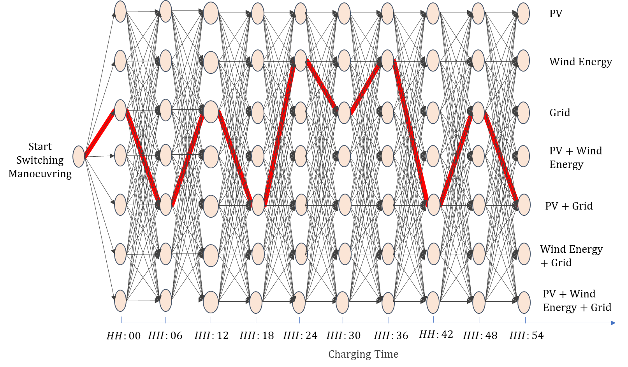
Figure 4. Schematic diagram of EVs fast charging probabilities to reach full capacity 94% using the Markov Decision Process Reinforcement Learning (MDP-RL).

Results and Discussion
Homer Pro simulated program has been used in this study as the first stage for our modelling, where all the data stated in section 2 of the PV system, Wind energy system, and EVs’ charging demand has been used as a data entry to the program. The simulated program selects the optimum feasible system architecture to supply the corresponding load. In our case study, the optimum solution is obtained by integrating the PV system, wind energy system, and utility grid. The capacity of the selected systems is a 7.05 kW PV system and a 400 kW wind energy system. In addition, the system indicates that the simple payback is 3.9 years, with a return of investment (ROI) of 21%, and an internal rate of return (IRR) of 25%. In addition, the energy to be purchased by this system is 85,184 kWh and the energy to be sold to the grid is 1,500,669 kWh. The output results from the Homer Pro simulated program represented in the rated capacity power, energy production, hours of penetration, penetration percentage, and Levelized cost for each renewable energy source are summarized in Table 2. Thus, the framework has been checked and perfectly evaluated using the Homer Pro program, so the next level reveals the first role of the aggregator, which redistributes the EVs’ charging demand to flatten the resultant active power without using the V2G property or the ToU pricing method.
Table 2. Analysis summary of the proposed microgrid
PV system
Total electrical production | 13,056 kWh/yr (0.648%)
Rated capacity | 7.05 kW
Mean output | 1.49 kW (35.8kWh/d)
Capacity factor | 21.2%
PV penetration | 2.66%
Hours of operation | 4,386 hrs/yr
Levelized cost | 1.52 LE/kWh
Wind Energy
Total electrical production | 1,918,104 kWh/yr (95.1%)
Rated capacity | 400 kW
Mean output | 219 kW
Capacity factor | 54.7%
Wind penetration | 391%
Hours of operation | 7,709 hrs/yr
Levelized cost | 0.688 LE/kWh

Scheduling the EVs in the Charging Station (Upper stage)
The influence of EVs’ fast charging in the EVCS on the daily load curve of the utility grid distribution network is presented in Figure 4. Without a price scheme of charging, without using the BESS or the vehicle to grid (V2G) capability, a better load profile with a low peak-to-average, load factor and peak-to-peak ratios is obtained using the MILP model based on the standard deviation concept as expressed in the equation (3). This equation has been implemented on the different scheduling alternatives to flat the curve and hence minimize the peak points of fast charging.
The net active power difference between the generated power from RESs and the consumed power from the EVCS is presented in Figure 5-a where MILP is compared with the traditional operation, which based on all the EVs will be charged at the same time after 6 minutes of each hour. To judge the performance of the proposed approach, the peak of MILP to the peak of traditional operation percentage of change value at the same hour has been measured as declared in Figure 5-b. The EV charging peak load has been reduced to 48.17%, equivalent to 4.5 kW at 07:00 am as shown in Figure 5-c.
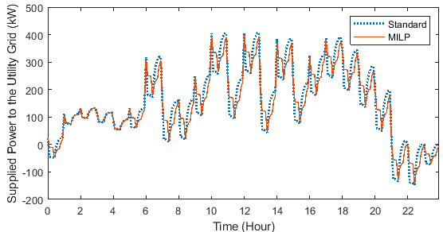
(a)
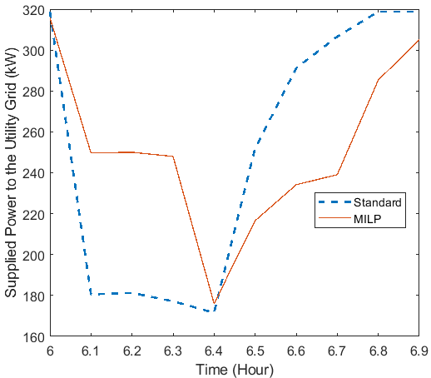 | 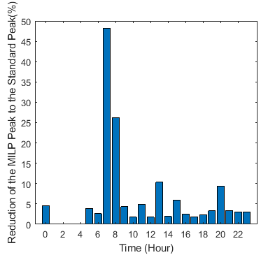
(b) | (c)
Figure 5. Results from the upper stage of the hierarchal model (a) EVCS active power difference between the generated power from RESs and the consumed power from the EVCS, (b) Declaration of the measurement method between the two peaks, and (c) peak to peak percentage of change between the MILP and traditional operation.
It is concluded that the proposed methodology based on MILP is minimizing the peak load hourly across the day by flattening the curve as in Figures 6-a and 6-b where a reduction reached 3.31% (4.5 kW) and 3.1% (2.25 kW) at 19:00 and 23:00 respectively. To illustrate the flexibility of the proposed model, the peak-to-average value has been calculated for each hour as shown in Figure 6-c. The peak-to-average was reduced by 4.5 kW which represents a reduction of 5.95% from 07:00 to 22:00 and it is noticed that from 02:00 to 04:00, no variation as only 1 EV enters the station. Finally, the load factor ratio is calculated to ensure the effectiveness of the proposed MILP model where the system ensured a load factor increase of 3.1276% where the LF of the traditional operation is 37.052% and the MILP model is 38.21% as shown in Figures 6-d.
In addition, by using the MILP, it is concluded that no variation will be obtained in the peak of MILP to the peak of traditional operation values while reducing the charging time to 30 minutes and the SOC to 88%. So, this stage ensures satisfaction for both the EV’s owner and the utility grid operator by balancing the generated and consumed power with only peak consumed power for 6 minutes.
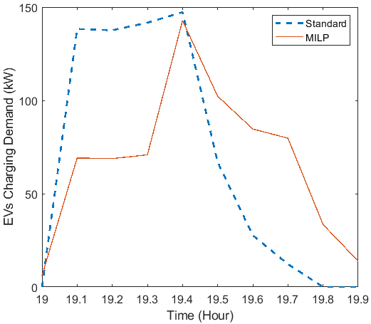 | 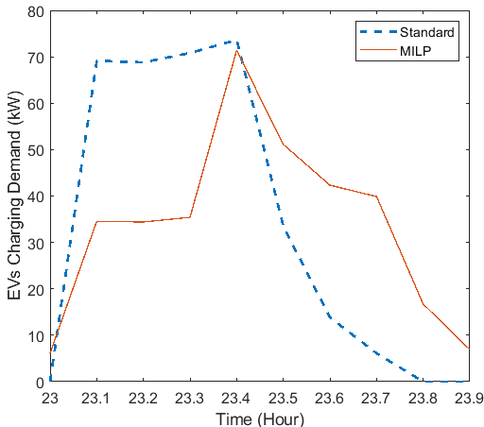
(a) | (b)
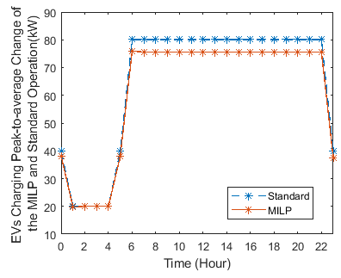 | 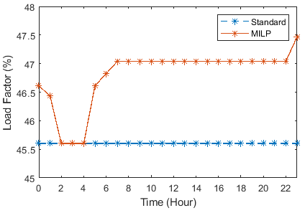
(c) | (d)
Figure 6. Results from the upper stage of the hierarchal model (a) EV charging demand using MILP and compared with traditional operation at 19:00, (b) EV charging demand using MILP and compared with traditional operation at 23:00, (c) EVs’ charging demand peak-to-average change of the MILP and traditional operation, and (d) Load factor of the proposed model concerning the traditional operation.

Maximizing the EVCS Profit (Second stage)
The second role of the aggregator is to maximize the EVCS revenue and minimize the EVs tariff. In this role, two different methodologies have been implemented using MILP and MDP-RL methods and the results are compared with the traditional operation where the RESs will supply all the EVs and the surplus power will be supplied to the grid. The status of each switch for both methods is precisely declared in Table 3, where P, W, and G are corresponding to the PV, wind energy, and grid switching status. The condition of each switch is considered as a binary number where 1 means the switch is closed and 0 means the switch is opened. As shown in Figures 7-a and 7-b, the EVs tariff percentage of change using MILP is bigger than using the MDP-RL with respect to the traditional operation, and also the EVCS revenue percentage of change using MILP is bigger than using MDP-RL with respect to the traditional operation.
EVs’ charging tariff increased by 21.19 % (842.17977 LE/day) using MILP and 15.03% (597.442618 LE/day) using the MDP-RL. However, the increase in the EVCS revenue reached 28.88% (1,583.42205 LE/day) and 20.10% (1,101.92988 LE/day) using MILP and MDP-RL, respectively, as shown in Figure 7-c. It is concluded that using MDP-RL is more convenient to satisfy a moderate balance between EV charging tariff and EVCS revenue which the revenue decreased only 6.81% from the MILP and also the EV charging tariff decreased by 5.08%. By using the MDP-RL the station will ensure a revenue of 2,403,122.26 LE/year, with respect to the traditional operation of EVCS of 2,000,917.849 LE/year.
Table 3. Switching manoeuvring status of sources
HH  MM |  | 0 | 1 | 2 | 3 | 4 | 5 | 6 | 7 | 8 | 9 | 10 | 11 | 12 | 13 | 14 | 15 | 16 | 17 | 18 | 19 | 20 | 21 | 22 | 23
 |  | MILP
00 | P | 0 | 0 | 0 | 0 | 0 | 0 | 1 | 1 | 1 | 1 | 1 | 1 | 1 | 1 | 1 | 1 | 1 | 1 | 1 | 0 | 0 | 0 | 0 | 0
 | W | 1 | 0 | 1 | 1 | 1 | 1 | 0 | 0 | 0 | 0 | 0 | 0 | 0 | 0 | 0 | 0 | 0 | 0 | 0 | 0 | 0 | 0 | 0 | 0
 | G | 0 | 1 | 0 | 0 | 0 | 0 | 1 | 1 | 1 | 1 | 1 | 1 | 1 | 1 | 1 | 1 | 1 | 1 | 1 | 1 | 1 | 1 | 1 | 1
06 | P | 0 | 0 | 0 | 0 | 0 | 1 | 1 | 1 | 1 | 1 | 1 | 1 | 1 | 1 | 1 | 1 | 1 | 1 | 1 | 0 | 0 | 0 | 0 | 0
 | W | 1 | 0 | 0 | 0 | 0 | 0 | 0 | 0 | 0 | 0 | 0 | 0 | 0 | 0 | 0 | 0 | 0 | 0 | 0 | 0 | 0 | 1 | 0 | 0
 | G | 1 | 1 | 1 | 1 | 1 | 1 | 1 | 1 | 1 | 1 | 1 | 1 | 1 | 1 | 1 | 1 | 1 | 1 | 1 | 1 | 1 | 1 | 1 | 1
12 | P | 0 | 0 | 0 | 0 | 0 | 1 | 1 | 1 | 1 | 1 | 1 | 1 | 1 | 1 | 1 | 1 | 1 | 1 | 1 | 0 | 0 | 0 | 0 | 0
 | W | 1 | 0 | 0 | 0 | 0 | 0 | 0 | 0 | 0 | 0 | 0 | 0 | 0 | 0 | 0 | 0 | 0 | 0 | 0 | 0 | 0 | 1 | 0 | 0
 | G | 1 | 1 | 1 | 1 | 1 | 1 | 1 | 1 | 1 | 1 | 1 | 1 | 1 | 1 | 1 | 1 | 1 | 1 | 1 | 1 | 1 | 1 | 1 | 1
18 | P | 0 | 0 | 0 | 0 | 0 | 1 | 1 | 1 | 1 | 1 | 1 | 1 | 1 | 1 | 1 | 1 | 1 | 1 | 1 | 0 | 0 | 0 | 0 | 0
 | W | 1 | 0 | 0 | 0 | 0 | 0 | 0 | 0 | 0 | 0 | 0 | 0 | 0 | 0 | 0 | 0 | 0 | 0 | 0 | 0 | 0 | 1 | 0 | 0
 | G | 1 | 1 | 1 | 1 | 1 | 1 | 1 | 1 | 1 | 1 | 1 | 1 | 1 | 1 | 1 | 1 | 1 | 1 | 1 | 1 | 1 | 1 | 1 | 1
24 | P | 0 | 0 | 0 | 0 | 0 | 1 | 1 | 1 | 1 | 1 | 1 | 1 | 1 | 1 | 1 | 1 | 1 | 1 | 1 | 0 | 0 | 0 | 0 | 0
 | W | 1 | 0 | 0 | 0 | 0 | 0 | 0 | 0 | 0 | 0 | 0 | 0 | 0 | 0 | 0 | 0 | 0 | 0 | 0 | 0 | 0 | 1 | 0 | 0
 | G | 1 | 1 | 1 | 1 | 1 | 1 | 1 | 1 | 1 | 1 | 1 | 1 | 1 | 1 | 1 | 1 | 1 | 1 | 1 | 1 | 1 | 1 | 1 | 1
30 | P | 0 | 0 | 0 | 0 | 0 | 1 | 1 | 1 | 1 | 1 | 1 | 1 | 1 | 1 | 1 | 1 | 1 | 1 | 1 | 0 | 0 | 0 | 0 | 0
 | W | 1 | 0 | 0 | 0 | 0 | 0 | 0 | 0 | 0 | 0 | 0 | 0 | 0 | 0 | 0 | 0 | 0 | 0 | 0 | 0 | 0 | 1 | 0 | 0
 | G | 1 | 1 | 1 | 1 | 1 | 1 | 1 | 1 | 1 | 1 | 1 | 1 | 1 | 1 | 1 | 1 | 1 | 1 | 1 | 1 | 1 | 1 | 1 | 1
36 | P | 0 | 0 | 0 | 0 | 0 | 1 | 1 | 1 | 1 | 1 | 1 | 1 | 1 | 1 | 1 | 1 | 1 | 1 | 1 | 0 | 0 | 0 | 0 | 0
 | W | 1 | 0 | 0 | 0 | 0 | 0 | 0 | 0 | 0 | 0 | 0 | 0 | 0 | 0 | 0 | 0 | 0 | 0 | 0 | 0 | 0 | 1 | 0 | 0
 | G | 1 | 1 | 1 | 1 | 1 | 1 | 1 | 1 | 1 | 1 | 1 | 1 | 1 | 1 | 1 | 1 | 1 | 1 | 1 | 1 | 1 | 1 | 1 | 1
42 | P | 0 | 0 | 0 | 0 | 0 | 1 | 1 | 1 | 1 | 1 | 1 | 1 | 1 | 1 | 1 | 1 | 1 | 1 | 1 | 0 | 0 | 0 | 0 | 0
 | W | 1 | 0 | 0 | 0 | 0 | 0 | 0 | 0 | 0 | 0 | 0 | 0 | 0 | 0 | 0 | 0 | 0 | 0 | 0 | 0 | 0 | 1 | 0 | 0
 | G | 1 | 1 | 1 | 1 | 1 | 1 | 1 | 1 | 1 | 1 | 1 | 1 | 1 | 1 | 1 | 1 | 1 | 1 | 1 | 1 | 1 | 1 | 1 | 1
48 | P | 0 | 0 | 0 | 0 | 0 | 1 | 1 | 1 | 1 | 1 | 1 | 1 | 1 | 1 | 1 | 1 | 1 | 1 | 1 | 0 | 0 | 0 | 0 | 0
 | W | 0 | 1 | 1 | 1 | 1 | 0 | 0 | 0 | 0 | 0 | 0 | 0 | 0 | 0 | 0 | 0 | 0 | 0 | 0 | 0 | 0 | 1 | 0 | 0
 | G | 1 | 0 | 0 | 0 | 0 | 1 | 1 | 1 | 1 | 1 | 1 | 1 | 1 | 1 | 1 | 1 | 1 | 1 | 1 | 1 | 1 | 1 | 1 | 1
54 | P | 0 | 0 | 0 | 0 | 0 | 1 | 1 | 1 | 1 | 1 | 1 | 1 | 1 | 1 | 1 | 1 | 1 | 1 | 1 | 0 | 0 | 0 | 0 | 0
 | W | 0 | 1 | 1 | 1 | 1 | 0 | 0 | 0 | 0 | 0 | 0 | 0 | 0 | 0 | 0 | 0 | 0 | 0 | 0 | 0 | 0 | 0 | 0 | 0
 | G | 1 | 0 | 0 | 0 | 0 | 1 | 1 | 1 | 1 | 1 | 1 | 1 | 1 | 1 | 1 | 1 | 1 | 1 | 1 | 1 | 1 | 1 | 1 | 1
 |  | MDP-RL
00 | P | 0 | 0 | 0 | 0 | 0 | 0 | 0 | 0 | 0 | 0 | 0 | 0 | 1 | 0 | 1 | 1 | 1 | 0 | 0 | 0 | 0 | 0 | 0 | 0
 | W | 0 | 0 | 0 | 0 | 0 | 0 | 0 | 1 | 0 | 1 | 0 | 0 | 0 | 1 | 0 | 0 | 0 | 1 | 0 | 1 | 1 | 0 | 0 | 0
 | G | 1 | 1 | 1 | 1 | 1 | 1 | 1 | 0 | 1 | 0 | 1 | 1 | 0 | 0 | 1 | 1 | 1 | 0 | 1 | 0 | 0 | 1 | 1 | 1
06 | P | 0 | 0 | 0 | 0 | 0 | 0 | 1 | 0 | 0 | 0 | 1 | 1 | 0 | 1 | 0 | 1 | 1 | 0 | 1 | 0 | 0 | 0 | 0 | 0
 | W | 0 | 1 | 1 | 0 | 0 | 1 | 0 | 1 | 0 | 1 | 0 | 0 | 1 | 0 | 1 | 0 | 0 | 0 | 0 | 0 | 0 | 0 | 0 | 0
 | G | 1 | 0 | 0 | 1 | 1 | 0 | 1 | 0 | 1 | 0 | 1 | 1 | 0 | 1 | 0 | 1 | 1 | 1 | 1 | 1 | 1 | 1 | 1 | 1
12 | P | 0 | 0 | 0 | 0 | 0 | 0 | 0 | 1 | 0 | 1 | 0 | 1 | 0 | 0 | 0 | 1 | 0 | 0 | 0 | 0 | 0 | 0 | 0 | 0
 | W | 0 | 0 | 0 | 0 | 0 | 0 | 0 | 0 | 1 | 0 | 0 | 0 | 0 | 1 | 0 | 0 | 0 | 0 | 0 | 1 | 0 | 1 | 0 | 0
 | G | 1 | 1 | 1 | 1 | 1 | 1 | 1 | 1 | 0 | 1 | 1 | 1 | 1 | 0 | 1 | 1 | 1 | 1 | 1 | 0 | 1 | 1 | 1 | 1
18 | P | 0 | 0 | 0 | 0 | 0 | 0 | 1 | 0 | 1 | 1 | 0 | 0 | 1 | 1 | 0 | 1 | 0 | 0 | 0 | 0 | 0 | 0 | 0 | 0
 | W | 0 | 0 | 1 | 1 | 1 | 1 | 0 | 1 | 0 | 0 | 1 | 0 | 0 | 0 | 1 | 0 | 1 | 1 | 1 | 1 | 1 | 1 | 0 | 0
 | G | 1 | 1 | 0 | 0 | 0 | 0 | 1 | 0 | 1 | 1 | 0 | 1 | 1 | 1 | 0 | 1 | 0 | 0 | 0 | 0 | 0 | 1 | 1 | 1
24 | P | 0 | 0 | 0 | 0 | 0 | 0 | 0 | 0 | 1 | 0 | 1 | 0 | 0 | 1 | 0 | 1 | 0 | 0 | 1 | 0 | 0 | 0 | 0 | 0
 | W | 1 | 1 | 0 | 0 | 1 | 1 | 1 | 1 | 0 | 1 | 0 | 0 | 0 | 0 | 1 | 0 | 0 | 0 | 0 | 1 | 0 | 0 | 0 | 0
 | G | 1 | 0 | 1 | 1 | 0 | 0 | 0 | 0 | 1 | 0 | 1 | 1 | 1 | 1 | 0 | 1 | 1 | 1 | 1 | 0 | 1 | 1 | 1 | 1
30 | P | 0 | 0 | 0 | 0 | 0 | 0 | 0 | 1 | 0 | 1 | 0 | 1 | 0 | 1 | 0 | 1 | 0 | 0 | 0 | 0 | 0 | 0 | 0 | 0
 | W | 0 | 1 | 1 | 0 | 0 | 1 | 0 | 0 | 0 | 0 | 0 | 0 | 0 | 0 | 0 | 0 | 1 | 1 | 0 | 0 | 1 | 1 | 0 | 0
 | G | 1 | 0 | 0 | 1 | 1 | 0 | 1 | 1 | 1 | 1 | 1 | 1 | 1 | 1 | 1 | 1 | 0 | 0 | 1 | 1 | 0 | 1 | 1 | 1
36 | P | 0 | 0 | 0 | 0 | 0 | 0 | 0 | 1 | 0 | 0 | 0 | 1 | 0 | 1 | 0 | 1 | 0 | 1 | 0 | 0 | 0 | 0 | 0 | 0
 | W | 0 | 0 | 0 | 0 | 0 | 1 | 1 | 0 | 1 | 0 | 0 | 0 | 0 | 0 | 0 | 0 | 1 | 0 | 0 | 0 | 1 | 0 | 0 | 0
 | G | 1 | 1 | 1 | 1 | 1 | 0 | 0 | 1 | 0 | 1 | 1 | 1 | 1 | 1 | 1 | 1 | 0 | 1 | 1 | 1 | 0 | 1 | 1 | 1
42 | P | 0 | 0 | 0 | 0 | 0 | 1 | 1 | 0 | 0 | 1 | 0 | 1 | 0 | 1 | 0 | 1 | 0 | 0 | 0 | 0 | 0 | 0 | 0 | 0
 | W | 1 | 0 | 1 | 0 | 1 | 0 | 0 | 1 | 1 | 0 | 1 | 0 | 0 | 0 | 1 | 0 | 0 | 0 | 0 | 1 | 1 | 1 | 0 | 0
 | G | 1 | 1 | 0 | 1 | 0 | 1 | 1 | 0 | 0 | 1 | 0 | 1 | 1 | 1 | 0 | 1 | 1 | 1 | 1 | 0 | 0 | 1 | 1 | 1
48 | P | 0 | 0 | 0 | 0 | 0 | 0 | 0 | 0 | 1 | 0 | 0 | 0 | 0 | 1 | 0 | 0 | 0 | 0 | 1 | 0 | 0 | 0 | 0 | 0
 | W | 0 | 0 | 1 | 1 | 1 | 1 | 0 | 0 | 0 | 0 | 0 | 1 | 0 | 0 | 0 | 1 | 1 | 0 | 0 | 1 | 0 | 1 | 0 | 0
 | G | 1 | 1 | 0 | 0 | 0 | 0 | 1 | 1 | 1 | 1 | 1 | 0 | 1 | 1 | 1 | 0 | 0 | 1 | 1 | 0 | 1 | 1 | 1 | 1
54 | P | 0 | 0 | 0 | 0 | 0 | 1 | 1 | 1 | 1 | 0 | 1 | 1 | 0 | 0 | 1 | 0 | 1 | 1 | 0 | 0 | 0 | 0 | 0 | 0
 | W | 0 | 0 | 1 | 1 | 1 | 0 | 0 | 0 | 0 | 0 | 0 | 0 | 0 | 1 | 0 | 0 | 0 | 0 | 1 | 1 | 0 | 0 | 0 | 0
 | G | 1 | 1 | 0 | 0 | 0 | 1 | 1 | 1 | 1 | 1 | 1 | 1 | 1 | 0 | 1 | 1 | 1 | 1 | 0 | 0 | 1 | 1 | 1 | 1

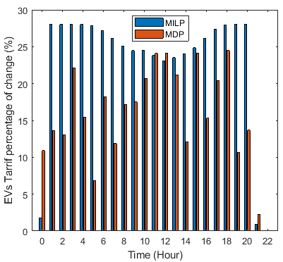 | 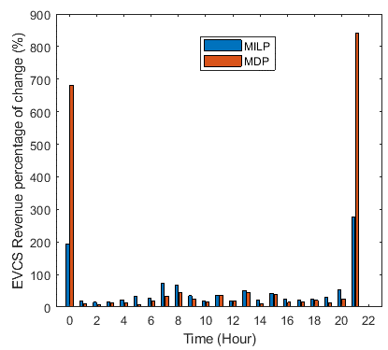
(a) | (b)
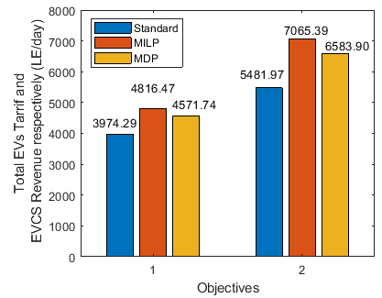
(c)
Figure 7. Results from the second stage of the hierarchal model compared to the standard operation (a) EVs charging tariff percentage of change, (b) EVCS revenue percentage of change, and (c) Total EVs charging tariff and EVCS revenue obtained by the main equation represented by the two objective functions.

Conclusion
This paper emphasizes the vital role of the aggregator which is considered the direct interface between electric vehicles (EVs) and the utility grid. A novel smart techno-economic operation of the electric vehicle charging station (EVCS) in Egypt is implemented and controlled by the aggregator based on a hierarchal model. Egypt is considered a prime strategic location for renewable energy projects due to the sunny weather and high wind speed. The upper stage of the model is ensuring the balance between the generated power from the RESs and the consumed power from the EVCS due to the fast DC charging of EVs. In addition, the aggregator maximizes the EVCS profit and minimizes the EVs tariff however, it is challenging as both objectives are conflicting with each other. The MILP is used in the upper model and reduced the consumed power by 48.17% (4.5 kW). As the peak demand is reduced, the generation capacity of the RESs and grid will not be overstretched and system stability would be improved. In the second model, MILP and MDP-RL have maximized the profit by 28.88% and 20.10.54%, respectively. However, an increase in the EVs charging tariff is obtained of 21.19.739%, and 15.03%, respectively. This work may be extended to use multiple categories of EVs and utilize artificial intelligence to recognize the EV while plugging into the charging point to collect all the corresponding EV data and satisfy the hierarchal control model. In addition, using AI for a precise prediction of the generated power from the available sources.

Nomenclature and Abbreviations
Nomenclature |  | Abbreviations
$$A_{pv}$$ | Installed PV module surface (m²). | BESS | Battery Energy Storage System
$$c_{T}$$ | Temperature coefficient of the PV module (${°C}^{-1}$). | CSP | Concentrating solar power
$$G_{i}$$ | Global solar irradiance (W/m²). | DCFC | DC fast charging
$$P_{a}(u)$$ | Wind turbine generator output power (kW). | DFR | Distribution feeder recognition
$$P(u)$$ | The linear variable region between the cut-in and cut-out speed (kW). | DGs | Diesel Generators
$$P_{r}$$ | The rated output power of the wind turbine (kW). | DPM | dynamic programming method
$$P_{pv}$$ | PV output power (W). | DPMA | Decentralized Profit Maximization Algorithm
$$P_{{PV}_{m, h}}$$ | Generated active power from the PV system at a specific minute and hour (kW). | DR | Demand Response
$$P_{W_{m, h}}$$ | Generated active power from the wind energy system at a specific minute and hour (kW). | EV | Electric Vehicle
$$P_{{EV}_{m, h}}$$ | Active power is required for EV fast charging at a specific minute and hour (kW). | EVCS | Electric Vehicle Charging Station
$$T_{PV}$$ | PV cell temperature ($°C$). | G2V | Grid to Vehicle
$$T_{STC}$$ | Standard test condition temperature ($°C$). | MDP-RL | Markov Decision Process Reinforcement Learning
$$V$$ | Wind speed (m/s). | MILP | Mixed-integer linear programming
$$V_{r}$$ | Rated wind speed (m/s). | MOERE | The Ministry of Electricity and Renewable Energy
$$V_{c-o}$$ | Cut-out wind speed (m/s). | O&M | Operation and maintenance costs
$$V_{c-i}$$ | Cut-in wind speed (m/s). | PEV | Plug-in Electric Vehicle
$$η_{pv}$$ | The reference module efficiency (%). | RES | Renewable Energy Source
$$η_{C,PV}$$ | The efficiency of the DC/DC PV converter (%). | RL | Reinforcement-learning
$$η_{C,EV-FC}$$ | The efficiency of the DC/DC EV fast-charging converter (%). | STC | Standard test condition
$$η_{C-W}$$ | The efficiency of the AC/DC wind converter (%). | ToU | Time-of-Use
$$η_{R,Grid-DC}$$ | The efficiency of the grid rectifier (%). | V2G | Vehicle to Grid
$$ρ_{S,PV}$$ | Price of selling the power to the utility grid from the PV system (LE)
$$ρ_{S,W}$$ | Price of selling the power to the utility grid from the wind energy turbine generator (LE)
$$ρ_{B,EV-PV}$$ | EV charging tariff using the PV system in (LE)
$$ρ_{B,EV-W}$$ | EV charging tariff using the wind turbine generator in (LE)
$$ρ_{B,EV-G}$$ | EV charging tariff using the utility grid in (LE)
$$Ψ$$ | A scenario of supplying the EVCS from PV, Wind, Grid or any combination of them
$$α$$ | The status of the switching scenario (ON/ OFF)

Acknowledgements
This work was supported by the Electrical Engineering Department, British University in Egypt (BUE), and the Division of Electrical and Electronic Engineering, London South Bank University (LSBU).

References
[1] Hemphill M. Electricity distribution system planning for an increasing penetration of plug-in electric vehicles in new south wales. Conference Electricity distribution system planning for an increasing penetration of plug-in electric vehicles in new south wales. IEEE, p. 1-6.
[2] Liu Z, Wu Q. EV charging analysis based on the National Travel Surveys of the Nordic Area. Conference EV charging analysis based on the National Travel Surveys of the Nordic Area. IEEE, p. 1-6.
[3] Ma C-T. System planning of grid-connected electric vehicle charging stations and key technologies: A review. Energies. 2019;12(21):4201.
[4] Quiros-Tortos J, Ochoa L, Butler T. How electric vehicles and the grid work together: Lessons learned from one of the largest electric vehicle trials in the world. IEEE Power and Energy Magazine. 2018;16(6):64-76.
[5] Ren H, Zhang A, Wang F, Yan X, Li Y, Duić N, et al. Optimal scheduling of an EV aggregator for demand response considering triple level benefits of three-parties. International Journal of Electrical Power & Energy Systems. 2021;125:106447.
[6] Michaelis J, Gnann T, Klingler A-L. Load Shifting Potentials of Plug-In Electric Vehicles—A Case Study for Germany. World Electric Vehicle Journal. 2018;9(2):21.
[7] Pirouzi S, Aghaei J, Vahidinasab V, Niknam T, Khodaei A. Robust linear architecture for active/reactive power scheduling of EV integrated smart distribution networks. Electric Power Systems Research. 2018;155:8-20.
[8] Muratori M. Impact of uncoordinated plug-in electric vehicle charging on residential power demand. Nature Energy. 2018;3(3):193-201.
[9] Cai S, Matsuhashi R. Model Predictive Control for EV Aggregators Participating in System Frequency Regulation Market. IEEE Access. 2021;9:80763-71.
[10] Mukherjee JC, Gupta A. Distributed charge scheduling of plug-in electric vehicles using inter-aggregator collaboration. IEEE Transactions on Smart Grid. 2016;8(1):331-41.
[11] Makeen P, Memon S, Elkasrawy M, Abdullatif SO, Ghali HA. Smart green charging scheme of centralized electric vehicle stations. International Journal of Green Energy. 2021:1-9.
[12] Makeen P, Ghali HA, Memon S. A Review of Various Fast Charging Power and Thermal Protocols for Electric Vehicles Represented by Lithium-Ion Battery Systems. Future Transportation. 2022;2(1):281-301.
[13] Tu H, Feng H, Srdic S, Lukic S. Extreme fast charging of electric vehicles: A technology overview. IEEE Transactions on Transportation Electrification. 2019;5(4):861-78.
[14] Makeen P, Ghali HA, Memon S, Duan F. Impacts of electric vehicle fast charging under dynamic temperature and humidity: Experimental and theoretically validated model analyses. Energy. 2022:125335.
[15] Geng B, Mills JK, Sun D. Coordinated charging control of plug-in electric vehicles at a distribution transformer level using the vTOU-DP approach. Conference Coordinated charging control of plug-in electric vehicles at a distribution transformer level using the vTOU-DP approach. IEEE, p. 1469-74.
[16] Uddin M, Romlie MF, Abdullah MF, Abd Halim S, Kwang TC. A review on peak load shaving strategies. Renewable and Sustainable Energy Reviews. 2018;82:3323-32.
[17] Mishra A, Irwin D, Shenoy P, Zhu T. Scaling distributed energy storage for grid peak reduction. Conference Scaling distributed energy storage for grid peak reduction. p. 3-14.
[18] Kütt L, Saarijärvi E, Lehtonen M, Rosin A, Mõlder H. Load shifting in the existing distribution network and perspectives for EV charging-case study. Conference Load shifting in the existing distribution network and perspectives for EV charging-case study. IEEE, p. 1-6.
[19] Onda H, Yamamoto S, Takeshit H, Okamoto S, Yamanaka N. Peak load shifting and electricity charges reduction realized by electric vehicle storage virtualization. AASRI Procedia. 2014;7:101-6.
[20] Aziz M, Oda T, Mitani T, Watanabe Y, Kashiwagi T. Utilization of electric vehicles and their used batteries for peak-load shifting. Energies. 2015;8(5):3720-38.
[21] Wu W, Lin B. Benefits of electric vehicles integrating into power grid. Energy. 2021;224:120108.
[22] Yu L, Li Y, Huang G, An C. A robust flexible-probabilistic programming method for planning municipal energy system with considering peak-electricity price and electric vehicle. Energy Conversion and Management. 2017;137:97-112.
[23] Elma O. A dynamic charging strategy with hybrid fast charging station for electric vehicles. Energy. 2020;202:117680.
[24] Dogan A, Kuzlu M, Pipattanasomporn M, Rahman S, Yalcinoz T. Impact of EV charging strategies on peak demand reduction and load factor improvement. Conference Impact of EV charging strategies on peak demand reduction and load factor improvement. IEEE, p. 374-8.
[25] Khan MW, Wang J. Multi-agents based optimal energy scheduling technique for electric vehicles aggregator in microgrids. International Journal of Electrical Power & Energy Systems. 2022;134:107346.
[26] Rashidizadeh-Kermani H, Najafi HR, Anvari-Moghaddam A, Guerrero JM. Optimal decision-making strategy of an electric vehicle aggregator in short-term electricity markets. Energies. 2018;11(9):2413.
[27] Li K, Mu Q, Wang F, Gao Y, Li G, Shafie-Khah M, et al. A business model incorporating harmonic control as a value-added service for utility-owned electricity retailers. IEEE Transactions on Industry Applications. 2019;55(5):4441-50.
[28] Firouzjah KG. Profit-based electric vehicle charging scheduling: Comparison with different strategies and impact assessment on distribution networks. International Journal of Electrical Power & Energy Systems. 2022;138:107977.
[29] Wang S, Bi S, Zhang YA. Reinforcement learning for real-time pricing and scheduling control in EV charging stations. IEEE Transactions on Industrial Informatics. 2019;17(2):849-59.
[30] Alghamdi TG, Said D, Mouftah HT. Profit Maximization for EVSEs-Based Renewable Energy Sources in Smart Cities With Different Arrival Rate Scenarios. IEEE Access. 2021;9:58740-54.
[31] Thangaraj A, Xavier SAE, Pandian R. Optimal coordinated operation scheduling for electric vehicle aggregator and charging stations in integrated electricity transportation system using hybrid technique. Sustainable Cities and Society. 2022;80:103768.
[32] Yang Z, Li K, Foley A. Computational scheduling methods for integrating plug-in electric vehicles with power systems: A review. Renewable and Sustainable Energy Reviews. 2015;51:396-416.
[33] Hijjo M, Frey G. Multi-objective optimization for scheduling isolated microgrids. Conference Multi-objective optimization for scheduling isolated microgrids. IEEE, p. 1037-42.
[34] Wang S, Bi S, Zhang Y-JA, Huang J. Electrical vehicle charging station profit maximization: Admission, pricing, and online scheduling. IEEE Transactions on Sustainable Energy. 2018;9(4):1722-31.
[35] Biroon RA, Abdollahi Z, Hadidi R. Fast and regular electric vehicle charging impacts on the distribution feeders. Conference Fast and regular electric vehicle charging impacts on the distribution feeders. IEEE, p. 1-7.
[36] Yang L, Ribberink H. Investigation of the potential to improve DC fast charging station economics by integrating photovoltaic power generation and/or local battery energy storage system. Energy. 2019;167:246-59.
[37] Ding T, Zeng Z, Bai J, Qin B, Yang Y, Shahidehpour M. Optimal electric vehicle charging strategy with Markov decision process and reinforcement learning technique. IEEE Transactions on Industry Applications. 2020;56(5):5811-23.
[38] Administration IT. Egypt - Country Commercial Guide. 2020.
[39] Azizivahed A, Arefi A, Ghavidel S, Shafie-Khah M, Li L, Zhang J, et al. Energy management strategy in dynamic distribution network reconfiguration considering renewable energy resources and storage. IEEE transactions on sustainable energy. 2019;11(2):662-73.
[40] Fazelpour F, Vafaeipour M, Rahbari O, Shirmohammadi R. Considerable parameters of using PV cells for solar-powered aircrafts. Renewable and Sustainable Energy Reviews. 2013;22:81-91.
[41] Mattei M, Notton G, Cristofari C, Muselli M, Poggi P. Calculation of the polycrystalline PV module temperature using a simple method of energy balance. Renewable energy. 2006;31(4):553-67.
[42] Yan D, Ma C. Stochastic planning of electric vehicle charging station integrated with photovoltaic and battery systems. IET Generation, Transmission & Distribution. 2020;14(19):4217-24.
[43] Samy M, Barakat S, Ramadan H. Techno-economic analysis for rustic electrification in Egypt using multi-source renewable energy based on PV/wind/FC. International Journal of Hydrogen Energy. 2020;45(20):11471-83.
[44] Reviews S. Solar panel cost Egypt: Prices & data 2022. https://wwwsolarreviewscom/solar-panel-cost/arkansas/egypt. 2022.
[45] Egypt MoEaECi. Ministry of Electricity and Energy Company in Egypt. Online Reference. 2022.
[46] (NERA) NaREA. Electric Feeding Tariff. Ministry of Electricity and Renewable Energy. 2022.
[47] Kot R, Rolak M, Malinowski M. Comparison of maximum peak power tracking algorithms for a small wind turbine. Mathematics and Computers in Simulation. 2013;91:29-40.
[48] Lydia M, Kumar SS, Selvakumar AI, Kumar GEP. A comprehensive review on wind turbine power curve modeling techniques. Renewable and Sustainable Energy Reviews. 2014;30:452-60.
[49] Makeen P, Ghali HA, Memon S. Experimental and theoretical analysis of the fast charging polymer lithium-ion battery based on Cuckoo Optimization Algorithm (COA). IEEE Access. 2020;8:140486-96.
[50] Makeen P, Ghali H, Memon S. Controllable Electric Vehicle Fast Charging Approach Based on Multi-Stage Charging Current Methodology. 2020 IEEE International Conference on Power and Energy (PECon). 2020:398-403.
[51] Laboratory IN. 2015 Chevrolet Volt Charging Power Profiles. 2022.
[52] Ucer E, Koyuncu I, Kisacikoglu MC, Yavuz M, Meintz A, Rames C. Modeling and analysis of a fast charging station and evaluation of service quality for electric vehicles. IEEE Transactions on Transportation Electrification. 2019;5(1):215-25.
[53] Samsatli S, Samsatli NJ. A general mixed integer linear programming model for the design and operation of integrated urban energy systems. Journal of Cleaner Production. 2018;191:458-79.
[54] Narimani MR, Vahed AA, Azizipanah-Abarghooee R, Javidsharifi M. Enhanced gravitational search algorithm for multi-objective distribution feeder reconfiguration considering reliability, loss and operational cost. IET Generation, Transmission & Distribution. 2014;8(1):55-69.
[55] Wu Z, Xia X. Optimal switching renewable energy system for demand side management. Solar Energy. 2015;114:278-88.
[56] Dabbaghjamanesh M, Kavousi-Fard A, Mehraeen S, Zhang J, Dong ZY. Sensitivity analysis of renewable energy integration on stochastic energy management of automated reconfigurable hybrid AC–DC microgrid considering DLR security constraint. IEEE Transactions on Industrial Informatics. 2019;16(1):120-31.
[57] Thakar S, Vijay A, Doolla S. System reconfiguration in microgrids. Sustainable energy, grids and networks. 2019;17:100191.
[58] Akaber P, Hughes T, Sobolev S. MILP‐based customer‐oriented E‐Fleet charging scheduling platform. IET Smart Grid. 2021;4(2):215-23.
[59] Kern T, Dossow P, Morlock E. Revenue opportunities by integrating combined vehicle-to-home and vehicle-to-grid applications in smart homes. Applied Energy. 2022;307:118187.
[60] Heuberger CF, Bains PK, Mac Dowell N. The EV-olution of the power system: A spatio-temporal optimisation model to investigate the impact of electric vehicle deployment. Applied Energy. 2020;257:113715.
[61] Hussain MT, Sulaiman NB, Hussain MS, Jabir M. Optimal Management strategies to solve issues of grid having Electric Vehicles (EV): A review. Journal of Energy Storage. 2021;33:102114.
[62] Franco JF, Rider MJ, Romero R. A mixed-integer linear programming model for the electric vehicle charging coordination problem in unbalanced electrical distribution systems. IEEE Transactions on Smart Grid. 2015;6(5):2200-10.
[63] Mesarić P, Krajcar S. Home demand side management integrated with electric vehicles and renewable energy sources. Energy and Buildings. 2015;108:1-9.
[64] Zhang C, Liu Y, Wu F, Tang B, Fan W. Effective charging planning based on deep reinforcement learning for electric vehicles. IEEE Transactions on Intelligent Transportation Systems. 2020;22(1):542-54.
[65] Mani A, Bakar SA, Krishnan P, Yaacob S. Comparison of optimized Markov Decision Process using Dynamic Programming and Temporal Differencing–A reinforcement learning approach. Conference Comparison of optimized Markov Decision Process using Dynamic Programming and Temporal Differencing–A reinforcement learning approach, vol. 2107. IOP Publishing, p. 012026.
[66] Mazyavkina N, Sviridov S, Ivanov S, Burnaev E. Reinforcement learning for combinatorial optimization: A survey. Computers & Operations Research. 2021;134:105400.

