**Comprehensive adsorption and irradiation modelling of LED driven photoreactor for H2 production**

Elaheh Hojaji1, Matjaz Valant2,3, Anna-Karin Axelsson1,

1. School of Engineering, London South Bank University, SE1 0AA London, United Kingdom

2. Institute of Fundamental and Frontier Sciences, University of Electronic Science and Technology of China, Chengdu 610054, China

3. Materials Research Laboratory, University of Nov Gorica, Vipavska 11c, 5270 Ajdovscina, Slovenia

**Abstract**

A newly developed hydrogen generation model describing both adsorption and irradiation mechanisms for an externally irradiated 10-LED photoreactor is presented and validated against experimental data. The surface reaction mechanism of the model is based on a pseudo-steady state Langmuir-Hinshelwood kinetic which incorporate the total radiative flux effect. The irradiation mechanism of the model is based on an approximate solution of the Radiative Transport Equation (RTE) together with the derivation of the geometrical positions of the particles in the cross-section of the reactor. This enables calculation of the total visible radiative flux density received by the particles in that area. Integration of the calculated total radiative flux density over the longitudinal reaction depth accounts for the total received photon flux by all particles inside the whole photoreactor. One of the main features of the irradiation mechanism is incorporation of the photocatalyst’s optical scattering and absorption coefficients, which are obtained by the spectrophotometric measurements in the LED output range of 410-500 nm. A least-square best fitting procedure is used to determine the model parameters, where they are successfully validated for a range of photocatalytic H2 experiments conducted at different catalyst loadings, photolyte concentrations, and incident radiation fluxes. The results indicate that the developed model can predict photocatalytic hydrogen production satisfactory with minor computational effort or use of any commercial software. The obtained information provides a coherent framework for the scaling-up and design of the LED-photoreactors.

**Keywords**

Photoreactor modelling, LED irradiation, Langmuir-Hinshelwood kinetics, RTE modelling, cadmium sulphide.

**Highlights**

1. Hydrogen generation model of an LED photoreactor validated by experiments.
2. Combined radiation field model and surface reaction kinetics.
3. Advanced radiation model by integrating the polychromic response of the catalysts.
4. Lactic acid oxidation and water reduction in presence of CdS-Pt and white LED’s.
5. Accurate model prediction in a wide range of operation condition.

**Graphical Abstract**

3D radiative flux distribution

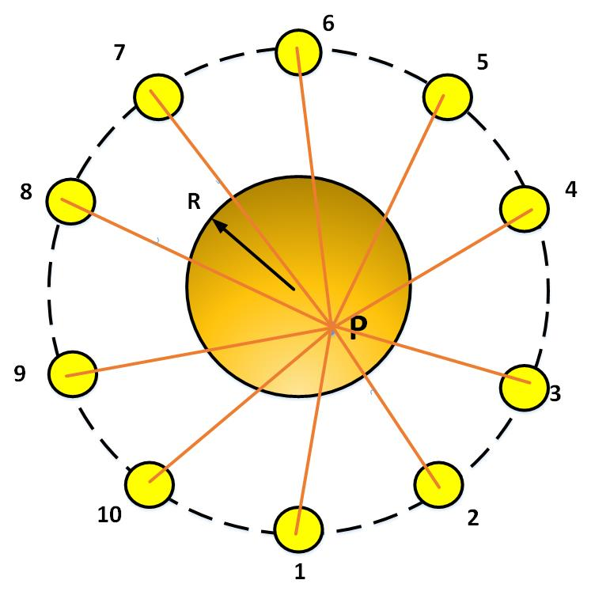

Slurry photoreactor surrounded by 10 LED lights

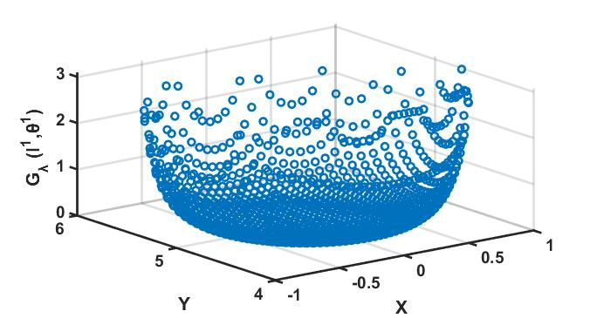

1. **Introduction**

Photocatalytic hydrogen production technologies are promising green technologies that can be driven by free available solar energy. These types of hydrogen technologies are based on redox reactions on a suitable semiconductor surface, triggered by absorption of incoming photon energy by the semiconductor particles. In recent decade, many investigations have been conducted on the reaction mechanisms of the photocatalytic hydrogen production, suitability of semiconductor materials and strategies to improve photocatalytic efficiencies [1–11].Some research efforts have also focused on developing descriptive reaction kinetics for the photocatalytic reactions, but mainly aimed for the photo-oxidation purposes using UV light- driven TiO2 semiconductors [12,13]. So far, there have been only a few conducted reaction kinetics studies using visible light-driven CdS semiconductors with a suitable cocatalysts [14–16], however none have been aimed for the hydrogen reactor scale-up purposes.

The accurate prediction for the photocatalytic hydrogen scale-up requires reliable and comprehensive models that incorporates both surface reaction kinetics alongside irradiation (photonic) mechanism. For the surface reaction kinetics, consideration of all dominating surface adsorption mechanism is needed, and for the irradiation part, both geometry of the particles and reactor with regards to the lights, and the total radiative flux received by the photocatalyst particles are needed. Furthermore, a thorough validation of the developed models with experimental data, as to confirm the accuracy of the models, is essential.

Over the years, David F. Ollis has developed several publications describing in-depth the kinetics of photocatalysed chemical mechanisms [23–25] and in particular how the Langmuir-Hinshelwood parameters, *k* and *K*, vary with light intensity in what is described as a *pseudo-steady state* approach, which is more appropriate to apply than a standard equilibrated adsorption Langmuir-Hinshelwood model. In addition, several researchers previously developed various irradiation models for different photoreactor configurations. In 2000 Cassano et al. [17] reported the importance of the light scattering effect to be included in a mathematical modelling of a UV light reactor . In 2003 Brandi et al. [18] developed a 1D model, describing the quantum yield effect relative to the incoming wavelength spectra based on a TiO2 + UV light slurry reactor. Li Puma et al. [19] developed in 2003, a two-flux model in a simple manner and later in 2004 [20], a six-flux absorption-scattering model representing the radiation field dependency to various reactor geometries. In 2018 Alvarado-Rolón et al. [21] used a four-flux absorption-scattering model and compared its accuracy with the six-flux and two-flux absorption-scattering models on a TiO2 + cylindrical UV light photocatalytic reactor system. The shared view among these studies is the importance of incorporating light distribution inside the photoreactor for a complete reaction rate evaluation. The photon-particle interactions inside the photoreactor can be described mathematically by the radiative transfer equations (RTE), which allow quantification of the radiation distribution on photocatalyst particles at a certain wavelength [26]. The RTE contains integro-differential equations that can be solved through various methods such as Monte Carlo method [27], discrete ordinates (DO) radiation methods [28] or Finite Volume Methods (FVM) [13]. However, these approaches are usually computationally expensive and prone to discretization error. In 2012, Palmisano et. al. [29] successfully reduced these complications by simplifying the RTE integro-differential equations, which resulted in a substantial reduction of computational time. The accuracy of the proposed radiation model was validated, by the same group in 2015, against a UV irradiated photoreactor for the photocatalytic oxidation of 4-nitrophenol using TiO2 [13].

In this study an energy-efficient LED photoreactor, as an economical alternative to more expensive Xenon lamps or solar simulator systems, was designed to validate the developed mathematical model. The LED output wavelengths were chosen to excite CdS particles. The distribution of the LED lights surrounding the photoreactor was carefully considered to eliminate limited light view angles resulting in a homogeneous illumination throughout the photoreactor. The mathematical model was developed to describe the hydrogen production rate by the surface reaction kinetics in conjunction with the radiation field dependency within the LED driven reactor vessel. For the oxidisable medium (hole donor) in the aqueous solution, lactic acid was chosen and for the photocatalyst slurry; CdS with a Pt co-catalyst. The model assumes hydrogen is produced from reduction of water via the excited electrons that transferred to the Pt cocatalyst and that oxidation of lactic acid to pyruvic acid is by the formed holes in the valence band of the semiconductor. The model also takes into account the optical parameters over entire catalyst’s absorption wavelength range as well as the chemical reaction parameters at different photocatalyst loading, lactic acid concentration and light intensity. The developed model is then validated by comparing it with experimental data obtained from the photocatalytic experiments. The least-square best fitting approach, using a non-linear derivative-free optimization method in MATLAB is employed for the estimation of the kinetic parameters.

|  |
| --- |
| **Notations $b$**  [dimensionless] parameter defined by Eq.7  [g cm-3] catalyst concentration $ε$ [dimensionless] emissivity constant  [s-1 m-3 nm-1] total radiative flux  [Wm-2 nm-1] total radiative flux at segment of $[L_{1} , θ_{1}]$ $h$ [cm] reaction height  ([Wm-2 nm-1] light intensity is a function of direction (Ω) and wavelength (  [Wm-2 nm-1] black body light intensity  [Wm-2 nm-1] incident radiative flux density at the reactor wall  [W m-2 nm-1] radiative flux density at segment of  [cm-1] light absorption coefficient ${ k}_{1}$ ($μ{mol}^{-1}s^{-1}$) adsorption equilibrium constant $k_{-1}$ [ ${litre}^{-1}s^{-1}]$ desorption equilibrium constant $k^{'}$ [ $m^{2}{litre}^{-1}J^{-1}]$ proportionality constant $L$ [cm] light path length $\left[LA\right]$ (M) lactic acid concentration $r_{H_{2}}$ [$μ$ mol/s] rate of hydrogen production $R_{∞}$ [dimensionless] diffuse reflectance of the catalyst $r_{1}$ [cm] distance between a particle inside the reactor and light of 1 $r_{0}$ [cm] distance between light 1 and the surface of the reactor $r_{1}^{L}$ [cm] distance from light 1 and circumference point farer from the light  [cm-1] scattering coefficient  [cm2 g-1] scattering coefficient per unit catalyst concentration  [cm2] area of cross-section of the reactor $t$ [min] reaction time  [cm3] reactor volume $θ$ [rad] cylindrical angular coordinate  α [dimensionless] light absorbing parameter  Ω [sr] solid angle $λ$ [m] radiation wavelength |

**2. Experimental**

**2.1 Photocatalytic hydrogen experiments**

The photocatalytic batch reactor experiments were conducted in a 60 ml quartz vessel (inner diameter 2.5 cm) with two side arms; one for hydrogen gas outlet and one for pre-purging argon gas to assure oxygen free reaction conditions. The reactor was externally irradiated by an array of 10 LED lamps (10 W cool white) that surrounded the outside of the reactor, where the axially positioned lights had a distance of 4 cm from the reactor wall. The LED light source was designed in a circular unit with an equal distance between the lights, ensuring complete photon energy coverage of the reaction solution. Each LED light was equipped with a heat sink to prevent generated heat from the lights into the reactor. The light spectral irradiance was determined using a spectrometer (GL Spectis 1.0) equipped with a 340-780 nm CMOS imaging sensor. For a typical photocatalytic experiment, various loadings of 5% Pt/CdS photocatalyst were dispersed in a solution of lactic acid before transferred to the photoreactor. A magnetic stirrer was used during the entire experiments to assure a homogeneous particle suspension. Before each run, the reaction solution was purged with argon gas for 15 min to remove dissolved air and keep the reaction system under an anaerobic condition. The photocatalytic reaction runs, as shown in Table.1, were conducted at the ambient temperature of 25°C and at various catalyst loading, lactic acid concentration and various incident light intensity. To collect the hydrogen, an inverted water-filled burette (accuracy of $±$ 0.1 ml) was used. The experimental errors were measured based on the standard deviation of 3 runs.

Table.1 Photocatalytic reaction runs at different catalyst loadings, lactic acid concentrations and incident fluxes.

|  |  |  |  |  |  |  |  |
| --- | --- | --- | --- | --- | --- | --- | --- |
| Run | Cat. loading  (g/cm3) | [LA] (M) | Incident flux at (W/m2) | Run | Cat. loading  (g/cm3) | [LA] (M) | Incident flux at (W/m2) |
| 1 | 0.00060 | 2.64 | 2.60 | 33 | 0.00060 | 2.64 | 1.20 |
| 2 | 0.00060 | 2.41 | 2.60 | 34 | 0.00060 | 2.42 | 1.20 |
| 3 | 0.00060 | 2.04 | 2.60 | 35 | 0.00060 | 2.03 | 1.20 |
| 4 | 0.00060 | 1.80 | 2.60 | 36 | 0.00060 | 1.90 | 1.20 |
| 5 | 0.00060 | 1.74 | 2.60 | 37 | 0.00060 | 1.80 | 1.20 |
| 6 | 0.00060 | 1.60 | 2.60 | 38 | 0.00060 | 1.74 | 1.20 |
| 7 | 0.00060 | 1.64 | 2.60 | 39 | 0.00060 | 1.68 | 1.20 |
| 8 | 0.00060 | 1.51 | 2.60 | 40 | 0.00060 | 1.58 | 1.20 |
| 9 | 0.00044 | 2.65 | 2.60 | 41 | 0.00060 | 2.31 | 0.30 |
| 10 | 0.00044 | 2.43 | 2.60 | 42 | 0.00060 | 2.22 | 0.30 |
| 11 | 0.00044 | 2.02 | 2.60 | 43 | 0.00060 | 2.12 | 0.30 |
| 12 | 0.00044 | 1.94 | 2.60 | 44 | 0.00060 | 2.00 | 0.30 |
| 13 | 0.00044 | 1.81 | 2.60 | 45 | 0.00060 | 1.93 | 0.30 |
| 14 | 0.00044 | 1.70 | 2.60 | 46 | 0.00060 | 1.65 | 0.30 |
| 15 | 0.00044 | 1.64 | 2.60 | 47 | 0.00060 | 1.43 | 0.30 |
| 16 | 0.00044 | 1.56 | 2.60 | 48 | 0.00060 | 1.41 | 0.30 |
| 17 | 0.00020 | 2.55 | 2.60 | 49 | 0.00060 | 1.30 | 2.60 |
| 18 | 0.00020 | 2.44 | 2.60 | 50 | 0.00060 | 1.28 | 2.60 |
| 19 | 0.00020 | 2.04 | 2.60 | 51 | 0.00060 | 1.01 | 2.60 |
| 20 | 0.00020 | 1.91 | 2.60 | 52 | 0.00060 | 0.98 | 2.60 |
| 21 | 0.00020 | 1.84 | 2.60 | 53 | 0.00060 | 0.91 | 2.60 |
| 22 | 0.00020 | 1.72 | 2.60 | 54 | 0.00060 | 0.86 | 2.60 |
| 23 | 0.00020 | 1.64 | 2.60 | 55 | 0.00060 | 0.85 | 2.60 |
| 24 | 0.00020 | 1.49 | 2.60 | 56 | 0.00060 | 0.70 | 2.60 |
| 25 | 0.00007 | 2.55 | 2.60 | 57 | 0.00060 | 0.63 | 2.60 |
| 26 | 0.00007 | 2.45 | 2.60 | 58 | 0.00060 | 0.62 | 2.60 |
| 27 | 0.00007 | 2.22 | 2.60 | 59 | 0.00060 | 0.5 | 2.60 |
| 28 | 0.00007 | 2.04 | 2.60 | 60 | 0.00060 | 0.48 | 2.60 |
| 29 | 0.00007 | 1.94 | 2.60 | 61 | 0.00060 | 0.44 | 2.60 |
| 30 | 0.00007 | 1.83 | 2.60 | 62 | 0.00060 | 0.42 | 2.60 |
| 31 | 0.00007 | 1.74 | 2.60 | 63 | 0.00060 | 0.30 | 2.60 |
| 32 | 0.00007 | 1.44 | 2.60 | 64 | 0.00060 | 0.25 | 2.60 |

**3. Hydrogen photoreactor modelling**

**3.1 Surface reaction kinetics**

The hydrogen generation reaction can be described as a joint event of the formed electrons and holes in the CdS after absorbing a photon. When the electron and holes have diffused to the surface, it is assumed that the simultaneous reduction/oxidation reactions occur on the particle surface. In the cathodic reduction step, the hydrogen gas is formed via reduction of adsorbed water molecules by the excited electrons that transferred from CdS to the Pt co-catalyst surface. Therefore the driving potentials is that of the Pt co-catalyst which is -0.04 eV [30], and is less negative than the flat band potential of CdS, -0.7 eV, but more negative than the redox potential of H+/H2 = 0 eV. In the anodic step, the oxidation of lactic acid is undertaken by the surface-trapped holes on the CdS with the valence band potential of +1.7 eV [31], which is more positive than the oxidation potential of lactate/pyruvate, +0.19 eV. It is assumed that the lactic acid is not dissociated at the experimental pH 1.20-1.34. It is also assumed that no OH- radicals are taking part in the oxidation, as the formation potential of the OH-radicals is +2.8 eV, which is much higher than the valence band potential of CdS. Also, there is no oxidation driven by free O2 due to the oxygen-free experimental conditions and, therefore, the oxidation pathway is by the surface-trapped holes only.

The anodic and cathodic reactions are then presented in Eq.(1) and (2).

Cathodic reaction:

H+/H2 = 0 eV (1)

Anodic reaction:

${CH}_{3}CH\left(OH\right)COOH +{ 2 h}^{+} {CH}_{3}\left(CO\right)COOH +{ 2 H}^{+}$

lactate /pyruvate = +0.19 eV (2)

The photocatalytic surface reactions can be expressed by five dominating steps; (i) absorption of photons with energy equal or higher than the CdS electron band gap (ii) dissociation of the excitons and their diffusion to the surface (iii) adsorption of reactants on the catalyst surface, (iv) simultaneous reduction and oxidation reactions on the surface and (v) desorption of the formed products. By these steps, it is understood that the rate of hydrogen formation is dependent on incoming (and absorbed) radiative flux as well as the rate of surface reactions. Therefore, the hydrogen production rate can be expressed as a product of Langmuir Hinshelwood surface reactions with the incorporation of total radiative flux received by all catalyst particles as Eq.3, (see Appendix A for the derivations).

$r_{H_{2}}={k^{'}G}^{α} \left(\frac{\left[LA\right]}{\frac{k_{-1}+k^{'}G^{α}}{k_{1}}+\left[LA\right]}\right)$ (3)

,where $r_{H_{2}}$ is the hydrogen production rate, ${ k}_{1}$ is adsorption equilibrium constant, $k_{-1}$ is desorption equilibrium constant, $\left[LA\right]$ is lactic acid concentration, $k^{'}$ is the proportionality constant and $G^{α}$ is the total received radiative fluxes from all lights and α is the light absorbing parameter. The hydrogen production rate produces two limiting cases; one when the total radiative flux on the reactor wall is high with $α$ =0.5 and one when it is low $α$ =1.0 [23,24]. The total radiative flux, $G^{α}$, is a function of photocatalyst particles’ positions inside the photoreactor and the angle of receiving photons, leading to an inhomogeneous distribution of radiative flux absorbed by the particles inside the reactor, with maximum values near the irradiated wall (where the lights are positioned) and negligible values towards the centre.

**3.2 Radiation field modelling**

The radiation distribution in our photoreactor system with 10 visible LED lights is modelled by the approach developed by G. Palmisano [29] for 6 UV-lights. The LED lights surrounding the reactor vessel are placed on a height that a complete illumination of the reaction solution is achieved. Therefore, there is no gradients in the radiative flux in the longitudinal reaction depth and the change of the flux is only considered in the cross-section (in two dimensions) of the cylindrical reactor, based on the two flux absorption-scattering model employed by G. Palmisano [29]. For each particle positioned in that area, contribution of the radiative flux from all 10 LED lights accounts for the total received fluxes. The radiative flux from each LED absorbed by an irradiated particle is evaluated by the radiative transfer equation (RTE), which expresses the radiation energy balance at a certain wavelength (λ) and given propagation direction (Ω). The RTE gives information of how the spatial intensity variation depends on the particle light absorption, particle emission and the two types of particle scattering (in-scattering and out-scattering). The complete form of the RTE can be seen in Eq. 4.

$\frac{dI_{Ω,λ}}{dx} = -{ k}_{λ}I_{Ω,λ} + εI_{bb,λ} - sI_{Ω,λ} + \frac{S}{4π}\int{I_{Ω,λ}ϕ(Ω^{'}},Ω) dΩ^{'}$ (4)

RTE = - (absorption) + (emission) - ( out-scattering) + (in-scattering)

where $\frac{dI_{Ω,λ}}{dx}$ describes changes of light intensity over *dx*. In Eq. 4, the first term represents absorption of the particle with light absorption coefficient $k$ and the second term represents emission of the particle, with emissivity of $ε$ and black body light intensity $I_{bb,λ}$. The third term represents light scattering from the particle with scattering coefficient $s$, which takes away photon energy from the propagation direction. The last term, in-scattering, describes the probability of light absorption and then its scattering in a particular direction originating from scattering from other particles within the reactor with $ϕ(Ω^{'},Ω)$ as a scattering phase function that is angular distribution of scattered radiation [13]. The complete form of the RTE involves a set of integrated-differential equations, where rigorous numerical procedures are required for obtaining the solution. The numerical solution of RTE can be eased if it is considered with speciﬁc assumptions such as negligible emission contribution, as the wavelength of the emission would have too high to excite any of the particles. The final RTE approximation , based on the Schuster-Schwarzschild isotropic scattering approach [32], consists of dividing the radiation field of two oppositely directed radiation fluxes; $I_{λ}$ (in the positive propagation direction) and $J_{λ}$ (in the negative propagation direction), where the effect of absorption and scattering terms of the RTE (Eq.4 ) can be described as:

$\frac{dI_{λ}}{ dx}=-\left(k_{λ}+s_{λ }\right)I_{λ}+s_{λ }J_{λ}$ (5)

$\frac{dJ_{λ}}{ dx}=-\left(k_{λ}+s_{λ }\right)J_{λ}+s_{λ}I_{λ}$ (6)

If it is assumed that the radiation flux in the negative propagation direction, $J_{λ}$, is negligible, an approximate solution to Eq. 5, as suggested by Palmisano et al.[29], can be presented as:

$\frac{I_{λ}}{ I_{0}}=\left(1-{R_{∞}}^{2}\right)exp⁡(-2bs^{*}C_{cat}L)$ (7)

where $I_{0}$ is the incident radiative flux density at the reactor wall, $R_{∞}$ the diffuse reflectance of the Pt/CdS catalyst, $C_{cat}$ the catalyst concentration in the solution, $s^{*}$ is scattering coefficient per unit catalyst concentration, $L$ is the light path length and $b$ is $\sqrt{{\left(1+\frac{k^{*}}{s^{*}}\right)}^{2}-1}$.

The wavelength-dependent diffuse reflectance, $R_{∞}$,and the scattering coefficient of the particles, $s^{*}$, were obtained by the spectrophotometric measurements of the Pt/CdS particles in the wavelength range 410-500 nm, coinciding with the reactor LED’s output. $R_{∞}$ was in a range of 0.16-017, $s^{*}$ was in a rage of 1-2 ×104 cm2 g-1 and was in the range of 0.16-0.17×104 cm2 g-1. The catalyst concentration $C_{cat}$ shows the effect of particles loading in the model and how the higher loading (shielding) would affect the theoretical hydrogen production. The light path length, $L$, of each LED to a photocatalyst particle positioned in the cross-section of the reactor, is obtained by deriving the geometrical position of the particle in the reactor with regards to the other lights.

If a particle is positioned in the reactor with radius R, where the reactor itself is positioned in the distance $r_{0}$ from one LED light, the particle coordinate $(L_{i} , θ_{i})$ can be defined as seen in Fig.1. For that particle coordinate, $i=1...10$ denotes number of lights, $θ_{i}$ denotes the angle of receiving photons to the particle by the light $i$,which varies between ${-θ}_{0}$ and ${+θ}_{0}$, and $L_{i}$ is the corresponding distance between the particle and the reactor wall. The geometrical derivation of all $θ_{i}$ and $L_{i} ,$ for $i=2..10$ are presented in Appendix B, where ($L_{1} , θ_{1}$) is chosen as the reference point.

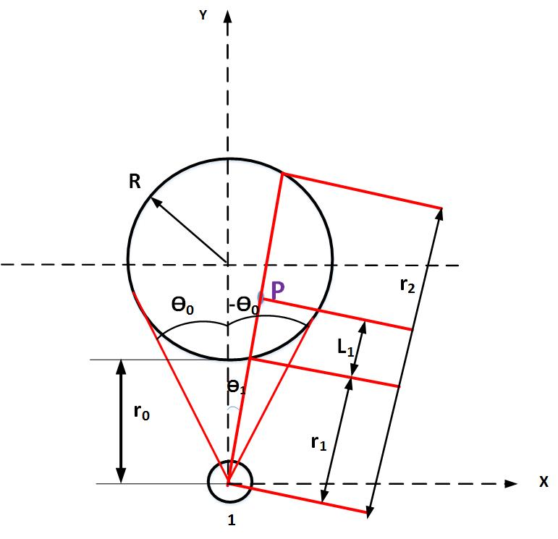

Fig 1. Derivation of the geometrical coordinate $(L_{i} , θ_{i})$ for particle P, inside a reactor with radius R, irradiated by one lamp.

Therefore, the radiative flux density of Eq.7 for light $i$ and a particle with coordinate $(L_{i} , θ_{i})$ at wavelength (λ), is evaluated using Eq.8:

$I_{λ}(L_{i} , θ_{i}) =I(0,θ_{i}) \left(1-{R_{∞}}^{2}\right)exp⁡(-2bs^{*}C_{cat}L_{i})$ (8)

, where $I(0,θ_{i})$ is the radiative flux density on the reactor wall in the direction of radiation. The term $I\left(0,θ_{i}\right)$ can be substituted with the term $I(0,0)\frac{r_{0}}{r_{i}}$ to adjust for the radiation intensity at $r_{1}$ [32], where the radiative flux density at coordinate (0, 0), $I(0,0)$, is measured by GL Spectis 1.0 device. In Fig. 2(a), the 3D-representation of the radiative flux density distribution by one LED light on a particle with the coordinate $(L_{1} , θ_{1})$ can be seen as $I_{λ}(L_{i} , θ_{i})$, where the maximum flux is observed closest to the LED lamp position. To obtain the overall radiative flux density from all 10 LED lights on that chosen particle, the individual contributions from all 10 lights are added up, $G_{λ}\left(L_{1} , θ_{1}\right),$ as seen in Fig. 2(b).

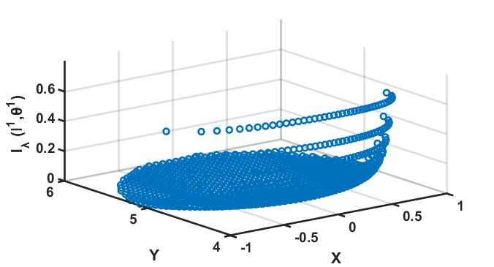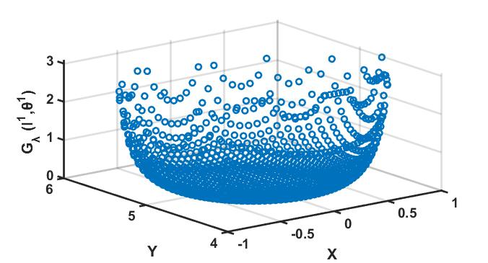

a

b

Fig.2 Three-dimensional representation of the radiative flux density distribution at coordinate ($L_{1} , θ_{1}$) for (a) 1 LED light as $I_{λ}(L_{1} , θ_{1})$ and for (b) all 10 LED lights as $G_{λ}(L_{1} , θ_{1})$ in (b), as simulated by MATLAB Software.

Having calculated $G_{λ}\left(L_{1} , θ_{1}\right)$ and substituted its values into Eq.3, the theoretical rate of hydrogen production results in:

$r_{H_{2}}={G_{λ} (L_{1} , θ_{1}) }^{α} \left(\frac{\left[LA\right]}{\frac{k_{-1}+{{k^{'}G}_{λ} (L_{1} , θ_{1}) }^{α}}{k_{1}}+\left[LA\right]}\right)$ (9)

Note that the experimental rates of hydrogen production are obtained for the entire reactor volume, whereas Eq.9 represents the theoretical rate of hydrogen production for a cross-section of the reactor at the coordinate $(L_{1} , θ_{1})$. Therefore, Eq.9 needs to be integrated over the whole reactor volume as:

${r_{H_{2}}}^{v}= k^{'}k_{1}\left[LA\right]\int{ {G_{λ} (L_{1} , θ_{1}) }^{α}\left(\frac{1}{k_{-1}+k^{'}{G_{λ}(L_{1} , θ_{1}) }^{α}+k_{1}\left[LA\right]}\right)dv }$ (10)

By substituting $dv$ with $dS.h$, where $dS=\left(r_{1}+L\right)dL dθ$ is the area of the cross-section and $h$ is the aqueous solution height within the reactor, we have:

${r_{H_{2}}}^{v}= {k^{'}k}_{1}\left[LA\right]h\int_{0}^{r_{2}-r_{1}}{\int_{{-θ}_{0}}^{+θ_{0}}{{G_{λ} (L_{1} , θ_{1}) }^{α}\left(\frac{1}{k_{-1}+k^{'}{G_{λ} (L_{1} , θ_{1}) }^{α}+k_{1}\left[LA\right]}\right)\left(r_{1}+L\right)dL dθ}}$ (11)

,where the angle $θ_{0}$ and path length, $L_{1}$ *,* in Fig. 1, can be expressed as [29]:

$θ_{0}=\cos^{-1}\left(\frac{\sqrt{2Rr_{0}+{r_{0}}^{2}}}{R+r_{0}}\right)$ (12)

where the boundary conditions of $L_{1}$ varies between $r_{1}$ and $r_{2}$ as:

$r_{1}=cosθ_{1}\left(R+r_{0}\right)-\sqrt{\cos^{2}θ_{1}{\left(R+r_{0}\right)}^{2}-r_{0}^{2}-2Rr_{0}}$ (13)

$r_{2}=cosθ_{1}\left(R+r_{0}\right)+\sqrt{\cos^{2}θ_{1}{\left(R+r_{0}\right)}^{2}-r_{0}^{2}-2Rr_{0}}$ (14)

The rate of hydrogen production from Eq.11 needs to be converted to $μ$ mol/s to be consistent with the experimental rate.

**4. Results and discussion**

The theoretical rate of hydrogen production from Eq.11 is fitted to the experimental rate of hydrogen production at different reaction runs as presented in Table.1 to obtain $α$, $k_{1}$, $k_{-1}$ and $k^{'}$ by a least-square best fitting procedure, using a non-linear derivative-free optimization method in MATLAB. The objective function ($O.F.$), which is the sum of squared difference between the experimental and the calculated values of H2 production rate, is then minimised as:

$O.F.=\sum_{1}^{64}{(}{H_{2}^{exp}-H_{2}^{cal})}^{2}$ (15)

The obtained fitted parameters for 64 runs are shown in Table.2, with the corresponding coefficient of determination of *R2* =0.87. Figure.3 (a, b and c) shows the comparisons between the experimental and predicted rates of hydrogen production at different initial lactic acid concentrations, incident flux intensities and catalyst loadings respectively. The cumulative formed hydrogen for the same conditions is presented in Fig. 4 (a, b and c). Both set of figures show a satisfactory agreement between the model and the experimental data points. In Fig.3(a), the model is compared with the experimental results when the initial concentration of lactic acid varied between 0.66-3.00 M at a fixed incident flux of 2.6 W/m2 and a catalyst loading of 0.0006 g/cm3. The experimental rate of H2 production increases non-linearly with increasing lactic acid concentration.

Table.2 Obtained model parameters.

|  |  |
| --- | --- |
| $k_{1}$ | 0.0907 |
| $k_{-1}$ | 0.0877 |
| $$k^{'}$$ | 0.1596 |
| $$α$$ | 0.52 |

The model prediction agrees well with the experimental non-linear behaviour, implying that the adsorbed lactic acid on the catalyst surface sites gradually reaches a limiting value where lower adsorption sites would be available by the increased lactic acid concentration (as reflected in the Langmuir Hinshelwood adsorption segment of the model, see Appendix. A). Lactic acid does not absorb radiation from the LED and therefore does not affect the irradiation model segment. The cumulated hydrogen at various lactic acid concentrations, as seen in Fig.4(a), also shows the gradual non-linear increase from 729 µmol to 2300 µmol after 4 hours irradiation.

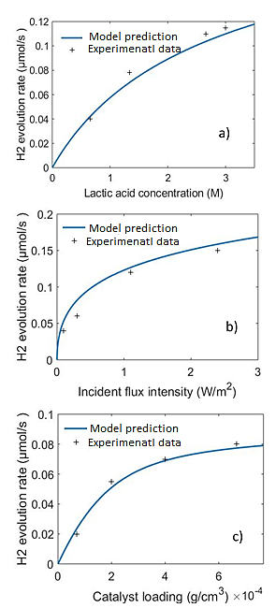

Fig.3. Model predicted H2 rate (blue line) vs. experimental rate (+), when lactic acid concentration (a), incident flux intensity (b) and loading of catalyst (c) are varied.

In Fig.3(b), the model is compared with the experimental data when the incident flux varied between 0.2 W/m2 to 2.6 W/m2 at a fixed initial lactic acid concentration of 2.66 M and a catalyst loading of 0.0006 g/cm3. According to this figure, an increase in the light intensity improves non-linearly the experimental rate of hydrogen generation, in agreement with the model predication. This means at the higher intensity, the more photon absorption and therefore more electron-hole generation, leading to an enhanced redox-reaction rate. A further increase of light intensity above 2.6 W/m2 is limited due to the power restriction, where the maximum rate of hydrogen production of 0.15 µmol/s is obtained.

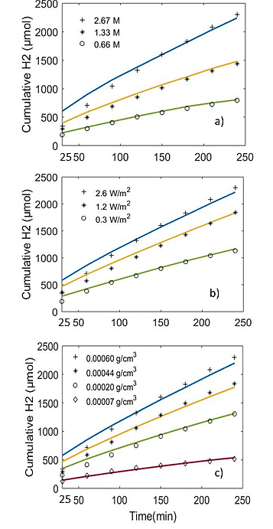

Fig.4. Model predicted cumulative H2 production (solid lines) compared with experimental H2 production over time at (a) varying lactic acid concentration, (b) incident flux intensity and (c) catalyst loading.

The non- linear increase of the reaction rate by the increased flux is probably due to the absorption limit of photocatalytic slurry at maximum incident flux of the light, beyond which no further absorption by the catalyst particles is observed. These results are completely in accordance with the cumulative hydrogen generation seen in Fig.4 (b), where rate of H2 production undergoes a gradual increase. Figure.3(c) compares the theoretical model and experimental rate of hydrogen production when the catalyst loading varied between 0.0006 to 0.00007 g/cm3 at a fixed incident flux of 2.6 W/m2 and an initial lactic acid concentration of 2.66 M. The model agrees satisfactory with the experimental results and shows clearly a levelling-out at higher particle loadings. This might be due to two factors; one is an exceeded photocatalyst adsorption limit for lactic acid (seen in the Langmuir Hinshelwood adsorption segment of the model), and the other is the shielding effect which does not allow all particles to be evenly irradiated (seen in the irradiation segment of the model). The gradual increase in the hydrogen production is also confirmed in the cumulated hydrogen data over time, Fig.4 (c), where the maximum of 2300 µmol H2 after 4 hours irradiation is obtained for the catalyst loading of 0.0006 g/cm3, in line with the theoretical and experimental results of Figure.3(c).

**5. Conclusion**

A hydrogen model describing adsorption and irradiation mechanisms for an externally LED-driven photoreactor was presented. The adsorption mechanism of the model (based on Langmuir-Hinshelwood adsorption isotherm) determined adsorption kinetics of lactic acid on the Pt/CdS particles and its photooxidation to pyruvic acid (via hole transfer), while simultaneously water molecules were reduced to hydrogen (via electron transfer). The irradiation mechanism of the model was developed using an approximate solution of RTE, derivation of geometrical positions of the particles in the cross-section of the reactor with regards to the lights, and the optical properties of the photocatalytic particles at the LED outputs. Hence, the developed irradiation segment accounted for the total visible radiative flux density received by the particles from all 10 LEDs in the cross-section of the reactor and then in the whole reactor. The developed model was then successfully validated against the experimental hydrogen data at different catalyst loadings, lactic acid concentrations, and incident radiation fluxes by incorporating the obtained kinetic parameters of $α$, ${ k}_{1}$, $k_{-1}$ and ${ k}^{'}$. All hydrogen experiments were conducted to their limiting values, where they were described well by the mathematical model. The satisfactory agreement between the model and experimental results show the model’s capability to predict the behaviour of any sized photocatalytic hydrogen reactor in a wide range of operating conditions. The developed model also allows analysis of flux distribution for any number of the switched-on lamps. The main advantage of the developed model is its good accuracy (*R2* =0.87) to predict H2 production which can be used for the design and scale-up of any photocatalytic batch reactor system regardless of type of radiation or reactor size.

**Acknowledgement**

M.V. acknowledges the financial support from the Slovenian Research Agency (research core funding No. P2-0412).

**Appendix A: Derivation of kinetic model**

The equilibrium of adsorption and desorption rate of lactic acid (LA) on CdS surface adsorption sites (S), or the vacant sites, can be expressed as:



$k_{1}LA+S$ $LA S$

$k_{-1}$

(reversible adsorption) (A1)

,where is the occupied sites by the lactic acid. The adsorbed lactic acid then donates electron to the valance band of CdS, where photogenerated holes on the CdS surface oxidise lactic acid to form pyruvic acid (PA) and proton as:

+  +

(photooxidation reaction) (A2)

The released protons (2 H+) would not contribute into the increase of pH, as change of hydroxyl concentration during the photocatalytic reaction was very small, but they would form water with the hydroxyl ions produced from the photoreduction of water molecules as:

$2 H_{2}O+ { 2 e}^{-}$ $H_{2}+2 OH^{-}$ (reduction reaction) (A3)

If the total amount of available surface adsorption sites is denoted with ${ [S]}_{tot}$, the vacant sites $\left[S\right]$ can be obtained as:

(A4)

A pseudo- steady state hypothesis is applied to the surface occupied sites by the lactic acid [*LAS*] (as stated by Ollis in 2005 [23]), where it assumes as:

(A5)

, where represents adsorption rate of lactic acid with adsorption constant of ${ k}_{1}$, ${ k}_{-1}\left[LAS\right]$ represents desorption rate of lactic acid with desorption constant of ${ k}_{-1}$ and ${ k}_{2}\left[LAS\right]$ represents product rate (pyruvic acid) formation with product formation constant of ${ k}_{2}$. By substituting Eq. A4 in A5 and solving for , we arrive at:

(A6)

Re-arrangement of Eq. A6 results in:

(A7)

, where is termed as $K_{a, app}$. $K_{a, app}$ is the apparent adsorption constant representing that lactic acid adsorption/desorption rate is affected by the product formation. In A7, can be approximated to 1, if the equation is expressed by surface coverage of lactic acid, *θA*, as;

[] (A8)

As the rate determining step is by the photooxidation step, see Eq. A2., the product formation rate from the holes can be described as;

(A9)

The substitution of Eq. A8 in A9 results in:

(A10)

As suggested by Ollis in 1990 [24], the product formation constant $k_{2}$ is a function of absorbed radiative flux, $I$, by the catalyst within the reactor as; $k_{2}={ k^{'}I}^{α}$. The constant of $k^{'}$ is the proportionality constant and $α$ is the light absorbing parameter that varies between 0.5 and 1. Therefore, Eq. A10 will be presented as:

(A11)

If It is assumed that the rate of hydrogen production by electrons are equal to the rate of product formation by the holes, therefore $r_{product-holes}$*= $r_{H2}$,*  where the expression for the rate of hydrogen production will be as:

(A12)

This expression accounts for the absorbed radiative flux from only one light, so incorporation of total received radiative fluxes from all lights, $G$, in this expression will result in the final expression:

(A13)

**Appendix B: Geometrical derivation of $L_{i}$ and $θ_{i}$ for LED-lights**

Fig. B1 shows the positions of the lights surrounding the reactor and the corresponding $L_{i},θ_{i}$.

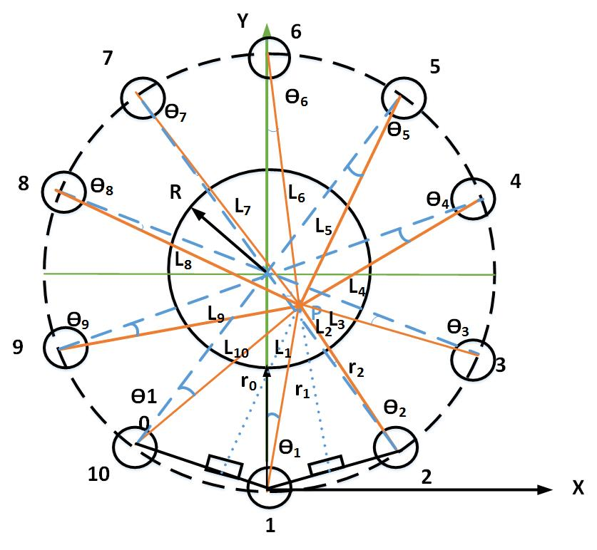

Fig B1. Schematic representation of the photoreactor and lamp positions used for the geometrical derivation of .The r1 and r2 represent the distance to random point of P and light 1 and 2, while $r_{0}$ represents the distance between light 1 and the surface of the reactor.

For a particle positioned at a point P with a given $θ_{1}$ and $L_{1}$, the below trigonometrical relations can be developed for each $L_{i},θ_{i}$ (i=2…) as:

Lamp 2 coordinates:

(B1)

(B2)

Lamp 3 coordinates:

(B3)

(B4)

Lamp 4 coordinates:

(B5)

(B6)

Lamp 5 coordinates:

(B7)

(B8)

Lamp 6 coordinates:

(B9)

(B10)

Lamp 7 coordinates:

(B11)

(B12)

Lamp 8 coordinates:

(B13)

(B14)

Lamp 9 coordinates:

(B15)

(B16)

Lamp 10 coordinates:

(B17)

(B18)

**Reference**

[1] S. Guan, X. Fu, Y. Zhang, Z. Peng, β-NiS modified CdS nanowires for photocatalytic H2 evolution with exceptionally high efficiency, Chem. Sci. 9 (2018) 1574–1585.

[2] Y. Xu, Y. Huang, B. Zhang, Rational design of semiconductor-based photocatalysts for advanced photocatalytic hydrogen production: the case of cadmium chalcogenides, Inorg. Chem. Front. 3 (2016) 591–615.

[3] J. Su, J. Zhou, L. Wang, C. Liu, Y. Chen, Synthesis and application of transition metal phosphides as electrocatalyst for water splitting, Sci. Bull. (2016).

[4] R.J. Braham, A.T. Harris, Review of major design and scale-up considerations for solar photocatalytic reactors, Ind. Eng. Chem. Res. 48 (2009) 8890–8905.

[5] K. Deng, L. Li, CdS Nanoscale Photodetectors, Adv. Mater. 26 (2014) 2619–2635.

[6] A.A. Ismail, D.W. Bahnemann, Photochemical splitting of water for hydrogen production by photocatalysis: A review, Sol. Energy Mater. Sol. Cells. 128 (2014) 85–101.

[7] S. Kohtani, E. Yoshioka, H. Miyabe, Photocatalytic Hydrogenation on Semiconductor Particles, in: Hydrogenation, InTech, 2012.

[8] D. Meissner, R. Memming, B. Kastening, D. Bahnemann, Fundamental problems of water splitting at cadmium sulfide, Chem. Phys. Lett. 127 (1986) 419–423.

[9] X.-J. Lv, W.-F. Fu, H.-X. Chang, H. Zhang, J.-S. Cheng, G.-J. Zhang, Y. Song, C.-Y. Hu, J.-H. Li, Hydrogen evolution from water using semiconductor nanoparticle/graphene composite photocatalysts without noble metals, J. Mater Chem .127 (2012) 419–423

[10] J. Yu, Y. Yu, B. Cheng, Enhanced visible-light photocatalytic H2-production performance of multi-armed CdS nanorods, RSC Adv. 2 (2012) 11829–11835.

[11] S. Cao, Y. Chen, C.-J. Wang, P. He, W.-F. Fu. Highly efficient photocatalytic hydrogen evolution by nickel phosphide nanoparticles from aqueous solution, Chem. Commun. 50 (2014) 10427.

[12] J. Marugán, R. van Grieken, A.E. Cassano, O.M. Alfano, Intrinsic kinetic modeling with explicit radiation absorption effects of the photocatalytic oxidation of cyanide with TiO2 and silica-supported TiO2 suspensions, Appl. Catal. B Environ. 85 (2008) 48–60.

[13] G. Palmisano, V. Loddo, V. Augugliaro, M. Bellardita, G. Camera Roda, F. Parrino, Validation of a two-dimensional modeling of an externally irradiated slurry photoreactor, Chem. Eng. J. 262 (2015) 490–498.

[14] J. Sabaté, S. Cervera-March, R. Simarro, J. Giménez, Photocatalytic production of hydrogen from sulfide and sulfite waste streams: a kinetic model for reactions occurring in illuminating suspensions of CdS, Chem. Eng. Sci. 45 (1990) 3089–3096.

[15] H.M.G. Tambago, R.L. De Leon, Intrinsic Kinetic Modeling of Hydrogen Production by Photocatalytic Water Splitting Using Cadmium Zinc Sulfide Catalyst, Int. J. Chem. Eng. Appl. 6 (2015) 220–227.

[16] S.Y. Ryu, J. Choi, W. Balcerski, T.K. Lee, M.R. Hoffmann, Photocatalytic Production of H2 on Nanocomposite Catalysts, Ind. Eng. Chem. Res. 46 (2007) 7476–7488.

[17] A.E. Cassano, O.M. Alfano, Reaction engineering of suspended solid heterogeneous photocatalytic reactors, Catal. Today. 58 (2000) 167–197.

[18] R.J. Brandi, M.A. Citroni, O.M. Alfano, A.E. Cassano, Absolute quantum yields in photocatalytic slurry reactors, Chem. Eng. Sci. 58 (2003) 979–985.

[19] G. Li Puma, Modeling of Thin-Film Slurry Photocatalytic Reactors Affected by Radiation Scattering, Environ. Sci. Technol. 37 (2003) 5783–5791.

[20] G. Li Puma, J.N. Khor, A. Brucato, Modeling of an Annular Photocatalytic Reactor for Water Purification:  Oxidation of Pesticides, Environ. Sci. Technol. 38 (2004) 3737–3745.

[21] O. Alvarado-Rolón, R. Natividad, R. Romero, L. Hurtado, A. Ramírez-Serrano, Modelling and Simulation of the Radiant Field in an Annular Heterogeneous Photoreactor Using a Four-Flux Model, Int. J. Photoenergy. 2018 (2018).

[22] C. Huang, W. Yao, A.T. -Raissi, N. Muradov, Development of efficient photoreactors for solar hydrogen production, Sol. Energy. 85 (2011) 19–27.

[23] D.F. Ollis, Kinetics of Liquid Phase Photocatalyzed Reactions:  An Illuminating Approach, J. Phys. Chem. B. 109 (2005) 2439–2444.

[24] C.S. Turchi, D.F. Ollis, Photocatalytic degradation of organic water contaminants: Mechanisms involving hydroxyl radical attack, J. Catal. 122 (1990) 178–192.

[25] C. Casado, R. Timmers, A. Sergejevs, C.T. Clarke, D.W.E. Allsopp, C.R. Bowen, R. van Grieken, J. Marugán, Design and validation of a LED-based high intensity photocatalytic reactor for quantifying activity measurements, Chem. Eng. J. 327 (2017) 1043–1055.

[26] M. Motegh, J. Cen, P.W. Appel, J.R. van Ommen, M.T. Kreutzer, Photocatalytic-reactor efficiencies and simplified expressions to assess their relevance in kinetic experiments, Chem. Eng. J. 207–208 (2012) 607–615.

[27] P.J. Valades-Pelayo, J. Moreira, B. Serrano, H. de Lasa, Boundary conditions and phase functions in a Photo-CREC Water-II reactor radiation field, Chem. Eng. Sci. 107 (2014) 123–136.

[28] A.L.L. Zazueta, H. Destaillats, G. Li Puma, Radiation field modeling and optimization of a compact and modular multi-plate photocatalytic reactor (MPPR) for air/water purification by Monte Carlo method, Chem. Eng. J. 217 (2013) 475–485.

[29] Two-Dimensional Modeling of an Externally Irradiated Slurry Photoreactor , Int. J. Chem. React. Eng. . 11 (2013) 675.

[30] H. Yan, J. Yang, G. Ma, G. Wu, X. Zong, Z. Lei, J. Shi, C. Li, Visible-light-driven hydrogen production with extremely high quantum efficiency on Pt–PdS/CdS photocatalyst, J. Catal. 266 (2009) 165–168.

[31] X. Li, J. Yu, J. Low, Y. Fang, J. Xiao, X. Chen, Engineering heterogeneous semiconductors for solar water splitting, J. Mater. Chem. A. 3 (2015) 2485–2534.

[32] M. Tokumura, H. Tawfeek Znad, Y. Kawase, Modeling of an external light irradiation slurry photoreactor: UV light or sunlight-photoassisted Fenton discoloration of azo-dye Orange II with natural mineral tourmaline powder, Chem. Eng. Sci. 61 (2006) 6361–6371.