Understanding the Cell and Genetics

Kate M Davies ^{1,2} J Paul Chapple² & E Meimaridou³
¹Senior Lecturer in Non-Medical Prescribing, Department of Advanced and Integrated Practice, London South Bank University, London, SE1 0AA / ²Honorary Research Fellow in Paediatric Endocrinology
²Professor of Molecular Cellular Biology, William Harvey Research Institute, Barts and the London School of Medicine, Queen Mary University of London, London, EC1M 6BQ, United Kingdom.
³ Lecturer in School of Human Sciences London Metropolitan University

Abstract
This is the first of a series of Continuing Professional Development articles discussing fundamental aspects of the biological basis to nursing practice. Cells and genes are the basic unit of life. It is therefore essential to understand how cells work if we are to comprehend normal physiology and pathophysiology. Here, we describe the different parts of the mammalian cell, relating structure to function. We also give examples of inherited diseases caused by mutations that impact specific parts of the cell. The aim is to provide children’s nurses with an accessible introduction to cell biology and genetics that links to their clinical interests.

Aim and intended learning outcomes
This article aims to review the fundamentals aspect of cell biology and how cellular dysfunction underlies human diseases. It will describe the common features of mammalian cells, including the structure and function of different organelles (specialised cell structures which carry out specific tasks). Throughout this article we will look at what happens when different parts of the cell go wrong, linking this to developmental disease and other conditions of childhood.

After reading this article and completing the time out activities, you should be able to:
- Describe the different parts and functions of a human cell.
- Discuss the main consequences of dysfunction of different cellular systems and link these to paediatric conditions you may encounter in your clinical practice.
- Outline what DNA, and RNA are and the cell life cycle
- Describe the differences between dominant and recessive inheritance
- Explain what chromosomal abnormalities are.
- Discuss the future in

Explaining Cells
Think about what are you made of. One answer to this question is ‘around 37 trillion cells’ (Bianconi et al., 2013). But what are cells? The best way to think of them is the basic building blocks that makes up the human body. Although all cells share common component parts (e.g. the cell membrane, cytoplasm and organelles) and have a similar general structure they have adaptations that specialise them to specific functions. This has resulted in humans having around 200 different cell types. These range from motor neurons, that can extend processes over a meter long to conduct nerve impulses (e.g. the axon that stretch from the base of the spine to a muscle in the big toe), to red blood cells that are biconcave in shape to aid oxygen absorption and carrying.

Time out 1
Pause now to consider the ways in which you have tried to describe cells to patients or parents. What did you wish to convey as regards your explanation? Why did an understanding of the cell seem important as regards an illness, or treatment that you were hoping to explain? Make a note of your answer, and we will return to this later with reference to pathophysiology.

Cellular structure
Human cells are tiny - between 5 and 50µm (µm = micrometers) in diameter (10µm is around 200x smaller than the diameter of the head of a pin). It is possible to see the nucleus and surrounding cytoplasm, which consists of membrane-bound organelles and the intracellular fluid. (Tortora & Derrickson, 2010)(Figure 1).

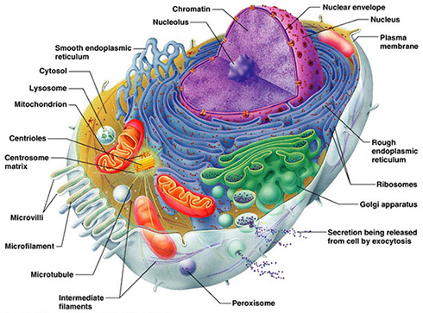
Figure 1. Structure of the mammalian cell

Cell membrane: external boundary
The cell membrane (also known as the plasma membrane) maintains the integrity of the cell by separating the cytoplasm from the external environment. It is semi-permeable allowing some substances, such as oxygen and carbon dioxide to freely pass by diffusion (the movement of a substance from a region of higher concentration to a region of lower concentration) (Tortora & Derrickson, 2010), while controlling the entry of others.

Nucleus: The Control Centre
The largest and most easily seen organelle the nucleus, and contains the genetic material (Peate & Nair, 2015) DNA – Deoxyribonucleic acid - which encodes all of the information necessary to make a cell and guide cellular processes.

The DNA is packaged as 23 pairs of chromosomes (46 in total), which will be discussed in more detail in the next section.

Mitochondria: The Power Station
Cellular processes require a source of energy to make them work. Ultimately this energy comes from the food we eat, but the molecular systems inside cells cannot use the calories in things like cakes directly. Instead, the energy must be kept in a readily available form that can fuel cells. This is achieved through cells using an energy carrier molecule called adenosine triphosphate (ATP) (Ward & Linden, 2013), which can be easily broken down to another molecule called to adenosine diphosphate (ADP) with an accompanying release of energy.

Mitochondria are the power stations of cells, functioning to make ATP through the process of cellular respiration and comprise of two membranes.

Mitochondrial disease
Mitochondrial disease encompasses a group of hereditary disorders that can develop in adulthood but frequently manifest at birth or early infancy. These are multi-system disorders that frequently affect organs with high energy demands such as the brain, heart and muscles. Clinical features include poor growth, muscle weakness and neurological problems, with examples including the neurodegenerative disease Leigh Syndrome and mitochondrial DNA depletion syndrome (MDDS) (Tuppen, Blakely, Turnbull, & Taylor, 2010). Mitochondrial diseases can have very variable clinical features and age of onset.

As there is no cure for mitochondrial disease, researchers have recently developed the ‘three person baby’ fertility techniques as a risk reduction treatment for mitochondrial disease (Amato, Tachibana, Sparman, & Mitalipov, 2014) (Figure 2) This works by transplanting the nucleus from a fertilised egg, where the mother has mitochondrial disease, into the egg of a healthy donor, where the nucleus has been removed, prior to implantation into the uterus. Thus the baby is born with normal mitochondrial DNA from the female donor and nuclear DNA from the parents.
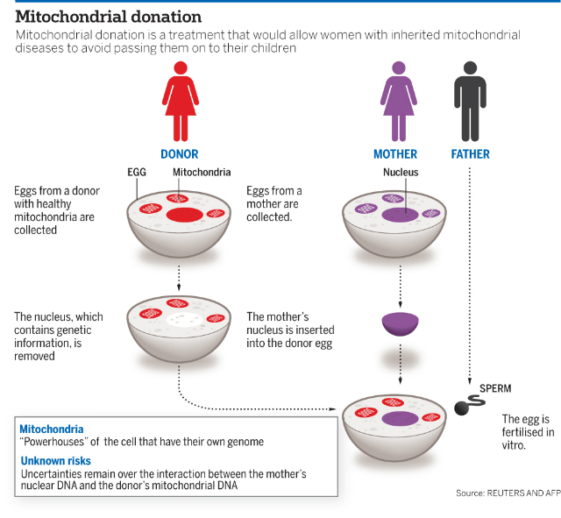
Figure 2. Three person baby invitro fertilisation approach to reduce the risk of inherited mitochondrial disease.

Mitochondrial disease in children
Mitochondrial disease is the most common inherited neurometabolic disorder of childhood, with an estimated 1 in every 8000 live births (Kisler, Whittaker, & McFarland, 2010). Diagnosis relies on the characteristic clinical features, where three or more body systems are affected, without an underlying diagnosis, e.g: liver failure, encephalopathy, uncontrolled seizures, and an increase in muscle weakness (Senger, Smith, Bindler, & Hollinger, 2018).

Endoplasmic Reticulum (ER): The Protein factory
The ER consists of an interconnected network of membrane-enclosed tubules and sacs, known as cisternae, that are continuous with the outer layer of the nuclear envelope. The ER functions in the production of proteins and lipids and can be divided into two types, smooth ER and rough ER, both of which differ in structure and function. (Peate & Nair, 2015)

Rough ER works as a kind of factory for synthesizing proteins and molecules. Smooth ER is important for the production of lipids and can also play a role in metabolising them to make other molecules. It is also where steroid hormones, such as oestrogens and testosterone, and fatty acids are synthesized.

The ER protein factory has an inbuilt quality control system that can detect proteins that have not been manufactured correctly. Perhaps the best studied example of this is cystic fibrosis, a genetic disease caused by mutations in the membrane protein cystic fibrosis transmembrane conductance regulator (CFTR) (Lukacs & Verkman, 2012).

Golgi Complex: The processing plant and distribution centre
The Golgi apparatus consists of membrane bound sacs (known as cisternae) that are stacked like a pile of plates. It is normally located in close proximity to the ER and sometimes there may be more than one Golgi per cell. The Golgi functions as a processing plant and distribution center for proteins and lipids that are synthesized in the ER, and its main function is to modify and package proteins (Tortora & Derrickson, 2010). For example, for some proteins to function properly they need to be chemically attached to a specific sugar.

Lysosomes
Human cells can have several hundred lysosomes. The inside of lysosomes contains enzymes that work to breakdown biomolecules including nucleic acids, proteins, lipids and carbohydrates.

Problems with lysosomes are linked to a group of approximately 50 rare inherited disorders. These lysosomal storage diseases (LSDs) occur because genetic mutations cause loss of function of specific lysosomal enzymes. This means the cell is unable to degrade a specific biomolecule (e.g. a lipid or glycoprotein) leading to its accumulation. Examples of LSDs include Gaucher’s disease where the function of an enzyme called beta-glucocerebrosidase is lost, or Tay-Sach’s disease, which can result in the destruction of cells in the spinal cord and brain. For some LSDs, there are potential therapies that aim to replace the missing enzyme, and future gene therapy is being explored.

Cytoskeleton: scaffolding and train tracks- mention cytoskeleton membrane interactions.
The cytoskeleton is a network of filaments that is found throughout the cytoplasm of animal cells (Ramaekers & Bosman, 2004). It acts to control the shape of cells (Peate & Nair, 2015) and how organelles are organised within the cells. It also provides the mechanical support that allows cells to divide and move.

Primary cilia: signaling antenna
The majority of vertebrate cells have a single slender sensory organelle known as the primary cilia that emanates from their surface (Marieb & Hoehn, 2007a). Cilia function to regulate a number of key signalling pathways in cells, including pathways important in human development and homeostasis. Given this role of cilia, it is not surprising that mutations in genes that are required for normal cilia function leads to a group of disorders with overlapping clinical phenotypes that have been collectively termed ciliopathies (Reiter & Leroux, 2017). One of the best studied of these diseases is Bardet Biedl Syndrome (BBS), which can be caused by mutations in more than 20 genes (Zaghloul & Katsanis, 2009). BBS’s primary characteristics include retinal degeneration, obesity, polydactyly (extra fingers or toes), hypogonadism, renal anomalies (kidney malformations and/or malfunctions) and learning disabilities.

Many diseases and conditions you encounter in clinical practice are caused by, or are a result of a problem at cellular level. This is particularly relevant to our understanding of genetic diseases that manifest in childhood, which is what will be explored next.

Genetics
Genes are the principle functional unit that control heredity, and store information in the form of DNA in the cells (Knight & Andrade, 2018a). The study of genetics is how we can explore specific traits that are passed down from one generation to the next. Genes themselves are made up of DNA. Every single person’s DNA - apart from identical twins – is totally unique. Each gene has codes for a specific protein, by detailing which amino acids must be joined together in a certain order. Inside a cell’s nucleus, are chromosomes, which are made up of long strands of DNA (See Figure 4)

Figure 4: DNA

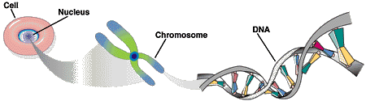

Understanding the role of DNA and chromosomes enables children’s nurses to better comprehend disease processes. In medicine, we explore how traits are passed down, or Molecular genetics, which is the study of the structure of DNA, RNA (ribonucleic acid) and proteins (Robinson, 2010).

DNA
DNA – Deoxyribonucleic acid – is a long, double stranded polymer: that is, a double chain of nucleotides (Marieb & Hoehn, 2007a). Nucleotides are the basis of nucleic acids, and are made up of three subunit molecules:

- A nitrogen containing base
- A five carbon sugar
- At least one phosphate group

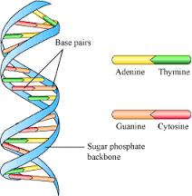
Figure 5 : The Double Helix

Figure 5 shows the double helix structure of DNA: it is composed of two strands of DNA, with two linked, coiled chains of nucleotides. There are four nucleotide bases found in DNA:
- Adenine (A)
- Guanine (G)
- Cytosine (C)
- Thymine (T)
These DNA bases pair up with each other, A with T and G with C to form base pairs. These base pairs with sugar and phosphate form the nucleotides. Two strands of long nucleotides wind around each other to form a double helix, and there are ten pairs of nucleotides per complete turn of the helix.

DNA is found mainly in the nucleus (nuclear DNA) but a small amount can be located in the mitochondria (mitochondrial DNA, mtDNA) of the cell. DNA has two main roles:

- It replicates itself before cell division, ensuring that any information in the next cells is identical
- It also provides instructions on how to build proteins throughout the body.

What triggers DNA synthesis is unknown, but once it begins, it carries on until all of the DNA has been replicated. The basis for biological inheritance relies on DNA replication; a process by which DNA double helix uncoils and slowly separates into its two nucleotide chains and then acts as a template for the new joining strand (Marieb, 2014)

Once reformed, the new double helix is identical to the one before. Sometimes during this replication process, there may be a change in the base sequence (McLafferty, Hendry, & Farley, 2012), and this is known as a mutation. Some mutations can be minor, or quite major, having a marked effect on protein synthesis, and therefore on its function. As there are so many nucleotide bases – about three billion base pairs – it is inevitable that errors will happen (Knight & Andrade, 2018b)

RNA and protein synthesis
DNA in genes provide instructions to make proteins, but first the information in a specific bit of the DNA must be transcribed, ie copied, to make a specific molecule of RNA (Ribonucleic Acid), which takes place in the Nucleus.

Transcription

Figure 7: Transcription
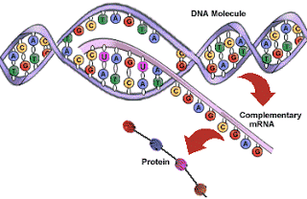

DNA itself is not involved in protein synthesis but an intermediate molecule known as Ribose Nucleic Acid (RNA) is required in a process known as transcription. The RNA is a single strand molecule – similar to DNA’s structure, except the deoxyribose – the modified sugar – is replaced by ribose – a more simplified, five carbon ‘normal’ sugar (Knight & Andrade, 2018b). In addition, the nucleic acid Thymine is replaced instead with Uracil (U).

Translation
Once mRNA exits the nucleus and enters the in the cytoplasm, it binds to ribosomes in the cell cytoplasm or ER to initiate translation. In essence, the language of nucleic acids (base sequence) is ‘translated’ into a language of proteins, which is an amino acid sequence, and follows on from Transcription.

Protein synthesis is one of the most fundamental biological processes that occur in the human body, and an understanding can help us understand medical and pharmacological processes. For example, some genetic disorders involve errors at the level of RNA splicing, where a nucleotide sequence is removed and exons (the DNA sequence and the corresponding sequence in RNA transcripts) are joined just before translation. The antibiotic Rifampicin (used to treat severe bacterial infections such as tuberculosis or meningitis) blocks bacterial transcription. Other antibiotics also target the translation phase, such as Chloramphenicol (commonly used for eye infections), Tetracycline (usually used to treat severe acne), and also Erythromycin, which is commonly used to treat respiratory infections (Pritchard & Korf, 2013).

Timeout 2
Have you used any of these antibiotics in practice? Does having a understanding of where the antibiotics work enable you to comprehend the disease process, and explain the purpose of the medication to your patient and their family? Practice with a colleague in explaining the process.

Chromosomes
Figure 8: A Chromosome

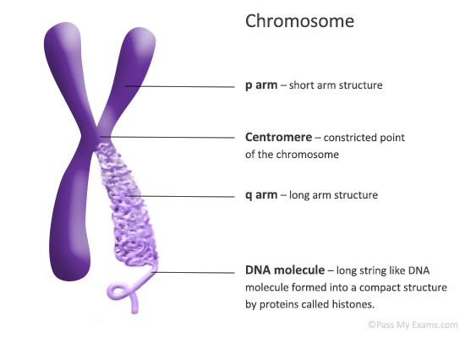

Chromatids Telomeres

A chromosome is a DNA molecule packaged into threads-like structures tightly coiled around proteins and carry the genetic information in the genes. It can clearly be seen how it fits into the DNA helix in Figure xxxx below:

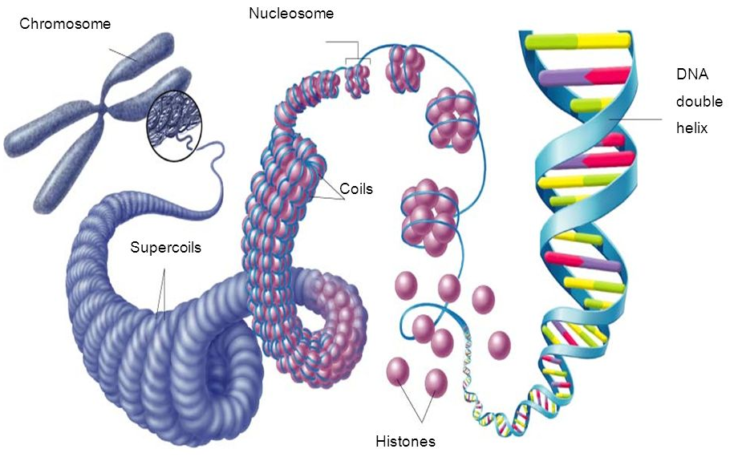
Figure xxx Chromosomes and The Double Helix

All cells in the human body (except gametes, ie ova and sperm) contain 46 chromosomes, and are arranged in pairs, and can be seen in what is known as a karyotype (See Figure 9). In both men and women, there are 23 pairs of chromosomes: there are 22 identical, or homologous pairs, which are called autosomes. In females, the 23rd pair is identical: XX, which is two X chromosomes. However, in males, there are two different chromosomes: XY, which can be seen in the bottom right hand corner of Figure 9. (Pritchard & Korf, 2013).

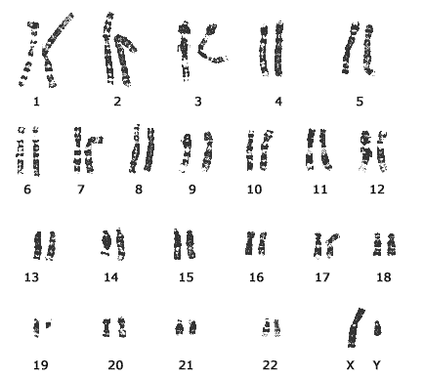
Figure 9: A karyotype

Every chromosome makes a substance called chromatin. The main functions of chromatin are:
- To ensure DNA is packaged more densely
- To allow Mitosis
- To prevent damage to DNA
- Help control DNA replication

During interphase – that is, a phase in Mitosis in where the cell is not undergoing cell division – the chromosome is in a relaxed state and is partially unwound. This helps in DNA replication and protein synthesis. However, once the cell prepares to divide, then the chromosome begins to tighten and package, to facilitate the separation of the chromosomes.

During early Mitosis, the chromosome can be visible under a microscope. The shorter arm of the chromosome is called the p arm (p for petite) and the longer arm is the q arm. At the tips are telomeres, which form a kind of ‘cap’ to protect the chromosome from degradation. (See Figure 10) Scientists ‘read’ chromosomes, and look at three main features:
- The size
- The banding pattern
- The position of the centromere (See Figure 10)

Figure 10: Chromosome banding

The banding pattern are patterns of light and dark transverse bands which become apparent when stained under a microscope, and are similar to a bar code. These bands describe the location of specific genes on a chromosome. So, for example, if you read 7q31, then you would know that you are looking at the 7th chromosome, on the long q arm, and band position number 31 – the cystic fibrosis gene.

DNA is distributed between these 23 pairs of chromosomes. A picture of chromosomes under the microscope is called a karyotype (see Figure 9). When a ‘karyotype test’ is ordered, cytogeneticists are looking at the chromosomal features described earlier. This is a simple blood test, and the results usually take a few days to come back.

To understand how genes carried in chromosomes are passed on, it is important to understand the cell life cycle and cell division.

The cell life cycle

The cell life cycle can be described as a series of changes a cell must undergo until it reproduces (Marieb & Hoehn, 2007b), and it includes:
Interphase: where the cell grows and continues with its normal daily activities and
Cell division, which is also known as the Mitotic phase

Interphase
This is the longest phase of the cell cycle, and is only ‘resting’ from cell division

Mitosis and Cytokinesis
Mitosis is the process where two ‘daughter’ nuclei are produced, with exactly the same genes as the ‘mother’ nucleus (Marieb, 2014). DNA replication occurs shortly before mitosis commences, so, for a very short while, the mother nucleus has, in effect, a ‘double dose’ of genes. The stages of Mitosis can be seen in Figure 11 and described below:

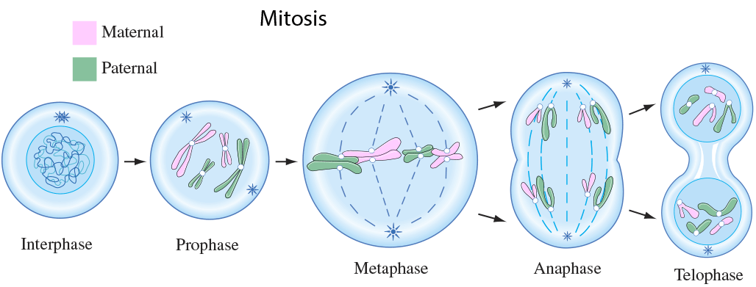
Figure 11: The stages of Mitosis

Prophase
This is where the two chromatids are visible. Chromatids are the two thread like strands where a chromosome divides, and are held together by the centromere. Centrioles in the cell help with cell division. The centrioles are made of microtubules. The centrioles move to the opposite ends the of the cell, with a mitotic spindle of microtubules, which are like threads.

Metaphase
This is a shorter stage, where the chromosomes group together at the ‘metaphase plate’ – kind of like a ‘cell equator’

Anaphase
The microtubules in the mitotic spindle begin to contract and bring the chromatids of the chromosome apart to the ends of the cell. Anaphase is complete with the chromosomes stop moving.

Telophase
This, in essence, is like the Prophase, but in reverse. The mitotic spindle disappears, and the chromosomes re-form (Boore, N., & Shepherd, 2016)

Cytokinesis
This is where the division of the cytoplasm occurs, and usually begins during late Anaphase and finishes during Telephase. A ‘cleavage furrow’ squeezes the original cytoplasmic mass into two parts, enabling the splitting of the original cell.

Meiosis
There are certain cells that go through an extra round of DNA separation into new cells, which are oocytes and sperm, our germ cells. The diploid cells, containing two complete sets of chromosomes are separated, and each oocyte or sperm cell ends up as haploid, with just one chromosome rather than two (Cedar, 2012). This is known as Meiosis.

Meiosis occurs in relation to reproduction, and it forms gametes in preparation for fertilisation, leading to the formation of a zygote, which eventually develops into a foetus (Boore et al., 2016). Meiosis is split into Meiosis 1 and Meiosis 2. Instead of producing two daughter cells, four are reproduced. This results in spermatogenesis and oogenesis, and will be explored in more detail in the article in the series Growth and Development. Male Meiosis entails how spermatogonia develop into spermatozoa, and takes roughly 64 days. In contrast, oogenesis begins in the foetus at 12 weeks gestation, but stops at 20 weeks, when the primary oocytes remain in the Prophase stage until ovulation at puberty.

It is useful to understand the stages of mitosis and meiosis as at these stages errors are likely to occur; at the chromosome pairing stage (Pritchard & Korf, 2013), and also when they cross over, causing translocations – where chromosomes re-arrange their parts – or at disjunction – where the chromatids separate in Anaphase. This can potentially cause aneuoploidy, which is where an individual may have an abnormal number of chromosomes in a cell. Extra or missing numbers of chromosomes in a cell is a very common cause of genetic disorders. An example could be seen in Cri-du-Chat syndrome, which is due to a deletion on chromosome 5. This affects 1 in every 50,000 live births. Children with Cri-du-Chat syndrome often have a characteristic cry like a kitten – hence the name. If a chromosome is missing, it is called monosomy. Trisomy is the term used for people who have an extra copy of their chromosome. This is seen in Trisomy 18, or Edwards Syndrome, and Trisomy 21, otherwise known as Down Syndrome.

Laws of inheritance

The basic principles which determine how genes are inherited are determined by the Laws – or Principles – of Inheritance (Boore et al., 2016). How characteristics are passed on were derived from Gregor Mendel’s experiments with plants (Pritchard & Korf, 2013), which showed that characteristics combine and segregate in types of mathematical proportions. Hereditary characteristics are in genes, and alleles are pairs or series of genes on a chromosome that determine the hereditary characteristics. We know our cells have two sets of chromosomes - from our mother, and one from our father. If both alleles at a gene are the same, they are described as homozygous. If they are different, they are heterozygous.

Alleles occur in pairs – but one allele can be more dominant than the other, and the other recessive. This is the Law of Dominance. During meiosis, when gametes form, the member of each alleles pair separate, so each gamete has only one allele from each pair. They are then restored again at fertilisation (Pritchard & Korf, 2013) This is the Law of Segregation. The Law of Independent Assortment is where genes of different traits can segregate independently during the formation of gametes. However, this can vary, as some genes can be on the same chromosome, and therefore can be inherited together. This is explained in Figure 13, known as The Punnett Square (Boore et al., 2016) , which demonstrates the probability of the offspring of two heterozygous parents having a particular genetic make up.

Heterozygous parent Aa

AA | Aa
Aa | aa
Heterozygous A a
Parent Aa A
a

Figure 13: The Punnett Square

A = Dominant gene
a = Recessive gene

- Homozygous Dominant: AA: Shows dominant characteristic
- Heterozygous Aa: Both show dominant characteristic
- Homozygous Recessive: aa: Does not show dominant characteristic

Dominant Inheritance

Some genes have more influence than others, and are called dominant genes. In inheritance, this means that only one copy of the defective gene is enough for a specific disease to develop (Knight & Andrade, 2018c). Its expression is dependent on that gene ‘winning’ ie, being replicated, when the other parent’s gene is added. Some genetic diseases are only carried on dominant genes. Known conditions that are autosomal dominant are Achondroplasia and Marfan Syndrome, or Huntington disease (Cedar, 2012).

Recessive inheritance
Here, both parents carry a gene for a disorder and create sperm and ova – half from each parents are likely to carry the recessive gene (Boore et al., 2016). Each pregnancy will have a 1 in 4 chance of the offspring having the condition (See Figure 14)

B b
BB | Bb
Bb | bb
B
b

1 – BB: No disease occurs
2 – Bb: One normal and one abnormal = carriers of the disease
3 – bb: Affected with the disease

Clinical examples of recessive inheritance include cystic fibrosis, sickle cell anaemia, and phenylketonuria (PKU).

Time Out 3 – Cystic Fibrosis.
Have a look at the Cystic Fibrosis Trust Charity page www.cysticfibrosis.org.uk/what-is-cystic-fibrosis/diagnosis/family-genetic-testing, specifically the area which explains how cystic fibrosis is diagnosed and passed on. What do you think of the website – do you think it relays the information so as families can understand the process? Does it tie in with what you have learned here? Practice explaining the inheritance process with a colleague

The rules of autosomal recessive inheritance are that:
- Affected children can be born to unaffected parents
- If both parents are affected, then all children are affected
- Affected parents with unaffected partners tend to have unaffected children due to the low probability of 1 in 4.

Chromosomal disorders
There are many variants of arrangements of chromosomes that account for clinical conditions. It is estimated that around 50% of miscarriages are due to a chromosomal disorder (Robinson, 2010). Monosomy arises if there is a missing chromosome and Trisomy is when there is an extra chromosome, as discussed earlier.

Monosomy
Monosomy is rare, but can be commonly seen in children with Monosomy of the X chromosome, which is known as Turner syndrome – this is the only survivable condition where an entire chromosome is missing (Knight & Andrade, 2018c). Many monosomies are due to partial losses of chromosomes where a part is missing, but may be attached to another part of a chromosome, which is known as Translocation. Other monosomies can occur due to errors during mitosis, which is usually due to types of chemical exposures and some types of cancer (Robinson, 2010).

Trisomy
The most common known condition here is Trisomy 21, or Down syndrome, where there are three copies of chromosome 21. Down syndrome affects roughly 1 in every 800 children, and is due to errors in meiosis. Other trisomy conditions include Trisomy 18 (Edward Syndrome), and Trisomy 13 (Patau Syndrome).

Chromosomal arrangements
This is where large scale changes occur, and include:
- Duplication
- Inversion
- Deletion
- Translocation
Duplication
Duplication occurs when parts of the chromosome are copied more than once, making the actual length of the chromosome longer.

These can also be classified as partial Trisomies. One form of autism is said to be due to duplication of part of chromosome 8 (Papanikolaou et al., 2006).

Inversion
This occurs when a section of the chromosome has been inverted, which results in a reversal of the gene sequence.

Haemophilia Type A may be caused by an inversion within the X chromosome (Tantawy, 2010)

Deletion
In a Deletion arrangement, large parts of the chromosome are missing. This happens in either the interphase of the cell cycle, or because of unequal crossings over during meiosis. Chromosome 5 deletion is due to the short arm missing, and is known as Cri-du-Chat syndrome (Cerruti Mainardi, 2006). Deletion of part of the long arm of chromosome 15 results in Prader Willi syndrome (Angulo, Butler, & Cataletto, 2015).

Translocation
This involves swopping over of large parts of the chromosome. It can be reciprocal, where the exchange is balanced (see Figure 18), and is the most common type.

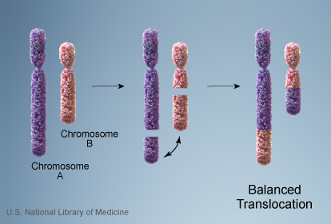

Figure 18: Balanced Chromosomal Translocation

Conversely, the translocation can be non-reciprocal, where the exchange is not even, and resulting therefore in some deletions (see Figure 19). Chromosomes 11 and 22 are often involved in reciprocal translocations, resulting in some birth defects like cardiac abnormalities and cleft palate, and also a hereditary form of breast cancer (Robinson, 2010)

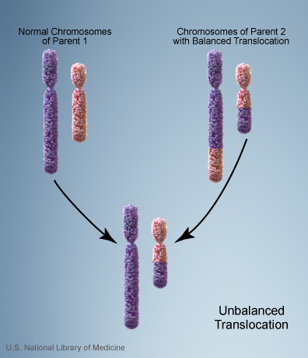

Figure 19: Unbalanced Chromosomal Translocation

The genetics of sex
The sex phenotype of a human is determined by two chromosomes: X and Y. Normally, females have two X chromosomes: XX, and males have one X and one Y chromosome

. It is home to approximately 900 – 1200 genes, and is so important for development that if it is missing, the developing zygote cannot progress. X chromosome genes are responsible for red blood cell formation, muscle development and function and blood clotting for example.

Embryological development for sexual differentiation begins around gestational age week four. It is dependent on whether there is ovarian or testicular tissue present as to what the genes do next. If there is no Y chromosome, two genes then work together to give the embryo the female phenotype.

In comparison to the X chromosome, the Y chromosome is small. Individuals can survive with one X and no Y chromosome. This leads geneticists to believe that the Y chromosome is not required for survival. Most of the genes on the Y chromosome are involved in male sex determination and sexual function.

Sex linked inheritance
Traits that are determined by genes on the sex chromosomes are said to be ‘sex linked’.

X linked inheritance
Females can have dominant or recessive properties of their X linked genes (Pritchard & Korf, 2013). Most sex linked disorders are caused by X linked recessive alleles in males.

A man (XY) receives his X chromosome from his mother, and would pass it to every daughter he has, resulting in mother and daughter being ‘obligate carriers’ of any X linked recessive gene which has been expressed by the male. Rules here show:
- This ‘mutant allele’ is passed from an affected man to every daughter
- A carrier mother passes this allele to half her sons who express it, and half her daughters who do not
- This mutant allele is NEVER passed from father to son

The rules of X linked dominant conditions are:
- The condition is expressed and transmitted by both males and females
- The condition occurs twice as frequently in females as it does in males
- An affected man always passes the condition to his daughter but never to his son
- An affected woman passes the condition to half her sons and half her daughters
(Pritchard & Korf, 2013)

X linked recessive diseases are usually expressed in males: As females have two copies (XX), and males only one (XY) , then males are usually more likely to be affected. Females would therefore have the chance in having a healthy gene in order to ‘compensate’ for defective one. Females, however, may be carriers. Well known X linked recessive disorders are Duchennes Muscular Dystrophy, Fragile X Syndrome, Haemophilia and red / green colour blindness. X linked dominant disorders are much less common and known conditions include Rett syndrome (lethal in males), or Alport syndrome, which affects kidneys and hearing (Knight & Andrade, 2018c)

Y linked inheritance
This is where genes are inherited from the Y chromosome, and occurs only from fathers to sons. The SRY gene is responsible for the sex determination, as previously discussed. In addition, another trait passed down on the Y chromosome is one for hairy ears! (Marieb & Hoehn, 2007c; Robinson, 2010).

Where next for genetics?
The future is very exciting within the world of genetics and how it is applied within medicine. Gene therapy (Cedar, 2012) is where genetic material is inserted into cells to compensate for abnormally structured or functioned genes. Ethical issues need to be considered carefully here, as decisions need to be made surrounding whether genes are ‘faulty’ and what is ‘normal’ in society. Alternatively, types of screening are carried out in IVF to see if fertilised eggs have had a defective gene passed on, and the parents can choose whether or not to have these embryos implanted

Conclusion
Understanding cell physiology is abstract – we cannot see what is happening. However, an understanding is vital in some instances where it plays a key role in understanding certain illnesses, or providing explanations to parents. The study of genetics is vast, and only an overview is given here, highlighting the importance of understanding basic genetic processes required in your clinical practice. It is likely that you will care for children one day with some type of inherited condition, so this article can provide you with a reminder on how inheritance works. As technology advances, the study of genetics will be at the forefront of medical science.

Quiz
1 – What is not a nucleotide in DNA?
- Adenine
- Guanine
- Thymine
- Uracil

2 – What is an autosome?
- A sex chromosome
- One of the other 22 chromosomes
- The centre of a chromosome
- A chromosome with only one copy

3 – What is Interphase?
- The ‘resting’ part of cell division
- Where cells produce two daughter nuclei
- Where the cell splits
- When the chromosomes re-form

4 – What are homologous chromosomes?
- A set of one maternal and one paternal chromosomes
- Chromosomes which have an extra copy
- Where one gene is dominant
- The same as heterozygous

5 – What is meant by recessive inheritance?
- Where two copies of an abnormal gene must be present
- Where you receive the gene from your mother
- Where the genes are only passed down from father to son
- Where the mother is a carrier

6 – What is included in Y linked inheritance?
- The gene for sex determination
- The gene for haemophilia
- Genes that result in Turner syndrome
- Genes that are responsible for forming red blood cells

7 – What is a chromosomal translocation?
- Where parts of the chromosome are copied
- Where part of the chromosome has turned around
- Where parts of the chromosome are missing
- Where parts of the chromosome swop over

8 – Why is genetic clinical screening important?
- To identify disease before the symptoms appear
- To warn the family the child will develop something
- To ensure the child knows everything they need to know about the condition at an early age
- To help the parent to tell friends and family

9 - Which statement about mitochondria is NOT true?
- Mitochondria make ATP
- Mitochondria are single membrane organelles
- Mitochondria have their own DNA
- Mitochondria are normally more abundant in cells with high energy demands

10 - Which sentence best describes the function of the Golgi?
- The Golgi plays a role in translation of RNA during protein synthesise
- The Golgi functions in degradation of damaged organelles and proteins
- The Golgi functions as a factory in which proteins received from the ER are further processed and sorted
- The Golgi functions as a factory in for production of the cellular energy source ATP

References

Amato, P., Tachibana, M., Sparman, M., & Mitalipov, S. (2014). Three-parent in vitro fertilization: gene replacement for the prevention of inherited mitochondrial diseases. Fertil Steril, 101(1), 31-35. doi:10.1016/j.fertnstert.2013.11.030
Angulo, M. A., Butler, M. G., & Cataletto, M. E. (2015). Prader-Willi syndrome: a review of clinical, genetic, and endocrine findings. J Endocrinol Invest, 38(12), 1249-1263. doi:10.1007/s40618-015-0312-9
Bianconi, E., Piovesan, A., Facchin, F., Beraudi, A., Casadei, R., Frabetti, F., . . . Canaider, S. (2013). An estimation of the number of cells in the human body. Annals of Human Biology, 40(6), 463-471. doi:10.3109/03014460.2013.807878
Boore, J., N., C., & Shepherd, A. (2016). Genetic and epigenetic control of biological systems. In Essentials of Anatomy and Physiology for Nursing Practice. London: Sage.
Cedar, S. H. (2012). Growing and Developing. In Biology for Health: Applying the Activities of Daily Living. Basingstoke: Palgrave Macmillan.
Cerruti Mainardi, P. (2006). Cri du Chat syndrome. Orphanet J Rare Dis, 1, 33. doi:10.1186/1750-1172-1-33
Kisler, J. E., Whittaker, R. G., & McFarland, R. (2010). Mitochondrial diseases in childhood: a clinical approach to investigation and management. Dev Med Child Neurol, 52(5), 422-433. doi:10.1111/j.1469-8749.2009.03605.x
Knight, J., & Andrade, M. (2018a). Genes and chromosomes 1: basic principles of genetics. Nursing Times, 114(7), 42 - 45.
Knight, J., & Andrade, M. (2018b). Genes and chromosomes 3: genes, proteins and mutations. Nursing Times, 114(9), 60 - 64.
Knight, J., & Andrade, M. (2018c). Genes and chromosomes 4: common genetic conditions. Nursing Times, 114(10), 54 - 58.
Lukacs, G. L., & Verkman, A. S. (2012). CFTR: folding, misfolding and correcting the DeltaF508 conformational defect. Trends Mol Med, 18(2), 81-91. doi:10.1016/j.molmed.2011.10.003
Marieb, E. N. (2014). Cells and Tissues. In Essentials of Human Anatomy and Physiology (10th ed.). Harlow: Pearson.
Marieb, E. N., & Hoehn, K. (2007a). Cells: The Living Units. In Human Anatomy and Physiology (7th ed.). San Francisco: Pearson.
Marieb, E. N., & Hoehn, K. (2007b). Chemistry comes alive. In Human Anatomy and Physiology (7th ed.). San Francisco: Pearson.
Marieb, E. N., & Hoehn, K. (2007c). Heredity. In Human Anatomy and Physiolgy (7th ed.). San Francisco: Pearson International Ltd.
McLafferty, E., Hendry, C., & Farley, A. (2012). Genetics, mitosis and meiosis. Nursing Standard, 26(48), 35 - 42.
Papanikolaou, K., Paliokosta, E., Gyftodimou, J., Kolaitis, G., Vgenopoulou, S., Sarri, C., & Tsiantis, J. (2006). A case of partial trisomy of chromosome 8p associated with autism. J Autism Dev Disord, 36(5), 705-709. doi:10.1007/s10803-006-0104-3
Peate, I., & Nair, M. (2015). Cells and Organelles. In Anatomy and Physiology for Nurses: At a glance. Oxford: Wiley Blackwell.
Pritchard, D. J., & Korf, B. R. (2013). Medical Genetics at a Glance. Oxford: Wiley-Blackwell.
Ramaekers, F. C., & Bosman, F. T. (2004). The cytoskeleton and disease. J Pathol, 204(4), 351-354. doi:10.1002/path.1665
Reiter, J. F., & Leroux, M. R. (2017). Genes and molecular pathways underpinning ciliopathies. Nat Rev Mol Cell Biol, 18(9), 533-547. doi:10.1038/nrm.2017.60
Robinson, T. R. (2010). Genetics for Dummies (2nd ed.). New Jersey: Wiley Publishing Inc.
Senger, B. A., Smith, D. W., Bindler, R. C., & Hollinger, M. R. (2018). A Case Study of a Child With Mitochondrial Disease. J Pediatr Health Care, 32(5), 494-499. doi:10.1016/j.pedhc.2018.05.002
Tantawy, A. A. G. (2010). Molecular genetics of hemophilia A: Clinical perspectives. Egyptian Journal of Medical Human Genetics, 11(2), 105-114. doi:10.1016/j.ejmhg.2010.10.005
Tortora, G. J., & Derrickson, B. (2010). Cells. In Essentials of Anatomy and Physiology (8th ed.). Asia: Wiley.
Tuppen, H. A., Blakely, E. L., Turnbull, D. M., & Taylor, R. W. (2010). Mitochondrial DNA mutations and human disease. Biochim Biophys Acta, 1797(2), 113-128. doi:10.1016/j.bbabio.2009.09.005
Ward, J. P. T., & Linden, R. W. A. (2013). Cells, membranes and organelles. In Physiology at a glance (3rd ed.). Oxford: Wiley Blackwell.
Zaghloul, N. A., & Katsanis, N. (2009). Mechanistic insights into Bardet-Biedl syndrome, a model ciliopathy. J Clin Invest, 119(3), 428-437. doi:10.1172/JCI37041

