Automated Inspection System for NDT of Steel Plates
M. Rakocevic, X. Wang, S. Chen, A. Khalid, T. Sattar and B. Bridge
South Bank University, Centre for Automated and Robotic NDT, 103 Borough Road, London SE1 OAA, tel : +44 171 815 7554, fax : +44 171 815 7580,
ABSTRACT: The aim of the research project is to automate NDT data acquisition and analysis on large steel plates with an ultrasonic inspection technique that is implemented with robotics instrumentation. The project researches NDT sensor deployment, ultrasonic data acquisition and analysis and intelligent flaw detection. A robotic system has been developed for the inspection of internal imperfections in flat steel plates and produces a map of defective areas. It is a magnetic vehicle with a self-navigating system that carries 16 transducers for ultrasonic testing. The software that has been developed controls the scan trajectory of the vehicle and locates and plots position of the ultrasonic sensors and the presence of any defects at these positions. Internal imperfections in the steel plate are detected by monitoring the backwall echo or the echo associated with an imperfection during the scanning. The system has easy mobility to carry out inspection from site to site and a display and image processing system to analyse and show results of the ultrasonic inspection.
1. Introduction
The overall aim of this research project is to automate NDT data acquisition and analysis on large steel plates with an inspection technique that is implemented with robotic instrumentation. Steel plates are to be inspected for internal defects in them and a map of defective areas should be produced. Plate products are sold throughout the world to a wide range of industries. They should meet the requirements of National, European, International and customers standards and are used for structural, shipbuilding, boiler, pressure vessel and other applications. The plates vary in size between 5 to 25 meters in length and 1.5 to 4 meters in width and 12.5 to 200 mm in thickness.
British Standard (BS5996) [1] specifies acceptance levels for internal imperfections in ferritic and austentic steel plate, strip and wide flat material based on ultrasonic testing. The classification is on the basis of the area, length and width of individual imperfection (see Figure 1). The maximum number of individual imperfections in a given area of plate also determines the classification.
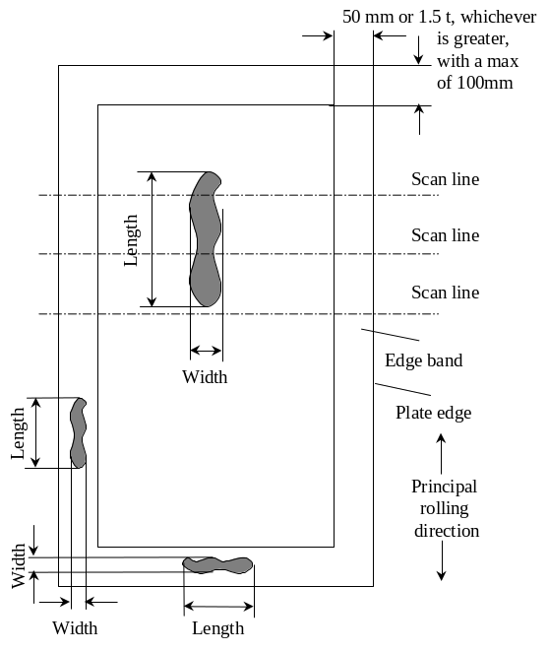Figure 1. Specifications for the plate inspection given by the British Standard.
According to British Standard the following criteria needs to be satisfied:
- The material surface is scanned with ultrasonic probes in straight parallel, equispaced scan lines normal to principal rolling direction. This is to ensure the detection of the minimum imperfection size with the limiting length and width dimensions.
- The pulse repetition frequency of each transducer in relation to the relative movement along each scan line is sufficient to ensure detection of the relevant minimum imperfection length and width dimension.
- Specified acceptance levels are used.

At present, the steel producer is using ‘multiple probe plate tester’. Four probes are arranged in the holder with required spacing between them. Holder is fixed on the ‘Hoover’ type of tester shown in Figure 2. The probes are connected via a multiplexer to a pulse echo flaw detector. A water canister is mounted on the trolley, and water is supplied via the pipe to feed the transducers with the necessary couplant for testing. Operator pushes plate tester over the plates. If different line spacing is required for testing, probe holder can be replaced. The design enables the operator to push the tester over the plates in the straight lines. This way of testing is dependent on the accuracy of the operator when pushing the trolley. He can not make sure he is making parallel scans along the width of the plate. Also, when testing the edge band, operator fixes the probe holder at an angle. In that case scan line separation can be smaller and therefore satisfy E1-E4 criteria in British Standard. Testing the plates this way depends very much on the operator, and is very subjective. He is the one who decides if there is a defect or not, as well as weather the plate was fully covered.
The inspection system developed at the Centre for Automated and Robotic NDT at South Bank University includes vehicle with a payload of sixteen ultrasonic NDT sensors and a multiplexer and the mobile rack cabinet with industrial PC, motor driver rack and the auxiliary power supply. The vehicle and the control unit are linked by a 30 metres long umbilical cable. (Figure 3 and 4).
The navigation of the system is based on an odometric system (e.g. encoders). In addition to encoders the mobile vehicle has a group of eddy current sensors to monitor plate edge so that it could align itself at the edge. This independent system reduces the error produced by the odometric system.
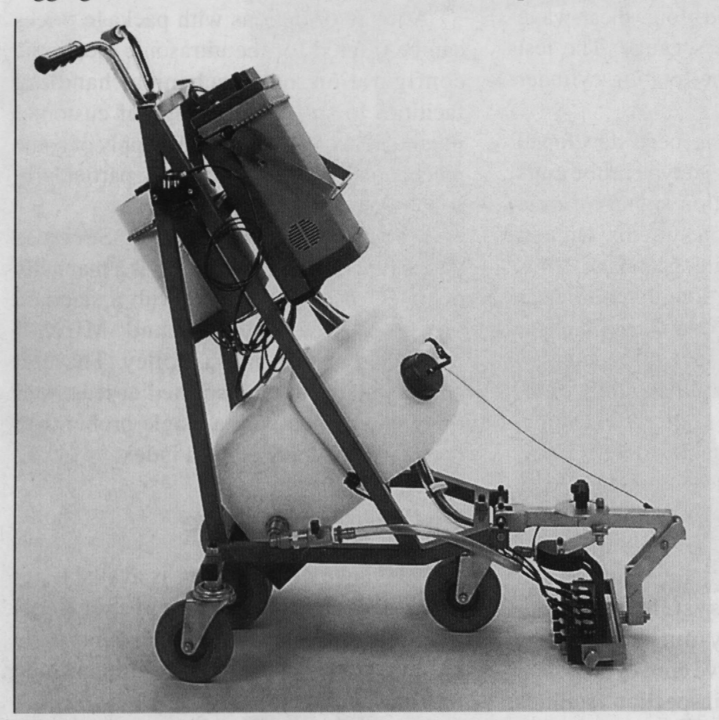
Figure 2. Manual plate tester used for testing plates at present.

Software has been developed to control the scan trajectory of the vehicle and locate and plot position of the ultrasonic sensors and to detect presence of any defects at these positions. It is a PC based fully programmable ultrasonic flaw detector able to control the movements of the vehicle and display a defect map of the steel plate.
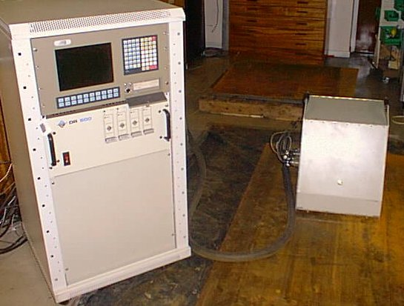
Figure 3. Inspection System in the laboratory.
With reference to the requirements for the body test of steel plates (according to BS5996) the different acceptance levels can be achieved by changing the probe holder, as described in Section 5. A band around the cut edges of the steel plate would be 100% scanned. The band scanning width could vary between 50mm to 100mm, depending on the thickness of the plate. The vehicle can operate with speeds of 5 ~ 10m/minute.
5 MHz piezo-electric wet-contact ultrasonic transducers are used for the ultrasonic scan. Water is used as a couplant to conduct ultrasound between the transmitter or the receiver and the steel.
The block diagram of the system is shown in Figure 4. Four NDT control cards are mounted inside the PC. Another card in the PC is used to control the vehicle. This card also has 16 digital inputs and 4 digital outputs connected to other sensors and switches via an interface board to form a complete control system that satisfies the requirement of plate inspection.
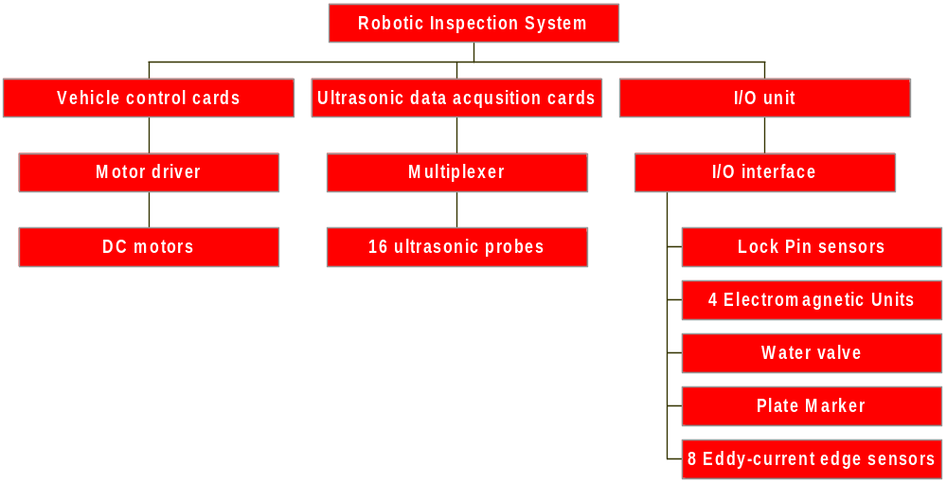Figure 4. Principle diagram of the inspection system.
2. The mobile vehicle
The mobile vehicle is a special two-platform structure utilising the differential drive mode. The inner platform is connected to the outer platform via a bearing. A PC controlled lock-pin that is driven by a DC motor is designed to fix two platforms together. The size of the vehicle is 400(w)×670(l)×440(h) and its weight is about 48kg. The main configuration of the vehicle is illustrated in Figure 5.
Wheels and driving motors with encoders and gearboxes are mounted on the inner platform. There are four castor wheels to support the outer platform of the vehicle. The driving wheels drive the vehicle forward or backward when the pin locks the inner and the outer platform together. The main point of this design is its turning mechanism. When four electric magnets mounted on the outer platform are switched on, the outer platform is attracted to the steel plate. The lock-pin is released so that the inner platform is able to rotate freely whilst the outer platform is firmly held on the plate. Two driving wheels turn in the opposite direction to rotate the inner platform around the central axis of the vehicle. The inner platform is allowed to turn ±90° and then fixed to the outer platform again by the pin (see Figure 6). This ensures that the moving direction of the vehicle can turn in right angle, but the orientation of the whole vehicle keeps constant so that the umbilical will not be twisted. The vehicle with the ultrasonic transducers mounted in front and back is therefore able to cover the whole steel plate in the raster scan.
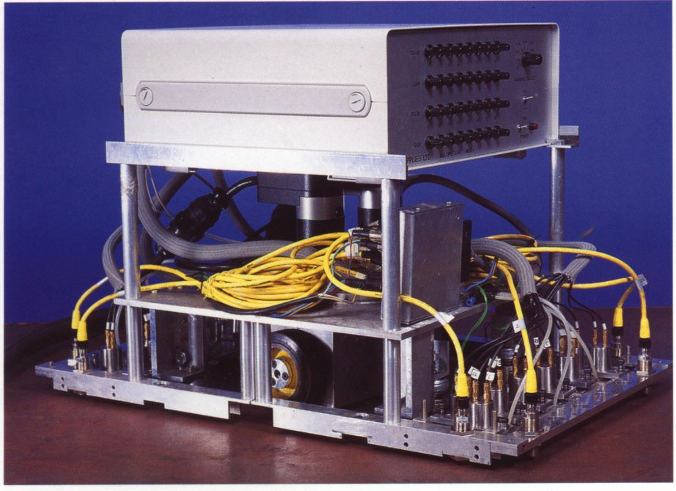
Figure 5. The mobile vehicle composition.

Two proximity switches are monitoring the position of the lock-pin. Strong permanent magnets underneath the inner platform are used to provide better friction between the wheels and the surface of plates in order to reduce the slippage of the vehicle. The water valve controls the water supply to provide suitable couplant for ultrasonic testing. All control signals of input/output are connected with an I/O interface box that is linked to the remote control cabinet via 50-way cable.
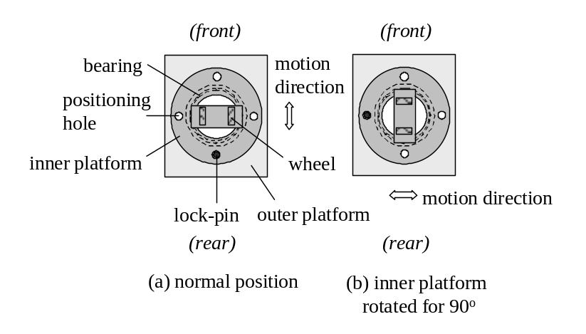 Figure 6. The principle of turning mechanism.

3. Navigation system
The ability of the inspection vehicle to sense environments and change its movements on that basis is what makes this robot be different from fixed automatic system. Without sensors, a blind mobile robot would be unable to work in uncertain environments. Besides the shaft encoder of the motor, proximate sensors are used for detecting the edge of the steel plate for self-guidance of the vehicle. The software controls the scan trajectory of the vehicle and locates and plots position of the ultrasonic sensors and the presence of any defects at these positions.
The central part of the navigation system that is used is odometric system (e.g. encoders). Odometry uses encoders to measure wheel rotation and/or steering orientation. Its advantage is that it is totally self-contained, and it is always capable of providing the vehicle with an estimate of its position. The disadvantage is that the position error grows without bound unless an independent reference is used periodically to reduce the error.
Proximate sensors are used as additional devices for detecting the edge of the plate and therefore are an independent reference for reducing the error produced by the encoder system.
Sensor | Size | Sensing distance for steel target | Output method | Maximum sensing rate | Power supply
Eddy current | M5x26-M30x60 | 0.8-15mm | Digital | 25-5kHz | DC, 6-50v, 100-300ma
Capacitance | M18x80-M30x88 | 10-20mm | Digital | 250-400Hz | DC, 8-30v, 250ma
Ultrasonic | M18-M30 | 10-500mm | Digital/analogy | 30-215kHz | DC, 9-50v
Table 1. The operating parameters of proximity sensors.
Table 1. gives the main operating parameters of three different proximity sensors. The eddy current sensor is the most commonly employed industrial sensor for detection of ferrous and non-ferrous metal objects over short distance [1]. They are less affected by environmental factors (humidity, dust etc.), and have high detection rate in comparison with the capacitance sensor. The disadvantage is that there is no commercial product of this type with the analogue output.
In the navigation for the inspection vehicle the edge detector has two functions:
- To monitor the edge of steel plate. The vehicle will immediately stop when the edge detector finds the edge of a plate.
- To determine the position of the vehicle relative to the edge. The slope angle of the vehicle relative to the edge of plate can be determined by the edge detector so that the vehicle can correct its orientation error.
First function requires instant response when the vehicle reaches the edge of the plate. If the maximum speed of the vehicle is 9m/min, i.e. 150mm/sec, the sensing rate of the edge sensor should be not less 100Hz to monitor small movement of the vehicle within 1.5mm.
An edge detector consists of 8 eddy current sensors, the circuit for signal detection and an interface with the PC.
A sensor consists of a coil, a carrier oscillator and associated amplifier. The output signal from eddy current coil is a time-variable AC voltage. The presence condition of steel plates may be detected simply by the change of signal amplitude when the sensor is in the air, so that a simple amplitude detector and a level comparator can be used. Although the detection results are simple on/off signals, they are not suitable for direct input into the peripheral digital channel of a PC due to the voltage level difference between sensors and the PC. A level converter hence has to be used.
An edge detector consists of a couple of eddy current sensors that are mounted in a line for measuring the inclined angle of the vehicle relative to the edge of a plate (Figure 7).
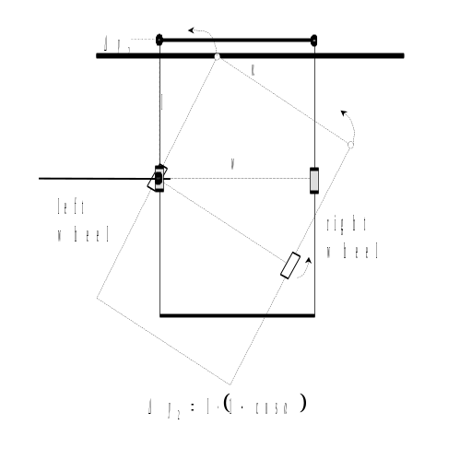 Figure 7. The determination of the slope angle by the edge detector.

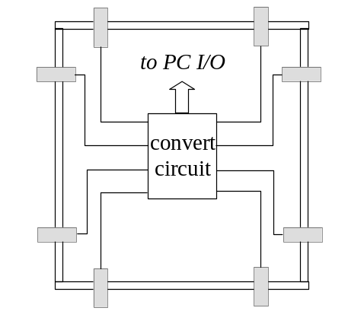 Figure 8. The edge sensors arrangement.
If the vehicle is not perfectly aligned with the edge of the plate, sensor will be reaching the edge with the time difference ds. Since the distance w between two sensors is constant and equal to the wheelbase of the vehicle the inclined angle α can be calculated as:
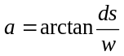 (3.1)
The accuracy of the edge self-align algorithm depends on the practical turning accuracy of the wheels rather than the calculation accuracy of turning parameters.
4. Ultrasonic data acquisition system
The system for ultrasonic NDT consists of ultrasonic and data acquisition expansion boards and a 16 channel multiplexer. Data acquisition boards include a general-purpose Master System Controller, 100 MHz Analogue to Digital converter and the 100 MHz peak amplitude and time interval measurement card (ATP4).
Software has been written for data acquisition and user interface in Windows environment. As the vehicle is moving on the plate in the x and y co-ordinates a screen map of defects is built on the PC using the signal amplitudes from two hardware gates on the amplitude measurement card. Default settings for the ultrasonic gates are set but can be changed in the dialogue box.
5. Design of the transducer holder for the steel plates inspection system
The testing of a steel plate for manufacturing defects is highly diversified, which is not surprising in view of the many different uses made of the plate in industry. The varying significance of a given plate defect, the wide range in plate thickness (from 1 mm to more than 100 mm), and the diversity of the defects according to their nature, shape, position and size all determine the testing strategy adopted.[3],[4]
A liquid or gel couplant has to be used to maintain ultrasonic contact between the probe and the tested material surface. All liquids have much lower acoustic impedance than metals, thus it is necessary to choose a liquid with as high acoustic impedance as possible along with suitable practical properties.
One major problem associated with automated testing systems is to ensure and maintain probe orientation and coupling. Uniform coupling at all points of a given specimen is very important for quick and reliable evaluation of the reading. Occasionally this can be checked by means of a backwall echo. In automatic testing, the absence of constant observation of the screen image and of the sense-orientated manual guidance of the probe is a shortcoming. It is possible to use the backwall echo for checking the coupling, although this has the disadvantage that it is not only bad coupling but also a flaw that can reduce signal amplitude.
Wear and insufficient constancy of the degree of coupling are the reasons for disfavouring direct contact of the transducer. Direct contact makes wear of the transducer unavoidable because the probe, during scanning, cannot simply be placed on and taken off again. It must be shifted because any change in the flaw echo while shifting the probe provides valuable information of the flaw to the examiner. Information such as the disappearance and reappearance of echoes and their change with depth can be observed. Particularly when used on rough surfaces of steel covered by very hard and sharp edge scale, the probe can become severely eroded. Spacing layers consisting of liquids or plastics cut down the wear but increase the amount of interfering echoes. Interfering reflection from the coupling layer can be greatly reduced by adding a layer of an additional absorbing material to the coupling layer. If thicker spacing layers are used the surface echo and its multiple echoes become separated from the transmitting pulse. [5]
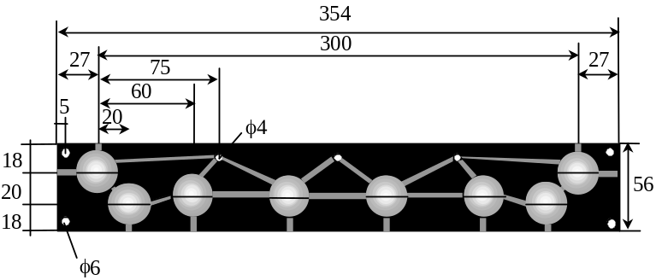
Figure 9. Third prototype of the holder (view from below).
In the transducer holder designed for this inspection system, the probes are permanently fixed. Hence, it is necessary to have a separate holder for each line separation. The holder is made of MoS₂ Filled Cast Nylon. This is a low friction self-lubricating material with high mechanical strength, high melting point and good abrasive resistance. It provides stable orientation of all probes, and no need for any adjustment before the testing. The holder is touching the surface, providing a couple of mm gap between the probes and the steel plate. Canals are machined into the bottom side of it to provide the water stream for each probe. Water is discharged from a pipe and a valve controls its flow (see Figure 9, 10).
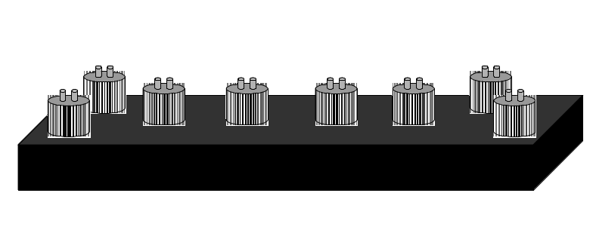
Figure 10. Third prototype of the holder (view from the front).
Previous versions of the transducer holder were made of aluminium, and had the ability of adjusting the spacing between the probes. Probes were fixed on the small aluminium plates that could be fixed along the holder at different spacing. The probe holder was fixed to the outer platform of the vehicle and for that reason the orientation of the probes was very dependent on the movement of the outer platform, and therefore the probes were not parallel with the surface all the time. Orientation of the transducer in the automated NDT inspection system is essential for correct and accurate measurements of signal amplitude or time of flight.
Experiments were done to show the effect of alternation of probe orientation angle to the signal amplitude. Results suggest that for the steel plates thicker than 50mm it is recommended to use single crystal probe, instead of the twin crystal one. The reason for that is that in the single crystal probe the angle of incidence equals zero, since the same crystal is used for transmitter and receiver and therefore it is parallel with the bottom of the probe. Transducers that are used for inspection are CD5-20 Sonatest twin element contact transducers.
6. Testing and Results
With reference to the requirements for the body test of steel plates the following acceptance levels can be achieved: B1 (100mm scan line separations), B2 (75mm), B3 (60mm) and B4 (35mm). A band around the cut edges of the steel plate would be 100% scanned. The band scanning width could vary between 50mm to 100mm, depending on the thickness of the plate.
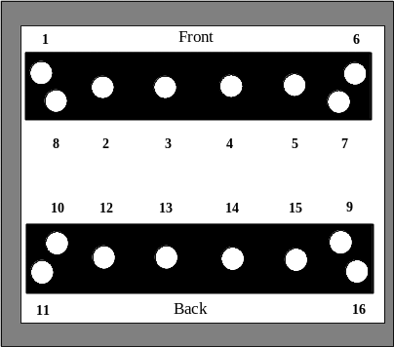
Figure 11. Ultrasonic probes arrangement in the transducer holder.
The presence of an internal imperfection is indicated by:
- A 50% reduction in the signal amplitude of the back wall echo, with or without the presence of an imperfection echo;
- The presence of an imperfection echo which equals or exceeds 50% of the amplitude of the reduced back wall echo.
Testing was conducted in one of the major steel production factories in UK.
In order to cover entire steel plate arrangement of ultrasonic probes is given in Figure 11.
Ultrasonic probes are connected to 16 channel multiplexer that acquire data from each probe. The scan generally starts from the bottom-left corner of the plate. The vehicle can be placed anywhere on the plate because it is designed to locate its starting position before it begins the scan. To begin with, the left edge of the plate is scanned using the two pairs of the side left ultrasonic transducers in the holder (see Figure 12). Top and bottom edges are scanned at the same time when the body is scanned, so that the vehicle does not have to go all the way around the plate and then go back to the starting position and do the body scan. Figure 12 gives the basic idea which probes are used for edge and which ones for body scan. Figure 13 gives the detailed scanning trajectory including first and second edge lines and all body scan lines. Each line presents the whole vehicle movement, not a single probe. The edge band width depends on the thickness of the plate and the maximum band width exceeds the width of the band that can be covered with two edge probes. Therefore it could be necessary to scan several lines at the same time with some overlap between the lines for the edge inspection. Finally the vehicle stops at the end point and returns to its starting position.
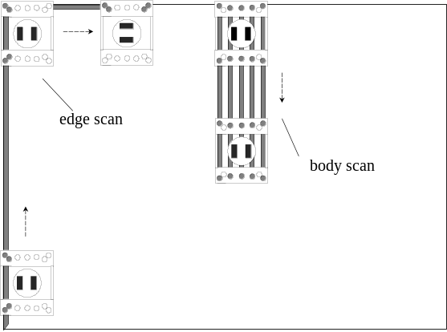
Figure 12. Scanning principle.
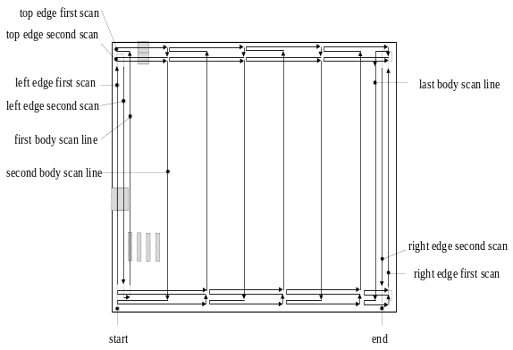
Figure 13. Scanning trajectory.
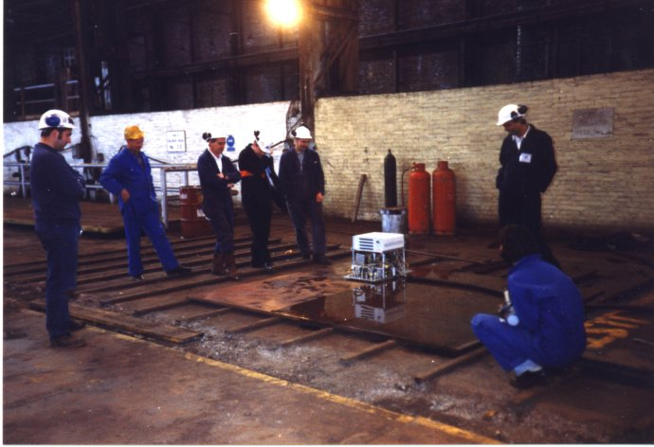
Figure 14. Inspection vehicle when testing 9.5m long and 3m wide steel plate.
Tests were undertaken three times on-site. First time vehicle did not have a cover on, and was therefore lighter than its design specifications. (Figure 14).
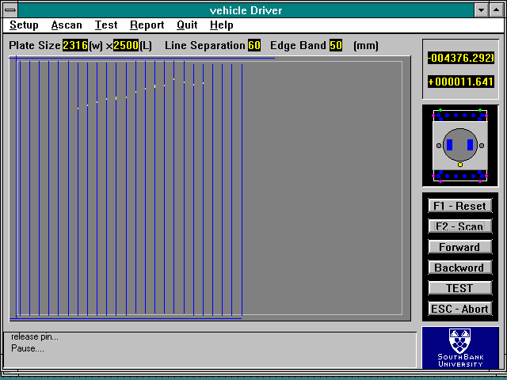
Figure 15. Results from the third probe holder prototype on the 50mm thick plate.
Different prototypes of probe holder were used for each visit. Results from the first and the second probe holder were not accurate enough, probes were loosing backwall echo signal, and many yellow dots, simulating defects or lost of couplant, could be seen on the screen.
In the latest visit on-site the transducer holder described in Section 5 was used.
First plate that was tested was 50mm thick, and had an internal imperfection, that can be seen as a yellow trace on the screen, Figure 15. Second plate was 20mm thick, and did not have any imperfections. It was 9.5m long and 3m wide, Figure 16. Vehicle was programmed to return a step back if defect was found, and check if it was a defect or probe has lost contact with the plate.
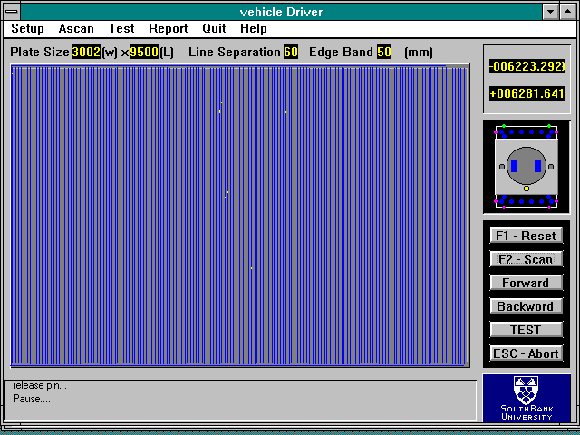
Figure 19. Results from the third probe holder prototype on the 20mm thick plate.
Since this holder was 30mm thick, it provided stable orientation of all probes, and no need for any adjustment before the testing. It was touching the surface, unlike the probes that were fixed to it with a couple of mm gap to the steel plate. This design tried to make sure that all 16 transducers are perfectly normal to the surface of the plate. The holder itself was touching the surface, and it was not firmly fixed to the vehicle, but just attached to it so that they would be moving together. In that case, movement of the vehicle was not affecting ultrasonic testing
7. Conclusion
A robotic system has been developed for the inspection of internal imperfections in flat steel plates, producing a map of defective areas. It is a magnetic vehicle with a self-navigating system that carries 16 ultrasonic transducers. The control software is implemented in Windows environment. The user-friendly interface provides real-time NDT display and virtual vehicle status simulation as well as control menus and buttons for control of the vehicle.
Edge detection system plays an important role in the inspection system. The eddy current sensor is employed for the plate edge detector due to its small size, high detection rate and insensitivity to environmental conditions. It has been proved that the two-sensor structure to detect an edge of plates is optimal for the configuration and accuracy of the control system. The results of the system testing have shown that the system meets the design requirements to perform NDT on steel plates. However, some problems with the stability of the ultrasonic signal and the scanning mechanism occurred when the robot was first tested on the very uneven plate. The modification of the two-platform mechanism, wheels, the lock-pin and the ultrasonic probe holder were done, improving the performance of the system. The system control software is modified as well to compensate some shortcomings of the hardware system. The latest field trial showed improved results. Three different ultrasonic holder designs are presented.
Mobile robot navigation in its environment is a central concern of mobile robot application. The absolute and relative positioning methods is two basic solutions of navigation. Odometry, utilising incremental and absolute optical encoders, is a relative positioning method most widely used for the mobile robot, whereas heading sensors such as gyroscopes and compasses can help to compensate for the foremost weakness of odometry.
8. References
- Specification for Acceptance Levels for Internal Imperfections in Steel Plate, Strip and Wide Flats, Based on Ultrasonic Testing, British Standard 5996.
- Wojcik S: Noncontact Presence Sensors for Industrial Environments, Sensors, pp. 48-54, 1984.
- Krautkramer J. and Krautkramer H: Ultrasonic Testing of Materials, New York: Springer-Verlag, 1983.
- Halmshaw R: Non-Destructive Testing, Edward Arnold 1987.
- American Society For Nondestructive Testing: Nondestructive Testing Handbook, Volume 7 - Ultrasonic Testing, Second Edition, 1991.

