Major opportunities of digital twins for smart buildings: A Scientometric and Content Analysis
Frank Ato Ghansah^{a*}and Weisheng Lu^{b}
ª PhD Candidate, Real Estate and Construction Department, Faculty of Architecture, The University of Hong Kong, Hong Kong
^{b} Professor, Real Estate and Construction Department, Faculty of Architecture, The University of Hong Kong, Hong Kong

Abstract
Purpose: Digital twins provide enormous opportunities for smart buildings; however, an up-to-date intellectual landscape to understand and identify the major opportunities of digital twins for smart buildings is still not enough. This study, therefore, performs an up-to-date comprehensive literature review to identify the major opportunities of digital twins for smart buildings.
Methodology: Scientometric analysis and content analysis are utilised to comprehensively evaluate the intellectual landscape of the general knowledge of digital twins for smart buildings.
Finding: The study uncovered 24 opportunities that were further categorised into four major opportunities: efficient building performance (smart “building” environment), efficient building process (smart construction site environment), information efficiency, and effective user interactions. The study further identified the limitations of the existing studies and made recommendations for future research in the methodology adopted and the research domain. Five research domains considered for future research: “real-time data acquisition, processing, and storage”, “security and privacy issues”, “standardised and domain modelling”, “collaboration between the building industry and the digital twin developers”, and “skilled workforce to enable a seamless transition from theory to practice”.
Practical and theoretical implication: All stakeholders, including practitioners, policymakers, and researchers in the field of “architecture, engineering, construction and operations” (AECO), may benefit from the findings of this study by gaining an in-depth understanding of the opportunities of digital twins and their implementation in smart buildings in the AECO industry. The limitations and the possible research directions may serve as guidelines for streamlining the practical adoption and implementation of digital twins for smart buildings.
Originality: This study adopts scientometric analysis and content analysis to comprehensively assess the intellectual landscape of relevant literature and identify four major opportunities of digital twins for smart building, to which scholars have given limited attention. Finally, a research direction framework is presented to address the identified limitations of existing studies and help envision the ideal state of digital twins for smart buildings.
Keywords: Digital twins, Major opportunities, Prospects, Scientometric analysis, Smart buildings.

1 Introduction
Smart buildings are digitally connected structures combining optimised and operational automation with intelligent space management to enhance user experience, increase productivity, reduce costs, and mitigate physical and cybersecurity risks (Wellener et al., 2018). The smart building notion has evolved primarily due to the development of new technologies that, when implemented, enable more intelligent resources and processes, allowing the building to run more efficiently, flexibly, interactively, and sustainably (Froufe et al., 2020). It is then widely accepted that using advanced technologies is a fundamental prerequisite to realise smart building, including but not limited to sensor deployment, big data engineering, cloud, and fog computing, etc. (Jia et al., 2019). As technology advances, similar concepts have evolved, including ‘intelligent building’ and ‘cognitive building’ (Cushman and Wakefield, 2019). One of the most popular areas of development among the supporting technologies is the Internet of Things (IoT) (Dong et al., 2019), which has born the idea of digital twins.
Though there is no commonly agreed definition of digital twins in the built environment, the existing subjective definitions consist of three items: the physical part, the digital part, and the information links between them (Grieves and Vickers., 2017; El Saddik, 2018). Michael Grieves originally defined a digital twin as a real-time digital footprint of a product system from the design and development to the end of its life cycle (Grieves, 2005). This is closely related to the cyber-physical system (CPS) integration concept (Tao et al., 2019; Boje et al., 2020) and the building information modelling (BIM) (Brilaski et al., 2019). It provides information and creates high-fidelity virtual model objects in virtual space to simulate assets’ behaviours in the real world and provide feedback (Tao et al., 2019). The digital twin concept may be achieved with IoT-based BIM (Brilaski et al., 2019) due to its IoT system, which is an essential component for digital twins (Cheng et al., 2016). Here, the study follows the definition by Michael Grieves.
The ambition to create smart buildings has been impeded until recently by massive amounts of unintegrated data (Telfer, 2021). Digital twin realises the promises of smart buildings when combined with IoT technology to enable seamless integration of various devices and the real-time data they generate (Jia et al., 2019). It collects data produced by sensors and other devices, systematises, and organises it to make deliberate decisions and encourage a more efficient building use of resources (Telfer, 2021). Recent research in the fields of architecture, engineering, construction, and operation (AECO) has focused on the use of digital twins in construction (Sacks et al., 2020) and renovation (Amorocho and Hartmann, 2021), as well as digital twinning of bridges (Lu and Brilakis, 2019) and the general built environment (Brilakis et al., 2019). Digital twins provide enormous opportunities for smart buildings, and research on it has been prolific, yet still, an up-to-date intellectual landscape to understand the major opportunities of digital twins for smart buildings is not enough.
Therefore, this study aims to identify the major opportunities of digital twins for smart building through scientometric analysis and content analysis of relevant studies. Contributions of the study include broad coverage of digital twins’ prospects for smart building using scientometric analysis and content analysis to identify the extent to which digital twin has been applied successfully in smart buildings. The findings can be used as a guideline to inform policies on the practical adoption and implementation of digital twins for smart buildings in the AECO industry. The study is organised as follows: Section 1 introduces the study; Section 2 provides a brief overview of digital twins for smart buildings; Section 3 details the research method; Section 4 considers the findings and discussion; Section 5 discusses the limitation of existing studies and make future recommendations; Section 6 deliberates on the theoretical and practical implications of the study, and finally, Section 7 concludes.

2. Brief overview of digital twins for smart building
As the smart building is discussed in detail in section 2.1, a digital twin is a digital replica of a physical product, process, or system (El Saddik, 2018; Brilakis, 2019), and this is defined originally by Michael Grieves as a real-time digital footprint of a product system from the design and development to the end of its life cycle (Grieves, 2005). What a digital twin should contain and how it represents the physical asset are determined by its purpose. It should be updated regularly to represent the current conditions of the physical asset. A digital twin should be standardised yet extensible and address key use cases directly and specialty use cases with extensions, cloud and computationally friendly, scalable, and verifiable (Brilakis, 2019).
Digital twins for smart buildings emerge from integrating sensor networks (IoT sensors, information technology (IT), and operational technology (OT) systems) and the digitisation of building systems to collect relate-time data about the smart building (Jia et al., 2019; Khajavi et al., 2019; Semeraro et al., 2021). When combined with context, this data is utilised to understand better, analyse, alter, and optimise processes in smart buildings. It provides models and data for designing production, control, and operation throughout the smart building life-cycle toward sustainability (Corrado et al., 2022; Zhao et al., 2022; Alibrandi, 2022). Other studies have also integrated digital twins with blockchain, and this can ensure security and data transparency (Teisserenc and Sepasgozar, 2021).
The concept of digital twins for smart building acts as a bridge between the physical world (i.e., the smart building) and the digital worlds (Tao et al., 2019), serving as a contextual model of an entire smart building environment (see Figure 1). The digital twin concept for smart building exists threefold: the physical (smart building), the digital part, and the information links between them (Grieves and Vickers, 2017; El Saddik, 2018).
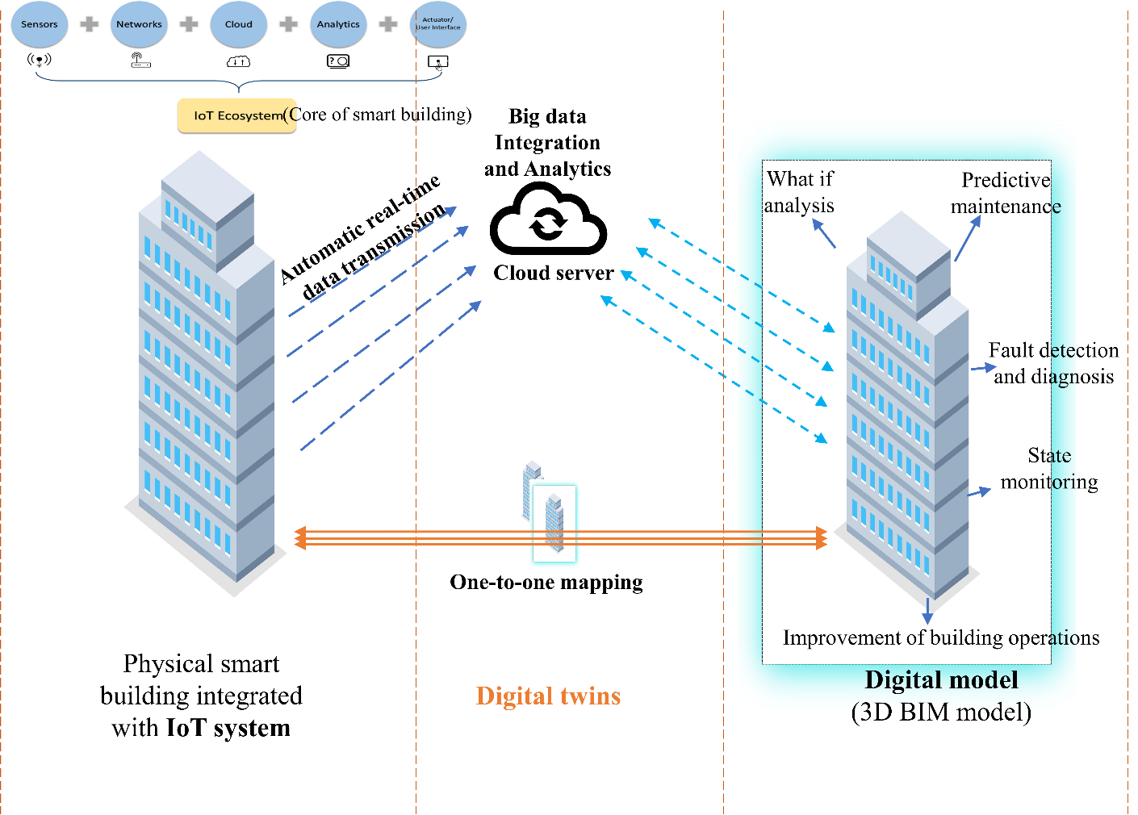
Fig. 1: Digital Twin for Smart building

2.1 Smart Building – The physical world
Smart buildings are digitally connected physical buildings capable of combing optimised and operational automation with intelligent space management to enhance user experience, increase productivity, reduce cost, and mitigate physical and cybersecurity risks (Froufe et al., 2020; Wellener et al., 2018; Zhao et al., 2022; Tan et al., 2022). Embedding buildings with IoT devices (Jia et al., 2019), a prerequisite for digital twins (Telfer, 2021), is the frontier in developing digital twins from smart buildings.
The difference between smart building and intelligence has been confusing because there is no agreement on the holistic approach. Some researchers use intelligent building and smart building to mean the same thing (Yang and Peng, 2001; Merabet et al., 2021), whilst others try to differentiate. In this study, both concepts are regarded same due to the common feature of IoT devices in both cases.
IoT, an open and comprehensive network of intelligent objects, auto-organises, shares information and resources, reacts, and acts in the face of situations and changing environments (Khajavi et al., 2019). IoT devices are necessary to interact with the physical world for data exchange (Jazdi, 2014), a vital feature of the smart building, such as the sensors sensing the conditions of the physical smart building, including its environments, and executing commands (Tao et al., 2019). Multiple sensors distributed and embedded in smart buildings obtain real-time data to measure the performance of buildings, examine user behaviour data, and determine environmental conditions such as high humidity, low temperature, etc. (Wang and Haghighi, 2016; Agostinelli et al., 2021; Tan et al., 2022).

2.2 The digital world
The Digital world constitutes the digital copy of the physical smart building to simulate and reflect the state and behaviour through modelling and analysis. The digital model serves as a communication and recording mechanism to help interpret the behaviours of smart buildings or users and to predict the future state of smart buildings, their environment, and users based on real-time data, historical data, experience, and knowledge, as well as data modelling (Hochhalter et al., 2014; Tao et al., 2019).
All kinds of data collected by the IoT sensors are transmitted to the digital world (see Figure 1), where processing is done with machine learning algorithms (Khajavi et al., 2019). The results are then fed back to the physical world to execute operations according to the control commands to adopt changes.

2.3 Linking between the physical and digital worlds
The linkage is an important dimension of digital twins that reflects a real-time change of the physical world to the digital world for data processing. This is achieved through effectively deploying the IoT sensors in the physical world (Jia et al., 2019) (See Figure 1). The data and control bus in the physical smart building provides support for real-time communication and data exchange (Tao et al., 2019).
Effective linkage needs to be ensured to produce a high-fidelity virtual model, which is necessary to realistically reproduce the physical smart building’s geometries, physical properties, behaviours, and rules (Tao et al., 2018). These models need to be highly consistent with the physical building in terms of geometry and structure and able to simulate their spatiotemporal status, behaviours, functions, and more (Schleich et al.,2017). The one-to-one mapping relationship between the physical smart building and the digital world of the digital twin assures effective linkage, creating a bi-directional relationship.
Given the brief backdrop in comprehending the concept of digital twins for smart buildings, there is not enough attention on reviewing the existing literature to identify the major opportunities. This study further identifies the major opportunities of digital twins for smart buildings adopting scientometric analysis and content analysis.

3 Research Methods
Figure 2 presents the workflow of the study. It includes the collection of publications, scientometric analysis using VOSviewer as science mapping, and content analysis.
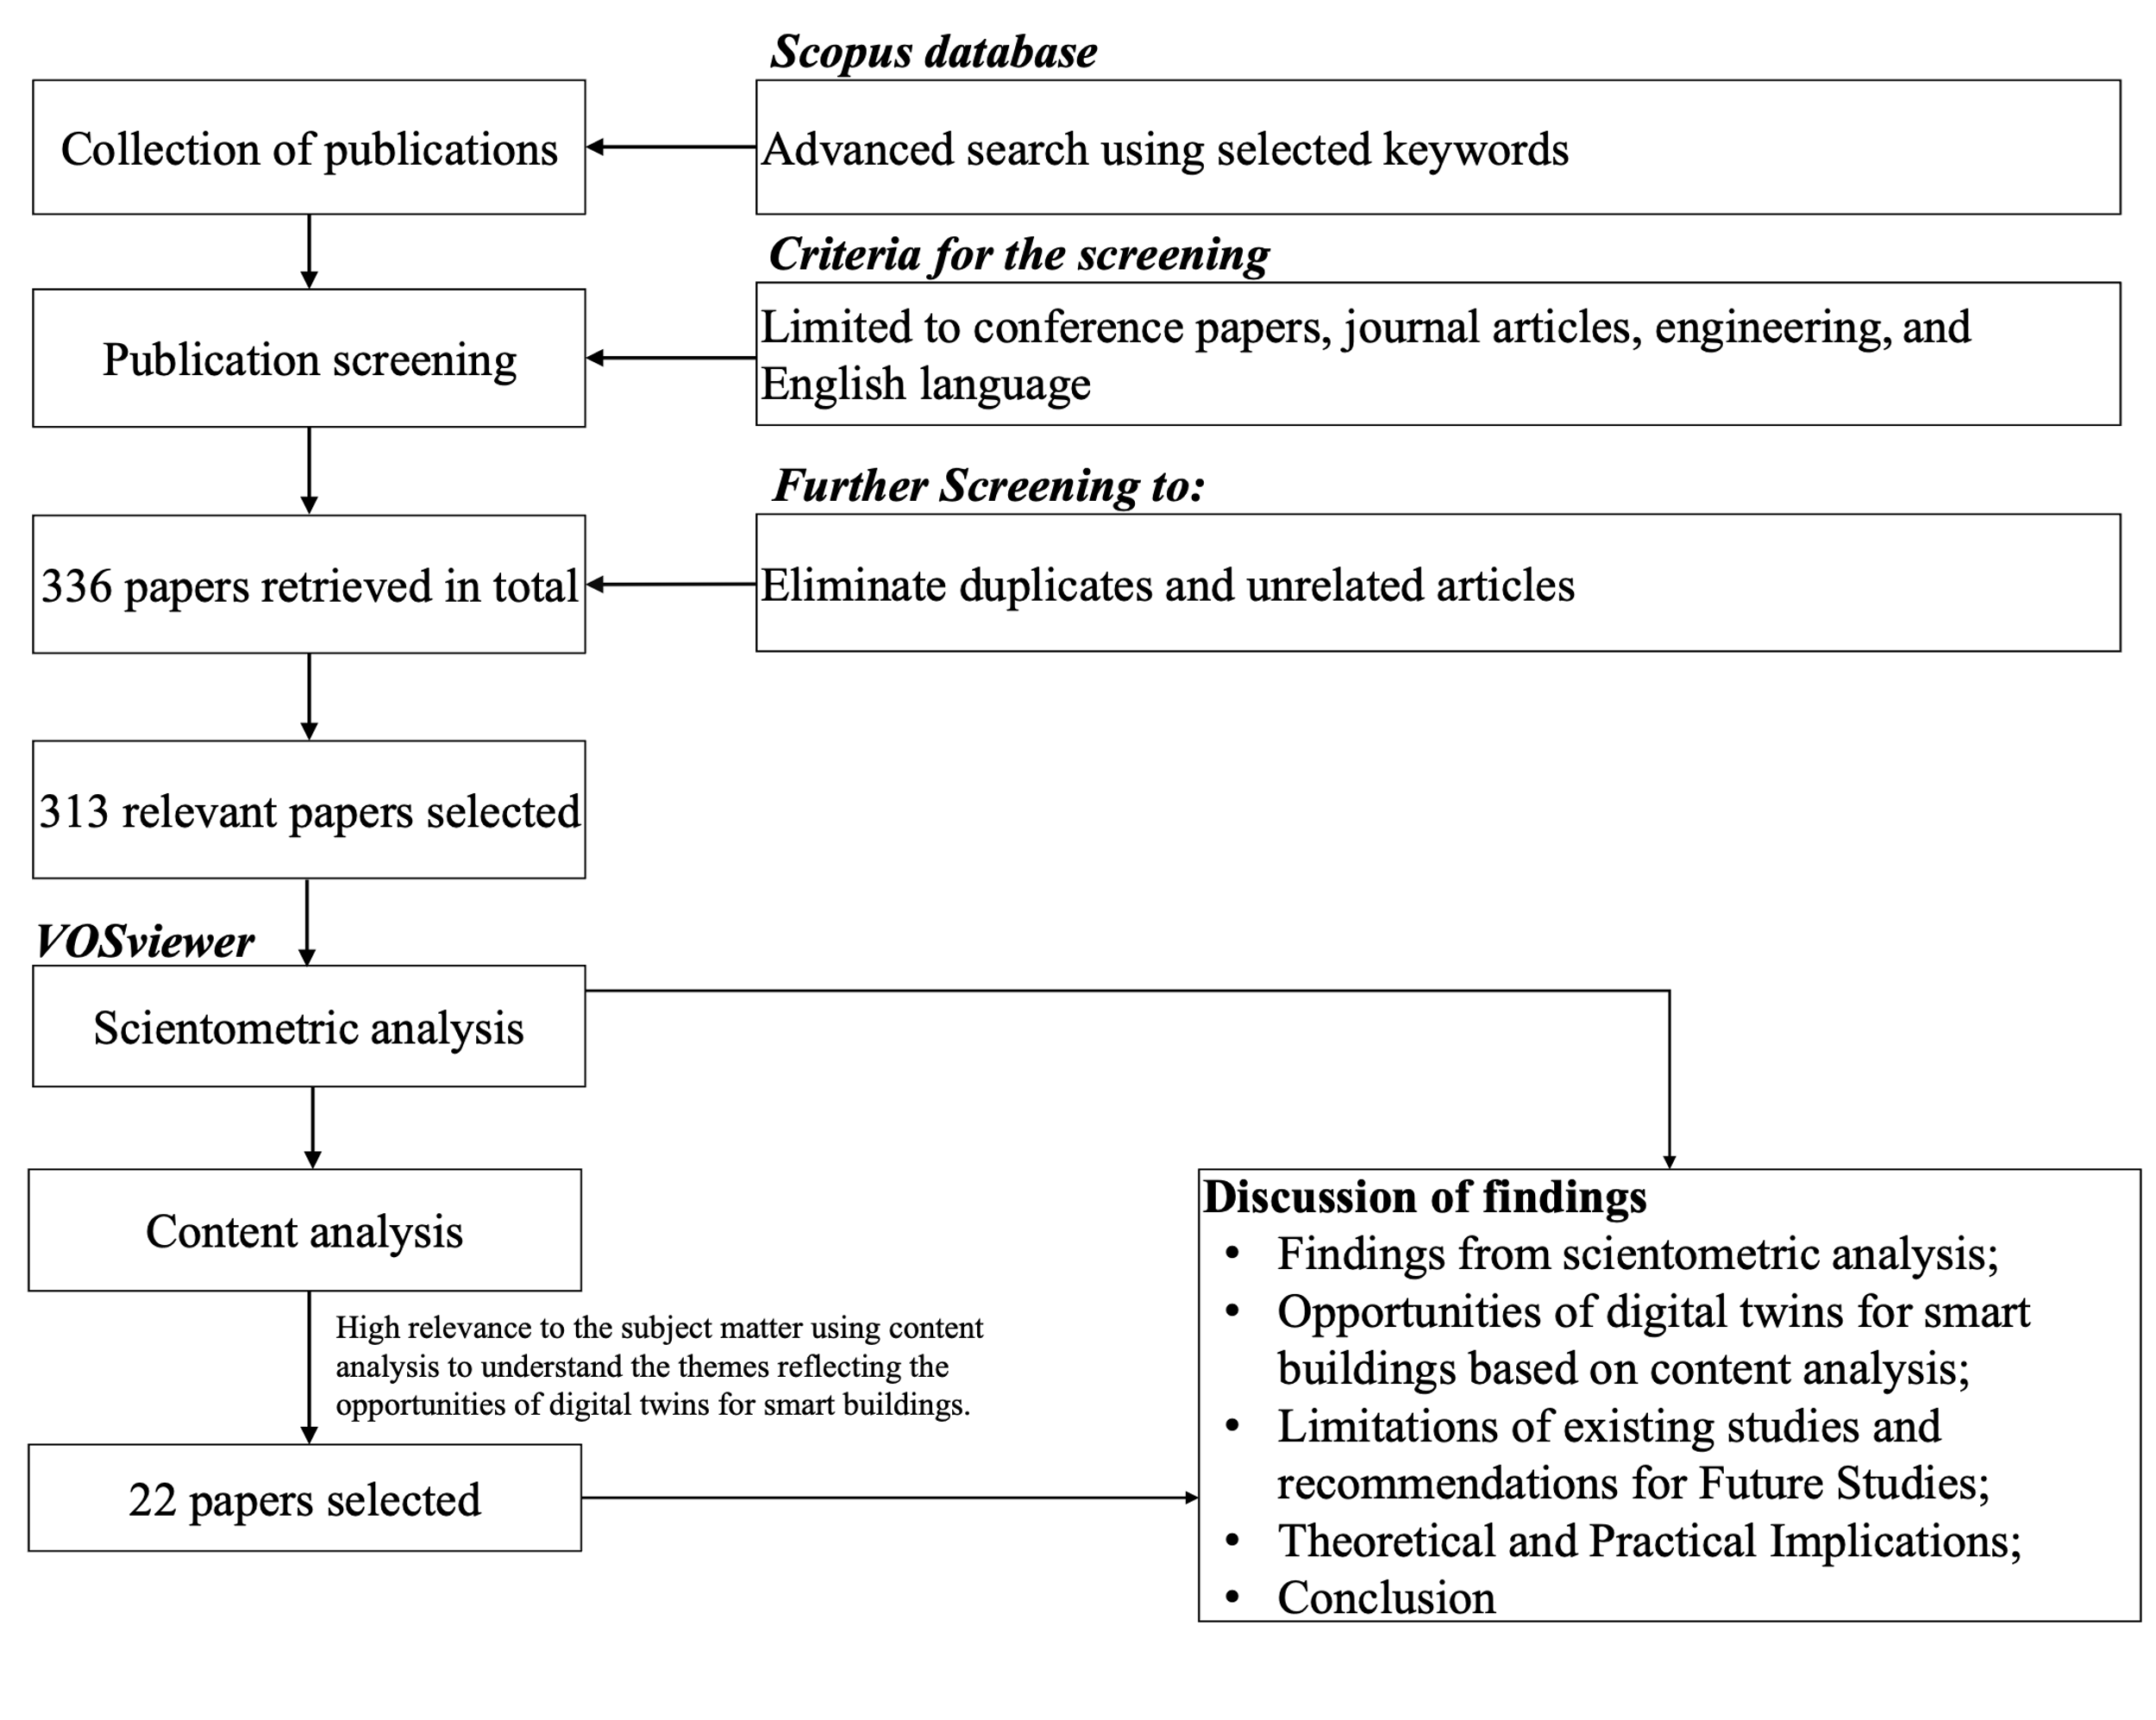
Figure 2: Workflow of the Study

3.1 Collection of Publications
Using the Scopus database, this study adopted a comprehensive approach to examining the research output of smart building and digital twins’ studies in the construction industry. Scopus database was selected because it has a wide range of academic publications with high accuracy and fast indexing processes compared to other databases such as the web of science, google scholar, and science direct (Zhao et al., 2019).
Under the title/abstract/keyword field of the Scopus search, keywords were inserted. The first section consisted of such as “digital twins” OR “digital replica” OR “digital twin” OR “virtual twin” OR “virtual counterpart”. The second part consisted of “construction engineering and management” OR “construction” OR “construction engineering” OR “construction management.” The third section included “smart building” OR “smart buildings” OR “cyber physical systems” OR “cyber-physical systems” OR “CPS”, whilst the last section involved “opportunities” OR “prospects” OR “possibilities”. The search was facilitated by the Boolean “OR” and “AND”. The search was limited to “journal articles and conference proceedings”, “English language”, and “engineering”. The study retrieved 336 publications from Scopus after the initial search. Filtering techniques were conducted to remove irrelevant articles by examining the articles based on the document title, abstract, keywords, introduction, methodology, and conclusion. The study also employed the “inclusion and exclusion” criteria (Akomea-Frimpong et al., 2022). Consequently, 313 publications were regarded as relevant, and their detailed information was considered for scientometric analysis.

4. Scientometric Analysis
The scientometric analysis was conducted based on the keyword co-occurrence analysis feature of VOSviewer software due to its capacity to execute science mapping and answer the key question concerning domain knowledge (Chen, 2018). Keyword co-occurrence analysis was conducted to offer an understanding of the existing research interest, providing the opportunity to unearth the hotspot and main research directions in any field and the interconnection between them (Cui and Zhang, 2018), as well as representing the core content of published documents and a good picture of the range of areas researched in the domain (van Eck and Waltman, 2019).
Keyword co-occurrence analysis constructs and maps the themes related to digital twin applications for smart buildings by considering “all keywords” surrounding the 313 publications (van Eck and Waltman, 2019). Labels and circles were used to represent the items on the network. The weight of an item determines its size. The item label is directly proportional to the number of publications in which the keywords were found. The distance between two keywords shows the relatedness of their co-occurrence link. The number of times keywords appear together in a document is referred to as co-occurrence, whereas the strength of the co-occurrence link is measured by the number of publications in which two terms appear together (van Eck and Waltman, 2019).
To get a reproducible representative network, the index keywords were used as the unit of analysis. The minimum number of keyword occurrences was set at 0, and 348 keywords met the required thresholds. Generic and irrelevant terms such as construction, survey, articles, human, etc., were omitted. Consequently, 56 themes reflecting the opportunities of digital twins for smart buildings were considered and further analysed. Table 1 shows the extracts of the top 19 themes with high link strength (≥4) from the analysis, while Figure 3 illustrates the network of keyword co-occurrence analysis. With the clustering technique in VOSviewer, the keywords were grouped into 16 clusters based on the different domains of digital twin application opportunities for smart buildings, as illustrated in Figure 3 with different colours.
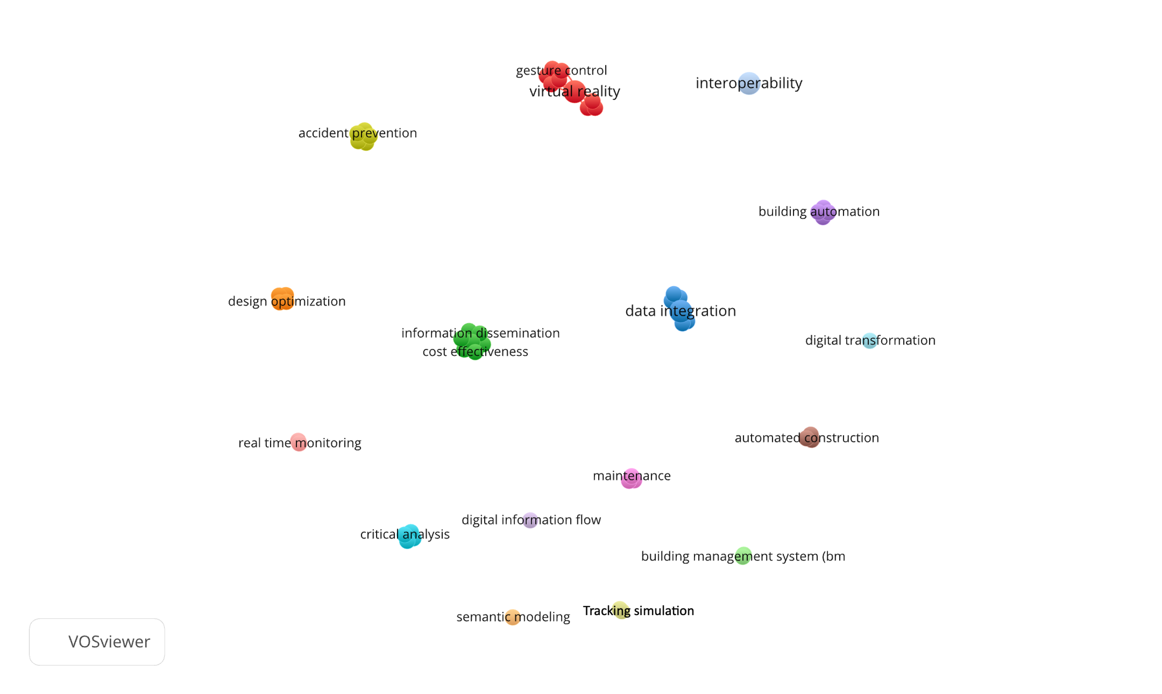
Figure 3: Keyword co-occurrence analysis

Table 1: Top 19 active keywords and their total link strengths regarding digital twin
ID | Theme | Link Strength | Occurrences | Avg. pub. Year | Avg. citations | Avg. norm. citations
1 | Virtual reality | 8 | 2 | 2019.5 | 9.5 | 2.4
2 | Cost-effectiveness | 6 | 1 | 2021 | 14 | 1.0667
3 | Information analysis | 6 | 1 | 2021 | 14 | 1.0667
4 | Information communication | 6 | 1 | 2021 | 14 | 1.0667
5 | Information dissemination | 6 | 1 | 2021 | 14 | 1.0667
6 | Information Sharing | 6 | 1 | 2021 | 14 | 1.0667
7 | Innovative solutions | 6 | 1 | 2021 | 14 | 1.0667
8 | Transparency | 6 | 1 | 2021 | 14 | 1.0667
9 | Data integration | 5 | 2 | 2020 | 6 | 0.4613
10 | Gesture control | 5 | 1 | 2017 | 18 | 1.8
11 | Human-robot collaboration | 5 | 1 | 2017 | 18 | 1.8
12 | Minimal energy | 5 | 1 | 2017 | 18 | 1.8
13 | Modularizations | 5 | 1 | 2017 | 18 | 1.8
14 | Simultaneous control | 5 | 1 | 2017 | 18 | 1.8
15 | Accident prevention | 4 | 1 | 2021 | 14 | 1.0667
16 | Human-computer interaction | 4 | 1 | 2021 | 14 | 1.0667
17 | Life-cycle management | 4 | 1 | 2021 | 14 | 1.0667
18 | Performance monitoring | 4 | 1 | 2021 | 14 | 1.0667
19 | Real-time control | 4 | 1 | 2021 | 14 | 1.0667
*For the remaining 37 themes, see Appendix A1

3.3 Content Analysis
Finally, 22 relevant articles (see table 2) were selected and reviewed rigorously based on their high relevance to the subject matter using content analysis to understand the themes reflecting the opportunities of digital twins for smart buildings. In doing so, the 56 themes were filtered further to map the literature source and avoid detailed repetition of concepts. The content analysis aided in understanding, examining, and analysing the themes/important concepts, being aware of prior studies, identifying omissions/gaps, and identifying the opportunities of digital twins for smart buildings. Consequently, the 22 articles were identified as producing 24 themes reflecting the opportunities/prospects of digital twins for smart buildings, as shown in Table 2.

4 Discussion of Findings
4.1 Discussion of Findings from Scientometric Analysis
From Table 1, the recentness of the keywords in digital twin applications for smart building in the construction industry is depicted through the average year published. Most recent terms such as “physical modelling”, “real-time information”, “virtual representations”, and “digital transformation” did not feature in Table 1 due to their low link strength. However, keywords such as “virtual reality”, “cost-effectiveness”, “information analysis”, “information communication”, and “information dissemination”, among others, have been studied comparatively. Also, the averaged normalised citation shows the influence of the various keywords on the digital twin application in the construction industry. Also, the keywords have shown a degree of influence and importance in advancing digital twins research in the construction industry.
Again, some keywords/themes related to digital twins have received special attention, i.e., they have high occurrence and link strength, while areas for practical implementation for the digital twin concept have been under-researched. For instance, from Table 1, virtual reality has received the most attention with the highest link strength, followed by cost-effectiveness, information analysis, information dissemination, information sharing, inoovative solution, and transparency. These themes reflect the propects of digital twins for smart buildings (Bevilacqua et al., 2020; Shirowzhan et al., 2020). However, some themes reflecting the significant application of digital twins for smart buildings are found with low link strength, and these include design optimisation, real-time information, real-time connection, systems thinking, remote control, real-time monitoring, and tracking simulations (Akanmu et al., 2020; Zhao et al., 2021; Celik et al., 2021). Overall, this study reveals all the themes (Appendix A1) as reflecting the prospects of digital twins in smart buildings, regardless of the link strength, occurrences, average publication year, average citation, and average normalised citation. To enhance the application of digital twin concepts to the field of AECO, a deliberate effort is required to consider critical aspects such as information analysis, transparency, safety, and human–computer interactions (Akanmu et al., 2020; Agnusdei et al., 2021). Scholarly works must be translated into practice to prevent businesses from losing interest in innovative concepts (Kirchherr and van Santen, 2019). However, to understand the major themes reflecting the opportunities of digital twins for smart buildings, content analysis is deployed to understand the detailed applications.

4.2 Opportunities of Digital Twins for Smart buildings
From the content analysis, in link with the scientometric results, 24 opportunities/prospects could be proposed for digital twins for smart building, as shown in Table 2. By applying thematic analysis, the 24 opportunities can be categorised into four major opportunities: efficient building performance (smart “building” environment), efficient building process (smart construction site environment), information efficiency, and effective user interactions. These are further discussed.

Table 2: Opportunities of digital twins for smart buildings
No | Categories | Opportunities/prospects | References
1 | Efficient building performance – smart “building” environment | Accident prevention | Bevilacqua et al. (2020)
 |  | Building management system | Zhao et al. (2021)
 |  | Building maintenance and performance monitoring throughout the building’s life-cycle | Lu et al. (2020a); Zhao et al. (2021); Akanmu et al. (2020); Zhao et al. (2022)
 |  | Real-time monitoring, control, and minimisation of energy consumption | Akanmu et al. (2020)
 |  | Real-time connection and information for risk assessment in buildings | Bevilacqua et al. (2020); Kaewunruen et al. (2021)
 |  | Remote control of the building to ensure security | Celik et al. (2021)
 |  | Systems thinking for aiding sustainable decision makings | Zhao et al. (2021)
 |  | Virtual reality and simultaneous control of buildings | Shirowzhan et al. (2020)
2 | Efficient building process – smart construction site environment | Automated construction | Schimanski et al. (2019); Correa (2020)
 |  | Building information modelling for design and operation optimisation | Sepasgozar et al. (2020)
 |  | Cost-effectiveness through efficient construction | Hlady et al. (2018)
 |  | Innovative solutions for the modularisation of building elements | Wang et al. (2021); Wei et al. (2022)
 |  | Smart construction to ensure operators’ safety | Schimanski et al. (2019); Bevilacqua et al. (2020); Correa (2020)
 |  | Tracking strategies and improving speed and accuracy | Ghosh et al. (2020); Akanmu et al. (2020); Zhao et al. (2022)
3 | Information efficiency | Improving planning and designing to aid physical modelling | Akanmu et al. (2020)
 |  | Rapid transformations to aid critical analysis of building processes | Lu et al. (2020a)
 |  | Aids effective data/information integration to allow critical information analysis | Lu et al. (2020a,b)
 |  | Monitors digital information flow and transformation to aid communication and decision-making | Lu et al. (2020b)
 |  | Real-time monitoring of information retrieval and dissemination/sharing | Akanmu et al. (2020)
 |  | Ensure real-time interoperability to develop efficient virtual representations | El Saddik et al. (2019); Zhao et al. (2022)
 |  | Real-time tracking of simulations and semantic modelling | Austin et al. (2020); Petrova-Antonova and Ilieva (2020)
4 | Effective user interactions | Gesture control | Gámez Díaz et al. (2020)
 |  | Human-computer interaction | Bevilacqua et al. (2020); Akanmu et al. (2020); Agnusdei et al. (2021); Choi et al. (2022)
 |  | Human-machine collaboration | Agnusdei et al. (2021); Choi et al. (2022)

4.2.1 Efficient Building Performance – Smart “Building” Environment
The smart building in this section refers to the complete building ready to be used. The digital twins’ concept facilitates building improvements by ensuring efficiency and adequacy in the building management system (Zhao et al., 2021). The digital twin assists in real-time monitoring of building performance and generates data for facility and building managers to assess buildings and perform maintenance (Akanmu et al., 2020; Lu et al., 2020a). This could generate data easily and seamlessly from human-unreachable parts of buildings. For instance, a critical area of building performance to consider in integrating digital twins is energy consumption, which has become an ongoing issue among facility managers. The digital twin can monitor energy usage in real-time to help control and minimise consumption. This involves the element of system thinking that can help to facilitate the decision makings regarding energy usage in buildings using digital twins (Zhao et al., 2021). As such, the digital twin plays a key role in helping smart buildings to overcome urgent sustainability challenges such as effective space management, dealing with climate change, and ensuring higher quality of life in buildings regarding energy consumption (Brink, 2021).
Also, the opportunity of digital twins in smart buildings regards the real-time monitoring to prevent accidents by assessing risks in smart buildings via simulations and remote control (Shirowzhan et al., 2020; Celik et al., 2021). This is achieved via the advancement of building intelligence, concerned with plugged-in devices as well as building instrumentation devices, including sensors, actuators, and controllers, capable of enabling efficient building automation while ensuring the comfort of building users (Lazarova-Molnar et al. 2015; Billanes et al. 2017), as shown in Figure 4. This also enables the display of virtual reality and simultaneous control of buildings to improve performance. For details in Figure 4, refer to Clausen et al. (2021).
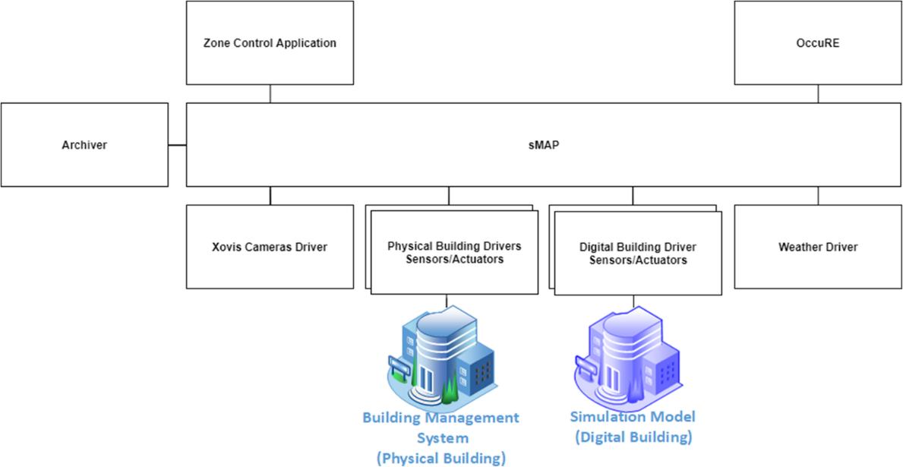
Figure 4: Digital twin framework for smart building (Clausen et al., 2021)

Moreover, digital twin application in smart building replaces conventional risk management with real-time AI-enabled data analytics and image analysis to draw deep insight into identifying hazards, evaluating risks and determining appropriate controls (Bevilacqua et al., 2020; Peake, 2021; Kaewunruen et al., 2021). By creating the digital model of smart building systems, networks, and HVACs, the digital twin creates a clearer picture to predict and monitor the building and its environs. Training machine learning models to analyse unstructured risk assessment reports and bringing together vast data sources to create real-time digital twins is an effective measure to identify and mitigate risks in smart buildings. Thus, it would be imperative to effectively utilise digital twins in risk assessments in smart buildings to inform decision-making concerning operations and management.

4.2.2 Efficient Building Process –Smart Construction Site Environment
A smart building can also be referred to as the smart environment of a construction site with the enabling plugged-in devices as well as building instrumentation devices, including sensors, actuators, and controllers, capable of enabling efficient construction automation while ensuring the comfort of workers on site (Lazarova-Molnar et al. 2015; Billanes et al. 2017). Digital twins in this domain can ensure workers’ safety via smart construction, where virtual simulation of the construction site can be used to understand the working conditions at specific locations. For instance, the digital twin can help facilitate giving effective directions to operators on-site during work execution, and this will assure their safety by creating a virtual environment that understands the working conditions at specific locations (Bevilacqua et al., 2020; Correa, 2020).
The digital twin could also help initiate innovative solutions for modularising building elements on construction sites, especially for modular construction projects (Wang et al., 2021; Wei et al., 2022). The real-time capability of digital twins and the associated virtual world can provide many alternatives to ensure building elements are fixed appropriately via effective monitoring using the virtual mean. It also can track adopted strategies on-site in real-time and improve speed and accuracy (Ghosh et al., 2020). The digital twin also helps optimise the building designs used on construction sites and operations toward the execution of building projects.
The construction phase of buildings is essential as it brings into being the physical smart building. As such, the digital twin has potential application at this phase by applying it to assess the structural system analysis integrity (Angjeliu et al., 2020). Other potential applications include resource management, schedule management, quality management, sequence management, etc., on construction sites (Opoku et al., 2021). Various technologies are also deployed in creating digital twins at this phase, including GPS, cameras, laser scanners, etc. (Liu et al., 2021).

4.2.3 Information Efficiency
One vital aspect of digital twins for smart buildings is the ability to provide efficient information in real-time, regardless of whether it is a smart “building” or a smart construction site. This may occur throughout the smart building’s life cycle. Digital twin monitors real-time digital information flow and transformation to aid communication and decision-making based on critical information analysis (Lu et al., 2020a,b). Due to the smartness of facilities, the digital twin monitors the information inflow with intelligence to ensure that the right information is disseminated to the right location in a building system. In smart buildings, digital twin ensures real-time interoperability to develop efficient virtual representations and improve planning and designing to aid physical modelling (Akanmu et al., 2020; El Saddik et al., 2019; Zhao et al., 2022).
Digital twin facilitates the predictability of situations/events in buildings or on-site based on the effective real-time tracking of simulations and semantic modelling (Austin et al., 2020; Petrova-Antonova and Ilieva, 2020). This aids in decision-making for smart building management based on reasoning. The transferred real-time data/information is processed and diagnosed with artificial intelligence and other machine learning models or data analytics. This draws deep insight into the existing big data in smart buildings to inform decisions concerning building system operations, building status, user status, environmental conditions, etc.

4.2.4 Effective User Interactions
User interaction is very important in smart buildings, which can be improved with digital twins. This can be applied in smart “buildings” and on construction sites focusing on the issue of communication, interaction, and cooperation. In smart “buildings”, digital twins can help monitor and understand the users’ real-time interaction and interactions with the building (Bevilacqua et al., 2020; Akanmu et al., 2020). This can be extended to energy consumption and intelligent use of electrical appliances such as air conditioners, heating, and cooling systems. The digital twin has the potential to effectively assess how users collaborate with smart building technologies and note all interactive issues via the virtual counterpart of smart buildings. These are further addressed to improve the user/human-machine interactions in buildings.
On smart construction sites, human-machine/robot collaboration is very important. Digital technologies can monitor construction sites in real-time effectively and report incoming collisions between robots/machines and workers on sites. This can be achieved by having a virtual real-time 3D BIM design of a construction site (Sepasgozar et al., 2020). Digital twins can offer a crucial analytic edge by gathering data from various sources on construction sites. Construction teams can then gain live insight into every recorded component/equipment/machine when physical assets are updated automatically and reveal real-time status, working conditions, and position of the physical assets on the construction site. With this, collaboration/interaction between machines and workers can be improved to enhance project execution during the construction phase of buildings (Agnusdei et al., 2021; Choi et al., 2022).

5. Limitations and Future Studies
Despite the opportunities created by the digital twin for smart buildings reported by the existing studies, limitations exist. This section, therefore, discusses the limitations of the existing studies concerning the methodology adopted and the domain of study and makes recommendations for future research directions.

5.1 Methodology adopted
Among the prior studies that have been conducted on digital twins for smart buildings, the methodologies adopted have limitations shown, as shown in Table 3. Most studies have adopted the case study, followed by the conceptual analysis. However, the case study is limited by its inefficiencies due to the generalisation issues, lack of scientific rigour, and difficulty replicating the results. The conceptual analysis, which the previous studies have also adopted, is also limited by a lack of rigour and empirical investigations and is subjected to increasing error and subjectivity. Among the previous studies, a limited number of experiments and surveys have also been adopted. This study, therefore, admonishes future studies to investigate the digital twins for smart buildings and reports on the significant opportunities by adopting a robust methodology that will minimise the degree of anticipated errors and increase its replicability to other scenarios and locations.

Table 3: Nature of methodologies adopted and their limitations.
Method | Author | Limitation
Conceptual analysis | Zhao et al. (2021); Bevilacqua et al. (2020); Akanmu et al. (2021); Correa (2020); Zhao et al. (2022); Lu et al. (2020a); El Saddik et al. (2019); Petrova-Antonova and Ilieva (2020); Agnusdei et al. (2021) | - Cannot create new concepts but only validates the existing ones;  - Requires long time and persistence to investigate and validate;  - Subject to increase error and subjectivity;  - Lack of empirical investigation to clarify concept;  - Lack of rigour  - Etc.
Experiment | Ghosh et al. (2020); Choi et al. (2022) | - Highly subjective;  - Situations may not be realistic;  - Time-consuming;  - Ethical issues or practical issues with variable control;  - Etc.
Case study | Schimanski et al. (2019); Celik et al. (2021); Shirowzhan et al. (2020); Sepasgozar et al. (2020); Kaewunruen et al. (2021); Hlady et al. (2018); Wang et al. (2021); Wei et al. (2022); Lu et al. (2020b); Austin et al. (2020), Akanmu et al. (2020) | - Lack of scientific rigour;  - Little basis for result generalisation;  - Researcher’s subjectivity may influence result;  - Difficult to replicate;  - Time-consuming and expensive;  - Etc.
Survey | Gámez Díaz et al. (2020) | - Not ideal for controversial issues;  - Possible inappropriateness of questions;  - Inflexible design;  - Etc.

5.2 The domain area
The proposed research domain and the future directions are based on examining the future works proposed by previous studies, their omissions, and the untapped potentials of digital twins for smart buildings based on the lessons from other industries that have advanced ahead of AECO. These have been discussed to recommend future research directions following the framework in Figure 5.

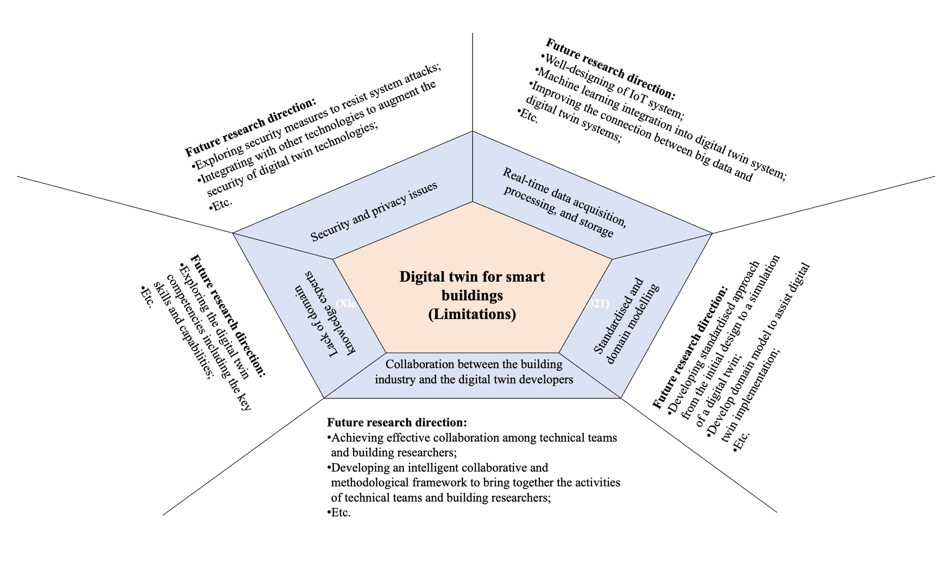
Figure 5: Research direction framework

(A) Real-time Data Acquisition, Processing, and Storage
Prior studies only consider attaining a data warehouse, which is inadequate if efficient digital twin is to be developed for smart buildings. However, in implementing digital twins, it is imperative to go beyond establishing only a data warehouse to a complete system that considers real-time data extraction, storage, and analysis. As such, the following limitations need to be considered:
IoT systems face the most challenge with the real data collection process (Aheleroff et al., 2021). IoT systems simultaneously collect meaningful real-time data from various data types within smart buildings, including occupant behaviours, indoor or outdoor environments, and the building structure. To ensure data is not duplicated, processing requires steps such as data cleaning and consistency after real-time data is transferred to the repository (Qi et al., 2021). Future research is encouraged to design the IoT system for the digital twin needs and collect real-time data for different purposes in smart buildings avoiding data duplication.
Formatting is positioned as a challenge after the data collection, as data exist in a different format, making it onerous to integrate into the digital twin’s data platform (Niederer et al., 2021). For instance, real-time data on the relationship between building users and appliance usage may be collected from humans containing images and voices and from appliances containing textual content (Rashid et al., 2019). Xie et al. (2011) also consistently discovered difficulty in real-time formatting data to solve building issues directly in steel construction due to different formats. Hence, a study is encouraged to design a digital twin system to efficiently and effectively re-format the data in real-time. For instance, a possible solution, such as machine learning algorithms, could be engaged in this process.
Due to the massive collection of real-time data, it is vital to optimise the digital twin’s storage architecture to guarantee protected real-time data from hazardous actions and ease recovery from back-ups and availability (Xie et al., 2011). A big data platform has been developed to support the requirements using distributed storage and processing systems. However, a big data connection to digital twins for smart buildings needs to be improved to achieve real-time data availability and updation; hence, future research is encouraged in this area.
IoT system deals with multiple tasks rather than just a single task with all related objects connected (Sacks et al., 2020). According to Alizadehsalehi and Yitmen (2021), digital twin technology needs to identify the stakeholders’ objectives to leverage real-time and historical data. However, a schema for data allocation is necessary to reduce the massive amount of information at the user end (Curry et al., 2013). Therefore, a study is required to bridge the gap between technical and application terminuses by engaging the combined effort of experts who develop the system and who have domain-specific knowledge.

(B) Security and Privacy Issues
Another limitation of the existing studies relates to the digital twins’ security and privacy risk, which arises due to the exponential growth of connected devices in smart buildings. The traditional network of IoT systems covers many heterogeneous entities, services, and networks that make it challenging to apply existing security systems directly (Jia et al., 2019). Li et al. (2020) discovered digital twins’ vulnerability lying with its IoT systems in different parts, including web interfaces, backend systems, network services, physical hardware, and software.
An insecure system may create concerns that prevent people from adopting the technology (Jia et al., 2019). For instance, using cameras as IoT systems for digital twins for smart buildings to monitor safety and workers’ activities may be uncomfortable for some people. Systems such as GPS reveal people’s whereabouts and routes, which may not be comfortable. It may also interfere with privacy issues, including energy usage.
For security and privacy issues, technologies, including the blockchain (Li et al., 2022) and others, can be integrated into the digital twin to detect third-party interference in personal data. This allows one party to access the necessary data under their exclusive control. The key enabling technologies of digital twins must follow the current practices and updates in security and privacy regulations. Research is required in all directions to augment the security of digital twin technology for smart buildings.

(C) Collaboration between the Building Industry and the Digital Twin Developers
Though electrical and computer engineering researchers are devoted to assembling and calibrating hardware and designing software, digital twin technology cannot realise its maximum value if it is not adequately applied in the building industry. This has been a limitation inferred from the prior studies. A collaboration between the technical team and the building researchers is needed to further the digital twin application for smart buildings (Sacks et al., 2020). Jia et al. (2019) asserted that building researchers have a better and deeper understanding of digital twin applications’ potential demands and requirements and their corresponding challenges. Effective collaboration can enable the digital twin developers to revise and optimise the system pointedly, whilst the building researchers’ study focuses on how to augment the use of digital twin to achieve parallel progress.
The expertise from the technical and application sides is equally important, and only an integrated collaboration can reap the benefits of a digital twin for smart building. Research on developing an intelligent collaborative and methodological framework is required to effectively bring together the activities of both the technical and building researchers to support the digital twin for smart buildings.

(D) Standardised and Domain Modelling
An additional limitation of the existing studies is the lack of a standardised modelling approach, a challenge within digital twin technology development with modelling smart building systems (Wanasinghe et al., 2020). A standardised approach is needed from the initial design to a digital twin simulation, whether physic-based or design-based. The standardised approaches ensure domain and user understanding while guaranteeing information flow between each stage of developing and implementing digital twins for smart buildings (Wagner et al., 2019).
The lack of domain modelling is also a challenge (Fuller et al., 2020) because of the need for standardised use. This is related to ensuring information about the main use is transferred to each development and functional stage of the digital twin modelling. This ensures compatibility with IoT and data analytics domains, allowing for the successful use of the digital twin for smart buildings. Thereby, studies are encouraged to investigate developing a standardised and domain modelling approach to assist digital twin implementation for smart buildings.

(E) Skilled Workforce
A skilled workforce is required to enable the interoperability, integration and linking of real-time data and models across all the systems in a smart building. The lack of domain knowledge experts challenges digital twin implementation (Broo and Schooling, 2021), especially in AECO. According to Plummer (2021), huge initial investments are required for installation and high maintenance expenditures due to the lack of experts. Hence, research is encouraged to explore the digital twin competencies consisting of the key skills and capabilities to drive the digital twin intervention and its implementation in smart buildings.

6. Theoretical and Practical Implications
Considering the emergence of digital twins, this is one of the few review studies that has focused on the opportunity of digital twins for smart buildings. Theoretically, the study makes a significant contribution to the body of knowledge by presenting the comprehensive outlook of the digital twin for smart building in the field of AECO by revealing the major opportunities. The study, therefore, contributes to the ongoing discourse on the digital twin application in the AECO industry. The study also concluded by identifying some limitations of the existing studies that call for further research in this domain.
Practically, the findings of this study may be used as a guideline for the practical adoption and implementation of a digital twin for smart buildings depending on specific purpose requirements, as well as informing policymaking. For instance, planning and strategising the digital twin systems to follow current practices and “security and privacy” regulations updates. This helps to inform policy makings and decisions on protecting personal user information when implementing digital twins for smart buildings, which will help advance the practice of digital twins. Also, the study suggests integrating digital twins into the information of the smart building services phase to facilitate better risk assessment, asset management, and communication through data visualisation.

7. Conclusion
Although research on digital twins for smart buildings has been active, an up-to-date intellectual environment for understanding the opportunities of digital twins for smart buildings is still lacking. This study provides an up-to-date comprehensive literature review to identify the major opportunities of digital twins for smart building through scientometric analysis and content analysis.
The study revealed 56 themes reflecting the opportunities of digital twins for smart buildings, with only 19 having a link strength ≥4 from the scientometric analysis. However, the top eight themes/keywords with the highest link strength >5 include “virtual reality”, “cost-effectiveness”, “information analysis”, “information communication”, “information dissemination”, “information sharing”, “innovative solutions”, and “transparency”. The content analysis, coupled with the result of the scientometric analysis, revealed 24 opportunities that were further categorised into four major opportunities: efficient building performance–smart “building” environment, efficient building process–smart construction site environment, information efficiency, and effective user interactions. These were evidently discussed to make a claim.
Limitations of the existing studies were divulged and discussed to make recommendations for future research in the methodology adopted and the research domain. Five research domains were considered for future research: “real-time data acquisition, processing, and storage”, “security and privacy issues”, “standardised and domain modelling”, “collaboration between the building industry and the digital twin developers”, and “skilled workforce to enable a seamless transition from theory to practice”. A research direction framework was finally proposed to help address the identified limitations of existing studies and envision the ideal state of a digital twin for smart building. All stakeholders, including practitioners, policymakers, and researchers in the field of AECO, may benefit from the findings of this study by gaining an in-depth understanding of the opportunities of digital twins and implementation in smart buildings in the AECO industry. The major opportunities discovered may not be the exact extent of digital twin opportunities in smart buildings, as the digital twin concept is emerging and maturing in the AECO industry from time to time. Hence, future researchers are encouraged to adopt other rigorous approaches to uncover new opportunities.
Despite the contributions of this study, some limitations need to be acknowledged. The scope of the study was limited to publications from the Scopus database published in English. Other scholars may argue for a more thorough review by extending the search to other databases, such as Web of Science, PubMed, JSTOR, ScienceDirect, IEEE Xplore, Academic Search Complete, etc. Nonetheless, the pattern of the findings should remain the same.

References
Agnusdei, G.P., Elia, V. and Gnoni, M.G. (2021). A classification proposal of digital twin applications in the safety domain. Computers & Industrial Engineering, 154, p.107137. https://doi.org/10.1016/j.cie.2021.107137.
Agostinelli, S., Cumo, F., Guidi, G. and Tomazzoli, C. (2021). Cyber-physical systems improving building energy management: Digital twin and artificial intelligence. Energies, 14(8), p.2338. https://doi.org/10.3390/en14082338.
Aheleroff, S., Xu, X., Zhong, R.Y. and Lu, Y. (2021). Digital twin as a service (DTaaS) in industry 4.0: an architecture reference model. Advanced Engineering Informatics, 47, p.101225. https://doi.org/10.1016/j.aei.2020.101225.
Akanmu, A.A., Anumba, C.J. and Ogunseiju, O.O. (2021). Towards next-generation cyber-physical systems and digital twins for construction. Journal of Information Technology in Construction., 26, pp.505-525. https://doi.org/10.36680/j.itcon.2021.027.
Akomea-Frimpong, I., Kukah, A.S., Jin, X., Osei-Kyei, R. and Pariafsai, F. (2022). Green finance for green buildings: A systematic review and conceptual foundation. Journal of Cleaner Production, p.131869. https://doi.org/10.1016/j.jclepro.2022.131869.
Alibrandi, U. (2022). Risk-informed digital twin of buildings and infrastructures for sustainable and resilient urban communities. ASCE-ASME Journal of Risk and Uncertainty in Engineering Systems, Part A: Civil Engineering, 8(3), p.04022032. https://doi.org/10.1061/AJRUA6.0001238.
Alizadehsalehi, S. and Yitmen, I. (2021). Digital twin-based progress monitoring management model through reality capture to extended reality technologies, Smart and Sustainable Built Environment, Vol. ahead-of-print No. ahead-of-print. https://doi.org/10.1108/SASBE-01-2021-0016.
Amorocho, J. A. P. and Hartmann, T. (2021). Reno-Inst: An Ontology to Support Renovation Projects Planning and Renovation Products Installation, Advanced Engineering Informatics, 50, 101415. https://doi.org/10.1016/j.aei.2021.101415.
Angjeliu, G., Coronelli, D. and Cardani, G. (2020). Development of the simulation model for Digital Twin applications in historical masonry buildings: The integration between numerical and experimental reality. Computers and Structures, 238, p.106282. https://doi.org/10.1016/j.compstruc.2020.106282.
Austin, M., Delgoshaei, P., Coelho, M. and Heidarinejad, M., (2020). Architecting smart city digital twins: Combined semantic model and machine learning approach. Journal of Management in Engineering, 36(4), p.04020026. https://doi.org/10.1061/(ASCE)ME.1943-5479.0000774.
Bevilacqua, M., Bottani, E., Ciarapica, F.E., Costantino, F., Di Donato, L., Ferraro, A., Mazzuto, G., Monteriù, A., Nardini, G., Ortenzi, M. and Paroncini, M. (2020). Digital twin reference model development to prevent operators’ risk in process plants. Sustainability, 12(3), p.1088. https://doi.org/10.3390/su12031088.
Billanes JD, Ma Z, Jørgensen, B. N. (2017). Consumer Central Energy Flexibility in Office Buildings. Journal of Energy and Power Engineering, p.11. https://doi.org/10.17265/1934-8975/2017.10.001.
Boje, C., Guerriero, A., Kubicki, S. and Rezgui, Y., (2020). Towards a semantic construction digital twin: directions for future research. Automation in construction, 114, p.103179. https://doi.org/10.1016/j.autcon.2020.103179.
Brilakis, I., Pan, Y., Borrmann, A., Mayer, H., Rhein, F., Vos, C., Pettinato, E. and Wagner, S. (2019). Built Environment Digital Twinning, https://publications.cms.bgu.tum.de/reports/2020_Brilakis_BuiltEnvDT.pdf, Accessed: 09/01/2022.
Brink, B. (2021). Overcoming sustainability challenges with digital twins, https://global.royalhaskoningdhv.com/digital/resources/blogs/overcoming-sustainability-challenges-with-digital-twins, Accessed:18/12/2021.
Broo, DG and Schooling, J. (2021). Digital twins in infrastructure: definitions, current practices, challenges, and strategies. International Journal of Construction Management, pp.1-10. https://doi.org/10.1080/15623599.2021.1966980.
Celik, Y., Petri, I. and Rezgui, Y. (2021). Leveraging BIM and blockchain for digital twins. In 2021 IEEE International Conference on Engineering, Technology, and Innovation (ICE/ITMC) (pp. 1-10). IEEE. https://doi.org/10.1109/ICE/ITMC52061.2021.9570246.
Chen, C., (2018). Eugene Garfield’s scholarly impact: A scientometric review. Scientometrics, 114(2), pp.489-516. https://doi.org/10.1007/s11192-017-2594-5.
Cheng, J.C., Chen, W., Chen, K. and Wang, Q. (2020). Data-driven predictive maintenance planning framework for MEP components based on BIM and IoT using machine learning algorithms. Automation in construction, 112, p.103087. https://doi.org/10.1016/j.autcon.2020.103087.
Choi, S.H., Park, K.B., Roh, D.H., Lee, J.Y., Mohammed, M., Ghasemi, Y. and Jeong, H., (2022). An integrated mixed reality system for safety-aware human-robot collaboration using deep learning and digital twin generation. Robotics and Computer-Integrated Manufacturing, 73, p.102258. https://doi.org/10.1016/j.rcim.2021.102258.
Clausen, A., Arendt, K., Johansen, A., Sangogboye, F.C., Kjærgaard, M.B., Veje, C.T. and Jørgensen, B.N. (2021). A digital twin framework for improving energy efficiency and occupant comfort in public and commercial buildings. Energy Informatics, 4(2), pp.1-19. https://doi.org/10.1186/s42162-021-00153-9.
Corrado, C.R., DeLong, S.M., Holt, E.G., Hua, E.Y. and Tolk, A. (2022). Combining Green Metrics and Digital Twins for Sustainability Planning and Governance of Smart Buildings and Cities. Sustainability, 14(20), p.12988. https://doi.org/10.3390/su142012988.
Correa, F.R. (2020). Integrating industry 4.0 associated technologies into automated and traditional construction. In ISARC. Proceedings of the International Symposium on Automation and Robotics in Construction (Vol. 37, pp. 285-292). IAARC Publications. https://doi.org/10.22260/ISARC2020/0041.
Cui, T. and Zhang, J. (2018). Bibliometric and review of the research on circular economy through the evolution of Chinese public policy. Scientometrics, 116(2), pp.1013-1037. https://doi.org/10.1007/s11192-018-2782-y.
Curry, E., O’Donnell, J., Corry, E., Hasan, S., Keane, M. and O’Riain, S. (2013). Linking building data in the cloud: Integrating cross-domain building data using linked data. Advanced Engineering Informatics, 27(2), pp.206-219. https://doi.org/10.1016/j.aei.2012.10.003.
Cushman and Wakefield (2019). The Evolution of Smart Buildings: Are Cognitive Buildings Fact or Fantasy? https://tinyurl.com/33p6y4dd, Accessed: 30/09/2021.
Dong, B., Prakash, V., Feng, F. and O’Neill, Z. (2019). A review of smart building sensing systems for better indoor environment control. Energy and Buildings, 199, 29-46. https://doi.org/10.1016/j.enbuild.2019.06.025.
El Saddik, A. (2018). Digital twins: The convergence of multimedia technologies. IEEE Multimedia, 25(2), 87-92. https://doi.org/10.1109/MMUL.2018.023121167.
El Saddik, A., Badawi, H., Velazquez, R.A.M., Laamarti, F., Diaz, R.G., Bagaria, N. and Arteaga-Falconi, J.S. (2019). Digital twins: a digital twin ecosystem for health and well-being. IEEE COMSOC MMTC Commun. Front, 14, pp.39-43. https://www.researchgate.net/profile/Abdulmotaleb-El-Saddik/publication/333079460_IEEE_COMSOC_MMTC_Communications_-Frontiers_Dtwins_A_Digital_Twins_Ecosystem_For_Health_And_Well-Being/links/5cda75ae299bf14d95951228/IEEE-COMSOC-MMTC-Communications-Frontiers-Dtwins-A-Digital-Twins-Ecosystem-For-Health-And-Well-Being.pdf. Accessed:28/11/2022.
Froufe, M.M., Chinelli, C.K., Guedes, A.L.A., Haddad, A.N., Hammad, A.W. and Soares, C.A.P. (2020). Smart buildings: Systems and drivers. Buildings, 10(9), 53. https://doi.org/10.3390/buildings10090153.
Fuller, A., Fan, Z., Day, C. and Barlow, C., 2020. Digital twin: Enabling technologies, challenges, and open research. IEEE Access, 8, pp.108952-108971. https://doi.org/10.3390/buildings10090153.
Gámez Díaz, R., Yu, Q., Ding, Y., Laamarti, F. and El Saddik, A. (2020). Digital twin coaching for physical activities: A survey. Sensors, 20(20), p.5936. https://doi.org/10.3390/s20205936.
Ghosh, A.K., Ullah, A.S., Kubo, A., Akamatsu, T. and D’Addona, D.M. (2020). Machining phenomenon twin construction for industry 4.0: A case of surface roughness. Journal of Manufacturing and Materials Processing, 4(1), p.11. https://doi.org/10.3390/jmmp4010011.
Grieves, M. and Vickers, J. (2017). Digital twin: Mitigating unpredictable, undesirable emergent behavior in complex systems. In Transdisciplinary perspectives on complex systems (pp. 85-113). Springer, Cham. https://doi.org/10.1007/978-3-319-38756-7_4.
Grieves, M.W. (2005). Product life-cycle management: the new paradigm for enterprises. International Journal of Product Development, 2(1-2), 71-84. https://doi.org/10.1504/IJPD.2005.006669.
Hlady, J., Glanzer, M. and Fugate, L. (2018). Automated creation of the pipeline digital twin during construction: Improvement to construction quality and pipeline integrity. In International Pipeline Conference (Vol. 51876, p. V002T02A004). American Society of Mechanical Engineers. https://doi.org/10.1115/IPC2018-78146.
Hochhalter, J., Leser, W.P., Newman, J.A., Gupta, V.K., Yamakov, V., Cornell, S.R., Willard, S.A. and Heber, G. (2014). Coupling damage-sensing particles to the digital twin concept (No. NF1676L-18764). https://ntrs.nasa.gov/citations/20140006408. Accessed:28/12/2021.
Jazdi, N. (2014). Cyber physical systems in the context of Industry 4.0. In 2014 IEEE international conference on automation, quality and testing, robotics (pp. 1-4). IEEE. https://doi.org/10.1109/AQTR.2014.6857843.
Jia, M., Komeily, A., Wang, Y., and Srinivasan, R.S. (2019). Adopting Internet of Things for the development of smart buildings: A review of enabling technologies and applications. Automation in Construction, 101, 111-126. https://doi.org/10.1016/j.autcon.2019.01.023.
Kaewunruen, S., Sresakoolchai, J., Ma, W. and Phil-Ebosie, O. (2021). Digital twin aided vulnerability assessment and risk-based maintenance planning of bridge infrastructures exposed to extreme conditions. Sustainability, 13(4), p.2051. https://doi.org/10.3390/su13042051.
Khajavi, S.H., Motlagh, N.H., Jaribion, A., Werner, L.C. and Holmström, J. (2019). Digital twin: vision, benefits, boundaries, and creation for buildings. IEEE access, 7, 147406-147419. https://doi.org/10.1109/ACCESS.2019.2946515.
Kirchherr, J.W. and van Santen, R. (2019). Research on the circular economy: A critique of the field. Resources, Conservation and Recycling, 151. https://doi.org/10.1016/j.resconrec.2019.104480.
Lazarova-Molnar, S., Kjærgaard, M.B., Shaker, H.R. and Jørgensen, B.N. (2015). Commercial buildings energy performance within context occupants in spotlight. In 2015 International Conference on Smart Cities and Green ICT Systems (SMARTGREENS) (pp. 1-7). IEEE. https://doi.org/10.5220/0005495203060312.
Li, X., Lu, W., Xue, F., Wu, L., Zhao, R., Lou, J. and Xu, J. (2022). Blockchain-Enabled IoT-BIM Platform for Supply Chain Management in Modular Construction. Journal of Construction Engineering and Management, 148(2), p.04021195. https://doi.org/10.1061/(ASCE)CO.1943-7862.0002229.
Liu, M., Fang, S., Dong, H. and Xu, C. (2021). Review of digital twin about concepts, technologies, and industrial applications. Journal of Manufacturing Systems, 58, 346-361. https://doi.org/10.1016/j.jmsy.2020.06.017.
Lu, Q., Parlikad, A.K., Woodall, P., Don Ranasinghe, G., Xie, X., Liang, Z., Konstantinou, E., Heaton, J. and Schooling, J. (2020b). Developing a digital twin at building and city levels: Case study of West Cambridge campus. Journal of Management in Engineering, 36(3), p.05020004. https://doi.org/10.1061/(ASCE)ME.1943-5479.0000763.
Lu, Q., Xie, X., Parlikad, A.K., Schooling, JM and Konstantinou, E. (2020a). Moving from building information models to digital twins for operation and maintenance. Proceedings of the Institution of Civil Engineers-Smart Infrastructure and Construction, 174(2), pp.46-56. https://doi.org/10.1680/jsmic.19.00011.
Lu, R. and Brilakis, I. (2019). Digital Twinning of Existing Reinforced Concrete Bridges from Labelled Point Clusters. Automation in Construction, 105, 102837. https://doi.org/10.1016/j.autcon.2019.102837.
Merabet, G.H., Essaaidi, M., Haddou, M.B., Qolomany, B., Qadir, J., Anan, M., Al-Fuqaha, A., Abid, M.R. and Benhaddou, D. (2021). Intelligent building control systems for thermal comfort and energy-efficiency: A systematic review of artificial intelligence-assisted techniques. Renewable and Sustainable Energy Reviews, 144, p.110969. https://doi.org/10.1016/j.rser.2021.110969.
Niederer, S.A., Sacks, M.S., Girolami, M. and Willcox, K. (2021). Scaling digital twins from the artisanal to the industrial. Nature Computational Science, 1(5), pp.313-320. https://doi.org/10.1038/s43588-021-00072-5.
Opoku, D.G.J., Perera, S., Osei-Kyei, R. and Rashidi, M. (2021). Digital twin application in the construction industry: A literature review. Journal of Building Engineering, p.102726. https://doi.org/10.1016/j.jobe.2021.102726.
Peake, A. (2021). The Power of AI and Digital Twins to Predict Risk, https://tinyurl.com/2p8davvz, Accessed:18/12/2021.
Petrova-Antonova, D. and Ilieva, S. (2020), August. Digital twin modelling of smart cities. In International Conference on Human Interaction and Emerging Technologies (pp. 384-390). Springer, Cham. https://doi.org/10.1007/978-3-030-55307-4_58.
Plummer, D. (2021). Workforce of the future - developing the skills to support the National Digital Twin, https://digitaltwinhub.co.uk/forums/topic/348-workforce-of-the-future-developing-the-skills-to-support-the-national-digital-twin/, Accessed:18/12/2021.
Qi, Q., Tao, F., Hu, T., Anwer, N., Liu, A., Wei, Y., Wang, L. and Nee, A.Y.C. (2021). Enabling technologies and tools for digital twin. Journal of Manufacturing Systems, 58, pp.3-21. https://doi.org/10.1016/j.jmsy.2019.10.001.
Rashid, K.M., Louis, J. and Fiawoyife, K.K. (2019). Wireless electric appliance control for smart buildings using indoor location tracking and BIM-based virtual environments. Automation in construction, 101, pp.48-58. https://doi.org/10.1016/j.autcon.2019.01.005.
Sacks, R., Brilakis, I., Pikas, E., Xie, H.S. and Girolami, M. (2020). Construction with digital twin information systems. Data-Centric Engineering, 1. https://doi.org/10.1017/dce.2020.16.
Schimanski, C.P., Pasetti Monizza, G., Marcher, C. and Matt, D.T. (2019). Pushing digital automation of configure-to-order services in small and medium enterprises of the construction equipment industry: A design science research approach. Applied Sciences, 9(18), p.3780. https://doi.org/10.3390/app9183780.
Schleich, B., Anwer, N., Mathieu, L. and Wartzack, S. (2017). Shaping the digital twin for design and production engineering. CIRP Annals, 66(1), pp.141-144. https://doi.org/10.1016/j.cirp.2017.04.040.
Semeraro, C., Lezoche, M., Panetto, H. and Dassisti, M. (2021). Digital twin paradigm: A systematic literature review. Computers in Industry, 130, p.103469. https://doi.org/10.1016/j.compind.2021.103469.
Sepasgozar, S.M., Hui, F.K.P., Shirowzhan, S., Foroozanfar, M., Yang, L. and Aye, L. (2020). Lean practices using building information modeling (BIM) and digital twinning for sustainable construction. Sustainability, 13(1), p.161. https://doi.org/10.3390/su13010161.
Shirowzhan, S., Tan, W. and Sepasgozar, S.M. (2020). Digital twin and CyberGIS for improving connectivity and measuring the impact of infrastructure construction planning in smart cities. ISPRS International Journal of Geo-Information, 9(4), p.240. https://doi.org/10.3390/ijgi9040240.
Tan, Y., Chen, P., Shou, W. and Sadick, A.M. (2022). Digital Twin-driven approach to improving energy efficiency of indoor lighting based on computer vision and dynamic BIM. Energy and Buildings, 270, p.112271. https://doi.org/10.1016/j.enbuild.2022.112271.
Tao, F., Qi, Q., Wang, L. and Nee, A.Y.C. (2019). Digital twins and cyber-physical systems toward smart manufacturing and industry 4.0: Correlation and comparison. Engineering, 5(4), 653-661. https://doi.org/10.1016/j.eng.2019.01.014.
Teisserenc, B. and Sepasgozar, S. (2021). Adoption of blockchain technology through digital twins in the construction industry 4.0: A pestels approach. Buildings, 11(12), p.670. https://doi.org/10.3390/buildings11120670.
Telfer, M. (2021). How digital twin technology is transforming smart building innovation, https://tinyurl.com/mryhjpc9, Accessed: 10/01/2022.
van Eck, N.J. and Waltman, L. (2019). VOSviewer Manual: Manual for VOSviewer Version1.6.11, https://www.vosviewer.com/documentation/Manual_VOSviewer_1.6.11.pdf., Accessed:16/12/2021.
Wagner, R., Schleich, B., Haefner, B., Kuhnle, A., Wartzack, S. and Lanza, G. (2019). Challenges and potentials of digital twins and Industry 4.0 in product design and production for high-performance products. Procedia CIRP, 84, 88-93. https://doi.org/10.1016/j.procir.2019.04.219.
Wanasinghe, T.R., Wroblewski, L., Petersen, B.K., Gosine, R.G., James, L.A., De Silva, O., Mann, G.K. and Warrian, P.J. (2020). Digital twin for the oil and gas industry: Overview, research trends, opportunities, and challenges. IEEE access, 8, pp.104175-104197. https://doi.org/10.1109/ACCESS.2020.2998723.
Wang, L. and Haghighi, A. (2016). Combined strength of holons, agents and function blocks in cyber-physical systems. Journal of manufacturing systems, 40, pp.25-34. https://doi.org/10.1016/j.jmsy.2016.05.002.
Wang, X., Wang, Y., Tao, F. and Liu, A. (2021). New paradigm of data-driven smart customisation through digital twin. Journal of manufacturing systems, 58, pp.270-280. https://doi.org/10.1016/j.jmsy.2020.07.023.
Wei, Y., Lei, Z. and Altaf, S. (2022). An Off-Site Construction Digital Twin Assessment Framework Using Wood Panelized Construction as a Case Study. Buildings, 12(5), p.566. https://doi.org/10.3390/buildings12050566.
Wellener, P., Michalik, J., Ashton, H., and James, G. (2018). Smart buildings: Four considerations for creating people-centred smart, digital workplaces, https://tinyurl.com/4d537aa5, Accessed: 10/01/2022.
Xie, H., Shi, W. and Issa, R.R. (2011). Using rfid and real-time virtual reality simulation for optimisation in steel construction. Journal of Information Technology in Construction, 16(19), pp.291-308. https://www.researchgate.net/profile/Raja-Issa/publication/285840465_Using_rfid_and_real-time_virtual_reality_simulation_for_optimization_in_steel_construction/links/55f57e9b08ae6a34f662dc4a/Using-rfid-and-real-time-virtual-reality-simulation-for-optimization-in-steel-construction.pdf. Accessed: 10/01/2022.
Yang, J. and Peng, H. (2001). Decision support to the application of intelligent building technologies. Renewable energy, 22(1-3), 67-77. https://doi.org/10.1016/S0960-1481(00)00085-9.
Zhao, J., Feng, H., Chen, Q. and de Soto, B.G. (2022). Developing a conceptual framework for the application of digital twin technologies to revamp building operation and maintenance processes. Journal of Building Engineering, 49, p.104028. https://doi.org/10.1016/j.jobe.2022.104028.
Zhao, X., Zuo, J., Wu, G. and Huang, C. (2019). A bibliometric review of green building research 2000–2016. Architectural Science Review, 62(1), 74-88. https://doi.org/10.1080/00038628.2018.1485548.
Zhao, Y., Xie, C. and Lu, M. (2021). Design of Smart Building Operations and Maintenance Management Service System. In International Conference on Applied Human Factors and Ergonomics (pp. 183-190). Springer, Cham. https://doi.org/10.1007/978-3-030-79760-7_23.

